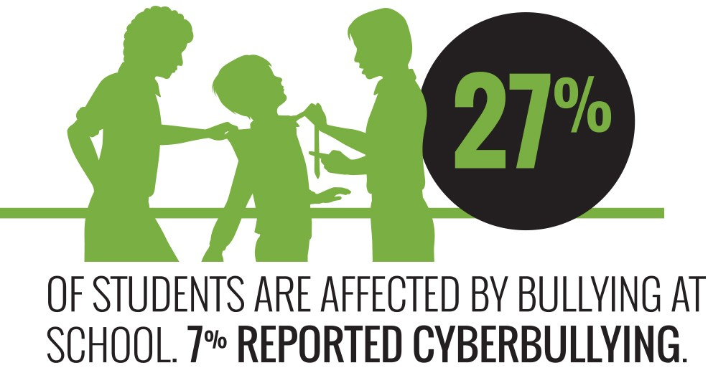
Face the facts:
CHILDREN’S RIGHTS • 2014

The Australian Human Rights Commission encourages the dissemination and exchange of information provided in this publication. All material presented in this publication is provided under Creative Commons Attribution 3.0 Australia, with the exception of:
- the Australian Human Rights Commission Logo
- photographs and images
- any content or material provided by third parties.
The details of the relevant licence conditions are available on the Creative Commons website, as is the full legal code for the CC BY 3.0 AU licence.

Attribution
Material obtained from this publication is to be attributed to the Australian Human Rights Commission with the following copyright notice:
© Australian Human Rights Commission 2014.
Face the Facts: Children’s rights • 2014 ISBN 978-1-921449-67-3
Design and layout Dancingirl Designs
Infographic Design Firefly Interactive
Content James Iliffe, Black and White Media Australia
Electronic format
This publication can be found in electronic format on the website of the Australian Human Rights Commission:
http://www.humanrights.gov.au/publications
Contact details
For further information about the Australian Human Rights Commission, please visit
www.humanrights.gov.au or email communications@humanrights.gov.au. You can also write to:
Communications Team
Australian Human Rights Commission GPO Box 5218
Sydney NSW 2001

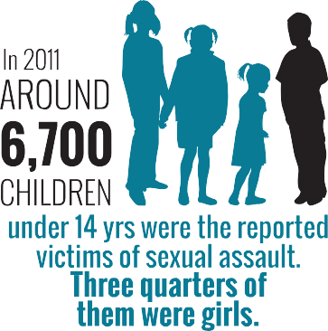
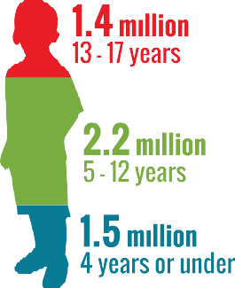
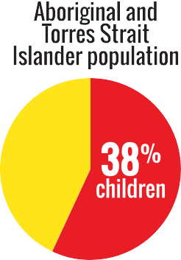
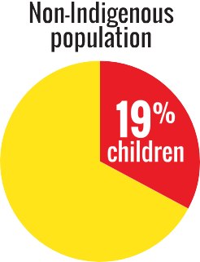
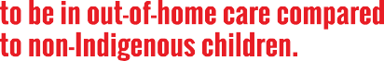
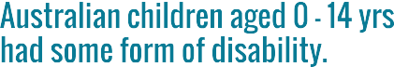
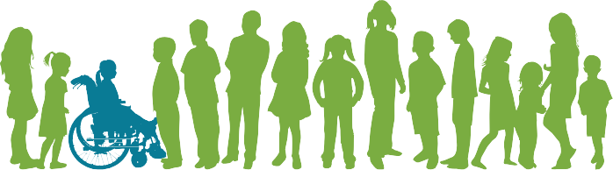

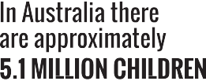

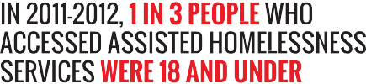

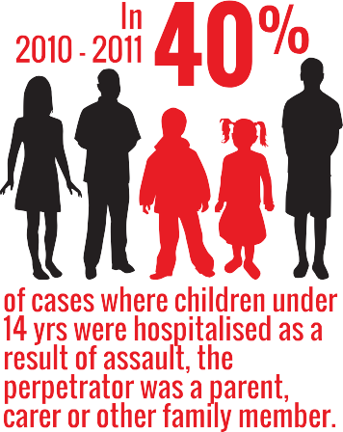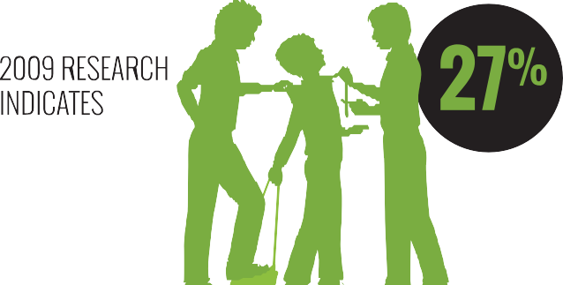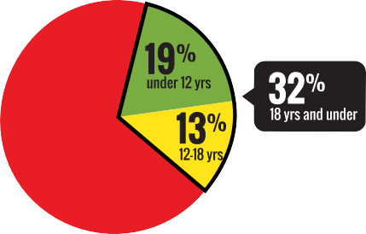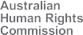
www.humanrights.gov.au/face-facts

Children’s rights

Most children in Australia grow up in a safe, healthy and positive environment.
Broadly speaking, children in Australia have access to high- quality schools and health services. Most live in safe and nurturing homes, where they can pursue their interests, be involved in their communities and plan for their futures.
However, twenty years after Australia signed the Convention on the Rights of the Child, there are still vulnerable groups of children and young people who are at risk of being left behind or falling through the cracks.
Children experiencing homelessness or mental health issues, children with disabilities, children living in out-of-home care, children in immigration detention and Aboriginal and Torres Strait Islander children require particular assistance to make sure their rights are protected.

About
  - There are approximately 5.1 million children in Australia. Roughly 1.5 million are aged four years or under; 2.2 million are aged between five and 12 years; and 1.4 million are aged between 13 and 17 years.1 The proportion of children among Australia’s total population has been steadily declining in recent decades due to sustained low fertility and increased life expectancy.2
  - In 2006, there were an estimated 294,000 Aboriginal and Torres Strait Islander children in Australia (4.2 per cent of all Australian children).3 Children make up more than half (57 per cent) of the total Aboriginal and Torres Strait Islander population.4
  - In 2009, around seven per cent (290,000) of Australia’s children aged 0 to 14 years had some form of disability. Of these children, more than half had severe or profound limitation of core activities.5
  - On 30 June 2012, there were 39,621 children living
in out-of-home care in Australia,6 an increase of 27 per cent from 2008.7 Aboriginal and Torres Strait Islander children were nearly ten times more likely to be in out- of-home care compared to non-Indigenous children.8
  - As of 31 January 2014, there were 1,006 children in closed immigration detention facilities in Australia.9

Key issues for children and their rights
- Across Australia during 2011-2012, 37,781 children aged 0 to17 years were the subject of one or more substantiations of abuse or neglect – an 18 per cent increase from 2007-2008.10
- Children often experience violence within the family. In 2010-2011, 39 per cent of hospitalised cases involving assault against children aged 0 to14 years
involved a perpetrator who was a parent, carer or other family member.11 Around 42 per cent of Aboriginal and Torres Strait Islander children reported witnessing violence against their mother or stepmother, compared with 23 per cent of all children.12
- Around 6700 children aged 0 to 14 years – or 157 in every 100,000 children – were the reported victims of sexual assault. Three quarters of these reported victims were girls.13
- In 2011-2012, around 107,200 people aged 0 to 24 years were assisted by specialist homelessness services; around 19 per cent were under 12 years and around 13 per cent were aged 12 to 18 years.14
- On an average day in 2011-2012, there were 6940 children and young people aged 10 years or older under youth justice supervision;15 the vast majority were male (83 per cent) and aged between 14 to 17 years (79 per cent).16. About 40 per cent of this group were Aboriginal or Torres Strait Islander.17
- Mental health problems and disorders comprise the highest burden (almost 50 per cent) of disease
among Australian children.18 From 2007 to 2011, there were 53 deaths by suicide of children aged under
15 years. Aboriginal and Torres Strait Islander children accounted for 17 (32 per cent) of these deaths.19
- Australian research in 2009 indicates that over a quarter (27 per cent) of students are affected by bullying at school; around seven per cent reported cyberbullying.20 Similarly, around a quarter of children and young people surveyed in 2011 said bullying was an issue. It was of most concern to children aged
11 to 14 years (28.3 per cent).21

Positive developments
  - The vast majority (93 per cent) of Australian children rate their health as “good”, “very good” or “excellent”.22
  - Most children in Australia are achieving national minimum standards for reading, writing and numeracy; are fully engaged in study or work; and have strong support networks.23
  - Most children say they are able to get support from outside their household in times of crisis.24
  - There has been a significant decrease in death rates among children in recent years, mostly due to a fall in injury-related deaths.25

Did you know?
Over 60 per cent of children and young people who took part in a survey by the Australian Human Rights Commission said they did not know or were unaware that they had special rights.26

Find out more
- Australian Human Rights Commission, Children’s Rights Report (2013)
- Australian Human Rights Commission, Back Me Up Cyber-bullying project (2012)
- Australian Institute of Health and Welfare, Young Australians: their health and wellbeing (2011)
- Australian Institute of Health and Welfare, A picture of Australia’s children 2012 (2012)
- Australian Institute of Health and Welfare, Youth justice in Australia 2011-12: An overview (2013)
- United Nations, Convention on the Rights of the Child

Our role
In 2013, a National Children’s Commissioner was appointed to the Australian Human Rights Commission.
A key role of the Commissioner is to monitor and report annually on the status of children’s rights in Australia and to make recommendations to ensure that children can enjoy their rights.
The Commissioner also promotes community awareness and discussion of children’s rights; undertakes research and educational programs; and can examine and make
recommendations on new and existing Commonwealth laws to ensure that the rights of children are respected.
To do this work, the Commissioner consults with children and children’s advocates.
Find out more about our work in this area.

Endnotes

- Australian Human Rights Commission, Children’s Rights Report 2013
(2013), p 19 (footnote 8).
- Australian Bureau of Statistics, 3101.0-Australian Demographic Statistics, June 2009 (December 2009).
- Australian Bureau of Statistics, 4725.0-Aboriginal and Torres Strait Islander Wellbeing: A focus on children and youth, April 2011 (May 2012).
- Australian Bureau of Statistics, above.
- Australian Bureau of Statistics, 4102.0-Australian Social Trends, June 2012 (2012).
- Australian Human Rights Commission, note 1, footnote 21.
- Australian Human Rights Commission, note 1, footnote 22.
- Australian Human Rights Commission, note 1, footnote 23.
- Department of Immigration and Border Protection, Immigration Detention and Community Statistics Summary: 31 January 2014 (2014) p 3.
- Australian Human Rights Commission, note 1, footnote 19.
- Australian Institute of Health and Welfare, A picture of Australia’s children 2012 (2012), p 90.
- Secretariat of National Aboriginal and Islander Child Care study cited in K Richards, ‘Children’s Exposure to Domestic Violence in Australia’, Australian Institute of Criminology Trends and Issues in Crime and Criminal Justice, 419 (2011).
- Australian Human Rights Commission, note 1, footnote 32.

- Australian Institute of Health and Welfare, Australia’s welfare 2013 (2013) p 178.
- Australian Institute of Health and Welfare, Youth justice in Australia 2011-12: an overview (2013), p 3, 18.
- Australian Institute of Health and Welfare, above, p 1.
- Australian Institute of Health and Welfare, note 14, p 181.
- Australian Institute of Health and Welfare, Young Australians: their health and wellbeing 2011 (2011); Australian Institute of Health and Welfare, The burden of disease and injury in Australia (2003).
- Australian Bureau of Statistics, 3303.0-Causes of Death, Australia, 2011
(March 2013).
- Child Health Promotion Research Centre, Edith Cowan University,
Australian Covert Bullying Prevalence Study (2009), p 284.
- Mission Australia, Insights into the concerns of young Australians: Making sense of the 2011 Youth Survey (2012), p 5.
- Australian Institute of Health and Welfare, Young Australians: their health and wellbeing 2011 (2011).
- Australian Institute of Health and Welfare, above.
- Australian Institute of Health and Welfare, note 22.
- Australian Institute of Health and Welfare, note 22.
- Australian Human Rights Commission note 1, p 21.

