

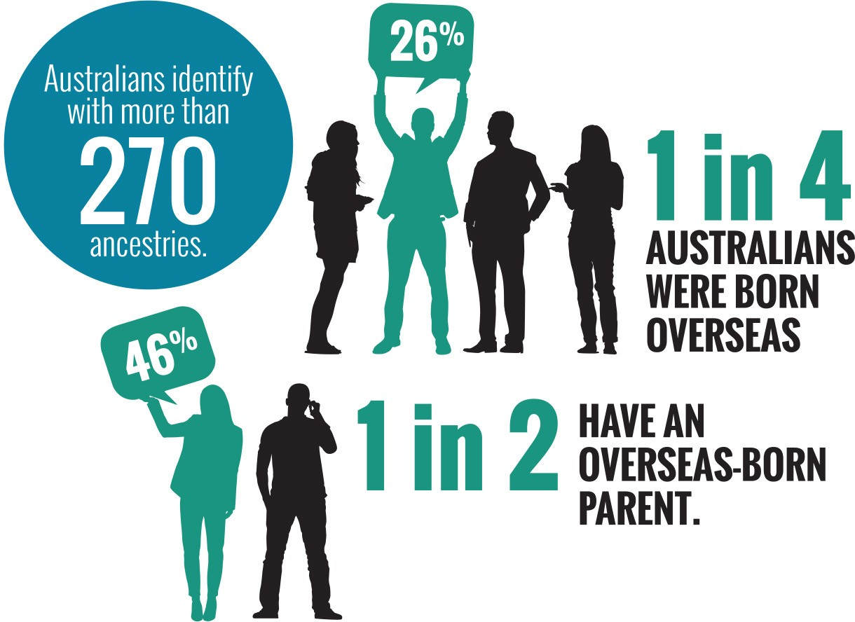

**Face the facts:**

CULTURAL DIVERSITY • **2014**

The Australian Human Rights Commission encourages the dissemination and exchange of information provided in this publication. All material presented in this publication is provided under Creative Commons Attribution 3.0 Australia, with the exception of:

* the Australian Human Rights Commission Logo
* photographs and images
* any content or material provided by third parties.

The details of the relevant licence conditions are available on the Creative Commons website, as is the full legal code for the CC BY 3.0 AU licence.

**Attribution**

Material obtained from this publication is to be attributed to the Australian Human Rights Commission with the following copyright notice:

© Australian Human Rights Commission 2014.

**Face the Facts:** Cultural diversity • **2014 ISBN** 978-1-921449-67-3

**Design and layout** Dancingirl Designs

**Infographic Design** Firefly Interactive

**Content** James Iliffe, Black and White Media Australia

**Electronic format**

This publication can be found in electronic format on the website of the Australian Human Rights Commission:

[**http://www.humanrights.gov.au/publications**](http://www.humanrights.gov.au/publications/sex-discrimination)

**Contact details**

For further information about the Australian Human Rights Commission, please visit

[**www.humanrights.gov.au**](http://www.humanrights.gov.au/)or email [**communications@humanrights.gov.au**.](mailto:communications@humanrights.gov.au) You can also write to:

Communications Team

Australian Human Rights Commission GPO Box 5218

Sydney NSW 2001

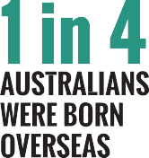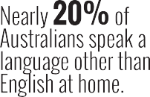

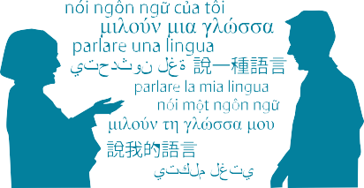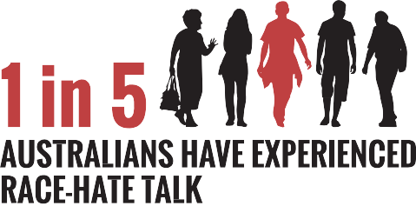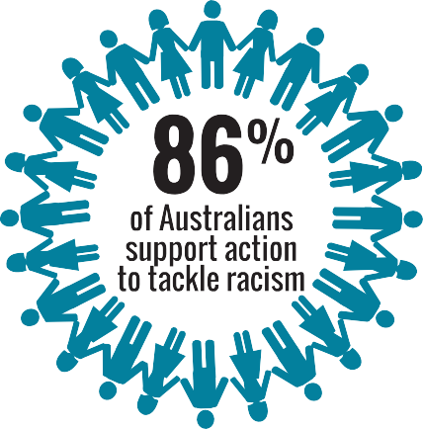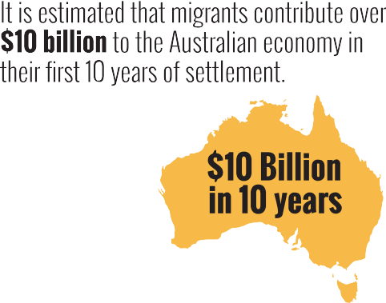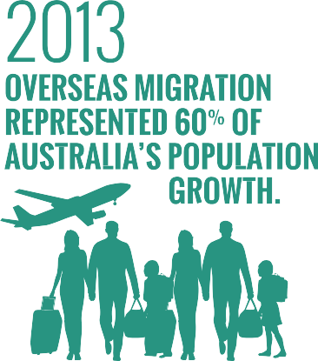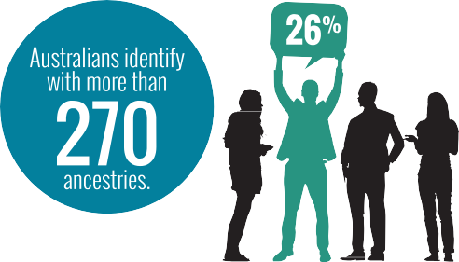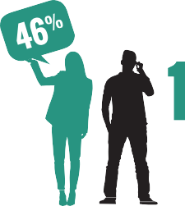

[**www.humanrights.gov.au/face-facts**](http://www.humanrights.gov.au/face-facts)

Cultural diversity

Australia is a vibrant, multicultural country. We are home to the world’s oldest continuous cultures, as well as Australians who identify with more than 270 ancestries. Since 1945, almost seven million people have migrated to Australia.

This rich, cultural diversity is one of our greatest strengths. It is central to our national identity.

In 1975, the [Racial Discrimination Act](https://www.humanrights.gov.au/publications/know-your-rights-racial-discrimination-and-vilification) came into force, making discrimination in different parts of public life against the law.

The Act, which was Australia’s first federal anti-discrimination law, continues to send a strong message about our common commitment to racial equality and the importance of a fair go for all.

In 1995, the Act was extended to make public acts of racial hatred against the law.

Despite this legal protection, too many people in Australia continue to experience prejudice and unfair treatment because of how they look or where they come from.

# About

* + One in four of Australia’s 22 million people were born overseas; 46 per cent were born overseas or have a parent who was born overseas; and nearly 20 per cent of Australians speak a language other than English at home.1
  + In 2012-2013, overseas migration represented 60 per cent of Australia’s population growth in the year.2
  + People born in the United Kingdom continue to be the largest group of overseas-born residents (5.3 per cent), followed by New Zealand (2.6 per cent), China (1.8 per cent), India (1.6 per cent) and Vietnam (0.9

per cent).3 In 2012-13, 123,438 people from more than 190 countries were approved to become Australian citizens.4

* + Migrants make an enormous contribution to Australia’s economy and provide an estimated fiscal benefit

of over 10 billion dollars in their first ten years of settlement.5 In 2010-11, international education contributed $16.3 billion to the Australian economy.6

* + Barriers to racial equality
* One in ten Australians (1.5 million of the nation’s adult population) believe that some races are inferior or superior to others.7
* Around 20 per cent of Australians have experienced race-hate talk;8 11 per cent have experienced race- based social exclusion;9 six per cent reported physical attacks based on their race and/or traditional dress; and 19 per cent reported discrimination because of their skin colour, ethnic origin or religion.10
* Of the 500 complaints lodged under the Racial Discrimination Act in 2012-2013*,* 192 related to incidents of racial hatred. This was a 59 per cent increase over the previous year, with a large proportion of the complaints (41 per cent) involving material on the Internet.11
* People born in countries where English is not the main spoken language are three times as likely to experience discrimination in the workplace,12 twice as likely to experience discrimination in education13 and

around four times as likely to experience discrimination in policing and housing.14

* Around one in three (35 per cent) recent migrants said they faced hurdles to finding their first job due to a lack of Australian work experience or references (64 per cent), language difficulties (33 per cent), a lack of local contacts or networks (23 percent) or difficulties having their skills or qualifications recognised (15 per cent).15

# Positive developments

* + Most new migrants say they feel a strong sense of belonging to Australia and that this feeling deepens over time.16
  + Most Australians (86 per cent) support action to tackle racism in Australia.17
  + Since being launched in 2012, over 200 organisations

– from the business, sports, education, local government and community sectors – have signed on as supporters of the national anti-racism campaign, *Racism. It Stops with Me*.

# Did you know?

* + The vast majority of Australians (84 per cent) believe that multiculturalism has been good for Australia.18

# Find out more

* + Australian Human Rights Commission; [National](http://itstopswithme.humanrights.gov.au/it-stops-with-me/strategy) [Anti-Racism Strategy 2012-2015](http://itstopswithme.humanrights.gov.au/it-stops-with-me/strategy) (2012)
  + Australian Human Rights Commission; [Racism.](http://itstopswithme.humanrights.gov.au/) [It Stops with Me](http://itstopswithme.humanrights.gov.au/) (2012- )
  + Department of Immigration and Border Protection; [*The People of Australia – Australia’s Multicultural*](http://www.immi.gov.au/living-in-australia/a-multicultural-australia/multicultural-policy/)[*Policy*](http://www.immi.gov.au/living-in-australia/a-multicultural-australia/multicultural-policy/)(2011)
  + Australian Bureau of Statistics, [*Reflecting a Nation:*](http://www.abs.gov.au/ausstats/abs%40.nsf/Lookup/2071.0main%2Bfeatures902012-2013)[*Stories from the 2011 Census*](http://www.abs.gov.au/ausstats/abs%40.nsf/Lookup/2071.0main%2Bfeatures902012-2013)(2012-2013)
  + University of Western Sydney, [*Challenging Racism:*](http://www.uws.edu.au/ssap/school_of_social_sciences_and_psychology/research/challenging_racism)[*The Anti-Racism Research Project*](http://www.uws.edu.au/ssap/school_of_social_sciences_and_psychology/research/challenging_racism)(2008)

# Our role

The Commission helps people resolve complaints of discrimination under the [Racial Discrimination Act](http://www.humanrights.gov.au/our-work/legal/legislation). The Act protects people across Australia from unfair treatment on the basis of their race, colour, descent, or national or ethnic origin. It also makes racial vilification against the law.

The [Race Discrimination Commissioner](https://www.humanrights.gov.au/race-discrimination-commissioner-dr-tim-soutphommasane) undertakes a wide range of activities to address racism and racial discrimination, which includes implementing the [National Anti-Racism](http://itstopswithme.humanrights.gov.au/it-stops-with-me/strategy) [Strategy](http://itstopswithme.humanrights.gov.au/it-stops-with-me/strategy) and coordinating the national anti-racism campaign*,* [Racism. It Stops with Me](http://itstopswithme.humanrights.gov.au/).

The Commissioner also undertakes research projects and provides policy advice on issues affecting different groups in the community.

Find out more about [our work](https://www.humanrights.gov.au/our-work/race-discrimination) in this area.

Endnotes

1. Australian Bureau of Statistics, *4102.0-Australian Social Trends*

(April 2013).

1. Australian Bureau of Statistics, [*3101.0-Australian Demographic Statistics,*](http://www.abs.gov.au/ausstats/abs%40.nsf/mf/3101.0)[*September 2013*](http://www.abs.gov.au/ausstats/abs%40.nsf/mf/3101.0)(March 2014).
2. Australian Bureau of Statistics, [*3412.0-Migration, Australia, 2011-12 and*](http://www.abs.gov.au/ausstats/abs%40.nsf/Lookup/3412.0Chapter12011-12%20and%202012-13)[*2012-13*](http://www.abs.gov.au/ausstats/abs%40.nsf/Lookup/3412.0Chapter12011-12%20and%202012-13)(December 2013).
3. Department of Immigration and Border Protection: [*Facts and Statistics*](http://www.citizenship.gov.au/learn/facts-and-stats/)

(2013)

1. Department of Immigration and Citizenship, [*Immigration update*](http://www.immi.gov.au/media/publications/statistics/immigration-update/update-2010-11.pdf)[*2010–2011*](http://www.immi.gov.au/media/publications/statistics/immigration-update/update-2010-11.pdf)(2011), p 109.
2. Australian Education International, [*Export Income to Australia from*](https://www.aei.gov.au/research/Research-Snapshots/Documents/Export%20Income%202010-11.pdf)[*Education Services in 2010–11*](https://www.aei.gov.au/research/Research-Snapshots/Documents/Export%20Income%202010-11.pdf)(November 2011).
3. University of Western Sydney, [*Challenging Racism: The Anti-Racism*](http://www.uws.edu.au/ssap/ssap/research/challenging_racism/findings_by_region)[*Research Project*](http://www.uws.edu.au/ssap/ssap/research/challenging_racism/findings_by_region)(2008).
4. University of Western Sydney, above.
5. University of Western Sydney, note 7.
6. Scanlon Foundation, [*Mapping Social Cohesion: The Scanlon Foundation*](http://www.scanlonfoundation.org.au/docs/2013_SocC_report_final.pdf)[*Survey 2013*](http://www.scanlonfoundation.org.au/docs/2013_SocC_report_final.pdf)(2013), p 2.
7. Australian Human Rights Commission, [*Annual Report 2012-2013*](https://www.humanrights.gov.au/publications/annual-report-2012-2013)(2013).
8. Victorian Health Promotion Foundation (VicHealth), [*More than tolerance:*](http://www.vichealth.vic.gov.au/discrimattitudes/)[*Embracing diversity for health: Discrimination affecting migrant and*](http://www.vichealth.vic.gov.au/discrimattitudes/)[*refugee communities in Victoria, its health consequences, community*](http://www.vichealth.vic.gov.au/discrimattitudes/)[*attitudes and solutions*](http://www.vichealth.vic.gov.au/discrimattitudes/)(2007).
9. VicHealth, above.
10. VicHealth, note 12.
11. Australian Bureau of Statistics, [*6250.0-Characteristics of Recent*](http://www.abs.gov.au/ausstats/abs%40.nsf/Products/6250.0%7ENov%2B2010%7EMain%2BFeatures%7EEmployment?OpenDocument)[*Migrants, Australia, November 2010*](http://www.abs.gov.au/ausstats/abs%40.nsf/Products/6250.0%7ENov%2B2010%7EMain%2BFeatures%7EEmployment?OpenDocument)(May 2011).
12. The [*Ipsos McKay Report: SBS Immigration Nation*](http://media.sbs.com.au/home/upload_media/site_20_rand_2115667245_sbs_immigration_nation_final_report_16_dec.pdf)(2011) found that

60 per cent of first-generation migrants felt a strong sense of belonging to Australia, which rose to 80 per cent by the second generation, in line with the national average.

1. University of Western Sydney, note 7.
2. Scanlon Foundation, note 10.