

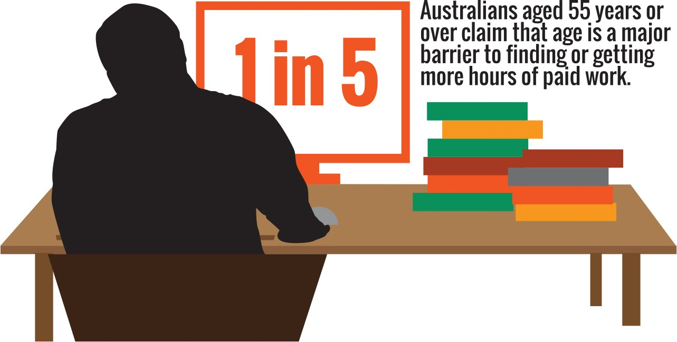

**Face the facts:**

OLDER AUSTRALIANS • **2014**

The Australian Human Rights Commission encourages the dissemination and exchange of information provided in this publication. All material presented in this publication is provided under Creative Commons Attribution 3.0 Australia, with the exception of:

* the Australian Human Rights Commission Logo
* photographs and images
* any content or material provided by third parties.

The details of the relevant licence conditions are available on the Creative Commons website, as is the full legal code for the CC BY 3.0 AU licence.

**Attribution**

Material obtained from this publication is to be attributed to the Australian Human Rights Commission with the following copyright notice:

© Australian Human Rights Commission 2014.

**Face the Facts:** Older Australians • **2014 ISBN** 978-1-921449-67-3

**Design and layout** Dancingirl Designs

**Infographic Design** Firefly Interactive

**Content** James Iliffe, Black and White Media Australia

**Electronic format**

This publication can be found in electronic format on the website of the Australian Human Rights Commission:

[**http://www.humanrights.gov.au/publications**](http://www.humanrights.gov.au/publications/sex-discrimination)

**Contact details**

For further information about the Australian Human Rights Commission, please visit

[**www.humanrights.gov.au**](http://www.humanrights.gov.au/)or email [**communications@humanrights.gov.au**.](mailto:communications@humanrights.gov.au) You can also write to:

Communications Team

Australian Human Rights Commission GPO Box 5218

Sydney NSW 2001

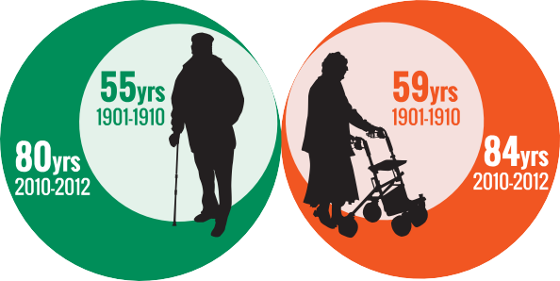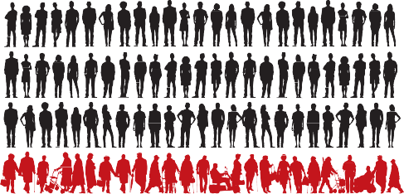

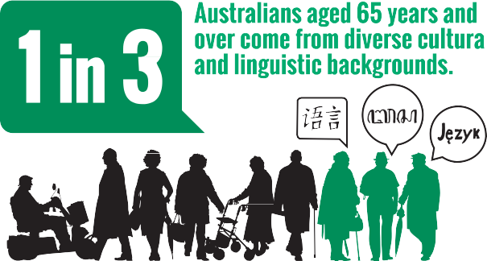

## 

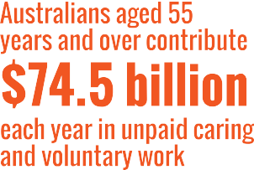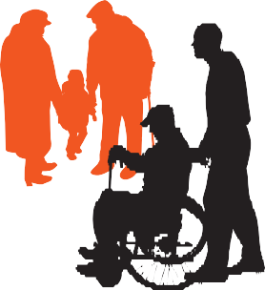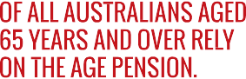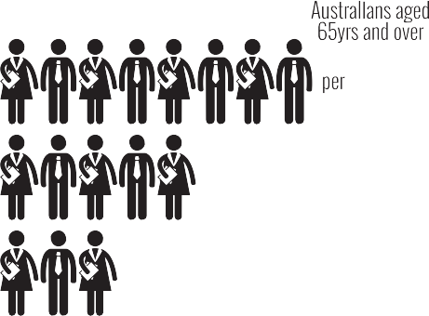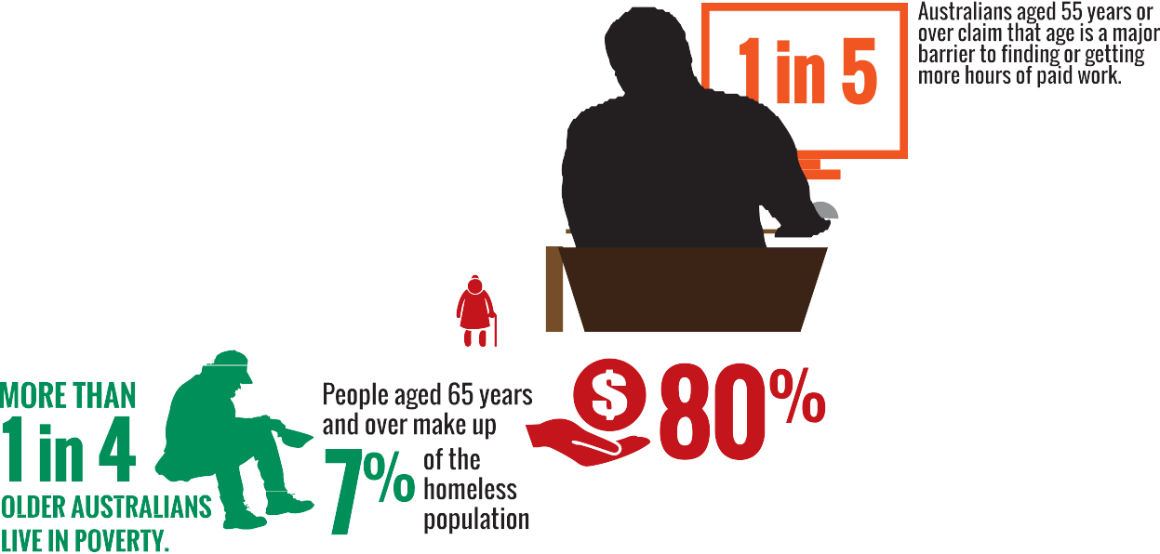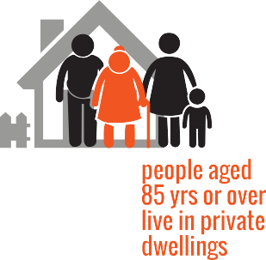

 



[**www.humanrights.gov.au/face-facts**](http://www.humanrights.gov.au/face-facts)



Older Australians

Every day, across the country, older Australians make an enormous contribution to our society.

For example, Australians aged 65 years and over contribute almost $39 billion each year in unpaid caring and voluntary work. If the unpaid contribution of those aged 55 to 64 years is included, that figure rises to $74.5 billion per year.1

Older Australians should be recognised for their role in building strong and healthy communities.

However, many say that negative attitudes about older people can translate into unfair treatment and social exclusion.

Being labelled as “too old” or “past their use-by date” means that some miss out on work, training, study and other opportunities.

In 2004, the [Age Discrimination Act](https://www.humanrights.gov.au/our-work/legal/legislation#Age) came into force. The Act makes it unlawful to treat people unfairly on the basis of their age in different areas of public life. It also highlights the need to tackle the negative stereotypes that can lead to age discrimination.

# About

* + By 2050, around one quarter of all Australians will be aged 65 years and over, with the proportion of younger Australians declining.2 In fact, the number of people aged 65 years and over will overtake the number of children aged 0 to 14 years by around 2025.3
  + There are twice as many women as men aged 85 years and over, reflecting their longer life expectancy.4 It is estimated that the number of Australians aged

85 and over will increase from 400,000 in 2010 to

1.8 million by 2050.5

* + One in three Australians aged 65 years and over come from diverse cultural and linguistic backgrounds. Around 840,000 Australians aged 65 years and over were born overseas.6

# Key issues for older Australians

* Around one in three Australians (35 per cent) aged between 55 and 64 years say they have experienced discrimination because of their age.7 The most common types of discrimination include being turned down for a job, being ignored or treated rudely and having disparaging jokes made about their age.8
* One in five Australians aged 55 years or over claim that age is a major barrier to finding a job or getting more hours of paid work. They say that employers consider them “too old”.9
* Approximately 80 per cent of all Australians aged 65 years and over rely on the Age Pension.10 There are currently five people of working age to support each person aged 65 years and over. However, by 2041 there will only be just half the number (2.5 people) of working age to support each retiree.11
* More than one in four older Australians live in poverty.12 People aged 65 years and over make up seven per cent of the homeless population.13
* Older Aboriginal and Torres Strait Islander people are almost three times more likely than non-Indigenous older people to need help with self-care, mobility or communication.14
* In 2009-2010 women reached retirement age with an average of 36 per cent – or $87,532 – less superannuation than men.15

# Positive developments

* + Australians enjoy one of the highest life expectancies in the world. Men today live nearly 80 years and women live 84 years, both up 25 years from a century ago.16 The physical health of older Australians is also improving and most people (82 per cent) are positive about their quality of life.17
  + The majority of older Australians live independently at home. Only one in four people aged 85 years or over live in care accommodation.18
  + Rates of volunteering among the “baby boomer” generation – recently retired, healthy and wanting to contribute to their communities – are continuing to rise compared to previous generations.19
  + Increasing paid employment of Australians over

55 years by five per cent would add $48 billion to the bottom line of our national economy, every year.20

# Did you know?

Over the past two decades, the number of centenarians (people aged 100 years and over) increased by 271%, compared with a 31 per cent in the general population over the same period.21

Australia has produced 23 verified super centenarians (aged 110 [years](http://www.reference.com/browse/wiki/Year) or older). The oldest Australian was Christina Cock, who died in 2002 aged 114 years.

# Find out more

* Australian Government, [*Australia to 2050: Future*](http://archive.treasury.gov.au/igr/igr2010/report/pdf/IGR_2010.pdf)[*challenges*](http://archive.treasury.gov.au/igr/igr2010/report/pdf/IGR_2010.pdf)(2010)
* Australian Human Rights Commission, [*Fact or fiction?*](https://www.humanrights.gov.au/fact-or-fiction-stereotypes-older-australians)[*Stereotypes of older Australians*](https://www.humanrights.gov.au/fact-or-fiction-stereotypes-older-australians)(2013)
* Australian Institute of Health and Welfare, [*Australia’s*](http://www.aihw.gov.au/publication-detail/?id=10737422172)[*heath 2012*](http://www.aihw.gov.au/publication-detail/?id=10737422172)(2012)
* Deloitte Access Economics, [*Increasing participation*](https://www.humanrights.gov.au/increasing-participation-among-older-workers-grey-army-advances2012)[*among older workers: The grey army advances*](https://www.humanrights.gov.au/increasing-participation-among-older-workers-grey-army-advances2012)(2012)

# Our role

The Commission helps people resolve complaints of unfair treatment under the [Age Discrimination Act](https://www.humanrights.gov.au/our-work/legal/legislation#Age).

Our work, led by the [Age Discrimination Commissioner](https://www.humanrights.gov.au/about/commissioners/age-discrimination-commissioner-hon-susan-ryan-ao), also includes research, policy advice and education initiatives that tackle the community attitudes that can lead to age discrimination.

For example, the Australian Government funded a [major](https://www.humanrights.gov.au/fact-or-fiction-stereotypes-older-australians) [research project](https://www.humanrights.gov.au/fact-or-fiction-stereotypes-older-australians) in 2013 to promote greater awareness of the damaging effects of negative stereotypes around ageing.

Find out more about [our work](https://www.humanrights.gov.au/our-work/age-discrimination) in this area.

Endnotes

1. Australian Institute of Family Studies, [*Measuring the value of unpaid*](http://www.aifs.gov.au/institute/pubs/respaper/rp34.html)[*household, caring and voluntary work of older Australians*](http://www.aifs.gov.au/institute/pubs/respaper/rp34.html)(2003).
2. Australian Human Rights Commission, [*Age Positive: Promoting Positive*](https://www.humanrights.gov.au/sites/default/files/fact_sheet_age_stereotying.pdf)[*and Diverse Portrayals of Older Australians: Research Project Fact Sheet*](https://www.humanrights.gov.au/sites/default/files/fact_sheet_age_stereotying.pdf)(2012).
3. Australian Bureau of Statistics, [*3101.0-Australian Demographic Statistics,*](http://www.abs.gov.au/ausstats/abs%40.nsf/0/AE3CAF747F4751CDCA2579CF000F9ABC?OpenDocument)[*June 2011*](http://www.abs.gov.au/ausstats/abs%40.nsf/0/AE3CAF747F4751CDCA2579CF000F9ABC?OpenDocument)(December 2011).
4. Australian Bureau of Statistics, [*3201.0-Population by Age and Sex,*](http://www.abs.gov.au/Ausstats/abs%40.nsf/mf/3201.0)[*Australian States and Territories, June 2010*](http://www.abs.gov.au/Ausstats/abs%40.nsf/mf/3201.0)(December 2010).
5. Australian Human Rights Commission, [*A human rights approach for*](https://www.humanrights.gov.au/human-rights-approach-ageing-and-health-respect-and-choice-home-based-and-residential-care-older)[*ageing and health – Respect and choice: home-based and residential*](https://www.humanrights.gov.au/human-rights-approach-ageing-and-health-respect-and-choice-home-based-and-residential-care-older)[*care for older people*](https://www.humanrights.gov.au/human-rights-approach-ageing-and-health-respect-and-choice-home-based-and-residential-care-older)(2012), footnote 3; The Treasury, Australian Government, [*Australia to 2050: Future Challenges*](http://archive.treasury.gov.au/igr/igr2010/default.asp)(2010), p 56.
6. Australian Bureau of Statistics, [*2006 Census Tables*](http://www.abs.gov.au/websitedbs/censushome.nsf/home/historicaldata2006?opendocument&amp;navpos=280)*: Country of birth by age and sex, by usual residence* (Cat. No. 2068.0).
7. Australian Human Rights Commission, note 2, footnote 2; Australian Bureau of Statistics, [*3222.0-Population Projections, Australia, 2006 to*](http://www.abs.gov.au/AUSSTATS/abs%40.nsf/DetailsPage/3222.02006%20to%202101?OpenDocument)[*2101*](http://www.abs.gov.au/AUSSTATS/abs%40.nsf/DetailsPage/3222.02006%20to%202101?OpenDocument)(September 2008).
8. Australian Human Rights Commission, above.
9. Australian Bureau of Statistics, [*4102.0-Australian Social Trends,*](http://www.abs.gov.au/AUSSTATS/abs%40.nsf/Lookup/4102.0Main%2BFeatures30Sep%2B2010)[*Sep 2010: Older People and the Labour Market*](http://www.abs.gov.au/AUSSTATS/abs%40.nsf/Lookup/4102.0Main%2BFeatures30Sep%2B2010)(September 2010).
10. Aged and Community Services Australia, [*An Ageing Australia: Fact*](http://www.agedcare.org.au/publications/resources/fact-sheets/acsa-fact-sheet-1-2008--an-ageing-australia.pdf/view)[*Sheet 1*](http://www.agedcare.org.au/publications/resources/fact-sheets/acsa-fact-sheet-1-2008--an-ageing-australia.pdf/view)(July 2011), p 2.
11. The Treasury, Australian Government, note 5.
12. Australian Human Rights Commission, [*Age discrimination: Exposing the*](https://www.humanrights.gov.au/publications/age-discrimination-exposing-hidden-barrier-mature-age-workers-2010)[*hidden barrier for mature age workers*](https://www.humanrights.gov.au/publications/age-discrimination-exposing-hidden-barrier-mature-age-workers-2010)(2010).
13. Department of Social Services, Australian Government, [*The Road Home:*](http://www.dss.gov.au/our-responsibilities/housing-support/programs-services/homelessness/the-road-home-the-australian-government-white-paper-on-homelessness-0)[*The Australian Government White Paper on Homelessness*](http://www.dss.gov.au/our-responsibilities/housing-support/programs-services/homelessness/the-road-home-the-australian-government-white-paper-on-homelessness-0)(2008).
14. Australian Institute of Health and Welfare, [*Older Aboriginal and Torres*](http://www.aihw.gov.au/indigenous-observatory-older-people/)[*Strait Islander people*](http://www.aihw.gov.au/indigenous-observatory-older-people/)(May 2011).
15. Council of Australia Governments (COAG) Reform Council, [*Tracking*](https://www.coagreformcouncil.gov.au/reports/gender-equity/tracking-equity-comparing-outcomes-women-and-girls-across-australia)[*equity: Comparing outcomes from women and girls across Australia*](https://www.coagreformcouncil.gov.au/reports/gender-equity/tracking-equity-comparing-outcomes-women-and-girls-across-australia)(2012).
16. Australian Institute of Health and Welfare, [*Aged care packages in the*](http://www.aihw.gov.au/publication-detail/?id=10737422820)[*community 2010-11: a statistical overview*](http://www.aihw.gov.au/publication-detail/?id=10737422820)(2012), p 122.
17. Australian Institute of Health and Welfare, [*Australia’s health 2012*](http://www.aihw.gov.au/publication-detail/?id=10737422820)(2012).
18. Australian Institute of Health and Welfare, [*Australia’s welfare 2011*](http://www.aihw.gov.au/publication-detail/?id=10737420537)(2011) p 168.
19. The Australia Institute, [*The benefits of an ageing population*](http://www.tai.org.au/documents/dp_fulltext/DP63.pdf)(2002).
20. Deloitte Access Economics for the Australian Human Rights Commission, [*Increasing participation among older workers: The grey army advances*](https://www.humanrights.gov.au/increasing-participation-among-older-workers-grey-army-advances2012)(2012), p i.
21. Australian Bureau of Statistics, [*3101.0-Australian Demographic Statistics,*](http://www.abs.gov.au/ausstats/abs%40.nsf/0/1CD2B1952AFC5E7ACA257298000F2E76?OpenDocument)[*June 2013*](http://www.abs.gov.au/ausstats/abs%40.nsf/0/1CD2B1952AFC5E7ACA257298000F2E76?OpenDocument)(December 2013).