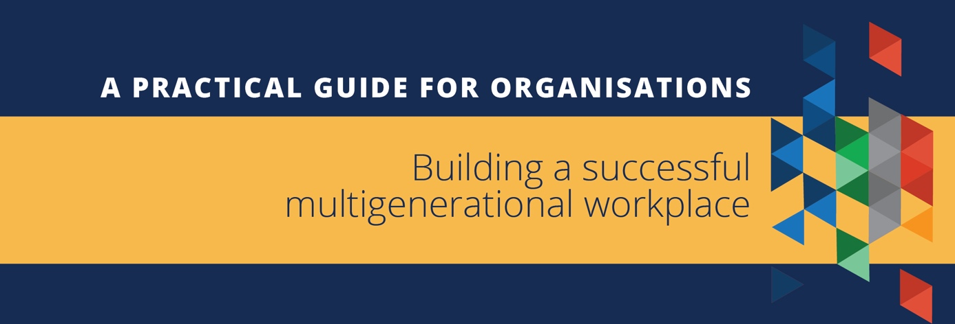

Australia’s population is ageing and Australians are living longer and healthier lives. Employees now span four, or even five generations. More workplaces report they have an older workforce, with over 19% of Australian businesses stating that more than half their workforce is over 50 years old.
However, recent research indicates that ageism continues to be an issue in many workplaces. The age at which workers are considered ‘older’ is becoming progressively younger, and about a quarter of Australian businesses say they are reluctant to hire older workers.
Employers have a legal responsibility to prevent age discrimination in the workplace, but beyond that, managing multigenerational teams and ageism is critical to ensuring a productive and high‑performing workforce.
Retaining older workers and tapping into the benefits of a multigenerational workforce provides a range of advantages for businesses and organisations, including the retention of organisational knowledge, greater diversity of skills and ideas, and enhanced productivity and innovation.
There are many ways business leadership, managers and human resources teams can encourage an inclusive workforce and help reduce age discrimination.
____________________________________________________________________________________
Visit our online resource hub to access free resources for employers and employees at www.humanrights.gov.au/olderworkers. |  |  |  | 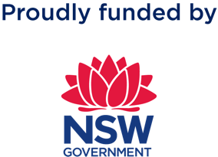

Four key principles to developing an efficient multigenerational workplace:
- The strengths and skills each employee brings to the team are more important than their age or generation.
- Work with all team members based on their particular strengths and skills.
- Develop clear policies and implement them.
- Ensure your workplace supports and values workers of all ages.

Leaders can demonstrate their commitment to building an inclusive and diverse workplace by:
- Developing a strategy for managing a multigenerational workforce which includes policies around recruitment, employee engagement, internal communications, collaboration and performance.
- Having clear policies about age discrimination, communicating these to managers and staff, and regularly checking that the practices reflect the policies.
- Encouraging a positive and inclusive culture that respects individual differences with no tolerance for discrimination or harassment.
- Ensuring line managers are supported by providing them with training on building and managing age-diverse teams.
- Ensuring older workers have the same opportunities to access training, progression, mentoring and leadership as workers of other ages. Consider tracking these by age cohorts so you can monitor progress.
- Communicating organisational values, goals and performance transparently.

- Offering secure contracts to workers where possible, regardless of their age.
- Ensuring team members have clearly defined roles and career pathways within the organisation.
- Clearly communicating to employees how the organisation handles discrimination complaints. Employees should know who they can speak to if they are discriminated against, or witness discrimination, and what the process for handling that complaint might look like.
- Ensuring that all workers have full and equal access to Work Health and Safety (WHS) and wellbeing support and that appropriate physical adjustments, equipment and other forms of adaptation are provided.
- Having an age-neutral approach to flexible work, where possible, which is promoted to all staff.

Managers can encourage collaboration through effective communication and respectful engagement and by:
- Talking to all team members individually about their goals and aspirations, and investigating ways the organisation can support these.
- Consulting with older workers about their needs and preferences in the workplace.
- Reminding team members of the benefits of diverse viewpoints.
- Creating opportunities for intergenerational mingling (e.g. through team building events, social events or projects that require cross-generational collaboration).
- Sharing routine and challenging tasks among your team members and ensuring all workers have the chance to learn new skills.
- Designing roles for older people that maximise the opportunity to interact with colleagues, clients and stakeholders.
- Ensuring all workers feel their opinions, ideas and experiences are valued.
- Being vigilant about not allowing ageist jokes in the workplace.
- Ensuring older workers have autonomy, variety in their work and opportunities for new experiences.
- Creating opportunities for older workers to share their knowledge and experience with other colleagues, including training and mentoring of younger or new staff.
- Introducing reverse mentoring initiatives in which younger workers teach older ones, and cross-mentoring programs where older and younger workers mentor each other.

Review your recruitment policy and practices
Recruitment is more than hiring the right person for the job. The way an organisation recruits new staff impacts the culture of that organisation. A good recruitment process can enhance an organisation’s reputation from a market perspective, as well as from a potential candidate and employee perspective, which can ultimately help the business's bottom-line.
Here are some tips for developing an inclusive recruitment process:
- Focus on the core duties of the job, not personal attributes, when advertising and interviewing for a new position.
- Use inclusive language in job advertisements such as ‘people of all ages are encouraged to apply’ and avoid ageist terms such as ‘digital native preferred’ or ‘seeking an up-and-comer’.
- Include people from a range of ages and backgrounds on the interview panel.
- Reflect on whether you have any ageist assumptions before reviewing resumes and interviewing candidates. For example, ‘older people can’t do digital’ or ‘this candidate is too experienced for the role’.
- When using a recruiter or a recruitment agency, be explicit that you expect to be provided with resumes from people of all ages.
- Do not ask for date of birth (or documents that contain this) until after the job has been offered and accepted—and then only if necessary for a work-related reason.

Avoid ageist assumptions
- Do not automatically select the oldest team members for redundancy.
- Do not assume all older workers are winding down to retirement—many women, for example, see their 50s as a time to build their careers after raising children,
- Do not apply policies to people with particular characteristics (e.g. over 50s or returning mothers or people with disability). In many cases a good policy, such as the right to flexibility, will appeal to a number of categories of workers.
- Be aware of intersectional issues such as age combined with gender. For example, older women may be more subject to inappropriate behaviour from colleagues and stakeholders, or may not receive the same respect as older men.

Australian Human Resources Institute (2021) ‘Employing and Retaining Older Workers’.
Australian Human Resources Institute (2021) ‘Employing and Retaining Older Workers’.

