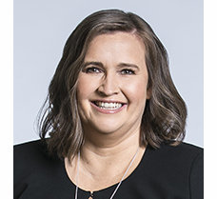 | Kate Jenkins  Sex Discrimination Commissioner  FIFTH YEAR OF TERM | ‘I look forward to a day when men and women are accepted into all walks of life and work—from parenting to rocket science—on the basis of who they are and what they do, and not their gender.’

TERM GOALS
Reduced violence against women | Improved women’s economic security and empowerment | Increased diversity in leadership

STRATEGIES  - Challenging everyday sexism and sexual harassment where we live, work, learn and play.  - Promoting broader social equality and addressing structural discrimination and intersectional disadvantage.  - Challenging the structural and attitudinal barriers affecting working parents, including parental leave, superannuation, flexible work, childcare, and sharing of unpaid work.  - Promoting the benefits of reducing gender-segregated workforces.  - Advocating for improved representation of women and girls in political, corporate, sporting and organisational leadership roles and promoting and facilitating opportunities for women and girls to have their voices heard at a local, national and international level.  - Taking a settings-based approach, focusing on the workplace, education and sport. | 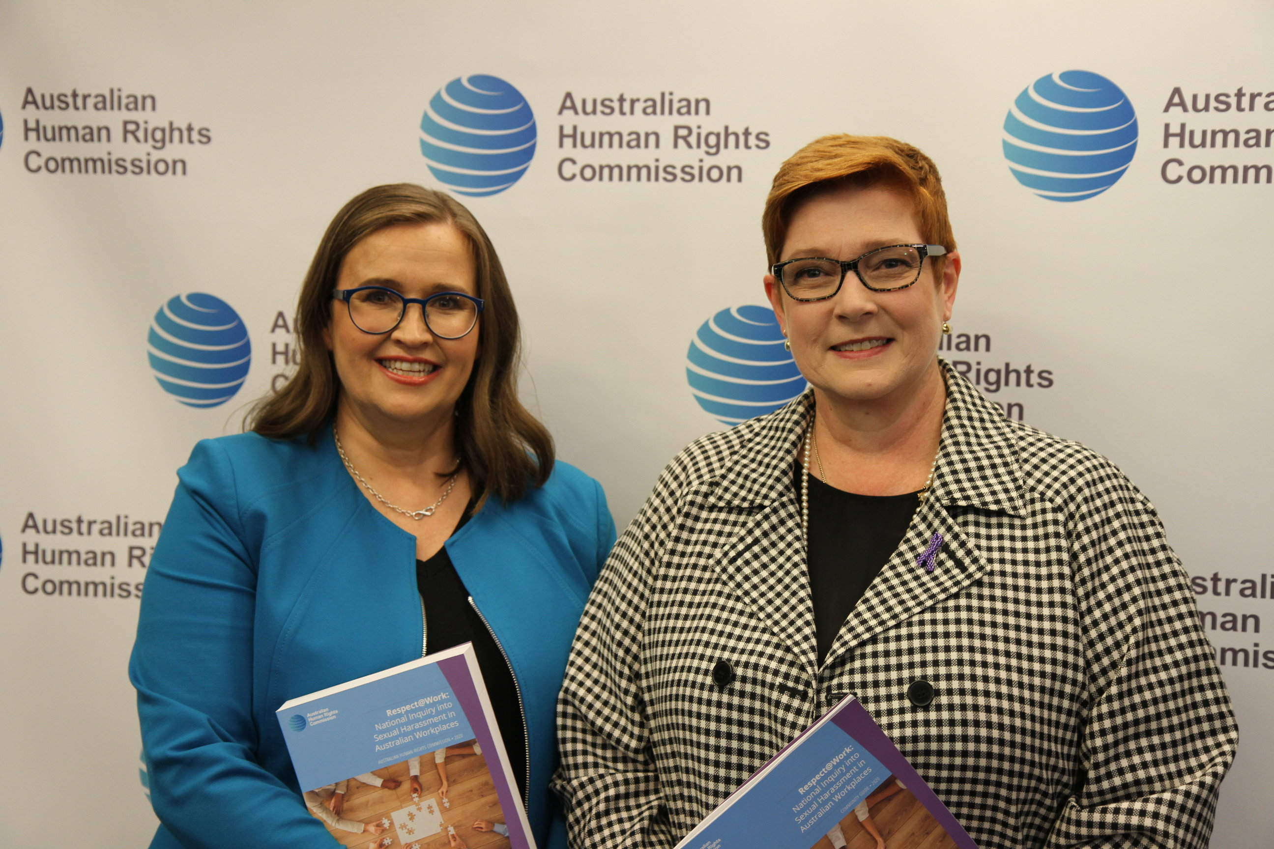  Commissioner Jenkins with Senator the Hon Marise Payne, Minister for Women, at the launch of the Respect@Work report Sydney, March 2020.

KEY ACTVITITES/ 2020–21 WORKPLAN
Violence against women projects | - This work includes advocating and promoting Respect@Work, Australia’s first National Inquiry into sexual harassment in Australian workplaces. The Inquiry builds on data from the fourth national sexual harassment in the workplace survey.  - This work also includes implementing specific recommendations from Respect@Work, including developing:  - Workplace Rights education for young people (recommendation 9)  - Training and education for the Fair Work Ombudsman and Fair Work Commission (Rec 34).  - a Code of Practice for Work Health and Safety authorities on sexual harassment (Recommendation 35),  - Guidelines on non-disclosure agreements (Recommendation 38),  - Respect@Work portal (Recommendation 48)  - Other projects include continued monitoring of the implementation of the Change the course report recommendations by Australian universities
Inclusion and sport | - Projects in this setting include supporting the work of Play by the Rules, a national collaboration to promote child safety, and promoting equal opportunity, anti-discrimination and inclusion in sport, especially in regard to women and girls.
Women’s economic security projects | - Projects include developing a Gender Framework, ensuring that the Australian Government considers gender issues in their decision making on COVID-19 recovery, including the identification of policy areas and actions to prioritise, implementation plans and communication strategies.
Defence Cultural Reform Collaboration | - This Collaboration engages the three Services and the Department of Defence to support and improve Defence cultural reform priorities.  - Projects include: Indigenous attraction, recruitment and retention across Defence; an Inclusive Leadership Network for senior leaders; supporting the development of a reliable reporting framework for workplace behaviour as well as a Navy-specific project with Clearance Divers
Increased diversity in leadership | - Projects include a discussion paper on Women in Politics, which will identify barriers to achieving gender balance in political representation across local, state and federal levels of Government, as well as strategies to improve gender balance in the political sphere.

