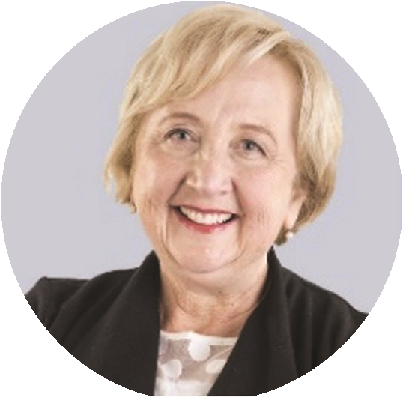
TERM GOALS
Anne Hollonds
National Children’s
Commissioner
SECOND YEAR OF TERM¹
‘It is my job to monitor how well our policies and services are supporting the rights and well-being of all our children, especially those who are living with disadvantage and are likely to miss out on the conditions that support a good childhood.’
- Recognition that children are a national priority in Australia
- Improved Aboriginal and Torres Strait Islander child safety and wellbeing
- Strengthened scrutiny of the legal and policy Improved frameworks to protect children’s rights and wellbeing
- Improved resourcing of National Children’s Commissioners to fulfill their mandate

PRINCIPLES / APPROACH

Applying a human rights-based approach to the work.

Highlighting the experiences and voices of the most vulnerable children.

Enabling and supporting children’s perspectives to be heard and built into policy development.

Ensuring coverage across the full spectrum of childhood (from newborn to teenagers).

Always providing an independent perspective that is robust, and evidence based.
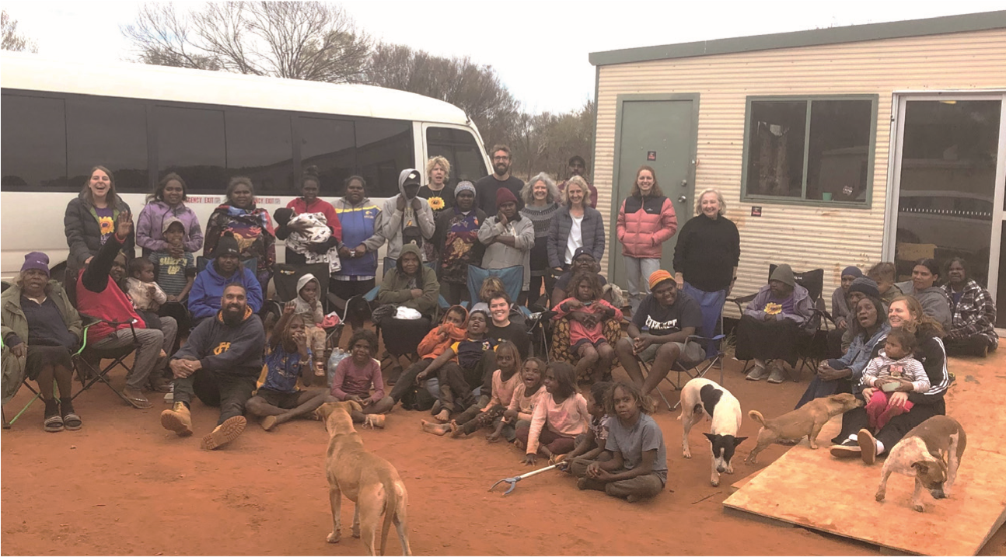
- Seeking to build strategic alliances across sectors, including by reinforcing mutual responsibilities for the wellbeing of children.
Commissioner Hollonds meeting with children, young people and families at Burt Creek Outstation, Northern Territory, June 2021.

1 Commissioner Hollonds’ second year commences in November.

KEY ACTIVITES: 2021-22 WORKPLAN
Keeping kids safe and well – your voices | - In collaboration with the Department of Social Services, this project will consult with children, young people and parents with lived experience of disadvantage and vulnerability. It will report their views on how the government can help to keep children, young people and families safe and healthy in their homes and community. This will feed into the first implementation plan to the successor to the National Framework for Protecting Australia’s Children (2009-2020).
Children’s Statutory Report | - Key issues pertaining to children’s rights in Australia will be tabled in a statutory report in the Federal Parliament.  - This report will include updates on Australia’s implementation of the Concluding Observations made by the Committee on the Rights of the Child in 2019.
Child rights impact assessment tool | - Develop a child rights and wellbeing impact assessment tool which can be applied to proposed legislative changes, and national policy frameworks, plans and strategies.
Experiences of children affected by family violence | - This project is in development. It will consult with children and young people about previous experiences of family and domestic violence and their experiences in seeking and accessing support services. The report findings, and their voice, will be fed into the Australian Governments’ successor plan, the ‘National Plan to Reduce Violence against Women and their Children’.
Mental health impacts of COVID-19 pandemic on at-risk children and young people | - In collaboration with the National Mental Health Commission, this project will consult with at-risk children and young people, as well as families and community supports, to understand the impacts of the COVID-19 pandemic on children and young people in different circumstances and locations; the mental health and related support and interventions required to support them, their families and communities; the main and unique challenges and barriers experienced by children and young people during the pandemic; actions that can be taken to address the priority action areas of the National Mental Health and Wellbeing Pandemic Response Plan, and other priority issues identified by children and young people.

