TERM GOALS
Dr Ben Gauntlett
Disability Discrimination Commissioner
THIRD YEAR OF TERM
‘Good disability policy benefits all Australians: not just the 4.5 million people with a disability in Australia. Ensuring that the voices of people with disability are central to policy decisions is the key to achieving positive outcomes and changing the trajectory of people’s lives for the better.’
- Increased access to meaningful employment opportunities for people with disability
- Greater community awareness of disability rights and disability discrimination
- Increased access to accessible housing for people with disability
- Strengthened legal and policy frameworks to protect disability rights

PRINCIPLES / APPROACH
- Ensuring meaningful consultation, engagement and collaboration with people with disability, including children and young people with disability, and their representative organisations to amplify their voices and promote self-advocacy.
- Promoting understanding and application of the social model of disability in education, policy development, law reform and structural change.
- Fostering stakeholder networks and partnerships to promote the participation of people with disability in the workforce and the broader community.
- Highlighting and addressing structural discrimination and intersectional disadvantage, faced by people with disability.
- Improving the collection and publication of disaggregated data relating to disability to facilitate evidence-based analysis, advocacy and decision-making.
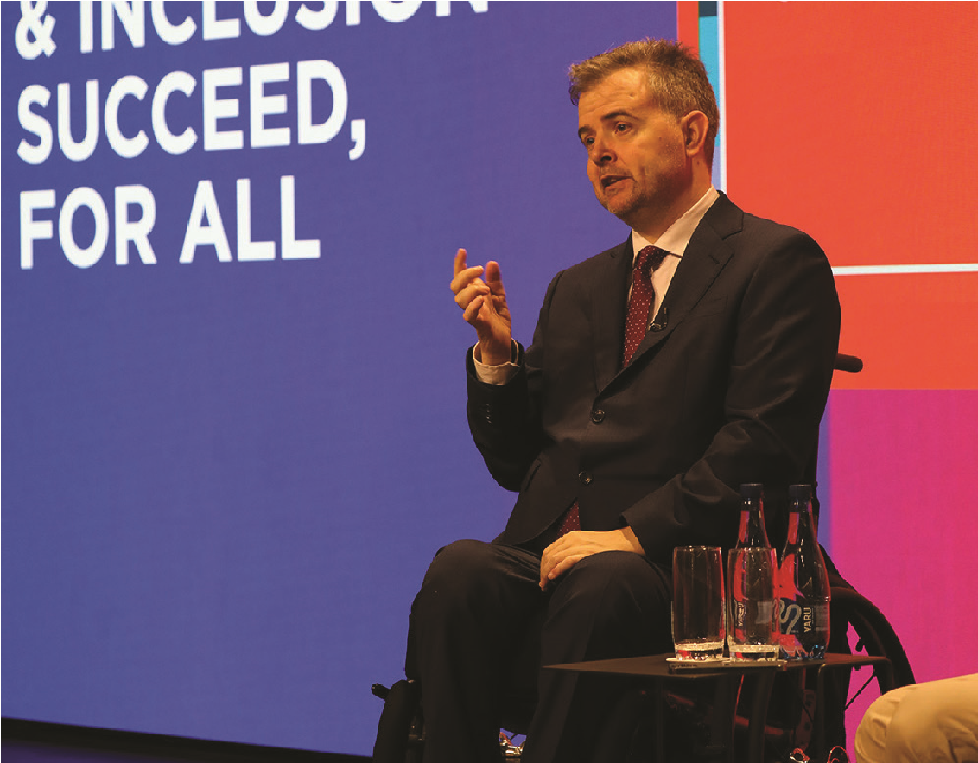
Commissioner Gauntlett, speaking at the launch of the 2021-2024 Westpac Group
Access and Inclusion Plan, May 2021.

KEY ACTIVITES: 2021-22 WORKPLAN
IncludeAbility Project | - Delivering the IncludeAbility employment project to increase access to meaningful employment opportunities for people with disability.  - Supporting IncludeAbility Employer Network members to increase their capacity to address barriers for Australians with disability through quarterly meetings and other engagement.  - Working with the Ambassador Advisory Group to ensure that lived experience of disability is central to IncludeAbility.  - Launching an online web portal hosting resources for both employers and employees to support the recruitment and career progression of people with disability.  - Providing IncludeAbility Employer Network members with the opportunity to participate in pilot employment programs to support the employment of people with disability within their organisation.
Accessible Housing Project | - Exhibiting the research outcomes of the Housing Modifications Research Project, delivered in partnership with the Faculty of Monash Art, Design & Architecture (MADA). This includes the outcomes of the MADA teaching units in which students have considered housing modification options with the Commissioner as the client.
Partnership with the Australian Public Service Commission | - Engaging with the Australian Public Service Commission to support the implementation of the Australian Public Service Disability Employment Strategy 2022-25.
Policy and law reform engagement | - Representing the rights and interests of people with disability by participating in a range of forums and committees across government and non-government sectors. This includes engagement in areas such as transport, education and employment to ensure the lived experience of people with disability is recognised and considered.  - Chairing the National Disability Data Asset Disability Advisory Council, a national asset being developed to support the collection and analysis of system level data to provide an evidence base for disability policy.  - Advocating for policy and law reform to ensure compliance with the Disability Discrimination Act 1992 (Cth), the Convention on the Rights of Persons with Disabilities (CRPD) and to promote the rights of people with disability.  - Contributing to reviews, inquiries and other mechanisms to advocate for a human rights approach across key disability rights policy areas including education, housing and employment.  - Engaging with the Royal Commission into Violence, Abuse, Neglect and Exploitation of People with Disability (Disability Royal Commission) on key issues.  - Participating in, and supporting the participation of civil society in, the CRPD’s Council of States Parties.

