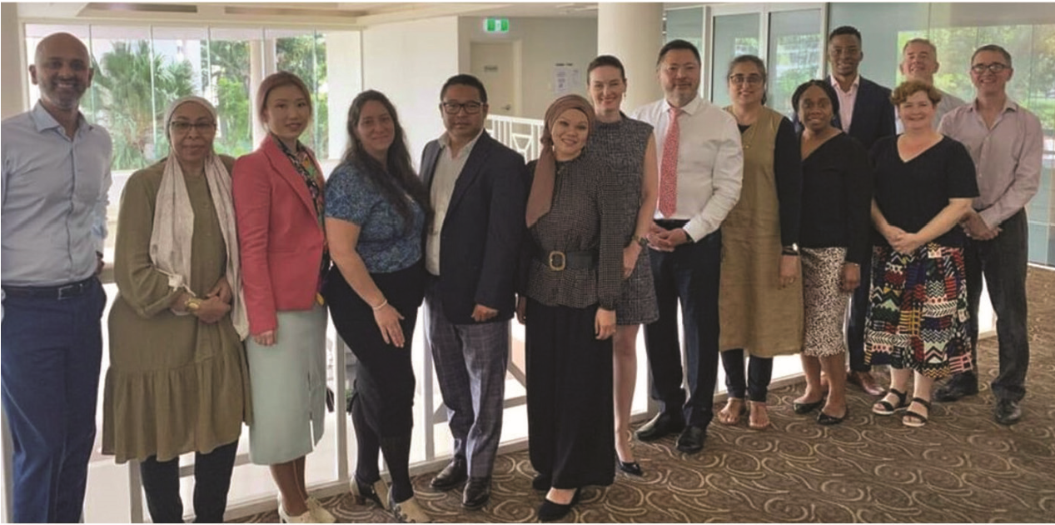
TERM GOALS
Commissioner Tan, with the Hon. Leanne Linard, Queensland Minister for Children and
Youth Justice and Multicultural Affairs and Members of the Multicultural Queensland
Advisory Council, May 2021.
Chin Tan
Race Discrimination
Commissioner
FOURTH YEAR OF TERM
‘Celebrating harmony and eliminating racial discrimination are two sides of the same coin. We cannot eradicate racism without fostering multiculturalism and social cohesion, and vice versa.’
- Improved protections against racial discrimination
- Reduced institutional racism and systemic inequities
- Increased capacity for multicultural and racial minority communities to advocate for their rights
- Increased awareness of racism and racial discrimination

PRINCIPLES / APPROACH
- Focusing on education and capacity building around racism and racial discrimination and supporting strategies to address them and build social cohesion and inclusion.
- Empowering communities through participation and strengths-based engagement—consulting and amplifying community voices on key issues.
- Engaging, collaborating, and partnering with key stakeholders to increase the reach and scope of work addressing racism and racial discrimination and promoting social cohesion, inclusion and diversity.
- Supporting equal participation including by promoting the benefits of culturally diverse workplaces and leaders.
- Using an evidence-based approach to shape Australia’s conversation on racism, racial discrimination, social cohesion, inclusion, and diversity.

KEY ACTIVITES: 2021-22 WORKPLAN
Leading the national conversation on race relations | - Progressing the development of a National Anti-Racism Framework with government, civil society and community partners. The Framework will reflect an agreed national approach to tackling racism and promoting social cohesion by outlining guiding principles and setting national outcomes.
Driving institutional and organisational change | - Driving change with a program of work to identify and address institutional racism including initiatives promoting equal participation and culturally competent workplaces such as a Workplace Cultural Diversity Tool. Collaborations with key stakeholders will seek to achieve organisational change around racism and racial discrimination.
Delivering education and raising community awareness | - Raising community awareness about racism and racial discrimination by designing and delivering anti-racism information, tools, and resources to the community including resources about institutional and structural racism. The Racism. It Stops With Me campaign will deliver core anti-racism and social cohesion messages and contribute to a national discussion about racism. Target sectors for the campaign will be sport, employment and education.
Building robust evidence for change | - Giving voice to the experiences of racism and racial discrimination in Australia and gathering evidence and intelligence to support Commission initiatives including through ongoing advocacy for national data collection. This program of work will also contribute to the Commission’s understanding of racist extremism.
Advocating for greater protections against race discrimination | - Working with experts and government and community partners to consider the operation of racial discrimination and related laws and policies and taking appropriate advocacy action including around the regulation of online spaces and the media landscape.

