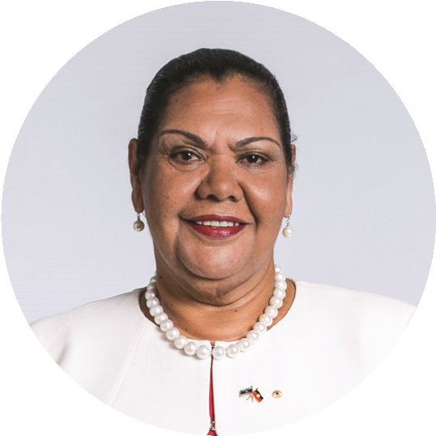
TERM GOALS
June Oscar AO
Aboriginal and Torres Strait Islander Social Justice Commissioner
FIFTH YEAR OF TERM
‘The Wiyi Yani U Thangani report puts in the hands of all Australians the lives and truths of our women and girls. Read and listen to them. In responding we will unleash their determination, power and potential to improve their lives and those of all Australians.’
- Elevated the voices of Aboriginal and Torres Strait Islander women and girls
- Reduced Aboriginal and Torres Strait Islander health inequality
- Progressed Constitutional reform
- Progressed native title reform
- Reduced numbers and rates of Aboriginal and Torres Strait Islander incarceration and children in the out of home care system
- Progressed the UN Declaration on the Rights of Indigenous Peoples to full effect through a national level coordinated action plan

PRINCIPLES / APPROACH
- Applying a human rights-based approach to working with Aboriginal and Torres Strait Islander communities that respects self-determination; participation in decision-making and free, prior and informed consent; non-discrimination and equality; and respect for and protection of culture.
- Empowering communities through participation and strengths-based engagement—gathering, and communicating community voice, content and discussion on key issues.
- Engaging with key organisations and campaigns supporting and advocating for families and enabling children to stay safe and connected to kin and culture and promoting justice sector reform including justice reinvestment initiatives.
- Engaging internationally to highlight Aboriginal and Torres Strait Islander issues, forge links with other Indigenous representatives, and hold our government to account on Indigenous rights.
- Promoting human rights-based, strengths-based and trauma-informed approaches to supporting Aboriginal and Torres Strait Islander people to lead change for their communities.
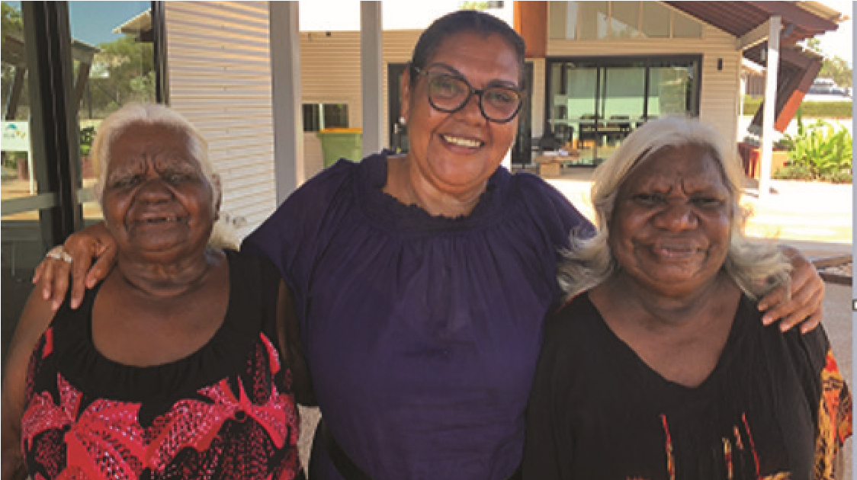
- Co-ordination, leadership and liaison with key bodies to drive constitutional and native title reform.
Commissioner Oscar (centre) with senior women participating in the Broome Senior
Women’s Engagement event, September 2019.

KEY ACTIVITES: 2021-22 WORKPLAN
Wiyi Yani U Thangani (Women’s Voices) Project Stage Two | - This year’s work is focused on the implementation of the Commissioner’s Wiyi Yani U Thangani (Women’s Voices) report (2020) which sets out First Nations women and girls’ aspirations for structural reform. Stage Two of Wiyi Yani U Thangani is about finding ways to translate these aspirations into meaningful change.  - Currently, Australia does not have the national architecture to define the many dimensions of gender equality and progress determined change, nor does it have a nationally consistent approach to respond holistically to the needs of First nations women and girls. This must change.  - Through working with First Nations women, girls, and their communities, Australian governments, and other key stakeholders, Stage Two will define the actions and structural changes — in law, policy, operational approaches, and institutional arrangements — required to achieve the outcomes women and girls are calling for. Stage Two will develop resources which will detail actions and provide guidance for implementation, monitoring and accountability.
Native title Project | - As Australia enters the post-determination era, many Aboriginal and Torres Strait Islander people are deeply disappointed about what native title has failed to deliver. There is a need to assess the challenges and opportunities that lie ahead from a human rights-based perspective.  - Building on the work of the Wiyi Yani U Thangani (Women’s Voices) Project, the native title Project will provide a stories-based picture of the current state of native title across Australia, specifically from the perspective of Aboriginal and Torres Strait Islander women involved in native title.  - The Project will identify and explore the challenges experienced by women in the native title system and their perspectives about what reforms are required to ensure Aboriginal and Torres Strait Islander peoples’ full enjoyment of human rights in relation to their traditional lands and waters.
The Close the Gap Campaign | - This multi-year collaboration is working with Australia’s peak Indigenous and non-Indigenous health bodies, NGOs and human rights organisations to achieve health and life expectation equality for Australia’s Aboriginal and Torres Strait Islander peoples.

