TERM GOALS
Kate Jenkins
Sex Discrimination
Commissioner
SIXTH YEAR OF TERM
‘I am optimistic that in 2021 the voices of women facing violence have finally been listened to and heard. It is time for respect in all aspects of life: at work, at home, in education, on our streets, in sport and online.’
- Reduced violence against women
- Increased diversity in leadership
- Improved women’s economic security and empowerment

PRINCIPLES / APPROACH
- Challenging violence against women in all parts of life: at work, on the street, at home, in education, in sport and online.
- Promoting broader social equality and cultural reform and addressing structural discrimination and intersectional disadvantage.
- Promoting women’s economic security through challenging the structural and attitudinal barriers affecting working parents, including parental leave, superannuation, flexible work, childcare, and sharing of unpaid work.
- Promoting the benefits of reducing gender-segregated paid and unpaid work.
- Advocating for improved representation of women and girls in political, corporate, sporting and organisational leadership roles.
- Promoting and facilitating opportunities for women and girls to have their voices heard at a local, national and international level.
- Taking a settings-based approach, focusing on the workplace, education and sport.

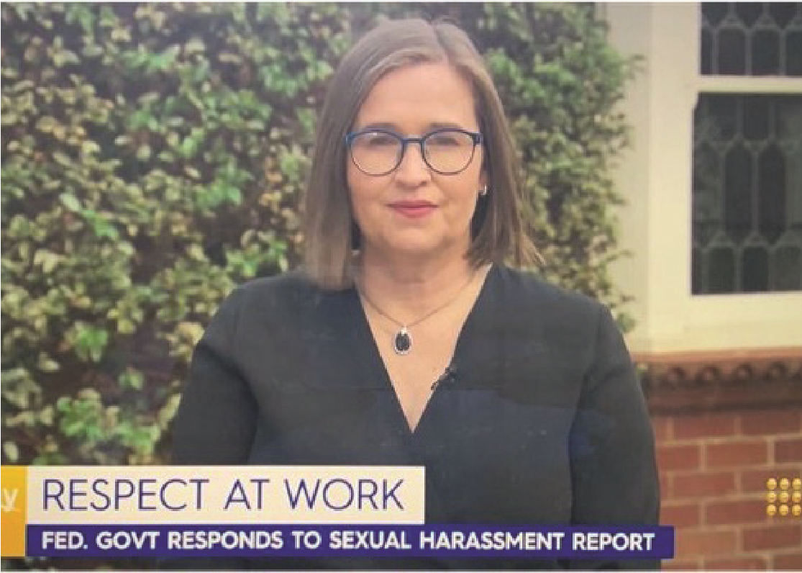
KEY ACTIVITES: 2021-22 WORKPLAN
Commissioner Jenkins, on the Today Show following the federal government’s
response to the Respect@Work report, Melbourne, April 2021.
Violence against women projects | - This work includes advocating and promoting Respect@Work, Australia’s first National Inquiry into sexual harassment in Australian workplaces, including partnering with others to implement workplace recommendations. The Inquiry builds on data from the fourth national sexual harassment in the workplace survey.  - This work also includes chairing the Respect@Work Council, comprising a core membership from the Fair Work Commission and Fair Work Ombudsman, Safe Work Australia and the Heads of Workplace Safety Authorities, the Heads of Workers’ Compensation Authorities, and the Australian Council of Human Rights Authorities.  - This work also includes implementing specific recommendations from Respect@Work, including developing:  - Fifth national survey on sexual harassment in Australian workplaces (Rec 2)  - Workplace rights education for young people (Rec 9)  - Education and training for the Fair Work Ombudsman and Fair Work Commission (Rec 34)  - Training and education for Safe Work Australia and WHS regulators (Rec 36)  - Training and education for workers’ compensation bodies (Rec 37)  - Judicial training and education (Rec 40)  - Respect@Work portal (Rec 48)  - Information and referral (Rec 52).  - This work also includes the Independent Review into Commonwealth Parliamentary Workplaces which aims to ensure that the people who work in parliamentary workplaces are treated with dignity and respect and have access to clear and effective mechanisms to prevent and address bullying, sexual harassment and sexual assault.  - Other projects include continued monitoring of the implementation of the Change the Course report recommendations by Australian universities.
Defence Cultural Reform Collaboration | - This Collaboration engages the three Services and the Department of Defence to support and improve Defence cultural reform priorities.  - Projects include: Indigenous attraction; recruitment and retention across Defence; attraction and recruitment of women in Defence; as well as a Navy-specific projects.
Australian Federal Police (AFP-Commission Partnership) | - The AFP-Commission Partnership is a four-year collaboration which operates to support the AFP’s efforts to promote cultural health, specifically through promoting diversity, inclusion and a healthy culture which ensures that staff feel safe, respected, connected, contributing, and progressing. The initial work will focus on agreed priorities, including assistance to support the AFP to implement strategies to address the 2020 staff survey results.
Women’s economic security projects | - This includes efforts aimed at ensuring that the Australian Government considers gender issues in their decision making on COVID-19 recovery, including the identification of policy areas and actions to prioritise, implementation plans and communication strategies.
Inclusion and sport | - Projects in this setting include promoting equal opportunity, anti-discrimination and inclusion in sport, especially in regard to women and girls.

