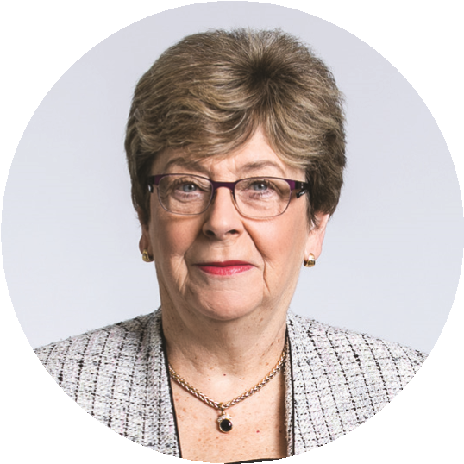
TERM GOALS
The Hon
Dr Kay Patterson AO
Age Discrimination
Commissioner
SIXTH YEAR OF TERM
‘I have an absolutely aversion to good solid reports ending up in the graveyard of good intentions. Therefore, I have made it my goal to advance, as far as possible, the implementation of sensible recommendations and practical solutions in relation to three main issues’
- Increased employment opportunities for older workers
- Improved recognition and responses to elder abuse
- Increased housing security for older women at risk of homelessness
- Promoted positive aging

PRINCIPLES / APPROACH
- Increasing awareness of the elder abuse national helpline (1800ELDERHelp / 1800 353 374).
- Increasing capacity and confidence of elder abuse stakeholders to identify signs and respond appropriately.
- Promoting and strategically advocating with stakeholders and decision makers to understand, engage with and implement key policy, process, and legislative recommendations.
- Developing specific initiatives to reach regional, rural, and remote stakeholders

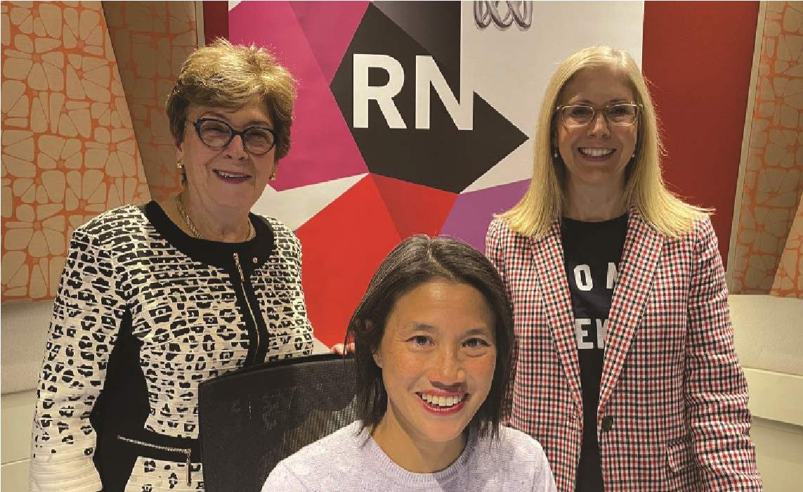
Commissioner Patterson (left) and Sarah McCann-Bartlett (right) CEO of Australian Human
Resources Institute, participating in ABC’s Radio National program ‘This working Life’ with
program host, Lisa Leong (centre), May 2021.

KEY ACTIVITES: 2021-22 WORKPLAN

Older Australians and employment program | - Fostering implementation of key recommendations from the 2016 Willing to Work report.  - Rights of Older Workers training package and awareness materials being delivered with support from Department of Communities and Justice NSW.  - Chairing the Collaborative Partnership on Mature Age Employment.
Elder abuse awareness program | - Fostering implementation of selected recommendations from the 2017 Australian Law Reform Commission’s Elder Abuse report.  - Ongoing distribution of elder abuse awareness bookmarks in English and core community languages.  - Conducting community engagement forums on the links between ageism and elder abuse, with targeted groups such as bank workers and health professionals in metropolitan and regional Australia.  - Creating and distributing of a second elder abuse awareness video.  - Developing elder abuse information for new arrivals.  - Research to explore connection between ageist attitudes and elder abuse in families.
Older women at risk of homelessness | - Encouraging initiatives that increase housing security for older women.  - This program emphasises advocacy with community groups and the private sector to encourage innovative housing solutions for older women at risk of homelessness. It will be informed by an examination of the state of research in this area and a review of the current initiatives and programs being undertaken in Australia.
Supporting and promoting positive ageing | - ‘What’s age got to do with it?’ This intergenerational project highlights stereotyping based on age, across the lifespan and in specified life arenas. Projects in 2021-22 include:  - infographics and other knowledge translation materials, and a web page  - ageism/intergenerational short film contest  - consultative elder abuse forums with stakeholders who interact with older people (such as allied health professionals)  - ageism awareness video and awareness campaign.  - Participating in the 100: The Centenarian Portrait Project by Teenagers to help this campaign build cross-generational awareness of positive ageing.

