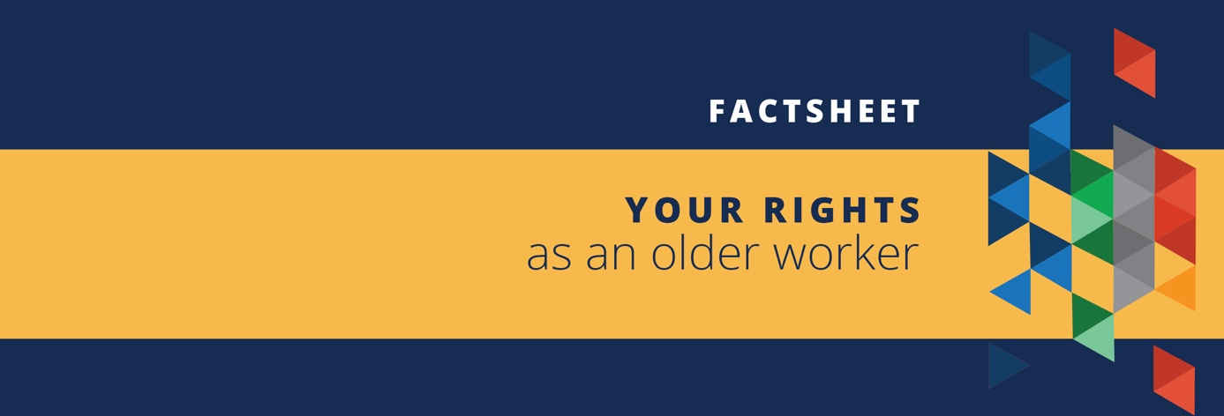

Age discrimination happens when someone is treated unfairly or denied an opportunity because of their age.
The Age Discrimination Act aims to ensure that all Australians – young, old and everyone in between – are treated equally and have the same opportunities.

As an older worker, you have the:
- Right to be considered as a candidate for a job based on your skills and experience, regardless of your age
- Right to be treated equally and fairly in a recruitment process
- Right to be free from discrimination and harassment, including jokes about ‘senior moments’ or digs about your age
- Right to equal access to opportunities for promotion, transfer or training
- Right to the same employment terms and conditions as other employees
- Right to not be fired because of your age.

____________________________________________________________________________________
Visit our online resource hub to access free resources for employers and employees at www.humanrights.gov.au/olderworkers.

What can you do if you experience age discrimination in the workplace?
Within your workplace, you can:
- Try to manage the situation yourself, but only if you feel comfortable and safe talking directly to the person who may be discriminating against you.
- Ask your manager or a trusted colleague to speak with the person who may be discriminating against you.
- Make an internal complaint. Your workplace should have policies in place to explain what you can do if you experience bullying, harassment and/or discrimination. This may involve making a formal complaint with your manager or human resources department.
You can also contact or make a complaint to an external organisation such as:
- Australian Human Rights Commission
- NSW Anti-Discrimination Board (or the equivalent body in your state or territory)
- Fair Work Commission
- Fair Work Ombudsman

