Set the Standard:
Report on the Independent Review into Commonwealth Parliamentary Workplaces
SUMMARY REPORT
November 2021

© Australian Human Rights Commission 2021.
The Australian Human Rights Commission encourages the dissemination and exchange of information presented in this publication.

All material presented in this publication is licensed under the Creative Commons Attribution 4.0 International Licence, with the exception of:
- photographs and images
- the Commission’s logo, any branding or trademarks
- where otherwise indicated.
To view a copy of this licence, visit https://creativecommons.org/licenses/by/4.0/legalcode.
In essence, you are free to copy, communicate and adapt the publication, as long as you attribute the Australian Human Rights Commission and abide by the other licence terms.
Please give attribution to: © Australian Human Rights Commission 2021.
Set the Standard: Report on the Independent Review into Commonwealth Parliamentary Workplaces Summary Report 2021
ISBN: 978-1-925917-60-4
Acknowledgements
Senior Policy Executive: Natasha de Silva Review Director: Somali Cerise
Directors: Amanda Alford (Research), Kate Lee (Engagement), Prabha Nandagopal (Legal).
Review team: Alexia Derbas, Christopher Hills, Craig Purcell, Gabriela Sanchez, Georgia Waters, Grace Gardiner, Helen Karatasas, Jack Jacobs, Jessica Phillips, Jessica Xu, Katie Harris, Kerin Leonard, Liz Lindberg, Louise Close, Matthew Clayfield, Nevo Rom, Rosie Ashley, Ruby Lew, Sally Cobb,
Sarah Haid, Tess Connolly, Trish Low.
Other Commission staff: Amy Lamont, Claire Hart, Connie Chung, Gabrielle Flax, Graeme Edgerton, Lauren Jones, Leah Pitt, Leon Wild, Lisa Stewart, Robin Perry, Sara-Evison Rose, Sonia Litz, Tara Crisp, Tara Sarathy.
The Commission thanks Alice Rose, Gabrielle Appleby, Maria Maley, Michelle Tuckey and Sonia Palmieri for their expert advice and contributions to the Review, Elena Campbell for editorial assistance, and Roy Morgan Research for assistance with the Review Survey.
The Commission also thanks Comcare, the Department of Foreign Affairs and Trade and the Workplace Gender Equality Agency for supporting the Review through the secondment of staff to the Review.
The Commission is especially grateful to all individuals that participated in the Review.
The Commission acknowledges the contribution of the Australian Government in funding the Review.
This publication can be found in electronic format on the Australian Human Rights Commission’s website at https://humanrights.gov.au/about/publications.
For further information about the Australian Human Rights Commission or copyright in this publication, please contact:
Australian Human Rights Commission GPO Box 5218, SYDNEY NSW 2001
Telephone: (02) 9284 9600
Email: communications@humanrights.gov.au
Design and layout: Satsuma Creative Cover image: Satsuma Creative
Printing: Fineline Print & Copy NSW

Contents

- Key Definitions 2
Key terms and definitions 3
- Introduction 6
  - What is the Independent Review into Commonwealth
Parliamentary Workplaces? 7
  - Why does this Review matter? 7
  - Understanding Commonwealth parliamentary workplaces 8
  - Overview of participation in the Review 10
- What We Heard 12
  - Drivers and risk factors for misconduct 13
  - Prevalence and impacts of bullying, sexual harassment
and sexual assault 19
    - Prevalence of bullying, sexual harassment and sexual assault 22
    - People who experienced bullying, sexual harassment
and sexual assault 22
    - Impacts and reporting 23
- Framework for Action 24
  - A snapshot of key recommendations 25
    - Principle 1: Leadership 25
    - Principle 2: Diversity, equality and inclusion 28
    - Principle 3: Performance 28
    - Principle 4: Accountability 30
    - Principle 5: Safety and wellbeing 31
  - How these shifts will be experienced by people in
Commonwealth parliamentary workplaces 32
  - Phases of implementation 34
- Conclusion 35
- Appendix 37
- Endnotes 44

1.

Key Definitions
This is Parliament. It should set the standard for workplace culture, not the floor of what culture should be.
(Interview 69, CPW Review)

Key terms and definitions

Bullying | Bullying is repeated and unreasonable behaviour that is directed towards a worker or a group of workers and creates a risk to physical or mental health and safety.
Commonwealth parliamentary workplace | A Commonwealth parliamentary workplace (CPW) includes Parliament House and the Parliamentary precincts, ministerial, parliamentary and electorate offices and any other place where work is carried out for, or in connection with, a Commonwealth parliamentarian, whether paid or unpaid.  A Commonwealth parliamentary workplace also includes, but is not limited to, work related travel and events, engagements, functions and any other work carried out by a person, in any capacity, in connection with the work of a Commonwealth parliamentarian.
Misconduct | The term misconduct is used in this Report to refer collectively to workplace bullying, sexual harassment and sexual assault. The Report also uses the term misconduct to refer to any conduct that would be prohibited by the Codes of Conduct recommended by the Commission. Where other forms of parliamentary misconduct are referred to, such as integrity matters, this is explicitly stated.
MOP(S) Act  employees | MOP(S) Act employees are staff employed under the Members of Parliament (Staff) Act 1984 (Cth) (MOP(S) Act). MOP(S) Act employees are employed by parliamentarians on behalf of the  Commonwealth. They are classified as personal staff or electorate staff and work directly with employing parliamentarians.  MOP(S) Act employees are not required to be apolitical or impartial.
Parliamentarians | This term refers collectively to Members of the House of Representatives and Senators.
Parliamentary service employees | Parliamentary service employees are employed under the  Parliamentary Service Act 1999 (Cth) (Parliamentary Service Act).  They are employed by parliamentary departmental heads on behalf of the Commonwealth to work in the Department of Parliamentary Services, Department of the House of  Representatives, Department of the Senate and Parliamentary Budget Office (collectively referred to in this Report as the parliamentary departments).  The parliamentary service is required to be impartial and non- partisan, and accountable to the Presiding Officers of the Parliament. The parliamentary service is independent of the executive government.

The Full Report of the Set the Standard: Report on the Independent Review into Commonwealth Parliamentary Workplaces
5
is available at https://humanrights.gov.au/set-standard-2021

Key terms and definitions
Public service employees | Public service employees are employed under the Public Service Act 1999 (Cth) (Public Service Act). They are employed by agency heads on behalf of the Commonwealth and work in public service departments and agencies.  The public service is required to be apolitical, and is accountable to the Australian community under the law and within the framework of Ministerial responsibility.
Sexual assault | Sexual assault is an act of a sexual nature carried out against a person’s will through the use of physical force, intimidation or coercion, including any attempts to do this. This includes rape, attempted rape, aggravated sexual assault (assault with a weapon), indecent assault, penetration by objects, forced sexual activity  that did not end in penetration and attempts to force a person into sexual activity.  Note, sexual assault occurs when a person is forced, coerced or tricked into sexual acts against their will or without their consent, including when they have withdrawn their consent.
Sexual harassment | Sexual harassment is an unwelcome sexual advance, unwelcome request for sexual favours or other unwelcome conduct of a sexual nature which, in the circumstances, a reasonable person, aware  of those circumstances, would anticipate the possibility that the person would feel offended, humiliated or intimidated.

The Full Report of the Set the Standard: Report on the Independent Review into Commonwealth Parliamentary Workplaces
6
is available at https://humanrights.gov.au/set-standard-2021

The Full Report of the Set the Standard: Report on the Independent Review into Commonwealth Parliamentary Workplaces
7
is available at https://humanrights.gov.au/set-standard-2021

2.

Introduction
When you make the workplace safer … you open up the possibility for us getting more people into the roles who are representative of Australia more broadly and that then flows through to a better policy making process and a stronger democracy.
(Interview 165, CPW Review)

What is the Independent Review into Commonwealth Parliamentary Workplaces?
On 5 March 2021, the Independent Review into Commonwealth Parliamentary Workplaces (Review) was established by the Australian Government, with support from the Federal Opposition and crossbench. Conducted by the Australian Human
Rights Commission and led by the Sex Discrimination Commissioner, the Review was asked to make recommendations to ensure that Commonwealth parliamentary workplaces are safe and respectful and that the nation’s Parliament reflects best practice in prevention and response to bullying, sexual harassment and sexual assault.
The Review’s Full Report is available at https://humanrights.gov.au/set-standard-2021.
The Full Report examines the complex ecosystem of workplaces which feature across Commonwealth parliamentary workplaces (CPWs), and the experiences of people who work, or have worked, in them. It also explores drivers and risk factors
for misconduct and the extent to which current legislation, policies and processes enable or impede safe and respectful workplaces, including by considering best and emerging practice in comparable jurisdictions. The Report proposes a detailed Framework for Action—stepping out a process of reform which, when implemented, will enable the nation’s Parliament to become a
leading example for workplaces across Australia.
This Summary Report provides the context and key findings from the Review, outlines the shifts
that are required to implement reform and explains how these shifts will contribute to cultural change. These shifts have been identified by the many participants in the Review who believed firmly in the value of their work—and equally in the value of safe and respectful CPWs.

Why does this Review matter?
As the Commission heard from participants in the Review,

[t]his is Parliament. It should set the standard for workplace culture, not the floor of what culture should be.1

Public confidence can erode when constituents do not see the standards and expectations in their own workplaces mirrored in their democratic institutions.
Parliament sets these minimum standards through legislation. As well as legislating the standards which the wider community should adopt, CPWs must model these standards themselves.
Parliaments in comparable jurisdictions, both at the state and international level, have identified this imperative for cultural reform, as outlined in the Review’s Full Report. In doing so, they have recognised that ensuring safe and respectful parliamentary workplaces is essential to public confidence, and to modelling best practice for the communities they represent.
This imperative has been further emphasised amid shifting global expectations around equality, safety and respect. Momentum for change is accelerating worldwide, while the experiences of Grace Tame, Brittany Higgins and a national conversation about consent involving people like Chanel Contos and Saxon Mullins have renewed calls in Australia for an end to gendered violence and harassment.

Workplaces across the country are taking concrete steps to prevent and respond to bullying, sexual harassment and sexual assault. Organisations are increasingly recognising that sexual harassment2 and bullying3 cost the Australian economy billions each year—indicating that the substantial and very real costs of misconduct are borne, not only by the
impacted individuals as the primary focus of concern, but by workplaces and communities as a whole.
Equally, organisations are recognising that ensuring a safe and respectful workplace culture influences their ability to attract and retain the best people and drive better organisational results.
A similar opportunity to improve performance has now been created by the commissioning of this Review and its recommended Framework for Action.
Ensuring a safe and respectful work environment in the Australian Parliament creates the chance to attract and retain the best parliamentarians and
staff; to drive institutional performance; and further, by supporting diversity, equality and inclusion, to improve representation and decision-making overall.
By implementing the proposed Framework for Action, CPWs can be a worthy reflection of the people who work within them, and the wider population which the Parliament is there to serve.

Understanding Commonwealth parliamentary workplaces
Commonwealth parliamentary workplaces comprise a complex ecosystem made up of multiple and geographically dispersed workplaces. People in
this ecosystem work under different employment arrangements and do not necessarily report to one central agency.
Parliamentarians are not directly employed and are instead accountable to the Parliament and to the Australian electorate. Parliamentarians directly
employ staff under the Members of Parliament (Staff) Act 1984 (Cth) (MOP(S) Act). The Department of Finance provides human resources services, including payroll, to MOP(S) Act employees, but parliamentarians make decisions relating to the recruitment, management and termination of these employees.
People working across CPWs include:
    - 227 parliamentarians
    - 2,256 MOP(S) Act employees*
    - 1,862 people employed under the Parliamentary Service Act 1999 (Cth) and the Public Service Act 1999 (Cth)
    - contracted service providers
    - other workers, including the media, interns and volunteers
    - Australian Federal Police.
Understanding the unique nature of these workplaces has been critical to understanding the experiences
of people who work within this ecosystem, and to informing recommendations which can ensure safe and respectful work environments.

- Based on information provided by the Department of Finance, there were 2,222 MOP(S) Act employees working in CPWs, either as electorate staff or as personal staff to Ministers and office-holders, as at 1 June 2021. Additionally, the Department of the Prime Minister and Cabinet informed the Review of 34 personal staff employed in Official Establishments (at The Lodge or Kirribilli House), as at 31 July 2021. For this reason, the Report uses a total figure of 2,256 MOP(S) Act employees.

Figure 1:
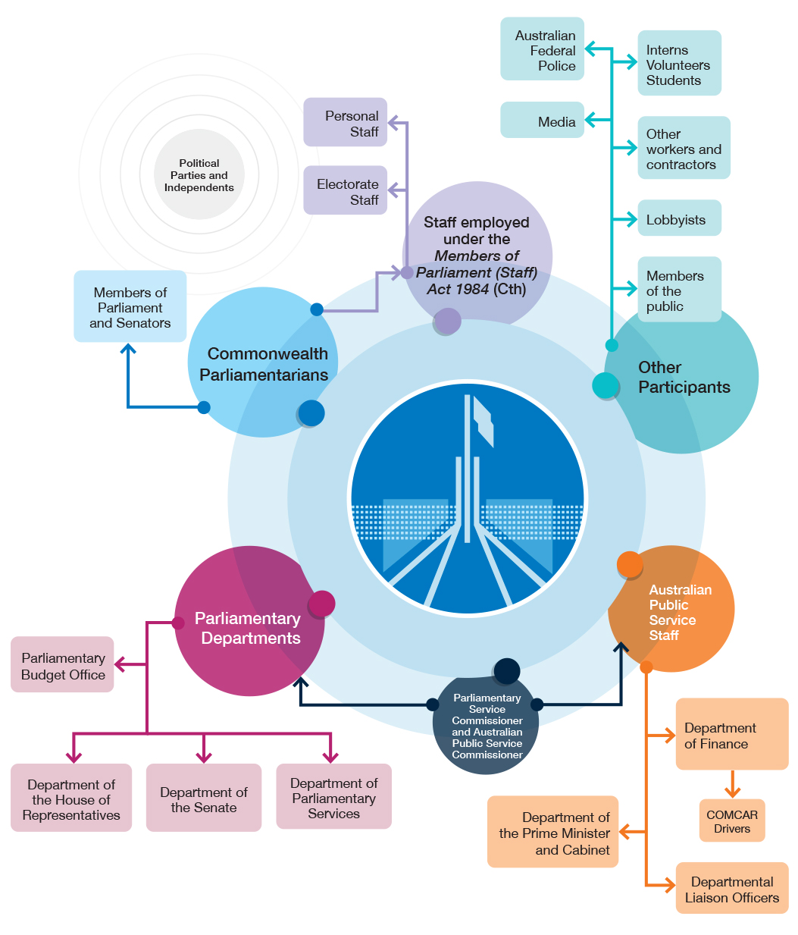
The ecosystem of Commonwealth parliamentary workplaces

Overview of participation in the Review
The Commission’s methodology for the Review was based on a number of principles, including that it be independent, consultative, evidence-
based, voluntary, confidential and trauma-informed. By taking this approach, the Review created an opportunity for people working across CPWs,
either now or in the past, to contribute to solutions. This approach included:
  - face-to-face, online and telephone interviews
  - written submissions
  - an online survey provided to people currently working in CPWs
  - focus groups
  - Requests for Information
  - review of relevant data, legislation, policies and processes
  - review and analysis of domestic and international research and data.
Overall, there were 1,723 individual contributions to the Review and contributions from 33 organisations.4 This included 935 survey responses, 490 interviews, 302 written submissions and 11 focus groups.
This level of participation provided the Commission with a robust primary evidence base. It means that the Commission’s findings and recommendations are informed and guided by the many voices and diverse experiences and expectations of people who work, or who have worked in, CPWs.
Participants told the Commission that they cared deeply about the Parliament as an institution, and the health of Australian democracy, and embraced the opportunity to drive positive change.

… this is for the most part,
a bunch of people who work extraordinarily hard … and the reason that they do it, is because they want to make the country
a better place and because they truly believe that they can make a difference.5

The Commission is grateful to the participants in the Review for their valuable and thoughtful contributions.

Figure 2: Overview of Review participants

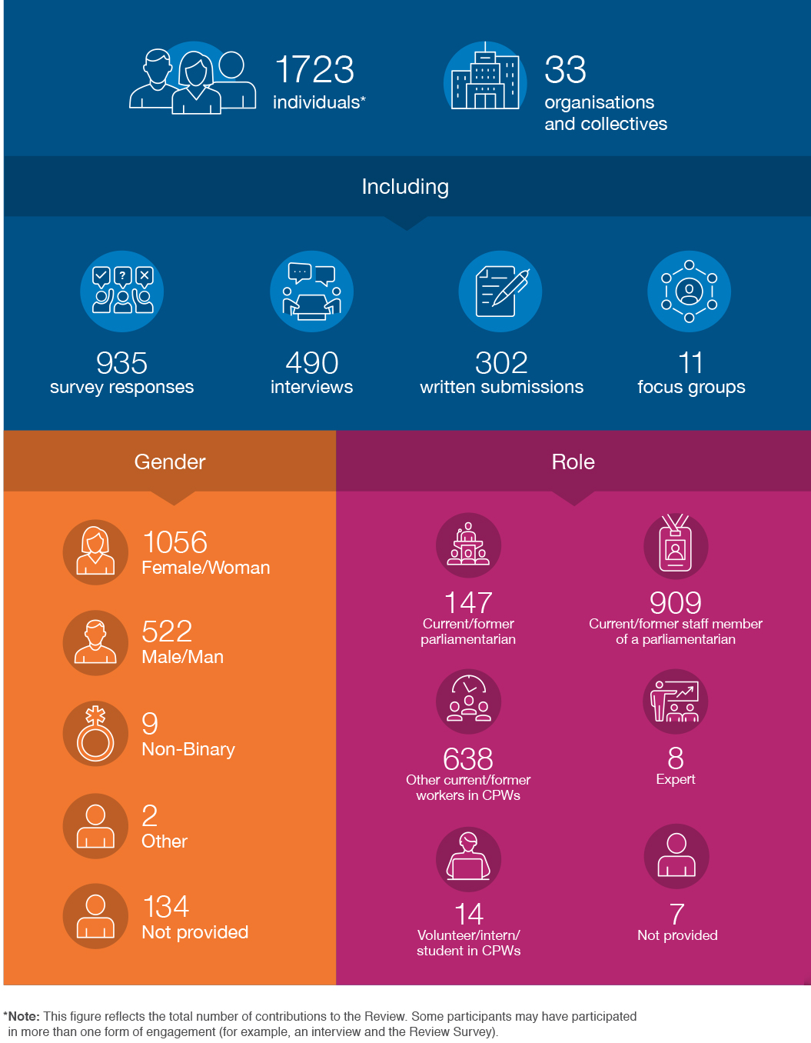

3.

What We Heard
So often I heard people crying in the toilets and felt bad for that person wondering what had happened. Sometimes it might have just been the pressure of the high stress work environment, but I never asked because I was just trying to survive myself and fight my own battles.
(Individual, Submission W214, CPW Review)

The Commission consistently heard from participants in the Review about the commitment that they felt to their work and to the Parliament. Participants
also valued the opportunity to contribute to decision- making at a national level in a way that can make a difference to people’s lives.
Participants described the multiple and distinct cultures which operate across CPWs, all influenced by a range of factors. These factors include the dynamic nature of the work, the influence of political parties and the pressure to get elected and stay elected. Elections, reshuffles and other transitions can also reset, change or reinforce culture. Further, the Commission heard that the Press Gallery also plays a role in shaping culture. The proximity to power influences the workplace culture in parliamentary departments.

Drivers and risk factors for misconduct
Within this broader context, participants described systemic drivers which contribute to misconduct across CPWs. Echoing broader research, participants told the Commission how drivers, such as power and gender inequality, have a particular impact in the CPW environment. Participants also described risk factors, some of which are specific to CPWs, which interact with these drivers to impede the functioning of a safe and respectful workplace culture.
Identifying the drivers and risk factors associated with bullying, sexual harassment and sexual assault is an important part of understanding, preventing and responding to these behaviours in CPWs.
    - Underlying drivers are systemic and structural and refer to societal dynamics or ‘root causes’, such as gender inequality. Drivers create an enabling context and social conditions for harms to occur, both within and outside workplaces, which cannot be reduced to individual
choices and behaviour. Drivers shape, but are independent of, particular workplace settings.
    - Risk factors are the more immediate set of contextually and institutionally specific risks in a workplace. On their own, and/or combined with underlying drivers, risk factors can influence the prevalence, patterns and persistence of bullying, sexual harassment and sexual assault. Each risk factor is unique in the way that it contributes to workplace harms, intersecting with underlying drivers to intensify and exacerbate bullying, sexual harassment and sexual assault.
- Underlying drivers
The Commission heard about the pursuit and exercise of power; the types of behaviour that are incentivised, rewarded, punished and reported; as well as an accompanying sense of entitlement that shape the culture and people’s experiences. This included descriptions of the power that parliamentarians wield within their offices and the pressure which can not only result in ‘top-down’ bullying, but lateral bullying as well. Others highlighted expectations within the public and parliamentary services that ‘we are meant to be providing a service at any cost … irrespective of how the Members behave’.6
The Commission also heard how gender inequality and a wider lack of diversity entrenches this power within one group, devaluing women and, consequently, fostering gendered misconduct.
Multiple participants spoke about the lack of women in senior roles, explaining that ‘[b]y crowding out women at the most senior levels of staffing, a
male-dominated and testosterone-fuelled culture dominates’7 as well as instances of everyday sexism.
Participants told the Commission that there is a lack of accountability for bullying, sexual harassment and sexual assault in CPWs, with these types of misconduct going unaddressed or even appearing to be rewarded. In addition, the Commission heard about contrasting experiences of entitlement and exclusion—where a dominant group can feel that they have licence to behave in a certain way, while those who do not fit into this dominant group can feel marginalised, and even targeted, and have little access to support.
- Risk factors for misconduct
Participants also identified a range of risk factors for misconduct. These include the absence of clear or consistent standards of conduct and behaviour, as well as limited people management skills or experience among parliamentarians and people
in senior positions.
The lack of standards and leadership ‘deficit’ combine to mean that leaders often do not know how to prevent or respond to misconduct, or to role model appropriate behaviour. Participants told the Commission that much of the misconduct they have observed or experienced came from those in
senior positions.

Participants also described how particular workplace dynamics across CPWs can contribute to misconduct, as well as reluctance to report or address it. These can include a high pressure, high stakes environment; an intense loyalty to the employing parliamentarian and party; and a fear of causing trouble in the context of prioritising political ‘optics’ over effectively responding to misconduct.
Further, the social conditions of work across CPWs, such as long and irregular hours, frequent travel and presence of alcohol, combined with wider employment conditions, such as a lack of merit-based recruitment and fragmented human
resources systems, lay the ground for bullying, sexual harassment and sexual assault to occur.
The following table describes the drivers and risk factors identified by the Commission. Informed by research,8 the table draws on the extensive contributions of participants across the Review to
highlight how these drivers and risk factors manifest in the context of CPWs and how this impacts the experiences of those who work there.

Table 1. Drivers and risk factors for misconduct in Commonwealth parliamentary workplaces

Drivers and risk factors for workplace bullying, sexual harassment and sexual assault | What does this look like in CPWs? | How do people working in CPWs experience these drivers and risk factors?
Driver:  Power imbalances | Participants described:  - a focus on the pursuit and exercise of power, as well as its misuse  - significant power inequalities and differentials in multiple directions  - exclusion from access to decision- making for particular groups  - insecure employment and high levels of power and discretion in relation to employment. | That it’s a culture which is all about power though doesn’t mean it has to be a culture which is about abuse of power.9  Pretty much the biggest bully wins every time, because if they  can get in the ear of the Minister or the Member, they hold all the power.  And you can’t do anything.10
Driver:  Gender inequality | Participants described:  - women’s under-representation in senior roles and the fact that men primarily control decision-making  - the way in which roles are segregated, with women and people from particular groups concentrated in lower status and lower paid positions  - pervasive everyday sexism and male entitlement  - limited systems and supports to encourage women into senior roles  - sexist media reporting and coverage. | It is a man’s world and you are reminded of it every day thanks to the looks up and down you get, to the representation in the parliamentary chambers, to the  preferential treatment politicians give senior male journalists over younger females at press conferences.11  I haven’t seen men overtly using a woman’s sex as a weapon against her in the workplace or using power to keep women in their place until  I worked at APH.12

Drivers and risk factors for workplace bullying, sexual harassment and sexual assault | What does this look like in CPWs? | How do people working in CPWs experience these drivers and risk factors?
Driver:  Lack of accountability | Participants described:  - a lack of accountability, particularly for parliamentarians, and limited recourse for those who experience misconduct  - a lack of visible sanctions  - overlapping responsibilities which disperse and dilute accountability  - fear and silence around reporting or making a complaint  - perceived political rewards for silence  - perceived rewards for bullying, sexism and public victim-blaming  - a fear of media reporting, including use of media to report in absence of other accountability mechanisms. | There are no ramifications for bad behaviour because there is no risk of MPs getting fired, or otherwise being held accountable for their actions.13  Politicians must understand their responsibility as employers and representatives to respect their staff and treat them as people not throwaway commodities.14  I was sexually harassed multiple times, sexually assaulted, bullied and terrorised. And I was told that if I ever sought help or spoke about  what happened to me my professional reputation and personal life would  be destroyed.15
Driver:  Entitlement and exclusion | Participants described:  - a lack of diversity among parliamentarians and workers  - a sense of entitlement by some people, reinforced by access to resources, power and networks  - exclusion of particular groups (including women, First Nations people, LGBTIQ+ people, people from culturally and linguistically diverse (CALD) backgrounds and people with disability) from decision-making  - structural and physical barriers to accessing roles and opportunities, and parliamentary infrastructure  - targeting of people from particular groups  - media reporting that perpetuates entitlement and exclusion. | …there is a male, stale and pale monopoly on power in that building … we urgently need people in those positions with different backgrounds and different life experiences.16  I think socially from a CALD background you’re seen as a community organiser and to go  get votes… [from] your…community  …and that’s your primary role and you’re not actually respected as a campaigner or a media advisor  or a policy advisor.17  There has been a clear indication given to me by my colleagues, peers and managers that I don’t belong here and that this isn’t a (physically or psychologically) safe space  for me, being a young woman of colour.18

Table 1. Drivers and risk factors for misconduct in Commonwealth parliamentary workplaces

Table 1. Drivers and risk factors for misconduct in Commonwealth parliamentary workplaces

Drivers and risk factors for workplace bullying, sexual harassment and sexual assault | What does this look like in CPWs? | How do people working in CPWs experience these drivers and risk factors?
Risk factor:  Unclear and inconsistent standards of behaviour | Participants described:  - the fact that standards of behaviour are unclear,  inconsistent and unenforced  - that there is no formally prescribed standard of behaviour for some workplace participants. | What happened to me and what happened to colleagues, friends, and acquaintances, should never be the standard at which the Parliament of Australia should operate at.19  I was a bit confused about whether what had been happening at work was crossing a line or whether it was an expected sort of thing.20
Risk factor: Leadership deficit | Participants described:  - leadership responses (individual and institutional) which minimise, trivialise or excuse misconduct  - inconsistent role modelling of respectful and inclusive behaviour  - a prioritisation of political gain over people management  - leaders who are not equipped with relevant skills or focused on people management. | Good culture starts from the top in any office.21  I personally observed extremely poor management due to unclear responsibilities, leadership, and due to people being put in roles because of their factional value and their political value but not because they were competent or because they were good managers.22
Risk factor: Workplace dynamics | Participants described:  - a ‘win at all costs’ and high- pressure and high-stakes environment  - the expectation of intense loyalty to political parties and employing parliamentarian  - fear, including fear of reporting due to becoming a target, a ‘problem’ for the party, including through media scrutiny, or career repercussions.  - the ‘weaponisation’ of information and prioritisation of ‘optics’. | Fear is a big factor, probably the biggest.23  So often I heard people crying in the toilets and felt bad … but I never asked because I was just trying to survive myself ...24  …people think that they have to protect the party and … Minister or the Member at all costs.25  …our whole job is putting out spot fires and finding solutions to problems. So you never want to be the problem yourself.26

Table 1. Drivers and risk factors for misconduct in Commonwealth parliamentary workplaces

Drivers and risk factors for workplace bullying, sexual harassment and sexual assault | What does this look like in CPWs? | How do people working in CPWs experience these drivers and risk factors?
Risk factor:  Social conditions of work | Participants described:  - a ‘work hard, play hard’ culture and a blurring between personal and professional life, particularly for parliamentarians and MOP(S) Act employees  - frequent and unpredictable travel, and long and irregular hours  - isolation from family and support networks and geographical remoteness  - significant alcohol use and a drinking culture, especially for parliamentarians and MOP(S) Act employees. | [T]here’s a culture around you must work all day every day.27  Every function, every event, alcohol consumption is basically unlimited, unmonitored, and encouraged, often provided for free. All socialising happened over alcohol.28
Risk factor:  Employment structures, conditions and systems | Participants described:  - a lack of transparent and merit- based recruitment  - a lack of consistent induction, training or professional development, particularly for parliamentarians and MOP(S) Act employees  - precarious employment, specifically among MOP(S) Act employees, and a lack of guidance around lawful reasons and processes for dismissal  - fragmented and inadequate human resources systems, and a lack of standardised policies and processes to prevent and manage misconduct  - physical and psychosocial safety risks. | [Department of] Finance tell us our employing member – employing Senator – is our  employer. But then our Senator will kind of say, “Well, you’re actually technically employed by Finance.” … You don’t really quite know whose job it is to fix …the chaos of it all.29  The workplace culture … was one in which the staff all lived and worked in perpetual fear of being  terminated by the MP.30  There needs to be an independent HR Department that is completely out of politics where people feel safe to complain, but also there are real ramifications for bullying, sexual harassment and generally bad behaviour. The current system is broken.31

Prevalence and impacts of bullying, sexual harassment and sexual assault
The drivers and risk factors identified above contribute to the prevalence, nature and impacts of bullying, sexual harassment and sexual assault across CPWs.
This section of the Summary Report outlines the prevalence, nature and impact of bullying, sexual harassment and sexual assault in CPWs. In particular it draws on the results of the anonymous online survey conducted as part of the Review. The results are supplemented with qualitative data from written submissions, interviews and focus groups.

A note about the Review Survey data
A total of 4,008 people were invited to
participate in the Review Survey. This included
current parliamentarians and people aged 18 years and older working in CPWs as at 19 July 2021.
There were 935 responses to the survey, which represents almost a quarter (23%) of all people working in CPWs.
The responses to the Review Survey have been weighted. Weighting was applied to the responses to correct imbalances in the results due to any non-response bias and to enable the results to be extrapolated to the general CPW population.
More information about the weighting and interpretation of the data, as well as statistical reliability, is described in the Methodology in Appendix 2 of the Full Report.

Figure 3. Bullying, Sexual Harassment and Sexual Assault in Commonwealth
parliamentary workplaces
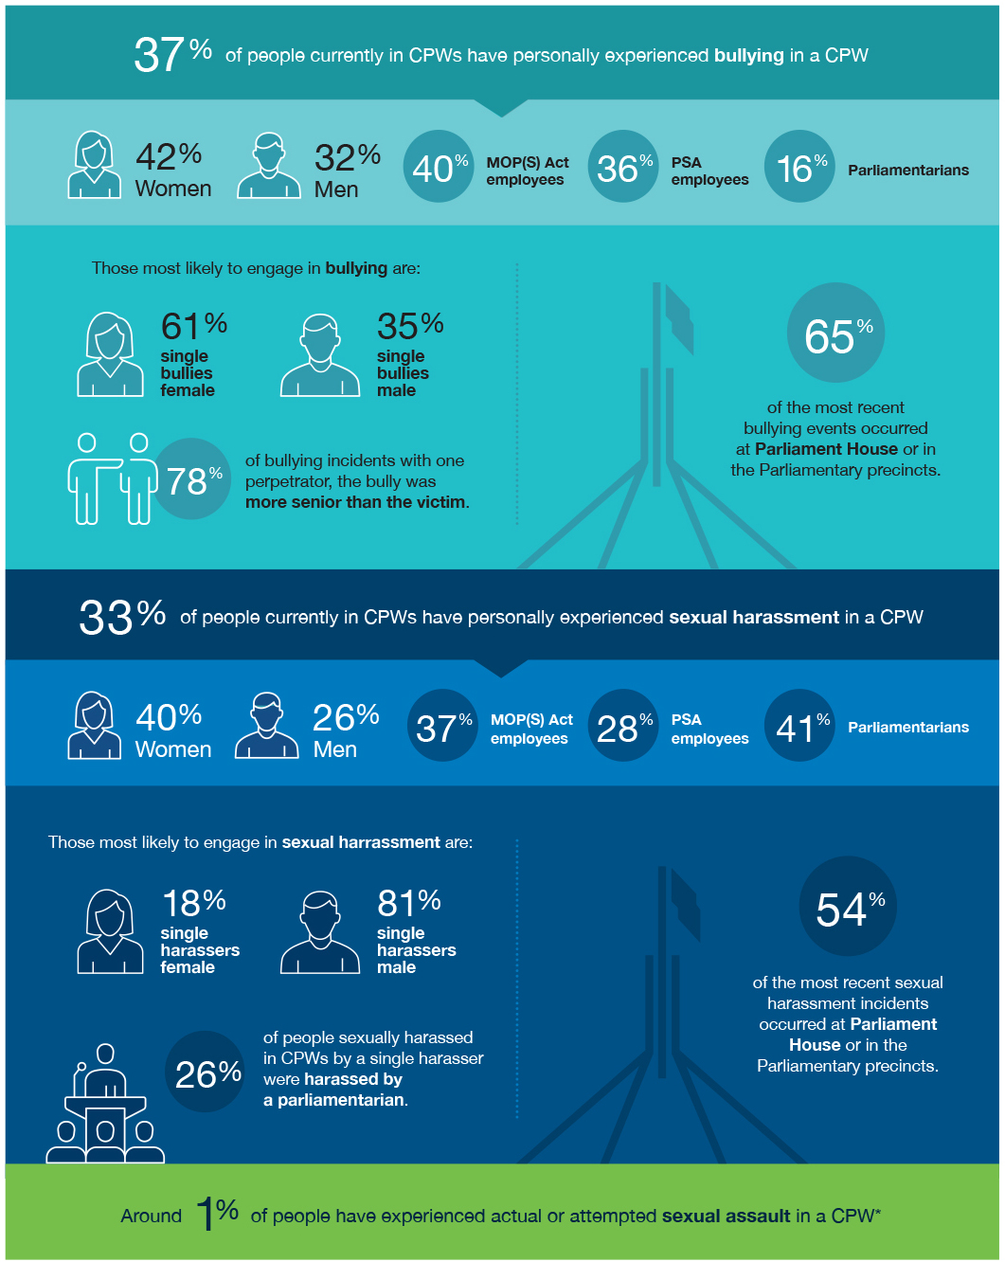

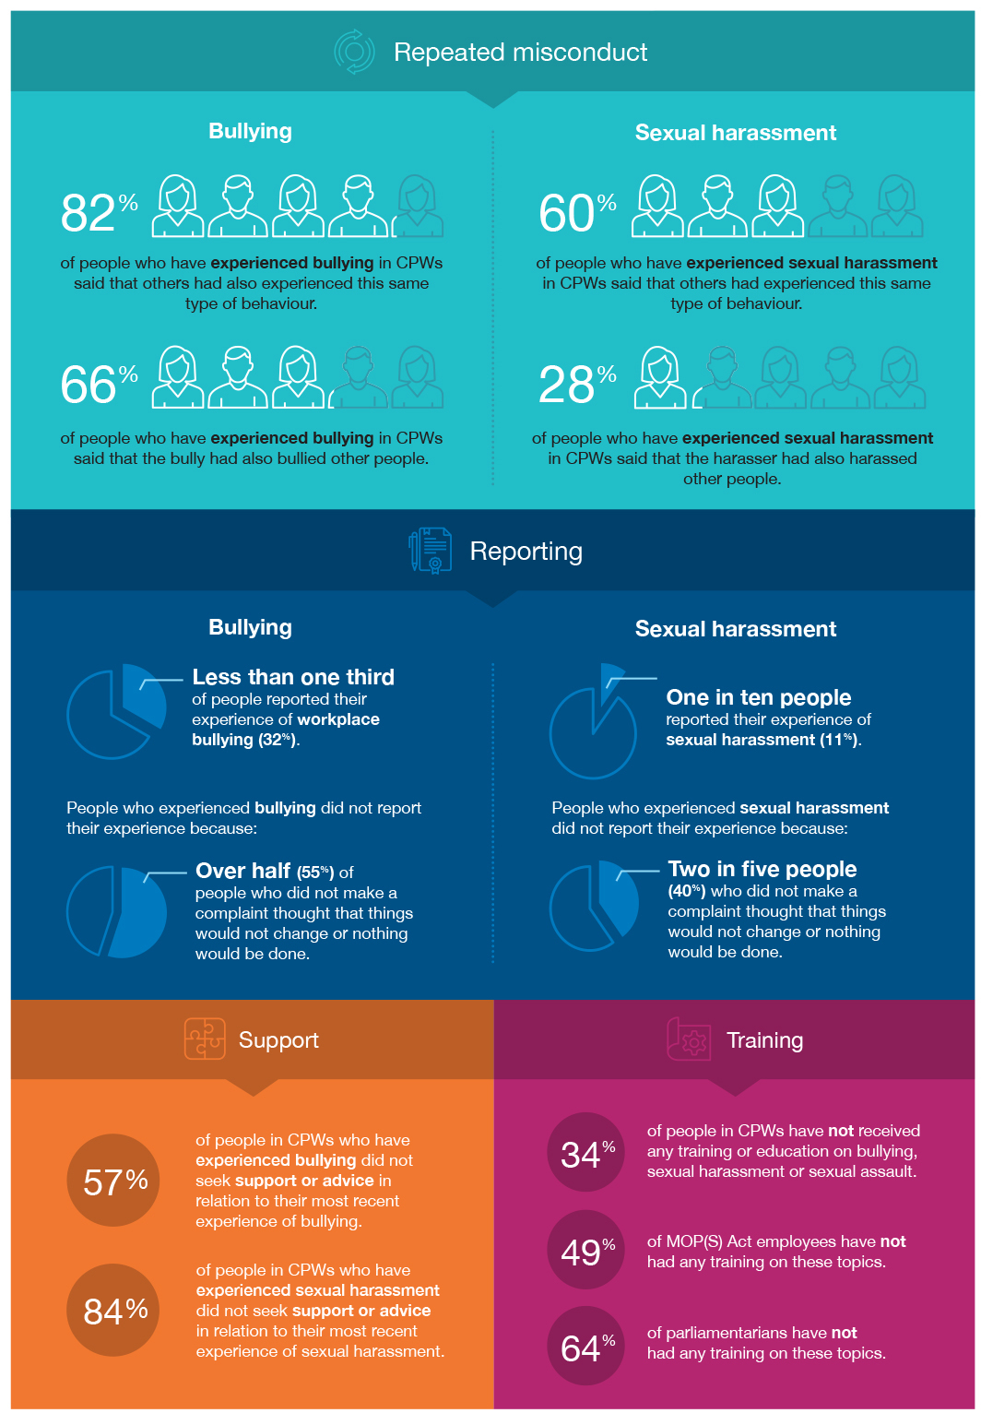

Prevalence of bullying, sexual harassment and sexual assault

The MP sitting beside me leaned over. Also thinking he wanted to tell me something, I leaned in.
He grabbed me and stuck his tongue down my throat. The others all laughed. It was revolting and humiliating.34
As indicated at Figure 3 above, the Review Survey found that 37% of people currently working in CPWs have experienced bullying while working there.

Frequently, like at least every week, the advice was go and cry in the toilet so that nobody can see you, because that’s what it’s like up here.32

One in three people (33%) have also experienced some form of sexual harassment while working there.

Aspiring male politicians who thought nothing of, in one case, picking you up, kissing you on the lips, lifting you up, touching you, pats on the bottom, comments about appearance, you know, the usual. The point I make with that… was the culture allowed it, encouraged it.33

Around 1% of people have experienced some form of actual or attempted sexual assault, noting that this is an indicative estimate based on a small number of respondents.
Over half (51%) of all people currently in CPWs have experienced at least one incident of bullying, sexual harassment or actual or attempted sexual assault in
a CPW. Overall, 77% of people within these workplaces have experienced, witnessed, or heard about
bullying, sexual harassment and/or actual or attempted sexual assault.
The experiences of bullying, sexual harassment and sexual assault differ significantly across CPWs, particularly based on gender and role.
The overall level of sexual harassment in CPWs is consistent with the national average of 33% from the 2018 National Survey on Sexual Harassment in
Australian workplaces (2018 National Survey). However, only people currently working in CPWs completed
the Review Survey, while the 2018 National Survey also captured people who have left or moved jobs, suggesting that the level of sexual harassment may be higher in CPWs.

People who experienced bullying, sexual harassment and sexual assault
The Review Survey results provide insight into which people in CPWs are more likely to experience bullying, sexual harassment and sexual assault. In particular, women experience sexual harassment (40%) and bullying (42%) at a higher rate than men.
Parliamentarians are the group of people within CPWs most likely to have experienced sexual harassment (41%), particularly female parliamentarians (63%).
MOP(S) Act employees are most likely to have experienced bullying (40%).

In addition to gender, the Review Survey results also highlighted the impact of power differentials on the experience of misconduct. In particular, 78% of people who experienced bullying in CPWs were bullied by someone more senior.

Impacts and reporting
Regardless of their role, participants noted that their experiences of bullying, sexual harassment and/or sexual assault had an impact on their mental and physical health, their confidence and ability to do their job, and their future career prospects, including their ability to get a reference. These experiences also caused significant distress and shame. One participant told the Commission about the impact on people they knew:
This is consistent with results from the Review Survey which indicated that most people who experienced bullying did not report it (only 32% of people reported). People did not report for a range of reasons, including because they thought that things would not change or that nothing would be done (55%) or because they thought that it would damage their reputation or career (47%). Similarly, most people who experienced sexual harassment did not report it (only 11% reported), including because they did not think that it was serious enough (55%), they believed that people would think that they were overreacting (43%), or they thought that things would not change or that nothing would be done (40%).

One tried to commit suicide, another admitted themselves into a mental facility. I know three women [who worked in CPWs] that are still seeing psychologists. One had a marriage breakdown, and one has completely dislocated with her children as a result of the direct influence of that Member of Parliament …
I will never work in a political office again, it’s not worth it.35

Some participants described feeling that the only options were to tolerate the misconduct or leave, rather than expecting that the misconduct could be addressed. Many also described the negative personal and career consequences that they experienced as a result of making a complaint.

The Full Report of the Set the Standard: Report on the Independent Review into Commonwealth Parliamentary Workplaces 25

4.

Framework for Action
No one warns young women of the true danger of entitled, powerful men, in a workplace that encourages and fosters heavy drinking, and the
truly terrifying element of pressure that culminates to create. We need to do better for all women that currently work in Parliament and for all future employees who deserve a safe, respectful workplace where they can contribute to the nation and be respected for their qualifications, experience,
value, and contributions.
(Individual, Sub W239, CPW Review)

In response to what the Commission heard about systemic drivers, risk factors and the misconduct to which they contribute, the Commission proposes a Framework for Action. This Framework steps
out five major shifts which can move CPWs from an environment in which there is a lack of strong leadership and clear standards and accountability
for misconduct, to one in which a safe and respectful workplace culture is the baseline standard.
Underpinning these five proposed shifts is the fundamental premise that workplace bullying, sexual harassment and sexual assault are not only unacceptable, but ultimately preventable.
To inform these shifts, the Commission identified five principles which are the foundation of cultural change. Detailed recommendations are set out against these principles and feature at Appendix 1. Certain key actions and mechanisms, however, underpin this
suite of recommendations and are discussed below. They are illustrated at Figures 4a and 4b.
The recommendations in the Framework for Action are mutually reinforcing and complementary and therefore cannot be cherry picked. The Commission recommends implementing all five shifts in a phased manner, with detailed information about the phases outlined below.

A snapshot of key recommendations

Principle 1: Leadership

Outcome: Leaders prioritise a safe and respectful culture, set clear expectations and model safe and respectful behaviour.
The Review highlighted the crucial role of leadership in building and maintaining safe, diverse and inclusive workplaces. While some participants described their employing parliamentarian as modelling a positive workplace culture, others identified leaders as lacking
essential people leadership skills at best; and ignoring, encouraging or personally engaging in misconduct
at worst.
The Commission’s recommendations aim to shift CPWs to a future state where there is strong institutional and individual leadership which fosters safe, diverse and inclusive workplaces, as well as shared accountability for change. The
Commission recommends the establishment of a Leadership Taskforce to drive implementation of the recommendations in the Full Report and monitor and regularly report on progress (Recommendation 2).

Recommendation:
Statement of Acknowledgement
The Commission recommends that leaders within the Parliament agree and deliver a Statement
of Acknowledgement (Recommendation 1). This Statement should publicly acknowledge people’s experiences of bullying, sexual harassment
and sexual assault in CPWs; the impact of the misconduct on individuals; and the lack of action in the past. The Statement should outline the institutional commitment to change, with shared accountability for progress.
How this recommendation will drive change:
An acknowledgement of the impact of misconduct demonstrates the acceptance and understanding by leaders in CPWs of the seriousness of misconduct and validates the accounts of individuals who have experienced harm. As a demonstration of institutional leadership, an acknowledgement can start to restore trust,
with transparency about the progress of reform implementation contributing to this rebuilding process and to cementing public confidence overall.

The Full Report of the Set the Standard: Report on the Independent Review into Commonwealth Parliamentary Workplaces 27

Figure 4a: Leadership Taskforce

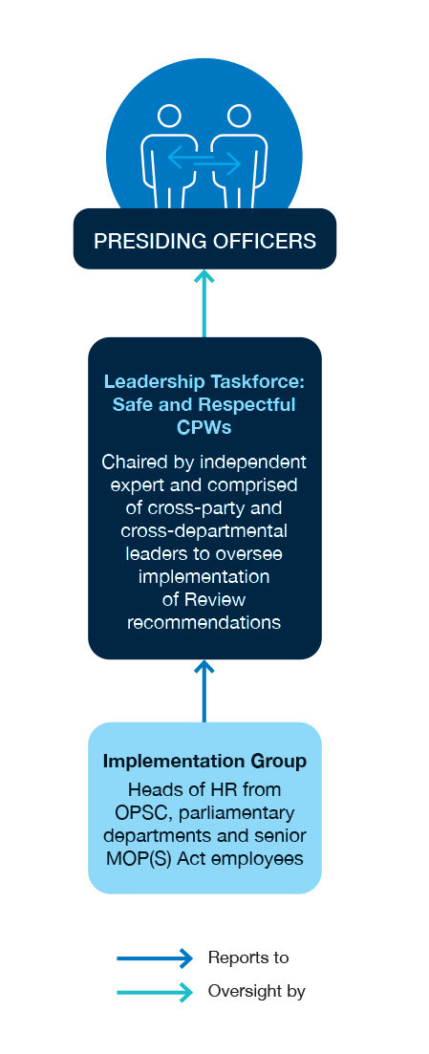
Figure 4b: Recommended structures

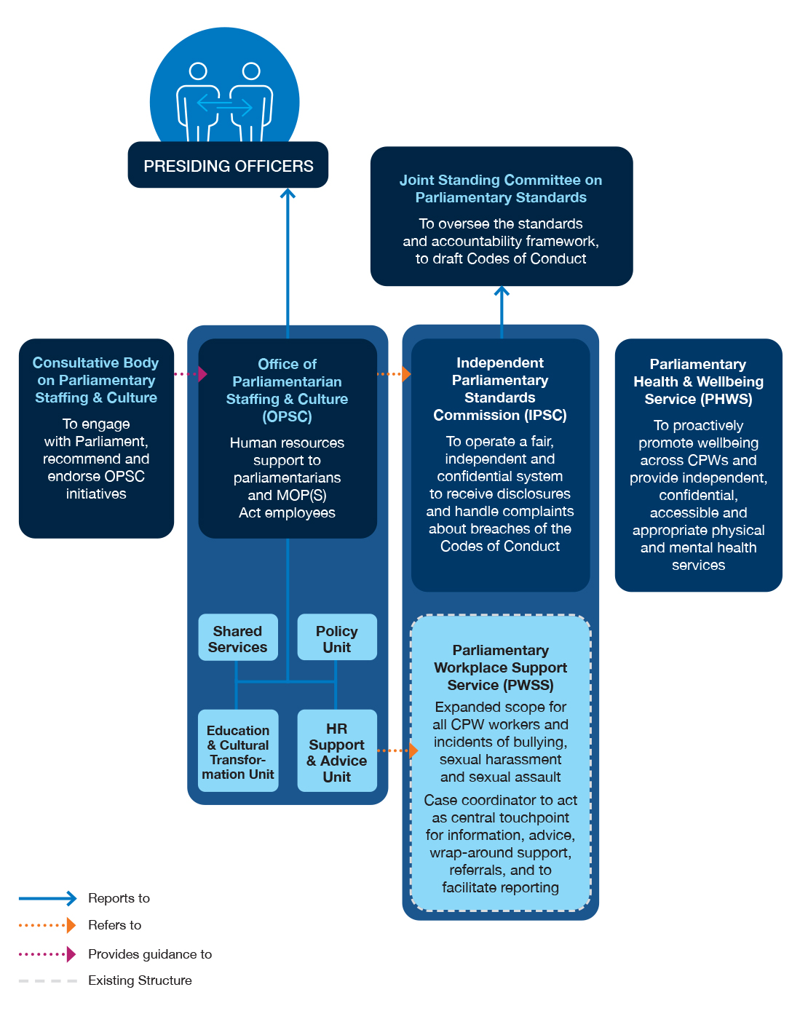

Principle 2:
Diversity, equality and inclusion

Principle 3: Performance

Outcome: People working in Commonwealth parliamentary workplaces are clear about their roles and responsibilities, and consistent and standardised systems, processes and advice exist to support performance.
Outcome: Commonwealth parliamentary workplaces are diverse and inclusive and everyone experiences respectful behaviour as the baseline standard.

The Commission heard that women are under- represented in decision-making roles and that there is a lack of broader diversity across CPWs. This lack of diversity contributes to a ‘boys club’ culture and to misconduct. It also means that CPWs are not representative of the wider population.
The Commission’s recommendations aim to shift CPWs to a future state where the Parliament attracts and retains people who reflect the full diversity of the community and where everyone contributes to robust and inclusive decision-making.
Recommendations:
Advancing gender equality, diversity and inclusion among parliamentarians and MOP(S) Act employees
As part of a 10 year strategy designed to advance gender equality, diversity and inclusion, the Commission recommends:
- targets to achieve gender balance among parliamentarians (Recommendation 5)
- specific actions to increase diversity among parliamentarians and MOP(S) Act employees (Recommendations 5 and 6).
To monitor progress, these measures would be accompanied by an annual public report of
diversity characteristics among parliamentarians and MOP(S) Act employees.
How these recommendations will drive change:
Greater gender balance and diversity is essential to preventing misconduct. Target-setting is increasingly common across public and private
sector organisations to accelerate progress towards gender balance and greater diversity. Targets that set aspirations, together with regular measurement and public reporting, drive change. They also inform strategies to increase diversity and inclusion and the allocation of resources.

The Commission found that human resources support for parliamentarians and MOP(S) Act employees is currently fragmented and dispersed across multiple agencies. A lack of clarity exists around who has authority to act in the employment relationship and there is a lack of standardised human resources processes that operate in other workplaces. In addition, there are concerns about confidentiality of information and a lack of confidence in the ability of current human resources supports and services to deliver constructive outcomes.
The need for a centralised people and culture function with the authority to enforce standards was identified by many participants, pointing to the gap which currently exists and the benefits that would be created by addressing it.
The establishment of an independent people and culture function through the proposed Office
of Parliamentarian Staffing and Culture (OPSC) would support a shift to a future state where parliamentarians and their staff are supported by clarity around employment arrangements, expectations and good employment practices.

Recommendation:
Office of Parliamentarian Staffing and Culture
The Commission recommends the development of a centralised people and culture function that is designed to provide tailored support to parliamentarians and MOP(S) Act employees (Recommendation 11). The function should be empowered to provide authoritative advice; drive strategic initiatives; deliver learning and
development outcomes; and to require compliance with policies and procedures.
The new function, known as the Office of Parliamentarian Staffing and Culture (OPSC) will be informed by the following key principles:
  - accountability to the Parliament, rather than Government
  - designed to centralise services; provide support and advice; develop strategic and diversity initiatives; and drive professionalisation
  - operation within a legislative and structural framework that allows for consultation with the Parliament, obtains authority from the Presiding Officers and provides accountability where standards are not met
  - retention of parliamentarian flexibility and control over employment decisions, but requiring standardised best practice
employment principles, particularly as they relate to recruitment and termination of employment and the management
of employees
  - recognition and support for confidentiality by accessing independent complaint pathways.
How this recommendation will drive change:
The OPSC would ensure that parliamentarians and MOP(S) Act employees have the support and advice they need to perform their roles effectively. Rather than responsibility for human resources practices lying within individual offices, the OPSC would require compliance with policies and procedures and establish an environment where standards, such as those around work health and safety obligations, can be enforced.
Just as important as clear employment arrangements is a professionalised workforce. However, current approaches to assembling teams, and recruiting, managing and developing MOP(S) Act employees,
are inconsistent across CPWs and often out of step with practices and standards common in contemporary Australian workplaces.
By contrast, best practice approaches to people management and professional development allow staff to perform at their best and support a shift to a future state which enables the optimal functioning of CPWs.
Recommendations:
Professionalising management practices for MOP(S) Act employees
The Commission recommends that the Office of Parliamentarian Staffing and Culture establish new standards and processes to facilitate best practice approaches to support a high-performance workforce, including in relation to:
- guidance on the composition and structure of parliamentarians’ offices
- recruitment
- induction processes
- performance management
- managing misconduct
- professional development of MOP(S) Act employees
- mandatory training on respectful workplace behaviour and people leadership
- fair termination of employment. (See Recommendations 12, 13, 14 and 15)
How these recommendations will drive change:
These recommendations are designed to support parliamentarians to establish their offices and manage their staff so that people are set up for success. They are also designed to ensure that people are clear on their roles and responsibilities, including in relation to preventing and responding to misconduct. The recommendations are also designed to improve performance, skills and professional development opportunities of MOP(S) Act employees. This is to enable them to perform at their best and develop their careers during their time in CPWs.

Principle 4: Accountability
Outcome: Clear and consistent standards of behaviour are in place; it is safe to make a report; complaints are addressed; and people are held accountable, including through visible consequences for misconduct.

Best practice demonstrates that clear and consistent standards of conduct are key elements in driving a safe and respectful workplace. The absence of these mechanisms, as highlighted by Review participants, makes the Australian Parliament out of step with developments in other parliamentary contexts and with standards of other Australian workplaces.
Establishing clear and consistent standards across CPWs will support a shift to a future state where all people working across CPWs understand what is expected for a safe and respectful workplace.
As well as clear and consistent standards, a trusted and independent mechanism to which people
can report breaches of the Codes of Conduct and through which they can be enforced is important. The Commission heard that current reporting processes were opaque and ineffective, and that participants consider that the risks of reporting outweigh the benefits.
Establishing an independent complaints mechanism will ensure that people working across CPWs feel confident to report misconduct and that standards will be enforced.

Recommendation:
Codes of Conduct
The Commission recommends that the Houses of Parliament establish a Code of Conduct for Parliamentarians and a Code of Conduct for Parliamentarians’ Staff (Recommendation 21). In addition, the Commission recommends that the
Houses of Parliament establish common Standards of Conduct for the Parliamentary Precincts (which includes Parliament House). The Standards will outline the responsibilities that all parliamentarians, staff, contractors, interns, volunteers, journalists and visitors have in making the parliamentary precincts safe and respectful.
How this recommendation will drive change:
Australian law prohibits workplace bullying, sexual harassment and sexual assault. Clear and
consistent standards of conduct are necessary for a safe and productive workplace. The most effective way to ensure that those standards are lived across a workplace is by articulating, promoting and enforcing them. These mechanisms will ensure that there are clear and consistent standards of conduct across all CPWs.

Recommendation:
Independent Parliamentary Standards Commission
The Commission recommends the establishment of a new Independent Parliamentary Standards Commission (IPSC) with responsibility for enforcing the respective Codes of Conduct and the Standards of Conduct (Recommendation 22). The
recommended IPSC will operate a fair, independent, confidential and transparent system to handle reports and complaints, equivalent to an internal workplace disciplinary process, but tailored to the specific circumstances of CPWs. The model would operate within the powers and privileges of the Houses of Parliament.
How this recommendation will drive change:
The IPSC will address a significant gap in CPWs by providing a safe and supportive reporting and complaints process and an independent mechanism for enforcement. On 23 September 2021, the Government announced the launch of
the Parliamentary Workplace Support Service, an independent complaints mechanism for serious incidents. By incorporating and expanding the existing Parliamentary Workplace Support Service, the IPSC will provide CPW participants with a central touch-point for information, advice, wrap-around support and referrals. The IPSC will provide options for reporting misconduct, including the option
to make reports anonymously. The IPSC can also accept historic complaints and those relating
to people who have left the workplace.
In addition, the IPSC will provide an internal accountability and enforcement function when there has been misconduct, a function currently missing from CPWs. The IPSC will make findings about misconduct and recommendations about sanctions, including decisions about low-level sanctions for misconduct by a parliamentarian. For more serious sanctions, the IPSC can make a recommendation directly to the relevant House
of Parliament. The IPSC will also provide a pathway for a decision to be appealed to a panel of Commissioners.
By building this crucial function into CPWs, all people working across CPWs will have clarity and confidence around reporting misconduct and the enforcement of workplace standards.

Principle 5: Safety and wellbeing
Outcome: People are physically and psychologically well and feel safe and supported in Commonwealth parliamentary workplaces.
Throughout the Review, the Commission heard about the high pressure and ‘win at all costs’ work environment in CPWs and its significant impact on people’s safety and wellbeing.
Participants identified a range of factors that create both physical and psychosocial risks, such as a ‘work hard, play hard’ culture, with high levels of stress, long and irregular hours, extensive travel and regular use of alcohol. This environment can not only mean that people’s physical and mental wellbeing suffers, but also that they are not able to access services which can assist them.
Establishment of a Parliamentary Health and Wellbeing Service will support a shift towards a future state in which a proactive approach to safety and wellbeing is taken, including a focus on prevention.
Recommendation:
Parliamentary Health and Wellbeing Service
The Commission recommends the establishment of a new Parliamentary Health and Wellbeing Service (PHWS) at Parliament House (Recommendation
26). The PHWS should be established following a feasibility study and build upon existing health services in CPWs. The PHWS should be available
to all people in CPWs and offer services onsite at Parliament House, as well as remotely. The PHWS should also be independent, confidential and accessible; provide appropriate and effective care; and establish referral pathways to other services.
How this recommendation will drive change:
A PHWS would ensure that all people working across CPWs understand that their physical and mental health is valued. It would also address barriers which people in CPWs experience in accessing existing services offering both physical and mental health care.

How these shifts will be experienced by people in Commonwealth parliamentary workplaces

The future—an employee experiencing misconduct
Leila is a young university graduate, who has been a member of a political party since her late teens and is now excited to be employed as a junior adviser (MOP(S) Act employee) to a Member of Parliament. Leila had responded to a job advertisement and was recruited through a merit-based process.
When she starts her role, Leila receives extensive induction and training.
This includes around the legislation and processes governing her employment arrangement; relevant Codes of Conduct; and reporting mechanisms for
any misconduct. Her manager goes through her role and responsibilities and explains the performance management and professional development frameworks for her role.
This is Leila’s first full time job, so she finds this information and training especially helpful. Just as helpful is the clear explanation from her employing parliamentarian and chief of staff about the type of office they run and the standards that are expected.
A few weeks after Leila starts, however, a senior adviser in the office starts to bully her—excluding her from meetings, withholding information that she needs in order to do her job, belittling her role and contribution and joking that she shouldn’t come to work-related social events because she doesn’t drink alcohol.
Leila quickly recognises that this behaviour is counter to the Code of Conduct for Parliamentarians’ Staff. She also remembers a recent team meeting where the chief of staff reminded everyone about expected behaviour in the office and encouraged people to report any issues.
She approaches her chief of staff, who thanks her for raising her concern; affirms that any bullying and exclusion is unacceptable; goes through the options for addressing the behaviour and supports; and asks Leila how she would like to proceed. He also indicates that he will support Leila in any report that she wishes to make to the Independent Parliamentary Standards Commission and suggests that she contact the Parliamentary Health and Wellbeing Service for any other support she might need. Leila also calls the Independent Parliamentary Standards Commission for some further support and advice. With the support of a case manager, she decides to request that her chief of staff speak to the senior adviser to ask that he apologise and stop his behaviour.

34 The Full Report of the Set the Standard: Report on the Independent Review into Commonwealth Parliamentary Workplaces

The future—a manager responding to misconduct
Tara is employed by a Minister and has been a longstanding member of a political party. She has worked at Parliament House for several years, first as an adviser to different Members of Parliament and then as a chief of staff. She did not have any leadership or people management experience when she first assumed that role.
Tara was pleased to have had the opportunity to contribute to the Independent Review into Commonwealth Parliamentary Workplaces. Since that time, her Minister has asked her to prioritise regular training on people management skills, as well as training on the prevention of and response to bullying, sexual harassment and sexual assault. She has also overseen the engagement of
new MOP(S) Act employees through transparent recruitment processes. Tara received advice and support from the Office of Parliamentarian Staffing and Culture (OPSC) to ensure that her team complete all the induction and training programs for MOP(S) Act employees.
Tara was pleased when the OPSC and the Codes of Conduct were established because she had previously experienced bullying as a junior adviser but did not feel able to report it. She had also witnessed colleagues being sexually harassed and had been uncertain how to support them.
A recently employed team member approaches Tara with concerns that a senior leader from another office was regularly making sexualised comments and jokes about her.
Tara feels confident in providing her team member with support and advice. She also feels confident telling her that there will be no negative consequences for her employment if she makes a report. Tara explains that there are protections for people who make complaints. She also explains that there are consequences where misconduct is found, no matter how senior the person is.
Tara asks her team member how she would like to proceed and says that she will support her team member if she wishes to report her concerns to the Independent Parliamentary Standards Commission (IPSC). Tara also encourages her team member to seek additional support from the Parliamentary Health and Wellbeing Service.
While her team member considers her options, Tara seeks advice from the OPSC on how to proceed without disclosing any details of the people involved and also refers to the guidance on managing misconduct.
The next day Tara checks in on her team member and tells her that she has her support whatever option she chooses. Tara’s team member tells her she has decided to make a complaint through the IPSC.

Phases of implementation
In addition to setting out a program of key shifts and structural reforms to support the functioning of
safe and respectful CPWs, the Commission proposes that its recommendations are implemented in a phased manner.
This is to ensure that immediate priorities can be progressed, while new structures and mechanisms are developed and established. In particular, the Commission is aware that some actions can deliver value relatively quickly for any new parliamentarians and MOP(S) Act employees joining CPWs following the next Federal election.
For this reason, the Commission has identified changes that can occur within the first six months following Parliament’s receipt of the Commission’s Full Report. These changes include the Statement of Acknowledgement and establishment of the Leadership Taskforce; development of strategies to increase gender balance and diversity, including a
review of physical infrastructure and policies around inclusion; and a review of standing orders and unwritten parliamentary conventions.
Immediate changes also include steps to initiate the establishment of the Office for Parliamentarian
Staffing and Culture, as well as a review of induction and training processes; establishment of a Joint Standing Committee on Parliamentary Standards; and a feasibility study for the recommended Parliamentary Health and Wellbeing Service.
Beyond this initial six months, the Commission has identified changes which can occur over a 6-12 month period, including the establishment of the Office
for Parliamentarian Staffing and Culture; adoption of the Codes of Conduct; and establishment of the Independent Parliamentary Standards Commission.

Steps during the 12-18 month period would include initiation of reporting, including on the implementation of recommendations, and commencement of the Parliamentary Health
and Wellbeing Service. At the 18-month point, an independent review of the implementation of all recommendations would be completed and, at the 24-month point, recommendations from this subsequent review would be put into action.
This phased approach is designed to ensure that change is seen as achievable, while acknowledging the legislative, cultural and operational shifts required.
The Commission recommends this Framework for Action in recognition of what we heard from
participants in the Review, including their experiences of misconduct and their solutions for reform.

36 The Full Report of the Set the Standard: Report on the Independent Review into Commonwealth Parliamentary Workplaces

5.

Conclusion
... this is for the most part, a bunch of people who work extraordinarily hard ... and the reason that they do it, is because they want to make the country a better place and because they truly believe they can make a difference.
(Interview 404, CPW Review)

The Commission is privileged to have been trusted with the experiences and insights of the many individuals who chose to participate in the Review. The people who work in CPWs are driven by a strong commitment to the national interest and are also deeply invested in the potential and imperative for change.
The Framework for Action proposed by the Commission provides a substantial program of reform and strong leadership will be critical to its success. All leaders in the Parliament now have access to the collective voice of the current and past workforce across CPWs. This is a firm basis for a historic legacy this Parliament can leave, creating a stronger Parliament for the future. An opportunity exists for leaders not only to set the standard, but to set in motion a program of lasting reform.
Creating and sustaining these changes will recognise that a safe and respectful workplace environment in Parliament is not only essential to the people who work there, but to the national interest and representative democracy that they are there to secure.

38 The Full Report of the Set the Standard: Report on the Independent Review into Commonwealth Parliamentary Workplaces

6.
Appendix: Recommendations

Recommendation 1:
Statement of Acknowledgement
The Presiding Officers should convene party leaders and the heads of the parliamentary departments to come together, agree and deliver a joint Statement of Acknowledgement to the Parliament. This Statement should acknowledge the harm caused
by bullying, sexual harassment, and sexual assault in Commonwealth parliamentary workplaces and a commitment to action and shared accountability.

Recommendation 2:
Institutional leadership
To demonstrate institutional leadership to ensure safe and respectful Commonwealth parliamentary workplaces, the Houses of Parliament should:
- establish a leadership taskforce, with oversight by the Presiding Officers, chaired by an independent expert and supported by an Implementation Group, to oversee the implementation of the recommendations made in this Report. It should have the following responsibilities:
  - developing and communicating an implementation plan with specific timeframes
  - defining and communicating common values which can drive cultural change across parliamentary workplaces
  - preparing an annual public report of progress made in the implementation of recommendations
  - tracking, on a quarterly basis, key measures of a safe and respectful work environment to monitor progress in implementation.

Recommendation 4:
Individual leadership
To strengthen individual leadership to ensure a safe and respectful work environment:
- parliamentarians and senior Members of Parliament (Staff) Act employees, including chiefs of staff, should:
  - engage in regular discussions to set expectations of conduct and champion the Codes of Conduct
  - create a safe reporting culture, including supporting people who experience misconduct
  - take responsibility for discharging work health and safety obligations
  - attend training on respectful workplace behaviour, people management and inclusive leadership
  - support employees to attend relevant training
- office-holders, parliamentary party leaders and leaders of parliamentary departments should:
  - engage in regular discussions to set expectations of conduct, champion the Codes of Conduct and create a safe reporting culture
  - demonstrate and reinforce the message that those individuals who engage in misconduct will not be protected, rewarded or promoted
- parliamentarians, party leaders and office- holders should report annually to the Parliament on the actions that they have taken to ensure a safe and respectful work environment.

(b) convene an annual parliamentary discussion

in both Houses of Parliament for office- holders, parliamentary party leaders and parliamentarians to share progress on the implementation of recommendations.

Recommendation 3:
External independent review of progress The Australian Government should establish a
follow up external independent review to examine
the implementation of recommendations made in this Report within 18 months of its tabling in the Parliament.
Recommendation 5:
Diversity among parliamentarians
To advance gender equality, diversity and inclusion among parliamentarians, parliamentary party leaders should lead and champion a 10-year strategy which includes the following elements:
- targets to achieve gender balance and specific actions to support the achievement of the targets
- specific actions to achieve gender balance and diverse representation across all parliamentary roles and portfolios

- specific actions to increase the representation of First Nations people, people from CALD backgrounds, people with disability, and LGBTIQ+ people.

Recommendation 8:
Diversity and inclusion in the parliamentary departments
Leaders of the parliamentary departments should

advance gender equality, diversity and inclusion

Recommendation 6:
Diversity among Members of Parliament (Staff) Act employees
To advance gender equality, diversity and inclusion among Members of Parliament (Staff) Act employees, parliamentary party leaders should lead and champion a 10-year strategy that includes the following elements:
- specific actions to increase gender balance and diverse representation among Members of Parliament (Staff) Act employees, with a focus on senior roles
- specific actions to increase the representation of First Nations people, people from CALD backgrounds, people with disability, and LGBTIQ+ people.
within parliamentary departments by:
- adopting specific actions to increase gender balance and diversity in leadership roles
- collecting and publicly reporting on workforce composition and leadership by diversity characteristics.

Recommendation 9:
Access and inclusion
The Presiding Officers, together with party leaders and parliamentary departments, should review the physical infrastructure, policies and practices within Commonwealth parliamentary workplaces to increase accessibility and inclusion.

Recommendation 10:

Recommendation 7:
Measurement and public reporting
The Office of Parliamentarian Staffing and Culture (see Recommendation 11), together with the Department of the Senate and Department of
the House of Representatives, should table an annual report to the Parliament with the following information:
  - diversity characteristics of parliamentarians, including by party affiliation (where applicable), and gender representation across specific roles such as office-holders, ministerial portfolios and committee roles (Department of the Senate and Department of the House of Representatives)
  - diversity characteristics of Members of Parliament (Staff) Act employees, including analysis by party affiliation (where applicable), role, classification and pay scale (Office of Parliamentarian Staffing and Culture).
Everyday respect in the parliamentary chambers
The Presiding Officers should review the Standing Orders and unwritten parliamentary conventions, including their application in practice, with a view to:
- eliminating language, behaviour and practices that are sexist or otherwise exclusionary and discriminatory
- improving safety and respect in the parliamentary chambers.

Recommendation 11:
Office of Parliamentarian Staffing and Culture
The Australian Government should establish an Office of Parliamentarian Staffing and Culture, within 12 months, to provide human resources support to parliamentarians and Members of Parliament (Staff) Act employees that is:
- centralised and accountable to Parliament, with the enforcement of standards
- designed to provide human resources support and administrative functions in the areas of policy development, training, advice and support, and education.

Recommendation 12:
Professionalising management practices for Members of Parliament (Staff) Act employees
The Office of Parliamentarian Staffing and Culture (see Recommendation 11) should establish standards and processes to professionalise management practices for Members of Parliament (Staff) Act employees with the following priorities to foster a safe and respectful work environment:
- guidance on office composition and staffing
- merit-based recruitment with a focus on improving diversity
- standardised induction for parliamentarians and Members of Parliament (Staff) Act employees to establish role clarity and expectations
- performance management systems
- management of misconduct
- best practice respectful workplace behaviour policies that include referral pathways to
the Independent Parliamentary Standards Commission.

Recommendation 13:
Professional development for Members of Parliament (Staff) Act employees
The Office of Parliamentarian Staffing and Culture (see Recommendation 11) should develop a professional development program for Members of Parliament (Staff) Act employees including a:
- framework of skills, competencies and capabilities linked to career pathways
- structured learning and development program and informal and formal skills development opportunities.

Recommendation 14:
Best practice training
To ensure that people working in Commonwealth parliamentary workplaces have the requisite knowledge and skills to prevent and respond to misconduct:
- the Office of Parliamentarian Staffing and Culture (see Recommendation 11) should develop and deliver mandatory best practice training for parliamentarians and Members of Parliament (Staff) Act employees, to be conducted during induction and annually on:
  - respectful workplace behaviour
  - relevant Codes of Conduct
- the Office of Parliamentarian Staffing and Culture (see Recommendation 11) should develop and deliver best practice people management and inclusive leadership training for parliamentarians and senior Members of Parliament (Staff)
Act employees
- the parliamentary departments should review and implement mandatory best practice respectful workplace behaviour training.

Recommendation 15:
Guidance material in relation to termination
of employment for Members of Parliament (Staff) Act employees
The Office of Parliamentarian Staffing and Culture (see Recommendation 11) should create and communicate new guidance materials and processes in relation
to termination of employment for Members of Parliament (Staff) Act employees. These should reflect the requirements of applicable legislation, including the Fair Work Act 2009 (Cth), and address the:
- laws that apply to the termination of employment of Members of Parliament (Staff) Act employees
- key categories of circumstances in, or reasons for, which Members of Parliament (Staff)
Act employees may be dismissed, with specific guidance on when it may be lawful and appropriate to dismiss an employee based on ‘loss of trust or confidence’
- practical steps and processes that should be followed when effecting different categories of dismissals, in order to meet applicable legal requirements.

Recommendation 16:
Fair termination of employment process for Members of Parliament (Staff) Act employees
The Office of Parliamentarian Staffing and Culture (see Recommendation 11) should support parliamentarians to meet their legal obligations in relation to the termination of Members of
Parliament (Staff) Act employees, by introducing the following process:

  - parliamentarians inform the Office of Parliamentarian Staffing and Culture promptly in writing or orally of any proposed dismissal before it is effected
  - the Office of Parliamentarian Staffing and Culture advises parliamentarians whether the proposed dismissal satisfies legal requirements, or identifies any deficiencies, and how to rectify these (Rectification Advice)
  - parliamentarians confirm in writing whether they will accept and implement any Rectification Advice
  - if a parliamentarian confirms that they will not accept and implement the Rectification Advice, or does not respond to the Rectification Advice,
the Office of Parliamentarian Staffing and Culture should notify the relevant Presiding Officer and make a record of this.

Recommendation 17:
Legislative amendments to
Members of Parliament (Staff) Act 1984 (Cth)
The Australian Government should ensure that the Members of Parliament (Staff) Act 1984 (Cth) is amended as follows:
- sections 16(3) and 23(2) be amended to include that the written notice of termination must specify the reasons relied upon for making the termination decision.
- for the avoidance of doubt and without limiting the application of other applicable laws, contracts or instruments, clarifying at the least, that a termination of employment under section 16(3) or section 23(2) is subject to and must comply with the requirements and provisions of:
  - the Fair Work Act 2009 (Cth) including,
but not limited to, the general protections provisions set out in Part 3-1 and the unfair dismissal provisions set out in Part 3-2
  - relevant anti-discrimination legislation
  - the employee’s contract of employment
- clarify that, for the avoidance of doubt, the Work Health and Safety Act 2011 (Cth) applies to a Member, Senator or officer in their capacity as employers of staff under the Members of Parliament (Staff) Act 1984 (Cth).

Recommendation 18:
Comprehensive review of the Members of Parliament (Staff) Act 1984 (Cth)
The Australian Government should undertake a comprehensive review of the operation and
effectiveness of the Members of Parliament (Staff) Act 1984 (Cth) to ensure consistency with modern employment frameworks.

Recommendation 19:
Monitoring, evaluation and continuous improvement
The Office of Parliamentarian Staffing and Culture, together with the Implementation Group (see Recommendation 2), should develop a shared monitoring and evaluation framework across Commonwealth parliamentary workplaces. This framework should ensure regular measurement and public reporting on key indicators to monitor progress in the prevention of and responses to bullying, sexual harassment and sexual assault.

Recommendation 20:
Expansion of the Parliamentary Workplace Support Service
The Australian Government should expand, within three months, the scope of the new Parliamentary Workplace Support Service to:
- make it available to all Commonwealth parliamentary workplace participants
- include all allegations of bullying, sexual harassment and sexual assault
- establish a clear pathway for anonymous reporting, including through a digital platform
- publish additional information on what happens with anonymous and bystander disclosures
- include historic complaints of bullying, sexual harassment and sexual assault and those relating to people who have left the workplace.

Recommendation 21:
Codes of Conduct
To establish clear and consistent standards of conduct:
- the Houses of Parliament should:
  - establish a Joint Standing Committee on Parliamentary Standards, within six months, to oversee standards and accountability, including developing:
    - a draft Code of Conduct for Parliamentarians
    - a draft Code of Conduct for Parliamentarians’ Staff
    - draft Standards of Conduct for the Parliamentary Precincts
  - adopt a Code of Conduct for Parliamentarians, within 12 months, in the Standing Orders of both Houses of Parliament
  - adopt Standards of Conduct for the Parliamentary Precincts, within 12 months, in the Standing Orders of both Houses of Parliament
- The Australian Government should ensure that, within 12 months, the Code of Conduct for Parliamentarians’ Staff is included in the Members of Parliament (Staff) Act 1984 (Cth).

Recommendation 22:
Independent Parliamentary Standards Commission
The Houses of Parliament should establish, within
12 months, an Independent Parliamentary Standards
Commission with delegated power that would:
- incorporate the new Parliamentary Workplace Support Service, including its advisory and support functions (and applying more broadly to misconduct covered by the Codes of Conduct)
- operate a fair, independent, confidential and transparent system to receive disclosures, as well as handle informal and formal complaints and appeals about misconduct
- make findings about misconduct
- make recommendations on sanctions (in relation to parliamentarians, staff and others as relevant under the Standards of Conduct in the Parliamentary Precincts)
- apply sanctions for a breach of the Code of Conduct for Parliamentarians where such sanctions do not interfere with the functions of the Parliament.

Recommendation 23:
Extend public interest disclosure protections
to Members of Parliament (Staff) Act employees
The Australian Government should, within 12 months, ensure that the Public Interest Disclosure Act 2013 (Cth) is amended to extend protections to people employed or engaged under the Members of Parliament (Staff) Act 1984 (Cth).

Recommendation 24:
Ensure protections against age and disability discrimination
The Australian Government, in line with recent amendments to the Sex Discrimination Act 1984 (Cth), should ensure that the Age Discrimination Act 2004 (Cth) and Disability Discrimination
Act 1992 (Cth) are amended to clarify that the laws apply to staff and consultants employed or engaged under the Members of Parliament (Staff) Act 1984 (Cth).

Recommendation 25:
Work health and safety obligations
The Implementation Group (see Recommendation 2) should work collaboratively to:
- develop, agree, and document an intra- parliamentary understanding of the application of, and responsibility for management of, work health and safety duties in Commonwealth parliamentary workplaces.
- review existing arrangements and consider ways to:
  - ensure consistent approaches to identify, eliminate, minimise and communicate about work health and safety risks across these workplaces
  - take a broader and proactive approach to work health and safety responsibilities, including an increased focus on psychosocial risks
  - directly and effectively address bullying, sexual harassment and sexual assault as work health and safety issues

- provide guidance, education and training on work health and safety obligations and duties in the context of bullying, sexual harassment and sexual assault.

Recommendation 26:
Parliamentary Health and Wellbeing Service
The Department of Parliamentary Services should
lead the establishment of a Parliamentary Health and
Wellbeing Service. At a minimum, the Service should be adequately resourced to:
- provide basic physical and mental health services
- be available to all people in Commonwealth parliamentary workplaces
- offer services onsite at Parliament House, as well as remotely, with appropriate privacy and confidentiality measures in place
- be operated by trusted and independent practitioners with knowledge and understanding of these specific workplaces
- proactively promote wellbeing and early intervention support.

Recommendation 27:
Review of Parliamentary sitting calendar and Order/Routine of Business
The Procedure Committees of the House of Representatives and the Senate should review the Parliamentary sitting calendar and the Order/Routine of Business with a view to enhancing wellbeing, balance and flexibility for parliamentarians and workers in Commonwealth parliamentary workplaces.

Recommendation 28:
Alcohol policies
The Implementation Group (see Recommendation 2) should:
- develop and implement consistent and comprehensive alcohol policies across Commonwealth parliamentary workplaces with a view to restricting availability in line with work health and safety obligations, and the principle of harm minimisation
- support implementation of these policies through measures including:
  - incorporating clear expectations and standards around the use of alcohol within respective Codes of Conduct for parliamentarians and Members of Parliament (Staff) Act employees
  - provision of support and a proactive focus on wellbeing and safety
  - provision of education, training and awareness raising opportunities
  - provision and encouragement of opportunities for networking and engagement that do not involve alcohol.

7. Endnotes

Interview 69, CPW Review.

Deloitte Access Economics, The Economic Costs of Sexual Harassment in the Workplace (2019). See Chapter 4.

Productivity Commission, Performance Benchmarking of Australian Business Regulation: Occupational Health & Safety (2010).

Note, this figure reflects the total number of contributions to the Review. Some participants may have participated in more than one form of engagement (for example, an interview and the Review Survey).

Interview 404, CPW Review.

Interview 88, CPW Review.

Individual, Submission W120, CPW Review.

The following reports and resources are key reference materials which identify the drivers and risk factors listed in the table: Australian Human Rights Commission, Respect@Work: National Inquiry into Sexual Harassment in Australian Workplaces (2020); Our Watch, Australia’s National Research Organisation for Women’s Safety (ANROWS) and the Victorian Health Promotion Foundation (VicHealth), Change the Story: A Shared Framework for the Primary Prevention of Violence Against Women and their Children in Australia (2015); Our Watch, Promising Practices in Workplace and Organisational Approaches for the Prevention of Violence Against Women (2015); Department of the Prime Minister and Cabinet, National Framework for Sexual Assault Prevention (2004); VicHealth, Violence against women in Australia: An overview of research and approaches to primary prevention (2017); Safe Work Australia, Guide for Preventing and Responding to Workplace Bullying (2016); Safe Work Australia, Work-Related Psychological Health and Safety: a Systematic Approach to Meeting Your Duties (2019); Safe Work Australia, Preventing Workplace Sexual Harassment: National Guidance Material (2021); Debbie Francis, External Independent Review: Bullying and Harassment in the New Zealand Parliamentary Workplace (2019); World Health Organisation, Violence against Women: Key facts (Fact Sheet, 2021), <https://www.who.int/news-room/fact-sheets/detail/violence-against-women>; International Labor Organization, Ending Violence and Harassment against Women and Men in the World of Work (2018) <https://www.ilo.org/wcmsp5/groups/public/---ed_norm/---relconf/documents/meetingdocument/wcms_553577.pdf>

Interview 223, CPW Review.

Interview 100, CPW Review.

Individual, Submission W227, CPW Review.

Individual, Submission W214, CPW Review.

Individual, Submission W199, CPW Review.

Individual, Submission W137, CPW Review.

Individual, Submission W257, CPW Review.

Interview 513, CPW Review.

Interview 231, CPW Review.

Individual, Submission W226, CPW Review.

Individual, Submission W245, CPW Review.

Interview 432, CPW Review.

Individual, Submission W64, CPW Review.

Interview 182, CPW Review.

Individual, Submission W157, CPW Review.

Individual, Submission W214, CPW Review.

Interview 385, CPW Review.

Interview 537, CPW Review.

Interview 7, CPW Review.

Interview 108, CPW Review.

Interview 174, CPW Review.

Individual, Submission W181, CPW Review.

Individual, Submission W158, CPW Review.

Interview 313, CPW Review.

Interview 379, CPW Review.

Individual, Submission W243, CPW Review.

Interview 110, CPW Review.

Australian Human Rights Commission www.humanrights.gov.au

