Legal Section
Australian Human Rights Commission
GPO Box 5218
Sydney NSW 2001

19 September 2011
Email: legal@humanrights.gov.au

Notice of application for exemption: Department of Human Services,
Ageing, Disability and Home Care (NSW) for an exemption from section 28 and 29 of the
Age Discrimination Act 2004 (Cth)(ADA)

Dear Legal Officer,
People with Disability Australia (PWD) welcomes the opportunity to provide a submission to the Australian Human Rights Commission regarding the NSW Department of Human Services, Ageing, Disability and Home Care’s (ADHC) application for exemption from the Age Discrimination Act 2004 (Cth)(ADA) section 28 and 29.
As you may be aware PWD is a national peak disability rights and advocacy organisation. Founded in 1981, the International Year of Disabled Persons, PWD seeks to provide people with disability with a voice of our own. We have a cross-disability focus representing the interests of people with all kinds of disability. PWD is a non-profit, non-government organisation.
PWD has a strong advocacy focus and commitment to issues affecting people with disability living in licensed residential centres (licensed boarding houses) in NSW. Our advocacy focus on boarding houses is supported by both individual and systemic advocacy program areas. PWD is funded by ADHC to operate the Boarding House Advocacy Project which provides targeted individual and group advocacy to people with disability who are residing in licensed boarding houses under the Boarding House Reform Program. PWD has been funded to provide this service by the since 2002.
PWD fully supports the application made by ADHC for an exemption from the ADA so that it may amend the screening tool to provide that persons under 18 years of age will be deemed unsuitable to become residents of a licensed boarding house.
PWD concurs with the statement that ADHC makes with regard to licensed boarding houses not being a suitable or safe place for persons under 18 years of age and strongly believes that these measures are necessary for Australia’s compliance to its international human rights obligations.
Relevant considerations to this application for exemption include:
• the Convention on the Rights of the Child (CROC) that protects the rights of children and young people up to the age of eighteen. As a signatory to the Convention, Australia has a responsibility to ensure that the rights of children are recognised and upheld;
• the Convention on the Rights of Persons with Disabilities (CRPD) which resolves to promote, protect and ensure the full and equal enjoyment of all human rights and fundamental freedoms for all people with disability, and to promote respect for their inherent dignity.
Article 7 of the CRPD make specific reference to children with disabilities. Obligations of state parties include:
- taking all necessary measures to ensure the full enjoyment by children with disabilities of all human rights and fundamental freedoms on an equal basis with other children; and
- the best interests of the child shall be a primary consideration.
Article 23, Respect for home and the family also provides guidance on obligations relating to
children with disability including:
- children with disability are to be accorded with the same rights as other children to family life;
- children with disability are effectively protected from concealment, abandonment, neglect and segregation; and
- children with disability unable to live with their immediate family are provided alternative care within their wider family, or if this is not possible, within the community in a family setting.
PWD has no grounds for objecting to this application for exemption.
If you have any questions regarding this submission, please contact Sonya Price-Kelly on sonyapk@pwd.org.au
Yours sincerely
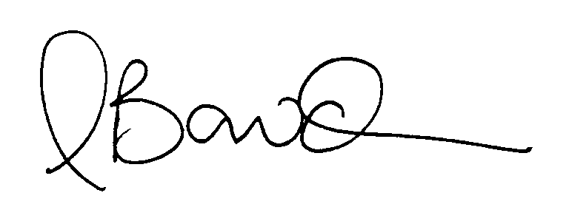
Matthew Bowden
Executive Director – Leadership Team

