


For more information see www.humanrights.gov.au/photo_comp or call (02) 9284 9618.
The Winner in each category will receive a voucher to the value of $500 at Digital Camera Warehouse. Highly Commended entries will each receive a certificate and a year’s subscription to Australian Photography Magazine (valued at $77).Winners will be advised by phone and mail on 10 December.
PRIZES
Entries close on Friday, 31 October 2008.
Winners, Highly Commended and Shortlisted entries in each category will be placed on our website and displayed at HREOC’s annual Human Rights Medals and Awards ceremony on 10 December.
Send in your entries and our judging panel will choose a Winner and Highly Commended in each of the three categories: Under 18 (male), Under 18 (female) and 18 and above (age at 30 June 2008).
We're searching for images that reflect the theme of the competition and provide a unique approach to a human rights subject. For some, the photograph will record a moment that celebrates dignity and justice; for others, it will capture fundamental rights and freedoms being recognised; or it may be an observance of what human rights means to you.
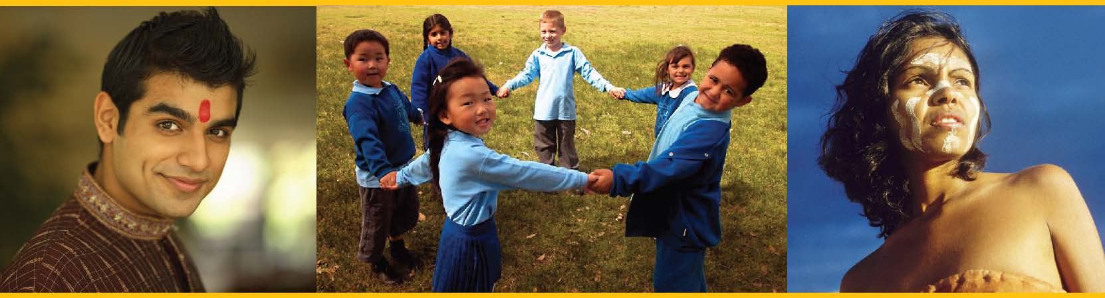
2008 HREOC Photo Competition
‘Dignity and justice for all of us’
To celebrate the 60th Anniversary of the Universal Declaration of Human Rights, the Human Rights and Equal Opportunity Commission (HREOC) is holding a photo competition based on the theme -‘Dignity and justice for all of us’.
The theme reinforces the vision of the Declaration as a commitment to universal dignity and justice, and reinforces how human rights are an inextricable part of our lives – for everyone, everywhere, everyday.

ENTRY CONDITIONS
Please read all the information below carefully and make sure you sign and include the declaration
and attach it to your submission.
- Entries are open to anyone residing in Australia (except HREOC staff).
- Entries from people aged under 18 years of age (as at 30 June 2008) must have signed adult consent.
- Entry is free. A maximum of six photos per entrant.
- All entries should be unframed.
- Photographs should have been taken in the last three years.
- Please send copies only. Do not send original material as submissions will not be returned.
- Each photograph must be accompanied by a title and up to 50 words explaining the picture and the circumstances in which it was taken.
- The photograph must be taken by the person whose name appears on the entry form.
- Submissions must include a fully completed and signed entry form.
- By signing the entry form, you give permission (a limited copyright) to HREOC to copy and publish your submission (including photographs and any written text) or any part of it. HREOC may publish your work on postcards and posters, in public displays, on websites, or in other publications, printed or digital.
- Digital adjustment - photographs will be accepted that have had minimal cleaning, levels and curves adjusted, slight cropping etc (no collages/text overlay etc.).
- Judges’ decisions will be final and no correspondence will be entered into.
- Winners and Highly Commended entry photographers will be notified and images and names will be published on the HREOC website.
- Personal details collected on this entry form will only be used for the purposes of this competition and related promotion.Your private information will not be given to any individual or organisation.
- HREOC may use the photographs for promotional purposes associated with this and any future HREOC photo competition.
- Copyright and intellectual property of the images remains the property of the photographer.
- Photographers will be credited wherever the images are used.
- Signing this entry form constitutes acceptance of these conditions.

I, (insert your name) _______________________________________ confirm that the photograph(s) I am submitting is/are my own work and that I am (at least 18 years old / a minor with permission from my guardian below). I agree to the conditions of entry above and consent to my photographic images being published and displayed by the HREOC as indicated.
Signature Date Signature of Parent /Guardian Date (if under 18)
Please include up to 50 words describing the picture and the circumstances in which it was taken (please attach another sheet if necessary):
_____________________ ___ / ___ / 2008 _____________________ ___ / ___ / 2008
PROFILE
Please fill in this form and attach to the photographs you are submitting for entry. (If you submit your entry via email, please post this form in separately and clearly label your emailed photos with your name). Name:________________________________________________________________________________________________ Age: Under 18 / Over 18 (please circle) – age is determined as at 30 June 2008 Gender: Male/Female (please circle) Address: ______________________________________________________________________________________________ Email: _______________________________________________________________Phone: ___________________________ Title of photograph(s) (include in file name of photo or on the back if a print): ________________________________________________
SEND ENTRIES TO:
● To enter by mail, send your unframed photographs, as a 20x25 cm to 20x30 cm print or on a Windows compatible CD Rom/DVD to:
2008 HREOC Photo Competition ‘Dignity and justice for all of us’ GPO Box 5218, Sydney, NSW, 2001
● To enter by email, send your high resolution jpeg (at 300dpi and up to 5MB file size per email) to:
photocomp@humanrights.gov.au
FURTHER INFORMATION:
If you have any questions, require any further information or would like an electronic copy of these forms and information sent to you please contact HREOC Public Affairs on
(02) 9284 9618 or email: photocomp@humanrights.gov.au

