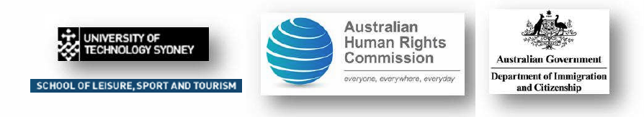

Sport, Race and Ethnicity: Building a Global Understanding 30 Nov – 2 Dec 2008

Colleagues,
In just over two months the University of Technology Sydney, with the support of the Australian Human Rights Commission and the Dept of Immigration and Citizenship, will be staging an international conference focusing on social inclusion and diversity issues in sport and physical activity.
Sport, Race and Ethnicity will involve academics, policy makers, sport industry practitioners and community leaders in three days of constructive debate and discussion.
We are particularly keen to involve people at the ‘coal face’ of sport delivery and development. I therefore extend to you an invitation to attend – either as a delegate or a presenter.
The conference has an industry/practitioner stream that is intended to suit speakers from diverse positions in sport and/or community development. There are also academic streams for those working in universities and government departments.
Abstract templates are available for interested parties.

Please send a request to the Conference Director Daryl Adair at Daryl.Adair@uts.edu.au.
For full details of the SRE conference, please visit the web site:
http://www.business.uts.edu.au/lst/sre/index.html

Key due dates:
31 October: early bird registrations (thereafter full registration up to 30 Nov)
31 October: first draft of full conference program
14 November: final draft of full conference program

Sincerely, Daryl

Daryl Adair
School of Leisure, Sport and Tourism
University of Technology Sydney
Tel: + 61 2 9514 5498



