Check against delivery
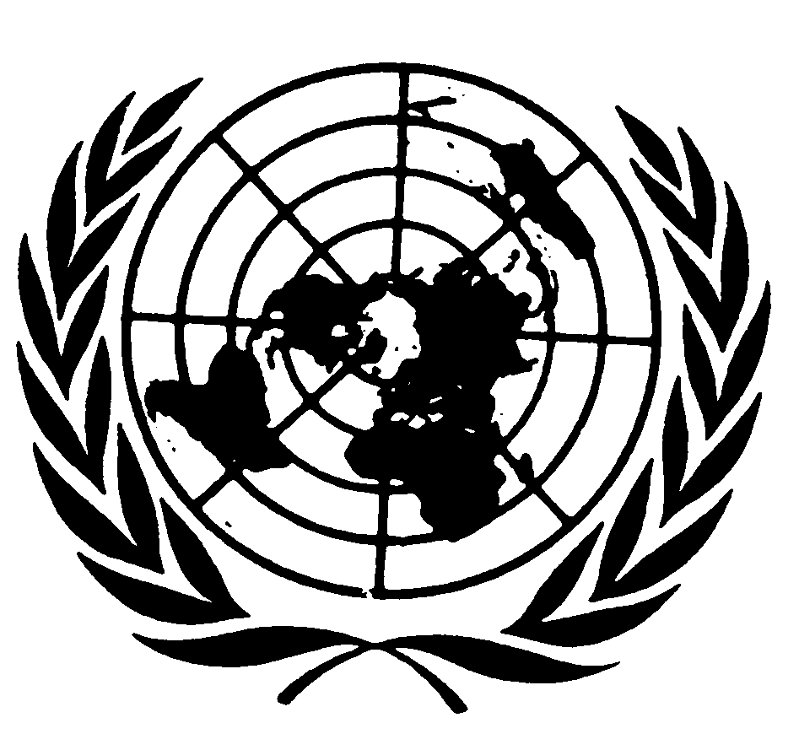

Statement by Professor James Anaya
Special Rapporteur on the Situation of the Human Rights and Fundamental Freedoms of Indigenous Peoples

Eighth Session of the UN Permanent Forum on Indigenous Issues

20 May 2008
New York


I am grateful for the opportunity to address the Permanent Forum and all those attending this session in order to share some of my experiences during my first year as Special Rapporteur on the situation of the human rights and fundamental freedoms of indigenous people. This has been a year of continual challenges in my work, with my optimism for a better future for indigenous peoples animated by positive developments in many places, yet tempered by the reality of ongoing struggles and violations of indigenous peoples rights across the globe.

Cooperation with the Permanent Forum and Expert Mechanism

My participation here is a fundamental part of the necessary cooperation between the Permanent Forum and my mandate as Special Rapporteur. The Human Rights Council has explicitly called upon me “to work in close cooperation with the Permanent Forum on Indigenous Issues and to participate in its annual session” (Human Rights Council Resolution 6/12, art. 1(e)). This cooperation now extends as well to the Council’s Expert Mechanism on the Rights of Indigenous Peoples, which had its first session last October. In my capacity as Special Rapporteur I participated in seminar in Madrid in February with the members of the Expert Mechanism and four members of the Permanent Forum, along with other experts, to explore ways to coordinate and streamline the work of the three mechanisms in order to maximize our collective impact and avoid unnecessary duplication.

I would like to acknowledge and express my gratitude for the support provided for this seminar by the International Work Group on Indigenous Affairs, Almáciga Intercultural Work Group, and the Spanish Agency for International Cooperation and Development of the Government of Spain. The report of the seminar, which includes a series of recommendations, has been made public and will be available on the website of the Special Rapporteur. I am eager to continue to cooperate with the Permanent Forum and Expert Mechanism to share work agendas, identify the strengths and limitations of our respective mandates, and to channel our work in the way that it will be most effective.

Normative Framework

While the Permanent Forum, the Expert Mechanism and I as Special Rapporteur have different roles, a common purpose that joins us is to advance the human rights of indigenous peoples throughout the world. Clearly an important point of reference for pursuing this common purpose is the United Nations Declaration on the Rights of Indigenous Peoples. In my first report to the Human Rights Council last September, I emphasized that the Declaration represents the global common understanding about the minimum content of indigenous peoples’ rights, building as it does upon a well-established body of international human rights law. It provides a normative framework for the work of all United Nations institutions and agencies in relation to indigenous issues. By article 42 of the Declaration itself, the General Assembly calls upon all United Nations bodies and agencies to “promote respect for and full application of the provisions of the Declaration.” And in its resolution reauthorizing the mandate of the Special Rapporteur on indigenous peoples, the Human Rights Council directs the Special Rapporteur to promote the Declaration in carrying out the work of the mandate.

Areas of Work

Since becoming Special Rapporteur just over a year ago, I have engaged in a range of activities within the terms of my mandate to monitor the human rights conditions of indigenous peoples worldwide and promote steps to improve those conditions. Throughout this work, I have attempted to incorporate a gender perspective as well as be attentive to the particular vulnerabilities of indigenous children. Overall, I have tried to develop work methods oriented toward constructive dialogue with governments, indigenous peoples, non-governmental organizations, relevant United Nations agencies, and other actors, in order to address problem situations and build on advances already made. The various activities I have carried out can be described as falling within four, interrelated spheres of activity.

Promoting Good Practices

A first area of my work follows from the directive given me by the Human Rights Council to “identify …and promote best practices” (H.R.C. res. 6/12, art. 1(a)). I am working to advance legal, administrative, and programmatic reforms at the domestic level to implement the standards of the Declaration on the Rights of Indigenous Peoples and other relevant international instruments. Reform of this kind is no small task, as it is necessarily full of all kinds of complexities and requires a strong commitment, both financial and political, on the part of Governments.

During my time as Special Rapporteur, I have been asked to provide assistance with constitutional and legislative reform initiatives by providing orientation on how to conform those initiatives to relevant international standards. Shortly after assuming my mandate in May 2008, I was asked by indigenous organizations and the President of the Constituent Assembly of Ecuador to provide technical assistance with that country’s constitutional revision process. After my visit to Ecuador, I communicated to the Government a series of observations on proposals for constitutional reform relating to the “plurinational” character of the country, collective rights, rights over traditional lands and territories, and the principle of free, prior and informed consent. Ecuador’s new Constitution was approved by referendum in September 2008 with provisions on each of these areas of concern. I continue to monitor Ecuador’s implementation of these reforms and subsequent legislation, and I invite information from indigenous organizations and the Government in this regard.

Also, in April 2009, I carried out a visit to Chile to assess the situation of the indigenous peoples in that country, as a follow up to the 2003 visit to the country by my esteemed predecessor Professor Rodolfo Stavenhagen. While many problems persist for indigenous peoples in Chile, as elsewhere, the Government of that country has taken important steps within the last year to advance protections for their rights, including by ratifying International Labor Organization Convention No. 169 in September 2008 and by committing to enact constitutional reforms to recognize and promote indigenous rights. In light of the constitutional reform process, I developed and submitted to the Government a report, which was made public, outlining and analyzing the various applicable elements of the right to consultation, and providing examples of consultation mechanisms in other countries. The Government has initiated consultations with the indigenous groups of Chile on the constitutional reform process, and I will continue to monitor their progress.

Additionally, the Government of Suriname extended an invitation to me as Special Rapporteur to provide it with technical and advisory assistance as it implements the judgment of the Inter-American Court of Human Rights in the case of Saramaka People v. Suriname. This judgment comprehensively addresses the rights of indigenous peoples to lands and resources and to free, prior, and informed consent. I have accepted the invitation to assist with this initiative and am available to help Suriname draft legislation to implement the judgment.

Clearly, an important component of efforts to build good practices at the domestic level is a policy of commitment to advance the rights of indigenous peoples in accordance with the Declaration. This year, Australia officially endorsed the Declaration and, in a widely circulated statement, committed to “fully implement the standards contained therein.” This is a welcome development in Australia’s policies towards indigenous peoples, which I noted in a press release issued jointly with the chairpersons of the Expert Mechanism and of the Permanent Forum. It also sets an important example for the three other States that did not vote in favor of adoption of the Declaration in the General Assembly in September 2007, as well as for those that abstained in the vote. I am encouraging these other states to take the same action and am optimistic that they eventually will. In August, I will carry out a visit to Australia to examine the situation of indigenous peoples in that country; the Declaration will provide an important frame of reference for this visit.

Thematic Studies

A second area of work, which is intended to contribute to good practices in specific country situations, involves conducting or participating in studies on issues or themes that are of interest to indigenous peoples across borders and regions of the world. My predecessor Professor Stavenhagen carried out a number of thematic studies during his time as Special Rapporteur to identify major issues and to provide a foundation for subsequent positive practical action and reform. These included studies on the impacts of development projects on indigenous communities, the implementation of domestic laws and international standards to protect indigenous rights, indigenous peoples and the education system, the relationship between formal state law and customary indigenous law, and international norms concerning indigenous peoples. However, taking into consideration Human Rights Council resolution 6/36 of December 2007, which established the Expert Mechanism with a mandate to provide thematic expertise and recommendations to the Council on issues affecting indigenous peoples, I now see my own work carrying out thematic studies as secondary to the other areas of my work. My role will for the most part be complementary and supportive of the work of the Expert Mechanism. In this regard, I provided information, based on my experiences as Special Rapporteur, for the Expert Mechanism’s current study on the right of indigenous peoples to education.

Apart from this input, I am collaborating with nongovernmental organizations and indigenous experts in two initiatives related to two thematic areas of recurrent concern to indigenous peoples. One is a seminar, organized by the NGOs Khredda and UNESCO Centre of Catalunya to take place in October of this year, on dispute resolution mechanisms in regard to extractive industries operating or seeking to operate within indigenous territories. This seminar, and the report it will generate, correspond to a recommendation made last year by the Permanent Forum that I carry out a study on transnational corporations, and it is intended to complement the Permanent Forum’s own work on this subject. A second initiative is a multifaceted study on legal pluralism and indigenous customary law, to be carried out in collaboration with the International Council on Human Rights Policy and the Office of the High Commissioner for Human Rights. This study will likely begin with a workshop at the University of Arizona later this year.

Country Reports

A third area of work involves investigating and reporting on the general human rights situations of indigenous peoples in selected countries. The country reports include conclusions and recommendations aimed at strengthening good practices, identifying areas of concern, and improving the human rights situations of indigenous peoples. The reporting process typically involves on site visits to the countries under review, during which I interact with government representatives, indigenous communities from different regions, and a cross section of civil society actors that work on issues relevant to indigenous peoples. These on site visits can only take place with government consent and cooperation. Over the past year, I have visited Brazil, Nepal and Botswana to report on those countries, and I have conducted a follow up visit to Chile to evaluate its progress in implementing the recommendations in the report of my predecessor, Professor Rodolfo Stavenhagen. I also plan on carrying out a follow up visit some time in the next few months to Colombia, another country reported on by my predecessor. I am currently awaiting comments from the governments of Brazil and Nepal on drafts of my reports on these countries, and am in the process of engaging in further exchanges of information with the governments concerned to develop an initial country report on Botswana and a follow up report on Chile. I will present all of these reports in my annual update to the Human Rights Council in September.

Communications on Allegations of Human Rights Violations

Finally, the fourth—and perhaps principal—area of my work as Special Rapporteur involves responding on an ongoing basis to specific situations of alleged human rights violations. A fundamental aspect of the mandate of the Special Rapporteur on the situation of the human rights and fundamental freedoms of indigenous people, as reaffirmed in Human Rights Council resolution 6/12 is “to gather, request, receive and exchange information and communications from all relevant sources, including Governments, indigenous people and their communities and organisations, on alleged violations of their human rights and fundamental freedoms” (para. 1(b)).

My ability to address specific situations of alleged violations relies to an important extent on the information provided to me by indigenous peoples and their organizations, NGOs and other sources. There are no formal requirements for submitting information to the Special Rapporteur. However, it is crucial that the information provided be accurate, complete, and up to date. I would like to take this opportunity to encourage the indigenous representatives present at the Permanent Forum to send me information about the concerns that they are facing in their respective communities. I would also like to thank the representatives of indigenous peoples for their participation here and their continued struggle; I know that many have traveled from very far to attend this session. Their efforts are the driving force behind the work of all of the United Nations mechanisms that deal with indigenous issues.

Over the past year, I have received information about situations of alleged human rights violations in countries in every continent and, in response, have sent numerous communications to governments about these situations. These cases involve infringements of the right to free, prior and informed consent, especially in relation to natural resource extraction and displacement or removal of indigenous communities; denial of the rights of indigenous peoples to lands and resources; indigenous peoples in voluntary isolation; incidents of threats or violence against indigenous peoples and individuals; and concerns about constitutional or legislative reforms in indigenous subject matter, among other situations.

Given the limited resources available to me, it is impossible to respond to every case that comes to my attention. But in general, I will do my best to act on detailed and credible information that presents a serious situation falling within my mandate in which intervention has a reasonable chance of having a positive impact, either by drawing needed attention to the situation or by prompting government authorities or other actors into corrective action. Alternatively, I may take action where the situation is representative of, or connected to, a broader pattern of human rights violations against indigenous peoples.

The usual first step in taking action on such information is to forward it to the government concerned, along with a request that the government respond. In some cases, I have issued public statements calling attention to or expressing concern over the human rights violations alleged. In addition, as I have already done in one case, I may issue observations with analyses and recommendations that I hope will be of use to the governments and indigenous peoples concerned in their efforts to address the situation. Summaries of the communications together with summaries of the government responses, if any, and observations I may make on the situations addressed are included in the reports to the Council.

In all my work as Special Rapporteur, I have been endeavoring to be proactive in efforts to prevent human rights violations from arising or escalating. These efforts require active engagement with governments, indigenous peoples and other actors to closely monitor and evaluate situations, identify underlying causes of immediate problems, promote specific action that builds on advances already made, and develop recommendations that are practical, well-founded in available knowledge, and in accordance with relevant human rights standards. I want to take this opportunity to thank the many indigenous peoples, governments, United Nations bodies and agencies, NGOs, and others that have cooperated with me in this regard.

Conclusion

In my first year as Special Rapporteur I have been developing my work methods to be as effective as possible in carrying out my mandate to respond to human rights violations that are brought to my attention and to promote positive change for indigenous peoples through various means. I will continue to collaborate with the Permanent Forum; the Expert Mechanism on the Rights of Indigenous Peoples; regional human rights institutions; United Nations agencies and programmes; non-governmental organizations; and indigenous peoples themselves to promote the full operationalization of the United Nations Declaration on the Rights of Indigenous Peoples and to find solutions to the problems indigenous peoples face in the enjoyment of their human rights. Towards this end, I am committed to working to ensure that indigenous peoples are effectively heard, and to facilitate constructive dialogue between indigenous peoples, governments, and other relevant actors. I would like to take this opportunity to reaffirm here my strong commitment to my role as Special Rapporteur, acknowledge with humility the responsibility it represents, and thank all those who have supported me and continue to support me as I try to contribute to moving toward reality the shared aspirations of a better future for the world’s indigenous peoples.

*****

