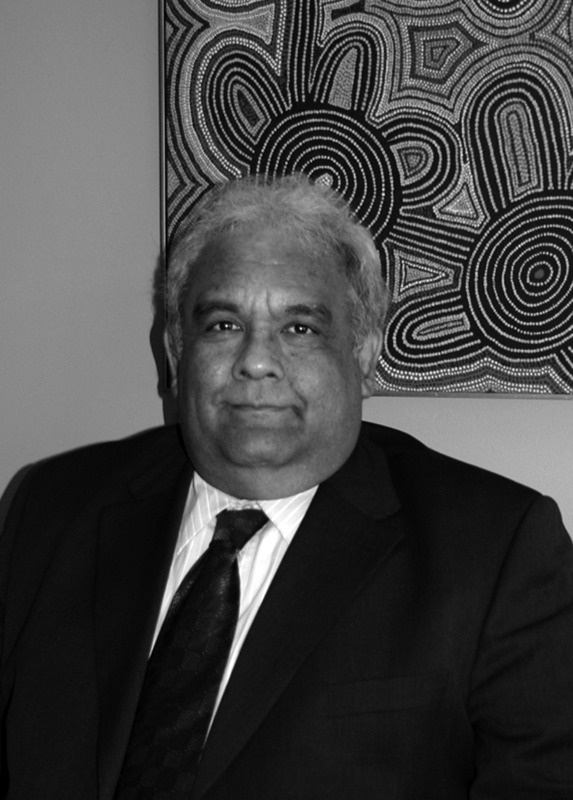
Social Justice Report 2005

Biography:

Aboriginal and Torres Strait Islander Social Justice Commissioner, Mr Tom Calma
Mr Calma is an Aboriginal elder from the Kungarakan tribal group and the Iwaidja tribal group whose traditional lands are south west of Darwin and on the Coburg Peninsula in Northern Territory, respectively. He has been involved in Indigenous affairs at a local, community, state, national and international level and worked in the public sector for over 30 years.

Mr Calma has broad experience in public administration, particularly in Indigenous education programs and in developing employment and training programs for Indigenous people from both a national policy and program perspective.

He served three terms as a Board member of Aboriginal Hostels Ltd and as a Board member for a private tourism and hospitality venture in the Northern Territory.
Until his appointment as Commissioner, on 12 July 2004 for five years, Mr Calma managed the Community Development and Education Branch at Aboriginal and Torres Strait Islander Services (ATSIS) where he worked with remote Indigenous communities to implement community-based and driven empowerment and participation programs. In 2003, he was Senior Adviser Indigenous Affairs to the Minister of Immigration, Multicultural and Indigenous Affairs.

From 1995-2002, he worked as a senior Australian diplomat in India and Vietnam representing Australia’s interests in education and training. During his time in India, he also oversaw the management of the Australian International Education offices in Pakistan, Nepal and Sri Lanka.
He moved to Canberra in 1992 and undertook various assignments, including Executive Director to the Secretary and Senior Executive of the Department of Employment, Education, Training and Youth Affairs (DEETYA).

In the early 1980s, Mr Calma and Indigenous colleagues established the Aboriginal Task Force (ATF) at the Darwin Community College (which later became the Darwin Institute of Technology ), which provided second chance education programs for Indigenous people. He became a senior lecturer and head of the ATF for six years.
Mr Calma has also been appointed as acting Race Discrimination Commissioner for a one-year term.

Commissioner Calma is a 2005 White Ribbon Day Ambassador. White Ribbon Day is the International Day for the Elimination of Violence Against Women.

