National Indigenous Representative Body

Adelaide Workshop Full Report

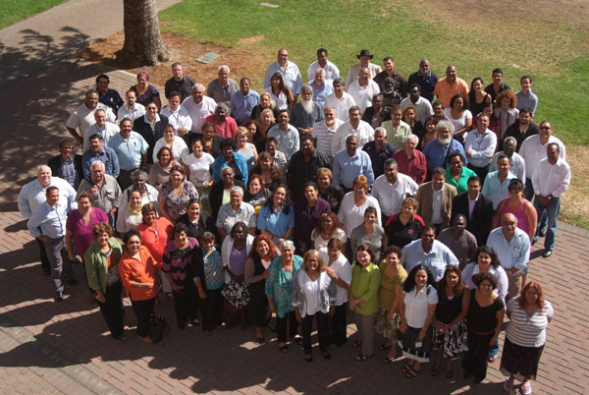

11-13 March 2009
Stamford Glenelg, Adelaide


Note – Use of the terms ‘Aboriginal and Torres Strait Islander
peoples’ and ‘Indigenous peoples’

The Aboriginal and Torres Strait Islander Social Justice Commissioner recognises the diversity of the cultures, languages, kinship structures and ways of life of Aboriginal and Torres Strait Islander peoples. There is not one cultural model that fits all Aboriginal and Torres Strait Islander peoples.

Aboriginal and Torres Strait Islander peoples retain distinct cultural identities whether they live in urban, regional or remote areas of Australia.

Throughout this issues paper, Aboriginals and Torres Strait Islanders are referred to as ‘peoples’. This recognises that Aboriginals and Torres Strait Islanders have a collective, rather than purely individual, dimension to their livelihoods.

On occasion, Aboriginal and Torres Strait Islander peoples are also referred to as ‘Indigenous peoples’. The use of the term ‘Indigenous’ has evolved through international law. It acknowledges a particular relationship of aboriginal people to the territory from which they originate. The United Nations High Commissioner for Human Rights has explained the basis for recognising this relationship as follows:

Indigenous or Aboriginal peoples are so-called because they were living on their lands before settlers came from elsewhere; they are the descendants – according to one definition – of those who inhabited a country or a geographical region at the time when people of different cultures or ethnic origins arrived, the new arrivals later becoming dominant through conquest, occupation, settlement or other means… (I)ndigenous peoples have retained social, cultural, economic and political characteristics which are clearly distinct from those of the other segments of the national populations.

Throughout human history, whenever dominant neighbouring peoples have expanded their territories or settlers from far away have acquired new lands by force, the cultures and livelihoods – even the existence – of indigenous peoples have been endangered.

The threats to indigenous peoples’ cultures and lands, to their status and other legal rights as distinct groups and as citizens, do not always take the same forms as in previous times. Although some groups have been relatively successful, in most part of the world indigenous peoples are actively seeking recognition of their identities and ways of life.

The Social Justice Commissioner acknowledges that there are differing usages of the terms ‘Aboriginal and Torres Strait Islander’, ‘Aboriginal’ and ‘indigenous’ within government policies and documents. When referring to a government document or policy, we have maintained the government’s language to ensure consistency.
Contents

1. Summary

2. BACKGROUND

3. WORKSHOP DISCUSSIONS
  - 20 Year Vision
  - Guiding Principles
  - Roles and Functions
  - National Representative Body Engagement with State, Territories & Regions
  - Structure
  - Relationship to Government
  - Funding Mechanism
  - Negotiable/ Not Negotiable

4. CONCLUSION

Glossary of Terms

Appendices
Appendix 1 - Steering Committee Biographies
Appendix 2 - Workshop Participants
Appendix 3 - Workshop Program
Appendix 4 - NIRB Flowcharts from Workshop Sessions
Appendix 5 - Structure of Torres Strait Regional Authority (TSRA)
Appendix 6 - ACT Indigenous Elected Body (ACTIEB)
Summary of workshop outcomes

Background

In December 2008, the Australian Government requested the Aboriginal and Torres Strait Islander Social Justice Commissioner to convene an independent, Steering Committee of Aboriginal and Torres Strait Islander people to develop a preferred model for a national representative body for Aboriginal and Torres Strait Islander peoples.

The Steering Committee is required to:

- develop a preferred model for a new national Indigenous representative body for presentation to the Australian Government in July 2009;
- make recommendations in regards to the establishment of an interim body from July 2009 which would operate until the finalised body takes effect; and
- ensure strong community support for such a representative model.

This work follows on from the consultations and submissions process conducted by the Government in 2008.

In January 2009, the Social Justice Commissioner invited Aboriginal and Torres Strait Islander men and women to nominate to attend a national workshop to guide the development of a new national Indigenous representative body. The workshop was set for 11-13 March 2009 in Adelaide. The purpose of the workshop was to:

- review submissions and the outcomes of consultations conducted by the Government to date on the establishment of a new representative body,
- identify the key elements or features of a new National Indigenous representative body which can then be distilled down to a series of preferred models for a new representative body, and
- identify a process for further consultation with Indigenous communities leading to the establishment of an interim representative body from July / August 2009.

The workshop was NOT intended to:

- endorse a final model for a national representative body or
- decide membership of a national representative body.

Through the plenary sessions, smaller working groups and an electronic survey conducted at the workshop, it was possible to identify those issues on which there was an emerging consensus among participants and those issues where there remained divergent views or at least, a need for further consultation. These are identified further below.

Terminology

At the outset of the workshop, it was acknowledged that there is a growing debate about the appropriate terminology to be used when referring to Aboriginal and Torres Strait Islander peoples. While accepting the international context for the term ‘indigenous’, participants in the workshop expressed a strong preference for the phrase ’Indigenous peoples’ not to be the primary descriptor used in the domestic Australian context. Preferences were voiced for the following terminology:

- Aboriginal and Torres Strait Islander peoples; and
- First nations or First peoples.

A majority of participants expressed their preference for the phrase ‘First nations’ or ‘First peoples’.

A 20 year vision for the national representative body

Workshop participants expressed the desire for a national representative body to contribute to generational change for Aboriginal and Torres Strait Islander peoples. Participants did not want, twenty years from now, for their children and grandchildren to be in the position where they needed to have the same discussions taking place at this workshop.

Participants identified that over the next 20 years, the national representative body would have a leading role to play in achieving constitutional recognition and a treaty, in closing the gap, and in Australia as a country owning and facing up to its history. The representative body would have contributed to a situation where our children are empowered, we are in control of our own destiny, are culturally strong and proud, economically independent and where the Aboriginal and Torres Strait Islander community/ies are united and not wracked by internal division.

Participants described their vision for the representative body as follows. In 20 years time, there is reciprocal respect between the representative body and tribal nations. The national representative body:

- is functioning effectively and efficiently;
- is self-sufficient and self-determining;
- is independently funded and free from government control or interference;
- is an organization that embodies the principles of self-determination and human rights at every level;
- has credibility and integrity in both Aboriginal and Torres Strait Islander and non-Indigenous communities and government;
- is standing on its own feet;
- is truly representative of the diverse makeup of Aboriginal and Torres Strait Islander populations – gender, rural/ regional/ remote, youth;
- utilizes and shares the diverse skill sets and expertise of our peoples;
- has a role in development of policy for service delivery in a truly influential way;
- is seen as a peak public body working at best standards for a public representative body;
- provides pathways for education, employment and professional development of Aboriginal and Torres Strait Islander peoples;
- is accessible to grassroots people; and
- is holding Government accountable for their obligations to Aboriginal and Torres Strait Islander peoples as citizens.

Guiding principles for a new representative body

There was agreement among the workshop participants on the importance of the national representative body pursuing the following objectives:

- playing a leading role in forging a new partnership between Governments and Indigenous peoples;
- ensuring Indigenous peoples contribute to and lead policy development on Indigenous issues;
- ensure that an Indigenous perspective is provided on issues across government;
- advocate for the recognition and protection of Indigenous peoples’ rights;
- ensure adequate accountability mechanisms exist for government’s performance in delivering services to Indigenous peoples and communities;
- ensure that commitments to closing the gap are supported by long term action plans;
- ensure and support good governance among Indigenous communities and organisations;
- ensure the equal participation of Indigenous women in all of its decision making processes; and
- ensure the equal participation of mainland Torres Strait Islanders.

There was also common agreement on the need for the national representative body to operate in accordance with the highest standards of ethical and moral conduct and to be open, transparent and accountable to Aboriginal and Torres Strait Islander peoples.

The adapted Nolan principles on public life (see below) were seen as setting out behavioural expectations for members of the national representative body.

Nolan Committee principles on public life

These principles relate to all aspects of public life. They were created by the Nolan Committee for the benefit the public in any way. These principles will apply to all who are employed by the national Indigenous representative body.

Eight Principles of Public Life

Selflessness
Holders of public office should take decisions solely in terms of the public interest. They should not do so in order to gain financial or other material benefit for themselves, their family, or their friends.
Integrity
Holders of public office should not try to place themselves under any financial or other obligation to outside individuals or organisations that might influence them in the performance of their official duties.
Objectivity
In carrying out public business, including making appointments, awarding contracts or recommending individuals for rewards or benefits, holders of public office should make choices on merit.
Accountability
Holders of public office are accountable for their decisions and actions to the public and must submit themselves to whatever scrutiny is appropriate to their office.
Openness
Holders of public office should be as open as possible about all the decisions and actions that they take. The holders of public office should give reasons for their decisions and restrict information only when the wider public interest clearly demands.
Honesty
Holders of public office have a duty to declare any private interests relating to their public duties and take steps to resolve any conflicts arising in a way that protects the public interest.
Leadership
Holders of public office should promote and support these principles by leadership and example.
Behaviour
Holders of public office must exhibit at all times the exemplary levels of personal and corporate behaviour.

The following key guiding principles were also identified for the national representative body:

- Accountability: to Aboriginal and Torres Strait Islander peoples, and also of government to the national representative body. This involves transparency in operations and through effective communication / dissemination of information with Aboriginal and Torres Strait Islander peoples;
- Authority: This will come from representativeness of the body, and also from development of a strong evidence base;
- Legitimacy: This will come from reflecting the diversity within Aboriginal and Torres Strait Islander communities – including issues relating to disability, mainland Torres Strait Islanders, geographic and cultural differences. It will also emerge from the body being representative and through advocating for the most vulnerable;
- Partnership: with both government and industry as well as with Aboriginal and Torres Strait Islander organisations, peak bodies and communities; and
- Respect: for culture and for the cultural diversity within Aboriginal and Torres Strait Islander communities.

The importance of recognising and protecting Aboriginal and Torres Strait Islander peoples’ human rights was also emphasised. The UN Declaration on the Rights of Indigenous Peoples was identified as providing the framework for engagement with Aboriginal and Torres Strait Islander peoples. Groups commonly raised the need for gender equality in representation.

Social inclusion was also highlighted as a key principle with the representative body playing a vital role in the education of the broader Australian community and working for the benefit of all Australians towards Reconciliation.

Roles and functions of a national representative body

There was common agreement among the workshop participants on the importance of the national representative body having the following roles and functions:

- advocacy;
- formulating policy and advising government;
- reviewing government programs;
- negotiating framework agreements with governments;
- monitoring service delivery by governments;
- conducting research and contributing to law reform processes; and
- representing Aboriginal and Torres Strait Islander peoples at the international level.

The majority of workshop participants also agreed that the national representative body should have the following roles and functions:

- a coordination or ‘clearing house’ role to promote the sharing of information between Indigenous representative organisations and service delivery organisations; and
- conducting facilitation and mediation services for Indigenous peoples.

Participants rated the following roles as the most important for a national representative body to undertake:

- advocacy;
- monitoring government service delivery;
- formulating policy and advice;
- negotiating framework agreements with governments; and
- reviewing government programs.

It was also noted that the representative body:

- could work with the federal government in planning expenditure of state / territory funds for Indigenous affairs;
- could be advised by peak bodies, and they could in turn be advised by the representative body;
- should be able to commission new research, informed by Indigenous knowledge systems and research methods, and should set the vision based on the desires, needs, priorities and aspirations of Aboriginal and Torres Strait Islander peoples; and
- should take a lead role in promoting a positive image of Aboriginal and Torres Strait Islander communities.

In relation to service delivery, it was commonly agreed that:

- the representative body should not deliver services or programs;
- it should set priorities for service delivery in consultation with Aboriginal and Torres Strait Islander peoples, communities and state / territory level representatives;
- it should have a mandate to set targets to hold governments accountable; and
- it could work with existing monitoring processes, as well as receive independent field reports from regional members or bodies.

Engaging with communities / representativeness

A majority of participants believed that the national representative body should have structures at the national, state / territory and regional levels to engage with Indigenous peoples.

A great majority of participants also agreed that it is essential for the national representative body to have a direct relationship with regions and a majority agreed that the organisation’s national membership should be drawn from the regional level. While there was support for the organisation to have a state / territory structure it was notably less than the support for a regional structure. There was however strong support for the national representative body to bring regional representatives together at the state / territory level.

There was strongest support for the national representative body to engage directly at a regional level. The overwhelming majority of participants believed that:

- The national representative body should include regional representative structures; and
- Should convene regional forums on a regular basis.

A substantial majority of participants also believed that the national representative body should:

- enter into partnerships with governments at the regional level;
- conduct regional planning or negotiate regional framework agreements; and
- draw its national membership from the regional level.

A substantial majority of participants also believed that the national representative body should:

- bring regional representatives together at the state / territory level; and
- convene state-wide planning forums.

The majority of participants also believed that the national representative body should:

- have a state / territory level structure; and
- negotiate state-wide framework agreements with government.

There was strong support for the representative body to form strategic alliances with peak bodies and Aboriginal and Torres Strait Islander agencies and businesses. There was also support for non-Indigenous organisations and NGOs to provide advice to the representative body on invitation.

Structure of the national representative body

There was strong support for the national representative body to be made up of an equal number of men and women, and for members to have integrity, vision and credibility, and to be required to adhere to a code of conduct.

There was also a strong view that members of the national representative body should not be appointed by government.

There was, however, not a clearly preferred mechanism for members of the representative body to be selected. There was mixed support for a direct election model and alternatively for a delegate model. The majority of participants, however, did not support peak bodies being able to directly nominate representatives onto the national body.

The direct election model posed a dilemma as many participants felt that a democratic process should be used, but that it did not always result in the most qualified or suitable applicants being selected. Many participants preferred a system that combined election with a merit selection process, so that applicants were assessed as possessing the necessary skills prior to the election being conducted. If an election model is used, participants generally preferred that each state and territory should be given the opportunity to work out a system that will work for them (and their regions) as a one size fits all approach may not work.

There was mixed support for the idea of eminent Indigenous leaders selecting representatives. Such a process would require an open, competitive and transparent process.

Relationship to government and funding mechanisms

There was also support for the representative body to be established under legislation and to report directly to Parliament – such as through a statutory authority model. Similarly, there was support for the body to be a non-government organisation such as through being a company limited by guarantee. Participants were concerned to ensure that the body be sustainable and have longevity beyond the political cycle.

Participants strongly expressed a view that while government funding would be required for the establishment period of the national representative body it needs to be able to operate independent from government. The idea of an establishment fund to provide a capital base for the organisation received strong support. Additionally there was a preference for the national Indigenous representative body to identify funds nationally and internationally from the philanthropic and corporate sector and that government funding should be used for a defined establishment period.

A substantial majority of participants rated the following funding options as important:

- have a fund established to give the body a capital base (like the Indigenous Land Corporation);
- receive (untied) government funding;
- be established through a future fund financed through a percentage of mining tax receipts; and
- gain charitable status to receive tax free donations.

Participants also identified the potential for the representative body to charge membership fees or charge for delivery of goods and services. However, the majority of participants did not see these options as important in funding the representative body.

Issues where a consensus has begun to emerge

Major areas of consensus from workshop participants included:

- Principles guiding the formation of the representative body and behavioural standards to be applied to members of the body;
- The roles and functions of the representative body (including that the representative body not undertake a service delivery role);
- Ensuring the equal participation of men and women as representatives;
- Ensuring that there are mechanisms in place to ensure the participation of groups that are generally marginalised such as young people, people with disabilities, members of the stolen generation and mainland Torres Strait Islanders;
- Ensuring that there is representation of the diversity of Aboriginal and Torres Strait Islander peoples based on gender, geographical locations, relationship to country and cultural diversity;
- That the representative body be self-determining and that it operate independently of government influence (including through how the governance of the body is structured, and by receiving untied or discretionary recurrent funding);
- That all representative body members are Aboriginal and/ or Torres Strait Islanders and there is a clear process to verify identity;
- Selection of new representative body representatives must be transparent, with a selection process determined by Aboriginal and Torres Strait Islander people and selections based on set criteria that includes identifying the specific and appropriate skills required.

Issues requiring further consideration

Issues on which no clear consensus emerged during the workshop included:

- whether the national representative body should use a delegate or direct election model, and the role of merit selection in either model;
- how a panel of eminent Indigenous peers would operate in any selection process (if at all);
- issues relating to structure of the national representative body and how it would engage at the regional and states/territory level; and
- further details on the qualities and skills required for the national representative body leadership. This is to inform the development of selection criteria if a merit based selection process is used.

2. BACKGROUND

In December 2008, the Australian Government requested Tom Calma, the Aboriginal and Torres Strait Islander Social Justice Commissioner at the Australian Human Rights Commission to convene an independent Steering Committee of Aboriginal and Torres Strait Islander people to develop a preferred model for a national representative body for Aboriginal and Torres Strait Islander peoples.

The Steering Committee is required to:

- convene an Indigenous Peoples Workshop in March 2009, with a possible second workshop in June 2009
- develop a preferred model for a new national Indigenous representative body for presentation to the Australian Government in July 2009
- make recommendations in regards to the establishment of an interim body from July 2009 which would operate until the finalised body takes effect, and
- ensure strong community support for such a representative model.

This work follows on from the consultations and submissions process conducted by the government in 2008. Information about the Steering Committee members is contained in Appendix 1 of this report.

In January 2009, the Social Justice Commissioner invited Aboriginal and Torres Strait Islander men and women to nominate to attend a national workshop to guide the development of a new national Indigenous representative body. The workshop was set for 11-13 March 2009 in Adelaide.

The purpose of the workshop was to:

- Review submissions and the outcomes of consultations conducted by the Government to date on the establishment of a new representative body,

- Identify the key elements or features of a new national Indigenous representative body which can then be distilled down to a series of preferred models for a new representative body, and

- Identify a process for further consultation with Indigenous communities leading to the establishment of an interim representative body from July / August 2009.

The workshop was NOT intended to:

- Endorse a final model for a national representative body or
- Decide membership of a national representative body.

The Department of Families, Housing, Community Services and Indigenous Affairs (FaHCSIA) established a dedicated unit to provide administrative support to the Social Justice Commissioner and the Steering Committee. Applications for the workshop were received by this support unit in FaHCSIA on behalf of the Steering Committee. All administrative arrangements for the workshop – including venue hire and catering, flying and accommodating all participants – was organised by FAHCSIA. All decisions relating to the convening of the workshop and selection of participants was then determined independently by the Steering Committee.

The Steering Committee convened the workshop on 11-13 March 2009 in Adelaide. The Workshop was limited to 100 people from across Australia. All participants were required to submit an application form. Applicants could self-nominate (with two written references) or be nominated by someone else.

The Steering Committee selected participants from a mix of urban, regional, rural and remote localities and were mindful of including different age groups and ensuring there was an equal number of men and women invited. 100 participants were selected out of a pool of 267 applications received. Approximately 40 applications were received after the closing date and were not considered.

All participants were selected based on merit. Selection criteria for applicants included that they:

- be an Aboriginal and/or Torres Strait Islander
- be nominated by an Indigenous community organisation or self nominated with two written references supporting the nomination
- have demonstrated leadership capacity and ability to take part in high level discussions on strategic issues
- be able to communicate and interact effectively with a diverse range of people
- have demonstrated capacity to represent views and interests
- be able to make a positive and considered contribution to the discussions and deliberations on the establishment of the new national Indigenous representative body, and
- be available to attend and participate in the program and events for the entire workshop.

A list of workshop participants is included as Appendix 2.

The workshop occurred over 3 days at the Stamford Glenelg in Adelaide from Wednesday 11 March to Friday 13 March. A pre-briefing and welcome dinner was held for participants on the evening of Tuesday 10 March.

The workshop was structured according to the sets of issues outlined in the issues paper released by the Social Justice Commissioner in July 2008 and titled Building a sustainable National Indigenous Representative Body – Key issues. There was a mix of plenary discussions and smaller working group discussions over the three days. Participants also divided into thematic groups (youth, Torres Strait Islanders, Northern Territory Group and others regarding the NT Intervention) and representatives from their respective states and territories, for additional sessions outside the workshop program. For a copy of the Workshop Program please refer to Appendix 3.

Workshop participants were also encouraged to participate in an online survey during the course of the workshop to establish at a broad level where agreement exists on key issues.

The workshop was chaired by Mr Tom Calma and Dr Jackie Huggins of the Steering Committee. Dr Lowitja O’Donoghue was invited to be the patron of the workshop in recognition of her substantial contribution in building national representative mechanisms in the past and her leadership on Aboriginal and Torres Strait Islander policy at the national level.

Three facilitators (Mr Justin Noel, Ms Kerry Arabena and Ms Sharon Kinchela) were selected to manage the workshop process. All facilitators are Aboriginal or Torres Strait Islander people. The facilitators were asked to drive the process towards consensus positions over the three days, to inform future consultations by enabling them to target those aspects where there was not consensus and a need for broad community consideration of the issues.

Photo: Workshop patron, Dr Lowitja O’Donoghue, with members of the Steering Committee (Dr Jackie Huggins, Mr Tom Calma, Dr Mark Bin-Bakar, Ms Nala Mansell-McKenna, Ms Yananymul Mununggurr, Mr Jason Glanville and Mr John (Toshi) Kris), Expert advisor to the committee, Professor Mick Dodson and Steering Committee secretariat (Ms Josephine Bourne and Mr Darren Dick). Absent: Ms Tanya Hosch, Mr Tim Goodwin, Mr Geoff Scott and Rosalie Kunoth-Monks.

2. DAY ONE: WEDNESDAY 11 MARCH 2009

Session 1: Setting the scene

In the opening session of the workshop, the scene was set by Traditional Owner Uncle Lewis O’Brien, The Honourable Minister Jenny Macklin, Aboriginal and Torres Strait Islander Social Justice Commissioner Tom Calma, and South Australian Aboriginal Social Engagement Commissioner Klynton Wanganeen.

We saw the pride and strength of the culture of the Kaurna people, as we were welcomed onto their lands.

Both Minister Macklin and Commissioner Calma set out the process as it will unfold over the coming months – culminating in a report by Commissioner Calma and the Steering Committee to the Minister in July 2009 recommending a model for a new national representative body and recommending a process (and potentially nominees) for an interim representative body.

It was noted that the process is being led by Aboriginal and Torres Strait Islander peoples and independent of the government by Commissioner Calma and the Steering Committee. And it was noted that there is no pre-determined outcome for the process. This workshop, in fact, forms a centrepiece of the second and final round of consultations leading to the proposal of a model to the government.

Minister Macklin confirmed the government’s hope that the national representative body will come into being by the end of 2009. Commissioner Calma challenged us to focus on how ‘we expedite the representative body coming into being within a relatively short timeframe while also being able to involve our communities’. And he noted that every day without a national representative body is of ‘critical concern’.

Minister Macklin expressed her hopes for a new national representative body as:

- being a place where divergent views can come to the table ;
- Being a voice for the most powerless;
- Providing a platform for new partnerships;
- Dealing with the serious, entrenched marginalisation and disadvantage experienced among our communities; and
- Influencing the way non-Indigenous peoples understand the challenges facing Aboriginal and Torres Strait Islander peoples.
Minister Macklin also noted that creating a new representative body is going to require a concerted effort with a willingness to work together and do things differently.

Commissioner Calma then set the challenge for a new representative body as achieving ‘two way’ accountability – to government and to Aboriginal and Torres Strait Islander peoples.

He talked of the ‘gap’ between the expectations from the Aboriginal and Torres Strait Islander community of what a national representative body should do and what government is prepared to support and work with. He identified as a challenge ‘closing the gap’ between the expectations of government and Aboriginal and Torres Strait Islander peoples in order to avoid the credibility problems of previous bodies, to ensure that it has influence with government and is an effective agent of change for communities.

Commissioner Calma also noted that the representative body will come into being at a time where there have been rapid advances in the recognition of the rights of Indigenous peoples internationally. In particular, he referred to the adoption by the General Assembly of the United Nations in September 2007. The Declaration includes the following relevant articles:

Article 18 - Indigenous peoples have the right to participate in decision-making in matters which would affect their rights, through representatives chosen by themselves in accordance with their own procedures, as well as to maintain and develop their own indigenous institutions.

Article 19 - States shall consult and cooperate in good faith with the indigenous peoples concerned through their own representative institutions in order to obtain free, prior and informed consent before adopting and implementing legislative or administrative measures that may affect them.

Commissioner Calma challenged participants to be very specific about what we want from a national representative body so we can move beyond the general principles and agreement that already exists. He noted the collective wisdom that exists among the people attending the workshop to meet this challenge.

Commissioner Wanganeen then set out the challenges that have existed in South Australia since the abolition of Aboriginal and Torres Strait Islander Commission. He noted the limits of his existing role as Community Engagement Commissioner in terms of resource constraints and not having a legislative basis for this role. He identified as critical that the Aboriginal and Torres Strait Islander communities and the general population have an understanding of the actual roles and functions of a representative body.

Commissioner Wanganeen reminded us of the importance of having your say in this process when he said: “say what you want or be prepared to accept what you are given.”

At the outset of the workshop, it was also acknowledged that there is a growing debate about the appropriate terminology to be used when referring to Aboriginal and Torres Strait Islander peoples. While accepting the international context for the term ‘indigenous’, participants in the workshop expressed a strong preference for the phrase’ indigenous peoples’ not to be the primary descriptor used in the domestic Australian context. Preferences were voiced for the following terminology:

- Aboriginal and Torres Strait Islander peoples; and
- First nations or First peoples.

A majority of participants in the workshop expressed a preference for ‘First nations’ or ‘first peoples’.

Session 2: Lessons from the past and the outcomes of consultations to date

Workshop Patron, Dr Lowitja O’Donoghue shared her reflections on her long and distinguished involvement in national representative bodies. She spoke some hard truths about ethical and behavioural standards within ATSIC, nepotism and other issues. She also told a cautionary tale about making a representative body ‘too big’ and unmanageable, as she believes had happened with ATSIC (particularly in its early years). And she spoke very tellingly about the personal toll and burden of leadership. Dr O’Donoghue requested that her specific comments remain confidential to the workshop participants and are not expanded on here.

Geoffrey Richardson from the Department of Families, Housing, Community Services and Indigenous Affairs provided a summary of the outcomes of consultations conducted by the government on the national representative body from July – November 2008. This included:

- 17 x Regional workshops
- 40 x Community workshops and consultations
- 20 x meetings with peak bodies and organisations
- A comprehensive mail-out to 2300 organisations on the ORIC mailing list
- Initial consultations with State/Territory Governments officials
- A public submission process, which received 106 submissions by the closing date
- Consultations with several hundred participants in the FAHCSIA Indigenous Leadership Program.

He noted that the Government has not dictated to Indigenous people what we should or shouldn’t have as our Representative Body. The Government did provide a series of broad Principles to guide the consultations. These set out the characteristics the Government would prefer to see in the Representative Body that it wishes to engage with to assist it meet its Aboriginal and Torres Strait Islander Affairs objectives. These included:

- Urban, regional, remote representation – recognising the great diversity of circumstances of Indigenous peoples
- Not necessarily conducting separate elections
- Not another ATSIC – this point relates to the structure of ATSIC. The Government does not wish to create another ATSIC structure which had:
  - Originally 800 elected officials later reduced to 388; 60 Regional Councils later reduced to 35 plus the TSRA; 17-20 full-time Commissioners plus 35 full-time Regional Council Chairs, plus offices, Personal Assistants; support staff; vehicles
- Preferably not a Service Delivery Role – the administration of Indigenous Affairs has changed significantly since the abolition of ATSIC. The changes include:
  - All Indigenous Programs distributed to mainstream Departments/Agencies (including functions to IBA and ILC)
  - An emphasis on Whole of Government approach; improving access to mainstream Programs; Agreement making
  - Emphasis on partnerships with State and Territory Governments

The key messages that emerged from the consultations in 2008 were:

- Widespread support for a new Representative Body
- The need to extend the consultation period
- Preference for the use of the terms Aboriginal and Torres Strait Islander rather than Indigenous
- No major support for a Service Delivery role
- The need for security of tenure and funding for the body.

There was also consistent support for a new representative body:

- To have transparency in its operations
- have clearly defined roles and functions
- to conduct training for members
- to play a key role in negotiating:
  - designated seats in Parliament
  - Constitutional recognition
  - a Treaty or Treaties.

In terms of the roles and functions of the body, there was support for it to have the following roles:

- Advocacy – domestically and internationally
- Monitoring & evaluation
- Advisory role to Government/Industry
- A consultation role with communities
- A linking role (organisations and communities)
- Research
- Mediation services
- Legislation (overseeing role)

In terms of structure, there was support for the body to have gender balance, representation from urban, rural and remote communities and Torres Strait Islander representation. While there was strong support for the body to be independent of Government, there was divided support between a statutory authority model and a private non-government model.

There was also support for the body to have a tiered structure (with community, regional, state, national level engagement), and also support for a streamlined national structure, regional bodies and for the national representative body to have membership on COAG and Ministerial Councils.

There was also mixed support for the selection of members of a representative body. Preferences included the following methods:

  - a general election
  - an application process
  - direct appointments
  - a membership process
  - drawing members from existing peak bodies
  - combinations of the above.

In terms of the skills and values possessed by members of the representative body, it was commonly raised that Members should:

  - possess appropriate skills and/or experience to fulfil the functions
  - demonstrate trust, integrity, honesty
  - be subject to a code of conduct.

The consultations also identified that the national representative body needs a sustainable funding source. There was support for Government funding to be provided, and also for other options such as a percentage of GDP and other tax options being built into the funding model, and for the body to charge membership and subscription fees.

Mr Richardson noted the challenges that will exist for the representative body, if it is to be operational within the year. This includes building it, establishing its membership base, facilitating staffing, offices, systems and logistics. If it is a statutory model, all of this will need to be passed through parliament as well.

He also noted that the representative body will have a major role to play in:

- Working with government to improve policies, programs & service delivery to support community self-reliance
- Building community consensus on key issues affecting Aboriginal & Torres Strait Islander peoples
- Maintaining and promoting Aboriginal and Torres Strait Islander culture, languages & traditions, whilst enabling full exercise of economic, social and legal rights
- Ensuring Aboriginal & Torres Strait Islander people are represented in discussions & debates on national issues.

3. WORKSHOP DISCUSSIONS

Following the introductory plenary sessions, the workshop was divided into smaller workshop groups. Each group recorded their discussion on a computer and provided this to the conference organisers at the end of each session. In some sessions, workshop participants created flowcharts or other diagrammatic representations of what a national representative body might look like. These are attached as Appendix 4. The Steering Committee has sought to reflect the main themes of discussion that emerged in the workshops as follows.

20 Year Vision

In the initial workshop session, participants were asked to reflect on the lessons from the past and also to identify a vision for what they would like to see a national representative body achieve in 20 years time. A selection of comments from the workshops is included in the text box below.

20 Years from Now:

- Australia as a country has owned its history – good and bad, right and wrong;
- The gap has been closed;
- We have achieved constitutional recognition and a treaty
- Our children are empowered;
- We are in control of our own destiny – making decisions for our people by our people;
- We are culturally strong and proud
- We are economically independent
- The community is united and not wracked by internal division

‘In 20 years time, we don’t want our grand kids having to undertake this same discussion.’

In 20 years time, the National Representative Body:

- is functioning effectively and efficiently;
- It is self-sufficient and self-determining;
- is independently funded and free from government control or interference.
- Is an organization that embodies the principles of self-determination and human rights at every level
- Has credibility and integrity in both Aboriginal and Torres Strait Islander and non-Indigenous communities and government
- Is standing on its own feet:
  - Sustainable
  - Independent
  - Self sufficient
  - Minimal reliance on Government
  - Structurally/administratively as well as financially
  - Structure that leaves decision making with Aboriginal/Torres Strait Islander people.
- Is truly representative of the diverse makeup of Aboriginal and Torres Strait Islander population – gender, rural/regional/remote, youth.
- Utilizes and shares the diverse skill sets and expertise of our peoples.
- Has a role in development of policy for service delivery in a truly influential way. Not tokenistic “consultation”. This may be through Parliamentary involvement or membership to Ministerial/COAG bodies.
  - Influence with Federal Cabinet
  - Monitoring of services delivered to Aboriginal and Torres Strait Islander people
  - Strong relationships with State Governments in the development
- Is seen as a peak public body working at best standards for a public representative body.
- Provides pathways for education, employment and professional development of Aboriginal and Torres Strait Islander peoples (including for working within Government)
- Is accessible to grassroots people, that they feel some ownership of and is there to truly represent their needs and take their local issues to higher levels for action, as well as regional, State, and national
- Is linked with other organisations and services
- Is not just working with Governments but also with private sector stakeholders through good policy, advocacy and consultation.
- Is holding Government accountable for their obligations to Aboriginal and Torres Strait Islander peoples as citizens
- Advocates on the basis of research in key areas - recognising that research guides good policy development

In 20 years time, there is reciprocal respect between the representative body and tribal nations.

Guiding Principles for a new national representative body

There was agreement among the workshop participants on the importance of the national representative body pursuing the following objectives:

- Playing a leading role in forging a new partnership between Governments and Indigenous peoples;
- Ensuring Indigenous peoples contribute to and lead policy development on Indigenous issues;
- Ensure that an Indigenous perspective is provided on issues across government;
- Advocate for the recognition and protection of Indigenous peoples’ rights;
- Ensure adequate accountability mechanisms exist for government’s performance in delivering services to Indigenous peoples and communities;
- Ensure that commitments to closing the gap are supported by long term action plans;
- Ensure and support good governance among Indigenous communities and organisations;
- Ensure the equal participation of Indigenous women in all of its decision making processes; and
- Ensure the equal participation of mainland Torres Strait Islanders.

The small working groups in the workshop considered the following question:

What principles should guide the formation of a new national Indigenous representative body?

Words that came up commonly in group discussions to describe principles of a new body included:

- accountability,
- integrity;
- legitimacy;
- partnership / collaboration;
- independence;
- transparency; and
- sustainable.

These principles were identified as inter-related.

Accountability is to Aboriginal and Torres Strait Islander peoples, and also of government to the national representative body. This involves transparency in operations and through effective communication / dissemination of information with Aboriginal and Torres Strait Islander peoples.

It was noted that the Representative Body will undoubtedly be placed under greater scrutiny than many other bodies. As such, needs to be transparent and accountable.

Authority needed to hold government accountable: authority will come from representativeness of body, and also from development of evidence base (such as through research and consultation capacity) so can input on issues across all areas of policy (not just those narrowly defined as Indigenous issues). There is a role for peak bodies in providing advice as experts to the representative body.

Importance of human rights –the importance of the UN Declaration on the Rights of Indigenous Peoples was noted as well as other international instruments such as the new International Convention on Persons with Disabilities.

The UN Declaration on the Rights of Indigenous Peoples was identified as providing the framework for engagement with Aboriginal and Torres Strait Islander peoples.

The role of the representative body in advocating for the vulnerable was highlighted – be it for children, women and the elderly; and in the fight against poverty.

Some groups also raised the issue of treaty negotiations being undertaken by the representative body, and also advocate for sovereignty to be recognised.

Legitimacy will come from reflecting the diversity within Aboriginal and Torres Strait Islander Communities – including issues relating to disability, mainstream Torres Strait Islanders, geographic and cultural differences; as well as being representative.

Several groups reflected on the importance of respect for culture and the importance of recognising cultural diversity among Aboriginal and Torres Strait Islander peoples, including:

- Recognition of law and culture and its role in maintaining cohesion among Aboriginal and Torres Strait Islander peoples;
- Importance of preserving and protecting cultural practices, laws and languages ;
- Continuing to pursue Aboriginal and Torres Strait Islander peoples’ rights to lands, sea and waterways, and to support traditional owners to carry out their obligations;
- Protecting traditional knowledge

Groups commonly raised the need for gender equality in representation.

Many groups referred to the importance of partnership – under this heading the following issues were mentioned:
- Importance of respect for rights,
- Proactive relationship rather than having the agenda set by government,
- Based on respect for cultural protocols;
- Relationships with government and industry;
- To assist in healing the damage imposed on Aboriginal and Torres Strait Islander peoples since colonisation, in partnership with mainstream;
- Educative role for non-Indigenous peoples.

Some groups also emphasised that the national representative body will operate for the common good / benefit of all Australians – contribute to social inclusion and reconciliation.
During this session, groups also identified the importance of principles on ethical behaviour as circulated by the Steering Committee. These included an adapted list of the Nolan Committee Principles, and Key Principles & Values created by participants at the National Indigenous Leaders Meeting held in Adelaide on 11-14 June 2004. These principles are reproduced here.

Nolan Committee principles on public life

These principles relate to all aspects of public life, they were created by the Nolan Committee for the benefit the public in any way. These principles will apply to all who are employed by the national Indigenous representative body.

Eight Principles of Public Life

Selflessness
Holders of public office should take decisions solely in terms of the public interest. They should not do so in order to gain financial or other material benefit for themselves, their family, or their friends.
Integrity
Holders of public office should not try to place themselves under any financial or other obligation to outside individuals or organisations that might influence them in the performance of their official duties.
Objectivity
In carrying out public business, including making appointments, awarding contracts or recommending individuals for rewards or benefits, holders of public office should make choices on merit.
Accountability
Holders of public office are accountable for their decisions and actions to the public and must submit themselves to whatever scrutiny is appropriate to their office.
Openness
Holders of public office should be as open as possible about all the decisions and actions that they take. The holders of public office should give reasons for their decisions and restrict information only when the wider public interest clearly demands.
Honesty
Holders of public office have a duty to declare any private interests relating to their public duties and take steps to resolve any conflicts arising in a way that protects the public interest.
Leadership
Holders of public office should promote and support these principles by leadership and example.
Behaviour
Holders of public office must exhibit at all times the exemplary levels of personal and corporate behaviour.

National Indigenous Leaders Meeting - Adelaide, 11-14 June 2004

Key Principles & Values for a National Indigenous Representative Body and a National inclusive process

1. We the Indigenous People of Australia and we alone have the right to
determine who represents us locally, regionally, nationally & internationally.

2. We are determined to establish a sustainable independent National
Indigenous Representative Body that reflects the aspirations and values of
our peoples.

3. The national Indigenous representative body needs to gain its legitimacy
from our people.

4. Any process to establish a national Indigenous representative body must
acknowledge who we are, honour our diversity and commit to inclusive
processes for all our people.

5. Our national Indigenous representative body must be open, transparent
and accountable to the Aboriginal & Torres Strait Islander peoples.

6. We respect and are committed to the right of our peoples to make free
and informed choices for them, their families and communities.

7. We have an obligation to respect and protect our right to self-determination,
our human rights, our humanity, our First Peoples' status and our inherent rights that flow from that status.

8. We have a duty to pursue social justice & economic development for all
Aboriginal and Torres Strait Islander peoples.

9. Our duty is to leave a lasting legacy for our grandchildren's grandchildren.

Roles and Functions of a new national representative body

Participants were divided into groups to consider different potential roles for a new representative body. The specific issues for consideration were:

What should be the roles and functions of a new body?
  - Advocacy?
  - Forming policy and advising government?
  - Law reform?
  - Reviewing government programs/legislation – or monitoring/evaluation?
  - Reviewing government service delivery?
  - Coordination?
  - The international arena?
  - Research?
  - Facilitation and mediation?
  - Other roles? Eg. communication with Aboriginal and Torres Strait Islander communities and the wider public

How could the National Indigenous Representative Body have a say in program delivery without delivering services? Should it:
- Set priorities for service delivery?
- Contribute to planning processes?
- Monitor government service delivery?

In relation to service delivery, it was commonly agreed that:

- The representative body should not deliver services;
- It should set priorities for service delivery in consultation with Aboriginal and Torres Strait Islander peoples, communities and state / territory level representatives;
- It should have a mandate to set targets to hold governments accountable – including establishing baseline data for setting priorities, with ‘scrutiny of government performance at state and territory and national level an important role that a representative body could play’
- It could work with existing monitoring processes, as well as receive independent field reports from regional members or bodies, but to perform this role well, it would need some investigative authority.

There was common agreement among the workshop participants on the importance of the national representative body having the following roles and functions:

- Advocacy;
- Formulating policy and advising government;
- Reviewing government programs;
- Negotiating agreements / frameworks with government;
- Monitoring service delivery by governments;
- Conducting research and contributing to law reform processes; and
- Representing Aboriginal and Torres Strait Islander peoples at the international level.

The majority of workshop participants also agreed that the national representative body should have the following roles and functions:

- A coordination or ‘clearing house’ role to promote the sharing of information between Indigenous representative organisations and service delivery organisations; and
- Conducting facilitation and mediation services for Indigenous peoples.

Participants rated the following roles as the most important for a national representative body to undertake:

- Advocacy;
- Monitoring government service delivery;
- Formulating policy and advice;
- Negotiating framework agreements with governments; and
- Reviewing government programs.

Some groups expressed concern that an advocacy role is inconsistent with developing policy. It was also suggested that the representative body could work with federal government in planning expenditure of state / territory funds for Indigenous affairs.

Peak bodies could act in an advisory capacity to the representative body, and also be advised by the representative body. It was suggested that the representative body should develop a framework to work with peak bodies and should facilitate building relationships with other bodies.

In relation to the international arena, it was noted that:

- There are a range of developments / processes for engagement – such as the UN Permanent Forum on Indigenous Issues, Expert mechanism on the Rights of Indigenous Peoples, UN Declaration on the Rights of Indigenous Peoples, human rights treaties, Human Rights Council and Special Rapporteur on Indigenous Issues
- Secretariat support is required for the coordination of international engagement by Aboriginal and Torres Strait Islander peoples
- There currently exists an Indigenous Peoples Organisations network, coordinated by the Australian Human Rights Commission – but that this needs to be adequately resourced for a coordination role.

In terms of a research role, it was noted that:

- The representative body should be able to commission new research, informed by Indigenous knowledge systems and research methods
- Should set the vision based on the desires, needs, priorities and aspirations of Aboriginal and Torres Strait Islander peoples
- Should establish a new framework / national standards in conduct of research on and for Indigenous peoples
- And should share the outcomes of research with communities.

In terms of a role in facilitation and mediation, it was noted that such a role could include supporting and responding to critical issues – e.g. Palm Island.

It was also noted that the national representative body should take a lead role in promoting a positive image of Aboriginal and Torres Strait Islander Communities.

National Representative Body Engagement with Regions and State/Territories

Participants had the opportunity to choose which discussion they wanted to contribute to in relation to how a new National Representative Body might engage with states, territories and regions. Each group considered one of the following questions:

Should the National Indigenous Representative Body be a national-level structure or include state/ territory and/ or regional structures?

How might a new body engage with Indigenous peoples at a regional level? Should it:
  - Include regional representation as a formal part of its structure?
  - Hold regular regional forums?
  - Conduct these itself, or in partnership with governments?
  - Engage through some other process?

How should the new body engage with Indigenous peoples at the state/ territory level? Should it:
- Draw its membership from regional representative bodies?
- Link in other ways?

A majority of participants believed that the national representative body should have structures at the national, state/territory and regional levels to engage with Indigenous peoples.

There was strongest support for the national representative body to engage directly at a regional level. The overwhelming majority of participants believed that:

- The national representative body should include regional representative structures; and
- Should convene regional forums on a regular basis.

A substantial majority of participants also believed that the national representative body should:

- Enter into partnerships with governments at the regional level;
- Conduct regional planning or negotiate regional framework agreements; and
- Draw its national membership from the regional level.

A substantial majority of participants also believed that the national representative body should:

- Bring regional representatives together at the state/territory level; and
- Convene state-wide planning forums.

The majority of participants also believed that the national representative body should:

- Have a state/territory level structure; and
- Negotiate statewide framework agreements with government.

Common themes from the discussion on Regional Engagement

Some participants prefer that the national body deal directly with regions and that a regional elected member(s) be the interface between local communities, and the national representative body. In this particular arrangement it was suggested that community forums and monthly meetings be convened in communities to allow for information exchanged between community and the regional representative(s). It was also suggested that this arrangement would include local working parties to local knowledge and expertise.

Also highlighted in discussion is the need for recognition of cultural /traditional ward systems. In this discussion about how regions might be determined the following suggestions were put forward:

- Indigenous Coordination Centre (ICC) boundaries or traditional boundaries
e.g.: Bio-regions
- National Aboriginal Community Controlled Health Organisation (NACCHO) Regions
- Existing boundaries in states and territories
- Look at existing structures e.g.: land councils
- Tindale Map – Language groups
- Or a combination of the above

Participants agreed that regional representatives should be selected from the local level through a democratic process, selecting local leaders onto regional councils either through election or from peak bodies such as the Aboriginal Medical Services. If an election model is used it was suggested that compulsory voting aligned with the Australian electoral roll should take place.

Discussions also emphasised the need for engagement “at the grass roots level”. To ensure that everyone is included in decision making the utilisation of a broad range of communication technology was suggested. It was also proposed that to specifically target youth engagement there be use of electronic surveys, school electronic taps, better relationships with schools and technologies such as SMS and social networking sites etc.

Another view during this discussion was that the regional representation should not be an amalgamation of peak bodies such as Legal Services, Land Councils and Aboriginal Health Services.

In addition, there was a general feeling that Indigenous Coordination Centres (ICCs) are not working and some people reported that ICCs do not visit their communities and they were perceived to have a “Mission Manager” mentality. The shared perception is that the ICCs are “middle men” and women who report back to the Federal Government and the preference is for a direct dialogue between regions and Federal Government by Indigenous peoples.

Common themes from the discussion on State/Territory Engagement

Discussion included the idea of drawing State representatives from regional representative bodies. It was noted that there are existing structures in states and territories and there will need to be a mechanism to engage them.
Western Australia has state-wide justice forums which have Aboriginal people and government working together at state, regional and local level; it was suggested that this model be looked at for best practice.

In comparison, concerns were raised about a number of state level advisory bodies being appointed or based on regions as defined by the state government and not being set up in a way that engages Indigenous people’s and communities. This was identified as an issue in many states and territories.

The role of existing regional or state-wide structures was discussed. For example:

- In the Torres Strait Islands, the Torres Strait Regional Authority (TSRA) is an Australian Government Statutory Authority under the Aboriginal and Torres Strait Islander Act 2005. There are also Torres Strait Regional Councils in the area; and existing relationships with peak bodies in health and education. For more information on the structure of the Torres Strait Regional Authority refer to Appendix 5.
- The ACT has established an Indigenous Elected Body in the last year. Canberra’s Aboriginal population has direct relationships with government and are currently looking at how it would link in to the National Representative Body. The current Aboriginal body has 2 years remaining in its term. For more information on the role and functions of the ACT Indigenous Elected Body (ACTIEB) refer to Appendix 6.

It was also noted that peak bodies have differing processes for their membership and most are centred on service delivery and not necessarily policy and advocacy. There are Aboriginal and Torres Strait Islander people not involved in peaks who have valuable contributions to make.

In the event that regional structures are established states and territories have to be able to negotiate how they are established in their own jurisdiction to ensure the structure meets their individual circumstances.

Discussions also reflected that communities usually put forward people who they have faith in, it is important that representatives have the appropriate and adequate level of skill required to carry out the work. In addition it is essential that qualified and knowledgeable people are on the selection panel who can make objective decisions to minimise nepotism.

There was a strong focus on building on the existing structures at a regional and state level, and also on providing an opportunity for the participation and representation of Non Government Organisations through a State Congress. This congress could inform the state and territory body of activities happening amongst Non Government Organisations; membership could be drawn from state bodies and representation can be draw from peaks.

Issues relating to the structure of a national representative body

Each workshop group considered the following question:

- What should the structure of a National Indigenous Representative Body look like? Should it:
- Be based on a delegate model, nominated by regional and state/ territory levels of the body?
- Have a direct election model, where Indigenous peoples elect representatives?
- Involve Indigenous peak bodies and maybe others to nominate representatives?
- Have Indigenous bodies participate in an advisory capacity?
- Have positions on the national body for different Indigenous community groups?
- Have equal numbers of Indigenous men and women?
- Allow non-Indigenous organisations to participate as advisors?
- Be chosen by a panel of eminent Indigenous peers?
- Be structured in another way? For example, youth participation and elders.

Some common themes and discussion in workshops included the following.

- Be based on a delegate model, nominated by regional and state/territory levels of the body?
- Local selection process that feeds into a regional selection process that feeds into a state/territory process that feeds into the national rep body
- National Rep Body members should not be ministerially appointed.
- Possessing a formal qualification should not be a pre-requisite however a possible representative should possess the ability and to undertake any necessary training or receive some training on how to do the job as part of a development pathway
- A Dual system: Direct election + appointed/merit selection should be utilised

- Have a direct election model, where Indigenous peoples elect representatives?
- Whether people must meet special selection criteria before they are able to nominate through an established pre-selection process. This might include criterion such as demonstrating high ethical standards (such as commitment to the Nolan principles outlined earlier in this report) and looking at an individual’s professional and personal history.
- While it is recognised that an election process gives Aboriginal and Torres Strait Islander peoples a chance to have their say (through voting) not all people are keen on the electoral process as it hasn’t always worked in the past and has encouraged nepotism
- Concern with voting - Big families Vs Small families
- If an election model is used states should be given the opportunity to work out a system that will work for them (and their regions) as a one size fits all approach may not work
- Compulsory voting – some suggested doing it through mainstream other groups pointed out that “a lot of Aboriginal and Torres Strait Islander people do not vote in general election”. If we look at compulsory voting – why can’t we look at another way of doing this? Process of registration for voting a year before – NIRB to create a register- not straight off the electoral role.
- other models such as ACT model of representative selection/ election may be an option
- A Dual system: Direct election + appointed/merit selection utilised

- Involve Indigenous peak bodies and maybe others to nominate representatives?
- Some (but not broad) support for peak bodies to have a representative on the national body and for them to be able to nominate representatives for the national body
- NIRB should negotiate the terms of the relationship with peak bodies but be very clear about its terms
- Peak bodies have a relationship with the national representative body in some shape or form

- Have Indigenous bodies participated in an advisory capacity?
- Agreement for Indigenous bodies to have communication with the national rep body
- Government’s already have a number of mechanisms already in place
- Structure needs to be more complex than just liaising with Indigenous bodies
- National rep body to outsource information/data from external sources when needed

- Have positions on the national body for different Indigenous community groups?
- Suggestion for an appointment process to fill the gaps in expertise on the NIRB
- May be difficult to select what Aboriginal and Torres Strait Islander groups should be represented

- Have equal numbers of Indigenous men and women?
- Very strong support for this – was seen as possible without compromising the quality of the members ultimately selected

- Allow non-Indigenous organisations to participate as advisors?
- Everyone in favour of this, as information/data needs to be obtained under certain circumstances
- Exclusive make-up of Aboriginal and Torres Strait Islander people on the national rep body, but they will seek information from non-Indigenous organisations when and as needed

- Be chosen by a panel of eminent Indigenous peers?
- Mixed support for the idea of eminent peers selecting representatives
- The eminent Indigenous peers must be selected appropriately for their experience and expertise. Some suggestions that the Social Justice Commissioner at AHRC have a role in this.
- Some groups reflected support for this approach, and noted that the Steering Committee did a great job in selecting the 100 participants for this workshop as an example of how it could work
- Selection criteria must be created for nominees to be selected from
- Needs to be an open, competitive and transparent selection process

- Be structured in another way? For example, youth participation and elders.
- NIRB will need to ensure that it is represented by a diversity of Aboriginal and Torres Strait Islander without compromising the quality of representatives. Ensure representation of the following groups:
  - Disabilities
  - Youth
  - Regional/rural/remote
  - Stolen generations
  - Traditional owners
  - Sector representations (i.e. health, housing, education, business etc.)
  - Designated places for particular Indigenous organisations/ agencies/ businesses to develop strategic alliance with etc.
  - Strong support for 50% men and 50% women on the NIRB, important for membership to be selected based on merit

- Interest groups should have their concerns represented

- Preference for a merit-based selection process
- Include local with regional
  - With selection process
  - Selection Criteria
  - Police Check clearance
  - References
  - Roles and responsibilities of people

- Representatives should have integrity, vision and credibility, adherence to a code of conduct is essential

Relationship to Government
The workshops considered the following questions:

- Should the National Indigenous Representative Body be established by government (for example as a statutory authority) or be independent of government?

- How should the National Indigenous Representative Body be structured to ensure a direct relationship with the federal government and the federal Parliament?

Common themes from Workshops

- Short, Medium and Long Term Goals need to be clearly stated from the outset and the terms of the relationship should clarify the intention and purpose of the relationship between the NIRB and the government in regards to achieving these goals.
- Long-term goals included
  - negotiating a Treaty
  - supporting Aboriginal and Torres Strait Islander people to secure identified and non-identified Seats in Parliament
  - work towards an Aboriginal and Torres Strait Islander Political Party
  - negotiate an agreed 10-20 Year Vision with government and work towards a NIRB that is an independent organisation.
- It is important that the NIRB is built to ensure Aboriginal and Torres Strait Islander peoples will be supported and allowed to work towards Achieving their Goals without government interference. Concerns were expressed about government creating barriers for particular goals if they are stated at the outset.
- In a relationship with government a Mandate or clear Terms of Reference will need to be negotiated to include measures for the NIRB to hold government accountable in areas of service delivery etc.
- Define an Establishment Phase of the NIRB e.g. within a five to ten year timeframe, and during this timeframe allow for the NIRB to evolve on Aboriginal and Torres Strait Islander peoples’ terms. Define the duration of elected or appointed members’ term and how many terms they can serve, this needs to be aligned with the organisations evolutionary phases. NIRB will require government funding for the establishment phase.
- Establish a clear and agreed understanding of words like ‘Partnership’ & Transparency; needs to defined and agreed upon by the NIRB and the Government.
- During discussions in the groups there was a general lack of support for a Statutory Authority Model. There were concerns because ATSIC was one and was shut down by the government and there are concerns about how much independence a statutory body really has.
- During the discussions there was support for the NIRB to use an Incorporated Model or Private Company Model and apply to the government for funding. This model would ensure the NIRB could set its own agenda and establish its own Terms of Reference for its operations. The concern with this was whether the government would commit to providing the resources to assist the NIRB with set-up and operations if it is independent of government. With a large membership base to legitimise the NIRB, the body could hold the government to account. Members of the NIRB should be elected in this model as Aboriginal and Torres Strait Islanders must actively support the organisation to increase its legitimacy with government.
- The NIRB should maintain a Bi-partisan Approach in its relationships with the changing governments; care needs to be taken so as not to appear to be aligned with any particular political party. An example was the bipartisan agreements such as the Aboriginal Hostel.
- The NIRB will have to build its Credibility with Aboriginal and Torres Strait Islander peoples as well as with government. Without the respect and legitimacy with government as a truly representative body the relationship will be strained and there will be a continued lack of trust from both parties. The NIRB will need to demonstrate to both parties its preparedness and capabilities to do the work set out in its goals and objectives. The NIRB’s credibility and integrity rests on the conduct of its governing and executive arm and accountability must also be implemented from within.
- The role of Advocacy is crucial, in a direct relationship with government concerns are that the NIRB will not be able to effectively carry out this without retribution.
- A relationship with government in regards to Research is integral to monitoring governments and holding accountable. For example the NIRB could collect data at a community level which is not always accessible or represented by the ABS data.

One group provided the following analysis of the benefits and potential disadvantages of different models for the new national representative body.

Positives of being Dependent  (re Solely Government Funded/ Statutory Authority Model) | Positives of being Independent Body
- As a statutory body, legislation would demand more accountability and transparency  - Content of legislation open to negotiation regarding mandate for NIRB to hold governments accountable on particular matters such as policy, service delivery etc.  - Access to existing operational structures  - Timeframe to work towards gaining independence  - Provision of funding and other resources  - Access to systems and processes.  - Funded appropriately and respected by government such as ACOSS  - Better for maintaining bipartisanship in a Statutory Model | - Strong autonomous voice  - Minimise manipulation and influence from government  - Self determination  - Non public servants  - Modelled similar to Telstra and AHRC  - Better representation at all levels  - Moves away from government bureaucracies, systems & processes  - Ability to be critical of government without fear of retribution  - Increase likelihood of international support and legitimacy on the international level  - Aboriginal & Torres Strait Islander people setting the agenda to address their needs, priorities and objectives in a culturally respectful manner  - Provide independent and culturally informed policy advice  - Develop community credibility
Negatives of being Dependent | Negatives of being Independent
- Government will put compliances on the NIRB that could undermine the goals of Indigenous peoples/ NIRB and it becomes government driven  - NIRB gets caught up in the policies set be government of the day  - Possibility for NIRB getting caught up in easy gains and not tackle the hard issues  - Employing government practices that are patronising and not empowering when addressing issues related to remoteness and issues that are not a mainstream priority.  - Perceived to be another arm of the government by Indigenous peoples  - Too much power and not enough consultation with Indigenous peoples  - Diminished capacity to advocate on behalf of Indigenous peoples because of power relationship between NIRB and the Government as funding body  - Diminished capacity to influence and inform policy development and analysis  - Scapegoat – blamed for everything that goes wrong | - Government may not link NIRB commitments or identified priorities of Indigenous peoples to their directions  - Competing priorities; those of the NIRB and those of the government  - Isolation  - Community Politics  - Conflict of Interest  - Gatekeepers  - Dependent on goodwill of corporate funders  - Be driven by independent funders priorities often with no social justice commitment  - Considered as a threat from the wider Australian community  - Lack of trust in leadership  - Lack of funding  - Limited access to appropriate infrastructure

How should the NIRB be structured to ensure a direct relationship with the federal government and the federal parliament?

- It is not a requirement that members of Parliamentary committees are members of Parliament. Indigenous committee and Executive members can be appointed to Parliament committees and government could provide resources to do so.
- The NIRB could be a committee of Parliament under the current system where a body can have the same powers as select committees of Parliament. This would give the NIRB powers to hold hearings where it could hold public sector agencies accountable as well as enquire into areas of need.
- The NIRB to support key people in our communities to stand for local, state and federal governments, we need Indigenous peoples at all levels of government.
- The NIRB to have direct links to the Productivity Commission and the Senate Estimates Committee. Accessibility to senate to question and challenge the spending on Aboriginal and Torres Strait Islander peoples.
- Chair of the new NIRB should have a direct position in cabinet; you don’t have to be in parliament to be in the cabinet.
- Provisions to engage in government processes
    - Budget
    - Policy
    - Decision making
- The NIRB to be involved in Ministerial appointments as well as elected representatives could even have a specific Ministerial Appointed Committee for Delegates from the NIRB. Application process should be transparent with selection criteria and appointed by independent committee.
- The NIRB Chairperson should have a permanent seat at COAG table.
- Human resources management, Identifying Aboriginal and Torres Strait Islander staff for positions in the NIRB, supporting their development and providing pathways through to leadership positions.

During the discussion funding was also covered in relation to the desire to be an independent body. Concerns were expressed about whether the Government will be prepared to financially support the NIRB’s long term goals. It was discussed that government should fund the establishment phase. The NIRB could harness funds through the following avenues:

- Philanthropic and Corporate sector.
- Get charitable contributions and also have an independent arm
- Percentage of the GDP.
- Government could advise how we gain equity whether it’s through GDP or taxation on resources.
- Financial contribution from the individual and/or collective organisations e.g. Oxfam, BHP etc. This is important to ensure sustainability.
- Shared work load on shared responsibilities e.g. constitutional recognition
- Land tax like the State Land Councils, receive money out of GDP and put into a trust and approach industry, despite dependence on the global economy. Royalties from mining Native title compensation
- Other funding could also include funding from Indigenous Land Council.
- Aboriginal Hostels funding
- Funding should be based on 10 year funding stream and that investment fund be established.

Funding Mechanisms

In this workshop session, the following question was addressed:

- How should the National Indigenous Representative Body be funded to ensure its ongoing security? Should it:
- Receive government funding?
- Gain charitable status to receive tax-free donations?
- Have an establishment fund to give the body a capital base?
- Charge membership fees?
- Charge for delivery of services and products?
- Be established as a future fund financed through a percentage of mining tax receipts?
- Have other ways of funding?

A substantial majority of participants rated the following funding options as important:

- Have a fund established to give the body a capital base (like the Indigenous Land Corporation);
- Receive (untied) government funding;
- Be established through a future fund financed through a percentage of mining tax receipts;
- Gain charitable status to receive tax free donations.

Participants also identified the potential for the representative body to charge membership fees or charge for delivery of goods and services. However, the majority of participants did not see these options as important in funding the representative body.

It was discussed that even if the NIRB ends up being a statutory authority it should aim for financial independence within its first 5-10 years of initial development and operation.

The idea of the NIRB employing a combination of different funding mechanisms was also discussed. Caution was expressed about where the NIRB accepts funds from to ensure that the goals and objectives of the NIRB are not influenced or limited due to the goals and aspirations of various funding bodies. Discussions also included the importance of ensuring that the NIRB is adequately costed and funds allocated accordingly.

Common Themes from Workshops

- Establishment fund required to provide future security and financial independence. Important to ensure the right equation is used to provide ongoing operational funds. Various sources to set up a future fund, this would be the main source of funding
- Government revenue – land tax, GST, income tax, stamp duty, parking and access fees in communities
- Infrastructure fees – power, water, electricity – percentage to be charged to government
- Natural Resources – wind farms, water – fees should be re-directed back to NIRB
- Investing on stock exchange
- Economic development – government matching which is raised by the NIRB
- Public trust funds, stolen wages and intervention funds as surplus money to be re-directed to NIRB
- Agreement on the NIRB having charitable status; depending on the particular form it takes. Its important that any funds/gifts from organisations or individuals are transparent and without strings attached.
- Charge a membership fee however would need to be mindful of individuals who may not be able to meet the cost; another suggestion was for the fee to be voluntary.
- The NIRB to charge a consultancy fee for the Government
- A Percentage of Mining Royalties
- Portion of Funds from cultural heritage through Tourism revenue, Aboriginal Art etc.
- Foreign investments
- Airport, shipping and freight tax; Alcohol and cigarette tax
- Funds from Carbon Trading
- Funding from CDEP since its closure funds have been allocated to go to the new job network to fund new indigenous employment. Is it a viable option to have that money put towards the new NIRB?
- Use the unions as an example- for them, not all money comes from fees, they have set themselves up as training agencies etc. The NIRB could also be an RTO and deliver training
- Charge a fee for service to Government agencies and non-government agencies e.g. for services such as mediation for private/government sector with traditional owners
- Percentage of funds from tax contributions
- As an interim measure, the Government should guarantee a certain amount of money over the next three years and during this time we can explore other options
- The NIRB should develop strategic alliances with bodies such as Indigenous Business Australia (IBA) and the Indigenous Land Corporation (ILC) and the Aboriginal Benefit Account (ABA)
- Access funds through Churches
- Government subsidises the NIRB for the employment and development Aboriginal and Torres Strait Islander people
- Accessing funds through mining rights, airport taxes, sea taxes, big property and business investments
- Generate big money through our land in areas and generating energy, whether it’s with wind, solar or trees
- Funds created through knowledge of bush medicines; we could create pharmaceuticals
- Combination of funding – from 3 tiers of government (State, Federal and Local), membership fees
- Use NSW Aboriginal Land Council model for financial self-management
- NIRB to engage leaders of services, of policy & advocacy, of communities, of culture; generate funds through services provided
- GST Receipts and Medicare Levy
- Particular arms may be funded in a range of ways e.g. a research arm could receive grants and funding to conduct that research why is there line spacing on some of this and not this section?
- Early funding would also require a sizeable budget allocated to PR and public education as to the role, structure and makeup of the new NIRB, for both Indigenous and Non-Indigenous peoples. This would need to be distinct from establishment and operational costs.
- Harness funds from International and multi-national funders, sources such as the United Nations as well as private and philanthropic funding sources overseas
- Membership – compulsory or voluntary financial membership as is the case with many student union organisations
- Stolen wages trust account – legislated to ensure it can’t benefit an individual but can go to a collective group (this could be tapped by the NIRB).
- Lotteries, gambling fund, taxes on gambling, cigarettes and alcohol?
- Tax on alcohol to address health issues endemic in the Indigenous community.

Quotes from the Discussion on what NIRB Funding could Support

- Support and increase Native Title – not to infringe on Native Title Rights
- Land purchase for communities and individuals
- Housing infrastructure
- Cultural & Language programs
- Educational programs – gifted & talented; literacy gaps; maths development; science development, scholarships & career support
- Proof of Aboriginal & Torres Strait Islander identities, the NIRB could create a consistent process
- Communities and individual people provided training on financial management – Financial education & literacy; in economic structures for economic independence – “learn how to do it themselves; not be reliant on others”. Based on work of Robert Kiyosaki “Rich Dad, Poor Dad” and George Class on “The Richest Man in Babylon”
- Establish Investment Portfolios – to create financial bases
- Provision of Research Grants

Key elements for a national representative body: What is negotiable & non- negotiable?

Participants were divided into groups to discuss and decide what they think is negotiable and not negotiable in relation to key features and functions of a National Representative Body.

Common themes from the Discussion about Non Negotiable Matters

- Self Determination – The new representative body will need to define what this means.
- Independent – Governance, untied funds and discretionary recurrent funding, membership not to be influenced by government.
- Representation of the diversity of Aboriginal and Torres Strait Islander people based on gender, geographical locations, relationship to country and cultural diversity.
- No service delivery – Service delivery is the responsibility of the Australian Government for all citizens
- Monitoring & Evaluating Government Service Delivery/ Programs – there has to be a two-way accountability process
- Advocacy Role – As a primary function for all Aboriginal and Torres Strait Islander people
- Bi-partisan Support from Government to ensure sustainability through change of government and also to ensure funding
- Gender Balance – Equality at the top in decision making, setting agendas and strategic planning
- Relationship to Government – Through the Prime Minister and Cabinet as well as State levels; representation on COAG
- Accountability –to Aboriginal and Torres Strait Islander people
- Identification – ensure all representative body members are Aboriginal or Torres Strait Islanders and establish a clear process to verify identity.
- Research and Policy Development – Create manage and monitor research, create guidelines and protocols to be used when all research is undertaken in line with practices underpinning Indigenous research methodology.
- Access to government data to check validity and analysis of data
- Openness, Transparency and Accountability – Opportunities for community input, Annual reports on operations
- Create Mandates – for the protection of culture, language, program design, design legislation, growth and development of Aboriginal and Torres Strait Islander people
- Selection of new representative body representatives must be transparent, process of selection must be determined by Aboriginal and Torres Strait Islander people, people must be selected based on set criteria that includes identifying the specific and appropriate skill set

Common themes from the Discussion about Negotiable Matters

- Accountability - Process on how we talk to government and other parties, process for reporting, administrative process and mechanism for engagement.

- Economic Sustainability and building within our people the long term economic sustainability, funding contracts and economic development processes.

- Depends on Model of Funding agreed upon:
- Receiving a blanket amount of funding for the set up period
- Funding avenues: combination of Government and other funding, as well as other funding sources and partnerships with existing fund. Might include a set up of Future Fund, including mechanism for support.
- Funding level needs to be negotiable with government.
4. CONCLUDING REMARKS

In 3 days, the workshop participants have made significant progress in identifying the principles to guide the creation of a new national representative body for Aboriginal and Torres Strait Islander peoples and in identifying its key roles and functions, representativeness and relationship to government.

The Steering Committee thanks all workshop participants for their dedication and their contribution.

The Steering Committee intends to continue to work with all workshop participants, as well as those who were unsuccessful in being invited to the workshop to build consensus among our peoples to create a national representative body that we all want and will support.

The Steering Committee intends to use the outcomes of the workshop to shape a second and final stage of consultations with Aboriginal and Torres Strait Islander peoples over the coming months.

Further consultation will aim to capture voices that may not have been heard yet, whether that is from special interest groups or particular geographic areas etc. It will also focus on those issues and questions that need further consideration or on which there is no clear consensus emerging to date from either the workshop or the first round of consultations. These include questions relating to the kind of qualities and skills needed by members of the national representative body ‘s leadership, mechanisms for the organisations to be truly representative of the diverse Aboriginal and Torres Strait Islander population etc, and processes for the selection of members to sit on the national body (such as by election, delegation or some other approach).

Feedback from participants on this report will also assist the Steering Committee to identify any more questions that need to be asked and existing questions that need further consultation.

We encourage all Aboriginal and Torres Strait Islander peoples to contribute in the coming months to the discussions to create our new representative body. As Klynton Wanganeen stated in his opening remarks: “say what you want or be prepared to accept what you are given.”

GLOSSARY OF TERMS

Statutory Authority

A statutory corporation is established by or under an Act of Parliament. It usually comprises or includes, a governing body or provides functions to am individual or collective body of people appointed by the Governor or a Minister. The Australian Human Rights Commission for example was established under the Human Rights and Equal Opportunity Act. It is a body corporate, with perpetual succession. It has a common seal, it may acquire, hold and dispose of real and personal property and it may sue and be sued in its corporate name.

Company Limited By Guarantee

An organisation can incorporate as a company limited by guarantee when there are a number of stakeholders whose interests have to be accounted for and where a profit motive is not the prime objective of the organisation. It must be a registered non-profit organisation specifically structured for a club or charity. It is registered as a legal entity separate from its members. The company can hold property and can sue and be sued. The company must reinvest all profits into the company for the benefit of its members. The liability of the company's members is limited to the amount the members undertake to contribute to the property of the company if it is wound up. Companies limited by guarantee are registered under the Corporations Act 2001, which is administered by ASIC. A company's registration is recognised Australia wide.

Incorporated Association

Associations are incorporated under State and Territory Associations Incorporation legislation, which is not administered by ASIC, but by the various state authorities. An incorporated association is also a legal entity separate from its individual members that can hold property, sue and be sued. Incorporating an association in a State or Territory restricts the organisation to operating in its home jurisdiction. For example, an association incorporated under the Associations Incorporation Act of New South Wales may only carry on business in New South Wales.
Charitable status

A charitable institution is an institution that is established and run solely to advance or promote a charitable purpose. An organisation’s purposes can be found from its governing document/s and from its activities, history and control. A charitable institution may be an organisation established by will or instrument of trust. It may also have the legal structure of an unincorporated association or a corporation. However, incorporation is not enough on its own for an organisation to be a charitable institution – what the organisation does is also relevant.

A charitable fund is a fund established under an instrument of trust or a will for a charitable purpose. Charitable funds mainly manage trust property, and/or hold trust property to make distributions to other entities or people. To be a charitable fund, your organisation must be a charity.

A public benevolent institution (PBI) is a non-profit institution organised for the direct relief of poverty, sickness, suffering, distress, misfortune, disability or helplessness. The characteristics of a PBI are: it is set up for needs that require benevolent relief; it relieves those needs by directly providing services to people suffering them; it is carried on for the public benefit; it is non-profit; it is an institution, and its dominant purpose is providing benevolent relief.

An income tax exempt fund (ITEF) is a non-charitable fund that is endorsed by the Tax Office to access income tax exemption. It applies to non-charitable funds established under a will or instrument of trust solely for: the purpose of providing money, property or benefits to income tax exempt deductible gift recipients (DGRs), or the establishment of DGRs. The beneficiaries of ITEFs can include DGRs that are charities and DGRs that are not charities.

A non-profit organisation is one which is not operating for the profit or gain of its individual members, whether these gains would have been direct or indirect. This applies both while the organisation is operating and when it winds up. Any profit made by the organisation goes back into the operation of the organisation to carry out its purposes and is not distributed to any of its members. The Tax Office accepts an organisation as non-profit if its constitution or governing documents prevent it from distributing profits or assets for the benefit of particular people – both while it is operating and when it winds up.

The following exemptions are available for the different funds/ institutions/ organisations:

- Income tax exemption - available to public benevolent institutions, charitable institutions, charitable funds, income tax exempt funds, and other selected non-profit organisations
- Fringe Benefit Tax exemption - available to public benevolent institutions and other selected non-profit organisations
- GST concessions for charities and deductible gift recipients - available to public benevolent institutions, charitable institutions, charitable funds, income tax exempt funds, and other selected non-profit organisations
- GST concessions for non-profit organisations - available to public benevolent institutions, charitable institutions, charitable funds and other selected non-profit organisations
- Deductible gift recipient - available to public benevolent institutions, charitable institutions, charitable funds, income tax exempt funds, and other selected non-profit organisations

A gift made to a non-profit organisation is not consideration for a sale and is not subject to GST. If a donor makes a gift to a gift deductible entity that operates a fund, authority or institution which can receive tax deductible gifts or contributions, the donor will not have to make an adjustment to their GST credit if the gift is made for the principal purpose of the endorsed fund, authority or institution.

Direct election

Here members of the organisation participate as individuals.116
They each have a vote for a representative.

Delegation

In this model, organisations, national Indigenous peak bodies,
regional and/or state/territory level representative organisations could nominate a delegate/s to represent them in the National Indigenous Representative Body. The delegate can be selected in a number of ways; elected from within the organisation or group, or appointed by its Board, officers or elders.

Merit selection

In this model, the members of a national executive would be selected through a merit selection process by a panel of eminent Indigenous
people. This process would be used during the establishment phase of the representative body. Once the representative body was in place and operating, the national executive could then establish its own procedure for the selection/ appointment of members in subsequent rounds.

APPENDICES

APPENDIX 1 – Biographies of National Indigenous Representative
Body Steering Committee members

Tom Calma (Chair) is an Aboriginal elder from the Kungarakan tribal group and a member of the Iwaidja tribal group. He is currently the Aboriginal and Torres Strait IslanderSocial Justice Commissioner and National Race Discrimination Commissioner at the Australian Human Rights Commission.
Mark Bin Bakar comes from the Kimberley and is a descendant of the Kitja Tribe. He is a member of the Australia Council's national Indigenous arts reference group (NIARG), and has an arts career spanning thirty years. A musician, a performer and radio announcer based in Broome, he is best known for his television character Mary Geddarrgyu, or Mary G. Mark was named Western Australia's Australian of the Year for 2007 and the National Indigenous Person of the Year for 2007/2008.
Tanya Hosch is a Torres Strait Islander woman. Tanya has experience working with State and Commonwealth Government agencies and is interested in projects relating to Indigenous youth. She has worked for the Human Rights and Equal Opportunity Commission, the Council for Aboriginal Reconciliation in Canberra, and with ATSIC. Tanya has been involved in the development and delivery of leadership programs for young people and attended the Prime Minister's 2020 Summit earlier in the year.
Geoff Scott is a Wiradjuri man and currently Adjunct Professor at the University of Technology, Sydney and Chief Executive Officer of the NSW Aboriginal Land Council. He has over twenty five years experience in the public service working in Indigenous policy. He was formerly the Director-General of the NSW Department of Aboriginal Affairs and the Deputy CEO of ATSIC. He is also currently Chairman of the Australian Indigenous Leadership Centre.
Dr Jackie Huggins AM is of the Bidjara (Central Queensland) and Birri-Gubba Juru (North Queensland) peoples. Jackie is a Director of the Telstra Foundation; Adjunct Professor in the School of Social Work and Applied Human Sciences, University of Queensland; Member of the Indigenous Advisory Board of the Queensland Centre for Domestic and Family Violence Research, Central Queensland University; former Co-Chair of Reconciliation Australia; former Chair of the Queensland Domestic Violence Council (2001); former Commissioner for Queensland for the National Inquiry into the Separation of ATSIChildren from their Families (1997); and former member of the ATSIC Review Panel (2003). In 2001 she was awarded a Member of the Order of Australia for services to the Indigenous community.
Tim Goodwin is a member of the Yuin nation on the south east coast of NSW. Tim serves on the Board of the Australian Research Alliance for Children and Youth (ARACY) and the Editorial Boards of the Australian Indigenous Law Review and Ngiya: Talk the Law. Tim is currently the Deputy Chair of the National Indigenous Youth Movement of Australia (NIYMA).
Yananymul Mununggurr is from the Yirrkala community in north east Arnhem Land and is a Djapu woman. She is currently the Chief Executive Officer of Laynhapuy Homelands Association and advocate for Indigenous people's political and cultural rights.
Jason Glanville is a member of the Wiradjuri peoples from south-western New South Wales. Over the past fifteen years Jason has worked in a range of positions in community-based Indigenous organisations, State and Federal Governments and non-government peak organisations. He is currently the Director of Policy and Strategy with Reconciliation Australia. He is also a Director of the Australian Indigenous Leadership Centre, Co-Director of the Ngiya Institute for Indigenous Law, Policy and Practice and Member of the National Aboriginal and Islander Day of Celebration Committee.
Rosalie Kunoth-Monks is an Arrente and Amatjere woman from Utopia. She is currently Shire President of Barkly Shire Council. Rosalie became the first Aboriginal Anglican nun in 1960 and after ten years left to work as a liaison officer with the Victorian Department of Aboriginal Affairs and it was during this time that she set up the first Aboriginal home for children in Victoria. Throughout her life Rosalie has remained passionately involved in traditional and contemporary Aboriginal issues including law and justice, culture and language, education and childcare.
John Toshi Kris is the Chair of the Torres Strait Regional Authority. The TSRA is a statutory authority that runs programs for Torres Strait Islanders, and Aboriginal persons, living in the Torres Strait area, and which seeks to maintain the special and unique Ailan Kastom of Torres Strait Islanders.
Nala Mansell-McKenna is a youth worker and political spokesperson for the Tasmanian Aboriginal Centre. She was a member of the previous government's National Indigenous Youth Leadership Group in 2004-05, and has organised many community activities.
Professor Mick Dodson - Australian of the Year 2009, is a member of the Yawuru peoples, the traditional Aboriginal owners of land and waters in the Broome area of the southern Kimberley region of Western Australia. He is currently Director of the National Centre for Indigenous Studies at the Australian National University, Professor of Law and the Australian National University College of Law, member of the United Nations Permanent Forum on Indigenous Issues and Co-Chair of Reconciliation Australia.
APPENDIX 2 – Workshop participants

The list of workshop attendees is attached below. Please note, some people who were initially elected have withdrawn – those people are not listed.
Patron – Dr Lowitja O’Donoghue
Queensland and Torres Straits region
Mr Desmond Tayley
Mr Gregory Phillips
Mr Todd Phillips
Mr (Lui) Ned David
Mr Alf Lacey
Mr Stephen Hagan
Mr Reginald Rickardo Guivarra
Mr Percy Neal
Mayor Napau Pedro Stephen
Mr Victor Hart
Mr Michael Williams
Ms Babinda Lency Adidi
Miss Victoria Jenkins
Ms Coralie Ober
Mrs Mary Ann Coconut
Mrs Delilah MacGillivray
Mrs Patricia Thompson
Ms Helen Akee
NSW
Mr Paul Gray
Mr Troy McGrath
Mr Sean Gordon
Mr Leon Donovan
Mr William Johnston
Mr Oliver Costello
Mr Leslie Ridgeway
Mr Tom Briggs
Mr Steve Widders
Mr Aden Ridgeway
Mr Russell Taylor
Miss Kirsten Cheatham
Ms Megan Davis
Ms Carla McGrath
Miss Renee Williamson
Ms Tina McGhie
Ms Kim O'Donnell
Ms Kirstie Parker
Ms Lynette Riley
Ms Shiralee Carroll
Ms Bev Manton
Ms Mary-Lou Buck
Ms Neita Scott
Mr Rick Griffiths
Australian Capital Territory
Mr Steven Brown
Mr Ron Morony
Mr Terry Williams
Ms Anne Martin
Mrs Matilda Ann House
Ms Mary Guthrie
Northern Territory
Mr Miritjunga Darren Maymuru
Mr Kim Hill
Mr Geoffrey Wangapa Jungarrayi Barnes
Mr Barayuwa Mununggurr
Mr Marius Puruntatameri
Mr Paul Ah Chee
Mr Wali Wunungmurra
Mr Banambi Wunungmurra
Mr Mialay Dhambarra Wunungmurra
Mr Harold Furber
Ms Barbara Shaw
Ms Amanda Ngalmi
Ms Ngaree Ah Kit
Ms Djapirri Mununggirritj
Mrs Marrpalawuy Marika
Mrs Bess Nungarrayi
South Australia
Dr Lowitja O’Donoghue
Commissioner Klynton Wanganeen
Mr Eddie Cubillo
Mr Tauto Sansbury
Prof Roger Thomas
Miss Rebecca Grace Richards
Ms Eugenia Flynn
Miss Diat Alferink
Ms Leanne Maree Liddle
Ms Sandra Miller
Western Australia
Miss Dorinda Cox
Mrs Loretta Harris
Ms Donna Kickett
Ms Glenda Kickett
Mrs Kayleen Hayward
Mrs Jennifer Kniveton (Gregory)
Mrs Dorothy Henry
Miss Rosetta Maria Sahanna
Mrs Patricia Mason
Assc Prof Ted Wilkes
Mr Braden Hill
Mr Peter Jeffries
Mr David Collard
Mr James (Jim) Morrison
Mr Brian Wyatt
Mr Sandy Davies
Tasmania
Mr Anthony King
Victoria
Mr Walter Saunders
Dr Mark Rose
Mr Graham Atkinson
Ms Lidia Alma Thorpe
Ms Leanne Miller
Ms Judy Saxton
Ms Jill Gallagher
Miss Lynette Austin
Mrs Muriel Bamblett
Ms Monica Morgan
Ms Daphne Yarram
APPENDIX 3 - Workshop Program

National Indigenous Representative Body Workshop
11-13 March 2009
Stamford Glenelg, Adelaide

Tuesday 10 March: Stamford Glenelg – Level 1

6-7 pm: Pre-workshop briefing for participants and cultural performance
7pm: Dinner

DAY 1

9:00am | Introduction Plenary session  - Welcome to Country – Uncle Lewis O’Brien  - Government perspective – The Hon Jenny Macklin MP, Minister for Families, Housing, Community Services and Indigenous Affairs  - Setting the scene – Mr Tom Calma, Aboriginal and Torres Strait IslanderSocial Justice Commissioner (Australian Human Rights Commission)  - Opening comments – Mr Klynton Wanganeen, South Australian Aboriginal Community Engagement Commissioner  - Overview of Workshop and Desired Outcomes – Mr Justin Noel, Lead workshop facilitator
10:00am | Morning Tea
10:30am | Plenary Session plus workshops  - Reflections on the challenge ahead – Dr Lowitja O’Donoghue, Patron – National Indigenous Representative Body workshop  - Overview of consultations and submissions to date – Mr Geoffrey Richardson, Department of Families, Housing, Community Services and Indigenous Affairs  - Followed by table discussions / workshops:  - reflections / lessons learned to date;  - vision scenario – in 5 years time, what do we want to have achieved from a representative body?
12:30pm – 1:45pm | Lunch
Key elements / features of a national representative body

2:00pm | - Principles underpinning a new national representative body
 | This session will cover question 1 of issues paper: What principles should guide the formation of a new National Indigenous Representative Body?
3:30pm | Afternoon Tea
4:00pm | 2. Roles and functions of a national representative body  - questions 2 and 3 of issues paper:  2. How could the National Indigenous Representative Body have a say in program delivery without delivering services? Should it:  - Set priorities for service delivery?  - Contribute to planning processes?  - Monitor government service delivery?  - What should be the roles and functions of a new body?  - Advocacy?  - Forming policy and advising government?  - Law reform?  - Reviewing government programs/legislation – or monitoring/evaluation?  - Reviewing government service delivery?  - Coordination?  - The international arena?  - Research?  - Facilitation and mediation?  - Other roles? Eg. communication with ATSICommunities and the wider public
 | Close of Day 1

DAY 2

9:00am | Chair – recap on day one and feedback from sessions
9:45am | Key elements / features of a national representative body (continued)
3. How a representative body engages with Indigenous peoples nationally, state/territory level, regionally and local
- questions 4 – 6, issues paper:

- Should the National Indigenous Representative Body be a national-level structure or include state/ territory and/ or regional structures?
- How might a new body engage with Indigenous peoples at a regional level? Should it:
  - Include regional representation as a formal part of its structure?
  - Hold regular regional forums?
  - Conduct these itself, or in partnership with governments?
  - Engage through some other process?
- How should the new body engage with Indigenous peoples at the state/ territory level? Should it:
- Draw its membership from regional representative bodies?
- Link in other ways?

10:30am | Morning tea
11:00am | Structure of a representative body and representativeness  Question 7, issues paper:  - What should the structure of a National Indigenous Representative Body look like? Should it:  - Be based on a delegate model, nominated by regional and state/ territory levels of the body?  - Have a direct election model, where Indigenous peoples elect representatives?  - Involve Indigenous peak bodies and maybe others to nominate representatives?  - Have Indigenous bodies participate in an advisory capacity?  - Have positions on the national body for different Indigenous community groups?  - Have equal numbers of Indigenous men and women?  - Allow non-Indigenous organisations to participate as advisors?  - Be chosen by a panel of eminent Indigenous peers?  - Be structured in another way? For example, youth participation and elders.
12:30pm | Lunch
2:00pm | Relationship to government  Issues paper question 8-9:  - Should the National Indigenous Representative Body be established by government (for example as a statutory authority) or be independent of government?  - How should the National Indigenous Representative Body be structured to ensure a direct relationship with the federal government and the federal Parliament?
3:30pm | Afternoon tea
4:00pm | Funding mechanisms:  Issues paper question 10:  - How should the National Indigenous Representative Body be funded to ensure its ongoing security? Should it:  - Receive government funding?  - Gain charitable status to receive tax-free donations?  - Have an establishment fund to give the body a capital base?  - Charge membership fees?  - Charge for delivery of services and products?  - Be established as a future fund financed through a percentage of mining tax receipts?  - Have other ways of funding?
5:30pm | Session closes
7:00pm – 11:00pm | Workshop dinner –  Entertainment by Mary G, Queen of the Kimberley  During Dinner: online survey / polling of all participants on key elements / features of a national representative body

DAY 3

9:00am | Chair – recap on days one and two
9:30am

Workshops:

Tables / workshops to consider draft outcomes of day one and two re key elements of national representative body, and make any additional suggestions / comments for inclusion in workshop outcomes document

10:30am | Morning tea  During Morning Tea: online survey / polling of all participants on key elements / features of a national representative body
11:00am | Plenary discussion or workshops:  Models – how design a national representative body that contains all the key elements identified in day 1 and 2
12:30pm | Lunch  During lunch break: online survey / polling of all participants on key elements / features of a national representative body
2:00pm  3;15pm | Final session: Agreed way forward  To address objective 3 of workshop:  Identify a process for further consultation with Indigenous communities leading to the establishment of an interim representative body from July / August 2009.  Closing remarks from Chair and facilitators
3:30pm | Afternoon tea and close of workshop

APPENDIX 4 – Flowcharts / Diagrams of proposed structures of a national representative body developed during the workshop

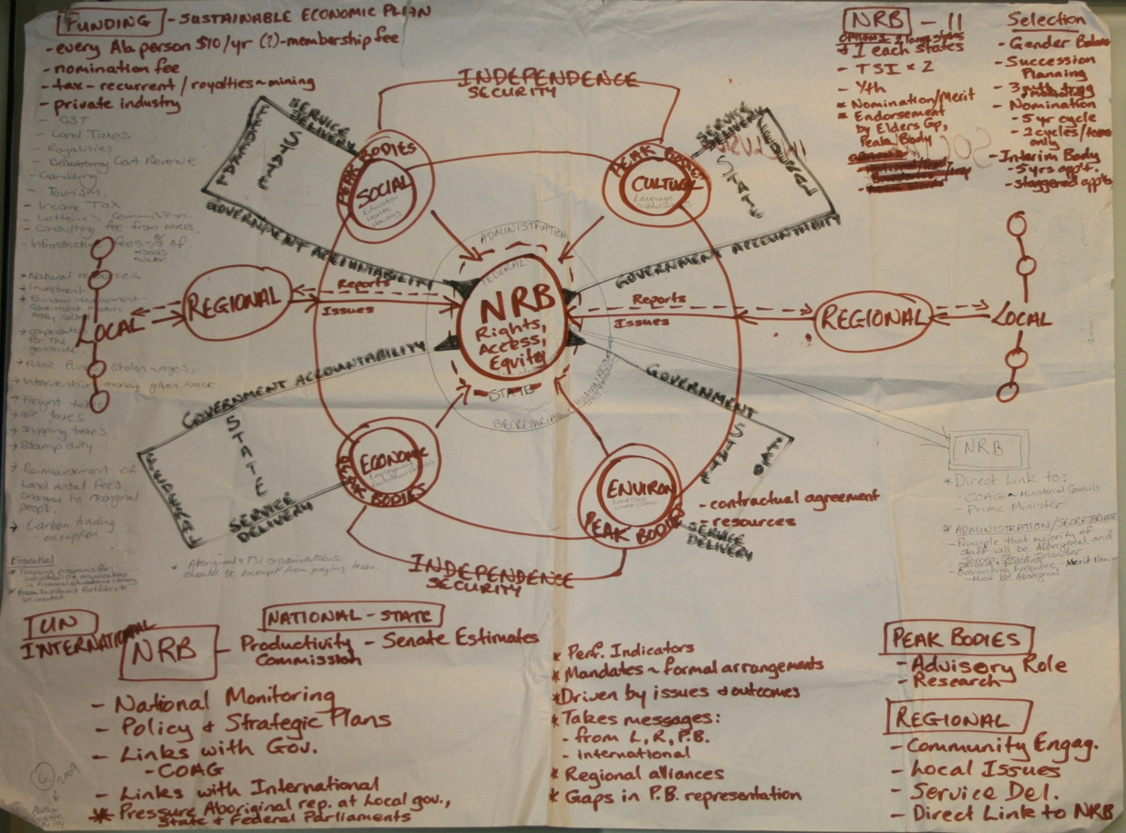

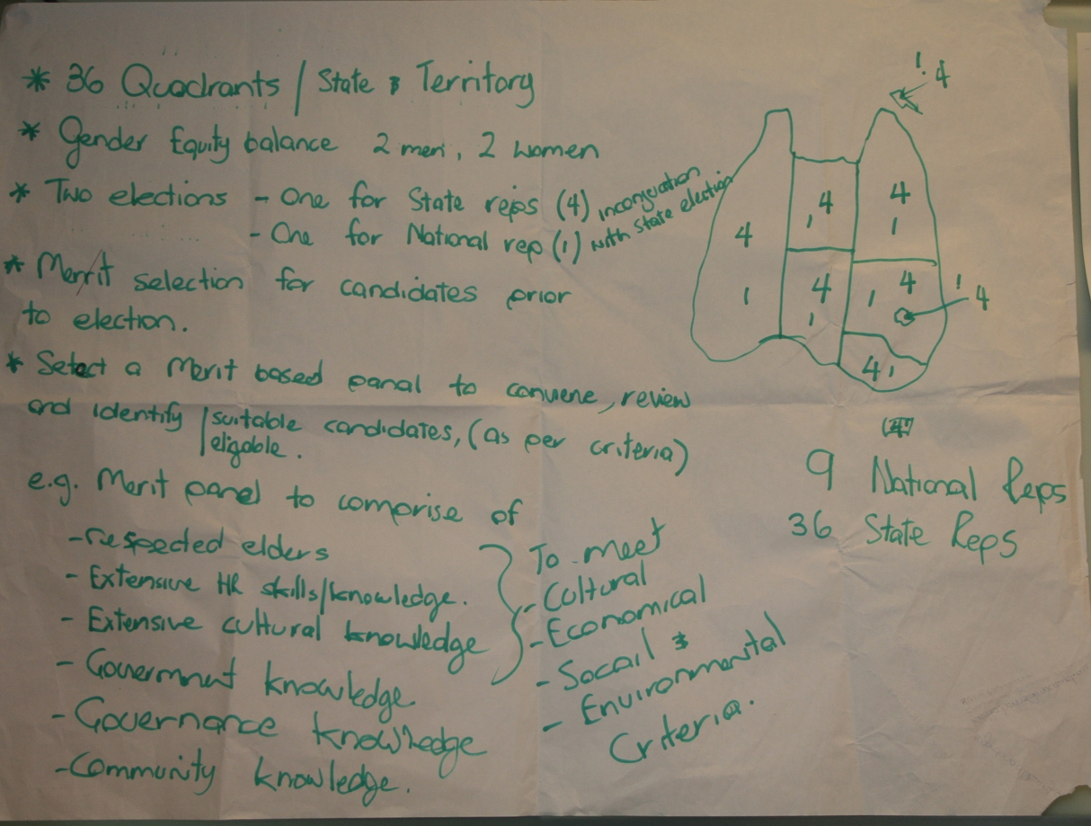

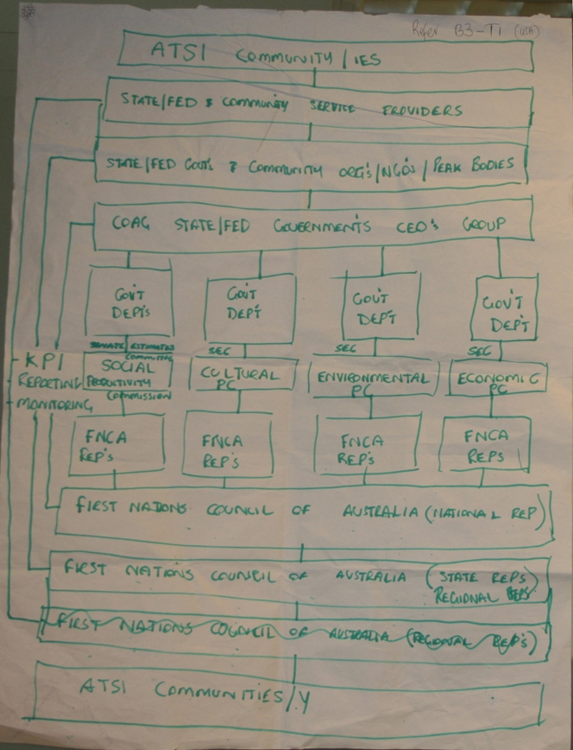

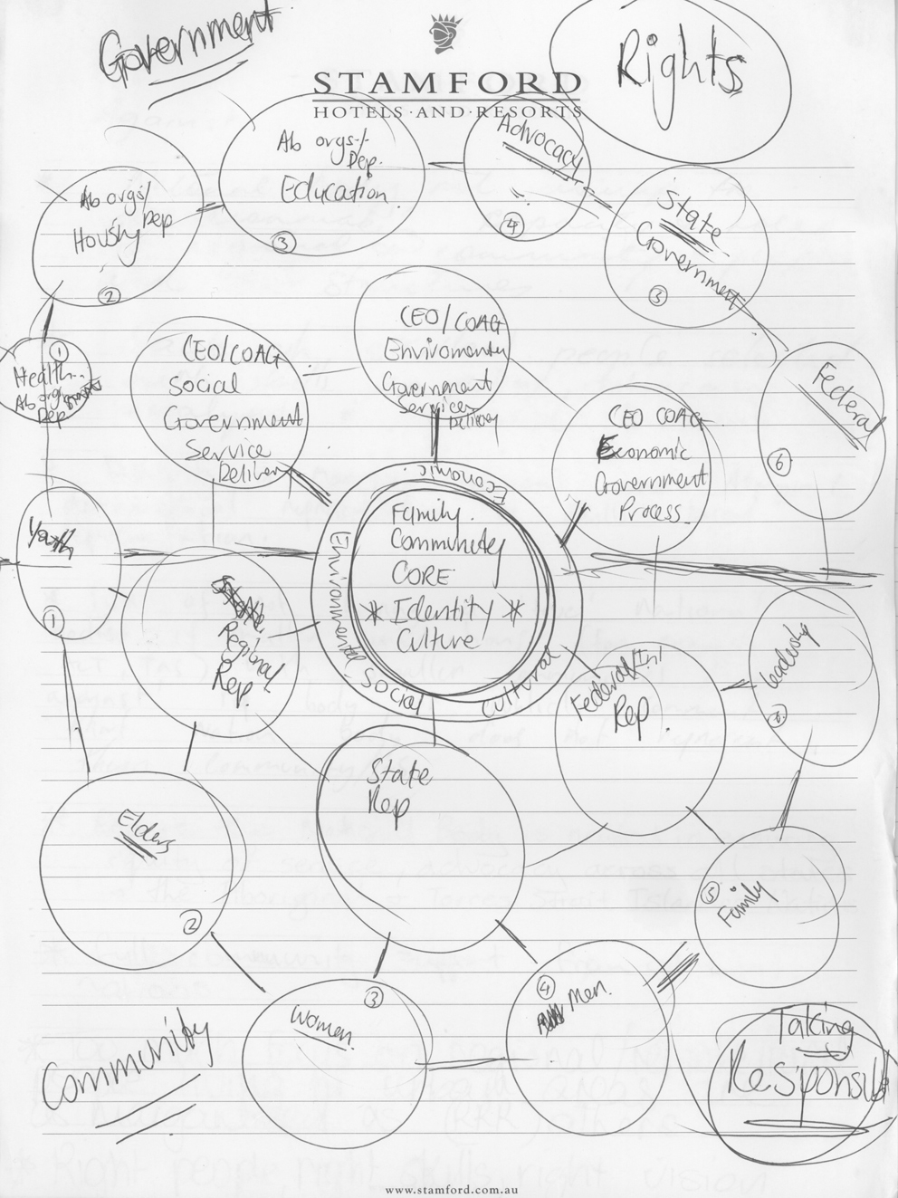

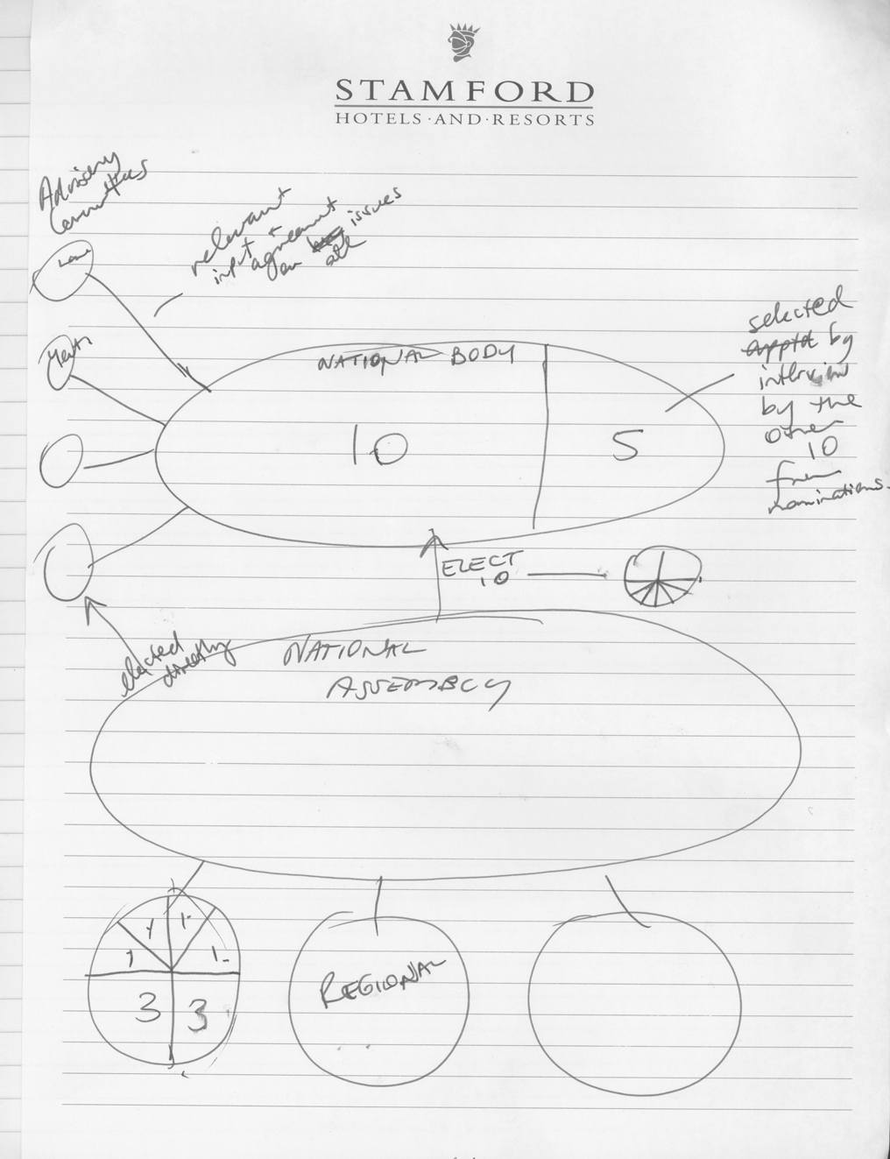

APPENDIX 5 –Responsibilities and Structure of Torres Strait Regional Authority (TSRA)

EXTRACTED from http://www.tsra.gov.au/the-tsra.aspx

The TSRA

The Torres Strait Regional Authority (TSRA) is an Australian Government Statutory Authority established on July 1 1994 under the ATSIC Act 1989, which is today known as the Aboriginal and Torres Strait Islander(ABORIGINAL AND TORRES STRAIT ISLANDER) Act 2005.

The TSRA has the responsibility to:

- Formulate, coordinate and implement programs for Torres Strait Islander and Aboriginal people living within the region;
- Monitor the effectiveness of these programs, including programs conducted by other bodies;
- Advise the Minister for Indigenous Affairs on matters relating to Torres Strait Islander and Aboriginal Affairs in the Torres Strait;
- Recognise and maintain the special and unique Ailan Kastom of the Torres Strait Islander people living in the Torres Strait Region; and
- Undertake activities necessary to perform its function as defined by the Aboriginal and Torres Strait Islander Act 2005 (Cth).

The TSRA Vision

NGALPUN YANGU KAABA WOEYDHAY, A NGALPUN MURUYGAW DANALAGAN MABAYGAL KUNAKAN PALAYK, BATHAYNGAKA (KALA LAGAU YA)
BUAIGIZ KELAR OBAISWERARE, MERBI MIR APUGE MENA OBAKEDI, MUIGE MERBI ARERIBI TONARGE, KO MERBI KEUB KERKEREM (MERIAM MIR)
NGALPAN MOEBAYGAL THOEPOERIWOEYAMOEYN, NGALPAN YA KUDUTHOERAYNU, NGALPAN IGILILMAYPA, SEPA SETHA WARA GOEYGIL SEY BOEY WAGEL (KALA KAWAU YA)
EMPOWERING OUR PEOPLE, IN OUR DECISION, IN OUR CULTURE, FOR OUR FUTURE
TSRA’s Goals

The TSRA aims to improve the lifestyle and wellbeing of the Torres Strait Islander and Aboriginal people living in the Torres Strait region. It aims to achieve this by:

- gaining recognition of our rights, customs and identity as indigenous peoples;
- achieving a better quality of life for all people living in the Torres Strait region;
- developing a sustainable economic base;
- achieving better health and community services;
- ensuring protection of our environment; and
- asserting our native title over the lands and waters of the Torres Strait region.

The TSRA administers Programs to help achieve these goals.

TSRA Structure

The Torres Strait Regional Authority (TSRA) consists of two parts - the elected Board and the Administration.

The TSRA Board

The TSRA Board consists of 20 elected Members who are all Torres Strait Islander or Aboriginal people living in the region. They are elected every four years by their individual communities.

15 of these Members become TSRA Members when they are elected as the Councillor of their Community to the Torres Strait Islands Regional Council and 2 representatives from Bamaga and Seisia, become Members when they are elected as Councillors for their communities to the Northern Peninsula Area Regional Council.
3 Members are elected for the TSRA Wards of Port Kennedy (on Thursday Island), Horn and Prince of Wales Islands, and Tamwoy, Rosehill, Aplin, Waiben and Quarantine (TRAWQ, on Thursday Island).

The Board determines TSRA's policies and budget allocations, and is the political arm of the TSRA.

The TSRA Board currently consists of:

- Mr John Toshie Kris, TSRA Chairperson & Member for St Pauls Community, Moa Island
- Ms Napcia Bin Tahal, Deputy Chairperson & Member for Horn and POW Islands
- Mr Kenny Bedford, Alternate Deputy Chairperson & Member for Erub (Darnley) Island
- Mr Wayne Guivarra, Member for Badu Island
- Mr Reg Williams, Member for Bamaga Communtity
- Mr Donald Banu, Member for Boigu Island
- Mrs Nancy Pearson, Member for Hammond Island
- Mr Willie Lui, Member for Warraber Island
- Mr Ron Day, Member for Mer (Murray) Island
- Mr Jeffrey Aniba, Member for Seisia Community
- Mr Keith Fell, Member for Mabuiag Island
- Mr Raymond Soki, Member for Dauan Island
- Mr Walter Mackie, Member for Iama (Yam) Island
- Mr John Mosby, Member for Masig (Yorke) Island
- Mr Philemon Mosby, Member for Poruma (Coconut) Island
- Mr John Abednego, Member for TRAWQ, Thursday Island
- Mr David Bosun, Member for Kubin Community, Moa Island
- Mr Philip Mills, Member for Port Kennedy, Thursday Island
- Mrs Florianna Bero, Member for Ugar (Stephen) Island
- Mr Ron Enosa, Member for Saibai Island

Board Members may also assume Portfolio responsibilities.

The TSRA Administration

The TSRA Administration is made up of staff who are Australian Government Public Servants. The Administration staff carry out the functions and responsibilities of the TSRA.

The General Manager heads the Administration and is appointed to the position by the Minister for Indigenous Affairs. For a copy of the TSRA Organisational Chart go to: http://www.tsra.gov.au/media/52006/tsra_org_chart08.pdf

APPENDIX 6 – Role & Functions of the ACT Indigenous Elected Body (ACTIEB)

EXTRACTED from: http://www.electedbody.com.au/role.htm

Our Role

The ACT Indigenous Elected Body (ACTIEB) has the following functions:

- to receive, and pass on to the Minister, the views of Aboriginal people and Torres Strait Islanders living in the ACT on issues of concern to them;
- to represent Aboriginal people and Torres Strait Islanders living in the ACT and to act as an advocate for their interests;
- to foster community discussion about
  - issues of concern to Aboriginal people and Torres Strait Islanders living in the ACT; and
  - the functions of ACTIEB; and
  - this Act;
- to conduct regular forums for Aboriginal people and Torres Strait Islanders living in the ACT and report the outcomes of those forums to the Minister;
- to conduct research and community consultation to assist ACTIEB in the exercise of its functions;
- to propose programs and design services for Aboriginal people and Torres Strait Islanders living in the ACT for consideration by the government and its agencies;
- to monitor and report on the effectiveness of programs conducted by government agencies for Aboriginal people and Torres Strait Islanders living in the ACT;
- to monitor and report on the accessibility by Aboriginal people and Torres Strait Islanders living in the ACT to programs and services conducted by government agencies for the general public;
- when asked by the Minister, to give the Minister information or advice about any matter stated by the Minister;
- when asked by a government agency or another person, and in consultation with UNEC, to recommend any reasonable action it considers necessary to protect ATSI cultural material or information considered sacred or significant by Aboriginal people and Torres Strait Islanders living in the ACT;
- any other function given to ACTIEB by the Minister;
- any other function given to ACTIEB under this Act or another territory law

United Nations High Commissioner for Human Rights, Fact sheet No.9 (Rev.1), The Rights of Indigenous Peoples, www.unhchr.ch/html/menu6/2/fs9.htm.
http://www.parliament.uk/about/how/members/standards.cfm.
Adapted from the seven principles of the Nolan Committee Principles of Public Life, http://www.fegovernance.org/nolan_committee.html

