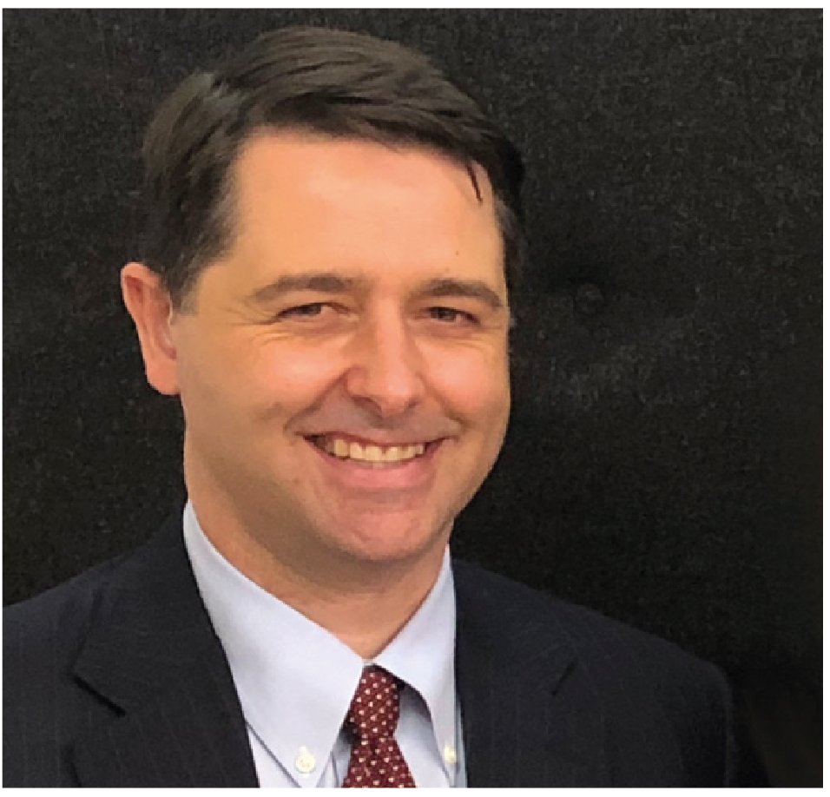 | Alastair McEwin  Disability Discrimination Commissioner  THIRD YEAR OF TERM | ‘It’s my job to promote and protect the rights of people with disability in Australia. I strongly believe that nothing will change unless people with disability are actively involved and represented in decision-making processes that affect them. ‘Nothing about us without us’.’

TERM GOALS
Improve housing accessibility | Improve inclusive education | Increase access to employment | Foster human rights in the National Disability Insurance Scheme | Improve safety and freedom from Violence | Improve disability rights in the criminal Justice System

STRATEGIES
- Developing relationships and collaborations to work with all stakeholders that will advance policy, legislative and practice change to improve the lives of people with disability.
- Advocacy and promotion of human rights for all people with disability underpinned by Australia’s disability discrimination laws and the principles of the United Nations Convention on the Rights of Persons with Disabilities—including rights to participation and choice, to live independently, and to equal treatment and accessibility.
- Undertaking research and analysis, informed by the voice and experiences of people with a disability, to build an evidence base of persuasive consultation materials and reports.

2018 –19 FEATURE PROGRAMS/PROJECTS
Accessible housing project | This project will develop an evidence based national policy position paper with stakeholders. It will outline evidence of the benefits of changes to the building code, the need to mandate a minimum standard of accessibility and advocate for government action to address the shortage of accessible housing.
Employment project | Working with stakeholders and employer/employee groups, this project will develop resources to promote innovative practice in inclusive employment and to increase understanding of rights and responsibilities.
National Disability Insurance Scheme: a human rights charter | Working with governments and Disability Advocacy Organisations, this project will research and deliver a set of principles on disability and human rights to support NDIS practice.
Violence against people with disability in institutional settings project | To increase understanding of the issue this project will finalise and release a research report into this issue and lead promotion and advocacy to encourage Government to implement the recommendations.
Nothing about us, without us leadership and advocacy program | Using consultation and advocacy strategies this work will lead dialogues to increase awareness of human rights issues faced by marginalised groups; specifically children and young people with disability and inclusive education; people with disability in the criminal justice system; and people with disability in rural and remote areas.

