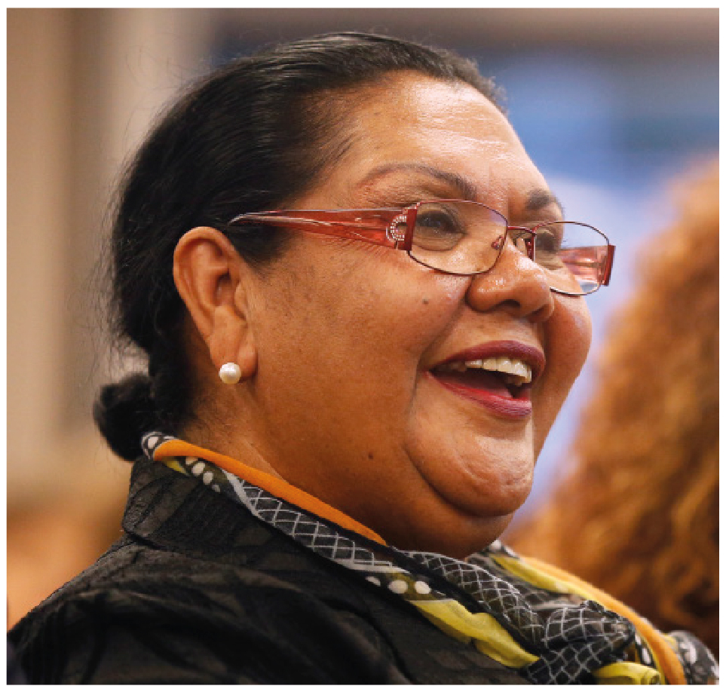 | June Oscar AO  Aboriginal and Torres Strait Islander Social Justice Commissioner  SECOND YEAR OF TERM | ‘As Aboriginal and Torres Strait Islander people we must be unshakable in our resolve to be everything that we are and always have been. When our voice counts, and we are making the decisions on matters that affect us, then our nation and its democratic institutions will reflect our rights and freedom. Our Australia will reflect all of who we are, an inclusive, embracing and equal nation. Imagine our potential then.’

TERM GOALS
Elevate the voice of Aboriginal and Torres Strait Islander women and girls | Reduce Aboriginal and Torres Strait Islander health inequality | Reduce numbers and rates of Aboriginal and Torres Strait Islander incarceration and children in the out of home care system | Progress constitutional reform | Progress the UN Declaration on the Rights of Indigenous Peoples to full effect through a national level coordinated action plan

STRATEGIES
- Applying a human rights based approach to working with Aboriginal and Torres Strait Islander communities that respects: self-determination; participation in decision-making and free, prior and informed consent; non-discrimination and equality; and respect for and protection of culture.
- Empowering communities through participation and strengths-based engagement—gathering, and communicating community voice, content and discussion on key issues.
- Engaging with key organisations and campaigns supporting and advocating for families and enabling children to stay safe and connected to kin and culture, and promoting justice sector reform including justice reinvestment initiatives.
- Engaging internationally to highlight Aboriginal and Torres Strait Islander issues, forge links with other Indigenous representatives, and hold our government to account on Indigenous rights.
- Promoting human rights based, strengths-based and trauma-informed approaches to supporting Aboriginal and Torres Strait Islander people in their communities.
- Co-ordination, leadership and liaison with key bodies to drive constitutional reform.

2018 –19 FEATURE PROGRAMS/PROJECTS
Wiyi Yani U Thangani Women’s Voices Aboriginal and Torres Strait Islander women and girls program | This year’s work continues the consultation phase of the program which is a national conversation with women and girls via community meetings and workshops in over 30 locations across Australia. These events will elevate the voice of Aboriginal and Torres Strait Islander women and girls through the gathering of, analysis and reporting of women and girls’ experiences and aspirations for their lives.
The Close the Gap Campaign  National Health Leadership Forum | This multi-year collaboration is working with Australia’s peak Indigenous and non-Indigenous health bodies, NGOs and human rights organisations to achieve health and life expectation equality for Australia’s Aboriginal and Torres Strait Islander peoples.

