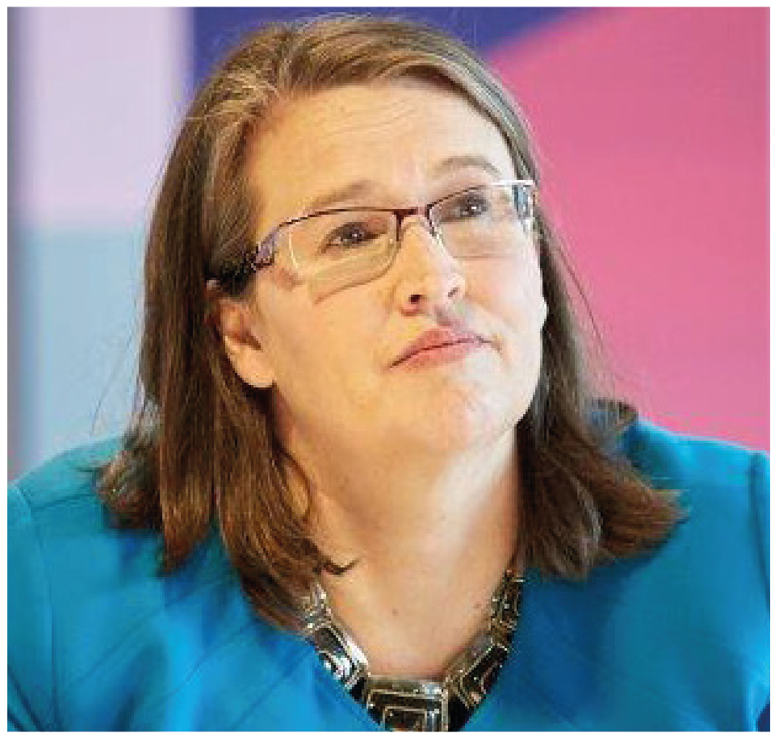 | Kate Jenkins  Sex Discrimination Commissioner  THIRD YEAR OF TERM | ‘I look forward to a day when men and women are accepted into all walks of life and work—from parenting to rocket science—on the basis of who they are and what they do, and not their gender.’

TERM GOALS
Reduce violence against women | Improve women’s economic security and empowerment | Increase diversity in leadership

STRATEGIES
- Challenging everyday sexism and sexual harassment where we live, work, learn and play.
- Promoting broader social equality and addressing structural discrimination and intersectional disadvantage.
- Challenging the structural and attitudinal barriers affecting working parents, including: parental leave, superannuation, flexible work, childcare, and sharing of unpaid work.
- Promoting the benefits of reducing gender-segregated workforces.
- Advocating for improved representation of women and girls in political, corporate, sporting and organisational leadership roles and promoting and facilitating opportunities for women and girls to have their voices heard at a local, national and international level.
- Taking a settings-based approach, focusing on the workplace, education and sport.

2018 –19 FEATURE PROGRAMS/PROJECTS
Violence against women projects | This work includes Australia’s first National Inquiry into sexual harassment in Australian workplaces. The Inquiry builds on data from the fourth national sexual harassment in the workplace survey. Other projects include continued monitoring of the implementation of the Change the course report recommendations by Australian universities.
Inclusion and sport | Projects in this setting include the development of federal guidelines on the inclusion of trans and intersex people in sport; national guidelines for equal opportunity in golf and supporting the work of Play by the Rules, a national collaboration to promote child safety, anti-discrimination and inclusion in sport.
Women’s economic security projects | Projects include developing guidelines for the application of special measures under the Sex Discrimination Act 1984 to advance substantial equality between men and women.
AHRC-ADF Collaboration on Cultural Reform in the Australian Defence Force 2018-2020 | This program engages all three services and the Department of Defence to support the ADF in its cultural reform strategy. Projects include: Navy Marine Warfare Officers project and Navy Clearance Divers project; Army Headquarters culture project; Air Force Indigenous recruitment and retention project and the Inclusive Leadership network project.
International engagement | Independently report on the status of Australian women and girls through a submission to, and appearance before, the UN Committee on the Elimination of Discrimination against Women and attendance at the Commission on the Status of Women, Session 63.

