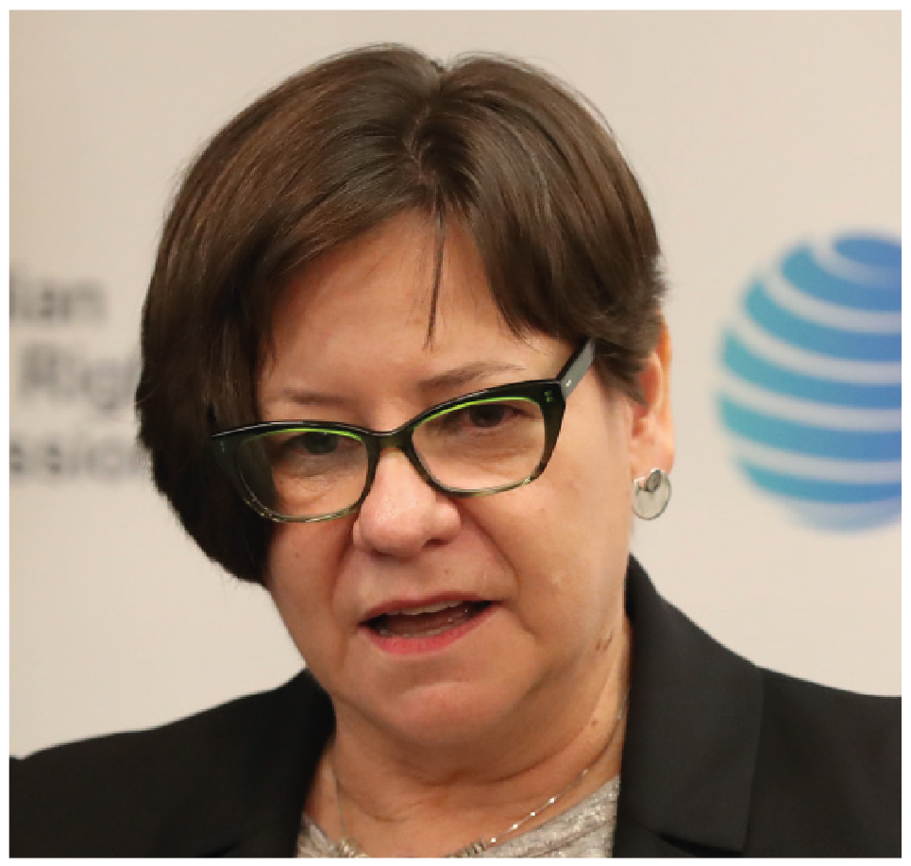 | Megan Mitchell  National Children’s Commissioner  SIXTH YEAR OF TERM | ‘We need to be promoting and strengthening the rights of children as a fundamental preventive measure. Every child deserves the opportunity to thrive in this country, regardless of the circumstances they were born into.’

TERM GOALS
Elevate children’s voices and participation | Ensure safe environments and respect for the rights of the child | Increase safeguards to health and wellbeing of all children in Australia, particularly those who are most vulnerable | Increase children’s civic engagement and active citizenship through education and awareness-raising | Track Australia’s commitments to protect the wellbeing and rights of children

STRATEGIES
- Promoting discussion and awareness of matters relating to the human rights of children in Australia.
- Undertaking research, or educational or other programs, for the purpose of promoting respect for children’s rights in Australia, and promoting the enjoyment and exercise of human rights by children in Australia.
- Examining existing and proposed Commonwealth enactments to assess whether they recognise and protect the human rights of children in Australia, and to report to the Minister the results of any such examination.
- Giving particular attention to children who are at risk or vulnerable, and consult with children where appropriate.

2018 –19 FEATURE PROGRAMS/PROJECTS
Children’s Rights Report 2018 | This year’s statutory report will be a ‘state of the nation’ review on the enjoyment and exercise of human rights by children and young people in Australia today. Sourcing of available data, research, stakeholder roundtables, consultations and workshops with children and a poll of children’s views will be used as the basis of the report and a benchmark for future reviews. A child friendly version of the report, an educational video on children’s rights and updates, using the latest national data, on the 2014 Children’s Rights Report on suicide and self-harm and the 2015 Children’s Rights Report on family and domestic violence will also be developed.
Report to the UN Committee on the Rights of the Child 2018 project | The content of the ‘state of the nation’ report will be used as the basis for reporting to the UN Committee on the Rights of the Child regarding Australia’s progress in meeting its child rights obligations. This written report and appearance before the Committee are scheduled for 2018–19.
Child Safe Organisations program | The Commissioner has led the development of the National Principles for Child Safe Organisations. This work has been commissioned by the Australian Government, with consultation from the states and territories and national sector peak bodies and advocacy groups. The program is building on the recommendations of the Royal Commission into Institutional Responses to Child Sexual Abuse and will submit the National Statement of Principles for Child Safe Organisations to the Council of Australian Governments for endorsement. A suite of resources, training and communication strategy will support implementation of the principles by organisations across Australia.

