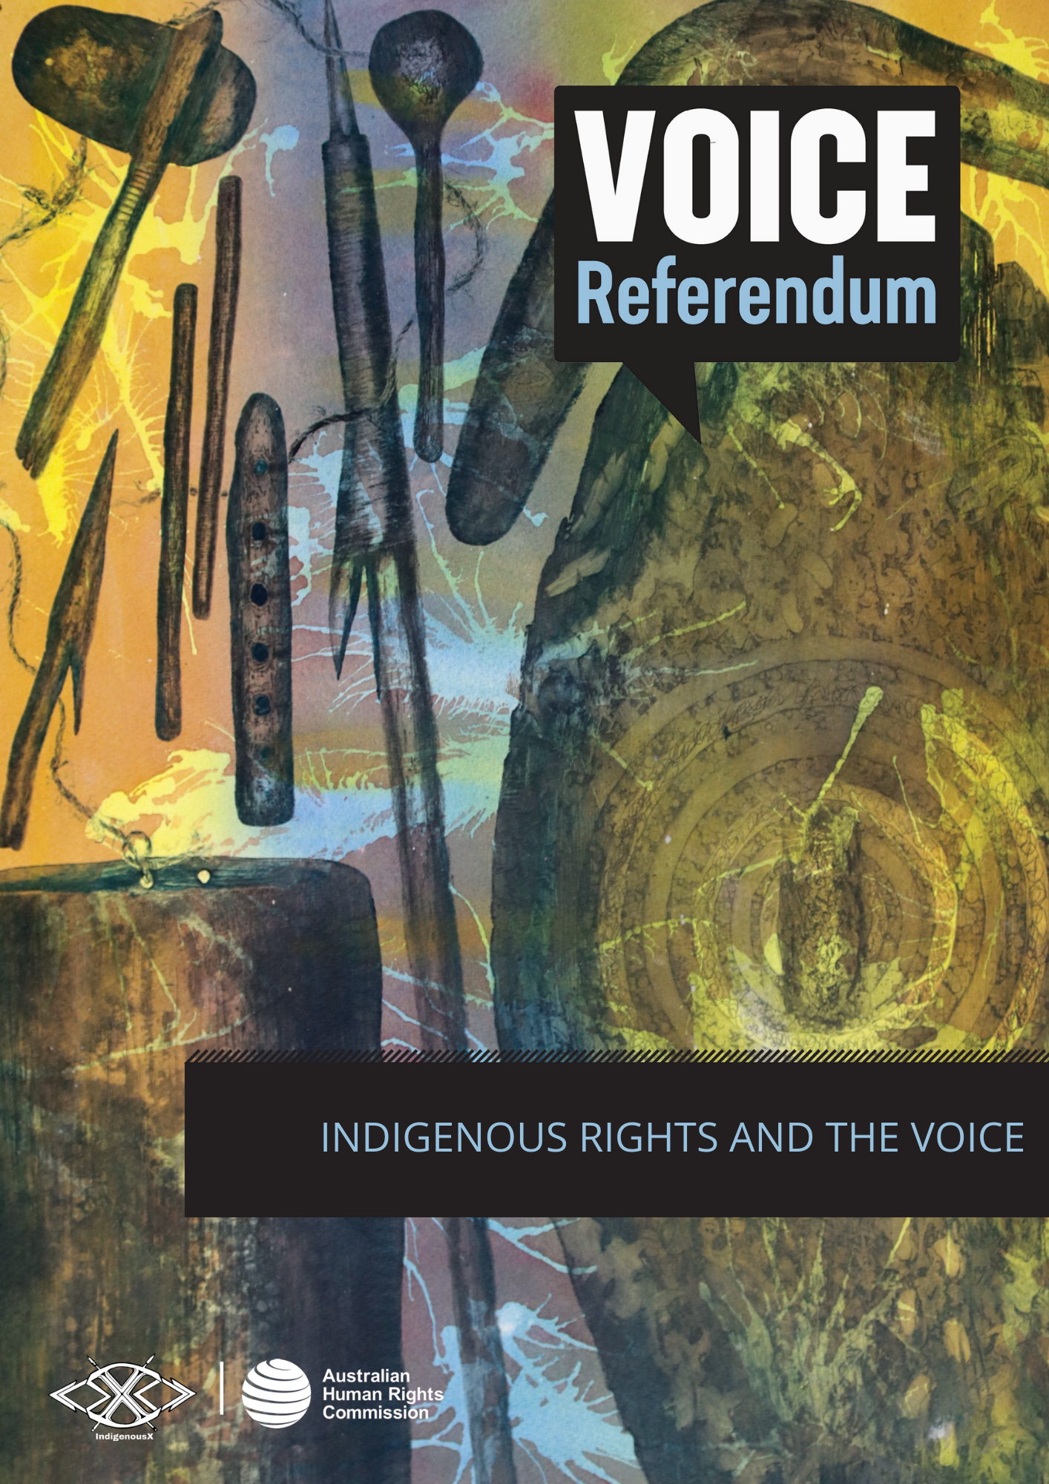

INDIGENOUS RIGHTS AND THE VOICE

What are Indigenous rights?
Indigenous peoples around the world have unique rights as the Traditional Owners and original Custodians of lands that have been colonised.
These individual and collective Indigenous rights are set out in the United Nations Declaration on the Rights of Indigenous Peoples (UNDRIP). UNDRIP establishes a universal framework of minimum standards for the survival, dignity and well-being of Indigenous peoples around the world.
UNDRIP sets out how universal human rights and fundamental freedoms apply to the distinct experiences of Indigenous peoples across the world. It includes the rights of Indigenous peoples to:
- Self-determination: the right to shape their own lives, including their economic, social, cultural, and political futures (Article 3). This is a central right of UNDRIP, and all other Indigenous rights in the Declaration help to achieve self-determination. Learn more about this in the ‘self-determination and Indigenous peoples’ section of the Voice referendum resource kit.
- Autonomy and self-government: the right to decide how to develop politically, economically, and socially (Article 4).
- Indigenous decision-making institutions: the right to maintain and strengthen their distinct political, legal, economic, social, and cultural institutions (Article 5).
- Culture: the right to practise and revitalise their cultural traditions and customs, including to maintain, protect and develop the past, present and future manifestations of their cultures (Article 11).
- Language: the right to establish and control their educational systems and institutions providing education in their own languages, in a manner appropriate to their cultural methods of teaching and learning (Article 14).
- Participation and representation: the right to participate in decision-making in matters that affect their rights, and through representatives they choose (Article 18).
- Consultation with government: the right to be consulted through their own representative institutions in order to obtain their free, prior and informed consent before adopting and implementing legislative or administrative measures that may affect them (Article 19).
- Determining future priorities: the right to be actively involved in developing and determining health, housing and other economic and social programs affecting them (Article 23).
- Land: the right to legal recognition and protection of the lands, territories, waters, coastal seas, and resources that they have traditionally owned or occupied (Article 26).
UNDRIP specifically requires that Governments around the world ‘in consultation and cooperation with Indigenous peoples, shall take the appropriate measures, including legislative measures, to achieve the ends of this Declaration’. Australia endorsed UNDRIP in 2009.

While Australia has long acknowledged the importance of Indigenous rights both in Australia and in international processes, our national government has not yet put in place legal protections for all of the Indigenous rights referred to in the UNDRIP and has therefore not yet fully implemented the requirements of the Declaration.

The 2023 referendum is asking the Australian people whether they agree to establishing an Indigenous Voice to Parliament as a potential way to make these rights a reality.

Please see the Commission’s community guide to UNDRIP.

How are Indigenous rights different from human rights for everyone?

Everyone is entitled to the full realisation and protection of human rights as set out in international human rights treaties. This applies to Indigenous peoples and non-Indigenous people alike. Foundational among these human rights principles, and captured in Article 7 of the Universal Declaration of Human Rights, is the right to be treated equally before the law and to non-discrimination.

While this may sound simple, ensuring that people are treated equally has proven a challenge the world over.

For this reason, many governments in the world have also agreed to human rights treaties for particular groups of people that set out how universal human rights standards apply to them. This is to ensure that everyone can fully enjoy their human rights – as women, as children, on the basis of their race, as persons with disability and as Indigenous peoples, for example.

Human rights principles that relate to Indigenous peoples (or Indigenous rights) set out minimum standards to ensure that Indigenous peoples can equally enjoy human rights alongside everyone else.

History shows that Indigenous peoples around the world have not equally enjoyed human rights. The UNDRIP acknowledges that recognising the distinct cultural characteristics of Indigenous peoples and the impact of their historical treatment is critical if we are to achieve equal enjoyment of human rights between Indigenous and non-Indigenous peoples.

Indigenous rights are not additional or special rights for Indigenous peoples. Instead, they show what factors should be recognised so that universal human rights standards can be fully realised for Indigenous peoples. As an example, UNDRIP sets out the importance of recognising Indigenous cultures and languages so that Indigenous peoples can equally enjoy the right to education.

What is the Indigenous Voice to Parliament?
The Indigenous Voice to Parliament is a proposal within the Uluru Statement from the Heart, an invitation shared with the Australian people in 2017. The Statement calls for three key pillars of significant substantive reform to help realise Indigenous rights: Voice, Treaty, and Truth.
The Statement’s first call to action is for a constitutionally enshrined Indigenous Voice to Parliament, to give Aboriginal and Torres Strait Islander peoples a say on laws and policies that affect them. Learn about the significance of constitutional change in the ‘referendums and constitutional recognition’ section of the Voice referendum resource kit.
The Voice referendum is seeking substantive reform by guaranteeing First Nations recognition in the Constitution, through a mechanism for participation. If the referendum is successful, the Voice will be able to make representations and provide advice to Parliament and the Executive on matters that affect Aboriginal and Torres Strait Islander peoples. As a representative structure, the Voice could also enable informed decision-making through the lived experience and expertise of Indigenous peoples across Australia.
Read the Uluru Statement from the Heart in full.

How could the Voice to Parliament support the realisation of Indigenous rights?
Central to the achievement of all human rights for Indigenous peoples is the right to participate in decisions that affect them, and to be represented by their own freely chosen representatives (Article 18 UNDRIP).
Through UNDRIP, governments have committed to consult and cooperate in good faith with Indigenous peoples through their own representative institutions before adopting laws or decisions that affect them (Article 19 UNDRIP).
The Voice proposes a mechanism that addresses both of these elements – a process for Indigenous peoples’ participation in decision making, and a mechanism for governments to consult with Indigenous peoples.
Enshrining the Voice in the Australian Constitution makes the Voice an ongoing mechanism for this participation and consultation.
Some opposition to the Voice proposal has related to its inclusion in the Constitution, and a view that an Indigenous representative mechanism does not need to be constitutionally enshrined.
Those who support the Uluru Statement have stated that including a Voice in the Constitution would prevent this Indigenous representative structure from being disbanded by government, as has occurred in the past.
The Voice could also promote the realisation of other human rights for Indigenous peoples, including to ensure the full realisation of rights to health, education, housing and the protection of Indigenous cultures.

How do other countries acknowledge Indigenous rights?
Other countries that have been colonised use First Nations representative mechanisms to support the realisation of Indigenous rights, as defined by UNDRIP.
Constitutional recognition of Indigenous peoples internationally occurs in a variety of ways, including the protection and promotion of Indigenous cultures, land titles and political representation. For example:
- In Aotearoa/New Zealand, Te Tiriti o Waitangi (the Treaty of Waitangi) recognises Māori sovereignty, and was signed by Māori Chiefs and the British Crown in 1840. While the Treaty itself is not enshrined in legislation, its principles have been given legal recognition through a series of court cases and legislative measures, such as the 1975 Treaty of Waitangi Act, which established the Waitangi Tribunal. The 1867 Māori Representation Act guaranteed Māori seats in Parliament that are separate from the general electoral system and are reserved exclusively for Māori representation. Representatives are elected by Māori voters to sit alongside other MPs in the New Zealand Parliament. Further, the 2002 Local Government Act requires councils to consult with Māori on issues that may affect their rights and interests. This consultation process allows for meaningful participation and input from Māori in policy and decision-making, particularly regarding resource management, cultural heritage, and land rights.

- In Norway, the Sámi Parliament was established through a 1987 amendment to the Constitution – the Sámi Act – as a representative body to enable Indigenous Sámi people to actively participate in political decision-making. The Sámi Parliament has 39 members who are elected every four years by Sámi voters in Norway. The Sámi Parliament has the power to make recommendations on issues affecting the Sámi people, including cultural preservation, land rights, and natural resource management. Norway has also implemented co-management arrangements which ensure Sámi perspectives and traditional knowledge are considered in decision-making related to natural resources and protected areas.

- Bolivia was the first country in the world to incorporate UNDRIP into domestic law and later, its Constitution. The Constitution, adopted in 2009, goes further than any previous legislation in Bolivia in securing rights and freedoms for the nation’s Indigenous peoples. Article 30 of the Constitution establishes the right to participation and prior consultation for Indigenous peoples in decisions that may affect their territories, natural resources, or cultural heritage. The Bolivian Plurinational Legislative Assembly, established in 2009, includes seven reserved seats for Indigenous people, who are elected by Indigenous customary law (usos y constumbres). This mechanism ensures that Indigenous peoples have a direct say in the country’s political decision-making processes.
The referendum question wording states that the Voice ‘may make representations’ to the Parliament and Executive Government. Since there is no legal requirement that the government must listen to, or act on, what it is advised by the Voice, the proposal is more limited in scope when compared to international examples of Indigenous participation in decision-making.
The principles of the Voice include that its members will be ’selected by Aboriginal and Torres Strait Islander communities, not appointed by the Executive Government’. This is similar to examples of Indigenous representation in Aotearoa/New Zealand, Norway and Bolivia, where Indigenous peoples elect their own representatives.
In contrast to international examples, the proposal for the Indigenous Voice to Parliament is not seeking a separate, parallel Indigenous parliament or representation in the Australian Parliament. Rather, it is a proposal for a representative mechanism that can provide recommendations to Parliament on issues that affect Indigenous peoples and communities.

Learn more about international examples of Indigenous representation
Examples detailed in the section above are included for reference, not as an endorsement of any particular model, including that which is currently proposed in Australia.
If you are interested to learn more about the international examples, and associated issues, we encourage you to explore the further reading list in the appendix at the end of the Voice referendum resource kit.

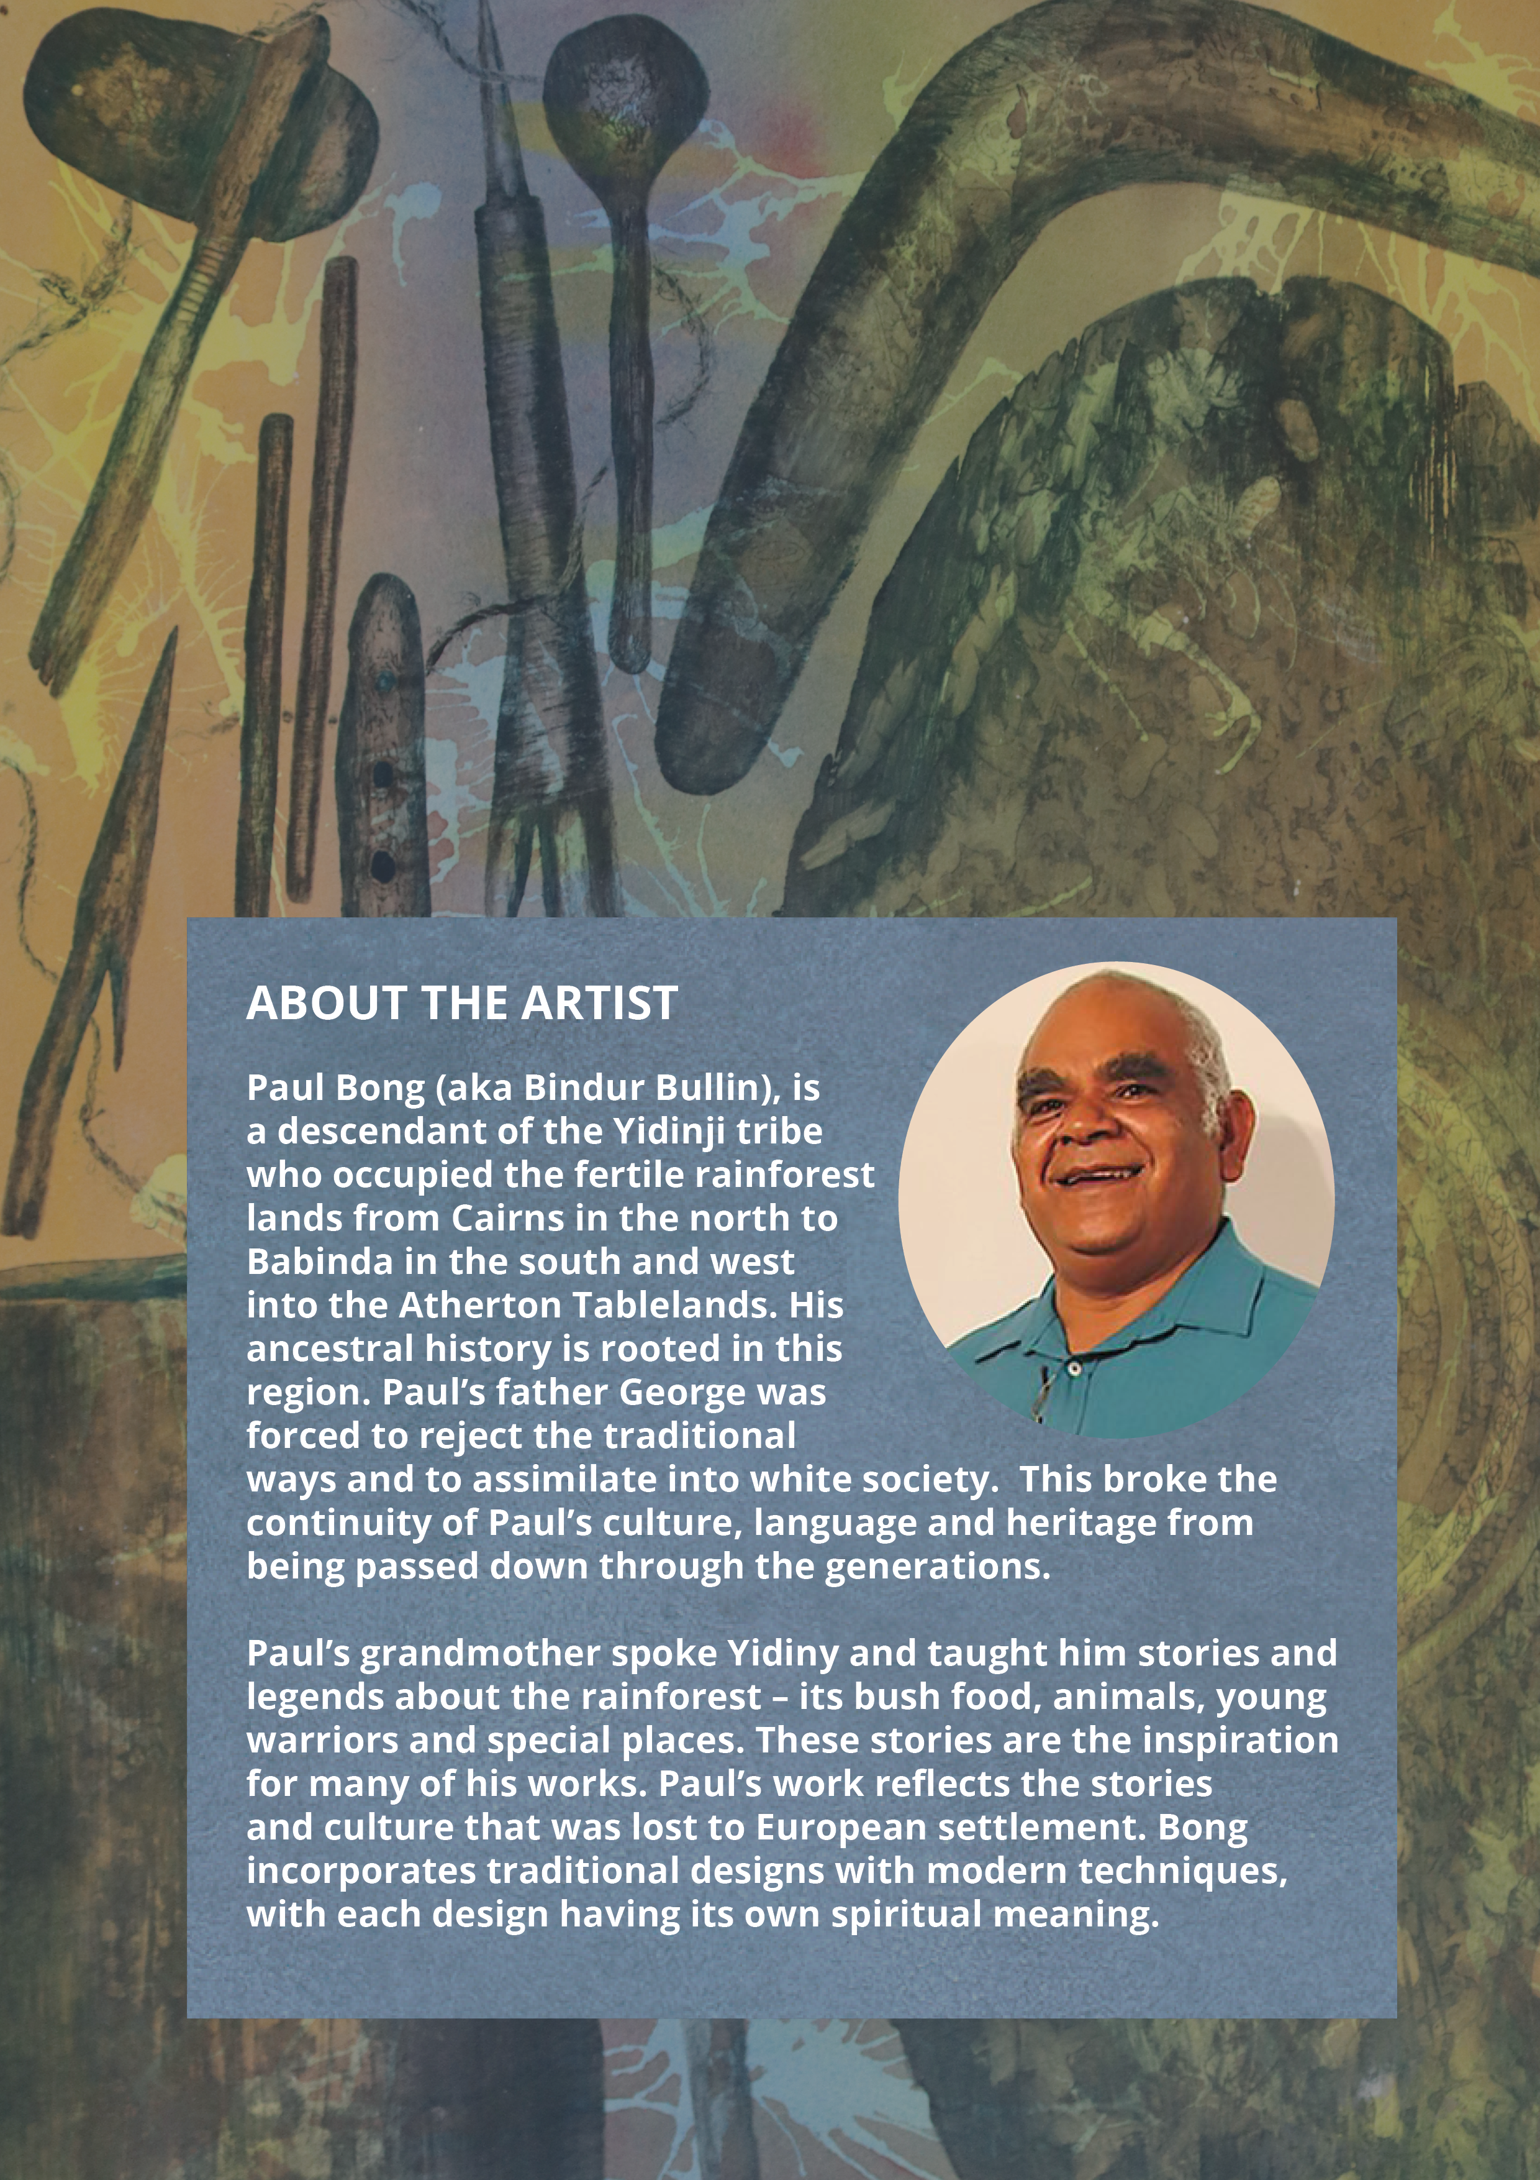

United Nations Declaration on the Rights of Indigenous Peoples, GA Res 61/295, UN GAOR, 61st sess, 107th plen mtg, Agenda Item 68, Supp No 49, UN Doc A/RES/61/295 (2 October 2007).
José Martínez Cobo, ‘Study of the Problem of Discrimination Against Indigenous Populations’ (1981) (Web Page 2023).
The New Zealand Wars, ‘The Treaty of Waitangi’ (Web Page 2023).
Waitangi Tribunal, ‘About the Waitangi Tribunal’ (Web Page 2023).
New Zealand History, ‘Māori and the vote’ (Web Page 2023).
New Zealand Legislation, ‘Local Government Act 2002’, (Web Page 2023).
Government of Norway/Regjeringen, ‘The Sámi Act’ (Web Page 2023).
Sámediggi, ‘About the Sámi Parliament’ (Web Page 2023).
Gunn Elin Fedreheim and Esther Blanco, ‘Co-management of protected areas to alleviate conservation conflicts: experiences in Norway’ (2017) 11(2) International Journal of the Commons 754 (Web Page 2023).
Roberta Rice, UNDRIP and the 2009 Bolivian Constitution: Lessons for Canada (The Internationalization of Indigenous rights: UNDRIP in the Canadian Context, Centre for International Governance Innovation, January 2014) 59-64 (Web Page 2023).
Constitución Política del Estado [Constitution] (Bolivia) 2009 [tr Constitute Project] (Web Page 2023).

