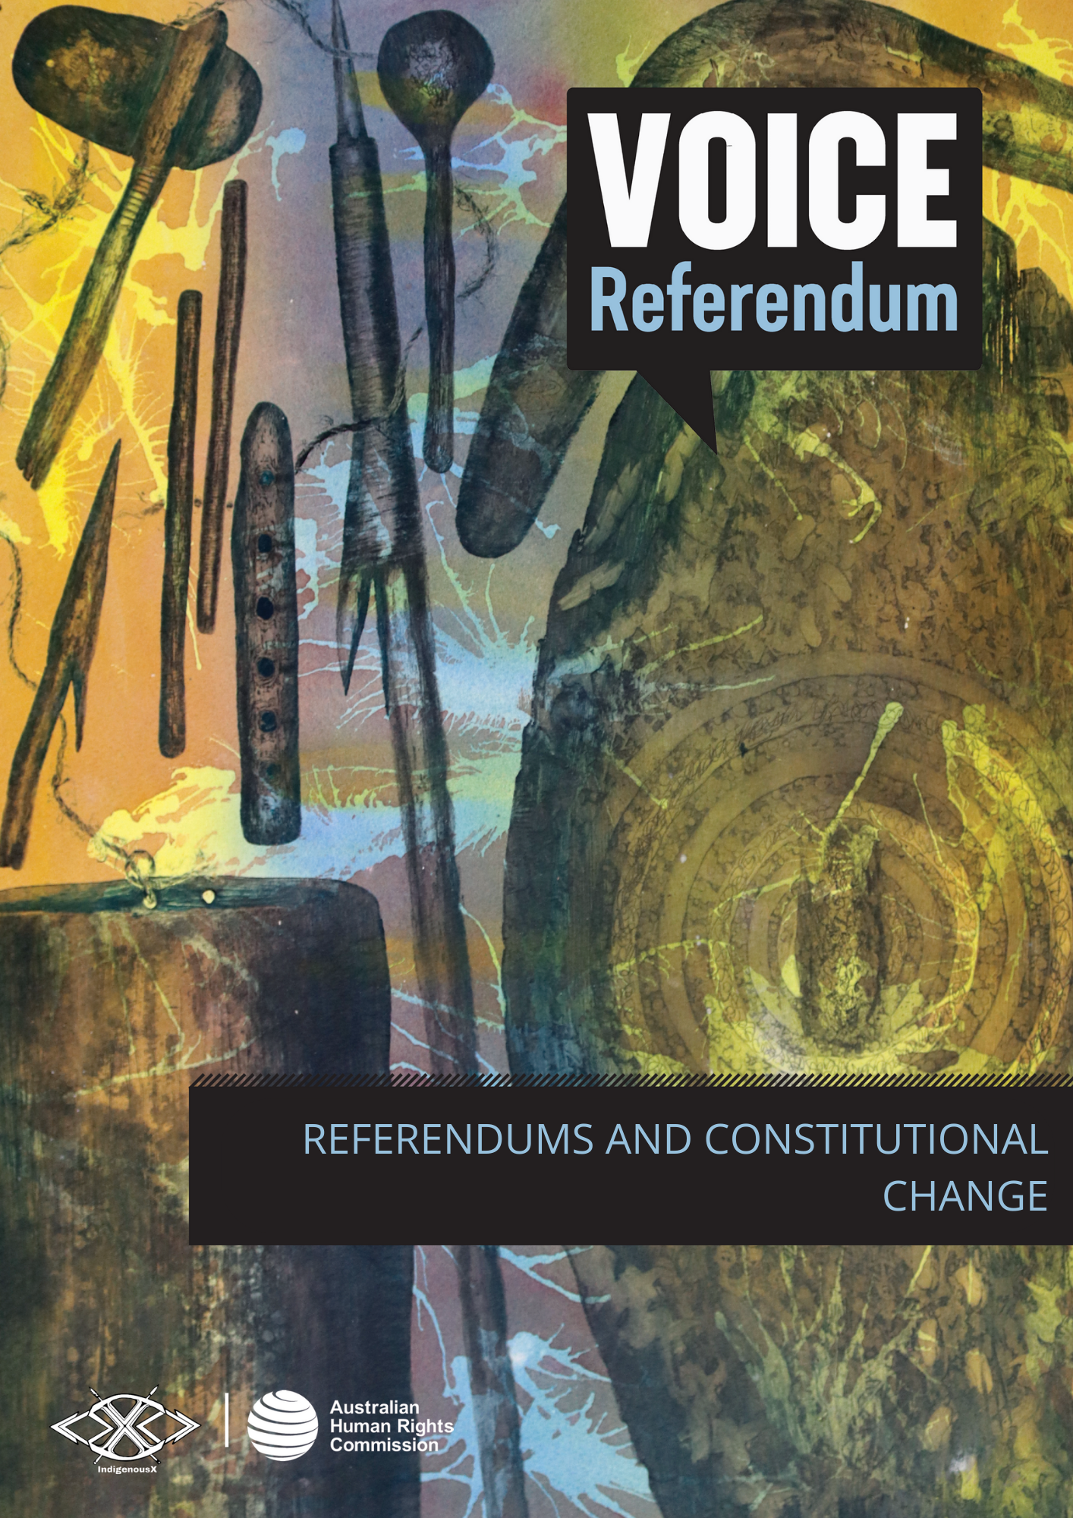

REFERENDUMS AND CONSTITUTIONAL CHANGE

Why is Australia holding a referendum in 2023?
The Australian Electoral Commission (AEC) will hold a referendum in late 2023. The referendum will ask Australians whether the Constitution should be changed to include a recognition of the First Peoples of Australia by establishing an Aboriginal and Torres Strait Islander Voice.
Calls for the Voice were primarily shared with the Australian people via the Uluru Statement from the Heart. The Statement seeks substantive reform through a constitutionally enshrined First Nations Voice to Parliament, and a Makarrata Commission to oversee the process of treaty-making and truth-telling. The Statement was released in 2017.

What will the referendum ask us?
When voting in the referendum, you will be asked to write ‘yes’ or ‘no’ to the following question:
A Proposed Law: to alter the Constitution to recognise the First Peoples of Australia by establishing an Aboriginal and Torres Strait Islander Voice. Do you approve of this proposed alteration?

The referendum proposes to add a new ‘Chapter IX – Recognition of Aboriginal and Torres Strait Islander Peoples’ to the end of the Constitution. The proposed wording of the amendment is:
In recognition of Aboriginal and Torres Strait Islander peoples as the First Peoples of Australia:
- there shall be a body, to be called the Aboriginal and Torres Strait Islander Voice;
- the Aboriginal and Torres Strait Islander Voice may make representations to the Parliament and the Executive Government of the Commonwealth on matters relating to Aboriginal and Torres Strait Islander peoples;
- the Parliament shall, subject to this Constitution, have power to make laws with respect to matters relating to the Aboriginal and Torres Strait Islander Voice, including its composition, functions, powers and procedures.

What is the Constitution and why is it important?
The Australian Constitution is a legal document that establishes the key institutions of government and sets out how Australia is governed. The unique status of the Constitution means that it can’t be changed by the Parliament of the day. While it enables Parliament to make laws (legislation), the Constitution itself can only be changed through a vote of the people – a referendum.
To become law, the proposed change to the Constitution must be approved by a ‘double majority’ of electors voting for the changes. This means a national majority of voters (more than 50%) from all states and territories, as well as a majority of voters (more than 50%) in a majority of states (at least four of the six states). The Australian Electoral Commission’s double majority fact sheet has more information.

Have we ever had a referendum before?
Yes, Australia has had a total of 44 nation-wide referendums since 1901, some of which have been held at the same time with a number of different questions being asked. Eight of these have been successful.
Example of previous successful referendums are listed on the Australian Electoral Commission’s website.

What is the significance of constitutional change?
The Uluru Statement from the Heart calls for the Voice to be constitutionally enshrined. To do so requires a referendum.
There is a key difference between a Voice that is constitutionally enshrined and one that is not. If enshrined in the Constitution, the Voice could not be abolished by government without holding another referendum to ask whether this is what the Australian people want. By contrast, if the Voice was established by legislation, it could be disbanded by repealing that legislation. For many, this is an important distinction, given the significant number of national Indigenous representative bodies that have been disbanded by previous governments.
Changing the Australian Constitution also has profound symbolic value. In the words of Aboriginal and Torres Strait Islander Social Justice Commissioner June Oscar AO, ‘the Constitution has maintained Australia’s greatest foundation myth, that our First Nations occupation of these lands pre-colonisation meant nothing and our existence had no bearing or consequence on the formulation of the Commonwealth’. The referendum provides an opportunity to formally recognise Aboriginal and Torres Strait Islander peoples as the First Peoples of these lands, through substantive reform to the Constitution.

What is my role in the referendum?
All Australian citizens aged 18 years and over are required by law to vote in the referendum. The Australian Human Rights Commission encourages voters to learn more about and reflect on human rights principles as they relate to the referendum and the proposed Voice to Parliament. More information about this is available in the following resources: Indigenous rights and the Voice, self-determination and Indigenous peoples, and the Voice and human rights.

Where can I find out more?
Information from the Australian Electoral Commission regarding the referendum.
Disinformation awareness fact sheet from the Australian Electoral Commission.

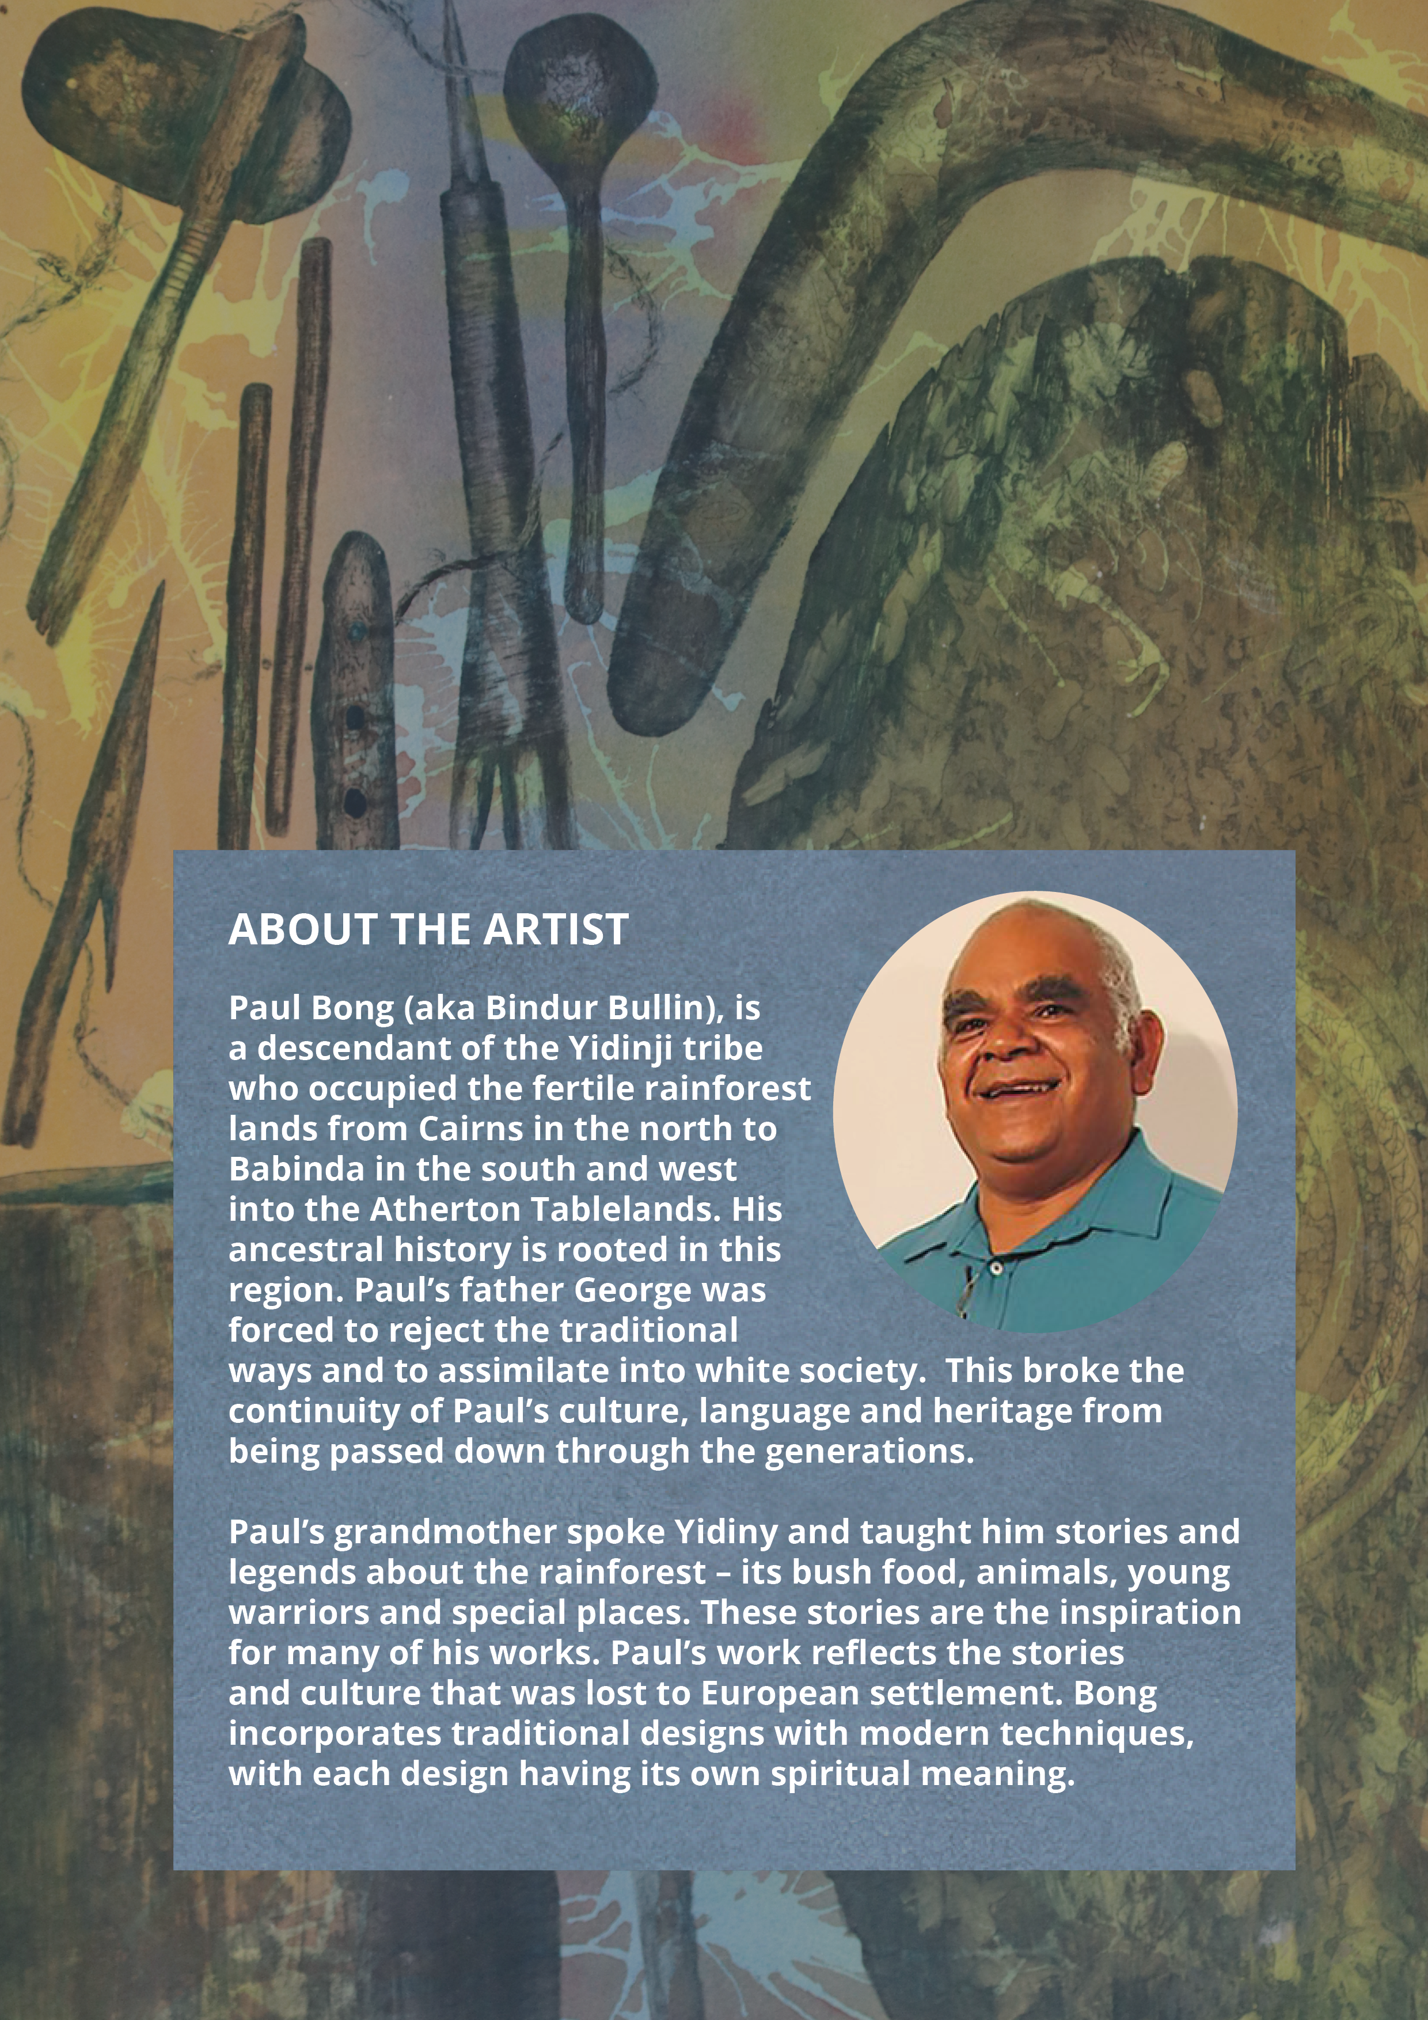

‘The Uluru Statement from the Heart’, The Voice (Web Page, 2023).
‘Understanding the Constitution’, The Australian Electoral Commission (Web Page, 2023).
‘Voice: A History of Representation’, ANTAR, Background report (Web Page 2023).
June Oscar AO, ‘Sir Wallce Kyle Oration’ (Speech, 22 August 2022).

