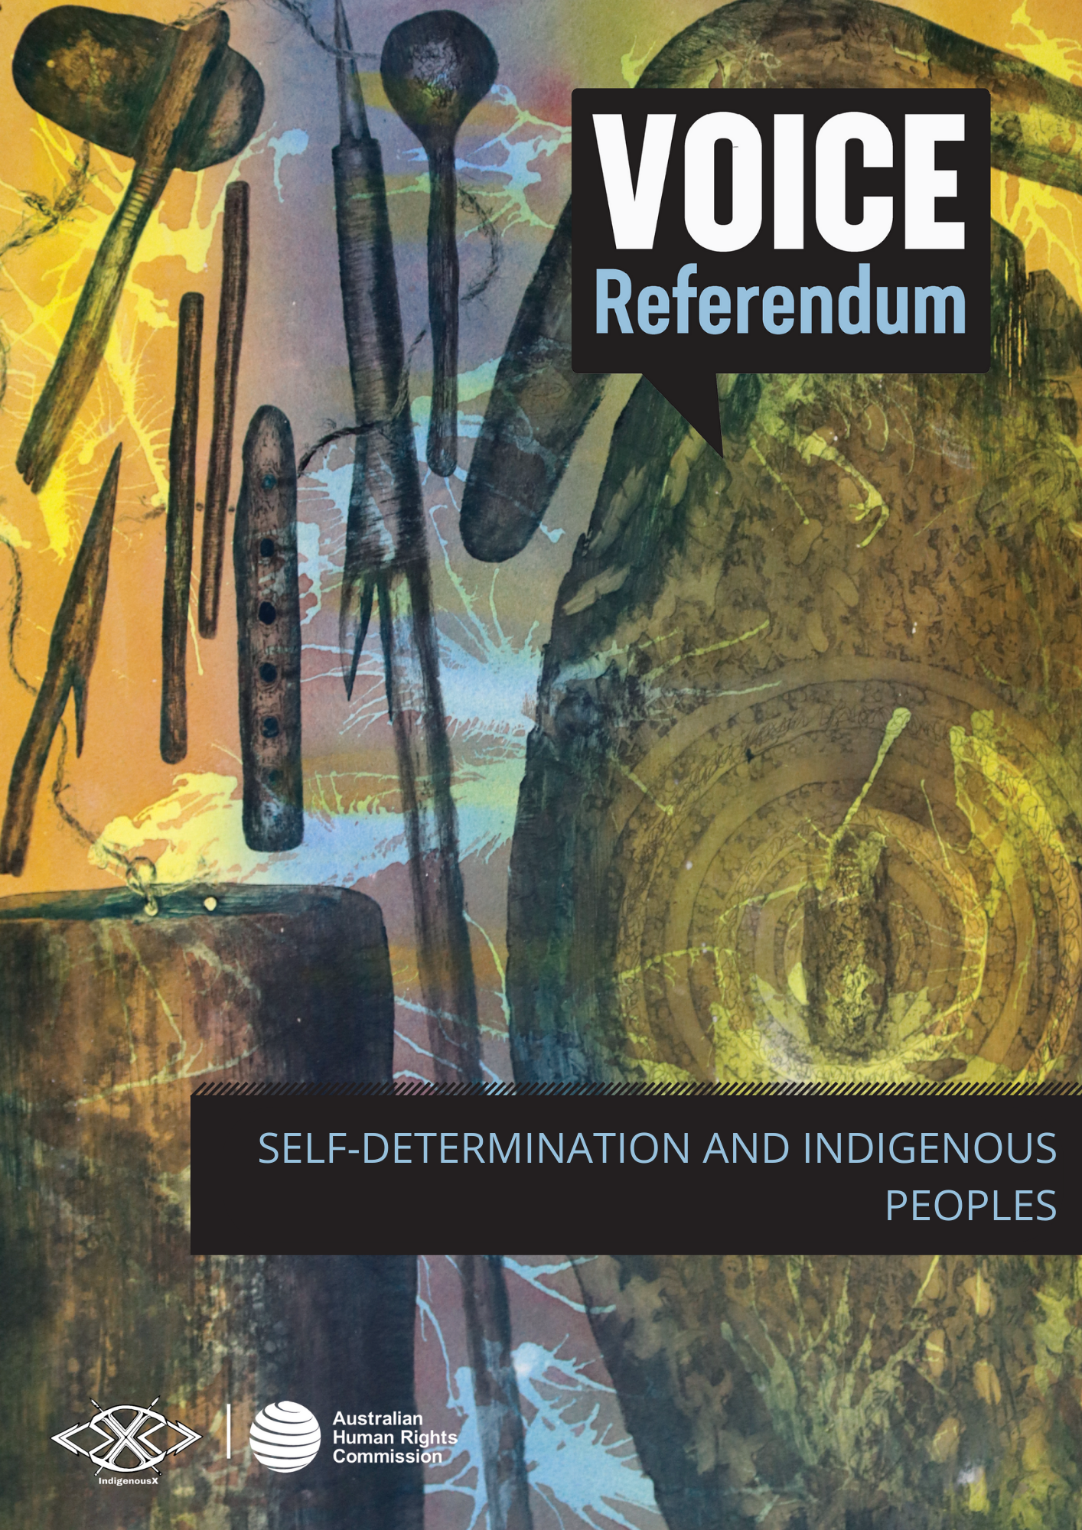

SELF-DETERMINATION AND
INDIGENOUS PEOPLES

What is self-determination?
Self-determination is an ongoing process of ensuring that peoples are able to make decisions about matters that affect their lives. Essential to the exercise of self-determination is choice, participation and control.

It is the right of peoples to freely determine their political status and economic, social and cultural development. The outcomes of self-determining processes must correspond to the free and voluntary choice of the people concerned.

The right to self-determination is enshrined in international law under Article 1 of the International Covenant on Civil and Political Rights as well as the International Covenant on Economic, Social and Cultural Rights.

While many traditional human rights are concerned with individual members of a society, self-determination is a collective right exercised by ‘peoples’.

Articles 3 and 4 of the United Nations Declaration on the Rights of Indigenous Peoples (UNDRIP) confirms that Indigenous peoples have the right to self-determination under international law.

This means Australia is obliged to ensure that Indigenous peoples have a say about their social, political, cultural, and economic needs. It requires official recognition of Indigenous nations’ and peoples’ representatives and institutions.

The right of Indigenous peoples to self-determination recognises long-held traditions of ‘independent decision-making, self-government, and institutional self-reliance’. This includes Aboriginal and Torres Strait Islander peoples, who practised self-determination and self-government for tens of thousands of years before colonisation began.

Does self-determination of Indigenous peoples undermine the existence of nation states?

No. Indigenous self-determination does not undermine the existence of nation states. Article 46 of UNDRIP states that nothing in the Declaration should impair the ‘territorial integrity or political unity’ of countries – Australia included.

Would the Indigenous Voice to Parliament enable self-determination?
The proposed Indigenous Voice to Parliament would create a dedicated mechanism for the First Peoples of Australia to have a say in policy and legislation that affects their daily lives. It could provide a means for exercising the right to self-determination. In order for the Voice to be consistent with the right to self-determination, it would need to be truly representative and accepted as such by Indigenous peoples.

Why is self-determination important for Aboriginal and Torres Strait Islander communities in Australia?

Self-determination is intrinsically linked to all other Indigenous rights. Australia cannot meet the minimum standards for the survival, dignity and well-being of Indigenous peoples without enabling the right to self-determination.

Indigenous peoples’ ability to exercise the right to self-determination has been significantly limited in countries around the world. This is due to colonisation and the deliberate and targeted exclusion from decision-making processes since colonisation. This has resulted in long-lasting and detrimental social, political, cultural and economic impacts.

For too long, Aboriginal and Torres Strait Islander peoples have been subjected to reactive and punitive policies, often impeding communities’ capacity to drive long-term change, and causing further harm.

For example, the Northern Territory Emergency Response (NTER), also known as the Northern Territory Intervention, and later, Stronger Futures, took place despite widespread community opposition and no consultation. It ultimately allowed the Federal Government to assume control of the day to day lives of members of more than 70 remote communities in the Northern Territory for 15 years.

The imposition of culturally inappropriate and punitive policy, coupled with a complete loss of autonomy, continues to negatively impact First Nations communities in the Northern Territory today. The NTER demonstrates that restricting the right of Indigenous peoples to self-determination can have detrimental and ongoing adverse outcomes.

Case Study: Self-determination in action
Aboriginal Community Controlled Health Organisations (ACCHOs)
Mainstream health services have consistently failed to effectively engage Aboriginal people and communities. In response to experiences of racism in primary health care and an unmet need for culturally safe and accessible services, the Redfern Aboriginal Medical Service was established in 1971 as the first Aboriginal Community Controlled Health Organisation in Australia. Since then, over 145 Aboriginal Community Controlled Health Organisations (ACCHOs) have been established to deliver holistic, comprehensive, and culturally safe primary healthcare services for Aboriginal and Torres Strait Islander peoples. The sector focuses on prevention, early intervention, comprehensive care and wrap-around supports, and has proven effective in improving both access and results, in comparison with mainstream health services.
ACCHOs have long adopted a holistic definition of health:
‘”Aboriginal health” means not just the physical well-being of an individual but refers to the social, emotional and cultural well-being of the whole Community in which each individual is able to achieve their full potential … thereby bringing about the total well-being of their Community. It is a whole of life view and includes the cyclical concept of life-death-life.’

Each ACCHO is autonomous and independent both of one another and of government, meaning care is tailored specifically to the needs of the local community, and of each individual patient. Furthermore, the ACCHO model acknowledges the diversity within Aboriginal and Torres Strait Islander communities, and that one-size-fits-all approaches are not appropriate in meeting the distinct needs of each First Nations community.

ACCHOs provide flexible and responsive services to address the socio-economic determinants of health that are specific to their region. In turn, ACCHOs support the social, emotional, physical and cultural wellbeing of Aboriginal and Torres Strait Islander peoples, families and communities, far beyond the mainstream definition of ‘health’.

The expansion and success of ACCHOs demonstrates that community-control over services, activities and programs is essential to realising self-determination and addressing inequality.

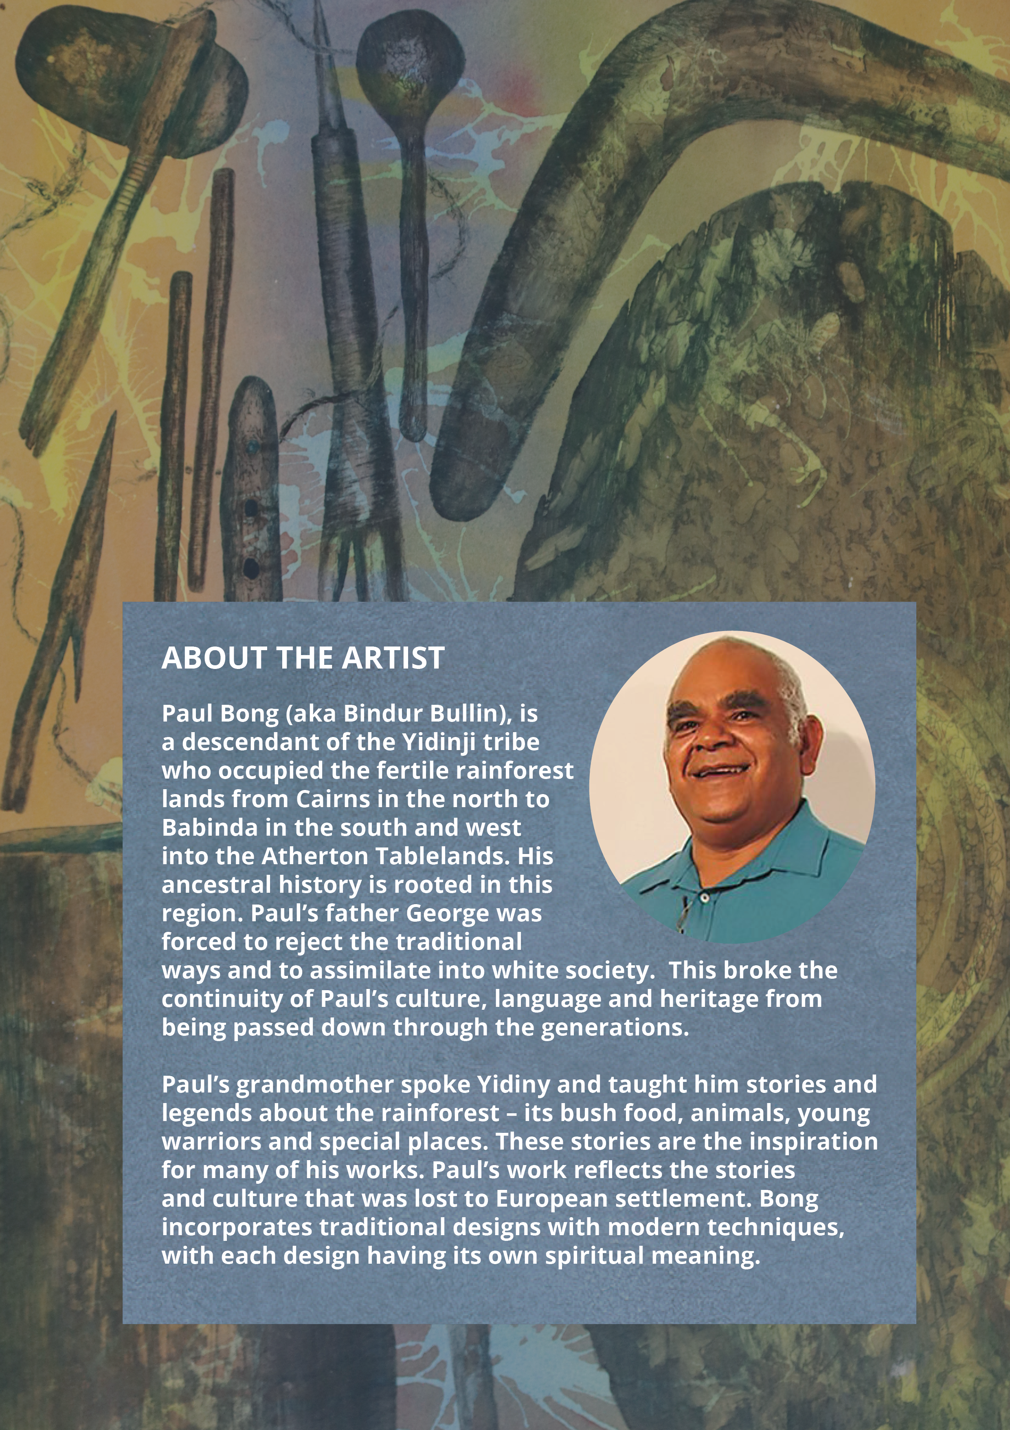

International Covenant on Civil and Political Rights, 999 UNTS 171, 16 December 1966 (entered into force 23 March 1976), Art. 1; International Covenant on Economic, Social and Cultural Rights, 993 UNTS 3, 16 December 1966 (entered into force 3 January 1976), Art. 1.
James Anaya, Indigenous Peoples in International Law (Oxford University Press, 1996) 77.
United Nations Declaration on the Rights of Indigenous Peoples, GA Res 61/295, UN GAOR, 61st sess, 107th plen mtg, Agenda Item 68, Supp No 49, UN Doc A/RES/61/295 (2 October 2007).
Asia Pacific Forum of National Human Rights Institutions and the Office of the United Nations High Commissioner for Human Rights, The United Declaration on the Rights of Indigenous Peoples: A Manual for Human Rights Institutions (August 2013) 19.
Australian Human Rights Commission, Social Justice Report 2002: Self-determination - the freedom to 'live well' (Report, December 2002).
United Nations Declaration on the Rights of Indigenous Peoples (n iii) art 46.
Nathan mudyi Sentance, ‘Genocide in Australia’, Australian Museum (Web Page 2022).
ABC News, What was the Northern Territory Emergency Response, better known in Indigenous Communities as The Intervention? (29 January 2023).
‘Our History and Future’, Aboriginal Medical Services Redfern (Web Page 2023).
Kathryn S Panaretto et al, 'Aboriginal community controlled health services: leading the way in primary health care' (2014) 200 (11) The Medical Journal of Australia, 649-652.
‘Aboriginal Community Controlled Health Organisations (ACCHOs)’, NACCHO (Web Page 2023).

