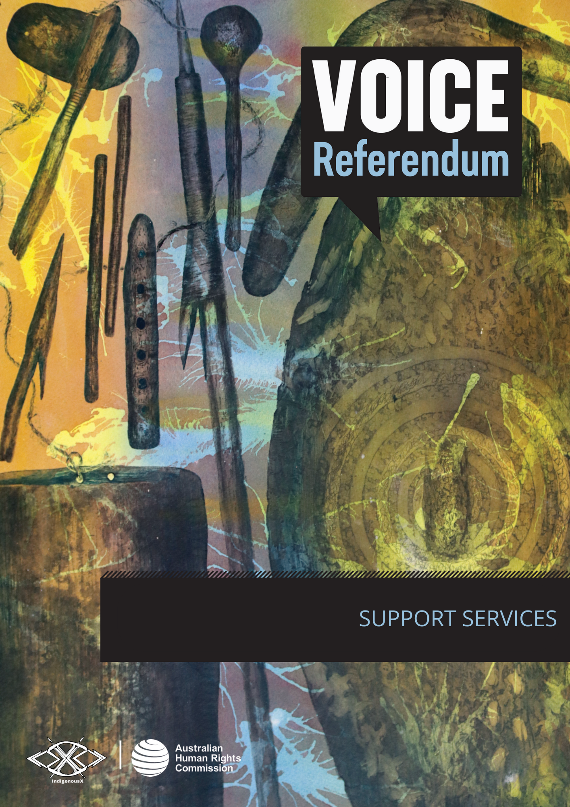

SUPPORT SERVICES

Racism directed towards Aboriginal and Torres Strait Islander people is likely to continue increasing in the lead up to the referendum. This is already being witnessed in online platforms, media outlets, political commentary, and everyday conversations.
Experiencing racism can be distressing and traumatic. If you experience racism, you may want to seek support. Support may come from family, friends or people within your community. However, formal support services are also available:
- eSafety Commission: A suite of resources for First Nations digital wellbeing, including practical actions to protect yourself online, and ways to report harmful content on the internet, are available via the Office of the eSafety Commissioner. Explore the full suite of eSafety First Nations resources.
- 13YARN: For culturally safe First Nations crisis support, you can give 13YARN a call on 13 92 76. They offer a free, confidential one-on-one yarning opportunity with an Aboriginal and/or Torres Strait Islander Crisis Supporter, 24 hours a day, 7 days a week.
- Wellmob: Online social, emotional and cultural resources, developed by and for First Nations people, are available through Wellmob. This includes websites, apps, podcasts, videos, social media, and online counselling with a focus on social and emotional wellbeing. Explore the WellMob resources.
- AIMhi-Y: A mobile app to support the wellbeing of First Nations young people, aged 12-25, called AIMhi-Y. The app is a strengths-based, digital wellbeing tool that integrates education and brief intervention, embedding guidance from Elders, and building connection with culture, Country and language. The AIMhi-Y app is available for download on mobile devices via the App Store (Apple) or Google Play (Android).

The true extent of racism in Australia is not well understood. If you experience racism, you may also want to report it. Doing so can inform evidence-based research that enables reporting on racism and its impacts, and strengthens anti-racism action.
- Call It Out is a secure, online register to report racism and discrimination experienced by First Nations people. Its purpose is to collect information on racism, including how it is experienced, how often it is occurring and the impact it is having on people. This data is hoped to progressively impact public policy into the future. Visit Call It Out to report an incident of racism.
- The Australian Human Rights Commission is an independent body that investigates complaints about human rights breaches, including discrimination on the basis of race, national or ethnic origin. It doesn’t cost anything to ask questions through the inquiry line or make a complaint, no matter where you live in Australia. The elements of the process, including how to make a complaint, are outlined on the Commission’s website.
- You may also be able to make a complaint to your state or territory-based anti-discrimination commission. What is unlawful can vary depending on where you live, more information about the reporting process can be found at the below websites.
  - Anti-Discrimination NSW: https://antidiscrimination.nsw.gov.au/anti-discrimination-nsw/complaints/how-to-make-a-complaint.html
  - Queensland Human Rights Commission: https://www.qhrc.qld.gov.au/complaints/making-a-complaint
  - Victorian Equal Opportunity and Human Rights Commission: https://www.humanrights.vic.gov.au/dispute-resolution/what-happens-when-you-make-a-complaint/
  - South Australia Equal Opportunity Commission: https://www.eoc.sa.gov.au/complaints/making-a-complaint
  - Northern Territory Anti-Discrimination Commission: https://adc.nt.gov.au/complaints
  - Western Australia Equal Opportunity Commission: https://www.wa.gov.au/service/community-services/social-justice-and-equity/make-discrimination-and-harassment-complaint
  - Equal Opportunity Tasmania: https://equalopportunity.tas.gov.au/complaints
  - ACT Human Rights Commission: https://hrc.act.gov.au/complaints/

