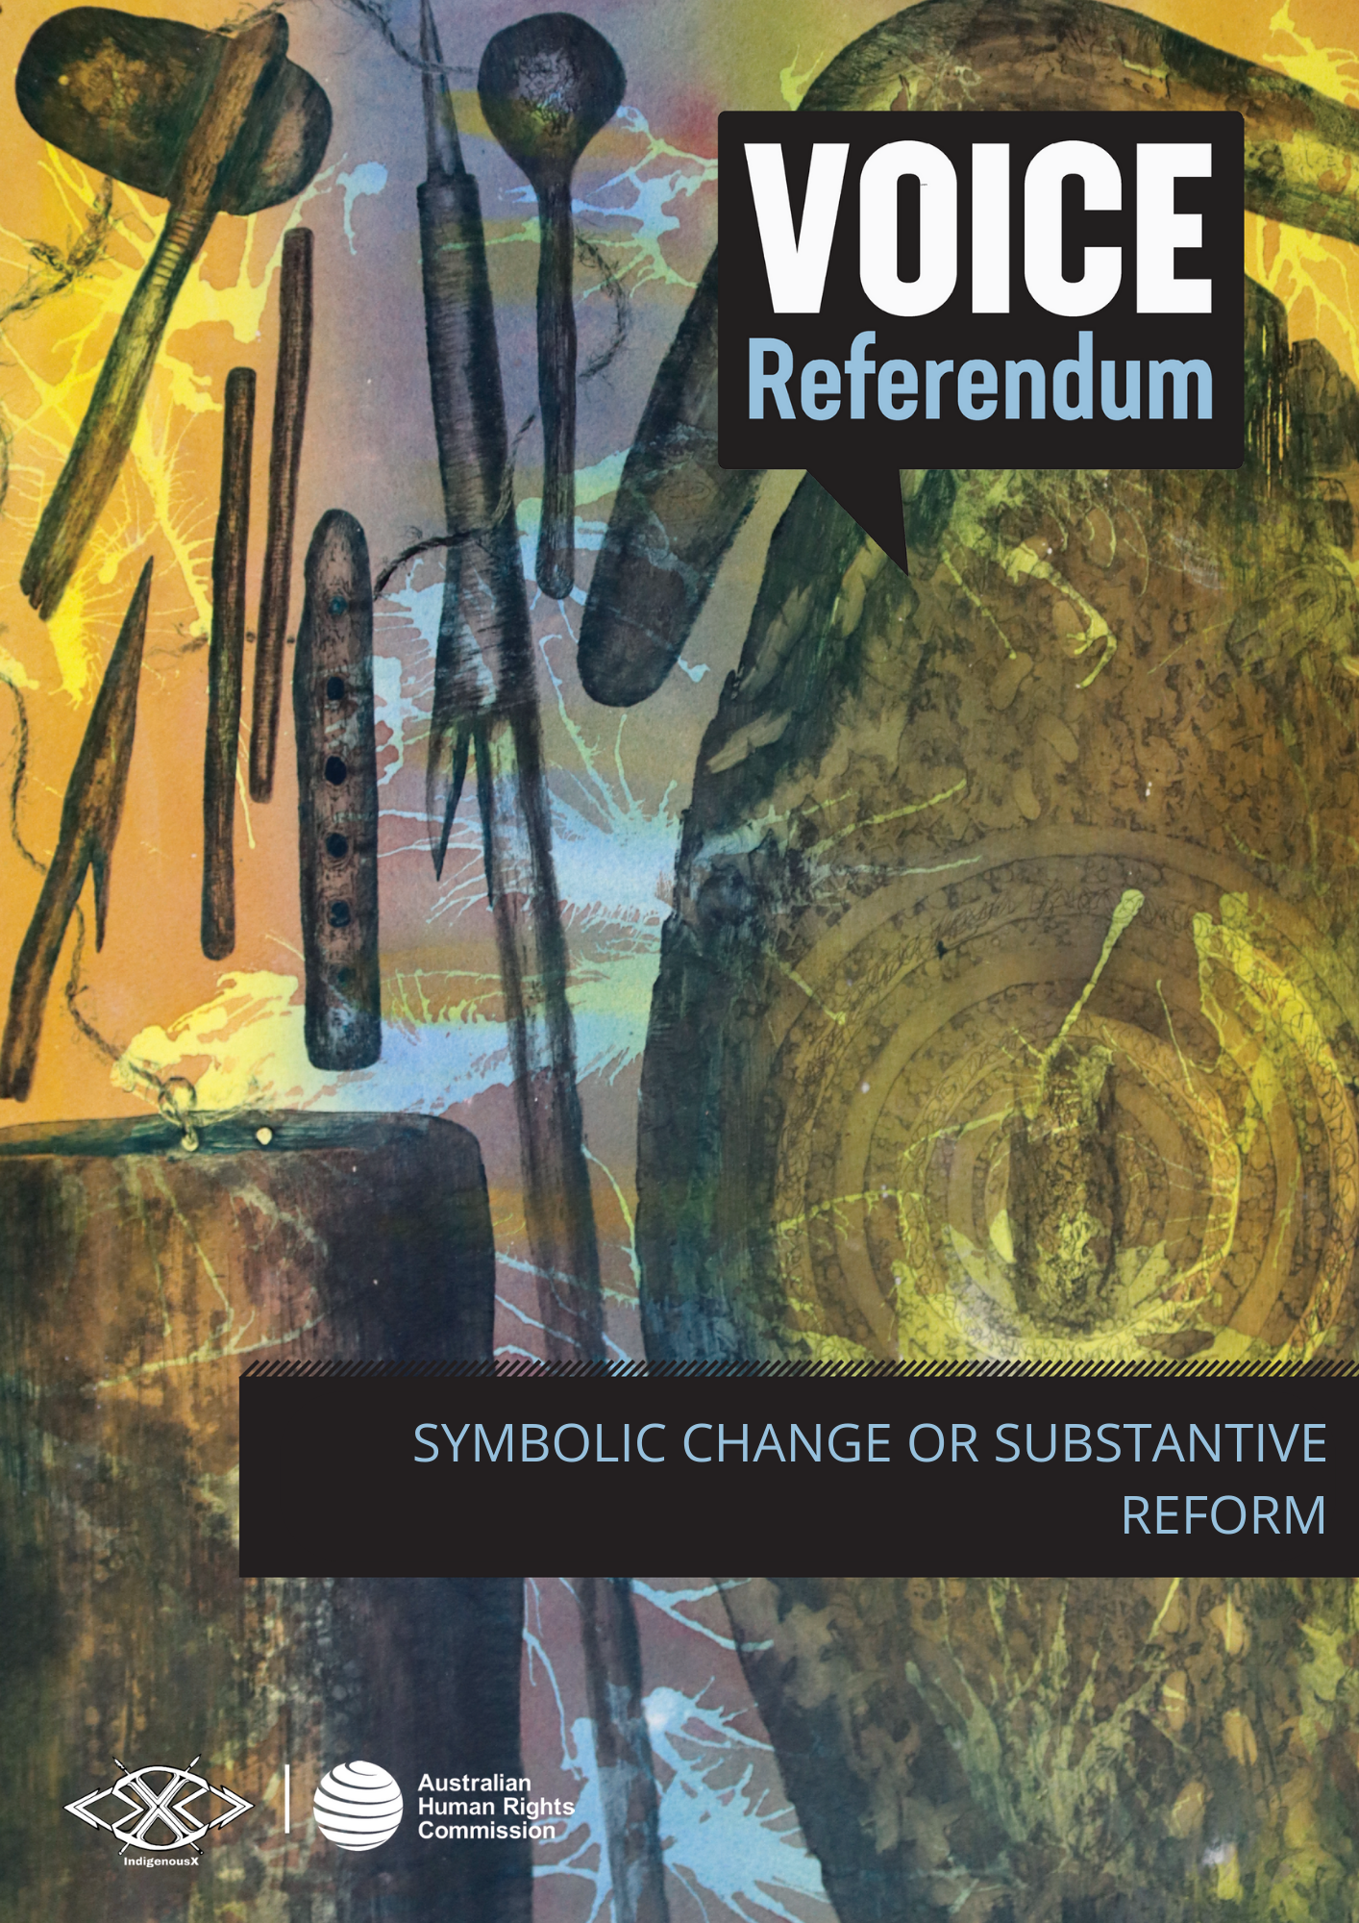

SYMBOLIC CHANGE OR SUBSTANTIVE REFORM

What is symbolic change?
A symbolic change to the Australian Constitution is a change that does not affect any existing duties, powers or legal relationships.
For example, some people support the idea of constitutional recognition in the form of an introduction or ‘preamble’ to the Constitution. Such a preamble would recognise that Indigenous peoples are the original inhabitants of the lands and waters now known as Australia. However, that recognition would not have any direct legal consequence.
The Australian Constitution does not currently have a preamble.

What is substantive reform?
The proposed Indigenous Voice to Parliament is an example of substantive legal reform. This is because it would provide for a new constitutionally entrenched legal entity with the function of making representations to the Parliament and the Australian Government on matters relating to Aboriginal and Torres Strait Islander peoples.
The proposed amendment to the Constitution would also give the Parliament a new power to make laws about the composition, functions, powers and procedures of the Voice.
Whether or not the substantive reform being offered is appropriate and/or adequate is something individuals must ask themselves when considering whether they will write yes or no in the upcoming referendum. Take the time to learn more about the proposed changes as well as the long history of Indigenous advocacy, starting with the information available in the ‘history of Aboriginal and Torres Strait Islander peoples advocating for the right to be heard’ section of the Voice referendum resource kit.

