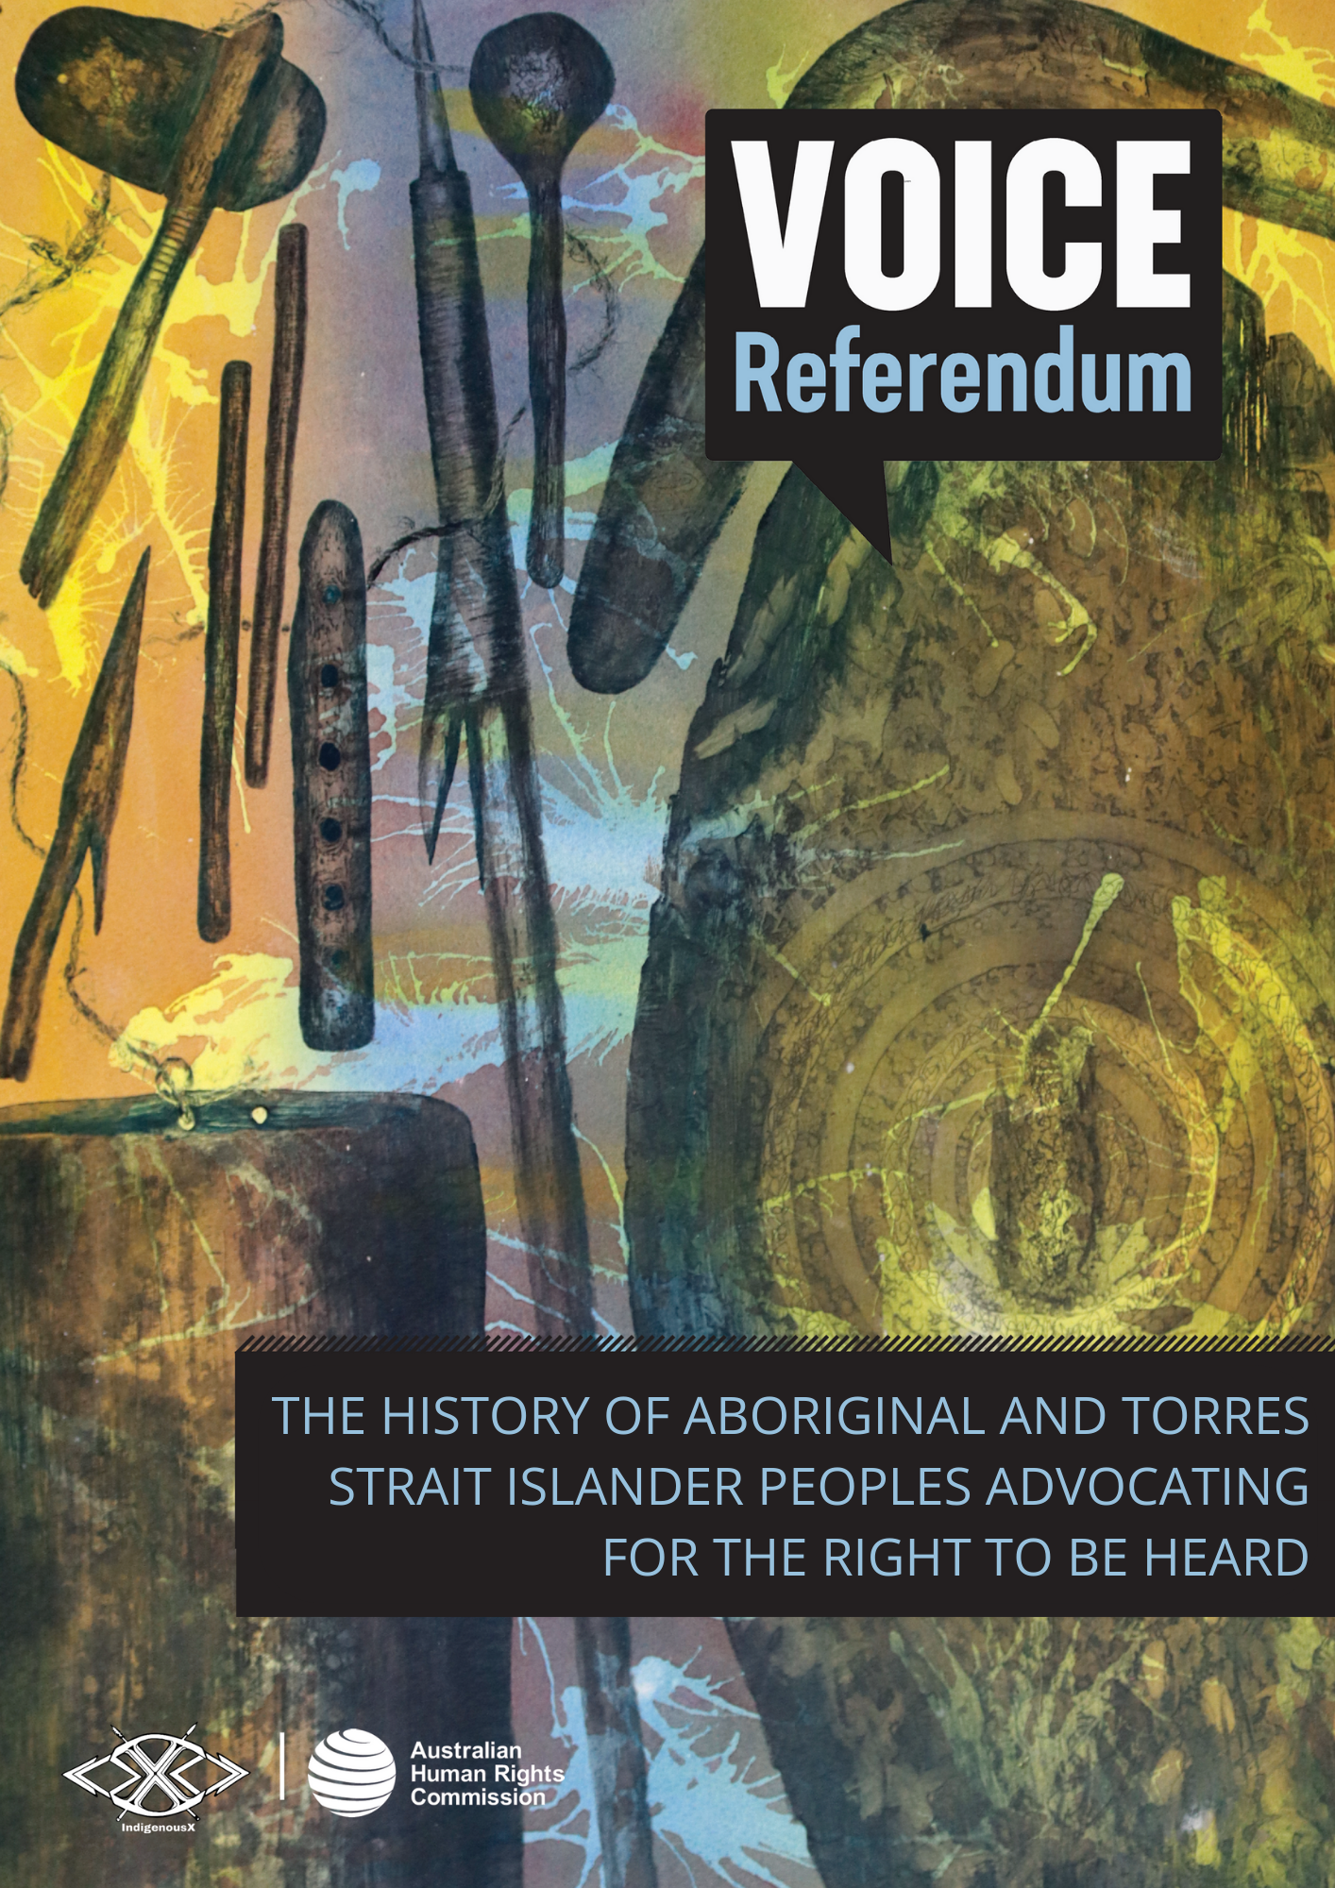

THE HISTORY OF ABORIGINAL AND TORRES STRAIT ISLANDER PEOPLES ADVOCATING FOR THE RIGHT TO BE HEARD

There is a long history of First Nations people advocating for the right to representation and participation in decisions that affect them. Although colonisation has significantly disrupted First Nations Law, structures and culture, Aboriginal and Torres Strait Islander peoples have persevered, demonstrating remarkable strength, resilience and tenacity when engaging with the Australian nation state to have their rights recognised.

First Nations peoples have resisted state-sanctioned injustice since colonisation began, well before the events listed below. Early examples include mass protests against the inhumane treatment and living conditions imposed upon residents of Aboriginal reservations, such as the Cummeragunja walk-off. The swell of support for change sparked by the Indigenous protest movement in Australia has led to changes to the Constitution in the past, as with the 1967 referendum. Much like the referendum taking place this year, the 1967 referendum was not initiated by a single event, but rather decades of growing national and international advocacy and support for change.

The events listed below are a selection of moments in history when Aboriginal and Torres Strait Islander peoples have taken action to call for large-scale change by Australian governments to realise their Indigenous rights.

WARNING: Aboriginal and Torres Strait Islander readers are warned that the following timeline contains names of deceased persons.

Please note, the following section uses culturally inappropriate terms of reference that have contributed to the historical erasure of hundreds of distinct Nations, languages and cultures that make up the lands now known as 'Australia'. Terminology can change over time, and it is best practice to find out what the preferred term is from the respective Aboriginal and/or Torres Strait Islander group or individual you are referring to.

Date | Historic Event
1933-8 | William Cooper Petition  In 1933 Yorta Yorta man William Cooper established the Australian Aborigines’ League (AAL) in Melbourne together with Margaret Tucker, Eric Onus, Anna and Caleb Morgan, and Shadrach James. Cooper was the founding secretary of the League which lobbied to improve the lives and rights of First Nations peoples, on behalf of their communities. From 1933–1938 Cooper gathered nearly 2000 signatures from First Nations people, on behalf of the AAL, for a petition to the King, calling for First Nations representation in the federal parliament.  The Government refused to present the petition to King George VI.  In December 1938, William Cooper and the AAL made history when they marched on the German Embassy in Melbourne to protest against the treatment of the Jewish community in Germany following the events known as Kristallnacht. It was the first protest in support of the Jewish community anywhere in the world.
1936 | Torres Strait Maritime Strike  In January 1936, Torres Strait Islanders united against the substandard working conditions of pearl divers. At the time, Torres Strait Islander communities made up a significant proportion of the labour workforce, as was the case with many First Nations groups in northern Australia, meaning that industrial action became a particularly effective tool for advancing change. Through the Maritime Strike, Islanders advocated for the right to choose how they spent their wages and to have control over their own affairs, in other words the right to self-determination. The Strike lasted 9 months and led to the repeal of highly restrictive legislation and the introduction of the Torres Strait Islanders Act in 1939. Although restrictive, this legislation recognised Torres Strait Islanders as a separate First Nations group with the right to vote and elect their own chairmen and councillors to local government.  The Torres Strait Maritime Strike not only paved the way for future reform towards self-government in the region but is also one of the first recorded strikes by First Nations peoples across the continent, initiating the Indigenous workers’ rights movement in Australia and leading to pivotal events, such as the Wave Hill Walk-Off in 1966.
1938 | Day of Mourning  150 years after colonisation began, celebrations were planned across the lands now known as Australia for the 26th of January 1938. In response to this, the Australian Aborigines’ League and the newly established Aboriginal Progressive Association, declared a Day of Mourning. They held a conference in Sydney, a landmark gathering of First Nations peoples, to draw attention to the violence, dispossession and inhumane conditions imposed upon Aboriginal communities, and to request full citizenship status and rights. This was one of many First Nations protests against injustice, denial of land and protectionist policies, and is considered by many to be the start of the Indigenous political movement in Australia.  A few days later, members of the Australian Aborigines’ League and the Aborigines Progressive Association led a delegation to the Prime Minister, Joseph Lyons, with a proposed national policy for Aboriginal people. Their requests were rejected by the Government.
1963 | Yirrkala Bark Petitions  In August 1963, two bark petitions were presented to the Australian House of Representatives, one in Yolŋu Matha and the other in English, with differing and distinct paintings framing the text. The paintings represent the two Yolŋu moieties, Dhuwa and Yirritja. This was the Yolŋu’s first formal proposal to have their land rights recognised. The 1963 petitions still hang in Parliament House, Canberra.  The petitions were the first documents to have incorporated First Nations ways of representing relationships to land that were formally acknowledged by the Commonwealth Parliament. Four additional petitions were made and presented in 1968, 1988 (see ‘The Barunga Statement’ below), 1998 and 2008. To this day, these petitions have not been effectively responded to by the Government.
1965 | The Freedom Ride  In February 1965, Charles Perkins and other students from the University of Sydney’s Student Action For Aborigines group led a 15-day bus journey across Northern NSW ‘to shine a light on the marginalisation of Aboriginal people in regional New South Wales’, known as the Freedom Ride. Ensuring that the protest was covered by the media, the students drew national and international attention to racial segregation and discrimination in public places such as swimming pools, picture theatres, hotels and RSL clubs, refusal of service in shops, and the inhumane conditions under which First Nations people were forced to live.  The Racial Discrimination Act 1975 (Cth) – introduced by the Government to implement Australia’s obligations under the International Convention on the Elimination of All Forms of Racial Discrimination (CERD) – makes it unlawful to discriminate against a person because of their race, descent, national or ethnic origin.  The Freedom Rides were also a way to campaign for the dismantling of racism facing Aboriginal and Torres Strait Islander communities in accessing health, education and housing services, barriers which still exist today.
1972 | Aboriginal Tent Embassy  On 26 January 1972, Michael Anderson, Billy Craigie, Bertie Williams and Tony Coorey set up a beach umbrella outside Parliament House in Canberra and named it the Aboriginal Embassy, protesting the Government’s stated opposition to Indigenous land rights. In response to persistent forced removal by police, the Aboriginal Tent Embassy operated in multiple locations before its permanent establishment on the lawns in front of Parliament House in 1992. The Embassy continues to operate today, advocating for First Nations land rights, sovereignty and self-determination.  The Aboriginal Tent Embassy is recognised as the longest continuous First Nations land rights protest in the world.
1988 | The Barunga Statement  Leader of the Gumatj clan of the Yolŋu, Galarrwuy Yunupingu, presented the Barunga Statement to the Prime Minister at the Barunga Sport and Cultural Festival. The Barunga Statement is an important part of the tradition of painted legal documents that have been presented to the Australian Government, beginning with the 1963 Yirrkala Bark Petitions. Fusing Yolŋu, Arrernte and Warlpiri symbolism with English text, the Statement calls for First Nations self-management and self-determination, a national system of land rights, compensation for loss of lands, respect for Aboriginal identity, an end to discrimination and the granting of full civil, economic, social and cultural rights for Indigenous peoples.  While the Statement has been permanently exhibited in Parliament House since 1991, many of the calls for action and recommendations within it have not yet been implemented by the Government.
1990 | Establishment of ATSIC  The Aboriginal and Torres Strait Islander Commission (ATSIC) was established to replace the National Aboriginal Conference as a national representative body for First Nations people in Australia. ATSIC consisted of elected regional councils and a board of commissioners to monitor and advise on service delivery and policy decisions directly affecting Indigenous communities.  ATSIC was abolished by the Government in 2005.
1988–92 | Mabo Decision  Mabo v Queensland (1988) and Mabo v Queensland [No. 2] (1992) delivered landmark rulings from the High Court of Australia on the land rights of First Nations people across the country. The High Court recognised and acknowledged the Meriam people’s traditional ownership of their land and waters (including Mer Island), overturning the fiction of terra nullius (‘land belonging to no-one’) that did not recognise Indigenous occupation and custodianship of land and waters. The Mabo [No. 2] decision recognised Aboriginal and Torres Strait Islander peoples’ continuing connection and rights to land and waters through native title in the Australian legal system and led to the passing of the Native Title Act 1993 (Cth).  In the years that followed, amendments were made to the Act that significantly weakened Aboriginal and Torres Strait Islander peoples’ procedural rights to native title claims, effectively diminishing the rights initially recognised through the Mabo decisions.
1994 | Establishment of Torres Strait Regional Authority  The Torres Strait Regional Authority (TSRA) was established as a self-governing body consisting of 20 elected representatives to administer the Torres Strait Islands, aiming to strengthen the region’s economic, cultural, and social development. TSRA, previously the Torres Strait ATSIC regional body, was separated from ATSIC between 1994 and 1997. It survived the abolition of ATSIC in 2005 and continues today, providing local and government services as well as a political representative structure for Torres Strait Islanders.  However, Torres Strait Islander communities have identified further progress towards greater autonomy and the establishment of a self-governing territory as key priorities.
1998 | National Sorry Day  The first National Sorry Day event was held one year after the tabling of the Commission’s report of the National Inquiry into the Separation of Aboriginal and Torres Strait Islander Children from their Families, the Bringing Them Home report. The inquiry and report examined the forcible removal of Aboriginal and Torres Strait Islander children from their families and communities and paid tribute to the strength of First Nations people who shared their stories. Many of the report’s recommendations have still not been implemented by the Government.  Today, First Nations children are removed from their families at rates higher than that of the Stolen Generations, disrupting their connection to Country, community and culture. Sorry Day continues to serve as an ongoing call to implement the recommendations of the Bringing Them Home report, and an opportunity to acknowledge the systemic failures that contribute to the disproportionate rates of child removals.
2007 | UNDRIP Adopted by the United Nations General Assembly  First Nations people in Australia played a key and significant role in the development of the United Nations Declaration on the Rights of Indigenous Peoples (UNDRIP). However, Australia was one of four nation states to vote against the Declaration in 2007, alongside Canada, New Zealand and the United States.  Following considerable international and domestic pressure, Australia reversed its position and formally endorsed the UNDRIP in 2009. Canada, New Zealand and the USA also reversed their opposition around this time. However, Australia has not yet put in place sufficient mechanisms for realising Indigenous rights on a national level and has therefore not effectively incorporated the UNDRIP into domestic law.
2009 | Establishment of National Congress of Australia’s First Peoples  In 2009, then Aboriginal and Torres Strait Islander Social Justice Commissioner, Tom Calma AO, led a national consultation for a new First Nations representative body, culminating in the creation of the National Congress of Australia’s First Peoples (NCAFP). The body was established in 2009, comprising three representative chambers: representatives from existing First Nations peak bodies, community representatives and individuals with expertise in different fields. It had a 50/50 gender parity policy for delegates and an ethics council with oversight of elections and organisational operations.  In 2013, the government withdrew the NCAFP’s funding and in 2019, it was forced out of operation and went into voluntary administration.
2016–17 | The Redfern Statement  In June 2016, national Aboriginal and Torres Strait Islander peak organisations and representative bodies came together to develop and announce the Redfern Statement. The Statement was an urgent call for an end to budget cuts and the restoration of funding to the Indigenous Affairs Portfolio. It laid out six key priority areas and recommendations, and covered issues ranging from engagement, health, justice, violence prevention, disability, children and families and calls for a new dialogue with the Government to address some of the major challenges facing Aboriginal and Torres Strait Islander peoples. In February 2017 the Statement was formally presented to the Prime Minister in Parliament House.
2017 | The Uluru Statement from the Heart  On 26 May 2017, at the National Constitutional Convention in Yulara on the lands of the Aṉangu people, the Uluru Statement from the Heart was presented to the Australian public by a group of First Nations people. Regional dialogues prior to the convention were hosted in 13 locations across Australia. 250 delegates were invited to attend the convention and many were in support of the Statement. For those delegates, it was an expression of desires for substantive constitutional reform and proposed a First Nations Voice to Parliament, and a Makarrata Commission that would undertake agreement-making (treaty) and truth-telling.

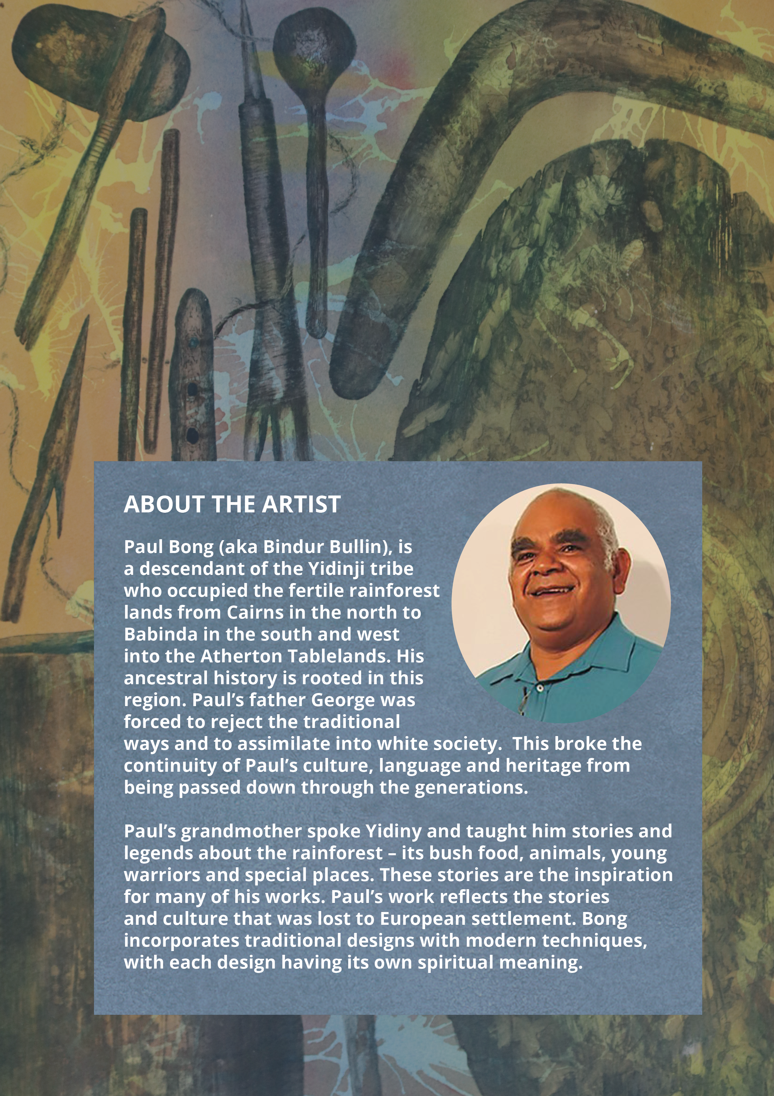

Rachael Knowles, ’What was the Cummeragunja Walk-Off?’, NITV (4 February 2022).
National Museum of Australia, William Cooper Protests (Web Page 2023).
National Archives of Australia, William Cooper Petition (Cabinet Paper) 1938 (Web Page 2023).
National Museum Australia, William Cooper protests (Web Page 2023).
Torres Strait Islander Act of 1939 (Qld), as repealed by Aborigines' and Torres Strait Islanders' Affairs Act 1965 (Qld) (Web Page 2023).
National Archives of Australia, William Cooper ’Day of Mourning’ Letter 1938 (Web Page 2023).
National Museum Australia, Defining Moments: Day of Mourning (Web Page 2023).
National Museum Australia, Defining Moments: Yirrkala Bark Petitions (Web Page 2023).
AIATSIS, 1965 Freedom Ride (Web Page 2023); Charles Perkins, A Bastard Like Me (URE Sydney, 1975).
Professor Bronwyn Carlson and Lynda-June Coe, A Short History of the Aboriginal Embassy - An Indelible Reminder of Unceded Sovereignty (24 March 2022) The Museum of Australian Democracy at Old Parliament House; National Museum of Australia, Defining Moments: Aboriginal Tent Embassy.
Ibid.
National Archives of Australia, Aboriginal Land Rights Protest (Web Page 2023).
AIATSIS, The Barunga Statement (Web Page 2023).
Dani Larkin et al, Aboriginal and Torres Strait Islander Peoples, Law Reform and the Return on the States (11 May 2022) Indigenous Constitutional Law; Kinglsey Palmer, ‘ATSIC: Origins and Issues for the Future. A Critical Review of Public Domain Research and Other Materials’ (Research Discussion Paper No 12/2004, Australian Institute of Aboriginal and Torres Strait Islander Studies, 2004).
Larissa Behrendt, ‘The abolition of ATSIC – Implications for democracy’, Democratic Audit of Australia – November 2005, 1 (Web Page, 2023).
John Hannaford, Jackie Huggins, and Bob Collins, ‘In the Hands of the Regions - A New ATSIC Report of the Review of the Aboriginal and Torres Strait Islander Commission’, Australian Indigenous Law Reporter, Vol. 8 No. 3 pp. 105-112 (November 2003).
Mabo v Queensland (1988) 166 CLR 186; Mabo v Queensland [No. 2] (1992) 175 CLR 1.
Torres Strait Regional Authority, Section Two: About the TSRA.
Australian Human Rights Commission, Wiyi Yani U Thangani (Women’s Voices): Securing Our Rights, Securing Our Future Report (Report, 2020) 86.
Australian Human Rights Commission, Bringing them Home: Report of the National Inquiry into the Separation of Aboriginal and Torres Strait Islander Children from their Families (Report, April 1997).
SNAICC – National Voice for our Children, the Family Matters Campaign, Monash University and the University of Technology Sydney, The Family Matters Report 2022 (Report, 2022).
Bronwyn Carlson, 'National Sorry Day is a day to commemorate those taken. But ‘sorry’ is not enough – we need action', The Conversation (online, 26 May 2022).
United Nations Declaration on the Rights of Indigenous Peoples, GA Res 61/295, UN GAOR, 61st sess, 107th plen mtg, Agenda Item 68, Supp No 49, UN Doc A/RES/61/295 (2 October 2007).
ANTAR, UNDRIP in Australia (16 December 2022).
James Haughton, Former Aboriginal and Torres Strait Islander Australian Government representative and advisory bodies: a quick guide (16 June 2023) Parliament of Australia.
Commonwealth, Parliamentary Debates, Senate, 15 February 2017, 18 Indigenous Australians – Redfern Statement (James McGrath, Assistant Minister to the Prime Minister).
‘Uluru Statement: a quick guide’, Parliament of Australia (Web Page 2023).

