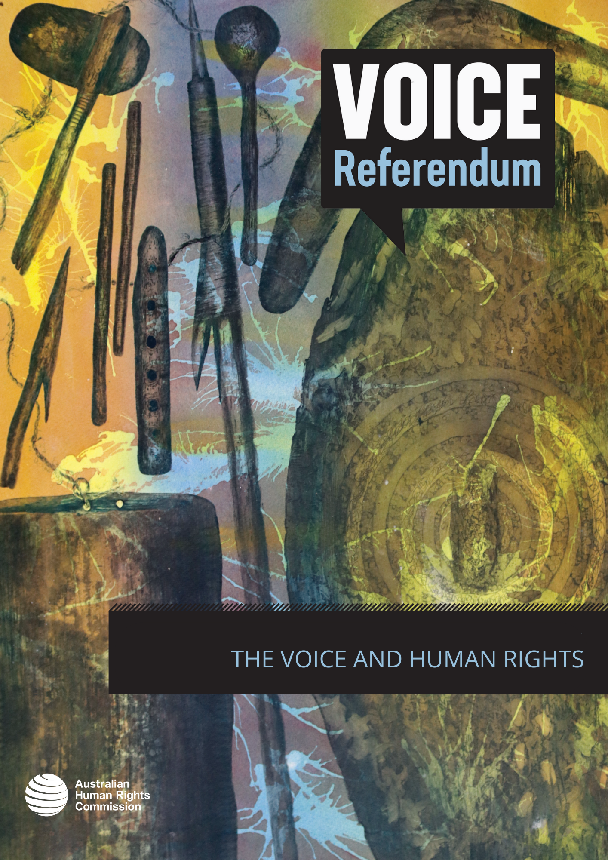

THE VOICE AND HUMAN RIGHTS

Is the Voice compatible with human rights?
All bills and legislative instruments that are introduced into the Australian Parliament must be accompanied by a Statement of Compatibility with human rights.
A Statement of Compatibility is an assessment of whether the bill or legislative instrument is compatible with rights and freedoms recognised in the seven international human rights treaties to which Australia is a signatory. These treaties are:
- the International Covenant on Civil and Political Rights (ICCPR)
- the International Covenant on Economic, Social and Cultural Rights (ICESCR)
- the International Convention on the Elimination of All Forms of Racial Discrimination (CERD)
- the Convention on the Elimination of All Forms of Discrimination against Women (CEDAW)
- the Convention against Torture and Other Cruel, Inhuman or Degrading Treatment or Punishment (CAT)
- the Convention on the Rights of the Child (CRC)
- the Convention on the Rights of Persons with Disabilities (CRPD).

A Statement of Compatibility accompanied the Constitution Alteration (Aboriginal and Torres Strait Islander Voice) 2023. The Statement of Compatibility confirms that “this Bill is compatible with the human rights and freedoms recognised or declared in the international instruments” to which Australia is a signatory (listed in the dot points above). It states that the Constitution Alteration Bill engages the following rights:
a. The right to self-determination in Article 1 of the ICCPR and Article 1 of ICESCR, as well as the principle in Article 3 of the United Nations Declaration on the Rights of Indigenous Peoples (UNDRIP);
b. The rights to equality and non-discrimination in Articles 2 and 26 of the ICCPR, Article 2(2) of ICESCR, and Article 5 of CERD, as well as the principle in Article 2 of the UNDRIP; and
c. The right to take part in public affairs and elections in Article 25 of the ICCPR.

The Statement of Compatibility confirms that:
- The Bill is consistent with the realisation of Aboriginal and Torres Strait Islander peoples’ right to self-determination.
- This Bill is consistent with the right to equality and non-discrimination.
- This Bill promotes the right to take part in public affairs.

Importantly, in relation to the right to self-determination, the Statement of Compatibility noted that the intention of the Voice proposal is that its members would be selected by Aboriginal and Torres Strait Islander people based on the wishes of local communities, and will improve the participation of members of those communities in decisions, policies and laws that affect their rights and interests.
In relation to the right to equality and non-discrimination, the Statement of Compatibility noted that the design of the Voice acknowledges the continuing disadvantage and historical exclusion of Aboriginal and Torres Strait Islander peoples from decision-making processes, and seeks to address this inequality through a mechanism that enables them to express their views to the Parliament and the Australian Government. Further, the exercise of this mechanism is designed to ensure that laws and policies are better attuned to addressing disadvantage faced by Aboriginal and Torres Strait Islander peoples and to improving outcomes for them.
In relation to the right to take part in public affairs, the Statement of Compatibility noted that the Voice would allow Aboriginal and Torres Strait Islander peoples to contribute their views on the decisions, policies and laws that affect them at a national level through an enduring representative body.
The Joint Parliamentary Committee on Human Rights assesses all bills (and their Statements of Compatibility) and is required to identify situations where a bill is not consistent with human rights. The Committee’s analysis of the Constitution Alteration (Aboriginal and Torres Strait Islander Voice) 2023 concluded that the contents of the Bill (i.e. the proposed Indigenous Voice to Parliament) is compatible with human rights, and accepted as accurate the reasoning in the Statement of Compatibility accompanying the bill.

Do international human rights instruments support the Voice?
The United Nations human rights treaty bodies are committees of independent experts that monitor the progress of nation states – including Australia – in meeting their obligations under international human rights treaties (listed in dot points above).
A range of these treaty bodies have commented on the Uluru Statement from the Heart, and the constitutional recognition of Aboriginal and Torres Strait Islander peoples. This includes the Committee on the Elimination of Racial Discrimination (2017), the Human Rights Committee (2017), and the Committee on Economic, Social and Cultural Rights (2017).
The United Nations Special Rapporteur on the rights of Indigenous peoples has also indicated support for the Uluru Statement. The most recent report of the Rapporteur on a visit to Australia, recommends that the Government “[p]lace full political weight behind and act on the proposals put forth by the Referendum Council, including the establishment of a ‘First Nations Voice’ in the Constitution and of a commission for treaty negotiation and truth-telling. Such measures would carry momentous significance to resetting the relationship with the First Peoples of Australia.”

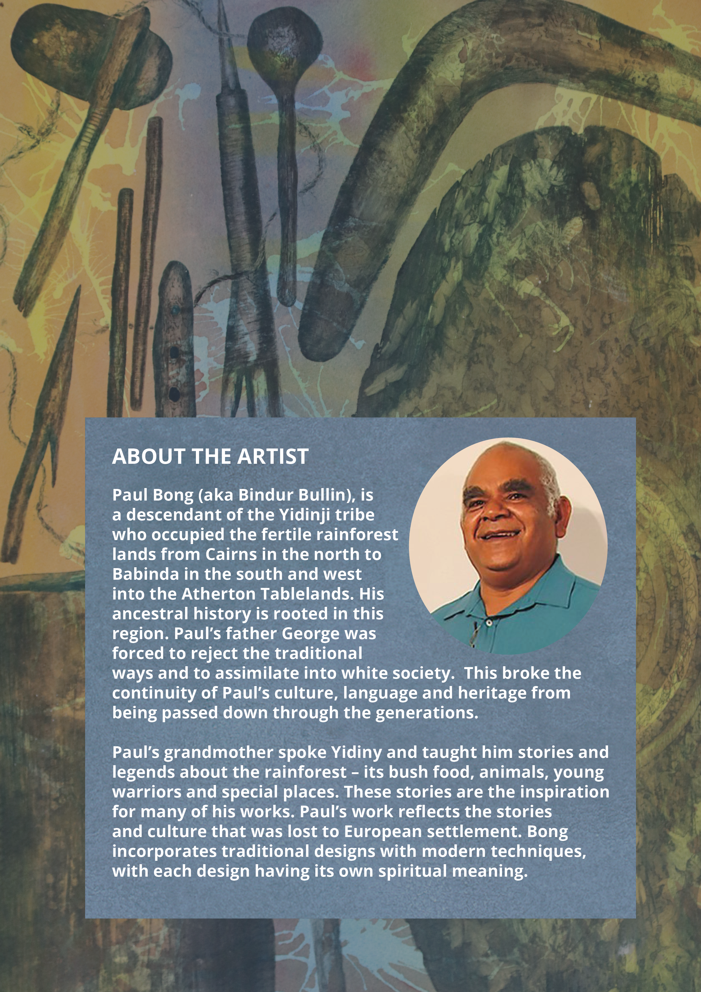

Human Rights (Parliamentary Scrutiny) Act 2011 (Cth), s 7(a).
Parliamentary Joint Committee on Human Rights, Human rights scrutiny report, Report 5 of 2023 (9 May 2023) 11–19.
Committee on the Elimination of Racial Discrimination, Concluding observations on the eighteenth to twentieth periodic reports of Australia, 2597 mtg, CERD/C/AUS/18-20 (26 December 2017) pt C para 7.
Human Rights Committee, Concluding observations on the sixth periodic report of Australia, 3418-9th mtg, CCPR/C/AUS/CO/6 (1 December 2017) 15.
Committee on Economic, Social and Cultural Rights, Concluding observations on the fifth periodic report of Australia, 14-15th mtg, E/C.12/AUS/CO/5 (11 July 2017) 49.
Ibid [107](a).

