Australian Human Rights Commission Inspection of Maribyrnong Immigration Detention Centre: Report

7–8 March 2017

Table of Contents
1 Introduction 5
2 Background 6
2.1 Previous monitoring visits 6
2.2 Inspection methodology 6
2.3 Relevant human rights standards 7
(a) Treatment of people in detention 7
(b) Conditions of detention 7
(c) Communication, association and complaints 8
(d) Legal and policy framework 9
2.4 National context 9
(a) Number of people in detention 9
(b) Length of detention 9
(c) Reasons for detention 10
(d) Administration of the detention network 10
(e) Ratification of OPCAT 11
2.5 Maribyrnong Immigration Detention Centre 11
3 Key issues and concerns 12
3.1 Treatment of people in detention 12
(a) Induction process 12
(b) Risk assessments 12
(c) General safety and security 14
(d) Relationships with staff 14
(e) Use of force and restraints 15
(f) Transfers between detention facilities 15
(g) Other invasive and restrictive measures 16
3.2 Conditions of detention 17
(a) Controlled movement policy 17
(b) Accommodation and living areas 17
(c) Indoor and outdoor exercise 18
(d) Activities and excursions 18
(e) Food 20
(f) Personal items 20
3.3 Physical and mental health 20
(a) Health services 20
(b) Physical health 21
(c) Mental health 21
(d) Continuity of care 22
3.4 Communication and complaints 22
(a) Telephone access 22
(b) Computer and internet access 24
(c) Visits 24
(d) Complaints 25
3.5 Legal and policy framework 26
(a) Mandatory detention 26
(b) Prolonged and indefinite detention 26
(c) Community alternatives to detention 28
(d) Case management and status resolution 29
4 Summary of recommendations 31
4.1 Recommendations to the Australian Government 31
4.2 Joint recommendations to the Department of Immigration and Border Protection and facility staff 31
4.3 Recommendations to the Minister and Department of Immigration and Border Protection 32
4.4 Recommendations to facility staff 34
5 Appendix: Photos taken during the Commission’s inspection 36
5.1 Facilities in Zone A 36
5.2 Facilities in Zone B 37
5.3 Facilities in Zone D 38
5.4 Facilities in Zone E 40
5.5 Facilities in Zone F 42
5.6 Shared facilities 43
Endnotes 46

Summary of key issues
The current risk assessment process may not allow for an accurate or appropriate determination of the risks posed by particular individuals, with the result that they may be subject to more restrictive measures than necessary. The lack of clarity about the risk assessment process is also a significant source of confusion and frustration.
The use of restraints during escort may have at times been excessive.
Certain aspects of the transfer process are unjustified, particularly in relation to the lack of prior warning of transfers and lack of adequate opportunities for people to pack their belongings and notify family members, friends and legal representatives prior to the transfer.
The implementation of a ‘controlled movement’ policy at the MIDC has had a significant impact on living conditions, freedom of movement and access to facilities, given the significant differences between conditions in each compound.
Current accommodation facilities at the MIDC are not suitable for groups of three to four people, as they do not afford sufficient space or privacy for groups of this size.
Indoor and outdoor exercise facilities at the MIDC may not be adequate, particularly in Zones D and E which have limited outdoor space and shade.
Some expressed concern that activities were not sufficiently engaging and meaningful, particularly in relation to education. The lack of opportunities for excursions is concerning, particularly in light of the limited space for outdoor recreation at the MIDC.
The new policy prohibiting all mobile phone use may restrict access to external communication to a greater degree than is necessary to ensure safety and security.
Current restrictions on visits may limit access to visits to a greater degree than is necessary to ensure safety and security.
While most of the people interviewed by the Commission team indicated that they had been in detention for six months or less, a significant number reported that they had been detained for far longer periods, in some cases for well over a year.
Consideration of community alternatives does not occur on a systematic basis for all people in detention, particularly for people who have had visas cancelled under section 501 of the Migration Act. In some cases, ongoing detention may not have been justifiable in the circumstances.
The reduction in the scope of the case manager role and its present limitations lead to a mismatch between the types of support that case managers can provide to people in detention, and the types of support that people in detention actually need, including to resolve their status.

Introduction
This report contains an overview of key observations and concerns arising from the Australian Human Rights Commission’s inspection of the Maribyrnong Immigration Detention Centre (MIDC) in March 2017.
The rationale for the Commission undertaking such inspections is to identify problems in the way that detainees’ human rights are being protected and to suggest ways of addressing those problems. Hence, while the report is balanced and points to some good practices, its primary focus is on issues of concern identified by the Commission. The report reflects conditions as they were at the time of the inspection.
The Commission also raised a number of additional issues with the Department of Immigration and Border Protection (DIBP) and facility staff during and subsequent to the inspection, including individual cases of concern.
The Commission acknowledges the assistance provided by DIBP and the Australian Border Force (ABF) in facilitating the Commission’s inspection. The Commission is grateful to the DIBP and ABF officers and detention service provider staff who assisted the Commission team during the inspection. A draft of this report was shared with DIBP in advance of its publication, to provide an opportunity for DIBP to respond to the identified issues.

Background

Previous monitoring visits
The Commission has conducted visits to immigration detention facilities in Australia since the mid-1990s. This has included periodic monitoring of detention facilities across the country and three major national inquiries into immigration detention.
The purpose of the Commission’s detention monitoring work is to ensure that Australia’s immigration detention system is compliant with our obligations under international human rights law. For many years, the Commission has expressed a range of concerns about aspects of the detention system that may lead to breaches of international human rights law. These include:
- the policy of mandatory immigration detention, which does not allow for adequate consideration of individual circumstances and can result in cases of arbitrary detention
- the indefinite and at times prolonged nature of immigration detention and the lack of a legislative time limit on detention
- the detention of children, which has led to breaches of numerous obligations under the Convention on the Rights of the Child (CRC)
- the indefinite detention of people who have received adverse security or character assessments, including in circumstances where they have not been convicted of a crime under Australian law
- conditions of detention, which in some cases have not met international standards
- the impacts of immigration detention on mental health
- the need for increased use of alternatives to immigration detention.
Further information about these concerns can be found in the Commission publication, Asylum Seekers, Refugees and Human Rights: Snapshot Report 2017.
The Commission can also investigate and, where appropriate, try to resolve through conciliation, complaints it receives from people in immigration detention regarding alleged breaches of human rights.

Inspection methodology
The Commission inspected the MIDC on 7 and 8 March 2017. The inspection was conducted by Human Rights Commissioner Edward Santow and three Commission staff.
During the inspection, the Commission team met with representatives from DIBP, ABF, Serco and International Health and Medical Services (IHMS); conducted an inspection of the facility; and held individual private interviews with 30 people detained at the MIDC.
The Commission considered the evidence gathered during the inspection against human rights standards derived from international law that are relevant to immigration detention.

Relevant human rights standards
This section provides a summary of some of the key international human rights standards relevant to the situation of people in immigration detention. Further information about these and other relevant standards can be found in the Commission publication, Human rights standards for immigration detention.
The MIDC is a high-security detention facility that is not used to detain children. As such, human rights standards relating to the detention of children were not applicable to this inspection.

Treatment of people in detention
Australia is obliged under articles 9(1) and 10(1) of the International Covenant on Civil and Political Rights (ICCPR) to, respectively, uphold the right to security of the person and ensure that people in detention are treated with humanity and respect for the inherent dignity of the human person. Australia also has obligations under article 7 of the ICCPR and articles 2(1) and 16(1) of the Convention Against Torture and other Cruel, Inhuman or Degrading Treatment or Punishment (CAT) not to subject anyone to torture or to cruel, inhuman or degrading treatment or punishment, and to take effective measures to prevent these acts from occurring.
These obligations require Australia to ensure that people in detention are treated fairly and reasonably, and in a manner that upholds their dignity. They should enjoy a safe environment free from bullying, harassment, abuse and violence. Security measures should be commensurate with identified risks, and should be the least restrictive possible in the circumstances, taking into account the particular vulnerabilities of people in detention. Measures that may constitute torture or cruel, inhuman or degrading treatment or punishment (such as collective punishment, corporal punishment, excessive use of force and holding people incommunicado) should be prohibited.

Conditions of detention
Australia has a range of obligations under the International Covenant on Economic, Social and Cultural Rights (ICESCR) relevant to the material conditions of immigration detention. These include the right to education (articles 6(2) and 13); the right to an adequate standard of living, including adequate food, clothing and housing (article 11); the right to the highest attainable standard of health (article 12); and the right to take part in cultural life (article 15(1)(a)).
Australia’s obligations under the ICCPR and CAT to treat people in detention with humanity and respect, and not to subject anyone to cruel, inhuman or degrading treatment or punishment, are also relevant to conditions of detention. In addition, Australia has an obligation under articles 17 and 18 of the ICCPR to uphold the right to privacy and freedom of religion respectively.
These obligations require Australia to ensure that detention facilities are safe, hygienic and uphold human dignity. People in detention should have their basic needs met and have access to essential services (such as health care and primary and secondary education) to a standard commensurate with those provided in the Australian community.
People in detention should have opportunities to engage in meaningful activities and excursions that provide physical and mental stimulation. People in detention should also be able to profess and practise the religion of their choice, including through being able to attend religious services, receiving pastoral visits from religious representatives and celebrating major religious holidays and festivals.
In light of the negative impacts of detention on mental health, the length of detention should be limited to the minimum period necessary to achieve a legitimate aim, and community-based alternatives to detention should be used wherever feasible.

Communication, association and complaints
Australia has a range of obligations under the ICCPR relevant to communication between people in detention and their family members, friends, representatives and communities outside detention. These include the right to freedom of expression and to seek, receive and impart information and ideas (article 19(b)); the right to freedom of association with others (article 22); and the right of ethnic, religious and linguistic minorities, in community with the other members of their group, to enjoy their own culture, to profess and practise their own religion and to use their own language (article 27). Under the ICESCR, Australia also has an obligation to uphold the right to take part in cultural life (article 15(1)(a)).
In addition, Australia has obligations under articles 23(1) of the ICCPR and 10(1) of the ICESCR to afford protection and assistance to the family as the natural and fundamental group unit of society. Australia also has obligations under article 17(1) of the ICCPR and article 16(1) of the CRC not to subject anyone to arbitrary or unlawful interference with their family.
These obligations require Australia to ensure that detention does not have a disproportionate impact on people’s ability to express themselves, communicate and associate with others, and remain in contact with their family members, friends, representatives and communities. People in detention should be able to receive regular visits, and should have access to adequate communication facilities (such as telephones and computers) as well as news and library services. People in detention should, if possible, be located in facilities within a reasonable distance from their family members, friends and communities.
External communication, in particular access to complaints processes, is also essential for the prevention of torture and other cruel, inhuman or degrading treatment or punishment. Australia has obligations under articles 13 and 16(1) of the CAT to ensure that anyone who alleges that they have been subjected to torture or to cruel, inhuman or degrading treatment or punishment, has the right to complain to and have their case examined by competent authorities.
To ensure these obligations are upheld, people in detention should have opportunities to raise concerns and issues regarding treatment and conditions in detention, and make complaints both internally and to independent monitors (including the Commission and the Commonwealth Ombudsman), without fear of repercussions.

Legal and policy framework
Australia has an obligation under article 9 of the ICCPR not to subject anyone to arbitrary detention. According to the United Nations Human Rights Committee, ‘arbitrary detention’ includes detention which, although lawful under domestic law, is unjust or disproportionate. In order for the detention of a person not to be arbitrary, it must be a reasonable and necessary measure in all the circumstances.
Australia has further obligations under article 9 of the ICCPR to ensure that anyone who is arrested has the right to be informed of the reasons for their arrest and the charges against them, and that anyone who is detained has the right to challenge the legality of their detention in court.
These obligations require Australia to ensure that people are only detained in immigration detention facilities when it is reasonable and necessary in their individual circumstances (such as where they pose an unacceptable health or security risk), and for a limited period of time. Community-based alternatives to detention should be used wherever possible. People held in immigration detention should be informed of the reasons for their detention and be able to seek juridical review of whether their detention is arbitrary.

National context
The Commission last visited the MIDC in April 2012. Since that time, there have been a number of significant changes in the legal, policy and operational context surrounding Australia’s immigration detention system.

Number of people in detention
The number of people in closed immigration detention, and particularly the number of children in detention, has reduced dramatically in recent years. As at April 2012, there were 4,329 people in closed detention, including 463 children. In the intervening years, the number of people in detention peaked at over 10,000 in July 2013, before declining to fewer than 2,000 in early 2015. The number of children in detention dropped from a high of almost 2,000 in July 2013 to fewer than 200 in early 2015.
As at March 2017, there were 1,328 people in detention, including just two children. This is the lowest level since 2009.

Length of detention
While the overall number of people in detention has declined, the average length of detention has increased significantly. In April 2012, the average length of detention was 139 days, dropping to 72 days by July 2013. Since then, the average length has steadily increased, peaking at 493 days in January 2017. As at March 2017, the average stood at 478 days.
As at April 2012, 1,484 people had been detained for over a year, comprising more than a third of the people in detention (although these figures do not differentiate between people in closed and community detention). By July 2013, this number had dropped to 228 people, or around two per cent of people in detention. The number of people in long-term detention has since increased, particularly as a proportion of the overall detention population. As at March 2017, 556 people — or 42 per cent of people in detention — had been detained for over a year.
The detention population as at March 2017 included almost 400 asylum seekers who arrived in Australia by boat. As no asylum seekers arriving by boat have been permitted to enter Australia since 2014, it is likely that these individuals arrived almost three years ago at a minimum.

Reasons for detention
In April 2012, the vast majority of people in detention were asylum seekers who arrived by boat, who comprised around 95 per cent of the detention population. Visa overstayers were the second-largest group in immigration detention, followed by people who had had their visas cancelled.
The composition of the detention population remained broadly consistent until the beginning of 2014. Since that time, asylum seekers have progressively comprised a smaller proportion of the detention population (although they remained by far the largest group in detention until 2016).
At the same time, the number of people in detention due to having their visas cancelled has increased. This increase has been largely due to legislative amendments that broadened the scope of section 501 of the Migration Act 1958 (Cth) (the Migration Act). Section 501 allows the Minister or their delegate to refuse or cancel a visa on the basis that a person does not pass the ‘character test’. Since this section was amended in late 2014, visa cancellations on character grounds have increased dramatically, from 76 cancellations in the 2013–14 financial year to 580 in 2014–15, and 983 in 2015–16.
As at March 2017, people who had had their visas cancelled under section 501 were the largest group in detention, comprising around a third of the detention population. Asylum seekers who arrived by boat comprised just under a third of the detention population, followed by people who had overstayed their visa and people who had had their visa cancelled on non-character grounds.

Administration of the detention network
At the time of the Commission’s last visit to the MIDC, Australia’s immigration detention network was administered by the Department of Immigration and Citizenship (currently named the Department of Immigration and Border Protection).
On 1 July 2015, DIBP and the Australian Customs and Border Protection Service merged to form a single department. The ABF was established as the new frontline operational agency for this department. The ABF is now responsible for administering detention operations and removals; while DIBP remains responsible for the overall policy framework for detention, as well as matters relating to visa processing, case management and status resolution.
As was the case in 2012, external contractors continue to play a central role in the management of immigration detention facilities. Serco Australia remains the contracted detention services provider, responsible for the day-to-day running of the facilities including security and provision of services and activities. IHMS remains the contracted health services provider, responsible for providing onsite physical and mental health services to people in detention.

Ratification of OPCAT
On 9 February 2017, the Australian Government announced its commitment to ratify the Optional Protocol to the Convention Against Torture and other Cruel, Inhuman or Degrading Treatment or Punishment (OPCAT) by December 2017. OPCAT provides for ongoing independent monitoring of places of detention, to ensure adherence to minimum standards in conditions and treatment.
At the request of the Attorney-General, the Commission is undertaking a consultation process regarding how best to implement OPCAT. Based on the experience in jurisdictions that have ratified and implemented OPCAT, the Commission sees this as an opportunity to consider, in a more systematic way, the adequacy and appropriateness of conditions of detention. The Commission looks forward to continuing to work with the Government to support the implementation of OPCAT.

Maribyrnong Immigration Detention Centre
The MIDC was built in 1983. It is a high-security detention facility which currently accommodates single adult men and women across six compounds or ‘zones’.
Zones A, D and E accommodate single adult men. Zone B accommodates single adult women. Zone C, used for single separation, was not in use at the time of the Commission’s inspection. Zone F is a small compound which generally accommodates only one or two people. Originally used for fast airport turnarounds, it currently accommodates people who are transitioning to immigration detention from prison. It is also used in cases where a person’s bail conditions specify that they must not associate with certain individuals.
At the time of the Commission’s inspection, there were 103 people detained at the MIDC. This included 97 men and six women. Thirty people had been detained as a result of having their visas cancelled under section 501 of the Migration Act; 23 people had had their visas cancelled on other grounds; 22 had arrived in Australia by boat to seek asylum; and 20 people had overstayed their visas. The detention population included people of 20 to 30 nationalities, with the most common countries of origin including New Zealand, Vietnam, Iran and Sri Lanka.
The MIDC is due to close permanently at the end of 2017.

Key issues and concerns

Treatment of people in detention

Induction process
At various points during interviews with Commission staff, many people expressed confusion about policies and processes in detention. Some reported that they had received limited information during the induction process, particularly regarding their rights and responsibilities in detention. Others recalled receiving some basic information during the induction process but could not remember specific details. Several people felt it would be beneficial to receive more information about ‘how things work’ in detention. A number of people who had previously been in prison observed that internal rules and operating procedures were clearer and more carefully explained in prison than in immigration detention.
The Commission considers that it may be beneficial to review the information provided during the induction process, to ensure that people in detention receive clear information about rights and responsibilities in detention, and about internal facility rules and operating procedures. It may also be useful to explore options for reiterating this information at different points in time, to ensure that people in detention are able to develop a clear understanding of ‘how things work’.

Facility staff should review induction procedures at Maribyrnong Immigration Detention Centre, to ensure that people in detention receive clear information about their rights and responsibilities in detention, and about internal facility rules and operating procedures.

Risk assessments
People in detention are assigned risk ‘ratings’ which are used to determine how they will be treated while in immigration detention. People in detention undergo two separate risk assessments: a security risk assessment, which is used to determine where people are placed both within individual detention facilities and within the detention network; and a transport risk assessment, which is used to determine the conditions of escort when people are taken outside the facility (such as during transfers or when attending external appointments).
Risk ratings are developed using an algorithm that determines a person’s rating based on inputs from staff. The assessment process takes into account a range of factors, including behaviour in detention, criminal history, risk of self-harm, community safety, safety of staff and treating practitioners, and opportunities to escape or reoffend. Risk ratings are reviewed at least monthly to determine whether they are still appropriate. Ratings can also be amended by the Superintendent based on consideration of individual circumstances.
It was evident during the private interviews that people in detention had a limited understanding of why they had received a particular rating. When the Commission raised this issue with facility staff, it was explained that people in detention are not usually told their risk ratings, much less the reasons why they have been given these ratings.
The Commission appreciates that it may not be appropriate in some cases to provide people with all information relevant to their risk ratings. However, the Commission is concerned that the current lack of clarity about the risk assessment process is a significant source of confusion and frustration among people in detention, to whom risk assessments can appear arbitrary or even punitive. For example, some expressed the view that making a complaint about conditions in detention could lead to a higher risk rating. Lack of information about risk assessments could also make it more difficult for people in detention to understand and comply with expectations regarding behaviour in detention.
The Commission is also concerned that the risk rating system may not be sufficiently nuanced to prevent unnecessary use of restrictive measures. For example, the Commission understands that people entering detention for the first time are automatically assigned a ‘high’ risk rating — regardless of their past behaviour — until their risk profile can be more thoroughly assessed. The Commission considers that this practice may be inappropriate in some cases, particularly where facility staff have access to information about the person’s risk profile (such as where a person has recently been in prison).
It also appeared that in some cases, behaviour related to mental health issues stemming from prolonged detention, or to frustration at the restrictiveness of the detention environment, had been taken into account when determining a person’s risk rating. The Commission appreciates the need to ensure the safety of all people in detention (including staff), regardless of the reasons for a person’s behaviour. However, the Commission questions whether applying further restrictive measures in response to particular types of behaviour may amplify rather than reduce the identified risks. For example, placing a person with significant mental health issues under more restrictive detention arrangements may lead to further deterioration of their health, potentially fuelling the very behaviour that was the basis for their higher risk assessment.
The Commission considers that the current risk assessment process may not in all cases allow for an accurate or appropriate determination of the risks posed by particular individuals. As such, risk assessments may result in some people being subject to measures that are more restrictive than is necessary in their individual circumstances.

The Department of Immigration and Border Protection and facility staff should ensure that:
a) people in detention are given clear information about the types of conduct which may lead to particular risk ratings
b) people in detention are informed of the reasons for their individual risk rating (unless doing so would present an unacceptable risk)

The Department of Immigration and Border Protection should review the current risk assessment and rating process to ensure that:
a) people in detention are not subject to more restrictive measures than are necessary in their individual circumstances
b) mental health status and other relevant vulnerabilities are adequately taken into account, with alternatives to restrictive measures considered where possible if vulnerabilities are identified.

General safety and security
The MIDC is a high-security detention facility. Security features observed by the Commission included a high external fence, wire-topped internal fences, secure internal doors and numerous security cameras in common areas and walkways (although not inside bedrooms). In addition, the MIDC now operates under a ‘controlled movement’ policy (see Section 3.2(a)). Members of Serco’s Emergency Response Team are typically equipped with body cameras and flexi-cuffs and may wear protective equipment (such as body armour, helmets and shields) when conducting an operation, but they do not carry weapons.
The majority of people interviewed by the Commission reported that they felt safe in detention. However, several people reported witnessing fights and violence, and a small number reported that they did not feel safe due to fear of violence from other people in detention. The Commission similarly received few reports of bullying or harassment in detention, although a small number of people relayed incidents in which they had been bullied or harassed by other people in detention, or by staff.
Some people also commented that, while they felt physically safe in detention, they did not feel ‘mentally safe’; that is, they were concerned about the impacts of detention on their mental health.
Overall, physical safety did not appear to be a widespread concern among the people interviewed by the Commission.

Relationships with staff
The people interviewed by the Commission expressed generally positive views of facility staff. A number of people made comments to the effect that ‘if you show them respect, they show you respect’; although some also noted that certain staff members were more respectful and helpful than others. Several people cited incidents in which staff members had been particularly unhelpful or disrespectful, or had acted in an intimidating way. A small number of people reported more serious incidents, such as assaults.
A few people commented that staff could benefit from more training, including in relation to de-escalation skills. Some also felt that staff members could be more proactively helpful in some circumstances, noting that staff at times did not seem to appreciate the urgency of some matters (particularly in relation to legal proceedings).
Overall, those interviewed by the Commission reported few serious concerns relating to staff. The Commission also wishes to acknowledge its positive interactions with facility staff, who were consistently helpful and accommodating during the inspection.

Use of force and restraints
The use of restraints was one of the most commonly-raised concerns during interviews with Commission staff. Many people reported that they had been mechanically restrained when being escorted outside the detention facility (such as to attend medical appointments or court hearings) or when being transferred between facilities.
The Commission was particularly concerned by reports that mechanical restraints were at times left on while the person was receiving medical treatment or undergoing diagnostic tests (such as x-rays). In some cases, restraints were reportedly used in circumstances where there appeared to be a limited risk of escape or harm to others. For example, some people indicated that they had been restrained even when receiving treatment in mobile clinics that remained parked inside the perimeter fence of the MIDC. The Commission also received reports of security staff remaining in the room during medical consultations.
Some people who had been transferred between detention facilities reported that they had been handcuffed for the entire duration of the journey. For those who had been transferred to or from Christmas Island, this meant that they had remained in handcuffs for most of the day.
The Commission is unable to verify these accounts or ascertain the circumstances that led to the use of restraints in these cases. The Commission also notes that use of mechanical restraints during escort must be approved by the Superintendent on each occasion. However, the Commission is concerned that the use of restraints may have at times been excessive.

The Department of Immigration and Border Protection and facility staff should review policies relating to the use of mechanical restraints, to ensure people in detention are not subject to more restrictive measures than are necessary in their individual circumstances. Particular consideration should be given to limiting the use of mechanical restraints during medical consultations and during transit where the risk of escape is low.

Transfers between detention facilities
Several of the people interviewed by the Commission expressed concern about the manner in which people are transferred between detention facilities. It was reported that people had been woken in the early hours of the morning by security staff wearing riot gear, were given little time to pack their belongings and did not have the opportunity to notify family members, friends or legal representatives before they were transferred. Those who had been transferred claimed that they had not been given prior warning or told why they were being transferred.
It was evident that the nature of transfers had created significant anxiety among some people in detention. Several people shared their fears of being transferred without notice, potentially to a facility on the other side of the country. Some expressed the view that manner in which transfers were conducted was unnecessarily intimidating and caused avoidable anxiety. In the words of one person, ‘staff come at 3:00am or 4:00am to shock you. Seven people drag you down, handcuff you in the room all the way to Christmas Island…Why treat them like animals? Why not tell them in advance?’
The Commission considers that certain aspects of the transfer process are unjustified, given that people are being transferred from a secure detention environment. In particular, the Commission considers that there would be few circumstances in which it would be justifiable to give people no prior warning of a transfer or deny them the opportunity to pack their belongings and notify family members, friends and legal representatives prior to the transfer.
The Commission is particularly concerned that, in a similar manner to risk assessments, lack of information about the reasons for transfers led to considerable confusion among people in detention — and, in some cases, may discourage them from seeking assistance or making complaints. For example, one person stated that he was reluctant to ask for further assistance with a significant medical issue because he was concerned that he may be seen to be ‘making trouble’ and would be ‘moved on’ to another facility, away from his family in Melbourne.

Where a person is being transferred between immigration detention facilities, the Department of Immigration and Border Protection and facility staff should ensure that the person:
a) is given adequate notice of the transfer
b) receives a clear explanation of the reasons for the transfer
c) is given an opportunity to pack their belongings and notify family members, friends and legal representatives prior to the transfer.

Other invasive and restrictive measures
People interviewed by the Commission reported that they were regularly pat searched when receiving visits and when leaving or entering the facility (such as to attend medical appointments). They also indicated that their rooms were regularly searched.
Few people reported having been held in single separation or subject to sanctions while in immigration detention.

Conditions of detention

Controlled movement policy
The MIDC currently operates under a ‘controlled movement’ policy. Where people in detention could previously move freely between compounds, they are now confined to their particular compound and need to be escorted by staff when moving to different areas.
Facility staff explained that the controlled movement policy had been implemented in response to changes in the cohort of people held at the MIDC, which had resulted in people who had committed violent crimes being detained alongside people who were potentially vulnerable (such as those seeking asylum). Staff indicated that the number of violent incidents in the facility had decreased since the policy was implemented.
The Commission acknowledges that the controlled movement policy was implemented with the aim of ensuring the safety of people in detention. However, the Commission also notes that the policy has had a significant impact on living conditions, freedom of movement and access to facilities for some of the people detained at the MIDC.
While all compounds at the MIDC are designed to be self-sufficient, there are nonetheless significant differences between conditions in each compound. For example, a person in Zone A reported that they could no longer access the chapel, which is located in Zone E; while a person in Zone E noted the limited access to gym facilities. There are also differences between compounds in terms of outdoor space (see Section 3.2(c) below). The Commission therefore suggests that it may be beneficial to review the impacts of the controlled movement policy on conditions and access to facilities at the MIDC.

The Department of Immigration and Border Protection should review the impacts of the controlled movement policy on conditions and access to facilities at the MIDC.

Accommodation and living areas
Accommodation arrangements were similar across all compounds. Bedrooms contained one or two bunk beds, with two to four people sharing each room. Bedrooms in Zones A, C and F were equipped with ensuite bathrooms, while Zones D and E had shared bathroom facilities. Each compound had shared laundry facilities and an indoor common area which typically contained televisions, seating areas, some basic recreation equipment (such as pool tables and books), computers, landline telephones and a kitchenette with basic appliances and breakfast supplies.
A number of the people interviewed by the Commission commented that their bedrooms were small, particularly if they were being shared by four adult men, and were not always adequately ventilated. Some reported that they had difficulty sleeping when sharing a small room with several other people, with one person claiming that ‘if one person wakes up, everyone wakes up’. Several commented on the lack of privacy in accommodation areas, with one person commenting that ‘you’re never on your own’. A couple of people reported that they had difficulty sleeping in bunk beds, for example due to injuries. Some people commented that the shared bathrooms were not kept sufficiently clean, although these complaints were not widespread.
The Commission considers that current accommodation facilities at the MIDC are not suitable for groups of three to four people, as they do not afford sufficient space or privacy for groups of this size. The Commission suggests that bedrooms at the MIDC should be shared between a maximum of two people.

The Department of Immigration and Border Protection should maintain a maximum occupancy rate of two people per bedroom at the MIDC.

Indoor and outdoor exercise
There were significant differences between compounds in relation to exercise facilities and outdoor areas. Zone A had a large grassed outdoor area with a basketball court. The outdoor areas in other compounds were all significantly smaller. Although these compounds also accommodated a smaller number of people, their outdoor areas provided limited space to move around or for outdoor exercise. There was limited shade in Zones D and E, and no grassed areas in Zone E. Zone A had a large and well-equipped gym which was shared on a roster with Zone D, while Zones B and E each had their own smaller gyms.
The Commission considers that indoor and outdoor exercise facilities at the MIDC may not be adequate, particularly in Zones D and E which have limited outdoor space and shade. Access to outdoor space is of particular concern given that the current restrictions on excursions at the MIDC (see Section 3.2(d) below). The Commission therefore suggests that facility staff consider strategies for providing greater access to outdoor space for all people at the facility, such as through providing rostered access to the outdoor space in Zone A or offering additional excursions.

Facility staff should implement strategies to provide greater access to outdoor space for all people detained at the MIDC, particularly those in Zones D and E.

Activities and excursions
Activities available at the MIDC included English classes, barista classes, sport and exercise activities, movies, games and religious services. The facility has a classroom for educational activities, and a dedicated Programs and Activities Hub which is used for a variety of purposes including arts and crafts, education, exercise and religious services.
During interviews with the Commission, some people spoke positively of the activities available in detention. A significant number of people participated in religious services and provided generally positive feedback on these services. Others, however, felt that activities were not sufficiently engaging or meaningful. For example, one person who spoke English as their first language noted that English classes were ‘very basic’, as they were designed for people who did not speak English. Some also made suggestions for additional activities that are not currently offered but would be more relevant to the needs of people in detention, such as drug and alcohol education.
Several people who had previously been in prison commented on the difference between the activities offered in prison and those offered in detention. The lack of opportunities for formal education or work were noted as particular gaps. Several people expressed concern that the range of activities offered in detention (in contrast to those offered in prison) did not adequately prepare people for life after release, whether that be in Australia or their country of citizenship. For example, one person expressed concern that they would ‘walk out of here with nothing. It puts me in a debilitating situation and makes it easy to fall into silly situations again’. Another commented that they were ‘wasting time in here’, while a third remarked that there was ‘no way to progress here at all’.
Facility staff acknowledged these gaps but also noted that they faced challenges in offering education and work opportunities to people in detention. For example, enrolment in formal study may not be appropriate for people who are due to be deported from Australia, and thus will be unable to complete the course of study.
The Commission recognises these challenges. Nonetheless, the Commission considers that there may be opportunities to provide more meaningful activities to people in detention, particularly in relation to education. For example, where enrolment in formal education is not possible, alternative educational activities could include short courses, workshops and a broader range of literacy and numeracy classes.
None of the people interviewed by the Commission reported that they had been on excursions while detained at the MIDC. Facility staff indicated that there had been a general reduction in excursions since May 2016 following several escapes from detention. The only excursions available at the time of the Commission’s inspection were bus tours, during which people did not leave the vehicle.
The lack of opportunities for excursions is concerning, particularly in light of the limited space for outdoor recreation at the MIDC. The Commission suggests that consideration be given to introducing regular excursions for people detained at the MIDC, with access restricted only where a person presents an unacceptable flight or safety risk.

Facility staff should implement strategies to provide greater access to educational opportunities for people detained at the MIDC.

Facility staff should introduce regular excursions for people detained at the MIDC, with access to excursions restricted only where a person presents an unacceptable flight or safety risk.

Food
Continental breakfast supplies (such as bread, cereal and milk) are available in all compounds, and cooked lunches and dinners are served daily in a central mess. People in detention have limited opportunities to cook their own food, although staff reported that portable barbeques are provided on occasion for this purpose. People in detention can also purchase snacks using points (see Section 3.2(f) below).
Several of the people interviewed by the Commission provided negative feedback on food, commenting that it was repetitive, of a low quality, not particularly flavourful and did not cater for the preferences of people from different backgrounds. However, some indicated that they had no complaints about food.

Personal items
People in detention earn points which can be used to purchase personal items such as cigarettes, drinks, snacks, phone cards and toiletries. People are allocated 25 points at the beginning of each week and can earn 25 additional points through participating in activities, plus a further ten points for good behaviour.
People interviewed by the Commission reported that they were generally satisfied with the points system and the items available for purchase, although several commented that the only razors available were low-quality and painful to use. A couple of people reported that they had medical issues that prevented them from participating in physical activity, which could in turn impact their ability to earn points.

Where a person is unable to participate in activities due to health issues, facility staff should adopt alternative methods for allocating points.

Physical and mental health

Health services
Medical services are provided onsite at the MIDC by IHMS. There is a general practitioner onsite four days a week during business hours, and nursing staff onsite from 8:00am to 10:00pm seven days a week. Outside of these hours, people in detention can approach Serco staff who then call the Healthdirect nurse triage line for medical advice. Dental and x-ray services are delivered onsite through mobile clinics. There is also a methadone program administered onsite.
People with mental health needs will initially be assessed onsite by a mental health nurse. Those with high or complex needs will be assessed within 24 hours. There is a counsellor onsite two days a week and a psychiatrist onsite during business hours once a fortnight. Specialist torture and trauma rehabilitation services are accessed offsite, although it was reported in some cases that these services may be delivered onsite.
People in detention can request medical assistance through filling in a medical request form. Request form boxes are checked twice daily. Facility staff reported that the average waiting time for medical consultation is usually a week. In emergencies, people are encouraged to notify Serco officers immediately.
People requiring specialist medical treatment are referred to the local public hospital. Facility staff indicated that the average waiting times for specialist treatment are the same as for the general community. Facility staff indicated that, where people are in urgent need of treatment, approval would be sought from DIBP to engage a private specialist.
Facility staff noted that they sometimes encountered problematic attitudes towards people in detention among staff in the local public health sector, which could lead to a lower standard of care. It was reported, for example, that the public health sector did not always respect the recommendations of IHMS staff, leading at times to premature discharges and failed admissions.

Physical health
Facility staff reported that people in detention tended to present with physical health issues similar to those seen among the general community, such as coughs and colds.
Some of the people interviewed by the Commission reported that they had generally received good medical care while detained at the MIDC. Others felt that their concerns had not been taken seriously by medical staff. Several people reported that staff had simply provided paracetamol for pain relief without adequately addressing their medical concerns. Some also reported delays in receiving medical treatment.

Mental health
Facility staff reported that situational depression and ‘detention fatigue’ were common among people detained at the MIDC, particularly those who had had visas cancelled under section 501. It was noted that people who had been released from prison — where they were able to earn an income and could work towards a clear release date — often had difficulty adjusting to the comparative lack of certainty and structure in immigration detention. In the words of one staff member, ‘they hit detention fatigue very quickly because they have nothing to look forward to. They say, “I’d rather be in prison”.’
A number of people interviewed by the Commission expressed concern that their mental health was deteriorating as a result of being held in detention. Those who had seen a counsellor or other mental health professional generally spoke positively of the assistance they had received, and found it helpful. However, some felt that they were not receiving adequate mental health support, or had experienced significant delays in receiving support.
The Commission did not receive reports of self-harm or attempted suicide during interviews with people in detention.
The Commission wishes to acknowledge the efforts of successive Australian Governments to strengthen the mental health services and response across the immigration detention network. However, the Commission notes that it is often the detention environment itself that causes mental health concerns. As such, only the prompt removal of people from immigration detention facilities will address the problem of high levels of mental ill health in the Australian immigration detention system.

Continuity of care
Facility staff expressed concerns about the challenges they faced in ensuring continuity of care for people being brought into the MIDC or released from detention, which could potentially place their health at risk. This was seen to be a particularly significant issue problem for vulnerable individuals, such as those receiving treatment for substance abuse problems.
For example, staff reported that once a person is granted a visa, they must be released from detention within a very short timeframe, which does not always allow adequate time to provide appropriate referrals and transition support. Staff related examples of cases in which people had rapidly reoffended after release due to substance abuse problems or, in one case, had passed away as a result of an overdose. It was observed that these outcomes may have been avoidable if staff had had more time to arrange transition support.
A small number of people interviewed by the Commission noted that they had experienced difficulties in continuing treatment or medication that they had been receiving before being detained at the MIDC, but few concerns were raised about continuity of care overall. However, in light of the concerns raised by facility staff, the Commission considers that it would be appropriate to consider improved strategies for ensuring continuity of care for people in detention.

The Department of Immigration and Border Protection should consult with facility staff to develop improved strategies for ensuring continuity of care for people entering or being released from immigration detention, particularly those who have been identified as vulnerable, such as those receiving treatment for substance abuse.

Communication and complaints

Telephone access
In February 2017, DIBP introduced a new policy that prohibits the possession and use of mobile phones in immigration detention facilities. According to a media release issued in November 2016, the new policy was implemented in response to concerns that some people in detention were using mobile phones ‘to organise criminal activities, threaten other detainees, create or escalate disturbances and plan escapes by enlisting outsiders to assist them’. The media release indicated that people in detention would be given increased access to landlines phones in place of mobile phones.
In mid-February, the Federal Court issued an injunction preventing the implementation of the new mobile policy. As a result, some people in detention have been able to retain their mobile phones. However, those who had already surrendered their phones to facility staff have not had them returned. Detention staff reported that this has been a cause of tension and frustration among people in detention, but that staff had limited options for addressing this issue while legal proceedings were underway.
Landline phones were present in all compounds at the MIDC. Those interviewed by the Commission indicated that they were generally able to access a landline phone when needed. However, some reported that the sound quality on landline phones was poor, stating that they at times heard echoes or other voices on the line. Some raised concerns about the privacy of calls on landlines phones. It was noted, for example, that the phones were located in common areas where others could overhear their conversations. Some also stated that they believed the echoes were an indication that the phones were being tapped.
Facility staff assured the Commission that landline phones were not being tapped (indeed, staff appeared surprised to learn that people in detention had these views). The Commission suspects that this perception may be another result of the general lack of information provided to people in detention with regards to facility operating procedures and security measures.
Some of the people interviewed by the Commission also reported that it was now more expensive for them to stay in touch with family members and friends. While local calls from facility landlines are free, phone cards are required for calls to mobile phones and international numbers. The cost of calls when using these cards was reported to be significantly higher than under a mobile phone plan, and had a particular impact on people whose family members or friends lived overseas.
The Commission acknowledges the efforts of staff to provide increased access to landline phones, and appreciates the challenges posed by the ongoing legal proceedings regarding access to mobile phones. However, the Commission considers that the new policy prohibiting all mobile phone use may restrict access to external communication to a greater degree than is necessary to ensure safety and security. As such, the Commission considers that this policy should be reviewed to ensure that access to mobile phones is restricted only to the extent necessary, and on an individualised basis rather than as a blanket policy.
The Commission also notes that asylum seekers who arrived by boat have for some time been barred from owning or using mobile phones in detention, solely on the basis of their mode of arrival. The Commission maintains that the Minister and Department of Immigration and Border Protection have not provided a reasonable justification for this policy.

The Department of Immigration and Border Protection should review its policy regarding the use of mobile phones in immigration detention facilities, with a view to restricting mobile phone usage only in response to unacceptable risks determined through an individualised assessment process.

Computer and internet access
Desktop computers were present in all compounds. Similarly to phones, some of the people interviewed by the Commission indicated that they were able to access the computers and internet when needed, while others felt that they did not have sufficient access. Some reported that limited access to computers caused fights between people in detention. Concerns were also raised about computers being slow or unreliable, certain websites being blocked and usage being monitored by staff.

Facility staff should provide clear information to people in detention regarding the privacy of landline telephone calls and internet usage.

Visits
Visits take place in a large, well-furnished room that is shared by people from all compounds. Private interview rooms are also available.
Many of the people interviewed by the Commission reported that they received visits from family members and friends. In general, people provided neutral or positive feedback relating to the visits process, although some did raise concerns about certain restrictions on visits. These concerns included the following:
- Food brought by visitors can only be taken back into compounds if it is shop-sealed, meaning that people in detention cannot take home-cooked food back into their compound.
- Visitors undergo a swab test that is used to detect traces of illicit drugs, and may be barred from further visits if they test positive. Some people whose visitors had tested positive disputed the accuracy of these tests.
- There was reported to be a lack of flexibility with regards to some aspects of organising visits in advance.
- People in detention must sit at an allocated table when receiving visitors, where they were previously able to move around the visits room.
- People in detention are not permitted to use the toilets in the visits room. If they need to use the toilets during a visit, they must be escorted back to their compound and are not permitted to return to the visits room.
The Commission appreciates that these restrictions have likely been implemented with a view to ensuring the safety and security of staff, visitors and people in detention. The Commission is concerned, however, that some of these measures may restrict access to visits to a greater degree than is necessary to ensure safety and security.
A number of people also raised concerns about the difficulties of staying in contact with family members while in detention, particularly where their families lived interstate. The Commission considers that people in detention should be accommodated as close as possible to any family members and friends who are living in the Australian community.

The Department of Immigration and Border Protection and facility staff should review restrictive measures which currently apply to visits, to determine whether they are necessary to ensure safety and security in all circumstances.

The Department of Immigration and Border Protection should seek to ensure that people in immigration detention are accommodated as close as possible to family members and friends living in the Australian community.

Complaints
People in detention have the right to make complaints about conditions and treatment both internally and to external agencies such as the Commission and the Commonwealth Ombudsman.
To make an internal complaint, people in detention can lodge a complaint form which is sent to DIBP’s Global Feedback Unit. Facility staff indicated that Serco will try to resolve the issue within ten business days and provide a response to the complainant. Issues that cannot be immediately resolved will be escalated. Facility staff also highlighted efforts to gather feedback and concerns through other forums, such as meetings of the Detainee Consultative Committee meetings and a comment book in the mess which is reviewed daily.
Most of the people interviewed by the Commission did not report that they had made internal complaints about conditions or treatment in detention. Among those who had, some reported that the complaint had led to their issue of concern being resolved, but others felt that complaints were not taken seriously or did not result in change.
Some people were aware of the external complaints processes available to them. Others were only vaguely aware of these processes, or indicated that they had seen signs or pamphlets promoting external complaints processes but had not had these processes explained to them.
The Commission observed that facility staff had, as requested, put up posters to notify people in detention about the Commission’s inspection of the MIDC. The Commission also observed signs or posters advertising internal and external complaints processes. However, these signs did not appear to be displayed consistently across compounds.
The limited awareness of complaints processes among the people interviewed by the Commission suggests that more could be done to promote these processes. Options could include providing additional information during the induction process and clearly displaying information about external complaints processes across all compounds and in common areas.

Facility staff should implement strategies to promote greater awareness of the external complaints processes available to people in immigration detention.

Legal and policy framework

Mandatory detention
In order to ensure that immigration detention is not arbitrary, people should only be detained when it is reasonable and necessary in their individual circumstances, and for a limited period of time. The Commission has long expressed concern that Australia’s legislative framework for immigration detention does not contain adequate safeguards to prevent detention from becoming arbitrary.
Under the Migration Act, immigration detention is mandatory for all unlawful non-citizens, regardless of circumstances. Once detained, unlawful non-citizens must remain in detention until they are either granted a visa or removed from Australia.
The detention of an unlawful non-citizen is not based on an individual assessment of the need for detention. All unlawful non-citizens are automatically detained, regardless of whether they pose a risk to the community. People who are detained cannot seek judicial review of whether or not their detention is arbitrary. Under the Migration Act, there is no time limit on how long a person can be detained.
These aspects of Australia’s immigration detention regime can result in people being detained in circumstances where there is no valid justification for their detention under international law. The Commission has previously recommended that, instead of the Migration Act requiring the mandatory immigration detention of broad groups of people, a person should only be detained if it is shown to be necessary in their individual case.

The Australian Government should introduce legislation to replace the current system of mandatory immigration detention with a case-by-case assessment process which takes individual circumstances into consideration.

Prolonged and indefinite detention
As noted above, there is no legislative time limit on immigration detention in Australia. The Commission has previously raised concerns about the prolonged periods of time for which some people have been detained. Prolonged detention is an issue of particular concern to the Commission in the current context, given that the average length of detention has risen significantly in recent years.
During meetings with staff at the MIDC, the Commission was pleased to learn about efforts to prevent prolonged indefinite detention for certain groups. For example, the Commission was informed that people who have exhausted their substantive visa options but cannot be readily removed from Australia will not generally be detained.
Nonetheless, the Commission remains concerned that some people continue to be detained for very long periods of time. Most of the people interviewed by the Commission team indicated that they had been in detention for six months or less. However, the Commission also spoke to a significant number of people who reported that they had been detained for far longer periods, in some cases for well over a year.
The Commission considers that time limits on detention and access to regular judicial oversight of detention would help to ensure that people are not detained for any longer than is necessary, in turn ensuring that detention does not become arbitrary.
The Commission has also previously raised concerns about particular groups who are at risk of prolonged indefinite detention, such as refugees who have received adverse security assessments. The Commission welcomes the progress made by the Australian Government in providing for an independent review of these adverse security assessments and in subsequently releasing almost all of these individuals from closed detention. However, the Commission remains concerned about the situation of people in similar circumstances — such as refugees who have had visas cancelled on character grounds — who may continue to face prolonged indefinite detention with little prospect of release.
The Commission considers that alternatives to closed detention should be contemplated for these individuals wherever possible. Where security or character concerns exist, conditions could be applied to mitigate any identified risks (such as a requirement to reside at a specified location, curfews, travel restrictions, reporting requirements or sureties).

The Australian Government should introduce legislation to amend the Migration Act 1958 so as to provide that unlawful non-citizens may be detained only for a strictly limited period of time necessary to conduct health, identity and security checks. Continued detention beyond this period of time should only be permitted following an individual assessment by a court or tribunal of the necessity for this continued detention, with further assessments to occur periodically up to a maximum time limit.

The Department of Immigration and Border Protection should urgently review the cases of people who cannot be returned to their countries of origin and face indefinite detention due to adverse security or character assessments, in order to:
a) identify possible risks in granting the person a visa or placing them in community detention
b) determine how any identified risks could be mitigated, for example by a requirement to reside at a specified location, curfews, travel restrictions, reporting requirements or sureties.

Community alternatives to detention
The Commission welcomes the Government’s ongoing commitment to using community-based alternatives to detention where possible, especially for children and other vulnerable groups. The Commission acknowledges that most people have their immigration status resolved while living in the community, rather than in closed detention.
However, information received during the Commission’s inspection suggests that consideration of community alternatives does not occur on a systematic basis for all people in detention. Some of the people interviewed by the Commission, when asked whether they had been considered for release from detention, claimed that they had not received any information about options for release.
In particular, people who have had visas cancelled under section 501 of the Migration Act do not appear to be considered for release into alternative community arrangements. The Commission acknowledges that short periods of immigration detention may be justifiable in some circumstances where an individual presents an unacceptable risk to the community. However, the Commission became aware of several cases in which ongoing detention may not have been justifiable in the circumstances.
For example, the Commission spoke to a number of people who had been detained after they had served their term of imprisonment; who had had their visa cancelled as a result of crimes committed some years earlier, and had long since been released from prison; or who had been charged with a crime and granted bail but were nonetheless administratively detained. The Commission questions whether ongoing immigration detention is necessary in all of these cases, given that the criminal justice system has determined that the people in question should be permitted to live freely in the community.
The Commission considers that community-based alternatives should be explored for all people in detention. Eligibility for community alternatives to detention should be determined on the basis of an individualised risk assessment, rather than the decision being founded more narrowly on the initial reasons for the person’s detention. Ongoing detention should only occur when a person presents an unacceptable risk that cannot be managed in a less restrictive way. In particular, people whose visas have been cancelled under section 501 should not automatically be categorised as posing an unacceptable risk to the Australian community.

The Minister and Department of Immigration and Border Protection should routinely consider community-based alternatives to closed immigration detention. Closed detention should only be used as a last resort for people who are individually assessed as posing an unacceptable risk to the Australian community, in circumstances where that risk cannot be managed in a less restrictive way.

The Minister and Department of Immigration and Border Protection should routinely consider people who have been detained as a result of having their visa refused or cancelled under s 501 of the Migration Act 1958 for release into community-based alternatives to detention, on the basis of individualised risk assessments.

Case management and status resolution
People in immigration detention are assigned a DIBP case manager, whose role is to assist people in resolving their immigration status. Status resolution options may include applying for a substantive visa, appealing a visa cancellation or voluntarily returning to one’s country of citizenship. Case managers also refer people for possible release from detention into alternative community arrangements. Case managers previously provided welfare services to people in detention but no longer fulfil this role.
A number of the people interviewed by the Commission expressed concerns about the case management process. They felt that their case managers had not kept them adequately informed about the status of their case; had not given them sufficient information about the various options for status resolution; and were not providing them with the support they needed to resolve their situation.
For example, several people reported that they had requested to return to their country of citizenship some time ago but that this had not occurred. They appeared to be unaware of why their return had been delayed, and expressed frustration that they continued to be detained despite their willingness to return.
Some felt that case managers simply could not provide the practical assistance they needed to resolve their situation. As described by one person, case management is ‘just delivery of information from [the Department of] Immigration’. Another stated ‘I don’t even know what [case managers] do’.
The Commission acknowledges that some of these comments may reflect the reduction in the scope of the case manager role and its present limitations, rather than issues with the performance of individual case managers. Nonetheless, this feedback suggests that there may be a mismatch between the types of support that case managers can provide to people in detention, and the types of support that people in detention actually need, including to resolve their status.
Several people indicated that they had received independent legal or migration advice regarding their case. However, a significant number had not received independent advice and appeared to be navigating the status resolution process with very little assistance from either case managers or independent representatives and advisers. This lack of assistance poses a particularly significant challenge for people with complex cases. For example, people whose visas have been cancelled due to criminal charges may be simultaneously navigating both the criminal justice system and the immigration status resolution process.
The Commission is concerned that the limitations of the case management system may delay or complicate the status resolution process. As a result, people may be detained for longer periods than is necessary or miss opportunities for status resolution simply because they were unaware of their options or how to pursue them. As such, the Commission considers that it would be beneficial to review the case management system, to determine whether it is operating as effectively as possible to assist people in detention to resolve their status.
Given the limitations of the case manager role, it is important that people in detention are able to access alternative forms of advice and assistance with status resolution. The Commission therefore considers that case managers should have the capacity to assist people in detention to access legal and migration advice, for example through providing information and referrals to relevant services (such as Legal Aid and specialist migration and asylum seeker advice services).

The Department of Immigration and Border Protection should review the case management system for people in immigration detention to determine:
a) the extent to which the case management system addresses the needs of people in detention
b) whether the case management system is operating as effectively as possible to facilitate status resolution, including through ensuring that people in detention have access to sufficient advice about their status and options for resolution.

Recognising the limited role of case managers, the Department of Immigration and Border Protection should introduce capacity for case managers to provide people in detention with appropriate information and referrals to migration and legal advice.

Summary of recommendations

Recommendations to the Australian Government
Recommendation 18 (mandatory detention)
The Australian Government should introduce legislation to replace the current system of mandatory immigration detention with a case-by-case assessment process which takes individual circumstances into consideration.

Recommendation 19 (prolonged and indefinite detention)
The Australian Government should introduce legislation to amend the Migration Act 1958 so as to provide that unlawful non-citizens may be detained only for a strictly limited period of time necessary to conduct health, identity and security checks. Continued detention beyond this period of time should only be permitted following an individual assessment by a court or tribunal of the necessity for this continued detention, with further assessments to occur periodically up to a maximum time limit.

Joint recommendations to the Department of Immigration and Border Protection and facility staff
Recommendation 2 (communication about risk assessments)
The Department of Immigration and Border Protection and facility staff should ensure that:
a) people in detention are given clear information about the types of conduct which may lead to particular risk ratings
b) people in detention are informed of the reasons for their individual risk rating (unless doing so would present an unacceptable risk)

Recommendation 4 (mechanical restraints)
The Department of Immigration and Border Protection and facility staff should review policies relating to the use of mechanical restraints, to ensure people in detention are not subject to more restrictive measures than are necessary in their individual circumstances. Particular consideration should be given to limiting the use of mechanical restraints during medical consultations and during transit where the risk of escape is low.

Recommendation 5 (transfers between detention facilities)
Where a person is being transferred between immigration detention facilities, the Department of Immigration and Border Protection and facility staff should ensure that the person:
a) is given adequate notice of the transfer
b) receives a clear explanation of the reasons for the transfer
c) is given an opportunity to pack their belongings and notify family members, friends and legal representatives prior to the transfer.

Recommendation 15 (visits)
The Department of Immigration and Border Protection and facility staff should review restrictive measures which currently apply to visits, to determine whether they are necessary to ensure safety and security in all circumstances.

Recommendations to the Minister and Department of Immigration and Border Protection
Recommendation 3 (risk assessments)
The Department of Immigration and Border Protection should review the current risk assessment and rating process to ensure that:
a) people in detention are not subject to more restrictive measures than are necessary in their individual circumstances
b) mental health status and other relevant vulnerabilities are adequately taken into account, with alternatives to restrictive measures considered where possible if vulnerabilities are identified.

Recommendation 6 (controlled movement policy)
The Department of Immigration and Border Protection should review the impacts of the controlled movement policy on conditions and access to facilities at the MIDC.

Recommendation 7 (occupancy rate)
The Department of Immigration and Border Protection should maintain a maximum occupancy rate of two people per bedroom at the MIDC.

Recommendation 12 (continuity of care)
The Department of Immigration and Border Protection should consult with facility staff to develop improved strategies for ensuring continuity of care for people entering or being released from immigration detention, particularly those who have been identified as vulnerable, such as those receiving treatment for substance abuse.

Recommendation 13 (mobile phones)
The Department of Immigration and Border Protection should review its policy regarding the use of mobile phones in immigration detention facilities, with a view to restricting mobile phone usage only in response to unacceptable risks determined through an individualised assessment process.

Recommendation 16 (family unity)
The Department of Immigration and Border Protection should seek to ensure that people in immigration detention are accommodated as close as possible to family members and friends living in the Australian community.

Recommendation 20 (people facing indefinite detention due to security or character assessments)
The Department of Immigration and Border Protection should urgently review the cases of people who cannot be returned to their countries of origin and face indefinite detention due to adverse security or character assessments, in order to:
a) identify possible risks in granting the person a visa or placing them in community detention
b) determine how any identified risks could be mitigated, for example by a requirement to reside at a specified location, curfews, travel restrictions, reporting requirements or sureties.

Recommendation 21 (alternatives to detention)
The Minister and Department of Immigration and Border Protection should routinely consider community-based alternatives to closed immigration detention. Closed detention should only be used as a last resort for people who are individually assessed as posing an unacceptable risk to the Australian community, in circumstances where that risk cannot be managed in a less restrictive way.

Recommendation 22 (alternatives to detention for people whose visas have been cancelled on character grounds)
The Minister and Department of Immigration and Border Protection should routinely consider people who have been detained as a result of having their visa refused or cancelled under s 501 of the Migration Act 1958 for release into community-based alternatives to detention, on the basis of individualised risk assessments.

Recommendation 23 (case management)
The Department of Immigration and Border Protection should review the case management system for people in immigration detention to determine:
a) the extent to which the case management system addresses the needs of people in detention
b) whether the case management system is operating as effectively as possible to facilitate status resolution, including through ensuring that people in detention have access to sufficient advice about their status and options for resolution.

Recommendation 24 (migration and legal advice)
Recognising the limited role of case managers, the Department of Immigration and Border Protection should introduce capacity for case managers to provide people in detention with appropriate information and referrals to migration and legal advice.

Recommendations to facility staff
Recommendation 1 (induction process)
Facility staff should review induction procedures at Maribyrnong Immigration Detention Centre, to ensure that people in detention receive clear information about their rights and responsibilities in detention, and about internal facility rules and operating procedures.

Recommendation 8 (outdoor space)
Facility staff should implement strategies to provide greater access to outdoor space for all people detained at the MIDC, particularly those in Zones D and E.

Recommendation 9 (educational opportunities)
Facility staff should implement strategies to provide greater access to educational opportunities for people detained at the MIDC.

Recommendation 10 (excursions)
Facility staff should introduce regular excursions for people detained at the MIDC, with access to excursions restricted only where a person presents an unacceptable flight or safety risk.

Recommendation 11 (points system)
Where a person is unable to participate in activities due to health issues, facility staff should adopt alternative methods for allocating points.

Recommendation 14 (privacy of communication)
Facility staff should provide clear information to people in detention regarding the privacy of landline telephone calls and internet usage.

Recommendation 17 (complaints processes)
Facility staff should implement strategies to promote greater awareness of the external complaints processes available to people in immigration detention.

Appendix: Photos taken during the Commission’s inspection

Facilities in Zone A
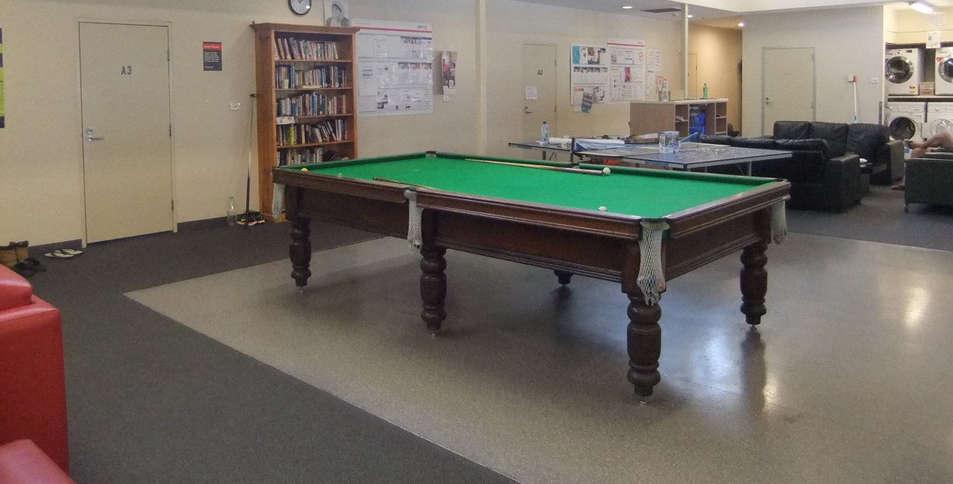
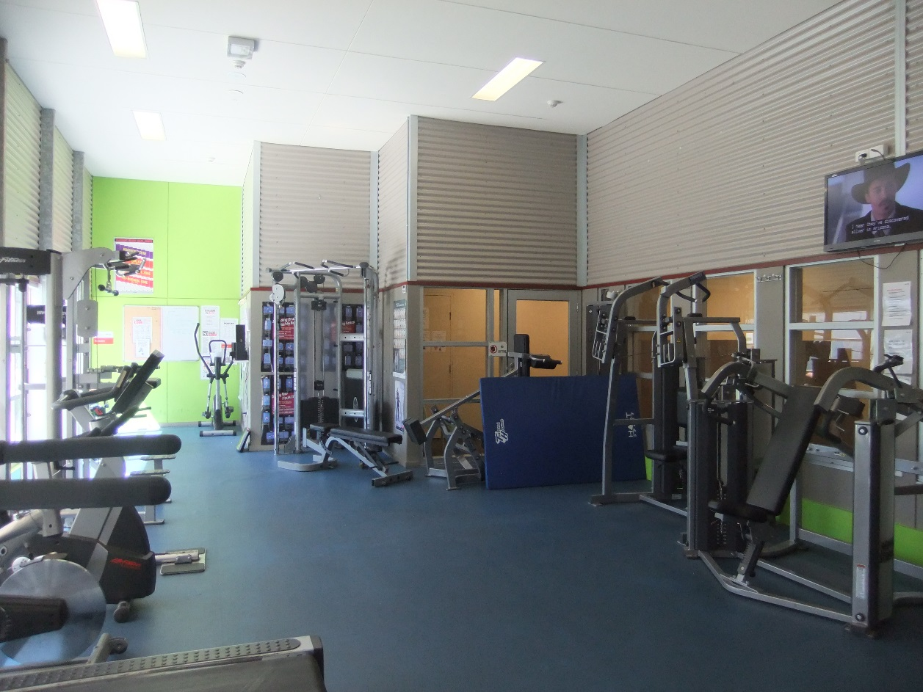

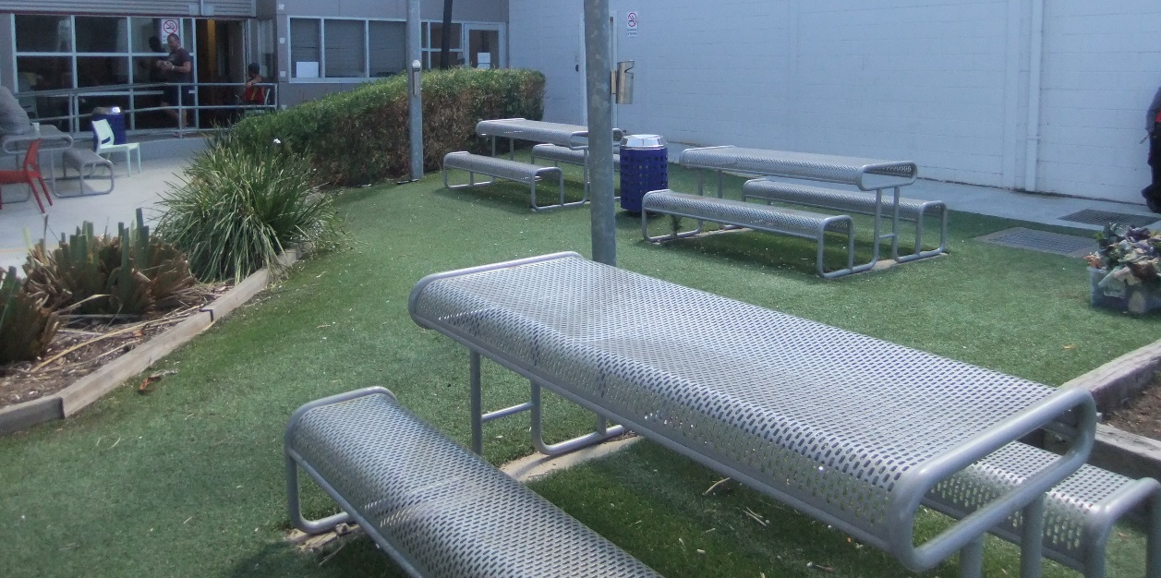

Facilities in Zone B
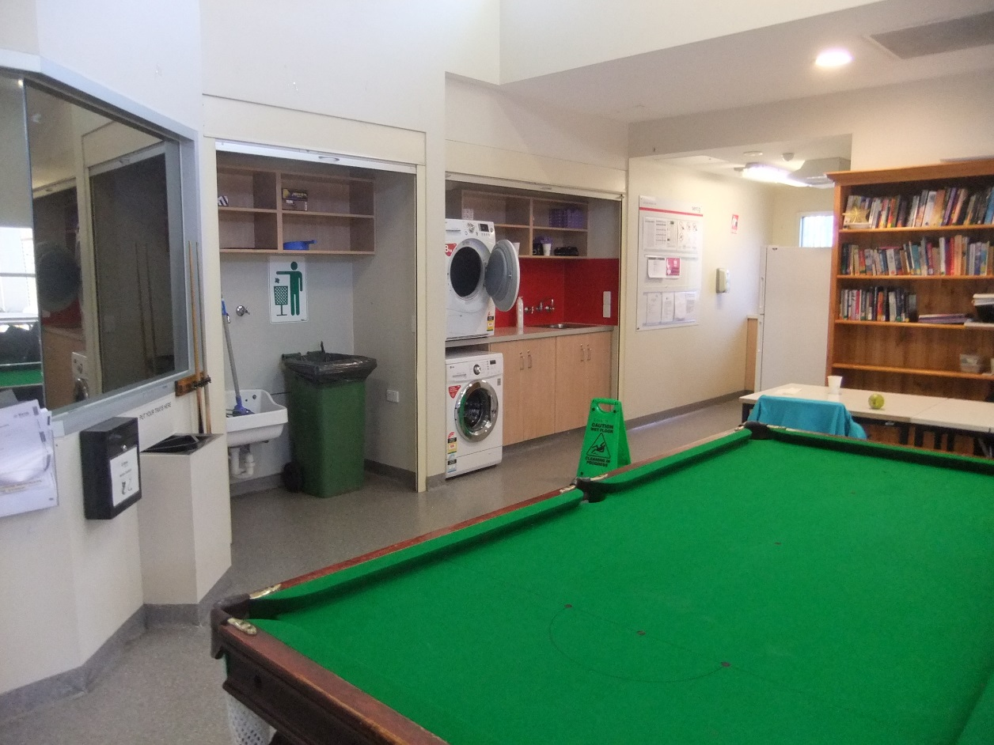
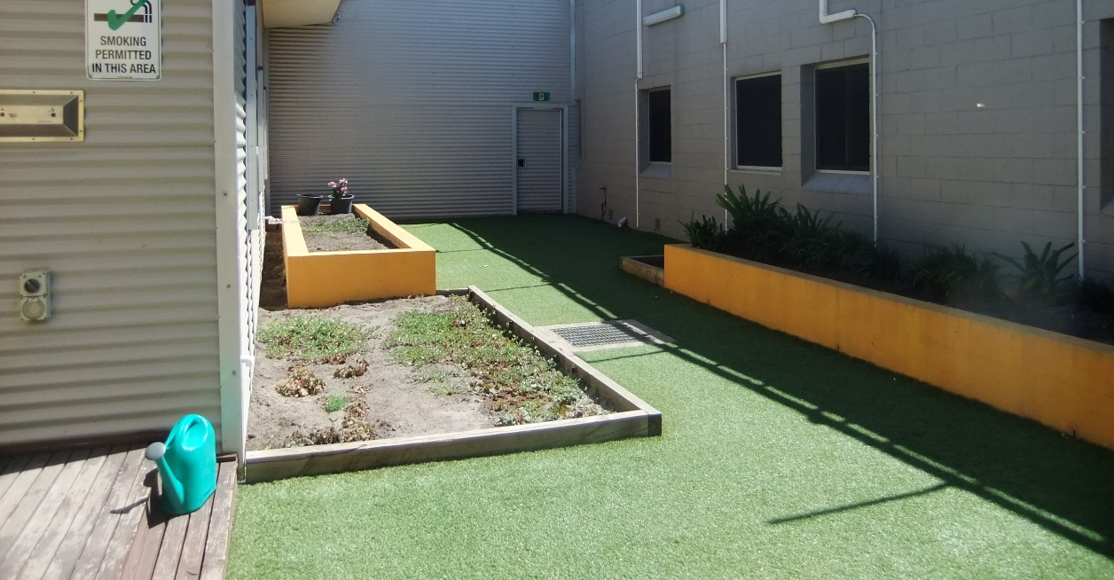

Facilities in Zone D
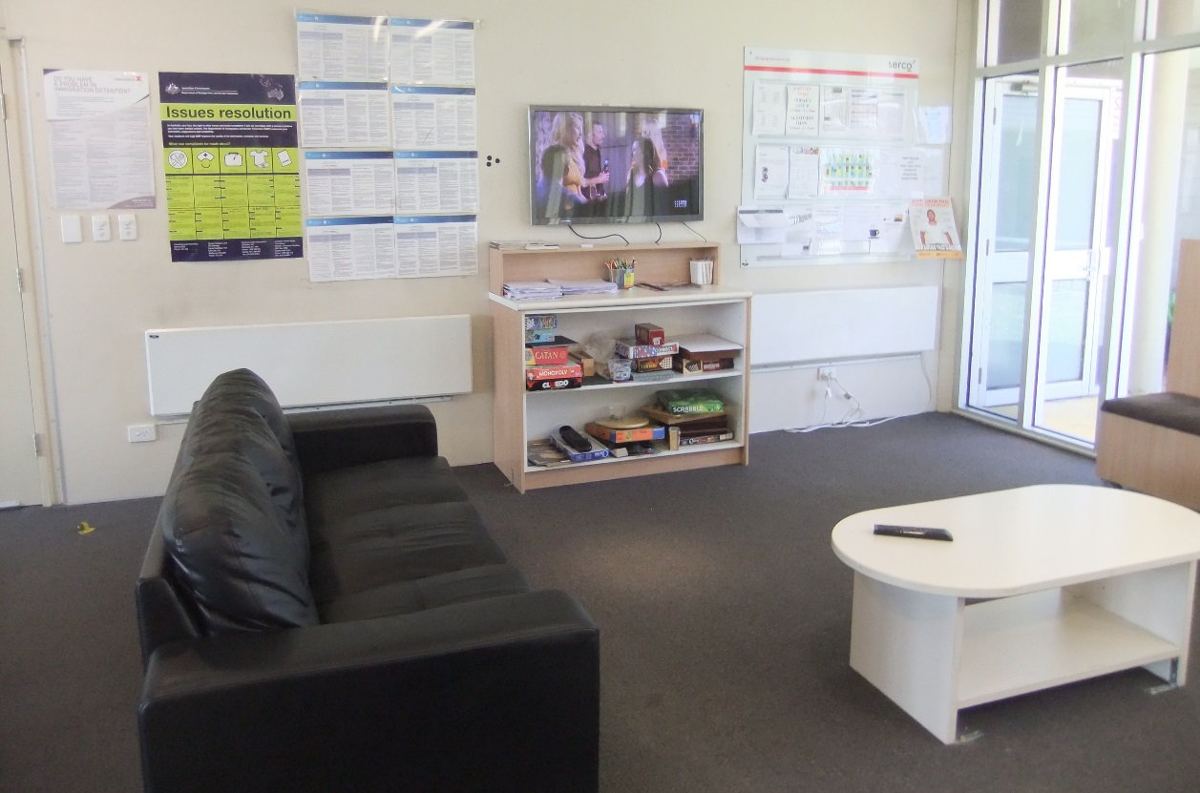
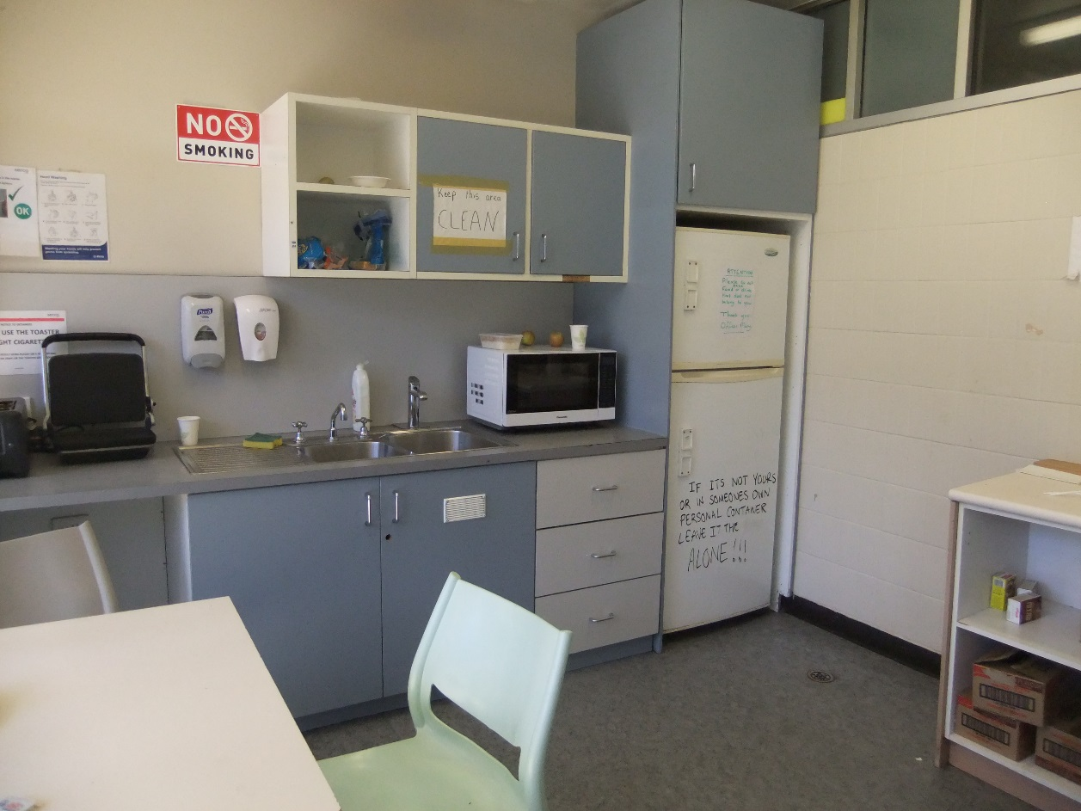
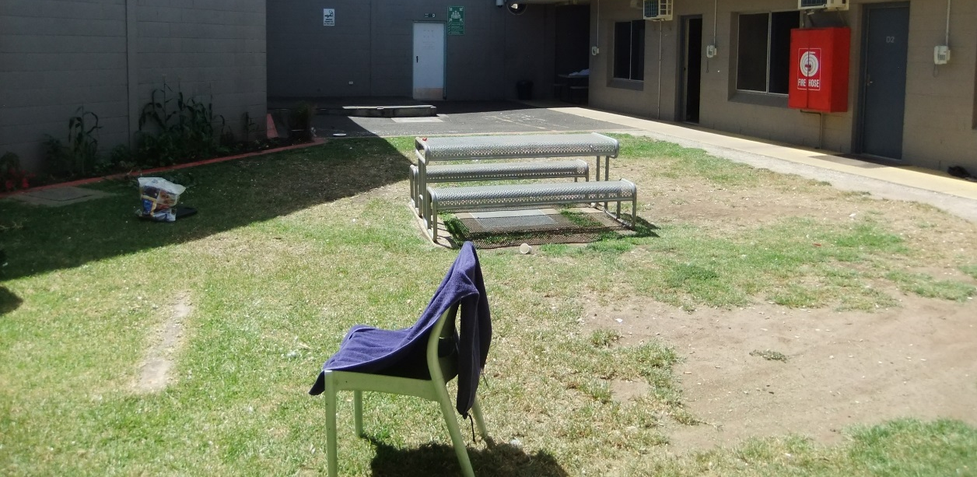

Facilities in Zone E
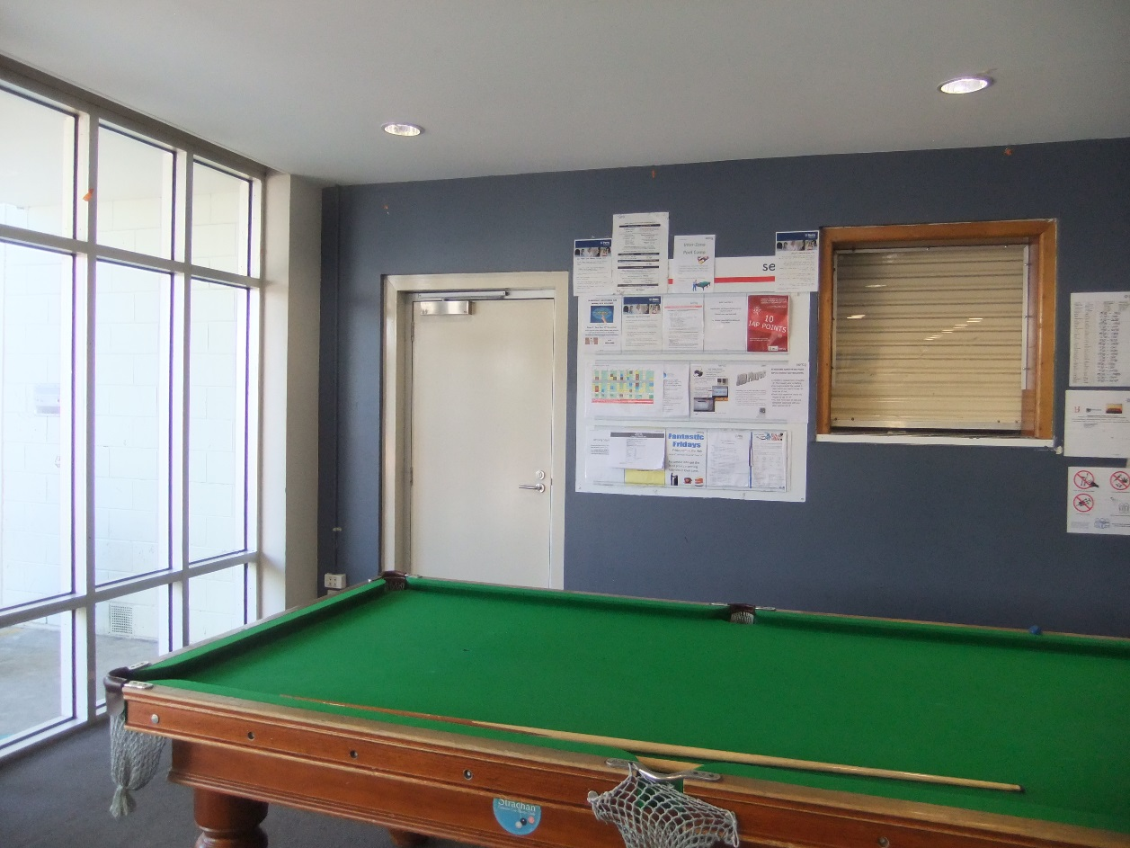
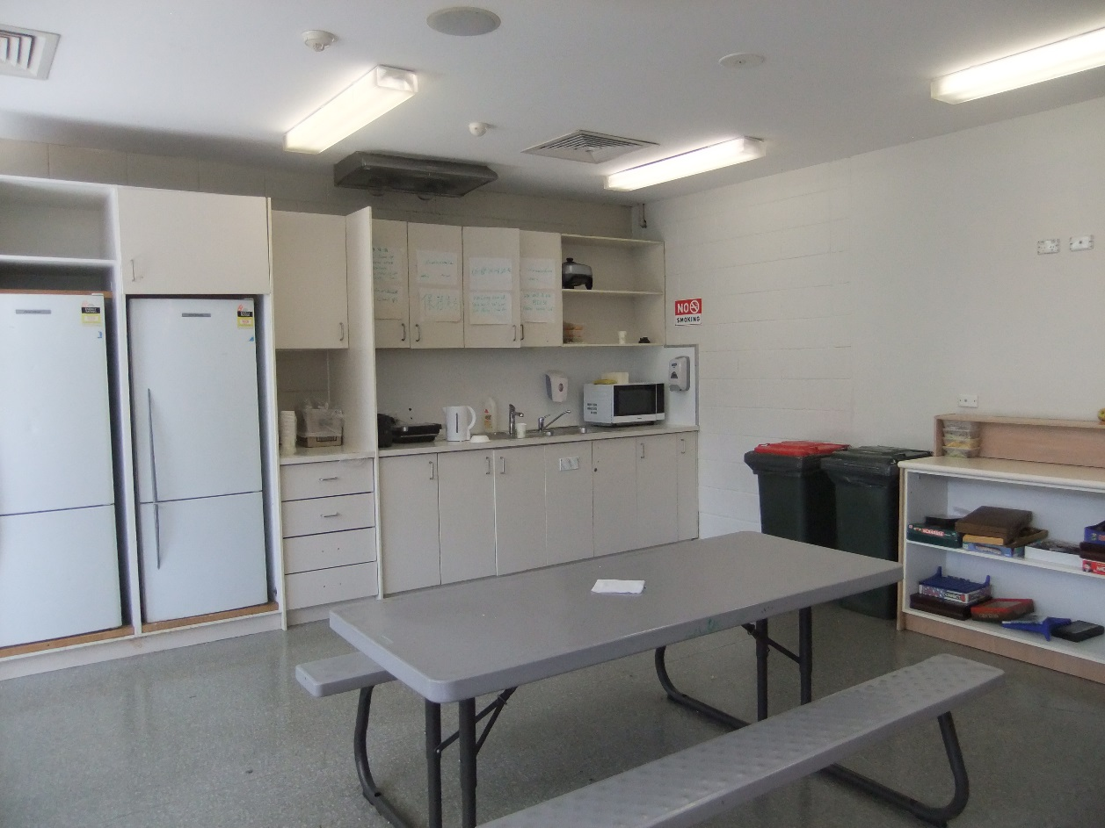
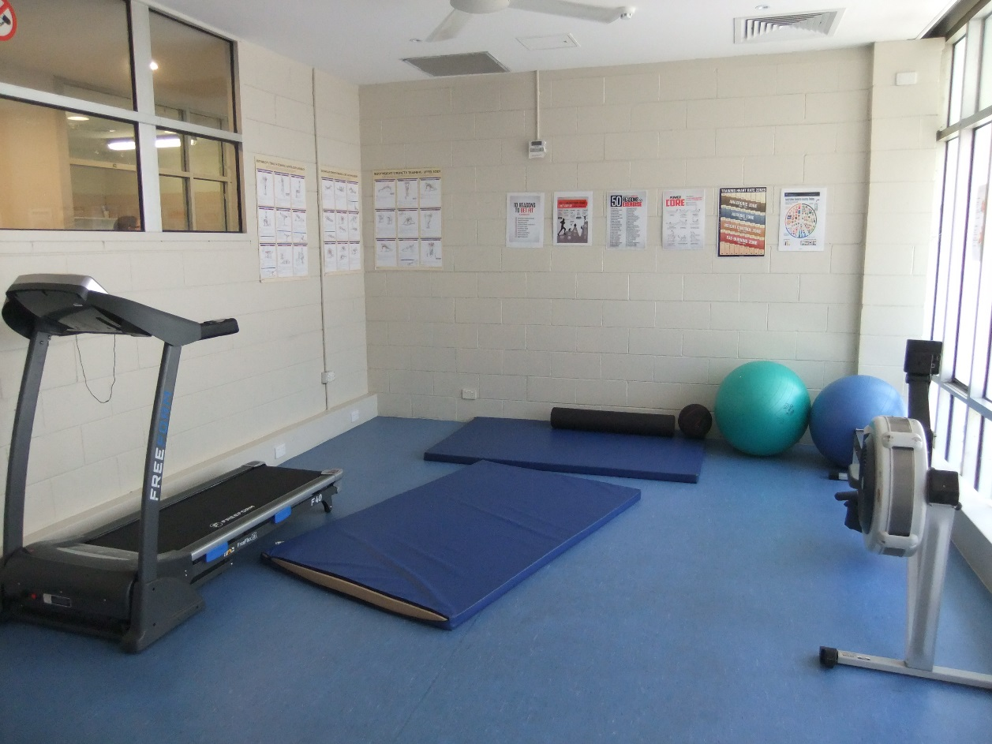

Facilities in Zone F
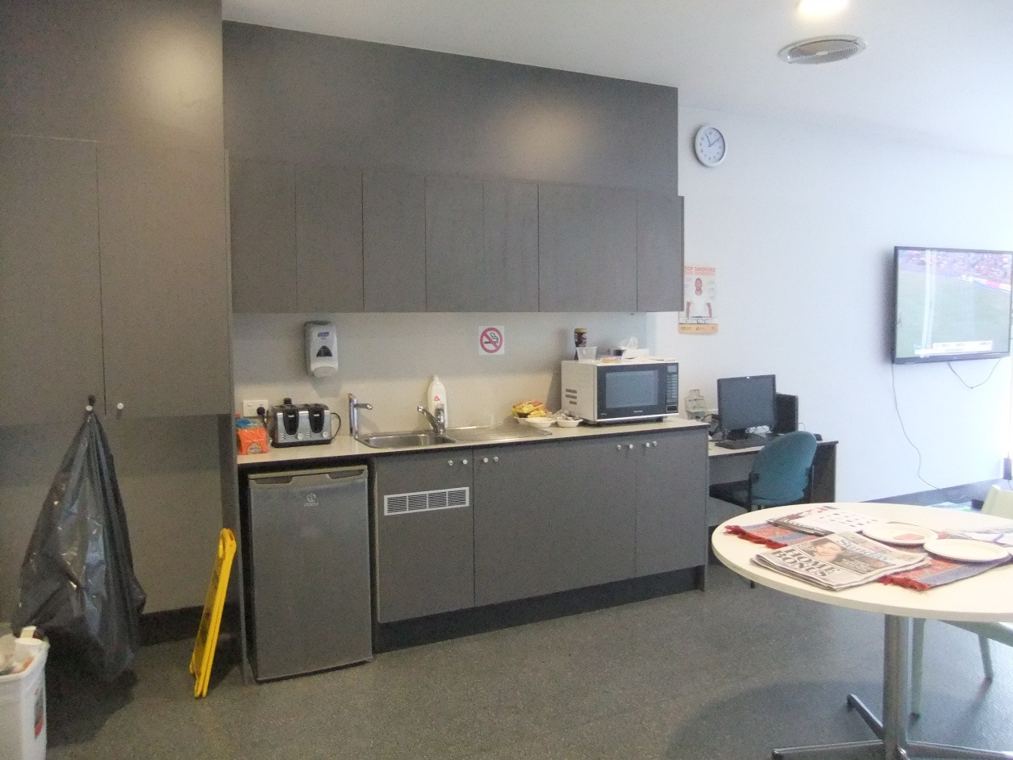
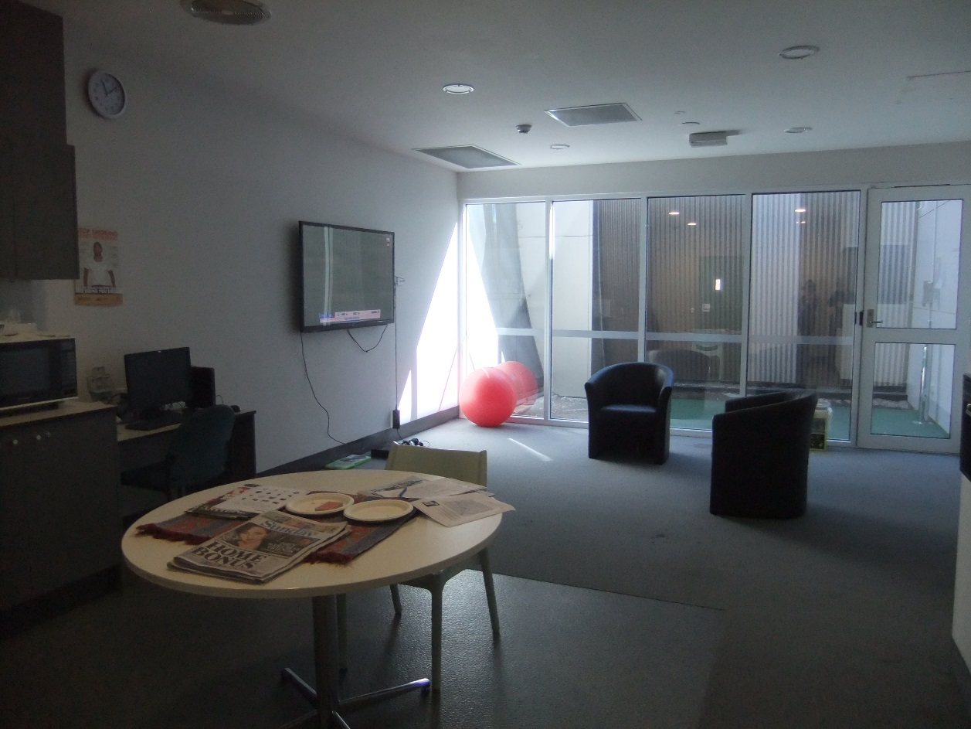

Shared facilities
Top to bottom: induction area, visits room, private interview room, mess, classroom, programs and activities hub.
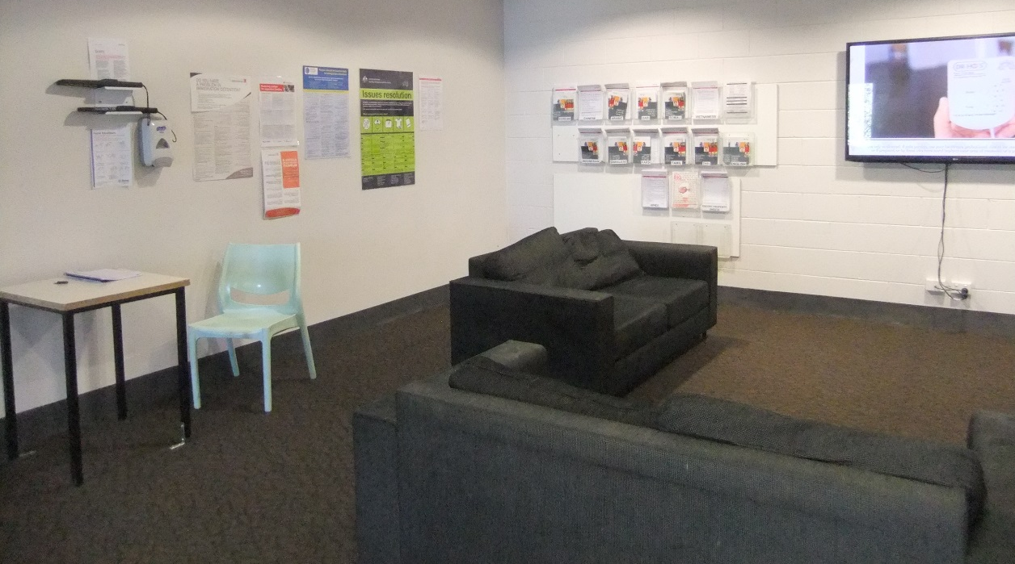
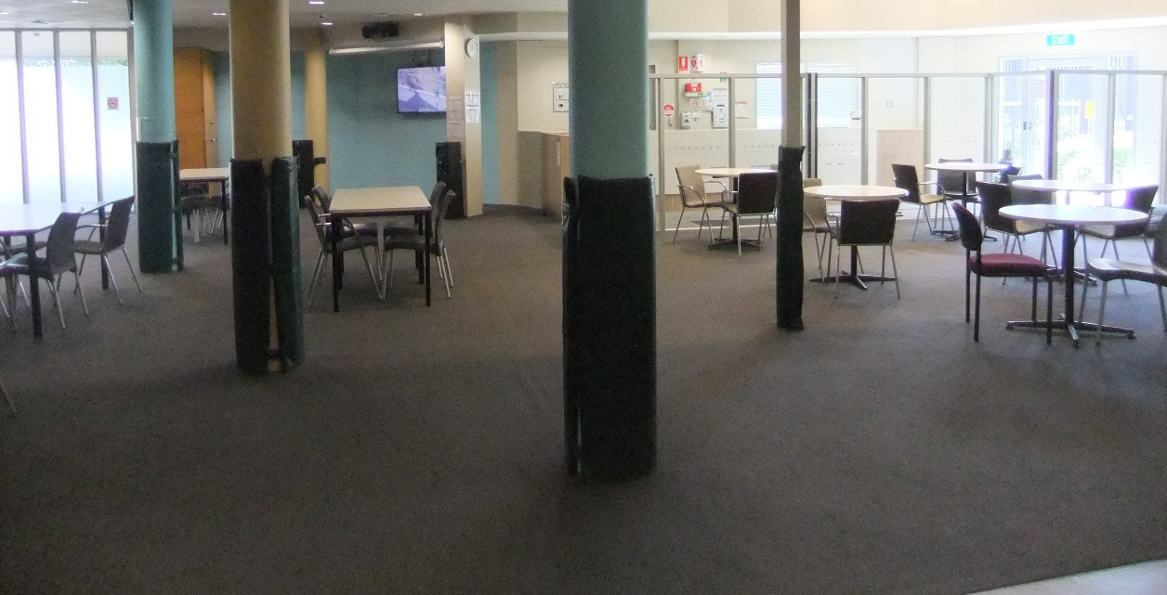
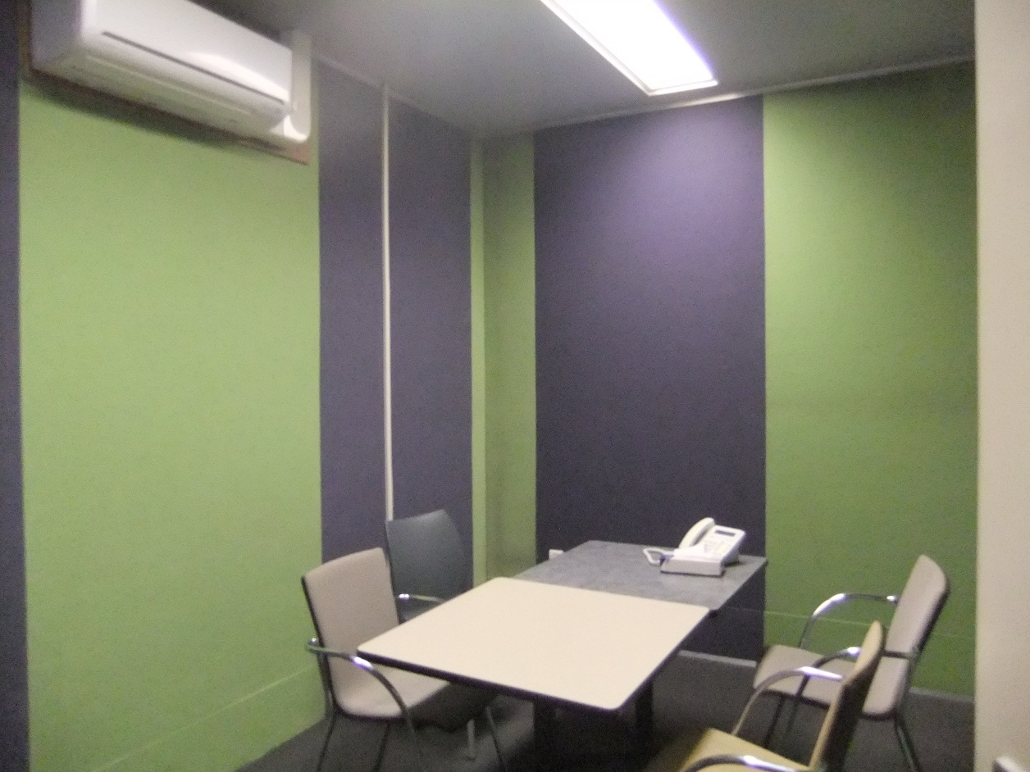
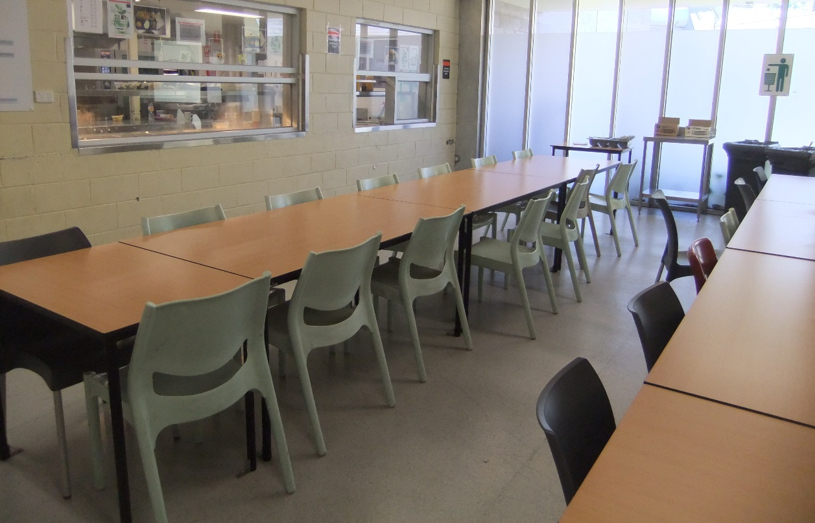

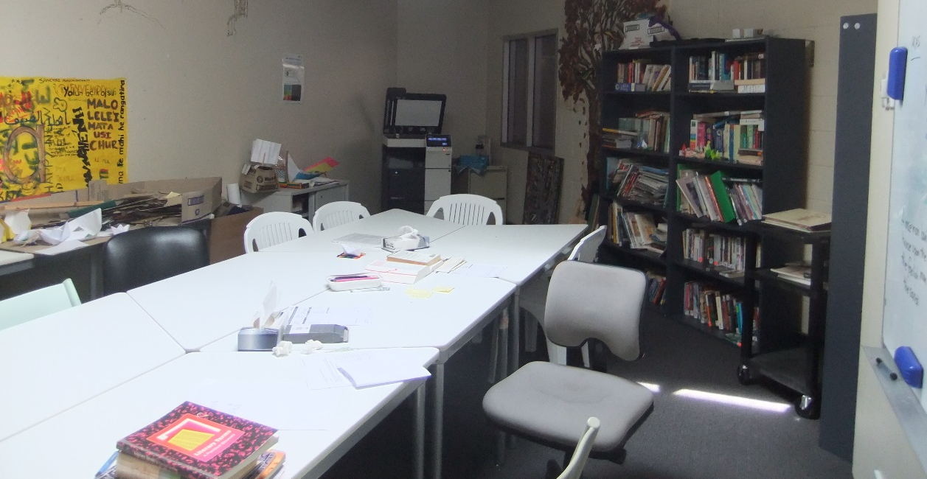
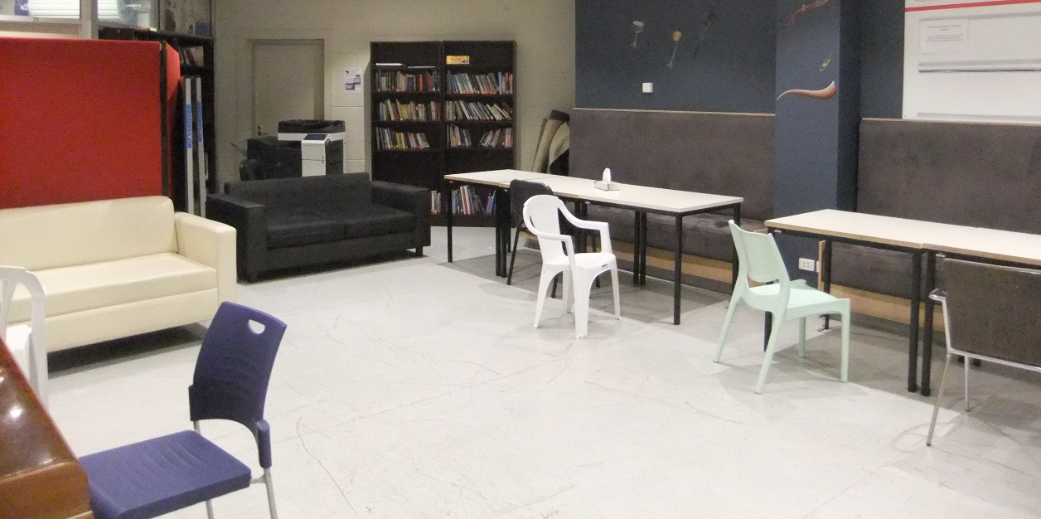

Endnotes

Reports from previous monitoring visits to immigration detention facilities can be found on the Commission’s website at https://www.humanrights.gov.au/our-work/asylum-seekers-and-refugees/immigration-detention-reports-and-photos
Human Rights and Equal Opportunity Commission, Those who've come across the seas: Detention of unauthorised arrivals (1998). At https://www.humanrights.gov.au/our-work/asylum-seekers-and-refugees/publications/those-whove-come-across-seas-detention (viewed 11 May 2017); Human Rights and Equal Opportunity Commission, A last resort? National Inquiry into Children in Immigration Detention (2004). At https://www.humanrights.gov.au/our-work/asylum-seekers-and-refugees/projects/last-resort-report-national-inquiry-children (viewed 11 May 2017); Australian Human Rights Commission, The Forgotten Children: National Inquiry into Children in Immigration Detention (2014). At https://www.humanrights.gov.au/our-work/asylum-seekers-and-refugees/projects/national-inquiry-children-immigration-detention-index (viewed 11 May 2017).
Australian Human Rights Commission, Asylum seekers, refugees and human rights: Snapshot Report (2nd edition) (2017) 11–25. At https://www.humanrights.gov.au/our-work/asylum-seekers-and-refugees/publications/asylum-seekers-refugees-and-human-rights-snapsho-0 (viewed 11 May 2017).
Australian Human Rights Commission, Human rights standards for immigration protection (2013). At https://www.humanrights.gov.au/our-work/asylum-seekers-and-refugees/publications/human-rights-standards-immigration-detention (viewed 11 May 2017).
International Covenant on Civil and Political Rights, opened for signature 16 December 1966, 999 UNTS 171 (entered into force 23 March 1976) arts 9(1), 10(1)
International Covenant on Civil and Political Rights, opened for signature 16 December 1966, 999 UNTS 171 (entered into force 23 March 1976) art 7; Convention against Torture and Other Cruel, Inhuman or Degrading Treatment or Punishment, opened for signature 10 December 1984, 1465 UNTS 85 (entered into force 26 June 1987) arts 2(1), 16(1).
International Covenant on Economic, Social and Cultural Rights, opened for signature 16 December 1966, 993 UNTS 3 (entered into force 3 January 1976) arts 6(2), 11, 12, 13, 15(1a).
International Covenant on Civil and Political Rights, opened for signature 16 December 1966, 999 UNTS 171 (entered into force 23 March 1976) arts 7, 10(1); Convention against Torture and Other Cruel, Inhuman or Degrading Treatment or Punishment, opened for signature 10 December 1984, 1465 UNTS 85 (entered into force 26 June 1987) arts 2(1), 16(1).
International Covenant on Civil and Political Rights, opened for signature 16 December 1966, 999 UNTS 171 (entered into force 23 March 1976) arts 17, 18.
International Covenant on Civil and Political Rights, opened for signature 16 December 1966, 999 UNTS 171 (entered into force 23 March 1976) arts 19(b), 22, 27.
International Covenant on Economic, Social and Cultural Rights, opened for signature 16 December 1966, 993 UNTS 3 (entered into force 3 January 1976) art 15(1a).
International Covenant on Civil and Political Rights, opened for signature 16 December 1966, 999 UNTS 171 (entered into force 23 March 1976) art 23(1); International Covenant on Economic, Social and Cultural Rights, opened for signature 16 December 1966, 993 UNTS 3 (entered into force 3 January 1976) art 10(1).
International Covenant on Civil and Political Rights, opened for signature 16 December 1966, 999 UNTS 171 (entered into force 23 March 1976) art 17(1); Convention on the Rights of the Child, opened for signature 20 November 1989, 1577 UNTS 3 (entered into force 2 September 1990) art 16(1).
Convention against Torture and Other Cruel, Inhuman or Degrading Treatment or Punishment, opened for signature 10 December 1984, 1465 UNTS 85 (entered into force 26 June 1987) arts 13, 16(1).
International Covenant on Civil and Political Rights, opened for signature 16 December 1966, 999 UNTS 171 (entered into force 23 March 1976) art 9(1)
Human Rights Committee, Van Alphen v Netherlands, Communication No. 305/1988, UN Doc CCPR/C/39/D/305/1988 (23 July 1990) [5.8]. At http://www.refworld.org/docid/525414304.html (viewed 7 December 2016); Human Rights Committee, A v Australia, Communication No. 560/1993, UN Doc CCPR/C/59/D/560/1993 (3 April1997) [9.4]. At http://www.refworld.org/docid/3ae6b71a0.html (viewed 7 December 2016).
International Covenant on Civil and Political Rights, opened for signature 16 December 1966, 999 UNTS 171 (entered into force 23 March 1976) arts 9(2), 9(4)
Department of Immigration and Citizenship, Immigration Detention Statistics Summary (30 April 2012) 3.
Department of Immigration and Citizenship, Immigration Detention Statistics Summary (31 July 2013) 3–4. At http://www.border.gov.au/ReportsandPublications/Documents/statistics/immigration-detention-statistics-july2013.pdf (viewed 12 May 2017); Department of Immigration and Border Protection, Immigration Detention and Community Statistics Summary (28 February 2015) 3, 5. At http://www.border.gov.au/ReportsandPublications/Documents/statistics/immigration-detention-statistics-feb2015.pdf (viewed 12 May 2017).
Department of Immigration and Citizenship, Immigration Detention Statistics Summary (31 July 2013) 3, 7. At http://www.border.gov.au/ReportsandPublications/Documents/statistics/immigration-detention-statistics-july2013.pdf (viewed 12 May 2017); Department of Immigration and Border Protection, Immigration Detention and Community Statistics Summary (28 February 2015) 3, 8. At http://www.border.gov.au/ReportsandPublications/Documents/statistics/immigration-detention-statistics-feb2015.pdf (viewed 12 May 2017).
Department of Immigration and Border Protection, Immigration Detention and Community Statistics Summary (31 March 2017) 4, 6. At http://www.border.gov.au/ReportsandPublications/Documents/statistics/immigration-detention-statistics-31-march-2017.pdf (viewed 24 May 2017).
Department of Immigration and Citizenship, Immigration Detention Statistics Summary (30 April 2012) 8; Department of Immigration and Citizenship, Immigration Detention Statistics Summary (31 July 2013) 9. At http://www.border.gov.au/ReportsandPublications/Documents/statistics/immigration-detention-statistics-july2013.pdf (viewed 12 May 2017).
Department of Immigration and Border Protection, Immigration Detention and Community Statistics Summary (31 January 2017) 11. At http://www.border.gov.au/ReportsandPublications/Documents/statistics/immigration-detention-statistics-31-jan-2017.pdf (viewed 12 May 2017).
Department of Immigration and Border Protection, Immigration Detention and Community Statistics Summary (31 March 2017) 11. At http://www.border.gov.au/ReportsandPublications/Documents/statistics/immigration-detention-statistics-31-march-2017.pdf (viewed 24 May 2017).
Department of Immigration and Citizenship, Immigration Detention Statistics Summary (30 April 2012) 8.
Department of Immigration and Citizenship, Immigration Detention Statistics Summary (31 July 2013) 9. At http://www.border.gov.au/ReportsandPublications/Documents/statistics/immigration-detention-statistics-july2013.pdf (viewed 12 May 2017);
Department of Immigration and Border Protection, Immigration Detention and Community Statistics Summary (31 March 2017) 11. At http://www.border.gov.au/ReportsandPublications/Documents/statistics/immigration-detention-statistics-31-march-2017.pdf (viewed 24 May 2017).
Department of Immigration and Border Protection, Immigration Detention and Community Statistics Summary (31 March 2017) 4. At http://www.border.gov.au/ReportsandPublications/Documents/statistics/immigration-detention-statistics-31-march-2017.pdf (viewed 24 May 2017).
Janet Phillips, Boat arrivals and boat ‘turnbacks’ in Australia since 1976: a quick guide to the statistics (17 January 2017). At http://www.aph.gov.au/About_Parliament/Parliamentary_Departments/Parliamentary_Library/pubs/rp/rp1617/Quick_Guides/BoatTurnbacks (viewed 26 June 2017); Peter Dutton, Minister for Immigration and Border Protection, ‘1000 days of strong and secure borders’ (Media Release, 23 April 2017). At http://www.minister.border.gov.au/peterdutton/Pages/1000-days-strong-secure-borders.aspx (viewed 26 June 2017).
Department of Immigration and Citizenship, Immigration Detention Statistics Summary (30 April 2012) 5.
See the Department of Immigration and Border Protection’s immigration detention statistics summaries, available at http://www.border.gov.au/about/reports-publications/research-statistics/statistics/live-in-australia/immigration-detention (viewed 12 May 2017).
Migration Amendment (Character and General Visa Cancellation) Act 2014 (Cth)
Department of Immigration and Border Protection, Key visa cancellation statistics (n.d.). At http://www.border.gov.au/about/reports-publications/research-statistics/statistics/key-cancellation-statistics (viewed 29 November 2016).
Department of Immigration and Border Protection, Immigration Detention and Community Statistics Summary (31 March 2017) 4, 7. At http://www.border.gov.au/ReportsandPublications/Documents/statistics/immigration-detention-statistics-31-march-2017.pdf (viewed 24 May 2017).
Louise K Newman, Nicholas G Procter and Michael J Dudley, ‘Suicide and self-harm in immigration detention’ (2011) 195(6) Medical Journal of Australia 310; Melissa Bull et al, ‘Sickness in the System of Long-term Immigration Detention’ (2013) 26 Journal of Refugee Studies 47; Ilan Katz et al, The experiences of Irregular Maritime Arrivals detained in immigration detention facilities: Final report (2013). At http://www.border.gov.au/ReportsandPublications/Documents/research/IMA-experiences-IDF.pdf (viewed 7 December 2016).
Department of Immigration and Border Protection, ‘New measures to combat illegal activity within immigration detention facilities’ (Media Release, 11 November 2016). At http://newsroom.border.gov.au/releases/new-measures-to-combat-illegal-activity-within-immigration-detention-facilities (viewed 26 May 2017).
Migration Act 1958 (Cth), ss 189, 196.

