Australian Human Rights Commission Inspection of Melbourne Immigration Transit Accommodation: Report

9–10 March 2017

Table of Contents
1 Introduction 5
2 Background 6
2.1 Previous monitoring visits 6
2.2 Inspection methodology 6
2.3 Relevant human rights standards 7
(a) Treatment of people in detention 7
(b) Conditions of detention 7
(c) Communication, association and complaints 8
(d) Legal and policy framework 9
2.4 National context 9
(a) Number of people in detention 9
(b) Length of detention 9
(c) Reasons for detention 10
(d) Administration of the detention network 10
(e) Ratification of OPCAT 10
2.5 Melbourne Immigration Transit Accommodation 11
3 Key issues and concerns 12
3.1 Treatment of people in detention 12
(a) Induction process 12
(b) General safety and security 12
(c) Relationships with staff 12
(d) Use of force and restraints 13
(e) Transfers between detention facilities 14
(f) Other invasive and restrictive measures 14
3.2 Conditions of detention 15
(a) Controlled movement policy 15
(b) Accommodation and living areas 16
(c) Indoor and outdoor exercise 16
(d) Activities and excursions 17
(e) Food 18
(f) Personal items 18
3.3 Physical and mental health 19
(a) Health services 19
(b) Physical health 19
(c) Mental health 20
3.4 Communication and complaints 21
(a) Telephone access 21
(b) Computer and internet access 22
(c) Visits 22
(d) Complaints 23
3.5 Legal and policy framework 24
(a) Mandatory detention 24
(b) Prolonged and indefinite detention 25
(c) Community alternatives to detention 26
(d) Case management and status resolution 27
4 Summary of recommendations 29
4.1 Recommendations to the Australian Government 29
4.2 Joint recommendations to the Department of Immigration and Border Protection and facility staff 29
4.3 Recommendations to the Minister and Department of Immigration and Border Protection 30
4.4 Recommendations to facility staff 31
5 Appendix: Photos taken during the Commission’s inspection 33
5.1 Facilities in Avon compound 33
5.2 Facilities in Bass compound 37
5.3 Facilities in Calder compound 38
5.4 Shared facilities 42
Endnotes 45

Summary of key issues
The use of restraints during escort (particularly to medical appointments) may have at times been excessive, had clearly caused significant distress among people detained at the MITA and may be deterring some individuals from seeking medical care.
The implementation of a ‘controlled movement’ policy at the MITA has had a significant impact on living conditions, freedom of movement and access to facilities, given the major differences between the three compounds currently in use.
Current accommodation facilities at the MITA afford limited space and privacy. This is of particular concern given the very long periods of time for which many people at the MITA have been detained.
Outdoor exercise facilities at the MITA may not be adequate for people in Bass compound, who remain confined to a relatively small and cramped compound with limited open space for most of the day.
The reduction in both the number and variety of excursions offered to people at the MITA is of concern, particularly given the length of time for which many people at the MITA have been detained and the limited space for outdoor recreation in Bass compound.
There is a clearly significant level of concern among people detained at the MITA about physical health care and the impact of detention on mental health. The Commission was particularly concerned by the number of people who expressed a sense of hopelessness about their situation.
The new policy prohibiting all mobile phone use may restrict access to external communication to a greater degree than is necessary to ensure safety and security, particularly in a lower-security facility like the MITA.
Many people at the MITA have been detained for prolonged periods of time. Most of the people interviewed by the Commission reported that they had been in immigration detention for at least a year, including a considerable number who had been detained for between four and seven years.
Many of the people interviewed by the Commission evidently had a poor understanding of the reasons for their ongoing detention, and expressed significant confusion, frustration and distress about their current situation and lack of progress with status resolution.
The reduction in the scope of the case manager role and its present limitations lead to a mismatch between the types of support that case managers can provide to people in detention, and the types of support that people in detention actually need, including to resolve their status. This support is particularly critical for people with complex cases who have been detained for the prolonged periods of time, a category into which many of the people interviewed by the Commission at the MITA would fall.

Introduction
This report contains an overview of key observations and concerns arising from the Australian Human Rights Commission’s inspection of the Melbourne Immigration Transit Accommodation (MITA) detention facility in March 2017.
The rationale for the Commission undertaking such inspections is to identify problems in the way that detainees’ human rights are being protected and to suggest ways of addressing those problems. Hence, while the report is balanced and points to some good practices, its primary focus is on issues of concern identified by the Commission. The report reflects conditions as they were at the time of the inspection.
The Commission also raised a number of additional issues with the Department of Immigration and Border Protection (DIBP) and facility staff during and subsequent to the inspection, including individual cases of concern.
The Commission acknowledges the assistance provided by DIBP and the Australian Border Force (ABF) in facilitating the Commission’s inspection. The Commission is grateful to the DIBP and ABF officers and detention service provider staff who assisted the Commission team during the inspection. A draft of this report was shared with DIBP in advance of its publication, to provide an opportunity for DIBP to respond to the identified issues.

Background

Previous monitoring visits
The Commission has conducted visits to immigration detention facilities in Australia since the mid-1990s. This has included periodic monitoring of detention facilities across the country and three major national inquiries into immigration detention.
The purpose of the Commission’s detention monitoring work is to ensure that Australia’s immigration detention system is compliant with our obligations under international human rights law. For many years, the Commission has expressed a range of concerns about aspects of the detention system that may lead to breaches of international human rights law. These include:
- the policy of mandatory immigration detention, which does not allow for adequate consideration of individual circumstances and can result in cases of arbitrary detention
- the indefinite and at times prolonged nature of immigration detention and the lack of a legislative time limit on detention
- the detention of children, which has led to breaches of numerous obligations under the Convention on the Rights of the Child (CRC)
- the indefinite detention of people who have received adverse security or character assessments, including in circumstances where they have not been convicted of a crime under Australian law
- conditions of detention, which in some cases have not met international standards
- the impacts of immigration detention on mental health
- the need for increased use of alternatives to immigration detention.
Further information about these concerns can be found in the Commission publication, Asylum Seekers, Refugees and Human Rights: Snapshot Report 2017.
The Commission can also investigate and, where appropriate, try to resolve through conciliation, complaints it receives from people in immigration detention regarding alleged breaches of human rights.

Inspection methodology
The Commission inspected the MITA on 9 and 10 March 2017. The inspection was conducted by three Commission staff and Mr Guy Coffey, a clinical psychologist who joined the inspection team as an independent mental health consultant.
During the inspection, the Commission team met with representatives from DIBP, ABF, Serco and International Health and Medical Services (IHMS); conducted an inspection of the facility; and held individual private interviews with 42 people detained at the MITA.
The Commission considered the evidence gathered during the inspection against human rights standards derived from international law that are relevant to immigration detention.

Relevant human rights standards
This section provides a summary of some of the key international human rights standards relevant to the situation of people in immigration detention. Further information about these and other relevant standards can be found in the Commission publication, Human rights standards for immigration detention.
At the time of the Commission’s inspection, there were no children detained at the MITA. As such, standards relating to the detention of children were not applicable to this inspection.

Treatment of people in detention
Australia is obliged under articles 9(1) and 10(1) of the International Covenant on Civil and Political Rights (ICCPR) to, respectively, uphold the right to security of the person and ensure that people in detention are treated with humanity and respect for the inherent dignity of the human person. Australia also has obligations under article 7 of the ICCPR and articles 2(1) and 16(1) of the Convention Against Torture and other Cruel, Inhuman or Degrading Treatment or Punishment (CAT) not to subject anyone to torture or to cruel, inhuman or degrading treatment or punishment, and to take effective measures to prevent these acts from occurring.
These obligations require Australia to ensure that people in detention are treated fairly and reasonably, and in a manner that upholds their dignity. They should enjoy a safe environment free from bullying, harassment, abuse and violence. Security measures should be commensurate with identified risks, and should be the least restrictive possible in the circumstances, taking into account the particular vulnerabilities of people in detention. Measures that may constitute torture or cruel, inhuman or degrading treatment or punishment (such as collective punishment, corporal punishment, excessive use of force and holding people incommunicado) should be prohibited.

Conditions of detention
Australia has a range of obligations under the International Covenant on Economic, Social and Cultural Rights (ICESCR) relevant to the material conditions of immigration detention. These include the right to education (articles 6(2) and 13); the right to an adequate standard of living, including adequate food, clothing and housing (article 11); the right to the highest attainable standard of health (article 12); and the right to take part in cultural life (article 15(1)(a)).
Australia’s obligations under the ICCPR and CAT to treat people in detention with humanity and respect, and not to subject anyone to cruel, inhuman or degrading treatment or punishment, are also relevant to conditions of detention. In addition, Australia has an obligation under articles 17 and 18 of the ICCPR to uphold the right to privacy and freedom of religion respectively.
These obligations require Australia to ensure that detention facilities are safe, hygienic and uphold human dignity. People in detention should have their basic needs met and have access to essential services (such as health care and primary and secondary education) to a standard commensurate with those provided in the Australian community.
People in detention should have opportunities to engage in meaningful activities and excursions that provide physical and mental stimulation. People in detention should also be able to profess and practise the religion of their choice, including through being able to attend religious services, receiving pastoral visits from religious representatives and celebrating major religious holidays and festivals.
In light of the negative impacts of detention on mental health, the length of detention should be limited to the minimum period necessary to achieve a legitimate aim, and community-based alternatives to detention should be used wherever feasible.

Communication, association and complaints
Australia has a range of obligations under the ICCPR relevant to communication between people in detention and their family members, friends, representatives and communities outside detention. These include the right to freedom of expression and to seek, receive and impart information and ideas (article 19(b)); the right to freedom of association with others (article 22); and the right of ethnic, religious and linguistic minorities, in community with the other members of their group, to enjoy their own culture, to profess and practise their own religion and to use their own language (article 27). Under the ICESCR, Australia also has an obligation to uphold the right to take part in cultural life (article 15(1)(a)).
In addition, Australia has obligations under articles 23(1) of the ICCPR and 10(1) of the ICESCR to afford protection and assistance to the family as the natural and fundamental group unit of society. Australia also has obligations under article 17(1) of the ICCPR and article 16(1) of the CRC not to subject anyone to arbitrary or unlawful interference with their family.
These obligations require Australia to ensure that detention does not have a disproportionate impact on people’s ability to express themselves, communicate and associate with others, and remain in contact with their family members, friends, representatives and communities. People in detention should be able to receive regular visits, and should have access to adequate communication facilities (such as telephones and computers) as well as news and library services. People in detention should, if possible, be located in facilities within a reasonable distance from their family members, friends and communities.
External communication, in particular access to complaints processes, is also essential for the prevention of torture and other cruel, inhuman or degrading treatment or punishment. Australia has obligations under articles 13 and 16(1) of the CAT to ensure that anyone who alleges that they have been subjected to torture or to cruel, inhuman or degrading treatment or punishment, has the right to complain to and have their case examined by competent authorities.
To ensure these obligations are upheld, people in detention should have opportunities to raise concerns and issues regarding treatment and conditions in detention, and make complaints both internally and to independent monitors (including the Commission and the Commonwealth Ombudsman), without fear of repercussions.

Legal and policy framework
Australia has an obligation under article 9 of the ICCPR not to subject anyone to arbitrary detention. According to the United Nations Human Rights Committee, ‘arbitrary detention’ includes detention which, although lawful under domestic law, is unjust or disproportionate. In order for the detention of a person not to be arbitrary, it must be a reasonable and necessary measure in all the circumstances.
Australia has further obligations under article 9 of the ICCPR to ensure that anyone who is arrested has the right to be informed of the reasons for their arrest and the charges against them, and that anyone who is detained has the right to challenge the legality of their detention in court.
These obligations require Australia to ensure that people are only detained in immigration detention facilities when it is reasonable and necessary in their individual circumstances (such as where they pose an unacceptable health or security risk), and for a limited period of time. Community-based alternatives to detention should be used wherever possible. People held in immigration detention should be informed of the reasons for their detention and be able to seek juridical review of whether their detention is arbitrary.

National context
The Commission last visited the MITA in May 2014, as part of the National Inquiry into Children in Immigration Detention. Since that time, there have been a number of significant changes in the legal, policy and operational context surrounding Australia’s immigration detention system.

Number of people in detention
The number of people in closed immigration detention, and particularly the number of children in detention, has reduced dramatically in recent years. The total number peaked at over 10,000 in July 2013, before declining to fewer than 2,000 in early 2015. The number of children in detention dropped from a high of almost 2,000 in July 2013 to fewer than 200 in early 2015.
As at March 2017, there were 1,328 people in detention, including just two children. This is the lowest level since 2009.

Length of detention
While the overall number of people in detention has declined, the average length of detention has increased significantly. In July 2013, the average length of detention was 72 days. Since then, the average has steadily increased. At the time of the Commission’s last visit to the MITA in May 2014, the average length of detention stood at 324 days and was steadily increasing. The average peaked at 493 days in January 2017, before dropping slightly to 478 days in March 2017.
The number of people in long-term detention has also increased, particularly as a proportion of the overall detention population. In July 2013, 228 people, or around two per cent of people in detention, had been in detention for over a year. By May 2014, this had increased to 983 people, or just under a quarter of the detention population. As at March 2017, the number of people detained for over a year has dropped to 556 — but they represented 42 per cent of people in detention.

Reasons for detention
Until the beginning of 2014, the vast majority of people in detention were asylum seekers who arrived by boat. Since that time, asylum seekers have progressively comprised a smaller proportion of the detention population, although they remained by far the largest group in detention until 2016.
At the same time, the number of people in detention due to having their visas cancelled has increased. This increase has been largely due to legislative amendments that broadened the scope of section 501 of the Migration Act 1958 (Cth) (the Migration Act). Section 501 allows the Minister or their delegate to refuse or cancel a visa on the basis that a person does not pass the ‘character test’. Since this section was amended in late 2014, visa cancellations on character grounds have increased dramatically, from 76 cancellations in the 2013–14 financial year to 580 in 2014–15, and 983 in 2015–16.
As at March 2017, people who had had their visas cancelled under section 501 were the largest group in detention, comprising around a third of the detention population. Asylum seekers who arrived by boat comprised just under a third of the detention population, followed by people who had overstayed their visa and people who had had their visa cancelled on non-character grounds.

Administration of the detention network
At the time of the Commission’s last visit to the MITA, Australia’s immigration detention network was administered by DIBP.
On 1 July 2015, DIBP and the Australian Customs and Border Protection Service merged to form a single department. The ABF was established as the new frontline operational agency for this department. The ABF is now responsible for administering detention operations and removals; while DIBP remains responsible for the overall policy framework for detention, as well as matters relating to visa processing, case management and status resolution.
As was the case in 2014, external contractors continue to play a central role in the management of immigration detention facilities. Serco Australia remains the contracted detention services provider, responsible for the day-to-day running of the facilities including security and provision of services and activities. IHMS remains the contracted health services provider, responsible for providing onsite physical and mental health services to people in detention.

Ratification of OPCAT
On 9 February 2017, the Australian Government announced its commitment to ratify the Optional Protocol to the Convention Against Torture and other Cruel, Inhuman or Degrading Treatment or Punishment (OPCAT) by December 2017. OPCAT provides for ongoing independent monitoring of places of detention, to ensure adherence to minimum standards in conditions and treatment.
At the request of the Attorney-General, the Commission is undertaking a consultation process regarding how best to implement OPCAT. Based on the experience in jurisdictions that have ratified and implemented OPCAT, the Commission sees this as an opportunity to consider, in a more systematic way, the adequacy and appropriateness of conditions of detention. The Commission looks forward to continuing to work with the Government to support the implementation of OPCAT.

Melbourne Immigration Transit Accommodation
The MITA was built in 2008. It is a low-security detention facility which accommodates single adult men, single adult women and couples across four compounds. The MITA was originally designed as a short-term detention facility for people who arrived in Australia by air but were not immigration cleared, and were to be deported rapidly after their arrival (referred to as ‘airport turnarounds’). The facility was subsequently expanded to accommodate asylum seekers who arrived in Australia by boat, including a significant number of children.
The Avon compound accommodates single adult males, new arrivals and airport turnarounds. The Bass compound, which is the newest compound at the MITA, accommodates single adult men. The Calder compound, previously used for families and children, accommodates single adult women and couples. The Eilden compound was not in use at the time of the Commission’s inspection.
At the time of the Commission’s inspection, there were 113 people detained at the MITA. This included 99 men and 14 women. Sixty of the people detained at the MITA were asylum seekers who had arrived by boat, around 20 of whom were subject to regional processing arrangements. Twenty-seven people at the MITA had been detained due to overstaying their visa, and a small number of people had had their visas cancelled on non-character grounds. None of the people detained at the MITA had had their visas cancelled under section 501 of the Migration Act. The most common countries of origin for people detained at the MITA included Sri Lanka, Iran, Malaysia, China and Pakistan.

Key issues and concerns

Treatment of people in detention

Induction process
A small number of people interviewed by the Commission reported that they had received limited information during the induction process, particularly regarding facility operating procedures. Overall, however, few people reported concerns about the induction process.

General safety and security
The MITA has traditionally been a low-security detention facility. However, staff indicated that the MITA is gradually transitioning from a low-security facility catering for people seeking asylum and family groups, to a higher-security facility with capacity to accommodate people with a variety of risk profiles. Staff reported that significant infrastructure works have been undertaken and further works are planned to facilitate this transition.
Security features observed by staff including a new external fence (installed in November 2015), high internal fences, secure doors and security cameras. In addition, the MITA now operates under a ‘controlled movement’ policy (see Section 3.2(a)).
A number of people interviewed by the Commission indicated that they felt safe in detention. Where people reported feeling unsafe, this was generally due to uncertainty about their status or concerns about their future, rather than because of any immediate threat to their physical safety.
However, some people noted the increasing restrictiveness of the detention environment at the MITA. For example, one person stated that ‘nothing makes me feel unsafe but I feel like I am in prison.’ Several people commented on the introduction of new security measures such as the ‘controlled movement’ policy and the deployment of Emergency Response Team officers.
It appeared that these changes were felt particularly keenly by people who had been detained for prolonged periods, and had thus experienced a gradual reduction in their freedoms over time — despite the fact that their behaviour had not changed. In the words of one person, ‘people new to detention can accept it, but we have been here longer’. Another observed that ‘at the beginning I felt okay here but now it is becoming a higher security zone’.
The Commission received few reports of bullying or harassment in detention, although a small number of people relayed incidents in which they had been bullied or harassed by other people in detention, or by staff.

Relationships with staff
The people interviewed by the Commission expressed generally positive views of facility staff, although some also noted that certain staff members were more respectful and approachable than others. For example, one person commented that ‘some officers treat us like friends, some treat us like detainees’. Another similarly noted that ‘some of them are very nice, some treat us like prisoners.’ A small number of people commented that some staff members had adopted a stricter or more ‘authoritative’ approach in recent times, although these concerns were not widespread.
Overall, those interviewed by the Commission reported few serious concerns relating to staff. The Commission also wishes to acknowledge its positive interactions with facility staff, who were consistently helpful and accommodating during the inspection.

Use of force and restraints
As noted above, none of the people detained at the MITA at the time of the Commission’s inspection had had visas cancelled on character grounds, and the majority were not considered to present a high risk. However, numerous people interviewed by the Commission reported that they had been held or mechanically restrained by security staff when being escorted outside the detention facility (typically to attend medical appointments).
Many people were clearly affronted, distressed and embarrassed about being subjected to these restrictive measures, and did not appear to understand why they had been held or restrained. In the words of one person, ‘[staff] hold my hands every time I go outside. I really don’t like it. I’m not a criminal and I'm not going to run away’.
The use of holds and restraints appeared to be particularly upsetting for people who had been in detention for prolonged periods, and had not previously been held or restrained in this manner. Some appeared to have difficulty understanding why they were suddenly being subjected to more restrictive measures despite the fact that their own behaviour had not changed.
A number of people shared concerns that the use of holds or restraints created negative perceptions among members of the public and their treating doctors. In the words of one person, ‘it makes doctors think I am dangerous’. Another claimed that ‘people in the waiting room moved away from me’.
Several people pointed out that they had been held or restrained when attending medical appointments but not when receiving torture and trauma counselling offsite, and did not understand why they were treated differently in each situation. The Commission understands that this may be due to differing arrangements with service providers. Evidently, however, this was not apparent to the people interviewed by the Commission, with the result that the use of holds and restraints appeared arbitrary and excessive.
The Commission was particularly concerned by reports that mechanical restraints were at times left on while the person was receiving medical treatment, and that security staff remained in the room during medical consultations. In some cases, holds and restraints were reportedly used in circumstances where there appeared to be a limited risk of escape or harm to others. For example, some people reported being held or handcuffed despite having medical conditions that significantly limited their mobility, including in circumstances where they could not walk without assistance.
Worryingly, some indicated that they had refused to attend medical appointments because they did not want to be held or restrained. For example, one person asserted that ‘I’m not going to agree [to be restrained] because we haven’t done anything criminal’. Another claimed that ‘people don’t go outside [for appointments] because they don't like being held’.
The Commission is unable to verify these accounts or ascertain the circumstances that led to the use of holds and restraints in these cases. The Commission also notes that use of mechanical restraints during escort must be approved by the Superintendent on each occasion. However, the Commission is concerned that the use of restraints may have at times been excessive, had clearly caused significant distress among people detained at the MITA and may be deterring some individuals from seeking medical care.

The Department of Immigration and Border Protection and facility staff should review policies relating to the use of holds and mechanical restraints, to ensure people in detention are not subject to more restrictive measures than are necessary in their individual circumstances. Particular consideration should be given to limiting the use of holds and mechanical restraints during medical consultations and during transit where the risk of escape is low.

Transfers between detention facilities
A small number of people expressed concern about the manner in which people are transferred between detention facilities. It was reported that in some cases, they had been given little prior warning of the transfer and had not been told where or why they were being transferred. In other cases, people reported that they had been given prior warning or had no concerns about the conduct of transfers.
Overall, transfers between detention facilities did not appear to be a major issue of concern among those interviewed by the Commission.

Other invasive and restrictive measures
A number of the people interviewed by the Commission reported that they were regularly pat searched. Some indicated that they found these searches distressing. One person, for example, claimed that being subjected to pat searches ‘kills my mood’, while another found the searches ‘scary and intimidating’. One person claimed the searches made him ‘feel like I’m a criminal’.
People also indicated that their rooms were regularly searched. Some complained that officers conducting these searches at times did not put their belongings back where they had been. One person, for example alleged that he no longer bothered to fold his clothes because he knew officers would not put them back neatly after searches. Some people also claimed that certain personal items that they had previously been given permission to have in their possession (including items purchased within the detention facility, or provided during activities) had been confiscated during searches.
The Commission appreciates that searches may at times be necessary to ensure safety and security in immigration detention. To minimise the distress caused to people in detention, however, searches should be only been conducted when necessary (particularly when the person concerned has been assessed as posing a low risk) and in a respectful manner (such as through ensuring that people’s belongings are returned to their original place, and ensuring that policies regarding permitted personal items are applied consistently by all staff).
Very few people reported having been held in single separation or subjected to sanctions while in immigration detention.

The Department of Immigration and Border Protection and facility staff should ensure that searches of people in detention, their accommodation and personal effects are conducted only for sound security reasons and in a respectful manner.

Conditions of detention

Controlled movement policy
The MITA currently operates under a ‘controlled movement’ policy. Where people in detention could previously move freely between compounds, they are now confined to their particular compound and need to be escorted by staff when moving to different areas. Facility staff explained that the controlled movement policy at the MITA was intended to separate single adult men from women, and was seen as necessary to reduce the risk of sexual assault.
The Commission acknowledges that the controlled movement policy was implemented with the aim of ensuring the safety of people in detention. However, the Commission also notes that the policy has had a significant impact on living conditions, freedom of movement and access to facilities for some of the people detained at the MITA, given the major differences between the three compounds currently in use.
For example, Bass compound has limited open space and shares outdoor exercise facilities (such as the football field) on a roster with other compounds, meaning that people in Bass can only access large outdoor spaces at certain times. By contrast, Calder compound — which accommodated a very small number of people at the time of the Commission’s inspection — has ample outdoor space that is accessible at all times. Similarly, in Avon and Bass compounds, a small number of computers (fewer than ten in each compound) were shared between dozens of people; whereas there were more computers than people in Calder compound.
The Commission therefore suggests that it may be beneficial to review the impacts of the controlled movement policy on conditions and access to facilities at the MITA.

The Department of Immigration and Border Protection should review the impacts of the controlled movement policy on conditions and access to facilities at the MITA.

Accommodation and living areas
Accommodation arrangements were similar across all compounds. Bedrooms contained one or two bunk beds, with two to four people sharing each room. Bedrooms in Bass and Calder compounds were equipped with ensuite bathrooms, while Avon had shared bathroom facilities. Each compound had shared laundry facilities and an indoor common area which typically contained televisions, seating areas and some basic recreation equipment (such as pool tables and books). The common area in Calder compound was considerably larger than in other compounds.
A number of the people interviewed by the Commission commented that their bedrooms were small, particularly if they were being shared with others. Some indicated that they had difficulty sleeping when sharing a small room with other people, for example due to others snoring or getting up in the middle of the night. A few people specifically raised concerns about the ‘noisy’ bunk beds in Bass compound, noting that the squeaking of the beds had interrupted their sleep.
The Commission considers that current accommodation facilities at the MITA afford limited space and privacy. This is of particular concern given the very long periods of time for which many people at the MITA have been detained. The Commission therefore suggests that shared accommodation arrangements should be minimised where possible in favour of private arrangements. Minimising shared accommodation would be particularly beneficial in Bass compound given that it has limited open space.

The Department of Immigration and Border Protection should seek to minimise shared accommodation arrangements at the MITA where possible.

Indoor and outdoor exercise
There were significant differences between compounds in relation to exercise facilities and open space. Avon compound had an indoor gym and a large outdoor area which included a volleyball court, a football field, seating areas and a garden. Bass compound had very limited open space but had rostered access to outdoor areas in Avon compound. Calder compound had an indoor gym and a very large outdoor area including a grassed oval, seating areas, a large and well-maintained vegetable garden and children’s play equipment (not currently in use).
The Commission considers that outdoor exercise facilities at the MITA may not be adequate for people in Bass compound. While people in this compound do have rostered access to indoor and outdoor exercise facilities, the Commission understands that this access is limited to a few hours per day. For most of the day, therefore, they remain confined to a relatively small and cramped compound with limited open space.
The Commission suggests that facility staff consider strategies for providing greater access to outdoor space for people in Bass compound, such as through offering increased access to the facilities in Avon compound. Given that the purpose of the controlled movement policy at the MITA is to separate single adult men from women, consideration could also be given to reducing movement controls between Avon and Bass compounds, which house single adult men only.

Facility staff should implement strategies to provide greater access to outdoor space for people detained in Bass compound at the MITA.

Activities and excursions
Activities available at the MITA included English classes, sport and exercise activities, art classes, games, gardening and religious services.
During interviews with the Commission, many people reported that they participated in activities. While some provided positive feedback on activities, others felt they were not sufficiently engaging or varied. For example, a few people commented that English classes focused on basic language skills and were therefore unsuitable for those with more advanced skills. Some also indicated that there was limited variety in the activities offered.
Considering the length of time for which many people at the MITA have been detained, and the limited opportunities for excursions (as discussed below), the Commission considers that there may be a need to review the activities currently on offer to determine whether they are adequately addressing the needs of people in detention. Particular consideration could be given to introducing a wider range of educational activities. The Commission recognises that there may be some challenges in providing access to formal education opportunities to people who do not have visas. Where enrolment in formal education is not possible, alternative options could be explored, such as short courses, workshops and a broader range of literacy and numeracy classes.
Among the people interviewed by the Commission, only a small number indicated that they had been on excursions while detained at the MITA. It was reported that there had been a reduction in both the number and variety of excursions offered. Some stated that the only excursions offered to them were bus tours, during which people did not leave the vehicle. A small number of people reported that they had not been able to visit places of worship.
Some people also indicated that they were reluctant to go on excursions due to concerns about being subjected to security measures. In the words of one person, ‘we don’t want to go through the hassle of pat downs and security clearances to go on excursions’. Another indicated that they had chosen not to go on excursions ‘because [security staff] hold our hands. Other people would watch me’.
The limited opportunities for excursions is concerning, particularly given the length of time for which many people at the MITA have been detained and the limited space for outdoor recreation in Bass compound. The Commission also notes that most of the people detained at the MITA are not deemed to present a high security or flight risk. The Commission therefore suggests that consideration be given to increasing the number and variety of excursions offered to people detained at the MITA, including excursions that would allow for more freedom of movement than the current bus tours. Access to excursions should be restricted only where a person presents an unacceptable flight or safety risk.

Facility staff should implement strategies to provide greater access to educational opportunities for people detained at the MITA.

Facility staff should increase the number and variety of excursions offered to people detained at the MITA, with access to excursions restricted only where a person presents an unacceptable flight or safety risk.

Food
Continental breakfast supplies (such as bread, cereal and milk) are available in all compounds, and cooked lunches and dinners are served daily in dedicated mess areas (one shared between Avon and Bass compounds, and one in Calder compound). There are limited opportunities at the MITA for people to cook their own food. People in detention can also purchase snacks using points (see Section 3.2(f) below).
A small number of people interviewed by the Commission provided negative feedback on food. For example, some commented that meals did not include enough vegetables or that their dietary requirements had not been adequately catered for. However, others indicated that they had no complaints about food or were satisfied that their dietary requirements were being met.

Personal items
People in detention earn points which can be used to purchase personal items such as cigarettes, drinks, snacks, phone cards and toiletries. People are allocated 25 points at the beginning of each week and can earn 25 additional points through participating in activities, plus a further ten points for good behaviour.
Few of the people interviewed by the Commission offered feedback about the process for purchasing personal items.

Physical and mental health

Health services
Medical services are provided onsite at the MITA by IHMS. The medical clinic is open from 8:00am to 9:00pm but its normal business hours are 9:00am to 5:00pm. Outside of these hours, people in detention can approach Serco staff who then call the Healthdirect nurse triage line for medical advice. The clinic is staffed by two primary care nurses and one general practitioner. Dental, optometry, physiotherapy and x-ray services are also delivered onsite.
The onsite mental health clinic is open from 9:00am to 5:00pm and is staffed by one or two mental health nurses. Nursing staff are also available on some evenings. There is a psychologist onsite three times a week and a psychiatrist onsite three times a month. Specialist torture and trauma rehabilitation services are accessed offsite.
People in detention can request medical assistance through filling in a medical request form. Medical requests are triaged, with Priority 1 cases seen immediately, Priority 2 within 24 hours and Priority 3 within a week.
People requiring specialist medical treatment are referred to the local public hospital. Facility staff indicated that the average waiting times for specialist treatment are the same as for the general community. Facility staff indicated that long waiting times in the public health system could present a challenge, as some people in detention attributed these delays to facility staff when waiting times are in fact out of their control.

Physical health
Facility staff reported that people in detention tended to present with physical health issues similar to those seen among the general community, although some individuals (such as people brought from regional processing countries for medical treatment) had more complex physical health needs. It was noted that poor dental health was a significant issue among people detained at the MITA. Staff also indicated drug and alcohol use was not a concern at the facility.
During interviews with the Commission, a significant number of people raised concerns about ongoing and at times serious physical health issues. Some felt that they had not received adequate medical treatment despite raising these concerns multiple times, or were not satisfied with the standard of care provided to them.
Several people reported that they were experiencing significant pain or discomfort that was not being satisfactorily managed. Some indicated that staff had simply provided paracetamol for pain relief without adequately addressing their medical concerns. A number of people raised specific concerns about dental treatment, alleging that DIBP had not approved certain procedures due to their cost, including in situations where the alternative treatment involved the extracting teeth.
The Commission appreciates the difficulties of providing adequate health care in a closed detention environment, particularly for people with complex or chronic health issues. However, feedback gathered by the Commission indicates that there is a clearly significant level of concern about physical health care among people detained at the MITA.

Mental health
Facility staff reported that situational depression and ‘detention fatigue’ were common among people detained at the MITA, particularly those who had been detained for prolonged periods of time. During interviews with the Commission, many people expressed concerns about the impact of detention on their mental health. They reported experiencing depression, stress, difficulties sleeping and reduced energy and motivation.
The Commission was particularly concerned by the number of people who expressed a sense of hopelessness about their situation. For example, one person stated that ‘I feel I am buried here in detention…I feel my life is finished’. Another similarly commented that ‘sometimes I have very bad dreams. Sometimes I feel like I died in detention’. Others stated that ‘it is all becoming very dark’ and ‘I give up, I am too tired’. A small number of people reported that they had had suicidal thoughts or had attempted suicide in the past.
Many people reported that they had received onsite mental health support and offsite torture and trauma counselling. Some indicated that they found these services helpful, particularly torture and trauma counselling. Others, however, provided negative feedback on mental health services. Some indicated that they did not find mental health support helpful because they continued to face ongoing detention and uncertainty about their future. In the words of one person, ‘there has been no decision made for me. Because of this, I talk to the counsellors. But they can't help me with these issues’. Another commented that ‘as soon as I see the gate coming back from [offsite counselling], my mind is down again’.
The Commission wishes to acknowledge the efforts of successive Australian Governments to strengthen the mental health services and response across the immigration detention network. However, the Commission notes that it is often the detention environment itself that causes mental health concerns, particularly where people have been detained for prolonged periods of time (as is the case with many people at the MITA). As such, only the prompt removal of people from immigration detention facilities will address the problem of high levels of mental ill health in the Australian immigration detention system.
The Commission has previously recommended that the Government establish an independent body to monitor the provision of physical and mental health services in immigration detention. In light of the concerns noted above, the Commission considers that the Government should revisit this recommendation.

The Australian Government should establish and resource an independent body to monitor the provision of physical and mental health services in immigration detention.

Communication and complaints

Telephone access
In February 2017, DIBP introduced a new policy which prohibits the possession and use of mobile phones in immigration detention facilities. According to a media release issued in November 2016, the new policy was implemented in response to concerns that some people in detention were using mobile phones ‘to organise criminal activities, threaten other detainees, create or escalate disturbances and plan escapes by enlisting outsiders to assist them’. The media release indicated that people in detention would be given increased access to landlines phones in place of mobile phones. The Commission observed that landline phones were present in all compounds at the MITA.
In mid-February, the Federal Court issued an injunction preventing the implementation of the new mobile policy. As a result, some people in detention have been able to retain their mobile phones. However, those who had already surrendered their phones to facility staff have not had them returned.
A significant number of people interviewed by the Commission commented on the new mobile phone policy. Several raised concerns about the privacy of calls on landline phones, noting that the phones were located in common areas where others could overhear their conversations. A few people also reported that the sound quality on landline phones was poor, and that the phones would occasionally cut out.
Some expressed concern that it would be more challenging for them to stay in touch with family and friends without a mobile phone. For example, a couple of people reported that it was difficult for people outside detention to call them directly. Others noted that it was now more expensive for them to stay in touch with family members and friends. While local calls from facility landlines are free, phone cards are required for calls to mobile phones and international numbers. The cost of calls when using these cards was reported to be significantly higher than under a mobile phone plan, and had a particular impact on people whose family members or friends lived overseas.
At the same time, some of the people interviewed by the Commission reported that they had no difficulties accessing phones when needed.
The Commission acknowledges the efforts of staff to provide increased access to landline phones, and appreciates the challenges posed by the ongoing legal proceedings regarding access to mobile phones. However, the Commission considers that the new policy prohibiting all mobile phone use may restrict access to external communication to a greater degree than is necessary to ensure safety and security, particularly in a lower-security facility like the MITA. The Commission also notes the potential impacts of the new policy on the mental health of people in detention, given that it may reduce opportunities for contact with family and friends.
As such, the Commission considers that this policy should be reviewed to ensure that access to mobile phones is restricted only to the extent necessary, and on an individualised basis rather than as a blanket policy.
The Commission also notes that asylum seekers who arrived by boat have for some time been barred from owning or using mobile phones in detention, solely on the basis of their mode of arrival. The Commission maintains that the Minister and Department of Immigration and Border Protection have not provided a reasonable justification for this policy.

The Department of Immigration and Border Protection should review its policy regarding the use of mobile phones in immigration detention facilities, with a view to restricting mobile phone usage only in response to unacceptable risks determined through an individualised assessment process.

Computer and internet access
Desktop computers were present in all compounds, although the level of access to computers varied significantly. In Avon and Bass compounds, the computers were located in common areas and a small number of computers were shared between dozens of people. In Calder compound, by contrast, the computers were located in a dedicated room and the number of computers exceeded the number of people living in the compound.
During interviews with the Commission, a small number of people raised issues relating to internet access. A few noted that they had difficulties using certain software or websites, or had limited opportunities to access the internet. Overall, however, internet access did not appear to be a widespread concern among the people interviewed by the Commission.

Visits
Visits take place in a well-furnished room that is shared by people from all compounds. Private interview rooms are also available.
A number of people interviewed by the Commission reported that they received visits from family members and friends. In general, people provided neutral or positive feedback relating to the visits process, although some did raise concerns about certain restrictions on visits. For example, some reported that people in detention are not permitted to use the toilets in the visits room. If they need to use the toilets during a visit, they must be escorted back to their compound and are not permitted to return to the visits room. A few people also raised concerns about the lack of flexibility in some aspects of the visits process.
Several people raised concerns about the difficulties of staying in contact with family members while in detention, particularly where their families lived interstate or overseas. A number of people who had been in detention for very long periods of time noted that they no longer had the opportunity to participate in home visits.
The Commission considers that people in detention should be accommodated as close as possible to any family members and friends who are living in the Australian community. In addition, home visits should be reintroduced where possible for people who have relatives living in the Australian community, with particular priority given to people in long-term detention.

The Department of Immigration and Border Protection should ensure that people in immigration detention are accommodated as close as possible to family members and friends living in the Australian community.

The Department of Immigration and Border Protection and facility staff should facilitate home visits for people in detention who have relatives living in the Australian community, with particular priority given to people in long-term detention. Access to home visits should be restricted only where a person presents an unacceptable flight or safety risk.

Complaints
People in detention have the right to make complaints about conditions and treatment both internally through DIBP’s Global Feedback Unit, and to external agencies such as the Commission and the Commonwealth Ombudsman. Meetings of the Detention Consultative Committee occur monthly.
Most of the people interviewed by the Commission did not report that they had made internal complaints about conditions or treatment in detention. Among those who had, very few indicated that the complaint had led to their issue of concern being resolved, with most reporting that their complaints did not result in change. A few also expressed reservations about making complaints due to concerns that it would have a negative impact on their relationships with staff. In the words of one person, ‘I maintain good relationships with staff and don't want to create distance’.
Similar feedback was offered in relation to external complaints processes. A number of people were aware of the processes available to them and some reported that they had made complaints to the Commission. However, several people indicated that external complaints processes did not lead to positive change. One person, for example, stated that ‘if you complain, nothing changes. They say that you can make a complaint. We did but nothing has changed’.
A couple of people indicated that they had difficulty making complaints due to limited English language skills. As one person noted, ‘I struggle to make complaints because I don’t speak English. I know the process to make complaints, but they never help us’.
The Commission observed that facility staff had, as requested, put up posters to notify people in detention about the Commission’s inspection of the MITA. The Commission also observed signs or posters advertising internal and external complaints processes. However, these signs did not appear to be displayed consistently across compounds.
Based on these comments and observations, the Commission considers that more could be done to promote and facilitate access to complaints processes, and foster greater confidence in these processes. Options could include clearly displaying information about external complaints processes across all compounds and in common areas; providing information sessions that include information about the possible outcomes of complaints and strategies for preventing victimisation of people who have made complaints; and offering appropriate referrals to people who require assistances to make complaints.

Facility staff should implement strategies to promote and facilitate access to the internal and external complaints processes available to people in immigration detention.

Legal and policy framework

Mandatory detention
In order to ensure that immigration detention is not arbitrary, people should only be detained when it is reasonable and necessary in their individual circumstances, and for a limited period of time. The Commission has long expressed concern that Australia’s legislative framework for immigration detention does not contain adequate safeguards to prevent detention from becoming arbitrary.
Under the Migration Act, immigration detention is mandatory for all unlawful non-citizens, regardless of circumstances. Once detained, unlawful non-citizens must remain in detention until they are either granted a visa or removed from Australia.
The detention of an unlawful non-citizen is not based on an individual assessment of the need for detention. All unlawful non-citizens are automatically detained, regardless of whether they pose a risk to the community. People who are detained cannot seek judicial review of whether or not their detention is arbitrary. Under the Migration Act there is no time limit on how long a person can be detained.
These aspects of Australia’s immigration detention regime can result in people being detained in circumstances where there is no valid justification for their detention under international law. The Commission has previously recommended that, instead of the Migration Act requiring the mandatory immigration detention of broad groups of people, a person should only be detained if it is shown to be necessary in their individual case.

The Australian Government should introduce legislation to replace the current system of mandatory immigration detention with a case-by-case assessment process which takes individual circumstances into consideration.

Prolonged and indefinite detention
As noted above, there is no legislative time limit on immigration detention in Australia. The Commission has previously raised concerns about the prolonged periods of time for which some people have been detained. Prolonged detention is an issue of particular concern to the Commission in the current context, given that the average length of detention has risen significantly in recent years.
Staff at the MITA indicated that significant efforts are being made to release people from detention, and the Commission was pleased to learn about efforts to prevent prolonged indefinite detention for certain groups. For example, the Commission was informed that people who have exhausted their substantive visa options but cannot be readily removed from Australia will not generally be detained.
Nonetheless, the Commission remains concerned that many people continue to be detained for very long periods of time. Most of the people interviewed by the Commission reported that they had been in immigration detention for at least a year, and in some cases for far longer. The Commission spoke to a considerable number of people who had been detained for between four and seven years.
The Commission considers that time limits on detention and access to regular judicial oversight of detention would help to ensure that people are not detained for any longer than is necessary, in turn ensuring that detention does not become arbitrary.
The Commission has also previously raised concerns about particular groups who are at risk of prolonged indefinite detention, such as refugees who have received adverse security assessments. The Commission welcomes the progress made by the Australian Government in providing for an independent review of these adverse security assessments and in subsequently releasing almost all of these individuals from closed detention. However, the Commission remains concerned that some of these individuals still remain in detention. The Commission also has concerns about the situation of people in similar circumstances — such as refugees who have had visas refused or cancelled on character grounds, or on the basis of criminal charges — who may continue to face prolonged indefinite detention with little prospect of release.
The Commission considers that alternatives to closed detention should be contemplated for these individuals wherever possible. Where security or character concerns exist, conditions could be applied to mitigate any identified risks (such as a requirement to reside at a specified location, curfews, travel restrictions, reporting requirements or sureties).

The Australian Government should introduce legislation to amend the Migration Act 1958 so as to provide that unlawful non-citizens may be detained only for a strictly limited period of time necessary to conduct health, identity and security checks. Continued detention beyond this period of time should only be permitted following an individual assessment by a court or tribunal of the necessity for this continued detention, with further assessments to occur periodically up to a maximum time limit.

The Department of Immigration and Border Protection should urgently review the cases of people who cannot be returned to their countries of origin and face indefinite detention due to adverse security or character assessments, in order to:
a) identify possible risks in granting the person a visa or placing them in community detention
b) determine how any identified risks could be mitigated, for example by a requirement to reside at a specified location, curfews, travel restrictions, reporting requirements or sureties.

Community alternatives to detention
The Commission welcomes the Government’s ongoing commitment to using community-based alternatives to detention where possible, especially for children and other vulnerable groups. The Commission acknowledges that most people have their immigration status resolved while living in the community, rather than in closed detention.
Many of the people interviewed by the Commission indicated that they were being considered for release from detention, or had previously been considered. However, it was evident that they generally had a poor understanding of the reasons for their ongoing detention, and were deeply frustrated that they had not been released into the community. One person, for example, stated that ‘I don't know why they are holding me inside like this’, while another similarly asserted that ‘I have no idea what I’m doing here’.
A significant number of people commented that others in similar circumstances had been released from into the community, and seemed mystified as to why they had not been similarly released. In the words of one person, ‘what is the difference between me and them?...Why do others get CD [community detention]? No one can give me any solution [sic] about that.’ Another simply stated that ‘I don't know how they choose us [for release]’.
The Commission considers that community-based alternatives should be explored for all people in detention. Where security or character concerns exist, conditions could be applied to mitigate any identified risks (such as a requirement to reside at a specified location, curfews, travel restrictions, regular reporting and, possibly, electronic monitoring). Ongoing detention should only occur when a person presents an unacceptable risk that cannot be managed in a less restrictive way. In addition, where ongoing detention is determined to be necessary, people should be kept informed of the reasons for their detention.

The Minister and Department of Immigration and Border Protection should routinely consider community-based alternatives to closed immigration detention. Closed detention should only be used as a last resort for people who are individually assessed as posing an unacceptable risk to the Australian community, in circumstances where that risk cannot be managed in a less restrictive way.

The Minister and Department of Immigration and Border Protection should ensure that all people in detention are kept informed of the reasons for their detention, including where ongoing detention is determined to be necessary.

Case management and status resolution
People in immigration detention are assigned a DIBP case manager, whose role is to assist people in resolving their immigration status. Status resolution options may include applying for a substantive visa, appealing a visa cancellation or voluntarily returning to one’s country of citizenship. Case managers also refer people for possible release from detention into alternative community arrangements. Case managers previously provided welfare services to people in detention but no longer fulfil this role.
Many of the people interviewed by the Commission expressed significant confusion, frustration and distress about their current situation and lack of progress with status resolution. Some were visibly distressed when discussing their status and seemed overwhelmed by the status resolution process. The Commission observed that concerns about status resolution appeared at times to overshadow other concerns about treatment and conditions in detention.
A number of people felt that they were not receiving adequate assistance from their case manager to resolve their status. For example, several people commented that their case manager was not able to provide information about the status of their case. As one person remarked, ‘you can't get any information about where your case is up to’.
Others noted that case managers appeared to simply report information from DIBP rather than proactively assisting people to resolve their status. For example, one person reported that ‘when I put in a request [to see my case manager] they say, “I don't have anything to say to you”’. Another stated that ‘the case manager is not helping really. Just repeating what Immigration has said’.
The Commission acknowledges that some of these comments may reflect the reduction in the scope of the case manager role and its present limitations, rather than issues with the performance of individual case managers. Nonetheless, this feedback suggests that there may be a mismatch between the types of support that case managers can provide to people in detention, and the types of support that people in detention actually need, including to resolve their status. This support is particularly critical for people with complex cases who have been detained for the prolonged periods of time, a category into which many of the people interviewed by the Commission at the MITA would fall.
Many people indicated that they had received independent legal or migration advice regarding their case. However, some had not received independent advice or reported that they attempted to seek advice and were unable to find someone who could assist them.
The Commission is concerned that the limitations of the case management system may delay or complicate the status resolution process. As a result, people may be detained for longer periods than is necessary or miss opportunities for status resolution simply because they were unaware of their options or how to pursue them. As such, the Commission considers that it would be beneficial to review the case management system, to determine whether it is operating as effectively as possible to assist people in detention to resolve their status.
Given the limitations of the case manager role, it is important that people in detention are able to access alternative forms of advice and assistance with status resolution. The Commission therefore considers that case managers should have the capacity to assist people in detention to access legal and migration advice, for example through providing information and referrals to relevant services (such as Legal Aid and specialist migration and asylum seeker advice services).

The Department of Immigration and Border Protection should review the case management system for people in immigration detention to determine:
a) the extent to which the case management system addresses the needs of people in detention
b) whether the case management system is operating as effectively as possible to facilitate status resolution, including through ensuring that people in detention have access to sufficient advice about their status and options for resolution.

Recognising the limited role of case managers, the Department of Immigration and Border Protection should introduce capacity for case managers to provide people in detention with appropriate information and referrals to migration and legal advice.

Summary of recommendations

Recommendations to the Australian Government
Recommendation 8 (independent health monitor)
The Australian Government should establish and resource an independent body to monitor the provision of physical and mental health services in immigration detention.

Recommendation 13 (mandatory detention)
The Australian Government should introduce legislation to replace the current system of mandatory immigration detention with a case-by-case assessment process which takes individual circumstances into consideration.

Recommendation 14 (prolonged and indefinite detention)
The Australian Government should introduce legislation to amend the Migration Act 1958 so as to provide that unlawful non-citizens may be detained only for a strictly limited period of time necessary to conduct health, identity and security checks. Continued detention beyond this period of time should only be permitted following an individual assessment by a court or tribunal of the necessity for this continued detention, with further assessments to occur periodically up to a maximum time limit.

Joint recommendations to the Department of Immigration and Border Protection and facility staff
Recommendation 1 (mechanical restraints)
The Department of Immigration and Border Protection and facility staff should review policies relating to the use of holds and mechanical restraints, to ensure people in detention are not subject to more restrictive measures than are necessary in their individual circumstances. Particular consideration should be given to limiting the use of holds and mechanical restraints during medical consultations and during transit where the risk of escape is low.

Recommendation 2 (searches)
The Department of Immigration and Border Protection and facility staff should ensure that searches of people in detention, their accommodation and personal effects are conducted only for sound security reasons and in a respectful manner.

Recommendation 11 (home visits)
The Department of Immigration and Border Protection and facility staff should facilitate home visits for people in detention who have relatives living in the Australian community, with particular priority given to people in long-term detention. Access to home visits should be restricted only where a person presents an unacceptable flight or safety risk.

Recommendations to the Minister and Department of Immigration and Border Protection
Recommendation 3 (controlled movement policy)
The Department of Immigration and Border Protection should review the impacts of the controlled movement policy on conditions and access to facilities at the MITA.

Recommendation 4 (shared accommodation)
The Department of Immigration and Border Protection should seek to minimise shared accommodation arrangements at the MITA where possible.

Recommendation 9 (mobile phones)
The Department of Immigration and Border Protection should review its policy regarding the use of mobile phones in immigration detention facilities, with a view to restricting mobile phone usage only in response to unacceptable risks determined through an individualised assessment process.

Recommendation 10 (family unity)
The Department of Immigration and Border Protection should ensure that people in immigration detention are accommodated as close as possible to family members and friends living in the Australian community.

Recommendation 15 (people facing indefinite detention due to security or character assessments)
The Department of Immigration and Border Protection should urgently review the cases of people who cannot be returned to their countries of origin and face indefinite detention due to adverse security or character assessments, in order to:
a) identify possible risks in granting the person a visa or placing them in community detention
b) determine how any identified risks could be mitigated, for example by a requirement to reside at a specified location, curfews, travel restrictions, reporting requirements or sureties.

Recommendation 16 (alternatives to detention)
The Minister and Department of Immigration and Border Protection should routinely consider community-based alternatives to closed immigration detention. Closed detention should only be used as a last resort for people who are individually assessed as posing an unacceptable risk to the Australian community, in circumstances where that risk cannot be managed in a less restrictive way.

Recommendation 17 (communication of reasons for detention)
The Minister and Department of Immigration and Border Protection should ensure that all people in detention are kept informed of the reasons for their detention, including where ongoing detention is determined to be necessary.

Recommendation 18 (case management)
The Department of Immigration and Border Protection should review the case management system for people in immigration detention to determine:
a) the extent to which the case management system addresses the needs of people in detention
b) whether the case management system is operating as effectively as possible to facilitate status resolution, including through ensuring that people in detention have access to sufficient advice about their status and options for resolution.

Recommendation 19 (migration and legal advice)
Recognising the limited role of case managers, the Department of Immigration and Border Protection should introduce capacity for case managers to provide people in detention with appropriate information and referrals to migration and legal advice.

Recommendations to facility staff
Recommendation 5 (outdoor space)
Facility staff should implement strategies to provide greater access to outdoor space for people detained in Bass compound at the MITA.

Recommendation 6 (educational opportunities)
Facility staff should implement strategies to provide greater access to educational opportunities for people detained at the MITA.

Recommendation 7 (excursions)
Facility staff should increase the number and variety of excursions offered to people detained at the MITA, with access to excursions restricted only where a person presents an unacceptable flight or safety risk.

Recommendation 12 (complaints processes)
Facility staff should implement strategies to promote and facilitate access to the internal and external complaints processes available to people in immigration detention.

Appendix: Photos taken during the Commission’s inspection

Facilities in Avon compound
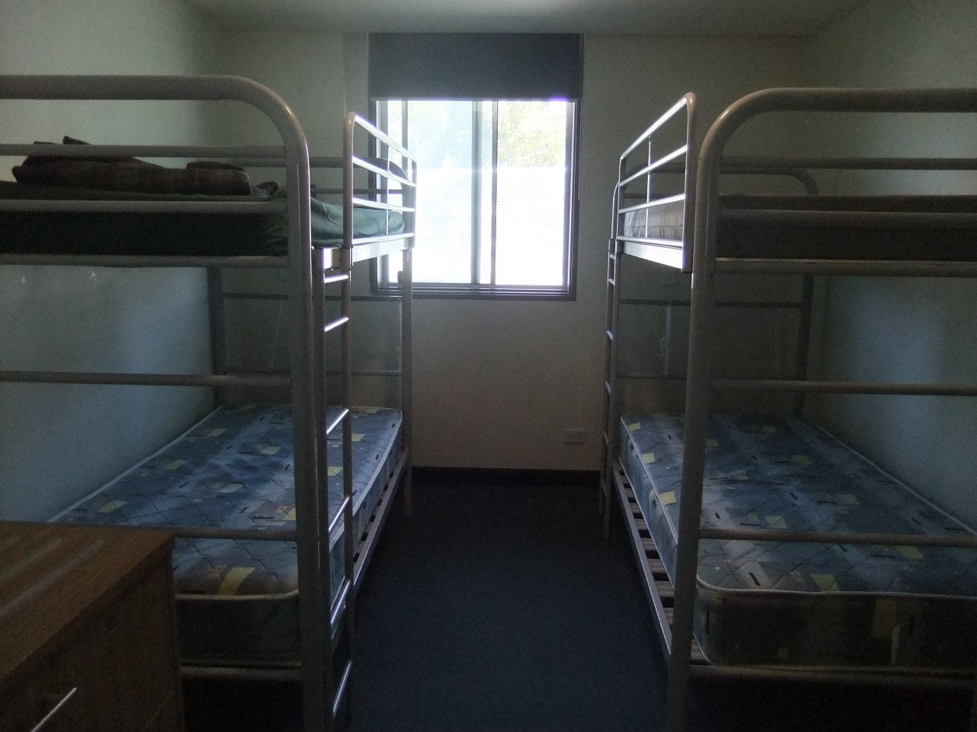
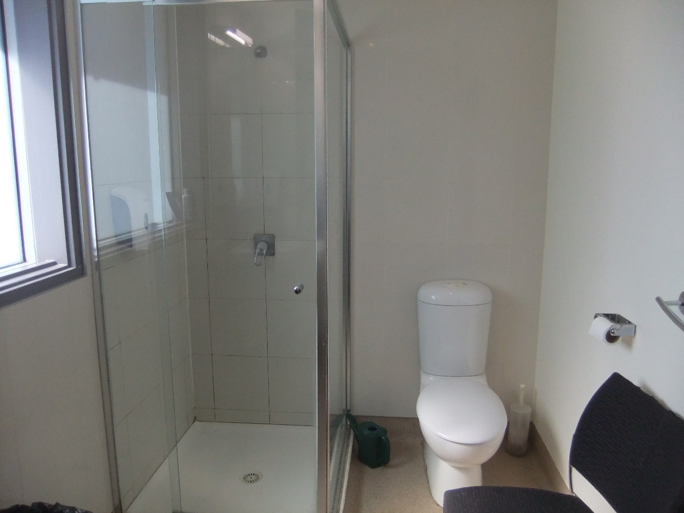
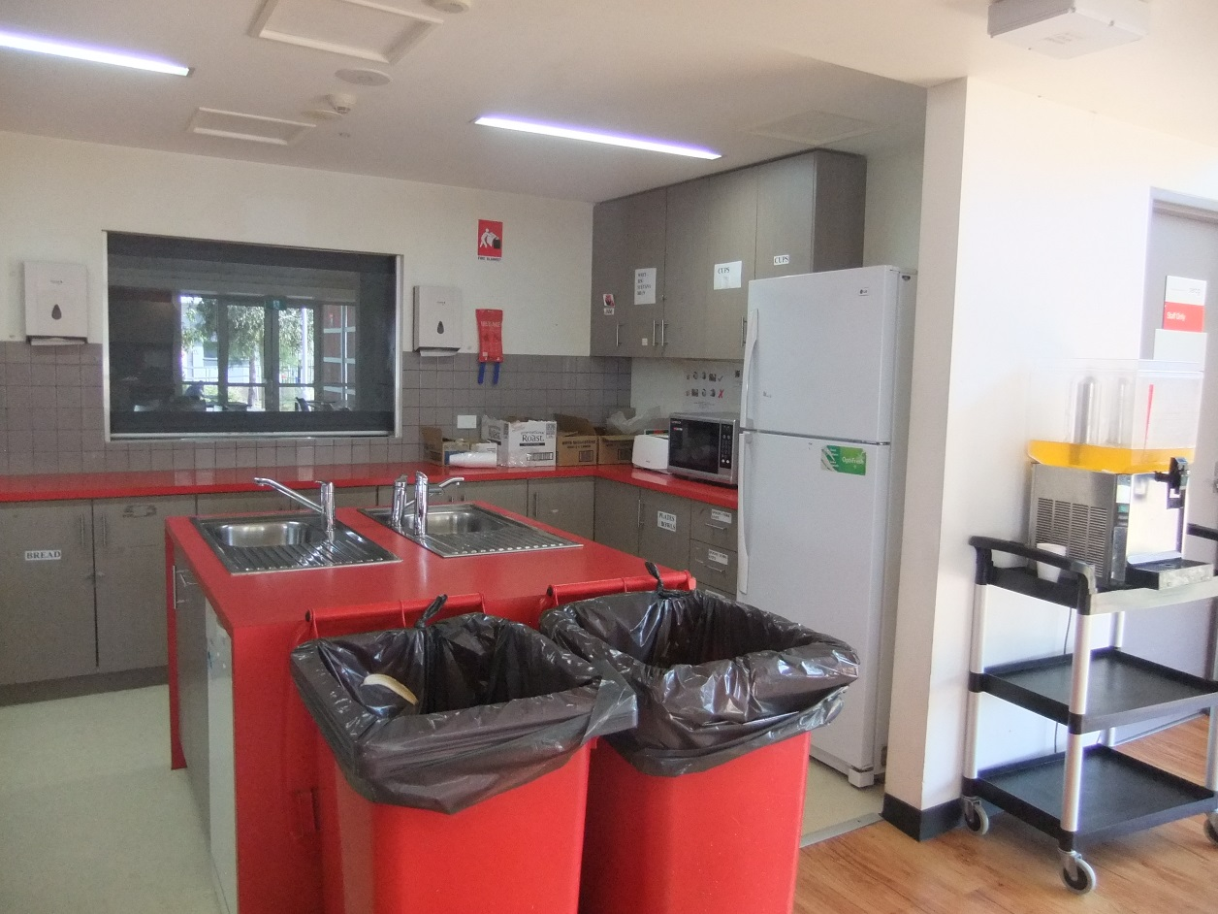
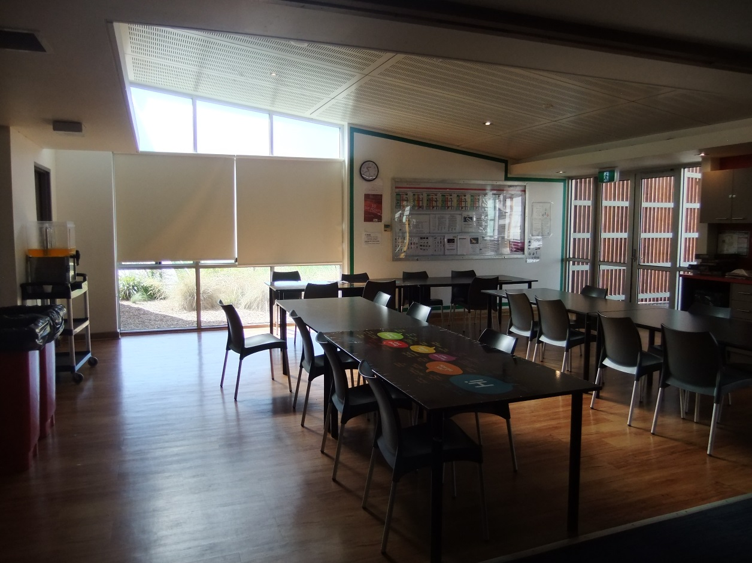
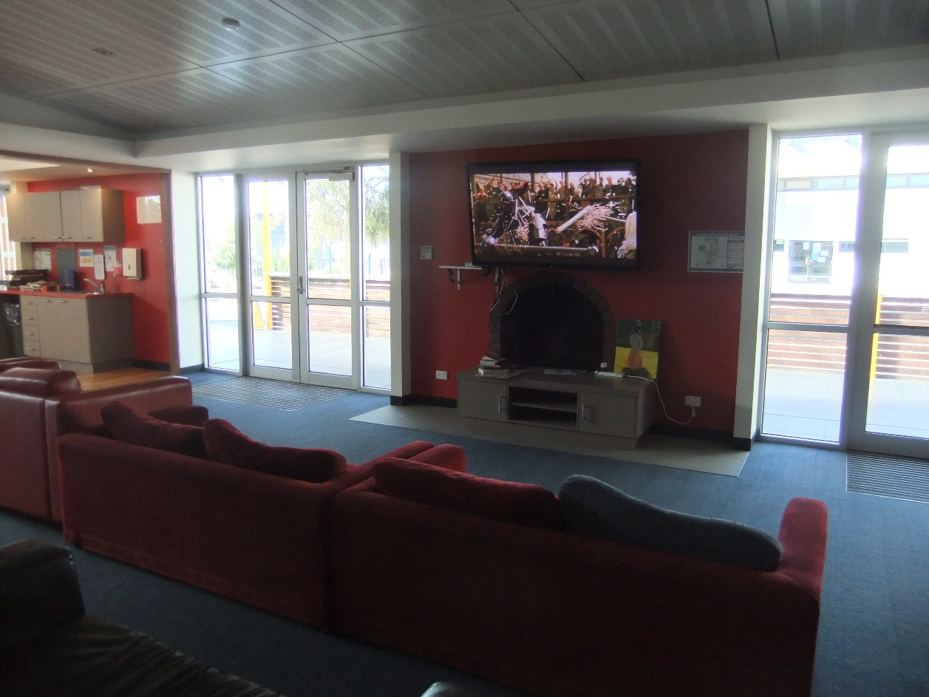
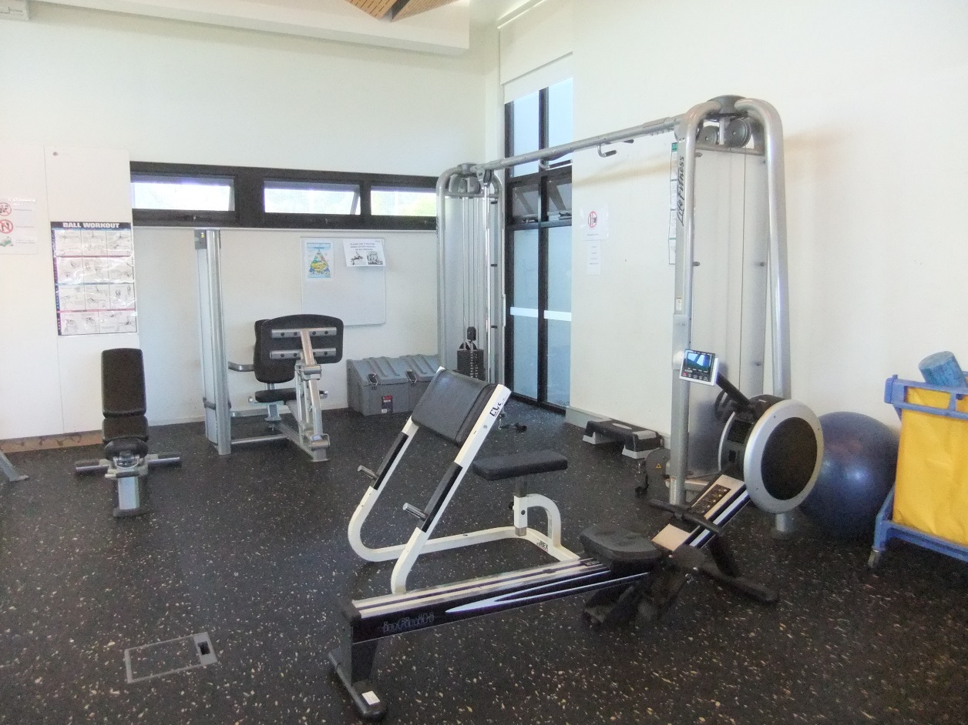
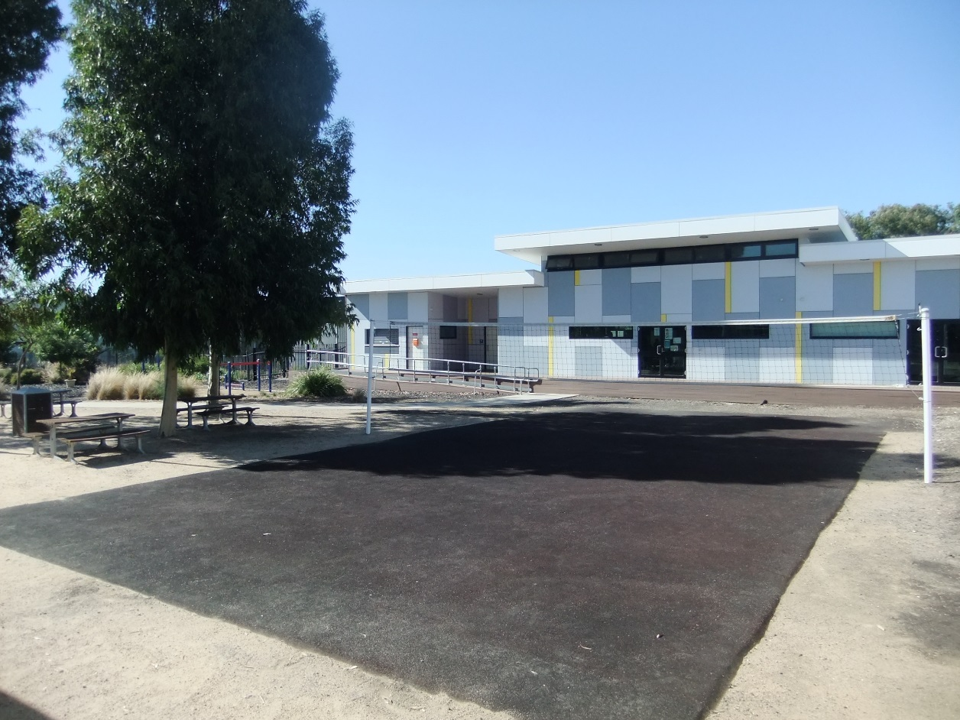
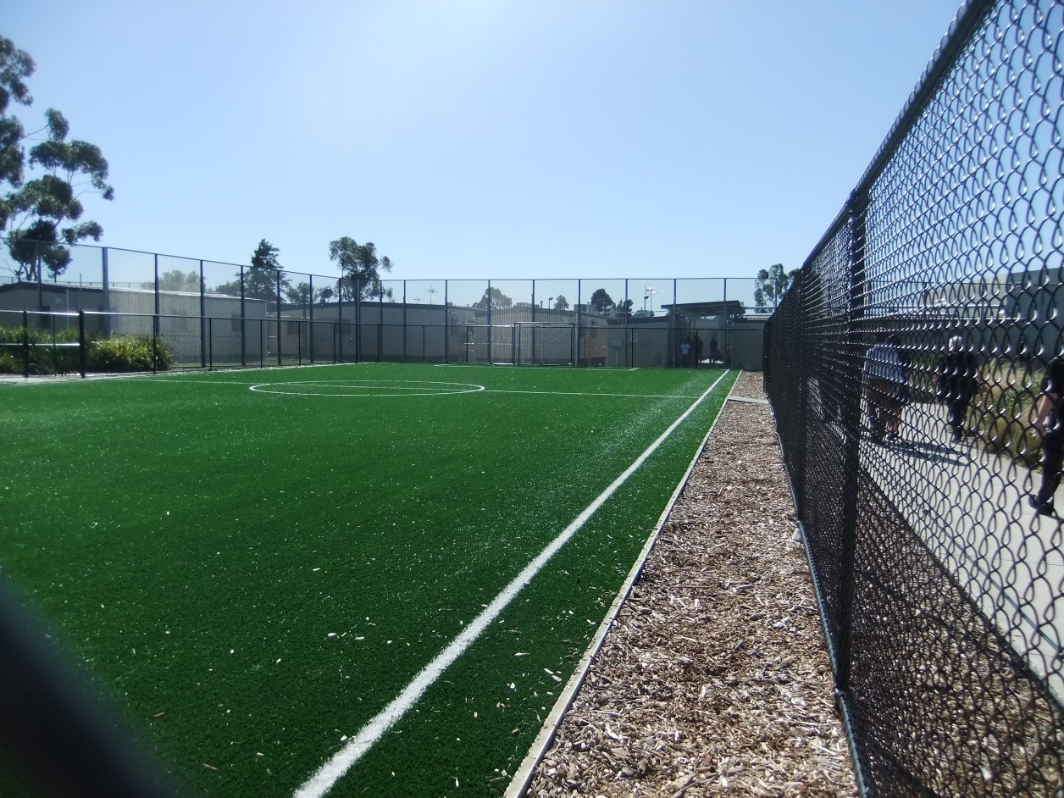

Facilities in Bass compound
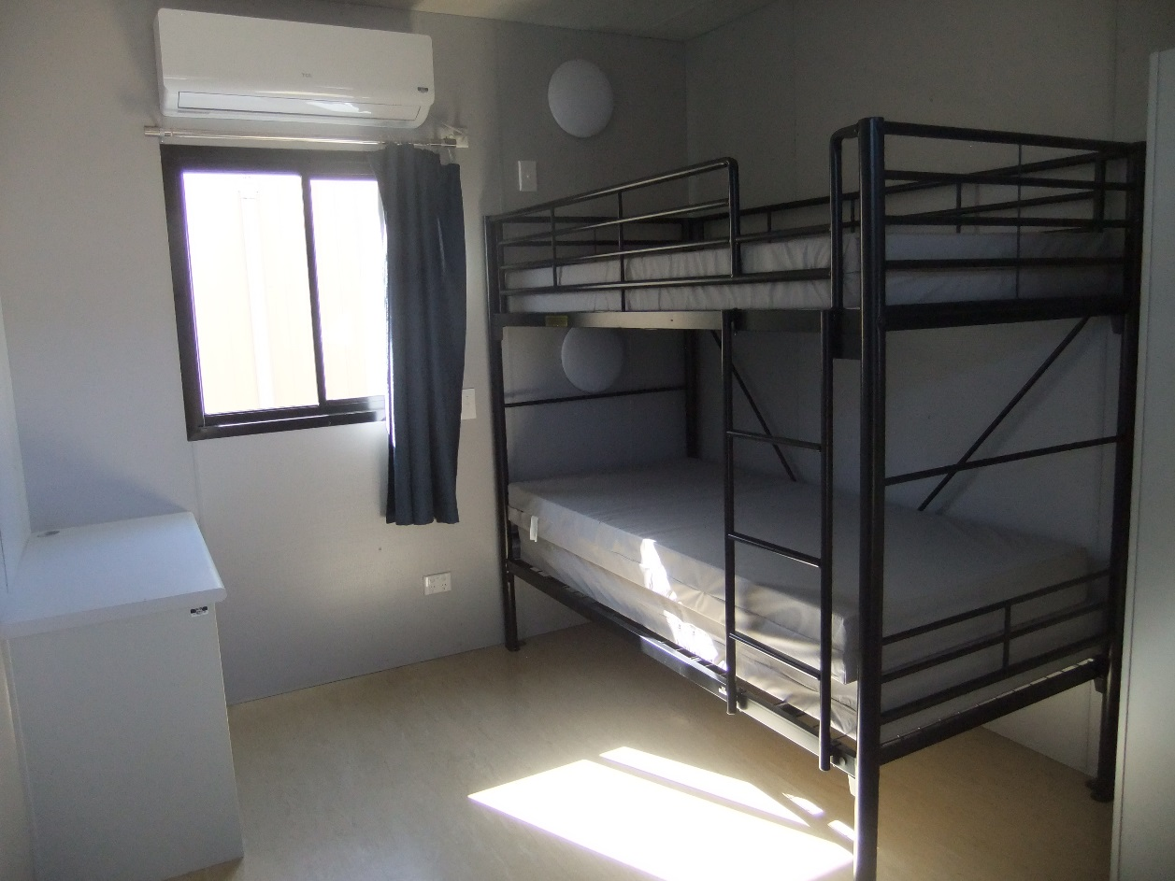
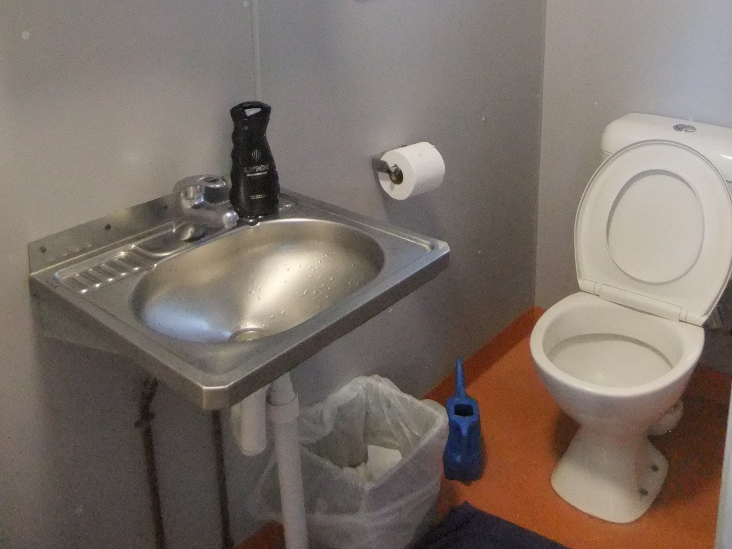
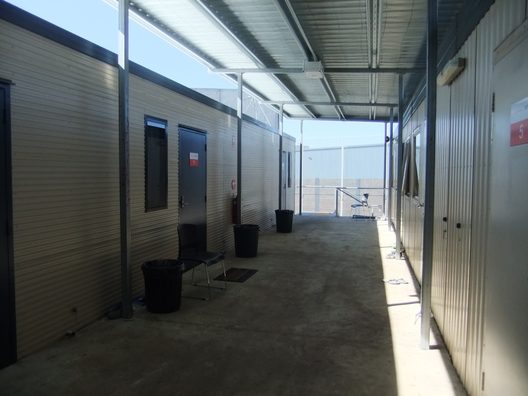

Facilities in Calder compound
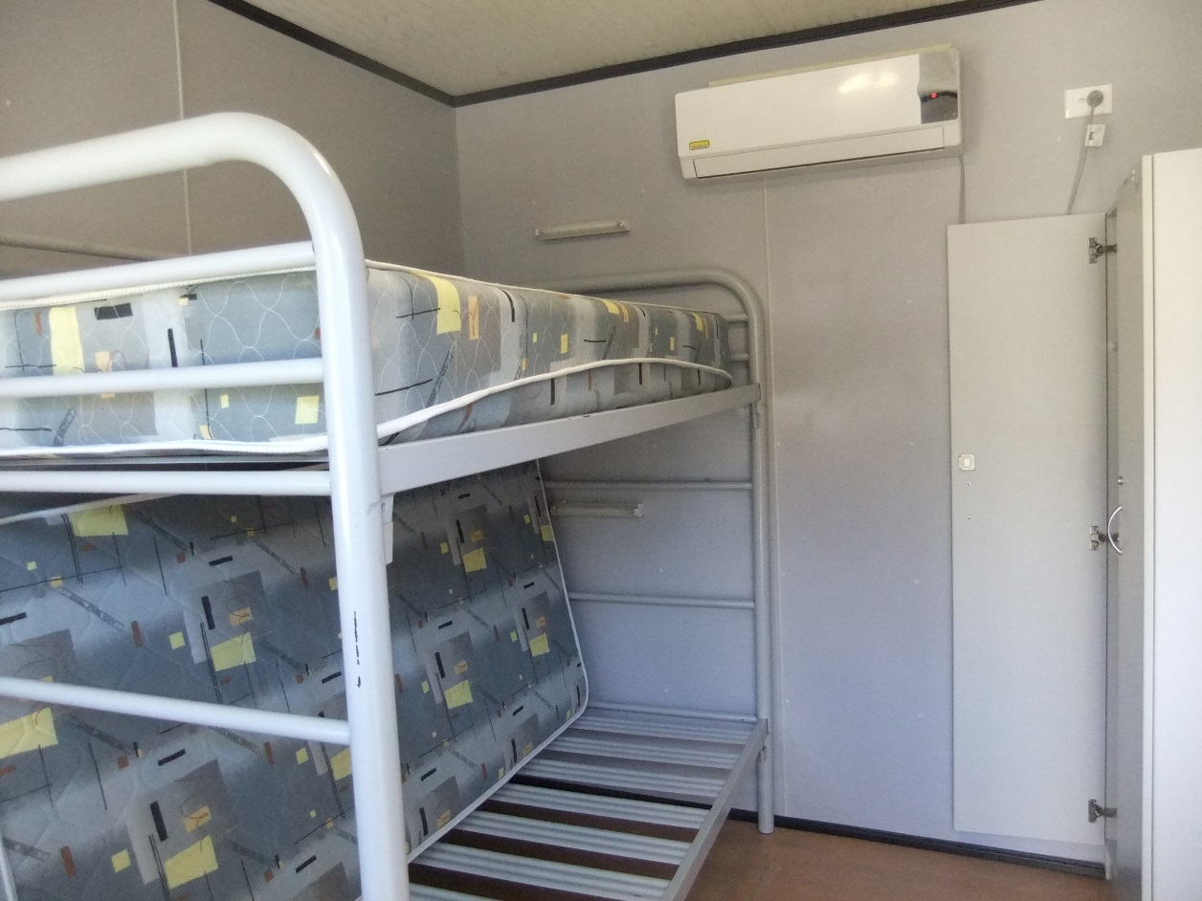
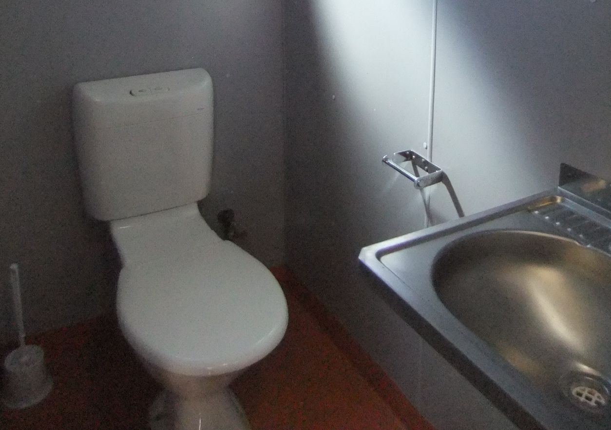
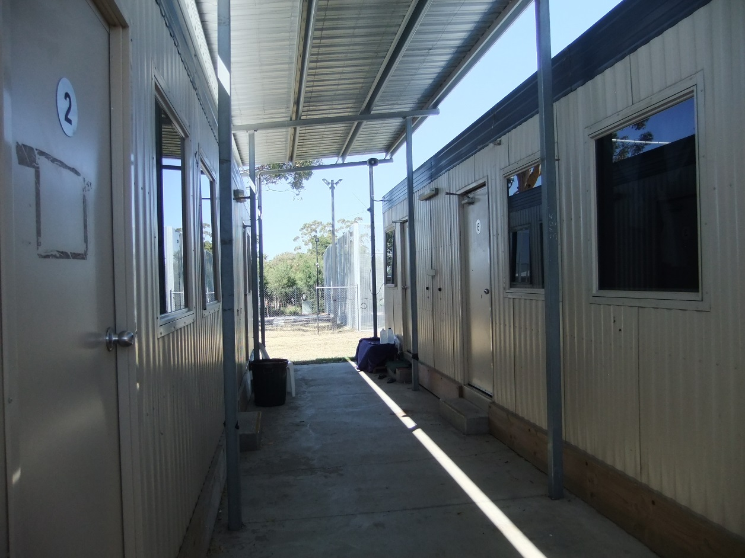
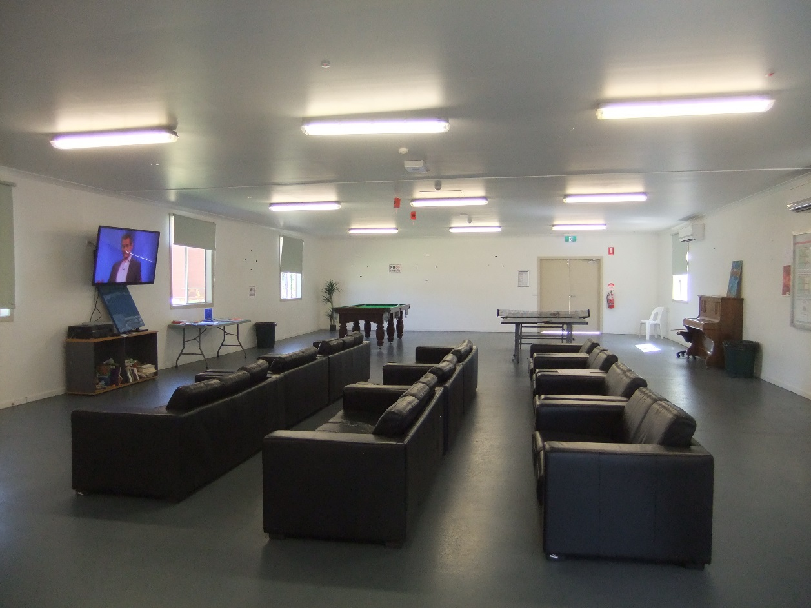
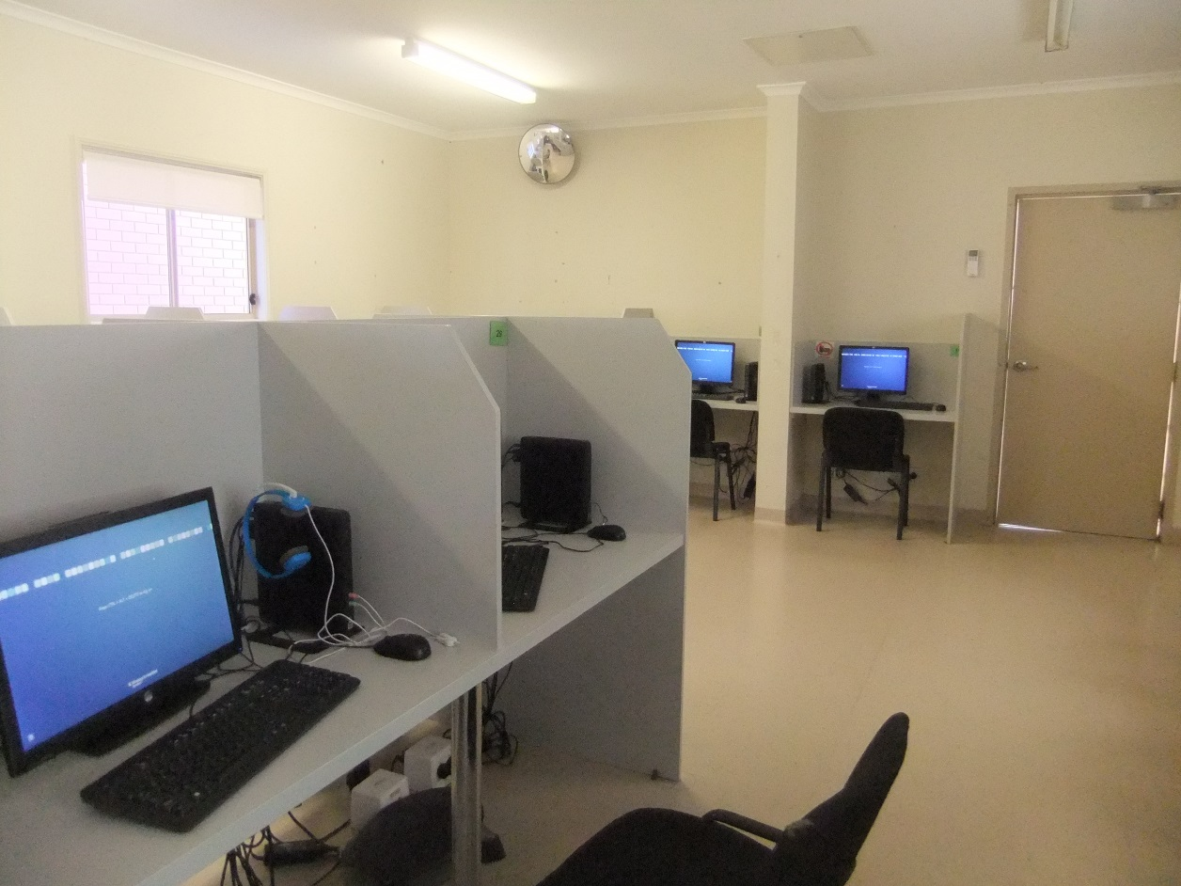
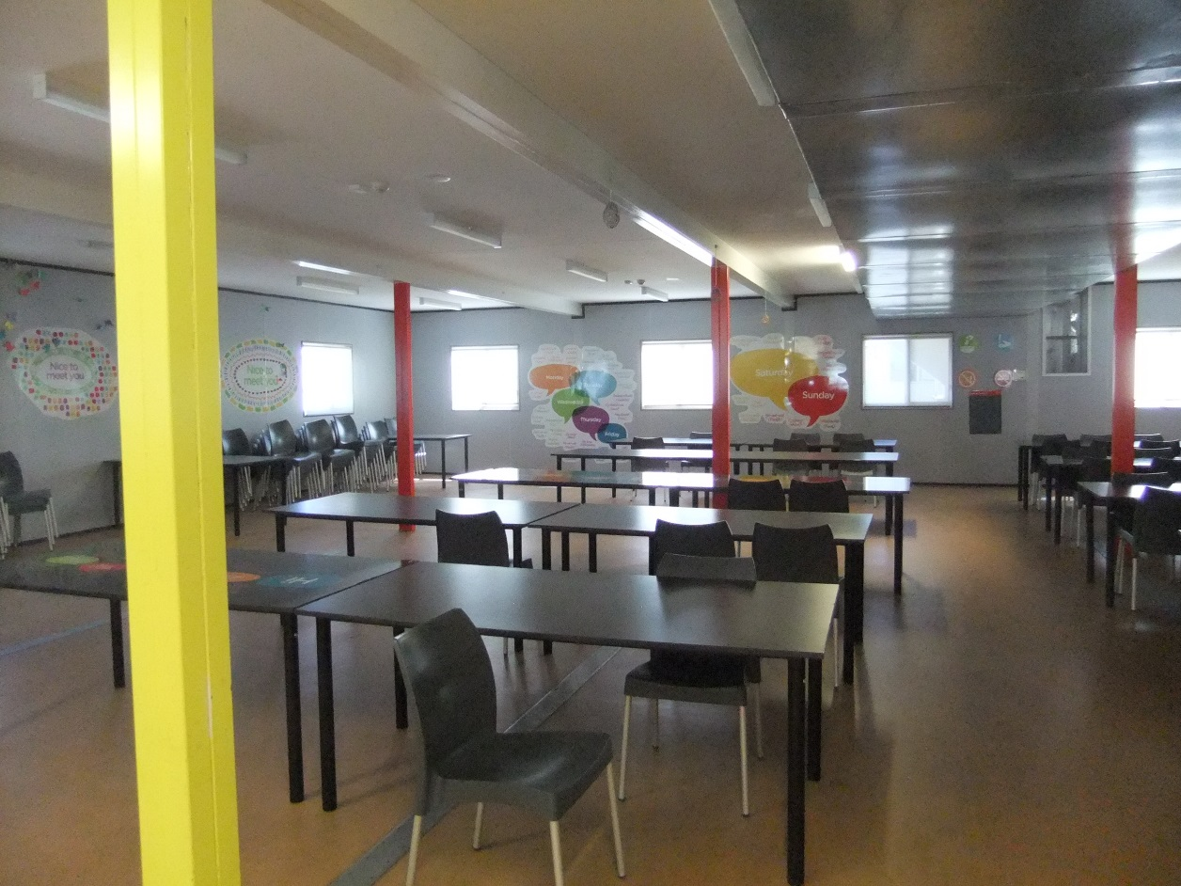
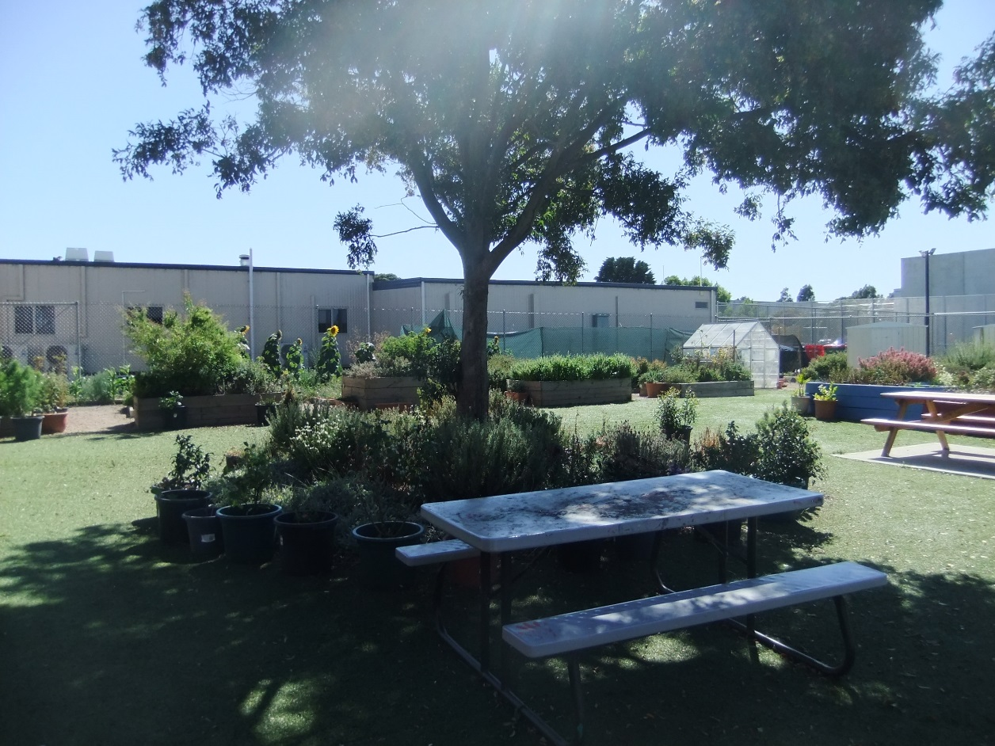
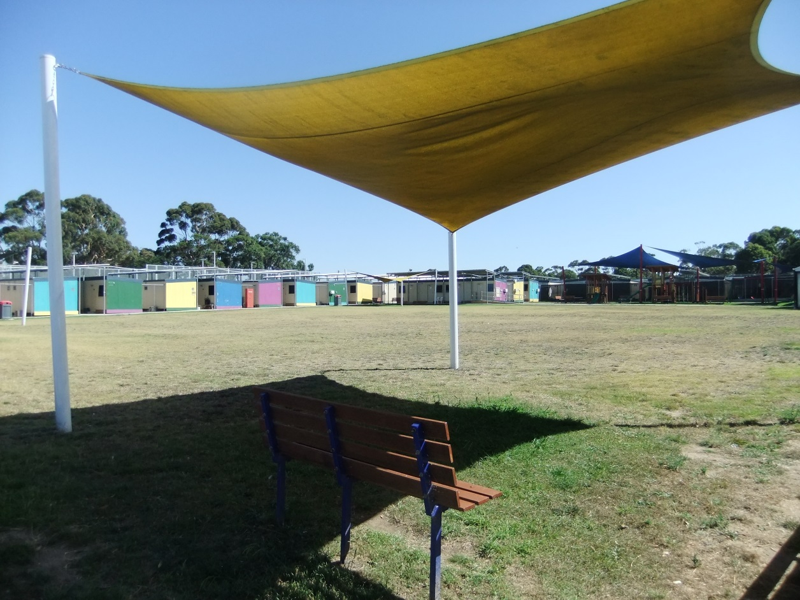

Shared facilities
Top to bottom: Avon and Bass mess, prayer room, visits room, private interview room.
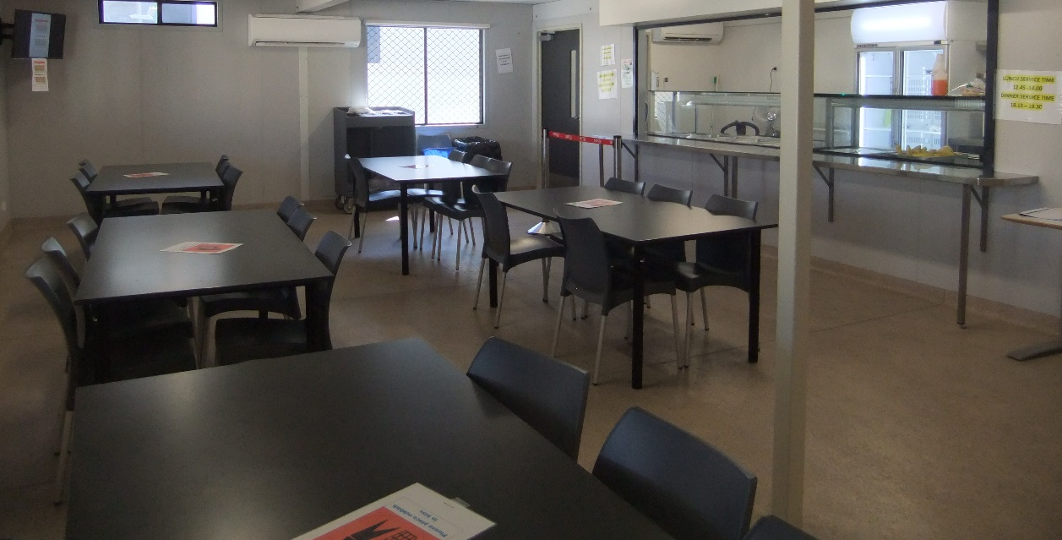
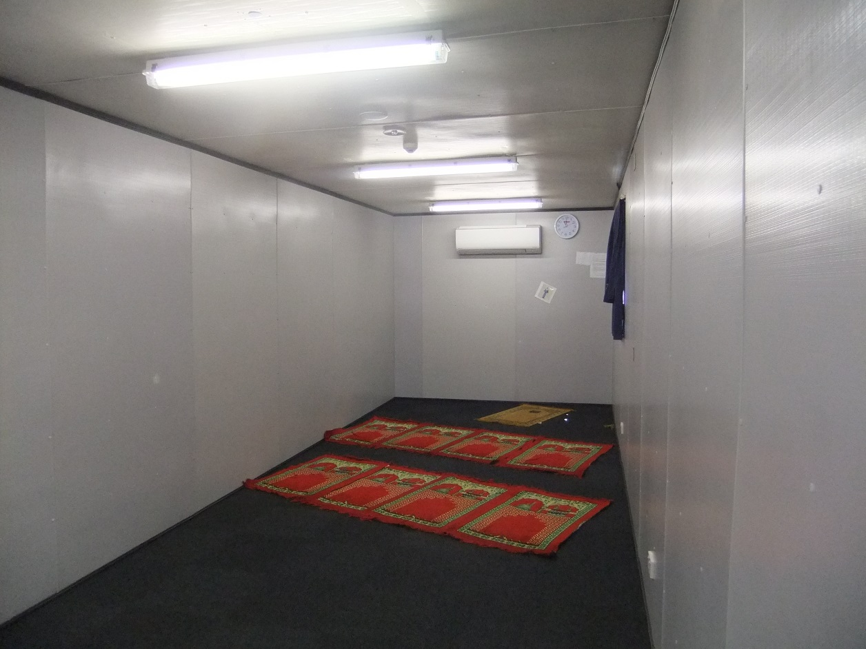
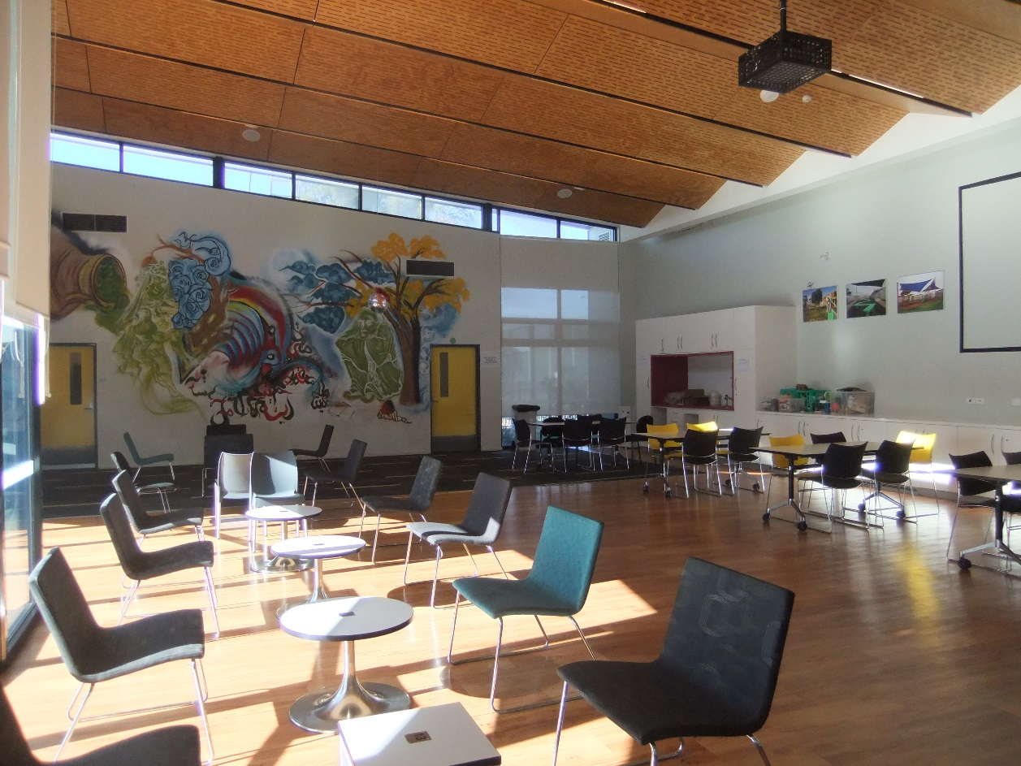
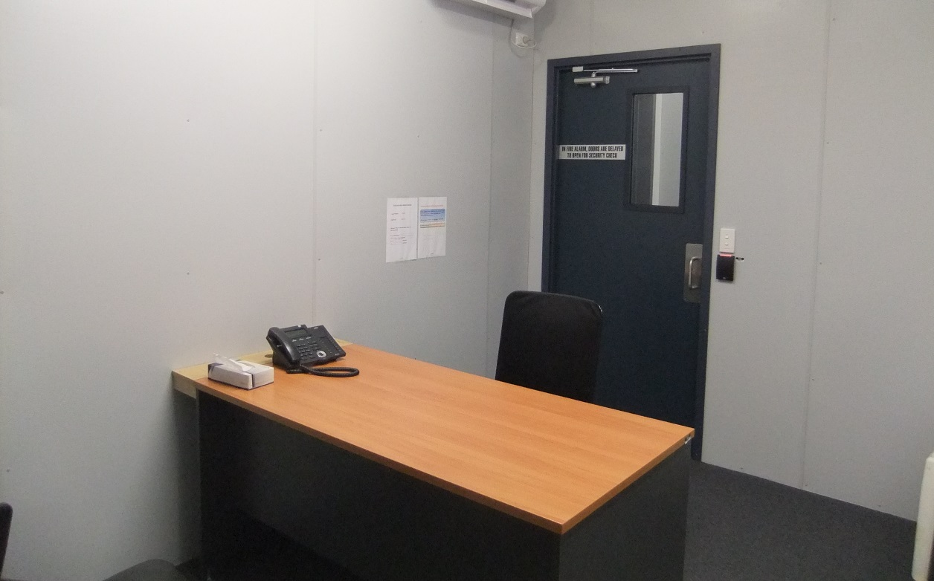

Endnotes

Reports from previous monitoring visits to immigration detention facilities can be found on the Commission’s website at https://www.humanrights.gov.au/our-work/asylum-seekers-and-refugees/immigration-detention-reports-and-photos
Human Rights and Equal Opportunity Commission, Those who've come across the seas: Detention of unauthorised arrivals (1998). At https://www.humanrights.gov.au/our-work/asylum-seekers-and-refugees/publications/those-whove-come-across-seas-detention (viewed 11 May 2017); Human Rights and Equal Opportunity Commission, A last resort? National Inquiry into Children in Immigration Detention (2004). At https://www.humanrights.gov.au/our-work/asylum-seekers-and-refugees/projects/last-resort-report-national-inquiry-children (viewed 11 May 2017); Australian Human Rights Commission, The Forgotten Children: National Inquiry into Children in Immigration Detention (2014). At https://www.humanrights.gov.au/our-work/asylum-seekers-and-refugees/projects/national-inquiry-children-immigration-detention-index (viewed 11 May 2017).
Australian Human Rights Commission, Asylum seekers, refugees and human rights: Snapshot Report (2nd edition) (2017) 11–25. At https://www.humanrights.gov.au/our-work/asylum-seekers-and-refugees/publications/asylum-seekers-refugees-and-human-rights-snapsho-0 (viewed 11 May 2017).
Australian Human Rights Commission, Human rights standards for immigration protection (2013). At https://www.humanrights.gov.au/our-work/asylum-seekers-and-refugees/publications/human-rights-standards-immigration-detention (viewed 11 May 2017).
International Covenant on Civil and Political Rights, opened for signature 16 December 1966, 999 UNTS 171 (entered into force 23 March 1976) arts 9(1), 10(1)
International Covenant on Civil and Political Rights, opened for signature 16 December 1966, 999 UNTS 171 (entered into force 23 March 1976) art 7; Convention against Torture and Other Cruel, Inhuman or Degrading Treatment or Punishment, opened for signature 10 December 1984, 1465 UNTS 85 (entered into force 26 June 1987) arts 2(1), 16(1).
International Covenant on Economic, Social and Cultural Rights, opened for signature 16 December 1966, 993 UNTS 3 (entered into force 3 January 1976) arts 6(2), 11, 12, 13, 15(1a).
International Covenant on Civil and Political Rights, opened for signature 16 December 1966, 999 UNTS 171 (entered into force 23 March 1976) arts 7, 10(1); Convention against Torture and Other Cruel, Inhuman or Degrading Treatment or Punishment, opened for signature 10 December 1984, 1465 UNTS 85 (entered into force 26 June 1987) arts 2(1), 16(1).
International Covenant on Civil and Political Rights, opened for signature 16 December 1966, 999 UNTS 171 (entered into force 23 March 1976) arts 17, 18.
International Covenant on Civil and Political Rights, opened for signature 16 December 1966, 999 UNTS 171 (entered into force 23 March 1976) arts 19(b), 22, 27.
International Covenant on Economic, Social and Cultural Rights, opened for signature 16 December 1966, 993 UNTS 3 (entered into force 3 January 1976) art 15(1a).
International Covenant on Civil and Political Rights, opened for signature 16 December 1966, 999 UNTS 171 (entered into force 23 March 1976) art 23(1); International Covenant on Economic, Social and Cultural Rights, opened for signature 16 December 1966, 993 UNTS 3 (entered into force 3 January 1976) art 10(1).
International Covenant on Civil and Political Rights, opened for signature 16 December 1966, 999 UNTS 171 (entered into force 23 March 1976) art 17(1); Convention on the Rights of the Child, opened for signature 20 November 1989, 1577 UNTS 3 (entered into force 2 September 1990) art 16(1).
Convention against Torture and Other Cruel, Inhuman or Degrading Treatment or Punishment, opened for signature 10 December 1984, 1465 UNTS 85 (entered into force 26 June 1987) arts 13, 16(1).
International Covenant on Civil and Political Rights, opened for signature 16 December 1966, 999 UNTS 171 (entered into force 23 March 1976) art 9(1)
Human Rights Committee, Van Alphen v Netherlands, Communication No. 305/1988, UN Doc CCPR/C/39/D/305/1988 (23 July 1990) [5.8]. At http://www.refworld.org/docid/525414304.html (viewed 7 December 2016); Human Rights Committee, A v Australia, Communication No. 560/1993, UN Doc CCPR/C/59/D/560/1993 (3 April1997) [9.4]. At http://www.refworld.org/docid/3ae6b71a0.html (viewed 7 December 2016).
International Covenant on Civil and Political Rights, opened for signature 16 December 1966, 999 UNTS 171 (entered into force 23 March 1976) arts 9(2), 9(4)
See Australian Human Rights Commission, The Forgotten Children: National Inquiry into Children in Immigration Detention (2014). At https://www.humanrights.gov.au/our-work/asylum-seekers-and-refugees/projects/national-inquiry-children-immigration-detention-index (viewed 11 May 2017).
Department of Immigration and Citizenship, Immigration Detention Statistics Summary (31 July 2013) 3–4. At http://www.border.gov.au/ReportsandPublications/Documents/statistics/immigration-detention-statistics-july2013.pdf (viewed 12 May 2017); Department of Immigration and Border Protection, Immigration Detention and Community Statistics Summary (28 February 2015) 3, 5. At http://www.border.gov.au/ReportsandPublications/Documents/statistics/immigration-detention-statistics-feb2015.pdf (viewed 12 May 2017).
Department of Immigration and Citizenship, Immigration Detention Statistics Summary (31 July 2013) 3, 7. At http://www.border.gov.au/ReportsandPublications/Documents/statistics/immigration-detention-statistics-july2013.pdf (viewed 12 May 2017); Department of Immigration and Border Protection, Immigration Detention and Community Statistics Summary (28 February 2015) 3, 8. At http://www.border.gov.au/ReportsandPublications/Documents/statistics/immigration-detention-statistics-feb2015.pdf (viewed 12 May 2017).
Department of Immigration and Border Protection, Immigration Detention and Community Statistics Summary (31 March 2017) 4, 6. At http://www.border.gov.au/ReportsandPublications/Documents/statistics/immigration-detention-statistics-31-march-2017.pdf (viewed 24 May 2017).
Department of Immigration and Citizenship, Immigration Detention Statistics Summary (30 April 2012) 8; Department of Immigration and Citizenship, Immigration Detention Statistics Summary (31 July 2013) 9. At http://www.border.gov.au/ReportsandPublications/Documents/statistics/immigration-detention-statistics-july2013.pdf (viewed 12 May 2017).
Department of Immigration and Border Protection, Immigration Detention and Community Statistics Summary (31 May 2014) 10. At http://www.border.gov.au/ReportsandPublications/Documents/statistics/immigration-detention-statistics-may2014.pdf (viewed 1 June 2017).
Department of Immigration and Border Protection, Immigration Detention and Community Statistics Summary (31 January 2017) 11. At http://www.border.gov.au/ReportsandPublications/Documents/statistics/immigration-detention-statistics-31-jan-2017.pdf (viewed 12 May 2017); Department of Immigration and Border Protection, Immigration Detention and Community Statistics Summary (31 March 2017) 11. At http://www.border.gov.au/ReportsandPublications/Documents/statistics/immigration-detention-statistics-31-march-2017.pdf (viewed 24 May 2017).
Department of Immigration and Citizenship, Immigration Detention Statistics Summary (31 July 2013) 9. At http://www.border.gov.au/ReportsandPublications/Documents/statistics/immigration-detention-statistics-july2013.pdf (viewed 12 May 2017);
Department of Immigration and Border Protection, Immigration Detention and Community Statistics Summary (31 May 2014) 10. At http://www.border.gov.au/ReportsandPublications/Documents/statistics/immigration-detention-statistics-may2014.pdf (viewed 1 June 2017).
Department of Immigration and Border Protection, Immigration Detention and Community Statistics Summary (31 March 2017) 11. At http://www.border.gov.au/ReportsandPublications/Documents/statistics/immigration-detention-statistics-31-march-2017.pdf (viewed 24 May 2017).
See the Department of Immigration and Border Protection’s immigration detention statistics summaries, available at http://www.border.gov.au/about/reports-publications/research-statistics/statistics/live-in-australia/immigration-detention (viewed 12 May 2017).
Migration Amendment (Character and General Visa Cancellation) Act 2014 (Cth)
Department of Immigration and Border Protection, Key visa cancellation statistics (n.d.). At http://www.border.gov.au/about/reports-publications/research-statistics/statistics/key-cancellation-statistics (viewed 29 November 2016).
Department of Immigration and Border Protection, Immigration Detention and Community Statistics Summary (31 March 2017) 4, 7. At http://www.border.gov.au/ReportsandPublications/Documents/statistics/immigration-detention-statistics-31-march-2017.pdf (viewed 24 May 2017).
Louise K Newman, Nicholas G Procter and Michael J Dudley, ‘Suicide and self-harm in immigration detention’ (2011) 195(6) Medical Journal of Australia 310; Melissa Bull et al, ‘Sickness in the System of Long-term Immigration Detention’ (2013) 26 Journal of Refugee Studies 47; Ilan Katz et al, The experiences of Irregular Maritime Arrivals detained in immigration detention facilities: Final report (2013). At http://www.border.gov.au/ReportsandPublications/Documents/research/IMA-experiences-IDF.pdf (viewed 7 December 2016).
See, for example, Australian Human Rights Commission, Immigration detention in Villawood: Summary of observations from visit to immigration detention facility in Villawood (2011) 18, 30. At https://www.humanrights.gov.au/sites/default/files/content/human_rights/immigration/idc2011_villawood.pdf (viewed 6 June 2017).
Department of Immigration and Border Protection, ‘New measures to combat illegal activity within immigration detention facilities’ (Media Release, 11 November 2016). At http://newsroom.border.gov.au/releases/new-measures-to-combat-illegal-activity-within-immigration-detention-facilities (viewed 26 May 2017).
Migration Act 1958 (Cth), ss 189, 196.

