Australian Human Rights Commission Inspection of Villawood Immigration Detention Centre: Report

10–12 April 2017

Table of Contents
1 Introduction 5
2 Background 6
2.1 Previous inspections 6
2.2 Inspection methodology 6
2.3 Relevant human rights standards 7
(a) Treatment of people in detention 7
(b) Conditions of detention 7
(c) Communication, association and complaints 8
(d) Legal and policy framework 9
2.4 National context 9
(a) Number of people in detention 9
(b) Length of detention 9
(c) Reasons for detention 10
(d) Administration of the detention network 10
(e) Ratification of OPCAT 11
2.5 Villawood Immigration Detention Centre 11
3 Key issues and concerns 12
3.1 Treatment of people in detention 12
(a) Induction process 12
(b) Risk assessments 12
(c) General safety and security 13
(d) Relationships with staff 14
(e) Use of force and restraints 15
(f) Transfers between detention facilities 16
(g) Other invasive and restrictive measures 16
3.2 Conditions of detention 17
(a) Redevelopment of the VIDC 17
(b) Accommodation 17
(c) Living areas 18
(d) Indoor and outdoor exercise 19
(e) Activities and excursions 20
(f) Food 21
(g) Personal items 21
3.3 Physical and mental health 22
(a) Health services 22
(b) Physical health 22
(c) Mental health 23
3.4 Communication and complaints 24
(a) Telephone access 24
(b) Computer and internet access 25
(c) Visits 26
(d) Complaints 26
3.5 Legal and policy framework 27
(a) Indefinite mandatory detention 27
(b) Community alternatives to detention 28
(c) Case management and status resolution 29
4 Summary of recommendations 31
4.1 Recommendations to the Australian Government 31
4.2 Joint recommendations to the Department of Immigration and Border Protection and facility staff 31
4.3 Recommendations to the Minister and Department of Immigration and Border Protection 32
4.4 Recommendations to facility staff 34
5 Appendix 1: Photos taken during the Commission’s inspection 35
5.1 Facilities in La Trobe, Lachlan and Lima compounds 35
5.2 Facilities in community area 38
5.3 Facilities in Hotham compound 40
5.4 Facilities in Blaxland compound (Dorms 1 and 2) 42
5.5 Facilities in Blaxland compound (Dorm 3) 45
5.6 Visits area 47
6 Appendix 2: Kessler Psychological Distress Scale 48
Endnotes 49

Summary of key issues
The current risk assessment process may not allow for an accurate or appropriate determination of the risks posed by particular individuals. As such, risk assessments may result in some people being subject to measures that are more restrictive than necessary, or placed in environments where they could be at risk of harm.
Urgent action is necessary to ensure the safety of all people at the VIDC. Many people (especially those in higher-security compounds) reported that they did not feel safe in detention and believed that they were at risk of physical violence.
The use of restraints during escort may not have been necessary in all circumstances.
Certain aspects of the transfer process are unjustified, particularly in relation to the lack of prior warning of transfers and lack of adequate opportunities for people to pack their belongings and notify family members, friends and legal representatives prior to the transfer.
Current accommodation arrangements in Blaxland compound do not meet the standards required by international law. Exercise facilities in Blaxland compound also remain inadequate. Use of this compound should cease as soon as possible.
The refurbishment of the main complex at the VIDC has significantly improved access to exercise facilities. However, the higher-security compounds are inherently more restrictive given their smaller size.
Some expressed concern that activities were not sufficiently engaging and meaningful. The lack of opportunities for excursions is concerning, particularly given the length of time for which many people at the VIDC have been detained and the limited space for outdoor recreation in higher-security compounds.
There is a clearly significant level of concern among people detained at the VIDC about physical health care and the impact of detention on mental health.
The new policy prohibiting all mobile phone use may restrict access to external communication to a greater degree than is necessary to ensure safety and security.
Many people at the VIFC have been detained for prolonged periods of time. Almost half of the people interviewed by the Commission reported that they had been in immigration detention for at least a year, including a considerable number who had been detained for three years or more.
Consideration of community alternatives does not occur on a systematic basis for all people in detention, particularly for people who have had visas cancelled under section 501 of the Migration Act. In some cases, ongoing detention may not have been justifiable in the circumstances.
The reduction in the scope of the case manager role and its present limitations lead to a mismatch between the types of support that case managers can provide to people in detention, and the types of support that people in detention actually need, including to resolve their status.

Introduction
This report contains an overview of key observations and concerns arising from the Australian Human Rights Commission’s inspection of the Villawood Immigration Detention Centre (VIDC) in April 2017.
The rationale for the Commission undertaking such inspections is to identify problems in the way that detainees’ human rights are being protected and to suggest ways of addressing those problems. Hence, while the report is balanced and points to some good practices, its primary focus is on issues of concern identified by the Commission. The report reflects conditions as they were at the time of the inspection.
The Commission also raised a number of additional issues with the Department of Immigration and Border Protection (DIBP) and facility staff during and subsequent to the inspection, including individual cases of concern.
The Commission acknowledges the assistance provided by DIBP and the Australian Border Force (ABF) in facilitating the Commission’s inspection. The Commission is grateful to the DIBP and ABF officers and detention service provider staff who assisted the Commission team during the inspection. A draft of this report was shared with DIBP in advance of its publication, to provide an opportunity for DIBP to respond to the identified issues.

Background

Previous inspections
The Commission has conducted inspections of immigration detention facilities in Australia since the mid-1990s. This has included periodic monitoring of detention facilities across the country and three major national inquiries into immigration detention.
The purpose of the Commission’s detention monitoring work is to ensure that Australia’s immigration detention system is compliant with our obligations under international human rights law. For many years, the Commission has expressed a range of concerns about aspects of the detention system that may lead to breaches of international human rights law. These include:
- the policy of mandatory immigration detention, which does not allow for adequate consideration of individual circumstances and can result in cases of arbitrary detention
- the indefinite and at times prolonged nature of immigration detention and the lack of a legislative time limit on detention
- the detention of children, which has led to breaches of numerous obligations under the Convention on the Rights of the Child (CRC)
- the indefinite detention of people who have received adverse security or character assessments, including in circumstances where they have not been convicted of a crime under Australian law
- conditions of detention, which in some cases have not met international standards
- the impacts of immigration detention on mental health
- the need for increased use of alternatives to immigration detention.
Further information about these concerns can be found in the Commission publication, Asylum Seekers, Refugees and Human Rights: Snapshot Report.
The Commission can also investigate and, where appropriate, try to resolve through conciliation, complaints it receives from people in immigration detention regarding alleged breaches of human rights.

Inspection methodology
The Commission inspected the VIDC from 10 to 12 April 2017. The inspection was conducted by then Commission President Professor Gillian Triggs, Human Rights Commissioner Edward Santow and four Commission staff. Dr Penny Abbott, an academic general practitioner, and Dr Angela Nickerson, a clinical psychologist, joined the inspection team as independent consultants.
During the inspection, the Commission team met with representatives from DIBP, ABF, Serco and International Health and Medical Services (IHMS); conducted an inspection of the physical conditions of detention; and held individual private interviews with 47 people detained at the VIDC. The Commission also held a number of informal group discussions with people detained at the facility.
The Commission considered the evidence gathered during the inspection against human rights standards derived from international law that are relevant to immigration detention.

Relevant human rights standards
This section provides a summary of some of the key international human rights standards relevant to the situation of people in immigration detention. Further information about these and other relevant standards can be found in the Commission publication, Human rights standards for immigration detention.
The VIDC is a high-security detention facility that is not used to detain children. As such, standards relating to the detention of children were not applicable to this inspection.

Treatment of people in detention
Australia is obliged under articles 9(1) and 10(1) of the International Covenant on Civil and Political Rights (ICCPR) to, respectively, uphold the right to security of the person and ensure that people in detention are treated with humanity and respect for the inherent dignity of the human person. Australia also has obligations under article 7 of the ICCPR and articles 2(1) and 16(1) of the Convention Against Torture and other Cruel, Inhuman or Degrading Treatment or Punishment (CAT) not to subject anyone to torture or to cruel, inhuman or degrading treatment or punishment, and to take effective measures to prevent these acts from occurring.
These obligations require Australia to ensure that people in detention are treated fairly and reasonably, and in a manner that upholds their dignity. They should enjoy a safe environment free from bullying, harassment, abuse and violence. Security measures should be commensurate with identified risks, and should be the least restrictive possible in the circumstances, taking into account the particular vulnerabilities of people in detention. Measures that may constitute torture or cruel, inhuman or degrading treatment or punishment (such as collective punishment, corporal punishment, excessive use of force and holding people incommunicado) should be prohibited.

Conditions of detention
Australia has a range of obligations under the International Covenant on Economic, Social and Cultural Rights (ICESCR) relevant to the material conditions of immigration detention. These include the right to education (articles 6(2) and 13); the right to an adequate standard of living, including adequate food, clothing and housing (article 11); the right to the highest attainable standard of health (article 12); and the right to take part in cultural life (article 15(1)(a)).
Australia’s obligations under the ICCPR and CAT to treat people in detention with humanity and respect, and not to subject anyone to cruel, inhuman or degrading treatment or punishment, are also relevant to conditions of detention. In addition, Australia has an obligation under articles 17 and 18 of the ICCPR to uphold the right to privacy and freedom of religion respectively.
These obligations require Australia to ensure that detention facilities are safe, hygienic and uphold human dignity. People in detention should have their basic needs met and have access to essential services (such as health care and primary and secondary education) to a standard commensurate with those provided in the Australian community.
People in detention should have opportunities to engage in meaningful activities and excursions that provide physical and mental stimulation. People in detention should also be able to profess and practise the religion of their choice, including through being able to attend religious services, receiving pastoral visits from religious representatives and celebrating major religious holidays and festivals.
In light of the negative impacts of detention on mental health, the length of detention should be limited to the minimum period necessary to achieve a legitimate aim, and community-based alternatives to detention should be used wherever feasible.

Communication, association and complaints
Australia has a range of obligations under the ICCPR relevant to communication between people in detention and their family members, friends, representatives and communities outside detention. These include the right to freedom of expression and to seek, receive and impart information and ideas (article 19(b)); the right to freedom of association with others (article 22); and the right of ethnic, religious and linguistic minorities, in community with the other members of their group, to enjoy their own culture, to profess and practise their own religion and to use their own language (article 27). Under the ICESCR, Australia also has an obligation to uphold the right to take part in cultural life (article 15(1)(a)).
In addition, Australia has obligations under articles 23(1) of the ICCPR and 10(1) of the ICESCR to afford protection and assistance to the family as the natural and fundamental group unit of society. Australia also has obligations under article 17(1) of the ICCPR and article 16(1) of the CRC not to subject anyone to arbitrary or unlawful interference with their family.
These obligations require Australia to ensure that detention does not have a disproportionate impact on people’s ability to express themselves, communicate and associate with others, and remain in contact with their family members, friends, representatives and communities. People in detention should be able to receive regular visits, and should have access to adequate communication facilities (such as telephones and computers) as well as news and library services. People in detention should, if possible, be located in facilities within a reasonable distance from their family members, friends and communities.
External communication, in particular access to complaints processes, is also essential for the prevention of torture and other cruel, inhuman or degrading treatment or punishment. Australia has obligations under articles 13 and 16(1) of the CAT to ensure that anyone who alleges that they have been subjected to torture or to cruel, inhuman or degrading treatment or punishment, has the right to complain to and have their case examined by competent authorities.
To ensure these obligations are upheld, people in detention should have opportunities to raise concerns and issues regarding treatment and conditions in detention, and make complaints both internally and to independent monitors (including the Commission and the Commonwealth Ombudsman), without fear of repercussions.

Legal and policy framework
Australia has an obligation under article 9 of the ICCPR not to subject anyone to arbitrary detention. According to the United Nations Human Rights Committee, ‘arbitrary detention’ includes detention that, although lawful under domestic law, is unjust or disproportionate. In order for the detention of a person not to be arbitrary, it must be a reasonable and necessary measure in all the circumstances.
Australia has further obligations under article 9 of the ICCPR to ensure that anyone who is arrested has the right to be informed of the reasons for their arrest and the charges against them, and that anyone who is detained has the right to challenge the legality of their detention in court.
These obligations require Australia to ensure that people are only detained in immigration detention facilities when it is reasonable and necessary in their individual circumstances (such as where they pose an unacceptable health or security risk), and for a limited period of time. Community-based alternatives to detention should be used wherever possible. People held in immigration detention should be informed of the reasons for their detention and be able to seek juridical review of whether their detention is arbitrary.

National context
The Commission last conducted a full inspection of the VIDC in April 2012. Since that time, there have been a number of significant changes in the legal, policy and operational context surrounding Australia’s immigration detention system.

Number of people in detention
The number of people in closed immigration detention, and particularly the number of children in detention, has reduced dramatically in recent years. As at April 2012, there were 4,329 people in closed detention, including 463 children. In the intervening years, the number of people in detention peaked at over 10,000 in July 2013, before declining to fewer than 2,000 in early 2015. The number of children in detention dropped from a high of almost 2,000 in July 2013 to fewer than 200 in early 2015.
As at April 2017, there were 1,392 people in immigration detention in Australia, including just one child.

Length of detention
While the overall number of people in detention has declined, the average length of detention has increased significantly. In April 2012, the average length of detention was 139 days, dropping to 72 days by July 2013. Since then, the average length has steadily increased, peaking at 493 days in January 2017. As at April 2017, the average stood at 450 days.
As at April 2012, 1,484 people had been detained for over a year, comprising more than a third of the people in detention (although these figures do not differentiate between people in closed and community detention). By July 2013, this number had dropped to 228 people, or around two per cent of people in detention. The number of people in long-term detention has since increased, particularly as a proportion of the overall detention population. As at April 2017, 541 people — or 39 per cent of people in detention — had been detained for over a year.
By way of comparison, the average length of immigration detention in Canada has remained at less than one month for the past five years. The number of people in long-term immigration detention in Canada (defined as detention exceeding 90 days) typically comprised ten per cent or less of the detention population over the same time period. In the United Kingdom, over 90 per cent of the people leaving detention over the past five calendar years had been detained for four months or less.

Reasons for detention
In April 2012, the vast majority of people in detention were asylum seekers who arrived by boat, who comprised around 95 per cent of the detention population. People who had overstayed their visa were the second-largest group in immigration detention, followed by people who had had their visas cancelled.
The composition of the detention population remained broadly consistent until the beginning of 2014. Since that time, asylum seekers have progressively comprised a smaller proportion of the detention population (although they remained by far the largest group in detention until 2016).
At the same time, the number of people in detention due to having their visas cancelled has increased. This increase has been largely due to legislative amendments that broadened the scope of section 501 of the Migration Act 1958 (Cth) (the Migration Act). Section 501 allows the Minister or their delegate to refuse or cancel a visa on the basis that a person does not pass the ‘character test’. Since this section was amended in late 2014, visa cancellations on character grounds have increased dramatically, from 76 cancellations in the 2013–14 financial year to 580 in 2014–15, and 983 in 2015–16.
As at April 2017, people who had had their visas cancelled under section 501 were the largest group in detention, comprising just under a third of the detention population. Asylum seekers who arrived by boat were the second-largest group in detention, followed by people who had overstayed their visa and who had had their visa cancelled on non-character grounds.

Administration of the detention network
At the time of the Commission’s last inspection of the VIDC, Australia’s immigration detention network was administered by the Department of Immigration and Citizenship (currently named the Department of Immigration and Border Protection).
On 1 July 2015, DIBP and the Australian Customs and Border Protection Service merged to form a single department. The ABF was established as the new frontline operational agency for this department. The ABF is now responsible for administering detention operations and removals; while DIBP remains responsible for the overall policy framework for detention, as well as matters relating to visa processing, case management and status resolution.
As was the case in 2012, external contractors continue to play a central role in the management of immigration detention facilities. Serco Australia remains the contracted detention services provider, responsible for the day-to-day running of the facilities including security and provision of services and activities. IHMS remains the contracted health services provider, responsible for providing onsite physical and mental health services to people in detention.

Ratification of OPCAT
On 9 February 2017, the Australian Government announced its commitment to ratify the Optional Protocol to the Convention Against Torture and other Cruel, Inhuman or Degrading Treatment or Punishment (OPCAT) by December 2017. OPCAT provides for ongoing independent monitoring of places of detention, to ensure adherence to minimum standards in conditions and treatment.
At the request of the Attorney-General, the Commission is undertaking a consultation process regarding how best to implement OPCAT. Based on the experience in jurisdictions that have ratified and implemented OPCAT, the Commission sees this as an opportunity to consider, in a more systematic way, the adequacy and appropriateness of conditions of detention. The Commission looks forward to continuing to work with the Government to support the implementation of OPCAT.

Villawood Immigration Detention Centre
The site of the VIDC was originally occupied by the Villawood Migrant Hostel, which was established to provide accommodation to people who migrated to Australia after World War II. The detention facility was established in 1984. It is a high-security facility with a capacity of 600 people. The VIDC currently accommodates single adult men and women across several compounds, with differing levels of security.
La Trobe and Lachlan are lower-security compounds which accommodate single adult men. Lima, also a lower-security compound, is used to accommodate single adult women and couples. These three compounds have access to a large central common area (referred to as the ‘community’ area) with various recreational facilities. Hotham, Mackenzie and Mitchell are self-contained, medium-security compounds which accommodate single adult men. The Mitchell compound was closed for refurbishment at the time of the Commission’s inspection. Blaxland is a high-security compound that is separate from the main facility and also accommodates single adult men.
At the time of the Commission’s inspection, there were 450 people detained at the VIDC. This included 405 men and 45 women. Around 40 per cent of these people had been detained as a result of having their visas cancelled under section 501 of the Migration Act; around 30 per cent had been detained due to non-compliance with visa conditions; and around 20 per cent had arrived in Australia by boat to seek asylum. The detention population included people of over 60 nationalities, with the top country of origin being New Zealand.

Key issues and concerns

Treatment of people in detention

Induction process
A small number of people interviewed by the Commission reported that they had received limited information during the induction process. Overall, however, few people reported concerns about the induction process.

Risk assessments
People in detention are assigned risk ‘ratings’ which are used to determine how they will be treated while in immigration detention. People in detention undergo two separate risk assessments: a security risk assessment, which is used to determine where people are placed both within individual detention facilities and within the detention network; and a transport risk assessment, which is used to determine the conditions of escort when people are taken outside the facility (such as during transfers or when attending external appointments).
Risk ratings are developed using an algorithm that determines a person’s rating based on inputs from staff. The assessment process takes into account a range of factors, including behaviour in detention, criminal history, risk of self-harm, community safety, safety of staff and treating practitioners, and opportunities to escape or offend. Risk ratings are reviewed at least monthly to determine whether they are still appropriate. Ratings can also be amended by the Superintendent based on consideration of individual circumstances.
The Commission is concerned that the risk rating system may not be sufficiently nuanced to prevent unnecessary use of restrictive measures. For example, the Commission understands that people entering detention for the first time are automatically assigned a ‘high’ risk rating — regardless of their past behaviour — until their risk profile can be more thoroughly assessed. The Commission considers that this practice may be inappropriate in some cases, particularly where facility staff have access to information about the person’s risk profile (such as where a person has recently been in prison). One person, for instance, reported that they had been considered a ‘minimum security’ prisoner but were automatically considered to be a ‘high’ risk in immigration detention.
The Commission also received feedback indicating that risk assessments may not be an effective means of ensuring the safety of people in detention. In particular, there appeared to be significant variation among people in higher-risk categories with regard to the level of risk they pose to the safety of others. The Commission is concerned that this variation may lead to the co-location of people who pose significant risks to others, and people who have higher risk ratings for reasons unrelated to violent behaviour.
For example, a number of people in higher-security compounds — who presumably have higher risk ratings — raised concerns about being detained alongside people who had previously committed violent crimes, or had significant substance abuse problems that fuelled threatening behaviour. As discussed in further detail below, many of these individuals had considerable concerns about their physical safety.
The Commission considers that the current risk assessment process may not in all cases allow for an accurate or appropriate determination of the risks posed by particular individuals. As such, risk assessments may result in some people being subject to measures that are more restrictive than is necessary in their individual circumstances, or potentially placed in environments where they could be at risk of harm.

The Department of Immigration and Border Protection should review the current risk assessment and rating process to ensure that:
a) people in detention are not subject to more restrictive measures than are necessary in their individual circumstances
b) ratings clearly denote the type of risk that a person is deemed to pose (such as risk to others or risk of escape), with a view to ensuring that people who present a risk to the safety of others can be readily distinguished from those who do not.

General safety and security
The VIDC is a high-security detention facility. Security features observed by the Commission included an external concrete wall, high internal fences, secure internal doors and gates, barbed wire on the eaves of buildings and security cameras, which have full coverage of non-private areas. Members of Serco’s Emergency Response Team are typically equipped with body cameras and flexi-cuffs and may wear protective equipment (such as body armour, helmets and shields) when conducting an operation, but they do not carry weapons.
Many of the people interviewed by the Commission indicated that they felt safe in detention or did not report concerns relating to physical safety. For others, however, safety was clearly a significant or even their primary concern. Many reported that they did not feel safe and believed that they were at risk of physical violence from other people in detention. They reported having been assaulted or threatened with violence, or witnessing violence among others.
A number of the people interviewed by the Commission were clearly fearful for their safety. For example, one person said, ‘I close the door of my room because I’m scared. In jail I had better safety than in detention.’ Another commented, ‘I am fearful for my life here. No one has been able to do anything for me’. One person asserted, ‘I don’t care about my visa. I care about my safety’.
Concerns about physical safety were far more prevalent among people detained in higher-security compounds. During interviews with people in lower-security compounds (such as La Trobe), only a small number of people expressed concerns about safety and few reported incidents of serious violence. By contrast, around half of those interviewed in Hotham compound indicated that they did not feel safe in detention, and safety was a near-universal concern among people interviewed in Blaxland and Mackenzie compounds. Many people in these higher-security compounds shared stories of violent incidents including fights and serious assaults.
Some felt that staff had not taken adequate steps to protect their safety following incidents of threatened or actual violence. For example, a number of people reported that they had made requests to be moved to different compounds to ensure their safety, but that these requests had been rejected. As noted by one person, ‘Even if there is fighting, they keep you in the same place’.
The Commission received a small number of reports of bullying and harassment, although in general there was far more concern about threatened or actual violence, as compared with non-physical forms of harassment.
The Commission acknowledges the challenges faced by facility staff in managing a mixed detention population that includes people who have committed serious crimes. The Commission also notes the considerable safety risks faced by staff in this environment.
However, the Commission is deeply concerned about the level of violence reported by people at the VIDC and considers that urgent action is necessary to ensure the safety of all people at the facility. This should include both immediate measures to protect people at risk of harm, and a broader review to prevent further violent incidents.

The Department of Immigration and Border Protection and facility staff should immediately implement measures to protect people at risk of violence at the VIDC, including through exploring alternative detention arrangements that would allow for victims of violence to be separated from the alleged perpetrators.

The Department of Immigration and Border Protection should establish an independent review of threatened and actual violence at the VIDC, with a view to identifying measures to prevent violence and protect those at risk of harm.

Relationships with staff
Some of the people interviewed by the Commission indicated that they had generally positive views of staff. A significant number, however, expressed concerns about relationships between staff and people in detention. Several people asserted that staff did not take people’s concerns seriously, ‘didn’t listen’ or had failed to act to protect people at risk of harm. A few people felt that the agencies involved in managing the VIDC did not take responsibility for addressing issues of concern. For example, one person claimed that when they had raised issues with staff, ‘ABF says it’s Serco; Serco says it’s ABF’.
Some also alleged that staff had treated people in a disrespectful manner, including through racial discrimination and intimidating behaviour. In the words of one person, ‘They talk down to us. They think they're in power, they have control over us. They don't treat us with respect’. A small number of people reported more serious incidents, such as alleged assaults by staff.
The Commission is unable to verify these accounts. The Commission also wishes to acknowledge its positive interactions with facility staff, who were consistently helpful and accommodating during the inspection.
Nonetheless, feedback provided during the Commission’s inspection indicates that some relationships between staff and people detained at the VIDC may be problematic. Some of the more serious incidents reported to the Commission — if substantiated — would give considerable cause for concern. The Commission therefore suggests that the Department commission an independent review of relationships between staff and people detained at the VIDC. In addition to examining these relationships more generally, the reviewer should be tasked with investigating alleged incidents of violence and mistreatment involving staff at the VIDC and providing advice and recommendations to address any identified problems.

The Department of Immigration and Border Protection should commission an independent review of relationships between staff and people detained at the VIDC, including alleged incidents of violence and mistreatment involving staff.

Use of force and restraints
Many of the people interviewed by the Commission reported that they had been mechanically restrained when being escorted outside the detention facility (such as to attend medical appointments or court hearings) or when being transferred between facilities. Where restraints were used for transport to medical appointments, people generally reported that they were removed prior to the consultation. A small number of people who had been transferred to the VIDC from Christmas Island reported that they had been handcuffed for the entire duration of the journey, which meant that they had remained in handcuffs for most of the day.
Some reported that they were affronted or embarrassed about being mechanically restrained. For example, one person noted, ‘It’s not good when people [outside detention] see you in handcuffs’, while another protested, ‘I’m not a criminal’.
A number of people indicated that restraints were used in a seemingly inconsistent fashion. For example, one person reported that they had been handcuffed when attending a court hearing but not when attending an appointment with a psychologist. The Commission understands that this may be due to differing arrangements with service providers. Evidently, however, this was not always apparent to the people interviewed by the Commission, with the result that the use of restraints appeared arbitrary or punitive.
The Commission is unable to verify these accounts or ascertain the circumstances that led to the use of restraints in these cases. The Commission also notes that use of mechanical restraints during escort must be approved by the Superintendent on each occasion. However, the Commission is concerned that the use of restraints may not have been necessary in all circumstances.

The Department of Immigration and Border Protection and facility staff should review policies relating to the use of mechanical restraints, to ensure people in detention are not subject to more restrictive measures than are necessary in their individual circumstances. Particular consideration should be given to limiting the use of mechanical restraints during medical consultations and during transit where the risk of escape is low.

Transfers between detention facilities
Several of the people interviewed by the Commission expressed concern about the manner in which people are transferred between detention facilities. It was reported that people had been woken in the early hours of the morning by multiple security officers, were given little time to pack their belongings and did not have the opportunity to notify family members, friends or legal representatives before they were transferred. Some claimed that they had not been given prior warning of transfers.
The Commission considers that certain aspects of the transfer process are unjustified, given that people are being transferred from a secure detention environment. In particular, the Commission considers that there would be few circumstances in which it would be justifiable to give people no prior warning of a transfer or deny them the opportunity to pack their belongings and notify family members, friends and legal representatives prior to the transfer.

Where a person is being transferred between immigration detention facilities, the Department of Immigration and Border Protection and facility staff should ensure that the person:
a) is given adequate notice of the transfer
b) receives a clear explanation of the reasons for the transfer
c) is given an opportunity to pack their belongings and notify family members, friends and legal representatives prior to the transfer.

Other invasive and restrictive measures
Some of the people interviewed by the Commission reported that they were regularly pat searched when receiving visits and when leaving or entering the facility (such as to attend medical appointments). Some also indicated that their rooms had been searched. A few people expressed concern about the manner in which searches were conducted (for example, some felt that they had been specifically targeted for room searches rather than searches occurring randomly), although these complaints were not widespread.
A small number of people reported that they had been held in single separation while in detention, with some expressing concerns about this practice. Some reported that they had been placed on ‘behaviour management plans’ and subject to sanctions, such as having non-contact visits. Overall, however, few people reported having been subjected to these kinds of restrictive measures.

Conditions of detention

Redevelopment of the VIDC
A major redevelopment of the VIDC has been underway since 2011. The facility is being progressively refurbished to replace ageing infrastructure and upgrade facilities. The first two stages of the redevelopment, which involved upgrades to accommodation, facilities and administration areas in the main complex, have been completed. The third stage, involving upgrades to high security accommodation areas to replace Blaxland compound, is due to be completed in 2019.
As a result of these progressive refurbishments, there is a stark contrast in conditions between the new, purpose-built facilities in the main complex and the decades-old infrastructure and facilities in Blaxland compound. The Commission has previously expressed concern that people in Blaxland compound would be the last to be relocated during the redevelopment, stating that it was not appropriate to continue to use this compound for further years while the entire redevelopment was undertaken.
As discussed in further detail below, the Commission continues to have serious concerns about conditions in Blaxland compound and considers that the use of this compound should cease as soon as possible. The Commission wishes to acknowledge that facility staff recognised the shortcomings in conditions in Blaxland compound and looked forward to the completion of the VIDC redevelopment.

As a matter of urgency, the Department of Immigration and Border Protection should cease using Blaxland compound at the VIDC. All people currently detained in this compound should be moved into alternative arrangements at the VIDC or other detention facilities as appropriate.

Accommodation
People detained in the main detention complex are housed in new, purpose-built accommodation facilities. In the lower-security compounds (such as La Trobe and Lima), bedrooms contain bunk beds with up to two people sharing each room. Bathroom facilities are also shared. In Mackenzie compound, rooms are shared by up to two people and are equipped with ensuite bathrooms. In Hotham compound, people are accommodated in private bedrooms with ensuite bathrooms. All compounds had shared laundry facilities.
Very few of the people interviewed by the Commission who were detained in lower-security compounds provided feedback or raised concerns relating to accommodation. Those in Hotham compound generally provided positive feedback regarding accommodation, although some noted that the bedrooms could become hot and stuffy due to a lack of fresh air. People in Mackenzie compound also raised this concern, with some also noting that the bedrooms and beds were uncomfortably small. A few people in Mackenzie compound reported that they had difficulty sleeping due to others in the compound making noise at night (such as through playing music).
The Commission considers that accommodation arrangements in the main detention complex represent a significant improvement over previous arrangements. To address concerns regarding cramped conditions and noise, the Commission suggests that shared accommodation arrangements should be minimised where possible in favour of private arrangements, particularly for people who are vulnerable or have been detained for prolonged periods.
There are three separate accommodation areas in Blaxland compound. In Dorms 1 and 2, up to six people share dormitory-style bedrooms, which have limited natural light, lack enclosed ceilings and offer virtually no privacy. In Dorm 3, which is generally used to accommodate people in long-term detention, bedrooms contain single beds and accommodate up to two people. There are shared bathroom and laundry facilities in all areas.
Several of the people interviewed by the Commission who were detained in Blaxland compound raised significant concerns about their accommodation. Those living in the dormitory-style bedrooms reported that their bedrooms were cramped, offered ‘no privacy’ and were noisy due to the number of people sharing the rooms and the lack of enclosed ceilings. Some also reported the presence of vermin (such as rats and cockroaches) in accommodation areas. Several people raised concerns about sanitation facilities, noting that a small number of showers and toilets were shared between 20 to 30 people. One person interviewed by the Commission asserted that ‘Blaxland should be closed. It’s unfit for people to be detained here’.
The Commission considers that current accommodation arrangements in Blaxland compound are unacceptable and do not provide humane and dignified conditions of detention as required by the ICCPR. While bedrooms in Dorm 3 do offer more privacy than those in Dorms 1 and 2, they are nonetheless cramped and are not suitable for people in prolonged detention. The Commission reaffirms that the use of Blaxland compound should cease as soon as possible.

The Department of Immigration and Border Protection should minimise shared accommodation arrangements at the VIDC, particularly for people who are vulnerable or have been detained for prolonged periods.

Living areas
Each compound at the VIDC has an indoor common area which typically contained televisions, seating areas, some basic recreation equipment (such as pool tables and books), computers and a kitchenette with basic appliances and breakfast supplies. In some compounds, communication facilities were located in dedicated areas. All compounds also had outdoor seating areas, some of which included gardens. People detained in lower-security compounds also have access to the ‘community’ area at the VIDC, which includes spacious outdoor seating areas and a range of purpose-built recreation facilities.
None of the people interviewed by the Commission who were detained in lower-security compounds expressed concerns about living areas. Several of those in higher-security compounds noted that the living areas were small and at times crowded, particularly in Blaxland compound. Some of the people in Mackenzie compound reported that there were no couches in the living area (which was confirmed by the Commission’s own observations) and suggested that they be replaced.

Indoor and outdoor exercise
All compounds in the main complex included indoor and outdoor exercise facilities, including gym equipment and outdoor playing fields. The ‘community’ area accessible to people in lower-security compounds provided ample space for exercise, with facilities including a well-equipped gym, indoor basketball court and a large oval.
Some of the people detained in Hotham and Mackenzie compounds felt that they had limited space for exercise due to the relatively small size of these compounds. In the words of one person, ‘You couldn’t make [the compound] better, it’s just too small. There’s too little of it’. Several indicated that they would like to be able to access the far larger community area.
Outdoor exercise facilities in Blaxland compound consist of courtyards and a basketball court. These areas have limited shade, synthetic grass and insufficient space for people to run around. Dorms 1 and 2 share an indoor gym on rotation, while Dorm 3 has its own exercise equipment located in the outdoor courtyard. Some of the people interviewed by the Commission indicated that they could only access the indoor gym for an hour at a time.
The Commission considers that the refurbishment of the main complex has significantly improved access to exercise facilities, particularly for those who are able to access the spacious community area. The Commission also acknowledges the efforts made to ensure access to adequate exercise facilities in Hotham and Mackenzie compounds.
However, the Commission notes that higher-security compounds are inherently more restrictive given their smaller size, which may become an issue of concern if people are detained in these compounds for prolonged periods. The Commission also considers that the exercise facilities in Blaxland compound remain inadequate, particularly in light of the fact that indoor spaces in this compound are generally small and cramped.
The Commission therefore suggests that facility staff consider strategies for providing greater access to outdoor space for people detained in higher-security compounds, such as through providing rostered access to the community area.

Facility staff should implement strategies to provide access to outdoor space for people detained in higher-security compounds at the VIDC.

Activities and excursions
Activities available at the VIDC included English classes, barista classes, sport and exercise activities, art and crafts, games and religious services. The community area contained a range of facilities for activities, including purpose-built classrooms, a coffee shop, a hairdresser and a library. Prayer rooms are also available.
During interviews with the Commission, some people spoke positively of the activities available in detention. Others, however, felt that activities were not sufficiently engaging or meaningful. For example, one person noted that English classes were not useful for people who spoke English as their first language, while another commented that some art and craft activities felt like ‘children’s activities’.
Considering the length of time for which many people at the VIDC have been detained, the Commission considers that there may be a need to review the activities currently on offer to determine whether they are adequately addressing the needs of people in detention. Particular consideration could be given to introducing a wider range of educational activities. The Commission recognises that there may be some challenges in providing access to formal education opportunities to people who do not have visas. Where enrolment in formal education is not possible, alternative options could be explored, such as short courses, workshops and a broader range of literacy and numeracy classes.
None of the people interviewed by the Commission reported that they had been on excursions in recent times while detained at the VIDC. The lack opportunities for excursions is concerning, particularly given the length of time for which many people at the VIDC have been detained and the limited space for outdoor recreation in higher-security compounds. The Commission suggests that consideration be given to introducing regular excursions for people detained at the VIDC, with access restricted only where a person presents an unacceptable flight or safety risk.

Facility staff should implement strategies to provide greater access to educational opportunities for people detained at the VIDC.

Facility staff should introduce regular excursions for people detained at the VIDC, with access to excursions restricted only where a person presents an unacceptable flight or safety risk.

Food
Continental breakfast supplies (such as bread, cereal and milk) are available in all compounds, and cooked lunches and dinners are served daily. Food is prepared in a canteen in the community area. Those in lower-security compounds collect meals directly from the canteen. People in higher-security compounds cannot access this canteen, with meals instead packaged and delivered to the compounds for them to collect. There are limited opportunities at the VIDC for people to cook their own food. People in detention can also purchase snacks using points (see Section 3.2(g) below).
Many of the people interviewed by the Commission provided negative feedback on food, commenting that it was repetitive, of a low quality, not particularly flavourful and did not cater for the preferences of people from different backgrounds or with certain dietary requirements. A few people commented that serving sizes were too small, and it was unclear whether they could request a second helping.
Several people raised concerns about a new policy regarding food brought by visitors. Whereas previously people in detention could previously take home-cooked food brought by visitors back into their compounds, they are now only permitted to take two packets of commercially-prepared, shop-sealed food. Home-cooked food can only be consumed in the visits area.

Personal items
People in detention earn points which can be used to purchase personal items such as cigarettes, drinks, snacks, phone cards and toiletries. People are allocated 25 points at the beginning of each week and can earn 25 additional points through participating in activities, plus a further ten points for good behaviour.
Those interviewed by the Commission provided limited feedback on the process for purchasing personal items. Some reported that they were not able to earn sufficient points to purchase all of the items they needed. A few people expressed concern that they were unable to participate in some activities due to health issues or mobility restrictions, which could in turn impact their ability to earn points.
In relation to other personal items, several people raised concerns that they had not been provided with adequate clothing despite making requests. A number of people had specifically requested winter clothing and were concerned that their clothes were not sufficiently warm for the cooling weather.

Where a person is unable to participate in activities due to health or mobility issues, facility staff should adopt alternative methods for allocating points.

Physical and mental health

Health services
Medical services are provided onsite at the VIDC by IHMS. The well-equipped medical clinic is open daily from 8:00am–10:00pm. Outside of these hours, people in detention can approach Serco staff who then call the Healthdirect nurse triage line for medical advice. The clinic is staffed by ten to 15 nurses and three doctors. Dental, optometry, hepatology, physiotherapy and immunisation services are delivered onsite. There is also a substantial opiate replacement program administered onsite.
People with mental health needs will initially be assessed onsite by a mental health nurse and triaged if they require further assistance. There is a mental health counsellor onsite Monday to Friday and a psychiatrist onsite two days per week. Specialist torture and trauma rehabilitation services are accessed offsite.
People in detention can request medical assistance through filling in a medical request form. Request form boxes are checked twice daily. Facility staff reported that medical requests should be triaged within 24 to 48 hours.
People requiring specialist medical treatment are referred to the local public hospital. Facility staff indicated that the average waiting times for specialist treatment are the same as for the general community. Staff also reported that there is an increasing preference for specialist health care to be delivered onsite by external providers.

Physical health
Facility staff reported that a significant number of people detained at the VIDC had chronic health conditions, including hepatitis B and C, cardiac issues and diabetes. A small number of people required 24-hour nursing care.
Staff reported that the number of medical staff at the facility had been reduced and expressed concern that current staffing levels may not be adequate to meet the needs of people in detention. Staff also noted challenges in ensuring continuity of care from people entering detention from correctional facilities, noting that the latter often do not provide detailed health information and are slow to transfer medical records to IHMS.
Some of the people interviewed by the Commission reported that they had received good medical care while detained at the VIDC. Others raised a range of concerns about the standard of medical care they had received. Some felt that their medical issues had not been taken seriously by medical staff; for example, several people reported that staff had simply provided medication for pain relief without adequately addressing their concerns. A number of people reported difficulties obtaining medication.
Several people reported long waiting times for appointments and delays in receiving medical treatment, including in some cases for significant health issues. One person claimed, for example, that ‘We say we’re in pain and wait for two days’. A number of people indicated that they had experienced difficulties with the management of complex or chronic health conditions while at the VIDC, which had in some cases had had a negative impact on their health. Some also raised specific concerns about delays in securing emergency medical treatment.
A small number of people expressed concern about the presence of illicit drugs in the facility, which could have a negative impact on people recovering from substance abuse problems. In the words of one person, ‘Outside it doesn’t come to you, you go to it. Here, it comes to you’.
The Commission appreciates the difficulties of providing adequate health care in a closed detention environment, particularly for people with complex or chronic health issues. However, feedback gathered by the Commission indicates that there is a clearly significant level of concern about physical health care among people detained at the VIDC.

Mental health
Facility staff reported that a significant number of people at the VIDC have diagnosed mental health problems, including anxiety, depression, bipolar disorder and schizophrenia.
During interviews with the Commission, a significant number of people expressed concerns about the impact of detention on their mental health. They reported experiencing depression, stress, boredom, difficulties sleeping and reduced motivation. One person stated, ‘The environment [in detention] is so psychologically harsh. It breaks people.’ Another similarly claimed, ‘This place is designed to break people’.
Several people expressed deep frustration and at times hopelessness about their continued detention and the uncertainty of their situation. For example, some commented that they were ‘very tired of this place’ or ‘exhausted in this place’. A person who had previously been in prison commented, ‘Jail is better, you have a sentence. Here there is nothing’. A small number of people reported that they had engaged in self-harm or attempted suicide in the past.
A number of people reported that they had received onsite mental health support and offsite torture and trauma counselling. Some provided positive feedback on these services, particularly torture and trauma counselling. However, several people (including some of those who had provided the positive feedback) felt that mental health support was not helpful or of limited effectiveness given that they continued to face ongoing detention. A small number of people reported that they had experienced delays in accessing mental health services.
As part of individual interviews, the Commission invited people to complete the ten-point Kessler Psychological Distress Scale (known as the K10 test), a self-administered screening tool used to measure general psychological distress. The test consists of ten questions which measure the frequency and severity of symptoms related to anxiety and depression. A copy of the test can be found in Appendix 2.
While the K10 test is not a substitute for a comprehensive psychiatric assessment by a trained medical professional, it can be expected that people who score under 25 on the K10 test are likely to be well or have a mild mental disorder. Around 95 per cent of the Australian population fall into this category. Those who score 25 to 29 are likely to have a moderate mental disorder (around three per cent of the Australian population), while those who score 30 or higher are likely to have a severe mental disorder (around two per cent of the Australian population).
Fifteen of the people interviewed by the Commission completed a K10 test. Of these, all but two scored over 30. The remaining two people both scored over 25. Those who completed the test gave varied answers to the ten questions, indicating that they were not automatically selecting the higher concern categories for all symptoms. Indeed, almost all of those who completed the test reported that they experienced certain symptoms only a little of the time or not at all.
The Commission notes that some of the people who completed the K10 test may have experienced significant trauma prior to being detained or before their arrival in Australia. The Commission also acknowledges that this relatively small sample may not be representative of the general detention population. Nonetheless, these high scores suggest that a significant number of the people detained at the VIDC are likely to be experiencing moderate to severe mental disorders, which may be caused or compounded by their experiences of detention.
The Commission wishes to acknowledge the efforts of successive Australian Governments to strengthen the mental health services and response across the immigration detention network. However, the Commission notes that it is often the detention environment itself that causes mental health concerns, particularly where people have been detained for prolonged periods of time (as is the case with many people at the VIDC). As such, only the prompt removal of people from immigration detention facilities will address the problem of high levels of mental ill health in the Australian immigration detention system.
The Commission has previously recommended that the Government establish an independent body to monitor the provision of physical and mental health services in immigration detention. In light of the concerns noted above, the Commission considers that the Government should revisit this recommendation.

The Australian Government should establish and resource an independent body to monitor the provision of physical and mental health services in immigration detention.

Communication and complaints

Telephone access
In February 2017, DIBP introduced a new policy that prohibits the possession and use of mobile phones in immigration detention facilities. According to a media release issued in November 2016, the new policy was implemented in response to concerns that some people in detention were using mobile phones ‘to organise criminal activities, threaten other detainees, create or escalate disturbances and plan escapes by enlisting outsiders to assist them’. The media release indicated that people in detention would be given increased access to landlines phones in place of mobile phones.
In mid-February, the Federal Court issued an injunction preventing the implementation of the new mobile policy. As a result, some people in detention have been able to retain their mobile phones. However, those who had already surrendered their phones to facility staff have not had them returned.
A significant number of people interviewed by the Commission raised concerns about the new mobile phone policy. Landline phones were present in all compounds at the VIDC; however, some reported that the sound quality on landline phones was poor or raised concerns about the privacy of calls on landlines phones (which were typically located in public areas).
A number of people also reported that it was now more expensive for them to stay in touch with family members and friends. While local calls from facility landlines are free, phone cards are required for calls to mobile phones and international numbers. The cost of calls when using these cards was reported to be significantly higher than under a mobile phone plan, and had a particular impact on people whose family members or friends lived overseas.
The Commission acknowledges the efforts of staff to provide increased access to landline phones, and appreciates the challenges posed by the ongoing legal proceedings regarding access to mobile phones. However, the Commission considers that the new policy prohibiting all mobile phone use may restrict access to external communication to a greater degree than is necessary to ensure safety and security. As such, the Commission considers that this policy should be reviewed to ensure that access to mobile phones is restricted only to the extent necessary, and on an individualised basis rather than as a blanket policy.
The Commission also notes that asylum seekers who arrived by boat have for some time been barred from owning or using mobile phones in detention, solely on the basis of their mode of arrival. The Commission maintains that the Minister and Department of Immigration and Border Protection have not provided a reasonable justification for this policy.

The Department of Immigration and Border Protection should review its policy regarding the use of mobile phones in immigration detention facilities, with a view to restricting mobile phone usage only in response to unacceptable risks determined through an individualised assessment process.

Computer and internet access
Desktop computers were present in all compounds. Some of the people interviewed by the Commission provided positive feedback regarding access to computers and the internet. A small number felt that they did not have sufficient access to computers. Concerns were also raised about computers being slow or unreliable and certain websites being blocked.

Visits
People detained in the main complex who are considered low risk receive visits in a large, well-furnished visits room. There is a separate visits area in the main complex for people considered to be high risk. Blaxland compound has its own visits area. Private interview rooms are also available.
A number of people interviewed by the Commission reported that they received visits from family members and friends. Some indicated that they had no difficulties receiving visits. Others raised concerns about some aspects of the visits process, such as a lack of flexibility in the process for organising visits, incidences of visitors being kept waiting for up to an hour, and the fact that visitors must undergo a swab test (used to detect traces of illicit drugs) before entering the facility. Some also noted that their visitors had to travel long distances to reach the VIDC, which made it difficult for them to visit on a regular basis.

Complaints
People in detention have the right to make complaints about conditions and treatment both internally through DIBP’s Global Feedback Unit, and to external agencies such as the Commission and the Commonwealth Ombudsman. Meetings of the Detention Consultative Committee occur monthly.
A number of people interviewed by the Commission indicated that they had made internal complaints about conditions or treatment in detention. Some of these people indicated that they were unsure of the outcome of their complaint, or that the complaints process had not led to their issue of concern being resolved. One person reported that they had not made any internal complaints because they ‘didn’t think there was any point’.
Some people were aware of the external complaints processes available to them. A number of people noted the limitations of these complaints processes in terms of resolving issues of concern.
The Commission occasionally observed signs or posters advertising internal and external complaints processes throughout the facility. However, these signs did not appear to be displayed consistently across compounds.
Based on these comments and observations, the Commission considers that more could be done to promote complaints processes and foster greater confidence in these processes. Options could include clearly displaying information about external complaints processes across all compounds and in common areas, and providing information sessions that include examples of complaints that have been successfully resolved.

Facility staff should implement strategies to promote greater awareness of the internal and external complaints processes available to people in immigration detention.

Legal and policy framework

Indefinite mandatory detention
The Commission has long expressed concern that Australia’s legislative framework for immigration detention does not contain adequate safeguards to prevent detention from becoming arbitrary. People can be detained for prolonged periods of time, on an indefinite basis, and in circumstances where there is no valid justification for their detention under international law. Information gathered during the Commission’s inspection of the VIDC confirmed that these concerns remain ongoing.
The Commission acknowledges that short periods of immigration detention may be justifiable in some circumstances where an individual presents an unacceptable risk to the community. However, the Commission became aware of several cases in which ongoing detention may not have been justifiable in the circumstances.
For example, the Commission spoke to a number of people who had been detained after having their visas cancelled under section 501, despite the fact that the criminal justice system did not require their ongoing detention. This included people who had served their term of imprisonment; who had been convicted of a crime but given a good behaviour bond rather than a custodial sentence; or who had been charged with a crime and granted bail but were nonetheless administratively detained. The Commission questions whether ongoing immigration detention is necessary in all of these cases, given that the criminal justice system has determined that the people in question should be permitted to live freely in the community.
Some of the people interviewed by the Commission indicated that they had been in immigration detention for a relatively short period of time. However, almost half of those interviewed reported that they had been detained for at least a year, and in some cases for far longer. The Commission spoke to a considerable number of people who had been detained for three years or more.
The Commission has also previously raised concerns about particular groups who are at risk of prolonged indefinite detention, such as refugees who have received adverse security assessments. The Commission welcomes the progress made by the Australian Government in providing for an independent review of these adverse security assessments and in subsequently releasing almost all of these individuals from closed detention. However, the Commission remains concerned about the situation of people in similar circumstances — such as refugees who have had visas cancelled on character grounds — who may continue to face prolonged indefinite detention with little prospect of release.
The Commission considers that alternatives to closed detention should be contemplated for these individuals wherever possible. Where security or character concerns exist, conditions could be applied to mitigate any identified risks (such as a requirement to reside at a specified location, curfews, travel restrictions, reporting requirements or sureties).

The Australian Government should introduce legislation to replace the current system of mandatory immigration detention with a case-by-case assessment process that takes individual circumstances into consideration. Closed detention should only be used as a last resort in circumstances where:
a) a person has been individually assessed as posing an unacceptable risk to the Australian community, and that risk cannot be managed in a less restrictive way
b) the necessity for continued detention has been individually assessed by a court or tribunal, with further assessments to occur periodically up to a maximum time limit.

The Department of Immigration and Border Protection should urgently review the cases of people who cannot be returned to their countries of origin and face indefinite detention due to adverse security or character assessments, in order to:
a) identify possible risks in granting the person a visa or placing them in community detention
b) determine how any identified risks could be mitigated, for example by a requirement to reside at a specified location, curfews, travel restrictions, reporting requirements or sureties.

Community alternatives to detention
The Commission welcomes the Government’s ongoing commitment to using community-based alternatives to detention where possible, especially for children and other vulnerable groups. The Commission acknowledges that most people have their immigration status resolved while living in the community, rather than in closed detention.
However, information received during the Commission’s inspection suggests that consideration of community alternatives does not occur on a systematic basis for all people in detention. In particular, people who have had visas cancelled under section 501 of the Migration Act do not appear to be considered for release into alternative community arrangements.
The Commission considers that community-based alternatives should be explored for all people in detention. Eligibility for community alternatives to detention should be determined on the basis of an individualised risk assessment, rather than the decision being founded more narrowly on the initial reasons for the person’s detention. Ongoing detention should only occur when a person presents an unacceptable risk that cannot be managed in a less restrictive way. In particular, people whose visas have been cancelled under section 501 should not automatically be categorised as posing an unacceptable risk to the Australian community.

The Minister and Department of Immigration and Border Protection should routinely consider all people in immigration detention for release into alternative community-based arrangements.

Case management and status resolution
People in immigration detention are assigned a DIBP case manager, whose role is to assist people in resolving their immigration status. Status resolution options may include applying for a substantive visa, appealing a visa cancellation or voluntarily returning to one’s country of citizenship. Case managers also refer people for possible release from detention into alternative community arrangements. Case managers previously provided welfare services to people in detention but no longer fulfil this role.
Many people interviewed by the Commission expressed concerns about the case management process. The most commonly-raised concern was that case managers were not providing people with the support they needed to resolve their situation. For example, one person stated that their case manager ‘knows the situation but hasn't helped to resolve it.’ Another asserted that case managers ‘do nothing’. Some reported that they saw their case managers infrequently or had only brief meetings.
Several people commented that their case manager was not able to provide useful information about the status of their case. One person, for example, claimed that their case manager always provided the same answer to their queries: ‘No news, no information’. Some also noted that case managers appeared to simply convey information from DIBP, rather than proactively assisting people to resolve their status. One person, for example, asserted that their case manager ‘is like a post officer’, while another reported, ‘[My case manager] says, I’m just the messenger’.
A number of people indicated that they had agreed to return to their country of citizenship but that this had not occurred. In some cases, they appeared to be unaware of why their return had been delayed, and expressed frustration that they continued to be detained when their return did not appear to be imminent. Others, by contrast, expressed concern that their case managers focused simply on encouraging them to return rather than exploring the various options for status resolution.
The Commission acknowledges that some of these comments may reflect the reduction in the scope of the case manager role and its present limitations, rather than issues with the performance of individual case managers. Nonetheless, this feedback suggests that there may be a mismatch between the types of support that case managers can provide to people in detention, and the types of support that people in detention actually need, including to resolve their status.
Several people indicated that they had received independent legal or migration advice regarding their case. However, a significant number had not received independent advice and appeared to be navigating the status resolution process with very little assistance from either case managers or independent representatives. This lack of assistance poses a particularly significant challenge for people with complex cases. For example, people whose visas have been cancelled due to criminal charges may be simultaneously navigating both the criminal justice system and the immigration status resolution process. A small number of people specifically noted that their case managers were unable to assist them to seek legal advice or representation, despite the fact that legal assistance may have facilitated status resolution.
The Commission is concerned that the limitations of the case management system may delay or complicate the status resolution process. As a result, people may be detained for longer periods than is necessary or miss opportunities for status resolution simply because they were unaware of their options or how to pursue them. As such, the Commission considers that it would be beneficial to review the case management system, to determine whether it is operating as effectively as possible to assist people in detention to resolve their status.
Given the limitations of the case manager role, it is important that people in detention are able to access alternative forms of advice and assistance with status resolution. The Commission therefore considers that case managers should have the capacity to assist people in detention to access legal and migration advice, for example through providing information and referrals to relevant services (such as Legal Aid and specialist migration and asylum seeker advice services).

The Department of Immigration and Border Protection should review the case management system for people in immigration detention to determine:
a) the extent to which the case management system addresses the needs of people in detention
b) whether the case management system is operating as effectively as possible to facilitate status resolution, including through ensuring that people in detention have access to sufficient advice about their status and options for resolution.

Recognising the limited role of case managers, the Department of Immigration and Border Protection should introduce capacity for case managers to provide people in detention with appropriate information and referrals to migration and legal advice.

Summary of recommendations

Recommendations to the Australian Government
Recommendation 13 (independent health monitor)
The Australian Government should establish and resource an independent body to monitor the provision of physical and mental health services in immigration detention.

Recommendation 16 (indefinite mandatory detention)
The Australian Government should introduce legislation to replace the current system of mandatory immigration detention with a case-by-case assessment process that takes individual circumstances into consideration. Closed detention should only be used as a last resort in circumstances where:
a) a person has been individually assessed as posing an unacceptable risk to the Australian community, and that risk cannot be managed in a less restrictive way
b) the necessity for continued detention has been individually assessed by a court or tribunal, with further assessments to occur periodically up to a maximum time limit.

Joint recommendations to the Department of Immigration and Border Protection and facility staff
Recommendation 2 (physical safety)
The Department of Immigration and Border Protection and facility staff should immediately implement measures to protect people at risk of violence at the VIDC, including through exploring alternative detention arrangements that would allow for victims of violence to be separated from the alleged perpetrators.

Recommendation 5 (mechanical restraints)
The Department of Immigration and Border Protection and facility staff should review policies relating to the use of mechanical restraints, to ensure people in detention are not subject to more restrictive measures than are necessary in their individual circumstances. Particular consideration should be given to limiting the use of mechanical restraints during medical consultations and during transit where the risk of escape is low.

Recommendation 6 (transfers)
Where a person is being transferred between immigration detention facilities, the Department of Immigration and Border Protection and facility staff should ensure that the person:
a) is given adequate notice of the transfer
b) receives a clear explanation of the reasons for the transfer
c) is given an opportunity to pack their belongings and notify family members, friends and legal representatives prior to the transfer.

Recommendations to the Minister and Department of Immigration and Border Protection
Recommendation 1 (risk assessments)
The Department of Immigration and Border Protection should review the current risk assessment and rating process to ensure that:
a) people in detention are not subject to more restrictive measures than are necessary in their individual circumstances
b) ratings clearly denote the type of risk that a person is deemed to pose (such as risk to others or risk of escape), with a view to ensuring that people who present a risk to the safety of others can be readily distinguished from those who do not.

Recommendation 3 (review of physical safety)
The Department of Immigration and Border Protection should establish an independent review of threatened and actual violence at the VIDC, with a view to identifying measures to prevent violence and protect those at risk of harm.

Recommendation 4 (relationships with staff)
The Department of Immigration and Border Protection should commission an independent review of relationships between staff and people detained at the VIDC, including alleged incidents of violence and mistreatment involving staff.

Recommendation 7 (closure of Blaxland compound)
As a matter of urgency, the Department of Immigration and Border Protection should cease using Blaxland compound at the VIDC. All people currently detained in this compound should be moved into alternative arrangements at the VIDC or other detention facilities as appropriate.

Recommendation 8 (shared accommodation)
The Department of Immigration and Border Protection should minimise shared accommodation arrangements at the VIDC, particularly for people who are vulnerable or have been detained for prolonged periods.

Recommendation 14 (mobile phones)
The Department of Immigration and Border Protection should review its policy regarding the use of mobile phones in immigration detention facilities, with a view to restricting mobile phone usage only in response to unacceptable risks determined through an individualised assessment process.

Recommendation 17 (people facing indefinite detention due to security or character assessments)
The Department of Immigration and Border Protection should urgently review the cases of people who cannot be returned to their countries of origin and face indefinite detention due to adverse security or character assessments, in order to:
a) identify possible risks in granting the person a visa or placing them in community detention
b) determine how any identified risks could be mitigated, for example by a requirement to reside at a specified location, curfews, travel restrictions, reporting requirements or sureties.

Recommendation 18 (alternatives to detention)
The Minister and Department of Immigration and Border Protection should routinely consider all people in immigration detention for release into alternative community-based arrangements.

Recommendation 19 (case management)
The Department of Immigration and Border Protection should review the case management system for people in immigration detention to determine:
a) the extent to which the case management system addresses the needs of people in detention
b) whether the case management system is operating as effectively as possible to facilitate status resolution, including through ensuring that people in detention have access to sufficient advice about their status and options for resolution.

Recommendation 20 (migration and legal advice)
Recognising the limited role of case managers, the Department of Immigration and Border Protection should introduce capacity for case managers to provide people in detention with appropriate information and referrals to migration and legal advice.

Recommendations to facility staff
Recommendation 9 (outdoor space)
Facility staff should implement strategies to provide access to outdoor space for people detained in higher-security compounds at the VIDC.

Recommendation 10 (educational opportunities)
Facility staff should implement strategies to provide greater access to educational opportunities for people detained at the VIDC.

Recommendation 11 (excursions)
Facility staff should introduce regular excursions for people detained at the VIDC, with access to excursions restricted only where a person presents an unacceptable flight or safety risk.

Recommendation 12 (points system)
Where a person is unable to participate in activities due to health or mobility issues, facility staff should adopt alternative methods for allocating points.

Recommendation 15 (complaints processes)
Facility staff should implement strategies to promote greater awareness of the internal and external complaints processes available to people in immigration detention.

Appendix 1: Photos taken during the Commission’s inspection

Facilities in La Trobe, Lachlan and Lima compounds
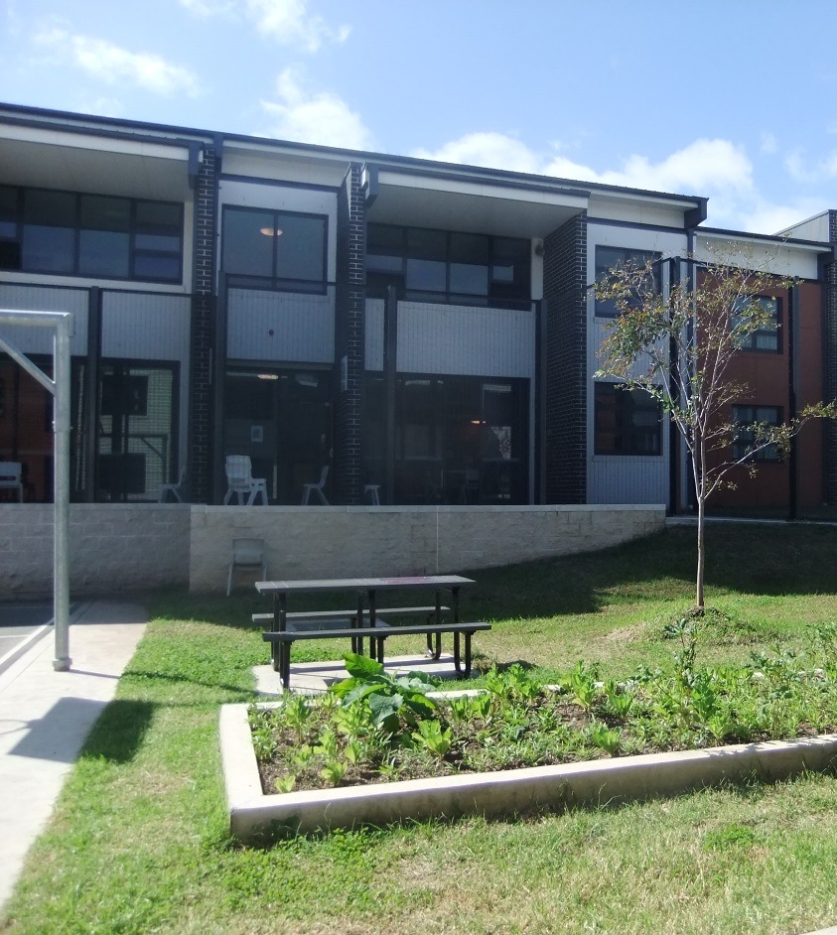
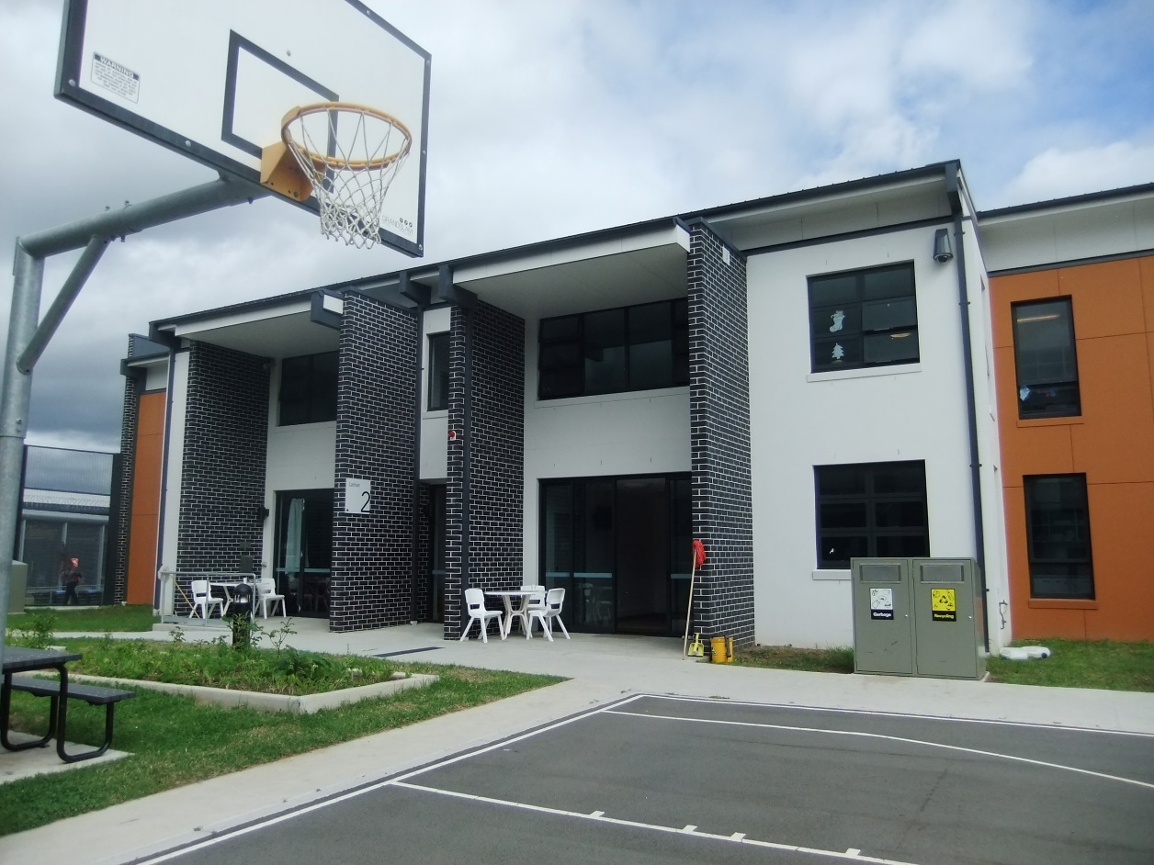
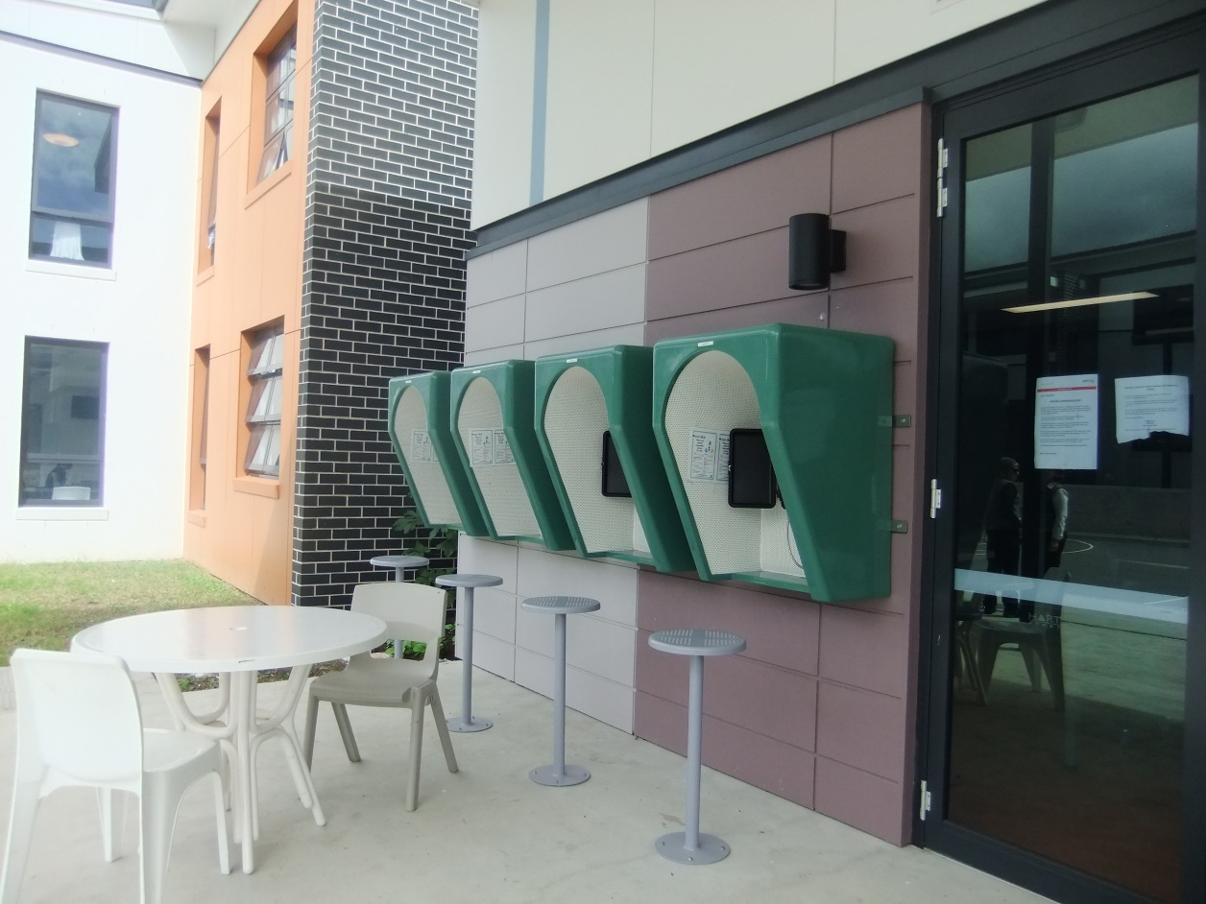
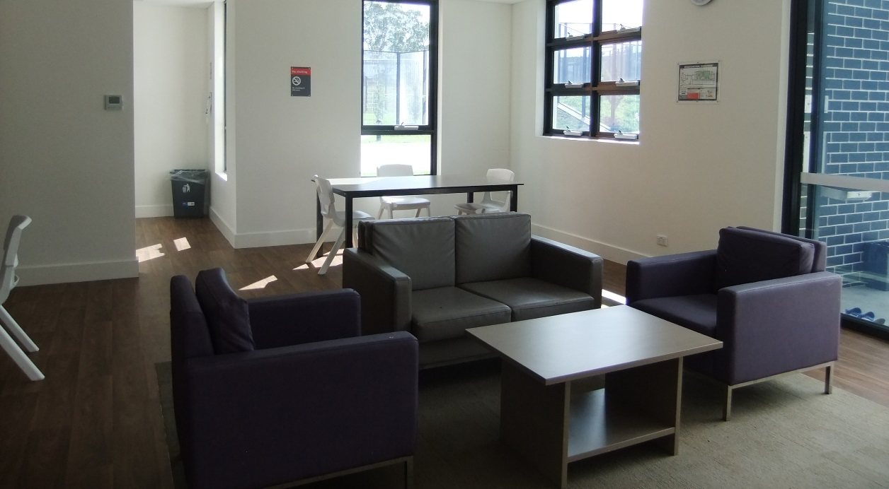

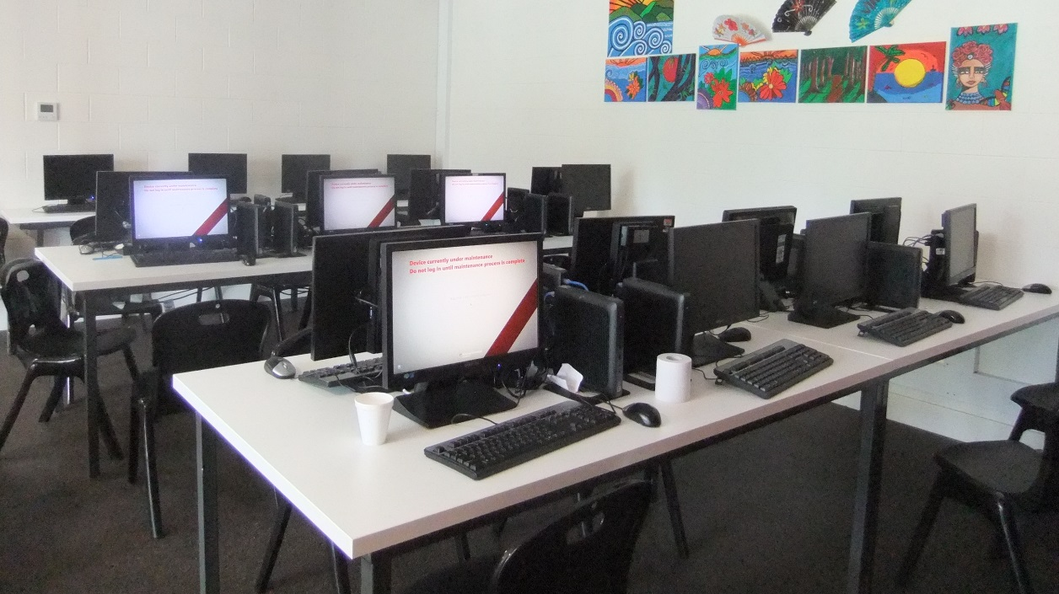

Facilities in community area
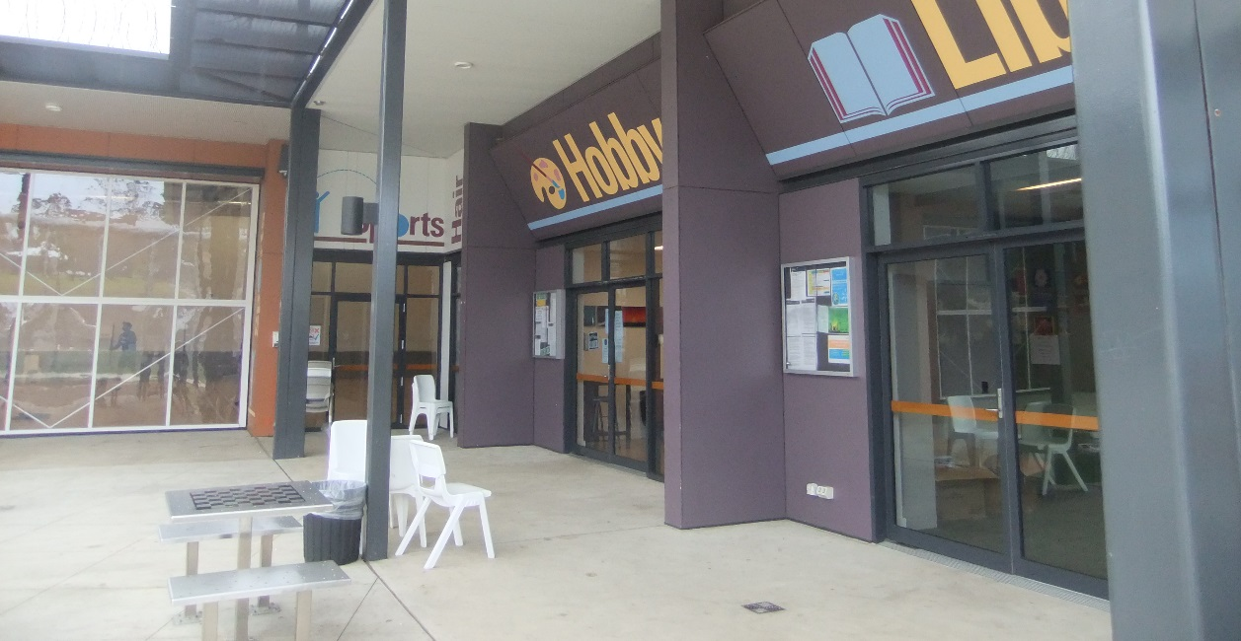
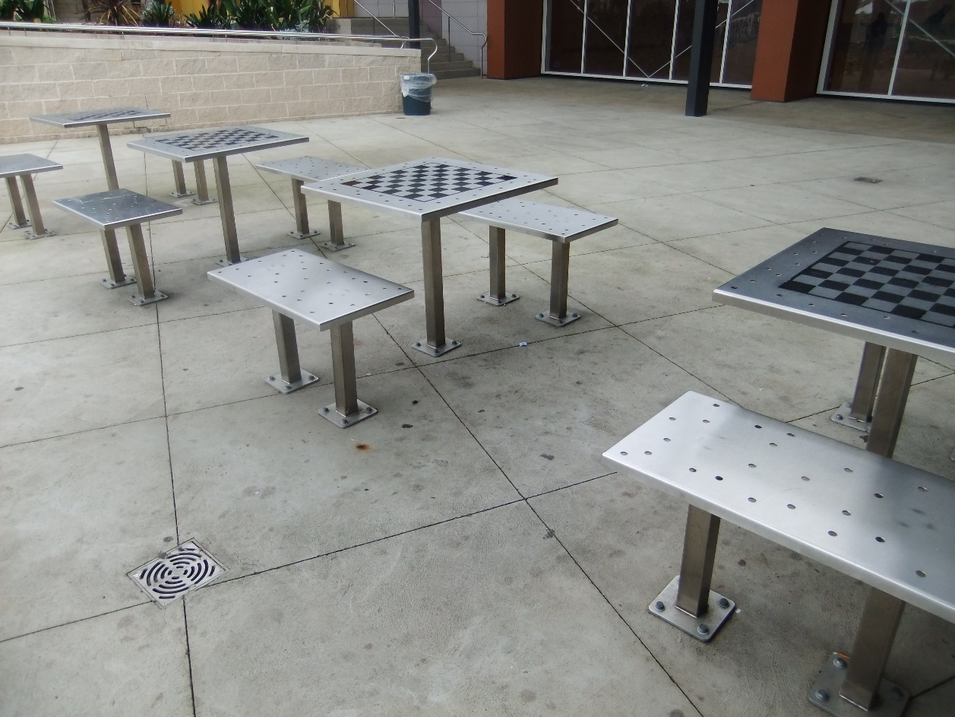
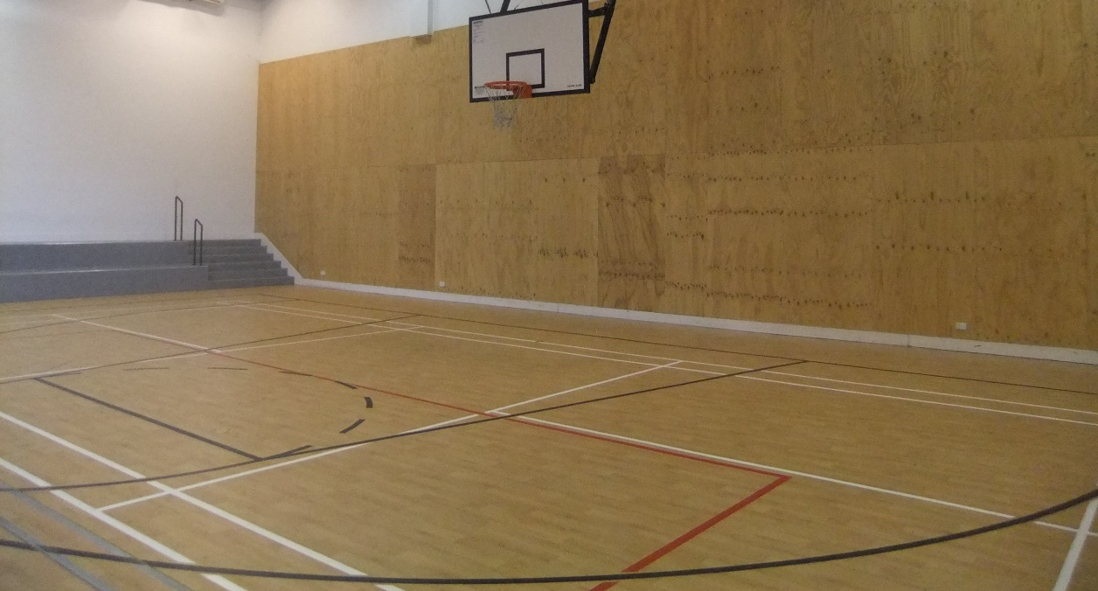

Facilities in Hotham compound
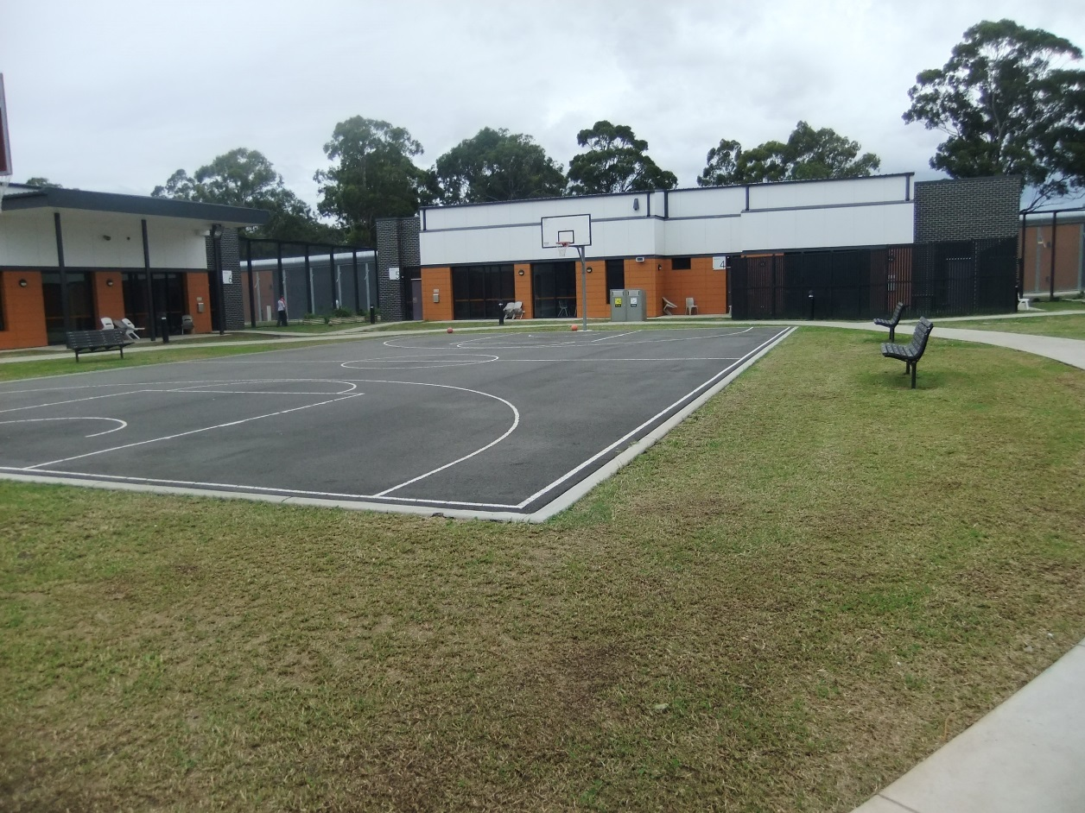
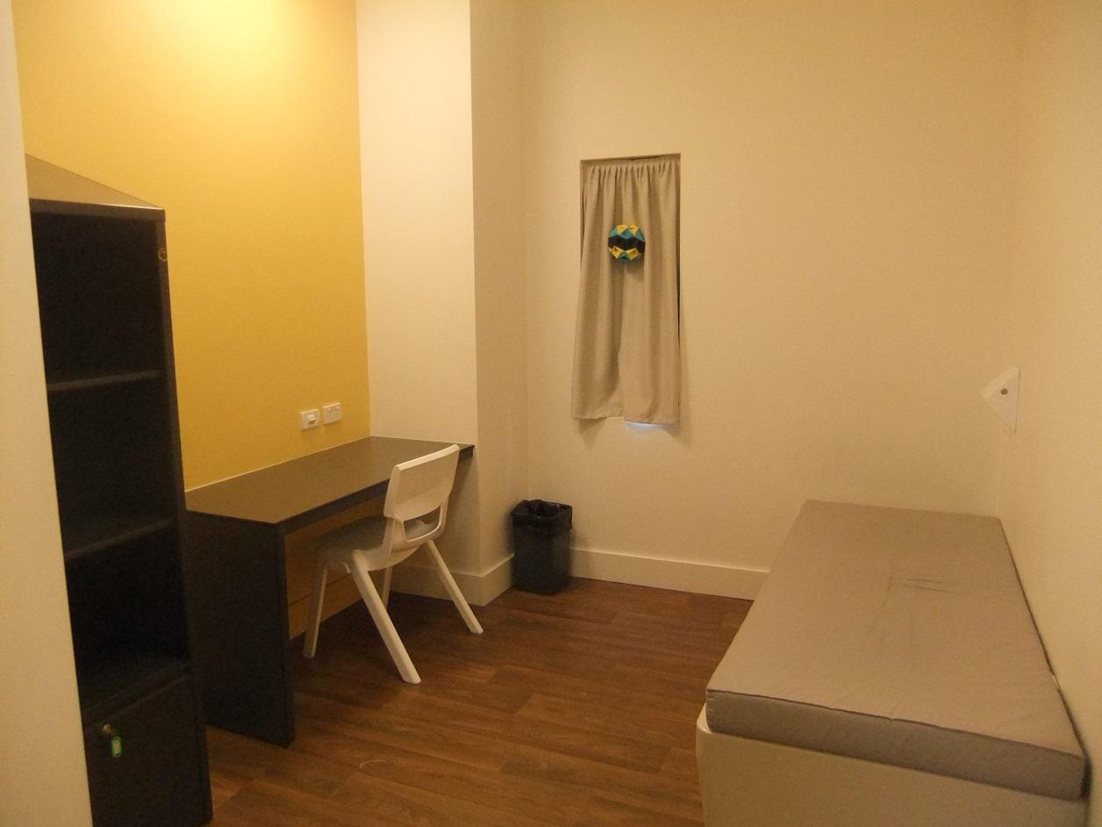
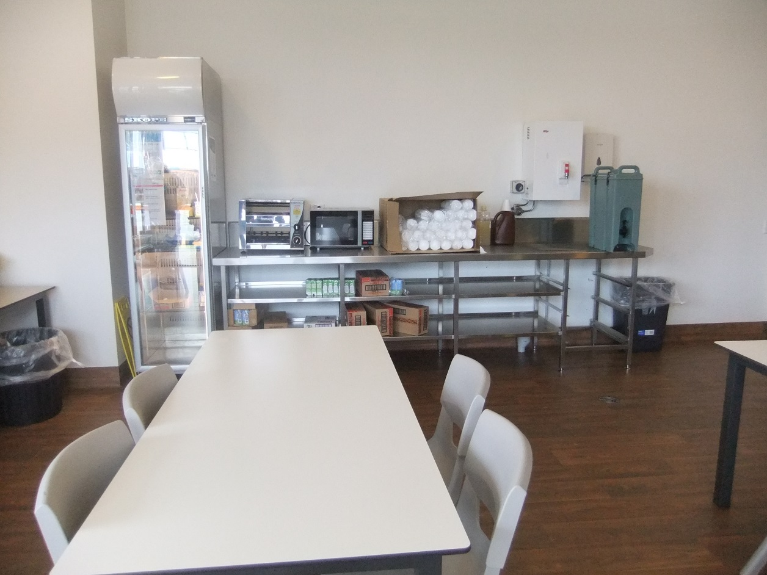
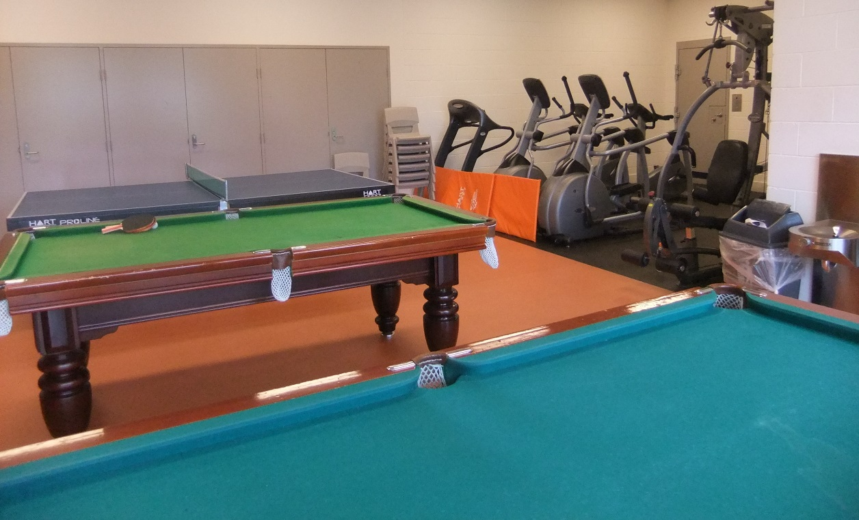

Facilities in Blaxland compound (Dorms 1 and 2)
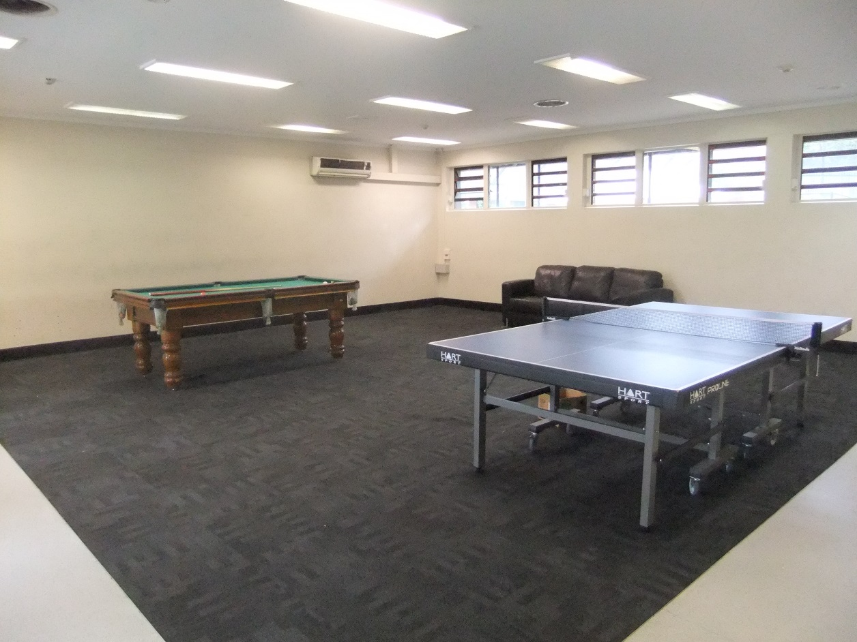
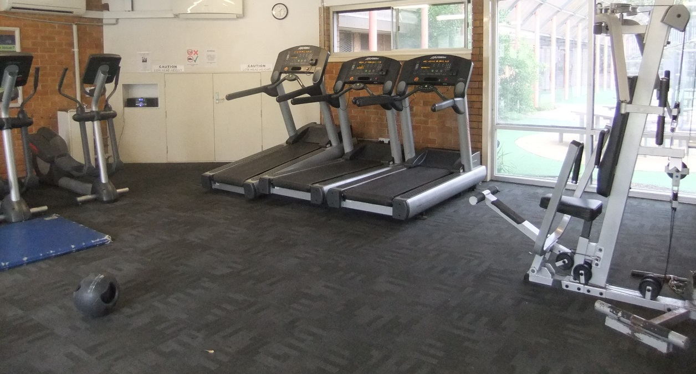
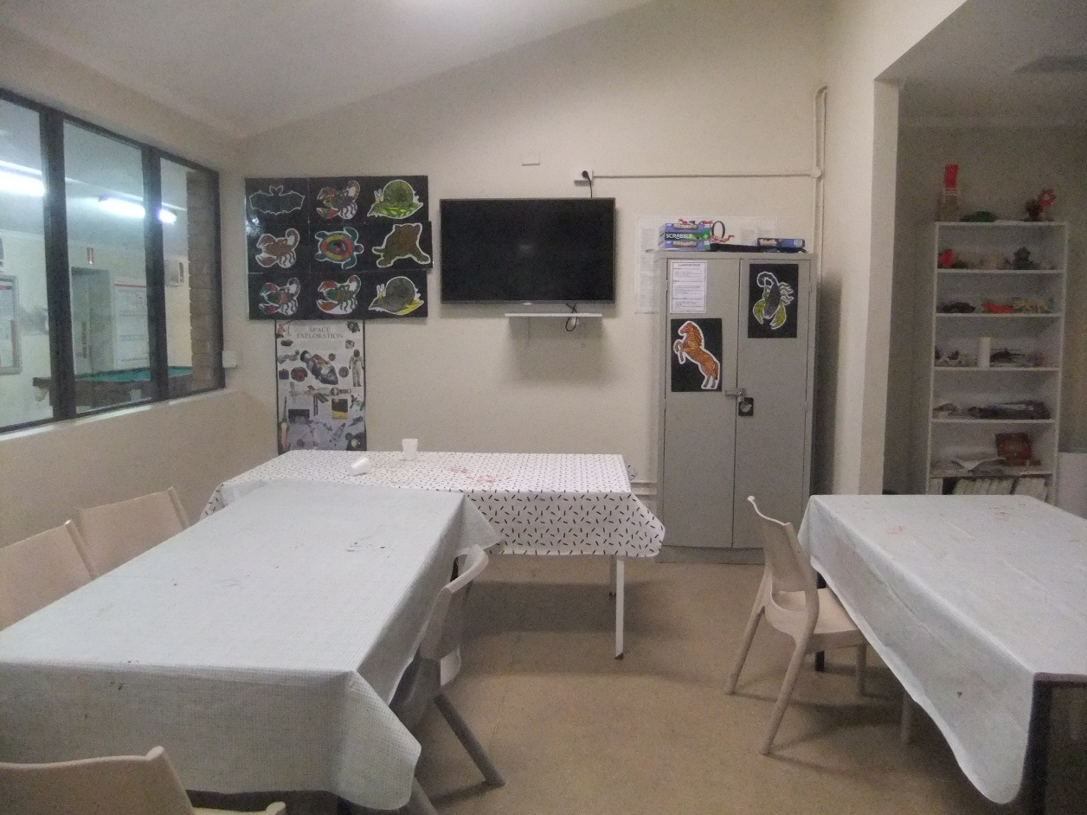
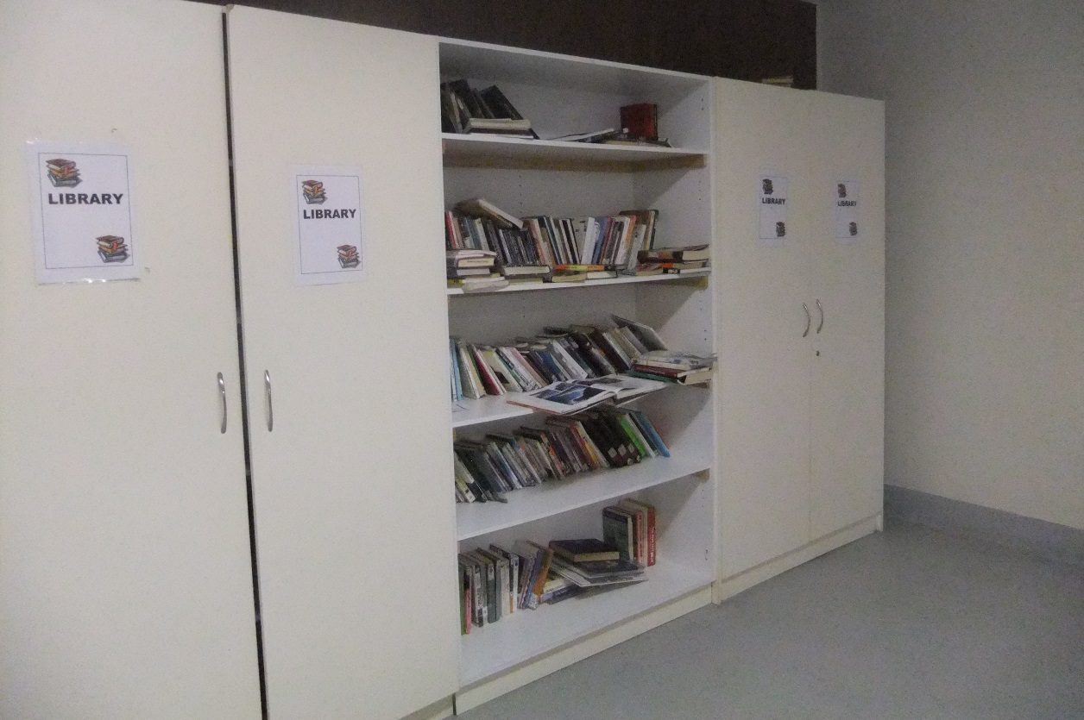

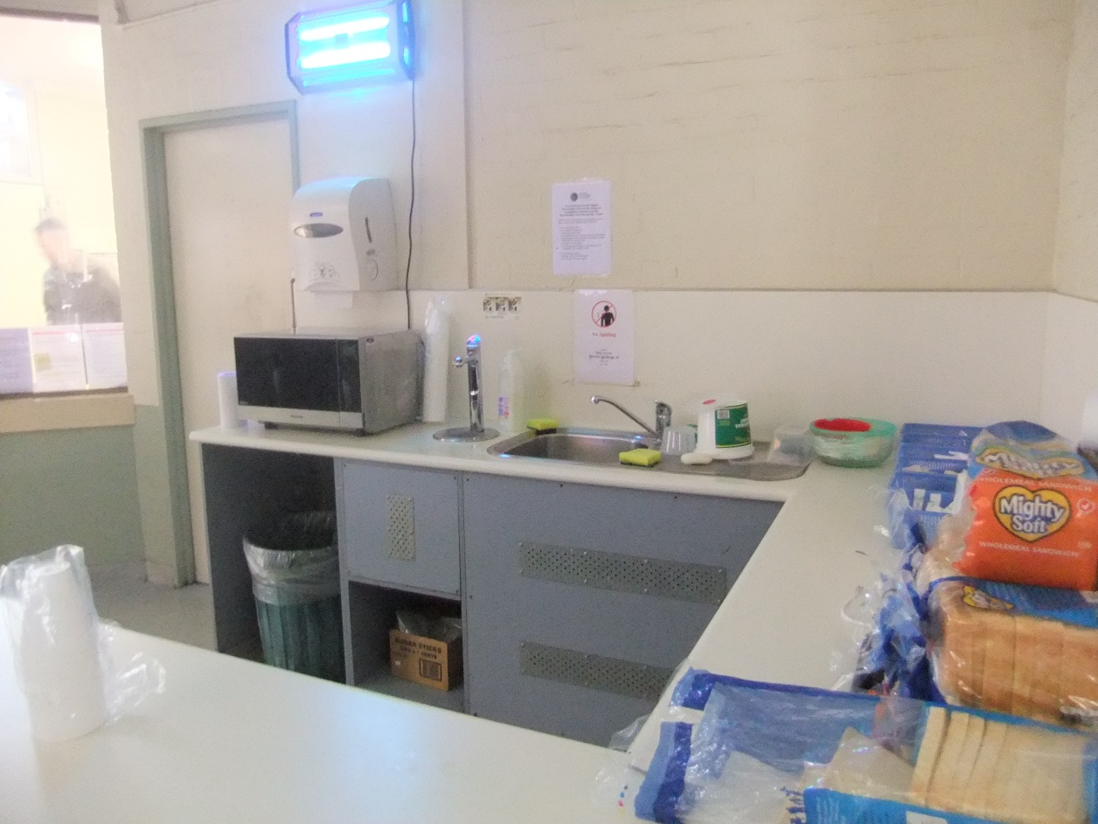
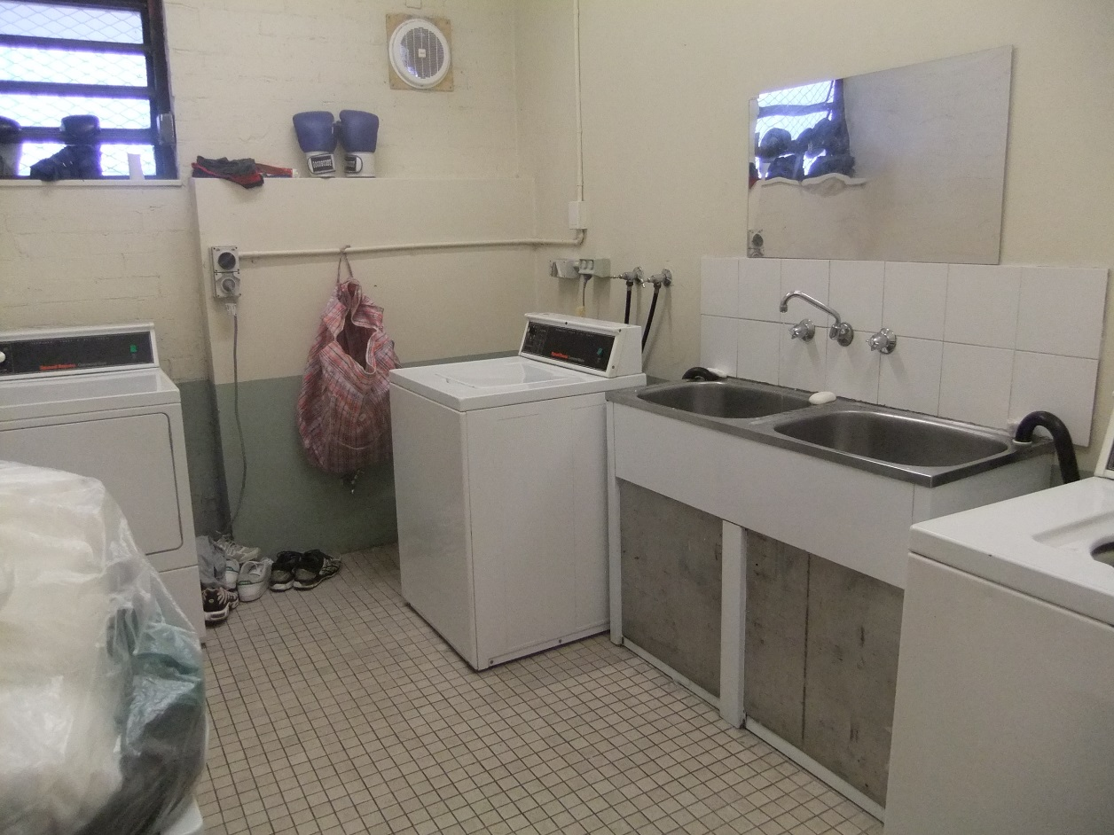

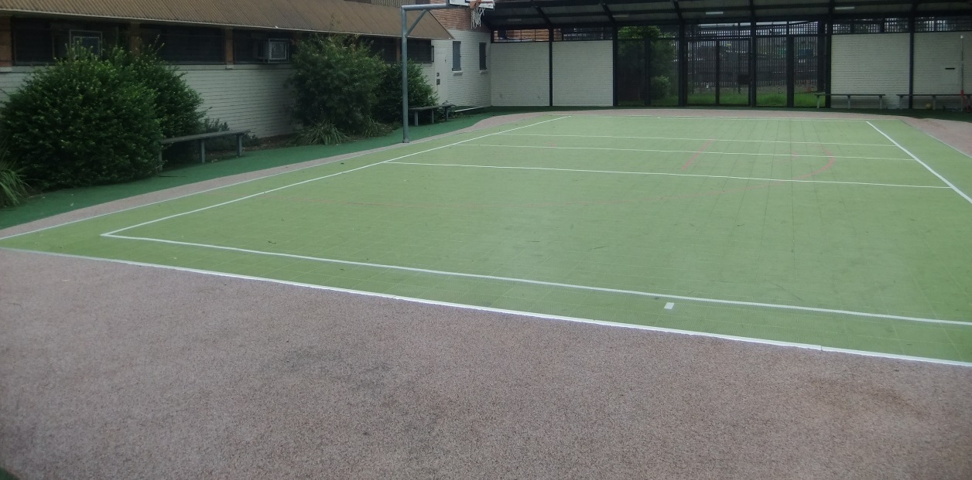

Facilities in Blaxland compound (Dorm 3)
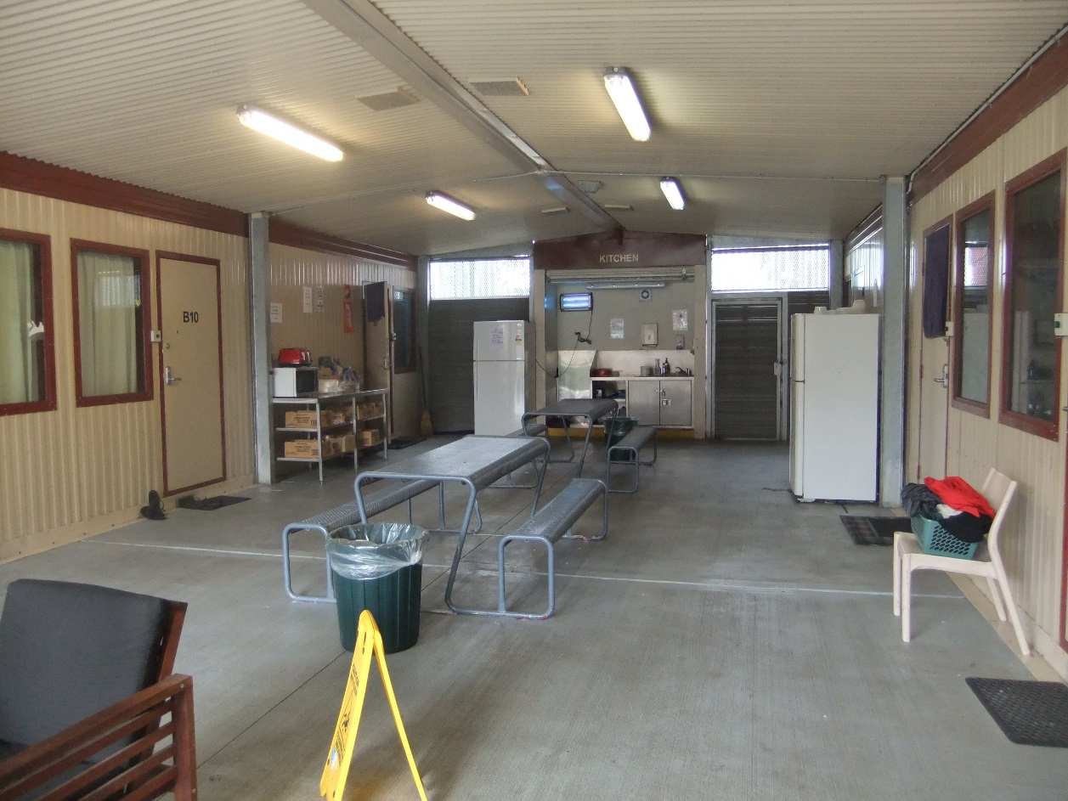
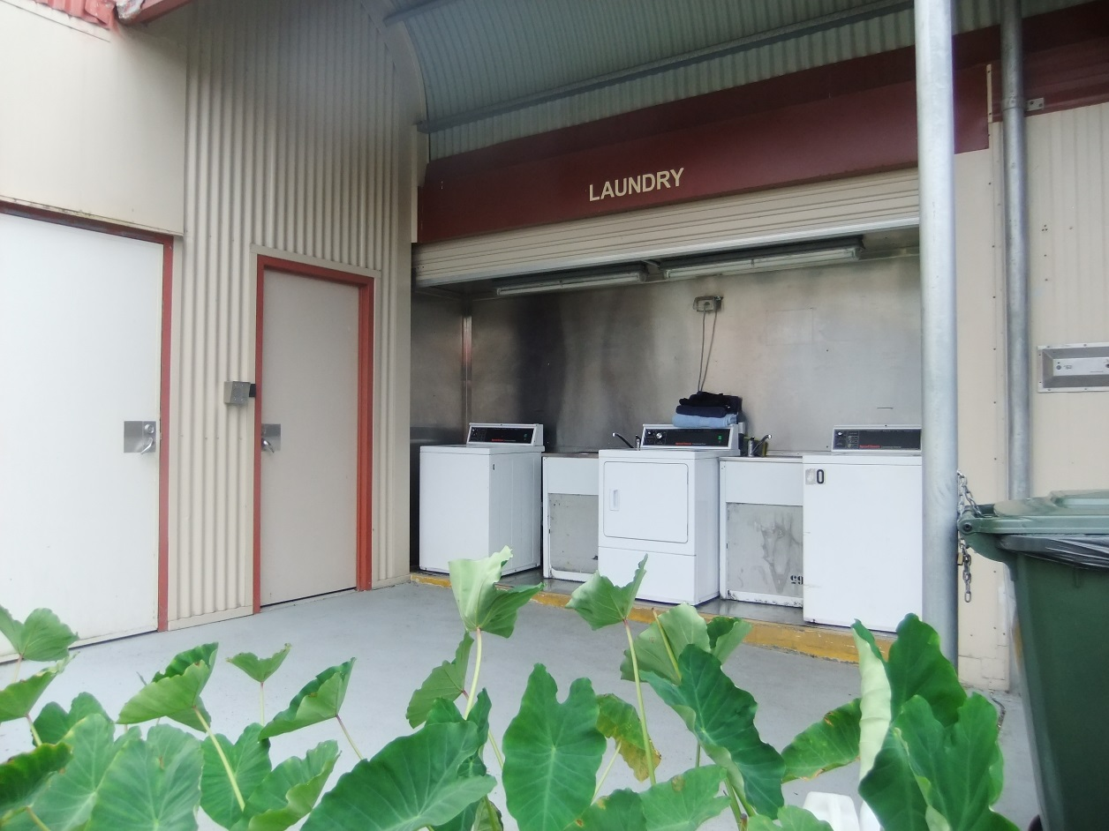
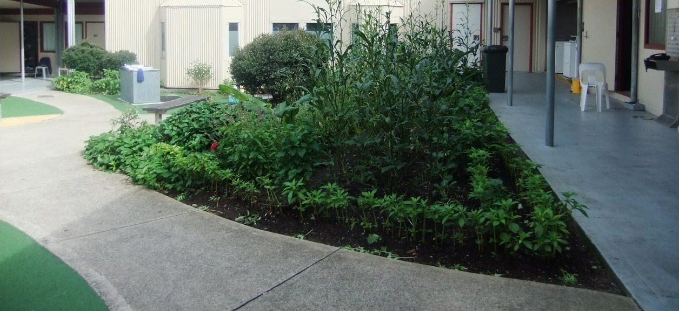

Visits area
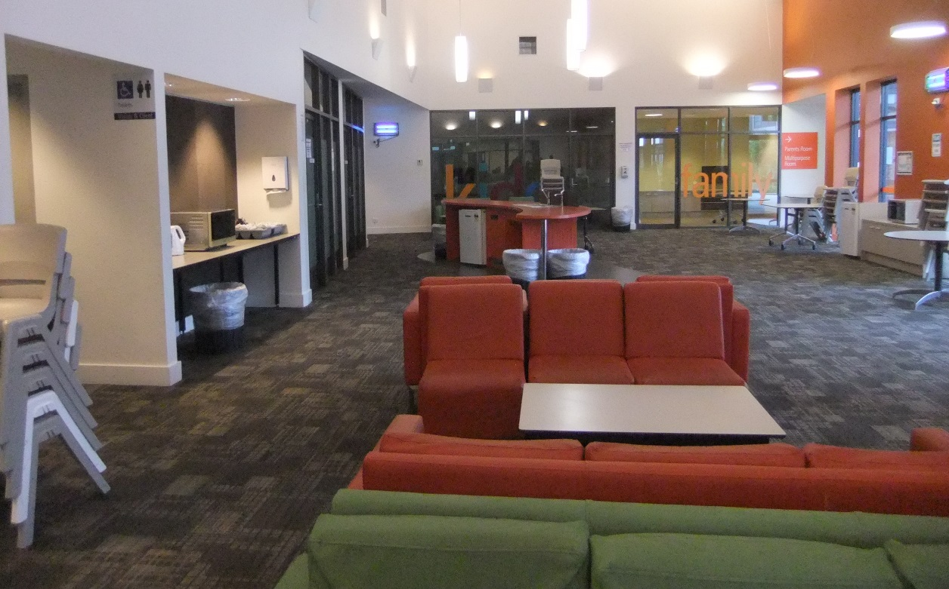
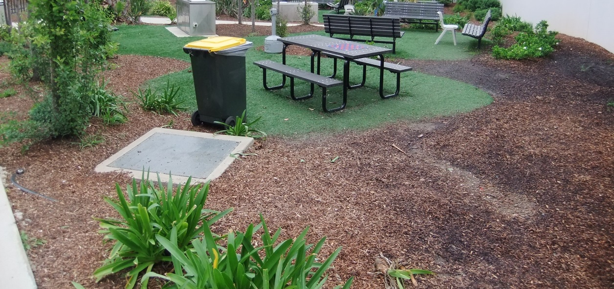

Appendix 2: Kessler Psychological Distress Scale
 | None of the time | A little of the time | Some of the time | Most of the time | All of the time
In the past four weeks, how often did you feel worn out for no good reason? | 1 | 2 | 3 | 4 | 5
In the past four weeks, how often did you feel nervous? | 1 | 2 | 3 | 4 | 5
In the past four weeks, how often did you feel so nervous that nothing could calm you down? | 1 | 2 | 3 | 4 | 5
In the past four weeks, how often did you feel hopeless? | 1 | 2 | 3 | 4 | 5
In the past four weeks, how often did you feel restless or fidgety? | 1 | 2 | 3 | 4 | 5
In the past four weeks, how often did you feel so restless you could not sit still? | 1 | 2 | 3 | 4 | 5
In the past four weeks, how often did you feel depressed? | 1 | 2 | 3 | 4 | 5
In the past four weeks, how often did you feel that everything was an effort? | 1 | 2 | 3 | 4 | 5
In the past four weeks, how often did you feel so sad that nothing could cheer you up? | 1 | 2 | 3 | 4 | 5
In the past four weeks, how often did you feel worthless? | 1 | 2 | 3 | 4 | 5

Endnotes

Reports from previous monitoring visits to immigration detention facilities can be found on the Commission’s website at https://www.humanrights.gov.au/our-work/asylum-seekers-and-refugees/immigration-detention-reports-and-photos
Human Rights and Equal Opportunity Commission, Those who've come across the seas: Detention of unauthorised arrivals (1998). At https://www.humanrights.gov.au/our-work/asylum-seekers-and-refugees/publications/those-whove-come-across-seas-detention (viewed 11 May 2017); Human Rights and Equal Opportunity Commission, A last resort? National Inquiry into Children in Immigration Detention (2004). At https://www.humanrights.gov.au/our-work/asylum-seekers-and-refugees/projects/last-resort-report-national-inquiry-children (viewed 11 May 2017); Australian Human Rights Commission, The Forgotten Children: National Inquiry into Children in Immigration Detention (2014). At https://www.humanrights.gov.au/our-work/asylum-seekers-and-refugees/projects/national-inquiry-children-immigration-detention-index (viewed 11 May 2017).
Australian Human Rights Commission, Asylum seekers, refugees and human rights: Snapshot Report (2nd edition) (2017) 11–25. At https://www.humanrights.gov.au/our-work/asylum-seekers-and-refugees/publications/asylum-seekers-refugees-and-human-rights-snapsho-0 (viewed 11 May 2017).
Australian Human Rights Commission, Human rights standards for immigration protection (2013). At https://www.humanrights.gov.au/our-work/asylum-seekers-and-refugees/publications/human-rights-standards-immigration-detention (viewed 11 May 2017).
International Covenant on Civil and Political Rights, opened for signature 16 December 1966, 999 UNTS 171 (entered into force 23 March 1976) arts 9(1), 10(1)
International Covenant on Civil and Political Rights, opened for signature 16 December 1966, 999 UNTS 171 (entered into force 23 March 1976) art 7; Convention against Torture and Other Cruel, Inhuman or Degrading Treatment or Punishment, opened for signature 10 December 1984, 1465 UNTS 85 (entered into force 26 June 1987) arts 2(1), 16(1).
International Covenant on Economic, Social and Cultural Rights, opened for signature 16 December 1966, 993 UNTS 3 (entered into force 3 January 1976) arts 6(2), 11, 12, 13, 15(1a).
International Covenant on Civil and Political Rights, opened for signature 16 December 1966, 999 UNTS 171 (entered into force 23 March 1976) arts 7, 10(1); Convention against Torture and Other Cruel, Inhuman or Degrading Treatment or Punishment, opened for signature 10 December 1984, 1465 UNTS 85 (entered into force 26 June 1987) arts 2(1), 16(1).
International Covenant on Civil and Political Rights, opened for signature 16 December 1966, 999 UNTS 171 (entered into force 23 March 1976) arts 17, 18.
International Covenant on Civil and Political Rights, opened for signature 16 December 1966, 999 UNTS 171 (entered into force 23 March 1976) arts 19(b), 22, 27.
International Covenant on Economic, Social and Cultural Rights, opened for signature 16 December 1966, 993 UNTS 3 (entered into force 3 January 1976) art 15(1a).
International Covenant on Civil and Political Rights, opened for signature 16 December 1966, 999 UNTS 171 (entered into force 23 March 1976) art 23(1); International Covenant on Economic, Social and Cultural Rights, opened for signature 16 December 1966, 993 UNTS 3 (entered into force 3 January 1976) art 10(1).
International Covenant on Civil and Political Rights, opened for signature 16 December 1966, 999 UNTS 171 (entered into force 23 March 1976) art 17(1); Convention on the Rights of the Child, opened for signature 20 November 1989, 1577 UNTS 3 (entered into force 2 September 1990) art 16(1).
Convention against Torture and Other Cruel, Inhuman or Degrading Treatment or Punishment, opened for signature 10 December 1984, 1465 UNTS 85 (entered into force 26 June 1987) arts 13, 16(1).
International Covenant on Civil and Political Rights, opened for signature 16 December 1966, 999 UNTS 171 (entered into force 23 March 1976) art 9(1)
Human Rights Committee, Van Alphen v Netherlands, Communication No. 305/1988, UN Doc CCPR/C/39/D/305/1988 (23 July 1990) [5.8]. At http://www.refworld.org/docid/525414304.html (viewed 7 December 2016); Human Rights Committee, A v Australia, Communication No. 560/1993, UN Doc CCPR/C/59/D/560/1993 (3 April1997) [9.4]. At http://www.refworld.org/docid/3ae6b71a0.html (viewed 7 December 2016).
International Covenant on Civil and Political Rights, opened for signature 16 December 1966, 999 UNTS 171 (entered into force 23 March 1976) arts 9(2), 9(4)
The Commission conducted an inspection of the Sydney Immigration Residential Housing facility (previously part of the VIDC complex) in March 2014, as part of the National Inquiry into Children in Immigration Detention. This facility is no longer operating as a place of closed detention and as such was not inspected by the Commission team in April 2017.
Department of Immigration and Citizenship, Immigration Detention Statistics Summary (30 April 2012) 3.
Department of Immigration and Citizenship, Immigration Detention Statistics Summary (31 July 2013) 3–4. At http://www.border.gov.au/ReportsandPublications/Documents/statistics/immigration-detention-statistics-july2013.pdf (viewed 12 May 2017); Department of Immigration and Border Protection, Immigration Detention and Community Statistics Summary (28 February 2015) 3, 5. At http://www.border.gov.au/ReportsandPublications/Documents/statistics/immigration-detention-statistics-feb2015.pdf (viewed 12 May 2017).
Department of Immigration and Citizenship, Immigration Detention Statistics Summary (31 July 2013) 3, 7. At http://www.border.gov.au/ReportsandPublications/Documents/statistics/immigration-detention-statistics-july2013.pdf (viewed 12 May 2017); Department of Immigration and Border Protection, Immigration Detention and Community Statistics Summary (28 February 2015) 3, 8. At http://www.border.gov.au/ReportsandPublications/Documents/statistics/immigration-detention-statistics-feb2015.pdf (viewed 12 May 2017).
Department of Immigration and Border Protection, Immigration Detention and Community Statistics Summary (30 April 2017) 4. At http://www.border.gov.au/ReportsandPublications/Documents/statistics/immigration-detention-statistics-30-april-2017.pdf (viewed 1 June 2017). Note that these figures do not include people detained in the Regional Processing Centres in Nauru and Manus Island, Papua New Guinea.
Department of Immigration and Citizenship, Immigration Detention Statistics Summary (30 April 2012) 8; Department of Immigration and Citizenship, Immigration Detention Statistics Summary (31 July 2013) 9. At http://www.border.gov.au/ReportsandPublications/Documents/statistics/immigration-detention-statistics-july2013.pdf (viewed 12 May 2017).
Department of Immigration and Border Protection, Immigration Detention and Community Statistics Summary (31 January 2017) 11. At http://www.border.gov.au/ReportsandPublications/Documents/statistics/immigration-detention-statistics-31-jan-2017.pdf (viewed 12 May 2017).
Department of Immigration and Border Protection, Immigration Detention and Community Statistics Summary (30 April 2017) 11. At http://www.border.gov.au/ReportsandPublications/Documents/statistics/immigration-detention-statistics-30-april-2017.pdf (viewed 1 June 2017).
Department of Immigration and Citizenship, Immigration Detention Statistics Summary (30 April 2012) 8.
Department of Immigration and Citizenship, Immigration Detention Statistics Summary (31 July 2013) 9. At http://www.border.gov.au/ReportsandPublications/Documents/statistics/immigration-detention-statistics-july2013.pdf (viewed 12 May 2017);
Department of Immigration and Border Protection, Immigration Detention and Community Statistics Summary (30 April 2017) 11. At http://www.border.gov.au/ReportsandPublications/Documents/statistics/immigration-detention-statistics-30-april-2017.pdf (viewed 1 June 2017).
Canada Border Services Agency, Detention Statistics (23 May 2017). At http://www.cbsa-asfc.gc.ca/security-securite/detent-stat-eng.html (viewed 25 September 2017).
United Kingdom Home Office, National Statistics: Detention (23 February 2017). At https://www.gov.uk/government/publications/immigration-statistics-october-to-december-2016/detention (viewed 25 September 2017); United Kingdom Home Office, National Statistics: Detention (3 March 2016). At https://www.gov.uk/government/publications/immigration-statistics-october-to-december-2015/detention (viewed 25 September 2017; United Kingdom Home Office, National Statistics: Immigration statistics, October to December 2014 (26 February 2015). At https://www.gov.uk/government/publications/immigration-statistics-october-to-december-2014/immigration-statistics-october-to-december-2014 (viewed 25 September 2017); United Kingdom Home Office, National Statistics: Immigration statistics, October to December 2013 (27 February 2014). At https://www.gov.uk/government/publications/immigration-statistics-october-to-december-2013/immigration-statistics-october-to-december-2013 (viewed 25 September 2017); United Kingdom Home Office, National Statistics: Immigration statistics, October to December 2012 (28 February 2013). At https://www.gov.uk/government/publications/immigration-statistics-october-to-december-2012/immigration-statistics-october-to-december-2012 (viewed 25 September 2017).
Department of Immigration and Citizenship, Immigration Detention Statistics Summary (30 April 2012) 5.
See the Department of Immigration and Border Protection’s immigration detention statistics summaries, available at http://www.border.gov.au/about/reports-publications/research-statistics/statistics/live-in-australia/immigration-detention (viewed 12 May 2017).
Migration Amendment (Character and General Visa Cancellation) Act 2014 (Cth)
Department of Immigration and Border Protection, Key visa cancellation statistics (n.d.). At http://www.border.gov.au/about/reports-publications/research-statistics/statistics/key-cancellation-statistics (viewed 29 November 2016).
Department of Immigration and Border Protection, Immigration Detention and Community Statistics Summary (31 March 2017) 4, 7. At http://www.border.gov.au/ReportsandPublications/Documents/statistics/immigration-detention-statistics-31-march-2017.pdf (viewed 24 May 2017).
Australian Human Rights Commission, Immigration detention in Villawood: Summary of observations from visit to immigration detention facility in Villawood (2011) 15–16. At https://www.humanrights.gov.au/sites/default/files/content/human_rights/immigration/idc2011_villawood.pdf (viewed 6 June 2017).
International Covenant on Civil and Political Rights, opened for signature 16 December 1966, 999 UNTS 171 (entered into force 23 March 1976) art 10(1)
Australian Bureau of Statistics, Information Paper: Use of the Kessler Psychological Distress Scale in ABS Health Surveys, Australia, 2007-08 (4 April 2012) 9. At http://www.abs.gov.au/ausstats/abs@.nsf/Lookup/34333D54F054CE51CA2579D50015D786?opendocument (viewed 16 June 2017).
Gavin Andrews and Tim Slade, ‘Interpreting scores on the Kessler Psychological Distress Scale (K10)’ (2001) 25, 6 Australian and New Zealand Journal of Public Health 494, 495.
Australian Bureau of Statistics, Information Paper: Use of the Kessler Psychological Distress Scale in ABS Health Surveys, Australia, 2007-08 (4 April 2012) 9. At http://www.abs.gov.au/ausstats/abs@.nsf/Lookup/34333D54F054CE51CA2579D50015D786?opendocument (viewed 16 June 2017); Gavin Andrews and Tim Slade, ‘Interpreting scores on the Kessler Psychological Distress Scale (K10)’ (2001) 25, 6 Australian and New Zealand Journal of Public Health 494, 495.
Louise K Newman, Nicholas G Procter and Michael J Dudley, ‘Suicide and self-harm in immigration detention’ (2011) 195(6) Medical Journal of Australia 310; Melissa Bull et al, ‘Sickness in the System of Long-term Immigration Detention’ (2013) 26 Journal of Refugee Studies 47; Ilan Katz et al, The experiences of Irregular Maritime Arrivals detained in immigration detention facilities: Final report (2013). At http://www.border.gov.au/ReportsandPublications/Documents/research/IMA-experiences-IDF.pdf (viewed 7 December 2016).
See, for example, Australian Human Rights Commission, Immigration detention in Villawood: Summary of observations from visit to immigration detention facility in Villawood (2011) 18, 30. At https://www.humanrights.gov.au/sites/default/files/content/human_rights/immigration/idc2011_villawood.pdf (viewed 6 June 2017).
Department of Immigration and Border Protection, ‘New measures to combat illegal activity within immigration detention facilities’ (Media Release, 11 November 2016). At http://newsroom.border.gov.au/releases/new-measures-to-combat-illegal-activity-within-immigration-detention-facilities (viewed 26 May 2017).
See Australian Human Rights Commission, Asylum seekers, refugees and human rights: Snapshot Report (2nd edition) (2017) 11–25. At https://www.humanrights.gov.au/our-work/asylum-seekers-and-refugees/publications/asylum-seekers-refugees-and-human-rights-snapsho-0 (viewed 11 May 2017). See also Australian Human Rights Commission, Inspection of Maribyrnong Immigration Detention Centre: Report (2017) 26–29. At https://www.humanrights.gov.au/our-work/asylum-seekers-and-refugees/publications/inspection-maribyrnong-immigration-detention (viewed 17 October 2017); Australian Human Rights Commission, Inspection of Melbourne Immigration Transit Accommodation: Report (2017) 24–27. At https://www.humanrights.gov.au/our-work/asylum-seekers-and-refugees/publications/inspection-melbourne-immigration-transit (viewed 17 October 2017).

