16–18 May 2017
Australian Human Rights Commission Inspection of Yongah Hill Immigration Detention Centre: Report

Table of Contents
1 Introduction 5
2 Background 6
2.1 Previous inspections 6
2.2 Inspection methodology 6
2.3 Relevant human rights standards 7
(a) Treatment of people in detention 7
(b) Conditions of detention 7
(c) Communication, association and complaints 8
(d) Legal and policy framework 9
2.4 National context 9
(a) Number of people in detention 9
(b) Length of detention 9
(c) Reasons for detention 10
(d) Administration of the detention network 10
(e) Ratification of OPCAT 10
2.5 Yongah Hill Immigration Detention Centre 11
3 Key issues and concerns 11
3.1 Treatment of people in detention 11
(a) Risk assessments 11
(b) General safety and security 12
(c) Relationships with staff 12
(d) Use of force and restraints 13
(e) Transfers between detention facilities 14
(f) Other invasive and restrictive measures 15
3.2 Conditions of detention 15
(a) Accommodation and living areas 15
(b) Indoor and outdoor exercise 16
(c) Activities and excursions 17
(d) Food 18
(e) Personal items 19
3.3 Physical and mental health 19
(a) Health services 19
(b) Physical health 19
(c) Mental health 20
(d) Continuity of care 22
3.4 Communication and complaints 22
(a) Telephone access 22
(b) Computer and internet access 23
(c) Visits 24
(d) Complaints 25
3.5 Legislative and policy framework 25
(a) Indefinite mandatory detention 25
(b) Community alternatives to detention 26
(c) Case management and status resolution 27

4 Summary of recommendations 30
4.1 Recommendations to the Australian Government 30
4.2 Joint recommendations to the Department of Immigration and Border Protection and facility staff 30
4.3 Recommendations to the Minister and Department of Immigration and Border Protection 31
4.4 Recommendations to facility staff 33
5 Appendix 1: Photos taken during the Commission’s inspection 34
5.1 Facilities in Hawk compound 34
5.2 Shared facilities 36
6 Appendix 2: Kessler Psychological Distress Scale 40
Endnotes 41

Summary of key issues
Efforts of facility staff at the YHIDC to limit the use of restraints appear to be progressing in a positive direction and may offer useful lessons for the broader detention network.
Certain aspects of the transfer process are unjustified, particularly in relation to the lack of prior warning of transfers and lack of adequate opportunities for people to pack their belongings and notify family members, friends and legal representatives prior to the transfer.
Bedrooms in the current compounds at the YHIDC afford limited space and privacy if shared between two people.
Current facilities at the YHIDC provide ample space for indoor and outdoor exercise.
Facilities for activities at the YHIDC are of a high standard and allow for provision of a wide range of activities. There is a regular schedule of excursions from the YHIDC. However, a significant number of people may not currently be accessing excursions due to lack of awareness or concerns about the possible use of restraints.
There is a significant level of concern about the standard of physical health care provided at the YHIDC and the impact of detention on mental health.
The new policy prohibiting all mobile phone use may restrict access to external communication to a greater degree than is necessary to ensure safety and security.
There is limited access to computers at the YHIDC as compared with other detention facilities. A number of people interviewed by the Commission felt that they did not have sufficient access to computers.
Many people at the YHIDC have been detained for prolonged periods of time. More than half of the people interviewed by the Commission reported that they had been in immigration detention for at least a year, including a considerable number who had been detained for two years or more.
Consideration of community alternatives does not occur on a systematic basis for all people in detention, particularly for people who have had visas cancelled under section 501 of the Migration Act. In some cases, ongoing detention may not have been justifiable in the circumstances.
The reduction in the scope of the case manager role and its present limitations lead to a mismatch between the types of support that case managers can provide to people in detention, and the types of support that people in detention actually need, including to resolve their status.

Introduction
This report contains an overview of key observations and concerns arising from the Australian Human Rights Commission’s inspection of the Yongah Hill Immigration Detention Centre (YHIDC) in May 2017.
The rationale for the Commission undertaking such inspections is to identify problems in the way that detainees’ human rights are being protected and to suggest ways of addressing those problems. Hence, while the report is balanced and points to some good practices, its primary focus is on issues of concern identified by the Commission. The report reflects conditions as they were at the time of the inspection.
The Commission also raised a number of additional issues with the Department of Immigration and Border Protection (DIBP) and facility staff during and subsequent to the visit, including individual cases of concern.
The Commission acknowledges the assistance provided by DIBP and the Australian Border Force (ABF) in facilitating the Commission’s visit. The Commission is grateful to the DIBP and ABF officers and detention service provider staff who assisted the Commission team during the visit. A draft of this report was shared with DIBP in advance of its publication, to provide an opportunity for DIBP to respond to the identified issues.

Background

Previous inspections
The Commission has conducted inspections of immigration detention facilities in Australia since the mid-1990s. This has included periodic monitoring of detention facilities across the country and three major national inquiries into immigration detention.
The purpose of the Commission’s detention monitoring work is to ensure that Australia’s immigration detention system is compliant with our obligations under international human rights law. For many years, the Commission has expressed a range of concerns about aspects of the detention system that may lead to breaches of international human rights law. These include:
- the policy of mandatory immigration detention, which does not allow for adequate consideration of individual circumstances and can result in cases of arbitrary detention
- the indefinite and at times prolonged nature of immigration detention and the lack of a legislative time limit on detention
- the detention of children, which has led to breaches of numerous obligations under the Convention on the Rights of the Child (CRC)
- the indefinite detention of people who have received adverse security or character assessments, including in circumstances where they have not been convicted of a crime under Australian law
- conditions of detention, which in some cases have not met international standards
- the impacts of immigration detention on mental health
- the need for increased use of alternatives to immigration detention.
Further information about these concerns can be found in the Commission publication, Asylum Seekers, Refugees and Human Rights: Snapshot Report.
The Commission can also investigate and, where appropriate, try to resolve through conciliation, complaints it receives from people in immigration detention regarding alleged breaches of human rights.

Inspection methodology
The Commission inspected the YHIDC from 16 to 18 May 2017. This was the first time that the Commission had inspected the facility. The inspection was conducted by the Commission’s President, Professor Gillian Triggs, and three Commission staff. Emeritus Professor Max Kamien, a general practitioner, and Dr Bernadette Wright, a clinical psychologist, joined the inspection team as independent consultants.
During the inspection, the Commission team met with representatives from DIBP, ABF, Serco and International Health and Medical Services (IHMS); conducted an inspection of the physical conditions of detention; and held interviews with people detained at the YHIDC, including 28 private interviews and five group interviews involving around 35 people.
The Commission considered the evidence gathered during the inspection against human rights standards derived from international law that are relevant to immigration detention.

Relevant human rights standards
This section provides a summary of some of the key international human rights standards relevant to the situation of people in immigration detention. Further information about these and other relevant standards can be found in the Commission publication, Human rights standards for immigration protection.
The YHIDC is a high-security detention facility that is not used to detain children. As such, standards relating to the detention of children were not applicable to this inspection.

Treatment of people in detention
Australia is obliged under articles 9(1) and 10(1) of the International Covenant on Civil and Political Rights (ICCPR) to, respectively, uphold the right to security of the person and ensure that people in detention are treated with humanity and respect for the inherent dignity of the human person. Australia also has obligations under article 7 of the ICCPR and articles 2(1) and 16(1) of the Convention Against Torture and other Cruel, Inhuman or Degrading Treatment or Punishment (CAT) not to subject anyone to torture or to cruel, inhuman or degrading treatment or punishment, and to take effective measures to prevent these acts from occurring.
These obligations require Australia to ensure that people in detention are treated fairly and reasonably, and in a manner that upholds their dignity. They should enjoy a safe environment free from bullying, harassment, abuse and violence. Security measures should be commensurate with identified risks, and should be the least restrictive possible in the circumstances, taking into account the particular vulnerabilities of people in detention. Measures that may constitute torture or cruel, inhuman or degrading treatment or punishment (such as collective punishment, corporal punishment, excessive use of force and holding people incommunicado) should be prohibited.

Conditions of detention
Australia has a range of obligations under the International Covenant on Economic, Social and Cultural Rights (ICESCR) relevant to the material conditions of immigration detention. These include the right to education (articles 6(2) and 13); the right to an adequate standard of living, including adequate food, clothing and housing (article 11); the right to the highest attainable standard of health (article 12); and the right to take part in cultural life (article 15(1)(a)).
Australia’s obligations under the ICCPR and CAT to treat people in detention with humanity and respect, and not to subject anyone to cruel, inhuman or degrading treatment or punishment, are also relevant to conditions of detention. In addition, Australia has an obligation under articles 17 and 18 of the ICCPR to uphold the right to privacy and freedom of religion respectively.
These obligations require Australia to ensure that detention facilities are safe, hygienic and uphold human dignity. People in detention should have their basic needs met and have access to essential services (such as health care and primary and secondary education) to a standard commensurate with those provided in the Australian community.
People in detention should have opportunities to engage in meaningful activities and excursions that provide physical and mental stimulation. People in detention should also be able to profess and practise the religion of their choice, including through being able to attend religious services, receiving pastoral visits from religious representatives and celebrating major religious holidays and festivals.
In light of the negative impacts of detention on mental health, the length of detention should be limited to the minimum period necessary to achieve a legitimate aim, and community-based alternatives to detention should be used wherever feasible.

Communication, association and complaints
Australia has a range of obligations under the ICCPR relevant to communication between people in detention and their family members, friends, representatives and communities outside detention. These include the right to freedom of expression and to seek, receive and impart information and ideas (article 19(b)); the right to freedom of association with others (article 22); and the right of ethnic, religious and linguistic minorities, in community with the other members of their group, to enjoy their own culture, to profess and practise their own religion and to use their own language (article 27). Under the ICESCR, Australia also has an obligation to uphold the right to take part in cultural life (article 15(1)(a)).
In addition, Australia has obligations under articles 23(1) of the ICCPR and 10(1) of the ICESCR to afford protection and assistance to the family as the natural and fundamental group unit of society. Australia also has obligations under article 17(1) of the ICCPR and article 16(1) of the CRC not to subject anyone to arbitrary or unlawful interference with their family.
These obligations require Australia to ensure that detention does not have a disproportionate impact on people’s ability to express themselves, communicate and associate with others, and remain in contact with their family members, friends, representatives and communities. People in detention should be able to receive regular visits, and should have access to adequate communication facilities (such as telephones and computers) as well as news and library services. People in detention should, if possible, be located in facilities within a reasonable distance from their family members, friends and communities.
External communication, in particular access to complaints processes, is also essential for the prevention of torture and other cruel, inhuman or degrading treatment or punishment. Australia has obligations under articles 13 and 16(1) of the CAT to ensure that anyone who alleges that they have been subjected to torture or to cruel, inhuman or degrading treatment or punishment, has the right to complain to and have their case examined by competent authorities.
To ensure these obligations are upheld, people in detention should have opportunities to raise concerns and issues regarding treatment and conditions in detention, and make complaints both internally and to independent monitors (including the Commission and the Commonwealth Ombudsman), without fear of repercussions.

Legal and policy framework
Australia has an obligation under article 9 of the ICCPR not to subject anyone to arbitrary detention. According to the United Nations Human Rights Committee, ‘arbitrary detention’ includes detention which, although lawful under domestic law, is unjust or disproportionate. In order for the detention of a person not to be arbitrary, it must be a reasonable and necessary measure in all the circumstances.
Australia has further obligations under article 9 of the ICCPR to ensure that anyone who is arrested has the right to be informed of the reasons for their arrest and the charges against them, and that anyone who is detained has the right to challenge the legality of their detention in court.
These obligations require Australia to ensure that people are only detained in immigration detention facilities when it is reasonable and necessary in their individual circumstances (such as where they pose an unacceptable health or security risk), and for a limited period of time. Community-based alternatives to detention should be used wherever possible. People held in immigration detention should be informed of the reasons for their detention and be able to seek juridical review of whether their detention is arbitrary.

National context

Number of people in detention
The number of people in closed immigration detention, and particularly the number of children in detention, has reduced dramatically in recent years. The number of people in detention peaked at over 10,000 in July 2013, before declining to fewer than 2,000 in early 2015. The number of children in detention dropped from a high of almost 2,000 in July 2013 to fewer than 200 in early 2015.
As at May 2017, there were 1,400 people in immigration detention in Australia, including just one child.

Length of detention
While the overall number of people in detention has declined, the average length of detention has increased significantly. In July 2013, the average length of detention hit a low of 72 days. Since then, the average length has steadily increased, peaking at 493 days in January 2017. As at May 2017, the average stood at 443 days.
In July 2013, 228 people had been detained for over a year, comprising around two per cent of people in detention. The number of people in long-term detention has since increased, particularly as a proportion of the overall detention population. As at May 2017, 531 people — or 38 per cent of people in detention — had been detained for over a year.
By way of comparison, the average length of immigration detention in Canada has remained at less than one month for the past five years. The number of people in long-term immigration detention in Canada (defined as detention exceeding 90 days) typically comprised ten per cent or less of the detention population over the same time period. In the United Kingdom, over 90 per cent of the people leaving detention over the past five calendar years had been detained for four months or less.

Reasons for detention
Historically, asylum seekers who arrived by boat have typically comprised the majority of people in detention. Since the beginning of 2014, this group has progressively comprised a smaller proportion of the detention population (although they remained by far the largest group in detention until 2016).
At the same time, the number of people in detention due to having their visas cancelled has increased. This increase has been largely due to legislative amendments that broadened the scope of section 501 of the Migration Act 1958 (Cth) (the Migration Act). Section 501 allows the Minister or their delegate to refuse or cancel a visa on the basis that a person does not pass the ‘character test’. Since this section was amended in late 2014, visa cancellations on character grounds have increased dramatically, from 76 cancellations in the 2013–14 financial year to 580 in 2014–15, and 983 in 2015–16.
As at May 2017, people who had had their visas cancelled under section 501 were the largest group in detention, comprising around a third of the detention population. Asylum seekers who arrived by boat were the second-largest group in detention, at around a quarter of the population, followed by people who had overstayed their visa and people who had had their visa cancelled on non-character grounds.

Administration of the detention network
Up until mid-2015, Australia’s immigration detention network was administered by DIBP. On 1 July 2015, DIBP and the Australian Customs and Border Protection Service merged to form a single department. The ABF was established as the new frontline operational agency for this department. The ABF is now responsible for administering detention operations and removals; while DIBP remains responsible for the overall policy framework for detention, as well as matters relating to visa processing, case management and status resolution.
External contractors play a central role in the management of immigration detention facilities. Serco Australia is the contracted detention services provider, responsible for the day-to-day running of the facilities including security and provision of services and activities. IHMS is the contracted health services provider, responsible for providing onsite physical and mental health services to people in detention.

Ratification of OPCAT
On 9 February 2017, the Australian Government announced its commitment to ratify the Optional Protocol to the Convention Against Torture and other Cruel, Inhuman or Degrading Treatment or Punishment (OPCAT) by December 2017. OPCAT provides for ongoing independent monitoring of places of detention, to ensure adherence to minimum standards in conditions and treatment.
At the request of the Attorney-General, the Commission is undertaking a consultation process regarding how best to implement OPCAT. Based on the experience in jurisdictions that have ratified and implemented OPCAT, the Commission sees this as an opportunity to consider, in a more systematic way, the adequacy and appropriateness of conditions of detention. The Commission looks forward to continuing to work with the Government to support the implementation of OPCAT.

Yongah Hill Immigration Detention Centre
The YHIDC opened in June 2012. It is a high-security detention facility which currently accommodates single adult men across four compounds (Eagle, Falcon, Hawk and Swan). Each compound houses around 150 people. At the time of the Commission’s inspection, the Eagle compound was closed for infrastructure works.
At the time of the Commission’s inspection, there were 270 people detained at the facility. People who had been detained as a result of visa cancellations comprised the largest group at the facility, followed by asylum seekers who had arrived by boat and people who had overstayed their visas. The detention population included people of over 50 nationalities, with the top five countries of birth being Bangladesh, Sri Lanka, Malaysia, Iran and New Zealand.

Key issues and concerns

Treatment of people in detention

Risk assessments
People in detention are assigned risk ‘ratings’ which are used to determine how they will be treated while in immigration detention. People in detention undergo two separate risk assessments: a security risk assessment, which is used to determine where people are placed both within individual detention facilities and within the detention network; and a transport risk assessment, which is used to determine the conditions of escort when people are taken outside the facility (such as during transfers or when attending external appointments).
Risk ratings are developed using an algorithm that determines a person’s rating based on inputs from staff. The assessment process takes into account a range of factors, including behaviour in detention, criminal history, risk of self-harm, community safety, safety of staff and treating practitioners, and opportunities to escape or offend. Risk ratings are reviewed at least monthly to determine whether they are still appropriate. Ratings can also be amended by the Superintendent based on consideration of individual circumstances.
The Commission has previously expressed concern that the risk rating system may not be sufficiently nuanced to prevent unnecessary use of restrictive measures, and may not allow for an accurate or appropriate determination of the risks posed by particular individuals.
During the Commission’s inspection of the YHIDC, very few people raised concerns about risk assessments.

General safety and security
The YHIDC is a high-security detention facility. Security features observed by the Commission included high external and internal fences, secure internal doors and gates, barbed wire on external fences and security cameras. Members of Serco’s Emergency Response Team are typically equipped with body cameras and flexi-cuffs and may wear protective equipment (such as body armour, helmets and shields) when conducting an operation, but they do not carry weapons.
Many of the people interviewed by the Commission indicated that they felt safe in detention or did not report concerns relating to physical safety. However, a number of people did raise concerns about their safety, relating incidents in which they had felt threatened or intimidated by other people in detention. Some also alleged they had been threatened or assaulted in other detention facilities prior to being transferred to the YHIDC.
Some people reported witnessing distressing incidents, such as fights, self-harm and suicide attempts, and violence between people in detention (and, in some cases, staff). A few highlighted the increase in the number of people in detention who had previously committed crimes and the presence of illicit drugs in the facility as factors affecting safety. A number of people also noted that the impacts of detention on their mental health and uncertainty about their future made them feel unsafe in detention.
The Commission received few reports of bullying or harassment in detention, although a small number of people relayed incidents in which they had been bullied or harassed by other people in detention, or by staff.
Overall, physical safety did not appear to be a widespread concern among the people interviewed by the Commission. However, a significant number of people were clearly apprehensive about their physical safety. The Commission acknowledges that facility staff were aware of concerns about safety and reported that they had implemented strategies to address these concerns. The Commission encourages facility staff to closely monitor the situation and implement additional measures in response to safety concerns as needed.

Facility staff should continue to monitor concerns relating to physical safety and implement additional strategies to address these concerns as needed.

Relationships with staff
Some of the people interviewed by the Commission indicated that they had generally positive views of staff. More commonly, however, people reported that their experiences with staff had been mixed. Several people alleged that some staff members were professional, helpful and respectful while others were disrespectful, rude or had treated them in a discriminatory manner. For example, some people alleged that staff members had sworn at them or had treated people of certain nationalities more favourably than others. A small number of people reported more serious incidents, such as assaults.
Overall, those interviewed by the Commission reported few serious concerns relating to staff. The Commission also wishes to acknowledge its positive interactions with facility staff, who went out of their way to assist the Commission team and ensure that the inspection was as productive as possible.
Nonetheless, the fact that a significant number of people reported negative interactions with some staff members (even if these incidents were relatively minor) suggests that it would be beneficial to monitor this issue so as to ensure that respectful relationships between staff and people in detention are maintained.

The Department of Immigration and Border Protection and facility managers should monitor interactions between staff and people in detention to ensure that respectful relationships are maintained.

Use of force and restraints
Many of the people interviewed by the Commission indicated that they had not been mechanically restrained while in detention or did not report concerns relating to use of force and restraints. Facility staff reported that they had made efforts to reduce the use of mechanical restraints when people were being escorted outside the detention facility. For example, staff claimed that it was rare for the Superintendent to authorise the use of restraints when people were being escorted to medical consultations.
Nonetheless, many people interviewed by the Commission reported that they had been handcuffed or held when being escorted outside the detention facility (such as to attend medical appointments, court hearings or excursions) or when being transferred between facilities.
Some people stated that they felt embarrassed about being mechanically restrained or had been deterred from leaving the facility due to concerns about the use of restraints. In the words of one person, ‘When they put me in handcuffs, it feels very bad. Sometimes I don't want to go because I have to wear handcuffs’. A number of people reported that they had been mechanically restrained for long periods of time, such as when they were being transferred between detention facilities. In some cases, the person concerned had remained in handcuffs or for most of the day.
The Commission is unable to verify these accounts or ascertain the circumstances that led to the use of restraints in these cases. The Commission also notes that use of mechanical restraints during escort must be approved by the Superintendent on each occasion. The Commission further acknowledges that some of these incidents may have occurred prior to the implementation of efforts to reduce the use of restraints. However, some incidents had reportedly occurred only a few weeks prior to the Commission’s inspections.
The use of restraints has been one of the most significant and commonly-raised concerns raised during the Commission’s other detention inspections in 2017. The Commission therefore welcomes efforts by facility staff at the YHIDC to reduce the use of restraints where possible. The Commission also notes ongoing concerns among some people detained at the YHIDC about the use of restraints in some circumstances. Nonetheless, the Commission considers that the efforts of facility staff at the YHIDC to limit the use of restraints appear to be progressing in a positive direction and may offer useful lessons for the broader detention network.

The Department of Immigration and Border Protection and facility staff should review policies relating to the use of mechanical restraints, to ensure people in detention are not subject to more restrictive measures than are necessary in their individual circumstances. Particular consideration should be given to limiting the use of mechanical restraints during medical consultations and during transit where the risk of escape is low.

As part of broader efforts to ensure people in detention are not subject to more restrictive measures than are necessary in their individual circumstances, facility staff should document and share information regarding strategies to limit the use of restraints where possible, particularly during escort to medical consultations.

Transfers between detention facilities
Several of the people interviewed by the Commission expressed concern about the manner in which people are transferred between detention facilities. It was reported that people had been woken in the early hours of the morning, were given little or no time to pack their belongings and did not have the opportunity to notify family members, friends or legal representatives before they were transferred. Some claimed that they been given little or no prior warning of transfers or were not informed of the reason for the transfer. Conversely, a smaller number of people reported that they had received adequate notice, had time to pack their belongings or were given a clear reason for the transfer.
It was evident that the nature of transfers had created significant concern and anxiety among some people in detention. For example, one person reported that people felt ‘on edge’ on Wednesdays and Thursdays, as these are the days on which people are typically transferred (without notice) to the Christmas Island detention facility. Some people raised concerns that being transferred to YHIDC had separated them from their support networks or interfered with the continuity of medical care (see Section 3.3(d) for further discussion of this issue).
The Commission considers that certain aspects of the transfer process are unjustified, given that people are being transferred from a secure detention environment. In particular, the Commission considers that there would be few circumstances in which it would be justifiable to give people no prior warning of a transfer or deny them the opportunity to pack their belongings and notify family members, friends and legal representatives prior to the transfer.

Where a person is being transferred between immigration detention facilities, the Department of Immigration and Border Protection and facility staff should ensure that the person:
a) is given adequate notice of the transfer
b) receives a clear explanation of the reasons for the transfer
c) is given an opportunity to pack their belongings and notify family members, friends and legal representatives prior to the transfer.

Other invasive and restrictive measures
Some of the people interviewed by the Commission reported that they were regularly pat searched when receiving visits and when leaving or entering the facility (such as to attend medical appointments). They also indicated that their rooms were regularly searched.
A number of people expressed concern about the manner in which searches were conducted. For example, some complained that officers conducting room searches at times did not put their belongings back where they had been, and a few people raised concerns about invasiveness of pat searches.
Very few people reported having been held in single separation or subject to sanctions while at the YHIDC.

Conditions of detention

Accommodation and living areas
Accommodation areas are identical across all four compounds at the YHIDC, each of which has a current capacity of 150 people. Bedrooms were shared by up to two people and contained a bunk bed, a small fridge, a television and storage for personal belongings. Bedrooms were equipped with ensuite bathrooms. Each compound had shared laundry facilities, an indoor common area which contained a kitchenette, seating and a television, and outdoor common areas which included gardens and landline telephones.
Facility staff reported that infrastructure works are planned over the next year, which will significantly alter current accommodation arrangements. Two of the compounds will be split into four smaller compounds, reducing the overall capacity of the facility to 420 people. The new compounds will be designed to provide higher-security accommodation.
Facility staff welcomed the infrastructure works, noting that they would allow staff to better target services across compounds and manage behavioural issues. Staff reported that they are planning to introduce an incentive-based program, where people will initially be accommodated in the smaller, high-security compounds and moved to the larger compounds on the basis of good behaviour.
A number of the people interviewed by the Commission commented that their bedrooms were small, with several people expressing the view that the rooms were too small and cramped to be shared between two people. A few people indicated that they had no concerns about their accommodation. A small number of people commented that the bathrooms were also small, although relatively few people provided feedback on sanitation facilities.
Overall, the standard of accommodation did not appear to be a major concern among the people interviewed by the Commission. Nonetheless, the Commission notes that the bedrooms in the current compounds at the YHIDC are indeed small and would afford limited space and privacy if shared between two people. As such, the Commission considers that shared accommodation arrangements should be minimised where possible in favour of private arrangements.
The Commission also notes that open space is relatively limited within compounds at the YHIDC and the indoor common areas are generally smaller than in other detention facilities. Currently, these limitations do not appear to present a significant problem given that people in detention have access to spacious recreation areas elsewhere in the facility complex (described in further detail in Sections 3.2(b) and (c) below).
However, the Commission notes that limited indoor and outdoor space within compounds may become a concern in the future if people in the new high-security compounds have restricted access to shared outdoor areas. The Commission looks forward to engaging further with facility staff on this issue once the infrastructure works are completed.

The Department of Immigration and Border Protection should minimise shared accommodation arrangements at the YHIDC.

Indoor and outdoor exercise
At the centre of the YHIDC is a large outdoor recreation area referred to as the ‘Green Heart’. This area contains substantial open space, playing fields and courts, an undercover gym, exercise equipment, shaded areas and gardens. People detained at the YHIDC can access the Green Heart at any time aside from mealtimes, when the area is closed to enable staff to conduct welfare checks. The YHIDC also has an indoor gym which is open from 8:00am to 12:00pm and from 2:00pm to 4:00pm daily.
The Commission considers that current facilities at the YHIDC provide ample space for indoor and outdoor exercise. The Commission notes that these facilities could be enhanced through installing additional shaded areas, as there is relatively limited shade in the Green Heart compared to the size of the detention population.

The Department of Immigration and Border Protection should consider installing additional shaded areas in the Green Heart of the YHIDC.

Activities and excursions
Activities available at the YHIDC included English classes, sport and exercise activities, cooking classes, art and crafts, music lessons, games and prayer groups. The complex includes a range of dedicated facilities for activities, including a large canteen containing seating, televisions and recreation equipment (such as pool tables), an art room, a workshop, a large purpose-built kitchen, classrooms and a well-stocked library. A prayer room is also available. These facilities were spacious, well-maintained and well-equipped for activities.
A number of people interviewed by the Commission indicated that they participated in activities and generally provided positive or neutral feedback on these activities. Some indicated that they did not participate in activities due to the state of their mental health.
The Commission considers that facilities available for activities at the YHIDC are of a high standard and allow for provision of a wide range of activities. The Commission also notes the proactive steps taken by facility staff to increase the variety of activities offered at the YHIDC. As an additional step, the Commission suggests that consideration could be given to introducing a wider range of educational activities, such as short courses, workshops and a broader range of literacy and numeracy classes. The Commission was pleased to learn that facility staff are already exploring options for increasing access to educational opportunities to people in long-term detention.
There is a regular schedule of excursions from the YHIDC. Excursions include a river valley walk, swimming and visits to wildlife parks, museums and a community garden. Excursions to places of worship are also available. Facility staff reported that they are reviewing potential locations for excursions with a view to identifying more secure venues that would be suitable for people who are considered to present a higher risk.
Many of the people interviewed by the Commission indicated that they had not been on excursions while detained at the YHIDC. Some stated that they were unaware of opportunities for excursions or were unsure how to access these opportunities. Others reported that they were reluctant to go on excursions due to concerns about being pat searched, restrained or accompanied by a large number of officers. Some also claimed that they were not permitted to go on excursions due to their risk rating.
The Commission welcomes the commitment of facility staff to maintaining regular excursions for people detained at the YHIDC, including people with higher risk ratings. Excursions can have a positive impact on the wellbeing of people in detention, particularly those who have been detained for long periods of time.
However, feedback gathered during interviews suggests a significant number of people may not currently be accessing excursions due to lack of awareness or concerns about the possible use of restraints. The Commission therefore suggests that facility staff adopt additional strategies to promote opportunities for excursions and provide clear information about circumstances in which restraints may be used. In addition, the Commission hopes that the identification of more secure excursion locations will reduce the need to use restraints in these circumstances.
A number of people raised specific concerns about limited opportunities to participate in religious services onsite, receive visits from religious leaders and go on excursions to places of worship. The Commission acknowledges that these limitations may in some cases be due to the facility’s location (for example, the Commission understands that there is no mosque within the vicinity of the YHIDC). Nonetheless, the Commission considers that efforts should be made to increase opportunities for religious practice and worship. This may include organising onsite prayer groups, facilitating visits by religious leaders and providing regular excursions to places of worship.

Facility staff should implement strategies to provide greater access to educational opportunities for people detained at the YHIDC.

Facility staff should implement strategies to promote greater awareness of opportunities for excursions and the circumstances in which restraints may be used on excursions.

Facility staff should implement strategies to increase opportunities for religious practice and worship.

Food
Continental breakfast supplies (such as bread, cereal and milk) are available in accommodation compounds, and cooked lunches and dinners are served daily. Food is prepared and served in a canteen in the main complex. There are limited opportunities at the YHIDC for people to cook their own food, although facility staff indicated that some of the refurbished compounds will include cooking areas where people can prepare meals. People in detention can also purchase snacks using points (see Section 3.2(e) below).
Many of the people interviewed by the Commission provided negative feedback on food, commenting that it was of a low quality, did not have adequate nutritional value and was at times insufficient. A small number of people noted that they were not permitted to take food back to their rooms. At the same time, a small number of people indicated that they had no complaints about the food.

Personal items
People in detention earn points which can be used to purchase personal items such as cigarettes, drinks, snacks, phone cards and toiletries. People are allocated 25 points at the beginning of each week and can earn 25 additional points through participating in activities, plus a further ten points for good behaviour.
A number of people interviewed by the Commission provided feedback on the process for purchasing personal items. Some reported that they were not able to earn sufficient points to purchase all of the items they needed. Several people noted that they were only permitted to retain one USB drive in the facility, with any remaining drives held in storage. For some, this raised concerns about privacy, as their USB drives were used to store confidential legal documents.

Physical and mental health

Health services
Medical services are provided onsite at the YHIDC by IHMS. The well-equipped medical clinic is open from 9:00am–5:00pm Monday to Friday. A nurse triage service operates from 5:00am–9:00pm. The clinic is staffed by a full-time general practitioner, two mental health nurses and seven primary health care nurses. Dental, physiotherapy and ultrasound services are delivered onsite. An opiate replacement program is also administered onsite.
Staff reported that, due to the relatively remote location of the facility, psychiatric services are primarily delivered through telehealth, although a visiting psychiatrist attends the facility for 30 hours per month. The Association for Services to Torture and Trauma Survivors has an office in the clinic from which it provides specialist torture and trauma rehabilitation services.
People in detention can request medical assistance through filling in a medical request form. Forms are collected daily and triaged for appointments. Services for people requiring specialist or intensive treatment are delivered through arrangements with hospitals in Perth and elsewhere.
Facility staff noted the challenges of providing adequate health services to the current cohort of people in detention within a primary health care model, under which a limited range of services are delivered within limited hours. It was noted that these limitations could place significant pressure on staff, who support a large number of people with complex and chronic health conditions.

Physical health
Facility staff reported that the increase in the number of people in detention due to visa cancellations had led to a change in medical presentations (for example, staff now encounter more patients with substance abuse problems).
Many of the people interviewed by the Commission raised concerns about the standard of medical care they had received at the YHIDC. Some felt that their health issues had not been taken seriously by medical staff, their appointments had been rushed or their concerns had not been satisfactorily addressed. For example, a number of people reported that staff had simply provided medication for pain relief without adequately addressing their health issues. Several also claimed that they had been treated with disrespect or in a discriminatory manner during medical appointments both within the facility and externally.
Some claimed that they had experienced delays in receiving treatment, including for serious or painful health and dental issues. A small number of people alleged that their health issues had initially been misdiagnosed, and they had consequently endured considerable pain and discomfort before receiving an accurate diagnosis and appropriate treatment. At the same time, a small number of people indicated that they had received good medical care while detained at the YHIDC.
The Commission wishes to acknowledge that a significant number of the negative comments described above related to a particular staff member and thus may not be reflective of the standard of care provided at the YHIDC in general. The Commission also appreciates the difficulties of providing adequate health care in a closed detention environment, particularly for people with complex or chronic health issues.
Nonetheless, the feedback gathered by the Commission indicates that there is a significant level of concern about physical health care among people detained at the YHIDC. Moreover, the consistency in feedback across several different interviews suggests that the performance of a particular staff member may be having a substantial impact on the standard of health care at the YHIDC. While this concern was raised with facility staff during the inspection, the Commission considers that an independent review may assist in more thoroughly documenting and addressing possible deficiencies in health care.

The Department of Immigration and Border Protection should establish an independent review of health care at the YHIDC, with a view to assessing the standard of care currently provided and proposing measures to address any identified deficiencies.

Mental health
Facility staff reported that around ten per cent of the population at the YHIDC had some kind of mental health or behavioural issue. They indicated that they had seen an increase in the rate of serious mental illnesses, such as schizophrenia, bipolar disorder and acquired brain injuries. The change was in part due to the increase in the number of people in detention due to visa cancellations, including people with pre-existing mental health issues (as opposed to mental health issues resulting from experiences of detention itself).
During interviews with the Commission, a significant number of people expressed concerns about the impact of detention on their mental health. They reported experiencing depression, stress, headaches, difficulties sleeping and symptoms of post-traumatic stress disorder.
Several people expressed deep frustration and at times hopelessness about their continued detention and the uncertainty of their situation. One person stated, ‘I do not feel any hope or light at the end of the tunnel’. Another commented, ‘The pain is just unbearable in this place’, while a third remarked, ‘I think it would be better that I died before I arrived here’. A small number of people reported that they had contemplated or attempted suicide in the past.
A number of people reported that they had received mental health support and torture and trauma counselling onsite. A few had also seen a psychiatrist. Some people provided positive feedback on these services. However, a similar number indicated they did not find mental health services helpful, generally due to the uncertainty of their situation. For example, a person who was facing indefinite detention reported that he had previously seen a counsellor on a monthly basis, but decided to discontinue these appointments because they did not change his circumstances.
As part of individual interviews, the Commission invited people to complete the ten-point Kessler Psychological Distress Scale (known as the K10 test), a self-administered screening tool used to measure general psychological distress. The test consists of ten questions which measure the frequency and severity of symptoms related to anxiety and depression. A copy of the test can be found in Appendix 2.
While the K10 test is not a substitute for a comprehensive psychiatric assessment by a trained medical professional, it can be expected that people who score under 25 on the K10 test are likely to be well or have a mild mental disorder. Around 95 per cent of the Australian population fall into this category. Those who score 25 to 29 are likely to have a moderate mental disorder (around three per cent of the Australian population), while those who score 30 or higher are likely to have a severe mental disorder (around two per cent of the Australian population).
Twenty of the people interviewed by the Commission completed a K10 test. Of these, five scored under 25, two scored between 25 and 29 and 13 scored over 30. More than half of the people in the latter category had scores in excess of 40. Those who completed the test generally gave varied answered to the ten questions and none selected the highest possible score across all ten questions, indicating that they were not automatically selecting the higher concern categories for all symptoms.
The Commission notes that some of the people who completed the K10 test may have experienced significant trauma prior to being detained or before their arrival in Australia. The Commission also acknowledges that this relatively small sample may not be representative of the general detention population. Nonetheless, these high scores suggest that a significant number of the people detained at the YHIDC are likely to be experiencing moderate to severe mental disorders, which may be caused or compounded by their experiences of detention.
The Commission wishes to acknowledge the efforts of successive Australian Governments to strengthen the mental health services and response across the immigration detention network. However, the Commission notes that it is often the detention environment itself that causes mental health concerns, particularly where people have been detained for prolonged periods of time (as is the case with many people at the YHIDC). As such, only the prompt removal of people from immigration detention facilities will address the problem of high levels of mental ill health in the Australian immigration detention system.
The Commission has previously recommended that the Government establish an independent body to monitor the provision of physical and mental health services in immigration detention. In light of the concerns noted above, the Commission considers that the Government should revisit this recommendation.

The Australian Government should establish and resource an independent body to monitor the provision of physical and mental health services in immigration detention.

Continuity of care
Facility staff expressed concerns about the challenges they faced in ensuring continuity of care for people being released from detention, which could potentially place their health at risk. This was seen to be a particularly significant issue problem for vulnerable individuals, such as those with significant mental health issues or who were receiving treatment for substance abuse problems.
Facility staff reported that it was more difficult to ensure continuity of care for people released directly onto Bridging Visas who, in contrast to those released into community detention, receive limited ongoing support. Concern was expressed that this lack of support could create a ‘revolving door’ scenario, where people who had originally been detained due to visa cancellations on character grounds may again come into contact with the criminal justice system after release due to untreated mental health or substance abuse problems.
A small number of people interviewed by the Commission also raised concerns about continuity of care. Several people reported that their medical care had been disrupted as a result of being transferred between detention facilities, or from a correctional facility to a detention facility. For example, one person reported that he had missed a specialist appointment (for which he had been waiting for some months) after being transferred unexpectedly to the YHIDC from another detention facility.

Communication and complaints

Telephone access
In February 2017, DIBP introduced a new policy that prohibits the possession and use of mobile phones in immigration detention facilities. According to a media release issued in November 2016, the new policy was implemented in response to concerns that some people in detention were using mobile phones ‘to organise criminal activities, threaten other detainees, create or escalate disturbances and plan escapes by enlisting outsiders to assist them’. The media release indicated that people in detention would be given increased access to landlines phones in place of mobile phones.
In mid-February, the Federal Court issued an injunction preventing the implementation of the new mobile policy. As a result, some people in detention have been able to retain their mobile phones. However, those who had already surrendered their phones to facility staff have not had them returned.
A number of people interviewed by the Commission raised concerns about the new mobile phone policy. Several people commented that the current situation, in which some people had access to mobile phones but others didn’t, was unfair and discriminatory.
Landline phones were present in all compounds at the YHIDC as well as in the canteen. Several people reported that they used the landline phones and some indicated that they were satisfied with these facilities. A small number of people reported that they had difficulties accessing landline phones when needed, including when making overseas calls or receiving calls from people outside the facility.
A number of people also reported that it was now more expensive for them to stay in touch with family members and friends. While local calls from facility landlines are free, phone cards are required for calls to mobile phones and international numbers. The cost of calls when using these cards was reported to be significantly higher than under a mobile phone plan, and had a particular impact on people whose family members or friends lived overseas. Some people reported that they were unable to use the phones as often as they would have liked due to the cost of phone cards.
The Commission acknowledges the efforts of staff to provide increased access to landline phones, and appreciates the challenges posed by the ongoing legal proceedings regarding access to mobile phones. However, the Commission considers that the new policy prohibiting all mobile phone use may restrict access to external communication to a greater degree than is necessary to ensure safety and security. As such, the Commission considers that this policy should be reviewed to ensure that access to mobile phones is restricted only to the extent necessary, and on an individualised basis rather than as a blanket policy.
The Commission also notes that asylum seekers who arrived by boat have for some time been barred from owning or using mobile phones in detention, solely on the basis of their mode of arrival. The Commission maintains that the Minister and Department of Immigration and Border Protection have not provided a reasonable justification for this policy.

The Department of Immigration and Border Protection should review its policy regarding the use of mobile phones in immigration detention facilities, with a view to restricting mobile phone usage only in response to unacceptable risks determined through an individualised assessment process.

Computer and internet access
Desktop computers were located in a dedicated room in the main complex. People in detention were allocated ten hours of computer access per week (or around one-and-a-half hours per day) on a rotating schedule. Facility staff indicated that people could request changes to the schedule if they were not able to make it at their allocated time, or needed additional hours to manage legal matters or on compassionate grounds. Six computer terminals were reserved for people working on legal matters.
A number of people interviewed by the Commission felt that they did not have sufficient access to computers at the YHIDC due to the time limitations. A small number commented that process for scheduling computer sessions was inflexible. For example, one person reported that they had been allocated a session late at night despite the fact that his medication, which caused drowsiness, had to be taken earlier in the evening. Another, who used the computers to communicate with family members overseas, indicated that he had been allocated sessions at times when his relatives were asleep. Conversely, a few people indicated that they had sufficient access to computers and the internet.
The Commission notes that the process for accessing computers and the internet at the YHIDC differs from other detention facilities, where computers are located in common areas (often within accommodation compounds) and can be accessed at any time of day. The Commission considers that similar arrangements should be introduced in some form at the YHIDC, with a view to providing provide more flexible access to computers and the internet. The current infrastructure works at the YHIDC could provide a useful opportunity to explore options for enhancing computer access.

The Department of Immigration and Border Protection and facility staff should explore options for providing unrestricted access to computers and the internet, such as through installing additional computer terminals in accommodation compounds and common areas.

Visits
Visits take place in a dedicated room that is shared by people from all compounds. Private interview rooms are also available.
A number of people interviewed by the Commission reported that they received visits from friends and community groups and provided positive feedback on these visits. Others indicated that they had not received visits while at the YHIDC, with some noting that the relative remoteness of the facility (as compared to facilities in metropolitan areas, such as the Villawood Immigration Detention Centre) made it more difficult for people to receive visits.
A significant number of people reported that they had family members (including partners and children) and friends living interstate. Some raised concerns about their placement at the YHIDC, questioning why they had not instead been detained in facilities in their home cities where they could maintain contact with their relatives and friends.
The Commission considers that people in detention should be accommodated as close as possible to any family members and friends who are living in the Australian community.

The Department of Immigration and Border Protection should accommodate people in immigration detention as close as possible to family members and friends living in the Australian community.

Complaints
People in detention have the right to make complaints about conditions and treatment both internally and to external agencies such as the Commission and the Commonwealth Ombudsman.
The Commission observed that facility staff had, as requested, put up posters to notify people in detention about the Commission’s inspection of the YHIDC. The Commission also observed signs or posters advertising external complaints processes.
Most of the people interviewed by the Commission indicated that they had not made an internal or external complaint or did not provide feedback on complaints processes. A number of people who had made complaints noted the limitations of these complaints processes in terms of resolving issues of concern. A small number of people raised the concern that making a complaint could lead to negative consequences. For example, some expressed fears that making a complaint would result in them being allocated a higher risk rating or being transferred to the Christmas Island detention facility.
Based on these comments, the Commission considers that more could be done to foster greater confidence in complaints processes. For example, facility staff could arrange information sessions that provide examples of complaints that have been successfully resolved and highlight strategies for preventing victimisation of people who have made complaints.

Facility staff should implement strategies to foster greater confidence in the internal and external complaints processes available to people in immigration detention.

Legislative and policy framework

Indefinite mandatory detention
The Commission has long expressed concern that Australia’s legislative framework for immigration detention does not contain adequate safeguards to prevent detention from becoming arbitrary. People can be detained for prolonged periods of time, on an indefinite basis, and in circumstances where there is no valid justification for their detention under international law. Information gathered during the Commission’s inspection of the YHIDC confirmed that these concerns remain ongoing.
A number of people interviewed by the Commission indicated that they had been in immigration detention for a relatively short period of time (in some cases for a matter of weeks). However, more than half of those interviewed reported that they had been detained for at least a year, and in some cases for far longer. The Commission spoke to a considerable number of people who had been detained for two years or more.
The Commission has also previously raised concerns about particular groups who are at risk of prolonged indefinite detention, such as refugees who have received adverse security assessments. The Commission welcomes the progress made by the Australian Government in providing for an independent review of these adverse security assessments and in subsequently releasing almost all of these individuals from closed detention. However, the Commission remains concerned about the situation of people in similar circumstances — such as refugees who have had visas cancelled on character grounds — who may continue to face prolonged indefinite detention with little prospect of release.
The Commission considers that alternatives to closed detention should be contemplated for these individuals wherever possible. Where security or character concerns exist, conditions could be applied to mitigate any identified risks (such as a requirement to reside at a specified location, curfews, travel restrictions, reporting requirements or sureties).

The Australian Government should introduce legislation to replace the current system of mandatory immigration detention with a case-by-case assessment process that takes individual circumstances into consideration. Closed detention should only be used as a last resort in circumstances where:
a) a person has been individually assessed as posing an unacceptable risk to the Australian community, and that risk cannot be managed in a less restrictive way
b) the necessity for continued detention has been individually assessed by a court or tribunal, with further assessments to occur periodically up to a maximum time limit.

The Department of Immigration and Border Protection should urgently review the cases of people who cannot be returned to their countries of origin and face indefinite detention due to adverse security or character assessments, in order to:
a) identify possible risks in granting the person a visa or placing them in community detention
b) determine how any identified risks could be mitigated, for example by a requirement to reside at a specified location, curfews, travel restrictions, reporting requirements or sureties.

Community alternatives to detention
The Commission welcomes the Government’s ongoing commitment to using community-based alternatives to detention where possible, especially for children and other vulnerable groups. The Commission acknowledges that most people have their immigration status resolved while living in the community, rather than in closed detention.
Several of the people interviewed by the Commission reported that they had been previously considered for release into community detention or onto a Bridging Visa. Some expressed confusion and frustration about the lack of progress with facilitating their release. A number of people commented that others in similar circumstances had been released into the community, and did not appear to understand why they had not been similarly released.
Information received during the Commission’s inspection also suggests that consideration of community alternatives does not occur on a systematic basis for all people in detention. In particular, people who have had visas cancelled under section 501 of the Migration Act do not appear to be considered for release into alternative community arrangements.
The Commission considers that community-based alternatives should be explored for all people in detention. Eligibility for community alternatives to detention should be determined on the basis of an individualised risk assessment, rather than the decision being founded more narrowly on the initial reasons for the person’s detention. Ongoing detention should only occur when a person presents an unacceptable risk that cannot be managed in a less restrictive way. In particular, people whose visas have been cancelled under section 501 should not automatically be categorised as posing an unacceptable risk to the Australian community.

The Minister and Department of Immigration and Border Protection should routinely consider all people in immigration detention for release into alternative community-based arrangements.

Case management and status resolution
People in immigration detention are assigned a DIBP case manager, whose role is to assist people in resolving their immigration status. Status resolution options may include applying for a substantive visa, appealing a visa cancellation or voluntarily returning to one’s country of citizenship. Case managers also refer people for possible release from detention into alternative community arrangements. Case managers previously provided welfare services to people in detention but no longer fulfil this role.
A significant number of people interviewed by the Commission raised concerns about the case management process. Some commented that the assistance provided by their case managers was very limited or not helpful in resolving their situation. Several people expressed confusion about the case management process, with some indicating that they did not know who their case manager was or how to contact them. A number of people commented on the lack of consistency in case management, reporting that they had had several different case managers during their time in detention.
Some of those interviewed expressed significant uncertainty about the current status of their case. For example, several people reported that they had requested to return to their country of citizenship but that this had not occurred. They expressed frustration at the lack of progress with facilitating their return, with some appearing to be unaware of why their return had been delayed. In addition, the lack of regular updates from case managers on progress with resolving their status appeared to have had a significant negative impact on the mental health of some individuals.
The Commission acknowledges that some of these comments may reflect the reduction in the scope of the case manager role and its present limitations, rather than issues with the performance of individual case managers. Nonetheless, this feedback suggests that there may be a mismatch between the types of support that case managers can provide to people in detention, and the types of support that people in detention actually need, including to resolve their status. The Commission is also concerned by the significant degree of confusion about the case management process among those interviewed.
Several people indicated that they had received independent legal or migration advice regarding their case. However, a number of people reported that they had not received legal advice, including some who had matters before the courts.
The Commission is concerned that the limitations of the case management system may delay or complicate the status resolution process. As a result, people may be detained for longer periods than is necessary or miss opportunities for status resolution simply because they were unaware of their options or how to pursue them. As such, the Commission considers that it would be beneficial to review the case management system, to determine whether it is operating as effectively as possible to assist people in detention to resolve their status.
Given the limitations of the case manager role, it is important that people in detention are able to access alternative forms of advice and assistance with status resolution. The Commission therefore considers that case managers should have the capacity to assist people in detention to access legal and migration advice, for example through providing information and referrals to relevant services (such as Legal Aid and specialist migration and asylum seeker advice services).

Facility staff should implement strategies to ensure that all people detained at the YHIDC have a clear understanding of who their case manager is and the process for contacting their case manager.

The Department of Immigration and Border Protection should review the case management system for people in immigration detention to determine:
a) the extent to which the case management system addresses the needs of people in detention
b) whether the case management system is operating as effectively as possible to facilitate status resolution, including through ensuring that people in detention have access to sufficient advice about their status and options for resolution.

Recognising the limited role of case managers, the Department of Immigration and Border Protection should introduce capacity for case managers to provide people in detention with appropriate information and referrals to migration and legal advice.

Summary of recommendations

Recommendations to the Australian Government
Recommendation 13 (independent health monitor)
The Australian Government should establish and resource an independent body to monitor the provision of physical and mental health services in immigration detention.

Recommendation 18 (indefinite mandatory detention)
The Australian Government should introduce legislation to replace the current system of mandatory immigration detention with a case-by-case assessment process that takes individual circumstances into consideration. Closed detention should only be used as a last resort in circumstances where:
a) a person has been individually assessed as posing an unacceptable risk to the Australian community, and that risk cannot be managed in a less restrictive way
b) the necessity for continued detention has been individually assessed by a court or tribunal, with further assessments to occur periodically up to a maximum time limit.

Joint recommendations to the Department of Immigration and Border Protection and facility staff
Recommendation 2 (relationships with staff)
The Department of Immigration and Border Protection and facility managers should monitor interactions between staff and people in detention to ensure that respectful relationships are maintained.

Recommendation 3 (mechanical restraints)
The Department of Immigration and Border Protection and facility staff should review policies relating to the use of mechanical restraints, to ensure people in detention are not subject to more restrictive measures than are necessary in their individual circumstances. Particular consideration should be given to limiting the use of mechanical restraints during medical consultations and during transit where the risk of escape is low.

Recommendation 5 (transfers)
Where a person is being transferred between immigration detention facilities, the Department of Immigration and Border Protection and facility staff should ensure that the person:
a) is given adequate notice of the transfer
b) receives a clear explanation of the reasons for the transfer
c) is given an opportunity to pack their belongings and notify family members, friends and legal representatives prior to the transfer.

Recommendation 15 (internet access)
The Department of Immigration and Border Protection and facility staff should explore options for providing unrestricted access to computers and the internet, such as through installing additional computer terminals in accommodation compounds and common areas.

Recommendations to the Minister and Department of Immigration and Border Protection
Recommendation 6 (shared accommodation)
The Department of Immigration and Border Protection should minimise shared accommodation arrangements at the YHIDC.

Recommendation 7 (shaded areas)
The Department of Immigration and Border Protection should consider installing additional shaded areas in the Green Heart of the YHIDC.

Recommendation 12 (review of health care)
The Department of Immigration and Border Protection should establish an independent review of health care at the YHIDC, with a view to assessing the standard of care currently provided and proposing measures to address any identified deficiencies.

Recommendation 14 (mobile phones)
The Department of Immigration and Border Protection should review its policy regarding the use of mobile phones in immigration detention facilities, with a view to restricting mobile phone usage only in response to unacceptable risks determined through an individualised assessment process.

Recommendation 16 (family unity)
The Department of Immigration and Border Protection should accommodate people in immigration detention as close as possible to family members and friends living in the Australian community.

Recommendation 19 (people facing indefinite detention due to security or character assessments)
The Department of Immigration and Border Protection should urgently review the cases of people who cannot be returned to their countries of origin and face indefinite detention due to adverse security or character assessments, in order to:
a) identify possible risks in granting the person a visa or placing them in community detention
b) determine how any identified risks could be mitigated, for example by a requirement to reside at a specified location, curfews, travel restrictions, reporting requirements or sureties.

Recommendation 20 (alternatives to detention)
The Minister and Department of Immigration and Border Protection should routinely consider all people in immigration detention for release into alternative community-based arrangements.

Recommendation 22 (case management)
The Department of Immigration and Border Protection should review the case management system for people in immigration detention to determine:
a) the extent to which the case management system addresses the needs of people in detention
b) whether the case management system is operating as effectively as possible to facilitate status resolution, including through ensuring that people in detention have access to sufficient advice about their status and options for resolution.

Recommendation 23 (migration and legal advice)
Recognising the limited role of case managers, the Department of Immigration and Border Protection should introduce capacity for case managers to provide people in detention with appropriate information and referrals to migration and legal advice.

Recommendations to facility staff
Recommendation 1 (physical safety)
Facility staff should continue to monitor concerns relating to physical safety and implement additional strategies to address these concerns as needed.

Recommendation 4 (information sharing on use of mechanical restraints)
As part of broader efforts to ensure people in detention are not subject to more restrictive measures than are necessary in their individual circumstances, facility staff should document and share information regarding strategies to limit the use of restraints where possible, particularly during escort to medical consultations.

Recommendation 8 (educational opportunities)
Facility staff should implement strategies to provide greater access to educational opportunities for people detained at the YHIDC.

Recommendation 9 (awareness of excursions)
Facility staff should implement strategies to promote greater awareness of opportunities for excursions and the circumstances in which restraints may be used on excursions.

Recommendation 11 (religious observance)
Facility staff should implement strategies to increase opportunities for religious practice and worship.

Recommendation 17 (complaints processes)
Facility staff should implement strategies to foster greater confidence in the internal and external complaints processes available to people in immigration detention.

Recommendation 21 (awareness of case management)
Facility staff should implement strategies to ensure that all people detained at the YHIDC have a clear understanding of who their case manager is and the process for contacting their case manager.

Appendix 1: Photos taken during the Commission’s inspection

Facilities in Hawk compound
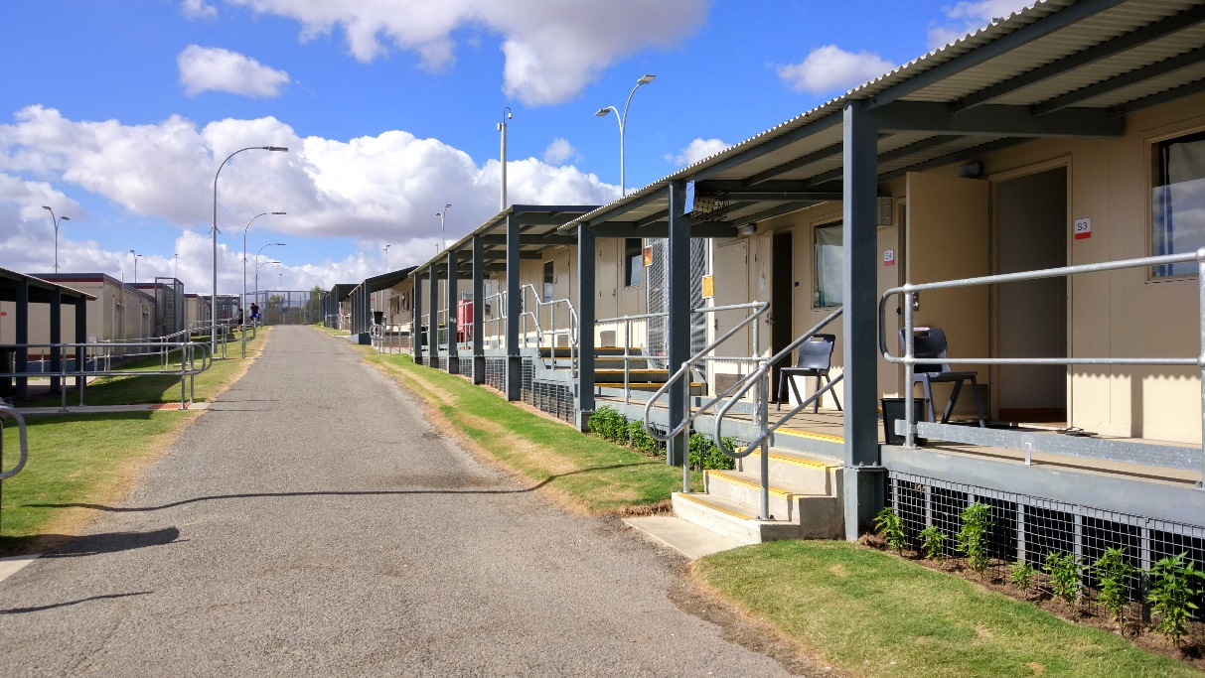
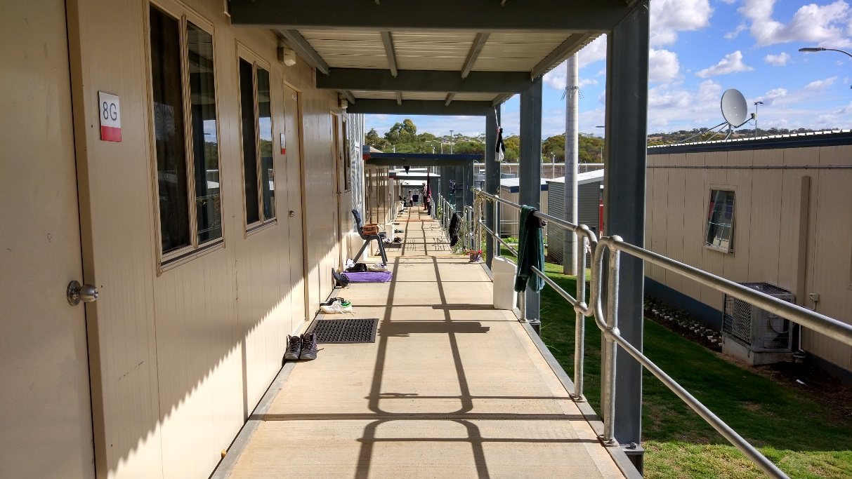
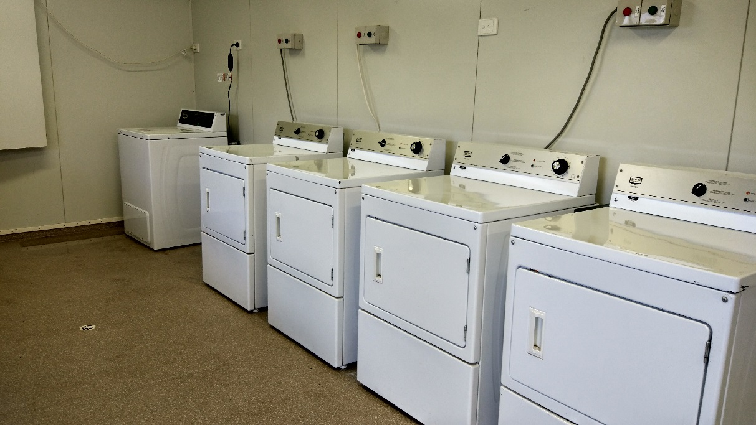
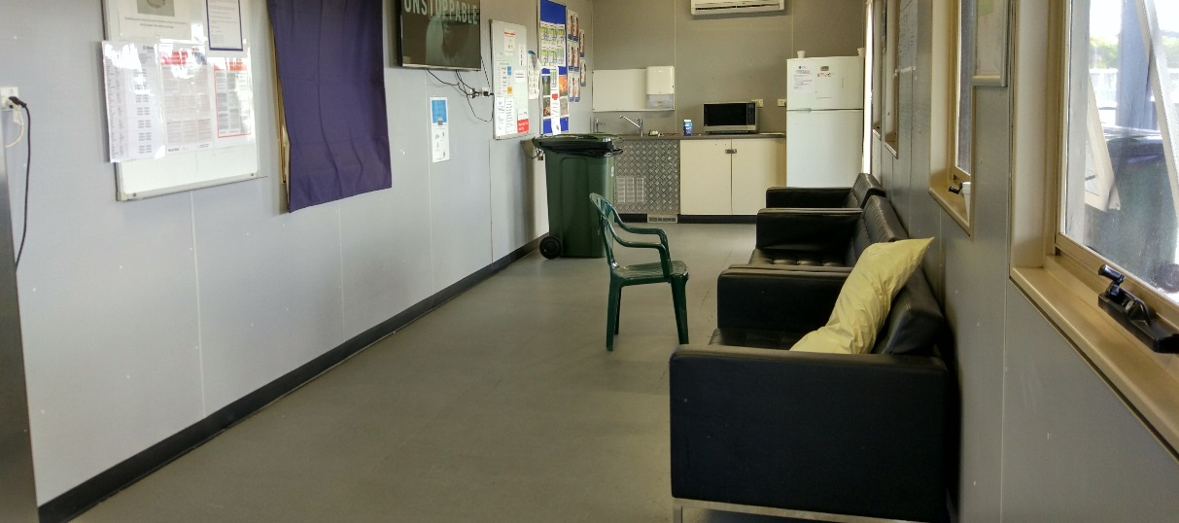
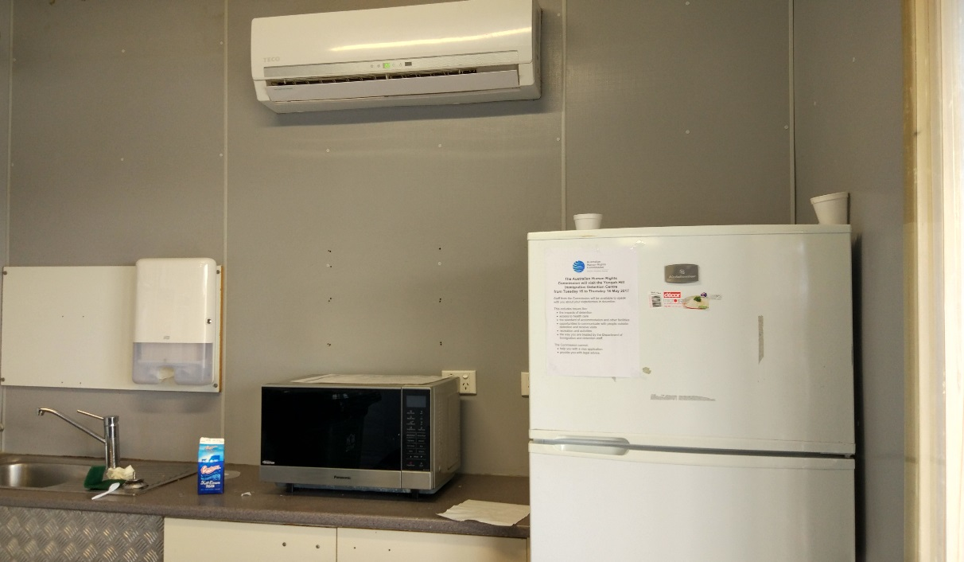

Shared facilities
Top to bottom: outdoor gym, indoor gym, computer room, canteen (x2), workshop, kitchen for cooking classes, art room, library, classroom, music and prayer room.
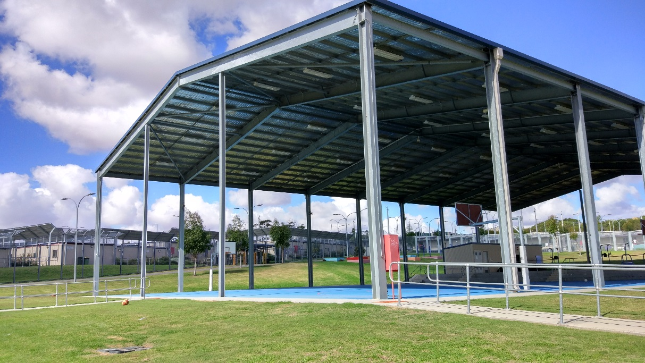
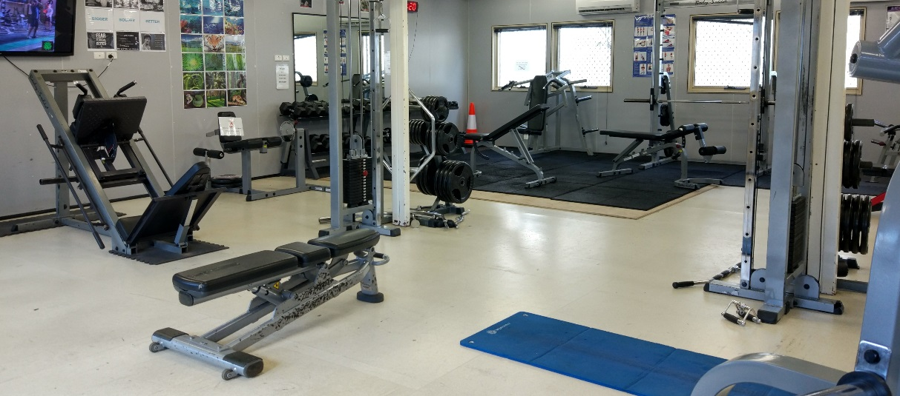
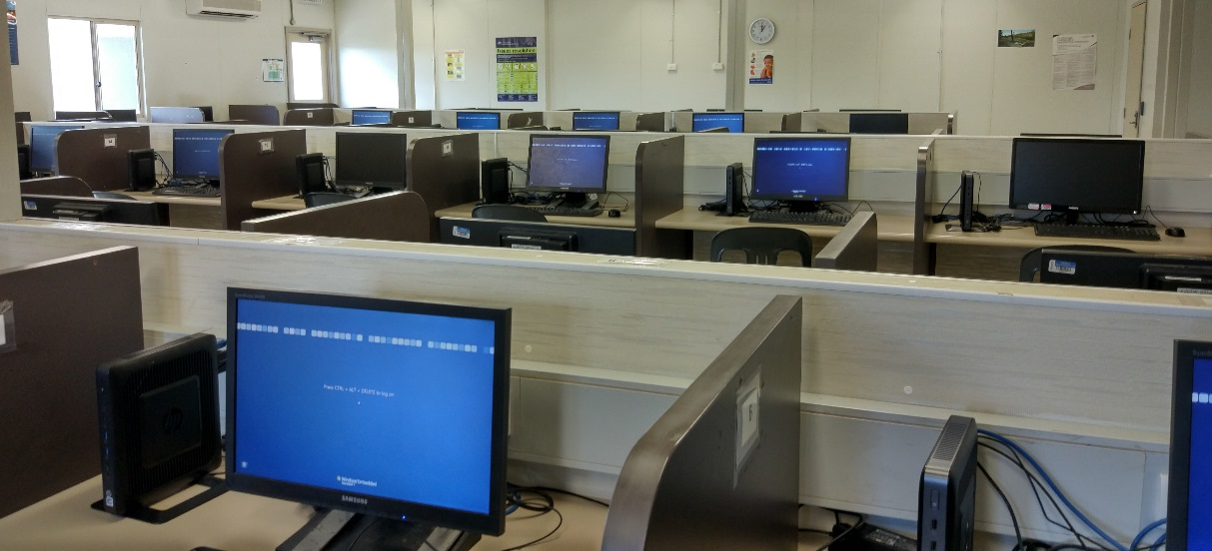
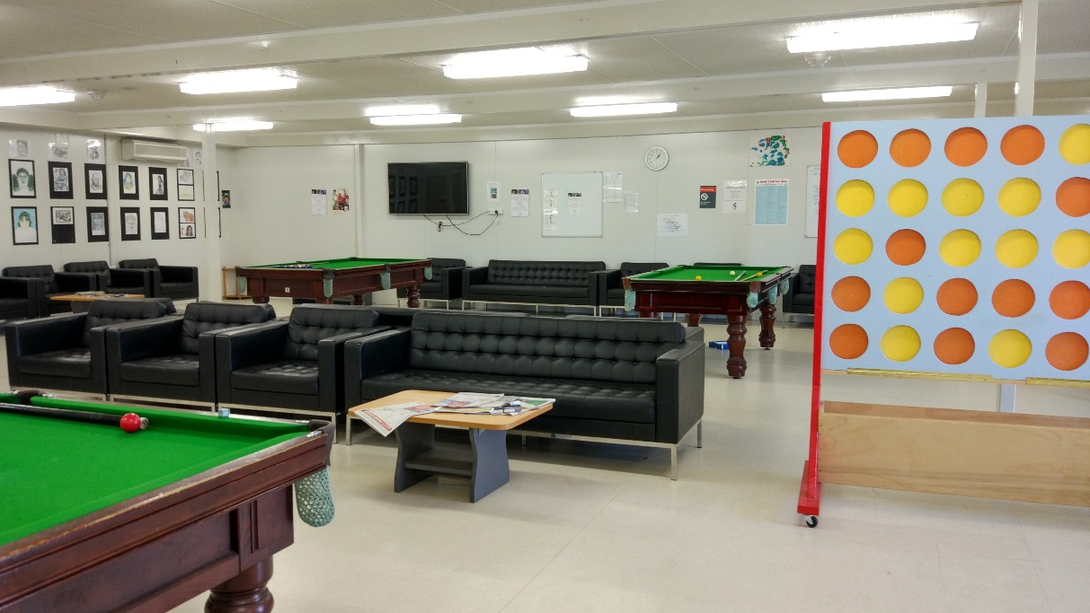
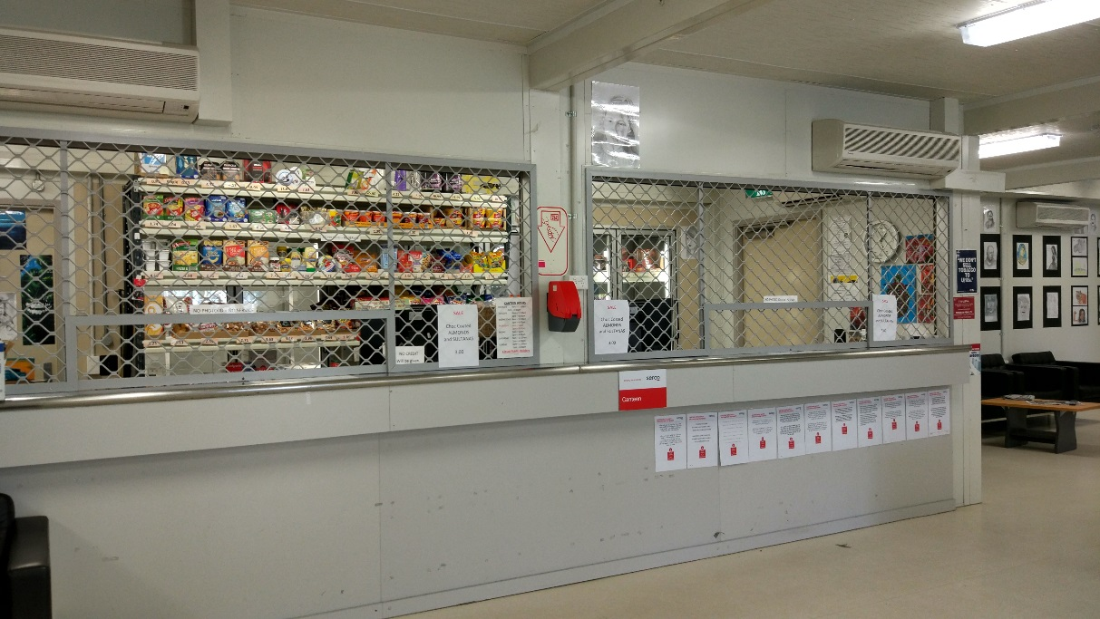
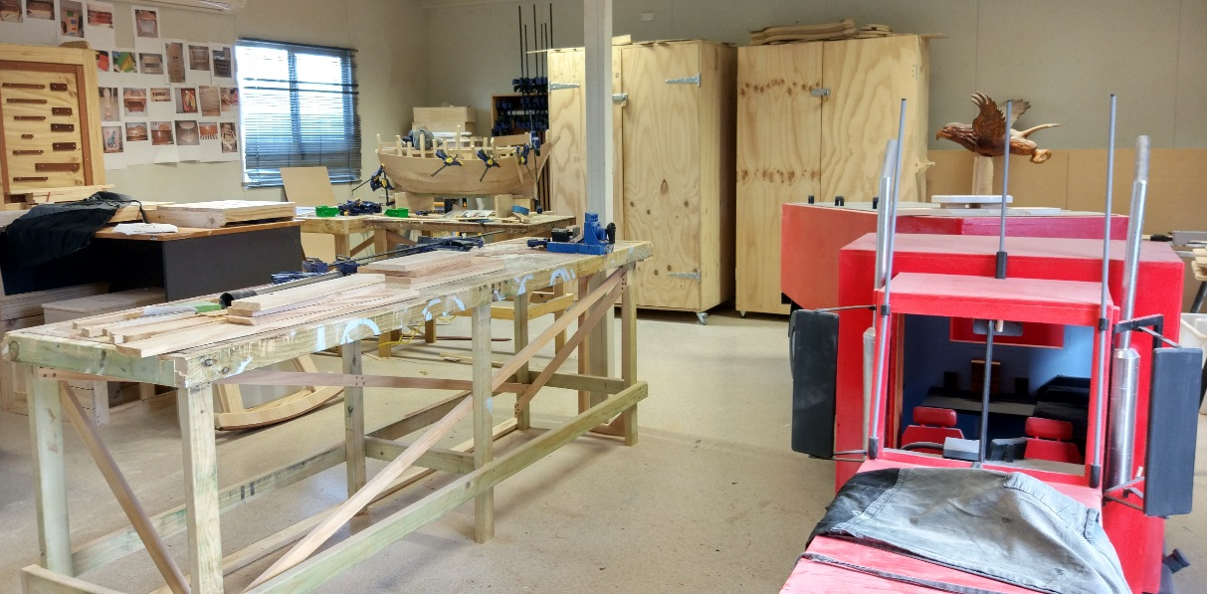

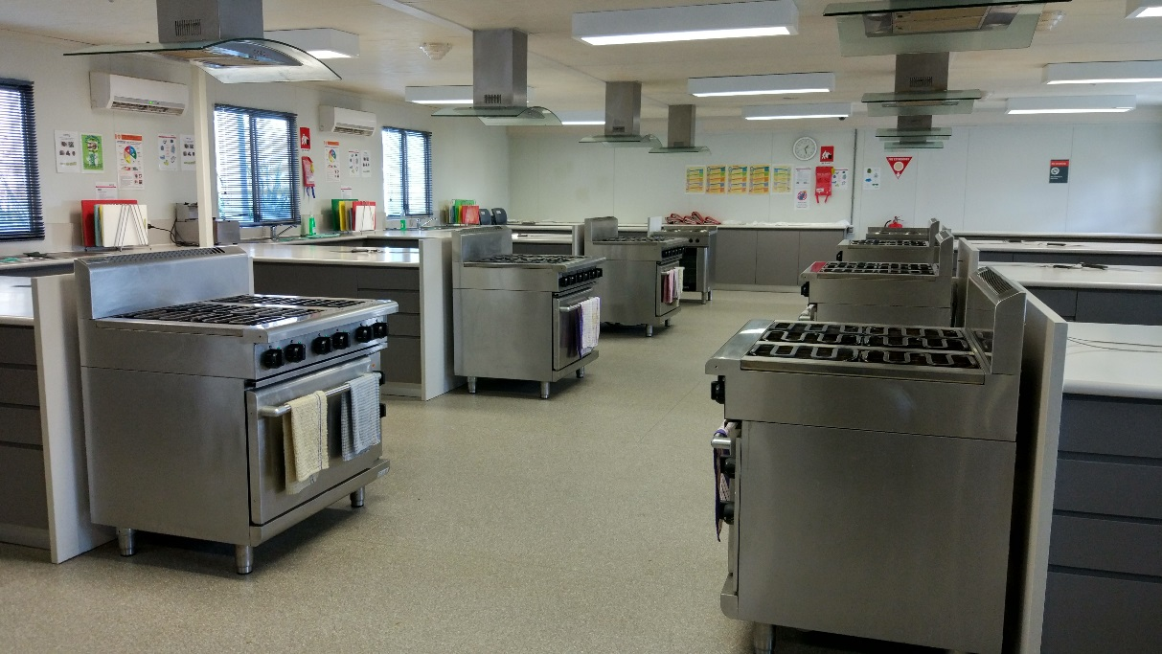
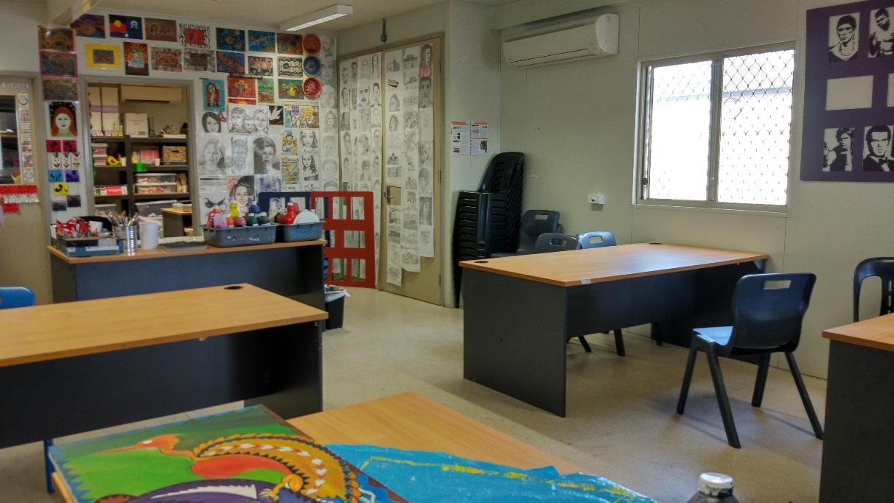
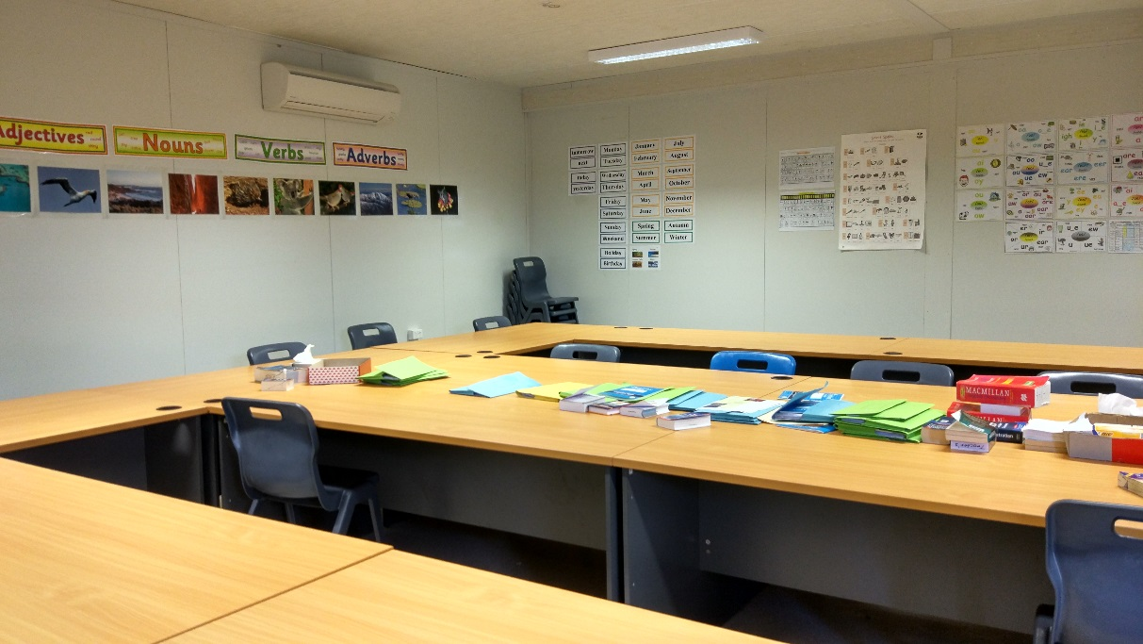
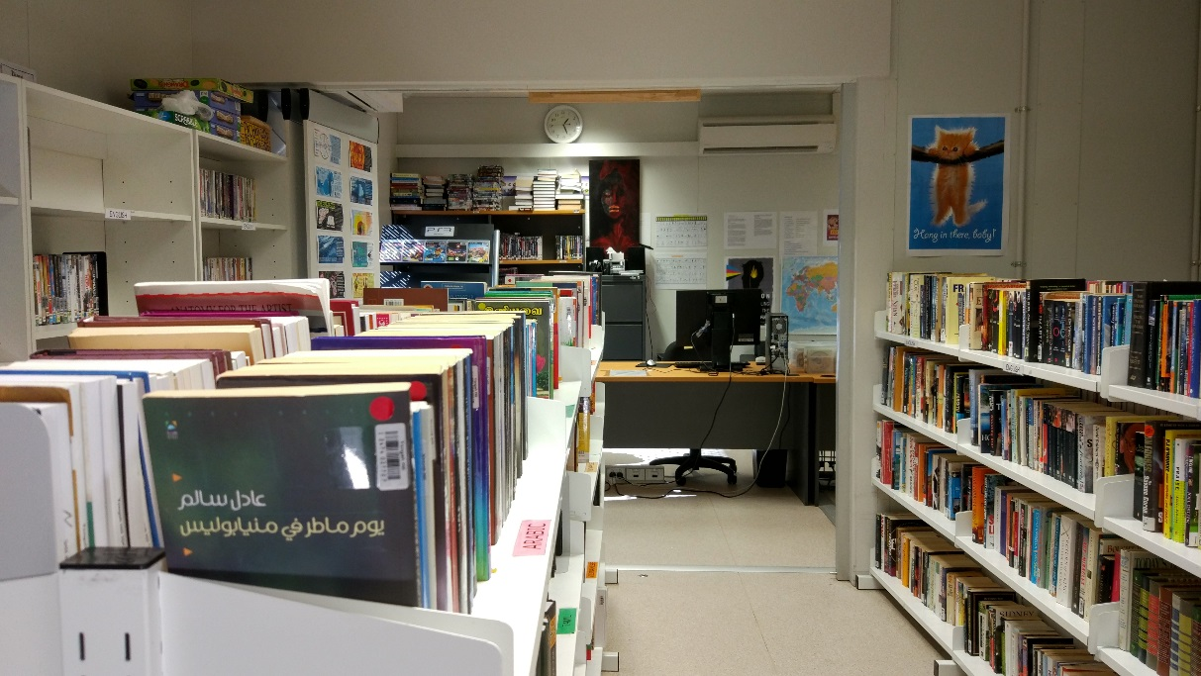
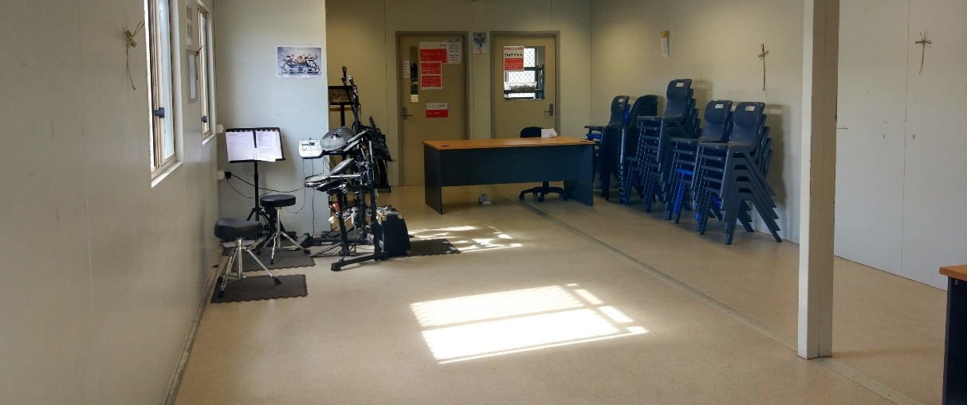

Appendix 2: Kessler Psychological Distress Scale
 | None of the time | A little of the time | Some of the time | Most of the time | All of the time
In the past four weeks, how often did you feel worn out for no good reason? | 1 | 2 | 3 | 4 | 5
In the past four weeks, how often did you feel nervous? | 1 | 2 | 3 | 4 | 5
In the past four weeks, how often did you feel so nervous that nothing could calm you down? | 1 | 2 | 3 | 4 | 5
In the past four weeks, how often did you feel hopeless? | 1 | 2 | 3 | 4 | 5
In the past four weeks, how often did you feel restless or fidgety? | 1 | 2 | 3 | 4 | 5
In the past four weeks, how often did you feel so restless you could not sit still? | 1 | 2 | 3 | 4 | 5
In the past four weeks, how often did you feel depressed? | 1 | 2 | 3 | 4 | 5
In the past four weeks, how often did you feel that everything was an effort? | 1 | 2 | 3 | 4 | 5
In the past four weeks, how often did you feel so sad that nothing could cheer you up? | 1 | 2 | 3 | 4 | 5
In the past four weeks, how often did you feel worthless? | 1 | 2 | 3 | 4 | 5

Endnotes

Reports from previous inspections of immigration detention facilities can be found on the Commission’s website at https://www.humanrights.gov.au/our-work/asylum-seekers-and-refugees/immigration-detention-reports-and-photos
Human Rights and Equal Opportunity Commission, Those who've come across the seas: Detention of unauthorised arrivals (1998). At https://www.humanrights.gov.au/our-work/asylum-seekers-and-refugees/publications/those-whove-come-across-seas-detention (viewed 11 May 2017); Human Rights and Equal Opportunity Commission, A last resort? National Inquiry into Children in Immigration Detention (2004). At https://www.humanrights.gov.au/our-work/asylum-seekers-and-refugees/projects/last-resort-report-national-inquiry-children (viewed 11 May 2017); Australian Human Rights Commission, The Forgotten Children: National Inquiry into Children in Immigration Detention (2014). At https://www.humanrights.gov.au/our-work/asylum-seekers-and-refugees/projects/national-inquiry-children-immigration-detention-index (viewed 11 May 2017).
Australian Human Rights Commission, Asylum seekers, refugees and human rights: Snapshot Report (2nd edition) (2017) 11–25. At https://www.humanrights.gov.au/our-work/asylum-seekers-and-refugees/publications/asylum-seekers-refugees-and-human-rights-snapsho-0 (viewed 11 May 2017).
Australian Human Rights Commission, Human rights standards for immigration protection (2013). At https://www.humanrights.gov.au/our-work/asylum-seekers-and-refugees/publications/human-rights-standards-immigration-detention (viewed 11 May 2017).
International Covenant on Civil and Political Rights, opened for signature 16 December 1966, 999 UNTS 171 (entered into force 23 March 1976) arts 9(1), 10(1)
International Covenant on Civil and Political Rights, opened for signature 16 December 1966, 999 UNTS 171 (entered into force 23 March 1976) art 7; Convention against Torture and Other Cruel, Inhuman or Degrading Treatment or Punishment, opened for signature 10 December 1984, 1465 UNTS 85 (entered into force 26 June 1987) arts 2(1), 16(1).
International Covenant on Economic, Social and Cultural Rights, opened for signature 16 December 1966, 993 UNTS 3 (entered into force 3 January 1976) arts 6(2), 11, 12, 13, 15(1a).
International Covenant on Civil and Political Rights, opened for signature 16 December 1966, 999 UNTS 171 (entered into force 23 March 1976) arts 7, 10(1); Convention against Torture and Other Cruel, Inhuman or Degrading Treatment or Punishment, opened for signature 10 December 1984, 1465 UNTS 85 (entered into force 26 June 1987) arts 2(1), 16(1).
International Covenant on Civil and Political Rights, opened for signature 16 December 1966, 999 UNTS 171 (entered into force 23 March 1976) arts 17, 18.
International Covenant on Civil and Political Rights, opened for signature 16 December 1966, 999 UNTS 171 (entered into force 23 March 1976) arts 19(b), 22, 27.
International Covenant on Economic, Social and Cultural Rights, opened for signature 16 December 1966, 993 UNTS 3 (entered into force 3 January 1976) art 15(1a).
International Covenant on Civil and Political Rights, opened for signature 16 December 1966, 999 UNTS 171 (entered into force 23 March 1976) art 23(1); International Covenant on Economic, Social and Cultural Rights, opened for signature 16 December 1966, 993 UNTS 3 (entered into force 3 January 1976) art 10(1).
International Covenant on Civil and Political Rights, opened for signature 16 December 1966, 999 UNTS 171 (entered into force 23 March 1976) art 17(1); Convention on the Rights of the Child, opened for signature 20 November 1989, 1577 UNTS 3 (entered into force 2 September 1990) art 16(1).
Convention against Torture and Other Cruel, Inhuman or Degrading Treatment or Punishment, opened for signature 10 December 1984, 1465 UNTS 85 (entered into force 26 June 1987) arts 13, 16(1).
International Covenant on Civil and Political Rights, opened for signature 16 December 1966, 999 UNTS 171 (entered into force 23 March 1976) art 9(1)
Human Rights Committee, Van Alphen v Netherlands, Communication No. 305/1988, UN Doc CCPR/C/39/D/305/1988 (23 July 1990) [5.8]. At http://www.refworld.org/docid/525414304.html (viewed 7 December 2016); Human Rights Committee, A v Australia, Communication No. 560/1993, UN Doc CCPR/C/59/D/560/1993 (3 April1997) [9.4]. At http://www.refworld.org/docid/3ae6b71a0.html (viewed 7 December 2016).
International Covenant on Civil and Political Rights, opened for signature 16 December 1966, 999 UNTS 171 (entered into force 23 March 1976) arts 9(2), 9(4)
Department of Immigration and Citizenship, Immigration Detention Statistics Summary (31 July 2013) 3–4. At http://www.border.gov.au/ReportsandPublications/Documents/statistics/immigration-detention-statistics-july2013.pdf (viewed 12 May 2017); Department of Immigration and Border Protection, Immigration Detention and Community Statistics Summary (28 February 2015) 3, 5. At http://www.border.gov.au/ReportsandPublications/Documents/statistics/immigration-detention-statistics-feb2015.pdf (viewed 12 May 2017).
Department of Immigration and Citizenship, Immigration Detention Statistics Summary (31 July 2013) 3, 7. At http://www.border.gov.au/ReportsandPublications/Documents/statistics/immigration-detention-statistics-july2013.pdf (viewed 12 May 2017); Department of Immigration and Border Protection, Immigration Detention and Community Statistics Summary (28 February 2015) 3, 8. At http://www.border.gov.au/ReportsandPublications/Documents/statistics/immigration-detention-statistics-feb2015.pdf (viewed 12 May 2017).
Department of Immigration and Border Protection, Immigration Detention and Community Statistics Summary (31 May 2017) 4. At http://www.border.gov.au/ReportsandPublications/Documents/statistics/immigration-detention-statistics-31-may-2017.pdf (viewed 5 July 2017). Note that these figures do not include people detained in the Regional Processing Centres in Nauru and Manus Island, Papua New Guinea.
Department of Immigration and Citizenship, Immigration Detention Statistics Summary (30 April 2012) 8; Department of Immigration and Citizenship, Immigration Detention Statistics Summary (31 July 2013) 9. At http://www.border.gov.au/ReportsandPublications/Documents/statistics/immigration-detention-statistics-july2013.pdf (viewed 12 May 2017).
Department of Immigration and Border Protection, Immigration Detention and Community Statistics Summary (31 January 2017) 11. At http://www.border.gov.au/ReportsandPublications/Documents/statistics/immigration-detention-statistics-31-jan-2017.pdf (viewed 12 May 2017).
Department of Immigration and Border Protection, Immigration Detention and Community Statistics Summary (31 May 2017) 11. At http://www.border.gov.au/ReportsandPublications/Documents/statistics/immigration-detention-statistics-31-may-2017.pdf (viewed 5 July 2017).
Department of Immigration and Citizenship, Immigration Detention Statistics Summary (31 July 2013) 9. At http://www.border.gov.au/ReportsandPublications/Documents/statistics/immigration-detention-statistics-july2013.pdf (viewed 12 May 2017).
Department of Immigration and Border Protection, Immigration Detention and Community Statistics Summary (31 May 2017) 11. At http://www.border.gov.au/ReportsandPublications/Documents/statistics/immigration-detention-statistics-31-may-2017.pdf (viewed 5 July 2017).
Canada Border Services Agency, Detention Statistics (23 May 2017). At http://www.cbsa-asfc.gc.ca/security-securite/detent-stat-eng.html (viewed 25 September 2017).
United Kingdom Home Office, National Statistics: Detention (23 February 2017). At https://www.gov.uk/government/publications/immigration-statistics-october-to-december-2016/detention (viewed 25 September 2017); United Kingdom Home Office, National Statistics: Detention (3 March 2016). At https://www.gov.uk/government/publications/immigration-statistics-october-to-december-2015/detention (viewed 25 September 2017; United Kingdom Home Office, National Statistics: Immigration statistics, October to December 2014 (26 February 2015). At https://www.gov.uk/government/publications/immigration-statistics-october-to-december-2014/immigration-statistics-october-to-december-2014 (viewed 25 September 2017); United Kingdom Home Office, National Statistics: Immigration statistics, October to December 2013 (27 February 2014). At https://www.gov.uk/government/publications/immigration-statistics-october-to-december-2013/immigration-statistics-october-to-december-2013 (viewed 25 September 2017); United Kingdom Home Office, National Statistics: Immigration statistics, October to December 2012 (28 February 2013). At https://www.gov.uk/government/publications/immigration-statistics-october-to-december-2012/immigration-statistics-october-to-december-2012 (viewed 25 September 2017).
See the Department of Immigration and Border Protection’s immigration detention statistics summaries, available at http://www.border.gov.au/about/reports-publications/research-statistics/statistics/live-in-australia/immigration-detention (viewed 12 May 2017).
Migration Amendment (Character and General Visa Cancellation) Act 2014 (Cth)
Department of Immigration and Border Protection, Key visa cancellation statistics (n.d.). At http://www.border.gov.au/about/reports-publications/research-statistics/statistics/key-cancellation-statistics (viewed 29 November 2016).
Department of Immigration and Border Protection, Immigration Detention and Community Statistics Summary (31 May 2017) 4, 7. At http://www.border.gov.au/ReportsandPublications/Documents/statistics/immigration-detention-statistics-31-may-2017.pdf (viewed 5 July 2017).
Australian Bureau of Statistics, Information Paper: Use of the Kessler Psychological Distress Scale in ABS Health Surveys, Australia, 2007-08 (4 April 2012) 9. At http://www.abs.gov.au/ausstats/abs@.nsf/Lookup/34333D54F054CE51CA2579D50015D786?opendocument (viewed 16 June 2017).
Gavin Andrews and Tim Slade, ‘Interpreting scores on the Kessler Psychological Distress Scale (K10)’ (2001) 25, 6 Australian and New Zealand Journal of Public Health 494, 495.
Australian Bureau of Statistics, Information Paper: Use of the Kessler Psychological Distress Scale in ABS Health Surveys, Australia, 2007-08 (4 April 2012) 9. At http://www.abs.gov.au/ausstats/abs@.nsf/Lookup/34333D54F054CE51CA2579D50015D786?opendocument (viewed 16 June 2017); Gavin Andrews and Tim Slade, ‘Interpreting scores on the Kessler Psychological Distress Scale (K10)’ (2001) 25, 6 Australian and New Zealand Journal of Public Health 494, 495.
Louise K Newman, Nicholas G Procter and Michael J Dudley, ‘Suicide and self-harm in immigration detention’ (2011) 195(6) Medical Journal of Australia 310; Melissa Bull et al, ‘Sickness in the System of Long-term Immigration Detention’ (2013) 26 Journal of Refugee Studies 47; Ilan Katz et al, The experiences of Irregular Maritime Arrivals detained in immigration detention facilities: Final report (2013). At http://www.border.gov.au/ReportsandPublications/Documents/research/IMA-experiences-IDF.pdf (viewed 7 December 2016).
See, for example, Australian Human Rights Commission, Immigration detention in Villawood: Summary of observations from visit to immigration detention facility in Villawood (2011) 18, 30. At https://www.humanrights.gov.au/sites/default/files/content/human_rights/immigration/idc2011_villawood.pdf (viewed 6 June 2017).
Department of Immigration and Border Protection, ‘New measures to combat illegal activity within immigration detention facilities’ (Media Release, 11 November 2016). At http://newsroom.border.gov.au/releases/new-measures-to-combat-illegal-activity-within-immigration-detention-facilities (viewed 26 May 2017).
See Australian Human Rights Commission, Asylum seekers, refugees and human rights: Snapshot Report (2nd edition) (2017) 11–25. At https://www.humanrights.gov.au/our-work/asylum-seekers-and-refugees/publications/asylum-seekers-refugees-and-human-rights-snapsho-0 (viewed 11 May 2017). See also Australian Human Rights Commission, Inspection of Maribyrnong Immigration Detention Centre: Report (2017) 26–29. At https://www.humanrights.gov.au/our-work/asylum-seekers-and-refugees/publications/inspection-maribyrnong-immigration-detention (viewed 17 October 2017); Australian Human Rights Commission, Inspection of Melbourne Immigration Transit Accommodation: Report (2017) 24–27. At https://www.humanrights.gov.au/our-work/asylum-seekers-and-refugees/publications/inspection-melbourne-immigration-transit (viewed 17 October 2017).

