Australian Human Rights Commission Inspection of Adelaide Immigration Transit Accommodation: Report

24–25 July 2017

Table of Contents
1 Introduction 5
2 Background 6
2.1 Previous inspections 6
2.2 Inspection methodology 6
2.3 Relevant human rights standards 7
(a) Treatment of people in detention 7
(b) Conditions of detention 7
(c) Communication, association and complaints 8
(d) Legal and policy framework 9
2.4 National context 9
(a) Number of people in detention 9
(b) Length of detention 9
(c) Reasons for detention 9
(d) Administration of the detention network 10
(e) Ratification of OPCAT 10
2.5 Adelaide Immigration Transit Accommodation 11
3 Key issues and concerns 11
3.1 Treatment of people in detention 11
(a) General safety and security 11
(b) Use of force and restraints 11
(c) Other invasive and restrictive measures 12
3.2 Conditions of detention 12
(a) Accommodation, sanitation and exercise facilities 12
(b) Activities and excursions 13
(c) Food 13
(d) Personal items 14
3.3 Physical and mental health 14
(a) Health services 14
(b) Health issues 14
(c) Continuity of care 15
3.4 Communication and complaints 15
(a) Mobile phone policy 15
(b) Communication facilities 16
(c) Visits 16
(d) Complaints 17
3.5 Legislative and policy framework 17
(a) Indefinite mandatory detention 17
(b) Community alternatives to detention 18
(c) Case management and status resolution 19
4 Summary of recommendations 21
4.1 Recommendations to the Australian Government 21
4.2 Joint recommendations to the Department of Home Affairs and facility staff 21
4.3 Recommendations to the Minister and Department of Home Affairs 21
4.4 Recommendations to facility staff 21
5 Appendix: Photos taken during the Commission’s inspection 22
5.1 Facilities in accommodation compounds 22
5.2 Shared facilities 23
Endnotes 25

Summary of key issues
Accommodation, sanitation and exercise facilities at the AITA are of an adequate standard for short periods of detention. However, in light of its small size and the basic nature of its facilities, the AITA is not an appropriate facility for people who are likely to be in detention for extended periods of time.
Feedback on staff at the AITA was generally positive.
There is a regular schedule of excursions from the AITA.
The Commission did not identify major or systemic concerns regarding the provision of health care at the AITA.
The new policy prohibiting all mobile phone use may restrict access to external communication to a greater degree than is necessary to ensure safety and security, particularly in a lower-security facility like the AITA.
Most of the people detained at the AITA remain at the facility for a short period of time. However, the Commission also met with individuals who had been detained for prolonged periods of time, in some cases for a year or more.
The Commission is particularly concerned about the circumstances of a small number of vulnerable individuals detained at the AITA, who had serious health issues requiring a high level of care. While acknowledging the efforts of facility staff and contractors to ensure adequate care for these individuals, the Commission considers that a detention facility is simply not a suitable environment for managing the care of people with significant health conditions, in circumstances where they are not being punished for committing a crime and they do not pose an unacceptable risk to the broader community.
Status Resolution Officers are not currently able to provide people in detention with adequate case management support.

Introduction
This report contains an overview of key observations and concerns arising from the Australian Human Rights Commission’s inspection of the Adelaide Immigration Transit Accommodation (AITA) facility in July 2017.
The rationale for the Commission undertaking such inspections is to identify problems in the way that detainees’ human rights are being protected and to suggest ways of addressing those problems. Hence, while the report is balanced and points to some good practices, its primary focus is on issues of concern identified by the Commission. The report reflects conditions as they were at the time of the inspection.
The Commission also raised a number of additional issues with the Department of Home Affairs (Home Affairs) and facility staff during and subsequent to the inspection, including individual cases of concern.
The Commission acknowledges the assistance provided by Home Affairs and the Australian Border Force (ABF) in facilitating the Commission’s inspection. The Commission is grateful to the Home Affairs and ABF officers and detention service provider staff who assisted the Commission team during the inspection. A draft of this report was shared with Home Affairs in advance of its publication, to provide an opportunity for Home Affairs to respond to the identified issues.

Background

Previous inspections
The Commission has conducted inspections of immigration detention facilities in Australia since the mid-1990s. This has included periodic monitoring of detention facilities across the country and three major national inquiries into immigration detention.
The purpose of the Commission’s detention monitoring work is to ensure that Australia’s immigration detention system is compliant with our obligations under international human rights law. For many years, the Commission has expressed a range of concerns about aspects of the detention system which may lead to breaches of international human rights law. These include:
- the policy of mandatory immigration detention, which does not allow for adequate consideration of individual circumstances and can result in cases of arbitrary detention
- the indefinite and at times prolonged nature of immigration detention and the lack of a legislative time limit on detention
- the detention of children, which has led to breaches of numerous obligations under the Convention on the Rights of the Child (CRC)
- the indefinite detention of people who have received adverse security or character assessments, including in circumstances where they have not been convicted of a crime under Australian law
- conditions of detention, which in some cases have not met international standards
- the impacts of immigration detention on mental health
- the need for increased use of alternatives to immigration detention.
Further information about these concerns can be found in the Commission publication, Asylum Seekers, Refugees and Human Rights: Snapshot Report 2017.
The Commission can also investigate and, where appropriate, try to resolve through conciliation, complaints it receives from people in immigration detention regarding alleged breaches of human rights.

Inspection methodology
The Commission inspected the AITA on 24 and 25 July 2017. The inspection was conducted by Human Rights Commissioner Edward Santow and one staff member.
During the inspection, the Commission team met with representatives from Home Affairs, ABF, Serco and International Health and Medical Services (IHMS); conducted an inspection of the physical conditions of detention; and held interviews with people detained at the AITA, including five individual interviews and a group interview.
The Commission considered the evidence gathered during the inspection against human rights standards derived from international law that are relevant to immigration detention.

Relevant human rights standards
This section provides a summary of some of the key international human rights standards relevant to the situation of people in immigration detention. Further information about these and other relevant standards can be found in the Commission publication, Human rights standards for immigration protection.
At the time of the Commission’s inspection, there were no children detained at the AITA. As such, standards relating to the detention of children were not applicable to this inspection.

Treatment of people in detention
Australia is obliged under articles 9(1) and 10(1) of the International Covenant on Civil and Political Rights (ICCPR) to, respectively, uphold the right to security of the person and ensure that people in detention are treated with humanity and respect for the inherent dignity of the human person. Australia also has obligations under article 7 of the ICCPR and articles 2(1) and 16(1) of the Convention Against Torture and other Cruel, Inhuman or Degrading Treatment or Punishment (CAT) not to subject anyone to torture or to cruel, inhuman or degrading treatment or punishment, and to take effective measures to prevent these acts from occurring.
These obligations require Australia to ensure that people in detention are treated fairly and reasonably, and in a manner that upholds their dignity. They should enjoy a safe environment free from bullying, harassment, abuse and violence. Security measures should be commensurate with identified risks, and should be the least restrictive possible in the circumstances, taking into account the particular vulnerabilities of people in detention. Measures that may constitute torture or cruel, inhuman or degrading treatment or punishment (such as collective punishment, corporal punishment, excessive use of force and holding people incommunicado) should be prohibited.

Conditions of detention
Australia has a range of obligations under the International Covenant on Economic, Social and Cultural Rights (ICESCR) relevant to the material conditions of immigration detention. These include the right to education (articles 6(2) and 13); the right to an adequate standard of living, including adequate food, clothing and housing (article 11); the right to the highest attainable standard of health (article 12); and the right to take part in cultural life (article 15(1)(a)).
Australia’s obligations under the ICCPR and CAT to treat people in detention with humanity and respect, and not to subject anyone to cruel, inhuman or degrading treatment or punishment, are also relevant to conditions of detention. In addition, Australia has an obligation under articles 17 and 18 of the ICCPR to uphold the right to privacy and freedom of religion respectively.
These obligations require Australia to ensure that detention facilities are safe, hygienic and uphold human dignity. People in detention should have their basic needs met and have access to essential services (such as health care and primary and secondary education) to a standard commensurate with those provided in the Australian community.
People in detention should have opportunities to engage in meaningful activities and excursions that provide physical and mental stimulation. People in detention should also be able to profess and practise the religion of their choice, including through being able to attend religious services, receiving pastoral visits from religious representatives and celebrating major religious holidays and festivals.
In light of the negative impacts of detention on mental health, the length of detention should be limited to the minimum period necessary to achieve a legitimate aim, and community-based alternatives to detention should be used wherever feasible.

Communication, association and complaints
Australia has a range of obligations under the ICCPR relevant to communication between people in detention and their family members, friends, representatives and communities outside detention. These include the right to freedom of expression and to seek, receive and impart information and ideas (article 19(b)); the right to freedom of association with others (article 22); and the right of ethnic, religious and linguistic minorities, in community with the other members of their group, to enjoy their own culture, to profess and practise their own religion and to use their own language (article 27). Under the ICESCR, Australia also has an obligation to uphold the right to take part in cultural life (article 15(1)(a)).
In addition, Australia has obligations under articles 23(1) of the ICCPR and 10(1) of the ICESCR to afford protection and assistance to the family as the natural and fundamental group unit of society. Australia also has obligations under article 17(1) of the ICCPR and article 16(1) of the CRC not to subject anyone to arbitrary or unlawful interference with their family.
These obligations require Australia to ensure that detention does not have a disproportionate impact on people’s ability to express themselves, communicate and associate with others, and remain in contact with their family members, friends, representatives and communities. People in detention should be able to receive regular visits, and should have access to adequate communication facilities (such as telephones and computers) as well as news and library services. People in detention should, if possible, be located in facilities within a reasonable distance from their family members, friends and communities.
External communication, in particular access to complaints processes, is also essential for the prevention of torture and other cruel, inhuman or degrading treatment or punishment. Australia has obligations under articles 13 and 16(1) of the CAT to ensure that anyone who alleges that they have been subjected to torture or to cruel, inhuman or degrading treatment or punishment, has the right to complain to and have their case examined by competent authorities.
To ensure these obligations are upheld, people in detention should have opportunities to raise concerns and issues regarding treatment and conditions in detention, and make complaints both internally and to independent monitors (including the Commission and the Commonwealth Ombudsman), without fear of repercussions.

Legal and policy framework
Australia has an obligation under article 9 of the ICCPR not to subject anyone to arbitrary detention. According to the United Nations Human Rights Committee, ‘arbitrary detention’ includes detention that, although lawful under domestic law, is unjust or disproportionate. In order for the detention of a person not to be arbitrary, it must be a reasonable and necessary measure in all the circumstances.
Australia has further obligations under article 9 of the ICCPR to ensure that anyone who is arrested has the right to be informed of the reasons for their arrest and the charges against them, and that anyone who is detained has the right to challenge the legality of their detention in court.
These obligations require Australia to ensure that people are only detained in immigration detention facilities when it is reasonable and necessary in their individual circumstances (such as where they pose an unacceptable health or security risk), and for a limited period of time. Community-based alternatives to detention should be used wherever possible. People held in immigration detention should be informed of the reasons for their detention and be able to seek judicial review of whether their detention is arbitrary.

National context

Number of people in detention
The number of people in closed immigration detention, and particularly the number of children in detention, has reduced dramatically in recent years. The number of people in detention peaked at over 10,000 in July 2013, before declining to fewer than 2,000 in early 2015. The number of children in detention dropped from a high of almost 2,000 in July 2013 to fewer than 200 in early 2015.
As at July 2017, there were 1,298 people in immigration detention in Australia, including just one child.

Length of detention
While the overall number of people in detention has declined, the average length of detention has increased significantly. In July 2013, the average length of detention hit a low of 72 days. Since then, the average length has steadily increased, peaking at 493 days in January 2017. As at July 2017, the average stood at 442 days.
In July 2013, 228 people had been detained for over a year, comprising around two per cent of people in detention. The number of people in long-term detention has since increased, particularly as a proportion of the overall detention population. As at July 2017, 476 people — or more than a third of the people in detention — had been detained for over a year.

Reasons for detention
Historically, asylum seekers who arrived by boat have typically comprised the majority of people in detention. Since the beginning of 2014, this group has progressively comprised a smaller proportion of the detention population (although they remained by far the largest group in detention until 2016).
At the same time, the number of people in detention due to having their visas cancelled has increased. This increase has been largely due to legislative amendments that broadened the scope of section 501 of the Migration Act 1958 (Cth) (the Migration Act). Section 501 allows the Minister or their delegate to refuse or cancel a visa on the basis that a person does not pass the ‘character test’. Since this section was amended in late 2014, visa cancellations on character grounds have increased dramatically, from 76 cancellations in the 2013–14 financial year to 580 in 2014–15, and 983 in 2015–16.
As at July 2017, people who had had their visas cancelled under section 501 were the largest group in detention, comprising around a third of the detention population. Asylum seekers who arrived by boat were the second-largest group in detention, at around a quarter of the population, followed by people who had overstayed their visa and people who had had their visa cancelled on non-character grounds.

Administration of the detention network
Up until mid-2015, Australia’s immigration detention network was administered by the Department of Immigration and Citizenship (subsequently renamed the Department of Immigration and Border Protection, and currently named the Department of Home Affairs).
On 1 July 2015, the Department of Immigration and Border Protection and the Australian Customs and Border Protection Service merged to form a single department. The ABF was established as the new frontline operational agency for this department. The ABF became responsible for administering detention operations and removals; while the Department of Immigration and Border Protection remained responsible for the overall policy framework for detention, as well as matters relating to visa processing, case management and status resolution.
On 20 December 2017, the Department of Immigration and Border Protection and the ABF became part of the newly-established Department of Home Affairs. The new Department incorporates all of the functions previously undertaken by the Department of Immigration and Border Protection, along with a range of functions relating to law enforcement, national security and emergency management.
As was the case in 2014, external contractors continue to play a central role in the management of immigration detention facilities. Serco Australia remains the contracted detention services provider, responsible for the day-to-day running of the facilities including security and provision of services and activities. IHMS remains the contracted health services provider, responsible for providing onsite physical and mental health services to people in detention.

Ratification of OPCAT
On 15 December 2017, the Australian Government ratified the Optional Protocol to the Convention Against Torture and other Cruel, Inhuman or Degrading Treatment or Punishment (OPCAT). OPCAT provides for ongoing independent monitoring of places of detention, to ensure adherence to minimum standards in conditions and treatment.
At the request of the Attorney-General, the Commission is undertaking a consultation process regarding how best to implement OPCAT. Based on the experience in jurisdictions that have ratified and implemented OPCAT, the Commission sees this as an opportunity to consider, in a more systematic way, the adequacy and appropriateness of conditions of detention. The Commission looks forward to continuing to work with the Government to support the implementation of OPCAT.

Adelaide Immigration Transit Accommodation
The AITA opened in 2011. It is a small, low-security detention facility with a capacity of around 25 people (or up to 38 at surge capacity). The AITA currently accommodates single adult men and women across three compounds.
At the time of the Commission’s inspection, there were 19 people detained at the AITA, all but one of whom were male. Around half of these people had been detained as a result of past and future criminal proceedings, including several whose visas had been cancelled under section 501 of the Migration Act. The remaining people were either individuals who had not been immigration cleared on arrival at an Australian airport (referred to as ‘airport turnarounds’), or individuals who had not complied with their visa obligations (such as through overstaying their visa).

Key issues and concerns

Treatment of people in detention

General safety and security
The AITA is a low-security facility. Security features observed by the Commission included a high external fence and numerous external security cameras. New internal and external CCTV cameras were being installed at the time of the Commission’s inspection.
Those interviewed by the Commission reported that they felt safe in detention and did not raise any concerns regarding physical safety. Feedback on staff was generally positive. Some individuals raised concerns about the actions of particular members of staff but most of these issues were not serious in nature.

Use of force and restraints
Few concerns were raised regarding the use of force or restraints. One person reported that that they had been mechanically restrained while attending appointments outside the facility, including for religious observance, which had impacted their ability to practise their religion. Facility staff indicated that the individual concerned had been detained as a result of criminal charges and the use of restraints was intended to mitigate the risk of escape.
Facility staff also reported that there had been an increase in the use of mechanical restraints in response to a series of escapes from immigration detention facilities. The Commission is concerned that this may in some cases have led to unnecessary or inappropriate use of restraints. For example, staff indicated that all single adults who have been at the facility for 30 days or less will be mechanically restrained during escort. The Commission considers that this practice does not allow for an accurate assessment of risk, potentially leading to excessive use of restraints.
The Commission has previously expressed concern that the use of restraints, when a person in detention is attending external appointments, may in some circumstances be excessive, and has recommended a broader review of this practice.

The Department of Home Affairs and facility staff should review policies and practices relating to the use of mechanical restraints, to ensure people in detention are not subject to more restrictive measures than are necessary in their individual circumstances. Particular consideration should be given to limiting the use of mechanical restraints during medical consultations and during transit where the risk of escape is low.

Other invasive and restrictive measures
A number of people interviewed by the Commission indicated that they had been body searched while in detention. They also indicated that their rooms were regularly searched. Those interviewed did not raise any concerns about the conduct of these searches, with one person reporting that body searches had been carried out in a respectful manner.
The Commission did not receive any reports of bullying, harassment or use of sanctions.
At the time of the Commission’s inspection, two people were being held in separate accommodation arrangements due to health or safety issues. Commission staff did not interview these two individuals (one of whom declined an invitation to speak with the Commission) but were permitted to inspect the separate accommodation areas. The Commission did not identify particular concerns about the use of single separation for the two individuals. However, the Commission has overarching concerns about the use of detention for people who have significant health issues. This issue is discussed further in Section 3.5(b).
The Commission was particularly concerned about the circumstances of a small number of vulnerable individuals detained at the AITA, who had serious health issues requiring a high level of care.

Conditions of detention

Accommodation, sanitation and exercise facilities
People detained at the AITA were accommodated in one of three single-storey compounds, connected by a covered walkway. Bedrooms accommodated up to five people. Rooms designed for up to two people were equipped with ensuite bathrooms, while people in larger bedrooms had access to shared bathroom facilities. Each compound had shared laundry facilities and an indoor common area with a television, pool table, kitchenette and seating.
A central outdoor communal area was shared by people from all accommodation buildings. This area included a newly-installed volleyball court, outdoor gym, basketball hoop, ping pong table, barbeque facilities, shaded areas, seating and gardens.
People interviewed by the Commission reported that they were generally satisfied with the standard of the facilities at the AITA. One person noted that the shared accommodation arrangements could become uncomfortable when a larger number of people were detained at the facility.
The Commission considers that accommodation, sanitation and exercise facilities at the AITA are of an adequate standard for short periods of detention (such as in cases where a person is to be rapidly removed from Australia). However, the Commission considers that the AITA is not an appropriate facility for people who are likely to be in detention for extended periods of time. This issue is discussed further in Section 3.5(a).

Activities and excursions
Activities available at the AITA include cooking classes, gardening, model building, English classes and history classes. Excursions generally take place three times per week for people who are considered ‘low risk’. Excursion sites include the local library, national parks and places of worship.
Most of the people interviewed by the Commission indicated that they participated in activities. Feedback on activities was generally neutral or positive, although some noted the limited range of activities available. One person reported that they regularly attended excursions, while another claimed that they had not been permitted to go on excursions due to being considered ‘high risk’.
The Commission welcomes the commitment of facility staff to maintaining regular excursions for people detained at the AITA. The Commission suggests that staff could also explore options for providing excursions to more secure sites, with a view to extending excursion opportunities to people who are considered to present a higher risk.

Facility staff should explore options for providing excursions to secure sites suitable for people who are considered to present a higher risk.

Food
Food is prepared in a central kitchen. There are separate cooking facilities for use by people in detention. Breakfast and lunch are provided daily. For dinner, people in detention can either cook their own meal or reheat a frozen meal provided by staff. People in detention can also purchase snacks using points (see Section 3.2(d) below).
Some of the people interviewed by the Commission raised concerns about the food. For example, some reported that the food was of a low quality, provided limited variety or did not adequately cater for their dietary needs. Others indicated that they were generally satisfied with the food provided.

Personal items
People in detention earn points which can be used to purchase personal items such as cigarettes, drinks, snacks, phone cards and toiletries. People are allocated 25 points at the beginning of each week and can earn 25 additional points through participating in activities, plus a further ten points for good behaviour.
Very limited feedback was provided to the Commission regarding the points system or the items available for purchase.

Physical and mental health

Health services
Health services are provided onsite at the AITA by IHMS. The small medical clinic is open from 8:00am to 9:00pm Monday to Friday, and is staffed by a general practitioner and two nurses.
Mental health counsellors are onsite two days per week and a psychiatrist visits once a month. Telehealth is also used to meet mental health needs. Facility staff reported that people who indicate a history of torture or trauma during the health induction process are referred to the Survivors of Torture and Trauma Assistance and Rehabilitation Service.
Facility staff noted that, due to the small number of people held at the AITA, people in detention are generally able to see medical staff relatively quickly. They also indicated that IHMS staff interact regularly with people at the facility to monitor health needs. Commission staff observed some of these interactions during the inspection.
People interviewed by the Commission generally provided positive feedback on the health services and medical staff at the AITA. For example, one person stated that medical staff ‘do their best to look after us’, while another expressed the view that the health services available at the AITA were ‘better than in prison’.
Overall, the Commission did not identify major or systemic concerns regarding the provision of health care at the AITA.

Health issues
Facility staff reported that they had seen a rise in cases of hepatitis C among people detained at the AITA. Staff attribute this to the increase in the number of people entering the facility directly from prison, following cancellation of their visas under section 501 of the Migration Act. Common mental health issues included depression, insomnia and anxiety. Facility staff indicated that there had been relatively few instances of alcohol and drug use within the AITA.
Some of the people interviewed by the Commission expressed concerns about their mental health, including the negative impact of detention on their mental health. A small number indicated that the medication they had received to assist with mental health issues was not effective.
The Commission wishes to acknowledge the efforts of successive Australian Governments to strengthen the mental health services and response across the immigration detention network. However, the Commission notes that it is often the detention environment itself that causes mental health concerns. As such, only the prompt removal of people from immigration detention facilities will address the problem of high levels of mental ill health in the Australian immigration detention system.

Continuity of care
Facility staff reported that they received good support for the prison system in terms of ensuring continuity of care for people who enter immigration detention directly from prison. While it could be more difficult to ensure continuity of care for people entering detention from the community, staff indicated that they endeavoured to obtain information about a person’s medical needs and, if necessary, provide them with medication on the day of their arrival.
Most of the people interviewed by the Commission did not provide feedback relating to continuity of care. One person reported that they had experienced significant difficulties in obtaining their medical records from prison.

Communication and complaints

Mobile phone policy
In February 2017, Home Affairs introduced a new policy that prohibits the possession and use of mobile phones in immigration detention facilities. According to a media release issued in November 2016, the new policy was implemented in response to concerns that some people in detention were using mobile phones ‘to organise criminal activities, threaten other detainees, create or escalate disturbances and plan escapes by enlisting outsiders to assist them’. The media release indicated that people in detention would be given increased access to landlines phones in place of mobile phones.
In mid-February, the Federal Court issued an injunction preventing the implementation of the new mobile policy. As a result, some people in detention have been able to retain their mobile phones. However, those who had already surrendered their phones to facility staff have not had them returned.
In September, the Australian Government introduced the Migration Amendment (Prohibiting Items in Immigration Detention Facilities) Bill 2017. The Bill would allow the Minister to determine, by legislative instrument, things to be prohibited in immigration detention facilities. Any item may be declared prohibited if the Minister is satisfied ‘might be a risk to the health, safety or security of persons in the facility, or to the order of the facility’. The Government has indicated that, should the Bill be passed, the Minister intends to determine mobile phones and SIM cards to be prohibited.
The Commission considers that prohibiting all mobile phone use may restrict access to external communication to a greater degree than is necessary to ensure safety and security, particularly in a lower-security facility like the AITA. As such, the Commission considers that this policy should be reviewed to ensure that access to mobile phones is restricted only to the extent necessary, and on an individualised basis rather than as a blanket policy.

The Department of Home Affairs should review its policy regarding the use of mobile phones in immigration detention facilities, with a view to restricting mobile phone usage only in response to unacceptable risks determined through an individualised assessment process.

Communication facilities
Landline telephones and computers with internet access were available in each compounds. People interviewed by the Commission reported that they were able to access phones when needed, although one expressed concern about the new mobile phone policy. Concerns were also raised about restrictions on access to certain computer programs and websites.
Some concern was expressed about the monitoring of phone and Skype calls. For example, one person claimed that they did not like to speak over the phone because they had been informed by other people in detention that phone calls were recorded. The Commission understands that telephone calls are not recorded or monitored but notes that there is evidently a perception among some people in detention that this does occur. As such, there may be a need for staff to implement strategies to counter this perception and assure people detained at the AITA that their communications over the phone or internet will remain private.

Facility staff should implement strategies to ensure that people detained at the AITA are aware that communications over the phone or internet are not monitored or recorded.

Visits
In relation to visits, concerns were raised that the accessible parking spot in the visitor car park was often impeded by delivery or other vehicles, or it was occupied by vehicles that did not have a disability permit. This made it difficult for elderly visitors or those with a physical disability to access the detention facility. This was observed first-hand by Commission staff on both days of the inspection.

Facility staff should ensure that the accessible parking spot in the visitor carpark is not improperly impeded or occupied, and is thus available for visitor use.

Complaints
People in detention have the right to make complaints about conditions and treatment both internally and to external agencies such as the Commission and the Commonwealth Ombudsman.
The Commission observed that facility staff had, as requested, put up posters to notify people in detention about the Commission’s inspection of the AITA. However, posters advertising internal and external complaints processes did not appear to be displayed consistently across the facility.
A number of people interviewed by the Commission noted the limitations of internal and external complaints processes in terms of resolving issues of concern. Some also raised concerns that making a complaint could lead to negative consequences, such as being transferred to another detention facility or reduced contact with family members.
Based on these comments, the Commission considers that more could be done to foster greater confidence in complaints processes. For example, facility staff could arrange information sessions that provide examples of complaints having been successfully resolved and highlight strategies for preventing victimisation of people who have made complaints.

Facility staff should ensure that information about the internal and external complaints processes available to people in detention is displayed prominently throughout the AITA.

Facility staff should implement strategies to foster greater confidence in the internal and external complaints processes available to people in immigration detention.

Legislative and policy framework

Indefinite mandatory detention
The Commission has long expressed concern that Australia’s legislative framework for immigration detention does not contain adequate safeguards to prevent detention from becoming arbitrary. People can be detained for prolonged periods of time, on an indefinite basis, and in circumstances where there is no valid justification for their detention under international law.
Facility staff reported that most of the people detained at the AITA remained at the facility for a short period of time, with median length of stay being around two weeks. A significant proportion of the people detained at the AITA are ‘airport turnarounds’, who are typically held in detention for a maximum of 72 hours. However, the Commission also met with individuals who had been detained at the AITA for several months, and in some cases for a year or more.
As noted in Section 3.2(a), the Commission considers that the AITA — in light of its small size and the basic nature of its facilities — is not an appropriate facility for people who are likely to be in detention for extended periods of time. As such, the Commission recommends that the AITA should only be used in cases where the person is expected to be in detention for a very short period of time, and should not be used for periods of detention that exceed a month.

The Australian Government should introduce legislation to replace the current system of mandatory immigration detention with a case-by-case assessment process that takes individual circumstances into consideration. Closed detention should only be used as a last resort in circumstances where:
a) a person has been individually assessed as posing an unacceptable risk to the Australian community, and that risk cannot be managed in a less restrictive way
b) the necessity for continued detention has been individually assessed by a court or tribunal, with further assessments to occur periodically up to a maximum time limit.

The Department of Home Affairs should ensure that the AITA facility is only used for short periods of detention not exceeding one month.

Community alternatives to detention
The Commission welcomes the Government’s ongoing commitment to using community-based alternatives to detention where possible, especially for children and other vulnerable groups. The Commission acknowledges that most people have their immigration status resolved while living in the community, rather than in closed detention.
Several of the people interviewed by the Commission reported that they wished to be considered for release into community detention or onto a Bridging Visa. Some expressed frustration that they continued to be detained despite the fact that, in their view, they did not pose a risk to the community. For example, one person reported that they had been charged with a crime and found not guilty but nonetheless remained in detention.
The Commission was particularly concerned about the circumstances of a small number of vulnerable individuals detained at the AITA, who had serious health issues requiring a high level of care. The Commission acknowledges the efforts of facility to ensure adequate care for these individuals. Indeed, staff reported that they were generally able to provide more intensive health care assistance to people at the AITA than may be possible at larger detention facilities with bigger populations. However, the Commission considers that a detention facility is simply not a suitable environment for managing the care of people with significant health conditions.
The Commission considers that community-based alternatives should be explored for all people in detention, and especially for those who have significant vulnerabilities. Ongoing detention should only occur when a person presents an unacceptable risk that cannot be managed in a less restrictive way.

The Minister and Department of Home Affairs should routinely consider all people in immigration detention (especially those with significant vulnerabilities) for release into alternative community-based arrangements.

Case management and status resolution
People in immigration detention are assigned a Home Affairs Status Resolution Officer, whose role is to assist people in resolving their immigration status. Status resolution options may include applying for a substantive visa, appealing a visa cancellation or voluntarily returning to one’s country of citizenship. Status Resolution Officers also refer people for possible release from detention into alternative community arrangements. Case managers from the Department of Immigration and Border Protection previously provided welfare services to people in detention, but Status Resolution Officers no longer fulfil this role.
A number of people interviewed by the Commission raised concerns about the case management process. They reported that their Status Resolution Officers contacted them infrequently, could be difficult to access, were not responsive to requests and could not provide adequate support with status resolution. Some people indicated that they had received independent legal or migration advice regarding their case. Others, however, reported they had not received legal advice, or had received advice about criminal matters but not immigration matters.
The Commission acknowledges that some of these comments may reflect the reduction in the scope of the case manager role and its present limitations, rather than issues with the performance of individual officers. Nonetheless, this feedback further confirms the concerns previously raised by the Commission that Status Resolution Officers are not currently able to provide adequate case management support to people in detention.
The Commission is concerned that the limitations of the case management system may delay or complicate the status resolution process. As a result, people may be detained for longer periods than is necessary or miss opportunities for status resolution simply because they were unaware of their options or how to pursue them. As such, the Commission considers that it would be beneficial to review the case management system, to determine whether it is operating as effectively as possible to assist people in detention to resolve their status.
Given the limitations of the Status Resolution Officer role, it is important that people in detention are able to access alternative forms of advice and assistance with status resolution. The Commission therefore considers that Status Resolution Officers should have the capacity to assist people in detention to access legal and migration advice, for example through providing information and referrals to relevant services (such as Legal Aid and specialist migration and asylum seeker advice services).

The Department of Home Affairs should review the case management system for people in immigration detention to determine:
a) the extent to which the case management system addresses the needs of people in detention
b) whether the case management system is operating as effectively as possible to facilitate status resolution, including through ensuring that people in detention have access to sufficient advice about their status and options for resolution.

Recognising the limited role of Status Resolution Officers, the Department of Home Affairs should introduce capacity for Status Resolution Officers to provide people in detention with appropriate information and referrals to independent migration and legal advice.

Summary of recommendations

Recommendations to the Australian Government
Recommendation 8 (indefinite mandatory detention)
The Australian Government should introduce legislation to replace the current system of mandatory immigration detention with a case-by-case assessment process that takes individual circumstances into consideration. Closed detention should only be used as a last resort in circumstances where:
a) a person has been individually assessed as posing an unacceptable risk to the Australian community, and that risk cannot be managed in a less restrictive way
b) the necessity for continued detention has been individually assessed by a court or tribunal, with further assessments to occur periodically up to a maximum time limit.

Joint recommendations to the Department of Home Affairs and facility staff
Recommendation 1 (mechanical restraints)
The Department of Home Affairs and facility staff should review policies and practices relating to the use of mechanical restraints, to ensure people in detention are not subject to more restrictive measures than are necessary in their individual circumstances. Particular consideration should be given to limiting the use of mechanical restraints during medical consultations and during transit where the risk of escape is low.

Recommendation 9 (length of detention)
The Department of Home Affairs should ensure that the AITA facility is only used for short periods of detention not exceeding one month.

Recommendations to the Minister and Department of Home Affairs
Recommendation 3 (mobile phones)
The Department of Home Affairs should review its policy regarding the use of mobile phones in immigration detention facilities, with a view to restricting mobile phone usage only in response to unacceptable risks determined through an individualised assessment process.

Recommendation 10 (alternatives to detention)
The Minister and Department of Home Affairs should routinely consider all people in immigration detention (especially those with significant vulnerabilities) for release into alternative community-based arrangements.

Recommendation 11 (case management)
The Department of Home Affairs should review the case management system for people in immigration detention to determine:
a) the extent to which the case management system addresses the needs of people in detention
b) whether the case management system is operating as effectively as possible to facilitate status resolution, including through ensuring that people in detention have access to sufficient advice about their status and options for resolution.

Recommendation 12 (migration and legal advice)
Recognising the limited role of Status Resolution Officers, the Department of Home Affairs should introduce capacity for Status Resolution Officers to provide people in detention with appropriate information and referrals to independent migration and legal advice.

Recommendations to facility staff
Recommendation 2 (excursions)
Facility staff should explore options for providing excursions to secure sites suitable for people who are considered to present a higher risk.

Recommendation 4 (privacy of communication)
Facility staff should implement strategies to ensure that people detained at the AITA are aware that communications over the phone or internet are not monitored or recorded.

Recommendation 5 (accessibility)
Facility staff should ensure that the accessible parking spot in the visitor carpark is not improperly impeded or occupied, and is thus available for visitor use.

Recommendation 6 (information about complaints processes)
Facility staff should ensure that information about the internal and external complaints processes available to people in detention is displayed prominently throughout the AITA.

Recommendation 7 (complaints processes)
Facility staff should implement strategies to foster greater confidence in the internal and external complaints processes available to people in immigration detention.

Appendix: Photos taken during the Commission’s inspection

Facilities in accommodation compounds
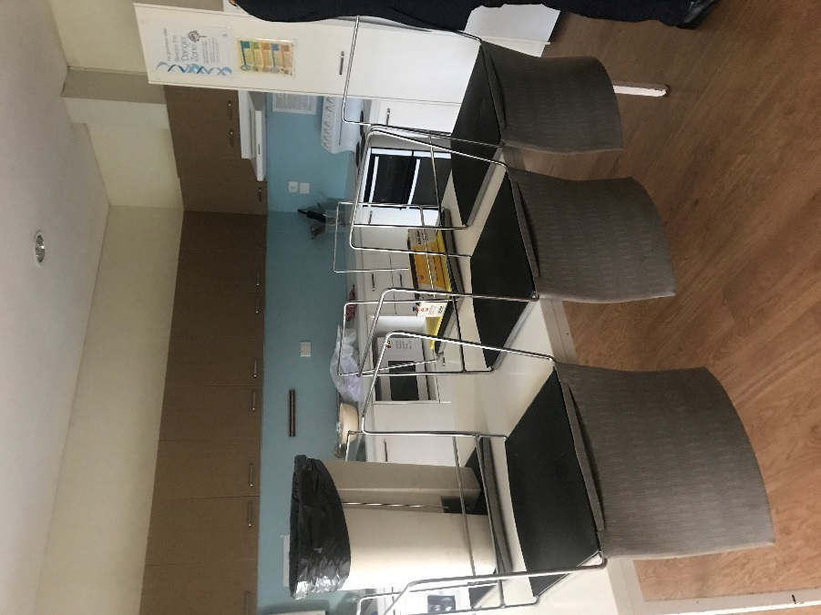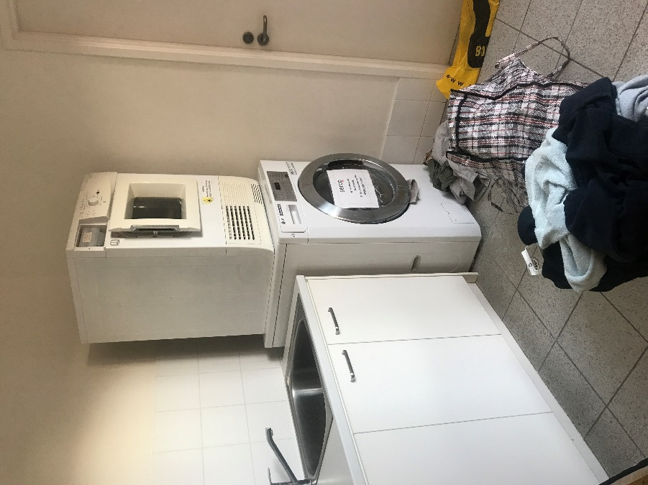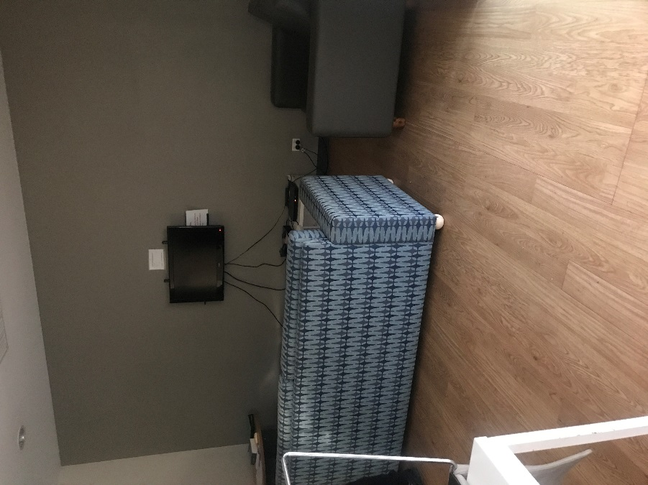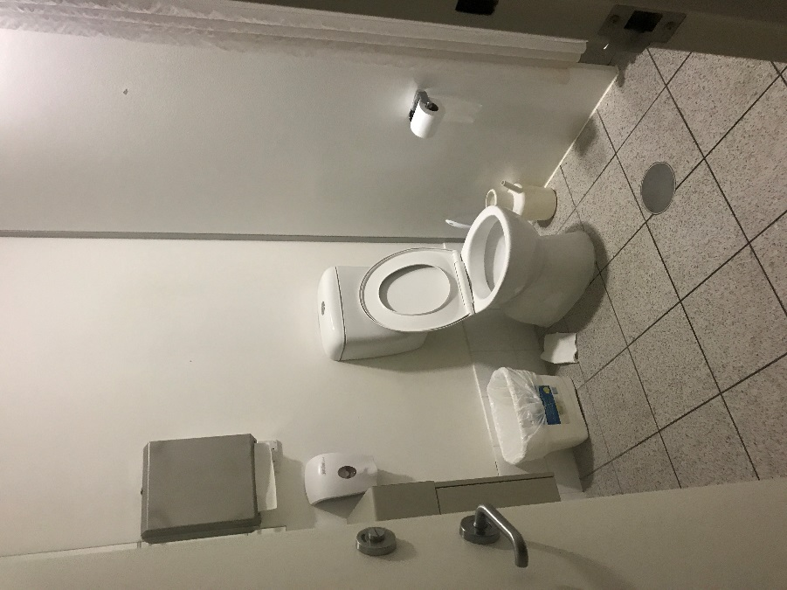

Shared facilities
Top to bottom: outdoor gym, outdoor recreation facilities (x2), computer room, private interview room.
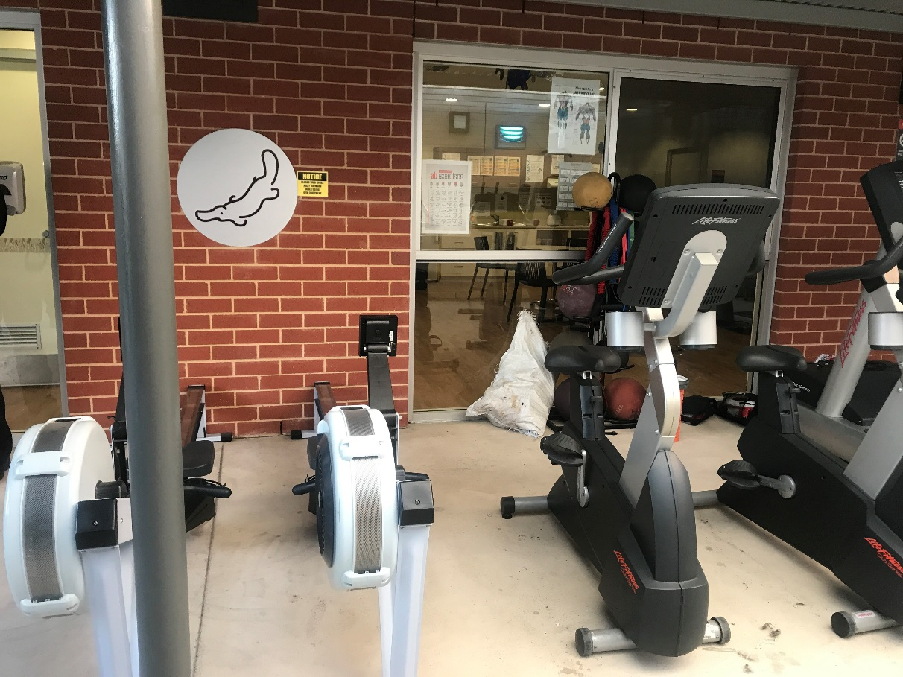
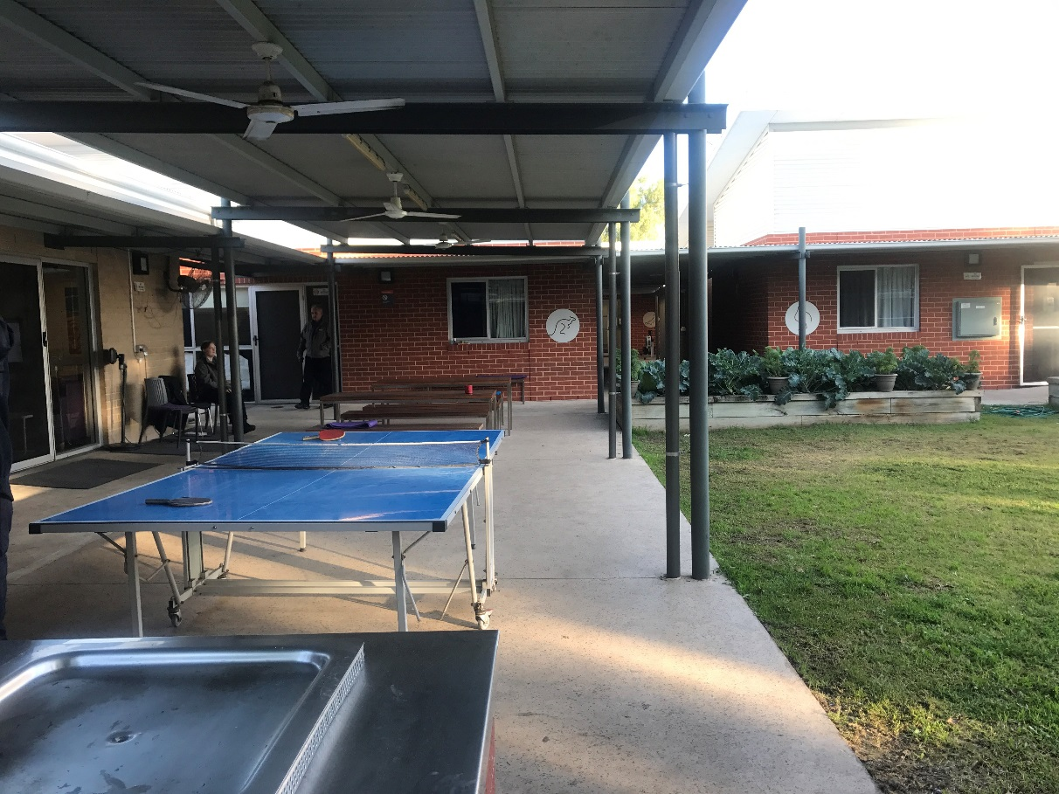

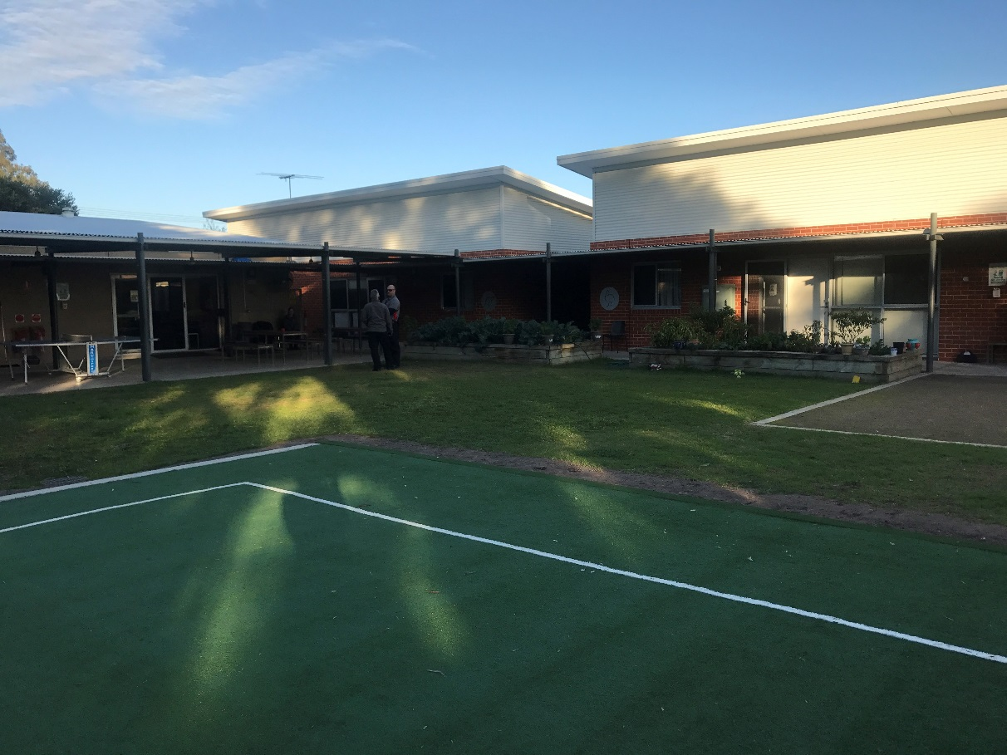
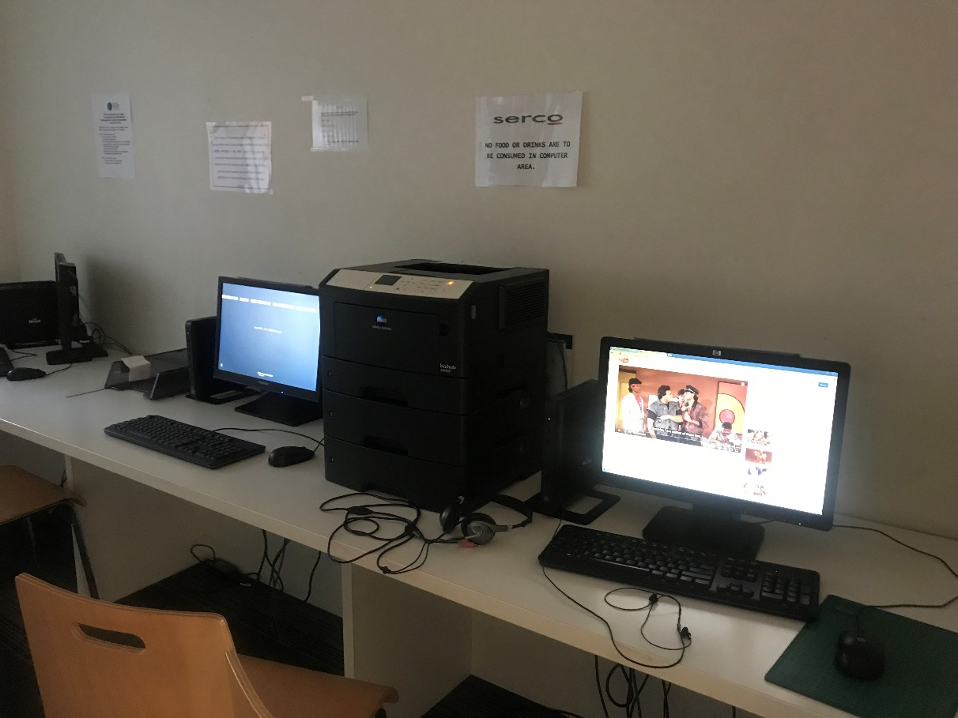

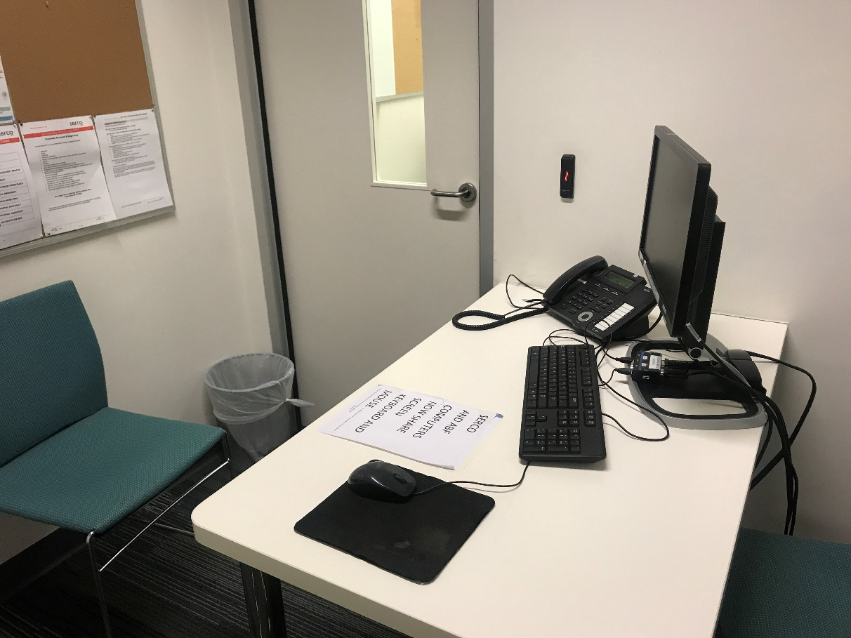

Endnotes

Reports from previous monitoring visits to immigration detention facilities can be found on the Commission’s website at https://www.humanrights.gov.au/our-work/asylum-seekers-and-refugees/immigration-detention-reports-and-photos
Human Rights and Equal Opportunity Commission, Those who've come across the seas: Detention of unauthorised arrivals (1998). At https://www.humanrights.gov.au/our-work/asylum-seekers-and-refugees/publications/those-whove-come-across-seas-detention (viewed 11 May 2017); Human Rights and Equal Opportunity Commission, A last resort? National Inquiry into Children in Immigration Detention (2004). At https://www.humanrights.gov.au/our-work/asylum-seekers-and-refugees/projects/last-resort-report-national-inquiry-children (viewed 11 May 2017); Australian Human Rights Commission, The Forgotten Children: National Inquiry into Children in Immigration Detention (2014). At https://www.humanrights.gov.au/our-work/asylum-seekers-and-refugees/projects/national-inquiry-children-immigration-detention-index (viewed 11 May 2017).
Australian Human Rights Commission, Asylum seekers, refugees and human rights: Snapshot Report (2nd edition) (2017) 11–25. At https://www.humanrights.gov.au/our-work/asylum-seekers-and-refugees/publications/asylum-seekers-refugees-and-human-rights-snapsho-0 (viewed 11 May 2017).
Australian Human Rights Commission, Human rights standards for immigration protection (2013). At https://www.humanrights.gov.au/our-work/asylum-seekers-and-refugees/publications/human-rights-standards-immigration-detention (viewed 11 May 2017).
International Covenant on Civil and Political Rights, opened for signature 16 December 1966, 999 UNTS 171 (entered into force 23 March 1976) arts 9(1), 10(1)
International Covenant on Civil and Political Rights, opened for signature 16 December 1966, 999 UNTS 171 (entered into force 23 March 1976) art 7; Convention against Torture and Other Cruel, Inhuman or Degrading Treatment or Punishment, opened for signature 10 December 1984, 1465 UNTS 85 (entered into force 26 June 1987) arts 2(1), 16(1).
International Covenant on Economic, Social and Cultural Rights, opened for signature 16 December 1966, 993 UNTS 3 (entered into force 3 January 1976) arts 6(2), 11, 12, 13, 15(1a).
International Covenant on Civil and Political Rights, opened for signature 16 December 1966, 999 UNTS 171 (entered into force 23 March 1976) arts 7, 10(1); Convention against Torture and Other Cruel, Inhuman or Degrading Treatment or Punishment, opened for signature 10 December 1984, 1465 UNTS 85 (entered into force 26 June 1987) arts 2(1), 16(1).
International Covenant on Civil and Political Rights, opened for signature 16 December 1966, 999 UNTS 171 (entered into force 23 March 1976) arts 17, 18.
International Covenant on Civil and Political Rights, opened for signature 16 December 1966, 999 UNTS 171 (entered into force 23 March 1976) arts 19(b), 22, 27.
International Covenant on Economic, Social and Cultural Rights, opened for signature 16 December 1966, 993 UNTS 3 (entered into force 3 January 1976) art 15(1a).
International Covenant on Civil and Political Rights, opened for signature 16 December 1966, 999 UNTS 171 (entered into force 23 March 1976) art 23(1); International Covenant on Economic, Social and Cultural Rights, opened for signature 16 December 1966, 993 UNTS 3 (entered into force 3 January 1976) art 10(1).
International Covenant on Civil and Political Rights, opened for signature 16 December 1966, 999 UNTS 171 (entered into force 23 March 1976) art 17(1); Convention on the Rights of the Child, opened for signature 20 November 1989, 1577 UNTS 3 (entered into force 2 September 1990) art 16(1).
Convention against Torture and Other Cruel, Inhuman or Degrading Treatment or Punishment, opened for signature 10 December 1984, 1465 UNTS 85 (entered into force 26 June 1987) arts 13, 16(1).
International Covenant on Civil and Political Rights, opened for signature 16 December 1966, 999 UNTS 171 (entered into force 23 March 1976) art 9(1)
Human Rights Committee, Van Alphen v Netherlands, Communication No. 305/1988, UN Doc CCPR/C/39/D/305/1988 (23 July 1990) [5.8]. At http://www.refworld.org/docid/525414304.html (viewed 7 December 2016); Human Rights Committee, A v Australia, Communication No. 560/1993, UN Doc CCPR/C/59/D/560/1993 (3 April1997) [9.4]. At http://www.refworld.org/docid/3ae6b71a0.html (viewed 7 December 2016).
International Covenant on Civil and Political Rights, opened for signature 16 December 1966, 999 UNTS 171 (entered into force 23 March 1976) arts 9(2), 9(4)
Department of Immigration and Citizenship, Immigration Detention Statistics Summary (31 July 2013) 3–4. At http://www.border.gov.au/ReportsandPublications/Documents/statistics/immigration-detention-statistics-july2013.pdf (viewed 12 May 2017); Department of Immigration and Border Protection, Immigration Detention and Community Statistics Summary (28 February 2015) 3, 5. At http://www.border.gov.au/ReportsandPublications/Documents/statistics/immigration-detention-statistics-feb2015.pdf (viewed 12 May 2017).
Department of Immigration and Citizenship, Immigration Detention Statistics Summary (31 July 2013) 3, 7. At http://www.border.gov.au/ReportsandPublications/Documents/statistics/immigration-detention-statistics-july2013.pdf (viewed 12 May 2017); Department of Immigration and Border Protection, Immigration Detention and Community Statistics Summary (28 February 2015) 3, 8. At http://www.border.gov.au/ReportsandPublications/Documents/statistics/immigration-detention-statistics-feb2015.pdf (viewed 12 May 2017).
Department of Immigration and Border Protection, Immigration Detention and Community Statistics Summary (31 July 2017) 4. At http://www.border.gov.au/ReportsandPublications/Documents/statistics/immigration-detention-statistics-31-july-2017.pdf (viewed 12 September 2017). Note that these figures do not include people detained in the Regional Processing Centres in Nauru and Manus Island, Papua New Guinea.
Department of Immigration and Citizenship, Immigration Detention Statistics Summary (31 July 2013) 9. At http://www.border.gov.au/ReportsandPublications/Documents/statistics/immigration-detention-statistics-july2013.pdf (viewed 12 May 2017).
Department of Immigration and Border Protection, Immigration Detention and Community Statistics Summary (31 January 2017) 11. At http://www.border.gov.au/ReportsandPublications/Documents/statistics/immigration-detention-statistics-31-jan-2017.pdf (viewed 12 May 2017).
Department of Immigration and Border Protection, Immigration Detention and Community Statistics Summary (31 July 2017) 11. At http://www.border.gov.au/ReportsandPublications/Documents/statistics/immigration-detention-statistics-31-july-2017.pdf (viewed 12 September 2017).
Department of Immigration and Citizenship, Immigration Detention Statistics Summary (31 July 2013) 9. At http://www.border.gov.au/ReportsandPublications/Documents/statistics/immigration-detention-statistics-july2013.pdf (viewed 12 May 2017).
Department of Immigration and Border Protection, Immigration Detention and Community Statistics Summary (31 July 2017) 11. At http://www.border.gov.au/ReportsandPublications/Documents/statistics/immigration-detention-statistics-31-july-2017.pdf (viewed 12 September 2017).
See the Department of Home Affairs’ immigration detention statistics summaries, available at http://www.border.gov.au/about/reports-publications/research-statistics/statistics/live-in-australia/immigration-detention (viewed 12 May 2017).
Migration Amendment (Character and General Visa Cancellation) Act 2014 (Cth)
Department of Immigration and Border Protection, Key visa cancellation statistics (n.d.). At http://www.border.gov.au/about/reports-publications/research-statistics/statistics/key-cancellation-statistics (viewed 29 November 2016).
Department of Immigration and Border Protection, Immigration Detention and Community Statistics Summary (31 July 2017) 4, 7. At http://www.border.gov.au/ReportsandPublications/Documents/statistics/immigration-detention-statistics-31-july-2017.pdf (viewed 12 September 2017).
Department of Immigration and Border Protection, ‘Update on Machinery of Government changes’ (Media Release, 20 December 2017). At https://www.homeaffairs.gov.au/News/Pages/machinery-government-changes.aspx (viewed 18 January 2018).
See Australian Human Rights Commission, Inspection of Maribyrnong Immigration Detention Centre (2017) 15. At https://www.humanrights.gov.au/our-work/asylum-seekers-and-refugees/publications/inspection-maribyrnong-immigration-detention (viewed 17 January 2018); Australian Human Rights Commission, Inspection of Melbourne Immigration Transit Accommodation (2017) 13–14. At https://www.humanrights.gov.au/our-work/asylum-seekers-and-refugees/publications/inspection-melbourne-immigration-transit (viewed 17 January 2018); Australian Human Rights Commission, Inspection of Villawood Immigration Detention Centre (2017) 15–16. At https://www.humanrights.gov.au/our-work/asylum-seekers-and-refugees/publications/inspection-villawood-immigration-detention-centre (viewed 17 January 2018).
Louise K Newman, Nicholas G Procter and Michael J Dudley, ‘Suicide and self-harm in immigration detention’ (2011) 195(6) Medical Journal of Australia 310; Melissa Bull et al, ‘Sickness in the System of Long-term Immigration Detention’ (2013) 26 Journal of Refugee Studies 47; Ilan Katz et al, The experiences of Irregular Maritime Arrivals detained in immigration detention facilities: Final report (2013). At http://www.border.gov.au/ReportsandPublications/Documents/research/IMA-experiences-IDF.pdf (viewed 7 December 2016).
Department of Immigration and Border Protection, ‘New measures to combat illegal activity within immigration detention facilities’ (Media Release, 11 November 2016). At http://newsroom.border.gov.au/releases/new-measures-to-combat-illegal-activity-within-immigration-detention-facilities (viewed 26 May 2017).
Migration Amendment (Prohibiting Items in Immigration Detention Facilities) Bill 2017 (Cth) sch 1 item 2.
Statement of Compatibility with Human Rights, Explanatory Memorandum, Migration Amendment (Prohibiting Items in Immigration Detention Facilities) Bill 2017 (Cth).
For further information and recommendations, see Australian Human Rights Commission, Submission No 11 to the Senate Standing Committee on Legal and Constitutional Affairs, Parliament of Australia, Inquiry into the Migration Amendment (Prohibiting Items in Immigration Detention Facilities) Bill 2017 [Provisions], 11 October 2017.
See Australian Human Rights Commission, Asylum seekers, refugees and human rights: Snapshot Report (2nd edition) (2017) 11–25. At https://www.humanrights.gov.au/our-work/asylum-seekers-and-refugees/publications/asylum-seekers-refugees-and-human-rights-snapsho-0 (viewed 11 May 2017). See also Australian Human Rights Commission, Inspection of Maribyrnong Immigration Detention Centre: Report (2017) 26–29. At https://www.humanrights.gov.au/our-work/asylum-seekers-and-refugees/publications/inspection-maribyrnong-immigration-detention (viewed 17 October 2017); Australian Human Rights Commission, Inspection of Melbourne Immigration Transit Accommodation: Report (2017) 24–27. At https://www.humanrights.gov.au/our-work/asylum-seekers-and-refugees/publications/inspection-melbourne-immigration-transit (viewed 17 October 2017).

