Australian Human Rights Commission Inspection of Perth Immigration Detention Centre: Report

21 August 2017

Table of Contents
1 Introduction 5
2 Background 6
2.1 Previous inspections 6
2.2 Inspection methodology 6
2.3 Relevant human rights standards 7
(a) Treatment of people in detention 7
(b) Conditions of detention 7
(c) Communication, association and complaints 8
(d) Legal and policy framework 9
2.4 National context 9
(a) Number of people in detention 9
(b) Length of detention 9
(c) Reasons for detention 10
(d) Administration of the detention network 10
(e) Ratification of OPCAT 11
2.5 Perth Immigration Detention Centre 11
3 Key issues and concerns 11
3.1 Treatment of people in detention 11
(a) Safety, security and relationships with staff 11
(b) Use of force and restraints 12
(c) Other invasive and restrictive measures 13
3.2 Conditions of detention 13
(a) Accommodation, sanitation and exercise facilities 13
(b) Activities and excursions 14
(c) Food 15
(d) Personal items 15
3.3 Physical and mental health 16
(a) Health services 16
(b) Health issues 16
3.4 Communication and complaints 17
(a) Mobile phone policy 17
(b) Communication facilities 18
(c) Visits 18
(d) Complaints 19
3.5 Legislative and policy framework 19
(a) Indefinite mandatory detention 19
(b) Community alternatives to detention 21
(c) Case management and status resolution 22
4 Summary of recommendations 24
4.1 Recommendations to the Australian Government 24
4.2 Joint recommendations to the Department of Home Affairs and facility staff 24
4.3 Recommendations to the Minister and Department of Home Affairs 24
4.4 Recommendations to facility staff 25
5 Appendix: Photos taken during the Commission’s inspection 27
5.1 Men’s compound 27
5.2 Women’s compound 29
5.3 High-security single separation room 30
5.4 Shared facilities 31
Endnotes 33

Summary of key issues
The physical infrastructure of the PIDC does not allow for segregation of different groups, which can present a challenge in terms of maintaining security.
Feedback on staff at the PIDC (particularly medical staff) was generally positive.
The recent use of mechanical restraints in circumstances where restraints had previously been deemed unnecessary, and without there having been any change in each affected person’s risk profile, may have at times been excessive.
Accommodation, living areas and exercise facilities at the PIDC are generally small and cramped, with limited outdoor space. In light of its small size and the basic nature of its facilities, the PIDC is not an appropriate facility for people who are likely to be in detention for extended periods of time.
Facility staff face significant challenges in offering meaningful activities at the PIDC due to the lack of dedicated facilities and staffing limitations.
There are regular excursions from the PIDC but new restrictions have limited access to excursions for some individuals.
The Commission did not identify major or systemic concerns regarding the provision of health care at the PIDC.
The new policy prohibiting all mobile phone use may restrict access to external communication to a greater degree than is necessary to ensure safety and security.
The Commission is particularly concerned about the circumstances of a small number of highly vulnerable individuals detained at the PIDC. While acknowledging the efforts of facility staff and contractors to ensure adequate care for these individuals, the Commission considers that a detention facility is simply not a suitable environment for managing the care of people with significant vulnerabilities (such as those with complex health care needs).
Status Resolution Officers are not currently able to provide people in detention with adequate case management support.

Introduction
This report contains an overview of key observations and concerns arising from the Australian Human Rights Commission’s inspection of the Perth Immigration Detention Centre (PIDC) in August 2017.
The rationale for the Commission undertaking such inspections is to identify problems in the way that detainees’ human rights are being protected and to suggest ways of addressing those problems. Hence, while the report is balanced and points to some good practices, its primary focus is on issues of concern identified by the Commission. The report reflects conditions as they were at the time of the inspection.
The Commission also raised a number of additional issues with the Department of Home Affairs (Home Affairs) and facility staff during and subsequent to the inspection, including individual cases of concern.
The Commission acknowledges the assistance provided by Home Affairs and the Australian Border Force (ABF) in facilitating the Commission’s inspection. The Commission is grateful to the Home Affairs and ABF officers and detention service provider staff who assisted the Commission team during the inspection. A draft of this report was shared with Home Affairs in advance of its publication, to provide an opportunity for Home Affairs to respond to the identified issues.

Background

Previous inspections
The Commission has conducted inspections of immigration detention facilities in Australia since the mid-1990s. This has included periodic monitoring of detention facilities across the country and three major national inquiries into immigration detention.
The purpose of the Commission’s detention monitoring work is to ensure that Australia’s immigration detention system is compliant with our obligations under international human rights law. For many years, the Commission has expressed a range of concerns about aspects of the detention system that may lead to breaches of international human rights law. These include:
- the policy of mandatory immigration detention, which does not allow for adequate consideration of individual circumstances and can result in cases of arbitrary detention
- the indefinite and at times prolonged nature of immigration detention and the lack of a legislative time limit on detention
- the detention of children, which has led to breaches of numerous obligations under the Convention on the Rights of the Child (CRC)
- the indefinite detention of people who have received adverse security or character assessments, including in circumstances where they have not been convicted of a crime under Australian law
- conditions of detention, which in some cases have not met international standards
- the impacts of immigration detention on mental health
- the need for increased use of alternatives to immigration detention.
Further information about these concerns can be found in the Commission publication, Asylum Seekers, Refugees and Human Rights: Snapshot Report.
The Commission can also investigate and, where appropriate, try to resolve through conciliation, complaints it receives from people in immigration detention regarding alleged breaches of human rights.

Inspection methodology
The Commission inspected the PIDC on 21 August 2017. The inspection was conducted by three Commission staff.
During the inspection, the Commission team met with representatives from Home Affairs, ABF, Serco and International Health and Medical Services (IHMS); conducted an inspection of the physical conditions of detention; and held individual private interviews with eight people detained at the PIDC.
The Commission considered the evidence gathered during the inspection against human rights standards derived from international law that are relevant to immigration detention.

Relevant human rights standards
This section provides a summary of some of the key international human rights standards relevant to the situation of people in immigration detention. Further information about these and other relevant standards can be found in the Commission publication, Human rights standards for immigration detention.
The PIDC is a medium-security detention facility that is not used to detain children. As such, human rights standards relating to the detention of children were not applicable to this inspection.

Treatment of people in detention
Australia is obliged under articles 9(1) and 10(1) of the International Covenant on Civil and Political Rights (ICCPR) to, respectively, uphold the right to security of the person and ensure that people in detention are treated with humanity and respect for the inherent dignity of the human person. Australia also has obligations under article 7 of the ICCPR and articles 2(1) and 16(1) of the Convention Against Torture and other Cruel, Inhuman or Degrading Treatment or Punishment (CAT) not to subject anyone to torture or to cruel, inhuman or degrading treatment or punishment, and to take effective measures to prevent these acts from occurring.
These obligations require Australia to ensure that people in detention are treated fairly and reasonably, and in a manner that upholds their dignity. They should enjoy a safe environment free from bullying, harassment, abuse and violence. Security measures should be commensurate with identified risks, and should be the least restrictive possible in the circumstances, taking into account the particular vulnerabilities of people in detention. Measures that may constitute torture or cruel, inhuman or degrading treatment or punishment (such as collective punishment, corporal punishment, excessive use of force and holding people incommunicado) should be prohibited.

Conditions of detention
Australia has a range of obligations under the International Covenant on Economic, Social and Cultural Rights (ICESCR) relevant to the material conditions of immigration detention. These include the right to education (articles 6(2) and 13); the right to an adequate standard of living, including adequate food, clothing and housing (article 11); the right to the highest attainable standard of health (article 12); and the right to take part in cultural life (article 15(1)(a)).
Australia’s obligations under the ICCPR and CAT to treat people in detention with humanity and respect, and not to subject anyone to cruel, inhuman or degrading treatment or punishment, are also relevant to conditions of detention. In addition, Australia has an obligation under articles 17 and 18 of the ICCPR to uphold the right to privacy and freedom of religion respectively.
These obligations require Australia to ensure that detention facilities are safe, hygienic and uphold human dignity. People in detention should have their basic needs met and have access to essential services (such as health care and primary and secondary education) to a standard commensurate with those provided in the Australian community.
People in detention should have opportunities to engage in meaningful activities and excursions that provide physical and mental stimulation. People in detention should also be able to profess and practise the religion of their choice, including through being able to attend religious services, receiving pastoral visits from religious representatives and celebrating major religious holidays and festivals.
In light of the negative impacts of detention on mental health, the length of detention should be limited to the minimum period necessary to achieve a legitimate aim, and community-based alternatives to detention should be used wherever feasible.

Communication, association and complaints
Australia has a range of obligations under the ICCPR relevant to communication between people in detention and their family members, friends, representatives and communities outside detention. These include the right to freedom of expression and to seek, receive and impart information and ideas (article 19(b)); the right to freedom of association with others (article 22); and the right of ethnic, religious and linguistic minorities, in community with the other members of their group, to enjoy their own culture, to profess and practise their own religion and to use their own language (article 27). Under the ICESCR, Australia also has an obligation to uphold the right to take part in cultural life (article 15(1)(a)).
In addition, Australia has obligations under articles 23(1) of the ICCPR and 10(1) of the ICESCR to afford protection and assistance to the family as the natural and fundamental group unit of society. Australia also has obligations under article 17(1) of the ICCPR and article 16(1) of the CRC not to subject anyone to arbitrary or unlawful interference with their family.
These obligations require Australia to ensure that detention does not have a disproportionate impact on people’s ability to express themselves, communicate and associate with others, and remain in contact with their family members, friends, representatives and communities. People in detention should be able to receive regular visits, and should have access to adequate communication facilities (such as telephones and computers) as well as news and library services. People in detention should, if possible, be located in facilities within a reasonable distance from their family members, friends and communities.
External communication, in particular access to complaints processes, is also essential for the prevention of torture and other cruel, inhuman or degrading treatment or punishment. Australia has obligations under articles 13 and 16(1) of the CAT to ensure that anyone who alleges that they have been subjected to torture or to cruel, inhuman or degrading treatment or punishment, has the right to complain to and have their case examined by competent authorities.
To ensure these obligations are upheld, people in detention should have opportunities to raise concerns and issues regarding treatment and conditions in detention, and make complaints both internally and to independent monitors (including the Commission and the Commonwealth Ombudsman), without fear of repercussions.

Legal and policy framework
Australia has an obligation under article 9 of the ICCPR not to subject anyone to arbitrary detention. According to the United Nations Human Rights Committee, ‘arbitrary detention’ includes detention that, although lawful under domestic law, is unjust or disproportionate. In order for the detention of a person not to be arbitrary, it must be a reasonable and necessary measure in all the circumstances.
Australia has further obligations under article 9 of the ICCPR to ensure that anyone who is arrested has the right to be informed of the reasons for their arrest and the charges against them, and that anyone who is detained has the right to challenge the legality of their detention in court.
These obligations require Australia to ensure that people are only detained in immigration detention facilities when it is reasonable and necessary in their individual circumstances (such as where they pose an unacceptable health or security risk), and for a limited period of time. Community-based alternatives to detention should be used wherever possible. People held in immigration detention should be informed of the reasons for their detention and be able to seek judicial review of whether their detention is arbitrary.

National context
The Commission last inspected the PIDC in July 2008. Since that time, there have been a number of significant changes in the legal, policy and operational context surrounding Australia’s immigration detention system.

Number of people in detention
The number of people in closed immigration detention, and particularly the number of children in detention, has fluctuated significantly over the past decade. At the time of the Commission’s 2008 inspection of the PIDC, there were 385 people (including 15 children) in detention across Australia. The number of people in detention increased dramatically over the subsequent years, peaked at over 10,000 in July 2013, before declining again to fewer than 2,000 in early 2015. The number of children in detention dropped from a high of almost 2,000 in July 2013 to fewer than 200 in early 2015.
As at August 2017, there were 1,259 people in immigration detention in Australia, including just one child.

Length of detention
While the overall number of people in detention has declined, the average length of detention has increased significantly. In July 2013, the average length of detention hit a low of 72 days. Since then, the average length has steadily increased, peaking at 493 days in January 2017. As at August 2017, the average stood at 445 days.
In July 2008, 131 people had been detained for over a year, comprising around a third of people in detention. By July 2013, the number of people detained for more than a year had increased to 228 people, but they represented just two per cent of the detention population. The number of people in long-term detention has since increased, both in terms of overall numbers and as a proportion of the detention population. As at August 2017, 454 people — or more than a third of the people in detention — had been detained for over a year.

Reasons for detention
In July 2008, the majority of people in immigration detention had been detained as a result of overstaying their visas. People who had been detained following a visa cancellation were the second-largest group in detention. Just six of the people in detention at this time were asylum seekers who had arrived by boat.
The increase in the detention population over subsequent years was primarily driven by an increase in the number of asylum seekers arriving in Australia by boat. By July 2013, this group represented over 90 per cent of the detention population. Since the beginning of 2014, most asylum seekers who arrived by boat were progressively released from detention (although they remained by far the largest group in detention until 2016).
At the same time, the number of people in detention due to having their visas cancelled has increased. This increase has been largely due to legislative amendments that broadened the scope of section 501 of the Migration Act 1958 (Cth) (the Migration Act). Section 501 allows the Minister or their delegate to refuse or cancel a visa on the basis that a person does not pass the ‘character test’. Since this section was amended in late 2014, visa cancellations on character grounds have increased dramatically, from 76 cancellations in the 2013–14 financial year to 580 in 2014–15; 983 in 2015–16; and 1,284 in 2016–17.
As at August 2017, people who had had their visas cancelled under section 501 were the largest group in detention, comprising over a third of the detention population. Asylum seekers who arrived by boat were the second-largest group in detention, at around a quarter of the population, followed by people who had overstayed their visa and people who had had their visa cancelled on non-character grounds.

Administration of the detention network
Up until mid-2015, Australia’s immigration detention network was administered by the Department of Immigration and Citizenship (subsequently renamed the Department of Immigration and Border Protection, and currently named the Department of Home Affairs).
On 1 July 2015, the Department of Immigration and Border Protection and the Australian Customs and Border Protection Service merged to form a single department. The ABF was established as the new frontline operational agency for this department. The ABF became responsible for administering detention operations and removals; while the Department of Immigration and Border Protection remained responsible for the overall policy framework for detention, as well as matters relating to visa processing, case management and status resolution.
On 20 December 2017, the Department of Immigration and Border Protection and the ABF became part of the newly-established Department of Home Affairs. The new Department incorporates all of the functions previously undertaken by the Department of Immigration and Border Protection, along with a range of functions relating to law enforcement, national security and emergency management.
As was the case in 2014, external contractors continue to play a central role in the management of immigration detention facilities. Serco Australia remains the contracted detention services provider, responsible for the day-to-day running of the facilities including security and provision of services and activities. IHMS remains the contracted health services provider, responsible for providing onsite physical and mental health services to people in detention.

Ratification of OPCAT
On 15 December 2017, the Australian Government ratified the Optional Protocol to the Convention Against Torture and other Cruel, Inhuman or Degrading Treatment or Punishment (OPCAT). OPCAT provides for ongoing independent monitoring of places of detention, to ensure adherence to minimum standards in conditions and treatment.
At the request of the Attorney-General, the Commission is undertaking a consultation process regarding how best to implement OPCAT. Based on the experience in jurisdictions that have ratified and implemented OPCAT, the Commission sees this as an opportunity to consider, in a more systematic way, the adequacy and appropriateness of conditions of detention. The Commission looks forward to continuing to work with the Government to support the implementation of OPCAT.

Perth Immigration Detention Centre
The PIDC opened in 1981. It was originally a secure facility for the Australian Federal Police but was later converted into an immigration detention facility. It is a small, medium-security facility adjacent to Perth airport, with an official capacity of 32. The PIDC currently accommodates single adult men and women across two compounds. The facility also contains two rooms designed for single separation.
At the time of the Commission’s inspection, there were 21 people detained at the PIDC, around three-quarters of whom were male. Most of these people had been detained as a result of having their visas cancelled under section 501. The remaining people included were either individuals who had not been immigration cleared on arrival at an Australian airport (referred to as ‘airport turnarounds’); individuals who had not complied with their visa obligations (such as through overstaying their visa); or asylum seekers who had arrived in Australia by boat.
The detention population included people of a dozen different nationalities, with the largest countries of origin being the United Kingdom, New Zealand and Vietnam.

Key issues and concerns

Treatment of people in detention

Safety, security and relationships with staff
The PIDC is a medium-security facility. Security features observed by the Commission included external security beams, high fencing, secure doors and numerous internal and external security cameras. The staff team at the PIDC does not include Emergency Response Team officers.
Some of the people interviewed by the Commission indicated that they did not feel safe in detention. Concerns about physical safety generally stemmed from witnessing distressing incidents in detention; being detained alongside people who had previously committed crimes or had significant mental health issues; or negative experiences in other detention facilities (such as assaults or intimidation). None of those interviewed reported that their safety had been seriously threatened during their time at the PIDC.
Facility staff noted that the mixed cohort at the PIDC (which included people with varying risk profiles) could present a challenge in terms of maintaining security, as the physical infrastructure of the facility did not allow for segregation of different groups.
Those interviewed by the Commission indicated that their interactions with staff (particularly medical staff) had generally been positive. Some, however, indicated that their experiences with staff have been mixed. One person, for example, felt that he had been treated disrespectfully by one staff member but spoke highly of another staff member in a similar role.
Overall, the Commission did not identify serious concerns relating to physical safety or relationships between staff and people detained at the PIDC.

Use of force and restraints
A number of people interviewed by the Commission reported that they had been mechanically restrained when being escorted outside detention (such as to attend court hearings, excursions or medical appointments, or when being transferred between detention facilities). Some noted that they found the use of restraints distressing.
A small number of people indicated that they had not previously been mechanically restrained during their time at the PIDC, but had recently been told (without explanation) that they would need to be restrained when attending external appointments. These individuals reported that they had refused to attend the appointment due to concerns about the use of restraints.
Facility staff advised that this change in practice was due to the fact that the acting ABF Superintendent had been on leave, and the relieving Superintendent had adopted a different approach to the use of restraints. However, this was evidently unclear to people detained at the PIDC, who did not understand why the policy had changed in the absence of any change in their own behaviour.
The Commission considers that people in detention should be given a clear explanation of the reasons for using mechanical restraints, particularly where there has been a change in practice. The Commission is also concerned that that the recent use of restraints in circumstances where restraints had previously been deemed unnecessary, and without there having been any change in the affected person’s risk profile, may have at times been excessive. The Commission has previously recommended a broader review of the use of restraints on people in detention.

Where mechanical restraints are used on people in detention (particularly where there has been a change in practice), facility staff should provide a clear explanation of the reasons for the use of restraints.

The Department of Home Affairs and facility staff should review policies and practices relating to the use of mechanical restraints, to ensure people in detention are not subject to more restrictive measures than are necessary in their individual circumstances. Particular consideration should be given to limiting the use of mechanical restraints during medical consultations and during transit where the risk of escape is low.

Other invasive and restrictive measures
A small number of people reported that they had been body searched or that their rooms had been searched while in detention. Some noted that they found these searches embarrassing.
At the time of the Commission’s inspection, one person was being held in separate accommodation arrangements due safety issues. Facility staff indicated that this individual had been in detention for a prolonged period of time and could not be accommodated at other detention facilities due to significant health issues. This person did not request a private interview with Commission staff. However, Commission staff were permitted to inspect the separate accommodation area (referred to as ‘High-Care Accommodation’).
Given the limited accommodation options at the PIDC for those requiring separation, the Commission did not identify particular concerns about the use of single separation for this individual. However, the Commission considers that the PIDC is not an appropriate facility for people who are in long-term detention and/or have significant health issues. These issues are discussed further in Section 3.5.

Conditions of detention

Accommodation, sanitation and exercise facilities
People detained at the PIDC are accommodated according to gender in one of two single-storey compounds, connected by communal spaces.
In the men’s compound, rooms accommodated up to seven people with a mix of bunk beds and single beds. There were several shared bathrooms, one of which also contained shared laundry facilities. The compound had two indoor common areas: a multipurpose room containing a library, television, couches and games; and common room containing a pool table, television, couches and a fridge.
The women’s compound contained four rooms (converted from cells used previously when the PIDC was a secure police facility), each with two bunk beds, and one shared bathroom. The compound also had two common areas: an outdoor covered common area, containing a seating area, television and gym equipment; and a small multipurpose room, containing computers, a television, couches and a small library.
The facility also contained two rooms used for single separation, which are separate from the main accommodation compounds. There was one high-security room containing a single bed and open ensuite bathroom (with partitions for privacy); and a lower-security room containing bunk beds and an ensuite bathroom.
Both accommodation compounds at the PIDC open onto outdoor courtyards. The courtyard in the men’s compound is an ‘active courtyard’, which consists of an open space covered with synthetic grass, with small garden beds around the perimeter and an undercover gym on one side. The female compound contains a ‘passive courtyard’ with garden beds, potted plants, tables and chairs and shared laundry facilities. Both courtyards are protected by shade cloths, although staff reported that the cloths are not particularly effective due to their height above the yards.
Some of the people interviewed by the Commission noted that their accommodation or living areas were cramped, especially where bedrooms were being shared between several people. Facility staff also indicated that the use of the PIDC to detain both men and women at the same time could lead to more cramped conditions, as it required staff to separate the facility in to male and female areas and limit movement between compounds.
The Commission considers that accommodation, living areas and exercise facilities at the PIDC are generally small and cramped, with limited outdoor space. This is particularly true of the women’s compound: the bedrooms retain some of the restrictive character of the former cells; the shared living areas are small, especially the indoor multipurpose room which has no natural light; and there is insufficient space to run around in the ‘passive courtyard’.
The Commission acknowledges the efforts of facility staff to provide adequate living conditions for people detained at the PIDC. However, the physical limitations of the facility are such that it is only suitable for very short periods of detention (such as in cases where a person is to be rapidly removed from Australia). The Commission considers that the PIDC is not an appropriate facility for people who are likely to be in detention for extended periods of time. This issue is discussed further in Section 3.5(a).

Activities and excursions
Activities available at the PIDC include personal trainer sessions, sporting activities, arts and crafts, games and educational activities. Religious visits are also available.
Staff reported that they faced significant challenges in offering meaningful activities at the PIDC due to the lack of dedicated facilities, with activities being held either in the courtyards or the dining room. There is no classroom and no dedicated space for religious services. Some of the people interviewed by the Commission indicated that they found the activities on offer ‘basic’ or ‘boring’, with one noting the lack of meaningful educational activities in particular. It was also noted that activities are reduced on weekends due to staffing limitations.
Facility staff reported that excursions from the facility are available, but have recently been restricted due to new risk assessment requirements. Excursion sites included parks, a swimming pool and the zoo. A number of the people interviewed by the Commission indicated that they had attended excursions while detained at the PIDC, although some noted that they had not been permitted to attend due to their risk rating or had declined to attend due to concerns about being mechanically restrained.
The Commission acknowledges the efforts of facility staff to provide meaningful activities for people detained at the PIDC. However, the Commission considers that the lack of dedicated facilities for activities highlights the unsuitability of the PIDC for anything other than very short periods of detention. The Commission welcomes efforts to provide regular excursions, which are likely to be of significant benefit to people detained at the PIDC due to the facility’s small size and limited outdoor space.
In light of the recent restrictions on excursions resulting from risk assessment processes, the Commission suggests that facility staff continue to explore options for providing excursions to more secure venues, with a view to minimising the use of restraints on excursions and extending excursion opportunities to people who are considered to present a higher risk.

Facility staff should continue to explore options for providing excursions to secure sites suitable for people who are considered to present a higher risk.

Food
Food is prepared in a central kitchen, with meals served in the adjacent dining room. Continental breakfast supplies and snacks are available in the dining room. People in detention can purchase additional snacks using points (see Section 3.2(d) below).
A number of people interviewed by the Commission raised concerns about the food, reporting that it was of a low quality or did not adequately cater for their dietary needs. One person noted the lack of opportunities at the PIDC for people to cook their own food.

Personal items
People in detention earn points which can be used to purchase personal items such as cigarettes, drinks, snacks, phone cards and toiletries. People are allocated 25 points at the beginning of each week and can earn 25 additional points through participating in activities, plus a further ten points for good behaviour.
Very limited feedback was provided to the Commission regarding the points system or the items available for purchase.

Physical and mental health

Health services
Health services are provided onsite at the PIDC by IHMS. The medical clinic is open from 9:00am to 5:00pm Monday to Friday, and is staffed by a general practitioner and registered nurse.
Where specialist treatment is required, people are referred to external providers in Perth, with waiting times in line with community standards. Facility staff reported that telehealth may be used in cases where specialist care is not immediately available in Perth. Services may also be provided through the medical clinic at the Yongah Hill Immigration Detention Centre (around an hours’ drive from the PIDC).
A mental health nurse is onsite for six hours per day from Monday to Friday, and 12 hours per day on weekends. Visiting psychologists and psychiatrists also provide mental health assistance onsite, while the Association for Services to Torture and Trauma Survivors provides counselling on a needs basis to people who have experienced torture or trauma.
Facility staff noted that chronic health conditions can often be managed more effectively at the PIDC than at larger facilities, as staff are able to interact regularly with all people in detention and develop a detailed understanding of their health needs. A number of people interviewed by the Commission provided positive feedback on the health services and medical staff at the PIDC.
Overall, the Commission did not identify major or systemic concerns regarding the provision of health care at the PIDC.

Health issues
Facility staff reported that, due to the increase in the number of people detained at the PIDC after having their visas cancelled under section 501, there has been a significant shift in the types of health issues encountered by medical staff. This included an increase in chronic physical and mental health conditions, and an increase in the number of people with a history of drug abuse. Related to both of these trends, staff reported that they at times experienced difficulties in securing approval for hepatitis C treatment for people in detention, including in cases where the person would be eligible for treatment had they been living in the Australian community.
Some of the people interviewed by the Commission expressed concerns about their mental health, particularly the negative impact of detention on their mental health. Several reported that they were receiving treatment for mental health issues. However, a number of people noted that mental health treatment was not effective or helpful due to the fact that they remained in detention. In the words of one person, counselling was ‘not helpful because my problems can't be fixed by someone talking to me. My problem is I'm locked up here and there is no justice for me.’
The Commission acknowledges the efforts of successive Australian Governments to strengthen the mental health services and response across the immigration detention network. However, the Commission notes that it is often the detention environment itself that causes mental health concerns. In its recent Concluding Observations on Australia, the United Nations Human Rights Committee raised concerns about ‘the high reported rates of mental health problems among migrants in detention, which allegedly correlate to the length and conditions of detention’. As such, only the prompt removal of people from immigration detention facilities will address the problem of high levels of mental ill health in the Australian immigration detention system.

Communication and complaints

Mobile phone policy
In February 2017, Home Affairs introduced a new policy that prohibits the possession and use of mobile phones in immigration detention facilities. According to a media release issued in November 2016, the new policy was implemented in response to concerns that some people in detention were using mobile phones ‘to organise criminal activities, threaten other detainees, create or escalate disturbances and plan escapes by enlisting outsiders to assist them’. The media release indicated that people in detention would be given increased access to landlines phones in place of mobile phones.
In mid-February, the Federal Court issued an injunction preventing the implementation of the new mobile policy. As a result, some people in detention have been able to retain their mobile phones. However, those who had already surrendered their phones to facility staff have not had them returned.
In September, the Australian Government introduced the Migration Amendment (Prohibiting Items in Immigration Detention Facilities) Bill 2017. The Bill would allow the Minister to determine, by legislative instrument, things to be prohibited in immigration detention facilities. Any item may be declared prohibited if the Minister is satisfied ‘might be a risk to the health, safety or security of persons in the facility, or to the order of the facility’. The Government has indicated that, should the Bill be passed, the Minister intends to determine mobile phones and SIM cards to be prohibited.
The Bill was referred to the Senate Legal and Constitutional Affairs Committee for inquiry and report. In November, the Committee recommended that the Bill be passed, subject to amendments ‘to ensure that detainees have access to communication facilities that will reasonably meet their needs, and enable timely, and where appropriate, private contact with friends, family, and legal services’. The Committee also recommended that Home Affairs establish a central information registry to record the status and location of people in immigration detention, to facilitate communication with people outside detention.
The Commission considers that prohibiting all mobile phone use in immigration detention may restrict access to external communication to a greater degree than is necessary to ensure safety and security. As such, the Commission considers that this policy should be reviewed to ensure that access to mobile phones is restricted only to the extent necessary, and on an individualised basis rather than as a blanket policy. The Commission has also recommended further amendments to the Migration Amendment (Prohibiting Items in Immigration Detention Facilities) Bill 2017, to ensure that possession of items which do not present inherent risks to safety and security (such as mobile phones) may only be prohibited in certain circumstances.

The Department of Home Affairs should review its policy regarding the use of mobile phones in immigration detention facilities, with a view to restricting mobile phone usage only in response to unacceptable risks determined through an individualised assessment process.

Communication facilities
Landline phones were located in both compounds at the PIDC. Computers with internet access were available 24 hours a day in a dedicated computer room.
People interviewed by the Commission provided limited feedback relating to communication facilities. A small number indicated that they had at times experienced difficulties accessing communication facilities, whereas others reported experiencing no difficulties. Some expressed concern that the computers had not been working for several days. Facility staff explained that this was due to a nationwide outage affecting both staff and facility computers across the detention network.
In its submission to the Legal and Constitutional Affairs Committee inquiry into the Migration Amendment (Prohibiting Items in Immigration Detention Facilities) Bill 2017, the Commission recommended that ensure that all people in immigration detention have adequate opportunities to communicate with people outside detention. This recommendation was endorsed by the Committee.

Visits
The PIDC has a small visits room that is used for one visit at a time, with people in detention able to see up to four visitors at once. There is also a private interview room used for legal visits and a non-contact visits room.
Few of the people interviewed by the Commission provided feedback relating to the process for requesting and receiving visits. However, one person noted that the visits were only available during limited hours, which could make it difficult for people in detention to receive visits from family members and friends who work during business hours.
Facility staff indicated that visits were not available after hours due to staffing limitations. The Commission recognises the challenges presented by limited staffing at small facilities such as the PIDC. Nonetheless, the Commission suggests that facility staff explore options for facilitating after-hours visits, such as offering such visits on request or on a limited number of days.
A number of people raised concerns about the impact of their detention on family members. This included people who had relatives living interstate, and people whose relatives were dependents or otherwise relied on them for care and support.
The Commission considers that people in detention should be accommodated as close as possible to any family members and friends who are living in the Australian community. Where a person in detention has caring responsibilities, their cases should be considered as a priority for release into alternative community-based arrangements.

The Department of Home Affairs should accommodate people in immigration detention as close as possible to family members and friends living in the Australian community.

Where a person in immigration detention has caring responsibilities, the Minister and Department of Home Affairs should consider their cases as a priority for release into alternative community-based arrangements.

Complaints
People in detention have the right to make complaints about conditions and treatment both internally and to external agencies such as the Commission and the Commonwealth Ombudsman.
The Commission observed that facility staff had, as requested, put up posters to notify people in detention about the Commission’s inspection of the PIDC. The Commission also observed signs or posters advertising external complaints processes.
A number of the people interviewed by the Commission reported that they had made a complaint internally or to an external agency. However, most of these individuals highlighted the limitations of complaints processes in terms of resolving issues of concern. It was noted, for example, that the findings and recommendations of external agencies were not enforceable.

Legislative and policy framework

Indefinite mandatory detention
The Commission has long expressed concern that Australia’s legislative framework for immigration detention does not contain adequate safeguards to prevent detention from becoming arbitrary. People can be detained for prolonged periods of time, on an indefinite basis, and in circumstances where there is no valid justification for their detention under international law.
In its recent Concluding Observations on Australia, the United Nations Human Rights Committee found that Australia’s system of indefinite mandatory detention ‘does not meet the legal standards under article 9 of the [ICCPR] due to the lengthy periods of migrant detention it allows’. The Committee recommended that Australia ‘bring its legislation and practices related to immigration detention into compliance with article 9’, including through reducing the initial period of mandatory detention; ensuring that ongoing detention is justified as reasonable, necessary and proportionate in light of individual circumstances; ensuring that detention is subject to periodic judicial review; expanding the use of alternatives to detention; and considering the introduction of a time limit on the overall duration of detention.
Facility staff indicated that some of the people held at the PIDC are detained for very short periods of time, including ‘airport turnarounds’ who may only be held in detention for a few days. However, staff also reported that some individuals are held at the PIDC for far longer periods of time.
Most of the people interviewed by the Commission reported that they had been in detention for at least a year, and in some cases for several years. Some of these individuals had been detained in other facilities prior to being transferred to the PIDC. However, a number had been held at the PIDC for several months.
The Commission wishes to acknowledge the facility staff recognised the limitations of the PIDC and had made efforts to ensure adequate support for people in long-term detention. However, as noted in Section 3.2(a), the Commission considers that the PIDC — in light of its small size and the basic nature of its facilities — is not an appropriate facility for people who are likely to be in detention for extended periods of time. As such, the Commission recommends that the PIDC should only be used in cases where the person is expected to be in detention for a very short period of time, and should not be used for periods of detention that exceed a month.
The Commission also became aware of cases in which ongoing detention may not have been justifiable in the circumstances. This included, for example, cases in which the person had had their visa cancelled under section 501 on the basis of historical convictions, and had been living in the community for years after serving their term of imprisonment. The Commission questions whether ongoing immigration detention is necessary in these cases, given that the criminal justice system has determined that the people in question should be permitted to live freely in the community.

The Australian Government should introduce legislation to replace the current system of mandatory immigration detention with a case-by-case assessment process that takes individual circumstances into consideration. Closed detention should only be used as a last resort in circumstances where:
a) a person has been individually assessed as posing an unacceptable risk to the Australian community, and that risk cannot be managed in a less restrictive way
b) the necessity for continued detention has been individually assessed by a court or tribunal, with further assessments to occur periodically up to a maximum time limit.

The Department of Home Affairs should ensure that the PIDC facility is only used for short periods of detention not exceeding one month.

Community alternatives to detention
The Commission welcomes the Government’s ongoing commitment to using community-based alternatives to detention where possible, especially for children and other vulnerable groups. The Commission acknowledges that most people have their immigration status resolved while living in the community, rather than in closed detention.
During the inspection, however, the Commission became particularly concerned about the circumstances of a small number of highly vulnerable individuals detained at the PIDC. This include people who had experienced trauma, had significant mental health issues or had serious physical health issues requiring a high level of care.
The Commission acknowledges the efforts of facility staff and contractors to ensure adequate care for these individuals. Indeed, it may be the case that staff are able to provide more intensive support to vulnerable individuals in a smaller facility such as the PIDC, than would be possible in larger detention facilities with bigger populations. However, the Commission considers that a detention facility is simply not a suitable environment for managing the care of people with significant vulnerabilities, such as those with complex health care needs.
The Commission considers that community-based alternatives should be explored for all people in detention, and especially for those who have significant vulnerabilities. Ongoing detention should only occur when a person presents an unacceptable risk that cannot be managed in a less restrictive way.

The Minister and Department of Home Affairs should routinely consider all people in immigration detention (especially those with significant vulnerabilities) for release into alternative community-based arrangements.

Case management and status resolution
People in immigration detention are assigned a Home Affairs Status Resolution Officer, whose role is to assist people in resolving their immigration status. Status resolution options may include applying for a substantive visa, appealing a visa cancellation or voluntarily returning to one’s country of citizenship. Status Resolution Officers also refer people for possible release from detention into alternative community arrangements. Case managers from the Department of Immigration and Border Protection previously provided welfare services to people in detention, but Status Resolution Officers no longer fulfil this role.
A small number of people interviewed by the Commission raised concerns that Status Resolution Officers could not provide adequate case management support. For example, one person claimed that their Officer simply encouraged them to return to their country of origin without canvassing other options. Some also expressed confusion about the status resolution process, and it appeared that they were not fully aware of the current status of their case or their options for status resolution. A small number indicated that they had not received independent legal or migration advice regarding their case.
The Commission acknowledges that some of these comments may reflect the reduction in the scope of the case manager role and its present limitations, rather than issues with the performance of individual officers. It was also evident that a number of the people interviewed by the Commission had complex immigration cases that may be difficult to resolve. Nonetheless, this feedback further confirms the concerns previously raised by the Commission that Status Resolution Officers are not currently able to provide people in detention with adequate case management support.
The Commission is concerned that the limitations of the case management system may delay or complicate the status resolution process. As a result, people may be detained for longer periods than is necessary or miss opportunities for status resolution simply because they were unaware of their options or how to pursue them. As such, the Commission considers that it would be beneficial to review the case management system, to determine whether it is operating as effectively as possible to assist people in detention to resolve their status.
Given the limitations of the Status Resolution Officer role, it is particularly important that people in detention are able to access alternative forms of advice and assistance with status resolution. The Commission therefore considers that Status Resolution Officers should have the capacity to assist people in detention to access independent legal and migration advice, for example through providing information and referrals to relevant services (such as Legal Aid and specialist migration and asylum seeker advice services).

The Department of Home Affairs should review the case management system for people in immigration detention to determine:
a) the extent to which the case management system addresses the needs of people in detention
b) whether the case management system is operating as effectively as possible to facilitate status resolution, including through ensuring that people in detention have access to sufficient advice about their status and options for resolution.

Recognising the limited role of Status Resolution Officers, the Department of Home Affairs should introduce capacity for Status Resolution Officers to provide people in detention with appropriate information and referrals to independent migration and legal advice.

Summary of recommendations

Recommendations to the Australian Government
Recommendation 7 (indefinite mandatory detention)
The Australian Government should introduce legislation to replace the current system of mandatory immigration detention with a case-by-case assessment process that takes individual circumstances into consideration. Closed detention should only be used as a last resort in circumstances where:
a) a person has been individually assessed as posing an unacceptable risk to the Australian community, and that risk cannot be managed in a less restrictive way
b) the necessity for continued detention has been individually assessed by a court or tribunal, with further assessments to occur periodically up to a maximum time limit.

Joint recommendations to the Department of Home Affairs and facility staff
Recommendation 2 (mechanical restraints)
The Department of Home Affairs and facility staff should review policies and practices relating to the use of mechanical restraints, to ensure people in detention are not subject to more restrictive measures than are necessary in their individual circumstances. Particular consideration should be given to limiting the use of mechanical restraints during medical consultations and during transit where the risk of escape is low.

Recommendations to the Minister and Department of Home Affairs
Recommendation 4 (mobile phones)
The Department of Home Affairs should review its policy regarding the use of mobile phones in immigration detention facilities, with a view to restricting mobile phone usage only in response to unacceptable risks determined through an individualised assessment process.

Recommendation 5 (family unity)
The Department of Home Affairs should accommodate people in immigration detention as close as possible to family members and friends living in the Australian community.

Recommendation 6 (people with caring responsibilities)
Where a person in immigration detention has caring responsibilities, the Minister and Department of Home Affairs should consider their cases as a priority for release into alternative community-based arrangements.

Recommendation 8 (length of detention)
The Department of Home Affairs should ensure that the PIDC facility is only used for short periods of detention not exceeding one month.

Recommendation 9 (alternatives to detention)
The Minister and Department of Home Affairs should routinely consider all people in immigration detention (especially those with significant vulnerabilities) for release into alternative community-based arrangements.

Recommendation 10 (case management)
The Department of Home Affairs should review the case management system for people in immigration detention to determine:
a) the extent to which the case management system addresses the needs of people in detention
b) whether the case management system is operating as effectively as possible to facilitate status resolution, including through ensuring that people in detention have access to sufficient advice about their status and options for resolution.

Recommendation 11 (migration and legal advice)
Recognising the limited role of Status Resolution Officers, the Department of Home Affairs should introduce capacity for Status Resolution Officers to provide people in detention with appropriate information and referrals to independent migration and legal advice.

Recommendations to facility staff
Recommendation 1 (explanation for use of mechanical restraints)
Where mechanical restraints are used on people in detention (particularly where there has been a change in practice), facility staff should provide a clear explanation of the reasons for the use of restraints.

Recommendation 3 (excursions)
Facility staff should continue to explore options for providing excursions to secure sites suitable for people who are considered to present a higher risk.

Appendix: Photos taken during the Commission’s inspection

Men’s compound
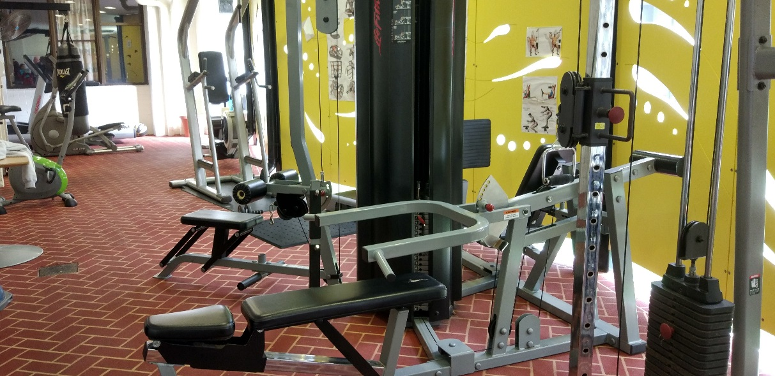
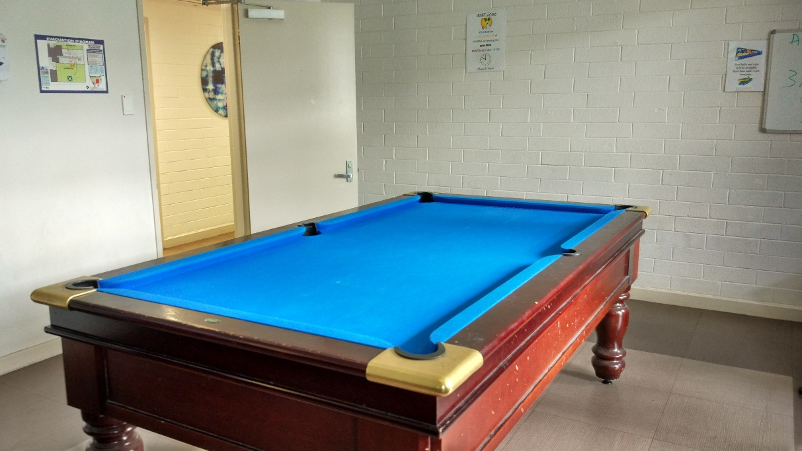
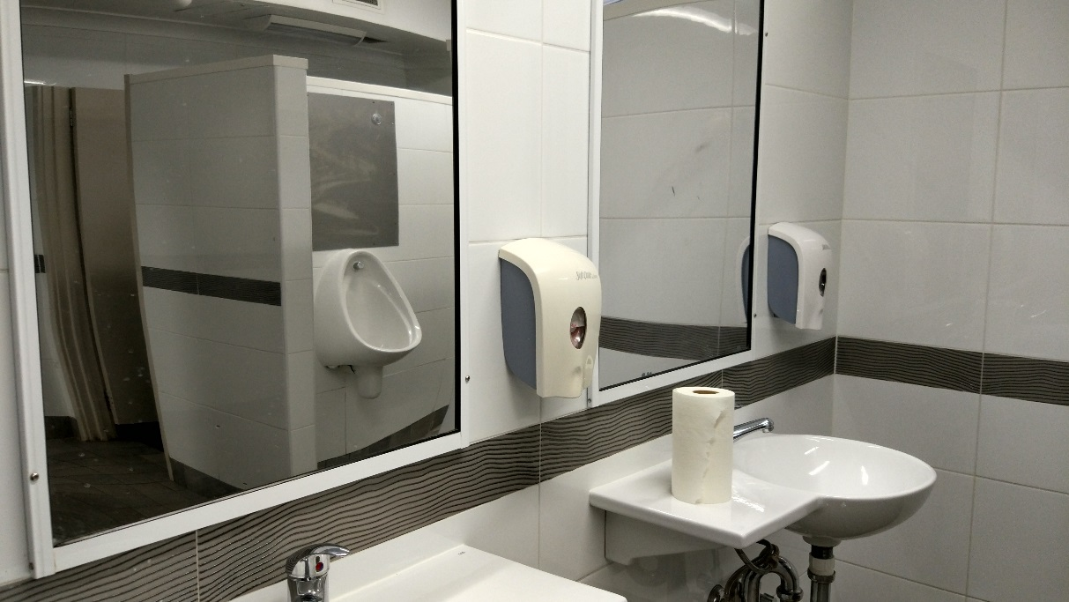
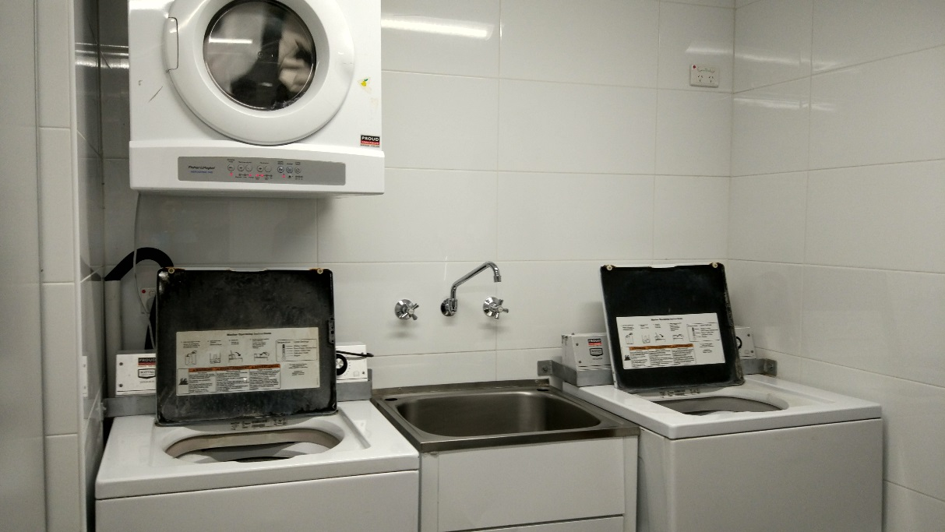

Women’s compound
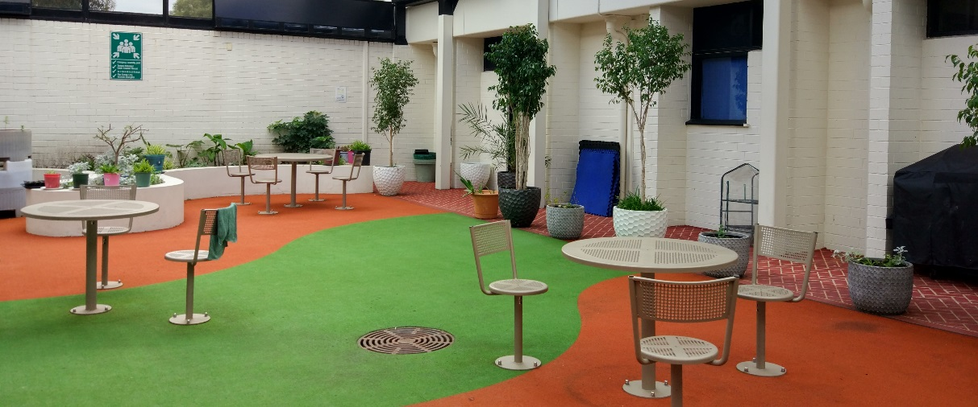

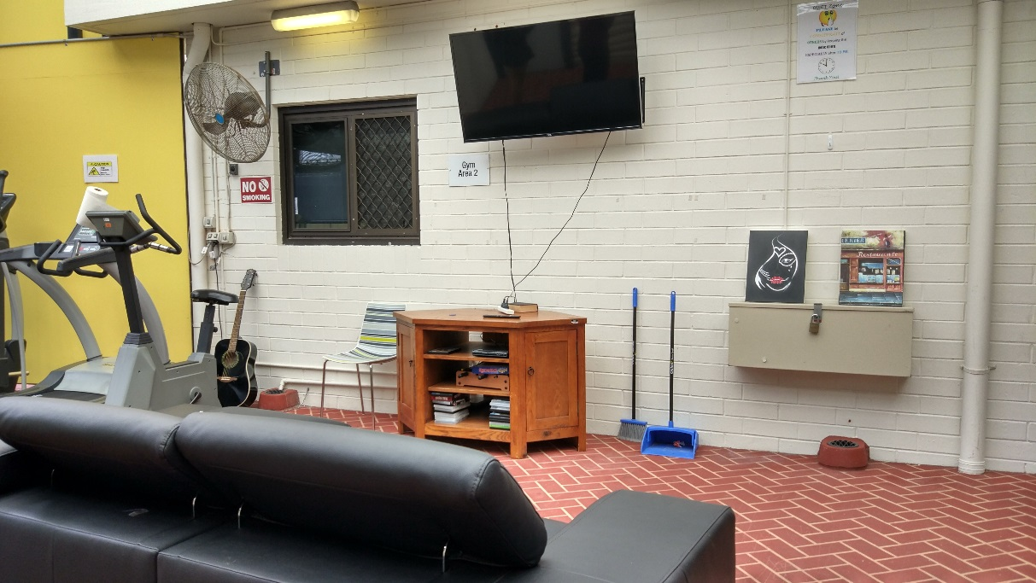

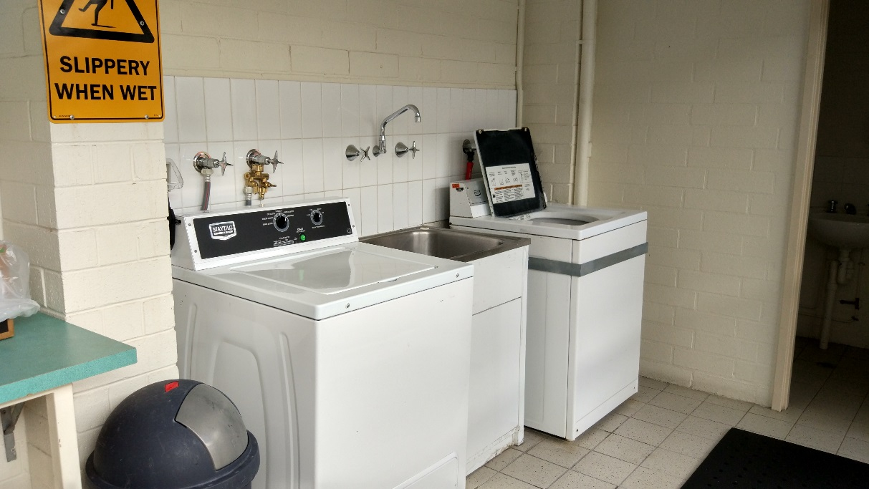

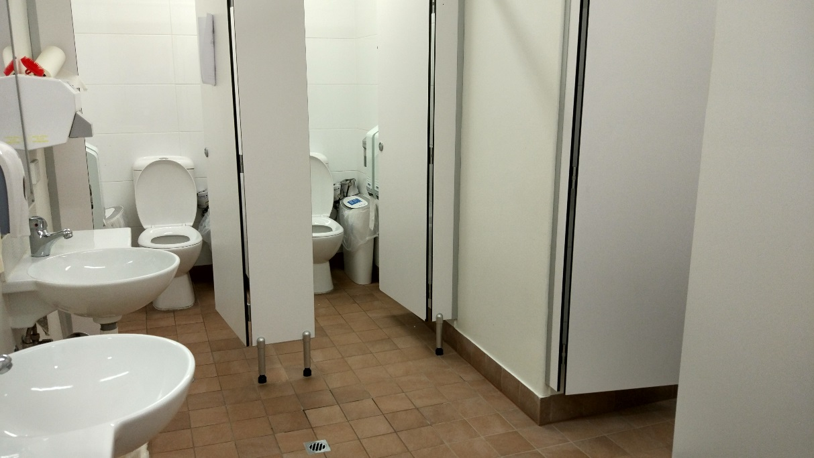

‘High-Care Accommodation’ room
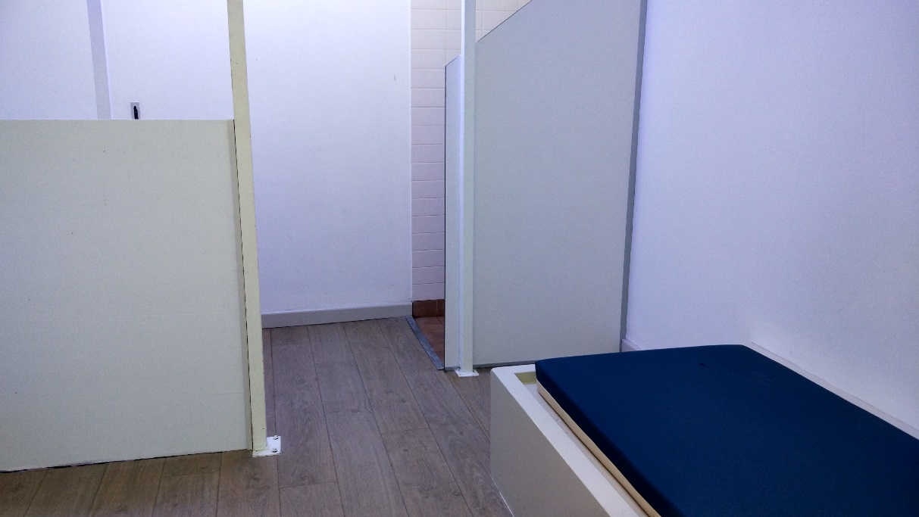

Shared facilities
From top to bottom: dining room, visits room, private interview room, non-contact visits room.
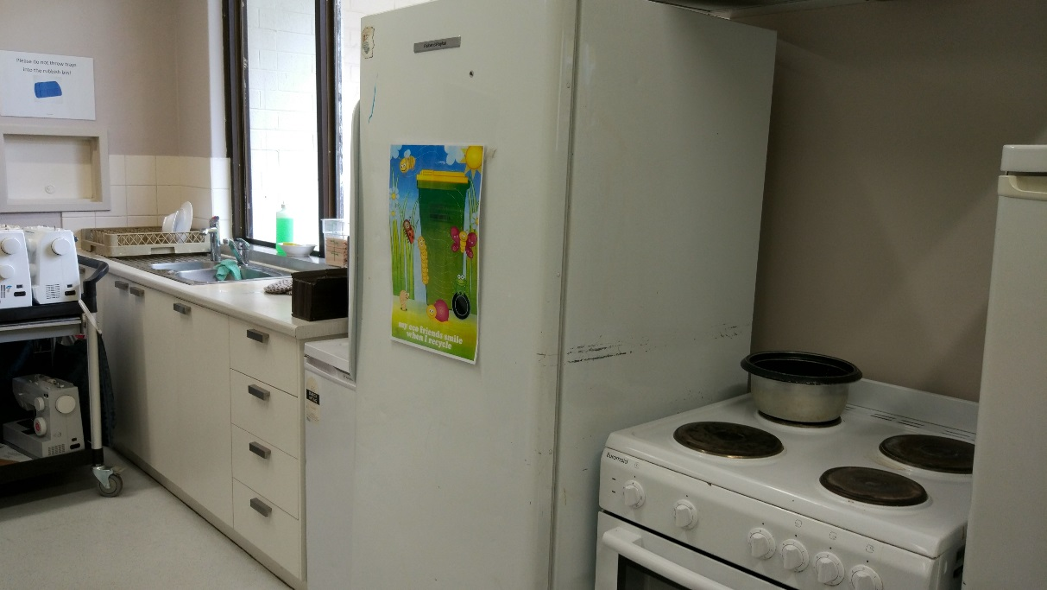
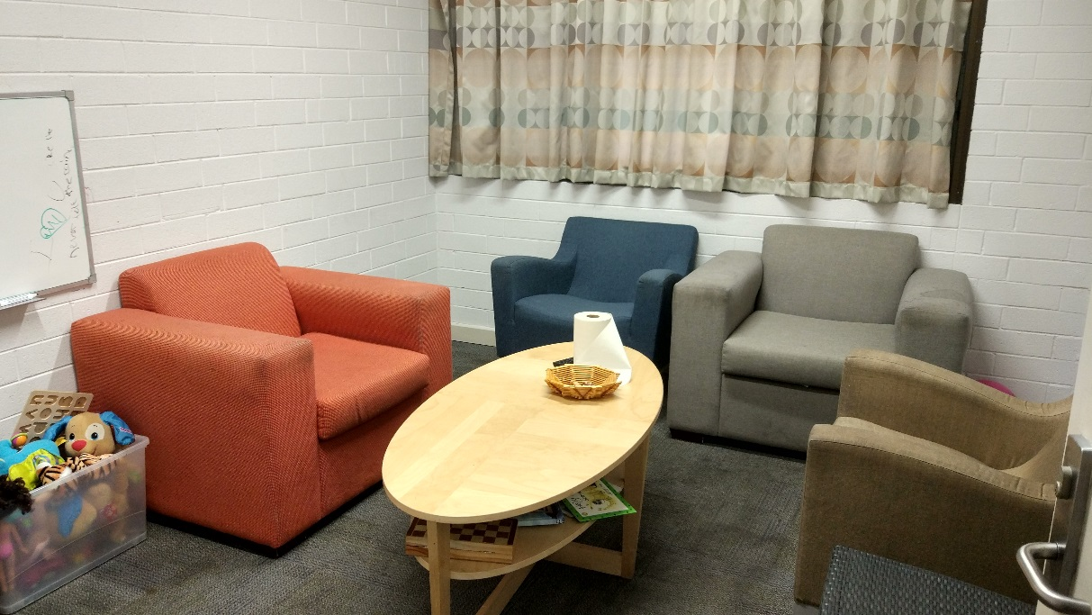

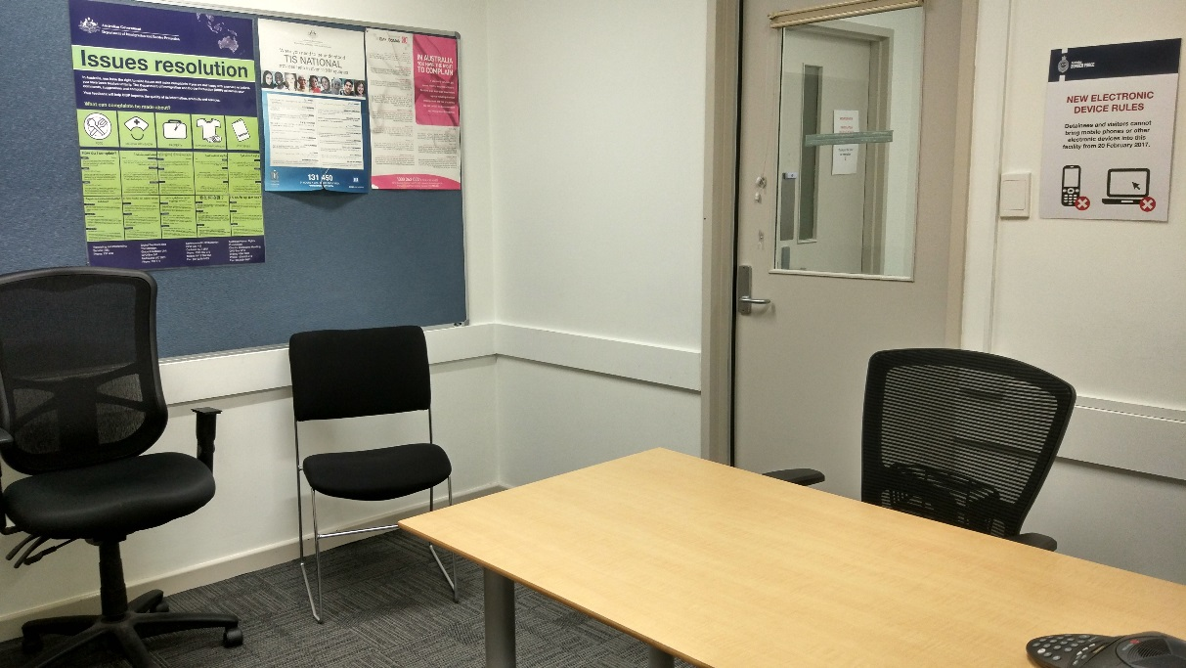

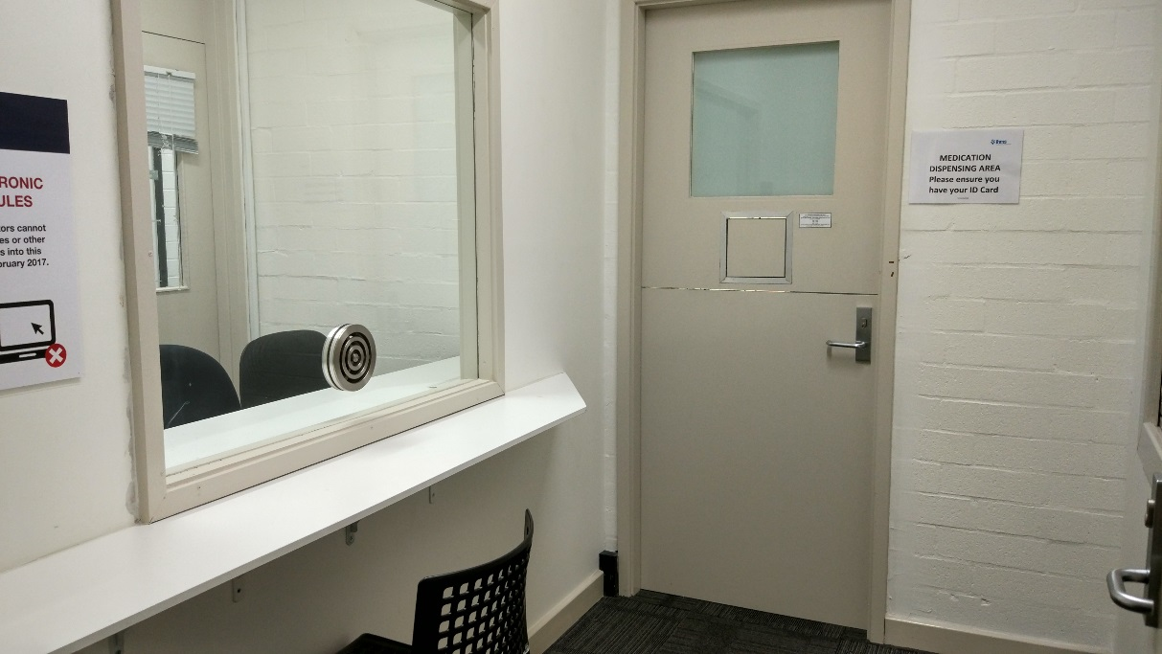

Endnotes

Reports from previous monitoring visits to immigration detention facilities can be found on the Commission’s website at https://www.humanrights.gov.au/our-work/asylum-seekers-and-refugees/immigration-detention-reports-and-photos
Human Rights and Equal Opportunity Commission, Those who've come across the seas: Detention of unauthorised arrivals (1998). At https://www.humanrights.gov.au/our-work/asylum-seekers-and-refugees/publications/those-whove-come-across-seas-detention (viewed 11 May 2017); Human Rights and Equal Opportunity Commission, A last resort? National Inquiry into Children in Immigration Detention (2004). At https://www.humanrights.gov.au/our-work/asylum-seekers-and-refugees/projects/last-resort-report-national-inquiry-children (viewed 11 May 2017); Australian Human Rights Commission, The Forgotten Children: National Inquiry into Children in Immigration Detention (2014). At https://www.humanrights.gov.au/our-work/asylum-seekers-and-refugees/projects/national-inquiry-children-immigration-detention-index (viewed 11 May 2017).
Australian Human Rights Commission, Asylum seekers, refugees and human rights: Snapshot Report (2nd edition) (2017) 11–25. At https://www.humanrights.gov.au/our-work/asylum-seekers-and-refugees/publications/asylum-seekers-refugees-and-human-rights-snapsho-0 (viewed 11 May 2017).
Australian Human Rights Commission, Human rights standards for immigration protection (2013). At https://www.humanrights.gov.au/our-work/asylum-seekers-and-refugees/publications/human-rights-standards-immigration-detention (viewed 11 May 2017).
International Covenant on Civil and Political Rights, opened for signature 16 December 1966, 999 UNTS 171 (entered into force 23 March 1976) arts 9(1), 10(1)
International Covenant on Civil and Political Rights, opened for signature 16 December 1966, 999 UNTS 171 (entered into force 23 March 1976) art 7; Convention against Torture and Other Cruel, Inhuman or Degrading Treatment or Punishment, opened for signature 10 December 1984, 1465 UNTS 85 (entered into force 26 June 1987) arts 2(1), 16(1).
International Covenant on Economic, Social and Cultural Rights, opened for signature 16 December 1966, 993 UNTS 3 (entered into force 3 January 1976) arts 6(2), 11, 12, 13, 15(1a).
International Covenant on Civil and Political Rights, opened for signature 16 December 1966, 999 UNTS 171 (entered into force 23 March 1976) arts 7, 10(1); Convention against Torture and Other Cruel, Inhuman or Degrading Treatment or Punishment, opened for signature 10 December 1984, 1465 UNTS 85 (entered into force 26 June 1987) arts 2(1), 16(1).
International Covenant on Civil and Political Rights, opened for signature 16 December 1966, 999 UNTS 171 (entered into force 23 March 1976) arts 17, 18.
International Covenant on Civil and Political Rights, opened for signature 16 December 1966, 999 UNTS 171 (entered into force 23 March 1976) arts 19(b), 22, 27.
International Covenant on Economic, Social and Cultural Rights, opened for signature 16 December 1966, 993 UNTS 3 (entered into force 3 January 1976) art 15(1a).
International Covenant on Civil and Political Rights, opened for signature 16 December 1966, 999 UNTS 171 (entered into force 23 March 1976) art 23(1); International Covenant on Economic, Social and Cultural Rights, opened for signature 16 December 1966, 993 UNTS 3 (entered into force 3 January 1976) art 10(1).
International Covenant on Civil and Political Rights, opened for signature 16 December 1966, 999 UNTS 171 (entered into force 23 March 1976) art 17(1); Convention on the Rights of the Child, opened for signature 20 November 1989, 1577 UNTS 3 (entered into force 2 September 1990) art 16(1).
Convention against Torture and Other Cruel, Inhuman or Degrading Treatment or Punishment, opened for signature 10 December 1984, 1465 UNTS 85 (entered into force 26 June 1987) arts 13, 16(1).
International Covenant on Civil and Political Rights, opened for signature 16 December 1966, 999 UNTS 171 (entered into force 23 March 1976) art 9(1)
Human Rights Committee, Van Alphen v Netherlands, Communication No. 305/1988, UN Doc CCPR/C/39/D/305/1988 (23 July 1990) [5.8]. At http://www.refworld.org/docid/525414304.html (viewed 7 December 2016); Human Rights Committee, A v Australia, Communication No. 560/1993, UN Doc CCPR/C/59/D/560/1993 (3 April1997) [9.4]. At http://www.refworld.org/docid/3ae6b71a0.html (viewed 7 December 2016).
International Covenant on Civil and Political Rights, opened for signature 16 December 1966, 999 UNTS 171 (entered into force 23 March 1976) arts 9(2), 9(4)
Department of Immigration and Citizenship, Immigration Detention Statistics Summary (18 July 2008) 1. The Commission visited the PIDC on 14 and 15 July 2008.
Department of Immigration and Citizenship, Immigration Detention Statistics Summary (31 July 2013) 3–4. At http://www.border.gov.au/ReportsandPublications/Documents/statistics/immigration-detention-statistics-july2013.pdf (viewed 12 May 2017); Department of Immigration and Border Protection, Immigration Detention and Community Statistics Summary (28 February 2015) 3, 5. At http://www.border.gov.au/ReportsandPublications/Documents/statistics/immigration-detention-statistics-feb2015.pdf (viewed 12 May 2017).
Department of Immigration and Citizenship, Immigration Detention Statistics Summary (31 July 2013) 3, 7. At http://www.border.gov.au/ReportsandPublications/Documents/statistics/immigration-detention-statistics-july2013.pdf (viewed 12 May 2017); Department of Immigration and Border Protection, Immigration Detention and Community Statistics Summary (28 February 2015) 3, 8. At http://www.border.gov.au/ReportsandPublications/Documents/statistics/immigration-detention-statistics-feb2015.pdf (viewed 12 May 2017).
Department of Immigration and Border Protection, Immigration Detention and Community Statistics Summary (31 August 2017) 4. At http://www.border.gov.au/ReportsandPublications/Documents/statistics/immigration-detention-statistics-31-august-2017.pdf (viewed 16 October 2017). Note that these figures do not include people detained in the Regional Processing Centres in Nauru and Manus Island, Papua New Guinea.
Department of Immigration and Citizenship, Immigration Detention Statistics Summary (31 July 2013) 9. At http://www.border.gov.au/ReportsandPublications/Documents/statistics/immigration-detention-statistics-july2013.pdf (viewed 12 May 2017).
Department of Immigration and Border Protection, Immigration Detention and Community Statistics Summary (31 January 2017) 11. At http://www.border.gov.au/ReportsandPublications/Documents/statistics/immigration-detention-statistics-31-jan-2017.pdf (viewed 12 May 2017).
Department of Immigration and Border Protection, Immigration Detention and Community Statistics Summary (31 August 2017) 11. At http://www.border.gov.au/ReportsandPublications/Documents/statistics/immigration-detention-statistics-31-august-2017.pdf (viewed 16 October 2017).
Department of Immigration and Citizenship, Immigration Detention Statistics Summary (18 July 2008) 4.
Department of Immigration and Citizenship, Immigration Detention Statistics Summary (31 July 2013) 9. At http://www.border.gov.au/ReportsandPublications/Documents/statistics/immigration-detention-statistics-july2013.pdf (viewed 12 May 2017).
Department of Immigration and Border Protection, Immigration Detention and Community Statistics Summary (31 August 2017) 11. At http://www.border.gov.au/ReportsandPublications/Documents/statistics/immigration-detention-statistics-31-august-2017.pdf (viewed 16 October 2017).
Department of Immigration and Citizenship, Immigration Detention Statistics Summary (18 July 2008) 2.
Department of Immigration and Citizenship, Immigration Detention Statistics Summary (31 July 2013) 5. At http://www.border.gov.au/ReportsandPublications/Documents/statistics/immigration-detention-statistics-july2013.pdf (viewed 12 May 2017).
See the Department of Home Affairs’ immigration detention statistics summaries, available at http://www.border.gov.au/about/reports-publications/research-statistics/statistics/live-in-australia/immigration-detention (viewed 12 May 2017).
Migration Amendment (Character and General Visa Cancellation) Act 2014 (Cth)
Department of Immigration and Border Protection, Key visa cancellation statistics (n.d.). At http://www.border.gov.au/about/reports-publications/research-statistics/statistics/key-cancellation-statistics (viewed 29 November 2016); Department of Immigration and Border Protection, Annual Report 2016–17 (2017) 8. At http://www.border.gov.au/ReportsandPublications/Documents/annual-reports/complete-annual-report-2016-17.pdf (viewed 23 October 2017).
Department of Immigration and Border Protection, Immigration Detention and Community Statistics Summary (31 August 2017) 4. At http://www.border.gov.au/ReportsandPublications/Documents/statistics/immigration-detention-statistics-31-august-2017.pdf (viewed 16 October 2017).
Department of Home Affairs, ‘Update on Machinery of Government changes’ (Media Release, 20 December 2017). At https://www.homeaffairs.gov.au/News/Pages/machinery-government-changes.aspx (viewed 18 January 2018).
See Australian Human Rights Commission, Inspection of Maribyrnong Immigration Detention Centre (2017) 15. At https://www.humanrights.gov.au/our-work/asylum-seekers-and-refugees/publications/inspection-maribyrnong-immigration-detention (viewed 17 January 2018); Australian Human Rights Commission, Inspection of Melbourne Immigration Transit Accommodation (2017) 13–14. At https://www.humanrights.gov.au/our-work/asylum-seekers-and-refugees/publications/inspection-melbourne-immigration-transit (viewed 17 January 2018); Australian Human Rights Commission, Inspection of Villawood Immigration Detention Centre (2017) 15–16. At https://www.humanrights.gov.au/our-work/asylum-seekers-and-refugees/publications/inspection-villawood-immigration-detention-centre (viewed 17 January 2018).
Louise K Newman, Nicholas G Procter and Michael J Dudley, ‘Suicide and self-harm in immigration detention’ (2011) 195(6) Medical Journal of Australia 310; Melissa Bull et al, ‘Sickness in the System of Long-term Immigration Detention’ (2013) 26 Journal of Refugee Studies 47; Ilan Katz et al, The experiences of Irregular Maritime Arrivals detained in immigration detention facilities: Final report (2013). At http://www.border.gov.au/ReportsandPublications/Documents/research/IMA-experiences-IDF.pdf (viewed 7 December 2016).
United Nations Human Rights Committee, Concluding observations on the sixth periodic report of Australia, 121st sess, Agenda Item 5, UN Doc CCPR/C/AUS/CO/6 (9 November 2017) [37].
Department of Immigration and Border Protection, ‘New measures to combat illegal activity within immigration detention facilities’ (Media Release, 11 November 2016). At http://newsroom.border.gov.au/releases/new-measures-to-combat-illegal-activity-within-immigration-detention-facilities (viewed 26 May 2017).
Migration Amendment (Prohibiting Items in Immigration Detention Facilities) Bill 2017 (Cth) sch 1 item 2.
Statement of Compatibility with Human Rights, Explanatory Memorandum, Migration Amendment (Prohibiting Items in Immigration Detention Facilities) Bill 2017 (Cth).
Senate Legal and Constitutional Affairs Legislation Committee, Parliament of Australia, Inquiry into the Migration Amendment (Prohibiting Items in Immigration Detention Facilities) Bill 2017 [Provisions] (2017) 25.
Senate Legal and Constitutional Affairs Legislation Committee, Parliament of Australia, Inquiry into the Migration Amendment (Prohibiting Items in Immigration Detention Facilities) Bill 2017 [Provisions] (2017) 25.
For further information and recommendations, see Australian Human Rights Commission, Submission No 11 to the Senate Standing Committee on Legal and Constitutional Affairs, Parliament of Australia, Inquiry into the Migration Amendment (Prohibiting Items in Immigration Detention Facilities) Bill 2017 [Provisions], 11 October 2017.
Australian Human Rights Commission, Submission No 11 to the Senate Standing Committee on Legal and Constitutional Affairs, Parliament of Australia, Inquiry into the Migration Amendment (Prohibiting Items in Immigration Detention Facilities) Bill 2017 [Provisions], 11 October 2017, 8–9.
Australian Human Rights Commission, Submission No 11 to the Senate Standing Committee on Legal and Constitutional Affairs, Parliament of Australia, Inquiry into the Migration Amendment (Prohibiting Items in Immigration Detention Facilities) Bill 2017 [Provisions], 11 October 2017, 11.
Senate Legal and Constitutional Affairs Legislation Committee, Parliament of Australia, Inquiry into the Migration Amendment (Prohibiting Items in Immigration Detention Facilities) Bill 2017 [Provisions] (2017) 25.
See Australian Human Rights Commission, Asylum seekers, refugees and human rights: Snapshot Report (2nd edition) (2017) 11–25. At https://www.humanrights.gov.au/our-work/asylum-seekers-and-refugees/publications/asylum-seekers-refugees-and-human-rights-snapsho-0 (viewed 11 May 2017). See also Australian Human Rights Commission, Inspection of Maribyrnong Immigration Detention Centre: Report (2017) 26–29. At https://www.humanrights.gov.au/our-work/asylum-seekers-and-refugees/publications/inspection-maribyrnong-immigration-detention (viewed 17 October 2017); Australian Human Rights Commission, Inspection of Melbourne Immigration Transit Accommodation: Report (2017) 24–27. At https://www.humanrights.gov.au/our-work/asylum-seekers-and-refugees/publications/inspection-melbourne-immigration-transit (viewed 17 October 2017).
United Nations Human Rights Committee, Concluding observations on the sixth periodic report of Australia, 121st sess, Agenda Item 5, UN Doc CCPR/C/AUS/CO/6 (9 November 2017) [37].
United Nations Human Rights Committee, Concluding observations on the sixth periodic report of Australia, 121st sess, Agenda Item 5, UN Doc CCPR/C/AUS/CO/6 (9 November 2017) [38].

