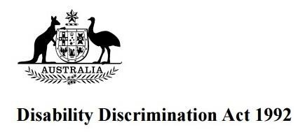

25th Anniversary Easy Read Guide March 2018

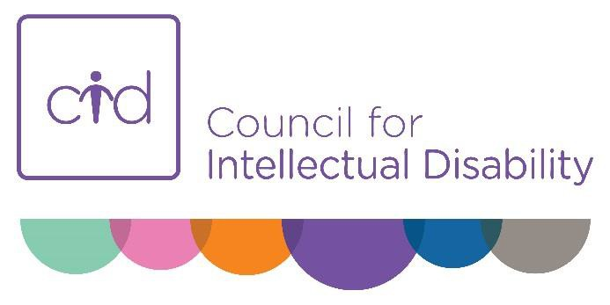

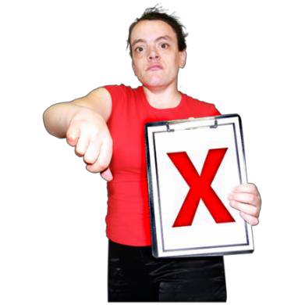Disability discrimination is when you are treated unfairly because you have a disability.

Disability Discrimination Act

The Disability Discrimination Act is a law that says people and the government must treat you fairly.
It is called the DDA for short.

It makes it illegal for you to be treated badly because of your disability.
It tries to make sure you get a fair go.

Making Changes

People and places must make changes to treat you fairly.

Sometimes it might be hard or cost too much for people to make changes for you.
This is called unjustifiable hardship.

They have to prove it is too hard to make changes.

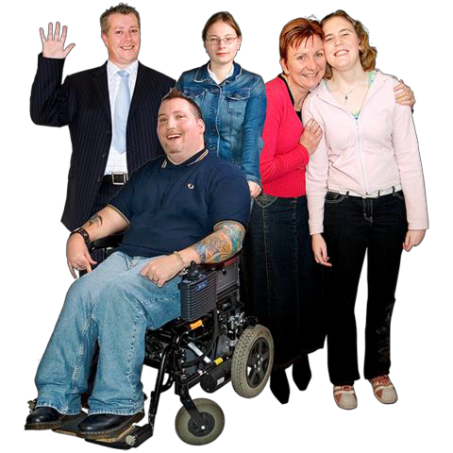

The DDA is for people who have any type of disability.

It protects you if you

- have a disability now
- had a disability in the past for example a time of mental illness
- might get a disability in the future because of a family history

The DDA is also for people who get treated badly because they are your family member or friend.

For example, someone not being allowed to eat in a restaurant because they are with a friend with disability.

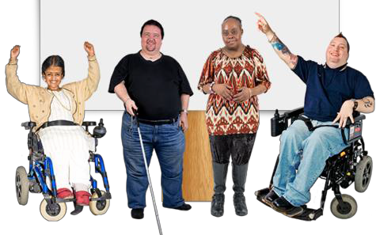

It is against the law to discriminate against you in these areas

- Employment or jobs
- Education
- Buying things and using services
- Playing sport and joining clubs and associations
- Buying or renting a house or other buildings
- Access to public places
- Using Commonwealth Government services

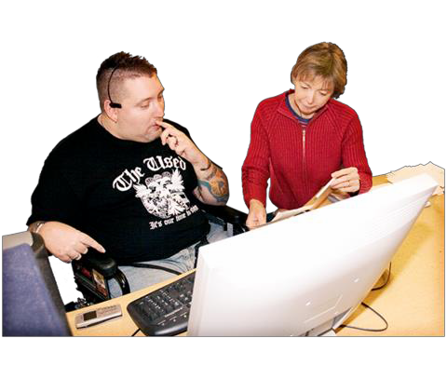

It is against the law to discriminate against you because of your disability at work or when you are looking for a job.

If you can do most of the job then you must have the same chance as anyone else.

Your workplace must make changes so you can do your job well.

They can

- Change the way they run the interview.
- Make the office space easier for you to work in.
- Change the tasks you have to do and give you extra breaks.
- Give you training and support.

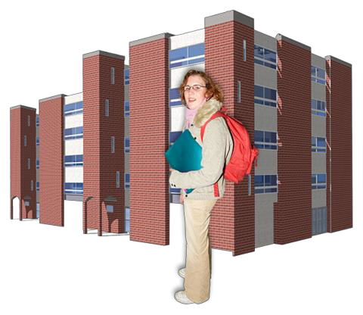

It is against the law for a school, TAFE or university to discriminate against you because you have a disability.
If you meet the rules to get into a school or a course then you must have the same chance as anyone to study there.

Places of education cannot

- Stop you from studying there because of your disability.
- Ask you to pay extra.
- Leave you out from activities.

They must make some changes so you can study well. Examples

- Make the rooms easier for you to get in and learn in.
- Give you equipment to help you learn.
- Give you extra time for exams or assignments.
- Give you information you can read and understand.

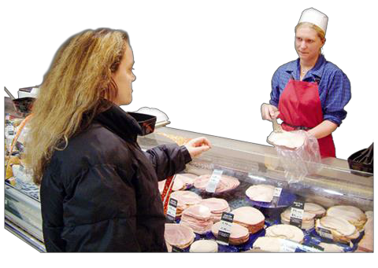

It is against the law for you to be discriminated against because of your disability when buying things or using services.

This includes

- Shops, cafes and restaurants
- The movies and places you go to for fun
- Banks and legal services
- Sports and clubs
- Health services
- Government services including transport

They cannot

- Stop you from buying something because of your disability.
- Ask you to pay extra for things for example pay extra for a wheelchair taxi.
- Serve you last for no good reason.

It is against the law for you to be left out from playing sport or being a member of a club, group or association because you have a disability.

This includes

- Sport and social clubs
- Drama or music groups
- Political parties and business groups
- Support groups

They cannot

- Stop you from applying to be a member.
- Ask you to pay extra.
- Leave you out of some activities.

The DDA says the club or group must meet in a place that is accessible.

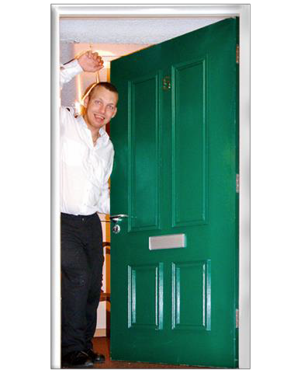

It is against the law for a real estate agent or landlord to discriminate against you because of your disability.

They cannot

- Stop you buying or applying to rent a place.
- Put you to the bottom of the application list if they think you will be a bad tenant because of your disability.

They must

- Offer you a place with fair conditions for example being allowed to have a guide dog.
- Offer you a place at the same price as other people.

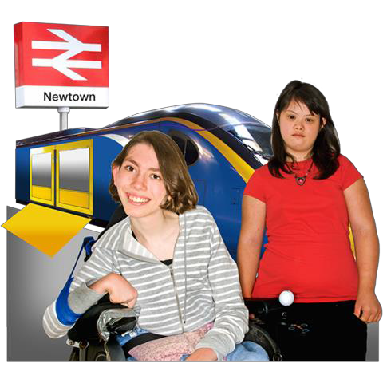

The DDA makes it against the law for public places and public transport to not be accessible.

Every public place should be open for you to enter and use.

For example

- Access at the entrance and inside the building.
- Things you use inside the building should be accessible including toilets and lift buttons you can easily reach.
- All parts of a place should be available to you not just the bad seats.
- Information about the place should be easy to read and understand.

You have the right to complain if a public place is not accessible.

The DDA makes it illegal for the Commonwealth Government to discriminate against you because you have a disability.

You must have access to

- Government offices
- Places where government programs are run like Centrelink
- Information about laws and government programs
- Voting places and information
- Courts

Remember

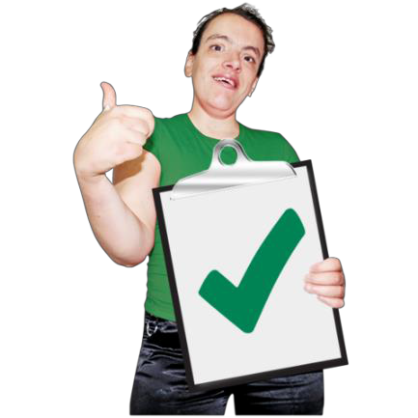The Disability Discrimination Act says people and the government must treat you fairly.

It tries to make sure you get a fair go.

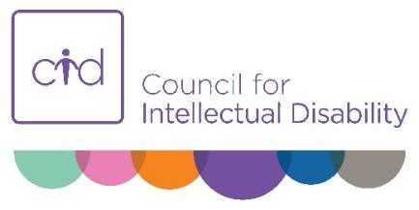Making a complaint

If you are discriminated against or bullied because of your disability you can complain to the Australian Human Rights Commission.

To make a complaint you can write a letter or email complaints@humanrights.gov.au

For information about making a complaint go to the website www.humanrights.gov.au

You can also call them on
02 9284 9600

This guide was made easy to read by Council for Intellectual Disability www.nswcid.org.au

