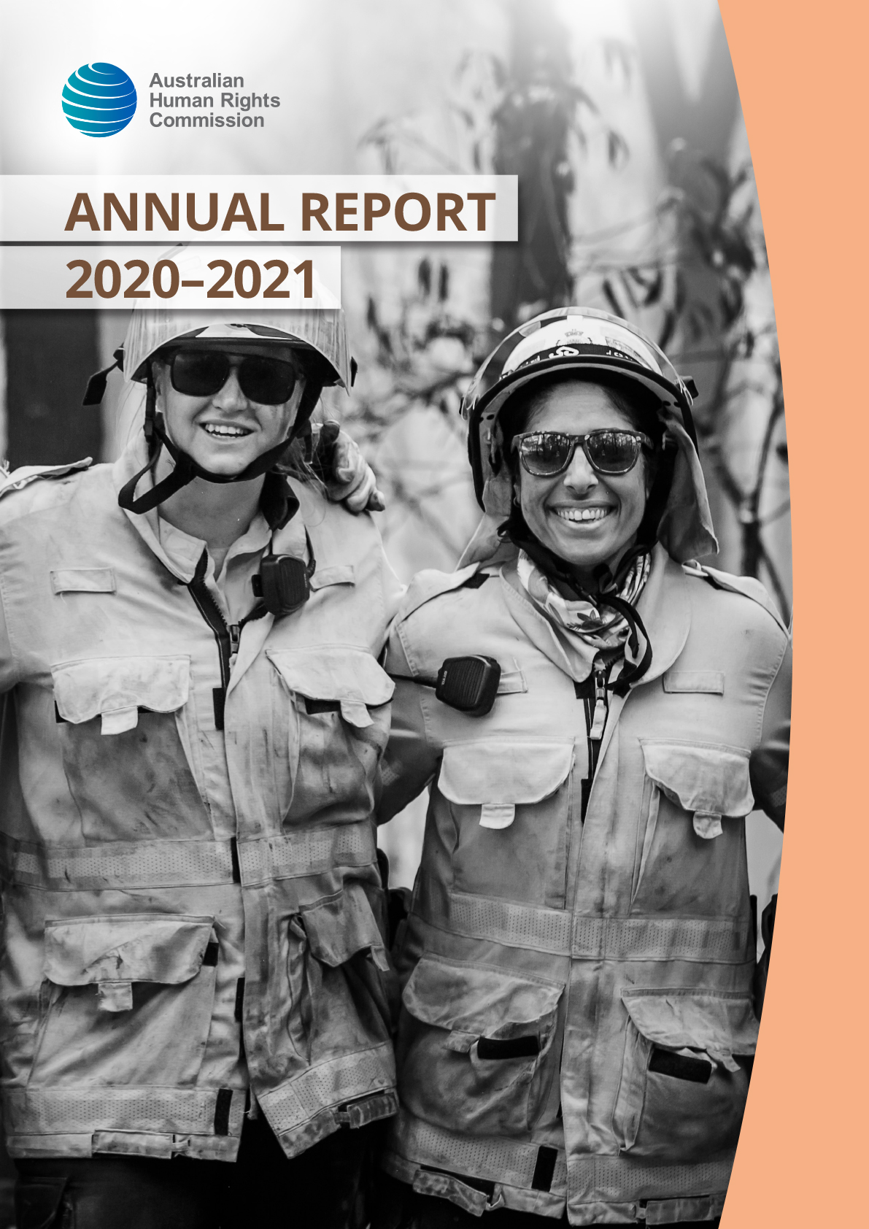
© Australian Human Rights Commission 2021
The Australian Human Rights Commission encourages the dissemination and exchange of information provided in this publication.
All material presented in this publication is licensed under the Creative Commons Attribution 4.0 International Licence, with the exception of:
- photographs and images
- the Commission’s logo, any branding or trademarks
- where otherwise indicated.

To view a copy of this licence, visit http://creativecommons.org/licenses/by/4.0/legalcode.
In essence, you are free to copy, communicate and adapt the publication, as long as you attribute the Australian Human Rights Commission and abide by the other licence terms.
Please give attribution to: © Australian Human Rights Commission 2021.
ISSN 1837-6444
Annual Report 2020–2021.
This publication can be found in electronic format on the Australian Human Rights Commission’s website at: www.humanrights.gov.au/our-work/commission-general/publications/annual-reports-index.
For further information about the Australian Human Rights Commission or copyright in this publication, please contact:
Communications Unit, Australian Human Rights Commission, GPO Box 5218, SYDNEY NSW 2001 Telephone: (02) 9284 9600, email: communications@humanrights.gov.au, website: www.humanrights.gov.au.
To order more publications from the Australian Human Rights Commission, download a Publication Order Form at: www.humanrights.gov.au/about/publications/, call: (02) 9284 9600, fax: (02) 9284 9611 or email: publications@humanrights.gov.au.
Design and layout: Australian Human Rights Commission
Printing: Elect Printing
Cover image: NSW RFS Volunteers at Wattle Creek, December 2019
Cover photo: NSW RFS
Contents
About the Commission 4
Organisational Structure 6
Our legislation and functions 7
The year in review 13
Annual Performance Statement 18
Financial Statements 85
Executive Remuneration 132
Other Requirements 138
Appendices 141
List of Annual Report requirements 155

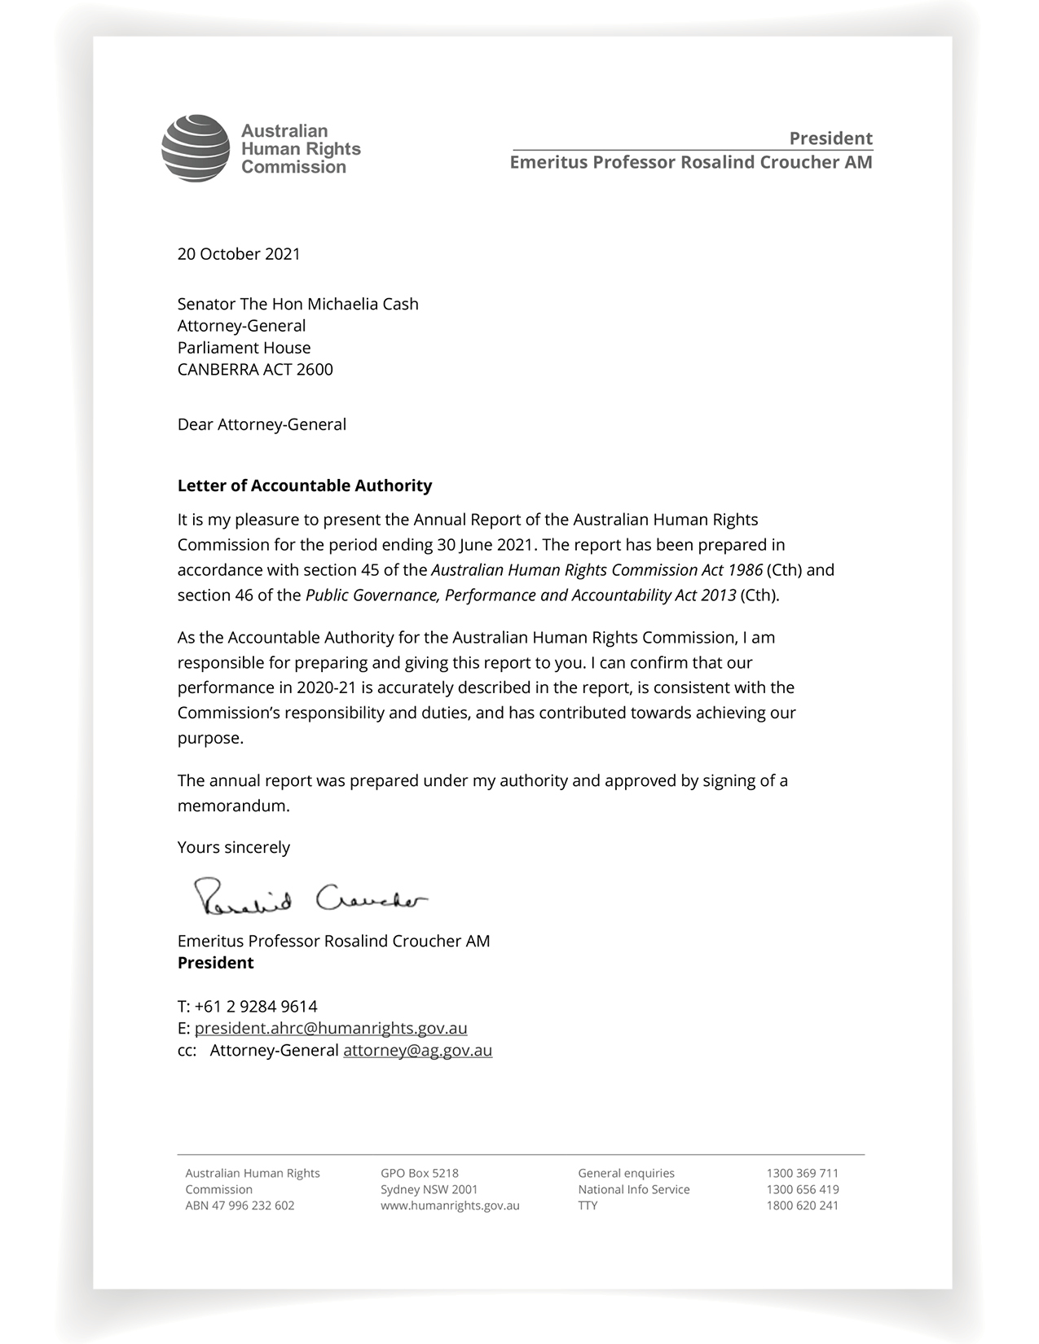

About the Commission

Our purpose
As Australia’s national human rights institution, our purpose is to ensure that Australians have access to effective, independent complaint handling and public inquiry processes on human rights and discrimination matters, and benefit from our human rights education, advocacy, monitoring and compliance activities.
Portfolio Budget Statement
The Australian Human Rights Commission (the Commission) is Australia’s national human rights institution.
We operate under the Australian Human Rights Commission Act 1986 (Cth) as well as federal laws that seek to ensure freedom from discrimination on the basis of age, disability, race, sex, sexual orientation, intersex status, and gender identity. The Commission also has specific responsibilities under the Native Title Act 1993 (Cth) and the Fair Work Act 2009 (Cth).
We operate as a Corporate Commonwealth Entity under the Public Governance, Performance and Accountability Act 2013 (Cth). Our operations are determined independently of the government through our President and Commissioners.
Our job is to work towards an Australia in which human rights are respected, protected, and promoted, finding practical solutions to issues of concern, advocating for systemic change and raising awareness across the community.
We provide direct services to the Australian community, in particular by assisting people to resolve disputes about discrimination and breaches of human rights. Much of our work is also at the policy level – encouraging government, industry, and community groups alike to see fundamental rights and freedoms realised. It involves building the case for change on issues ranging from age discrimination in employment to constitutional recognition of Aboriginal and Torres Strait Islander peoples. It involves providing a human rights analysis to the courts and parliamentary inquiries, conducting research, and contributing to partnerships.
Our work also involves exchanging ideas with equivalent bodies around the world, while closer to home, we monitor and report on the experiences of those particularly vulnerable to disadvantage.
From addressing complaints of discrimination, to engaging with government on policy issues, the Commission’s task is both to apply those rights that are currently recognised in our laws, and to aspire for greater recognition and protection of those that are not
Our vision is for an Australia where human rights are enjoyed by everyone, everywhere, every day.

Achieving our purpose
There is no simple way to solve complex human rights issues. From the challenges that face people with a disability seeking to live independently, to ensuring that Australia’s immigration detention policies meet our human rights obligations and treat people with dignity, the promotion of human rights must address issues for individuals as well as the need for broader, systemic change.
Our Corporate Plan is the roadmap that guides the Commission’s work for the reporting period. The plan contains the Commission’s performance framework, which links the performance criteria outlined in our 2020–2021 Portfolio Budget Statement to the results in this Annual Report. The Commission’s performance measurement framework is detailed in Appendix 1.

Organisational Structure
The Commission is a national independent statutory body established under the Australian Human Rights Commission Act 1986 (Cth).
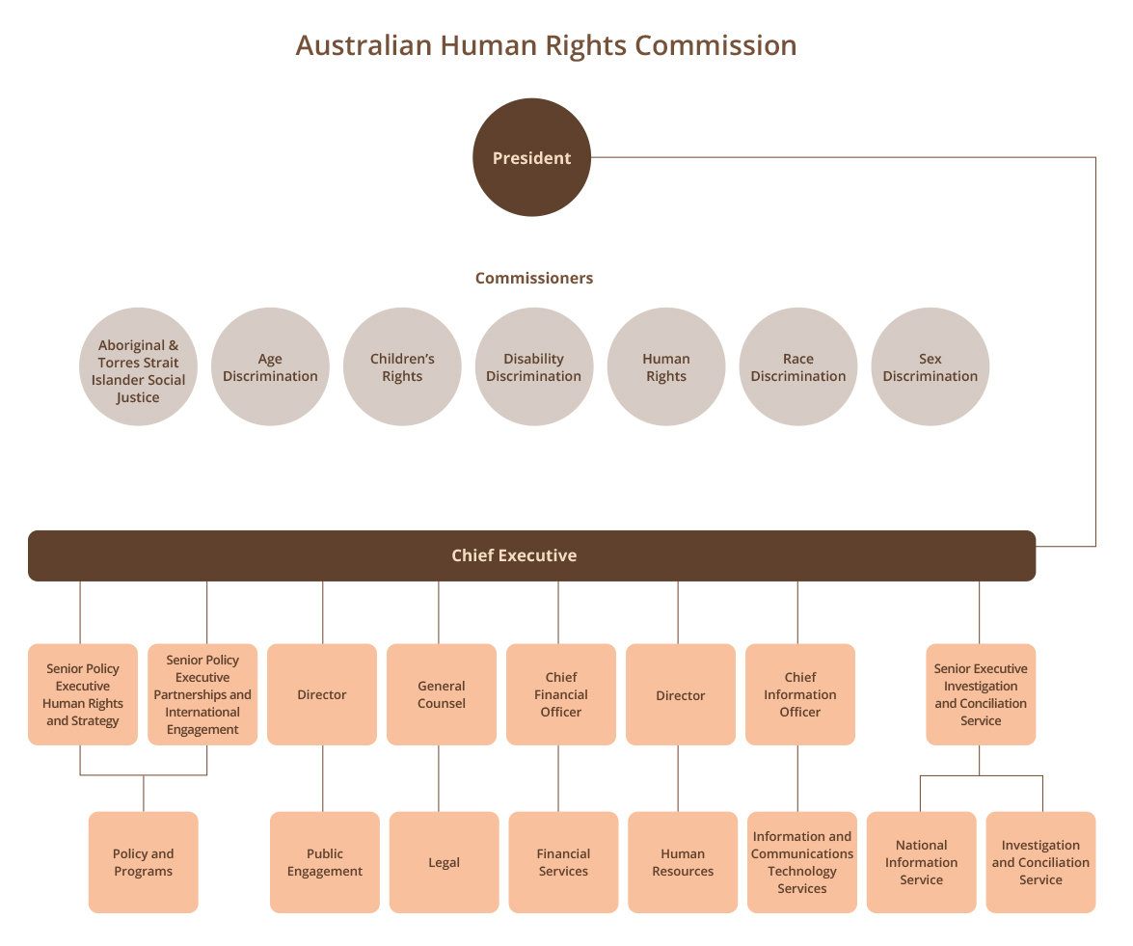

See Appendix 2 for key employee statistics, as of 30 June 2021.

Our legislation and functions

Legislation
The Commission exercises functions under the following Acts:

Australian Human Rights Commission Act 1986 (Cth)
Establishes the Commission and outlines its powers and functions.
It defines human rights by reference to the following international instruments:
- International Covenant on Civil and Political Rights
- Convention on the Rights of the Child
- Declaration of the Rights of the Child
- Convention on the Rights of Persons with Disabilities
- Declaration on the Rights of Disabled Persons
- Declaration on the Rights of Mentally Retarded Persons
- Declaration on the Elimination of All Forms of Intolerance and of Discrimination Based on Religion or Belief
- Convention Concerning Discrimination in Respect of Employment and Occupation.

Racial Discrimination Act 1975 (Cth)
Gives effect to Australia’s obligations under the International Convention on the Elimination of All Forms of Racial Discrimination.
Its main aims are to:
- promote equality before the law for all persons, regardless of their race, colour, descent or national or ethnic origin
- make discrimination on the basis of race, colour, descent or national or ethnic origin unlawful
- provide protection against racial hatred.

Sex Discrimination Act 1984 (Cth)
Gives effect to Australia’s obligations under the Convention on the Elimination of All Forms of Discrimination Against Women and to other relevant international instruments including the International Covenant on Civil and Political Rights.
Its main aims are to:
- promote equality between men and women
- eliminate discrimination on the ground of sex, sexual orientation, gender identity, intersex status, marital or relationship status, pregnancy (or potential pregnancy) and breastfeeding in work, education, and other areas of public life
- eliminate discrimination on the ground of family responsibilities in work
- eliminate sexual harassment in work, education, and other areas of public life.

Disability Discrimination Act 1992 (Cth)
Its main aims are to:
- eliminate discrimination against people with disabilities as far as is possible
- promote community acceptance of the principle that people with disabilities have the same fundamental rights as all members of the community
- ensure as far as practicable that people with disabilities have the same rights to equality before the law as other people in the community.

Age Discrimination Act 2004 (Cth)
Its main aims are to:
- promote equality before the law for all persons regardless of their age
- eliminate discrimination against persons on the ground of age in many areas of public life, such as employment, education and the provision of goods, services, or facilities
- change negative stereotypes about people based on their age (young or old).

The Commission
We exercise our functions under this federal legislation by:
- investigating and conciliating complaints of discrimination or breaches of human rights
- developing an extensive and accessible website containing research, publications, resources and education programs for young people, teachers, community groups, business, media, and the community at large
- working with the media to raise and promote public awareness about important human rights issues
- working with organisations and leaders in the community, government, and business sectors to provide education on relevant human rights issues and to support them in their efforts to better protect and promote human rights
- holding public inquiries and consultations to resolve systemic human rights issues of national importance that we have identified
- working closely with the federal government to provide independent advice regarding the development of laws, programs and policies that will better protect and promote human rights
- publishing reports on Aboriginal and Torres Strait Islander social justice, native title, and children’s rights
- making submissions to parliamentary and other inquiries in order to identify human rights issues which may arise in proposed or existing laws and policies
- working in the legal system by appearing as an intervener or as amicus curiae in cases that involve human rights
- working with other national human rights institutions, particularly through the Asia Pacific Forum of National Human Rights Institutions.
The President, the Aboriginal and Torres Strait Islander Social Justice Commissioner, the National Children’s Commissioner and the Sex Discrimination Commissioner have additional responsibilities.

President and Accountable Authority
The President is the single Accountable Authority of the Commission, responsible for its financial and administrative affairs. The President is also responsible for the complaint-handling function of the Commission. See Appendix 3 for Accountable Authority details provided under subsection 17BE(j) of the Public Governance, Performance and Accountability Rule 2014 (Cth).

Aboriginal and Torres Strait Islander Social Justice Commissioner
Under the Australian Human Rights Commission Act 1986 (Cth), the Aboriginal and Torres Strait Islander Social Justice Commissioner may report to the Minister on the exercise and enjoyment of human rights of Indigenous peoples and undertakes social justice education and promotional activities.
This Commissioner may report under the Native Title Act 1993 (Cth) on the operation of the Act and its effect on the exercise and enjoyment of human rights of Indigenous peoples. In addition, the Commissioner reports, when requested by the Minister, on any other matter relating to the rights of Indigenous peoples under this Act.

Sex Discrimination Commissioner
The Sex Discrimination Commissioner has functions under the Fair Work Act 2009 (Cth) in relation to federal awards and equal pay

National Children’s Commissioner
Under the Australian Human Rights Commission Act 1986 (Cth), the National Children’s Commissioner may report to the Minister on the enjoyment and exercise of human rights by children in Australia.

Responsible Minister
In this period, the Hon Christian Porter MP was the Attorney-General responsible for the Commission to 30 March 2021. Senator the Hon Michaelia Cash, Attorney-General, assumed office and became Minister in Parliament responsible for the Commission on 30 March 2021.
The Attorney-General has a number of powers under the Australian Human Rights Commission Act 1986 (Cth).

Governance
The Commission leadership (consisting of the President, Commissioners and Chief Executive) hold formal Commission meetings with senior management four times a year. These meetings facilitate high-level reporting of progress against the annual work plan and President and Commissioners’ term goals, allow management to provide updates from across the Commission’s work, and provide a space for key decisions by the President and Commissioners. Published materials by the Commission are formally approved, as required, through a process in accordance with the Australian Human Rights Commission Act 1986 (Cth). The Commission obtains appropriate ethics approval for all relevant major activities.
Our risk management framework provides a mechanism for proactively identifying and mitigating risks across the organisation, and for monitoring the operating environment. We are supported by our Audit and Risk Committee as well as our internal auditors who conduct regular audit reviews and other assurance activities for our strategic planning and core business processes.

President and Commissioners over the 2020–2021 period
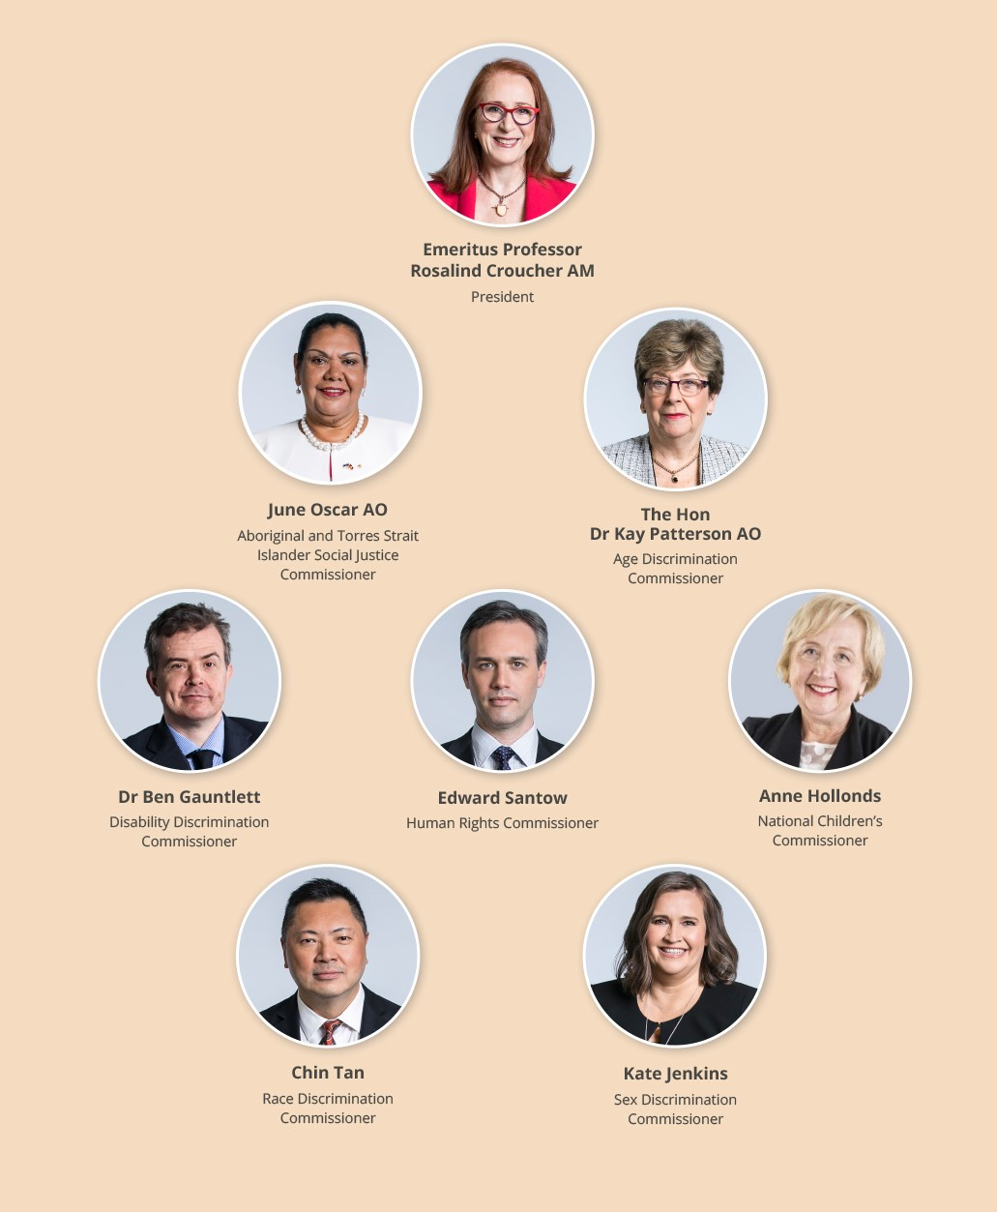

Location
The office of the Australian Human Rights Commission is located in Sydney, with three Commissioners based in Melbourne and one in the Kimberley region of Western Australia. The Australian Human Rights Commission conducts its activities nationally – including by maintaining a National Information Service, and conducting consultations, meetings, and events across Australia.

Achieving a National Reach
Being a small entity, with limited resourcing and a single base to our organisation, creates challenges to ensuring national coverage of our work and engaging with communities in rural, regional, and remote areas.
In addressing this, we have made it a priority for the Commission to build consideration of rural, regional and, where possible, remote activity into our planning processes. These can vary from consultation and engagement events, to conducting training and workshops, commissioned research, and other Commission engagements.
This is our fourth year of monitoring and reporting on this priority.
In this reporting period, the Commission has had engagements in every state and territory. However, the COVID-19 pandemic has limited our ability to conduct engagements ‘in person’, especially due to state and territory border closures and lockdowns.
Our focus on this priority will continue with an emphasis on ensuring that the increased reliance on digital technologies does not impact negatively on the reach and access of vulnerable and marginalised groups in these areas.

The year in review

From the president
The 2020–2021 financial year has been a period of great hardship for many people in Australia and across the world.
The COVID-19 pandemic has continued unabated for the entire reporting period. Millions of Australians have been in lockdown with stay-at-home public health orders for lengthy periods of time. Children have been educated remotely from home, and without access to the great benefits and community that schools offer. Borders between states and territories have shut, often at short notice and for lengthy periods of time. Families have been separated. Many people have struggled economically, with uncertain employment exacerbated by lockdowns and being felt particularly by the most marginalised in our community.
The situation has been overwhelming and has undoubtedly created challenges for the mental health of people across the community. But there have been signs of reassurance too.
Outbreaks of COVID-19 in Australia have been contained to a greater extent than most other places globally, although we are now challenged by the highly contagious Delta variant. Leaders of governments nationally have also engaged in regular, often daily, dialogue with the public to explain their actions to protect the lives and health of all people in Australia – something that is unprecedented in modern times. Aboriginal and Torres Strait Islander communities have been untouched by the virus for the duration of the pandemic – a testament to the success and importance of Indigenous community-controlled health services. And workplaces nationally have quickly adapted to more flexible styles of working from home and accommodating caring responsibilities – forever changing traditional cultural attitudes to work.
As with last year, I have been humbled and inspired by the extraordinary efforts of our frontline workers. Everyone is playing their part – most of the community have demonstrated their willingness to do their bit to prevent the spread of COVID-19, by social distancing and accepting very difficult restrictions on individual liberties and freedoms in the name of a greater good. So many Australians are now being vaccinated to reach the herd immunity that will make it so much easier to live with COVID-19.
It has been the most extraordinary display of commitment. It has highlighted vividly that we are more than a collection of individuals. That we see ourselves as part of a community, with responsibilities to each other, and where the rights of each other matter.
The Australian Human Rights Commission often sees the most difficult aspects of the pandemic, through our role in handling discrimination and human rights complaints. We received a 35% increase in complaints when compared to the previous reporting period and this trend is continuing with current projections estimating over 4,500 complaints in the next reporting cycle. In the initial phase of the pandemic, these complaints were primarily related to race discrimination. Since then, they have largely related to disability discrimination, and human rights complaints relating to masks and border closures (both domestically and internationally).
I am very proud of the fact that our Investigation and Conciliation Service continues to receive exceptionally high satisfaction ratings from those participating in the process. It is notable that the highest satisfaction ratings come from respondents to complaints – that the Commission is seen as professional, supportive, and impartial in how it acquits its role in addressing complex complaints, often in stressful circumstances, is a testament to the quality of our staff.
We are, however, facing significant capacity constraints in dealing with the dramatic increase in complaint numbers over the past year.
Our Commissioners have also focused much of their effort on contributing to pandemic-related challenges – such as those affecting people with a disability, children, women, people from non-English speaking backgrounds, Aboriginal and Torres Strait Islander peoples, people in vulnerable situations such as immigration detention, as well as in considering the reasonableness and appropriateness of limitations on people’s rights that have been introduced to respond to the pandemic.
One thing is clear from this.
People care about their human rights and fundamental freedoms. And they are troubled when rights are restricted.
As President, I have spent the year engaging with the community on the Free and Equal project: looking to the adequacy of human rights protections in law, policy and programs at the federal level. The outcomes of this will be released in the coming year when the Commission publishes a series of position papers and reports.
In brief, what these discussions have revealed is that our legal framework for protecting rights is extremely limited. Our anti-discrimination laws are out of date and less effective than they should be. This is accompanied by limited protection of human rights and fundamental freedoms more generally.
The pandemic response shows us that the community is willing and able to have discussions about the balancing of human rights, whether restrictions imposed are justifiable or not, and what would be the most proportionate approach to addressing an issue.
As we move out of crisis mode with the pandemic, it is timely for us to build on this dialogue and extend it to other areas of human rights concern in Australia.
As a nation, we should be having the same discussions about the myriad of issues that exist in our community.
Why do we not make better use of alternatives to the jailing of children as young as 10 years of age (especially when we know that we are talking about a small group of children, and the vast majority of crimes committed are minor)?
Why do we insist on detaining people found to be refugees in closed detention settings for lengthy periods of time, rather than placing them in community settings, especially when we know that the vast majority pose limited security threats to the community and that they suffer severe mental health impacts as a result of detention?
We know that when governments have failed to act to protect Australians, we often look to Royal Commissions to identify how people should be treated into the future. Royal Commissions into the treatment of people in aged care, institutional abuse of children, children in detention and care and protection in the NT have all had better protection of human rights at the centre of their concerns and proposals for reform.
It is time that we put into practice better laws and policies to protect people’s human rights rather than conducting Royal Commissions to examine human rights breaches after the fact.
It is my hope that one of the abiding legacies of the COVID-19 pandemic will be to open up the conversation about how best we can protect human rights and, by doing so, to best respect the rights of Australians wherever they are, and every day.
The past year has also been a landmark year in addressing sexual harassment. The Commission’s report of the National Inquiry into Sexual Harassment in Australian Workplaces, Respect@Work, was tabled in March 2020. Subsequent developments in the community, and most notably in the federal Parliament, have put much focus on the report and its recommendations. Amendments to the Sex Discrimination Act 1984 (Cth) currently sit before the federal Parliament to implement some of the recommendations of the report. These amendments are a positive start, and the Commission looks forward to engaging with government and Parliament about the need to move further to fully implement the report’s recommendations.
The Commission is currently conducting a review of the Australian Parliament as a Workplace, led by Sex Discrimination Commissioner Kate Jenkins, to report in late 2021. It speaks to the credibility of the Commission among the broader Australian community that we were tasked with undertaking this review – where our credibility, expertise and independence were all critical factors for the government.
The past year has also seen the culmination of two major projects conducted over several years – first, by our Human Rights Commissioner, Ed Santow, on human rights and technology; and second, by our Aboriginal and Torres Strait Islander Social Justice Commissioner, June Oscar AO, the Wiyi Yani U Thangani report on the voices of Indigenous women and girls.
Both reports set out bold visions for reform to law, policy and practice, to equip the Australian community to maximise the benefit of new technologies and artificial intelligence, while keeping the rights of the citizen at the heart of new developments, and to better protect the rights of Aboriginal and Torres Strait Islander women and girls, particularly by drawing on their strengths and addressing the structural barriers that they face in our community. Mr Santow concluded his five-year term as Human Rights Commissioner in July 2021, and I thank him for his contributions over this period. The human rights and technology report will be a lasting legacy for his advocacy over many years.
The new National Children’s Commissioner, Anne Hollonds, commenced in this reporting year and has been focused on protecting the most vulnerable children in our community who are at risk of abuse, neglect, and separation from their families. National consultations with at-risk families and children have been held to inform the next iteration of the national child protection framework. The Commissioner has called for more joined-up, holistic support across the multiple national frameworks that exist to protect children – to ensure the most vulnerable do not fall between the gaps (or silos) of different systems.
The Race Discrimination Commissioner, Chin Tan, has also been focused on policy coherence in relation to racism and social cohesion. A concept paper was released in March 2021 setting out the need for a national anti-racism framework – elevating treating racism to the same level as how we treat the scourge of family violence, for example. The Commission is encouraged by the engagement of the federal and state and territory governments with the proposal. National consultations are currently underway and will result in a detailed model for future action by government.
The Disability Discrimination Commissioner, Dr Ben Gauntlett, launched the IncludeAbility project this year, designed to equip employers with the knowledge and tools to increase meaningful employment opportunities for people with disability. The project also provides important information for people with disability seeking employment about their rights, tips on applying for roles, preparing for an interview, and what they can expect from prospective employers.
The Age Discrimination Commissioner, the Hon Dr Kay Patterson AO, has focused considerable attention on the importance of addressing elder abuse in the community, through community awareness activities including a highly successful video, ‘Know the Signs’ and in working with governments to implement the Australian Law Reform Commission’s report on elder abuse.
As we move forward, the Commission is facing certain financial issues. The Commission has been operating beyond its annual funding sources. This is in part a result of cost pressures faced by the Commission including the costs associated with supporting Commissioners and an increase in complaints over the past five years. In addition, the work of the Commission has increased substantially because of the COVID-19 pandemic, with the Commission recording a 35% increase in complaints this year and this trend is continuing with current projections estimating over 4,500 complaints in the next reporting cycle. The Commission is working with the Government to address these issues in a way that ensures that the Commission can meet our statutory obligations in promoting and protecting human rights in Australia.
We look forward to Australia emerging from the pandemic with our communities stronger, and with people more connected to each other; with there being a greater appreciation of the importance of respecting each other’s rights and our individual and collective role in achieving this; and with the knowledge that no challenge is too great for our nation to face – knowing that bold, determined action can be taken on any number of human rights challenges, if there is a will to do so.
Emeritus Professor Rosalind Croucher AM
President

Annual Performance Statement

Introductory Statement
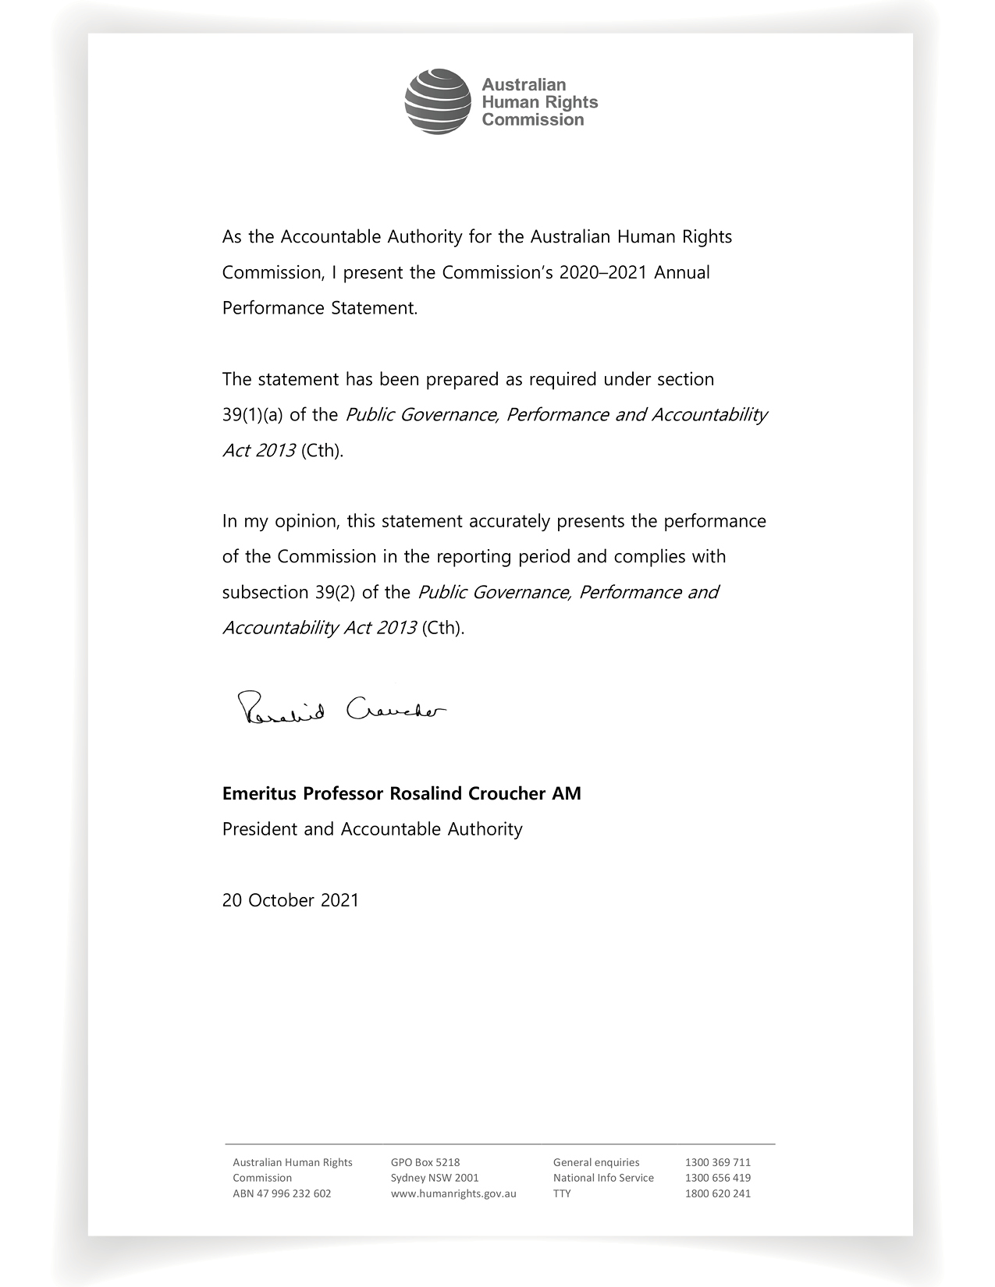

Results

Introduction
The Commission undertakes a wide range of activities in pursuit of our statutory functions. We focus our work on issues that constitute ‘protected attributes’ under federal discrimination law or for which there is a mandated special purpose Commissioner. This includes race, age, disability, sex discrimination, Aboriginal and Torres Strait Islander social justice, children, sexual orientation, gender identity and intersex status, and issues within the role of the Human Rights Commissioner, including asylum seekers and immigration, national security, and technology issues.
We must inquire into and attempt to conciliate complaints of unlawful discrimination and breaches of human rights, and process applications for exemptions under the age, disability, and sex discrimination acts.
We may also produce reports to the federal Parliament in relation to the enjoyment and exercise of human rights by children in Australia, by Aboriginal and Torres Strait Islander persons, and to the Minister in relation to complaints of breaches of human rights. We have a range of functions to raise awareness, conduct research and develop educational resources about human rights, and consider the compatibility of legislation with human rights.
The Australian Human Rights Commission Act 1986 (Cth) requires us to exercise our functions in a manner that achieves the ‘greatest possible benefit to the people of Australia’ and ‘with regard for the indivisibility and universality of human rights’. Accordingly, we also conduct human rights education, intervene in human rights matters before the courts, and promote the role of business in addressing human rights.
Our work priorities are set through an annual planning process framed by the four goals in our 2020–2021 Corporate Plan. In addition, the Commission ensures its work helps achieve the outcome articulated in its Portfolio Budget Statement (PBS), being:
‘An Australian society in which human rights are respected, protected and promoted through independent investigation and resolution of complaints, education and research to promote and eliminate discrimination, and monitoring and reporting on human rights.’

The sole program of which, Program 1.1, is:
‘Australians have access to independent human rights complaint handling and public inquiries processes and benefit from human rights education, promotion and monitoring, and compliance activities.’

Performance Measurement
The performance statement in this report identifies how the Commission has met its purpose. These results are reported in relation to our performance measurement framework, published in the 2020–2021 Corporate Plan. In this framework, our purpose and functions are reflected in the organisational goals and outcomes. The outcomes are pitched to a level where we can reasonably expect to contribute to them:
- within the four-year outlook of each corporate plan
- through the collective contributions of our President and Commissioners across their individual terms
- through our ongoing programs and services, and
- in an operating context that remains stable.
Progress indicators are mapped to each of the outcomes. They are designed to provide reasonable evidence of contribution to the outcome, and include output, process, and outcome measures. They are, in turn, supported by a range of data from monitoring and evaluation strategies implemented across the Commission’s programs and services.
Six of the outcomes correspond to the performance criteria in the Commission’s PBS, and eleven of the indicators correspond to the performance targets in our PBS. This relationship is indicated in the full framework table, located in Appendix 1, and throughout the following statement. In this way, a clear line of sight is maintained between our PBS, work plan, and results.
In reporting against all the progress indicators, we have focused on case studies and exemplar activities to demonstrate our performance.

Audit Committee
Under the Public Governance, Performance and Accountability Rule 2014 (Cth) (PGPA rule) requirement (subsection 17(2)(b)), our Audit and Risk Committee has assessed this performance statement, reviewing the completeness and appropriateness of the performance information, systems and framework, and the completeness and appropriateness of our performance reporting.
Under the PGPA Rule requirement (subsection 17BE(taa)), the following information is provided:
(a) Electronic address of the audit committee charter: http://humanrights.gov.au/sites/default/files/ahrc_audit_and_risk_committee_charter.pdf
(b) Audit and Risk Committee members in 2020–2021:
- Rachel Holt (Former Chair)
- Donna Hargreaves
- Rocelle Ago
- Linda Waugh (Current Chair)
- Navaka Arachchige.
(c) Qualifications, knowledge, and experience of committee members:
Rachel Holt was the Chair of the Audit and Risk Committee. She holds a Bachelor of English and Art History and a Master of English, a Graduate Diploma of Legal Practice and was admitted to the Supreme Court of New South Wales (NSW) in 2010. Ms Holt is also a nationally accredited mediator. Ms Holt has worked as a solicitor (in community legal centres), an Investigator Conciliator and Principal Investigator and is currently Senior Executive of the Commission’s Investigation and Conciliation Service (ICS). Ms Holt manages the budget, staffing and overall strategic direction of the ICS and exercises statutory delegation on behalf of the President.
Donna Hargreaves was an independent external member of the Audit and Risk Committee. She holds a Bachelor of Business (Accounting) and is a Certified Practising Accountant. Ms Hargreaves has held a number of senior roles within the government sector including most recently Director, Financial Governance and Compliance (NDIS), various roles within the Department of Finance, and Acting Accountant General (Solomon Islands Ministry of Finance and Treasury). In her roles, Ms Hargreaves has provided high level advice and briefing to federal Ministers on policy and budgetary matters, managed and prepared monthly financial statements, and developed and implemented financial assurance and compliance frameworks.
Rocelle Ago is an independent external member of the Audit and Risk Committee. She holds a Bachelor of International Studies, Bachelor of Laws (Hons Class I), Graduate Diploma in Legal Practice and a Master of Laws and was admitted to the Supreme Court of NSW and High Court of Australia in 2006. Ms Ago is currently Principal Director, Freedom of Information at the Office of the Australian Information Commissioner (OAIC). In her role, Ms Ago manages the Australian Information Commissioner’s regulatory functions under the Freedom of Information Act 1982 (Cth). Ms Ago has worked in legal regulatory and policy roles across various agencies including the OAIC, Department of Health, Attorney-General’s Department, and the Administrative Appeals Tribunal.
Navaka Arachchige is an independent external member of the Audit and Risk Committee. He is the Chief Financial Officer of the Administrative Appeals Tribunal and has over 15 years of public sector experience in finance and corporate services including governance, audit, risk, and procurement. Mr Arachchige holds membership of the Association of Certified Chartered Accountants (ACCA) UK and the Chartered Institute of Management Accountants (CIMA) UK. He also holds a Master of Commerce degree specialising in Management Information Systems from the University of NSW.
Linda Waugh is the Chair of the Audit and Risk Committee. She is the Merit Protection Commissioner (Australian Public Service and Parliamentary Services). Ms Waugh has over 20 years’ experience working in public sector integrity and oversight bodies in both the Commonwealth and state governments. She has a breadth of experience across complaints and investigations, risk and governance, policy reform and education, systems reviews, and auditing and legislative reviews. Ms Waugh holds a Bachelor of Arts, a Post Graduate Diploma of Psychology, and a Master of Business Administration.
(d) The Audit and Risk Committee held 5 meetings in 2020–2021 on these dates:
- 18 August 2020
- 8 September 2020
- 8 December 2020
- 9 March 2021
- 25 May 2021
Under the PGPA Rule requirement that all the members of the audit committee must be persons who are not employees of the entity (s.17(4AA)), Rachel Holt resigned as the Chair of the Audit and Risk Committee on the 9 March 2021. She attended meetings on 18 August 2020, 8 September 2020, 8 December 2020, and 9 March 2021.
Donna Hargreaves resigned from the Audit and Risk Committee on 8 December 2020. She attended meetings on 18 August 2020, 8 September 2020, and 8 December 2020.
Rocelle Ago attended all Audit and Risk Committee meetings in 2020–2021.
Linda Waugh was appointed as the Chair of the Audit and Risk Committee on 9 March 2021. She attended the 9 March 2021 and 25 May 2021 meetings.
Navaka Arachchige was appointed to the Audit and Risk Committee on 26 April 2021. He attended the 25 May 2021 meeting.
Except for the meeting on 25 May 2021, all other meetings were conducted remotely due to COVID-19.
(e) Member remuneration:
No Audit and Risk Committee member was remunerated for their service on the committee during this period.

Commission activity
The following provides a snapshot of the Commission’s monitored activity for 2020–2021.
Public presence | 19 Major events
 | 70 Web news
 | 2,626 Media enquiries
 | 210 Interviews
 | 19 Opinion pieces
Key speaking engagements | 233 Combined Commission Executive orations, keynotes, and other major speeches
Digital engagement | 53 YouTube videos
 | 5,648 YouTube subscribers
 | 6,554,059 Website visits
 | 10,800,522 Website pageviews
 | 108,000 Facebook followers (Commission only)
 | 99,205 Twitter followers (Combined Commission/Commissioner)
National Information Service | Assisted 15,746 enquiries from people and organisations seeking information about discrimination and human rights
Investigation and Conciliation Service | Accepted 3,113 complaints about discrimination and breaches of human rights
 | Conducted 1,517 Conciliation processes, with 70% of these complaints successfully resolved
Reports, research, educational resources, and publications | 24 Reports, reviews, issues and discussion papers, guidelines, corporate publications, information, and training resources
Human rights education and training | 9 Combined virtual (real time or blended/moderated) and face-to-face training workshops with 206 participants
 | 38 Combined virtual or face-to-face information webinars reaching
Legal expertise and investigation | 25 Submissions to public inquiries, with 9 invited appearances at hearings
 | 2 Interventions in Court proceedings (judgment delivered)
 | 6 Australian Human Rights Commission Act reports
Appendix 4 lists the Commission’s key activities, programs and services in 2020–2021.
Appendix 5 lists the Commission’s reports, resources and other publications completed in 2020–2021.

Goal 1: Greater prioritisation and embedding of human rights issues at the national level

Outcome 1.1
The national human rights reform agenda proposed in the national conversation initiative is considered by the Parliament, government and the non-government sector.

Progress indicators 1.11 and 1.12
Implementation of the national conversation initiative is viewed by stakeholders as impartial, inclusive, participatory and consensus led; Parliament, government and non-government stakeholders access and engage with the relevant stages of the national conversation initiative.

Free and Equal: an Australian Conversation on Human Rights
The Commission’s Free and Equal: An Australian Conversation on Human Rights (Free and Equal) project seeks to identify what an effective system of human rights protection for 21st century Australia would look like, and what steps Australia needs to take to get there. The project will outline the actions necessary for governments to meet their obligations to respect, protect, and fulfil human rights.
Free and Equal is a multi-limbed project that has progressed through several stages. It began with the release of a 2019 Issues Paper describing the human rights landscape and asking general questions about priorities for reform, followed by three technical discussion papers on discrimination law, increasing the positive framing of human rights in Australian legislation, and accountability mechanisms. These papers sparked an inclusive national conversation on human rights reform, held via submissions and a broad series of consultations and events led by the President.
The project will culminate in the next reporting period, with the release of a series of position papers setting out the Commission’s proposed reform agenda. Each of the position papers is designed to complement the others, and to address necessary human rights reforms across different areas of law, policy, and practice. Together, they will communicate the Commission’s actionable vision for a comprehensive, harmonised, and robust human rights framework that embeds Australia’s international obligations, fosters preventative approaches, and enhances accountability.
The project has continued to attract strong engagement from organisations, individuals, and public bodies at every stage. For example, the initial discussion papers prompted over 160 submissions, and in this reporting period alone 42 consultations were held with 190 participants from legal, business, NGO and public sectors, academia, and parliamentarians. This adds to a total of more than 1,000 stakeholders engaging across the life of the project, inclusive of submissions, consultations, roundtables, technical workshops, and a national conference attended by the UN High Commissioner for Human Rights, Her Excellency Dr Michelle Bachelet.
The level of public and stakeholder engagement with Free and Equal will ensure that the recommendations developed are pragmatic, evidence-based and grounded in a level of consensus built across the relevant sectors. The Commission anticipates strong community and stakeholder support for the final recommendations as a result of this process – a critical process outcome for the initiative.
The Commission is currently finalising the Discrimination Law Reform Position Paper, which will be released in the coming months. It builds on the Commission’s other work, including the report, Respect@Work: National Inquiry into Sexual Harassment in Australian Workplaces. The Position Paper outlines the need to shift the focus of the federal discrimination law system to a more preventative approach. The recommendations are also designed to strengthen and simplify the current system, and to provide greater certainty to its users, inclusive of business, government, and individuals.
Parallel to the discrimination work, in this reporting period the Commission has focused on developing a model for a federal Human Rights Act and other mechanisms for positively embedding human rights in policy development, which will be the subject of the second Free and Equal Position Paper. Based on submissions and the wealth of experience generated through many years of research and advocacy on this issue, the Commission developed options for reform and identified areas of complexity in early 2021.
Over May and June 2021, the Commission embarked on a period of targeted engagement on early proposals, seeking technical and detailed feedback from key stakeholders. Stakeholders are concerned about the weak and piecemeal human rights protections afforded to Australians. They have welcomed the Commission’s efforts to develop a model for a Human Rights Act as a necessary means of ensuring comprehensive rights coverage. These sentiments are reflected in the below feedback:
‘The timing of the AHRC’s Inquiry is particularly important having regard to several current matters of national debate and significance, including questions of freedom of expression, freedom of religion and press freedoms. Rather than a piecemeal debate which often raises individual freedoms in isolation, [we] welcome the AHRC’s comprehensive approach to reviewing Australia’s legal and policy framework for respecting, protecting, and fulfilling human rights generally. [We] consider that the Inquiry is essential to understanding the role of the rule of law and human rights in underpinning a healthy Australian democracy’.
–Submission No. 166

‘I commend the Commission; this is a good initiative – dealing with spot fires related to human rights is damaging to the whole area – a focus on developing a Human Rights Act, particularly one that reflects United Nations Declaration on the Rights of Indigenous Peoples, is welcome.’
–Consultation with Indigenous legal stakeholders, June 2021
Drawing on the recommendations formulated through the Free and Equal project, the Commission will continue to work with Parliament, government, and the community to embed more effective human rights frameworks into our national processes.

Progress indicator 1.13
Commission recommendations to the United Nations Human Rights Council as part of Australia’s 3rd Universal Periodic review are reflected in the Council recommendations to Australia.

Third Universal Periodic Review
Australia appeared before the Human Rights Council as part of the third cycle of the Universal Periodic Review (UPR) in January 2021. This appearance was initially scheduled for November 2020; however, it was postponed due to the COVID-19 pandemic.
The Commission, as Australia’s A-status National Human Rights Institution (NHRI), plays a distinct role in the UPR process by providing an independent assessment of Australia’s human rights situation and the steps taken by the Australian Government since the last appearance. As reported in the previous reporting period, the Commission made its submission to the United Nations in July 2019. The submission describes the status of human rights in Australia and makes 48 recommendations about ongoing challenges.
Following Australia’s appearance, the Commission assessed the impact of its recommendations in the process through the extent to which it was reflected in the UPR report, finding that:
40 out of 48 recommendations were wholly or partially reflected in the country recommendations in the UPR report, or 83% of the total Commission recommendations.
Some of the more strongly reflected recommendations include those focused on the immigration system and treatment of asylum seekers, with related recommendations made by 44 countries; and the recommendation that the minimum age of criminal responsibility be raised to at least 14 years, with the same recommendation made by 31 countries.
This suggests that the Commission’s advocacy throughout the UPR process was effective, and that the Commission’s concerns about Australia’s human rights compliance align closely with the concerns of the international community.
Throughout this process, the Commission engaged with stakeholders across Parliament, government, and the non-government sector. This includes providing input and feedback to the Australian Government on its report to the UPR, engaging in discussions about potential ‘voluntary commitments’ that could be made through this process, and coordinating with NGOs to maximise our collective impact through advocacy – including by holding briefings in late 2020 on overarching UPR issues and subject-specific human rights concerns.
The Commission will continue to work towards securing tangible outcomes through engagement with government and public advocacy on the UPR recommendations.

Outcome 1.2
The leadership and advocacy of Commissioners on thematic areas or identified human rights issues, improves the enjoyment of human rights by affected groups.

Progress indicator 1.21
Research, reporting and advice activities of the Commission:
- are viewed as evidenced, persuasive and credible by stakeholders
- increase understanding of the human rights issues and impacts raised
- strengthen stakeholder capacity to promote and advocate for the human rights issues raised.

Human Rights and Technology
Commissioner Santow has led the Human Rights and Technology project over three years, guiding the public conversation on how to protect human rights in an era of unprecedented technological development.
The Human Rights and Technology Final Report 2021 (Final Report) was tabled by the Attorney-General in Parliament in May 2021. It is the culmination of two national rounds of public consultation with government, industry, civil society and academia, as well as leading experts from around the world. It is the most extensive public consultation ever undertaken on human rights and artificial intelligence (AI).
The Final Report’s 38 recommendations provide a roadmap for reform to promote responsible innovation and enhance accountability and human rights protections in the use of AI and Digital Communications Technologies.
The Final Report was launched with a series of 14 information webinars. Each webinar targeted a sector or profession, including civil society, legal and compliance, business, and government, and focused on a key topic such as AI in decision making, or accessible technology. The Commission reached well over 1,000 stakeholders via the webinars, and recordings of the webinars are available online for ongoing stakeholder engagement.
A key strength of the project is the long-term targeted stakeholder involvement in the inclusive consultation process. Technical experts, private sector leaders, advocates, people with lived experience, of disability and decision makers have been engaged at every step of the consultation and involved with the formation of the final recommendations. Overall, the consultation stages have drawn together stakeholders representing a broad range of interests, to consider significant and pressing areas of Australian public policy. The result is a set of Final Report recommendations that are consensus-driven, expertly informed, and achievable.
Commissioner Santow has engaged with an estimated 25,000 people at international and Australian events, conferences, and expert meetings relevant to the project, and is recognised as an expert leader on human rights and new technologies.
The Commission is also leading the discussion for businesses on human rights compliant development and use of AI. The Commissioner and team published a Technical Paper in November 2020 – Using Artificial Intelligence to Make Decisions: Addressing the Problem of Algorithmic Bias.
The Technical Paper investigates how unfairness and even unlawful discrimination can arise through ‘algorithmic bias’ in realistic commercial scenarios, and it provides guidance regarding how these problems might be addressed. The Technical Paper, the first of its kind in Australia, offers unique practical assistance to business on human rights compliant use of AI. It highlights the importance of a multidisciplinary, multistakeholder cooperation to produce practical guidance for businesses wishing to innovate responsibly.
The project has been evaluated at significant milestones and the findings reported in previous reporting periods. Figure 1 summarises the high level of engagement in this project and stakeholder views. A final evaluation will be undertaken and reported in the next period.
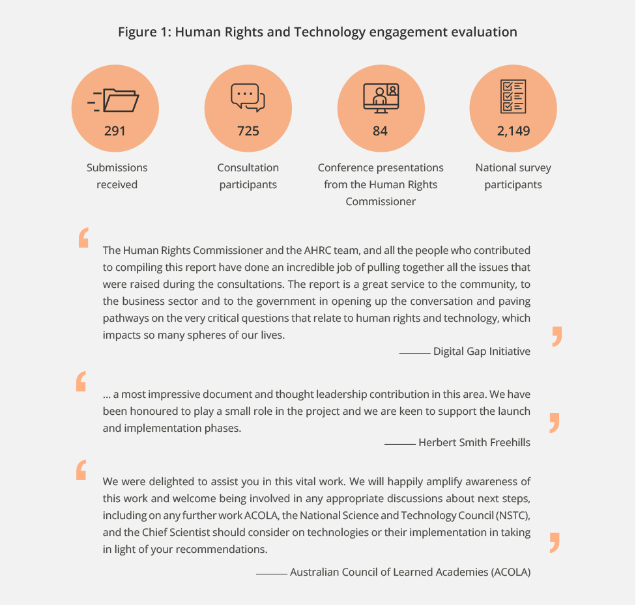

Immigration Detention, Refugee and Asylum Seeker program
Commissioner Santow leads the Commission’s work on human rights issues affecting asylum seekers, refugees, and people in immigration detention. This involves monitoring of immigration detention facilities, conducting research and consultation projects on specific issues of concern, and engagement with Parliament regarding changes to Australia’s migration laws.

Covid-19 and risks in immigration detention
In mid-2020, the Commission commenced a targeted review of measures taken by the Government in response to the risks posed by COVID-19 for people in immigration detention facilities. This involved analysis of information and documents provided by the Department of Home Affairs (Home Affairs) as well as other relevant information. The Commission assessed this material against human rights standards, expert health advice, and relevant guidelines.
In June 2021, the Commission published the report, Management of COVID-19 Risks in Immigration Detention, which outlines the findings of this targeted review, and includes 20 recommendations for change. The Commission recommended that the Government take practical steps to improve the Australian response to this particular COVID-19 risk, and to end measures that unnecessarily restrict human rights especially of people who are detained. Home Affairs agreed in full or in part with eight recommendations. This proportion of recommendation uptake by Home Affairs is a positive development, and the Commission will work with Government towards implementation of these recommendations.
The report received positive feedback from civil society organisations, many of whom have used it to inform and strengthen their policy and advocacy work. The report was also well received by other detention monitoring bodies, which considered the report an important resource to inform and complement their own work.
Just out of this reporting period, the program hosted a webinar in July 2021 with a focus on how the ongoing and serious risks posed by COVID-19 should be managed in Australia’s immigration detention facilities. A total of 80 stakeholders from across civil society, academia, government, and the health sector attended the webinar and discussion of the report.

Monitoring immigration detention
Also, in this period, the Commission published its report following physical inspections of all immigration detention facilities on the Australian mainland conducted in 2019. This report provides a comprehensive assessment of the human rights issues specific to individual facilities, as well as systemic issues across Australia’s immigration detention network.
Commissioner Santow has maintained regular contact with the Australian Government in relation to the Commission’s ongoing monitoring of immigration detention, with high-level monthly meetings with senior officials from the Australian Border Force and Home Affairs.

National Anti-Racism Framework
In response to growing calls from organisations, businesses, and communities across Australia for action to address key gaps in national data and responses to racism, Commissioner Tan called for a National Anti-Racism Framework in March 2021. Communities’ experiences during the COVID-19 pandemic identified clear gaps in current national strategies and initiatives to address racism. The aim of the Commissioner’s initiative is to establish a National Anti-Racism Framework that defines a coordinated approach to tackling racism and fostering social cohesion, and that guides actions on anti-racism and racial equality in Australia.
In this reporting period, a Concept Paper was released setting out a vision for the National Anti-Racism Framework as a long-term central reference point to guide the actions of government, non-government organisations, business, educators, health professionals, police and other justice authorities, civil society and the community. The Concept Paper identifies a national data collection system, which can operate to identify the extent and nature of racism in Australia and provide a more detailed and nuanced picture of the diverse make-up of the Australian population as a key priority.
To consult meaningfully on the Concept Paper, a partnership model is being developed. The model shares leadership of the consultation process with First Nations and multicultural peak organisations, human rights organisations, and governments. In using this approach, partners’ expert strategies and networks will help increase reach to key communities and audiences, ensure multi-sector and community support and involvement, and build a foundation of trust for the Framework. The consultation story below (case study 1) provides an example of this model and the community response to the initiative.
To date, the initiative has completed scoping consultations (using the model outlined) and undertaken briefings on the Framework to government, peak bodies, human rights organisations, and communities. This has resulted in key endorsements of the Framework from a range of organisations and agencies.
In the coming year, the initiative will continue the consultation phase in partnership with peak bodies, community and human rights organisations, and governments. The findings will be incorporated into an accessible, updated version of the Concept Paper and a consultation report.
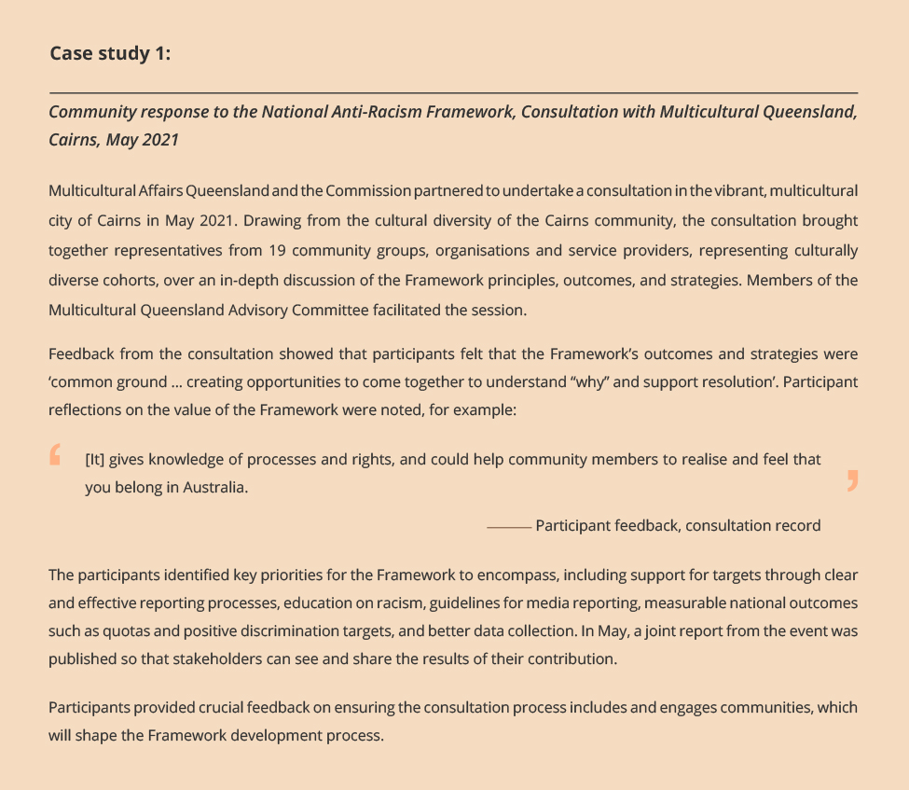

What’s Age Got to Do With It?
In this reporting period, Commissioner Patterson commissioned multiphase research exploring current age-based stereotypes and intergenerational connections across the lifespan and through life roles, in order to demonstrate their accuracy or otherwise, and to highlight the effect of ageist attitudes through real-world scenarios such as elder abuse.
The rationale was to investigate age-based social attitudes for both younger and older adult cohorts through a human rights lens, to explore the gap in research about the experience of younger adults, and to contribute to understanding how ageism affects generations across the lifespan.
The research has been completed, and the report, What’s age got to do with it?, will be released in the second half of 2021.

Wiyi Yani U Thangani
Led by Commissioner Oscar, this multi-year project culminated in the release of the Wiyi Yani U Thangani (Women’s Voices): Securing Our Rights, Securing Our Future (Wiyi Yani U Thangani) report in December 2020. The report builds on the analysis of 109 online submissions, 313 survey responses, and 106 meetings and consultations with 2,294 women and girls across Australia, capturing their strengths, experiences, challenges, and aspirations, and ensuring that their voices are heard and listened to on the issues that affect their lives and communities.
‘What keeps me strong is my grandmothers—they didn’t have the power to have a voice and I am bloody determined to make sure my girls have a voice.’
—Consultation participant, 2020
The report puts forward a series of principles to guide action, with seven overarching recommendations and four pathways forward. These set out women and girls’ call for actions to transform the ways in which policy, legislation, and programs are designed to respond to their needs and aspirations, and elevate First Nations women and girls’ voices across a broad range of subject areas key to improving gender equality, and their enjoyment of human rights.
Propelled by truth-telling, self-determination and healing, the report is the first time in a generation that First Nations women and girls have been heard as a collective since the 1986 Women’s Business report. Following its publication, Federal Minister for Indigenous Australians, the Hon Ken Wyatt AM MP, described the report as a landmark achievement that provides the government with a better understanding of the issues that impact First Nations women and girls, and will be influential in shaping the direction of future Government policy towards shared decision making and partnership with First Nations Australians.
In this reporting period, Commissioner Oscar and her team commenced ‘Stage Two’ of the project. Using the report as a tool for dialogue and support to take action, the team have taken a multipronged approach to socialising the report across Australia (Figure 2).
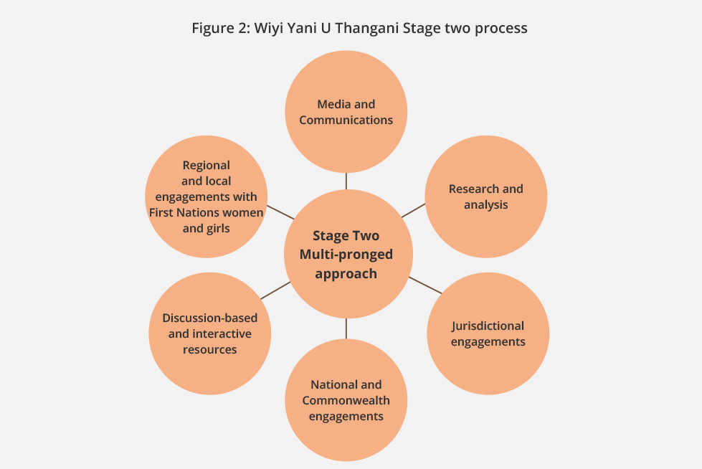
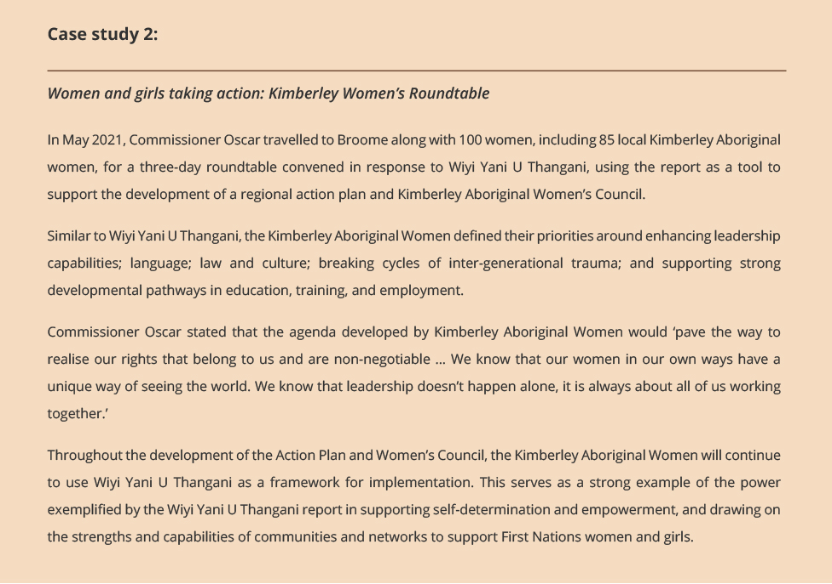

Progress indicator 1.22
Instances of programs attracting strategic partnerships that advance the priority human rights issues we have advocated for.

Australian Federal Police-Commission Partnership 2021–2026
In May 2021, the Commission embarked upon a new partnership under the leadership of Commissioner Jenkins with the Australian Federal Police (AFP). This partnership is in place to assist the AFP in its next step along its journey to deepening its positive workplace culture. The partnership is under a 5-year Memorandum of Understanding. The work of the partnership focuses on the AFP’s progress in its efforts to support a diverse and inclusive AFP workplace. In the coming year, the partnership will assist to refresh internal strategy and policy, and to understand AFP staff experience with trend data – supporting quantitative understanding with qualitative deeper dives. The Commission personnel offer specialised advice and guidance, and work in an integrated manner with the internal AFP team.

Employment of people with disability
Less than half (48%) of working age Australians with a disability are employed – compared to 80% of those without a disability. Increasing the employment of people with disability not only supports fulfillment and financial independence at a personal level, it improves business operations, workplace innovation, staff and customer satisfaction, and broader economic prosperity.
To address this concerning statistic, Commissioner Gauntlett, with seed funding from the Paul Ramsay Foundation, has developed the IncludeAbility Project which aims to enhance meaningful and sustainable employment opportunities for people with disability. The three-year project will achieve this by increasing the capacity of public and private sector employers to successfully employ, retain, and promote people with disability in their organisations.
The IncludeAbility Project is comprised of four key components. In this reporting period, significant implementation progress has been accomplished across each of these since external engagement commenced at the end of 2020:
- The Employer Network – 16 CEOs and senior executives from high-profile Australian employers were invited to join the IncludeAbility Employer Network and commit to improving meaningful employment opportunities for people with disability in their own workplaces. Network members include the Woolworths Group, the Kmart Group and Australia Post.
- The Ambassador Advisory Group – 16 individuals with disability from diverse employment backgrounds were invited to act as Ambassadors for IncludeAbility and ensure that the voices of people with lived experience are central to the project. The Ambassadors also reflect the intersectionality of disability with age, gender, race, and other diversity characteristics also represented.
- The IncludeAbility website – a public facing web portal has been developed to host 20 Commission designed resources – including guides, factsheets, and an e-Learn module. The Commissioner’s understanding of the need to support both employees looking for jobs, and employers focused on improving workplace culture and practice has directly shaped the two-pronged approach to the web portal. The website will be launched in September 2021.
- The Pilot programs – the next phase of the project will see the Commission work with the Employer Network, and other experts, to co-design two pilot employment programs to support the meaningful employment of people with disability. The Commissioner is currently engaged in conversations with organisations who have both operational capacity and specialist knowledge in disability employment to support the pilots.
The goals of IncludeAbility are timelier than ever with the economic impacts of COVID-19 further reducing employment opportunities for people with disability.
IncludeAbility is creating a safe space for employers to discuss ideas and share learnings, and is on track to improve the opportunities available to people with disability.

Impacts of the COVID-19 pandemic on the mental health of at-risk children and young people
In this reporting period, the Commission and the Kids Helpline co-authored the report Impact of COVID-19 on Children and Young People who Contact Kids Helpline. This report was launched in September 2020 and received very positive feedback.
As we continue to face the impacts of COVID-19 in our lives, the newly appointed National Children’s Commissioner has commenced work in collaboration with the National Mental Health Commission to consult with at-risk children and young people about the impacts of the COVID-19 pandemic on them. This includes their mental health, and related support and interventions required to support them, their families and communities, the main and unique challenges and barriers experienced by at-risk children and young people during the pandemic, and actions that can be taken to address the priority action areas of the National Mental Health and Wellbeing Pandemic Response Plan, and other priority issues identified by the group.
A final report will be provided to the National Mental Health Commission by June 2022.

Independent Review into Commonwealth Parliamentary Workplaces
In March 2021, the Commission was asked to undertake an Independent Review of Commonwealth Parliamentary Workplaces (Review) by the federal Government, with the support of the Opposition and crossbench. Led by Commissioner Jenkins, the Review is examining the culture of Commonwealth parliamentary workplaces with the aim of ensuring that the national Parliament reflects best practice in the prevention of and response to bullying, sexual harassment, and sexual assault.
After receiving ethics approval, the Review commenced its data gathering phase in late May 2021. The Commission invited written submissions and interview registrations from current and former Commonwealth parliamentarians, people who currently work or have previously worked for Commonwealth parliamentarians, and other workers in Commonwealth parliamentary workplaces, including interns and volunteers.
In this reporting period (to 14 July), 345 people have participated in the Review. This includes 222 interviews and 124 written submissions, with a further 125 interview registrations, including 12 current or former Commonwealth parliamentarians scheduled in the forward year. Further, an online survey of current parliamentarians, people currently working for parliamentarians and other people working in Commonwealth parliamentary workplaces is planned for July 2021, along with targeted focus groups. The Commission has also issued several Requests for Information to relevant agencies.
In July 2021, the Commission launched the progress update for the Review. The update outlined the work to date, an overview of participation, and the methodology.
The data gathering process is expected to conclude in August 2021. To date, participants have commented about how safe, respected and valued they have felt through the process. Additionally, many participants have emphasised that they have appreciated the opportunity to share their experiences:
‘The one thing that really stood out for me in relation to the interview was how safe I felt to share my views.’
‘I found the conversation very easy, and I felt that I was heard and that there was real interest in what my experiences and views were.’
‘I would encourage people to participate as I found it a safe process, particularly being via teleconference, and the care shown by the interviewers, who also took the time to follow up on my wellbeing, was genuine.’
–Inquiry participants
The final report is expected to be provided to the Government in November 2021.

Progress indicator 1.23
Instances of changed Federal and state government policy, practice and legislative change that reflect our advice.

Embedding accessibility in housing through advocacy
Increasing the availability of accessible housing for people with disability is one of Commissioner Gauntlett’s term goals as Disability Discrimination Commissioner. Improving housing accessibility should be pursued in two ways: by modifying and adapting existing homes, and ensuring that new homes are constructed to meet minimum accessibility requirements.
In support of this goal, Monash University’s Department of Architecture was commissioned to develop a scoping report on adaptable housing. Commissioner Gauntlett acted as the client for several design research units taught during semester one 2021. Adaptable Housing for People with Disability in Australia: A Scoping Study, published in April 2021, considers design-informed approaches and new innovations to adapting, retrofitting, or fabricating existing homes to improve accessibility for people with disability. An exhibition of the outcomes of the design research units will be held in the second half of 2021.
Dr Gauntlett was also successful in advocating for the inclusion of mandatory minimum accessibility standards in the National Construction Code 2022. The Commissioner wrote to ten state and federal Building Ministers highlighting the obligation of governments to legislate access to housing under the Convention on the Rights of Persons with Disabilities and the social and economic benefits of increasing accessible housing. These letters drew attention to the findings of the Committee on the Rights of Persons with Disabilities which recommended that Australia amend existing legislation to mandate accessibility standards. The Commissioner’s correspondence was complemented by meetings with three Building Ministers to discuss the benefits of accessible housing for both people with disability, and the broader community.
The Building Ministers agreed in April 2021 to include mandatory minimum accessibility standards in the National Construction Code 2022 and consequently all new housing will comply with the Liveable Housing Design Guidelines (LHDG) Silver Standard. This is a significant development which will ensure that accessibility is embedded in all housing design and will enable people with disability to access housing which meets their needs.

Respect@Work
In the previous reporting period, Commissioner Jenkins launched the Respect@Work: National Inquiry into Sexual Harassment in Australian Workplaces (Respect@Work) report alongside the Minister for Women, Senator the Hon Marise Payne, on 6 March 2020. Respect@Work examined the nature, prevalence, and drivers of sexual harassment in Australian workplaces, and measures to address and prevent it, finding that sexual harassment is pervasive, occurring in every industry and across every level in Australian workplaces.
Respect@Work drew on a national survey of 10,000 workers, 60 public consultations with 600 participants, 460 written submissions, and a comprehensive modelling of the high economic costs of workplace sexual harassment by Deloitte Access Economics. In this reporting period – to raise awareness of the report’s findings and recommendations – over 13 Respect@Work webinars were conducted between May and October 2020. The webinars had a broad reach and focused on recommendations that were relevant to particular stakeholder groups – including legal practitioners, employment, legal and regulatory practitioners, workers and unions, government and non-government policy practitioners, international partners, and academics. Feedback indicates that the webinars were well received by key stakeholders and led to increased understanding of and commitment to the Respect@Work recommendations.
Respect@Work paved the way for transformative legislative, regulatory, and cultural change across the Australian workforce with respect to sexual harassment. On 8 April 2021, the Government released its official response to Respect@Work, titled Roadmap for Respect: Preventing and Addressing Sexual Harassment in Australian Workplaces (Roadmap for Respect). All 55 of the Respect@Work report recommendations were agreed upon (in full, in part, or in principle) or noted.
‘The Kate Jenkins’ report, Respect@Work is a game changer. It is changing the very narrative that will drive the appropriate actions needed right across governments and across our society.’
–The Hon Scott Morrison MP, Prime Minister, 8 April 2021.
In June 2021, the Australian Government introduced the Sex Discrimination and Fair Work (Respect at Work) Amendment Bill 2021, which gives effect to Respect@Work recommendations 16, 20, 21, 22, 29, and 30. Specifically, this Bill clarifies that harassing a person on the basis of sex is unlawful; broadens the scope of persons protected to include interns, volunteers and self-employed persons; clarifies that a complaint of victimisation can be considered as either a civil or criminal matter; extends the time frame for which a complaint can be made to the AHRC; clarifies that the Fair Work Commission (FWC) may make an order to stop sexual harassment; and clarifies that sexual harassment is a valid reason for dismissal.
‘This legislation is a considerable step in achieving greater safety and economic security for women across the whole of our society.’
–Senator the Hon Michaelia Cash, Attorney-General, 24 June 2021.
Implementing recommendation 14, the Respect@Work Council (the Council) was established in March 2021 by the Assistant Minister to the Attorney-General, Senator the Hon Amanda Stoker, and has to date convened twice, in March and May 2021. The Council is chaired by Commissioner Jenkins and brings together leaders from eight key government regulators and policy makers responsible for sexual harassment policies and complaints. The Council’s objective is to improve coordination, consistency, and clarity across existing legal and regulatory frameworks, to identify ways to promote safer workplaces, and to provide oversight of the implementation of key Respect@Work recommendations. The Council is supported by a Secretariat located within the Attorney-General’s Department.

Partnerships to implement Respect@Work
Under a Memorandum of Understanding (MoU) with the Attorney-General’s Department, the Commission is taking the lead on implementation of Respect@Work recommendations 2, 9, 34, 36, 37, 40, 48, and 52. Under the MoU, the Attorney-General’s Department will pay the Commission a total of $1,307,399 to achieve key deliverables including the development of education and training materials that will address the nature, drivers, and impacts of sexual harassment, as well as the rights and responsibilities of employers and workers with respect to sexual harassment. An online platform will also be developed that will deliver information, education, and resources to support all workplaces to prevent and respond to sexual harassment. The online platform is due to be completed and active within 12 months.
In partnership with the Australian Council of Superannuation Investors (ACSI), Commissioner Jenkins led a research project to understand current approaches to how companies are collecting, using, and reporting data regarding sexual harassment. The project involved a set of consultations with 16 ASX200 companies, as well as a survey that 118 ASX200 companies completed. The report, Equality Across the Board: Investing in Workplaces that Work for Everyone, was launched on 17 June 2021, and was promoted broadly throughout investor and employer audiences. The report makes six recommendations for company boards on the actions they can take to prevent and respond to sexual harassment within the workplace. The recommendations focus on the need for boards to demonstrate leadership, develop the requisite skills and expertise on gender and sexual harassment, align executive appointments and performance management with the organisation’s values, build positive workplace culture, improve transparency through internal and external reporting, and ensure relevant systems and frameworks are in place to collect and analyse data regarding sexual harassment. It makes two recommendations to investors on their role to hold companies accountable. Specifically, it recommends that investors seek information about the systems and frameworks in place in their investee companies, and that they advocate for improved transparency. The report has generated interest and positive feedback from corporate, investor, regulator, and non-government organisation audiences.
Commissioner Jenkins has collaborated with several organisations, including the Minerals Council of Australia, Science in Australia Gender Equity (SAGE), the Australian Institute of Company Directors (AICD), the Fair Work Commission, Comcare, and others, to implement the Respect@Work framework that aims to strengthen the prevention of and response to sexual harassment in the workplace. As a result, these organisations have enhanced protections against sexual harassment within their workplaces by improving risk mitigation strategies, implementing positive initiatives to improve workplace culture, building capacity of workplace leaders, and redesigning policies, procedures, and reporting mechanisms so that they are easily accessible and victim centric.
Respect@Work has set the foundation upon which other reviews into the nature and prevalence of sexual harassment have been conducted, including the Independent Review into Commonwealth Parliamentary Workplaces, the South Australian Review into Sexual Harassment in the Legal Profession, and the Review of Sexual Harassment in Victorian Courts and VCAT.

Outcome 1.3 [PBS criterion]
Law and policy makers, at all levels, consider and address the human rights impacts we identify through our submissions, Inquiries, research, reports and United Nations engagement.

Progress indicator 1.31 [PBS target]
High proportion of Committee inquiry reports reflect and cite the Commission’s advice.

Submissions
Our human rights scrutiny and parliamentary committee work is led by the Commission’s President. We contribute to parliamentary processes, seeking to ensure that our expertise on human rights, with a particular focus on Australia’s international human rights obligations, is applied to matters under consideration by the Parliament, by providing a persuasive voice when scrutinising proposed laws and policies.
This year, the Commission made 25 submissions to parliamentary committees, government inquiries, and other legislative review processes – providing specialist, independent policy and legal analysis of the human rights impact of current and proposed laws and on public policy issues. In addition, the Commission also made submissions to various United Nations processes, including a submission to the Universal Periodic Review (reported under progress indicator 1.13) and the United Nations Committee on the Elimination of Discrimination Against Women.
We evaluate the impact of the Commission’s submission work on law and policy by monitoring appearances before committees and inquiries, citation in any reports, and examining the extent to which any recommendations we make are reflected in any committee reports.
These metrics help demonstrate the extent to which the Commission’s contributions influence public debate on proposed laws and policies and provide valuable input to inquiries into social policy issues. In this period:
- one third of the available reports cited our submissions
- Commissioners were invited to appear 9 times at inquiry hearings – a further indicator of the value of the Commission’s contribution.

Progress indicator 1.32
Instances of our recommendations to UN mechanisms being reflected in treaty body concluding observations and other reports.

United Nations Engagement and Scrutiny
As a national human rights institution, the Commission has a role in engaging with United Nations (UN) human rights mechanisms, including the UN Human Rights Council, treaty bodies and special procedures (such as special rapporteurs). This role is independent of the Australian Government and non-government organisations.
In this reporting period, scheduled UN treaty appearances were delayed due to the COVID-19 pandemic, and there was no significant treaty body activity for the Commission.
Progress on the third Universal Periodic Review is provided under Progress Indicator 1.13 above.

Progress indicators 1.33 and 1.34 [PBS targets]
Respectively: The majority of our applications to the courts for leave to appear are accepted; Instances of our court submissions reflected in the final judgment of the matter

Contribution of expertise on human rights to court process
The Commission has the power to intervene, with the leave of the court, in proceedings that involve issues of race, sex, age and disability discrimination, human rights issues, and equal opportunity in employment.
In this period, the Commission made 2 applications for leave to intervene, with both being granted by the courts. Judgment was handed down in 2 of the matters in which we intervened (one where leave was granted in the previous year and one from the current year). The case study below is an analysis developed from one of the judgments and provides an illustration of our submissions being reflected in the final judgment.
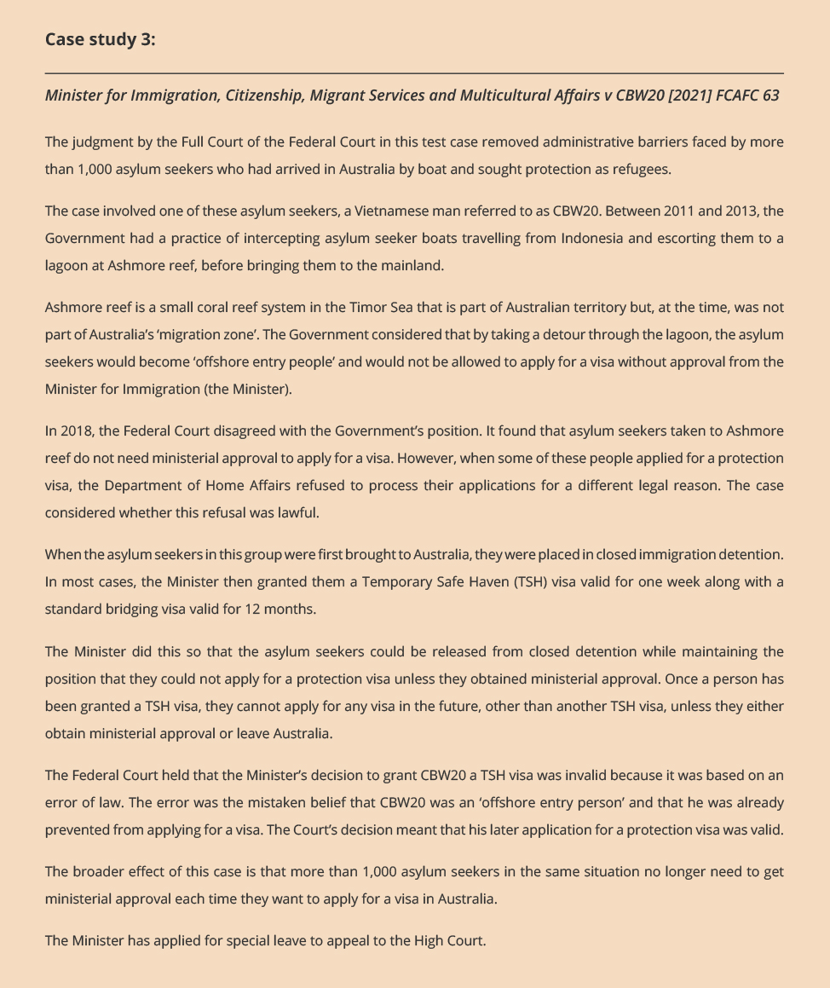

Goal 2: More people, communities, and organisations respect and understand human rights

Outcome 2.1 [PBS criterion 1]
Our education activities increase capability among individuals, communities and organisations to promote and protect human rights and address discrimination.

Progress indicator 2.11 [PBS target]
Most participants in our adult training programs report:
- satisfaction with the quality and relevance of the training
- increased understanding, expertise, reframed attitudes.

Building capacity for child safety: Child Safe Organisations e-learning suite
‘I think this is an excellent resource and great that it’s free. It is good that it is interactive, easy to understand and is focused on children and young people’.
–Survey respondent
The Commission developed the National Principles for Child Safe Organisations which were endorsed by the Council of Australian Governments on 19 February 2019.
In August 2019, a suite of 11 Child Safe Organisation e-learning modules were launched as part of this program. The modules are designed to help organisations increase their knowledge and understanding of the National Principles and identify the steps they need to take as they work towards implementing them. These are available at no cost to any organisation or interested party.
Since the launch, over 10,000 people have registered to use the modules to assist them in making changes to policy and practice, and to protect and promote children’s human rights in their context.
Users were asked to complete an optional online evaluation survey. To date, nearly 5,000 respondents have completed the survey, which captured demographics, process feedback around content and useability, early outcomes in regard to knowledge, satisfaction, benefit, and improvements. Key findings are shown in figure 3 below.
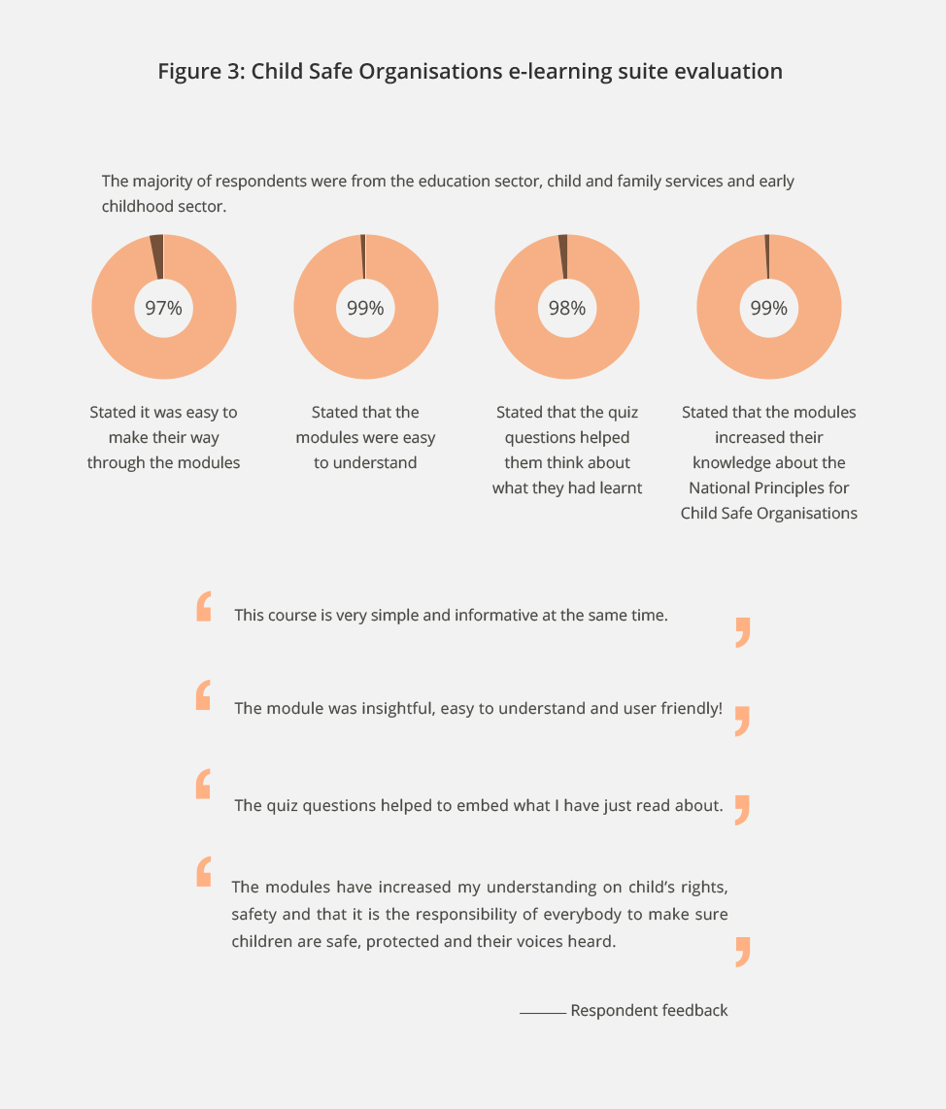

e-Learning modules on human rights
In this reporting period, the Commission released a suite of free e-learning modules on human rights and human rights frameworks. The e-learning modules are freely available on the Commission’s website and are designed to provide a basic introduction to human rights and responsibilities, and the United Nations human rights frameworks.
The Commission also continues to offer a range of other free e-learning modules on:
- National Principles on Child Safe Organisations (featured above)
- Benefits of Multigenerational Workforces (with support from the NSW Department of Communities and Justice).
The e-learning course on Benefits of a Multigenerational Workforce aims to increase understanding of the benefits of employing older people and highlights practical ways of working with older employees to foster engagement and retention. Participants gain a deeper awareness of the nature of age discrimination in employment and learn practical ways of working within a multigenerational team.

Preventing and responding to sexual harassment – workshops with various private and public sector organisations
In this reporting period, the Commission has responded to increased demand for training on how to prevent and respond to sexual harassment in the workplace. These training workshops, tailored for both staff, middle, and senior management, focus on increasing participants’ understanding of:
- the meaning of workplace sexual harassment
- the legal framework surrounding sexual harassment
- the impacts sexual harassment may have on individuals and Australian workplaces
- the role workplace culture can play in preventing sexual harassment
- responsibilities of employees and employers, including managers and senior executives, in preventing and responding to workplace sexual harassment
- effective bystander support strategies
- how to effectively respond to reports of sexual harassment
- how to support staff who have been impacted by sexual harassment
- how to have conversations with colleagues about preventing and addressing sexual harassment in the workplace.

Progress indicator 2.12
Instances of organisations working with the Commission to develop human rights education/training activities.

Harnessing the power of older workers – NSW Government
The NSW Government funded the Commission to undertake several projects in alignment with its NSW Ageing Strategy 2016–2020.
Initially, the Commission developed and released Multigenerational workforces: A guide to the rights of older workers under the Age Discrimination Act 2004 (Cth). The guide provides employers and other work providers with information about the operation of the Act and practical guidance about promoting the inclusion of older workers in multigenerational workforces. This was followed (in the last reporting period) by a series of workshops on the benefits of multigenerational workforces delivered to NSW public sector employees and hiring managers.
In this period, the Commission developed an awareness campaign harnessing the power of older workers, including developing an older workers resource hub and public awareness campaign, and hosting a webinar focused on practical actions that businesses can take to foster age-friendly work environments in which older workers are valued for their skills and experience.
Progress against this indicator is also provided by the International Program report (Progress indicator 3.24). In this performance story the three evaluation case studies of technical education and training workshops demonstrate satisfaction and learning outcomes.

Outcome 2.2 [PBS criterion]
Our information resources, services, events, and campaigns reach inform and influence users and audiences.

Progress indicator 2.21 [PBS target]
Targeted audiences are reached, access our information resources and services, and participate in our events and campaigns. Demonstrated by:
- digital engagement analytics exceeding the previous year’s benchmark by 5%
- high rates of users report them as engaging and relevant.

Public and digital engagement
For the 2020–2021 period, the Commission moved into its second year of the updated website. These results show the Commission exceeded the indicator and PBS target of 5% growth in pageviews and website visits – with a 5.4% increase in pageviews and 6.7% increase in website visits for 2020–2021.
Other digital engagement and data in this reporting period:
- 130,151 users searched the website
- subscribers to our interest lists went to over 62,000, and the Commission’s monthly e-newsletter reached over 36,000 people
- the website was visited 6,554,059 times with 10,800,522 pageviews
- the Commission compiled its COVID-19 information in one central area on the website – there have been 21,000 pageviews
- an interactive report site was created for the Human Rights and Technology Final Report – it received 28,000 pageviews.

Events and launches
Our public presence helps us to reach large and diverse audiences and to facilitate informed debate. In this period, we hosted and promoted numerous major events that have engaged substantial audiences and generated significant awareness and debate through media coverage, including:
- Human Rights Day Oration by Rosemary Kayess
- Kep Enderby Memorial Lecture, panel discussion moderated by Nyadol Nyuon
- Rights Talk: Balancing COVID-19 and Human Rights
- Harnessing the Power of Older Workers Webinar
- Human Rights and Technology Webinar series: Civil Society; Government; Accessibility
- Respect@Work Webinar series: Legal Practitioners; Employment, Law reform and regulatory practitioners; Unions and workers; International insights; Government and non-government policy practitioners; Academics; International Perspectives on Workplace Sexual Harassment
- Webinar on Australia’s National Disability Strategy: Beyond 2020
- Wiyi Yani U Thangani (Women’s Voices) report launch
- Elder Abuse awareness campaign launch
- Equity Across the Board: Investing in workplaces that work for everyone report launch
- Final report of the Independent Review of Gymnastics in Australia launch

Human Rights Heroes Campaign
The Commission chose not to host the annual Human Rights Awards in 2020 in their traditional format due to the COVID-19 pandemic and instead opted for a digital amplification campaign – Human Rights Heroes – to highlight the work of grassroots and community human rights champions during this difficult year.
The Commission invited the public to nominate the people and organisations making the most positive and inspiring contribution to human rights on the ground in Australia. We received no shortage of nominations. Ten outstanding #HumanRightsHeroes were shortlisted as finalists and, from 7–9 December 2020, the Commission used its extensive social media reach to celebrate their extraordinary stories of achievement, leveraging our following to shine a spotlight on their work, and bring national attention to them.
The 10 finalists of the #HumanRightsHeroes campaign were (in alphabetical order):
- Addi Road
- Adnyamathanha women Vivienne McKenzie, Regina McKenzie, and Heather Stuart
- Ben Bjarnesen (Founder LGBTI Domestic Violence Awareness Day)
- Beverley Wright (C&K Kindergarten Durack) and all teachers and educators
- Corey Tutt (Deadly Science)
- The NSW Rural Fire Service Volunteers
- Sikh Volunteers Australia
- The Torres Strait 8
- Yasseen Musa
- Zaki Haidari (Refugee Advice and Casework Service)
The #HumanRightsHeroes campaign was very successful, attracting a high level of engagement and reaching well beyond our traditional stakeholder audience with its positive celebration of human rights.

COVID-19 and Human Rights Guidance
The Commission created a new section of our website – COVID-19 and Human Rights – to answer the most common questions and concerns we have heard on the pandemic and human rights. The content includes general guidance on mandatory vaccination and mask wearing in public health orders from a discrimination law perspective, information on the human rights principles the Commission would apply to assess COVID-19 emergency measures, and guidance on what international human rights law says about how to balance human rights and public health during a pandemic. The information has been viewed 21,000 times.

Closing the Gap
The Close the Gap campaign (co-Chaired by Commissioner Oscar and Karl Briscoe) is the people’s movement aiming to raise the health, life expectancy, and broader socio-economic outcomes of Aboriginal and Torres Strait Islander peoples to that of the non-Indigenous population. It aims to do this through effective advocacy for the implementation of a human rights-based approach to Indigenous health, as set out in the Social Justice Report of 2005.
The campaign consists of the Close the Gap Campaign Steering Committee – a coalition of 52 of Australia’s peak Aboriginal and Torres Strait Islander health organisations, health professional bodies, and human rights organisations. The Campaign’s secretariat operates from the Commission.
With the new National Agreement on Closing the Gap signed in 2020, the Campaign is now focused on the priority reforms and new targets as set out in this agreement. The 2021 Campaign report, Leadership and Legacy through Crises: Keeping our Mob Safe, was again produced by the Lowitja Institute and showcased Aboriginal and Torres Strait Islander leadership capacity to respond effectively to the multiple crises faced over the past year.
The report skilfully ties together best practice case studies of responses to COVID-19, bushfires, and climate change. It also includes the voices of Indigenous youth and leadership on social and emotional wellbeing and suicide prevention. This was an ambitious report, largely funded by Oxfam Australia, and is woven together with the striking public health imagery created last year to appropriately inform community members around their health and wellbeing.
During the build-up to the report launch, Australians for Native Title and Reconciliation (ANTaR) once again coordinated the National Close the Gap Day events, handling enquiries nationwide, recording an upsurge in people signing the pledge on their site to Close the Gap. Following report launches in Parliament House, and more recently in community (Tharawal Aboriginal Medical Service), this year’s online report launch broke new ground. Over 2,000 participants attended the launch online and were met with a diverse panel. The Campaign leadership was joined by Minister Ken Wyatt, Sir Michael Marmot, and representatives from the community-based case studies in the report – Angel Owen (Seed Mob), Kevin Mckenzie (Alive and Kicking Goals!), and Professor James Ward (Aboriginal and Torres Strait Islander COVID-19 response).
Finally, the Campaign and co-Chairs supported the coalition of organisations advocating for a visible and mandated health warning on alcohol products last year. This was put to a ministerial vote and succeeded by just one vote, a significant win for public health considering the strength and influence of the alcohol industry lobbyists, even in the midst of a global pandemic.

Elder Abuse - know the signs
In this reporting period, Commissioner Patterson continued her term goal and program to improve Australia’s recognition and response to elder abuse, building on the findings of the 2017 Australian Law Reform Commission (ALRC) report, Elder Abuse – A National Legal Response, and encouraging implementation of the recommendations.
This included launching an elder abuse awareness video on 1 October 2020 (International Day of Older Persons) to increase awareness of elder abuse and the national helpline, 1800 ELDERHelp (1800 353 374). Following the launch, a ‘Know the Signs’ campaign was run. The campaign’s reach and response outcomes are detailed in case study 4. The video has been launched across Australia through social media, radio and television. Internationally, the Serbian Red Cross used the video in their 2021 World Elder Abuse Awareness Day (WEAAD) campaign in Belgrade, and across Serbia. The video continues to be distributed across a range of channels and a second video is in development, to be launched later in 2021.
Commissioner Patterson continued to distribute elder abuse awareness bookmarks – a resource developed with the agreement of the concept originators, ACT Legal Aid, and in partnership with the Attorney-General’s Department.
The bookmarks and posters continue to be very popular with thousands printed, and importantly, distributed. Figure 4 shows distribution as of 30 June 2021.
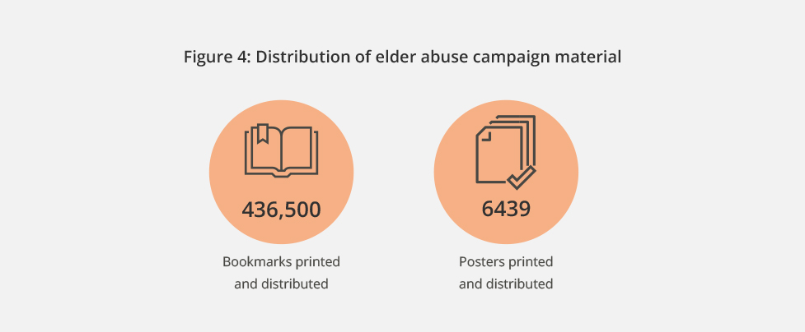
The bookmark is being translated into 5 key community languages (Arabic, German, Simplified Chinese, Greek and Italian) with further languages to follow in 2021–22. The bookmarks will be distributed with support from government and community stakeholders.
COVID-19 continued to cause disruption to the distribution of the elder abuse materials; however, numerous organisations disseminated the resources during this period. For example, a partnership with Australia Post resulted in a campaign from June and July 2021 distributing bookmarks in 3,501 outlets across Australia, in conjunction with World Elder Abuse Awareness Day on 15 June.
In this period, Commissioner Patterson also facilitated a collaboration among allied health stakeholders to develop elder abuse training materials for their workforces. She continued to raise the importance of harmonising powers of attorney legislation across jurisdictions and developing a national online register of powers of attorney with the Meeting of Attorneys-General.
In the coming year, Commissioner Patterson will continue her advocacy and education around elder abuse and the supports available.
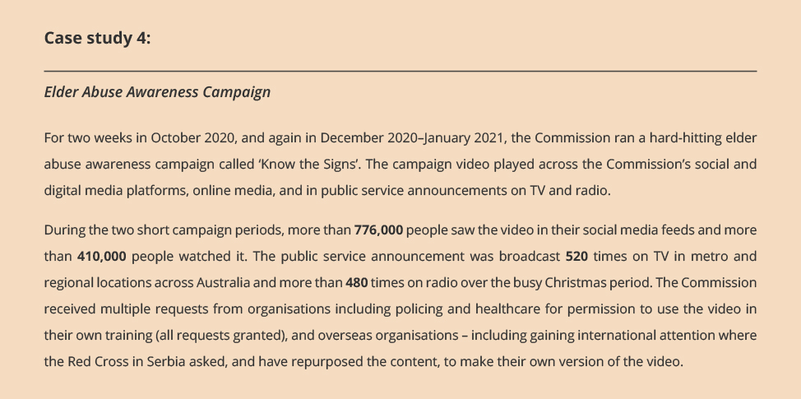

Racism. It Stops with Me
Since 2012, the Racism. It Stops With Me (RISWM) campaign has been supporting Australians to understand the nature and impact of racism, and providing tools to address it. Over this period, the campaign has achieved strong brand recognition and a significant supporter base, including more than 400 organisational supporters. Previous evaluations attest to the strength of the campaign in building the capacity of supporters to recognise and challenge racism. The following quotes from annual evaluations illustrate this foundational achievement.
‘Being a small jurisdiction, we don’t have money to prepare our own collateral, our own videos. It’s really useful to use the campaign resources … Tasmania doesn’t have the same big profile organisations working on racism, so we’ve seen the need to take the lead – the campaign helps with this.’
—Equal Opportunity Tasmania

‘We were trying to push for anti-racism work before the campaign came along, so it helped get everyone on board.’
—Flinders University
‘Being a supporter is an invitation for people to actually start talking about [racism].’
—Uniting
In 2020, the Black Lives Matter movement, a rise in racism linked to COVID-19, and ongoing concern about far-right extremism, saw conversations around race and racism change significantly in Australia. In response to this, Commissioner Tan’s campaign team initiated a refresh of the campaign, seeking to provide supporters with the tools to engage in current conversations and challenge racism in their workplaces, communities, schools, and homes. The work undertaken in this reporting period includes activities to design and develop a new:
- public awareness campaign and accompanying educational resources
- RISWM website
- Workplace Cultural Diversity Tool to support employers looking to improve their approach to cultural diversity and inclusion in the workplace.
Community and stakeholder views are an important part of the process. Two Expert Advisory Groups were established to advise on the development of the RISWM public awareness campaign and Workplace Cultural Diversity Tool. Each group is made up of experienced academics, practitioners, and advocates from a diverse range of industries and cultural backgrounds, each with expertise in anti-racism or the promotion of cultural diversity and inclusion.
The consultation strategy for the RISWM public awareness campaign included 12 meetings with community organisations, anti-racism academics, and practitioners, spanning NSW, Victoria, and Queensland. A preliminary consultation survey for the Workplace Cultural Diversity Tool was circulated among stakeholders. Secondary consultations will take place in the next financial year.
The coming year will see the rollout of the public awareness campaign and accompanying educational resources, and the launch of the new Workplace Cultural Diversity Tool, which will be hosted on the RISWM website.

Spectator Racism
A key project under the RISWM initiative was the development of a set of guidelines for responding to incidents of spectator racism at Australian sporting matches. Completed in this reporting period, the project facilitated a workshop, bringing together more than 20 representatives from Australian sporting codes and anti-racism experts. Using this experience and evidence, the campaign team drafted a set of guidelines, and a list of resources to be developed to support their implementation. Scheduled to launch in the next reporting period, the Spectator Racism Guidelines provide practical steps to support sporting codes, clubs, and venues to respond to incidents of spectator racism, and reduce the occurrence of these incidents in the future. In the coming year, these guidelines and accompanying resources will be endorsed by Australian sporting codes and made publicly available.

Progress indicator 2.22
Instances of legal information, resources, guidelines, and exemption processes helping employers and organisations to comply with Australian discrimination and human rights law.

Guidelines

Increasing transport accessibility
Transport accessibility is a key factor in ensuring people with disability can live independently. Commissioner Gauntlett is committed to improving the accessibility of transport options for people with disability. He participates in a number of forums on this issue and is a member of the National Accessible Transport Steering Committee, which is overseeing the process of modernising the Disability Standards for Accessible Public Transport 2002 (Cth) (Transport Standards).
In this reporting period, the Commissioner led the development of the Guidelines: Equivalent Access under the Disability Standards for Accessible Public Transport 2002 (Cth) (Equivalent Access Guidelines), in partnership with the Department of Infrastructure, Transport, Regional Development and Communications. The Equivalent Access Guidelines were published in July 2020 and provide clarification on how equivalent access solutions are used to comply with the requirements of the Transport Standards and the Disability Discrimination Act 1992 (Cth).
The Equivalent Access Guidelines address the need for both public transport operators and users to understand equivalent access provisions whereby equipment or facilities may be varied from the requirements provided that an equivalent standard of amenity, availability, comfort, convenience, dignity, cost, and safety is maintained. Equivalent access provisions allow transport providers the flexibility to develop innovative solutions and consider how public transport can meet the needs of people with disability.
These guidelines were developed following consultation with key stakeholders, including people with disability, operators and providers of public transport, and state and federal government public transport departments.

International recognition for the Commission’s COVID-19 Disability and Human Rights Guidelines
In August 2020, the Commission published the Guidelines on the Rights of People with Disability in Health and Disability Care during COVID-19 (Guidelines).
Commissioner Gauntlett has been a member of the Australian Government’s Advisory Committee on the Health Emergency Response to Coronavirus (COVID-19) for People with Disability since its establishment in April 2020. The Advisory Committee developed the Management and Operational Plan for COVID-19 for People with Disability, and Commissioner Gauntlett was invited to develop human rights focused guidelines to support the plan.
The Guidelines examine the rights outlined in the Convention on the Rights of Persons with Disabilities that may be at particular risk during a pandemic and provide practical examples for practitioners and people with disability. The Department of Health commended the Guidelines to Australia’s professional medical associations, as well as private hospitals and providers.
The global and ongoing nature of the pandemic has meant that the Guidelines have garnered an international audience, for example:
- Mr Gerard Quinn, the newly appointed UN Special Rapporteur on the rights of persons with disabilities, communicated in unsolicited feedback that he would be drawing on the Guidelines in his academic writing on the impact of the pandemic.
- The Commonwealth Forum of National Human Rights Institutions profiled the Guidelines in its March 2021 report, Protecting Disabled People’s Rights during COVID-19: Good Practice from Across the Commonwealth. The report highlights the Guidelines as an example of providing guidance on good practice.

Legal information and resources

Reports to the Minister under the Australian Human Rights Act 1986 (Cth)
When the Commission receives a complaint of a breach of human rights or workplace discrimination (other than unlawful discrimination under the Discrimination Acts), we attempt to resolve the complaint through conciliation. If conciliation is inappropriate or unsuccessful, and we find that there has been a breach of human rights or that the matter amounts to workplace discrimination, then we may prepare a report of the complaint for the Attorney-General.
When the Commission receives several complaints raising the same or similar issues, it may prepare one report focusing on the systemic issue raised by the group of complaints.
In this period, the Commission prepared 6 reports to the Attorney-General. Each of these reports is published on the Commission’s website. The following report dealt with the use of force against a person in immigration detention:
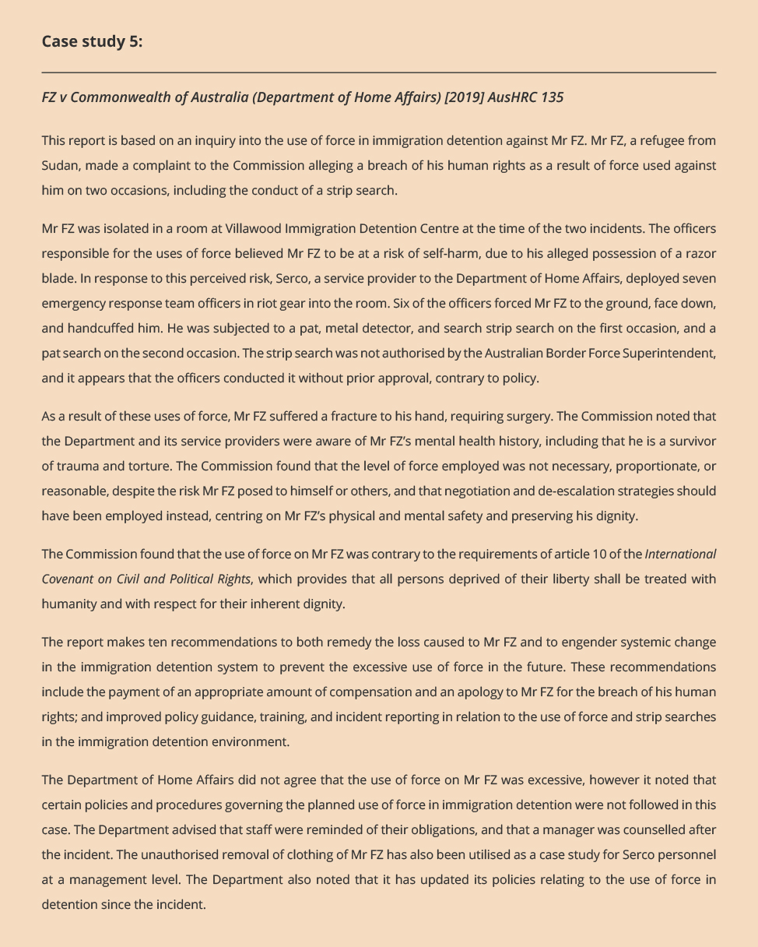

Goal 3: More people, communities, and organisations take action to respect protect and promote human rights in their own contexts

Outcome 3.1 [PBS criterion]
Our activities increase the capacity of vulnerable groups, communities and their advocates to understand and advocate for their rights.

Progress indicator 3.11 [PBS target]
Instances of participants/community stakeholders reporting:
- robust processes that facilitate their access and participation
- experiences of meaningful participation that are beneficial and empowering.

Keeping children safe
In this reporting period, the National Children’s Commissioner has been consulting with children, young people, and families with lived experience of disadvantage and vulnerability on how to keep children safe and healthy in their homes and in their communities.
Keeping Kids Safe and Well – Your Voices is a national consultation project which will inform the first five-year implementation plan to the National Framework for Protecting Australia’s Children (2009–2020) successor plan, currently being developed by all Australian governments.
In May 2021, the Children’s Rights team held 7 pilot consultations with 59 participants in Sydney, NSW, to test the planned content and methodology for the national consultations, and to ensure that the experience of children, young people, and families was safe and meaningful.
Forty-four children, young people, and families who participated in the pilots completed an evaluation for the session they attended. As shown in figure 5, most indicated they were satisfied with their consultation experience. In specifying why, some went on to identify that the best quality of the pilot consultation was the open, safe environment, where they felt they could share honestly. Others said that the best thing was the discussion with other participants who had similar experiences on topics that were important to them. When asked about the worst ‘aspect’ of the pilot consultation, over half said that there was no ‘worst’ aspect.
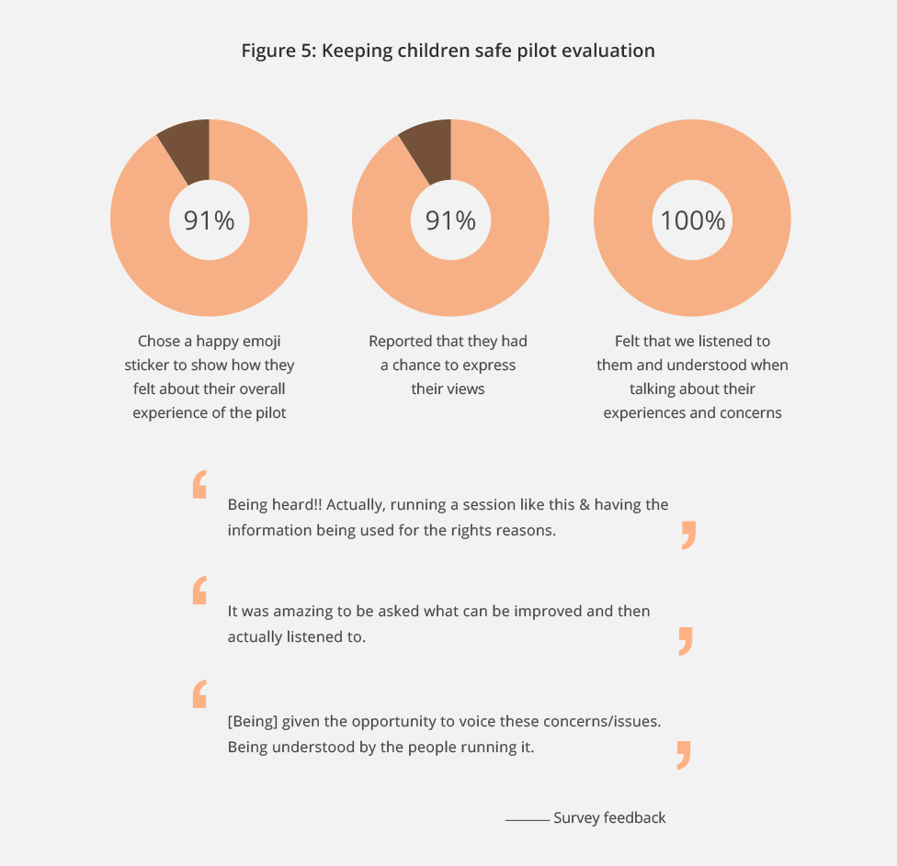
Using the feedback from the pilot consultations, the National Children’s Commissioner and team completed 20 consultations in this period, meeting with over 200 children, young people, and families across Sydney, regional NSW, Australian Capital Territory, Northern Territory, South Australia, and Tasmania.
The consultations will continue into next year with the final report provided to the Department of Social Services in October 2021.

Native Title
In this period, the Commission has undertaken research towards the development of the next Native Title report, as specified under section 209 of the Native Title Act 1993 (Cth) and section 46C of the Australian Human Rights Commission Act 1986 (Cth).
This work has contributed to elevating the voices of First Nations women and communities by listening and sharing their experiences navigating the multifaceted and challenging native title legislative and policy context. In doing so, the Commission is breaking down the complexity of the system and presenting policy makers and civil society with a better understanding of First Nations peoples’ lived realities and day to day struggles with native title. The report aims to be tabled in the Parliament by the end of 2021.
The data collection involved online interviews and in-depth conversations with First Nations women, and professionals working with native title across Australia, as well as a targeted online survey and a submissions process. This collection of data is limited to specifically targeted individuals in native title processes with diverse experiences across different sectors and locations within Australia. It creates a valuable opportunity to reach key voices with experience in the native title system and facilitate meaningful and genuine engagement.
In May 2021, Commissioner Oscar advocated for the importance of this process at the Australian Institute of Aboriginal and Torres Strait Islander Studies (AIATSIS) Summit, stating that the native title system needs to better accommodate First Nations systems of governance and decision making, prioritising the needs of communities over Western frameworks. This recommendation, along with the personal experiences of First Nations peoples and professionals working with native title is anticipated to be published in the report.

Outcome 3.2 [PBS criterion]
Our activities increase the capacity of Governments, organisations, other groups and services to understand and address the human rights impact of their actions, particularly when working with vulnerable groups and communities.

Progress indicator 3.21 and 3.22 [PBS target]
Instances of stakeholders in our activities with organisations reporting that our work has contributed to increased understanding of the impact of their systems and operations on human rights; Instances of stakeholders in our activities with organisations making changes to organisational policy and practice, to protect and promote human rights in their context.

Commission-Defence Collaboration to support and improve cultural reform across Defence (2014–2024)
The Commission has worked with the Australian Defence Force (ADF) for the past 7 years to support and improve cultural reform. A four-year agreement to continue this work was signed in June 2020. Led by Commissioner Jenkins, the Commission team brings a human rights-based approach to its cultural reform work with Defence. This means turning human rights from legal instruments into effective policies and practical realities. Defence has worked with this approach to redefine problems, examine root causes, and expand its range of responses to problems.

Data reporting framework for unacceptable behaviour
In this reporting period, the Commission team supported Defence to improve its data collection systems on unacceptable behaviour. Data is crucial to understanding the scale of unacceptable behaviour in terms of the number of individuals affected and providing insights into where and how unacceptable behaviour is occurring and the underlying drivers or causes. The Commission developed a data reporting framework for Defence to understand what and how unacceptable behaviour is occurring, whether and in what ways it is changing, and what the key risk and protective factors are to inform how and where to target interventions aimed at preventing unacceptable workplace behaviours.

Optimising Navy workplace culture
The Commission team is working in partnership with a specialist Navy cohort to define its ideal culture – based on Defence values, attitudes, and beliefs – to support the Navy’s mission. Cohort members and the Commission jointly scoped and defined the project and will co-develop and deliver the outcomes. This bottom-up, inclusive methodology will strengthen support for the project within the cohort and maximise the relevance of proposed changes.
In this process 106 Navy cohort representatives and 18 other Navy stakeholders have participated in online consultations and interviews or face-to-face consultations and interviews in NSW, Western Australia, Victoria, and Canberra – with the evaluation feedback in figure 6 indicating satisfaction with the process to date.
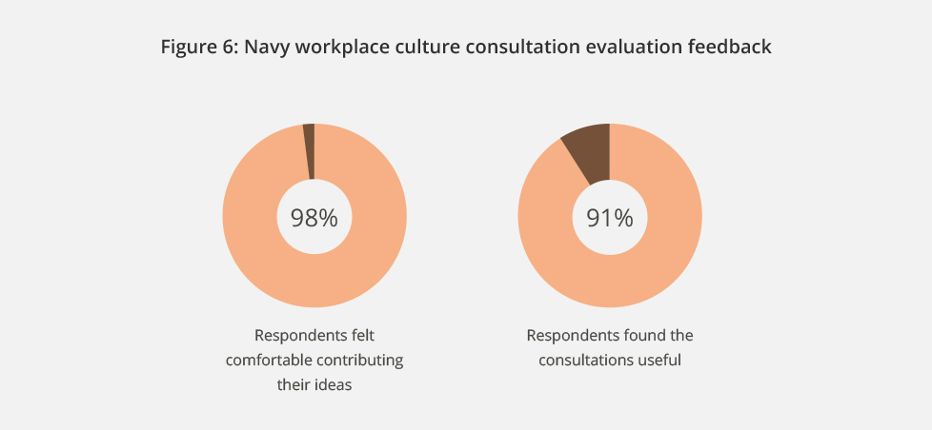

Enhancing Indigenous employment outcomes in Defence
The Indigenous Project is the first Defence collaboration project where the Commission has collaborated with all three services (Army, Navy, and Air Force) and the Department of Defence.
The project aims to enhance Indigenous employment outcomes and create a more inclusive and culturally safe environment for Indigenous personnel.
This project has been informed by consultation with Indigenous stakeholders and Defence personnel. This has involved:
- speaking with 303 Defence personnel, 226 of whom were Indigenous, via focus groups and interviews
- receiving over 500 survey responses, 405 from Indigenous participants
- consulting with 110 additional stakeholders, including Indigenous communities in four remote and regional locations.
In the coming year, the Commission will finalise a report on barriers and enablers to the inclusion of Aboriginal and Torres Strait Islander peoples in the ADF and Defence APS. The report will also identify opportunities to strengthen the relationship between Defence and Aboriginal and Torres Strait Islander peoples and communities.

Employing Older Workers Report
Commissioner Patterson was pleased to be involved once more in the Australian Human Resources Institute (AHRI) older worker survey in 2021, following similar surveys in 2014 and 2018. The 2021 survey contained some key results, including:
- Respondent organisations who say they ‘definitely’ or ‘probably’ have an age above which they are reluctant to recruit has dropped from 52% in 2014 to 27% in 2021. This is encouraging.
- However, the number who responded ‘maybe’, rather than they would ‘definitely’ or ‘probably not’ have an age limit, has increased.
- Respondents’ perception of what age range constitutes an ‘older’ worker has shifted to a younger age over the three surveys.
- In 2018, 11% of respondents identified people 51–55 years as an ‘older’ worker. In 2021 this has increased to 17%. Across the same period there has also been an 8% drop in those selecting 61–65 as the appropriate age range of ‘older’ workers. These findings are of concern.
- The number of respondents who recognise that the departure of older workers causes a loss of key skills or knowledge has increased by 14% since 2014.
- However, there is little or no increase in the same time period in organisations that take action to capture corporate knowledge as older workers transition out of the workplace.
Overall, the research suggests some small continuing gains, but also a number of areas where progress has stalled or even gone backwards. This survey was completed during the COVID-19 period, and it is likely that this had an impact on the answers and on organisational behaviours.
The survey received widespread media coverage, and the results will continue to inform strategies and advocacy for both Commissioner Patterson and AHRI.

Sport and cultural reform
The Commission regularly operates through partnerships and collaborations with government, business, the non-government sector, and internationally. We have built a reputation for expertise in human rights in research, consultation, and implementation design. Our operation as an independent agency is critical to our capability in this regard: it means we are a trusted neutral interlocutor that can bring diverse, and often competing, interests together to address difficult human rights challenges.
Over several years of engagement and partnerships programs, the Commission has developed a strategic focus on sport and human rights. The growing interest from sporting bodies to collaborate with the Commission is a testament to our knowledge, expertise, and the value we bring to these relationships. In 2021–2022, the Commission will continue to build on our extensive work and relationships in the area of sport. For example, the Commission is partnering with the Fédération Internationale de Football Association (FIFA) and the New Zealand Human Rights Commission (NZHRC) to conduct a human rights risk assessment for the FIFA Women’s World Cup, which will be held in Australia and New Zealand in 2023. The Commission is again partnering with Golf Australia to develop disability inclusion guidelines. In addition, with spectator racism continuing to be a significant challenge for the Australian sporting community, this will be a particular focus of the Commission’s work in 2021–2022. In this reporting period, Sport and Cultural Reform review projects were delivered for Gymnastics Australia and Basketball Australia.

Change the Routine: report on the Independent Review into Gymnastics in Australia
In this reporting period, the Commission delivered an independent review of culture and practice at all levels of the sport of gymnastics in Australia, and released the final report, Change the Routine: Report on the Independent Review into Gymnastics in Australia. Gymnastics Australia engaged and funded the Commission to conduct the review in August 2020. following the release of the documentary ‘Athlete A’ that moved athletes around the world, including in Australia, to share their experience of abuse in the sport online.
With ethics approval, the review engaged with members and former members of the gymnastics community, including children and young people, from across Australia through verbal and written methods. Under this participatory model, the Commission completed:
- 47 semi-structured interviews with 57 participants across Australia
- a submission process receiving 138 written submissions
- a review of all relevant corporate policies, protocols, and governance structures at all levels of the sport.
The Commission’s ability to provide a robust, safe, and meaningful experience for participants was demonstrated through feedback. Participants consistently reflected on the importance of the review to them, commenting on the value of having a say and, importantly, of feeling heard. For example:
‘Thank you, for actually giving us an opportunity to stand up, because that’s what we need. People need more opportunities to speak up.’
—Interview participant

‘Thanks for giving a voice to people like me who would really like to see change.’
—Submission sport
The report placed athletes’ voices at the centre and made significant findings about the culture of gymnastics in Australia. It found that a ‘win-at-all-costs’ approach prevailed across the sport and that this created unacceptable risks for the safety and wellbeing of gymnasts. These risks were further exacerbated by the often very young age of female gymnasts, power imbalances between athletes and coaches, an underlying culture of control over gymnasts’ lives, and a tolerance throughout the sport for negative behaviour – such as bullying and victimisation.
The final report, Change the Routine, made 12 recommendations for adoption at all levels of the sport, including the need to:
- transform coaching practices and education, including regarding negative weight management practices and body shaming
- ensure all matters regarding child abuse and neglect, misconduct, bullying, sexual harassment and assault are investigated externally of the sport
- encourage and promote athlete empowerment and participation.
Commissioner Jenkins launched the report alongside the President of the Gymnastics Australia Board, Ben Heap, in May 2021.
Gymnastics Australia welcomed the report and committed to working closely with state and territory associations, clubs, the athlete community, and Sport Integrity Australia to implement all 12 recommendations:
‘Gymnastics Australia thanks the Australian Human Rights Commission for its considered findings and will adopt all 12 recommendations contained in the report … We will regularly and transparently update the community on our progress.’
—Gymnastics Australia, May 2021
Gymnastics Australia also issued an unreserved apology to all athletes and family members who experienced any form of abuse participating in the sport.
The report received widespread media coverage and contributed to broader discussions about the treatment of athletes across all sporting codes throughout Australia.

Racial Equality Review in Basketball Australia
During the reporting period, the Commission was also commissioned by Basketball Australia to undertake a review into racial equality in the sport at a national level. The review was requested against the backdrop of global protests and calls for racial justice through the Black Lives Matter movement.
Through the review, the Commission again used a participatory approach to engage with current and former national players and their families, coaches, administrators and Basketball Australia staff, through interviews, focus groups and written submissions. Drawing on this engagement, and a desktop audit of Basketball Australia’s relevant policies and procedures, the Commission made 12 recommendations for action and reform under three key focus areas. These were: leadership and governance; cultural safety and inclusion; and pathways for progression.
The final report was launched online in March 2021 with Basketball Australia CEO commenting on the impact of the report for the organisation, stating:
‘The findings and recommendations of this review are a call to action for Basketball Australia to improve its culture and its structural systems to build an organisation and a sport where everyone can grow, develop, progress, and feel included … Basketball Australia has committed to adopting and implementing the recommendations within the report.’
— Basketball Australia CEO, Jerril Rechter AM

Progress indicator 3.23 [PBS target]
Instances of business stakeholders reporting that our work has contributed to increased understanding and awareness of their role to prevent modern slavery in their supply chains and operations, and how to address it.

Strategy for Business and Human Rights: Modern Slavery
The Commission’s program of work in this area is led by the President and seeks to leverage the growing momentum internationally and domestically around the 2011 United Nations Guiding Principles on Business and Human Rights (UNGPs), and other business and human rights (BHR) standards. The Commission’s leadership and expertise in the area of modern slavery is evidenced by the growing number of invitations to provide training and to speak at conferences and webinars.
The Commission also continues to provide input into government processes, including by participating in the National Roundtable on Modern Slavery and Human Trafficking, and also serving on the Advisory Group on the monitoring and evaluation of the National Action Plan to Combat Modern Slavery 2020–2025. In addition, the Commission is a member of the Government and Advisory Board for the Australian OECD National Contact Point (AusNCP). The AusNCP considers complaints about breaches by businesses of the OECD Guidelines for Multinational Enterprises, which set out standards for responsible business conduct. The Commission has also supported efforts to socialise and progress the UNGPs through involvement in the advocacy activities of the Global Alliance of National Human Rights Institutions (GANHRI) Business and Human Rights Working Group.

Supporting business to effectively tackle modern slavery
The Modern Slavery Act 2018 (Cth) requires certain large entities and the Government to report annually on their efforts to address risks of modern slavery in their global operations and supply chains.
Over the reporting period, the Commission has continued to support Australian businesses to effectively respond to the Modern Slavery Act 2018 (Cth) through a partnership with KPMG. The Commission and KPMG Australia have developed two practical sector-specific guides focusing on the property and construction sector, and the financial services sector. Following the launch of these resources, the Commission has been invited to present the guides to a broad range of audiences and stakeholders.
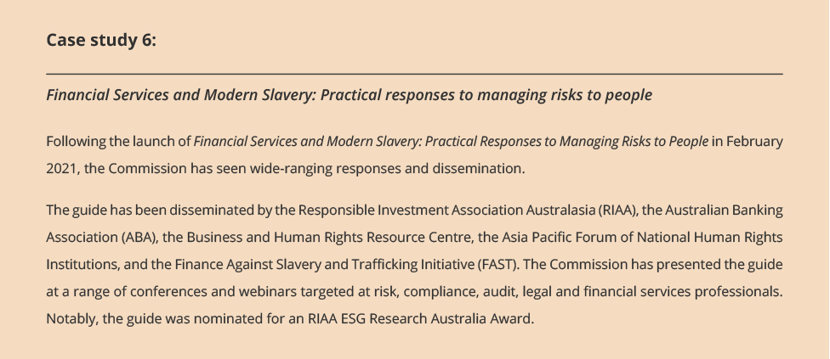
The Commission has also partnered with the Cleaning Accountability Framework (CAF) to tackle modern slavery and labour exploitation in the cleaning industry. Under the partnership, the Commission will provide expert human rights input into CAF’s approach to managing modern slavery risks, and the development of a resource for migrant workers.

Leading by example
As a small, Commonwealth Corporate Entity, the Commission is not required to report under the Modern Slavery Act 2018 (Cth). However, in this period, the Commission has continued under its ‘Leading by example’ project to take steps to identify and address key risk areas for modern slavery in our own supply chains. The Commission’s work in this space not only reflects our organisational values, but also aligns with the Commonwealth Government’s efforts to respond to modern slavery risks in government procurement.

Progress indicator 3.24
Instances of partners:
- increased knowledge and application of human rights frameworks, principles, and practices to advance human rights reform
- practice/policy reform relating to human rights principles, which are reviewed or developed as a result of technical cooperation activities.

International Programs
The Commission is funded by the Department of Foreign Affairs and Trade (DFAT) to conduct human rights capacity-building programs in the Asian region. Over the past year, activities were delivered online due to COVID-19 related travel restrictions.

Vietnam Human Rights Fund 2017-2021
Under the Vietnam Human Rights Fund, the Commission has two initiatives – the Human Rights Education Partnership, and the Advancing Responsible Business Conduct Partnership. Supported by DFAT, both Partnerships aim to contribute to the promotion and protection of human rights in Vietnam, over the 2017–2022 period.
1. Human Rights Education Partnership
This program focuses on assisting the Ho Chi Minh National Academy of Politics (the Academy) in its mandate to implement the Prime Minister’s decree on embedding human rights education into the Vietnamese curriculum, and to build the capacity of Vietnamese government agencies and educational institutions to enhance the promotion and protection of human rights through education. In the 2020– 2021 period, the program team has:
- supported the Academy in publishing online learning courses on human rights on the Academy’s website
- supported the Academy in seeking copyright permissions from various UN agencies for publishing Vietnamese language translations on key human rights publications
- liaised with the Academy on promoting and supporting the distribution of the Vietnamese language version of RightsApp
- entered into a Memorandum of Understanding with the Asia Pacific Forum of Human Rights Institutions on the translation of the Human Rights Education Manual into Vietnamese.
2. Advancing Responsible Business Conduct Partnership
This Partnership with the Vietnamese Chamber of Commerce and Industry (VCCI) aims to advance responsible business conduct in Vietnam through increasing the human rights knowledge and capabilities of businesses and future business leaders. Under this Partnership, the Commission has partnered with VCCI to deliver training to lecturers from business schools on responsible business conduct (see case study below) and has developed guidance for the apparel and footwear industry.
The Commission and VCCI launched the Responsible Business Conduct and the Apparel and Footwear Industry guidance and accompanying fact sheet in April 2021, in Hanoi. Opening remarks were delivered by Mr Nguyen Quang Vinh, Secretary General VCCI, and Ms Robyn Mudie, Australia’s Ambassador to Vietnam, signalling both Vietnam’s and Australia’s commitment to the issue of responsible business conduct.
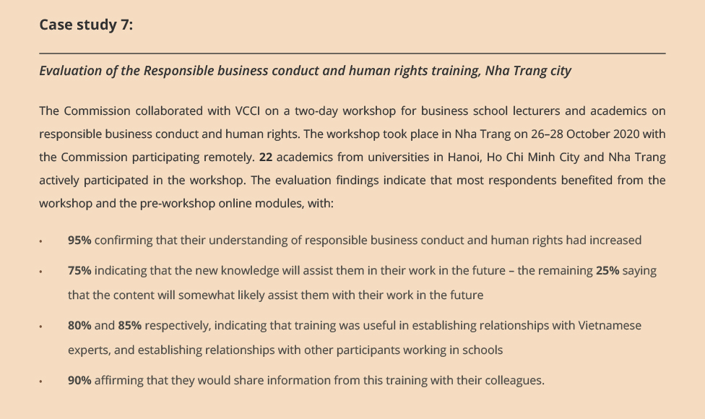

Lao PDR-Australia Human Rights Technical Cooperation Program (HRTCP)
The Lao PDR–Australia HRTCP is designed to strengthen the promotion and protection of human rights in the Lao People’s Democratic Republic (PDR), by sharing Australia’s experiences, supporting the Lao Government to enhance its engagement with the United Nations human rights mechanisms, and building capacity around the Convention on the Rights of People with Disability, the International Covenant on Economic, Social and Cultural Rights, and the Universal Periodic Review (UPR).
The year saw significant disruption to the program and its operation due to the COVID-19 pandemic, but was nevertheless able to make considerable gains by adopting new ways of working and remaining flexible. As a result of the pandemic, the HRTCP was extended and varied to include an additional program of work to assist the Government of Laos embed human rights principles in its COVID-19 recovery efforts. Overall, the HRTCP continues to operate successfully, and feedback from partners and activity participants has been positive.
In this period, the HRTCP delivered capacity-building seminars for lecturers and students at the National University of Laos on disability rights and UN treaty body engagement (see case study 8), and a UPR Implementation workshop for government officials (see case study 9). An online module on human rights in the context of COVID-19 is also under development.
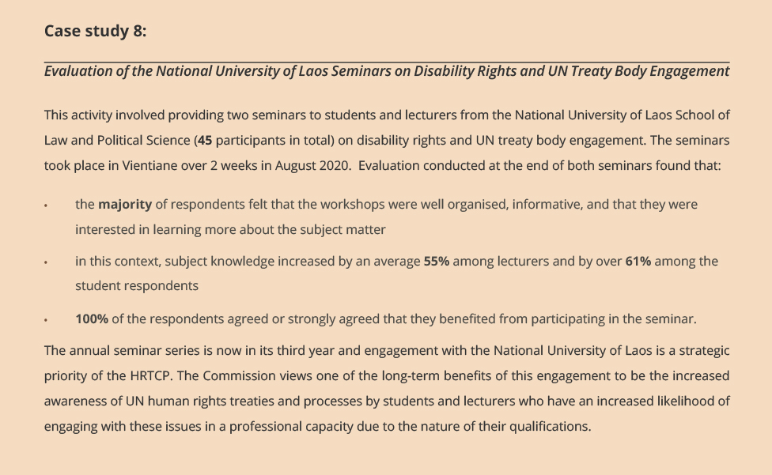
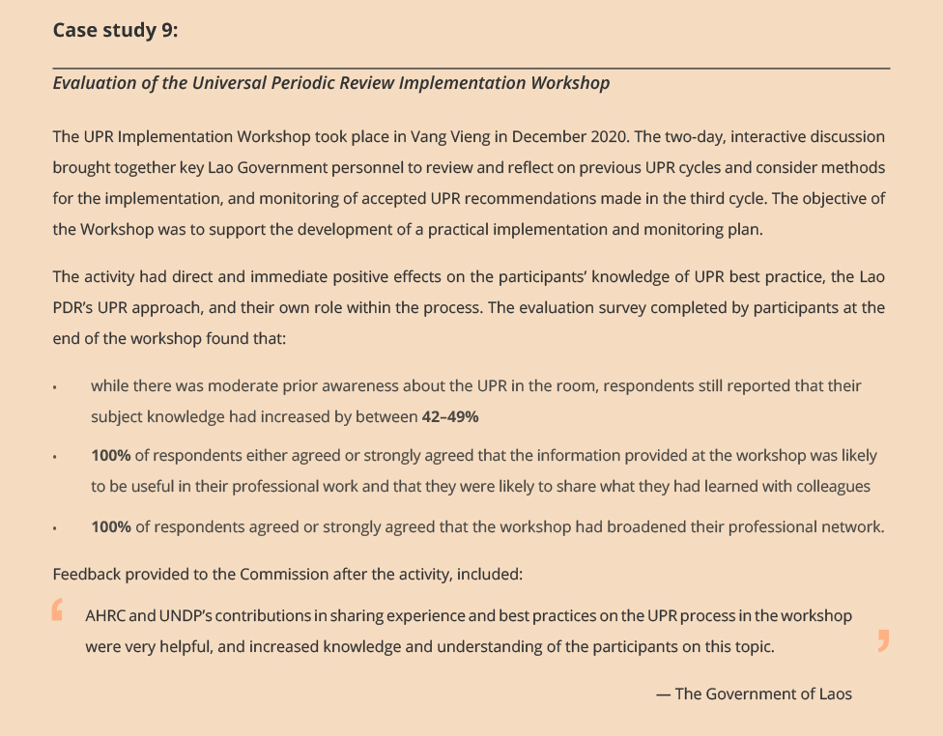
Now well established in its fourth year, the HRTCP has made solid progress towards all active end of program outcomes and strategic priorities. The HRTCP continues to be a valuable opportunity to engage with the Government of Laos on human rights related issues and share information about Australian practice and experience. Activity participants have reported on numerous occasions how valuable they found it to hear about international examples, and this will remain a key feature of the HRTCP for future years.
Over the four years of operation, the Commission has managed to adapt and evolve its program management processes to respond to the Lao PDR’s unique circumstances. Despite the pandemic disruptions this year, the positive outcomes to date have meant that a transparent and valuable relationship has developed between the two partners.

Supporting Human Rights in Association of Southeast Asian Nations (ASEAN)
The Commission engages with a range of key stakeholders in the Indo-Pacific region on a variety of issues, highlighting the Commission’s reputation in the region for providing high quality human rights technical input and capacity building and ability to foster strong relationships. In this reporting period:
- The Commission continued to play a leadership role in the Asia Pacific Forum of National Human Rights Institutions (APF), and the Global Alliance of National Human Rights Institutions (GANHRI) with the President serving as the APF Chair and on the GANHRI Bureau (board).
- The Australian Embassy in Cambodia approached the Commission in late January 2021 to seek its advice and support around Cambodia’s disability law reform process. Since then, the Commission has provided written feedback on the draft law, and Disability Discrimination Commissioner Dr Ben Gauntlett engaged in a successful high-level roundtable with representatives from the Cambodian Government and Australian Government.
- Disability Discrimination Commissioner Dr Ben Gauntlett participated in a webinar on Advancing the Protection of Disability Rights in ASEAN in the post-pandemic context on 19 April 2021.
- A program of work has been developed with the Vietnamese Government on human rights, technology, and cyber security.

Goal 4: Effective access to justice and remedy for people and communities whose rights are breached

Outcome 4.1 [PBS criterion]
We deliver a fair and effective investigation and conciliation service.

National Information and Investigation and Conciliation Services
In 2020–2021, the Commission assisted over 15,746 people and organisations by providing information about the law and the complaint process, assisting with problem solving, and providing referrals to other services.
In 2020–2021, the Commission accepted 3,113 complaints of alleged discrimination and breaches of human rights and finalised 2,624 complaints. The Commission conducted approximately 1,517 conciliation processes, of which 1,054 complaints (70%) were successfully resolved.

Progress indicator 4.11 [PBS target]
85% of complaints are finalised in under 12 months, 40% of complaints are resolved by conciliation, 85% of parties to complaints are satisfied with the service they receive.
In the 2020–2021 period, the Commission met and exceeded all criteria in the above indicator:
- 98% of complaints were finalised within 12 months
- 41% of complaints were resolved by conciliation
- 90% of surveyed participants reported that they were satisfied with the service they received, with 74% rating the service ‘very good’ or ‘excellent’
- 96% of surveyed participants to complaints that were conciliated reported that they were satisfied, and 84% rated the service as ‘very good’ or ‘excellent’ (figure 7, provides a breakdown of this data).
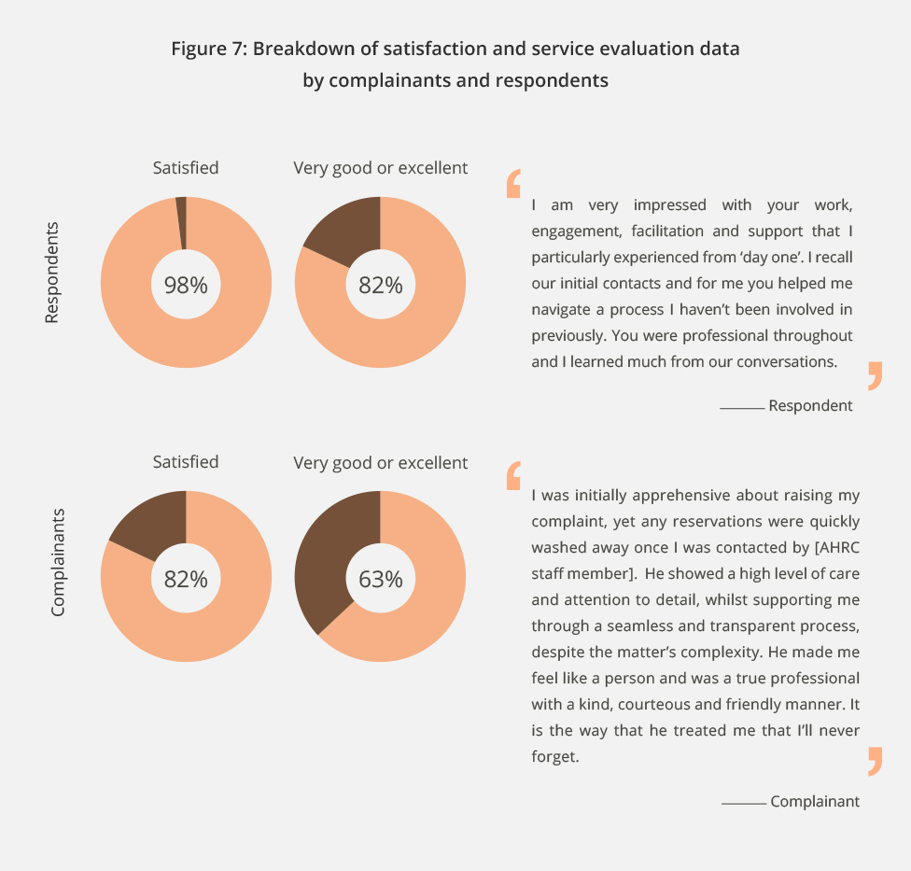

Progress indicator 4.12 [PBS target]
Instances where the terms on which investigation and conciliation disputes are resolved include systemic outcomes that accord with the objectives of the law.
Information on the outcomes of conciliated complaints under federal anti-discrimination law indicates that 38% of outcomes included terms which will have benefits for people beyond the individual complainant. For example, agreements to introduce anti-discrimination policies and provide anti-discrimination training in workplaces and agreements to undertake modifications to buildings and services to address potential discriminatory factors.

Progress indicator 4.13 [PBS target]
Instances where participation in the investigation and conciliation process results in increased understanding of rights and responsibilities in the law.
Commission evaluation survey data highlights the educative effect of the Commission’s complaint process. For example, in relation to conciliated complaints, 79% of surveyed participants indicated that involvement in the complaint process had assisted them to better understand their rights and responsibilities under federal human rights and anti-discrimination law.
These case studies are an example of outcomes under the above indicators.
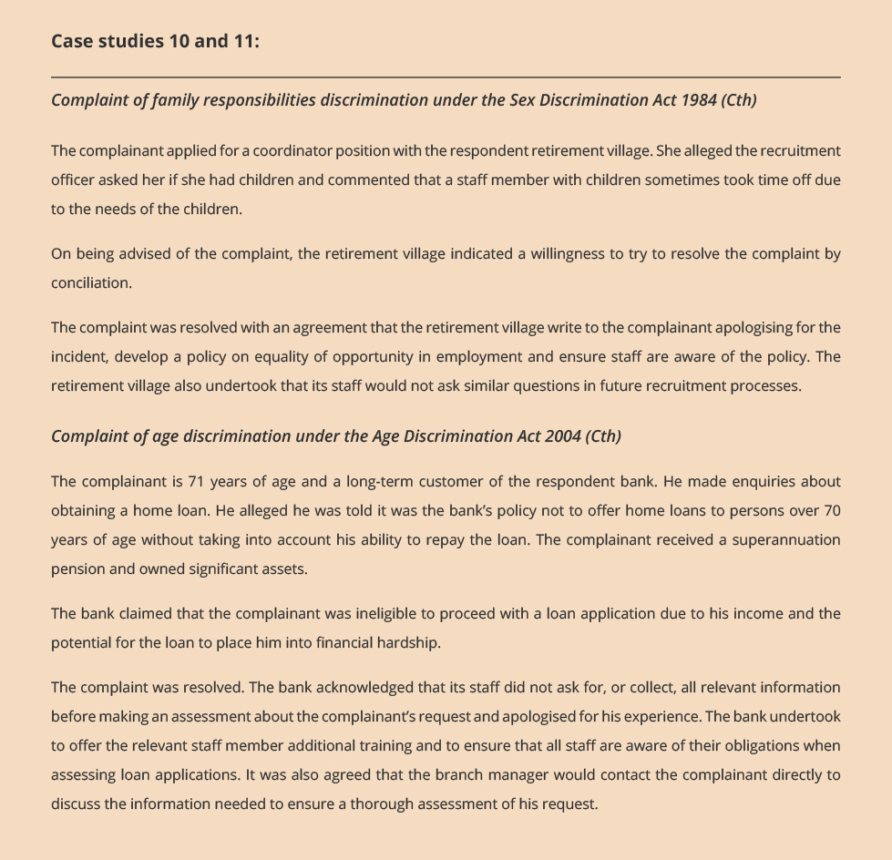

Performance Analysis – how we are meeting our goals

Introduction
The Commission operates in a complex and fluid cultural, social, economic, and political context. The nature of human rights issues is that they are many and diverse and the ultimate results (what difference, what benefit) of our activities are difficult to measure and attribute, generally being long-term and incrementally achieved, and undertaken collaboratively with multiple stakeholders.
In this context the Commission’s performance framework maps progress indicators to performance expectations that are feasible in the 1 to 4-year outlook of the Corporate Plan (all being well in our operating context).
This statement has provided a range of monitored and evaluated activities, project examples, and case studies to illustrate our performance.
The tables below provide an assessment of the extent to which we have met the performance expectations and the challenges, context, and lessons from this years’ experience.
Refer to Appendix 1 for the full performance measurement framework table.

Goal 1
Outcomes 1.1, 1.2, 1.3 (PBS criterion)
Performance expectation | To what extent did we meet it?
For outcome 1.1  Recommendations to Australia from the third United Nations (UN) Universal Periodic Review (UPR) are accepted by federal Government and progressed.  Recommendations and actions in the ‘national conversation’ report to the Attorney-General and federal Parliament are positively received and progressed or adopted. | The national conversation initiative and UPR project operate in a multi-year context. In this reporting period:  - A high degree of take up of the Commission’s recommendations was achieved through the UPR process, with the vast majority of recommendations adopted by countries. It now remains to be seen how actively the Australian Government will seek to address key human rights concerns that have been identified initially by the Commission and NGOs in Australia, and subsequently reflected by the international community.  - The final research and participatory consultation phases of the Free and Equal process have resulted in robust stakeholder engagement – strengthening the credibility and persuasiveness of the findings, delivering clear stakeholder-led narrative to anchor the recommendations and position papers as they are finalised in the next period.  - The testing through consultation of the Commission’s proposed recommendations for the Free and Equal project have also strengthened the proposed recommendations and built stakeholder buy-in for them.
For outcome 1.2  Our research, reporting, and advice influences decision makers and other stakeholders to take action to address the identified human rights issues. | Over the past year, the Commission has also advanced several research and reporting initiatives that are multi-year in their operation. These projects have achieved progress results that will strengthen their influence, including:  - empowering and inclusive consultation processes that participants feel have elevated their voices and views  - diverse stakeholders brought together with often differing vested interests and still generated ownership  - collaborative, strategic partnerships that have increased reach and accessed technical expertise benefiting the overall findings and outcomes of the projects.  A high degree of satisfaction was expressed by stakeholders across different projects and programs, indicating a high level of trust in and support for the Commission’s expertise and leadership role.
For outcome 1.3  Parliamentary committee inquiry reports adopt the human rights issues raised in our submissions and recommendations.  UN treaty body concluding observations and other recommendations are adopted by Government and implemented.  Arguments presented in our submissions to courts influence outcomes for parties and non-parties in a way that is consistent with human rights. | Trust in our human rights expertise, the rigour and evidence base of our analysis, and of our reputation for robust, independent engagement are critical to the success of the Commission against this outcome area.  In this reporting period, parliamentary submissions were referenced by parliamentary committees with a number of our issues reflected in the final inquiry reports. In our United Nations engagement, the Commission’s advice and recommendations were reflected in the outcomes of the Universal Periodic Review process.  The Commission has strict criteria for when it seeks leave of the court to intervene in legal proceedings. We only seek leave when it is appropriate to do so – accordingly, the number of interventions conducted is not a measure of the success of this work. A more reliable indicator is first, the acceptance by the courts of our request to intervene and, second, the extent to which our advice is used.  In this period, all our requests to intervene were accepted. The case studies presented in this statement show the contributions we made in these court proceedings.
Many of the projects and activities referred to under Goal 1 seek to provide national leadership by identifying important issues that are not sufficiently on the national policy agenda and create momentum for those issues to be addressed.
The Commission has been successful in raising awareness and building greater understanding of issues (such as the importance of focusing on human rights protections for new technologies, or on hearing the distinct voice of children, or Aboriginal and Torres Strait Islander girls and women to understand the main issues that affect them). Having achieved greater awareness and recognition of these issues, the challenge ahead is achieving systemic change to address concerns that have been identified. This is a longer-term objective which requires the Commission to advocate for issues that may not be priorities for government at the time that they are raised; and to identify opportunities that may arise to shift existing approaches through law, policy, and practice. This implementation challenge is bigger than the Commission, often requiring action from actors across multiple domains – political, business, and the community.
In the past year, the COVID-19 pandemic has created challenges to achieving this goal. The Commission has had to modify its approach to different projects, such as adapting to online consultation techniques and conducting awareness activities through virtual processes. The Commission has changed to the use of online technologies well, but this has nevertheless created challenges in accessing more vulnerable and marginalised communities, in outreach beyond the cities, and in building awareness of key findings at a time when the priority focus has to be on addressing the public health crisis facing the country and world.

Goal 2
Outcomes 2.1, 2.2 (both are PBS criterion)
Performance expectation | To what extent did we meet it?
For outcome 2.1  Participants in education activities benefit through achieving the stated human rights learning and capability objectives. | Human rights education is a mandated function of the Commission, achieved directly through specific training and resource development programs, and indirectly as a critical pre-condition in the success outcomes of other programs.  - In this statement we provide evidence of meeting this expectation through the development of targeted adult learning training packages expertly delivered. Participant level evidence shows this work has exceeded individual targets, with most participants very satisfied after finding them relevant, engagingly delivered, and worthwhile – and in turn reporting raised knowledge, understanding, ability, and skill results.  - This performance expectation is met and enhanced when individual training results are supported and sustained as part of a greater organisational educational and change agenda. Examples in this statement include initiatives where the Commission is working with partners to develop multi-faceted organisational approaches to achieving common human rights goals.  - In this reporting period, the Commission successfully transitioned its training strategy to focus on online delivery. This ensured training can be delivered within the parameters of existing physical distancing requirements while offering learners greater convenience and flexibility.
For outcome 2.2  Target audiences benefit from our information resources, services, campaigns, and events. | Foundational to meeting this expectation is that targeted audiences are reached, access our information resources and services, and participate in our events and campaigns.  The effectiveness of website and multimedia engagement in supporting reach and access is evidenced through the digital engagement data provided – which exceeded the 5% growth target for pageviews and website visits. This statement also lists a wide range of high-profile public events and educational and information resources that have been delivered. Access and reach are demonstrated through the stakeholder participation rates, digital access, and download data provided across the reported work.  This statement provides clear examples of this expectation through target audiences that have benefited from our legal and guideline resources and have found a key awareness campaign (and its resources) relevant and valuable.
The requirement to deliver all training through online techniques is likely to be a focus for some time due to the COVID-19 pandemic. The benefit of this is that it enables greater systematisation of our training resources, potential for larger reach beyond physical attendance requirements, and longevity through being able to utilise materials in multiple formats and contexts.
The challenge is maintaining online systems and educational resources that are engaging and useful, and that are targeted to need. The Commission is well placed to meet this challenge, and in 2020–2021 concluded a restructure of our public engagement and education staffing, building a skill-set to deepen our public engagement and conduct knowledge transfer through a variety of means.
Webinars and online industry forums have been a key strategy employed by the Commission to build awareness of the Respect@ Work and Human Rights and Technology reports, to great effect. Webinars have achieved significant participation rates, and satisfaction with quality and content. The online conduct of some events, for example the Kep Enderby annual lecture, have resulted in a significant increase in participation rates, demonstrating the long-term value of using such tools.
Our education and outreach work is growing, through a mix of fee for service opportunities and external partnerships. A challenge we will continue to face is balancing our proactive, resource development capacity so that we are relevant and a leading provider of content, and ensuring we have capacity to meet demand on emerging issues of concern to the community in a timely and effective manner.
We will continue to re-invest funding obtained through fee for service arrangements to grow our educational capacity and skills capacity, as well as maintaining rigorous evaluation processes to improve and grow our existing training work.
The Commission conducts a number of public events each year. We are focused on progressively building digital-based communication capacities, such as through in-house skills in developing infographics, short videos and other social media content; and in building into our work digital engagement strategies to improve our reach. We are also focused on identifying ways to adapt our materials for multiple audiences to achieve broader reach and awareness of human rights issues.

Goal 3
Outcomes 3.1, 3.2 (both are PBS criterion)
Performance expectation | To what extent did we meet it?
For outcome 3.1  Participants and stakeholders, in our consultations, research and education, and informing activities experience participation, empowerment and benefit. | Ensuring authentic and inclusive participation in our programs and initiatives is an important Commission value. Achieving it also strengthens the credibility and influence of the reports and other products that projects culminate with. This statement provides:  - Examples of initiatives that have achieved inclusive participation strategies that attracted a diverse range of stakeholders to activities and in turn receiving feedback on the authenticity of the Commission’s leadership and independence in that activity.  - Examples of initiatives that demonstrate the performance expectation through the empowerment and benefit of more vulnerable participants in consultations, research and education, and informing activities. Several of these initiatives describe activities that build on the empowerment through participation providing real time participant feedback, such as consultation results presented as word cloud resources that can be shared among the community or community versions of the reports. In the coming period, several will develop education and advocacy resources for communities to use by and for themselves.
For outcome 3.2  Our activities with stakeholder organisations lead to systemic and sustained action, including changes to organisational policy and practice, to protect and promote human rights in their context.  Our activities with Australian business increase their capability to identify, prevent, and address modern slavery in their operations and supply chains.  Our regional technical cooperation activities increase stakeholder capacity to advance national reform in partner states. | In this period, most initiatives working directly with partner organisations have met or progressed this expectation.  Examples in the statement demonstrate foundational results across these expectations through activities that have first increased participating organisations understanding of the impact of their systems and operations on human rights, and then gone on to collaboratively deliver activities that turn human rights from legal instruments into effective policies and practical realities.  The benefit from initiatives undertaken with several partners is also illustrated by the renewal of multi-year funding arrangements and the establishment of new partnerships.  The activities of our business and human rights strategy evidence how we have met this expectation through the collective results of multi-year activities in which business participants report an increased understanding of their role in preventing modern slavery and greater capacity to take practical action address it.  Regional technical cooperation programs:  These programs work in a long-term multi-year context where this expectation is progressed within the challenges of international work. This statement demonstrates progressive results towards this expectation that include the strengthening of relationships between the Commission and the key implementing state partners, positive learning outcomes from the annual programs of human rights educational and knowledge exchange events, and the commencement of technical information resources.  With the onset of COVID-19 these programs pivoted to blended learning models. This combination of online modules and interactive sessions allows the capacity-building work to continue, despite the travel restrictions. The value of these initiatives to both he regional countries and the Australian Government is further illustrated by the extensions to the scope of programs in both countries.
Critical to achieving this goal is the development of effective partnerships at the community level and with sectors of society, such as sporting organisations and the business community. The Commission is currently revamping its national anti-racism strategy, which has the potential to foster many partnerships across different sectors and provide a basis for greater collaboration across sectors.
The Commission has formed effective partnerships with sporting organisations through its work on child safety, as well as sports specific guidance to assist compliance with discrimination laws and in assisting cultural reform initiatives. The challenges to undertaking this work relate to our small staffing footprint to progress partnerships and the need for individual activities to be fully funded (requiring us to be agile and flexible in staffing projects at short notice).
Effective community partnerships also enable the Commission to access members of the community who may be distrusting of government or otherwise difficult to access.

Goal 4
Outcomes 4.1 (PBS criterion)
Performance expectation | To what extent did we meet it?
For outcome 4.1  Our investigation and conciliation of complaints and dispute resolution meet performance indicators on timeliness, efficiency, and service user satisfaction. | In the 2020–2021 period, the Commission met and exceeded all targets.
For outcome 4.1  Our investigation and conciliation of complaints and dispute resolution processes have systemic and educational outcomes. | Nearly half or 38% of conciliated outcomes included terms beneficial for people beyond the individual complainant.
The Commission’s National Information Service (NIS) and Investigation and Conciliation Service (ICS) both contribute significantly to the Commission’s key functions as Australia’s National Human Rights Institution, by providing education about human rights and responsibilities and by providing an accessible, fair and impartial complaint-handling process.
Throughout the 2020–2021 reporting year, COVID-19 has continued to drive exceptionally high complaint numbers and inquiries. COVID-19 related international travel restrictions and COVID-19 related measures such as mandatory mask wearing and vaccinations have contributed to the Commission receiving the highest number of complaints on record in 2020–2021. This upward trend is continuing and current projections estimate complaints received for the 2021-22 reporting period to be over 4,500.
The unprecedented number of complaints has impacted on the speed in which the ICS is able to action complaints with a consequential increase in complaint-handling timeframes. Additionally, while there is broad community support for state and Commonwealth government measures designed to protect public safety, it is inevitable that some measures appear to have had a disproportionate impact on certain cohorts within the community. Notable examples include Australian citizens and permanent residents unable to return to Australia due to travel caps, and people with disability who feel unfairly targeted by some of the protective measures widely adopted across Australia, such as mandatory mask wearing.
Despite the above challenges, over 1,050 complaints were resolved through an ICS conciliation process in 2020–2021. This represents successful dispute resolution for well over 2,300 individuals and organisations, notwithstanding the extraordinary challenges faced by the community grappling with evolving COVID-19 realities.
The ongoing state lockdowns and travel restrictions have restricted staff ability to travel. This has led to continuing and expanded use of technology, which has in turn enabled ICS staff to bring together individuals located across Australia in a single conciliation and encouraged the facilitation of cross-country community education forums in ways not previously explored.

Financial Statements

Independent Audit Report 86
Statement by the Accountable Authority and Chief Finance Officer 88
Statement of Comprehensive Income 89
Statement of Financial Position 91
Statement of Changes in Equity 93
Cash Flow Statement 96
Notes to and forming part of the financial statements 98
Overview 98
1. Financial Performance 101
2. Financial Position 108
3. Funding 122
4. People and Relationships 122
5. Managing Uncertainties 126
6. Other Information 131

Independent Audit Report
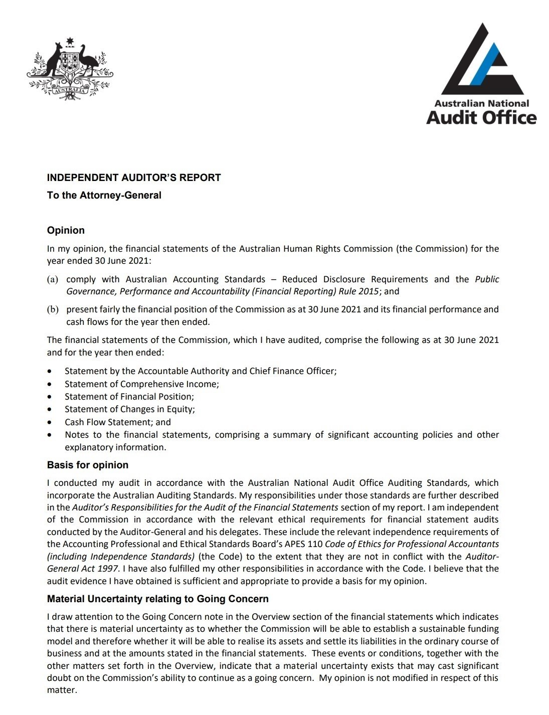
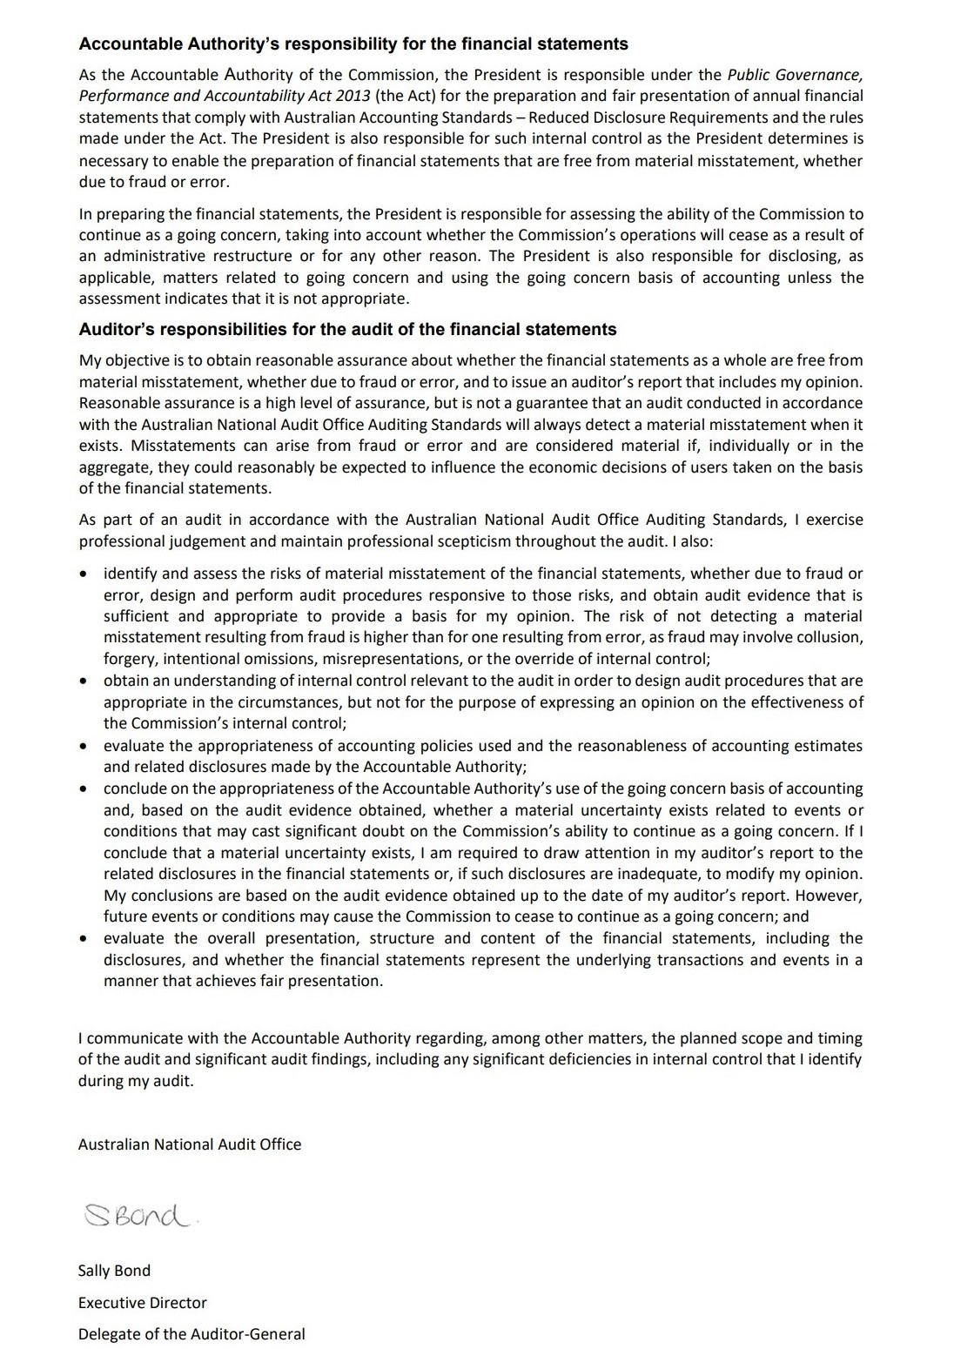

Statement by the Accountable Authority and Chief Finance Officer
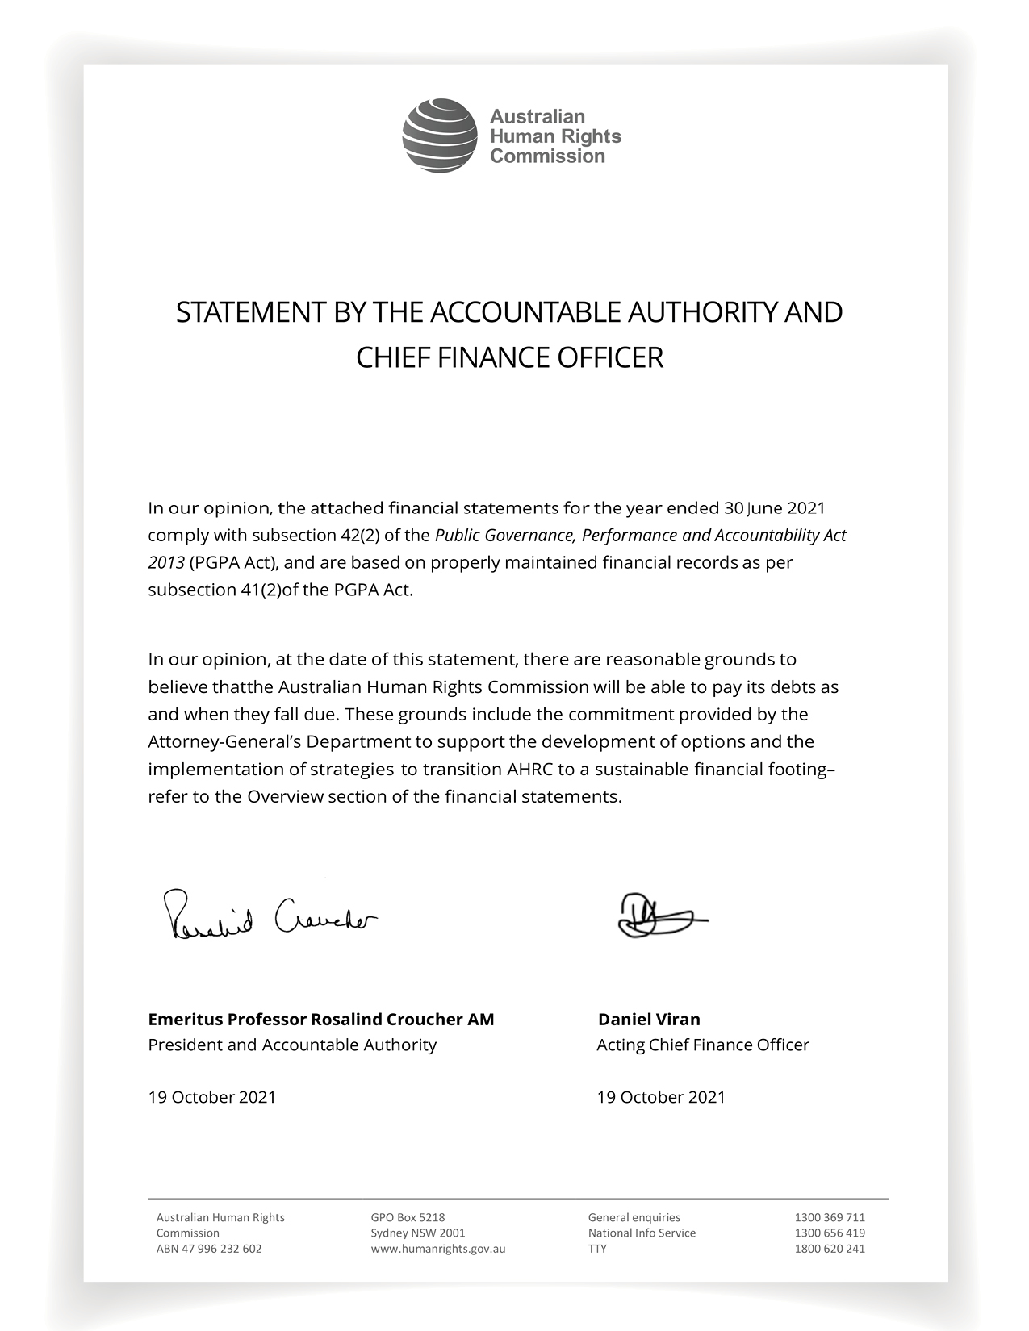

Statement of Comprehensive Income
for the period ended 30 June 2021
 |  | 2021 | 2020 | Original Budget
 | Notes | $'000 | $'000 | $'000
NET COST OF SERVICES
Expenses
Employee benefits | 1.1A | 20,345 | 19,522 | 15,657
Suppliers | 1.1B | 4,394 | 5,213 | 3,576
Depreciation and amortisation | 2.2A | 4,251 | 4,177 | 3,819
Finance costs | 1.1C | 15 | 47 | -
Other expenses | 1.1D | 349 | - | -
Total expenses |  | 29,353 | 28,959 | 23,052
Own-source income
Own-source revenue
Rendering of Services | 1.2A | 7,126 | 5,408 | 5,484
Interest | 1.2B | 7 | 40 | 50
Other Revenue | 1.2C,D | 980 | 1,198 | 985
Total own-source revenue |  | 8,112 | 6,646 | 6,519
Gains
Other Gains | 1.2E | - | 1 | 46
Total gains |  | - | 1 | 46
Total own-source income |  | 8,112 | 6,647 | 6,565
Net cost of services |  | (21,241) | (22,312) | (16,487)
Revenue from Government | 1.2F | 16,515 | 16,538 | 16,515
Deficit attributable to the Australian Government |  | (4,726) | (5,774) | 28
OTHER COMPREHENSIVE INCOME
Items not subject to subsequent reclassification to net cost of services
Changes in asset revaluation reserve |  | 1,815 | 171 | -
Total other comprehensive income |  | 1,815 | 171 | -
The above statement should be read in conjunction with the accompanying notes.

Budget Variances Commentary
Primary variances relate to the suppliers, rendering of services revenue, employee benefits, and changes in asset revaluation reserve. Supplier variance is related to expenditure incurred in the delivery of a new Budget measure and new partnership agreements during the financial period. The rendering of services revenue is also related to the new partnership agreements. Higher than anticipated employee benefits costs relate to recruitment of non-ongoing staff to support the activities of the new Budget measure and partnership projects. The change in asset revaluation reserve reflects the fair value increment to leasehold improvements and aligns with the Commission's new property lease term. Detailed commentary on the operating loss is included in the Overview, under the Going Concern Basis of Accounting.

Statement of Financial Position
as at 30 June 2021
 |  | 2021 | 2020 | Original Budget
 | Notes | $’000 | $’000 | $’000
ASSETS
Financial assets
Cash and cash equivalents | 2.1A | 3,356 | 2,575 | 4,237
Trade and other receivables | 2.1B | 1,498 | 3,317 | 602
Total financial assets |  | 4,854 | 5,892 | 4,839
Non-financial assets¹
Property lease | 2.2A | - | 2,975 | -
Infrastructure, Plant and Equipment | 2.2A | 1,893 | 1,006 | 632
Intangibles | 2.2A | 557 | 812 | 594
Other Non-Financial Assets | 2.2B | 531 | 346 | 346
Total non-financial assets |  | 2,981 | 5,140 | 1,572
Total assets |  | 7,835 | 11,032 | 6,411
LIABILITIES
Payables
Suppliers | 2.3A | 1,767 | 963 | 957
Other Payables | 2.3B | 6,599 | 5,475 | 4,814
Total payables |  | 8,366 | 6,438 | 5,771
Interest bearing liabilities
Leases | 2.4A | - | 3,051 | -
Total interest bearing liabilities |  | - | 3,051 | -
Provisions
Employee provisions | 4.1A | 4,905 | 4,069 | 3,138
Total provisions |  | 4,905 | 4,069 | 3,138
Total liabilities |  | 13,271 | 13,558 | 8,909
Net liabilities |  | (5,436) | (2,525) | (2,498)
EQUITY
Contributed equity |  | 2,511 | 2,511 | 2,511
Reserves |  | 2,451 | 637 | 637
Accumulated losses |  | (10,399) | (5,672) | (5,646)
Total equity |  | (5,436) | (2,525) | (2,498)
The above statement should be read in conjunction with the accompanying notes.
1. Right-of-use assets are included in the property lease line item.

Budget Variances Commentary
ASSETS
Total assets are higher than budgeted due to the fair value increment of leasehold improvements and the timing difference of trade receivables.
LIABILITIES
Total liabilities are higher than budgeted due to higher revenue received in advance from new partnership agreements, higher employee provisions related to COVID-19 and reduced leave taken and timing difference of suppliers payable..
EQUITY
Total equity reflects the operating loss accumulated results from prior years. The Overview, under the Going Concern Basis of Accounting provides further details.

Statement of Changes in Equity
for the period ended 30 June 2021
 |  | 2021 | 2020 | Original Budget
 | Notes | $’000 | $’000 | $’000
CONTRIBUTED EQUITY
Opening balance
Balance carried forward from previous period |  | 2,511 | 2,511 | 2,511
Closing balance as at 30 June |  | 2,511 | 2,511 | 2,511
ACCUMULATED LOSSES
Opening balance
Balance carried forward from previous period |  | (5,673) | (1,935) | (5,674)
Adjustment for errors |  | - | (5) | -
Adjustment on initial application of AASB 16 |  | - | 2,041 | -
Adjusted opening balance |  | (5,673) | 101 | (5,674)
Comprehensive income
Surplus/(Deficit) for the period |  | (4,726) | (5,774) | 28
Closing balance as at 30 June |  | (10,399) | (5,673) | (5,646)
ASSET REVALUATION RESERVE
Opening balance
Balance carried forward from previous period |  | 637 | 466 | 637
Comprehensive income
Other comprehensive income |  | 1,815 | 171 | -
Closing balance as at 30 June |  | 2,452 | 637 | 637
TOTAL EQUITY
Opening balance
Balance carried forward from previous period |  | (2,525) | 1,042 | (2,526)
Adjustment for errors |  | - | (5) | -
Adjustment for changes in accounting policies |  | - | 2,041 | -
Adjusted opening balance |  | (2,525) | 3,078 | (2,526)
Comprehensive income
Surplus/(Deficit) for the period |  | (4,726) | (5,774) | 28
Other comprehensive income |  | 1,815 | 171 | -
Total comprehensive income |  | (2,911) | (5,603) | 28
Transactions with owners
Contributions by owners |  | - | - | -
Total transactions with owners |  | - | - | -
Closing balance as at 30 June |  | (5,436) | (2,525) | (2,498)
The above statement should be read in conjunction with the accompanying notes
Accounting Policy
Equity Injections
Amounts appropriated which are designated as ‘equity injections’ for a year (less any formal reductions) and Departmental Capital Budgets (DCBs) are recognised directly in contributed equity in that year.
Budget Variances Commentary
Equity has decreased due to the operating result for the reporting period and reflects prior year accumulated losses.
As a corporate Commonwealth entity and in accordance with Budget Process Operating Rules the Commission budgets for a break-even operating result.
During the reporting period a combination of factors as outlined in the commentary on the Statement of Comprehensive Income resulted in an operating deficit. Further details are provided in the Overview, under the Going Concern Basis of Accounting.

Cash Flow Statement
for the period ended 30 June 2021
 |  | 2021 | 2020 | Original Budget
 | Notes | $’000 | $’000 | $’000
OPERATING ACTIVITIES
Cash received
Receipts from Government |  | 16,515 | 16,538 | 16,515
Sale of goods and rendering of services |  | 11,915 | 7,431 | 6,534
Interest |  | 7 | 40 | 50
GST received |  | 276 | 387 | -
Total cash received |  | 28,713 | 24,396 | 23,099
Cash used
Employees |  | (21,020) | (19,609) | (15,147)
Suppliers |  | (3,749) | (5,611) | (3,030)
Interest payments on lease liabilities |  | (15) | (46) | -
Total cash used |  | (24,784) | (25,266) | (18,177)
Net cash from/(used by) operating activities |  | 3,929 | (870) | 4,922
INVESTING ACTIVITIES
Cash used
Purchase of property, plant and equipment |  | (6) | (139) | (266)
Purchase of intangibles |  | (91) | (458) | -
Total cash used |  | (97) | (597) | (266)
Net cash from/(used by) investing activities |  | (97) | (597) | (266)
FINANCING ACTIVITIES
Cash used
Principal payments of lease liabilities |  | (3,051) | (2,900) | (2,994)
Total cash used |  | (3,051) | (2,900) | (2,994)
Net cash from/(used by) financing activities |  | (3,051) | (2,900) | (2,994)
Net increase/(decrease) in cash held |  | 781 | (4,367) | 1,662
Cash and cash equivalents at the beginning of the reporting period |  | 2,575 | 6,942 | 2,575
Cash and cash equivalents at the end of the reporting period | 2.1A | 3,356 | 2,575 | 4,237
The above statement should be read in conjunction with the accompanying notes.
Budget Variances Commentary
The major Cash Flow Statement variances include cash received and used for operating activities and cash used for investing activities.
During the reporting period the Commission continued to meet its statutory obligations and increased workload for the delivery of its program outcomes which impacted cash utilisation on operating activities.
Reduced purchases of plant and equipment reflect the deferral of this expenditure and redirection of funds to meet operating activities.

Notes to and forming part of the financial statement
for the period ended 30 June 2021

Overview
Objectives of the Entity
The Australian Human Rights Commission (the Commission) is an Australian Government controlled entity. It is a not-for-profit entity. The Commission's objective is to ensure that Australians have access to independent human rights complaint handling and public inquiry processes and benefit from human rights education, promotion, monitoring and compliance activities.
The Commission is structured to meet the following outcome:
An Australian society in which human rights are respected, protected and promoted through independent investigation and resolution of complaints, education and research to promote and eliminate discrimination, and monitoring, and reporting on human rights.
The continued existence of the entity in its present form and with its present programs is dependent on Government policy and on continuing funding by Parliament for the entity’s administration and programs.
The Basis of Preparation
The financial statements are general purpose financial statements and are required by section 42 of the Public Governance, Performance and Accountability Act 2013.
The financial statements have been prepared in accordance with:
- Public Governance, Performance and Accountability (Financial Reporting) Rule 2015 (FRR); and
- Australian Accounting Standards and Interpretations – Reduced Disclosure Requirements issued by the Australian Accounting Standards Board (AASB) that apply for the reporting period.
The financial statements have been prepared on an accrual basis and in accordance with the historical cost convention, except for certain assets and liabilities at fair value. Except where stated, no allowance is made for the effect of changing prices on the results or the financial position. The financial statements are presented in Australian dollars.
Going Concern Basis of Accounting
The financial statements have been prepared on a going concern basis under the Australian Accounting Standards which assumes that AHRC will realise assets and settle liabilities in the ordinary course of business, and amounts have been recognised on this basis.
The Commission is a national independent statutory body established under the Australian Human Rights Commission Act 1986. It would require legislative change to either cease or wind-up operations.
The Commission made an operating loss of $4.726 million for the year ended 30 June 2021 (2019-20: loss of $5.774 million). As at 30 June 2021, the Commission has accumulated losses of $10.399 million (2019-20: $5.672 million), net liabilities of $5.436 million (2019-20: $2.525 million) and net current liabilities of $5.327 million (2019-20: $6.407 million). The balance of cash and equivalents as at 30 June 2021 was $3.356 million (2019-20: $2.575 million).
The Commission has prepared cashflow forecasts which indicate that it will have insufficient cash to fund its operations for at least 12 months from the date of signing these financial statements without additional funding and support.
The Attorney-General’s Department has committed to establishing a steering committee, in conjunction with AHRC and the Department of Finance, to support the development of options and the implementation of strategies to transition Commission to a sustainable financial footing. The committee will provide the Attorney-General’s Department with the basis upon which it will determine the amount and timing of funding it will allocate from its reserves in 2021-22 to support the transition.
Despite the commitment from the Attorney-General’s Department to identify options and strategies to address the Commission's current financial position, there is material uncertainty as to whether the Commission will be able to establish a sustainable funding model, and therefore be able to realise its assets and settle its liabilities in the ordinary course of business and at the amounts stated in the financial statements. The financial statements do not include any adjustments to assets and liabilities that may be necessary if the Commission is unable to continue as a going concern.
New Accounting Standards
Adoption of New Australian Accounting Standard Requirements
No accounting standard has been adopted earlier than the application date as stated in the standard.
The following new standard were issued prior to the signing of the statement by the accountable authority and chief finance officer, were applicable to the current reporting period and had no material effect on the Commission's financial statements:

Standard/ Interpretation | Nature of change in accounting policy, transitional provisions*, and adjustment to financial statements
AASB 1059 Service Concession Arrangements: Grantors | - AASB 1059 became effective from 1 July 2020.  - The new standard addresses the accounting for a service concession arrangement by a grantor that is a public sector entity by prescribing the accounting for the arrangement from a grantor’s perspective.  - Prior to the issuance of AASB 1059, there was no definitive accounting guidance in Australia for service concession arrangements, which include a number of public private partnerships (PPP) arrangements. The AASB issued the new standard to address the lack of specific accounting guidance and based the content thereof broadly on its international equivalent: International Public Sector Accounting Standard 32: Service Concession Arrangements: Grantor.  - The details of the changes in accounting policies, transitional provisions and adjustments are disclosed below and in the relevant notes to the financial statements.

Application of AASB 1059 Service Concession Arrangements: Grantors
AASB 1059 Service Concession Arrangements: Grantors has no impact on the Commission.
Taxation
The entity is exempt from all forms of taxation except Fringe Benefits Tax (FBT) and the Goods and Services Tax (GST).
Events After the Reporting Period
The Commission is not aware of any significant events that have occurred since balance date that warrant disclosure in these financial statements.

1. Financial Performance
This section analyses the financial performance of Australian Human Rights Commission for the year ended 2021.

1.1 Expenses
 | 2021 | 2020
 | $’000 | $’000
1.1A: Employee benefits
Wages and salaries | 15,807 | 15,001
Superannuation
Defined contribution plans | 1,835 | 1,759
Defined benefit plans | 631 | 645
Leave and other entitlements | 1,788 | 1,765
Separation and redundancies | 116 | 134
Other employee expenses | 168 | 218
Total employee benefits | 20,345 | 19,522
Accounting Policy
Accounting policies for employee related expenses is contained in the People and relationships section.
1.1B: Suppliers
Goods and services supplied or rendered
General property operating expenses | 1,020 | 1,129
Insurance | 51 | 44
Office consumables | 55 | 87
Official travel | 173 | 768
Postage and freight | 17 | 12
Printing and publications | 212 | 148
Professional services and fees | 1,656 | 1,769
Reference materials, subscriptions and licenses | 734 | 576
Staff training | 33 | 101
Telecommunications | 111 | 127
Other | 176 | 315
Total goods and services supplied or rendered | 4,238 | 5,077
Goods supplied | 267 | 235
Services rendered | 3,971 | 4,842
Total goods and services supplied or rendered | 4,238 | 5,077
Other suppliers
Workers compensation expenses | 30 | 25
Low value leases | 126 | 111
Total other suppliers | 156 | 136
Total suppliers | 4,394 | 5,213
Accounting Policy
Short-term leases and leases of low-value assets
The Commission has elected not to recognise right-of-use assets and lease liabilities for short-term leases of assets that have a lease term of 12 months or less and leases of low-value assets (less than $10,000). The Commission recognises the lease payments associated with these leases as an expense on a straight-line basis over the lease term.
1.1C: Finance costs
Interest on lease liabilities | 15 | 47
Total finance costs | 15 | 47
Accounting Policy
All borrowing costs are expensed as incurred.
1.1D: Other expenses
Reconciled data migration balances | 9 | -
Reconciled shared service arrangement MOU balances | 340 | -
Total other expenses | 349 | -

1.2 Own-Source Revenue and Gains
 | 2021 | 2020
 | $’000 | $’000
Own-Source Revenue
1.2A: Rendering of Services
Rendering of services | 7,126 | 5,408
Total revenue from contracts with customers | 7,126 | 5,408
Disaggregation of revenue from contracts with customers
Major product / service line:
Service delivery | 7,126 | 5,408
 | 7,126 | 5,408
Type of customer:
Australian Government entities (related parties) | 6,265 | 4,784
State and Territory Governments | 6 | 100
Non-government entities | 855 | 524
 | 7,126 | 5,408
Timing of transfer of goods and services:
Over time | 6,641 | 4,673
Point in time | 485 | 735
 | 7,126 | 5,408

Accounting Policy
Revenue from the rendering of services is recognised when performance of specific service obligations, that are required and enforceable under a contract or agreement made between the Commission and the customer, sufficiently allow the Commission to determine when they have been satisfied.
The principal activities from which the Commission generates its revenue include, service fees and direct cost recoveries from the supply of domestic and international human rights technical assistance programs, development of education resources and delivery of training services, provision of shared corporate services and accommodation, and interest earned on short-term bank deposits.
The Commission predominantly provides services to its customers under agreed terms and conditions contained in contracts or agreements made between the two parties. The nature, timing of satisfaction of performance obligations, and any significant payment terms are specified in the agreed terms and conditions, milestones and payment schedules.
The transaction price is the total amount of consideration to which the Commission expects to be entitled in exchange for transferring promised services to a customer. The consideration promised in a contract with a customer may include fixed amounts, variable amounts, or both. No consideration from contracts is excluded in the transaction price. In the event that a change is required to any of the terms and conditions contained in a contract or agreement, including transaction price, a Contract Variation is agreed between the parties. The Commission has a right to consideration from a customer in an amount that corresponds directly with the value to the customer of the Commission's performance completed to date under the original contract or subsequent variations to the contract.
Where performance obligations are satisfied over time, revenue is recognised monthly in arrears following a review costs incurred for the delivery of service obligations for the project(s) and activities related to the customer contract. Costs incurred are primarily recurring in nature, and the customer simultaneously receives and effectively gains control of the services as the Commission performs its obligations.
Revenue for performance obligations satisfied at a point in time is recognised in accordance with specified milestones for the performance of obligations in the contract, for example "acceptance of a final report by the customer". Customer contracts with performance obligations satisfied at a point in time are short-term and include agreed dates for completion of milestones and transferral of any deliverable(s), this also indicates when a customer obtains control of outputs from the promised services. Milestone completion is confirmed with relevant contract manager prior to revenue recognition.
Receivables for goods and services, which have 30 day terms, are recognised at the nominal amounts due less any impairment allowance account. Collectability of debts is reviewed at end of the reporting period. Allowances are made when collectability of the debt is no longer probable.

 | 2021 | 2020
 | $’000 | $’000
1.2B: Interest
Deposits | 7 | 40
Total interest | 7 | 40
Accounting Policy
Interest revenue is recognised using the effective interest method.
1.2C: Other Revenue
Operating lease
Sub lease rental income | 934 | 1,152
Total rental income | 934 | 1,152
1.2D: Other Revenue
Resources received free of charge
Remuneration of auditors | 46 | 46
Total other revenue | 46 | 46
Accounting Policy
Resources Received Free of Charge
Resources received free of charge are recognised as revenue when, and only when, a fair value can be reliably determined and the services would have been purchased if they had not been donated. Use of those resources is recognised as an expense. Resources received free of charge are recorded as either revenue or gains depending on their nature.
Gains
1.2E: Other Gains
Other - Sale of assets | - | 1
Total other gains | - | 1
Accounting Policy
Other Gains
Gains on the reduction of prior year provisions are recognised at their nominal value as gains, when, and only when, the original provision for services has been determined to no longer be required.
Sale of Assets
Gains from disposal of assets are recognised when control of the asset has passed to the buyer.
1.2F: Revenue from Government
Attorney-General's Department:
Corporate Commonwealth entity payment item | 16,515 | 16,538
Total revenue from Government | 16,515 | 16,538
Accounting Policy
Revenue from Government
Funding received from the Attorney-General's Department (received by the Commission as a corporate Commonwealth entity) is recognised as Revenue from Government unless the funding is in the nature of an equity injection or a loan.

2. Financial Position
This section analyses the Australian Human Rights Commission assets used to conduct its operations and the operating liabilities incurred as a result. Employee related information is disclosed in the People and Relationships section.

2.1 Financial Assets
 |  | 2021 | 2020
 |  | $’000 | $’000
2.1A: Cash and cash equivalents
Cash on hand and at bank |  | 3,356 | 2,575
Total cash and cash equivalents |  | 3,356 | 2,575

Accounting Policy
Cash is recognised at its nominal amount. Cash and cash equivalents includes:
a) cash on hand;
b) demand deposits in bank accounts with an original maturity of 3 months or less that are readily convertible to known amounts of cash and subject to insignificant risk of changes in value. At the reporting date the Commission did not hold any term deposits with a maturity greater than three months.

2.1B: Trade and other receivables
Goods and services receivables
Goods and services |  | 1,498 | 3,317
Total goods and services receivables |  | 1,498 | 3,317
Other receivables
Interest |  | - | -
GST Receivable from the Australian Taxation Office |  | - | -
Total other receivables |  | - | -
Total trade and other receivables (gross) |  | 1,498 | 3,317
Less impairment loss allowance |  | - | -
Total trade and other receivables (net) |  | 1,498 | 3,317
Trade and other receivables (net) expected to be recovered
More than 12 months |  | 1,498 | 3,317
Total trade and other receivables (net) |  | 1,498 | 3,317
Accounting Policy
Receivables
Receivables are measured at amortised cost using the effective interest method less impairment.

2.2 Non-Financial Assets
2.2A: Reconciliation of the Opening and Closing Balances of Property Lease, Infrastructure, Plant and Equipment and Intangibles
Reconciliation of the Opening and Closing Balances of Property Lease, Infrastructure, Plant and Equipment and Intangibles for 2021
 | Property Lease | Lease Improvements | Lease Improvements - Work in Progress | Computer, Plant and Equipment | Intangibles |  | Intangibles - Work in Progress | Total
 | $’000 | $’000 | $’000 | $’000 | $’000 |  | $’000 | $’000
As at 1 July 2020
Gross book value | 5,951 | 852 | 5 | 149 | 2,407 |  | - | 9,364
Accumulated depreciation, amortisation and impairment | (2,975) | - | - | - | (1,595) |  | - | (4,570)
Total as at 1 July 2020 | 2,975 | 852 | 5 | 149 | 812 |  | - | 4,794
Adjusted total as at 1 July 2020 | 2,975 | 852 | 5 | 149 | 812 |  | - | 4,794
Additions
Purchase | - | - | 1 | - | 36 |  | 55 | 92
Work in progress transfer | - | 6 | (6) | - | - |  | - | -
Revaluations and impairments recognised in other comprehensive income | - | 1,775 | - | 40 | - |  | - | 1,815
Depreciation and amortisation | - | (842) | - | (88) | (346) |  | - | (1,275)
Depreciation on right-of-use assets | (2,975) | - | - | - | - |  | - | (2,975)
Total as at 30 June 2021 | - | 1,791 | - | 101 | 502 |  | 55 | 2,450
Total as at 30 June 2021 represented by
Gross book value | 5,951 | 1,791 | - | 101 | 2,443 |  | 55 | 10,342
Accumulated depreciation, amortisation and impairment | (5,951) | - | - | - | (1,941) |  | - | (7,893)
Total as at 30 June 2021 | - | 1,791 | - | 101 | 502 |  | 55 | 2,450
Carrying amount of right-of-use assets | - | - | - | - | - |  | - | -
No indicators of impairment were found for infrastructure, plant and equipment and intangibles.
No infrastructure, plant and equipment and intangibles are expected to be sold or disposed of within the next 12 months.
Revaluations of non-financial assets
All revaluations were conducted in accordance with the revaluation policy stated at Note 2.2. On 30 June 2021, an independent valuer conducted the revaluations.

Reconciliation of the opening and closing balances of Infrastructure, Plant and Equipment and Intangibles for 2020
 | Property Lease | Lease Improvements | Lease Improvements - Work in Progress | Computer, Plant and Equipment | Intangibles | Intangibles - Work in Progress | Total
 | $’000 | $’000 | $’000 | $’000 | $’000 | $’000 | $’000
As at 1 July 2019
Gross book value | - | 2,213 | 5 | 66 | 1,949 | 192 | 4,425
Accumulated depreciation, amortisation and impairment | - | (722) | - | (49) | (1,210) | - | (1,981)
Total as at 1 July 2019 | - | 1,491 | 5 | 17 | 739 | 192 | 2,444
Recognition of right of use asset on initial application of AASB 16 | 5,951 | - | - | - | - | - | 5,951
Adjusted total as at 1 July 2019 | 5,951 | 1,491 | 5 | 17 | 739 | 192 | 8,395
Additions
Purchase | - | - | - | 139 | 458 | - | 597
Work in progress transfer | - | - | - | - | - | (192) | -
Revaluations and impairments recognised in other comprehensive income | - | 132 | - | 39 | - | - | 171
Depreciation and amortisation | - | (771) | - | (46) | (385) | - | (1,202)
Depreciation on right-of-use assets | (2,975) | - | - | - | - | - | (2975)
Total as at 30 June 2020 | 2,975 | 852 | 5 | 149 | 812 | - | 13,381
Total as at 30 June 2020 represented by
Gross book value | 5,951 | 852 | 5 | 149 | 2,407 | - | 9,364
Accumulated depreciation, amortisation and impairment | (2,975) | - | - | - | (1,595) | - | (4,570)
Total as at 30 June 2020 represented by | 2,975 | 852 | 5 | 149 | 812 | - | 4,794
Carrying amount of right-of-use assets | 2,975 | - |  | - | - | - | 2,975

Accounting Policy
Assets are recorded at cost on acquisition except as stated below. The cost of acquisition includes the fair value of assets transferred in exchange and liabilities undertaken. Financial assets are initially measured at their fair value plus transaction costs where appropriate.
Assets acquired at no cost, or for nominal consideration, are initially recognised as assets and income at their fair value at the date of acquisition, unless acquired as a consequence of restructuring of administrative arrangements. In the latter case, assets are initially recognised as contributions by owners at the amounts at which they were recognised in the transferor’s accounts immediately prior to the restructuring.
Asset Recognition Threshold
Purchases of property, plant and equipment are recognised initially at cost in the statement of financial position, except for purchases costing less than $5,000, which are expensed in the year of acquisition (other than where they form part of a group of similar items which are significant in total).
The initial cost of an asset includes an estimate of the cost of dismantling and removing the item and restoring the site on which it is located. This is particularly relevant to ‘make good’ provisions in property leases taken up by the entity where there exists an obligation to restore the property to its original condition. These costs are included in the value of the Commission's leasehold improvements with a corresponding provision for the ‘make good’ recognised.
Lease Right of Use (ROU) Assets
Leased ROU assets are capitalised at the commencement date of the lease and comprise of the initial lease liability amount, initial direct costs incurred when entering into the lease less any lease incentives received. These assets are accounted for by Commonwealth lessees as separate asset classes to corresponding assets owned outright, but included in the same column as where the corresponding underlying assets would be presented if they were owned.
On initial adoption of AASB 16 the Commission has adjusted the ROU assets at the date of initial application by the amount of any provision for onerous leases recognised immediately before the date of initial application. Following initial application, an impairment review is undertaken for any right of use lease asset that shows indicators of impairment and an impairment loss is recognised against any right of use lease asset that is impaired. Lease ROU assets continue to be measured at cost after initial recognition in Commonwealth agency, GGS and Whole of Government financial statements.
Revaluations
Following initial recognition at cost, property, plant and equipment (excluding ROU assets) are carried at fair value (or an amount not materially different from fair value) less subsequent accumulated depreciation and accumulated impairment losses. Valuations are conducted with sufficient frequency to ensure that the carrying amounts of assets did not differ materially from the assets’ fair values as at the reporting date. The regularity of independent valuations depended upon the volatility of movements in market values for the relevant assets.
Revaluation adjustments are made on a class basis. Any revaluation increment is credited to equity under the heading of asset revaluation reserve except to the extent that it reversed a previous revaluation decrement of the same asset class that was previously recognised in the surplus/deficit.
Revaluation decrements for a class of assets are recognised directly in the surplus/deficit except to the extent that they reversed a previous revaluation increment for that class.
Any accumulated depreciation as at the revaluation date is eliminated against the gross carrying amount of the asset and the asset restated to the revalued amount.
Depreciation
Depreciable property, plant and equipment assets are written-off to their estimated residual values over their estimated useful lives to the entity using, in all cases, the straight-line method of depreciation. Depreciation rates (useful lives), residual values and methods are reviewed at each reporting date and necessary adjustments are recognised in the current, or current and future reporting periods, as appropriate.
Depreciation rates applying to each class of depreciable asset are based on the following useful lives:
 | 2021 | 2020
Leasehold improvements | Lease term | Lease term
Computer, plant and equipment | 4 to 10 years | 4 to 10 years
The depreciation rates for ROU assets are based on the commencement date to the earlier of the end of the useful life of the ROU asset or the end of the lease term.
Impairment
All assets were assessed for impairment at 30 June 2021.
Where indications of impairment exist, the asset’s recoverable amount is estimated and an impairment adjustment made if the asset’s recoverable amount is less than its carrying amount.
The recoverable amount of an asset is the higher of its fair value less costs of disposal and its value in use. Value in use is the present value of the future cash flows expected to be derived from the asset. Where the future economic benefit of an asset is not primarily dependent on the asset’s ability to generate future cash flows, and the asset would be replaced if the entity were deprived of the asset, its value in use is taken to be its depreciated replacement cost.
Derecognition
An item of property, plant and equipment is derecognised upon disposal or when no further future economic benefits are expected from its use or disposal.
Intangibles
The entity's intangibles comprise internally developed software for internal use. These assets are carried at cost less accumulated amortisation and accumulated impairment losses.
Software is amortised on a straight-line basis over its anticipated useful life. The useful lives of the Commission's software are 2 to 5 years (2020: 2 to 5 years years).
All software assets were assessed for indications of impairment as at 30 June 2021.
Accounting Judgements and Estimates
The fair value of infrastructure, plant and equipment has been taken to be the market value of similar assets as determined by an independent valuer.

 |  | 2021 | 2020
 |  | $’000 | $’000
2.2B: Other Non-Financial Assets
Prepayments |  | 531 | 346
Total other non-financial assets |  | 531 | 346
Other non-financial assets expected to be recovered
No more than 12 months |  | 500 | 341
More than 12 months |  | 31 | 5
Total other non-financial assets |  | 531 | 346
No indicators of impairment were found for other non-financial assets.

2.3 Payables
 | 2021 | 2020
 | $’000 | $’000
2.3A: Suppliers
Trade creditors and accruals | 1,767 | 963
Total suppliers | 1,767 | 963
Suppliers expected to be settled
No more than 12 months | 1,767 | 963
Total suppliers | 1,767 | 963
2.3B: Other Payables
Salaries and wages | 250 | 155
Superannuation | 173 | 111
Other employee expenses | 1 | -
Revenue received in advance | 6,168 | 5,191
GST payable to the Australian Tax Office | 6 | 18
Total other payables | 6,599 | 5,475
Other payables to be settled
No more than 12 months | 6,599 | 5,475
Total other payables | 6,599 | 5,475

2.4 Interest Bearing Liabilities
 | 2021 | 2020
 | $’000 | $’000
2.4A: Leases
Lease liabilities | - | 3,051
Total leases | - | 3,051
Total cash outflow for leases for the year ended 30 June 2021 was $3.051m (2020: $2.913m)
Accounting Policy
Refer Overview section for accounting policy on lease.

2.5 Other Provisions
2.5A: Other Provisions
The Commission had no other provisions for the period ended 30 June 2021.

3. Funding
This section identifies the Australian Human Rights Commission funding structure.

3.1 Corporate Commonwealth Entity Payment
3.1A: Annual Corporate Commonwealth Entity Payment ('Recoverable GST exclusive')
Annual Corporate Commonwealth Entity Payment for 2021
The Commission's funding is received through a grant from the Attorney-General's Department. Refer to Note 1.2F.

4. People and relationships
This section describes a range of employment and post employment benefits provided to our people and our relationships with other key people.

4.1 Employee Provisions
 | 2021 | 2020
 | $’000 | $’000
4.1A: Employee provisions
Leave | 4,848 | 4,069
Separations and redundancies | 57 | -
Total employee provisions | 4,905 | 4,069
Employee provisions expected to be settled
No more than 12 months | 2,315 | 3,151
More than 12 months | 2,590 | 918
Total employee provisions | 4,905 | 4,069
Accounting policy
Liabilities for short-term employee benefits and termination benefits expected within twelve months of the end of reporting period are measured at their nominal amounts.
Leave
The liability for employee benefits includes provision for annual leave and long service leave.
The leave liabilities are calculated on the basis of employees’ remuneration at the estimated salary rates that will be applied at the time the leave is taken, including the Commission's employer superannuation contribution rates to the extent that the leave is likely to be taken during service rather than paid out on termination.
The liability for long service leave has been determined by reference to the work of an actuary performed for the Department of Finance (DoF) and summarised in the Standard Parameters for use in 2020-21 Financial Statements published on the DoF website. The estimate of the present value of the liability takes into account attrition rates and pay increases through promotion and inflation.
Separation and Redundancy
Provision is made for separation and redundancy benefit payments. The Commission recognises a provision for termination when it has developed a detailed formal plan for the terminations and has informed those employees affected that it will carry out the terminations.
Superannuation
The Commission's staff are members of the Commonwealth Superannuation Scheme (CSS), the Public Sector Superannuation Scheme (PSS), or the PSS accumulation plan (PSSap), or other superannuation funds held outside the Australian Government.
The CSS and PSS are defined benefit schemes for the Australian Government. The PSSap is a defined contribution scheme.
The liability for defined benefits is recognised in the financial statements of the Australian Government and is settled by the Australian Government in due course. This liability is reported in the Department of Finance’s administered schedules and notes.
The Commission makes employer contributions to the employees' defined benefit superannuation scheme at rates determined by an actuary to be sufficient to meet the current cost to the Government. The Commission accounts for the contributions as if they were contributions to defined contribution plans.
The liability for superannuation recognised as at 30 June represents outstanding contributions for the final fortnight of the financial year.
Accounting Judgements and Estimates
The long service leave has been estimated in accordance with the FRR taking into account expected salary growth, attrition and future discounting using the government bond rate.

4.2 Key Management Personnel Remuneration
Key management personnel are those persons having authority and responsibility for planning, directing and controlling the activities of the Commission. The Commission has determined the key management personnel to be the President, Commissioners and Chief Executive.
 | 2021 | 2020
 | $’000 | $’000
Short-term employee benefits | 3,203 | 3,242
Post-employment benefits | 242 | 257
Other long-term employee benefits | 56 | 79
Total key management personnel remuneration expenses¹ | 3,501 | 3,578
The total number of key management personnel that are included in the above table are 9 (2020: 9).
- The above key management personnel remuneration excludes the remuneration and other benefits of the Portfolio Minister. The Portfolio Minister's remuneration and other benefits are set by the Remuneration Tribunal and are not paid by the Commission.
- Other long-term employee benefits results from the movement in accrued leave balances for the period.

4.3 Related Party Disclosures
Related party relationships:
The Commission is an Australian Government controlled entity. Related parties to this entity are Key Management Personnel including the Portfolio Minister and Executive, and other Australian Government entities.
Transactions with related parties:
Given the breadth of Government activities, related parties may transact with the government sector in the same capacity as ordinary citizens. Such transactions include the payment or refund of taxes, receipt of a Medicare rebate or higher education loans. These transactions have not been separately disclosed in this note.
Significant transactions with related parties can include:
- the payments of grants or loans;
- purchases of goods and services;
- asset purchases, sales transfers or leases;
- debts forgiven; and
- guarantees.
Giving consideration to relationships with related entities, and transactions entered into during the reporting period by the entity, it has been determined that there are no related party transactions to be separately disclosed.

5. Managing Uncertainties
This section analyses how the Australian Human Rights Commission manages financial risks within its operating environment.

5.1 Contingent Assets and Liabilities
Quantifiable Contingencies
At the time signing these financial statements, the Commission had no quantifiable contingent liabilities.
Unquantifiable Contingencies
At the time of signing these financial statements the Commission:
- was a respondent to five judicial review applications in the Federal Court. While the Federal Court may award costs in such applications, any costs order is unlikely to be significant. In four of the proceedings, the Commission has filed a submitting notice, the applicant is unrepresented and the Commonwealth Attorney-General is appearing as a contradictor. The fifth proceeding has only recently been commenced and the Commission has written to the Attorney-General so that she can consider whether to appear as contradictor. In our view that proceeding is without merit and there is unlikely to be any significant cost exposure, regardless of the position taken by the Attorney.
- was a respondent to a complaint alleging unlawful discrimination. This complaint has been delegated to a senior lawyer at a law firm to conduct the inquiry. The complainant seeks damages (amongst other things) as a remedy. If the complaint is unable to be resolved, it is possible that the complainant may seek to bring legal proceedings in the future. The complaint is at an early stage. At this point, it is not possible to quantify any potential liability to the Commission.
In addition, there are a number of outstanding applications for leave to appeal in relation to proceedings involving the Commission that remain unchanged since our letter to you last year. Those proceedings are as follows:
- An application for leave to appeal a decision of the Federal Court summarily dismissing judicial review proceedings against the Commission’s has been filed. The Attorney-General has been joined to the proceeding to act as a contradictor, and the Commission has filed a submitting notice. Any costs order is unlikely as the appeal proceedings are in our view without merit.
- A further three Federal Court appeals have been filed in relation to interlocutory orders made in the three related first instance proceedings. The first instance proceedings have been dismissed by the Court as an abuse of process, and the applicant requires leave of the Court in each case in order to appeal. The Commission is a respondent in two of the appeals. The Commission has made written submissions as to why leave should not be granted. A costs order is unlikely as the appeal proceedings are in our view without merit.
Accounting Policy
Contingent liabilities and contingent assets are not recognised in the statement of financial position but are reported in the notes. They may arise from uncertainty as to the existence of a liability or asset or represent an asset or liability in respect of which the amount cannot be reliably measured. Contingent assets are disclosed when settlement is probable but not virtually certain and contingent liabilities are disclosed when settlement is greater than remote.

5.2 Financial Instruments
 | 2021 | 2020
 | $’000 | $’000
5.2A: Categories of financial instruments
Financial assets at amortised cost
Cash on hand and at bank | 3,356 | 2,575
Trade and other receivables | 1,498 | 3,317
Total financial assets at amortised cost | 4,854 | 5,892
Total financial assets | 4,854 | 5,892
Financial Liabilities
Financial liabilities measured at amortised cost
Trade creditors and accruals | 1,767 | 963
Total financial liabilities measured at amortised cost | 1,767 | 963
Total financial liabilities | 1,767 | 963

Accounting Policy
Financial assets
In accordance with AASB 9 Financial Instruments, the entity classifies its financial assets in the following categories:
- financial assets at fair value through profit or loss;
- financial assets at fair value through other comprehensive income; and
- financial assets measured at amortised cost.
The classification depends on both the entity's business model for managing the financial assets and contractual cash flow characteristics at the time of initial recognition. Financial assets are recognised when the entity becomes a party to the contract and, as a consequence, has a legal right to receive or a legal obligation to pay cash and derecognised when the contractual rights to the cash flows from the financial asset expire or are transferred upon trade date.
Comparatives have not been restated on initial application.
Financial Assets at Amortised Cost
Financial assets included in this category need to meet two criteria:
- the financial asset is held in order to collect the contractual cash flows; and
- the cash flows are solely payments of principal and interest (SPPI) on the principal outstanding amount.
Amortised cost is determined using the effective interest method.
Effective Interest Method
Income is recognised on an effective interest rate basis for financial assets that are recognised at amortised cost.
Impairment of Financial Assets
Financial assets are assessed for impairment at the end of each reporting period based on Expected Credit Losses, using the general approach which measures the loss allowance based on an amount equal to lifetime expected credit losses where risk has significantly increased, or an amount equal to 12-month expected credit losses if risk has not increased.
The simplified approach for trade, contract and lease receivables is used. This approach always measures the loss allowance as the amount equal to the lifetime expected credit losses.
A write-off constitutes a derecognition event where the write-off directly reduces the gross carrying amount of the financial asset.
Financial liabilities
Financial liabilities are classified as either financial liabilities ‘at fair value through profit or loss’ or other financial liabilities. Financial liabilities are recognised and derecognised upon ‘trade date’.
Financial Liabilities at Amortised Cost
Financial liabilities, including borrowings, are initially measured at fair value, net of transaction costs. These liabilities are subsequently measured at amortised cost using the effective interest method, with interest expense recognised on an effective interest basis.
Supplier and other payables are recognised at amortised cost. Liabilities are recognised to the extent that the goods or services have been received (and irrespective of having been invoiced).

 | 2021 | 2020
 | $’000 | $’000
5.2B: Net gains or losses on financial assets
Financial assets at amortised cost
Interest revenue | 7 | 40
Net gains/(losses) on financial assets at amortised cost | 7 | 40
Net gains on financial assets | 7 | 40

5.3 Fair Value Measurement
The following tables provide an analysis of assets and liabilities that are measured at fair value. The remaining assets and liabilities disclosed in the statement of financial position do not apply the fair value hierarchy.
The different levels of the fair value hierarchy are defined below.
Level 1: Quoted prices (unadjusted) in active markets for identical assets or liabilities that the entity can access at measurement date.
Level 2: Inputs other than quoted prices included within Level 1 that are observable for the asset or liability, either directly or indirectly.
Level 3: Unobservable inputs for the asset or liability.
Accounting Policy
The Commission considers the fair value hierarchy levels at the end of the reporting period. There were no transfers in or out of any levels during the reporting period.

5.3A: Fair value measurement
 | Fair value measurements at the end of the reporting period
 | 2021 | 2020 | Category (Level 1, 2 or 3) | Valuation Technique(s) and Inputs Used
 | $'000 | $'000
Non-financial assets ¹
Infrastructure, plant and equipment | 1,893 | 1,006 | 2 | Market approach. Market replacement cost less estimate of written down value of asset used.
- There were no non-financial assets where the highest and best use differed from its current use during the reporting period.
- The remaining assets and liabilities reported by the Commission are not measured at fair value in the Statement of Financial Position.

6. Other Information

6.1 Aggregate Assets and Liabilities
6.1A: Current/non-current distinction for assets and liabilities
 | 2021 | 2020
 | $’000 | $’000
Assets expected to be recovered in:
No more than 12 months
Trade and other receivables | 1,998 | 3,658
Total no more than 12 months | 1,998 | 3,658
More than 12 months
Trade and other receivables | 31 | 5
Total more than 12 months | 31 | 5
Total assets | 2,029 | 3,663
Liabilities expected to be settled in:
No more than 12 months
Other payables | 6,599 | 5,475
Leases | - | 3,051
Employee provisions | 2,315 | 3,151
Total no more than 12 months | 8,914 | 11,677
More than 12 months
Employee provisions | 2,590 | 918
Total more than 12 months | 2,590 | 918
Total liabilities | 11,504 | 12,595

Executive Remuneration

Introduction
This section contains information about the remuneration of the Australian Human Rights Commission (the Commission) Key Management Personnel, Senior Executive Service (SES) and other highly paid staff.

Remuneration Policies and Practices
Remuneration for the President and Commissioners is set by the Remuneration Tribunal. The Remuneration Tribunal also determines increases to remuneration and allowances.
The Commission’s remuneration for SES and other highly paid staff is determined by the President under section 24(1) of the Public Service Act 1999 (Cth). When determining SES and other highly paid staff remuneration, the President has regard to the Australian Public Service Remuneration report and comparable agencies.
SES determinations set out salary on commencement and provide for increments of salary, in line with percentage increases awarded to the Commissioners by the Remuneration Tribunal.

Key Management Personnel
The Commission has determined that our key management personnel (KMP) are the President, Commissioners and Chief Executive. The term of the National Children’s Commissioner commenced on 2 November 2020.
The KMP and their terms are:
Name | Position Title | Term as KMP
Rosalind Croucher | President | Full Year
Ben Gauntlett | Disability Discrimination Commissioner | Full Term
Anne Hollonds | National Children's Commissioner | Part Year - Term Commenced 2 November 2020
Kate Jenkins | Sex Discrimination Commissioner | Full Year
June Oscar | Aboriginal and Torres Strait Islander Social Justice Commissioner | Full Year
Kay Patterson | Age Discrimination Commissioner | Full Year
Edward Santow | Human Rights Commissioner | Full Year
Chin Tan | Race Discrimination Commissioner | Full Year
Padma Raman | Chief Executive | Full Year

Details for KMP remuneration for the period ended 30 June 2021 are in note 4.2 of the financial statements. Disaggregated information is shown in the table below and is prepared in accordance with the Public Governance, Performance and Accountability Rule 2014 (Cth) (PGPA Rule) and Commonwealth Entities Executive Remuneration Reporting Guide for Annual Reports, Resource Management Guide No. 138, updated 21 July 2021.

Individual KMP Remuneration
 |  | Short-Term Benefits |  |  | Post-Employment Benefits | Other Long-Term Benefits |  | Termination Benefits | Total Remuneration
Name | Position Title | Base Salary | Bonuses | Other Benefits and Allowances | Superannuation Contributions | Long Service Leave | Other Long-Term Benefits | Termination Benefits | Total Remuneration
Rosalind Croucher | President | 461,603 | - | - | 21,694 | 4,822 | - | - | 488,119
June Oscar | Aboriginal and Torres Strait Islander Social Justice Commissioner | 349,062 | - | 40,063 | 21,694 | 7,458 | - | - | 418,250
Kay Patterson | Age Discrimination Commissioner | 339,078 | - | - | 21,694 | 7,458 | - | - | 365,246
Ben Gauntlett | Disability Discrimination Commissioner | 350,070 | - | - | 35,167 | 6,108 | - | - | 391,346
Edward Santow | Human Rights Commissioner | 349,055 | - | - | 21,694 | 7,608 | - | - | 378,357
Anne Hollonds | National Children's Commissioner | 241,283 | - | - | 14,184 | 3,183 | - | - | 258,650
Chin Tan | Race Discrimination Commissioner | 341,387 | - | 40,476 | 35,167 | 6,205 | - | - | 423,235
Kate Jenkins | Sex Discrimination Commissioner | 352,114 | - | 7,366 | 21,694 | 8,008 | - | - | 389,182
Padma Ramen | Chief Executive | 334,611 | - | - | 49,242 | 4,644 | - | - | 388,496
 |  | $3,115,263 | $- | $87,878 | $242,230 | $73,108 | $- | $- | $3,500,882

Senior Executive Service Remuneration
The Commission has three Senior Executive Service Officers: the Chief Executive, who is included in the KMP disclosures; Senior Executive - Investigation and Conciliation Service; and Senior Policy Executive - Human Rights and Scrutiny. The table below provides average annual reportable remuneration for SES officers.
Average annual reportable remuneration paid to SES Staff in 2021 |  | Short-Term Benefits |  |  | Post-Employment Benefits | Other Long-Term Benefits |  | Termination Benefits | Total Remuneration
Total reportable Remuneration | Number of Staff | Base Salary | Bonuses | Other Benefits and Allowances | Superannuation contributions | Long Service Leave | Other Long-Term Benefits | Average Termination Benefits | Average Total Remuneration
$0-$220,000 | - | - | - | - | - | - | - | - | -
$220,001-$245,000 | - | - | - | - | - | - | - | - | -
$245,001-$270,000 | 2 | 209,434 | - | - | 35,071 | 2,687 | - | - | $247,192
Total number of SES Staff | 2

Other Highly Paid Staff Remuneration
The Commission has two staff that meet the definition of other highly paid staff. The table below contains average annual remuneration for other highly paid staff.
Average annual reportable remuneration paid to Other Highly Paid Staff in 2021 |  | Short-Term Benefits |  |  | Post-Employment Benefits | Other Long-Term Benefits |  | Termination Benefits | Total Remuneration
Total reportable Remuneration | Number of Staff | Base Salary | Bonuses | Other Benefits and allowances | Superannuation Contributions | Long Service Leave | Other Long-Term Benefits | Average Termination Benefits | Average Total Remuneration
$230,000-$245,000 | 1 | 203,107 | - | - | 36,026 | 3,178 | - | - | $242,312
$245,001-$270,000 | - | - | - | - | - | - | - | - | -
$270,001-$295,000 | 1 | 240,533 | - | - | 38,940 | 7,119 | - | - | $286,592
Total number of Other Highly Paid Staff | 2

Other Requirements

Environment Statement
Human rights principles are fundamentally embedded within the principles of ecologically sustainable development. The Commission uses energy saving methods in its operations and it endeavours to make the best use of resources while reducing its environmental impact through appropriate recycling schemes.
In 2020–2021 we continued to mitigate the effects of our impact on the environment by:
- maintaining our commitment to an Electronic Document Record Management System (EDRMS), facilitating digital recordkeeping, which has been recognised as being a frontrunner for clever use of technology within Government
- using Microsoft Teams facilities to reduce air and road travel
- building on the establishment of our paperless record management system for the Investigation and Conciliation Service
- continuing to facilitate the management of paperless corporate operations through the continued use of and implementation of any enhancements available for our enterprise resource management system
- participating in Earth Hour (to the extent possible during COVID-19)
- powering down all non-essential electronic equipment (including multi-use devices and non-essential air conditioning units) during the Christmas to New Year, and other sustained shutdown periods, including during the COVID-19 pandemic
- encouraging utilisation of facilities and other workspace initiatives made available under our building lease, which support the Commission’s commitment to environmental sustainability
- providing opportunities for staff to ride and walk to work and to participate in our building’s sustainable waste management system which promotes recycling.

Workplace Health and Safety
Under Work Health and Safety Act 2011 (Cth) requirements, the following information is provided for this reporting period:
(a) initiatives taken during the year to ensure the health, safety and welfare of workers who carry out work for the entity
The Commission introduced a range of new initiatives in the reporting period to support our organisational response to the pandemic. The most significant safety measure was to enable all staff to work remotely to limit their exposure to pandemic related risk. In support of better remote working ergonomic practice, staff were invited to virtually attend several webinars delivered by an ergonomic specialist. Where practical, staff were able to relocate some office equipment and furniture to support their home-based work arrangements. We also introduced a positive psychology program, Mindarma for staff to complete online to ensure their mental health was protected during this period. Managers were also encouraged to undertake Mental Health First Aid courses and provided with a range of WHS specialist online resources.
(b) health and safety outcomes (including the impact on injury rates of workers) achieved as a result of initiatives mentioned under paragraph (a) or previous initiatives
There were no physical or psychological injuries recorded during the reporting period.
(c) statistics of any notifiable incidents of which the entity becomes aware during the year that arose out of the conduct of businesses or undertakings by the entity
There were no notifiable incidents recorded during the reporting period.
(d) any investigations conducted during the year that relate to businesses or undertakings conducted by the entity, including details of all notices given to the entity during the year under Part 10 of this Act
There were no investigations conducted during the reporting period.
(e) such other matters as are required by guidelines approved on behalf of the Parliament by the Joint Committee of Public Accounts and Audit.
There were no other matters to report during the reporting period.

Payments to advertising, market research, and other designated organisations
Under section 311A of the Commonwealth Electoral Act 1918 (Cth), we are required to disclose payments of $14,300 or more (inclusive of GST) to advertising agencies, market research organisations, polling organisations, media advertising organisations and direct mail organisations. In this reporting period, the following payments were made:
Name of Organisation | Type of Organisation | Purpose | Payment $ (inc of GST)
QMR | Market Research | External research on national age-based stereotypes and intergenerational connections | 113,425
IPSO Limited | Market Research | As above | 27,260
Qualtrics | Market Research | External research on the nature, prevalence and reporting of inappropriate behaviours and sexual harassment in an organisational setting | 30,545

Appendices

Appendix 1: Performance measurement framework table 2020-2021
Table notes:
- This framework was introduced in 2020–2021. This is the Commission’s first report against it. It will be continually reviewed to ensure the performance indicators meet the requirements for performance measures for Commonwealth entities under section 16EA of the PGPA Rule.
- For brevity, some PBS criteria and targets are abridged, and several have been divided across the table’s cells to better meet the technical functions of the framework.

Goal 1
Goal | Outcomes (and PBS criteria) | Performance expectation | Progress indicator (and PBS target) | 2020-2021 | 2021-2022 | 2022-2023 | 2023-2024
1 Greater prioritisation and embedding of human rights issues at the national level. | 1.1 The national human rights reform agenda proposed in the national conversation initiative is considered by the Parliament, government, and the non-government sector. | Recommendations and actions in the national conversation report to the Attorney-General and federal Parliament are positively received and progressed/or adopted. | 1.11 Implementation of the national conversation initiative is viewed by stakeholders as impartial, inclusive, participatory, and consensus led. | x | x | - | -
 |  |  | 1.12 Parliament, government, and non-government sector stakeholders access and engage with the relevant stages of the national conversation initiative. | x | x | - | -
 |  | Recommendations to Australia from the third United Nations (UN) Universal Periodic Review are accepted by federal Government and progressed. | 1.13 Commission recommendations to the UN Human Rights Council as part of Australia’s third Universal Periodic review are reflected in the Council recommendations to Australia. | x | x | - | -
 | 1.2 The leadership and advocacy of Commissioners on thematic areas or identified human rights issues improves the enjoyment of human rights by affected groups. | Our research, reporting, and advice influences decision makers and other stakeholders to take action to address the identified human rights issues. | 1.21 Research, reporting, and advice activities reporting of the Commission:  - are viewed as evidenced, persuasive and credible by stakeholders  - increase understanding of the human rights issues and impacts raised  - strengthen stakeholder capacity to promote and advocate for the human rights issues raised. | x | x | x | x
 |  |  | 1.22 Instances of programs attracting strategic partnerships that advance the priority human rights issues we have advocated for. | x | x | x | x
 |  |  | 1.23 Instances of changed federal and state government policy, practice, and legislative change that reflect our advice. | x | x | x | x
 | 1.3 Law and policy makers, at all levels, consider and address the human rights impacts we identify through our submissions, inquiries, research, reports and United Nations engagement. [PBS criterion] | Parliamentary committee inquiry reports adopt the human rights issues raised in our submissions and recommendations. | 1.31 High proportion of committee inquiry reports reflect and cite the Commission’s advice. [PBS target] | x | x | x | x
 |  | UN treaty body concluding observations and other recommendations are adopted by Government and implemented. | 1.32 Instances of our recommendations to UN mechanisms being reflected in treaty body concluding observations and other reports. | x | x | x | x
 |  | Arguments presented in our submissions to courts influence outcomes for parties and non-parties in a way that is consistent with human rights. | 1.33 Majority of our applications to the courts for leave to appear are accepted. [PBS target] | x | x | x | x
 |  |  | 1.34 Instances of our court submissions reflected in the final judgment of the matter. [PBS target] | x | x | x | x

Goal 2
Goal | Outcomes (and PBS criteria) | Performance expectation | Progress indicator (and PBS target) (feasible qualitative and quantitative measures of the expected performance | 2020-2021 | 2021-2022 | 2022-2023 | 2023-2024
2 More people, communities, and organisations respect and understand human rights. | 2.1 Our education activities increase capability among individuals, communities, and organisations to promote and protect human rights and address discrimination. [PBS criterion] | Participants in education activities benefit through achieving the stated human rights learning and capability objectives. | 2.11 Most participants in our adult training programs report:  - satisfaction with the quality and relevance of the training,  - increased understanding, expertise, reframed attitudes. [PBS target] | x | x | x | x
 |  |  | 2.12 Instances of organisations working with the Commission to develop human rights education/ training activities. | x | x | x | x
 | 2.2 Our information resources, services, events, and campaigns reach, inform, and influence users and audiences. [PBS criterion] | Target audiences benefit from our information resources, services, campaigns, and events. | 2.21 Targeted audiences are reached, access our information resources and services, and participate in our events and campaigns. Demonstrated by:  - digital engagement analytics exceeding the previous year’s benchmark by 5%  - high rates of users report them engaging and relevant. [PBS target] | x | x | x | x
 |  |  | 2.22 Instances of legal information, resources, guidelines, and exemption processes helping employers and organisations to comply with Australian discrimination and human rights law. | x | x | x | x

Goal 3
Goal | Outcomes (and PBS criteria | Performance expectation | Progress indicator (and PBS target) (feasible qualitative and quantitative measures of the expected performance) | 2020-2021 | 2021-2022 | 2022-2023 | 2023-2024
3 More people, communities, and organisations take action to respect, protect, and promote human rights in their own contexts. | 3.1 Our activities increase the capacity of vulnerable groups, communities, and their advocates to understand and advocate for their rights. [PBS criterion] | Participants and stakeholders in our consultations, research, and education and informing activities experience participation, empowerment, and benefit. | 3.11 Instances of participants/ community stakeholders reporting:  - robust processes that facilitate their access and participation  - experiences of meaningful participation that are beneficial and empowering. [PBS target] | x | x | x | x
 |  |  |  | x | x | x | x
 | 3.2 Our activities increase the capacity of governments, organisations, other groups and services to understand and address the human rights impact of their actions, particularly when working with vulnerable groups and communities. [PBS criterion] | Our activities with stakeholder organisations lead to systemic and sustained action, including changes to organisational policy and practice, to protect and promote human rights in their context. | 3.21 Instances of stakeholders in our activities with organisations reporting that our work has contributed to increased understanding of the impact of their systems and operations on human rights. [PBS target] | x | x | x | x
 |  |  | 3.22 Instances of stakeholders in our activities with organisations making changes to organisational policy and practice, to protect and promote human rights in their context. [PBS target] | x | x | x | x
 |  | Our activities with Australian business increase their capability to identify, prevent, and address modern slavery in their operations and supply chains. | 3.23 Instances of business stakeholders reporting that our work has contributed to increased understanding and awareness of their role to prevent modern slavery in their supply chains and operations, and how to address it. | x | x* | - | -
 |  | Our regional technical cooperation activities increase stakeholder capacity to advance national reform in partner states. | 3.24 Instances of partners’:  - increased knowledge and application of human rights frameworks, principles, and practices to advance human rights reform  - practice/policy reform relating to human rights principles, which are reviewed or developed as a result of technical cooperation activities. | x** | - | - | -
*Business and Human Rights Strategy 2019–2022
**Regional human rights technical cooperation programs are currently funded to 2021.

Goal 4
Goal | Outcomes (and PBS criteria) | Performance expectation | Progress indicator (and PBS target) (feasible qualitative and quantitative measures of the expected performance) | 2020-2021 | 2021-2022 | 2022-2023 | 2023-2024
4 Effective access to justice and remedy for people and communities whose rights are breached. | 4.1 We deliver a fair and effective investigation and conciliation of complaints service. [PBS criterion] | Our investigation and conciliation of complaints and dispute resolution meet performance indicators on timeliness, efficiency, and service user satisfaction. | 4.11 85% of complaints are finalised in under 12 months.  40% of complaints are resolved by conciliation.  85% of parties to complaints are satisfied with the service they receive. [PBS target] | x | x | x | x
 |  | Our investigation and conciliation of complaints and dispute resolution processes have systemic and educational outcomes. | 4.12 Instances where the terms on which investigation and conciliation disputes are resolved include systemic outcomes that accord with the objectives of the law. [PBS target] | x | x | x | x
 |  |  | 4.13 Instances where participation in the investigation and conciliation process results in increased understanding of rights and responsibilities in the law. [PBS target] | x | x | x | x

Appendix 2: Key employee statistics
The Australian Human Rights Commission has a single office located in Sydney to which all staff are attached. During the Covid-19 period, however, 20 staff were working remotely across different states and territories.
 | Ongoing Full Time | Ongoing Part Time | Non-Ongoing Full Time | Non-Ongoing Part Time
As at 30 June 2021
Male | 19 | 2 | 13 | 4
Female | 49 | 23 | 55 | 19
Total | 68 | 25 | 68 | 23 | 184
As at 30 June 2020
Male | 21 | 2 | 11 | 2
Female | 50 | 22 | 29 | 8
Total | 71 | 24 | 40 | 10 | 145

Appendix 3: Accountable Authority
Under PGPA Rule section 17BE (j), (i)-(v) the table below provides details of the Commission’s Accountable Authority during the reporting period 2020–2021.
Name |  |  |  | Period as the accountable authority or member within the reporting period
 | Qualifications of the Accountable Authority | Experience of the Accountable Authority | Position Title/ Position held  Executive/ Non-Executive | Date of Commencement | Date of Cessation | Number of meetings of accountable authority attended
Emeritus Professor Rosalind Croucher AM | - LLD (Honorius causa), Macquarie University, 2020  - LLD (Honoris causa), University of New South Wales, 2018  - PhD, University of New South Wales, 1994  - LLB University of Sydney, 1980  - BA (Hons) University of Sydney, 1977  - AMusA AMEB (Oboe), 1977 | - Director, Australian Academy of Law, 2013–2018  - President, ALRC, August 2009–July 2017  - Dean, Macquarie Law School, November 1999– February 2007  - Admitted as legal practitioner, 1980 | Australian Human Rights Commission President | 30 July 2017 | - | -

Appendix 4: Key activities, program areas and services 2020-2021
President: Rosalind Croucher
Free and Equal: An Australian Conversation on Human Rights
Engagement with United Nations Mechanisms
International and Human Rights Technical Cooperation Programs
Business and Human Rights Strategy
Human Rights Education and Training
Human Rights Scrutiny
Investigation and Conciliation Service and National Information Service
Aboriginal and Torres Strait Islander Social Justice Commissioner: June Oscar
Wiyi Yani U Thangani (Women’s Voices)
Close the Gap Campaign
Native Title
Age Discrimination Commissioner: Kay Patterson
Older Australians and Employment
Older Women at Risk of Homelessness
Elder Abuse Awareness Program
Supporting and Promoting Positive Ageing
Disability Discrimination Commissioner: Ben Gauntlett
Accessible Housing
Disability and Employment
Disability Royal Commission Engagement
Engagement with the United Nations Committee on the Rights of Persons with Disabilities
Disability and COVID-19
Human Rights Commissioner: Edward Santow
Human Rights and Technology
Immigration Detention and Asylum Seekers Program
Protecting the Human Rights of People Born with Variations in Sex Characteristics in the Context of Medical Interventions
Human Rights and COVID-19
National Children’s Commissioner: Anne Hollonds
Keeping Kids Safe and Well – Your Voices
The Mental Health of at-risk Children and Young People
Building Capacity for Child Safety: Child Safe Organisations
Race Discrimination Commissioner: Chin Tan
National Anti-Racism Framework
National Anti-Racism Strategy and Racism. It Stops With Me
Sharing the Stories of Australian Muslims
Sex Discrimination Commissioner: Kate Jenkins
Violence against Women Projects: National Inquiry into Sexual Harassment in Australian Workplaces
Commission–Defence Collaboration for Cultural Reform in the Australian Defence Force
Sport and Cultural Reform
Women’s Economic Security Projects
Independent Review into Commonwealth Parliamentary Workplaces
Australian Federal Police–Commission Partnership 2021–2026
Organisational
Legal Services (inc. legal interventions)
Public Engagement (inc. communications, media, digital engagement, major events and launches)

Appendix 5: Major events, reports, publications and resources
Aboriginal and Torres Strait Islander Social Justice | - Wiyi Yani U Thangani (Women’s Voices): Securing Our Rights, Securing Our Future (2020)
 | - Wiyi Yani U Thangani Community Guide (2020)
 | - Close the Gap Campaign Annual Report (2021)
Age | - Elder Abuse: Know the Signs (video) (2020)
 | - Employing and Retaining Older Workers (2021)
Australian Human Rights Commission Act Reports | - No. 135 FZ v Commonwealth of Australia (Department of Home Affairs) (2019 [pub. 2020])
 | - No. 136 Mr AC v Commonwealth of Australia (Department of Home Affairs) (2020)
 | - No. 137 Hamedani v Commonwealth of Australia (Department of Home Affairs) (2020)
 | - No. 138 PD v Commonwealth of Australia (Department of Home Affairs) (2020)
 | - No. 139 LF v Commonwealth of Australia (Department of Home Affairs) (2020)
 | - No. 142 Ms PQ and Ms PR v Commonwealth of Australia (Department of Home Affairs) (2021)
Business and Human Rights | - Property, Construction and Modern Slavery (2020)
 | - Financial Services and Modern Slavery: Practical Responses to Managing Risks to People (2021)
 | - Responsible Business Conduct and the Apparel and Footwear Industry (2021)
Children | - Impact of COVID-19 on Children and Young People who Contact Kids Helpline (2020)
Corporate | - Annual Report 2019–2020 (2020)
 | - Corporate Plan 2020–2024 (2020)
Disability | - Guidelines on the Rights of People with Disability in Health and Disability Care during COVID-19 (2020)
 | - Guidelines: Equivalent Access under the Disability Standards for Accessible Public Transport 2002 (Cth) (2020)
 | - Adaptable Housing for People with Disability in Australia: A Scoping Study (2021)
Education and Training | - e-Learning module package on human rights
Human Rights | - Using Artificial Intelligence to Make Decisions: Addressing the Problem of Algorithmic Bias (2020)
 | - Human Rights and Technology Final Report (2021)
Immigration Detention and Asylum Seekers | - Inspections of Australia’s Immigration Detention Facilities 2019 Report (2020)
 | - Management of COVID-19 Risks in Immigration Detention (2021)
Race | - Australian Human Rights Commission & Multicultural Queensland Advisory Council Consultation Report, Community Consultation: National Anti-Racism Framework (2021)
 | - Developing a National Anti-Racism Framework (2021)
 | - Racial Equality Review of Basketball Australia (2021)
Sex and gender | - Change the Routine: Report on the Independent Review into Gymnastics in Australia (2021)
 | - Equality Across the Board: Investing in Workplaces that Work for Everyone (2021)

List of Annual Report requirements
Below is the table set out in Schedule 2A of the PGPA Rule. Section 17BE(u) requires this table be included in entities’ annual reports.

Requirement table
PGPA Rule Reference | Part of Report | Description | Requirement
17BE | Contents of annual report
17BE(a) | 7-8 | Details of the legislation establishing the body. | Mandatory
17BE(b)(i) | 7-8 | A summary of the objects and functions of the entity as set out in legislation. | Mandatory
17BE(b)(ii) | 4 | The purposes of the entity as included in the entity’s corporate plan for the reporting period. | Mandatory
17BE(c) | 10 | The names of the persons holding the position of responsible Minister or responsible Ministers during the reporting period, and the titles of those responsible Ministers. | Mandatory
17BE(d) | N/A | Directions given to the entity by the Minister under an Act or instrument during the reporting period. | If applicable, mandatory
17BE(e) | N/A | Any government policy order that applied in relation to the entity during the reporting period under section 22 of the Act. | If applicable, mandatory
17BE(f) | N/A | Particulars of non-compliance with: (a) a direction given to the entity by the Minister under an Act or instrument during the reporting period; or (b) a government policy order that applied in relation to the entity during the reporting period under section 22 of the Act. | If applicable, mandatory
17BE(g) | 18-84 | Particulars of non-compliance with: (a) a direction given to the entity by the Minister under an Act or instrument during the reporting period; or (b) a government policy order that applied in relation to the entity during the reporting period under section 22 of the Act. | Mandatory
17BE(h), 17BE(i) | N/A | A statement of significant issues reported to the Minister under paragraph 19(1)(e) of the Act that relates to non-compliance with finance law and action taken to remedy non-compliance. | If applicable, mandatory
17BE(j) | 149 | Information on the accountable authority, or each member of the accountable authority, of the entity during the reporting period. | Mandatory
17BE(k) | 6 | Outline of the organisational structure of the entity (including any subsidiaries of the entity). | Mandatory
17BE(ka) | 148 | Statistics on the entity’s employees on an ongoing and non-ongoing basis, including the following:  (a) statistics on full-time employees;  (b) statistics on part-time employees;  (c) statistics on gender;  (d) statistics on staff location. | Mandatory
17BE(l) | 12 | Outline of the location (whether or not in Australia) of major activities or facilities of the entity. | Mandatory
17BE(m) | 10 | Information relating to the main corporate governance practices used by the entity during the reporting period. | Mandatory
17BE(n), 17BE(o) | N/A | For transactions with a related Commonwealth entity or related company where the value of the transaction, or if there is more than one transaction, the aggregate of those transactions, is more than $10,000 (inclusive of GST):  (a) the decision-making process undertaken by the accountable authority to approve the entity paying for a good or service from, or providing a grant to, the related Commonwealth entity or related company; and  (b) the value of the transaction, or if there is more than one transaction, the number of transactions and the aggregate of value of the transactions. | If applicable, mandatory
17BE(p) | N/A | Any significant activities and changes that affected the operation or structure of the entity during the reporting period. | If applicable, mandatory
17BE(q) | N/A | Particulars of judicial decisions or decisions of administrative tribunals that may have a significant effect on the operations of the entity. | If applicable, mandatory
17BE(r) | N/A | Particulars of any reports on the entity given by:  (a) the Auditor-General (other than a report under section 43 of the Act); or  (b) a Parliamentary Committee; or  (c) the Commonwealth Ombudsman; or (d) the Office of the Australian Information Commissioner. | If applicable, mandatory
17BE(s) | N/A | An explanation of information not obtained from a subsidiary of the entity and the effect of not having the information on the annual report. | If applicable, mandatory
17BE(t) | N/A | Details of any indemnity that applied during the reporting period to the accountable authority, any member of the accountable authority or officer of the entity against a liability (including premiums paid, or agreed to be paid, for insurance against the authority, member or officer’s liability for legal costs). | If applicable, mandatory
17BE(taa) | 22-24 | The following information about the audit committee for the entity:  (a) a direct electronic address of the charter determining the functions of the audit committee;  (b) the name of each member of the audit committee;  (c) the qualifications, knowledge, skills, or experience of each member of the audit committee;  (d) information about each member’s attendance at meetings of the audit committee;  (e) the remuneration of each member of the audit committee. | Mandatory
17BE(ta) | 132 | Information about executive remuneration. | If applicable, mandatory
17BF | Disclosure requirements for government business enterprises
17BF(1)(a)(i) | N/A | An assessment of significant changes in the entity’s overall financial structure and financial conditions. | If applicable, mandatory
17BF(1)(a)(ii) | N/A | An assessment of any events or risks that could cause financial information that is reported not to be indicative of future operations or financial conditions. | If applicable, mandatory
17BF(1)(b) | N/A | Information on dividends paid or recommended. | If applicable, mandatory
17BF(1)(c) | N/A | Details of any community service obligations the government business enterprise has including:  (a) an outline of actions taken to fulfil those obligations; and  (b) an assessment of the cost of fulfilling those obligations. | If applicable, mandatory
17BF(2) | N/A | A statement regarding the exclusion of information on the grounds that the information is commercially sensitive and would be likely to result in unreasonable commercial prejudice to the government business enterprise. | If applicable, mandatory

FURTHER INFORMATION
Australian Human Rights Commission

GPO Box 5218 SYDNEY NSW 2001
Telephone: (02) 9284 9600
Complaints Infoline: 1300 656 419
General enquiries and publications: 1300 369 711
TTY: 1800 620 241
Fax: (02) 9284 9611
Website: www.humanrights.gov.au.

For detailed and up to date information about the Australian Human Rights Commission visit our website at: www.humanrights.gov.au.
To order more publications from the Australian Human Rights Commission, download a Publication Order Form at: www.humanrights.gov.au/our-work/publications, call: (02) 9284 9600, fax: (02) 9284 9611 or email: publications@humanrights.gov.au.

Australian Human Rights Commission Audit and Risk Committee Charter (2019): https://humanrights.gov.au/sites/default/files/ahrc_audit_and_risk_committee_charter.pdf and 2020–2021 Operating context: Risk oversight and management: https://humanrights.gov.au/sites/default/files/2020.07.29_operating_context_analysis_2020-21.pdf
https://humanrights.gov.au/our-work/commission-general/publications/corporate-plan-2020-2021
Engagement over the previous two reporting periods: 22 consultations, roundtables, and technical workshops with 450 participants, 8 small group meetings with 31 key stakeholders, over 160 written submissions, and 1 national conference with over 400 participants.
In partnership with Gradient Institute, Consumer Policy Research Centre (CPRC), CHOICE and CSIRO’s Data61.
Quotes are sourced from the project’s feedback monitor.
The positive benefits of this to participating women and girls was evaluated and reported in the 2018–19 Annual Report.
The majority of improvement feedback indicated users are experiencing technical difficulties with the platform hosting the modules. The Commission is in the process of addressing this through a new platform provider.
The National Anti-Racism Framework, Human Rights and Technology, and Wiyi Yani U Thangani are reported under Goal 1, but also demonstrated outcomes relevant to Progress Indicator 3.11.
For example: Human Rights and Technology, National Anti-Racism Framework, Wiyi Yani U Thangani, Respect@Work.
For example: Harnessing the power of older workers with NSW Government, Preventing and responding to sexual harassment – workshops with private and public sector organisations, Commission-Defence collaboration program.
Free and Equal: An Australian Conversation on Human Rights and Human Rights and Technology.
Reviews of Gymnastics Australia and Basketball Australia, National consultations on child safety.

