The Australian Human Rights Commission encourages the dissemination and exchange of information provided in this publication.
All material presented in this publication is licensed under the Creative Commons Attribution 4.0 International Licence, with the exception of:
- photographs and images;
- logos, any branding or trademarks;
- content or material provided by third parties; and
- where otherwise indicated.
To view a copy of this licence, visit http://creativecommons.org/licenses/by/4.0/legalcode.
In essence, you are free to copy, communicate and adapt the publication, as long as you attribute the Australian Human Rights Commission and abide by the other licence terms.
Attribution
Material obtained from this publication is to be attributed to the Australian Human Rights Commission with the following copyright notice:
© Australian Human Rights Commission 2022.
Corporate Plan 2022–2023
ISSN 2206-8368 (Online)
Design and layout: Dancingirl Designs
Electronic format
This publication can be found in electronic format on the website of the Australian Human Rights Commission: [INSERT LINK].
Contact details
For further information about the Australian Human Rights Commission, please visit www.humanrights.gov.au.

Contents
Preface 4
Our purpose 6
Our values 9
Our goals 9
Who we are 10
Key activities, how we work 12
Improving enjoyment of human rights by all, supporting access to justice and remedies for people and communities whose rights are breached 13
Strengthening Australia’s human rights frameworks, embedding human rights issues at a national level 15
Better understanding of, and respect for, human rights so people and communities take action to defend human rights in their own context 17
Maintaining the international standing of the Commission, representing human rights concerns within Australia and contributing to human rights advancement globally 18
Ensuring that the Commission is sustainable into the future and able to strategically implement its statutory mandate 19
Our performance framework 20
President and Commissioner terms 20
Commission goals, outcomes and telling our ‘performance story’ 21
Measuring our performance 22
Operating environment 25
Risk oversight and management 26
Our organisational structure 28
Index of Corporate Plan requirements 29

Preface
As the Accountable Authority of the Commission, I am pleased to present our 2022–23 Corporate Plan.
This plan covers the four-year period to 2025–26, as required under section 35(1)(b) of the Public Governance, Performance and Accountability Act 2013 (Cth). It identifies the strategic and operating framework in which the Commission operates, and the actions we will take to achieve our purpose.
This plan has a particular focus on ensuring the sustainability of the Commission into the future as we face two main challenges: our financial sustainability and our institutional integrity. Over the past year, financial pressures that have been building over many years have culminated in an unsustainable financial situation. The Commission has instituted significant reforms to its internal governance and financial management frameworks to ensure rigorous accountability and oversight, as well as reducing staffing levels while short-term funding measures have been agreed with the Government. We continue to negotiate with the Government about a response to address the long-term cost pressures we face, to ensure that we have capacity to support the work of our statutory Commissioners and address the exponential increase in discrimination and human rights complaints received over recent years.
Our institutional integrity has also been under challenge, with the Commission’s ‘A status’ as a national human rights institution under threat. The Sub-Committee on Accreditation of the Global Alliance of National Human Rights Institutions will revisit this issue in October 2023. The Commission is working with the Government on the introduction of legislative and policy protections to ensure public trust in the process for the appointment of Commissioners into the future.
This Plan ensures a line of sight between our Portfolio Budget Statement and the purpose and strategic goals of our organisation, as set out below.

The Plan articulates how our strategy, programs and activities contribute to achieving our vision for an Australian society in which human rights are respected, promoted and protected. Where every person is free and equal in dignity and rights.

Emeritus Professor Rosalind Croucher AM
President

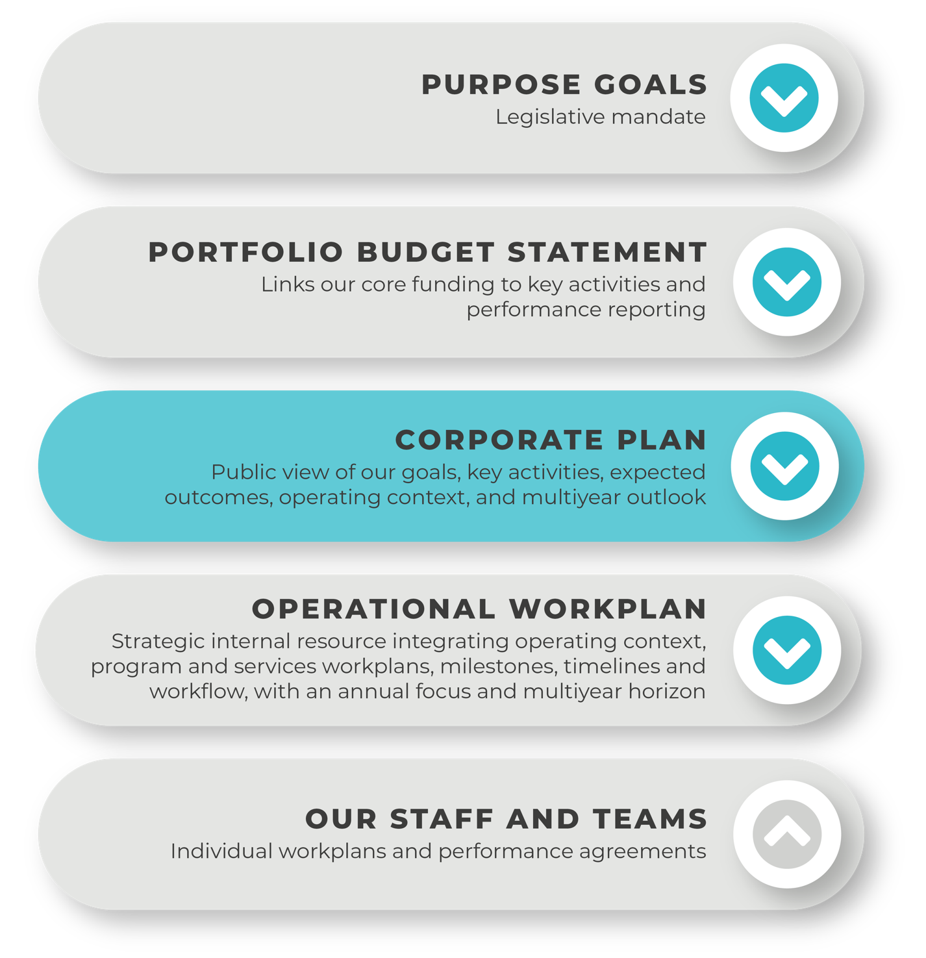

Our purpose
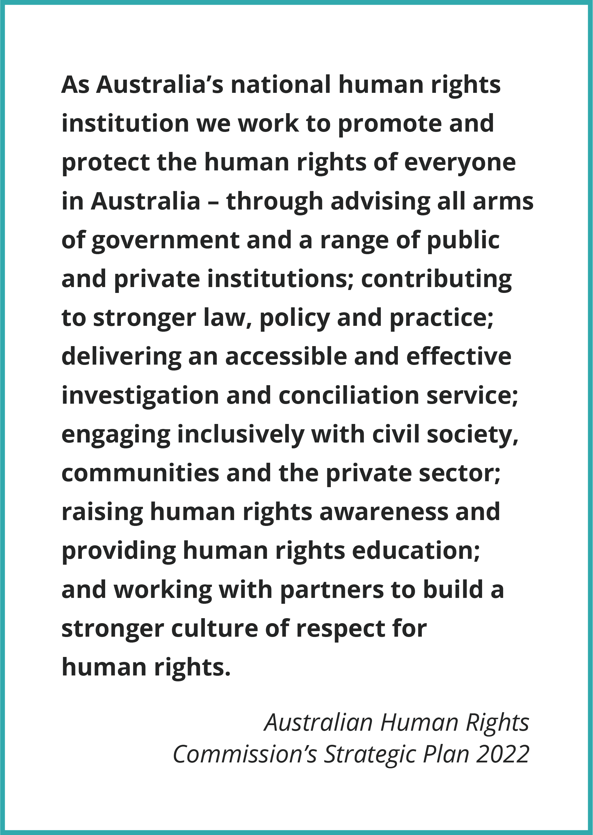

As Australia’s national human rights institution, we work to promote and protect the human rights of everyone in Australia. Our vision is an Australian society in which human rights are respected, promoted and protected. Where every person is free and equal in dignity and rights.
We do this through: setting out a national agenda for reform in law, policy and practice; advising all arms of government; delivering accessible and effective investigation and conciliation services; engaging inclusively with civil society, communities and the private sector; raising human rights awareness and providing human rights education; and working with partners to build a stronger culture of respect for human rights.

Our statutory functions require us to undertake activities that:
- Promote understanding, acceptance and public discussion of human rights in Australia (including through our special purpose Commissioners).
- Improve access to justice for all by investigation into, and attempt to conciliate, complaints of unlawful discrimination, or breaches of human rights or discrimination in employment.
- Promote strengthening of, and compliance with, human rights and federal discrimination law (including through the preparation of guidelines, developing and monitoring disability standards, our intervention function and considering applications for temporary exemptions under relevant discrimination laws).
- Undertake research, educational and other programs for promoting human rights, including by reporting to Parliament on the status of enjoyment of human rights by children and Aboriginal and Torres Strait Islander peoples.
- Conduct inquiries into acts or practices that may be contrary to human rights, report on laws that Parliament should make, or actions that the Commonwealth should take, to meet Australia’s international human rights obligations.
- Examining laws and proposed laws for consistency with human rights.

We undertake this work in a complex strategic and operating environment, as set out in the diagram below.
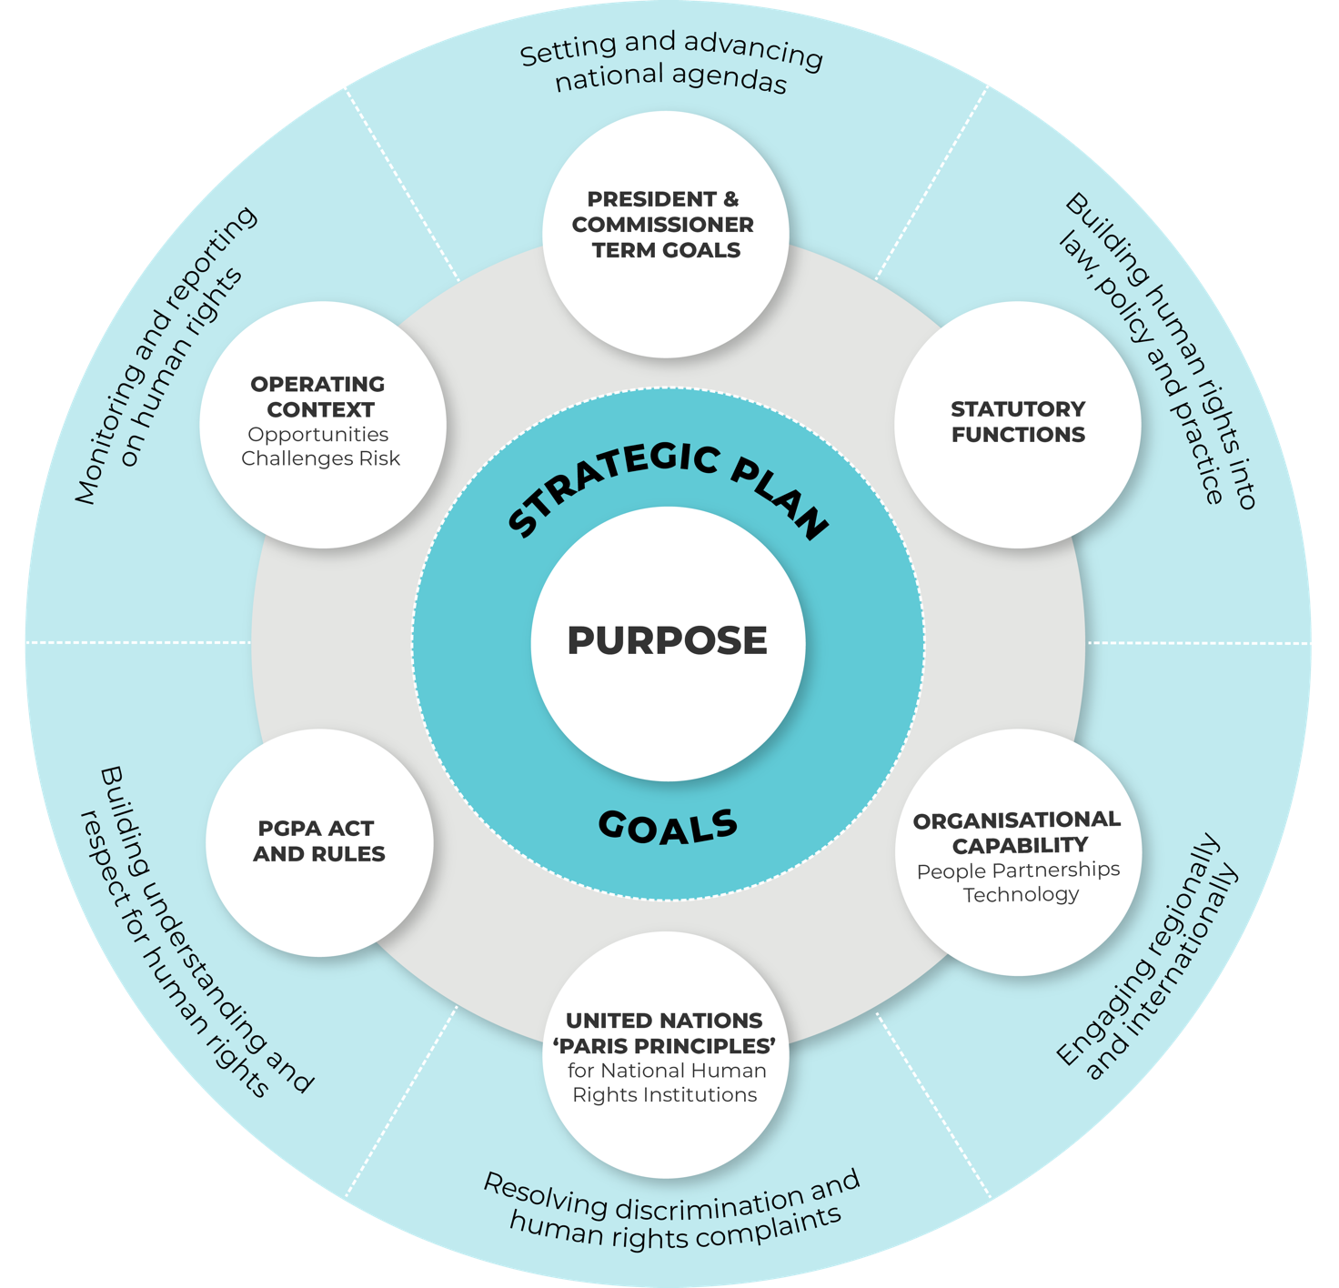

Our values
Complementary to the APS values, in the work we do, and in how we work with our partners and each other, Commission staff and statutory officeholders value and promote:
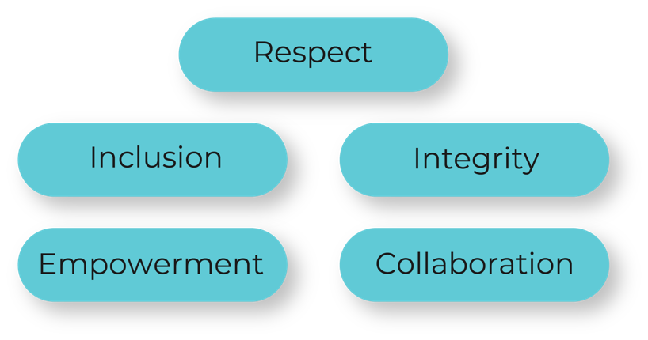

Our goals
Our vision and purpose are reflected in our goals.
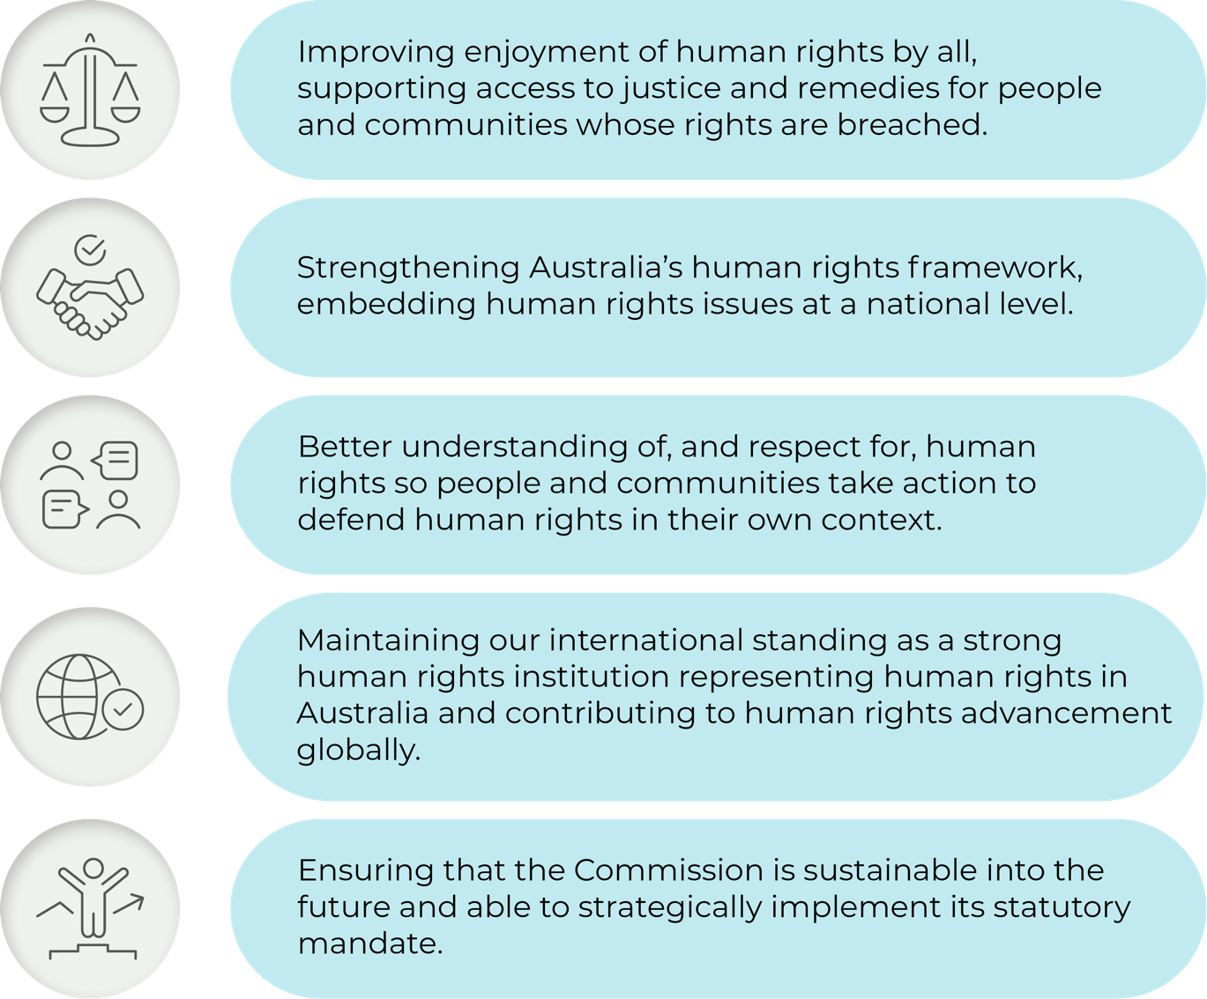

Who we are
The Commission is an independent statutory organisation, established by the Australian Human Rights Commission Act 1986 (Cth) and exercising functions under Australia’s four federal discrimination laws. We work to ensure that human rights are respected, protected and promoted in Australia and internationally.
The Commission also has specific responsibilities under the Native Title Act 1993 (Cth) and the Fair Work Act 2009 (Cth). Our operations are determined independently of the government in line with our internal governance framework.
We are accredited as an ‘A status’ national human rights institution (NHRI). This accreditation is regularly reviewed through United Nations sanctioned processes by the Global Alliance of NHRIs.
At our most recent accreditation review in March 2022, consideration of our ‘A status’ was deferred to October 2023 on the basis of issues of potential non-compliance. To achieve ‘A status’, NHRIs must be established and operate in compliance with the United Nations Principles Relating to the Status of National Institutions for the Promotion and Protection of Human Rights – commonly known as the ‘Paris Principles’. The Principles require us to operate in a robust, independent manner to provide accountability for human rights in Australia. Ensuring retention of our ‘A status’ is a major focus of the Commission for 2022–23.

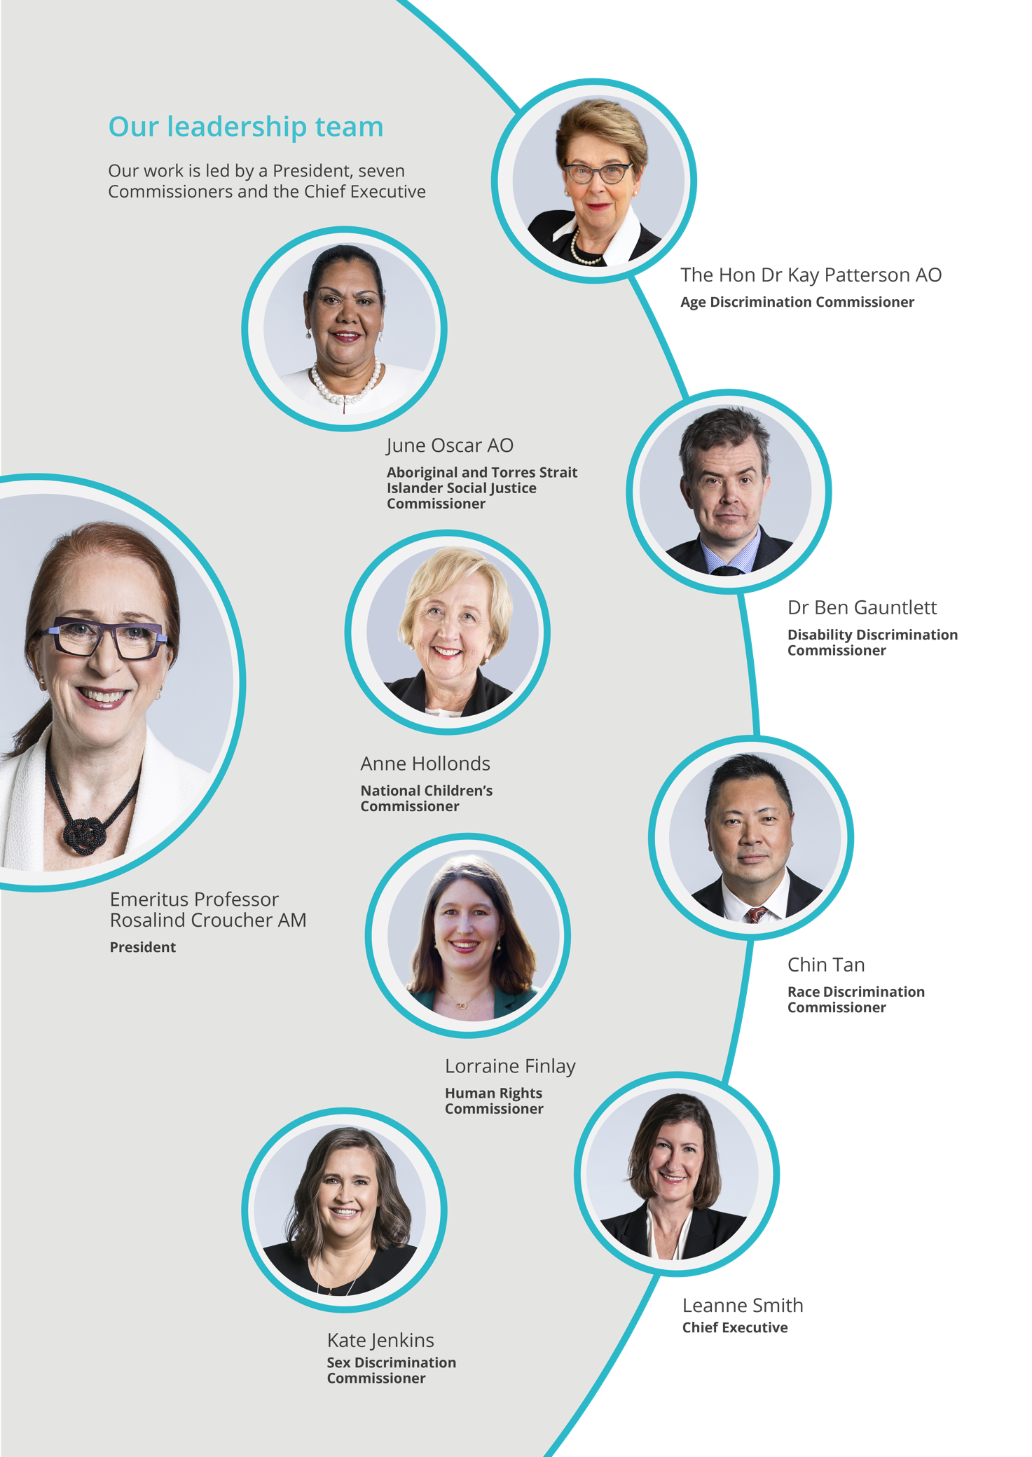

Key activities, how we work
There is no simple way to solve complex human rights issues. Accordingly, we adopt a range of differing approaches to fulfil our statutory functions and achieve our purpose.
We conduct some activities on an ongoing or regular basis – such as complaint handling under federal discrimination law, statutory reports on the human rights status of children and Indigenous peoples, and educational outreach.
Other key activities are undertaken for a defined period, such as major inquiries, engagement in United Nation human rights scrutiny processes, and partnership programs with other government entities, the business and community sectors.
Our President and Commissioners are responsible for our key activities. Each of these statutorily appointed officeholders has their own strategic goals and work programs, anchored in their specific functions and specialist portfolios to guide their work over the course of their appointments.

For the President and Commissioner term goals, key activities and workplans, visit our Corporate Plan website page at [INSERT LINK]

Improving enjoyment of human rights by all, supporting access to justice and remedies for people and communities whose rights are breached
Human rights protection needs to be a central part of laws, policies and practices, to build a fairer and more inclusive Australia. The advocacy of our Commissioners, as well as the partnerships we engage in, help us to positively influence laws and practices and drive other practical changes.
We have a track record of drawing national attention to pressing human rights issues, raising community awareness, and encouraging positive action by governments, service providers and others.
In 2022–23, the Commission will engage with the Government in implementing the Commission’s two major recent reports on gender equality: Respect@Work and Set the Standard.
The Government has committed to full implementation of the Respect@Work report, which will involve legislative reform to the Sex Discrimination Act 1984 (Cth). The Commission has also made reform proposals across all four of the federal discrimination laws in the Free and Equal project. We will continue to advocate for this broader reform agenda to ensure that all discrimination laws are fit for purpose and meet the needs of contemporary Australia.
Commencing in 2022, the National Children’s Commissioner is due to commence a multi-year project to conduct a national prevalence study with secondary students on consent. Supported by the Sex Discrimination Commissioner, this major study will collect information about the extent of secondary students’ consent education and their understanding of these issues as well as invite schools to share their experiences of delivering respectful relationships education.
The Human Rights Commissioner will conduct a national symposium to consider a roadmap to achieve the full implementation of the Optional Protocol to the Convention Against Torture (OPCAT). This roadmap will ensure there are rigorous oversight processes for all places of detention in Australia, protecting often vulnerable cohorts of our community. This work will feed into significant international scrutiny processes related to OPCAT in the second half of 2022 – including the next periodic review of Australia’s performance under the Convention Against Torture and a two week visit to Australia of the Sub-Committee on the Prevention of Torture to consider the adequacy of oversight mechanisms established under OPCAT.
One of our core functions is to help people resolve complaints of unlawful discrimination and other breaches of human rights through our complaint-handling service. People can complain to us about discriminatory treatment or breaches of their human rights in employment or more generally. Our conciliation service usually resolves complaints without any need for recourse to the court and achieves systemic improvements in the workplace.
The COVID-19 pandemic has, and continues to, significantly impact our complaints work – we have seen a significant and sustained increase in discrimination and human rights complaints. This has created a substantial backlog for all discrimination complaints – race, age, LGBTI, sex, sexual harassment, disability and other human rights grounds.
Addressing this backlog is a priority issue for the Commission over the coming two years, and will require additional capacity and funding commitments from government.
Our National Information Service offers advice to businesses and members of the community about the operation of discrimination laws.
We use information about trends in complaints to develop targeted education programs and suggest policy reforms to address the underlying factors that lead to discrimination.

The Commission’s project, Free and Equal: The Free and Equal project is a national conversation on human rights that will be completed in the 2022–23 financial year. Late 2021 saw the release of a Position Paper outlining a federal discrimination law reform agenda for the next decade. In 2022–23 we will release a Position Paper setting out a model for a federal Charter of Rights and other reforms to positively protect human rights, as well as a final report to Parliament recommending reforms to implement a national framework for human rights.

Strengthening Australia’s human rights frameworks, embedding human rights issues at a national level
We focus on increasing understanding and respect for human rights in our community. This includes building recognition that everyone has a responsibility to respect the rights of others. We empower people to engage in meaningful activity on human rights and to make the connection between what human rights are and how they apply to everyday life in Australia.
The Aboriginal and Torres Strait Islander Social Justice Commissioner is following up the landmark Wiyi Yani U Thangani: Women’s Voices report with a Virtual Policy Forum on women’s safety and protection in September 2022 and the First Nations Women’s and Girls National Leadership Summit in May 2023.
The National Children’s Commissioner is leading national consultations with children to directly input their voices into national frameworks to protect children from abuse and neglect, and in situations of violence through the Keeping kids safe and well – your voices project. This year will focus on continued advocacy around the report to ensure the voices and views of young people are applied and used in policy development and service delivery. A child rights and wellbeing assessment tool is also in development in 2022–23 for legislation and policy makers to assess the impact of legislation and policy on the rights and wellbeing of Australian children.
The Sex Discrimination Commissioner will lead the fifth annual workplace sexual harassment survey. We will also be expanding our cultural reform partnership beyond the Australian Defence Force and Australian Federal Police to include the Australian Border Force to address cultural reforms within the Respect@Work framework.
The Commission continues its focus on education and capacity building about racism and racial discrimination and supporting strategies to address them. In July 2022 the Commission launched its updated and enhanced Racism. It Stops With Me campaign, led by the Race Discrimination Commissioner, which contributes to the national discussion about racism from an interpersonal, institutional and systemic perspective. The Commission will also be advancing consideration of a National Anti-Racism Framework to ensure a holistic, comprehensive approach across governments and the community to address the scourge of racism in our community.
The Commission sees human rights protection as a shared endeavour between governments, NGOs, the business sector and civil society. The Commission has an expanding range of partnerships and collaborations to advance human rights. The Commission will continue its focus of engaging diverse partnerships across sectors. This year we will continue to engage sporting bodies, both in our Racism. It Stops with Me campaign and in our engagement to develop sport and disability guidelines – for example working with Golf Australia.

Better understanding of, and respect for, human rights so people and communities take action to defend human rights in their own context
Some people in Australia are especially vulnerable to discrimination, exclusion, and unfair treatment. We have a responsibility to monitor the situation facing these groups, identify issues of concern and propose solutions that will improve their lives.
The Commission will continue its work in increasing the awareness and understanding of issues affecting older people, through the work of the Age Discrimination Commissioner. In 2022–23 the work will continue to focus on the issues and barriers affecting the employment of older workers, with projects including the Older Workers Survey Report in collaboration with the Australian Human Resources Institute. The Commission will increase understanding in the community around elder abuse including the development of a new awareness video. Ground-breaking new research will be commissioned on age stereotyping in industries that work particularly closely with older Australians. Continued engagement and advocacy will take place on key issues including older women at risk of homelessness and supporting and promoting positive ageing.
Ensuring meaningful consultation and collaboration with people with a disability in the development of tangible outcomes continues to be a focus of the Commission and the Disability Discrimination Commissioner, including highlighting structural discrimination and intersectional disadvantage faced by people with a disability. In 2022, the Commissioner will focus on phase two of the IncludeAbility employment project, including the development of pilot employment programs in partnership with Employment Network Providers and progress the Accessible Housing Project through the development of information kits and further evidence of good practice based on the research findings on campus at the Faculty of Monash Art, Design and Architecture (MADA).
In 2022–23, the Commission will release reports on children’s rights, conditions in immigration detention, and the impact of COVID-19 on the mental health of young people, as well as a Native Title Report on the experience of Aboriginal and Torres Strait Islander women in protecting their traditional lands and waters through the native title system.

Maintaining the international standing of the Commission, representing human rights concerns within Australia and contributing to human rights advancement globally
As a national human rights institution, we engage in UN mechanisms, such as the Human Rights Council and human rights treaty bodies, to provide a credible, independent voice on the status of human rights in Australia. This is part of the Commission approach to lift the consideration of human rights across law, policy and practice. It also forms a key plank of Australia’s international advocacy on human rights and contributes to our international reputation as a leading democratic country with a robust approach to human rights scrutiny.
This reputation is under challenge due to international concerns about the integrity of the Commission, due to the process for the selection and appointment of Commissioners. The Commission underwent its five-yearly accreditation review as a national human rights institution in March 2022. The review committee deferred consideration of whether the Commission should maintain its ‘A status’ as a national human rights institution until October 2023, to provide time for the Government to address concerns about appointment processes. Ensuring that we are re‑accredited as an ‘A status’ institution is a key priority for the Commission in 2022, and we welcome commitments from the Government to achieve this.
We also undertake technical cooperation programs funded by DFAT, in Vietnam and the Lao People’s Democratic Republic, as well as other activities with the ASEAN Inter-Governmental Commission on Human Rights and regional partners in the Asia-Pacific region. In 2022–23 this work will focus on the development of education models in schools and the private sectors through our Vietnam Human Rights Education Partnership and engagement with whole-of-government and civil society.

Ensuring that the Commission is sustainable into the future and able to strategically implement its statutory mandate
The Commission has implemented significant and substantial improvements to its governance and financial management frameworks over the past year. We will continue to work to monitor, strengthen and embed these systems in the coming year, as well as to advocate for appropriate resourcing to ensure we are financially sustainable into the longer term. The sustained high workloads in our investigation and conciliation service remain a matter of great concern, as well as the ability to appropriately support Commissioners by ensuring that they are adequately resourced to fulfil their statutory functions independently.
The focus will be to ensure that Australians have access to independent complaints handling and public inquiry processes and benefit from human rights education, advocacy, monitoring and compliance systems to enable the Commission to effectively meet its performance outcomes.

Our performance framework

President and Commissioner terms
Our planning and performance framework differs from many other agencies as a President and seven Commissioners lead our work in different priority areas as independent statutory officeholders. The President and Commissioners are appointed as individual vacancies arise and for terms that end at different times (usually after 5–7 years).
Each officeholder develops term goals and work programs for their portfolios. The figure below shows the status of the terms of our President and Commissioners and how it links to the four-year reporting outlook of this Corporate Plan. The different stages that Commissioners are at in their terms is factored into our planning and performance framework, and through our annual planning and reporting processes.
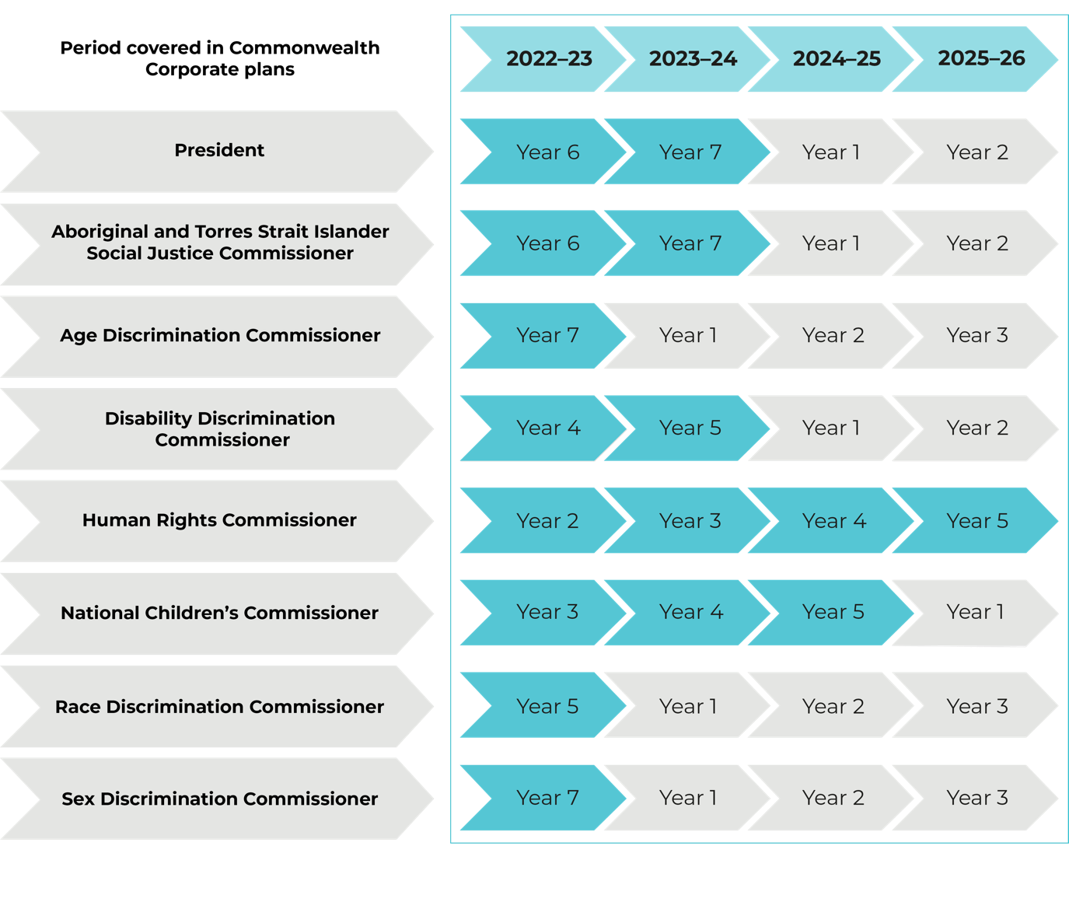

Commission goals, outcomes and telling our ‘performance story’
Having our purpose and functions reflected in organisational goals and outcomes helps us to tell an entity-level ‘performance story’, through the contributions of successive Presidents and Commissioners and our ongoing, statutorily required programs and services.
Our organisational goals and outcomes map on page 16 shows the ‘line of sight’ between President and Commissioner portfolio goals and programs and the pursuit of organisational level goals and outcomes.
The outcomes are the changes we anticipate from our work. They are pitched to a level where we can reasonably expect to contribute to them:
- within the four-year outlook of this Corporate Plan
- through the collective annual-to-term results of President and Commissioner activities and other ongoing programs and services, and
- in our given operating environment.

Measuring our performance
Measuring our impact (what difference, what benefit), in the context and nature of our work, is complex. The ultimate results of our activities are often long-term and incrementally achieved.
Our role is generally collaborative and challenging. Understanding both the attribution of outcomes and broader contributions to systemic change in collaboration with others in our work continues to be explored.
Our performance measurement framework shows how we measure our results in this context. It maps performance expectations and progress indicators to each organisational outcome. The progress indicators are designed to provide ‘reasonable’ evidence of contribution to the given outcome, and are, in turn, supported by data from monitoring and evaluation strategies implemented across the Commission’s programs and services.

For the Commission’s performance measurment framework, visit our Corporate Plan website page at [INSERT LINK]

Organisational goals and outcomes map
Our Purpose
Goals
1  Improving enjoyment of human rights by all, supporting access to justice and remedies for people and communities whose rights are breached. | 2  Strengthening Australia’s human rights framework, embedding human rights issues at a national level. | 3  Better understanding of, and respect for, human rights so people and communities take action to defend human rights in their own context. | 4  Maintaining our international standing as a strong human rights institution representing human rights in Australia and contributing to human rights advancement globally. | 5  Ensuring that the Commission is sustainable into the future and able to strategically implement its statutory mandate.

Outcomes
1.1 We deliver a fair and effective investigation and conciliation of complaints service.* | 2.1 The leadership and advocacy of the President and Commissioners on thematic areas or identified human rights issues, improves the enjoyment of human rights by affected groups. | 2.2 Law and policy makers, at all levels, consider and address the human rights impacts we identify through our submissions, Inquiries, research, reports and United Nations engagement.* | 2.3 The national human rights reform agenda proposed in the Free and Equal: An Australian conversation on human rights report is considered and addressed by the Parliament, government and the non-government sector. | 3.1 Our education activities increase capability among individuals, communities and organisations to promote and protect human rights and address discrimination.* | 3.2 Our information resources, services, events and campaigns reach, information and influence users and audiences.* | 4.1 Our activities increase the capacity of vulnerable groups, communities and their advocates to understand and advocate for their rights.* | 4.2 Our activities increase the capacity of governments, organisations, other groups and services to understand and address the human rights impact of their actions, particularly when working with vulnerable groups and communities.* | 4.3 The Commission is compliant with the Paris Principles (Principles Relating to the Status of National Human Rights Institutions) and is assessed as an independent and effective national human rights institution. | 5.1 The Commission has a clear strategic direction and confidently implements its mandate with secure and sustainable funding that is transparently and accountably managed.
Terms
President and Commissioner Term Goals |  | Outcomes of President, Commissioner advocacy and programs, core programs and services |  |  |  | Whole of Commission workplan—how we deliver these outcomes |  | Capability to deliver and  operational context
*Asterisk denotes linkage to PBS Performance Criteria.

Operating environment
We work in a complex social and political context with multiple factors that can affect how and how well we achieve our purpose. In deciding how to exercise our functions, we examine our forward operating environment each year.
In doing so we assess the factors (constraints, dependencies, risks, challenges, strengths and opportunities) that may have an impact on our work in the coming year, and in our four-year outlook.
The figure below shows the key factors identified in the assessment for the 2022–23 (to 2026) environment.
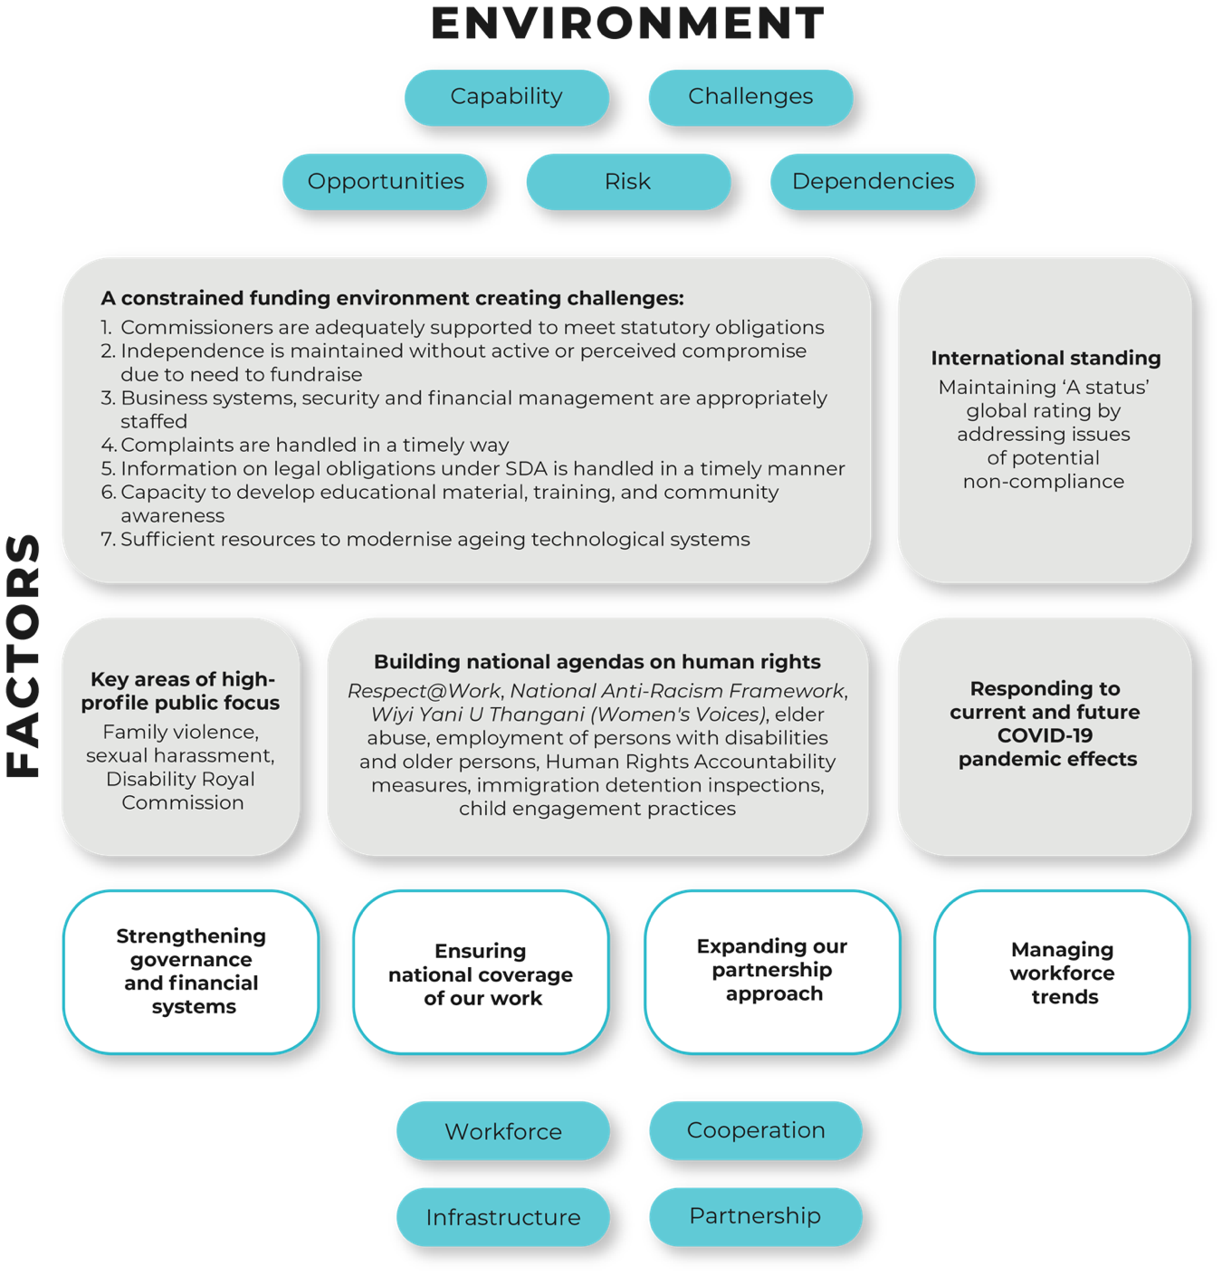

For the full analysis of this operating environment, including our workforce, digital infrastructure and investment, cooperation and partnerships capabilities, and the key factors, the varying degrees of control we have over them, as well as our management strategy, visit our Corporate Plan website page [INSERT LINK]

Risk oversight and management
We adopt a positive risk management culture that promotes an open and proactive approach to managing risk.
Our existing risk management framework provides a mechanism for proactively identifying and mitigating risks across the organisation, and for monitoring the operating environment. The risk management framework is tailored to meet the needs of the Commission, and covers three main areas:
- Key strategic risks: including a constrained funding environment, damage to the Commission’s independence and reputation, not managing relationships with key government stakeholders and other external parties and not responding quickly and effectively to a changing political landscape.
- Core business risks: including policy activities that are not aligned to the Commission’s strategic objectives, failing to provide an accessible and effective complaint-handling service that complies with all relevant laws and community engagement activities that fail to achieve the objective of increased public awareness of human rights.
- Corporate support risks: including failure to recruit and retain appropriately skilled and diverse staff, the misuse of assets or resources, business continuity processes not in place, IT interruption, outage or information compromise and an unsafe work environment.

For more on the mitigation strategies and controls in place to manage these key risks, visit our Corporate Plan website page at [INSERT LINK]

Our organisational structure
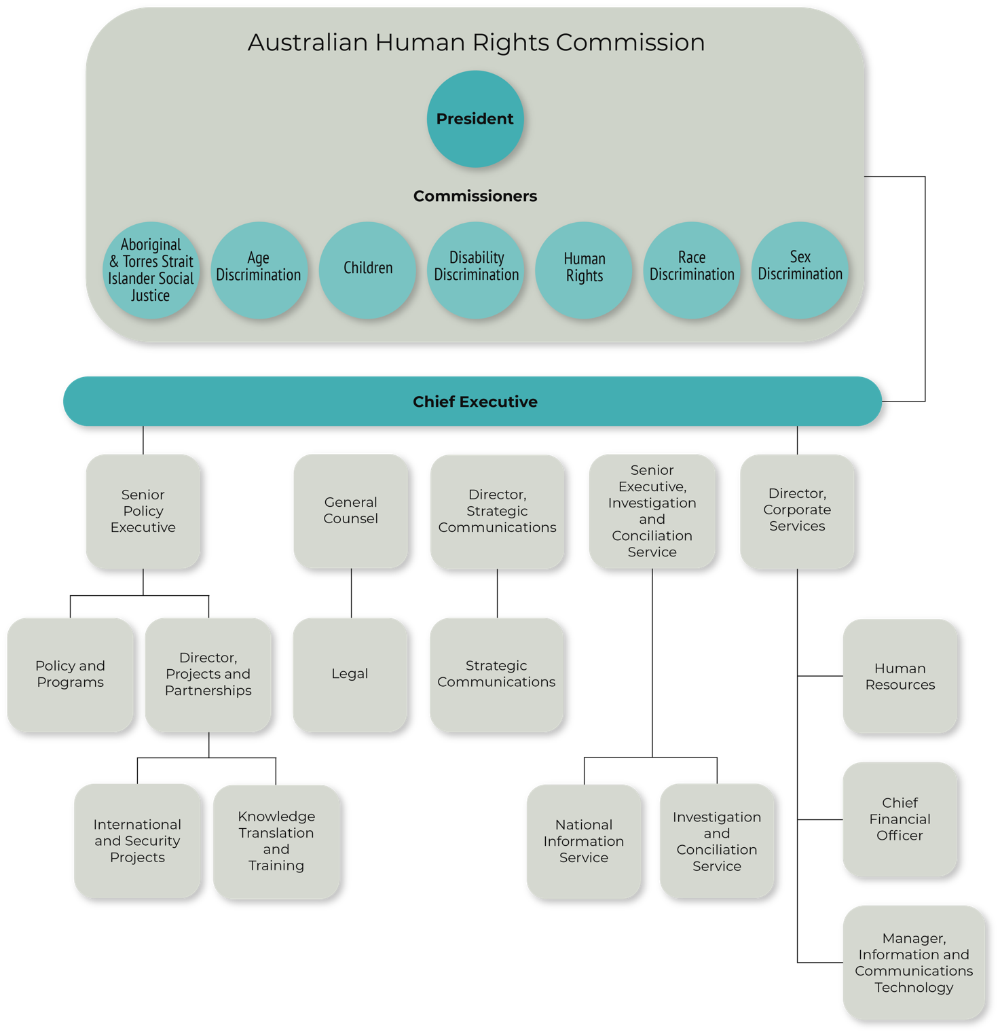

Index of Corporate Plan requirements
The table details the requirements met by the Australian Human Rights Commission corporate plan and the page reference(s) for each requirement.
Requirement | Page(s)
Introduction  - Statement of preparation  - Reporting period for which the plan is prepared  - Reporting periods covered by the plan | 4  4  4  4
Purpose | 6
Key activities | 12–19
Operating environment  - Risk oversight and management | 18  26
Performance | 20–24

Materials providing additional information on our key activities, operating context and performance measurement are on our Corporate Plan webpage [INSERT LINK]

Further Information
Australian Human Rights Commission

GPO Box 5218 SYDNEY NSW 2001
Telephone: (02) 9284 9600
Complaints Infoline: 1300 656 419
General enquiries and publications: 1300 369 711
TTY: 1800 620 241
Fax: (02) 9284 9611
Website: www.humanrights.gov.au

For detailed and up to date information about the Australian Human Rights Commission visit our website at: www.humanrights.gov.au. To order more publications from the Australian Human Rights Commission, download a Publication Order Form at: www.humanrights.gov.au/our-work/publications, call: (02) 9284 9600, fax: (02) 9284 9611 or email: publications@humanrights.gov.au.

Further information: https://ganhri.org/paris-principles/.

