

The Australian Human Rights Commission encourages the dissemination and exchange of information provided in this publication.

All material presented in this publication is provided under a Creative Commons Attribution 3.0 Australia, with the exception of:

* the Australian Human Rights Commission logo,
* photographs and images, and
* any content or material provided by third parties.

The details of the relevant licence conditions are available on the [Creative Commons](http://creativecommons.org/licenses/by/3.0/legalcode) website, as is the full legal code for the [CC BY 3.0 AU licence](http://creativecommons.org/licenses/by/3.0/legalcode).

**Attribution**

Material obtained from this publication is to be attributed to the Australian Human Rights Commission with the following copyright notice:



**Corporate Plan** 2019–2020

**ISSN 2206-8368 (Online)**

**Third party copyright**

Wherever a third party holds copyright in material presented in this publication, the copyright remains with that party. Their permission may be required to use the material.

The Commission has made all reasonable efforts to:

clearly label material where the copyright is owned by a third party. Please note this does not include photos, images and video which are all regarded as third party material, and ensure that the copyright owner has consented to this material being presented on this website.

**Graphic design** Dancingirl Designs

**Cover photo** WRD photography & design

**Internal photography** Australian Human Rights Commission (unless otherwise acknowledged)

Contents

1 Preface 4

2 Our purpose 5

3 Our goals 5

4 Who we are 6

Our leadership team 7

5 How we work, what we do 8

6 Our performance framework 12

President and Commissioner workplans 12

Outcomes and evaluation 15

7 Environment 18

8 Capability 20

Our people 20

Partnerships 22

Information technology: our digital capability 23

Risk management 24

9 Our organisational structure 25

# Preface

The Australian Human Rights Commission is a small independent statutory agency that is part of the Attorney-General’s portfolio.

This Corporate Plan articulates how we achieve our purpose and promote an Australian society where human rights are enjoyed by everyone, everywhere, everyday.

It has been prepared in accordance with s 35(1)(b) of the Public Governance, Performance and Accountability Act 2013 (Cth) (PGPA Act) and s 46AA of the Australian Human Rights Commission Act 1986 (Cth). It sets out the connection between our purpose and goals, operating environment, and organisational impact over the next 4 years to 2023.

Additional materials that provide further detail are on our Corporate Plan webpage at <https://www.humanrights.gov.au/our-work/commission-general/publications/corporate-plan-2019-2020>. These include the key programs and services led by our Commissioners that we anticipate will contribute to our impact over the 2019–2020 financial year, as well as our outcomes framework and other related matters.

Figure 1: Our strategic framework

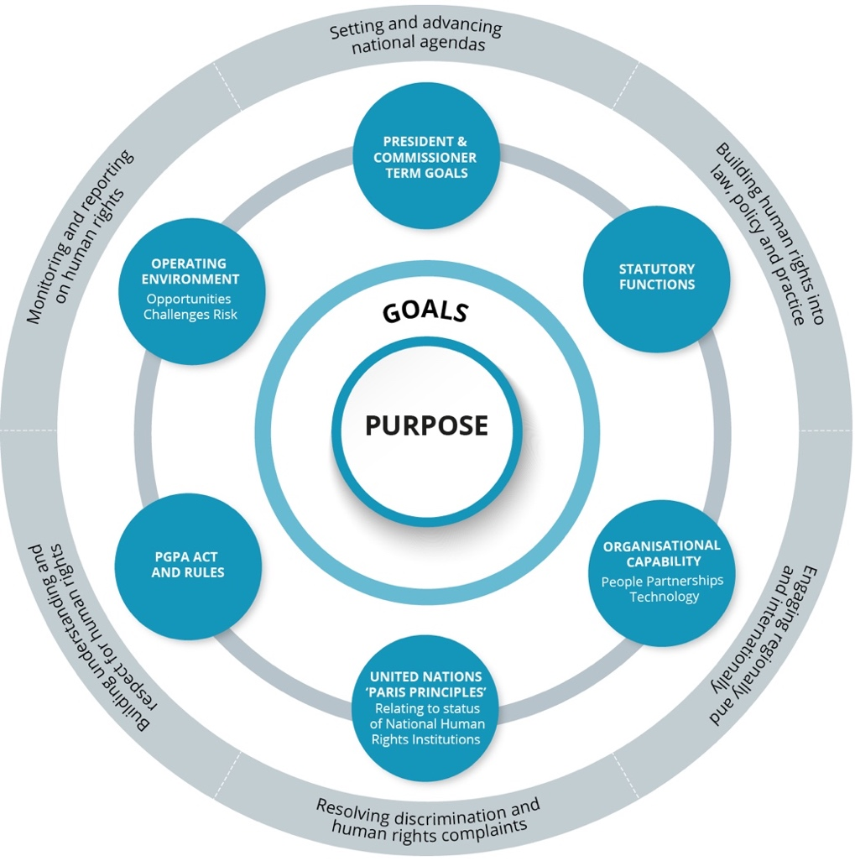

# Our purpose

|  |
| --- |
| As Australia’s national human rights institution, our purpose is to ensure that Australians have access to effective, independent complaint handling and public inquiry processes on human rights and discrimination matters, and benefit from our human rights education, advocacy, monitoring and compliance activities. |

Our vision of *Human rights, everyone, everywhere, everyday,* is an Australia where respect for human rights and freedoms is the cornerstone of a cohesive and peaceful society in which everyone can contribute and feel safe and included.

To achieve this we need an effective system of human rights protection: where the promotion of human rights is a shared endeavour—by government, business, the non-government organisation sector, educators, service providers and the community at large.

# Our goals

Our vision and purpose are reflected in our goals.

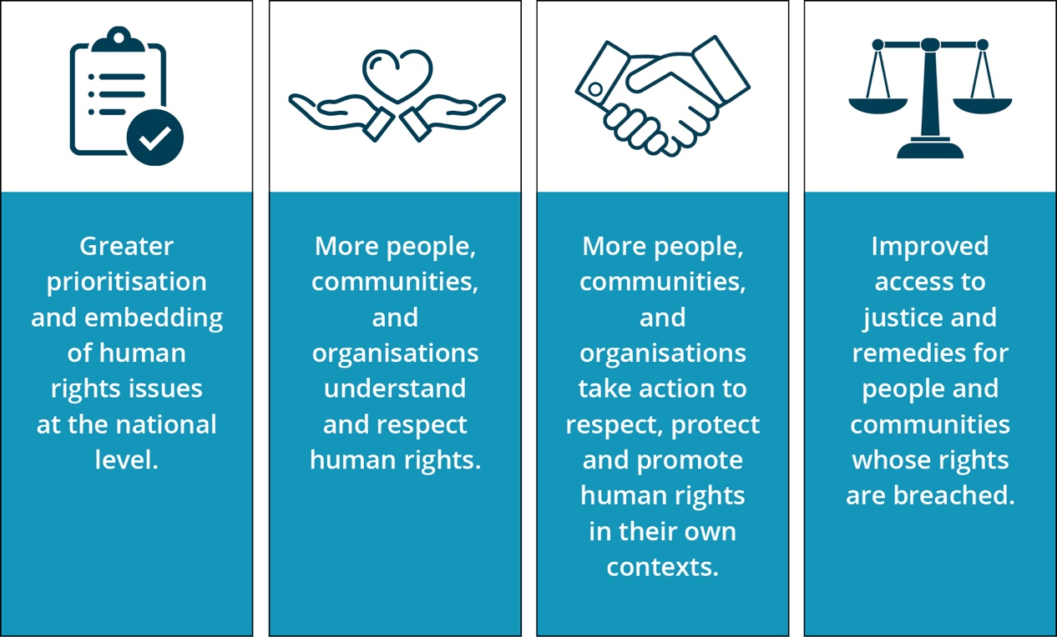

# Who we are

The Australian Human Rights Commission was established in 1986,[1] by the federal Parliament, as an independent statutory organisation charged with protecting and promoting the human rights of all people in Australia.

We are accredited as an ‘A status’ national human rights institution (NHRI). This accreditation is regularly reviewed through United Nations sanctioned processes by the Global Alliance of NHRIs. To be given ‘A status’, NHRIs must be established and operate in compliance with the United Nations Principles Relating to the Status of National Institutions for the Promotion and Protection of Human Rights—commonly known as the ‘Paris Principles’.[2] The principles require us to operate in a robust, independent manner in order to provide accountability for human rights in Australia.

We have statutory functions under the Australian Human Rights Commission Act 1986 (Cth) as well as the Race Discrimination Act 1975 (Cth), Sex Discrimination Act 1984 (Cth), Disability Discrimination Act 1992 (Cth) and Age Discrimination Act 2004 (Cth). The Commission also has specific responsibilities under the Fair Work Act 2009 (Cth) and Native Title Act 1993 (Cth).

## Our leadership team

Our work is led by a President, seven Commissioners and Chief Executive.

**Emeritus Professor Rosalind Croucher AM**—President

**June Oscar AO**—Aboriginal and Torres Strait Islander Social Justice Commissioner

**The Hon Dr Kay Patterson AO**—Age Discrimination Commissioner

**Dr Ben Gauntlett**—Disability Discrimination Commissioner

**Edward Santow**—Human Rights Commissioner

**Megan Mitchell**—National Children’s Commissioner

**Chin Tan**—Race Discrimination Commissioner

**Kate Jenkins**—Sex Discrimination Commissioner

**Padma Raman**—Chief Executive

# How we work, what we do

There is no simple way to solve complex human rights issues. Accordingly, we adopt a range of differing approaches to fulfilling our statutory functions and achieving our purpose.

* **Setting and advancing national human rights agendas**

We have a track record of drawing national attention to pressing human rights issues, raising community awareness and encouraging positive action by governments, service providers and others.

Major projects such as the Human Rights and Technology project, Wiyi Yani U Thangani (Aboriginal and Torres Strait Islander Women and Girls) project and the National Inquiry into Sexual Harassment in the Workplace Inquiry are placing these significant issues on the national agenda.

* **Building understanding and respect for human rights**

We focus on increasing understanding and respect for human rights in our community. This includes building recognition that everyone has a responsibility to respect the rights of others. We empower people to engage in meaningful activity on human rights and to make the connection between what human rights are and how they apply to everyday life in Australia.

Projects raising awareness among older Australians of elder abuse and tools to address it, engaging with Muslim communities to create broader awareness in the community of their experiences of exclusion, and developing educational resources for schools, workplaces and public servants increase understanding of human rights.

* **Building human rights into Australian laws, policy and practices**

We consider that human rights protection needs to be a central part of laws, policies and practices in order to build a fairer and more inclusive Australia.

The advocacy of our Commissioners, as well as the partnerships we engage in, help us to positively influence laws and practices and drive other practical changes.

Our work developing guidance for businesses on modern slavery practices, tools for organisations to ensure they are child safe into the future, and our engagement with Parliament on the human rights impact of proposed laws put human rights issues on the agenda.

* **Monitoring and reporting on the human rights situations of vulnerable groups**

Some people in Australia are especially vulnerable to discrimination, exclusion and unfair treatment. We have a particular responsibility to monitor the situation facing these groups, identify issues of concern and propose solutions that will improve their lives.

Our National Children’s Report, as well as reports of conditions in immigration detention centres, put the spotlight on the situation of vulnerable people in Australia.

* **Engaging regionally and internationally with human rights agencies and systems**

As a national human rights institution, we engage in UN mechanisms such as the Human Rights Council and human rights treaty bodies to provide a credible, independent voice on the status of human rights in Australia. In 2019–2020, this includes reporting to treaty bodies on the rights of children, people with a disability and in relation to torture and situations of cruel, inhuman or degrading treatment.

We also engage with other national human rights institutions in the Asia-Pacific region, across the Commonwealth and at the global level.

* **Resolving discrimination and human rights complaints**

One of our core functions is to help people resolve complaints of discrimination and other breaches of human rights through our complaint-handling service.

Our National Information Service offers advice to businesses and members of the community about the operation of discrimination laws. People can complain to us about discriminatory treatment or breaches of their human rights in employment or more generally. Our conciliation service often resolves complaints without the need to proceed to court and achieves systemic improvements in the workplace.

We use information about trends in complaints to develop targeted education programs and suggest policy reforms to address the underlying factors that lead to discrimination.

|  |
| --- |
| **Free and equal: An Australian conversation on human rights**  In 2019–2020, the Commission is embarking on a major program to identify a national reform agenda for human rights to guide actions over the next decade. As a multiyear initiative, it draws on all these approaches and unites the work and expertise of all the Commission. The purpose of the national conversation is to:   * promote awareness of the importance of human rights to 21st century Australia * identify current limitations and barriers to better human rights protections * identify what key principles should underpin the reform of human rights in Australia * build agreement across the Parliament, government and the community about what we can do collectively to better promote, protect and fulfil human rights.   The first stage includes public consultations and submissions, supplemented by technical workshops on key human rights issues. The centrepiece of this year’s work is a national conference on human rights and series of community consultations involving the UN High Commissioner for Human Rights. By mid–2020 the Commission will release its reform agenda which will focus on actions to ensure that:   * the community understands human rights and is able to protect them (for themselves and others) * communities are resilient and a protective factor against human rights violations * law and policy makers explicitly consider the impact on human rights of their decisions and are accountable for this impact * robust institutions exist to promote and protect human rights * government and the community can work together to fully realise human rights—understanding the respective role of each other * public servants, and contracted service providers, see the protection of human rights as core business in exercising their functions * other issues that are identified as priorities for human rights protection by the Australian community are addressed. |

|  |
| --- |
| Our **statutory functions** require us to undertake activities that:   * Promote understanding, acceptance and public discussion of human rights in Australia (including through our specialist Commissioners). * Promote compliance with human rights and federal discrimination law (including through the preparation of guidelines; developing and monitoring disability standards; and considering applications for exemptions under relevant discrimination laws). * Undertake research, educational and other programs for promoting human rights, including by reporting to Parliament on the status of enjoyment of human rights by children and Aboriginal and Torres Strait Islander peoples. * Conduct inquiries into acts or practices that may be contrary to human rights; report on laws that Parliament should make, or actions that the Commonwealth should take, to meet Australia’s international human rights obligations; and examine laws and proposed laws for consistency with human rights. * Inquire into, and attempt to conciliate, complaints of unlawful discrimination, or breaches of human rights or discrimination in employment.[3] |

# Our performance framework

## President and Commissioner workplans

Our strategic planning and performance framework differs from many other agencies as the terms of our President and Commissioners do not align with the four-year outlook of the Commonwealth Corporate Plan cycle.

Statutory Commissioners lead our work in different priority areas, are appointed at different times and for terms that end at different times (usually after 5 years). As a result, our planning, implementation and outcomes outlook operates across different temporal boundaries:

* the annual planning and corporate plan process
* the rolling four-year period required of Commonwealth corporate plans
* the timeframes for President and Commissioner terms (Figure 2).

Figure 2: Current status of President and Commissioner terms across the   
4-year outlook of this Corporate Plan[4]

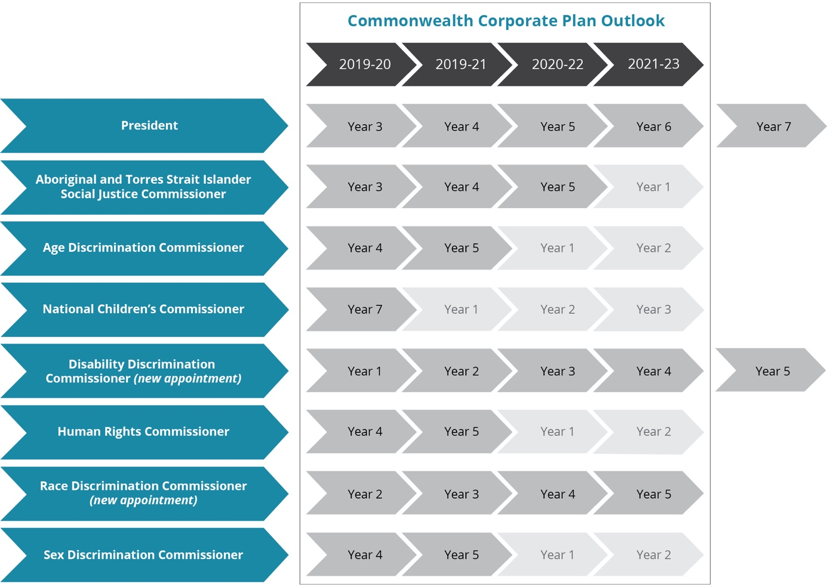

The President and each Commissioner have term goals and work programs anchored in their specific functions and specialist portfolios. Collectively these contribute to our organisational goals and purpose.

For a profile of the President and Commissioner goals and work programs, click on the icons below or visit our website at https://www.humanrights.gov.au/our-work/commission-general/publications/corporate-plan-2019-2020.

|  |  |  |  |
| --- | --- | --- | --- |
| **President**  Emeritus Professor  Rosalind Croucher AM | **Aboriginal and Torres Strait Islander Social Justice Commissioner**  June Oscar AO | **Age Discrimination Commissioner**  The Hon Dr Kay  Patterson AO | **Disability Discrimination Commissioner**  Dr Ben Gauntlett[5] |
| **Human Rights Commissioner**  Edward Santow | **National Children’s Commissioner**  Megan Mitchell | **Race Discrimination**  **Commissioner**  Chin Tan | **Sex Discrimination Commissioner**  Kate Jenkins |

## Outcomes and evaluation

The first level of the Commission’s outcomes framework is shown in Figure 3. Outcomes with an asterisk correspond to the Performance Criteria in the Commission’s Portfolio Budget Statement (PBS).

The outcomes are the results we expect to achieve from our collective work program. The framework helps us to measure and to tell the story of our impact, as the outcomes are pitched to a level where we can:

* reasonably expect to contribute towards them
* within the four-year outlook of this corporate plan
* if all goes well, when operating within our environment.

For more detail in relation to our progress indicators and PBS performance targets, visit our website at <https://www.humanrights.gov.au/our-work/commission-general/publications/corporate-plan-2019-2020>.

Figure 3: Outcomes framework[6]

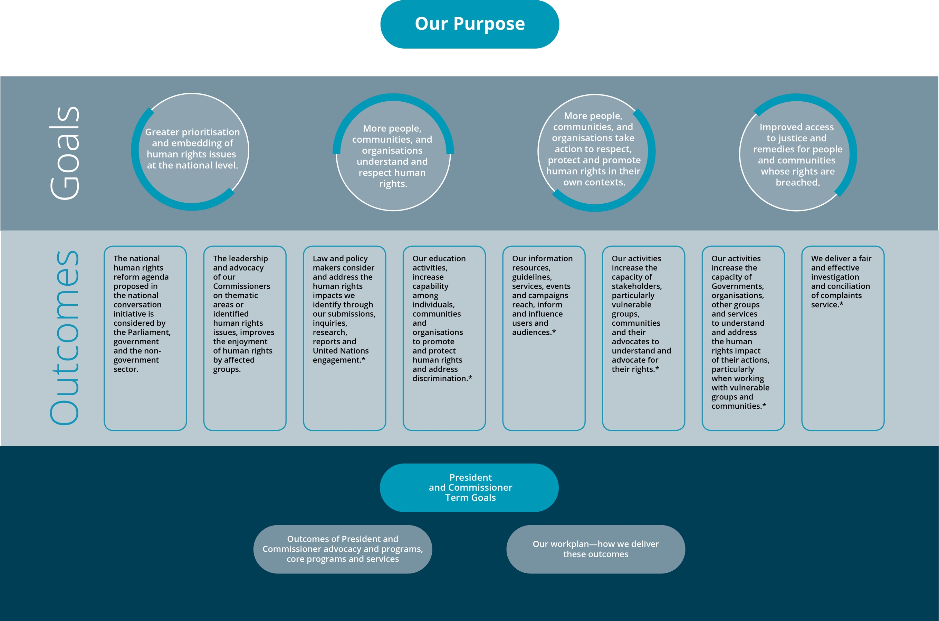

# Environment

The Commission operates in a complex social and political environment with multiple factors that can affect how, and how well, we achieve our purpose. Each year we examine our operating environment to assess the risks/challenges and opportunities that may have an impact on our work.

The key challenges and opportunities that have the potential to affect us are summarised below. For the more detailed analysis of our operating environment, the varying degrees of control we have over these matters and our management strategy, visit our Corporate Plan webpage at <https://www.humanrights.gov.au/our-work/commission-general/publications/corporate-plan-2019-2020>.

|  |  |
| --- | --- |
| **External** | |
| Opportunities   * The ‘national conversation’ project will deliver a national reform agenda for human rights that could shape federal human rights priorities over the next 5–10 years. Providing the opportunity to make a comprehensive and sustainable difference to human rights in Australia. * Reputational consolidation and growth in the context of the national conversation project and agenda-driven Commissioner Programs we expect to continue to elevate our distinct role and value as Australia's National Human Rights Institution. * National and world focus on violence/harassment issues continues and provides momentum to utilise Commission’s functions to achieve positive change (e.g. sexual harassment, elder abuse, abuse of children and people with a disability, and racial intolerance). * International and Universal Periodic Review engagement: Australia’s place on UN Human Rights Council, multiple treaty body and UPR appearances in the next two years, the Commission President’s role as chair of the Asia Pacific Forum and the global focus on Sustainable Development Goals are timely agents for change in this period. | Challenges   * 2019 Federal election. We need to ensure our program of work is flexible to respond to changing government priorities that have key human rights impacts. * High profile debates relating to Commission functions and legislation are likely to continue attracting some public scrutiny particularly in relation to harassment and vilification. * Constrained funding environment: While we have begun to access increased funding for specific projects, achieving increases to our appropriated budget remains a challenge. This requires a whole-of-Commission approach to identifying organisational priorities. * Paris Principles compliance: ensuring that the Commission as Australia’s National Human Rights Institution (NHRI) retains our ‘A status’ accreditation ahead of Australia’s next review, due in 2021. |
| **Internal** | |
| Opportunities and challenges   * **Building partnerships and financial support for our work:** an increasing reliance upon this to complete our work program needs agility, guidance, coordination and recognition that not all Commission functions or priority work areas can attract such funding. * **Ensuring national coverage of our work:** especially countering a Sydney / East Coast bias, and the need for a rural and regional engagement lens. This will be our second year of monitoring and publicly reporting data on the national coverage of our work. * **Managing an increasingly mobile workforce** by developing new strategies to harness staff engagement in a ‘for now—not forever’ approach. * **Increasing our digital capability:** we have several initiatives in place designed to improve our internal and external digital engagement and to help us tomeet the requirements of the Commonwealth Digital 20/20 policy. | |

# Capability

## Our people

Our most important asset is our people. We understand the importance of a diverse and inclusive workplace culture and the need to foster excellence and expertise in our staff. With our internal and external stakeholders, we lead by example and operate in accordance with the human rights standards that we expect of others.

|  |
| --- |
| In the 2018 Australian Public Service (APS) Employee Census survey,  95% of surveyed Commission staff agreed with the statement: *I am proud to work in my agency*  93% with: *I work beyond what is required in my job to help my agency achieve its objectives*  93% with: *My agency is committed to creating a diverse workforce.*[7] |

There are also challenges for the organisation, for example:

* The breadth of the work we want to do vs. limited appropriated budget and other resources—to ensure that our workload remains achievable and our staff are productive but not overwhelmed, we integrate robust planning processes with the agility to monitor and move internal resources to support new or changing work program priorities.
* A stronger ‘mobility mindset’ amongst our newer staff cohorts, and a need to harness this talent more quickly and effectively, rather than building for a longer-term return on investment—to manage this we are investing in the leadership capacity of our more senior staff, including the capacity to operate with a more mobile workforce without compromising our work quality.

**Integrating our purpose into our day-to-day work**

This Corporate Plan sets out how the Commission meets its purpose, goals and the outcomes in our Portfolio Budget Statement.

It is important that our staff can relate to our purpose can see a clear ‘line of sight’ between their day-to-day work, their activities and our goals. Figure 4 illustrates the internal and external processes that structure this line of sight to the day-to-day work of our staff.

|  |
| --- |
| In last year’s APS census survey, 95% of our surveyed staff agreed with the statement: *I can identify a clear connection between my job and my agency’s purpose.*[8] |

Figure 4: Integrating our purpose into our day to day work

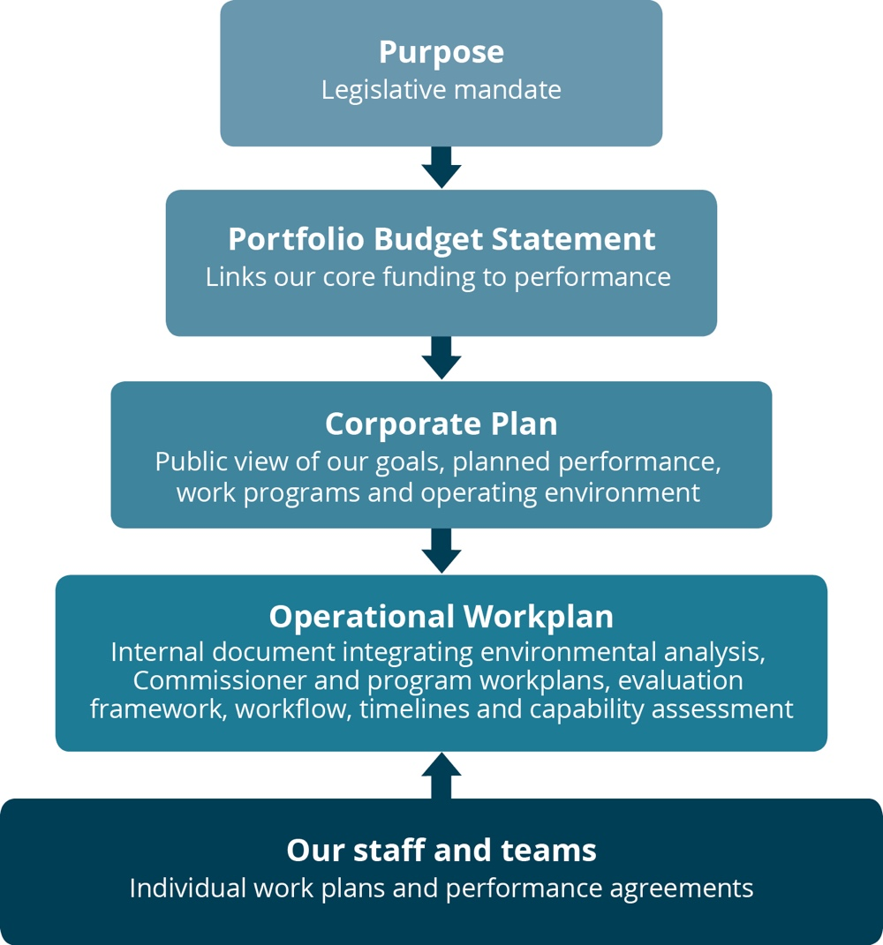

## Partnerships

The Commission regularly works in partnership across government, business, the non-government sector and internationally. We are a source of expertise on human rights research, consultation and implementation design. We also have a track record of being trusted as providing a neutral, ‘safe’, meeting place for different sectors to come together to jointly address difficult human rights challenges.

Partnerships increase our capability through shared skills and resources and create a collective ability to achieve outcomes greater than the individuals or organisations acting alone. It is a central feature of how we work.

Governments and entities from all sectors consistently invite us to work with them to share our human rights expertise and to enter into collaborations on specific human rights projects and advocacy activities. In doing so, we have become accomplished in collaborating with professionalism and integrity.

Our partnerships are diverse and take many forms, including agreements for in-kind,   
pro-bono technical support and/or financial support. They can be informal or formalised by a letter, MOU or legal contract, and may be short to long term. Figure 5 shows the range of our partner categories.

In this coming year, we will continue to build relationships and undertake partnerships where there is strategic benefit to the organisation.

Figure 5: Partner categories

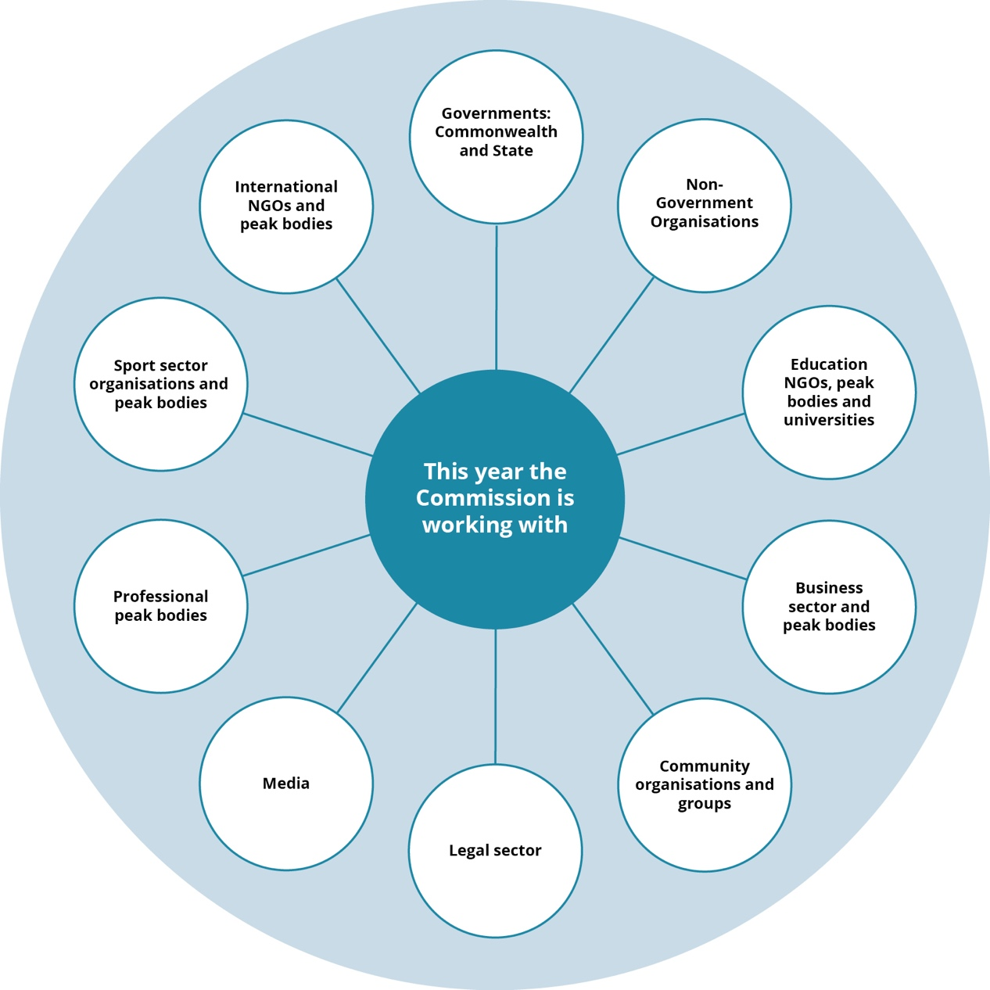

Information technology: our digital capability

Information and communications technology (ICT) has a crucial role in supporting the organisation’s communications and sharing of information, both internally and externally.

Our ICT team manages a complex network with a diverse range of supported platforms. To ensure the continuity and availability of ICT services and a reliable and resilient network service requires increasing investment, which is challenging in our fiscal environment.

In this context an ongoing internal challenge has been to ensure the Commission will meet the requirements of the Commonwealth’s Digital Continuity 2020 policy. This is being addressed through an innovatively supported project using an artificial intelligence enabled eDRMS in partnership with Record Point. As a result, the Commission is being cited as an exemplar across the public service.

This work will also deliver a significant increase in our digital capability through information management, 24/7/365 access to systems and data, and increased security and resilience.

Risk management

We foster a positive risk management culture and process into all levels of our operations and governance. Our risk management framework and its process aims to comply with the Commonwealth Risk Management Policy for entities. Our framework to do this covers three areas:

* Strategic risks: including reputation and public image, managing external relationships.
* Core business risks: including complaints management, community engagement, media and public awareness, organisational alignment.
* Administration and corporate service risk assessment: including financial management, asset management, fraud and corruption prevention, business continuity, regulatory compliance, procurement and contract management, human resources, information and communications technology management, Workplace Health and Safety management, project management and records management.

Our processes to manage risk, include:

* undertaking a regular process to review and oversee these risks is with our internal auditors
* regularly review and update risk registers (which document and evaluate risks and controls)
* participating in the annual Comcover risk management benchmarking survey
* conducting an operating environment risk analysis looking at the strategic and business risk in the context of our strategic and annual planning processes.

Currently the responsibility for the coordination of our risk framework and process lies across several staff. To further improve our processes we are developing a dedicated position with the overall responsibility of coordinating and overseeing our risk management.

# Our organisational structure

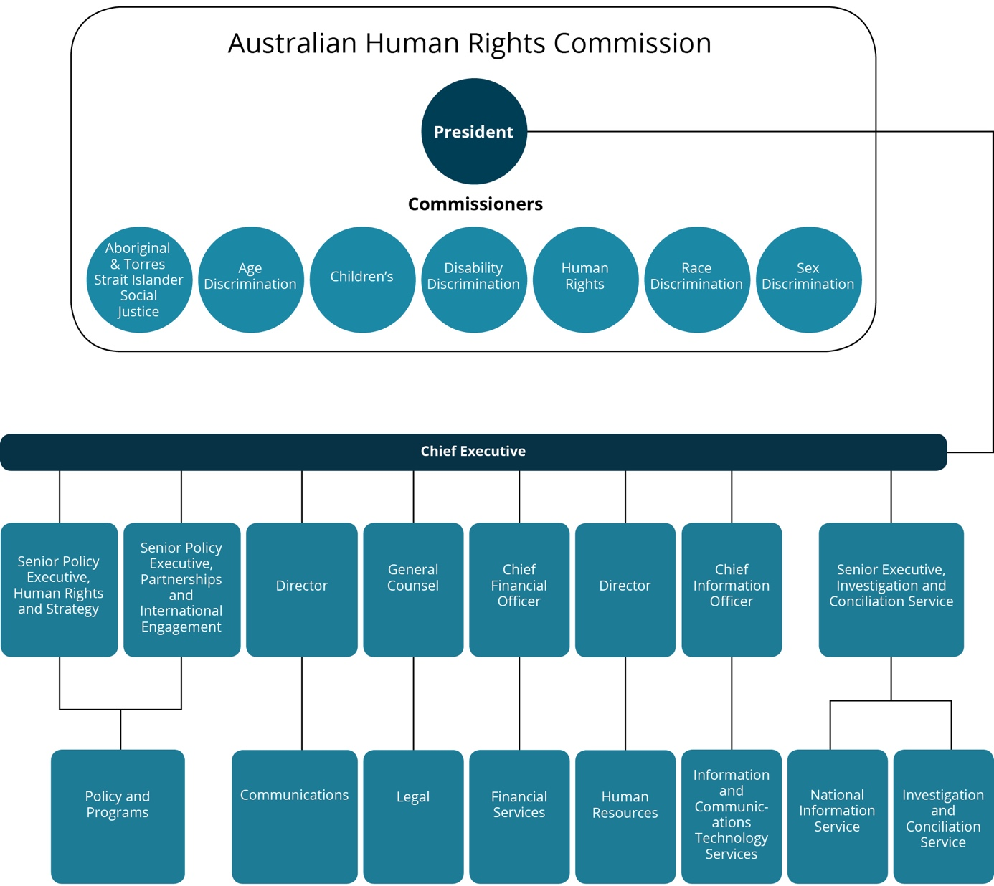

Further Information

**Australian Human Rights Commission**

Level 3, 175 Pitt Street

SYDNEY NSW 2000

GPO Box 5218

SYDNEY NSW 2001

Telephone: (02) 9284 9600

Complaints Infoline: 1300 656 419

General enquiries and publications: 1300 369 711

TTY: 1800 620 241

Fax: (02) 9284 9611

Website: [www.humanrights.gov.au](https://www.humanrights.gov.au/).

For detailed and up to date information about the Australian Human Rights Commission visit our website at: [www.humanrights.gov.au](http://www.humanrights.gov.au/). To order more publications from the Australian Human Rights Commission, download a Publication Order Form at: [www.humanrights.gov.au/our-work/publications](http://www.humanrights.gov.au/our-work/publications), call: (02) 9284 9600, fax: (02) 9284 9611 or email: [publications@humanrights.gov.au](mailto:publications@humanrights.gov.au).

**Australian Human Rights Commission**

[www.humanrights.gov.au](https://www.humanrights.gov.au/)

1. The Commission was initially set up for a period of five years in 1981. It was later established as permanent agency in 1986.
2. Further information: <http://nhri.ohchr.org/EN/AboutUs/Pages/ParisPrinciples.aspx>.
3. This is a general overview. See the specific legislation for exact wording, in particular s 11 of the Australian Human Rights Commission Act 1986 (Cth). Some functions are set out in other legislation.
4. The current President is appointed for a seven-year term and the original five-year term of the National Children’s Commissioner has been extend by two years.
5. Commissioner Gauntlett commenced as Disability Discrimination Commissioner in May 2019. His term goals and a strategic work program will develop in the coming year and will be published at a later date.
6. Asterisk denotes linkage to PBS Performance Criteria.
7. APS wide responses were 72%, 78%, 77% respectively.
8. APS wide response was 79%.