Observations from visits conducted by the Australian Human Rights Commission from December 2011 to May 2012
Community arrangements for asylum seekers, refugees and stateless persons
26 JULY 2012

Table of Contents
1 Summary 4
2 Recommendations 5
3 Introduction 7
4 Australia’s mandatory detention and excision regime 9
4.1 The origins and impact of mandatory immigration detention and excision 9
4.2 Recent developments 12
(a) The Hawke-Williams review 12
(b) The NSW coronial inquest 13
(c) The Joint Select Committee on Australia’s Immigration Detention Network 13
(d) Challenge to the dual processing of claims for asylum 14
(e) Challenge to the Malaysian arrangement 15
(f) Further attempts to allow removal of asylum seekers to third countries 16
5 Community arrangements for asylum seekers, refugees and stateless persons 16
5.1 Benefits of community arrangements and effective international examples 17
5.2 The development of community arrangements in Australia 18
5.3 The Commission’s visits and interviews 20
(a) Strengthening the use of community arrangements for asylum seekers, refugees and stateless persons 21
(b) Using community arrangements at the earliest possible opportunity 22
(c) Opportunities to make a livelihood and engage in other meaningful activities 24
6 Some barriers to use of community arrangements 27
6.1 The Commission’s visits and interviews 27
6.2 Refugees who have received adverse security assessments 28
(a) The security assessment requirement 28
(b) The situation of people with adverse security assessments 29
(c) Procedural fairness 30
(d) Indefinite detention of people who have received adverse security assessments 32
(e) Lack of durable solutions 34
(f) High Court challenge: Plaintiff M47/2012 v Director General of Security 35
6.3 Refugees of interest to or who have been charged by the Australian Federal Police 36
(a) Australian Federal Police and Parliamentary response to detention centre disturbances 36
(b) The situation of refugees who are of interest to or have been charged by the Australian Federal Police 36
(c) Impact of changes to the character provisions under the Migration Act 37
(d) Prolonged detention of refugees who are of interest to or have been charged by the Australian Federal Police 38
6.4 Stateless persons 39
7 Closed detention 41
7.1 The impact of prolonged detention in closed immigration detention facilities 41
7.2 Observations relating to closed immigration detention facilities 43
(a) Health and mental health service provision 44
(b) Mitigation of suicide and self-harm 46
(c) Staff interactions with people in detention 47
(d) Redevelopment, capital works and infrastructure 48
(e) Restrictive places of detention 51
(f) Mobile Phones 52

Summary
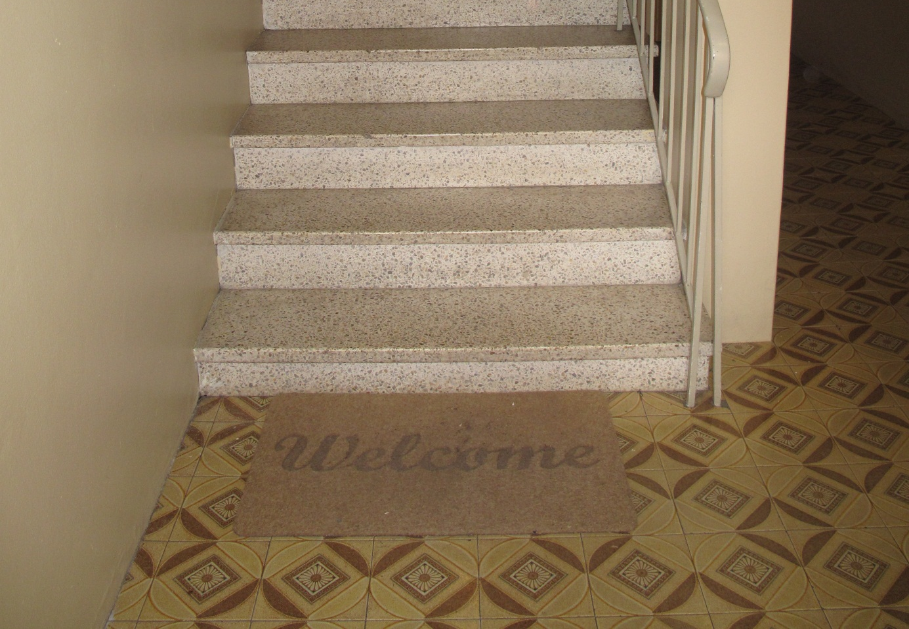
Stairs leading to flat occupied by family in community detention.
This report is about two distinct subject matters. The first of these is the welcome move by the Australian Government to transfer increasing numbers of asylum seekers, refugees and stateless persons into community arrangements. The second is the situation of people who remain in immigration detention facilities with little or no prospect of being released.
Australia has a legal and policy framework which provides for mandatory and indefinite immigration detention. Despite this framework, the Australian Government has recently taken measures to transfer large numbers of asylum seekers, refugees and stateless persons out of closed detention into the community, pending the resolution of their claims for protection. This is being achieved through the use of community detention and bridging visas.
The Australian Human Rights Commission recently visited a number of people living in the community under these arrangements. The Commission found that, as well as being better aligned with Australia’s international human rights obligations, community arrangements offer a far more humane and effective approach to the treatment of asylum seekers, refugees and stateless persons than closed detention.
The Commission also visited four immigration detention facilities this year to speak with asylum seekers, refugees and stateless persons. Some of these people had received adverse security assessments and some of them were people of interest to the Australian Federal Police or had been charged in relation to detention centre disturbances during early 2011. Under current arrangements, many of these people appear likely to remain in closed detention for the foreseeable future. The Commission witnessed alarming levels of despair amongst people experiencing prolonged and indefinite detention with little prospect of a community placement.
Australia’s system of mandatory, indefinite immigration detention leads to breaches of our international human rights obligations and it has a devastating human impact. Community placement options should urgently be pursued for all asylum seekers, refugees and stateless people who do not pose an unacceptable risk to the Australian community.
Artwork on the bedroom door of a man in detention, Maribyrnong Immigration Detention Centre.

Recommendations
Recommendation 1: The Australian Government should end the system of mandatory and indefinite immigration detention.
Recommendation 2: The need to detain should be assessed on a case-by-case basis taking into consideration individual circumstances. That assessment should be conducted when a person is taken into immigration detention or as soon as possible thereafter. A person should only be held in a closed immigration detention facility if they are individually assessed as posing an unacceptable risk to the Australian community and that risk cannot be managed in a less restrictive way. Otherwise, they should be permitted to reside in the community while their immigration status is resolved – if necessary, with appropriate conditions imposed to mitigate any identified risks. If a risk to the community cannot be effectively mitigated, consideration should be given to whether the person can be placed in a less restrictive form of detention.
Recommendation 3: Australian Government policy should be reformed so that individuals in immigration detention who have received an adverse security assessment can be considered for release from detention, or for placement in a less restrictive form of detention.
Recommendation 4: The Australian Government should comply with its international human rights obligations by providing for a decision to detain a person, or a decision to continue a person’s detention, to be subject to prompt review by a court. To comply with article 9(4) of the International Covenant on Civil and Political Rights, the court must have the power to order the person’s release if their detention is not lawful. The lawfulness of their detention is not limited to domestic legality – it includes whether the detention is compatible with the requirements of article 9(1) of the International Covenant on Civil and Political Rights, which affirms the right to liberty and prohibits arbitrary detention.
Recommendation 5: The Australian Government should work towards a uniform model of community assessment and placement for asylum seekers, irrespective of their place or mode of arrival in Australia. An individual assessment of suitability for community placement should be conducted at the earliest opportunity post-arrival. Features of such a model should include:
- Permission for adult asylum seekers placed in the community to seek paid employment, irrespective of their level of vulnerability.
- Opportunities for engagement in meaningful activities, including permission to attend English language classes and to enrol in vocational training.
- A level of income support sufficient to meet basic needs for those who are unable to generate an independent income.
- Access to essential health care and counselling.
- Full access to formal education for school-aged children.
Recommendation 6: The Australian Government should introduce reforms so that refugees who have received adverse security assessments from the Australian Security Intelligence Organisation are provided with:
- Information sufficient for them to be reasonably informed of the basis of the adverse assessment.
- Access to merits review by the Security Division of the Administrative Appeals Tribunal.
- Procedural mechanisms to provide for effective merits and judicial review, including opportunities for a person to know the basis of their assessment and to make submissions on the content of that assessment, either directly or through an appropriate person such as a Special Advocate.
Recommendation 7: The Australian Government should develop a formal statelessness determination mechanism which recognises both de jure and de facto statelessness, and establish administrative pathways for the grant of substantive visas to stateless persons who have been found not to be refugees or otherwise owed protection.
Recommendation 8: A uniform national policy on the use of restrictive places of detention should be developed and should cover all places of detention that may be used for observation and segregation. Mental health and suicide prevention experts should be consulted in the development of this policy. The policy should specify that there is to be no co-location of people who are considered to be at risk of suicide or other forms of self-harm with people who are under observation due to aggressive or threatening behaviours.

Introduction
External view, flat occupied by family in community detention.
Over recent months, the Australian Government has moved increasing numbers of asylum seekers and refugees who arrived in Australia by boat from closed immigration detention into the community, pending resolution of their claims for protection. This has been achieved through use of community detention and bridging visas, building on measures introduced by successive Australian Governments.
The Australian Human Rights Commission welcomes the increased use of community arrangements for asylum seekers and refugees, which, along with other recent reforms, brings the Australian Government’s treatment of asylum seekers and refugees closer into alignment with its international human rights obligations.
This report considers the circumstances and experiences of asylum seekers, refugees and a small number of stateless persons who have been transferred out of closed detention into the community under these arrangements. It also considers the circumstances and experiences of refugees, asylum seekers and stateless persons who face, or have until recently faced, the prospect of protracted and indefinite detention in closed facilities.
This report draws on observations made during the Commission’s visits to and discussions with asylum seekers and refugees in community detention and living in the community on bridging visas from December 2011 to May 2012. It is also informed by the Commission’s visits to Villawood Immigration Detention Centre (Villawood IDC), Sydney Immigration Residential Housing (Sydney IRH), Maribyrnong Immigration Detention Centre (Maribyrnong IDC) and Melbourne Immigration Transit Accommodation (Melbourne ITA) in April 2012.
Throughout this report, community detention and bridging visas are collectively referred to as ‘community arrangements’. High-security immigration detention centres, through to medium-security detention facilities (such as Sydney IRH and Melbourne ITA), are collectively referred to as ‘closed detention’. As international human rights law requires the use of detention only as a last resort, this report refers to ‘community arrangements’ rather than to the commonly used term ‘alternatives to detention’. As community arrangements ought to be considered the norm, detention in closed facilities should be considered the ‘alternative’ option, to be used only in exceptional circumstances.
The Commission’s recent visits and discussions have affirmed the Commission’s long-held view that community arrangements offer a far more humane and effective approach to the treatment of asylum seekers and refugees than closed detention. Maximum benefits will be derived where asylum seekers are placed in the community at the earliest opportunity following arrival, with appropriate support and opportunities for self-reliance and meaningful activities.
The Commission’s work in relation to asylum seekers, refugees and immigration detention has involved investigating complaints by people in detention, conducting national inquiries and visiting places of detention to monitor and report on conditions. The Commission has recently adopted a new approach to its detention visiting activities, under which detailed monitoring and reporting of conditions of immigration detention of the kind undertaken over recent years will no longer occur. The Commission will continue to visit sites across the immigration detention network. However, these visits will generally be shorter; they will be more focused upon specific issues and reports regarding conditions of detention will no longer be produced. This report is reflective of the new approach.
The human rights of all people in immigration detention are of concern to the Commission because the right to liberty is a fundamental human right. However, the Commission has particular concerns about issues faced by asylum seekers, refugees and stateless persons, due to their specific vulnerabilities. For this reason, the report that follows focuses on the circumstances and experiences of these populations.
The Commission acknowledges the assistance provided by the Department of Immigration and Citizenship (DIAC) and the Australian Red Cross in facilitating the Commission’s visits and interviews. The Commission also acknowledges the cooperation received from DIAC, Serco, International Health and Medical Services (IHMS) and Marist Youth Care staff in relation to visits to sites of closed and community detention. This report was provided to DIAC and to the Australian Security Intelligence Organisation (ASIO) in advance of its publication in order to provide those agencies with an opportunity to prepare a response. The response provided by DIAC is available on the Commission’s website. ASIO provided feedback to the Commission on the report and advised that it would not be making a public response on this occasion.
The Commission also thanks the men, women and children with whom Commission staff met for their generosity and openness during the visits and interviews.

Australia’s mandatory detention and excision regime
Mural, Villawood Immigration Detention Centre.

The origins and impact of mandatory immigration detention and excision
This year marks the twentieth anniversary of Australia’s introduction of mandatory immigration detention and the eighteenth anniversary of the system of mandatory, indefinite immigration detention. In the current context, it is apt to recall that mandatory detention was introduced in reaction to the arrival of asylum seekers by boat, with concerns about a potential ‘influx’ spurring bipartisan support for increasingly tough measures on persons who arrived in Australia without a visa.
Amendments to the Migration Act 1958 (Cth) (Migration Act) in 1992 both required the detention of certain ‘designated persons’ and prevented any judicial review of detention by providing that ‘a Court is not to order the release from custody of a designated person’. These amendments did, however, impose a 273 day time limit on immigration detention.
Additional legislative amendments in response to further boat arrivals in Australia commenced in 1994. The 1994 legislation:
- broadened the application of mandatory detention to all persons who either arrived without a visa or who were in Australia on an expired or cancelled visa
- removed the 273 day time limit on detention, instead providing that an ‘unlawful non-citizen’ could only be released from detention on the grant of a visa, removal or deportation from Australia
- introduced a system of bridging visas to allow release from immigration detention in certain circumstances.
The next major change to Australia’s system for responding to asylum seekers who arrive by boat occurred in September 2001. A raft of amending legislation was enacted at this time in response to what became known as ‘the Tampa crisis’ and in pursuit of the so-called ‘Pacific Solution’. Among other things, the 2001 legislation:
- designated Christmas Island, Ashmore and Cartier Islands and the Cocos (Keeling) Islands as ‘excised offshore places’
- prohibited persons who arrived in Australia via such places, or ‘offshore entry persons’, from making a protection visa application, other than at the discretion of the Minister
- provided for the transfer to third countries for processing of their protection claims of asylum seekers who are intercepted at sea or reach an ‘excised offshore place’.
In more recent times, Australia has taken significant steps towards implementing a system of community placement on the mainland for asylum seekers and refugees who have arrived in Australia by boat. As noted above, this is a welcome development, aspects of which align with recent Commission recommendations and international human rights standards.
Nevertheless, Australia retains a legal and policy framework of excision and of mandatory, indefinite immigration detention. Under this framework, any person who is not a citizen and does not hold a valid visa must be detained, regardless of his or her individual circumstances. For people who arrive on the Australian mainland, this requirement is contained in the Migration Act. For people in this situation who arrive at an ‘excised offshore place’, such as Christmas Island, detention is discretionary under the Migration Act, but current Australian Government policy is that all such people are detained. Further, as noted, immigration detention in Australia is not subject to a time limitation. Once detained, non-citizens who do not hold valid visas must be kept in detention until they are removed from Australia or granted a visa. It would be legal under Australian law to hold someone in immigration detention for the rest of his or her life, as long as detention continues to be for one of the purposes in the Migration Act.
The Commission has raised concerns over many years that the system of mandatory, indefinite detention leads to breaches of Australia’s international human rights obligations, including the prohibition on arbitrary detention. Concerns about Australia’s system of mandatory, indefinite immigration detention are also held by a number of United Nations bodies.
Australia has binding obligations to ensure that no one is subjected to arbitrary detention. To comply with international law, detention must be a proportionate means to achieve a legitimate aim. In determining whether detention is proportionate, consideration must be had to the availability of alternative means for achieving that end which are less restrictive of a person’s rights. Detention should only be used as a last resort, and when it is used, it should be the least restrictive form avaliable and should not continue beyond the period for which it can be justified.
The Commission recognises that immigration detention may be legitimate for a strictly limited period of time. However, the need to detain a person should be assessed on a case-by-case basis taking into consideration their individual circumstances.
To avoid detention being arbitrary, there should be an individual assessment of the necessity of detention for each person, as soon as possible after a person is taken into detention. A person should only be held in an immigration detention facility if they are individually assessed as posing an unacceptable risk to the Australian community and that risk cannot be met in a less restrictive way. Otherwise, they should be permitted to reside in the community while their immigration status is resolved – if necessary, with appropriate conditions imposed to mitigate any identified risks.
The Commission has also repeatedly raised concerns about the significant human impact of mandatory immigration detention. During visits to immigration detention facilities over many years, people in detention have repeatedly told the Commission of the detrimental impact of lengthy detention upon their physical and mental health, and of the anxiety and desperation which they experience due to the indefinite nature of their detention. People have often spoken to the Commission about the psychological impacts of their prolonged detention, including high levels of sleeplessness, loss of concentration, feelings of hopelessness and powerlessness and thoughts of self-harm or suicide. The Commission heard of the devastating impact of detention again during the visits that are the subject of this report.
Artwork by man in detention, Melbourne Immigration Transit Accommodation.

Recent developments
Because of Australia’s system of mandatory, indefinite immigration detention, asylum seekers who arrive in Australia by boat spend at least some time, and often protracted periods, in immigration detention. An increased detention population, comprising many people who had experienced lengthy periods of detention, led to significant overcrowding and heightened tensions in immigration detention facilities during 2010 and early 2011.
As tensions rose, critical incidents in immigration detention became common. Self-harm in detention has occurred at high rates for much of the past two years and has involved instances of lip-sewing, self-laceration, voluntary starvation and ingestion of chemicals. There have also been eight deaths in immigration detention, six of which appear to have been suicides. Further, detention facilities have been the scenes of violent protests, including at Christmas Island Immigration Detention Centre (Christmas Island IDC) in March 2011 and at Villawood IDC in April 2011.
A number of inquiries and investigations have recently been conducted into aspects of the immigration detention network, with a focus on critical incidents. Additionally, in 2010 and 2011 the High Court of Australia handed down two decisions which had a significant impact on Australian asylum seeker and refugee law and policy.

The Hawke-Williams review
On 18 March 2011, Minister for Immigration and Citizenship, the Hon Chris Bowen MP, announced an independent review would be conducted by Dr Allan Hawke AO and Ms Helen Williams AO into the incidents including riots that occurred at Christmas Island IDC in March 2011. On 21 April 2011, the Minister announced that the scope of the review would be expanded to include the protests that took place at Villawood IDC on 20-21 April 2011.
The review’s terms of reference covered:
- the respective roles and responsibilities of DIAC and the detention services provider Serco in managing these detention centres
- the means by which breaches of security were achieved
- prior indicators which may have assisted in preventing the incidents
- the adequacy of infrastructure, staffing and case management at the relevant facilities
- training and supervision of DIAC and Serco staff
- communication and coordination between relevant government agencies and contractors
- the appropriateness of the measures taken in response to the incidents.
The report of this review was released on 31 August 2011. It contains 48 recommendations aimed at preventing further critical incidents in detention, all of which DIAC agreed to. The Minister for Immigration and Citizenship has asked DIAC to report on its progress in implementing the recommendations by mid-2012.

The NSW coronial inquest
Also last year, the NSW Coroner conducted an inquest into the deaths of Mr Josefa Rauluni, Mr Ahmed Al-Akabi and Mr David Saunders at Villawood in 2010. Magistrate Mary Jerram handed down the findings of the inquest on 19 December 2011. Her Honour found that the three men took their own lives. Her Honour observed that people in immigration detention centres, due in part to the loss of their families, freedom, status and work, must be ‘at much greater risk of suicide than the general community’. For this reason, those responsible for people in detention ‘owe a greater than normal duty of care to those persons regarding their health and wellbeing’. In Her Honour’s view, DIAC, Serco and the detention health services provider IHMS all warranted criticism for the way in which that duty of care was fulfilled with respect to the three men who died.
Magistrate Jerram found that some individual DIAC, Serco and IHMS staff members were ‘careless, ignorant or both, and communications were sadly lacking’ in relation to the men who died, but that no individual acted in bad faith deliberately. Rather, in Her Honour’s view, a series of systemic failures led to the deaths. These included a lack of appropriate screenings and protocols to minimise risk for the deceased men; a lack of consistency arising from high staff turnover; a failure to record or share important information and ‘startling examples of mismanagement’.

The Joint Select Committee on Australia’s Immigration Detention Network
The Commonwealth Parliament established a Joint Select Committee (JSC) on Australia’s Immigration Detention Network on 16 June 2011. The JSC was charged with conducting a comprehensive inquiry into various aspects of Australia’s immigration detention network, including its management, resourcing, potential expansion, possible alternative solutions, the government’s detention values, the effect of detention on people detained and various issues relating to riots and disturbances in detention.
The JSC handed down a substantial report of its inquiry on 30 March 2012. The report contains 31 recommendations, which include that:
- Following initial health, identity, character and security checks, asylum seekers should be granted bridging visas or released into community detention.
- People held in immigration detention should be accommodated in metropolitan rather than remote facilities wherever possible.
- The Minister for Immigration and Citizenship should be replaced as guardian of unaccompanied minors in immigration detention.
- Consistent child protection arrangements should be implemented across the detention network.
- Effective review mechanisms should be made available to people who have received adverse security assessments.
- IHMS staffing levels within immigration detention should be reviewed.
At the time of publication of this report, the government had yet to respond to the JSC’s report and its recommendations.

Challenge to the dual processing of claims for asylum
In 2010, the High Court of Australia heard and decided Plaintiff M61/2010E v Commonwealth. In this case, two Sri Lankan asylum seekers who arrived in Australia by boat challenged the separate system of processing asylum claims which applied to people who arrived in Australia at an ‘excised offshore place’ like Christmas Island.
The plaintiffs argued that they were not afforded procedural fairness in the assessment of their refugee claims or the merits review of the negative decisions which arose from those claims. They argued that the officers conducting the primary assessments and reviews erred in law by considering themselves not to be bound by the provisions of the Migration Act or the decisions of Australian courts. The Commonwealth and the Minister for Immigration and Citizenship argued that refugee status assessment and review processes applying to people who arrived in Australia at an ‘excised offshore place’ are an exercise of non-statutory executive power and therefore there was no obligation on officers conducting these processes to afford applicants procedural fairness or to decide applications according to law.
The High Court unanimously decided that the refugee status assessment and review processes are not an exercise of non-statutory executive power but rather are ‘steps taken under and for the purposes of the Migration Act’. Officers responsible for undertaking the assessments and reviews in the immediate case were therefore bound to act according to law and to afford the plaintiffs procedural fairness. This decision resulted in access to Australian courts for judicial review being granted to asylum seekers who arrive in Australia by boat at Christmas Island and other ‘excised offshore places’.
On 25 November 2011, the government announced that Australia would return to a policy of using a single statutory system for processing asylum claims. The new streamlined arrangements commenced on 24 March 2012. All claims for protection are now assessed according to the refugee status determination process established by the Migration Act, regardless of the place or mode of arrival of the person lodging the claim. All asylum seekers in Australia now have access to the same opportunities to appeal a negative decision in the Refugee Review Tribunal or Administrative Appeals Tribunal. In addition, a scheme for assessing complementary protection claims also commenced on 24 March 2012.
The Commission welcomed Australia’s return to a single system for processing claims for protection, which should lead to a fairer, more efficient and more cost-effective system. However, the Commission remains concerned that the provisions relating to ‘excised offshore places’ remain in the Migration Act, allowing the government to return to a policy of dual processing at any time.

Challenge to the Malaysian arrangement
In May 2011, the Australian Government announced the Arrangement between the Government of Australia and the Government of Malaysia on Transfer and Resettlement, whereby up to 800 asylum seekers who arrived in Australia by boat would be removed to Malaysia for processing of their claims for protection. Under the arrangement, the Australian Government agreed to accept 4000 recognised refugees from Malaysia for resettlement in Australia.
In Plaintiff M70/2011 v Minister for Immigration and Citizenship, the validity of this arrangement was challenged by two asylum seekers who were subject to transfer under the arrangement. The High Court held that the Minister for Immigration and Citizenship’s declaration of Malaysia as a third country to which asylum seekers who arrive in Australia by boat can be removed was invalid, and ordered that the Minister not remove the plaintiffs from Australia to Malaysia.
The majority of the High Court concluded that the Minister could only validly declare a country under s 198A of the Migration Act to which asylum seekers can be taken for the processing of their claims if that country satisfies the criteria set out in that section as a matter both of law and of objective fact. These include that the third country must provide:
- access to effective procedures for the processing of asylum claims
- protection for asylum seekers pending a decision on their claims for refugee status
- protection for people found to be refugees, pending their voluntary return to their countries of origin or their resettlement in other countries.
The High Court found that Malaysia was not, and is not, obliged under law to provide these protections. Malaysia is not a party to the Convention Relating to the Status of Refugees or its 1967 Protocol. The arrangement between the Australian and Malaysian Governments, and the purported protections contained therein, were not legally binding. Further, domestic Malaysian law does not recognise the status of refugees.
The High Court also held that the removal of unaccompanied minors who arrive in Australia by boat seeking asylum, or the taking of children in this situation to another country pursuant to s 198A of the Migration Act, cannot lawfully be effected without the written consent of the Minister for Immigration and Citizenship (or his delegate). It confirmed that any decision to provide that consent would be subject to judicial review.
In response to the decision in Plaintiff M70/2011 v Minister for Immigration and Citizenship, on 12 September 2011, the Prime Minister and the Minister for Immigration and Citizenship announced that the Australian Government would introduce amendments to the Migration Act to ‘restore the understanding of the third country transfer provisions of the Migration Act that existed prior to the High Court’s decision on 31 August 2011’. The Ministers also announced an intention to amend the Immigration (Guardianship of Children) Act 1946 (Cth) (IGOC Act), ‘to enable decisions to be made with respect to minors’.
The amendments to the Migration Act and IGOC Act were introduced by the government on 21 September 2011, but have not yet passed Parliament.

Further attempts to allow removal of asylum seekers to third countries
In two incidents over the space of a week in July 2012, a known 94 asylum seekers tragically drowned en route to Australia. This led to intense parliamentary debate surrounding the reintroduction of proposed legislative amendments to enable the removal of asylum seekers who arrive in Australia by boat to third countries for the processing of their protection claims. The amendments were not passed.
The Prime Minister of Australia, the Hon Julia Gillard MP, subsequently announced the appointment of an Expert Panel on Asylum Seekers to provide recommendations to the Australian Government on policy options to prevent asylum seekers risking their lives on dangerous boat journeys to Australia. The Expert Panel will take into account Australia’s international obligations and right to maintain its borders. It will consult with a Multi-Party Reference Group, amongst others, and is due to report before the end of August 2012.

Community arrangements for asylum seekers, refugees and stateless persons
It was in this context that the expansion of the use of community arrangements in Australia occurred.
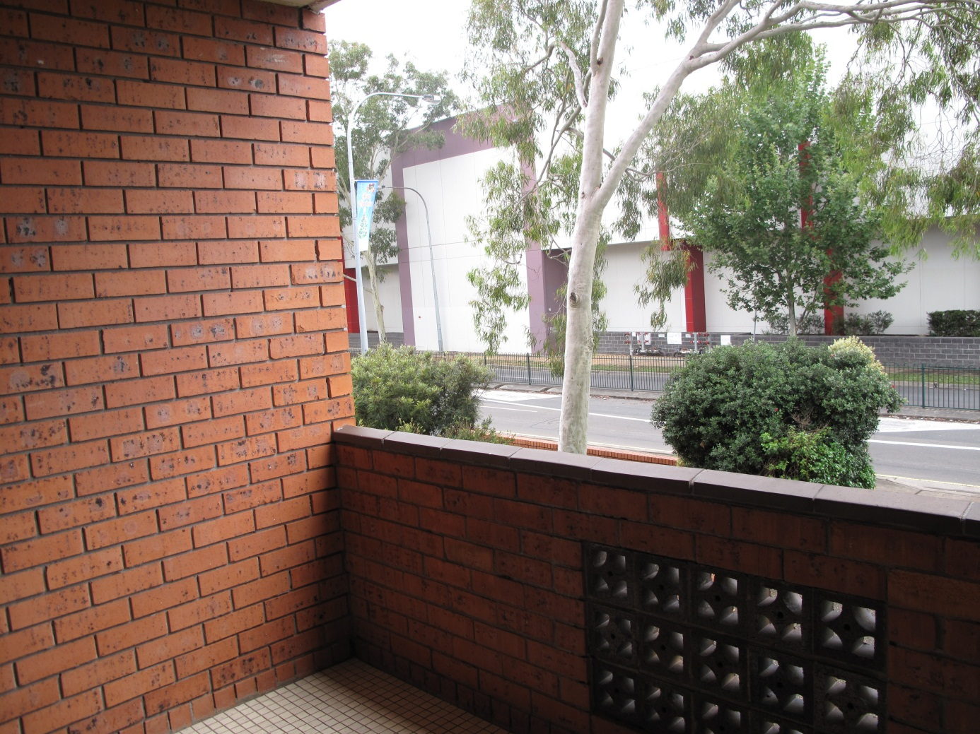
View from balcony, flat occupied by family in community detention.

Benefits of community arrangements and effective international examples
There are a host of benefits associated with community arrangements for asylum seekers, refugees and stateless persons. Community arrangements are more closely aligned with international human rights law and standards than models of indefinite closed immigration detention. They also provide for far more humane treatment of people seeking protection.
There are further practical benefits. For example, community placement can be much cheaper than closed detention. Effective community arrangements allow for readier transition to life as an Australian resident for people who are granted protection, and people who are found not to be owed protection have been shown to be more willing and able to return to their countries of origin when they have been living in the community than when held in closed detention. As community arrangements entail fewer risks to the health, mental health, safety and wellbeing of asylum seekers, refugees and stateless persons, they are likely to lead to lower rates of suicide and self-harm as well as fewer claims for compensation. There are also very low rates of absconding from community arrangements. Finally, community placements allow for the full enforcement of immigration law and conditions can be applied within a community setting which enable mitigation of any identified risks.
Community arrangements for asylum seekers, refugees and stateless persons have been in use by countries around the world for many years. For example:
- In Canada, people may be released from immigration detention on bail or bond and incur negative financial consequences if they breach the conditions of their release, which might include reporting requirements or handing over travel documents.
- In Spain, asylum seekers are either released into the broader community or accommodated in an open reception centre from which they are free to come and go. They are given a small monthly allowance and permitted to access medical and psychological services, a social worker, legal aid and educational opportunities. Asylum seekers can be housed in reception centres for up to six months, after which time they are assisted to find independent housing and employment or, if they are vulnerable, they may apply for an extension.
- Sweden uses a ‘reception program’ under which asylum seekers are issued with identification documents on arrival which are used by immigration officials to track their cases. After spending around a week in a transit or processing centre, asylum seekers are released into the community and can use their documentation to access some basic services. They are permitted to work in a range of circumstances, and if they do, they must contribute to their costs of living.
- New Zealand uses a ‘tiered system’ of monitoring and detention. Reporting and residence requirements can be used to manage people’s cases in the community, and if asylum seekers living in the community fail to comply with certain conditions, they are subject to arrest and detention.

The development of community arrangements in Australia
As noted above, the Australian Government has made significant progress over the past two years towards implementing a system of community arrangements for asylum seekers, refugees and stateless persons who would otherwise be held in closed detention.
This progress builds on measures introduced by previous Australian Governments, in particular the introduction of the community detention mechanism in 2005. At this time the Migration Act was amended to give the Minister for Immigration and Citizenship the power to make a ‘residence determination’ in respect of a person in immigration detention, which allows that person to live in a specified residence in the community. A person in this position is said to be in ‘community detention’.
On 29 July 2008, the then Minister for Immigration and Citizenship, Senator the Hon Chris Evans MP, announced the New Directions in Detention policy. Under the New Directions policy, immigration detention is to be used as a last resort and for the shortest practicable period, and there is a presumption that people will be permitted to reside in the community unless they pose an unacceptable risk. This policy was not enshrined in legislation, and prior to late 2010, very few people were transferred from closed detention into the community prior to resolution of their status.
On 18 October 2010, the Australian Government announced that it would begin moving significant numbers of children and their families into community detention. A year later, on 25 November 2011, the government announced that following initial health, security and identity checks, selected asylum seekers who arrive in Australia by boat would be placed into the community while their asylum claims were assessed. This was to be achieved through extending the use of community detention to vulnerable individuals in addition to children and families. It was also to be achieved by granting bridging visas, for the first time, to people who had arrived in Australia by boat.
People in community detention remain in immigration detention as a matter of law. However, they are generally not under supervision and can move about in the community subject to conditions attached to their residence determination. Such conditions might include, for example, a curfew, the requirement to sleep at a specified residence every night, travel restrictions and requirements to report regularly to DIAC. Accordingly, the community detention system allows for people to be subjected to fewer restrictions on their liberty than in closed detention, while at the same time mitigating risks and promoting compliance with immigration processes.
People who have been granted bridging visas are not in immigration detention and can live lawfully in the community. A bridging visa can be granted to a person while their application for a substantive visa is being processed, while arrangements are being made for a person to leave Australia or at other times when a person doesn’t have a visa. Generally people granted bridging visas are not subject to any restrictions on their liberty. However conditions may be placed on bridging visas, such as reporting requirements.
The government has transferred significant numbers of people out of closed immigration detention facilities since the announcements of 2010 and 2011 were made. Between 18 October 2010, when the government announced that it would significantly increase the number of families and children moving into community detention, and 19 July 2012, 4234 people had been approved for community detention, including 2008 children. There were 1320 people, including 431 children, in community detention as at 19 July 2012. Between 25 November 2011, when the first bridging visas were granted to asylum seekers who arrived in Australia by boat, and 19 July 2012, 3211 people from this class had been granted bridging visas. There were 2418 people who had arrived in Australia by boat living in the community on bridging visas as at 19 July 2012.

The Commission’s visits and interviews
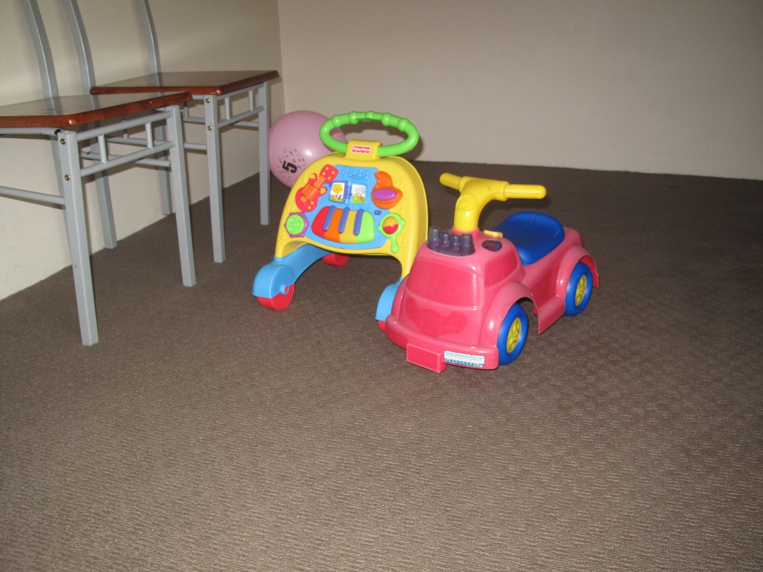
Flat occupied by family in community detention.
Commission staff conducted a series of visits and interviews with asylum seekers, refugees and stateless persons in community arrangements between December 2011 and May 2012. During these visits, the Commission met with couples with children, a multi-generational family group, unaccompanied minors, vulnerable adult men and one vulnerable adult woman. These people came to Australia from Afghanistan, Sri Lanka, Iran and Iraq. Some of them were stateless. The people with whom the Commission met included school students, babies and toddlers, older people, people who had experienced torture and trauma and people with disabilities.
The comments and recommendations which follow are based on observations made during the Commission’s visits and interviews. The Commission has not conducted a comprehensive review of community arrangements and has only met with a small sample of people living in the community. However these observations allow an informed assessment of the impact of community arrangements on asylum seekers, refugees and stateless persons.
The Commission appreciates that there are significant logistical and other challenges involved in transferring large numbers of people from closed detention to community arrangements, and that it is critical to the success of these initiatives that supporting community infrastructure is sufficient to meet demand. Matters relating to service provider capacities, availability of accommodation and other logistical challenges have not been addressed in this report.

Strengthening the use of community arrangements for asylum seekers, refugees and stateless persons
“I really breathed the air into my body for the first time in so many months. And I thought – I can live again now.” (Sri Lankan refugee on a bridging visa in Sydney)
“I believe that being outside of detention, even with all the difficulties, is better than in detention. Here you have a friend to go to, a park to go to. Even on the best day in detention, you are still looking at the wires around you…” (Iranian asylum seeker on a bridging visa in Queensland)
“When we are here, we go to school – it is better than detention; we can go outside; go shopping; buy things; catch a train by ourselves; have activities.” (16-year-old unaccompanied Afghan asylum seeker in community detention in Sydney)
“In detention our son was bored, he didn’t play with the other kids, he cried, he just said, ‘I want to get out’. But here he is doing much better. It has made a big difference being in the community.” (Stateless asylum seeker in community detention in Melbourne)
The Commission has long argued that community arrangements ought to be the norm for asylum seekers and refugees, and the use of closed immigration detention should be a measure of last resort. The Commission’s visits and conversations with people in community detention and on bridging visas have reinforced the view that community arrangements, with appropriate opportunities and support, comprise a far more humane and effective model than closed detention for asylum seekers pending status resolution.
The overwhelming majority of people who spoke with the Commission reported that community arrangements were far preferable to being held in closed detention. All who spoke with Commission staff, including those with heightened vulnerabilities, stated that the challenges which they faced living in the community were less difficult than those which they had confronted while in a detention facility.
People told the Commission of a range of benefits associated with their community placement.
- People spoke of the additional measure of freedom they experienced through being able to leave their residence as they wanted; visit new places such as landmarks in the city or a farm; and engage in activities and social events in the community such as barbeques.
- People also spoke of the increased level of independence they experienced through, for example, being able shop for their own groceries; plan and cook their own meals; and organise their own transportation to appointments.
- Some people told the Commission that the best thing about community placement was the ability it gave them to stay in closer contact with friends, family members and support people.
- Others told Commission staff their children were faring much better in community arrangements than they did in closed detention.
While a vast majority of people in community placement spoke of this arrangement as preferable to closed detention, there were a small number of exceptions to this rule. These comprised a family who felt more socially isolated in the community than they had while detained at Leonora, and two people who feared that the longer than anticipated wait for a decision on their claim was attributable to them having been ‘forgotten’ as they were less visible to authorities in the community.
Nonetheless, it appeared to the Commission that the benefits of community placement far outweighed any disadvantages. Asylum seekers and refugees living in community arrangements have, to a much greater extent than those living in detention facilities, opportunities to live in normalised environments, to personalise the space they reside in and to plan their days. Community arrangements also appear to help people cope with the stresses associated with undergoing often lengthy and sometimes traumatic refugee status assessment processes and associated checks.
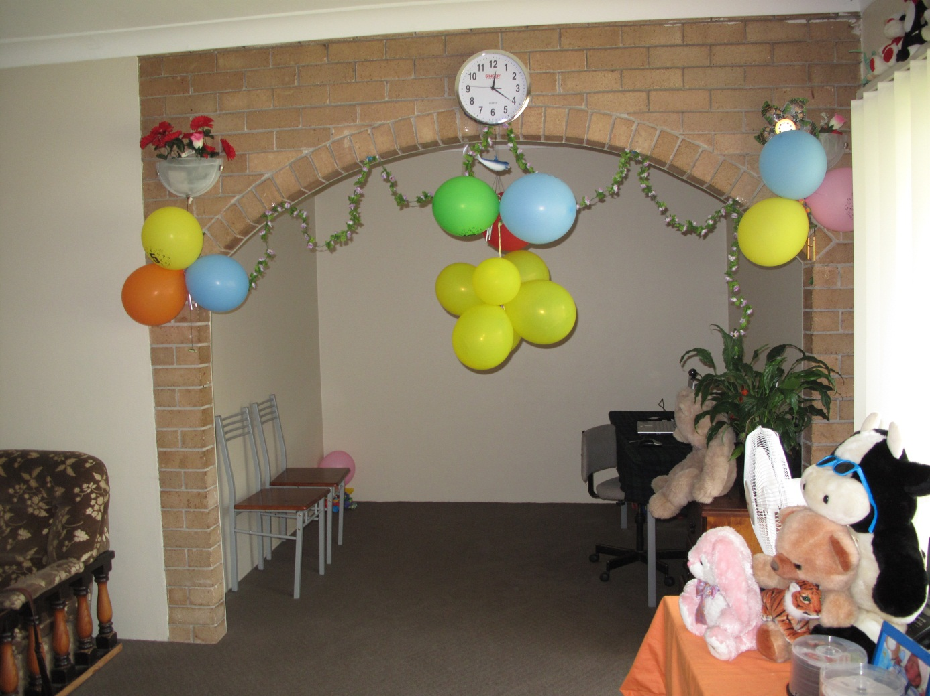
Flat occupied by family in community detention.

Using community arrangements at the earliest possible opportunity
“For the first month out of the detention centre I was dreaming of the things I saw there. That pushes you to the edge of being mad.” (Iranian asylum seeker on a bridging visa in Sydney)
“I was a very happy boy before. After I spent a lot of time in the camp, it affected me very badly ... I moved from home, I was separated from my mother and I came to the detention centre – I was on my own. I was very sad, very depressed.” (Iranian asylum seeker on a bridging visa in Sydney who arrived in Australia as an unaccompanied minor)
“After a while he is getting better, much better. At the beginning he was affected about his experiences in detention. But with time he is getting better.” (Stateless asylum seeker in community detention in Melbourne, speaking about his two-year-old son)
“I felt a bit happy at first because I was a bit free. But it also felt weird. It was a strange experience – especially after a year.” (Iranian asylum seeker in community detention in Melbourne)
“For now I feel OK – in my body and my mind. I think being busy helps with that. But because of the prolonged detention I had great mental distress.” (Sri Lankan refugee on a bridging visa in Melbourne)
It was apparent from the Commission’s visits and interviews that people who had been transferred into the community within a few months of their arrival, whether on bridging visas or in community detention, were coping better than people who had endured extended periods of time in closed detention prior to their community placement.
Over many years of monitoring immigration detention facilities and speaking with people in detention, the Commission has witnessed the highly damaging effects of prolonged, indefinite immigration detention. Countless people in detention have told the Commission of the acute anxiety, distress and frustration they have experienced as a consequence of their detention, and the pervading uncertainty as to how long it will last. In many cases, people in detention have pre-existing vulnerabilities arising from experiences of torture and trauma or the loss of or separation from loved ones.
The effects of prolonged, indefinite immigration detention on the wellbeing of people who have experienced detention do not dissipate immediately upon a person’s release. Most of the refugees and asylum seekers in community placement with whom the Commission spoke told staff of their experiences of detention and the legacy of such experiences in their everyday lives. Some people spoke of invasive memories which interrupted their sleep and affected their appetite. Others spoke of disturbing dreams. Still others told the Commission that they had problems with their memory, concentration and ability to learn, all of which they attributed to the effects of being held in closed detention.
It appeared however that some asylum seekers and refugees in community arrangements, when provided with appropriate support, felt that they could begin to recover from their experiences of detention and regain a degree of hope for their future. Many people told the Commission that since being placed in the community, they – and, where relevant, their children – were coping better. Many people felt able to reengage with their families, the community and DIAC processes.
People’s recovery appeared especially pronounced when they had spent shorter periods of time in detention facilities. Those who had spent prolonged periods in detention prior to their community placement reported that they continued to be powerfully affected by difficult past experiences.
Artwork by children in community detention.

Opportunities to make a livelihood and engage in other meaningful activities
“It was difficult to find the work and the work is hard. I am very busy. I work 54 hours per week across 6 days. But it is good to be busy also. It is difficult in many ways, but I am happier now.” (Sri Lankan refugee on a bridging visa in Sydney)
“I hope I get a job … otherwise I’ll have nothing to do but sit around, waiting for my visa.” (Iranian asylum seeker on a bridging visa in Queensland)
“They say that this is freedom, but I’m not allowed to have freedom. These are very sensitive times in life – these ages I have been while here. They are the best times to study and to work – to develop. But I have been wasting my time. This is very unhealthy. I now feel like I am very old.” (Iraqi asylum seeker in community detention in Melbourne)
“I would really like to work and study. I look at here as if it were Iran. I was not allowed to work or study there. And I had no identity there either. But I feel like my situation is much worse here now, because I am no longer single. I have to provide for my family, but I can’t. After a year, we were told that we can study.” (Iranian asylum seeker in community detention in Melbourne)
“I am allowed to do voluntary work. And I have done – a lot. But I have stopped now. I would like to be able to earn my own money. To not rely on a handout.” (Iraqi asylum seeker in community detention in Melbourne)
“It’s very difficult to spend all day and night in the house. It means we are saving money, but it’s boring staying at home all the time!” (Sri Lankan refugee couple in community detention in Sydney)
“We are so grateful to the authorities: they rescued us from the ocean at a time when I thought that my wife might die and now they have placed us in the community. But I am not allowed to work to support my family, and that is very hard. We have tried to do everything that’s best for our son – to bring him to safety. But sometimes not knowing what the future holds and having nothing to really do can make our days feel unbearable.” (Iranian asylum seeker in community detention in Melbourne)
It was evident from the Commission’s visits and interviews that opportunities for self-reliance and meaningful activities are critical to rebuilding resilience amongst asylum seekers, refugees and stateless persons.
People in community detention, unlike people who have been granted a bridging visa, are not permitted to engage in paid work in Australia. Families with children and people with vulnerabilities are more likely to be placed into community detention than granted a bridging visa, due to the additional support which is generally associated with that community placement option. Consequently, a large number of people in community arrangements are not permitted to engage in paid employment.
The prohibition on paid employment was a source of distress amongst the adults in community detention with whom Commission staff spoke. Most people in this situation expressed feelings ranging from demoralisation to despair at their inability to support themselves or their families, or to contribute to Australian society. Some felt that their dignity was undermined by not being able to work; others were at pains to convey that they had not wished to become a burden on Australian society. Those who had been in community detention for longest appeared most highly distressed by this issue.
Moreover, some people told the Commission of the impact of the lack of opportunities to engage in specific activities aside from work. People told the Commission of their desire to engage in meaningful activities which allowed scope for personal development. For example, some spoke of their desire to study English or to engage in vocational training. In some cases, people told the Commission they had been advised that they were prevented from undertaking studies of this nature because of the conditions attached to their community detention or bridging visa; in other situations people were unclear about what activities they were permitted to pursue. Asylum seekers and refugees told the Commission that the lack of opportunities to engage in meaningful activities led to idleness, apathy and a sense of worthlessness and lost opportunity.
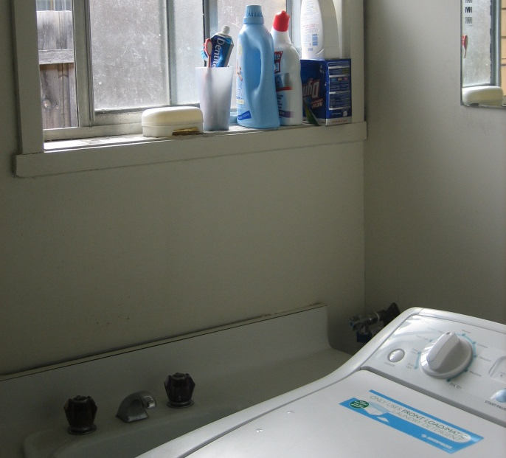
Left and right: flat occupied by family in community detention.
The opportunity to work should be afforded to all adults who have been placed in community arrangements. While the Commission appreciates that some people may not find or sustain employment readily due to multiple impediments to workforce participation, all those who feel able to work should nevertheless be given the chance to do so, irrespective of their level of vulnerability.
The Commission understands that families and vulnerable individuals in community detention may now be considered for transfer onto bridging visas if it appears that they are in a position to earn. This is a positive step. However, to avoid delay in allowing people opportunities to gain a livelihood, people in this situation should be considered for a bridging visa grant in the first instance wherever possible, as long as they continue to be provided with levels of support commensurate with their basic needs.
The Commission also believes that people in community arrangements should be given opportunities to engage in meaningful activities, aside from work. These ought to include eligibility for adult English language classes and permission to enrol in vocational training. Where such opportunities are already available under current arrangements, this should be made clear to those concerned.

Some barriers to use of community arrangements
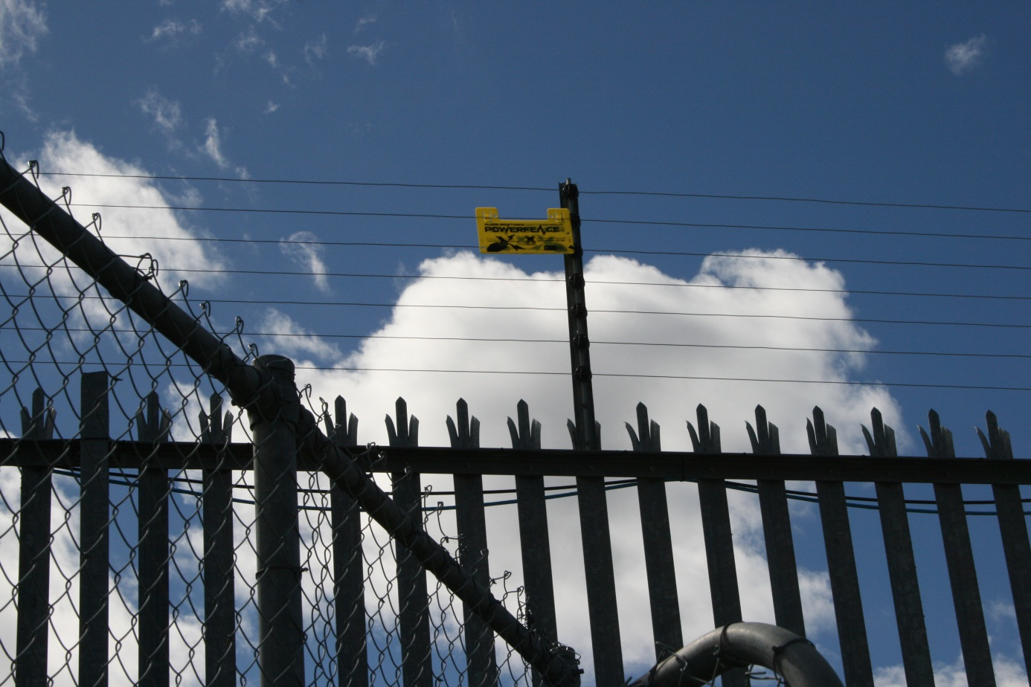
Electrified fence, Villawood Immigration Detention Centre.
Despite the significant positive developments of the past two years, the Commission remains seriously concerned about some aspects of Australian law and policy on asylum seekers, refugees and immigration detention. The Commission is primarily concerned about the prolonged or indefinite detention and lack of durable solutions or substantive visa pathways for certain groups of people in immigration detention. These include stateless persons; refugees who have received adverse security assessments; and refugees who are of interest to or have been charged by the Australian Federal Police (AFP).

The Commission’s visits and interviews
During its recent visits to Villawood IDC, Sydney IRH, Maribyrnong IDC and Melbourne ITA, the Commission interviewed over 50 people in detention and spoke informally to many others. The people with whom the Commission spoke were from Afghanistan, Sri Lanka, Burma, Iraq and Iran – a number of them stateless. Most of these people were men but Commission staff also spoke with women and children.
As has been noted, these visits focused on the circumstances and experiences of people who remain in closed detention with little or no prospect of a community placement or imminent resolution of their immigration status. The people with whom the Commission met included 27 refugees who have received adverse security assessments; seven people who are ‘of interest’ to or have been charged by the AFP in relation to detention centre disturbances in early 2011; and 14 people who identify as stateless and have been found not to be refugees. There was some cross-over between these categories.
It is the Commission’s practice to ensure that the identity of people who speak with Commission staff in the context of detention visits cannot be discerned through our reports. The quotes that follow are drawn from interviews between Commission staff and people in closed detention, and are grouped according to the categories noted above. Given the limited number of people from within these categories in each of the detention facilities visited by the Commission, identifying information has not been included alongside the quotes.

Refugees who have received adverse security assessments
The Commission has for several years raised a range of concerns about the processes and outcomes associated with security assessments conducted by ASIO in respect of refugees. Some improvements have recently been made in this area. Nevertheless, some of the Commission’s most serious concerns about the human rights of refugees involve the legal framework governing the conduct of security assessments and the consequences of an adverse security assessment for a refugee.
The Commission’s concerns with respect to ASIO security assessments are threefold. First, security assessment processes are subject to inadequate procedural safeguards, as refugees who have received adverse assessments are not told the reasons for ASIO’s decision nor are they provided any substantive opportunity for appeal. Second, refugees with adverse security assessments are currently not considered for community placement but rather remain indefinitely detained in closed facilities. Many of these people have already spent prolonged periods in detention. Third, durable solutions are not being found for refugees who have received adverse security assessments.

The security assessment requirement
Most classes of visas, including protection visas, contain a requirement that the applicant meet Public Interest Criterion 4002 of the Migration Regulations 1994 (Cth) (Migration Regulations), which states:
The applicant is not assessed by the Australian Security Intelligence Organisation to be directly or indirectly a risk to security, within the meaning of section 4 of the Australian Security Intelligence Organisation Act 1979.
Accordingly, although a security assessment is not required prior to the grant of a visa, asylum seekers and refugees who do undergo an ASIO security assessment must not be assessed as being directly or indirectly a risk to security, otherwise they will not be granted a permanent visa to remain in Australia. The Australian Government’s position is that ASIO security assessments should be conducted only after an asylum seeker has been recognised as a refugee.

The situation of people with adverse security assessments
“A thousand days have passed. There has been no change in our circumstances and we don’t know what will be the future.”
“Inside here is mental torture. Every day I’m dying. In Sri Lanka, they can shoot me – one shot and I’m gone. Here I am dying every day.”
“I feel like a walking corpse. I feel like we are locked up in a dark room. We can’t see the light in here.”
“Every day, every cell in my body is dying.”
“I despair at what this is doing to my son. He was born outdoors, when we were running from the war. All his life he has been running and in camps. There was just that one time of hope and safety for him – here in Australia, when it seemed as though we could make a new life. And now I see no future – for him or for me. I don’t know how to protect him from my despair. I try to hide my feelings from him but they are overwhelming. He sees me upset and it is too much for him now.”
“My wife has left me now, because I have been away for so long, without being able to support them. I don’t know how they are surviving. It is so dangerous where they are living. I worry about them so much … I cannot bear to think about what their lives are now. It is only because I have children that I do not kill myself – even though it seems that I may never see them again. But I have thought of it many times.”
“Our feelings are numb; we are broken.”
“How can you live without a destination?”
“Limbo is my destiny. My future is dark. I’m looking for a candle to brighten my future.”
“I am scared. I cannot sleep, but I see strange and terrifying things at night, while I am awake. Things are not normal in my head now. And I no longer have any hope at all. I just keep asking my God for permission to join him.”
“Sometimes we shout at the managers here – because we are desperate, and they are our only relationships. But in fact, we know that they are doing what they can for us. They tell Government about our pain, but they cannot do more than that. We see, often, that they are suffering too.”
“I can’t give them anything; I can’t do anything for them. I will spend as much time as possible listening to them. And I’ve been screamed at for an hour – because I am the face of the Minister.” (Member of staff speaking of refugees with adverse security assessments)
As at 19 July 2012, there were 54 people in detention facilities in Australia who had been recognised as refugees but had received adverse security assessments. There were also six children in closed detention who were living with their parents who had received adverse security assessments.
The Commission had concerns about the wellbeing of all people in detention it encountered during these visits. However, Commission staff were struck particularly by the acute levels of hopelessness and despair exhibited by refugees in this situation.
Almost all refugees with adverse security assessments who elected to speak with the Commission spoke about dying. Some people in this situation showed Commission staff letters which they had written to DIAC and to Members of Parliament, asking for a ‘mercy killing’ to be arranged. Further, some people stated that they wished to donate their organs following their death, as they felt that this was all they were able to contribute to the society which they had hoped to join and which had sustained them over many months.
Commission staff held serious concerns for the immediate safety of many of the refugees with adverse security assessments with whom they met. The Commission understands that, since the time of its visits to detention facilities in April, at least one person in this position has made a serious attempt at suicide and another had a panic attack which required his hospitalisation. The Commission continues to hold grave concerns for the wellbeing and safety of the refugees who remain in Australia’s detention facilities due to adverse security assessments.

Procedural fairness
“They didn’t tell us why. When you arrest a criminal, you have to tell them why. Is this the law in Australia?”
“If I had committed a crime, I wouldn’t need the reasons because I would know them. They said I have a negative security clearance – how can I accept this when I haven’t known what I have done?”
“They say we are a threat, but we have never thought of doing any of these things.”
“We respect ASIO; we know they are looking out for the security of their citizens. But how can we accept their decisions when we don’t know what we have done? We’re very confused and we don’t understand.”
“Give me the opportunity for another interview. I believe something is missing.”
“Since the day I arrived, I’ve been stamped as a terrorist. What will people on the outside think? That we have done something wrong. If they come and speak to us, they will know we’re not a terrorist. We want them to know the truth.”
As noted, refugees who have received adverse security assessments do not have to be provided with the reasons for ASIO’s decision and have very limited access to independent review mechanisms. For this reason, in the view of the Commission, security assessments conducted by ASIO are subject to inadequate procedural safeguards. This is particularly troubling given the magnitude of the consequences of an adverse assessment, namely, the deprivation of a person’s liberty for an indefinite period of time.
When ASIO furnishes an adverse security assessment in respect of a person to a Commonwealth agency, the agency is ordinarily required by law to give the person who is the subject of the assessment a notice informing them of the making of the assessment and a copy of the assessment. However, this requirement does not extend to adverse security assessments regarding proposed actions taken under the Migration Act in relation to a person who is not an Australian citizen, the holder of a permanent visa or the holder of a special category visa. In practice, people in this situation are not provided with the reasons for their security assessments.
Accordingly, refugees who are the subject of an adverse security assessment are not advised of the grounds upon which they have received their assessment, nor are they provided with the information necessary to challenge it. Provision of such information could prevent the identification of critical errors, such as errors concerning a person’s identity or the bona fides of an informant.
Even if a refugee subject to an adverse security assessment were provided with the information on which that assessment was based, he or she would have extremely limited opportunities to appeal it.
Merits review through the Administrative Appeals Tribunal of security assessments in relation to proposed actions taken under the Migration Act is not available to people who are neither Australian citizens nor the holders of permanent or special category visas. This includes recognised refugees awaiting the grant of protection visas.
Further, substantive judicial review of adverse security assessments is effectively unavailable to refugees, even though the High Court of Australia has held that ASIO decisions are subject to judicial review. This is primarily because Australian courts cannot consider the merits of an adverse assessment but are limited to considering jurisdictional error.
That the legal framework governing ASIO security assessments contains inadequate procedural safeguards has created a powerful sense of injustice, confusion and frustration among refugees with adverse assessments who remain in detention. Many people who spoke to the Commission about their adverse security assessments expressed bewilderment as to the reasons for their assessment. Some told the Commission that they had received an adverse assessment without even having been interviewed by ASIO; others said they were interviewed at a time when they were awaiting supporting documentation from their country of origin, which they received shortly after the interview occurred. Most refugees with adverse assessments expressed distress and significant dismay at their inability to challenge their assessments, stating that they were convinced that some mistake had been made. For example, one man told the Commission he believed he had received an adverse security assessment due to a mix-up in relation to his name.
In the Commission’s view, the following procedural safeguards should be introduced in Australia.
- Any person in Australia who has been refused a visa as a result of an adverse security assessment – including a person who is not an Australian citizen, the holder of a permanent visa or the holder of a special category visa – should be provided with information to enable them to be reasonably informed of the information that ASIO has relied upon and the grounds for making the determination.
- Administrative Appeals Tribunal review should be extended to all people in Australia who have been refused a visa as a result of an adverse security assessment – including people who are not Australian citizens, the holders of a permanent visa or the holders of a special category visa. Review of adverse security assessments should be conducted by the Security Division of the Administrative Appeals Tribunal.
- The Australian Government should explore options for providing for effective merits and judicial review of adverse security assessments. These should include opportunities for applicants with adverse assessments to know the basis of their assessment and to make submissions on the content of that assessment, either directly or through an appropriate person such as a Special Advocate.

Indefinite detention of people who have received adverse security assessments
“We have been here for such a long time, for three years. Even a government is only in power for three years.”
“Even a murderer would know when his sentence is finishing, when he would get out. This is worse than a prison, this is hell.”
“I have passed the time without having any progress in my life. Who can replace lost life?”
“We feel like a dog on a leash and they’re pulling us back.”
“We have heard that in this country, if you keen an animal in a cage for more than six months it is a crime. We have been in detention for nearly four years.”
“He cries and says, ‘When are you coming? When are you coming? I want to play with my dad.’”
“They give me clothes, a room to sleep in; I can see that the Australian Government does all this. I wish to repay this country for feeding me for the last 34 months, but I can’t do anything from here.”
“Give us a conditional visa and observe our behaviour. We would then take the decision happily.”
“Give us an opportunity to show that we are not a security threat. We have been here for three years. This is a big country. It has a strong police force. Release us and let us go to the police every week. If we are shown to be a threat, then deport us. There is no threat on our part.”
As noted above, in order to be granted a permanent protection visa, refugees must meet Public Interest Criterion 4002 which provides that they have not been assessed by ASIO as being directly or indirectly a risk to security. As such, refugees who receive an adverse security assessment are not eligible to receive a protection visa allowing them to remain in Australia.
Further, there appears to be no prospect of refugees who have received adverse security assessments being placed in the community, through the use of bridging visas or community detention, while durable solutions for them are being pursued.
While the Minister for Immigration and Citizenship has the power to grant a visa to any person in immigration detention, the current Australian Government position appears to be that refugees who have received adverse security assessments will not be placed in the community via the grant of a bridging visa.
Refugees with adverse security assessments appear not to be eligible for placement in community detention either. While the Residence Determination Guidelines issued in September 2009 by the former Minister for Immigration and Citizenship, Senator the Hon Chris Evans MP, allow refugees who have received adverse security assessments to be transferred from closed detention into community detention along with conditions to mitigate any potential risk, the Australian Government’s current position is that people in this situation should not be granted a residence determination. The Commission understands that the Residence Determination Guidelines are currently being updated.
Some people who have been transferred into community detention while awaiting the outcome of their application for protection have subsequently received an adverse security assessment while living in the community. As a result of the Australian Government’s policy, DIAC has been required to re-detain people in this situation in closed facilities. This is despite the fact that they may have already spent some time out of closed detention facilities living in the Australian community, without raising the concerns of any authorities.
Accordingly, refugees who have received adverse security assessments face the prospect of indefinite detention in closed facilities, in addition to the sometimes prolonged periods for which they have already been detained. This indefinite detention may amount to arbitrary detention in breach of the International Covenant on Civil and Political Rights.
As noted above, in order to avoid arbitrary detention, there must be an individual assessment of whether it is necessary, reasonable and proportionate to hold a person in detention. Moreover, if it is decided that a person must be detained, this should be in the least restrictive manner and detention should not continue beyond the period for which it can be justified. Currently, however, once a person has received an adverse security assessment recommending that they not be granted a permanent visa, there does not appear to be any further individualised assessment of whether that person is a risk to the Australian community and in particular whether they could be placed in less restrictive arrangements than closed detention. Rather, it seems to be assumed that because a person has received such an assessment, they necessarily pose a risk to the community which warrants continuing detention in closed facilities. This may not be the case. As the New Zealand Court of Appeal recognised in Choudry v Attorney General, it is ‘obvious that all risks to national security do not call for equal treatment. It is also apparent that different risks can be identified and distinguished.’
Commission staff witnessed firsthand the devastating effects of indefinite detention on refugees with adverse security assessments during recent visits. Among the people in this situation with whom the Commission met were a family of five, including a baby who was born in detention in Australia; a woman in detention who was accompanied by her young son and whose husband has passed away; a pair of adult brothers, one of whom had extensive vulnerabilities; and a man whose wife and son had been granted protection visas and were reportedly struggling to cope with life in the community without him.
As noted above, many refugees with adverse security assessments had already spent prolonged periods in detention and could not see any prospect of being released or transferred into community arrangements. Others had been granted a residence determination and had experienced life in the broader Australian community, only to be re-detained in a closed facility upon receipt of their adverse security assessment. People spoke to the Commission of the acute distress they experienced as a result of their ongoing detention and expressed emotions ranging from acute anxiety to anger to despair. Many told Commission staff that their ability to eat, sleep or think clearly had been drastically compromised by their predicament. Thoughts of self-harm and suicide were common. Most people’s distress was compounded by long periods of separation from their families, in some cases living in the Australian community, and in some cases remaining in their countries of origin or in situations of danger elsewhere.

Lack of durable solutions
“They say there is a third country that will look after you, but the third country doesn’t consider us; no one does.”
“If we have been accepted as a refugee here, what other country will take us? If Australia has called us a security risk, what other country will take us?”
“To say something, they say a third country is looking into your case. Sometimes they even say, ‘you can go home to your own country’. It’s just talk. There is no action in regards to this.”
“They tell us, ‘why don’t you go back to your home?’ This is the same as telling us, ‘why don’t you commit suicide?’”
There do not appear to be any durable solutions currently available for refugees who have received adverse security assessments.
Last year DIAC advised the Commission that the government was actively exploring durable solutions for individuals with adverse security assessments that are consistent with Australia's international obligations, including its non-refoulement obligations. It further noted that these ‘may include resettlement in a third country or safe return to [a person’s] country of origin where country circumstances allow, where the risk of relevant harm occurring no longer exists or where reliable and effective assurances can be received from the home country.’ The Commission has since been advised by DIAC that the return of a refugee to their country of origin on the basis of diplomatic assurances is a theoretical option that could be explored but is not being pursued at this stage. Were it to be pursued, the Commission would hold serious concerns that relying on diplomatic assurances in returning a refugee to their country of origin could breach Australia’s non-refoulement obligations. Further, nothing presently indicates that third country resettlement is realistic.
The apparent lack of workable long-term solutions to the situation of refugees with adverse security assessments was a source of immense distress for people with whom the Commission met. Many expressed disbelief that durable solutions to their situation were in fact being pursued. Others could not see viability in any of the prospective solutions proposed. This led to an inability to conceive of any future apart from continuing detention in an immigration facility. People with whom the Commission spoke appeared to struggle to maintain any hope in relation to their circumstances and to give meaning to their days in this context.

High Court challenge: Plaintiff M47/2012 v Director General of Security
On 18, 19 and 21 June 2012, a refugee who received an adverse security assessment brought a challenge in the High Court of Australia against the Director General of Security, the Minister for Immigration and Citizenship and the Commonwealth of Australia, amongst others. The plaintiff in this matter challenged the processes by which ASIO conducted the security assessment which led to his receiving an adverse security assessment signed by the Director General of Security. The plaintiff also challenged his continuing detention in a closed facility.
With regard to the procedural issues, the plaintiff argued that in furnishing an adverse security assessment, ASIO failed to comply with the requirements of procedural fairness. The defendants argued that ASIO had complied with the requirements of procedural fairness by conducting an interview with the plaintiff and providing him the opportunity to advance relevant evidence.
With respect to detention, the plaintiff argued that his continuing and potentially indefinite detention is unlawful, because he is not being detained for any purpose authorised by the Migration Act.
The High Court has previously held, in Al-Kateb v Godwin, that the Migration Act authorises and requires the detention of ‘unlawful non-citizens’ even if their removal from Australia was not reasonably practicable in the foreseeable future. The plaintiff sought to distinguish his situation from the finding in this case, as he has been recognised as a refugee, while Mr Al-Kateb was found to be stateless and considered not to be owed Australia’s protection. In the alternative, the plaintiff argued that Al-Kateb v Godwin was wrongly decided and should be overturned.
The defendants submitted that the plaintiff’s detention is authorised and required by ss 189 and 196 of the Migration Act.
At the time of writing, the High Court’s judgment in Plaintiff M47/2012 v Director General of Security was reserved. The decision in this matter may have significant consequences for refugees with adverse security assessments who remain in detention.

Refugees of interest to or who have been charged by the Australian Federal Police
A further group of people in closed detention about whom the Commission holds particular concerns are refugees who are of interest to or have been charged by the AFP in relation to detention centre disturbances in early 2011. People in this situation face prolonged periods of detention with little hope of transfer into community arrangements. If convicted, they have reduced prospects of receiving a permanent protection visa.
    - Australian Federal Police and Parliamentary response to detention centre disturbances
As noted in section 4.2, Christmas Island and Villawood IDCs became scenes of violent protests during March and April 2011 respectively. These protests occurred at a time of significant overcrowding, protracted periods of detention and associated unrest across the detention network.
The protests on Christmas Island and at Villawood involved extensive damage to property as well as injuries to detainees, detention centre staff and authorities attending the scenes. They were followed by criminal investigations during which a number of people became ‘persons of interest’ to the AFP, some of whom have subsequently been charged or convicted. At the time of writing, 61 people in closed detention remained ‘of interest’ to the AFP, over a year after commencement of criminal investigations.
In July 2011, the Australian Parliament passed amendments to the Migration Act to ‘toughen the penalties for criminal behaviour in immigration detention’. Under the amendments, a person who is convicted of any offence committed while in immigration detention will automatically fail the character test applied prior to the grant or cancellation of a visa. A consequence of this amendment is that refugees who fall within this category may not be granted a permanent protection visa.
    - The situation of refugees who are of interest to or have been charged by the Australian Federal Police
“When I was in detention centres for 18 months I said, ‘I will be patient’. But every human being has limits. We have been here for 39 months now. And we are tired – mentally very tired. They made me crazy. And that is why I have done this. They told me to come down from the roof, that they would help me, send me to a psychologist. But they put me in jail for seven months.”
“I had no future, I had no hope. I went on top of the roof. I was going to jump. I felt like ending my life. But a few days later I got a positive decision. And now, my life has changed again.”
“I don’t really understand the charge against me. I know it relates to when the centre was burned down. When that happened I had just been told I was a refugee. I was on my way out – and my journey was over. But that has changed completely now. After I was in prison, the judge said that I would be going into the community, but they just brought me straight back here instead. I feel like a soccer ball. I am a refugee, but my case manager says that my security assessment has been stopped now – because I have been charged. And they also tell us that we may never get a permanent visa.”
During its recent visits to closed detention facilities the Commission met with seven refugees who were of interest to or had been charged by the AFP in association with the detention centre disturbances in early 2011. Most had received a security clearance, and those who had not were awaiting completion of their security assessment. At least one person with whom the Commission spoke had been found to be a refugee prior to the disturbances and remained in detention at that time pending completion of security and other checks. Some of the people in this group advised the Commission that they had been detained for over three years and all appeared to have been detained for over two years.
All of the refugees with whom the Commission met who were of interest to or had been charged by the AFP expressed intense feelings of frustration, despair and helplessness in relation to their circumstances. Many expressed anxiety about whether they would ever be released from immigration detention and some expressed fear that their mental and physical health were deteriorating rapidly.
Many ‘persons of interest’ told the Commission that they believed that there was no active investigation underway in relation to allegations made against them. Some people who had been charged told the Commission that they felt that they were being punished for personal protest actions which were motivated by their desperation at the length of their detention and which had not resulted in damage to property or harm to other people. Others who had been charged keenly felt that it was paradoxical that they remained indefinitely detained as a result of behaviours which they had exhibited only in response to the unbearable frustrations associated with being detained for a prolonged period in the first place. One man expressed confusion and exasperation at having been returned to immigration detention from a correctional facility after he was charged, as he had understood from court proceedings that he was to be bailed into the community.

Impact of changes to the character provisions under the Migration Act
Under 2011 amendments to the Migration Act, a person who is convicted of an offence committed while in immigration detention will automatically fail the character test that is conducted before a person is granted a visa. A person who fails the character test cannot be guaranteed a visa, even if Australia has recognised that person as a refugee – the Minister for Immigration and Citizenship, or his delegate, may decide not to grant a visa to a person in these circumstances. The Commission understands that consideration has been given to granting temporary visas, including Removal Pending Bridging Visas, instead of permanent protection visas, to refugees who fail the character test because they have been convicted of offences committed while in immigration detention.
The practical effect of a decision not to grant a recognised refugee a permanent protection visa on the basis that they were convicted of an offence committed in detention, or to grant a refugee in this situation a temporary rather than a permanent visa, appears to be to further punish a person over and above any penalty which may be imposed by the courts. It is not appropriate for penalties for criminal conduct to be imposed through the administration of migration law and policy.
People in detention who were of interest to or had been charged by the AFP expressed significant apprehension to the Commission as to the impact that their involvement in police matters may have on their prospects of being granted protection in Australia. Many people in this situation expressed great anxiety that they may not receive a permanent protection visa if ultimately convicted of the offence for which they had been charged.
Concerns have also been raised with the Commission by a number of parties regarding the potentially grave consequences of the amendments to the character test provisions of the Migration Act on refugees, some of whom have been convicted of very minor offences and many of whom are reportedly highly vulnerable following prolonged periods of immigration detention.
The Commission believes that the Minister and his delegates should adopt a humanitarian approach when considering applications for protection visas from refugees in these circumstances.
    - Prolonged detention of refugees who are of interest to or have been charged by the Australian Federal Police
Further to concerns regarding the lengthy timeframes for AFP investigations and the potential curtailment of durable solutions for refugees who have been convicted of minor offences, the Commission is troubled by the prolonged detention in closed facilities of refugees who have been charged by or remain of interest to the AFP. As noted, all the refugees within these categories with whom the Commission met appeared to have been detained for at least two years and some had been detained for up to a year following their recognition as refugees.
The Commission understands that the Minister for Immigration and Citizenship has indicated to DIAC that he is not inclined to consider the exercise of his discretionary powers to grant a bridging visa or community detention to any person who has been charged with offences alleged to have been committed whilst in immigration detention. The Commission also understands that, while open to receiving submissions relating to community placement options for people who remain of interest to the AFP, the Minister has indicated that he will not necessarily consider exercising his discretionary powers in these instances.
The Commission is greatly concerned that recognised refugees, many of whom have received a security clearance, are being detained for protracted periods without foreseeable prospect of release. As reiterated throughout this report, a person should only be held in an immigration detention facility if they are individually assessed as posing an unacceptable risk to the Australian community and that risk cannot be met in a less restrictive way. Otherwise, they should be permitted to reside in the community while their immigration status is resolved – if necessary, with appropriate conditions imposed to mitigate any identified risks. These standards should be applied to all people in detention, irrespective of any alleged or established participation in detention centre disturbances.
The Commission understands that status resolution processes – that is, the processing of claims for protection and the conduct of security assessments for those found to be owed protection – are automatically suspended if a person is charged. The Commission is concerned that, in the current circumstances, this approach may contribute to considerably lengthened periods of immigration detention for recognised refugees who have already been subject to protracted detention. One man who had been found to be a refugee a year earlier told Commission staff of his significant distress at having been advised that the processing of his security assessment had been suspended in light of his charge.

Stateless persons
“I have had three written decisions now. In all of them they say that I am stateless. So I do not understand. What happens now? Why am I here? I have nowhere to go. Do I have a future? No one can give me answers.”
“I am wondering why they are keeping me here for a long, long time, even though I am innocent. I asked for another lawyer, but since I have been rejected I have been told that there are no other options for me. This was more than half a year ago. I ask ‘why haven’t you helped me in all that time?’ – but they don’t answer my question.”
“I have no country. It is very terrible. I am completely unhappy. I have two options: survive, look after my health, be patient; my other option is to die.”
“I wanted a country that acknowledges me. I found the opposite.”
“Every time I look at the gates and wires around me now I have to close my eyes. It is just too painful for me now to see these things. Mainly now, I sleep. Before I started taking pills, I could not sleep at all – I would just walk around the compound at night. There were always other people out there too – just ghosts, like me.”
“In the detention centre I’ve become cold about living. I have lost the will to live.”
“When they throw the dice and it says, ‘let him out’, they will let me out.”
“I’m a wilted plant now. I’ve lost my hope. I think they need to let me out. I’m not brave like others to take my life, but I think that I am just dying here now anyway. People speak to me, and often they are kind, but I can no longer concentrate on what they are saying.”
“The person is just lingering – it almost feels like storage.” (Member of staff speaking of stateless people in detention)
The Commission has long held concerns about the protracted immigration detention of, and lack of substantive visa pathways available to, people who appear to be stateless and have been found not to be refugees. As at 15 May 2012, there were 555 people in closed detention in Australia who identified as being stateless, 114 of whom had been detained for over 540 days.
Australia has obligations in respect of stateless persons as a party to the Convention relating to the Status of Stateless Persons and the Convention on the Reduction of Statelessness. In the view of the Commission, Australia would better meet these obligations if it were to develop a formal, comprehensive procedure for determining statelessness. The Commission also submits that an administrative mechanism should be made available for stateless persons to seek a permanent remedy for their statelessness in Australia.
Guidelines for Assessing Claims of Statelessness have recently been made available to DIAC decision-makers for the purpose of assessing whether a person meets the requirements for the grant of a protection visa. However these Guidelines do not comprise a statelessness determination mechanism, nor do they provide for the grant of a visa in response to an assessment that a person is stateless.
While statelessness in itself is not a ground for claiming refugee status, it may be a relevant consideration in a person’s refugee claim. While some stateless persons are found to be refugees, or to be otherwise owed protection, others are not.
As Australia does not grant protection visas to people on the basis of statelessness alone, a person may be assessed as likely to be stateless (and therefore unlikely to be able to be removed), and yet left without resolution of their situation. Under Australia’s current arrangements, the only prospect of a lasting resolution for people in this situation is through the exercise of non-compellable discretionary Ministerial power to grant a person a visa, or locating a third country that is willing to accept the person as a lawful permanent resident. Pursuit of third country residency options has historically left people who are stateless in situations of protracted immigration detention.
Many of the stateless people with whom the Commission met during its recent detention visits expressed bewilderment and despair at the fact that they had received records of decisions, including primary decisions, review decisions and in some instances judicial review decisions, which accepted their claims of statelessness, yet left them without any associated visa outcome. Many of these people had been detained for extensive periods of time and also reported high levels of hopelessness, thoughts of self-harm and anxiety regarding their deteriorating mental health.
The Commission understands that several of the apparently highly vulnerable stateless people with whom it met have since been approved for community placements, or transferred into less restrictive forms of closed detention.
The Commission further understands that the Minister for Immigration and Citizenship has recently clarified to DIAC that he is open to receiving submissions recommending bridging visa grants or community detention placement for people who are stateless who have been found not to be owed protection. In light of the significant number of people in this situation, and the length of detention of many, the Commission urges that such submissions be swiftly referred and considered. Along with other people currently subject to closed immigration detention, people who are stateless ought to be placed in the community at the earliest opportunity, unless they are considered to pose an unacceptable risk. If a person is assessed as posing such a risk, consideration should be given to placing them in a less restrictive form of immigration detention.
In addition to pursuing community placement options for stateless persons, the Commission recommends that the Australian Government take measures to ensure the lasting resolution of their situation. These should include the development of a formal statelessness determination mechanism which incorporates recognition of de jure as well as de facto statelessness. The term de facto statelessness describes persons who formally possess a nationality, but whose nationality is not ‘effective’. The Final Act of the Convention on the Reduction of Statelessness recommends that ‘persons who are stateless de facto should as far as possible be treated as stateless de jure to enable them to acquire an effective nationality’. Measures to resolve the situation of stateless persons should also include the establishment of administrative pathways for the grant of substantive visas to stateless persons who have been found not to be refugees or otherwise owed protection.

Closed detention
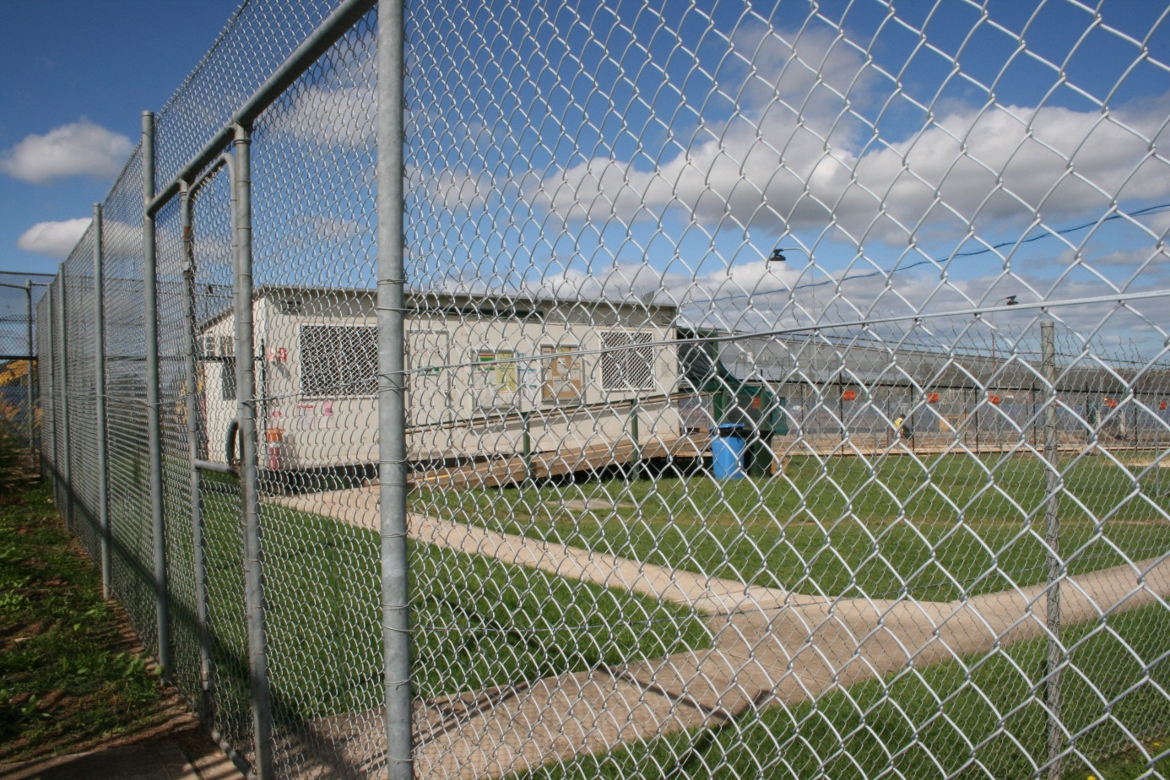
Internal fences, Villawood Immigration Detention Centre.

The impact of prolonged detention in closed immigration detention facilities
“I used to think, when I was in Iran, that I could handle prison here for 10 years. But it has its own psychological pressures.”
“No one wants to be a refugee. Everyone needs freedom. Why do they keep us like this?”
“Our pain is something else. We have not come here to eat good food or use the internet.”
“You might see things happening; see changes. But I don’t. This is my life, this is my whole world.”
“In Australia, if you have a pet, you take your pet out at least once a week. I haven’t had an excursion in the two years I’ve been in detention … I don’t even know what Australians look like.”
“Imagine you were in a hotel room and you couldn’t get out. How would you feel? It doesn’t matter what the facilities are like. You just want to get out.”
“Too many people die in detention. No one can give any answer, why these people lose their life for nothing.”
“I have escaped from force and power and pressure in the Iranian system. I cannot accept that I would be out of favour here, with the Australian system. That is very painful.”
As noted above, the Commission has adopted a new approach to its detention visiting activities. The Commission will continue to conduct short visits to detention sites with a focus on specific issues, but is no longer able to undertake detailed monitoring and reporting of conditions of immigration detention.
The Commission visited Villawood IDC, Sydney IRH, Maribyrnong IDC and Melbourne ITA in April 2012. In keeping with the new approach, detailed monitoring of conditions of detention of the kind undertaken in recent years was not conducted during these visits. Instead, the Commission focussed on the situation of people who face prolonged and indefinite detention in closed facilities, including refugees who have received adverse security assessments; refugees who are of interest to or have been charged by the APF; and stateless persons who have not been recognised as refugees. While the human rights and wellbeing of all people in immigration detention are of concern to the Commission, the plight of people who face little or no prospect of release from closed detention in the foreseeable future is of particularly serious concern.
The Commission heard resoundingly of the distress, frustration, anxiety and despair caused by people’s ongoing and indefinite detention. For many people with whom the Commission met, this has been compounded by witnessing so many others move out of closed detention in relatively short timeframes, because they have either been granted permanent protection visas or moved into community placement under the Australian Government’s expansion of community arrangements for asylum seekers and refugees.
Most people the Commission met with in closed facilities were at pains to convey that the conditions of detention were of little import to them. Rather, it was the prolonged and indefinite nature of their detention which was causing people distress: the fact of remaining in closed detention, separated from friends, family and other support networks, for prolonged periods of time, in some cases with little or no prospect of release.
These visits to closed detention facilities once again reinforced the Commission’s long-held concerns about Australia’s system of mandatory, indefinite immigration detention.
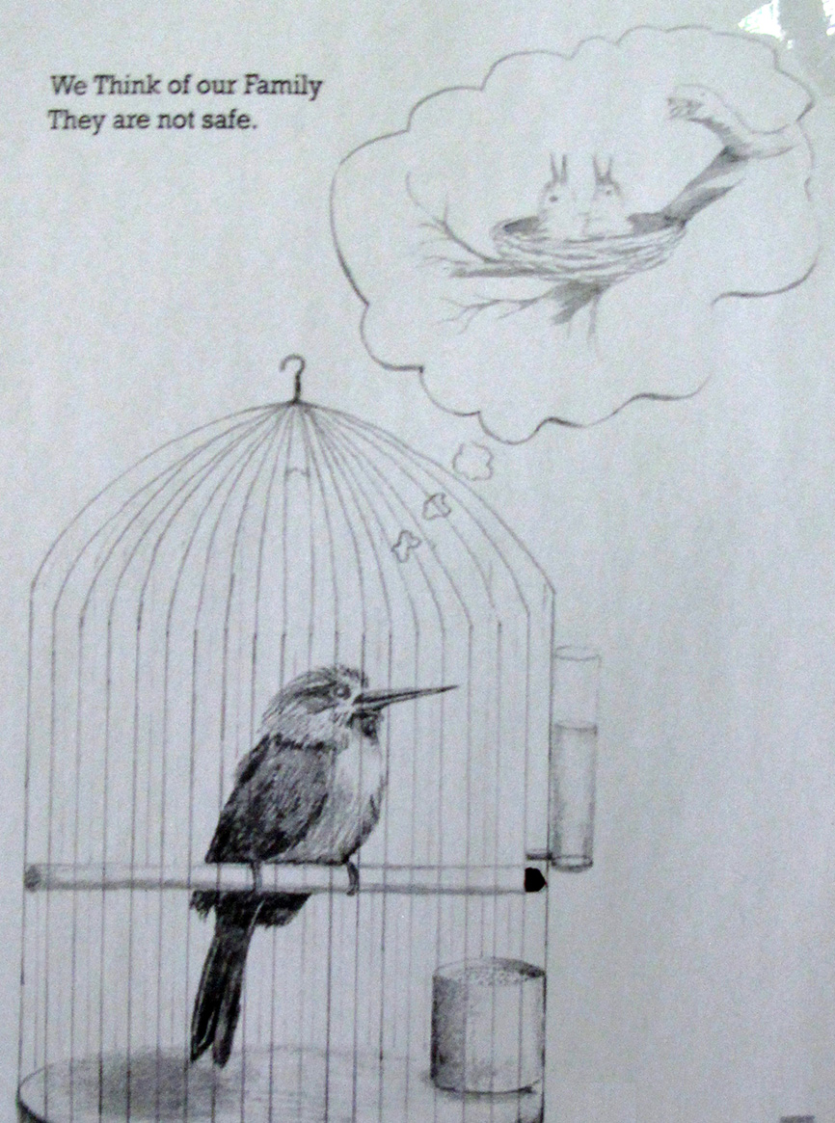
Artwork on the bedroom door of a man in detention, Maribyrnong Immigration Detention Centre.

Observations relating to closed immigration detention facilities
Notwithstanding the Commission’s new approach to detention visits, some observations about conditions of detention were made during the most recent round of visits. Conditions of detention and the services provided to people who are detained remain important given the range of international human rights standards relating to people deprived of their liberty.
The Commission was pleased to observe a number of positive developments at immigration detention facilities in Sydney and Melbourne, some of which are representative of changes which have been made across the immigration detention network. However, Commission staff also noted a number of areas in which further improvement is needed. The most significant of these are outlined below.
The Commission last visited Villawood for detention monitoring purposes in February 2011. Following this visit, a detailed report was issued containing findings and recommendations to which DIAC provided a public response. Many of the Commission’s observations from its most recent round of detention visits relate to progress made against the findings and recommendations of its 2011 Villawood report.

Health and mental health service provision
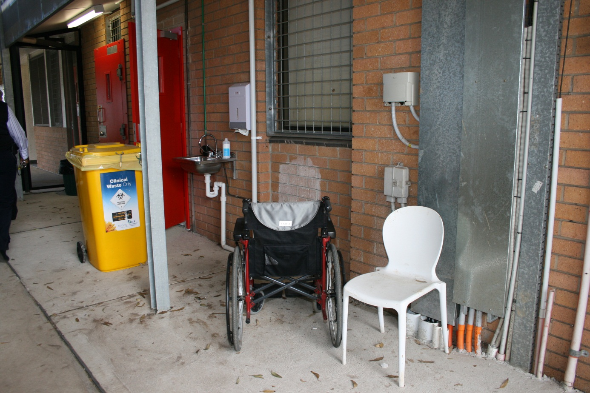
Outside makeshift clinic, Villawood Immigration Detention Centre.
In its 2011 Villawood report, the Commission made a series of recommendations relating to physical and mental health services. These included that:
- DIAC consider increasing IHMS staffing levels
- the clinical governance framework for the delivery of mental health services to detainees across the immigration detention network be overhauled such that it is overseen by a consultant psychiatrist with whom ultimate responsibility lies
- active outreach work be extended into accommodation areas across the detention network
- DIAC require at least a minimal IHMS presence at Villawood IDC 24 hours per day, seven days per week
- DIAC require at least a minimal onsite IHMS presence at Sydney IRH.
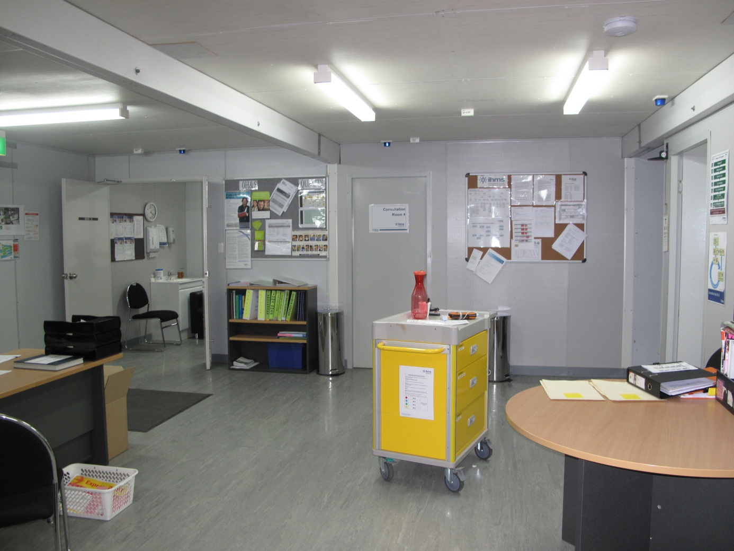
Clinic, Melbourne Immigration Transit Accomodation.
The most recent visit to immigration detention facilities in Sydney and Melbourne revealed a number of positive developments in the area of health and mental health care many of which the Commission understands have been applied across the detention network. These include:
- An overhaul of the clinical governance framework for the delivery of mental health services at Villawood IDC and across the detention network, involving the appointment of a psychiatrist to oversee mental health service delivery and provide clinical supervision. At all facilities visited, the Commission received positive feedback from IHMS and other staff regarding the leadership of and changes introduced by the new clinical director.
- A comprehensive revision of all IHMS clinical policies, which have been submitted to DIAC for consideration, within the context of contract negotiations.
- The intention that clinical outreach activities will commence within Villawood IDC once staff numbers and Serco escort arrangements have been confirmed, and the recent commencement of mental health group work sessions which the Commission was told are being well received.
- Measures which have been taken to make IHMS services routinely available to people being held at Sydney IRH, and the intention for a more established presence is envisaged there shortly, with the construction of an onsite clinic.
- Increases to IHMS’s physical and mental health staff hours at Villawood which have been made since the Commission’s last visit, and a submission that has been made to DIAC for a further staffing increase (although the round-the-clock IHMS presence recommended by the Commission appears not to be under consideration).
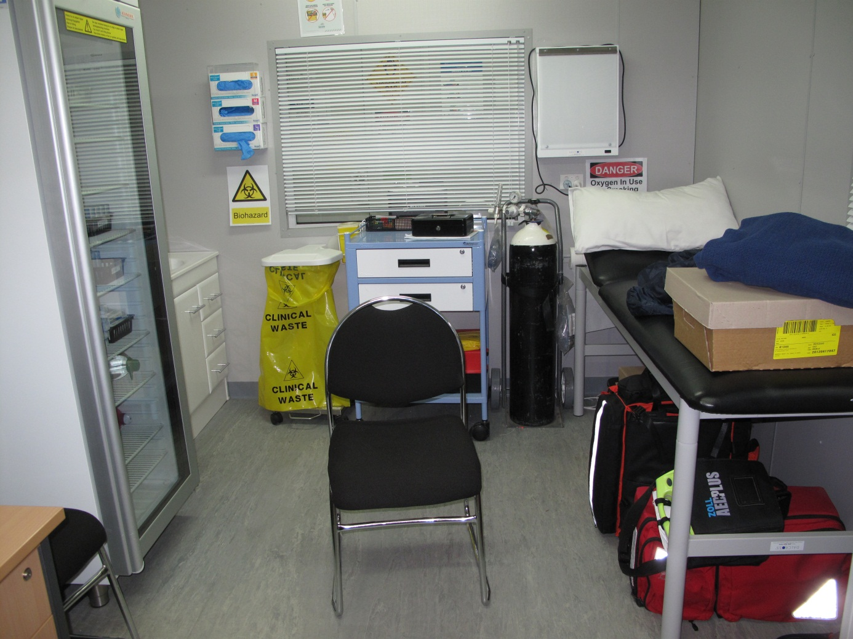
Consultation room, clinic, Melbourne Immigration Transit Accomodation.

Mitigation of suicide and self-harm
The Commission made a series of recommendations towards mitigating the risk of self-harm and suicide among people in detention in its 2011 Villawood report. These included that DIAC ensure that a safety audit be conducted across Villawood IDC and all other detention facilities, and that all appropriate measures be taken to minimise the risk of suicide and self-harm.
It appears that a safety audit has not been conducted at any of the sites visited by the Commission, nor a tool developed for the purpose of conducting such audits across the detention network.
The Commission continues to call for safety audits to be conducted and appropriate measures taken to mitigate the potential for further self-harm, suicide attempts and suicide in immigration detention facilities. Such measures should be taken urgently. Since the time of the Commission’s visit to Villawood in February 2011, there have been a further four deaths in immigration detention, two of which occurred at Villawood and three of which appear to have been suicides.

Staff interactions with people in detention
Serco poster, Maribyrnong Immigration Detention Centre.
On previous visits to immigration detention facilities, and in some detention monitoring reports, the Commission has made observations about the interactions between staff and people in detention. During its recent visits, the Commission was struck by the dedication to their work and concern for detainees exhibited by the majority of detention staff with whom it met.
The interagency management teams at Sydney and Melbourne, comprising officers from DIAC, Serco and IHMS, appeared to have strong rapports, respectful professional relationships and an appreciation of the challenges of each other’s roles. Several members of operations and case management staff were commended by their colleagues to the Commission as approachable and effective.
While some people in detention who met with the Commission raised concerns regarding their treatment by staff, many of those who exhibited most distress made a point of noting that they felt that they had been treated with compassion and respect by local management and case management staff.
This feedback resonated with the ways in which many DIAC, IHMS and Serco staff spoke of their concerns regarding the circumstances of people in detention. It appeared that some staff were deeply affected by the often traumatic nature of their work, including responding to suicides and other acts of self-harm. The Commission observed positive signs of peer support, but held concerns for the welfare of some staff.
Some Serco officers with a background in welfare, rather than security, have recently been employed to work with people in detention at Melbourne ITA and Sydney IRH. The introduction of this new welfare-oriented approach to working with detainees was raised as a positive development by staff across agencies working in these facilities. The Commission witnessed positive interactions between welfare-orientated Serco staff and some of the most vulnerable people being held in immigration detention. The Commission welcomes the introduction of this approach and encourages its expansion.
The Commission was pleased to learn that the former policy of case management disengagement in client protest situations, including acts of self-harm such as voluntary starvation, has been nuanced to afford local operations managers a degree of discretion in deciding whether to intervene. On previous detention visits the Commission observed the negative effects of the policy of disengagement, including increased risks to staff safety and potential aggravation of self-harm. The Commission heard from local operations and case management staff that their early intervention in self-harm and other protest actions will often allow them to de-escalate situations by attempting to resolve concerns and convey their interest in securing client wellbeing within the scope of established parameters.

Redevelopment, capital works and infrastructure
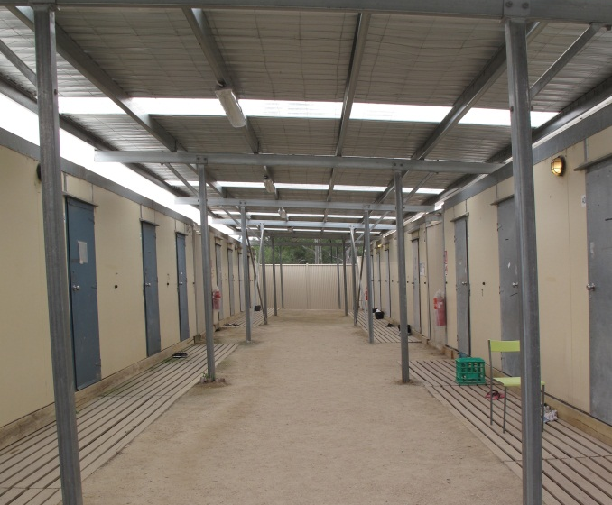
Left: kitchen, Banksia unit, Villawood Immigration Detention Centre; right: old accommodation quarters, Melbroune Immigration Transit Accomodation.
In its 2011 report on immigration detention at Villawood, the Commission recommended that the redevelopment of Villawood IDC should be undertaken as soon as possible. The Commission also recommended that:
- the redevelopment include the demolition of Blaxland, the most high-security compound at Villawood IDC
- DIAC ensure that people are detained in the least restrictive form of detention possible at the facility
- the infrastructure concerns raised by the Commission in its 2008 Immigration detention report be addressed in the redevelopment process.
The Commission welcomed various aspects of both completed and planned works at Villawood observed during its most recent visit. These include:
- The significantly improved physical environment of the Banksia unit, including incorporation of a women-specific observation area and self-catering facilities.
- The planned use of far less evident security features in the redevelopment; and assurances that all detainees will be provided lockable personal storage space and access to kitchenettes.
- Advice that consideration is being given to minimising or ceasing use of the loudspeaker system for personal paging in the new development, with reliance instead upon personal notifications by officers to be stationed in each accommodation area.
The Commission was concerned to learn that it is still proposed to use Blaxland in its current form until the final stage of the redevelopment. There are clearly considerable logistical and other challenges associated with the implementation of a major, multi-year redevelopment of a site which remains in constant use. Nevertheless, it remains the Commission’s view that, given the harshness of the physical environment at Blaxland, people held in that compound should be the first to be moved to redeveloped spaces at Villawood, or be transferred to other facilities if that is not feasible and if they are not eligible for community placement.
With respect to infrastructure, the Commission welcomes the new development at Melbourne ITA, which offers a far more benign environment than exists in many other immigration detention facilities. Commission staff were struck, however, by the notable distinction between the new and old sections of Melbourne ITA. In particular, the main accommodation quarters, which house highly vulnerable long-term detainees, have a bleak and dilapidated appearance which is starkly at odds with the new visitor, recreation and administrative areas. The Commission encourages consideration of measures that could be taken to upgrade the main accommodation quarters at Melbourne ITA.
At Sydney IRH, staff spoke highly of the recently constructed visits and recreation area and hoped that it might generate a sense of community within the facility. However, the people in detention with whom the Commission spoke were distressed by the change of policy to visiting arrangements which accompanied its opening. Previously, people were able to receive visitors in the outdoor garage attached to their residence. For most this had already felt like a difficult arrangement, as they wished to be able to host family and friends within their residence. Under the new arrangements, visitors must be received in the visits area, a more institutional, less personalised space which affords no privacy. Several detainees at Sydney IRH told Commission staff that they felt affronted by the change of policy, which appeared to them to be punitive and culturally insensitive.
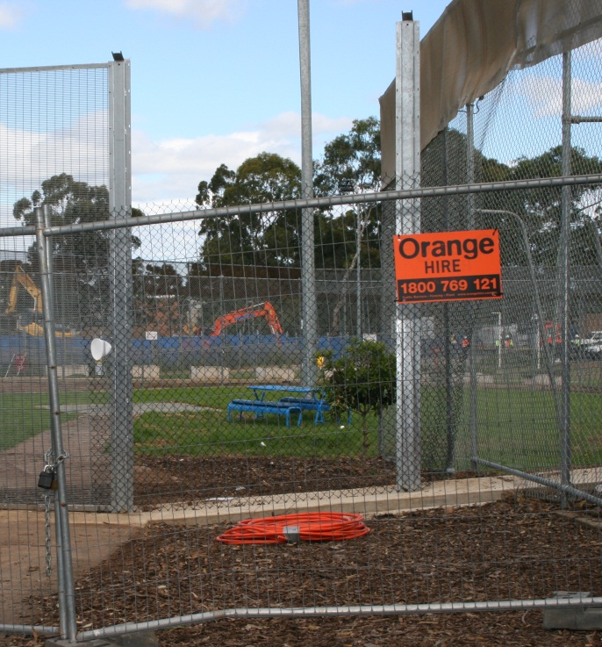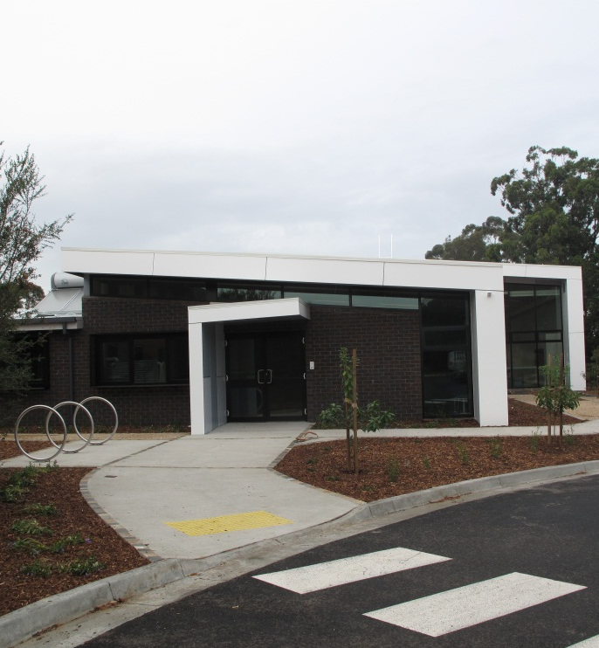
Left: construction works, Villawood Immigration Detention Centre; right: new visits area, Melbourne Immigration Transit Accomodation.
Despite the range of positive developments which have been made or are proposed in relation to health care service provision in detention, the current clinical spaces at Melbourne ITA, Maribyrnong IDC and Villawood IDC appear entirely inadequate. At Villawood IDC, IHMS staff have been working out of extremely constrained quarters since the destruction of their former clinic during last year’s riots. Staff at this site did, however, appear satisfied that the clinics which are close to completion at both Villawood IDC and Sydney IRH will provide functional settings for their work. The Commission heard numerous concerns about the clinical facilities at Melbourne ITA and Maribyrnong IDC, including that there are serious spatial constraints, in terms of both therapeutic and administrative areas; that clinical and interview spaces are used in multi-purpose capacities to which they are not suited; and that there is a lack of effective soundproofing. Despite these concerns, it appears that provisions have not been made for the expansion and upgrading of clinical facilities in the capital works program at Melbourne ITA and Maribyrnong IDC.

Restrictive places of detention
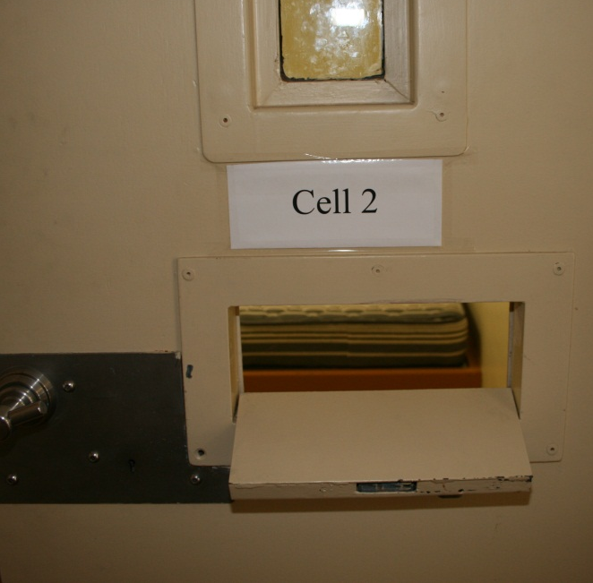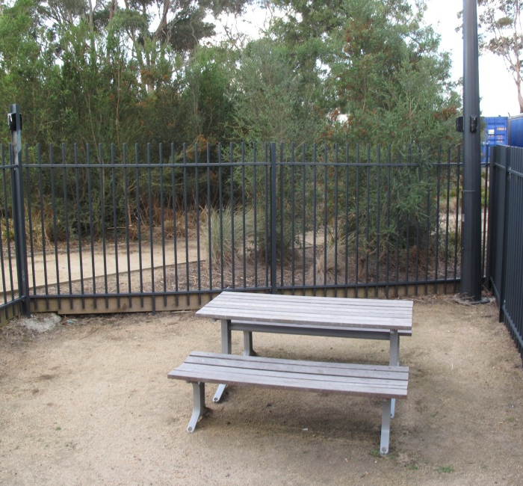
Left: downstairs, Murray unit – restrictive place of detention used for behavioural management; right: enclosed courtyard, Maygar annexe, Melbourne Immigration Transit Accomodation.
In its 2011 Villawood report, the Commission recommended that DIAC develop a written policy setting out the decision-making process, criteria and rationale for placing a person in the Blaxland annexe, the most restrictive part of the highest security compound at Villawood IDC. The Commission also recommended that the annexe not be used for managing people who have been involved in violent or aggressive behaviour at the same time as it is being used to monitor people who have been placed on observation because they are at risk of suicide or self-harm.
In response to this recommendation, DIAC advised the Commission that its then draft ‘Safe use of more restrictive detention’ policy would be reviewed by the Detention Health Advisory Group Mental Health Sub-Group, and would assist in guiding decisions in relation to the placement of people in restrictive places of detention across the immigration detention network, including the Blaxland annexe.
Disappointingly, it appears that a written policy on the use of Blaxland annexe has not been developed. During the Commission’s most recent visit, staff at Villawood advised that they had not recent co-located in the annexe people who have been involved in aggressive behaviour with people who are deemed to be at risk of suicide or self-harm. However, this practice does not appear to have been ruled out.
Further, the Commission has not been able to obtain a copy of the ‘Safe use of more restrictive detention’ policy, in draft or final form, nor has the Commission been able to establish whether it has ever been used. It is not clear whether any standard written guidance exists for the use of annexes and observation rooms across the network other than the three for which First Assistant Secretary level approval is required on a daily basis – that is, the Murray Unit in Villawood IDC, Zone C in Maribrynong IDC and the Support Unit in Christmas Island IDC.

Mobile phones
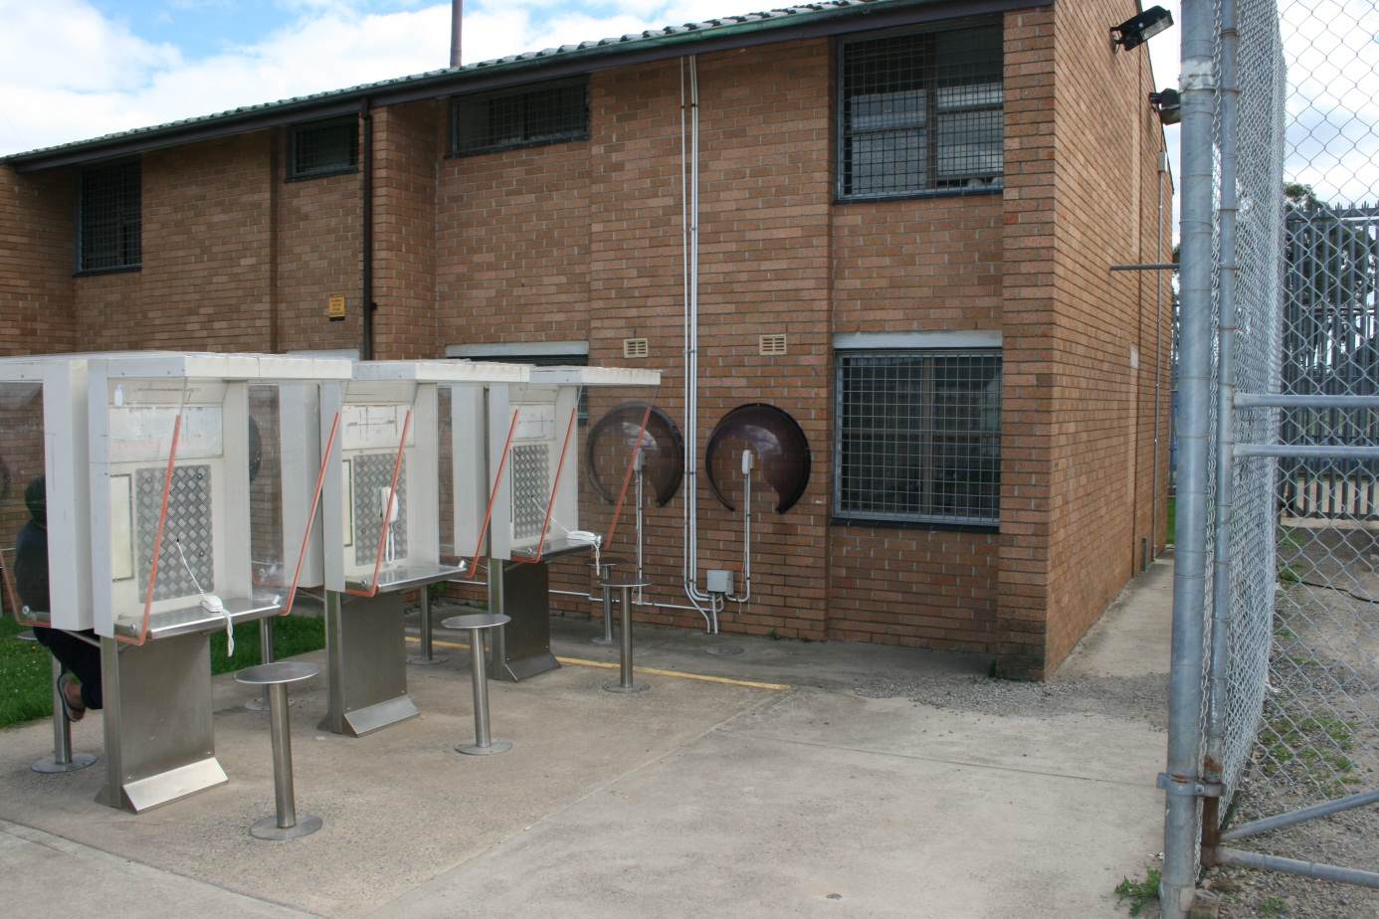
External telephones, Villawood Immigration Detention Centre.
In previous reports of visits to immigration detention sites, the Commission has raised concerns about the policy which prohibits people who have arrived by boat seeking asylum from having mobile telephones in detention facilities. This policy does not apply to other groups of people in detention.
DIAC’s mobile phone policy can restrict access to communication between people in detention and their family members and support networks; limit the extent to which asylum seekers can hold private telephone conversations with legal representatives or migration agents; and cause tensions between different groups in detention. It also unnecessarily adds to the difficulties associated with people in the community attempting to contact asylum seekers in detention. Further, it can place additional pressure on sometimes inadequate communications infrastructure in detention, by increasing demand for landline telephones.
During the Commission’s most recent visits, the policy of permitting access to mobile phones only to those people in detention who did not arrive by boat remained a source of distress and consternation. Across facilities, people who were denied mobile phones told the Commission that the policy felt punitive. Further, staff and management raised serious concerns about the operational challenges which they face in implementing a two-track approach.
It remains the Commission’s view that there has not been a reasonable justification provided for this policy and it should be reconsidered.

The term ‘refugee’ is used throughout this report to refer to refugees whose status has been recognised in Australia. None of the refugees with whom the Commission spoke in the context of producing this report had been granted a Protection Visa. The term ‘stateless’ is used throughout this report to refer to people who appear to be or identify as being either de jure or de facto stateless. Recognised refugees who may also be stateless are referred to as refugees. The Commission recognises that refugee status and statelessness are declaratory, not constitutive, in nature. As such, asylum seekers may also be refugees and may also be stateless.
See section 5.2 of this report for discussion and precedents relating to the use of community detention and bridging visas for people who have arrived in Australia by boat seeking asylum.
The Commission conducted visits to multiple people and families in community detention, in their residences, on 13 December 2011, 20 and 21 February 2012 and 17 April 2012. The Commission conducted visits to and telephone interviews with asylum seekers and refugees living in the community on bridging visas on 15, 16, 17 and 24 May 2012.
The Commission visited Villawood Immigration Detention Centre and Sydney Immigration Residential Housing from 10 to 13 April 2012, and Maribyrnong Immigration Detention Centre and Melbourne Immigration Transit Accommodation from 18 to 20 April 2012.
The Australian Government collectively refers to these forms of immigration detention as ‘held’ detention.
The Commission’s reports of complaints about alleged human rights breaches in immigration detention are available at http://humanrights.gov.au/legal/humanrightsreports/index.html. The Commission’s national inquiry reports are A last resort? National Inquiry into Children in Immigration Detention (2004), at http://humanrights.gov.au/human_rights/children_detention_report/index.html and Those who’ve come across the seas: Detention of unauthorised arrivals (1998), at http://humanrights.gov.au/human_rights/immigration/seas.html (viewed 6 July 2011). Over the past two years, the Commission visited seven immigration detention facilities and produced five detailed public reports. For further information see http://www.humanrights.gov.au/human_rights/immigration/detention_rights.html#9_3. Further information about the Commission’s activities relating to immigration detention is available at http://humanrights.gov.au/human_rights/immigration/detention_rights.html#9.
The Department of Immigration and Citizenship’s response is available at http://www.humanrights.gov.au/human_rights/immigration/2012community-arrangements_DIACresponse.
For further discussion of the origins and history of Australia’s mandatory immigration detention see J Phillips and H Spinks, Immigration Detention in Australia, Background Note, Parliamentary Library, Parliament of Australia, 23 January 2012, at http://www.aph.gov.au/About_Parliament/Parliamentary_Departments/Parliamentary_Library/pubs/BN/2011-2012/Detention (viewed 23 July 2012).
Migration Act 1958 (Cth), s 183.
See Migration Amendment Act 1992 (Cth), s 3 which inserted the then s 54Q(2)(b) into the Migration Act.
See Migration Reform Act 1992 (Cth); Migration Laws Amendment Act 1993 (Cth). Section 2 of the Migration Reform Act 1992 (Cth) provides that the main provisions of the Act commence on 1 November 1993. Section 2 of the Migration Laws Amendment Act 1993 (Cth) deferred the commencement of certain amendments contained in the Migration Reform Act 1992 (Cth) until 1 September 1994.
For a description of the Tampa crisis see, for example, M Crock, B Saul and A Dastyari, Future Seekers II: Refugees and the Law in Australia (2006).
See Migration Amendment (Excision from Migration Zone) Act 2001 (Cth); Migration Amendment (Excision from Migration Zone) (Consequential Provisions) Act 2001 (Cth).
Migration Act 1958 (Cth), s 189.
See Migration Act 1958 (Cth), s 189(3); C Evans, New Directions in Detention – Restoring Integrity to Australia’s Immigration System (Speech delivered at the Centre for International and Public Law Seminar, Australian National University, Canberra, 29 July 2008), at http://www.minister.immi.gov.au/media/speeches/2008/ce080729.htm (viewed 6 June 2012).
Migration Act 1958 (Cth), s 196.
Al-Kateb v Godwin (2004) 219 CLR 562. See also Migration Act 1958 (Cth), s 196.
See, for example, ‘UNHCR urges Australia to review policy of detaining asylum seekers’ (Media Release, 1 February 2002), at http://www.un.org/apps/news/story.asp?NewsID=2785&Cr=australia&Cr1=asylum; ‘Changes to Australian detention arrangements’ (Media Release, 19 April 2010), at http://unhcr.org.au/unhcr/index.php?option=com_content&view=article&id=175&catid=35&Itemid=63; United Nations Human Rights Committee, Concluding observations of the Human Rights Committee: Australia, UN Doc CCPR/C/AUS/CO/5 (2009), para 23, at http://www2.ohchr.org/english/bodies/hrc/docs/co/CCPR-C-AUS-CO-5.doc; United Nations Committee on Economic, Social and Cultural Rights, Concluding observations of the Committee on Economic, Social and Cultural Rights: Australia, UN Doc E/C.12/AUS/CO/4 (2009), para 25, at http://www2.ohchr.org/english/bodies/cescr/docs/AdvanceVersions/E-C12-AUS-CO-4.doc; A Grover, Report of the Special Rapporteur on the right of everyone to the enjoyment of the highest attainable standard of physical and mental health: Mission to Australia, UN Doc A/HRC/14/30/Add.4 (2010), pp 21-24, at http://www.unhcr.org/refworld/docid/49faf7652.html; United Nations Human Rights Council, Report of the Working Group on the Universal Periodic Review: Australia (2011), see paras 28, 42, 49, 78, 86.123, 86.127, 86.131 and 86.132, at http://www.ohchr.org/EN/HRBodies/UPR/PAGES/AUSession10.aspx; United Nations Commission on Human Rights, Report of the Working Group on Arbitrary Detention: Visit to Australia (2002), UN Doc E/CN.4/2003/8/Add.2, see Executive Summary, at http://www.unhcr.org/refworld/type,MISSION,,AUS,3e2e7ca54,0.html; United Nations Committee on the Rights of the Child, Concluding Observations: Australia (2005), UN Doc CRC/C/15/Add.268, para 62, at http://www.unhcr.org/refworld/publisher,CRC,,AUS,45377eac0,0.html (all viewed 6 June 2012).
See International Covenant on Civil and Political Rights (1966), art 9(1), at http://www2.ohchr.org/english/law/ccpr.htm (viewed 6 June 2012); Convention on the Rights of the Child (1989), art 37(b), at http://www2.ohchr.org/english/law/crc.htm (viewed 6 June 2012).
United Nations Human Rights Committee, C v Australia, Communication No 900/1999, UN Doc CCPR/C/76/D/900/1999 (2002), para 8.2, at http://www.unhcr.org/refworld/docid/3f588ef00.html (viewed 6 June 2012).
See Working Group on Arbitrary Detention, Report of the Working Group on Arbitrary Detention (15 January 2010), UN Doc A/HRC/13/130, para 59, at http://www2.ohchr.org%2Fenglish%2Fbodies%2Fhrcouncil%2Fdocs%2F13session%2FA.HRC.13.30_en.pdf (viewed 6 June 2012); this requirement is set out explicitly in the Convention on the Rights of the Child, note 19, art 37(b).
The United Nations Human Rights Committee has held that detention should not continue beyond the period for which a State party can provide appropriate justification. See A v Australia [1997] UNHRC 7, UN Doc CCPR/C/76/D/900/1993 (the fact that the author may abscond if released into the community with not sufficient reason to justify holding the author in immigration detention for four years); C v Australia [2002] UNHRC 52, UN Doc CCPR/C/76/D/900/1999. In the case of children, international law specifically requires that detention be used only for the shortest appropriate period of time: Convention on the Rights of the Child, note 19, art 37(b). These requirements are reflected in the Australian Government’s New Directions in Detention policy, which states that ‘[d]etention in immigration detention centres is only to be used as a last resort and for the shortest practicable time’: New Directions in Detention, note 15.
See sections 6 and 7 of this report.
See, for example, observations relating to self-harm by people in detention at Commonwealth Ombudsman, ‘Inquiry to examine suicide and self-harm in immigration detention’ (Media Release, 29 July 2011), at http://www.ombudsman.gov.au/media-releases/show/189 (viewed 10 July 2012); Australian Human Rights Commission, 2011 Immigration detention at Curtin: Observations from visit to Curtin Immigration Detention Centre and key concerns across the detention network (2011), section 8.3, at http://www.humanrights.gov.au/human_rights/immigration/idc2011_curtin.html (viewed 10 July 2012); Australian Human Rights Commission, 2011 Immigration detention at Villawood (2011), section 11.3, at http://www.humanrights.gov.au/human_rights/immigration/idc2011_villawood.html (viewed 10 July 2012).
The deaths in immigration detention occurred at Curtin Immigration Detention Centre on 21 August 2010 and 28 March 2011; Villawood Immigration Detention Centre on 20 September 2010, 16 November 2010 and 8 December 2010; Scherger Immigration Detention Centre on 17 March 2011 and Sydney Immigration Residential Housing on 26 October 2011 and 27 February 2012.
A Hawke and H Williams, Independent Review of the Incidents at the Christmas Island Immigration Detention Centre and Villawood Immigration Detention Centre (2011), at http://www.immi.gov.au/media/publications/pdf/2011/independent-review-incidents-christmas-island-villawood-full.pdf (viewed 27 June 2012).
Independent Review of the Incidents at the Christmas Island Immigration Detention Centre and Villawood Immigration Detention Centre: Minister’s response, p 1, at http://www.immi.gov.au/media/publications/pdf/2011/response-independent-review-incidents-christmas-island-and-villawood-full.pdf (viewed 27 June 2012).
Findings in the inquests into the deaths of Josefa Raulini, Ahmed Obeid Al-Akabi and David Saunders at Villawood Detention Centre, New South Wales, in 2010, at http://www.coroners.lawlink.nsw.gov.au/agdbasev7wr/_assets/coroners/m401601l3/05_villawoodfindings-redacted.pdf (viewed 27 June 2012).
Above, p 10.
Above, p 10.
Above, p 10.
Above, p 11.
Above, pp 10-11.
Joint Select Committee on Australia’s Immigration Detention Network: Terms of reference, at http://www.aph.gov.au/Parliamentary_Business/Committees/Senate_Committees?url=immigration_detention_ctte/immigration_detention/tor.htm (viewed 27 June 2012).
Joint Select Committee on Australia’s Immigration Detention Network, Final Report (2012), at http://www.aph.gov.au/Parliamentary_Business/Committees/Senate_Committees?url=immigration_detention_ctte/immigration_detention/report/index.htm (viewed 27 June 2012).
Plaintiff M61/2010E v Commonwealth (2010) 243 CLR 319, at http://www.austlii.edu.au/au/cases/cth/HCA/2010/41.html (viewed 28 June 2012).
It should be noted, however, that DIAC did provide officers conducting the primary assessments and reviews with guidance on making decisions in accordance with natural justice or procedural fairness. This guidance was contained in, for example, the Refugee Status Assessment Procedures Manual. See above, para 43.
Above, para 9(a).
Minister for Immigration and Citizenship, ‘Bridging visas to be issued for boat arrivals’ (Media Release, 25 November 2011), at http://www.minister.immi.gov.au/media/cb/2011/cb180599.htm (viewed 23 July 2012).
Minister for Immigration and Citizenship, ‘New Single Protection Visa Process Set to Commence’ (Media Release, 19 March 2012), at http://www.minister.immi.gov.au/media/cb/2012/cb184344.htm (viewed 25 May 2012).
For further information about the new streamlined processing arrangements, see Department of Immigration and Citizenship, Implementation of a single process for Irregular Maritime Arrivals (Questions and Answers), at http://www.immi.gov.au/visas/humanitarian/_pdf/implementation_single_process_ima.pdf (viewed 22 May 2012).
The International Covenant on Civil and Political Rights, the Convention against Torture and Other Cruel, Inhuman or Degrading Treatment and Punishment and the Convention on the Rights of the Child all require that people who are at risk of death or serious human rights violations in their countries of origin not be returned to face such risks – see further note 88 below. Complementary protection schemes provide people who have not been found to be refugees, but whose return would lead to serious human rights violations, to be provided with a level of protection similar to ‘Convention’ refugees. The Migration Amendment (Complementary Protection) Act 2011 (Cth) came into force in October 2011 and administrative processing of claims under the complementary protection scheme commenced on 24 March 2012.
Australian Human Rights Commission, ‘Bridging visas are a more humane way to treat people seeking protection’ (Media Release, 25 November 2012), at http://www.humanrights.gov.au/about/media/media_releases/2011/115_11.html (viewed 8 June 2012).
Above.
Plaintiff M70/2011 v Minister for Immigration and Citizenship (2011) 244 CLR 144, at http://www.austlii.edu.au/au/cases/cth/HCA/2011/32.html (viewed 28 June 2012).
Arrangement between the Government of Australia and the Government fo Malaysia on Transfer and Resettlement (25 July 2011), Clause 16, at http://www.minister.immi.gov.au/media/cb/2011/cb168739.htm (viewed 10 July 2012).
The Commission’s submissions as Intervener in Plaintiff M70/2011 v Minister for Immigration and Citizenship can be found at http://www.hcourt.gov.au/cases/case-m70/2011 (viewed 10 July 2012).
Prime Minister and Minister for Immigration and Citizenship, ‘Legislation to restore Migration Act powers’ (Media Release, 12 September 2011), at http://www.alp.org.au/federal-government/news/legislation-to-restore-migration-act-powers/ (viewed 28 June 2012).
Above.
See transcripts of parliamentary debate of Migration Legislation Amendment (The Bali Process) Bill 2012 (Cth) at http://www.aph.gov.au/Parliamentary_Business/Bills_Legislation/Bills_Search_Results/Result?bId=r4747 and http://parlinfo.aph.gov.au/parlInfo/search/display/display.w3p;query=Id%3A%22chamber%2Fhansards%2F77c820b8-ec44-4d61-a787-9d81d07e3ff0%2F0014%22 (viewed 10 July 2012).
Prime Minister and Minister for Immigration and Citizenship, Transcript of Joint Press Conference, Canberra (28 June 2012), at http://www.pm.gov.au/press-office/transcript-joint-press-conference-canberra-29 (viewed 24 July 2012).The Expert Panel is led by retired Air Chief Marshall Angus Houston AC AFC and also comprises Mr Paris Aristotle AM, Director of the Victorian Foundation for Survivors of Torture, and Professor Michael L'Estrange AO, Director of the National Security College.
Expert Panel on Asylum Seekers, Terms of Reference, at http://expertpanelonasylumseekers.dpmc.gov.au/terms (viewed 10 July 2012).
For example, in Canada, providing for asylum seekers living in the community has been costed at $10-12 per person per day, compared with $179 for detention. In Australia, the Community Assistance Support program, a service for certain vulnerable asylum seekers living in the community, has been costed at a minimum of $38 per day, as opposed to a minimum of $125 per day for immigration detention. Costs calculated in Canadian and Australian dollars respectively. See United Nations High Commissioner for Refugees, Back to Basics: The Right to Liberty and Security of Person and ‘Alternatives to Detention’ of Refugees, Asylum-Seekers, Stateless Persons and Other Migrants, p 60, at http://www.unhcr.org/refworld/docid/4dc935fd2.html (viewed 6 July 2012); International Detention Coalition and La Trobe Refugee Research Centre, There are Alternatives: A handbook for preventing unnecessary immigration detention (2011), box 12, at http://idcoalition.org/cap/handbook/ (viewed 6 July 2012).
There are Alternatives, above, section 4.3.3 and endnotes 51-54.
There are Alternatives, above, section 5.
Research indicates that less than 10% of asylum applicants abscond when released to proper supervision and facilities, or, in other words, over 90% of asylum applicants comply with their conditions of release. See Back to Basics, note 53, Executive Summary; There are alternatives, above, sections 3.2 and 5.1 and box 12.
There are Alternatives, note 53, box 14.
There are Alternatives, note 53, box 8.
There are Alternatives, note 53, box 9.
There are Alternatives, note 53, box 2.
See Migration Act 1958 (Cth), s 197AB.
New Directions in Detention, note 15.
See, for example, Australian Human Rights Commission, 2010 Immigration detention on Christmas Island (2010), sections 11 and 13.2, at http://www.humanrights.gov.au/human_rights/immigration/idc2010_christmas_island.html (viewed 10 July 2012); Australian Human Rights Commission, 2011 Immigration detention at Villawood (2011), section 7, at http://www.humanrights.gov.au/human_rights/immigration/idc2011_villawood.html (viewed 10 July 2012).
Minister for Immigration and Citizenship and Prime Minister, ‘Government to move children and vulnerable families into community-based accommodation’ (Media Release, 18 October 2010), at http://www.minister.immi.gov.au/media/cb/2010/cb155484.htm (viewed 6 June 2012).
‘Bridging visas to be issued for boat arrivals’, note 39.
Bridging visas have been used for many years to allow, among others, asylum seekers who arrive by plane to live lawfully in the Australian community. See Prime Minister of Australia and Minister for Immigration and Citizenship, ‘Asylum seekers; Malaysia agreement; Commonwealth Ombudsman’ (Joint Press Conference, 13 October 2011), at http://www.minister.immi.gov.au/media/cb/2011/cb179299.htm (viewed 10 July 2012).
Department of Immigration and Citizenship, Bridging visas: form 1024i, at www.immi.gov.au/allforms/pdf/1024i.pdf (viewed 29 June 2012).
Written communication from Department of Immigration and Citizenship to Australian Human Rights Commission, 24 July 2012
Above.
Above.
Above.
See note 3.
The Commission has raised concerns about security assessment processes and outcomes in numerous reports and public statements including 2010 Immigration detention on Christmas Island, note 63, section 10; Australian Human Rights Commission, 2010 Immigration detention in Darwin (2010), section 5, at http://www.humanrights.gov.au/human_rights/immigration/idc2010_darwin.html (viewed 10 July 2012); 2011 Immigration detention at Villawood, note 24, section 8.4; 2011 Immigration detention at Curtin, note 24, section 5.1. The Commission has also made submissions on security assessment processes and outcomes to Parliamentary reviews and inquiries, including to the 2011 Independent Review of the Intelligence Community (at http://www.humanrights.gov.au/legal/submissions/2011/20110431_intelligence.html, viewed 24 July 2012) and the 2011 Joint Select Committee Inquiry into Australia’s Immigration Detention Network (at http://www.humanrights.gov.au/legal/submissions/2011/201108_immigration.html, viewed 24 July 2012). Further, Commission President the Hon Catherine Branson QC wrote to the Attorney-General on 23 September 2010, 12 October 2011, 1 March 2012 and 15 May 2012, and the Minister for Immigration and Citizenship on 23 September 2010, 26 August 2011 and 15 May 2012, about the Commission’s concerns in relation to ASIO security assessment processes and outcomes.
For example, in March 2011, ASIO introduced a security referral framework for asylum seekers who arrive in Australia by boat, designed to streamline the security checking process for people in this situation and allow ASIO to focus on complex cases while finalising non-complex cases relatively quickly. According to ASIO, this new ‘triage method’ allows for more efficient conduct of security assessments: see Australian Security Intelligence Organisation, ASIO Report to Parliament 2010-11 (2011), pp VII-VIII and 25-26, at http://www.asio.gov.au/img/files/Report-to-Parliament-2010-11.pdf (viewed 10 July 2012). For further information on and an analysis of the new triage approach, see Australian National Audit Office, Security Assessments of Individuals (Report no. 49, 2012), at http://www.anao.gov.au/Publications/Audit-Reports/2011-2012/Security-Assessments-of-Individuals (viewed 25 July 2012).
See ASIO Report to Parliament 2010-11, above, p 25.
Written communication from Australian Security Intelligence Organisation to Australian Human Rights Commission, 23 July 2012.
Australian Security Intelligence Organisation Act 1979 (Cth), s 37(1). The notice and the copy of the assessment are not to be provided to the person if the Attorney-General certifies that withholding the notice ‘is essential to the security of the nation’ or that withholding some or all the statement of grounds contained in the assessment ‘would be prejudicial to the interests of security’: Australian Security Intelligence Organisation Act 1979 (Cth), s 37.
Australian Security Intelligence Organisation Act 1979 (Cth), s 36.
Australian Security Intelligence Organisation Act 1979 (Cth), s 36.
Church of Scientology Inc v Woodward (1982) 154 CLR 25.
For further information on security assessments processes, and procedural safeguards which should be introduced to improve them, see Australian Human Rights Commission, Submission to the Independent Review of the Intelligence Community, note 73.
Under s 195A of the Migration Act 1958 (Cth), the Minister for Immigration and Citizenship has the power to grant a visa to any person in immigration detention. This is because, by operation of s 195A(3), the requirement under s 65 that the Minister be satisfied of certain criteria before granting a visa – including that a person who has undergone an ASIO security assessment must not be assessed as being a risk to security – does not apply.
See International Covenant on Civil and Political Rights, note 19, art 9(1); see also Convention on the Rights of the Child, note 19, art 37(b). See further note below.
See note 22.
Choudry v Attorney General [1999] 2 NZLR 582.
Department of Immigration and Citizenship, response to Australian Human Rights Commission, 2011 Immigration detention at Villawood (2011), recommendation 5, at http://www.humanrights.gov.au/human_rights/immigration/idc2011_villawood_response.html (viewed 10 July 2012).
Written communication from Department of Immigration and Citizenship to Australian Human Rights Commission, 24 July 2012.
Australia is prohibited under article 33(1) of the Convention Relating to the Status of Refugees and its 1967 Protocol from expelling or returning refugees to territories where their lives or freedom would be threatened on the basis of their race, religion, nationality, membership of a particular social group or political opinion. However, this prohibition does not apply to refugees whom there are reasonable grounds for regarding as a danger to the security of Australia, or who, having been convicted by a final judgment of a particularly serious crime, constitutes a danger to the Australian community: see article 33(2). Australia has further and broader non-refoulement obligations under the International Covenant on Civil and Political Rights, Convention on the Rights of the Child and Convention against Torture and Other Cruel, Inhuman or Degrading Treatment or Punishment, which prevent the removal of anyone from Australia to a country where they are in danger of torture or cruel, inhuman or degrading treatment or punishment. See Convention Relating to the Status of Refugees (1954), art 33(1) and Protocol Relating to the Status of Refugees (1967), both at http://www.unhcr.org/protect/PROTECTION/3b66c2aa10.pdf (viewed 10 July 2012); International Covenant on Civil and Political Rights, note 19, arts 6 and 7; Convention on the Rights of the Child, note 19, arts 6 and 37; Convention against Torture and Other Cruel, Inhuman or Degrading Treatment or Punishment (1987), at http://www2.ohchr.org/english/law/cat.htm (viewed 10 July 2012). For further analysis of the operation of these articles as non-refoulement provisions, see United Nations Human Rights Committee, GT v Australia, Communication No 706/1996, UN Doc CCPR/C/61/D/706/1996, at http://www.unhcr.org/refworld/country,,HRC,,AUS,,4ae9acbfd,0.html; United Nations Human Rights Committee, C v Australia, Communication No 900/1999, UN Doc CCPR/C/76/D/900/1999, at http://www.unhcr.org/refworld/docid/3f588ef00.html; United Nations Human Rights Committee, Kindler v Canada, Communication No 470/1991, UN Doc CCPR/C/48/D/470/1991, at http://www.unhcr.org/refworld/publisher,CAN_SC,,USA,3ae6b6ed0,0.html; United Nations Human Rights Committee, Ng v Canada, Communication No 469/1991, UN Doc CCPR/C/49/D/469/1991, at http://www.unhcr.org/refworld/country,,HRC,,HKG,,4028b5002b,0.html; United Nations Human Rights Committee, Cox v Canada, Communication No 539/1993, UN Doc CCPR/C/52/D/539/1993, at http://www.unhcr.org/refworld/publisher,HRC,,USA,4028ba144,0.html; United Nations Committee on the Rights of the Child, General Comment No 6: Treatment of unaccompanied and separated children outside their country of origin, UN Doc CRC/GC/2006/6, at http://www.unhcr.org/refworld/docid/42dd174b4.html (all viewed 10 July 2012).
Section 196 of the Migration Act provides that an unlawful non-citizen is to be detained until he or she is: - removed from Australia under section 198 or 199; or - deported under section 200; or - granted a visa.
Al-Kateb v Godwin (2004) 219 CLR 562.
Transcripts of the proceedings in Plaintiff M47/2012 v Director General of Security can be found at http://www.austlii.edu.au/au/other/HCATrans/2012/144.html, http://www.austlii.edu.au/au/other/HCATrans/2012/145.html and http://www.austlii.edu.au/au/other/HCATrans/2012/149.html (all viewed 9 July 2012).
For a full account of the protests see Independent Review of the Incidents at the Christmas Island Immigration Detention Centre and Villawood Immigration Detention Centre, note 26.
Minister for Immigration and Citizenship, ‘Character test changes passed by parliament’ (Media Release, 5 July 2011), at http://www.minister.immi.gov.au/media/cb/2011/cb167979.htm (viewed 23 July 2012
Migration Act 1958 (Cth), s 501(6)(aa).
In announcing the changes Minister for Immigration and Citizenship, the Hon Chris Bowen MP, stated: ‘Anyone considering engaging in destructive and criminal behaviour in detention must now face the reality that such action will significantly increase their chances of not being granted a permanent visa’. ‘Character test changes passed by parliament’, note 93.
See Migration Act 1958 (Cth), s 501.
For further analysis of the potential impact of the amendments to the character provisions of the Migration Act 1958 (Cth), see Australian Human Rights Commission, Submission to the Senate Legal and Constitutional Committees’ Inquiry into the Migration Amendment (Strengthening the Character Test and Other Provisions) Bill 2011 (31 May 2011), at http://www.humanrights.gov.au/legal/submissions/2011/20110531_migration.html (viewed 10 July 2012).
Concerns raised with the Commission include cases of refugees having been convicted for the theft (and subsequent return) of small food items from detention centre kitchens, without signs of forced entry.
Advice provided to the Australian Human Rights Commission by Department of Immigration and Citizenship, 2 July 2012.
Advice provided to the Australian Human Rights Commission by Department of Immigration and Citizenship, 3 July 2012.
Commonwealth, Official Committee Hansard: Senate Legal and Constitutional Affairs Legislation Committee – Estimates (21 May 2012), p 68 (John Moorhouse, Deputy Secretary, Immigration Detention Services Group, Department of Immigration and Citizenship), at http://parlinfo.aph.gov.au/parlInfo/download/committees/estimate/b429b5c1-1858-47f9-ab41-542ef70c9e51/toc_pdf/Legal%20and%20Constitutional%20Affairs%20Legislation%20Committee_2012_05_21_1050.pdf (viewed 10 July 2012).
Convention relating to the Status of Stateless Persons (1954), at http://www2.ohchr.org/english/law/stateless.htm (viewed 8 June 2012); Convention on the Reduction of Statelessness (1961), at http://www2.ohchr.org/english/law/statelessness.htm (viewed 8 June 2012).
Department of Immigration and Citizenship, Protection Visa Procedures Advice Manual: Annex: Guidelines – Assessing Claims of Statelessness. Available through LEGENDcom, the Department’s electronic database of migration and citizenship legislation and policy documents which is available to members of the public on a subscription basis – see http://www.immi.gov.au/business-services/legend/ (viewed 10 July 2012).
Convention on the Reduction of Statelessness (with Final Act of the United Nations Conference on the Elimination or Reduction of Future Statelessness held at Geneva from 24 March to 18 April 1959, and Resolutions I, II, III and IV of the Conference) (1961), Resolution 1, at http://treaties.un.org/doc/Publication/UNTS/Volume%20989/volume-989-I-14458-English.pdf (viewed 8 June 2012).
See note 4.
See United Nations Standard Minimum Rules for the Treatment of Prisoners (1955), at http://www2.ohchr.org/english/law/treatmentprisoners.htm (viewed 10 July 2012); United Nations Body of Principles for the Protection of All Persons under Any Form of Detention or Imprisonment (1988), at http://www2.ohchr.org/english/law/bodyprinciples.htm (viewed 10 July 2012); United Nations Rules for the Protection of Juveniles Deprived of their Liberty (1990), at http://www2.ohchr.org/english/law/res45_113.htm (viewed 10 July 2012); United Nations High Commissioner for Refugees, UNHCR Revised Guidelines on Applicable Criteria and Standards Relating to the Detention of Asylum Seekers (1999), at www.unhcr.org.au/pdfs/detentionguidelines.pdf (viewed 7 July 2012).
2011 Immigration detention at Villawood, note 24; Department of Immigration and Citizenship, Response to the Australian Human Rights Commission Statement on Immigration Detention in Villawood (2011), at http://humanrights.gov.au/human_rights/immigration/idc2011_villawood_response.html (viewed 10 July 2012).
2011 Immigration detention at Villawood, note 24,Recommendation 10.
2011 Immigration detention at Villawood, note 24, Recommendation 11.
See, for example, 2010 Immigration detention on Christmas Island, note 63, section 18; 2011 Immigration detention at Curtin, note 24, section 9.6.
2011 Immigration detention at Villawood, note 24, Recommendation 7. See also Australian Human Rights Commission, Submission to the Parliamentary Committee on Public Works on the proposed redevelopment of the Villawood Immigration Detention Facility (2008), at http://www.humanrights.gov.au/legal/submissions/2009/20090918_villawood_immigration.html (viewed 10 July 2012).
2011 Immigration detention at Villawood, note 24, Recommendation 8.
See Response to the Australian Human Rights Commission Statement on Immigration Detention in Villawood, note 107, p 6.
See 2010 Immigration detention in Darwin, note 73, section 10; 2011 Immigration detention at Villawood, note 24, section 15; 2011 Immigration detention at Curtin, note 24, section 15.

