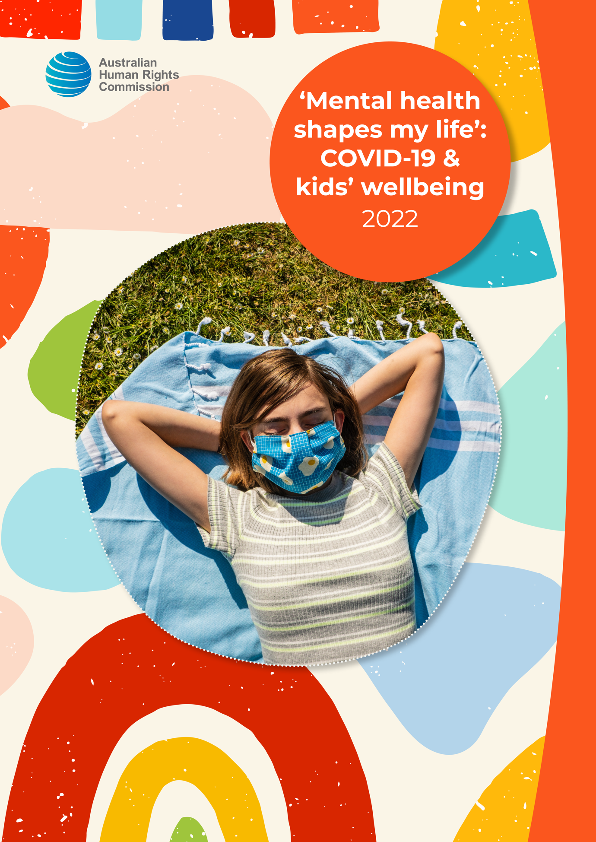

‘Mental health shapes my life’: COVID-19 & kids’ wellbeing

##### What you need to know

If you feel unsafe or worried about anything, it is important to speak up and ask for help. You can talk to someone you trust—like a family member, friend, teacher or school counsellor.

You can also talk to **Kids Helpline**:

* on the phone on **1800 55 1800**
* online at **www.kidshelpline.com.au**

You can also talk to someone at **headspace**:

* in-person at a headspace centre (see their website for locations)
* on the phone on **1800 650 890**
* online at **www.eheadspace.org.au**

If you think you are in immediate danger, you can call the **police** by dialling **000**.

Hello!

I’m Anne Hollonds, the National Children’s Commissioner.

My job is to protect the rights of all children in Australia and make sure they get the help they need to be safe and well.

For more than two years, children and families in Australia have been living through the global COVID-19 pandemic.

In some places, schools were closed, and everyone had to learn at home. Sometimes we couldn’t go outside our local area, or even outside our homes, and we couldn’t travel (even to see family). To keep safe from the virus, we had to wear masks, and we had to get vaccinated to participate in some activities. Many people have felt scared, worried and uncertain.

People have been especially worried about the effects of the pandemic on children’s mental health and wellbeing.

The National Mental Health Commission asked me to run a national survey to find out more. In early 2022, we asked children and their parents/guardians and grandparents, about their experiences over the last two years, and how they were feeling. We wanted to know how to help children recover, and how to prepare for any future emergencies.

Lots of people answered our survey! We heard from **4,559 children** aged 9–17, and **2,796 parents/guardians and grandparents** across Australia.

We heard that children across Australia experienced the pandemic in different ways. But that for many children and families, the last two years have been difficult.

We asked many questions about how children felt, and this is what we heard.

##### Words that people use about COVID-19

COVID-19, COVID, coronavirus, virus, pandemic

We are going to call it ‘the pandemic’ in this summary.

# What does mental health and wellbeing mean to you?

A lot of children told us what mental health means to them.

It basically shapes my life. If I don't have good mental health and wellbeing, I struggle in everything. —Girl, aged 12–13, VIC

They also said that mental health and wellbeing is just as important as physical health:

I think that having a healthy brain is as important as having a healthy heart. —Boy, aged 9–11, VIC

# How has the pandemic made you feel over the last two years?

Many children said that the pandemic had a negative impact on how they felt.

About 1 in 4 children said they felt more down, scared or worried than they did before the pandemic, especially girls and children who identify as non-binary or other.

We also heard some children experienced different mental health issues, like depression and anxiety, during the pandemic.

We asked children to choose their main worries over the last two years from a list. The top worries chosen were:

1. Missing out on things I look forward to, like holidays and school camps
2. Less time with friends and family in person
3. Catching or spreading COVID-19.

But a lot of children also said that usually they feel happy in their lives.

# How did the pandemic affect you?

## Social connection

Children said that one of their top concerns was their loss of social connection. Remote learning, fear of catching the virus, social distancing and travel restrictions all meant that children could not see their friends and family as much. They couldn’t play sport or do other activities with other people in the community. This made them feel lonely, isolated, sad, and angry.

They missed their friends and family, and said that when they couldn’t see them, they felt sad or anxious.

I love my friends and I love seeing them, so when I can’t do that, I struggle to focus due to anxiety. —Girl, aged 12–13, VIC

I miss my friends and a lot of my family most because I don’t live with all of my family and I couldn’t really see them because of Covid. —Girl, aged 9–11, ACT

But some children also said they enjoyed spending more time at home with family.

In lockdown I got to spend more time with my family at home, and I learnt new skills such as time management with doing work at home. —Girl, aged 9–11, NSW

## Physical health

Many children said they were worried about catching the virus or passing it on to other people, and some said they were scared of getting vaccinated.

I’m worried I might die from COVID or pass it on to other vulnerable people. —Boy, aged 12–13, with a disability, VIC

I’m worried about losing my Elders and unwell people in our large, connected Aboriginal Community to COVID infections. —Girl, aged 16–17, Aboriginal and/or Torres Strait Islander, WA

Getting adverse effects from the vaccine. —Girl, aged 16–17, NSW

Many children said that their eating, physical exercise and sleeping patterns changed during the pandemic. Almost 1 in 3 children said they were doing less regular physical exercise or sport than before.

## Education

Schools closing and remote learning was a big change for most children. 38% of children said they found remote learning harder than learning at school. 16% said they liked remote learning better than face-to-face learning at school.

But the main thing that many children really missed about being at school was seeing their friends and teachers. This affected their mental health and wellbeing.

##### What was difficult about remote learning?

I prefer school because I can ask for help from my teacher when I need it instead of on emails and chat rooms. —Girl, aged 9–11, NSW

Sometimes my Mum didn’t know what she was teaching me. The schoolwork made no sense to her. —Boy, aged 14–15, VIC

Doing work at home is not a good option for me because I get too distracted and struggle to feel motivated. I also couldn’t see friends or have interactions with other people as much. —Child, who identifies as non-binary or other, aged 16–17, NSW

I needed less schoolwork. Last year especially, I needed time to refocus and reorganise, but that is impossible when you are working on 6 assignments at the same time. —Boy, aged 16–17, SA

The screens were incredibly annoying at the zoom chats because you wanted to chat to your friends in a different class and I found it straining muscles in your body, not getting enough exercise. —Girl, aged 9–11, NSW

##### What was good about remote learning?

I prefer online learning because you can eat and sleep anytime you want. You can also work at your own pace. —Boy, aged 9–11, from a specific cultural or ethnic background, NSW

I could split my work up in any order I wanted and that helped me manage it with my ADHD. —Child who identifies as non-binary or other, aged 12–13, from a specific cultural or ethnic background, VIC

The classroom was too noisy and school tried to give me headphones instead of asking the others to be quiet during writing time. —Boy, aged 9–11, who speaks a language other than English at home, QLD

I liked it because I was with my family and I like family more than school. —Girl, aged 9–11, QLD

I felt more comfortable, less judged and less anxious. —Child who identifies as non-binary or other, aged 14-15, NSW

## What was it like returning to school after lockdown?

When children returned to school after lockdown, the virus was still around. Some people had to wear masks at school and get tested. Some children, and families, said that the return to school made them anxious.

I’m worried about going back to school and doing RAT tests and wearing masks all day at school and getting covid. I’m safer staying at home. —Boy, aged 9–11, Aboriginal and/or Torres Strait Islander, with a disability, NSW

I hate masks and my mum can’t even come into the school and the test hurts and makes my nose bleed. —Child with undisclosed gender, aged 12–13, NSW

But most children said they were feeling very **positive**, **excited and enthusiastic** about returning to school. Some said it was hard to get used to learning at school after remote learning.

It made me so happy to be able to go back to school and made me feel so lucky. It showed me how much I really needed my teachers and they helped me when I felt down or upset. —Girl, aged 9–11, NSW

Going back to school this year is amazing because I get to see my friends again although it can be a little hard because it is a little bit awkward in person after being online for as long as we were. —Child who identifies as non-binary or other, aged 12–13, NSW

## Safety at home

Most children said they felt safe at home over the last two years, but some said they only felt safe ‘sometimes’, and a few said they did not feel safe at all. Family stress, conflict and violence were some reasons why they didn’t feel safe.

Having a stressed mum and a lot of fights was hard, I think by the end of it we got a bit sick of each other and that was really tough. I was also struggling mentally so it was hard to feel safe even by myself really. —Child who identifies as non-binary or other, aged 16–17, NSW

I am hopeful that I never have to see my dad again after what he did. I’m worried that we have to go and live with him, which I hope never happens. —Boy, aged 9–11, from a specific cultural or ethnic background, NSW

## News and information

Some children said that all the news and information about the pandemic had a bad effect on their mental health and wellbeing. Some parents/guardians and grandparents were also worried about this.

I needed to not hear or see ANYTHING about COVID-19. —Girl, aged 9–11, from a specific cultural or ethnic background, VIC

When I look at the news, especially recently, that hope and aspiration become hopelessness, and it decreases the level of excitement I have for the future. —Girl, aged 14–15, from a specific cultural or ethnic background, VIC

## Digital technology and social media

In lockdown, lots of children relied more on digital technology and social media than before. Many children said they had at least one problem or negative experience with technology and social media. The top problems chosen by children were:

1. Using social media or technology for gaming or things like YouTube a lot more than usual
2. Tiredness from extra time on screens
3. Being distracted by social media or technology a lot more than usual.

Some children also mentioned cyberbullying during the pandemic.

Going back to school is hard, as some people from the school are cyberbullying me, and it hurts me. —Girl, aged 9–11, VIC

But technology was not all bad: some children and families thought it could also help with mental health and wellbeing.

I’m glad that we can have cool technologies that we can use to communicate easier with family members from far away! —Boy, aged 12–13, NSW

## Money and jobs

Some children said they were worried about having enough money for basic things, like food and paying bills. Others said they were worried that someone in their family—including them— would lose their jobs or wouldn’t be able to find a job. Some worried about someone in their family losing jobs because of vaccination mandates.

I’m worried about COVID never going away and more lockdowns and mum not being able to pay the bills. —Boy, aged 16–17, NSW

I’m sick of lockdowns, mask wearing, and can't get a job. I’m worried about more of my family losing their jobs. —Girl, aged 16–17, Aboriginal and/or Torres Strait Islander, NSW

# Getting help and support for mental health in the pandemic

Children told us the top three things that helped them stay happy and hopeful over the last two years:

1. Support of my parents and family
2. Contact with friends
3. Using technology for things like games and social media.

Most children said that their family had helped them over the last two years.

We always talk about stuff that is going on. They help me to know what is happening and why. I can ask as many questions that I want and they always try to answer honestly. —Boy, aged 12–13, QLD

Always there for me and made sure I had what I needed to feel safe in my home and happy. —Girl, aged 16–17, from a specific cultural or ethnic background, VIC

One of the most important things for children was a need to connect with others, and to feel loved and cared for.

Just needed some love really, I felt pretty lonely a lot of the time, and some support for starting high school in 2021, which was such odd conditions, so many unsures, it was just hard. —Girl, aged 12–13, WA

## Have you ever had help for your mental health? Was it hard to get help?

We asked children if they had ever got help for their mental health and wellbeing, either in the past or right now. 36% said they never had help, and 23% said they had got some help.

And a few children also told us some reasons why it was hard to get help for mental health. The top reasons they chose were:

1. Fear of people finding out and judging my problems
2. Not being able to get an appointment or long waiting lists
3. Feeling scared or worried, and not feeling like I was understood when I asked for help.

I did think about seeking help but I was so uncomfortable and anxious to do anything because I didn’t want to be judged because I feel as though I don’t need to seek help as many others need it more than me. I basically thought I could get through it by myself. —Girl, aged 16–17, VIC

I need help because I recently felt lonely and needed to let my anger out but I was too scared to ask for help. —Girl, aged 12–13, VIC

I have a support worker that I would see fortnightly that I could not see due to lockdowns. —Boy, aged 14–15, VIC

Children and parents/guardians and grandparents also said the cost of mental health and wellbeing was a problem for them.

## How would you like to get help?

Children said they would feel most comfortable getting help for their mental health ‘in person’.

I needed to talk to someone but I refused to do it online as that was part of the problem I needed the human contact and I hated online support. —Boy, aged 16–17, NSW

I needed to see my psychologist in person. I don't like telehealth. —Boy, aged 9–11, with a disability, VIC

## Did your school help look after your mental health?

Many children said their school supported their mental health and wellbeing in the last two years. Older children, children with disabilities and children who identify as non-binary or other said this less than other children.

Some ways that schools supported children during the pandemic:

* teachers doing regular wellbeing checks
* holding ‘Wellbeing Wednesdays’
* sending cards and chocolates
* getting a mental health dog!

My school had a ‘Wellness Wednesday’ every second Wednesday, so we could take a break from remote learning. They set us some mindful activities like drawing, listening to calming music, puzzles, cooking and fun things like those. Our family – we made pavlova and a Christmas tree platter as well as playing games (not online) and obstacle courses. —Girl, aged 9–11, from a specific cultural or ethnic background, NSW

But many children, and families, said they thought schools could do more to support children’s mental health and wellbeing.

A completely safe space to do anything. Whether you just need somewhere comfortable to break down and get upset about something. Being able to offer advice, or just listening without judging, acting as a way to vent. Being able to recommend methods of coping, or even suggesting counsellors or therapists outside of the school that they think would suit the student, if they find it necessary. —Girl, aged 14–15, QLD

# How do you feel about the future?

Most children said they were hopeful for the future, even though we have had all this worry and uncertainty. Younger children were more hopeful than older children.

**What do you hope for in the future?**

I am hopeful that COVID will go away and everyone will just forget about it and things will go back to normal. —Girl, aged 12–13, SA

I am hopeful I will get to go to camp this year. —Girl, aged 12–13, from a specific cultural or ethnic background, VIC

Getting to see my friends after COVID finishes and getting to go on holiday and getting to see my grandparent I have not seen in 3 years. —Girl, aged 9–11, SA

I’m looking forward to graduating and moving out of home. —Girl, aged 12–13, from a specific cultural or ethnic background, QLD

I am 18 in a few months and am then able to get my p’s and drive my car alone. I’m also looking forward to finally getting out of school and starting uni and things like that. I’ve got concerts too that are finally able to happen. —Girl, aged 16–17, VIC

In the future I want to travel or do something important for the environment. —Child who identifies as non-binary or other, aged 16–17, NSW

**What do you worry about in the future?**

COVID getting worse and me never be able to have a play date again. —Girl, aged 9–11, VIC

I am worried that COVID will continue through the best years of my life, affecting my social life and experiences before university starts. —Girl, aged 16–17, SA

I am worried about paying bills and finding a job. —Girl, aged 14–15, SA

Not getting into selective high school, not finding a job and not being successful overall. —Girl, aged 9–11, from a specific cultural or ethnic background, NSW

I am scared about the Ukraine and Russia war. I am worried it will turn into a World War. —Girl, aged 9–11, WA

Climate change and the lack of action from the adults in charge. —Child with gender undisclosed gender, aged 9–11, WA

# So, what can we do to help children have good mental health and wellbeing?

The main things that children and families said would help support mental health were:

#### Greater awareness and understanding of mental health in the community

Make it more known that it’s ok for kids to reach out and help remove the stigma surrounding mental health in schools. —Child who identifies as non-binary or other, aged 16–17, VIC

You can’t just make someone better without eliminating the problems first. Also removing all bad emotions is a horrific idea. Sometimes we need to be sad or depressed. Maybe people should change the way they think about mental illness and not stigmatise it and give actual support. —Boy, aged 16–17, QLD

#### More and better mental health and wellbeing support services and programs

Someone just to be there. Someone to talk to face to face. Not a zoom screen. —Girl, aged 12–13, with a disability, VIC

I would have it that for places like Kids Helpline where we chat [we] didn’t have a long wait and with other websites and apps that they have free chats with a qualified therapist. —Girl, aged 9–11, VIC

#### Schools that really support mental health and wellbeing

I am hopeful that this will help schools understand how we really feel and take the advice and actually do something instead of nodding their heads and saying great idea then never following up on it. —Boy, aged 9–11, NSW

I would like this support to have a big enough reach that everyone in the school gets to see a counsellor, or some such, at least once, so that everyone gets the support and assistance that they need, regardless of their ability to ask for help. —Girl, aged 12–13, VIC

#### Giving children a voice and thinking about what they need

As many as 4,559 children answered this survey!

Children want to talk about how the pandemic has affected them. Adults need to make sure children are listened to in any plans, policies or laws in the future.

Parents/guardians and grandparents also said children should have a voice in what happens in the pandemic.

They were forgotten during this period and none of the policies considered children. They should have a better voice in future pandemics and not be shut out. —Father, NSW

# Do you want to know more?

In the full report, there is a lot more information about the survey. It also has a list of **recommendations** for government, schools and services to better support children’s mental health and wellbeing.

You can find the full report on the Australian Human Rights Commission website: [www.humanrights.gov.au/mentalhealthshapesmylife](http://www.humanrights.gov.au/mentalhealthshapesmylife).

# Fun Activity

Can you find some of the important words that are used in this report?

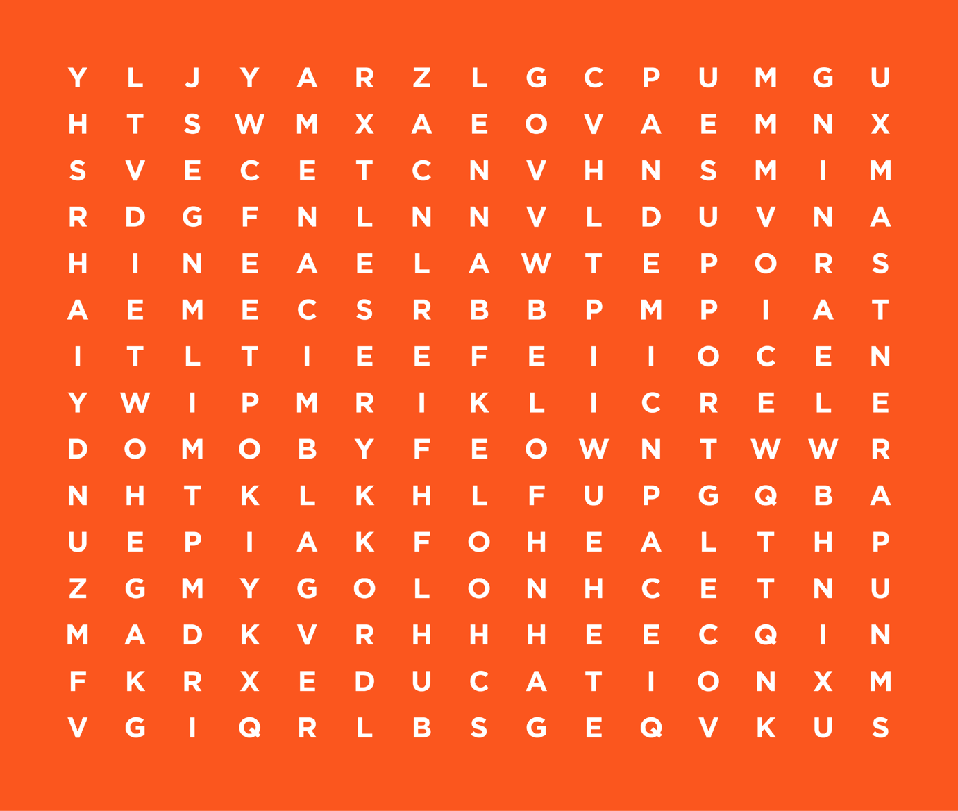

[connection, education, family, friends, mental health, pandemic, help, remote learning, wellbeing, voice, parents, safety, school, support, technology]

The Australian Human Rights Commission encourages the dissemination and exchange of information presented in this publication.



All material presented in this publication is licensed under the [Creative Commons Attribution 4.0 International Licence](http://creativecommons.org/licenses/by/4.0/legalcode), with the exception of:

* photographs and images;
* the Commission’s logo, any branding or trademarks;
* content or material provided by third parties; and
* where otherwise indicated.

To view a copy of this licence, visit <http://creativecommons.org/licenses/by/4.0/legalcode>.

**Attribution:** Material obtained from this publication is to be attributed to © Australian Human Rights Commission 2022.

**‘Mental health shapes my life’: COVID-19 & kids’ wellbeing (for children and young people)**

ISBN 978-1-925917-68-0

**Acknowledgments:** *‘Mental health shapes my life’: COVID-19 & kids wellbeing* was drafted by Susan Newell, Kelly Hand, Niamh Kealy, Susan Nicolson, and Ashlee Taylor.

The National Children’s Commissioner also thanks Darren Dick at the Australian Human Rights Commission.

**Design and layout:** Dancingirl Designs

**Electronic format:** This publication can be found in electronic format on the website of the Australian Human Rights Commission: <https://www.humanrights.gov.au/our-work/childrens-rights/publications>.

**Contact details**: For further information about the Australian Human Rights Commission, please visit [www.humanrights.gov.au](http://www.humanrights.gov.au).