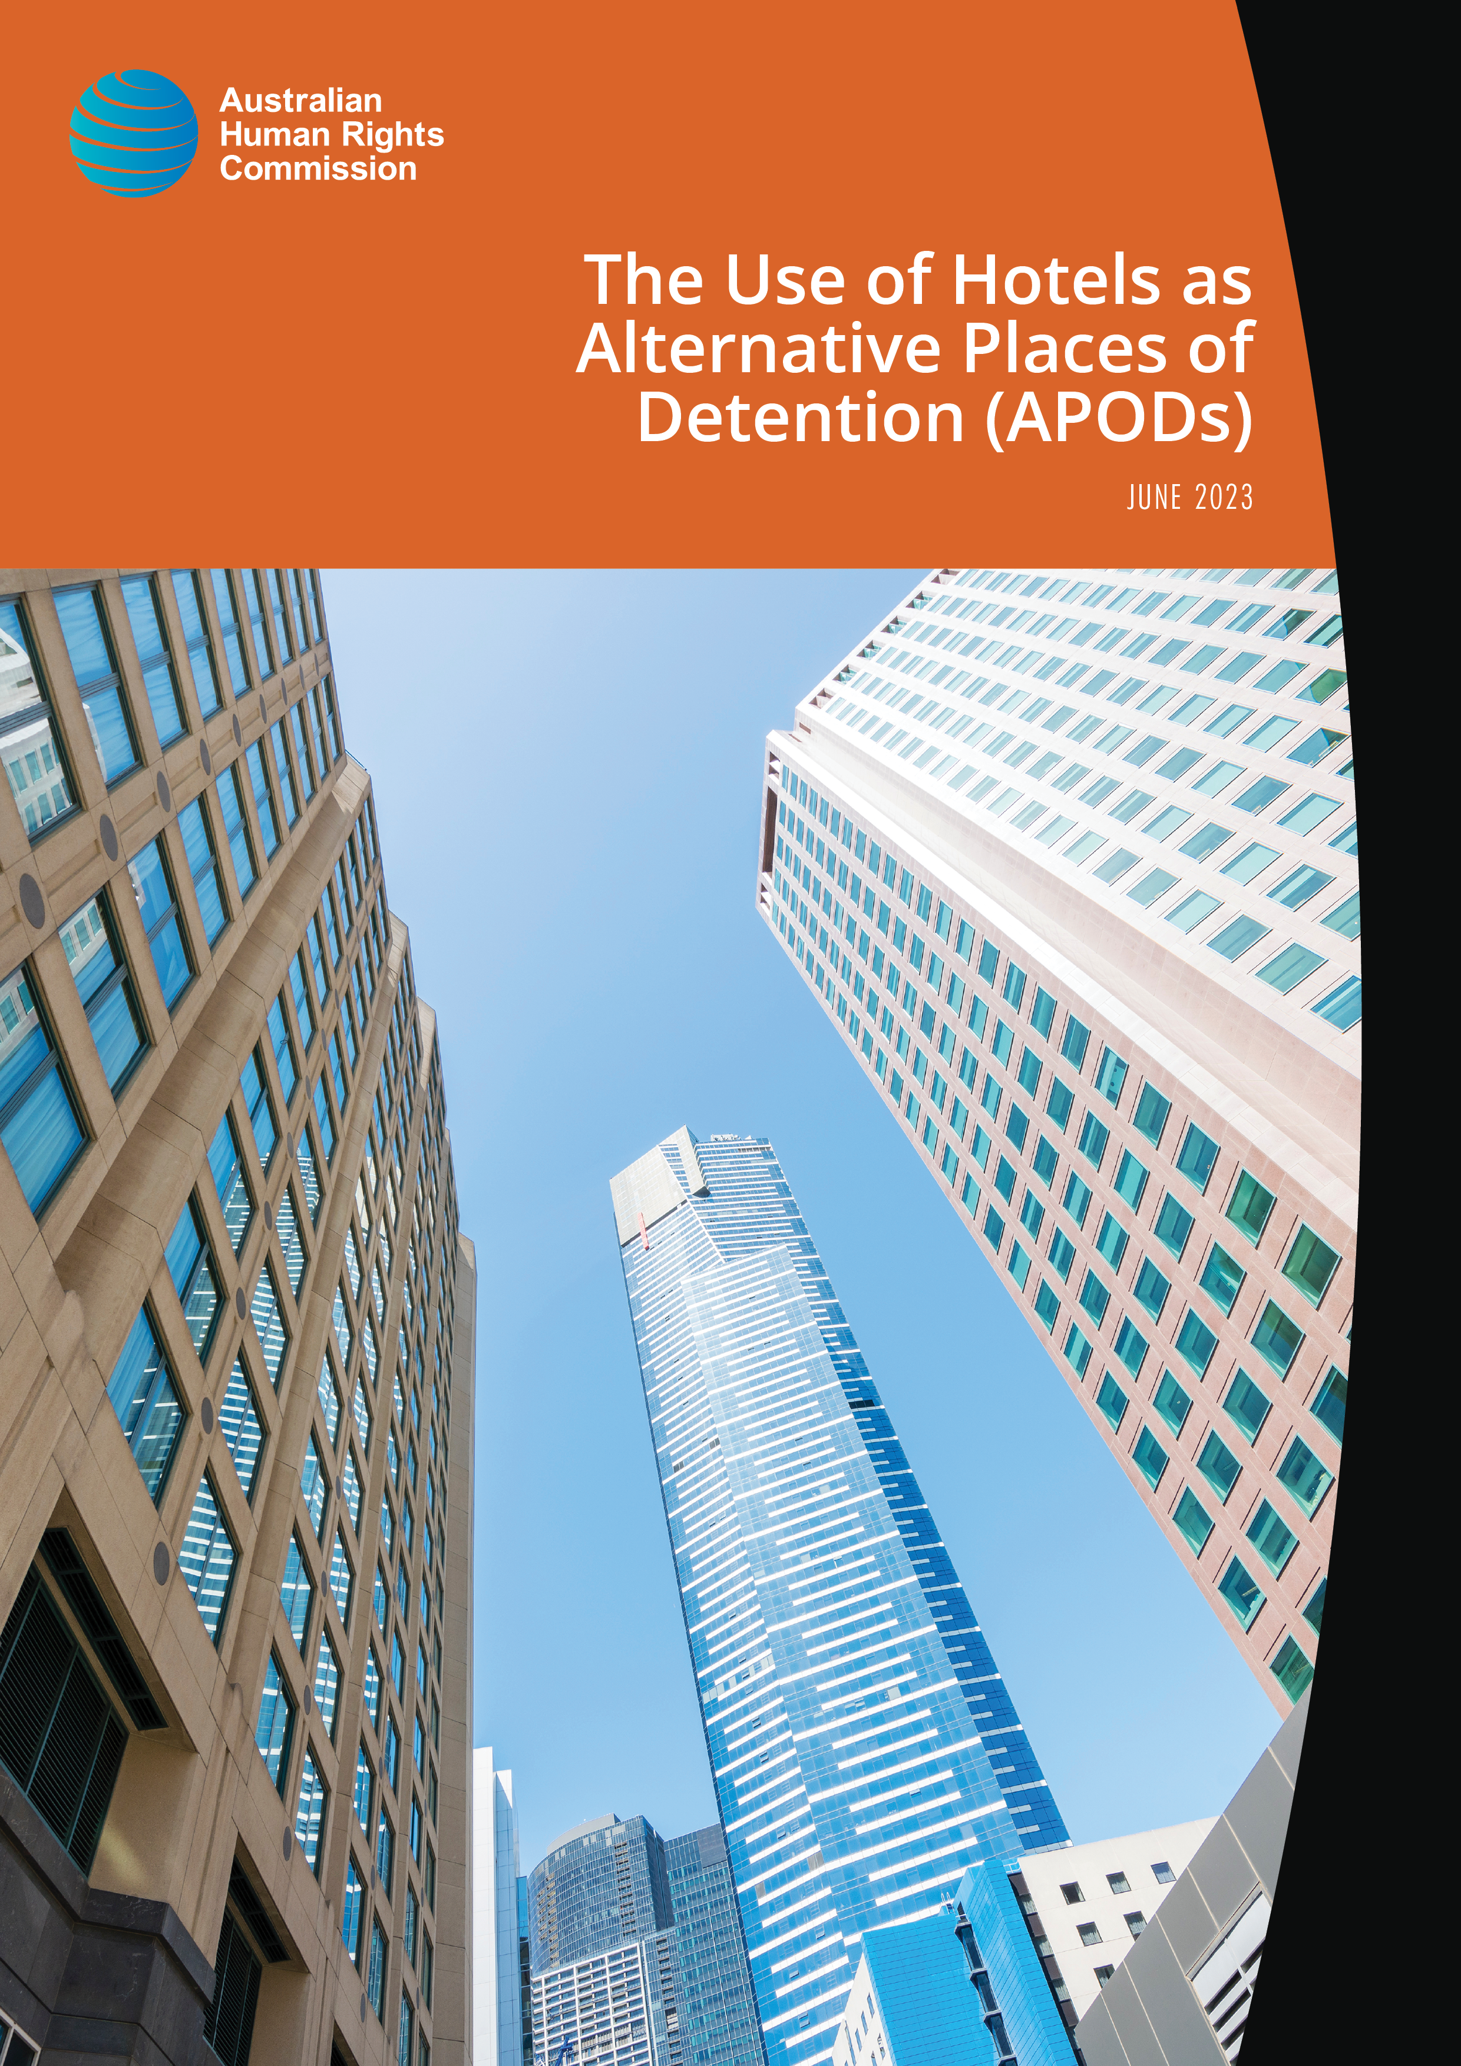

The Australian Human Rights Commission encourages the dissemination and exchange of information presented in this publication.
All material presented in this publication is licensed under Creative Commons Attribution 3.0 Australia, with the exception of:
- photographs and images
- organisational logos, any branding or trademarks
- where otherwise indicated.
To view a copy of this licence, visit https://creativecommons.org/licenses/by/3.0/au/.
In essence, you are free to copy, communicate and adapt the publication, as long as you attribute the Australian Human Rights Commission and abide by the other licence terms.
Please give attribution to: © Australian Human Rights Commission.
The Use of Hotels as Alternative Places of Detention (APODs) • June 2023
ISBN 978-1-925917-51-2
The Australian Human Rights Commission is Australia’s National Human Rights Institution. It is an independent statutory organisation with responsibility for leading the promotion and protection of human rights in Australia.
Authors:
Lorraine Finlay and Steven Caruana
Acknowledgements:
- President Rosalind Croucher.
- Australian Human Rights Commission staff: Jodie Ball, Kelly Britto, Darren Dick, Graeme Edgerton, Jennifer Katrib, and Llewellyn Spink.
- Independent medical consultant, Professor Suresh Sundram, for his expertise, advice, and review of this report.
- The Department of Home Affairs, the Australian Border Force, and contracted detention service providers, Serco and International Health and Medical Services, for their responses to requests for information and documents to inform this review.
- Current and former detainees, civil society organisations, and networks, for sharing information to inform this review.
This publication can be found in electronic format on the Australian Human Rights Commission’s website at https://humanrights.gov.au/our-work/publications.
For further information about copyright in this publication, please contact:
Communications Unit
Australian Human Rights Commission
GPO Box 5218
SYDNEY NSW 2001
Telephone: (02) 9284 9600
TTY: 1800 620 241
Email: communications@humanrights.gov.au
Design and layout: Dancingirl Designs
Cover image: Adobe Stock

The Use of Hotels as Alternative Places of Detention (APODs)
Inspection Report
June 2023

Australian Human Rights Commission

Contents
Commissioner’s Foreword 6
1. Introduction 8
2. Background 10
2.1. Immigration detention in Australia 10
2.2. History of APODs 11
2.3. Methodology 12
2.4. Relevant human rights standards 14
2.5. Key Statistics 15
2.6. Facility Information 17
3. Key observations and concerns 18
3.1. Length of detention 18
3.2. Physical conditions of detention 22
(a) Accommodation 22
(b) Shared facilities and outdoor space 34
(c) Freedom of movement 38
(d) Privacy 39
(e) Communication and visits 40
(f) Food 44
(g) The use of restraints 45
3.3. Programs and activities 46
3.4. Health care 49
(a) IHMS health services 50
(b) Access to specialist health care 52
(c) Mental health care 57
3.5. Management of the COVID-19 Pandemic 60
3.6. Alternatives to Closed Detention 62
4. Releases from Hotel APODs 64
4.1. The Role of Ministerial Discretion 65
4.2. The Process of Release 66
5. Post-Release Support 70
5.1. Status Resolution Support Services 71
5.2. Visa Renewal Process 74
5.3. Medical Care 75
6. Appendix 1 – List of Recommendations 78

Commissioner’s Foreword
Alternative places of detention (APODs) have been used in Australia for over twenty years. While the use of hotels as APODs may be appropriate as a short-term option in exceptional cases, the Australian Human Rights Commission has consistently expressed the view that hotel APODs are not appropriate to be used for lengthy periods of detention, and has previously raised specific concerns relating to the conditions in hotel APODs. This inspection report again highlights many of those same concerns.
Since these inspection visits took place in mid-2022, the Commission has welcomed the consistent trend of the overall numbers of individuals detained in hotel APODs being reduced. However, we still consider this inspection report to be relevant for three key reasons.
The first is that it highlights the way that, in recent years, hotel APODs have come to be seen as a regularised part of Australia’s immigration detention network, rather than being limited to use in exceptional circumstances.
The second is that hotel APODs continue to be used, albeit that the total number detained in hotel APODs has been reduced. Given this, the observations made in this report about the conditions in hotel APODs are still relevant.
The third is that the report highlights significant concerns around both the way that releases from hotel APODs have been conducted and the provision of post-release support. These are issues that have broader relevance beyond hotel APODs in terms of the operation of the wider immigration detention network. The Commission hopes that this report will encourage necessary steps to be taken to improve the support that is available, particularly to ensure continuity of medical care when individuals are released.
The Commission would like to thank all of those who contributed to the inspection visits and report. We would also like to acknowledge the constructive engagement of the Department of Home Affairs and Australian Border Force, both in facilitating the inspection visits and responding to the inspection report.
The response of the Department has been published alongside this report. Of the 24 recommendations that have been made by the Commission, the Department has agreed with two recommendations, disagreed with five recommendations, and noted the remaining 17. Many of these recommendations reflect similar recommendations made by the Commission in past reports, and are consistent with recommendations made by other oversight bodies, such as the Commonwealth Ombudsman. We would welcome the opportunity to discuss ways the Commission could work with the Department in the future to engage in a more substantive way with these long-standing recommendations.
The oversight and monitoring of places of detention by independent bodies such as the Australian Human Rights Commission plays an important role in shining a light on conditions of detention in Australia. But merely shining a light is, on its own, inadequate. It is what happens next that is the critical step.
It is my hope that this inspection report not only shines a light on the use of hotel APODs in Australia, but leads to steps actually being taken to address the issues that have been highlighted.

Lorraine Finlay
Human Rights Commissioner
June 2023

Introduction
Over the past thirty years, the Australian Human Rights Commission (Commission) has conducted inspections of immigration detention facilities in Australia. This has included national inquiries into immigration detention, thematic reports to highlight particular issues, and periodic monitoring of detention facilities across the country.
In conducting inspections of immigration detention facilities, the Commission aims to assess whether these facilities and the treatment of those detained complies with Australia’s obligations under international human rights law. The Commission has consistently expressed a range of concerns about aspects of Australia’s immigration detention system and its compliance with Australia’s international obligations.
In recent times, the Commission has raised specific concerns about the use of hotels as alternative places of detention (‘hotel APODs’) and has warned that they are not appropriate places to detain people for extended periods of time. This report records the key observations and concerns that arose from the Commission’s consideration of the use of hotel APODs in Brisbane and Melbourne, following inspection visits and interviews conducted in 2022.
The Commission particularly acknowledges the contribution made by Dr Suresh Sundram, who assisted with these inspections as an independent medical consultant. Dr Sundram participated in the inspection visits and interviews alongside Commission staff, and provided advice on issues relating to health care and other medical issues concerning people in immigration detention. We also acknowledge the NSW Service for the Treatment and Rehabilitation of Torture and Trauma Survivors (STARTTS) for the training provided to Commission staff, and all of the individual staff at the Commission who assisted with these inspections.
The Commission also acknowledges the assistance provided by the Department of Home Affairs (Department), and Australian Border Force (ABF) in facilitating the Commission’s detention inspections. The Commission team was assisted during the inspections by staff from the Department, ABF and detention service providers, and we are grateful for the assistance that was provided.
In accordance with the usual practice, the Commission provided a copy of this report to the Department on 11 April 2023 to provide an opportunity for response to the Commission’s findings and recommendations prior to publication. The response from the Department was received on 23 May 2023, and has been published alongside this report.
Since the time that this inspection was initially planned and then undertaken, the majority of individuals detained in hotel APODs have been released, and the average period of time spent detained in hotel APODs has significantly reduced. The Commission welcomes these developments and acknowledges the efforts to reduce both the overall number of people detained in hotel APODs and the length of time that they are detained.
Even with this reduction in numbers, it is the Commission’s view that examining the past and continued use of hotels as APODs, and the impact this has had upon the people who were (or are still) detained, is important. It is our intention that this report will not only document the recent use of hotel APODs and help to improve current conditions and policies, but will also influence future policy decisions around the use of APODs in Australia.

Background

Immigration detention in Australia
Immigration detention is mandatory in Australia for all unlawful non-citizens. Once they are detained, an unlawful non-citizen must remain in detention until they are either granted a visa or removed from Australia.
The detention of an unlawful non-citizen is not based on an individual assessment of the need for detention, or an assessment as to whether the individual concerned poses an unacceptable risk to the community. The Commission has previously recommended that closed immigration detention should only be used in circumstances where it is strictly necessary to manage unacceptable risks to the community.
Unlawful non-citizens subject to closed immigration detention are usually detained in purpose-built immigration detention facilities, with seven such facilities being in operation as at February 2023. In some circumstances, individuals can be released from closed immigration detention facilities into alternative, community-based arrangements. This may include release on short-term visas (such as a Bridging visa E) or a residence determination, where the Minister determines that a person may reside in a specified place rather than being held in a detention facility. Both of these options involve the Minister exercising a legal power that is personal, non-compellable, and discretionary.
The Australian Government also operates an offshore processing regime, which involves transferring asylum seekers to third countries for their claims to be processed. Regional processing arrangements were in place in Papua New Guinea until the end of 2021, and continue to operate in Nauru. The Commission has consistently expressed concerns about Australia’s off-shore processing arrangements, and emphasised that transferring asylum seekers to third countries does not release Australia from its obligations under international human rights law.
Refugees and asylum seekers subject to offshore processing who have been transferred to Australia are defined as ‘transitory persons’ under the Migration Act. A transitory person may be brought to Australia for a temporary purpose, which may include receiving medical treatment that is unavailable offshore. While in Australia, transitory persons are subject to mandatory immigration detention, and are required to return to a regional processing country once the temporary purpose for which they were brought to Australia is completed.
Between February – December 2019 the ‘Medevac law’ was in operation, providing a legislative pathway for refugees and asylum seekers held in offshore detention to be transferred to Australia for urgent medical treatment. There were 192 transitory persons temporarily transferred to Australia under the Medevac law, referred to throughout this report as the ‘Medevac cohort’. They were generally detained at hotel APODs upon their initial transfer to Australia.

History of APODs
In addition to established immigration detention centres, the Migration Act also provides for the Minister to approve (in writing) other places being used as detention facilities. These Alternative Places of Detention (APODs) are intended to be used for people who have particular needs that cannot be met within existing detention centres, and may include hospitals, aged care facilities, or mental health facilities.
APODs have been used in Australia for more than twenty years, and ‘were originally conceived as a more sensitive alternative for vulnerable people with needs that immigration detention centres couldn’t accommodate’. However, in recent times ‘a practice has also emerged for hotels to be used as APODs to house people where this does not stem from a specific need of the person being held, but for other reasons, such as relieving overcrowding in other immigration detention facilities’.
There is no complete list of all previously designated hotel APOD facilities (and the dates during which they were operational), nor an indication of the total number of individuals who have been held in APODs since their establishment. An interactive map developed by researchers from Macquarie University and UNSW’s Kaldor Centre for International Refugee Law has attempted to identify all known former hotel APODs that have been used across Australia between December 2002 and December 2022.
The Commission has previously inspected a number of hotel APODs, including one in Brisbane in 2018, and hotel APODs in both Brisbane (Kangaroo Point Central Hotel and Apartments) and Melbourne (Mantra Bell City) in the second half of 2019.
It is known that there were, as at 31 July 2022, 77 hotels approved as APODs under the Migration Act, with seven in operation. These included the Meriton Suites Hotel in Brisbane and the Park Hotel in Melbourne that were the focus of the inspections covered in this report.

Methodology
The Commission undertook inspection visits to Brisbane and Melbourne in May and June 2022 for the purpose of examining the use of hotel APODs.
The original detention visit requests to ABF encompassed visits to both the Meriton Suites APOD and Quality Inn APOD in Brisbane, and the Park Hotel APOD in Melbourne (Melbourne APOD). The inspection team from the Commission conducted inspections of the physical conditions of detention at the Meriton Suites APOD in Brisbane (Brisbane APOD) but did not physically inspect either the Quality Inn APOD or the Melbourne APOD as both facilities were being used exclusively for COVID-19 quarantine purposes at the relevant times.
Before undertaking the inspection visits, all relevant staff at the Commission undertook training in Responding to Refugee-Related Trauma and Distress, delivered by the NSW Service for the Treatment and Rehabilitation of Torture and Trauma Survivors (STARTTS).
In both Brisbane and Melbourne, the inspection teams met with representatives from the Department, ABF, and contracted detention services providers, Serco and International Health and Medical Services (IHMS). The inspection teams held interviews with sixteen people who were detained at the Brisbane APOD at the time of the inspection visit, as well as conducting a series of interviews with individuals who had previously been detained in hotel APODs in either Brisbane or Melbourne. Meetings were also held with a range of community service providers who engage directly with current and former detainees, and written information was received from five such organisations.
The Commission engaged Dr Suresh Sundram as an independent medical consultant to participate in the inspection visits and provide advice on issues relating to the physical and mental health of people being detained in hotel APODs. Dr Sundram is the Head of the Department of Psychiatry at the School of Clinical Sciences at Monash University and the Director of Research, Mental Health Program at Monash Health. He has particular expertise in the area of forced migrant mental health, and is the head of the Asylum Seeker and Refugee Mental Health research group at the School of Clinical Sciences at Monash Health.
While conducting the relevant inspection visits, interviews and meetings, the Commission focused on gathering information about conditions and the treatment of detainees in hotel APODs. Information was also gathered with respect to the circumstances surrounding the release of detainees from hotel APODs and their experiences following release. The Commission considered the material gathered during the inspection by reference to international human rights law standards that are relevant to immigration detention, as outlined below.

Relevant human rights standards
The following international human rights treaties, which Australia has ratified, contain obligations that are relevant to the conditions and treatment of people in immigration detention:
- International Covenant on Civil and Political Rights (ICCPR)
- International Covenant on Economic, Social and Cultural Rights (ICESCR)
- Convention relating to the Status of Refugees (Refugee Convention).
- International Convention on the Elimination of All Forms of Racial Discrimination (ICERD)
- Convention on the Elimination of All Forms of Discrimination against Women (CEDAW)
- Convention against Torture and Other Cruel, Inhuman or Degrading Treatment or Punishment (CAT)
- Optional Protocol to the Convention Against Torture and Other Cruel, Inhuman or Degrading Treatment or Punishment (OPCAT)
- Convention on the Rights of the Child (CRC)
- Convention on the Rights of Persons with Disabilities (CRPD)
Australia has a range of specific obligations that are applicable with respect to refugees and asylum seekers under the Refugee Convention.
Some key obligations relevant to conditions and treatment in immigration detention, and specifically in relation to hotel APODs, include those relating to: security of persons; humane treatment in detention; freedom from arbitrary detention; freedom from torture and other cruel, inhuman or degrading treatment or punishment; freedom of movement; right to privacy; freedom of religion; freedom of expression and association; right to the highest attainable standard of health; participation in cultural life; and protection of the family.
Further information about the relevant standards can be found in the Commission publication, Human rights standards for immigration detention.

Key Statistics
The Australian Government releases monthly statistics providing an overview of the number of people in onshore immigration detention. At the time of writing, the most recent statistics – released in February 2023 – provided information that was accurate as at 31 December 2022, and stated that there were:
- 1,089 people detained in immigration detention facilities
- 538 people living in the community after being approved for residence determinations
- 10,721 unauthorised maritime arrivals living in the community on a Bridging visa E.
There were 33 individuals detained in APODs, with fewer than 25 being male and fewer than 15 being female. Of these, the majority were in immigration detention as a result of their visa being cancelled on character grounds under s 501 of the Migration Act. There are no children recorded as being currently detained in APODs.
At the time of the Commission’s inspection of the Brisbane APOD, there were 29 individuals detained at that facility – 23 males and 6 females. Of these, one individual recorded by the Department as being a biological male identified as a transgender female. The majority had been detained as a result of having their visas cancelled under s 501 of the Migration Act, and the majority had been detained for more than 91 days in total.
The Commission did not physically inspect either the Melbourne APOD or the Quality Inn APOD in Brisbane, as both of these facilities were being used exclusively for quarantine purposes. At the time of the inspection there were fewer than 10 individuals detained at the Quality Inn APOD, and 5 individuals detained at the Melbourne APOD.
The numbers of individuals being detained in APODs began to be reported separately in the departmental monthly statistics from July 2020, at which point there were 238 individuals detained in APODs. These numbers have (for the most part) steadily declined over the last two years, as seen below in Figure 1.

Figure 1: Individuals detained in APODs
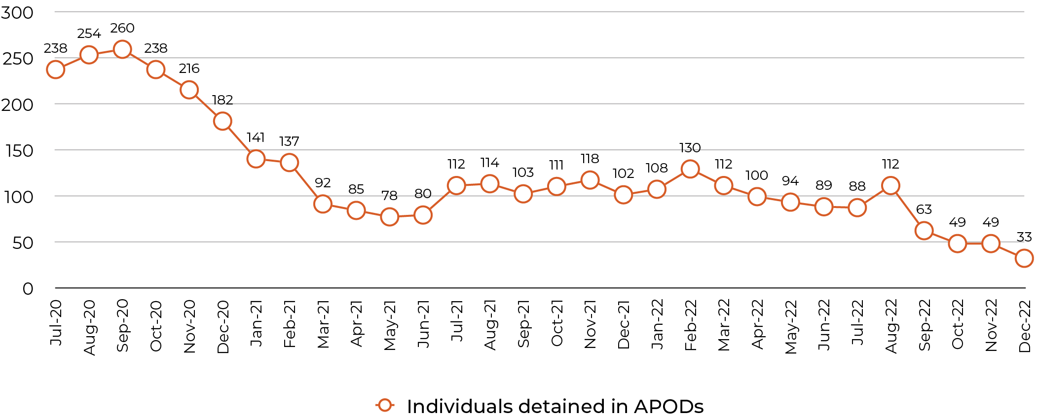
Figure 1: Data taken from Department of Home Affairs, Immigration Detention and Community Statistics Summaries <https://www.homeaffairs.gov.au/research-and-statistics/statistics/visa-statistics/live/immigration-detention>.
These numbers are a significant reduction when compared to the number of people previously reported as being detained in APODs. For example, it was reported as at 31 July 2013 that there were 2,486 people detained in mainland APODs (including 1,126 children), and a further 2,213 people detained in APODs on Christmas Island and the Cocos (Keeling) Islands (including 688 children).
With respect to transitory persons specifically there were, as at 31 December 2022, 1,122 transitory persons residing temporarily in Australia, including those from the Medevac cohort who remain in Australia. Of these, 8 remained in held detention while the remainder have been released into alternative, community-based arrangements under either a Bridging E visa or residence determination.
The Commission welcomes the fact that a significant number of people being held in hotel APODs were released prior to these inspections occurring, and that the number of people held in hotel APODs has continued to decline since the inspections were completed.
One important trend with respect to the use of hotel APODs has been the shift in the cohort that is primarily held in these facilities. At the time of the Commission’s previous inspections in 2018 and 2019 the majority of those detained were part of the Medevac cohort. The majority of individuals currently detained in hotel APODs are there because they have had their visas cancelled under s 501 of the Migration Act. This raises particular considerations in terms of both risk assessment and also the normalisation of the use of hotel APODs as part of the detention network.

Facility Information
Both the Brisbane APOD and Melbourne APOD are commercial hotels in central locations in Brisbane and Melbourne respectively.
The Brisbane APOD consists of sole occupancy floors within the hotel, with six levels of the hotel being used as the detention facility. The remainder of the facility continued to be used as a hotel, and there was no reason to believe that any guests were aware that the hotel was also being used as an APOD. There was a separate entrance/exit provided through the basement so that the front lobby of the hotel did not need to be used either by staff, or when transporting detainees off-site. A person entering the hotel through the front lobby would be unaware that parts of the hotel were being used as a place of detention.
As noted above, the Melbourne APOD was being used exclusively as a quarantine facility at the time of the Commission’s planned inspection visit. As a result, the Commission was unable to attend the facility in person and conducted interviews instead, with staff at the nearby Melbourne Immigration Transit Accommodation (MITA), in an effort to obtain accurate information about the conditions. Interviews were also conducted at an external location with a number of people who had previously been detained at the Melbourne APOD, and with a range of community service providers who have worked directly with individuals who were detained at the Melbourne APOD.

Key observations and concerns
This inspection report identifies three key areas of concern.
The first is the continued use of hotel APODs for lengthy periods of detention. The Commission has consistently expressed the view that hotel APODs should only be used in exceptional circumstances and for the shortest possible time. The key observations during these inspection visits confirmed the previously expressed view that hotel APODs are not appropriate to be used for lengthy periods of detention, with specific concerns relating to the conditions of detention outlined at [4.2] – [4.5].
The second key area of concern relates to the releases from hotel APODs that occurred from December 2020 onwards. While the Commission welcomes the reduction in the overall numbers of individuals detained in hotel APODs, the role of ministerial discretion and the way in which releases have been conducted have both been identified as areas that would benefit from review and improvement.
The final key area of concern is the provision of post-release support. In particular, the Commission has concerns about the adequacy of post-release arrangements in terms of the support provided through the SRSS, the visa renewal process, and the continuity of medical care post-release.

Length of detention
As at 31 July 2022, the average length of time that individuals had spent detained in hotel APODs was 69 days. The longest continuous period of detention in a hotel APOD was 634 days.
Time spent detained in hotel APODs cannot be considered in isolation, with many individuals – particularly those within the Medevac cohort – having also spent lengthy periods detained in other immigration detention facilities. The average length of time spent in immigration detention in Australia continues to increase, reaching 806 days as at 31 January 2023.

Figure 2: Average length of time for people held in immigration detention facilities in Australia (January 2018 – January 2023)
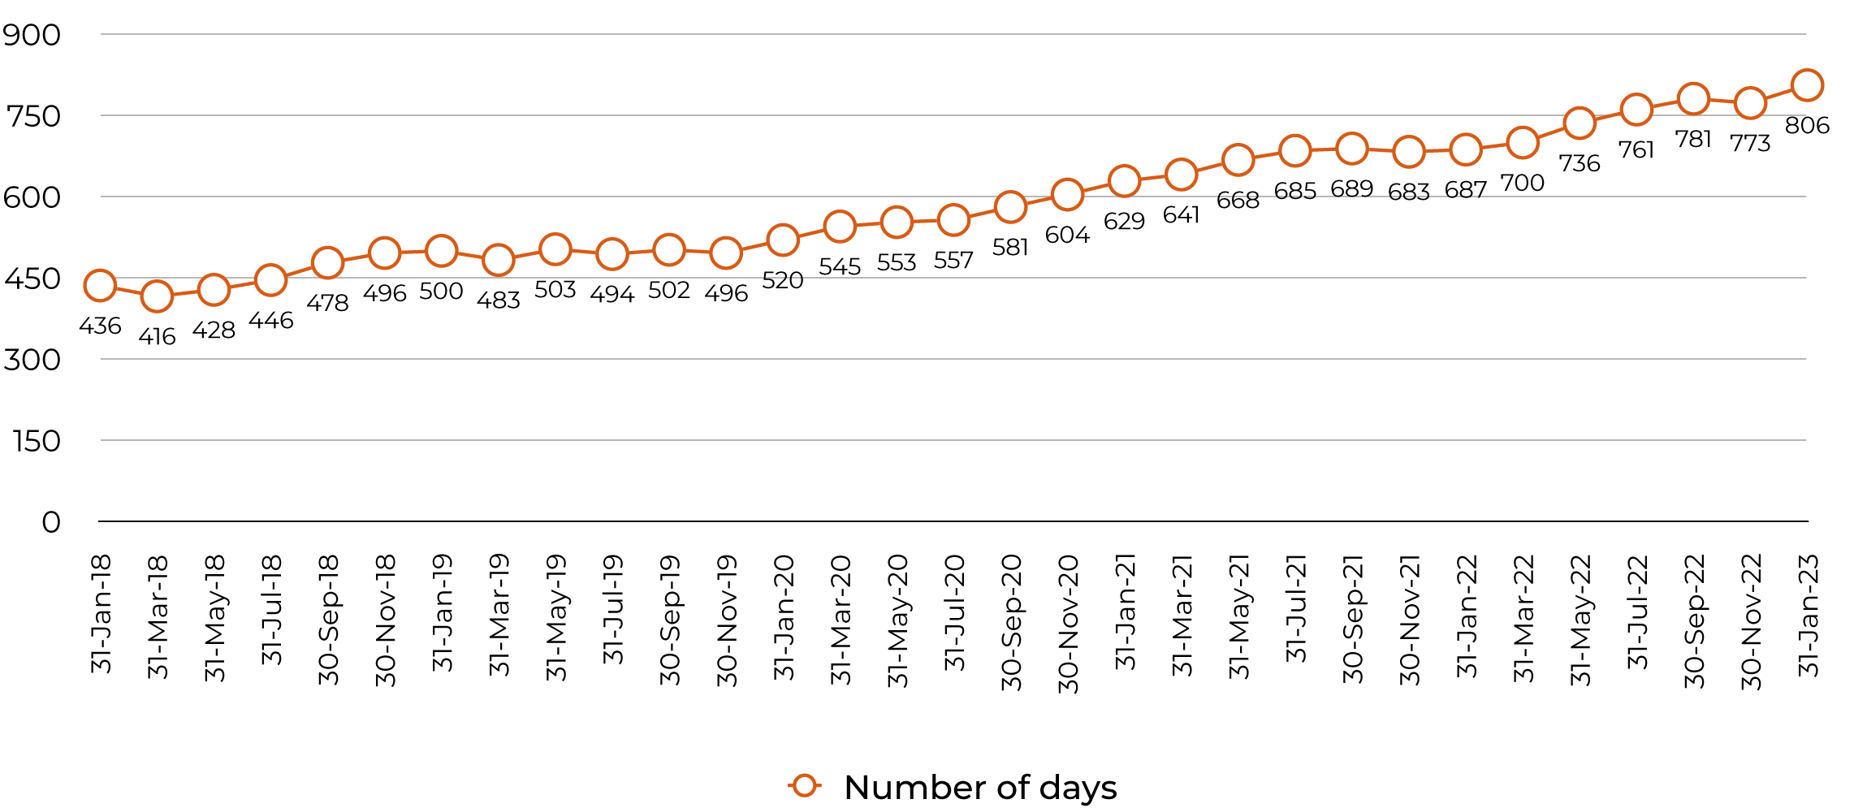
Figure 2: Data taken from Department of Home Affairs, Immigration Detention and Community Statistics Summaries <https://www.homeaffairs.gov.au/research-and-statistics/statistics/visa-statistics/live/immigration-detention>.
The average length of time spent in immigration detention is far higher in Australia than in comparable jurisdictions. For example, in the United Kingdom in 2021, 76% of all detainees had been in immigration detention for fewer than 7 days. In Canada, the average length of detention was 24.1 days between July and September 2021.
While the average length of time spent in immigration detention continues to increase, the average length of time spent in detention within hotel APODs specifically has reduced significantly in recent times. For example, the average length of time that individuals had spent detained in hotel APODs was 322 days as at 31 August 2020, but had reduced to 69 days by 31 July 2022. This reflects a shift in the nature of the individuals being detained, from being predominantly members of the Medevac cohort to now being primarily individuals whose visas have been cancelled on character grounds under s 501 of the Migration Act.
While it is positive that the average time spent in hotel APODs is being reduced, this does not diminish the significant concerns about the excessive lengths of time that individuals are being detained, both in closed immigration detention generally and in hotel APODs specifically.
The observations made by the Commission in previous inspection reports with respect to the negative impacts of prolonged detention continue to be relevant:
Prolonged detention is a risk factor for mental ill-health, as the negative impacts of immigration detention on mental health tend to worsen as the length of detention increases. This is of particular concern in the current context given the consistently high average length of detention in recent years, and the large number of people being held in closed facilities for prolonged periods.
Hotel detention has a serious and significant impact on an individual’s human rights. The Commission has previously observed that ‘almost every human rights problem in closed immigration detention is made worse the longer an individual is detained’. Individuals that were interviewed as part of these inspections consistently stated that the length of time spent in detention, and the continuing uncertainty of their situation, was contributing substantially to a worsening of both their physical and mental health.
For example, one individual detained in a hotel APOD explained:
‘The sole purpose of being here seems to be to torture. To be made to suffer like this it is not possible for them to be human, they must be aliens.
Two or three years ago I could think about life outside but now I am not capable of envisaging outside at all. I have no imagination; everything is blurry and now can’t see anything’.
Another simply said ‘I am deeply sad and tired and stay in silence, my heart is full of pain and anxiety. I am shaky and hopeless and don’t know what a normal life is’.
The significant impact of lengthy detention in hotel APODs was reinforced by the community service organisations that engaged with the Commission during the course of these inspections. For example, one organisation that works directly with current and former detainees observed that while many of their clients:
‘have primary traumatic experiences of refugee torture and trauma prior to arrival in Australia, which may be the initial cause of symptoms, it is the secondary trauma caused by the detention environment and related systemic issues that has further exacerbated, perpetuated and prolonged clients’ psychiatric presentations and lack of treatment responsiveness’.
A consistent observation made by community service organisations was that the individuals who had been detained for extended periods in hotel APODs exhibited complex and concerning medical issues, including significant deteriorations in mental health that were observed to occur during that detention. In particular, they emphasised the difference they had observed between the individuals who were part of the initial releases from hotel APODs in 2021 and those released later in 2022, suggesting that many in the latter group had been ‘broken beyond repair’.
Using hotels as alternative places of detention is also not a cost-effective option. The average administered cost per annum of detaining a person in hotel accommodation was estimated by ABF at approximately $471,493 per person in 2019-20. This contrasts to the average costs per annum of the Status Resolution Support Services (SRSS) program (including income support) for a person residing in the community being between $16,652 – $46,490. While a full comparison is not possible based on the costs captured by the ABF, the disparity between these estimates is sufficiently stark to lead to the conclusion that the use of hotel APODs is a comparatively more expensive option than community-based alternatives.
Hotels are intended as short-term accommodation options. They are not designed to be used for lengthy periods of detention, and are not appropriate for this purpose. For this reason, the Commission reiterates its previous conclusion that hotel APODs should only be used in exceptional circumstances and for the shortest possible time. They should not be used as long-term places of detention under any circumstances.
In drawing this conclusion, the Commission acknowledges the challenges involved with finding appropriate low-security accommodation for the significant number of vulnerable people who were transferred to Australia at short notice as part of the Medevac cohort, as well as the significant impact of the COVID-19 pandemic. The use of hotel APODs in Brisbane and Melbourne may have originally been intended as a short-term measure, and it would not have been known initially how long people would be detained at these locations.
However, while these challenges are recognised, they do not detract from the conclusion that hotel APODs are not suitable for use as places of detention for lengthy periods of time. Hotels should only be used as Alternative Places of Detention in exceptional circumstances and for the shortest possible time.

Recommendation 1:
The Department should ensure that hotels are only used as Alternative Places of Detention in exceptional circumstances and for the shortest possible time.

Physical conditions of detention

Accommodation
While the structure and layout of each hotel APOD facility is different, the key similarity is that they are functioning hotels. This is reflected in the physical conditions of the accommodation itself, which were reasonable in the facilities that were inspected.
Indeed, the Brisbane APOD continues to function simultaneously as a hotel that is open to the public, with only specific floors being used for the purposes of detention. At the time of writing, a standard one-bedroom apartment at the Brisbane APOD could be booked online from approximately $160 per night.
The particular challenges posed by dual-use facilities was highlighted by the fire that occurred at the Melbourne APOD on 23 December 2021, which caused significant damage to the property. Individuals who were detained at the Melbourne APOD at the time described how everybody else (including hotel staff and travellers returning to Australia who were subject to COVID-19 pandemic-related hotel quarantine) was evacuated from the hotel, but detainees were only evacuated to Level 1 and were not escorted from the building itself. This was despite it being reported that a number of detainees were asthmatic, and that one detainee subsequently ended up being hospitalised for smoke inhalation.
The Commonwealth Ombudsman has previously observed following a visit to the Melbourne APOD that ‘knowledge of correct emergency evacuation procedures was lacking’. The Commission concurs in the recommendation made by the Commonwealth Ombudsman that the Department ‘should ensure appropriate emergency management procedures are in place and should regularly test and review them to ensure they remain fit for purpose’. The Department agreed with this recommendation, and confirmed that each immigration detention facility has an Emergency Management Committee to ensure that emergency management procedures are in place.
Given the particular challenges posed by hotel APODs that often function as dual-use facilities, it would be appropriate for the Department to review emergency management procedures for each hotel APOD to ensure that appropriate procedures are in place.

Recommendation 2:
The Department should review emergency management procedures for each hotel APOD to ensure appropriate procedures are in place.

The accommodation at the Brisbane APOD included both one and two-bedroom apartments, each with a single private bathroom (containing a toilet and shower), kitchenette and laundry. The two-person apartments also contained a separate lounge area. Each apartment included a television, high speed internet and air conditioning. None of the rooms had accessible balconies.
The apartments that were viewed during the inspection were unoccupied and had been fully cleaned, but were identical in lay-out and facilities to the apartments being used for detainees at the Brisbane APOD.

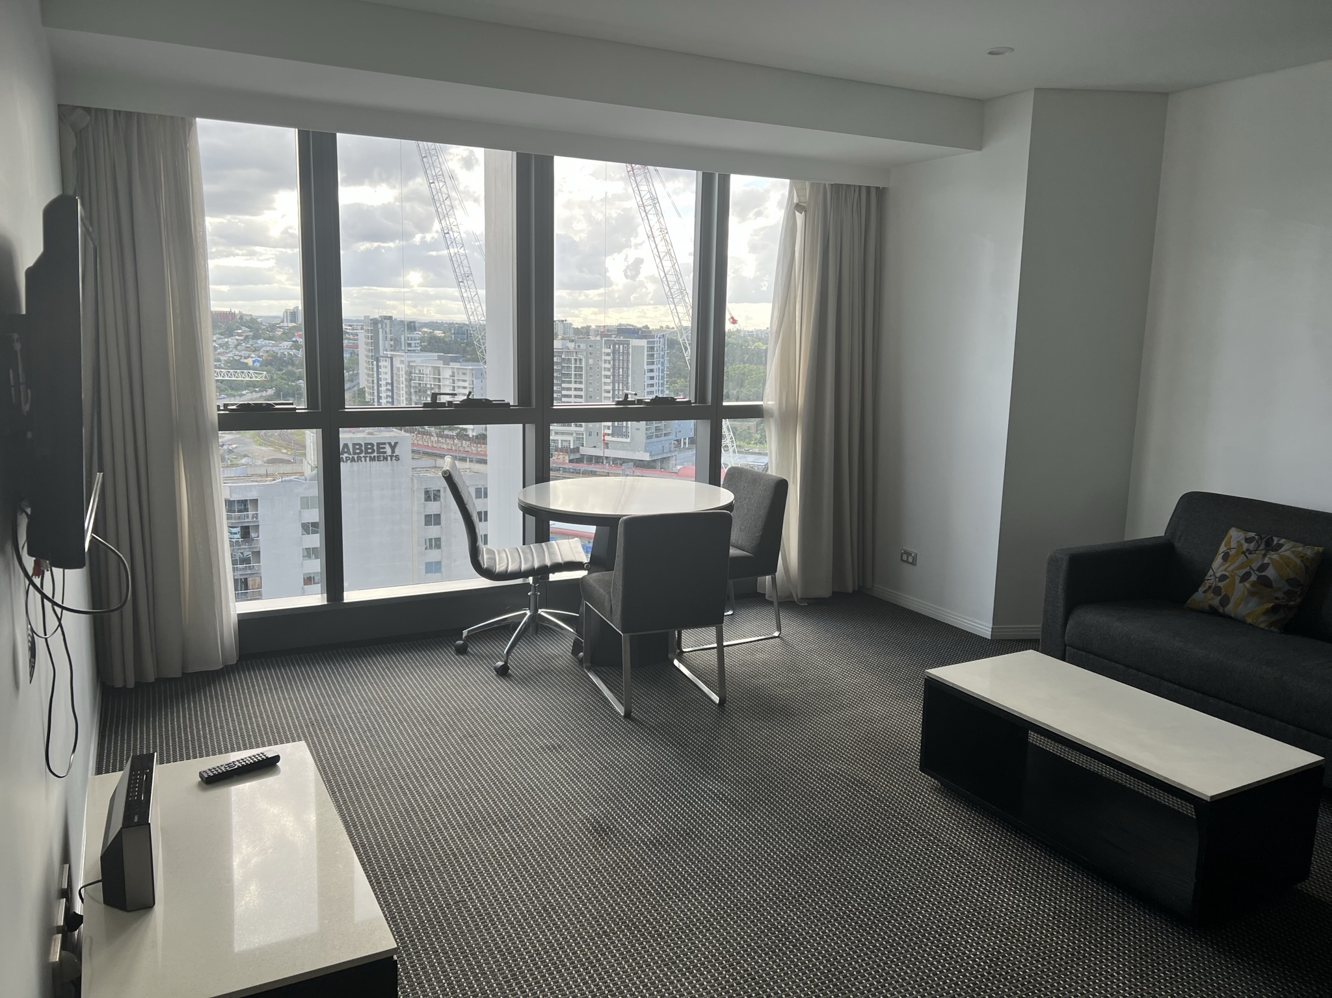

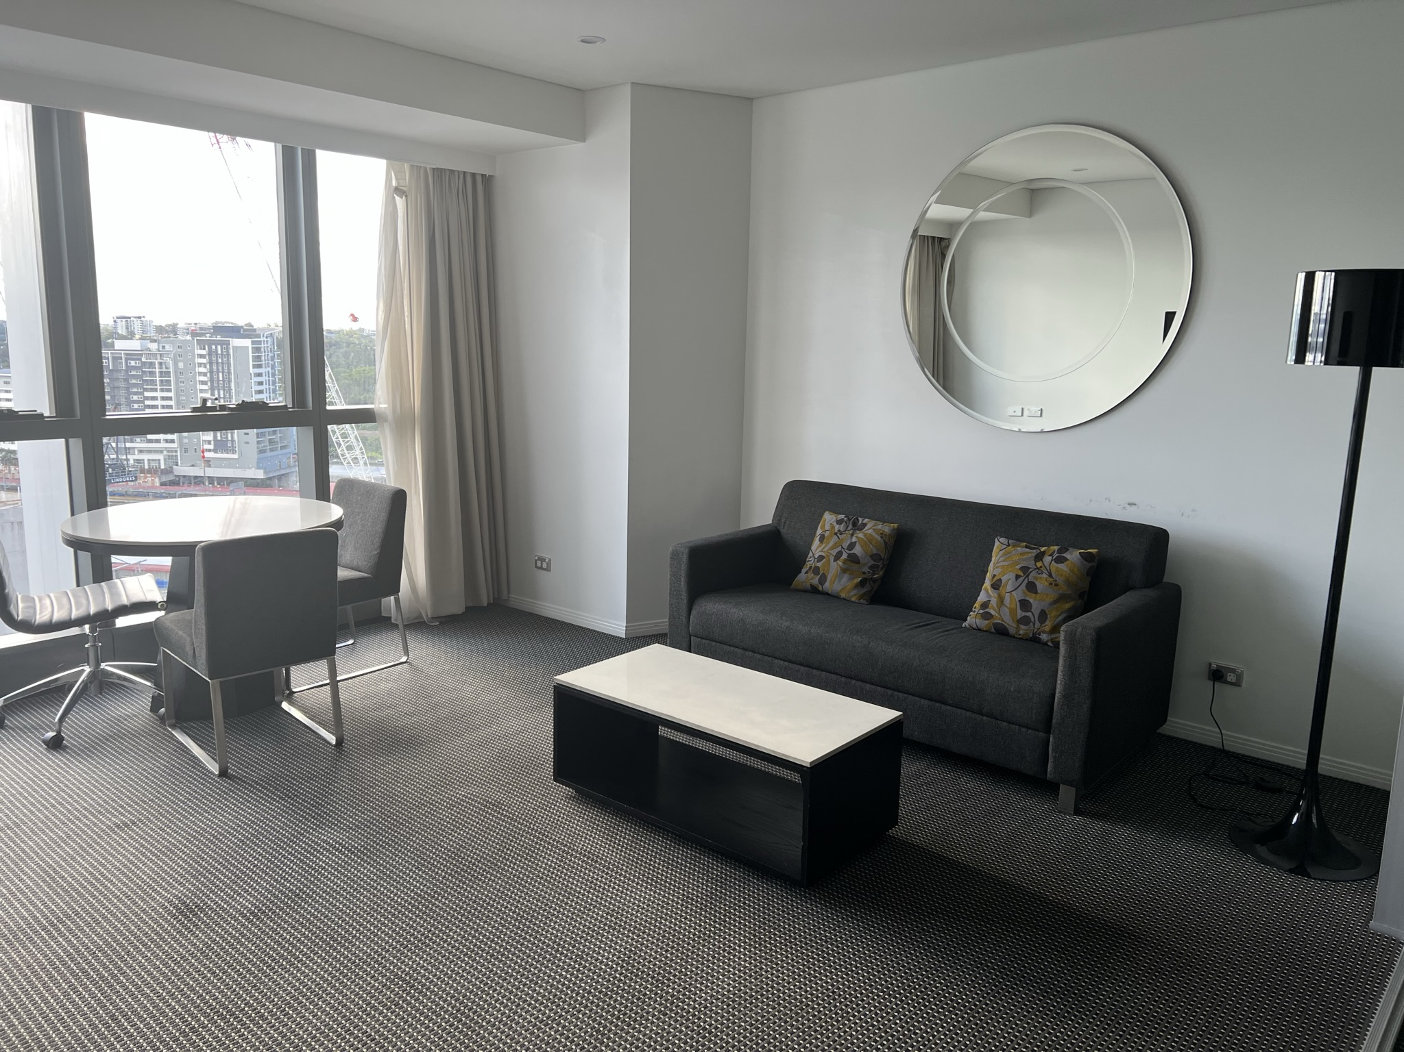
Living area in two-bedroom apartment, Brisbane APOD.
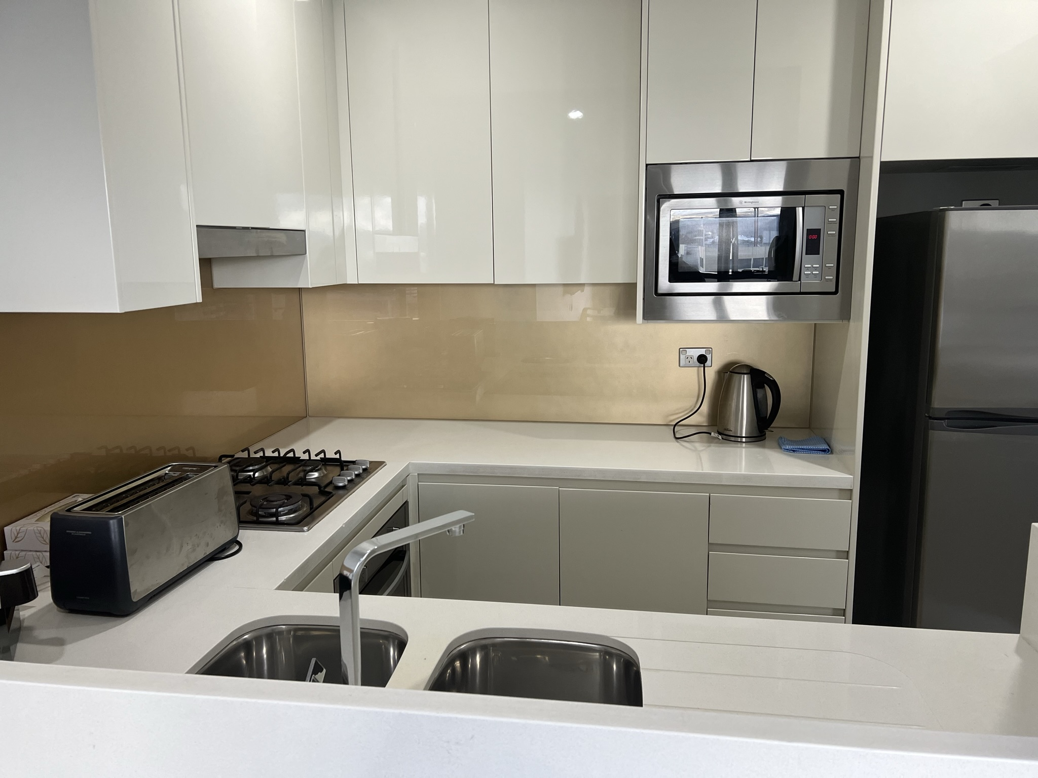
Kitchen area in two-bedroom apartment, Brisbane APOD.
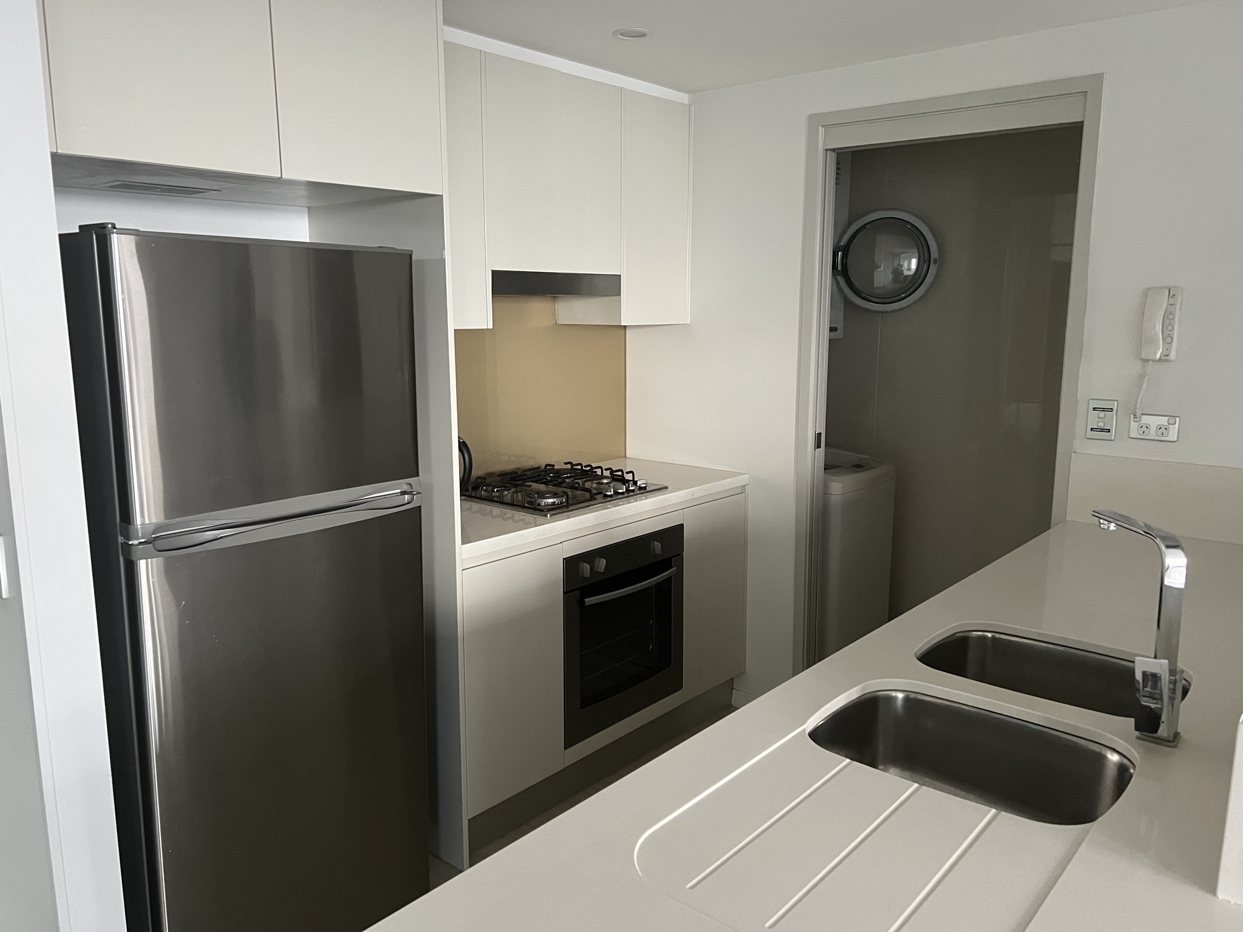
Kitchen & laundry in one-bedroom apartment, Brisbane APOD.

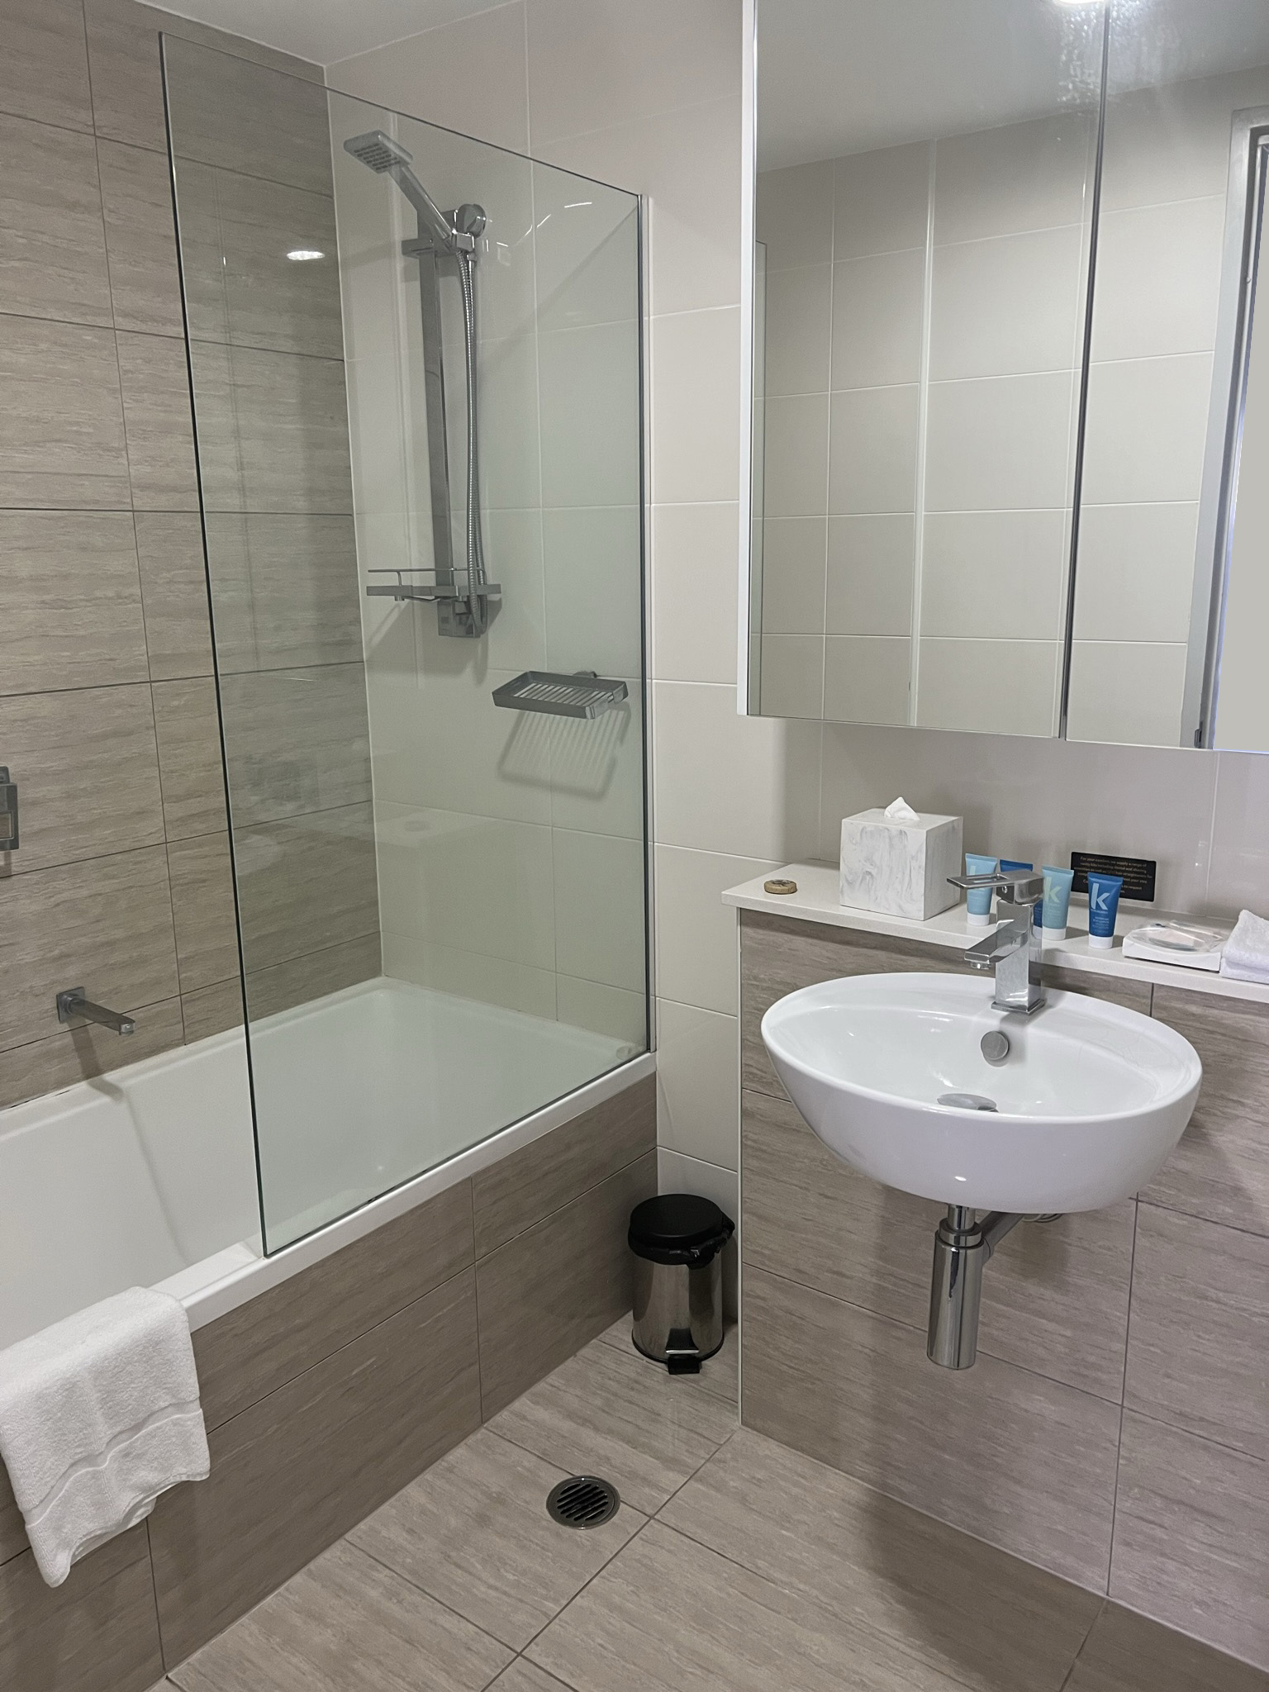
Bathroom in two-bedroom apartment, Brisbane APOD.
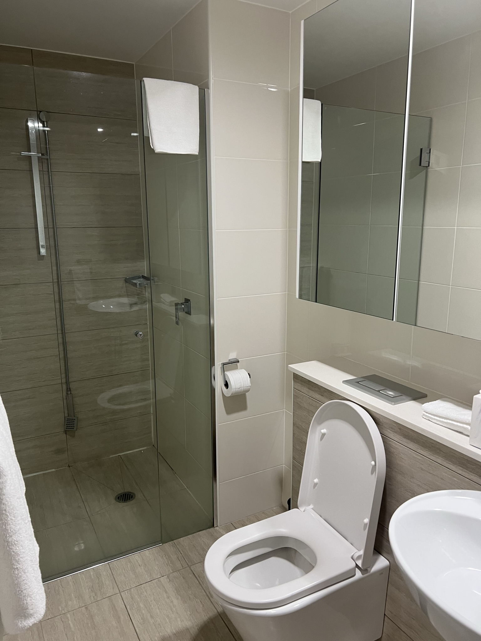
Bathroom in one-bedroom apartment, Brisbane APOD.
While some individuals were accommodated in their own apartments, there were others that were required to share accommodation. This included, at times, shared accommodation being provided in one-bedroom apartments.
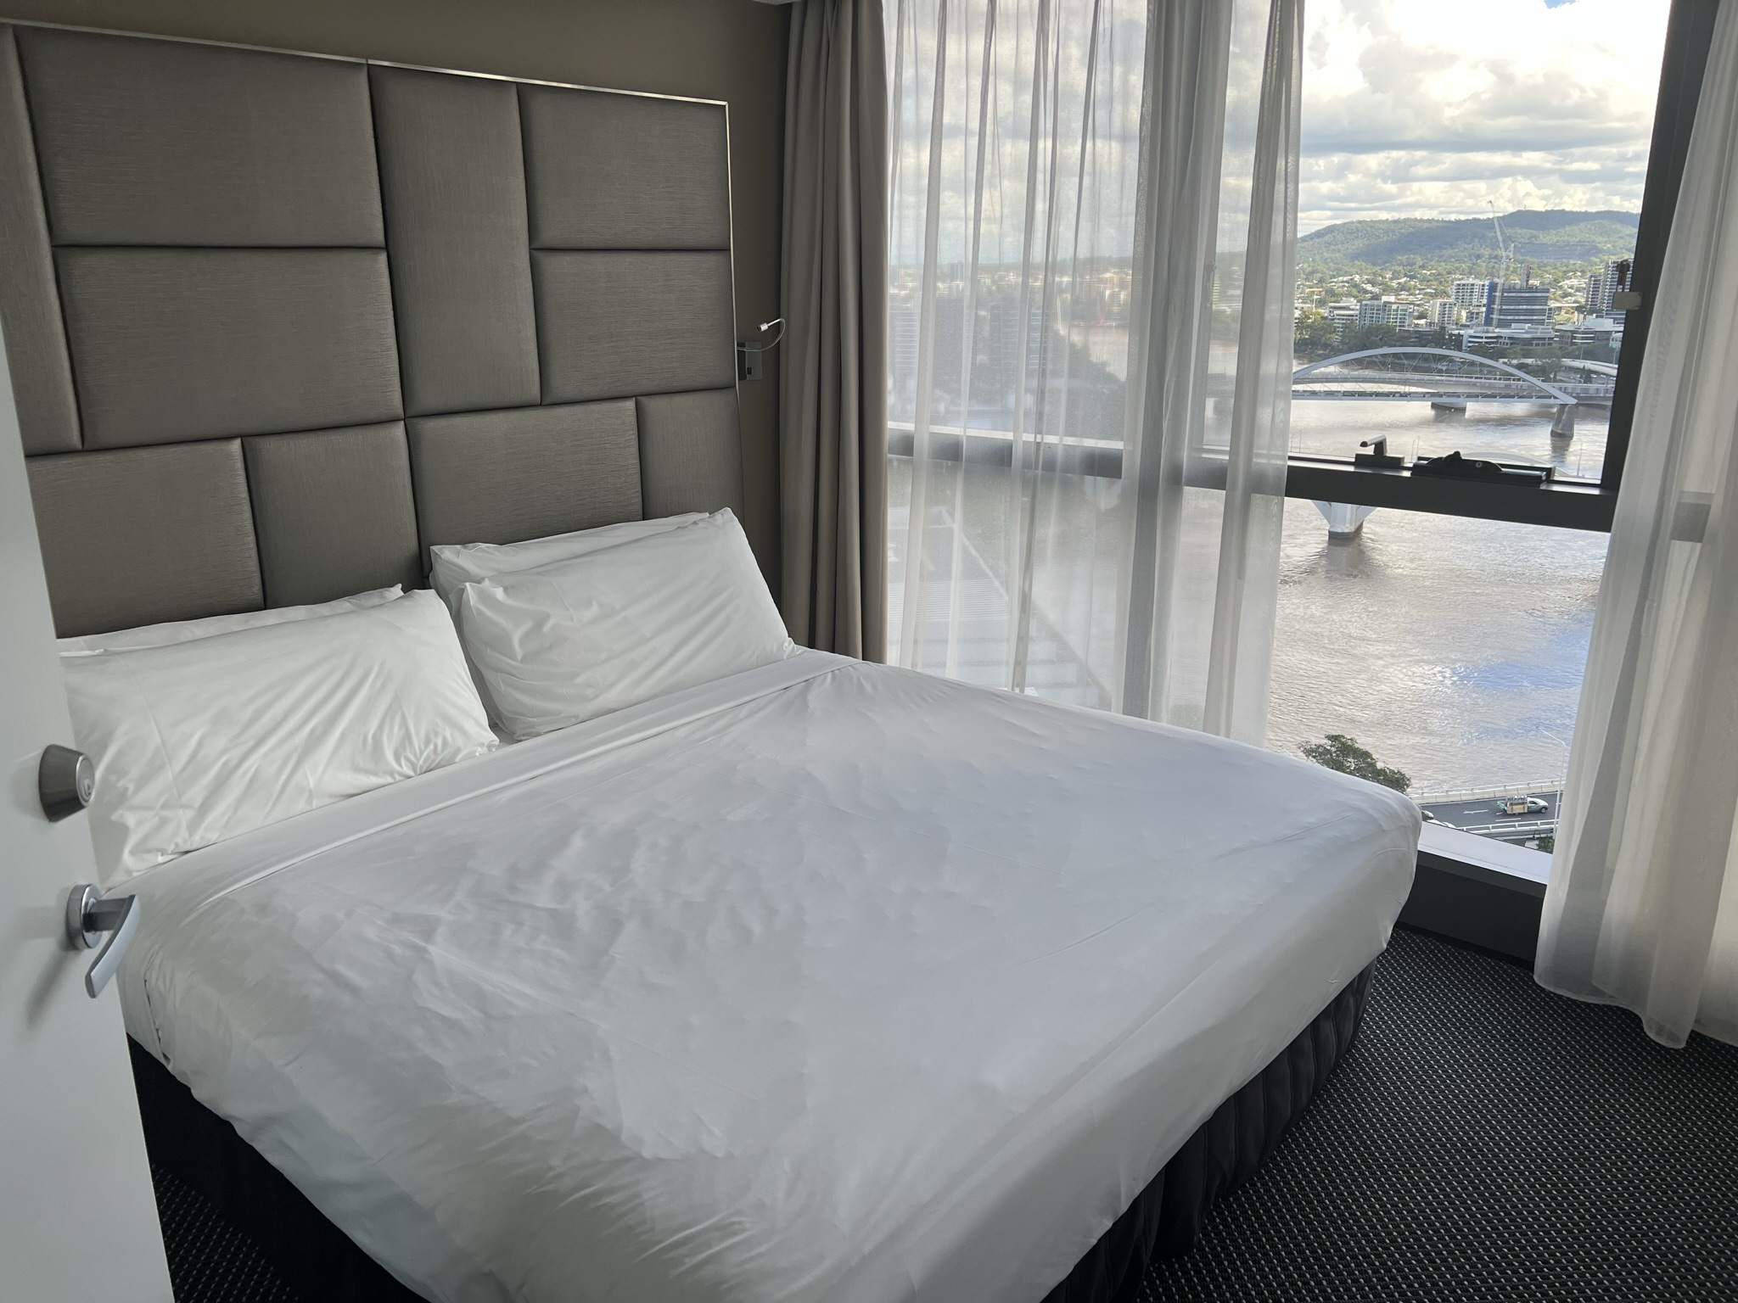
Bedroom in two-bedroom apartment, Brisbane APOD.
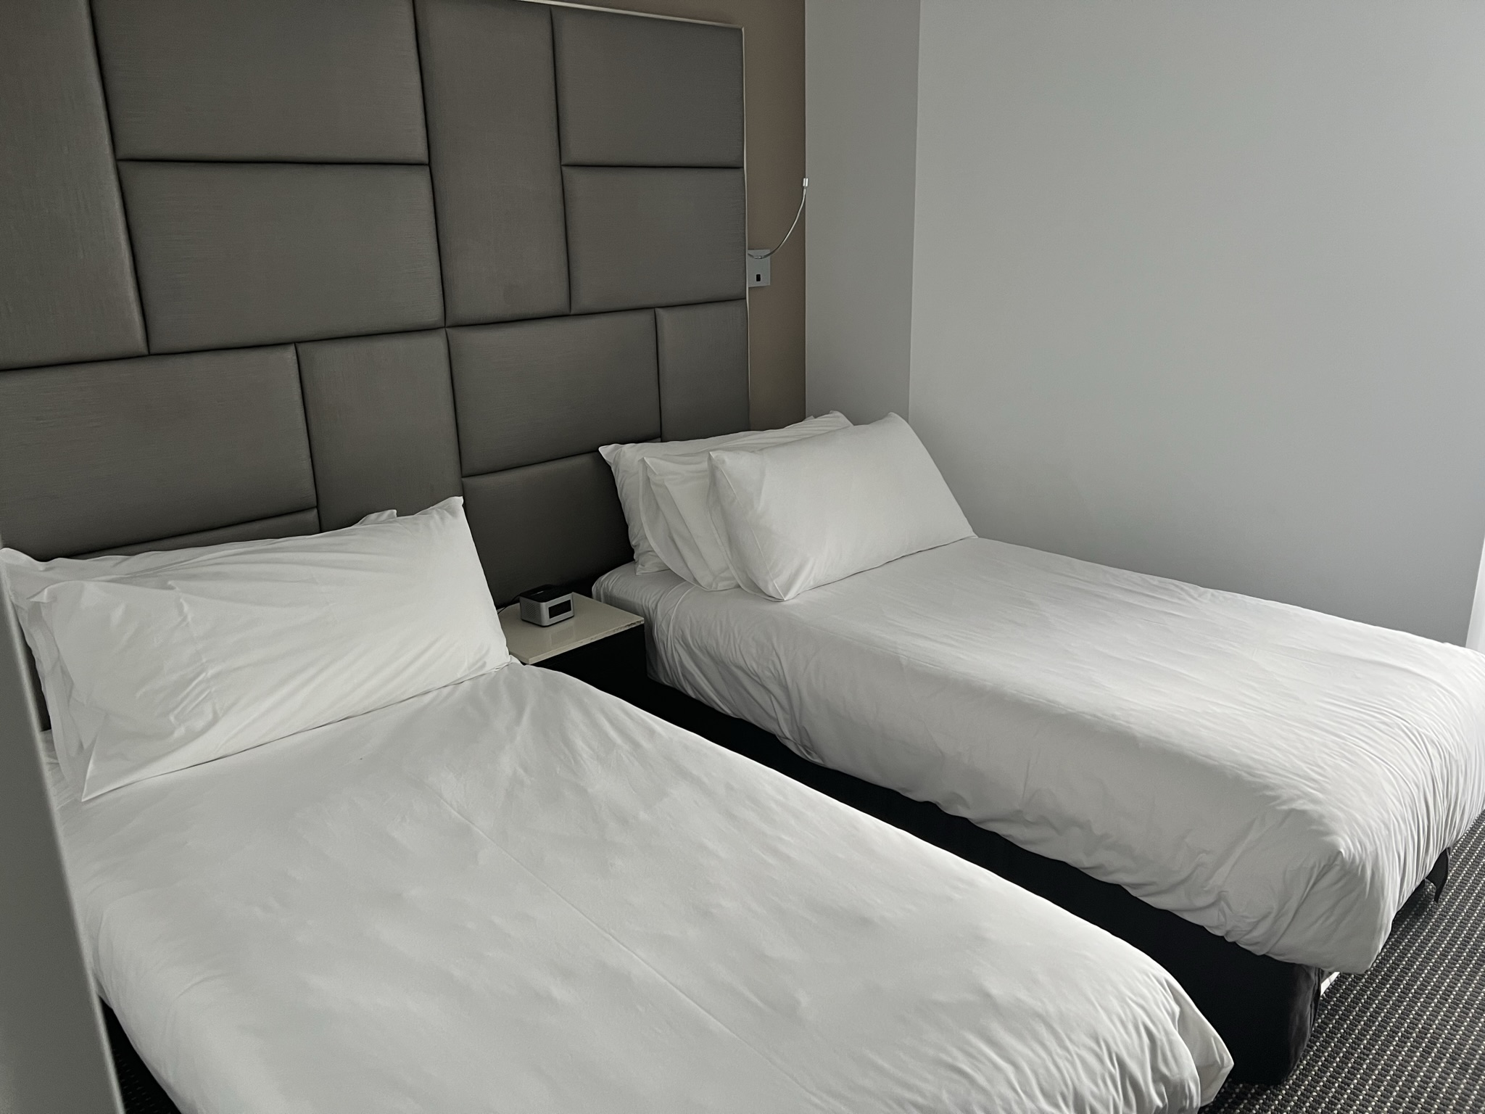
Bedroom in one-bedroom apartment, Brisbane APOD.
Some individuals commented that being detained at the hotel APODs was preferable to being at either the Brisbane Immigration Transit Accommodation (BITA) or Melbourne Immigration Transit Accommodation (MITA) as they were more likely to have single occupancy rooms, be separated from people who had violent or criminal records (with a number saying that they felt safer in the hotel APODs) and were able to tell relatives that they were staying in a ‘hotel’ rather than a detention facility which reduced their humiliation and anxiety.
At the same time, detainees described how they were largely confined to their rooms, with social isolation and entrenched loneliness being significant problems. People who were required to share a room also reported having no choice of whom they shared accommodation with and a distressing lack of privacy.
Most of the individuals interviewed by the Commission reported that they were satisfied with the physical condition of the accommodation at the hotel APODs. There were, however, some reports of the cleaning of rooms being problematic, with basic cleaning equipment sometimes being denied. Examples given included laundry powder not being available at various points, and shared nail clippers being provided that had not been properly cleaned.
Individuals reported that when they were first placed in the Melbourne APOD, they were unable to open the windows in their rooms, meaning that they had no access to fresh air when they were in their rooms. The lack of fresh air in the rooms was a significant issue, particularly given that individuals described being confined to their rooms for the overwhelming majority of the time. This appears to have now been somewhat addressed, as the windows could be opened to a limited extent in all of the rooms the Commission inspected at the Brisbane APOD. However, the fact that windows could only be opened to a limited extent highlights the importance of ensuring that individuals be given the opportunity to spend time either outdoors or in spaces with better access to fresh air.

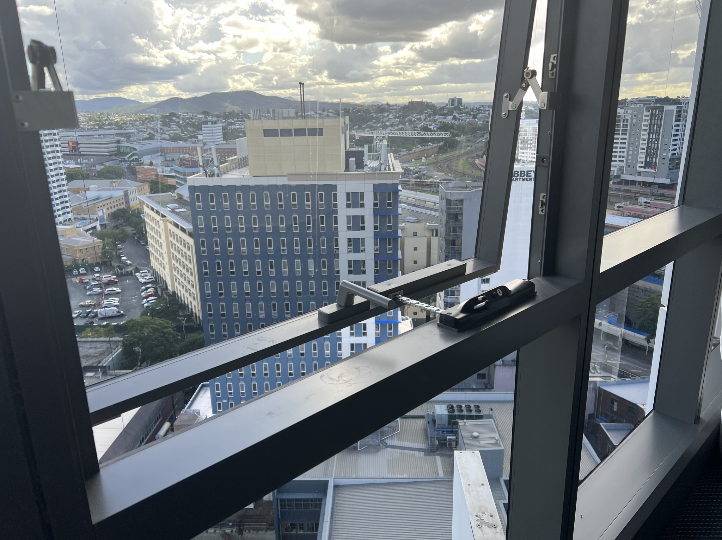
Window opened to maximum extent at Brisbane APOD.
The importance of having access to fresh air has also been recognised in the context of individuals required to undertake hotel quarantine during the COVID-19 pandemic. For example, the NSW Ombudsman received 73 complaints and inquiries relating to a lack of access to fresh air and exercise from 30 March 2020 to 31 January 2021, while the Queensland Human Rights Commission found that people in hotel quarantine had a right to daily access to fresh air. The Definition of Good Practice developed as part of the National Review of Hotel Quarantine states that access to open spaces and fresh air should be enabled.

Recommendation 3:
Individuals detained in hotel APODs must be able to access fresh air in any rooms where they are required to reside.

The location of hotel APODs in close proximity to other people and activities was something that was described by detainees in both positive and negative terms. Some commented that being so close to the world gave them hope, and particularly that being able to see and hear people in the street protesting against their detention made them feel as though they had support. Others said that it made things more difficult, as being able to see people moving about freely in the streets highlighted their own confinement.
One detainee told us that ‘It’s a tease, mocking you because you’re so close to everything’. Another explained that being able to see people moving about freely in the streets made things more difficult:
‘I can see through a window people getting on with their lives. Doing what normal people do. For me, I have had this taken away for nine years without any reason. What crime have I committed?’

Shared facilities and outdoor space
While the individual accommodation areas at the hotel APODs are generally more spacious than those at other immigration detention facilities, the shared facilities and outdoor spaces are significantly more limited. These limitations were exacerbated by additional restrictions being imposed during the COVID-19 pandemic, as discussed further below.
For example, detainees at the Brisbane APOD have minimal access to shared facilities and outdoor space. Most detainees described being confined to their rooms for the majority of the day, with one individual stating that he had not been outdoors at any point during his five months of detention in the hotel APOD. While detainees were allowed to visit each other’s rooms in accordance with a pre-arranged ‘buddy system’, this was limited to one nominated ‘buddy’ who was located on the same floor of the hotel.
The only shared facility at the Brisbane APOD was a common room on the women’s floor that could be accessed by female detainees for a scheduled social group that took place for two hours on Monday, Wednesday and Friday afternoons each week. No access to this common room was available at any other times, with a number of individuals expressing frustration at the fact that they were only allowed to access this common room for limited periods and for the purpose of participating in the social group.
There were no other shared facilities at the Brisbane APOD that could be accessed by detainees. There were no shared facilities available to male detainees within the Brisbane APOD at all, and no outdoor space available for any detainees. The Brisbane APOD did not provide any dedicated space within the facility for exercise. While there was a limited supply of gym equipment that could be requested by individuals for use in their rooms, detainees informed us that this was often not available due to demand. The Brisbane APOD did not have any prayer rooms or communal spaces for worship.
To provide detainees with the opportunity to access outdoor space and to exercise outdoors, daily excursions were conducted to BITA. The daily excursion allowed detainees to spend approximately 60 – 90 minutes in a designated outdoor space at BITA, which was used exclusively by the Brisbane APOD detainees during this time. The space itself contained no recreational equipment or other features, with one individual describing it as being ‘just an area where you could walk around a bit and smoke’. Another individual described the space as being ‘the size of half of a basketball court and surrounded by fences’.
Detainees explained that the daily excursions were primarily used by smokers given that there is nowhere within the Brisbane APOD itself where they are allowed to smoke. Given the limits on the number of individuals who could be escorted to BITA at any one time, detainees informed us that they were able to access the external recreation visits to BITA at most twice each week, and that smokers were prioritised for these visits. Those organising the excursions estimated that 20% of individuals at the Brisbane APOD did not engage in these visits, meaning that they did not have any access to outdoor space while detained at the Brisbane APOD.
It appeared that conditions at the Melbourne APOD were initially better, with detainees having access to a common room, outdoor space and a small gym. However, conditions deteriorated significantly following the fire in December 2021 which resulted in the gym being closed and access to the outdoor space being limited to smokers for only a few minutes at a time. Detainees reported that staff did offer to transport them to the gym at MITA on a number of occasions, and there were twice daily visits to MITA to allow access to recreation facilities. However some individuals stated that they were reluctant to return after the first visit ‘as they felt a strong reaction to the wire fences and being in a car with three to four security staff’, and others reported that there was not enough room on the transport vehicle for every detainee to be taken to MITA every day.
Similar concerns have also been reported by the Commonwealth Ombudsman with respect to the Melbourne APOD. The Commonwealth Ombudsman recently concluded that ‘[b]ased on the intended operational capacity at the Melbourne APOD, it is unlikely that all people in detention would have had a genuine opportunity for daily fresh air access and outdoor exercise’.
The lack of access to shared facilities and outdoor space is a significant concern. International human rights standards indicate that people in detention should have access to at least one hour of open-air exercise every day. The human rights standards for immigration detention developed by the Commission emphasise that there should be ‘sufficient opportunities for association with peers and participation in cultural, spiritual and religious activities, including voluntary work in the community, sports, physical exercise and leisure activities and activities in the open air, so as to provide physical and mental stimulation’.
Conditions in the hotel APODs appear to consistently fall short of these minimum standards. The lack of access to sufficient outdoor space and shared facilities for exercise and recreation appears to be key factor contributing to the significant decline in the physical and mental wellbeing of those detained in hotel APODs.
While the provision of daily visits from the hotel APODs to other immigration detention or transit facilities is a welcome attempt to provide some access to outdoor space and exercise, it is insufficient overall. The current arrangements mean that daily access to outdoor space and exercise can – at best – be offered to only a limited number of detainees and cannot be extended to accommodate all detainees. This is yet another reason that hotel APODs are unsuitable as long-term detention options. While they continue to be used, it is essential that further strategies are explored to increase access to shared facilities and outdoor space, and to provide more opportunities for detainees to engage in exercise, recreation and other activities.

Recommendation 4:
The Department should implement strategies to provide greater access to shared facilities and outdoor space for people detained in hotel APODs.

Recommendation 5:
Every individual detained in a hotel APOD should be able to access at least one hour of suitable exercise in the open air every day.

Freedom of movement
Individuals detained at the Brisbane and Melbourne APODs were significantly more restricted in their movements than individuals detained at low security compounds in other immigration detention facilities. This is despite APODs generally (with some exceptions) being considered to be lower-security facilities.
For example, at the Brisbane APOD detainees were not able to move freely within the hotel, being restricted to the same floor as their room, only being able to visit other rooms in accordance with the ‘buddy system’ described above, and not being able to leave their rooms without being escorted by security. This was particularly restrictive for those who did not have access to shared spaces on their hotel floor, which was the case for every single male detainee at the Brisbane APOD at the time of our inspection visit.
Detainees described spending the majority of their time effectively confined to their rooms. Being confined in this way was consistently described by detainees as contributing to isolation, anxiety, loneliness, boredom, and depression.
The Commission has previously acknowledged that restrictions on freedom of movement within immigration detention facilities ‘may be reasonable in some situations if they are necessary to manage risks and are proportionate in the circumstances’. It is not clear that the significant restrictions placed on the movements of detainees in hotel APODs meet this criteria, particularly in light of the extended periods of time that individuals are being detained in hotel APODs.
The restrictions appear to be primarily due to the nature of the facilities, rather than any risk factors particular to the detainees themselves. This further highlights the unsuitability of hotel APODs as long-term detention options.
Recommendation 6:
The Department should implement strategies to provide greater freedom of movement, and to ensure that any restrictions on movement within hotel APODs are both necessary to manage risk and proportionate in the circumstances.

Privacy
A number of detainees commented that they felt they had a greater degree of privacy in hotel APODs as compared with other immigration detention centres. However, others highlighted the continuous presence of security officers in close proximity and frequent checks that were conducted throughout the day and night. Detainees described being regularly woken in the middle of the night as headcounts were performed, and that they ‘feel that anyone can enter their room at any time with no warning. They feel there are no boundaries’.
Staff advised that continuous line of sight monitoring of detainees within hotel rooms only occurred where it was assessed as necessary to ensure the safety of individuals in circumstances where heightened risks of suicide or self-harm were identified. While acknowledging that there may be limited circumstances where continuous monitoring is required to ensure safety and security, the Commission reiterates the recommendation from earlier inspection reports that continuous monitoring should only be used when it is demonstrated to be necessary, reasonable and proportionate in the circumstances.
During the inspection visit to the Brisbane APOD, the Commission observed multiple security officers being stationed on each floor, with the stated intention that no individual would be able to open the front door to their room, or to leave their room, without being observed. Detainees were observed being escorted by staff whenever they left their room.
Detainees stated that the presence of security officers during external medical and counselling appointments could frequently be intimidating and intrusive, as well as undermining the confidence that individuals have in the confidentiality of those appointments. A number of individuals raised concerns with us about privacy during these appointments, particularly with regards to the proximity of security officers.
It is essential that the policies, procedures and practices that inform the operation of hotel APODs respect the privacy of the individuals who are detained. The Commission recommends that all policies, procedures and practices relating to the supervision and monitoring of individuals detained at hotel APODs be reviewed to ensure they are necessary, reasonable and proportionate with regards to respecting the right to privacy.

Recommendation 7:
The Department should review all policies, procedures and practices relating to the supervision and monitoring of detainees at hotel APODs to ensure they are necessary, reasonable and proportionate with regards to respecting the right to privacy.

Communication and visits
Most individuals at the hotel APODs had unrestricted access to personal mobile phones and laptops, had unlimited access to wireless internet, and were able to obtain phone cards using Individual Allowance Program points. There were also tablets and phones available for loan as needed.
One concern that was regularly raised by both detainees and those working with them was the practical barriers that existed with respect to accessing legal advice and other assistance. Detainees described a lack of private spaces within hotel APODs (particularly for those individuals who were required to share rooms) as posing a significant barrier to receiving confidential legal assistance, as well as engaging with other services (including medical or counselling services). Those working with detainees highlighted examples such as there being a lack of facilities to allow for in-person meetings at the APODs, no private spaces for detainees to take telephone calls, and difficulties in obtaining consent forms within appropriate timeframes.
It is the responsibility of the Department of Home Affairs to ensure that every person detained in immigration detention is afforded ‘all reasonable facilities … for obtaining legal advice or taking legal proceedings in relation to his or her immigration detention’. In light of the practical barriers that were consistently raised with the Commission, it is recommended that further strategies be explored to ensure that individuals held in hotel APODs are able to regularly access and engage with the legal assistance and other services they are entitled to.

Recommendation 8:
The Department should implement strategies to ensure that people detained in hotel APODs are able to regularly access and engage with the legal assistance and other services they are entitled to, in a manner that respects the confidentiality of these services.

The Commission’s Human rights standards for immigration detention states that detainees must be able to receive regular visits from family and friends, and that such visits must take place ‘in an appropriate place and in private’. The Commission was advised that visits were stopped in all immigration detention facilities (including hotel APODs) for a period of time during the COVID-19 pandemic. While visits had resumed by the time of the inspection, there were still some additional restrictions that applied in line with guidance provided by national and state health authorities.
The Commission was advised that, at the time of the inspection, all visits for individuals detained at the Brisbane APOD were being conducted at BITA, with some exceptions for scheduled visits by the Queensland Program of Assistance to Survivors of Torture and Trauma (QPASTT) in circumstances assessed to be high-risk. The fact that visits were not able to be regularly facilitated at the hotel APOD itself creates an additional barrier to visits, with detainees being required to undertake transportation to BITA in order to receive any visitors.

Recommendation 9:
Visits should routinely be facilitated at the detention facility in which the detainee is ordinarily held, other than in exceptional circumstances.

The Commission was advised that visits were able to take place between 7am – 9pm each day. Visitors must apply to visit a detainee, with applications required to be lodged no less than five business days in advance for visits by personal visitors, volunteers delivering approved programs and activities, religious or spiritual visitors and health professionals, and no less than one business day in advance for legal representatives or migration agents. These application periods can be waived in limited circumstances, including for emergency or other compassionate reasons.
The Australian Border Force website provides that individuals wishing to lodge an application to visit a detainee can do so either online or through a paper-based application. The online application requires individuals to select the location that they are wishing to visit, but the drop-down menu does not include all of the hotel APODs currently in use amongst the locations that are available to be selected. Instead, the online application advises to select ‘the facility closest to the location of the person in immigration detention’ if they are held in a location that is not listed.
The website advises that a paper-based application can be lodged by contacting the relevant immigration detention facility directly, however the link provided does not include any hotel APODs amongst the immigration detention facilities that are listed.
Finally, the website advises that visiting hours can be obtained by contacting the relevant immigration detention facility, but does not list or provide contact details for any hotel APOD among the locations that are listed. This makes applying to visit an individual detained in a hotel APOD or even determining the visiting hours of a hotel APOD more difficult than for other immigration detention facilities.
While it is accepted that there may be operational reasons for the locations of hotel APODs not being listed in the same way as permanent immigration detention facilities, this should not result in it being any more difficult for visits to be facilitated. One way to address this would be to provide a central telephone and email contact point for all hotel APODs, in much the same way as telephone and email contact points are provided for each individual permanent detention facility. This would provide a central contact point allowing visitors to obtain information about visiting hours and other conditions of entry, and to lodge applications to visit at hotel APODs.

Recommendation 10:
The Department should establish a central contact point for all hotel APODs (including telephone and email details) to assist in facilitating visits.

Food
Concerns about the quality of the food provided at the hotel APODs have been raised in previous inspection reports, as well as in media reports that have raised allegations of food being served containing maggots and mould. These issues have also been highlighted by the Commonwealth Ombudsman, who confirmed that there had been an incident of maggots being found in the dinner of a person detained at the Melbourne APOD. The Commonwealth Ombudsman further reported that ‘[d]uring our discussions with the Serco staff who were working at the time of the incident, it was clear there was insufficient appreciation of the significance of the contaminated food, and how important it is for people in detention to have confidence in the quality and safety of food provided’.
Staff at the hotel APODs described positive efforts to provide detainees with a range of foods and to improve the quality of the meals provided. All individuals held at the Brisbane APOD had access to kitchen facilities in their rooms, and had access to a range of breakfast and staple food items that could be stored in their rooms and used at any time. Both lunch and dinner meals were delivered to rooms in the morning, with individuals given a weekly menu to select from and dietary requirements being accommodated.
While recognising these efforts, the Commission also received further reports of mouldy and unappetising food during these inspection visits. It is a minimum requirement that each detainee be provided with sufficient food of nutritional value and quality adequate for health and strength.

The use of restraints
Previous inspection reports have made recommendations about the use of restraints (including handcuffs) on people when they are escorted outside of detention facilities. This might include individuals being transferred between immigration detention facilities or taken to external medical appointments.
This issue was again raised with the Commission during these inspections, with some detainees having refused to attend external medical appointments after being informed that restraints would be used. There were also reports of inconsistency in the use of force, with a number of individuals stating that they had been required to wear restraints on some occasions when being transferred to medical appointments but not on others. They informed us that they were not clear on the reasons for these different approaches, and that when they asked they were only told that the Department ‘reviews this from time to time’.
The relevant Procedural Instruction governing the use of force within the immigration detention network provides, inter alia, that there is a presumption against the use of force, that restraints should only be used as a measure of last resort, and that restraints may only used for the shortest amount of time possible to the extent that it is both lawful and reasonably necessary. Any planned use of restraints requires approval by the ABF Detention Superintendent (Facility) and requires an independent risk analysis to be conducted, which includes consultation with IHMS to ensure that there are no medical reasons precluding the use of restraints against an individual detainee.
While it is recognised that there may be a legitimate need to use physical restraints in certain circumstances, it is also important to acknowledge that the use of restraints on detainees may risk exacerbating some medical conditions (particularly mental health issues) and is particularly problematic with respect to individuals who have previously been victims of torture and trauma.
One factor that does not routinely form part of the existing risk assessment is the impact that not being escorted outside of the detention facility may have on the health or wellbeing of the individual detainee. For example, non-attendance at a medical appointment or not being able to be escorted to another detention facility to use the outdoor spaces may negatively impact upon an individual’s physical or mental health.
The Procedural Instruction does potentially allow for this factor to be considered in that it requires that any use of force ‘must always be reasonable and officers must consider the individual circumstances of any detainee against whom force and/or restraints need to used’. However, it would be preferable for this to be a mandatory factor to be addressed by IHMS in the written advice that they provide as part of the approval request for any planned use of force.

Recommendation 11:
The Procedural Instruction relating to the use of force should be amended to require that the impact that not being escorted outside of the detention facility may have on the health or wellbeing of the individual detainee be considered as a mandatory factor in the risk analysis prepared when seeking approval for a planned use of force.

Programs and activities
Consistent with previous inspections, facility staff continued to report challenges in providing programs and activities to people in immigration detention which were sufficiently meaningful to prevent boredom and to provide structure and routine. These challenges are exacerbated in the hotel APODs due to the inadequate facilities and lack of access to outdoor space.
The Commission saw examples during the inspections of committed activities officers who were present on a daily basis at the hotel APODs, and who were able to provide a limited selection of creative materials such as books, games, and art supplies. There was some access to non-English language selections, however this was extremely limited.
A regular comment that was made by those who had been held in both hotel APODs and other immigration detention facilities was that the availability of programs and activities was significantly worse in the hotel APODs. Similarly, a number of individuals who had previously served sentences of imprisonment in adult correctional facilities commented that they had access to a wider range of programs and activities in prison than they had in the hotel APODs.
In particular, there is a lack of opportunities for education and training for detainees in hotel APODs, with facility staff informing the Commission that it remains departmental policy that people detained in immigration detention centres are not allowed to access programs and activities that lead to a qualification or certification. One individual confirmed that they had to give up their enrolment in a TAFE course when they were released from prison and transferred into a hotel APOD.
People held in hotel APODs appear to be significantly more restricted in the range of programs and activities that they are able to access when compared to people held in other immigration detention facilities, or those detained in adult correctional facilities.
One individual stated that ‘in jail, I had jobs to do and a routine. There’s none of that in here. In here I have nothing to do. I would rather be in jail’. Others commented that they ‘just sit in a room and do nothing everyday’, ‘[t]here is nothing to get up to look forward to’ and ‘how can I better myself when I’m just locked up?’.
Another individual stated: ‘I have no energy in my body, there is too much thinking. I am in a room alone all the time with no plan for the day, no activities to do. I don’t see anyone or have conversations with anyone and constantly am thinking about life and what sort of life I am having, over eight years in detention and my loss of freedom. Always I think about these sad, negative things’.
The lack of access to meaningful programs and activities in hotel APODs has a range of detrimental effects. These include contributing to the deterioration in the mental health of detainees, and fuelling boredom, frustration and apathy. These impacts are worsened by the length of time that some people are being detained in hotel APODs. The inability to access recognised programs of study and vocational training while in detention also makes it harder for individuals to subsequently integrate into the community if they are released from detention into the community.
The Commission has previously recommended that the Department of Home Affairs should revise its programs and activities policy to give people in immigration detention access to recognised programs of study and vocational training. The Department has previously stated that it disagrees with this recommendation. For the reasons outlined above, we would reiterate this recommendation and, in particular, highlight the longer-term benefits to the Australian community of ensuring that people released from detention have strong prospects of successfully integrating into the community.

Recommendation 12:
People held in hotel APODs should have regular access to the equivalent range of programs and activities as people held in other immigration detention facilities.

Recommendation 13:
The Department should revise its programs and activities policy to give people in immigration detention (including hotel APODs) access to recognised programs of study and vocational training.

Health care
Repeated studies have highlighted the damaging impact that lengthy periods of detention have on an individual’s physical and mental health, with the severity of these impacts increasing the longer the period of detention.
When assessing the health care services available in hotel APODs it is also important to recognise the background context, with many of the people detained for the longest periods in the Brisbane and Melbourne APODs being part of the Medevac cohort. This is a cohort who were transferred to Australia from offshore processing centres specifically to allow them to receive assessment and treatment for known medical conditions. Individuals within this group reported complex, and often worsening, physical and mental health issues and described significant delays in receiving treatment. It is not unreasonable to expect that the reason for their transfer to Australia should have informed the level of health care services available at the hotel APODs.
The following observation previously made by the Commission with respect to this particular cohort continues to be relevant in this context:
It is of significant concern that many refugees and asylum seekers transferred to Australia for the specific purpose of medical treatment and/or assessment have not received the health care they require in a timely manner. In the Commission’s view, the health needs of this group differ significantly from those of people in the Australian community, and those of other groups of people in immigration detention. As outlined above, they were transferred to Australia for medical reasons, and many waited long periods in Nauru and PNG for proper assessment and treatment of their health conditions prior to their transfer to Australia.
During the Commission’s inspections there were clear examples of individuals and teams who were striving to provide high quality health care services. However, there was also concerning evidence of suboptimal practices, and as outlined below a number of particular concerns about the health care services provided to those detained in hotel APODs.

IHMS health services
IHMS is contracted by the Department Home Affairs to provide primary and mental health care services in Australia’s immigration detention facilities, including hotel APODs. As outlined in previous inspection reports, the IHMS health service in each facility is ‘nurse-led’; nurses triage all requests for health care; all appointments are initially made with a nurse; nurses undertake detailed health assessments, planning of health care, delivery of treatments, ongoing monitoring of treatment and management of medicines; and the service is led by managers and team leaders who are also nurses. This is also the case with respect to the IHMS health service provided in hotel APODs.
The IHMS health services in both the Brisbane APOD and Melbourne APOD provided for on-site nurse-led care from Monday to Friday with, for example, a registered nurse being present at the Brisbane APOD from 7am – 7pm on these days. A general practitioner and mental health nurse were both available on-site 2-3 days per week, with a psychiatrist available as needed. Outside the on-site operating hours of the IHMS health service, Serco staff at both facilities could call the Health Advice Service (a nurse-led phone advice service) if required. Facility staff could also request external emergency medical assistance whenever it was required.
All IHMS staff interviewed by the Commission considered that they had an appropriate level of autonomy in treating patients, and that any recommendations they made in relation to a person’s health were generally respected and facilitated by the ABF and Serco staff. A number of individual detainees at the hotel APODs gave positive feedback with regards to the IHMS staff, although others remarked on significant differences in procedures and the overall level of care depending on the individual staff member.
Community health providers who provided medical care to individuals following their release from hotel APODs described a range of common physical issues that they saw in former detainees that appear to have either been caused or exacerbated by the time spent detained in hotel APODs. This included individuals being overweight, having high cholesterol levels, lacking vitamin D, suboptimal type II diabetes mellitus care, and mobility issues. The lack of exercise and access to outdoor spaces, as well as variable food quality, were identified as contributing factors to these health issues.
Community health providers also invariably described the former detainees that they saw as having significant physical and mental health issues, and reported that in a substantial number of cases there were dental or medical issues that required urgent attention. The evidence presented to us suggests that there were significant limitations in the way that medical needs were addressed in hotel APODs.
It was also suggested that some of the unaddressed health issues that were seen in former detainees gave rise to questions about the clinical governance and medical responsibility in the hotel APODs, and were indicative of a lack of urgency when dealing with observed medical issues. For example, following the release of detainees from hotel APODs some community health organisations described ‘urgently arranging dental reviews, optometry, outpatient medical specialist appointments, dietician and physiotherapy appointments for their chronic conditions’ and from the issues they were seeing concluded that ‘[t]here has not been any patient-centred care and little ongoing management of these patients’ chronic medical needs’. Care appeared to be principally reactive to patient identified needs, with the holistic preventative primary care health approach needed for complex and chronic conditions often missing.
A number of specific examples were given to illustrate these concerns, including there being several individuals who had been diagnosed with latent tuberculosis only after being released from hotel APODs. When asked about these particular examples, IHMS staff indicated that all detainees would be screened for tuberculosis as part of a full screening process conducted prior to their transfer to Australia, and that this should have been identified either in this initial screening or in one of the subsequent ongoing assessments that are regularly conducted. The Commission was informed that it would be ‘incredibly rare’ for this not to be identified, and yet it appears that there were at least several examples of this occurring.
A further issue that was commonly raised was the difficulties in accessing care outside of the on-site operating hours. Detainees described designated medical staff as not being available on weekends or outside of business hours, and that this led to significant delays in receiving medical care at those times. A number of individuals stated that they were only ever provided with Panadol after hours, and it was acknowledged by staff that when the IHMS staff were not on site, the security staff were only authorised to distribute Panadol in response to detainee requests.

Access to specialist health care
When people in detention require specialist health care that cannot be provided by the IHMS health service – such as dental, optometry or physiotherapy – IHMS will either contract external providers or make referrals through the public health system. IHMS staff have informed the Commission that they aim to provide a standard of health care in immigration detention that is broadly comparable to that available to the general Australian community through the public health system.
The Commission has previously expressed concern about the length of time that individuals who were part of the Medevac cohort were waiting to access the medical assessments or treatments for which they had originally been transferred. These delays are on top of the long delays already experienced in Nauru and PNG waiting for the proper assessment and treatment of their health conditions prior to being transferred to Australia, noting that we were advised by IHMS staff that the length of time a person has waited for assessment or treatment offshore is not considered in accessing health care through the public health system in Australia. Previous recommendations from the Commission have focused on ensuring that this specific cohort is provided with immediate and expedited access to required health care services.
A number of the individuals released noted that by the time of their release from the hotel APOD they had still not received treatment for the medical issue that had led to them being transferred to Australia in the first place. One individual described himself as having been ‘brought here as a patient but then they put me in jail’.
While the majority of the Medevac cohort have subsequently been released from hotel APODs into the community, the challenges and delays in accessing health care have continued subsequent to their release. This is further discussed below. These continuing delays mean that the recommendations previously made by the Commission remain relevant and are repeated here, noting that the urgency has further increased given that it is now over two years since the recommendations were initially made.

Recommendation 14:
The Department should ensure immediate and expedited access to medical treatment through the public health system for the Medevac cohort to ensure that the medical conditions that led to their being transferred to Australia are appropriately treated.

Recommendation 15:
Where the Medevac cohort cannot access the medical treatment they require through the public health system within a reasonable time, the Department should ensure immediate access to health care through the private health system and provide funding for this.

The length of time that individuals detained in hotel APODs are waiting to access medical services continues to be of significant concern. The delays appear to be particularly significant with respect to dental services, with examples given to the Commission of individuals waiting over six months for a dental appointment, and a number of individuals indicating that the delays had left them experiencing significant pain and affecting their ability to eat. Individuals reported that they had difficulty in managing their symptoms while waiting for treatment, and some described the delays as contributing to a worsening of those symptoms.
The Commonwealth Ombudsman has similarly identified IHMS staff having trouble procuring dental care for people in detention who require significant treatment as being ‘a recurring theme’.
It is acknowledged that there can be lengthy waiting times under the public health system for the general Australian public. IHMS staff advised that waiting times were equivalent to those experienced in the Australian community by those seeking similar treatment through the public health system. These delays have been exacerbated by the ongoing impact of the COVID-19 pandemic, and it was advised that this similarly reflects increased waiting times being experienced by the broader Australian community.
An additional factor in the case of individuals detained in immigration detention facilities (including hotel APODs) has been the impact of operational quarantine during the COVID-19 pandemic, where detainees returning from an external appointment were often required to undertake a period of quarantine. The specific quarantine requirements varied across facilities and at different periods. As an example, the Commission was advised that in early 2022 individuals detained at BITA were required, as a matter of course, to undertake seven days operational quarantine upon returning from an external appointment. Reduced operational quarantine periods had been approved in limited cases where the medical appointment was considered critical, and the detainees were willing to adopt additional precautionary measures to reduce the risk (such as wearing masks and undertaking rapid antigen tests).
At the time of the inspection of the Brisbane APOD, the Commission was advised by staff that detainees returning from off-site medical appointments were required to quarantine for between 5 – 7 days, although exemptions from this requirement could be requested. The Commission was informed that the majority of individuals attending off-site medical appointments had been exempted over the past few months, however there were no figures available to quantify this. There appeared to be some confusion about these requirements amongst detainees, with at least one individual informing us that they had been told they would be required to quarantine if they attended an external medical appointment, but that they were not told they could request an exemption.
The Commission does not know how many individuals have been subject to operational quarantine, either at hotel APODs specifically or immigration detention facilities more broadly. A number of individuals detained at hotel APODs confirmed with us that they had refused to attend external appointments because they did not want to be required to quarantine, which then exacerbated the delays in being able to access medical treatment. These individuals did not appear to be aware of any level of discretion being available with respect to the application of operational quarantine.

Many of the community service organisations that we spoke to reinforced this as a significant issue for the detainees they had worked with, with one observing:
For many who already had poor mental health, a week of isolation from the rest of the group was especially harmful and intolerable and hence it is preferable to skip vital external medical appointments rather than be subjected to lengthy quarantine. “ABF said I need another scan at the hospital, but I refuse. I will not go. I will wait. I cannot go to quarantine” one refugee at the Park Hotel said.
A number also expressed frustration when noting that the staff who escorted them to external appointments had continued to work in the hotel APOD facility following their return, while they had been placed in operational quarantine. We were advised that staff accompanying detainees to external appointments were required to comply with additional risk mitigation measures, including wearing personal protective equipment and undertaking rapid antigen testing. It was acknowledged that detainees were not given the option of taking these additional risk mitigation measures as an alternative to quarantine.
While the Commission accepts that operational quarantine will be necessary in some circumstances, quarantine should only be used where medically necessary and where there has been a thorough assessment of the individual risk. The routine application of operational quarantine following external appointments does not appear to have been sufficiently targeted to ensure that it was used only when necessary.

Recommendation 16:
Quarantine should only be used where medically necessary, and where there has been an individual assessment of risk. The application of reasonable risk mitigation measures as an alternative should always be considered as part of the risk assessment process.

Mental health care
The Commission has consistently raised concerns about the need to improve mental health care availability in immigration detention centres, and the risk of people failing to receive timely access to appropriate mental health support when they need it most. While the challenges of providing mental health care in the immigration detention environment (including the significant impact of the COVID-19 pandemic) continue, it is concerning that the same issues have continued to be raised with us during these inspection visits.
During interviews conducted as part of the Inspections of Australia’s immigration detention facilities 2019 Report (2019 Report), many people reported to the Commission that they had concerns about their mental health. They reported experiencing depression, anxiety, stress, difficulties sleeping, problems with concentration and/or memory and lack of motivation. During interviews, the Commission observed withdrawal, distress and fatigue. These same issues were again reported to the Commission, and the same observations were made by the Commission during interviews conducted as part of these inspections.
Many of the individuals detained in hotel APODs have significant and complex mental health issues. Individuals are able to access mental health support from the IHMS health service, and referrals to specialist external providers (including torture and trauma counselling) can be made when an initial IHMS assessment indicates that this is required and the service cannot be offered by the IHMS staff team. However, some individuals indicated to us that they had not been able to access mental health support in a timely manner when they needed it most, that there were numerous barriers making it more difficult than it should be to access the mental health support that they needed, and that they felt the mental health care provided was inadequate. Comments made to the Commission during interviews included that there was ‘no follow up’ and that ‘If I had proper counselling I think I could deal with it better’.
A further concern consistently raised by community service providers with the Commission was a perception that medication for mental health was overprescribed in hotel APODs, and that there was a focus on using medication to control symptoms experienced by detainees rather than implementing strategies to make longer-term and more sustainable improvements to mental health.
It is widely recognised that lengthy stays in detention are a significant risk factor for mental ill-health, and that these negative impacts worsen as the time spent in immigration detention increases. As discussed above, community service organisations consistently emphasised the marked deterioration in mental health that they observed amongst those released from hotel APODs later in 2022 when compared to those who had been released earlier. Both the length of time spent detained in hotel APODs and the continued uncertainty around both releases and future pathways appeared to be significant factors contributing to the worsening mental health of detainees.
In the 2019 Report, the Commission expressed alarm about the mental health of the broader detention population and concluded that ‘current treatment practices appear inadequate to deal with this problem’. The Commission made a number of recommendations relating specifically to mental health care, including that the Department ‘should commission a group of independent mental health experts to conduct a comprehensive review of the mental health care provided in immigration detention’.
The Department agreed in principle with this recommendation and commissioned ‘a holistic review of mental health services to detainees’ in early 2020. This review was conducted during the period 7 May 2020 – 12 July 2020 and the report was provided to the Department on 15 July 2020 (2020 Departmental Review). The Department has indicated that the recommendations contained within the 2020 Departmental Review will be addressed, however it has also indicated that it will not be releasing the report publicly and is not considering a follow up review.
Based on the limited information that is publicly available, the Commission considers that the 2020 Departmental Review does not adequately address the recommendation made by the Commission the 2019 Report. The Commission is particularly concerned that no detention centres were visited during the review, only two detainees were interviewed, and it does not appear that any external service providers with experience in providing mental health services to detainees were interviewed.
In terms of the qualifications and expertise of those conducting the review, the only information that has been provided is that the company commissioned to undertake the review ‘engaged appropriately qualified clinical professionals’ and that the specialist team involved included ‘a Specialist Psychiatrist with a special interest in psychodynamic psychotherapy and personality disorders; and a Senior Clinical Governance doctor in Australia, who is a Research Associate at a Department of Global Health and Population school within a University’. It is not possible to make an informed assessment of the expertise that underpinned this review without further information.
Given both the lack of information available to allow for any assessment as to the adequacy of the 2020 Departmental Review, and the fact that the same issues that initially led to the Commission recommending a review continued to be raised during these inspections, the Commission considers that, as a priority, additional work needs to be done by the Department to review and improve the mental health care provided in immigration detention, including in hotel APODs. This includes both publicly releasing the 2020 Departmental Review to allow for a transparent assessment of work done to date, and also commissioning a group of independent mental health experts to conduct a comprehensive follow up review of the mental health care provided in immigration detention.

Recommendation 17:
The Department should publicly release the 2020 Departmental Review into mental health care in immigration detention and as a priority commission a group of independent mental health experts to conduct a comprehensive follow up review of the mental health care provided in immigration detention facilities.

Management of the COVID-19 Pandemic
At the time of the Commission undertaking these inspections, there were still active measures in place to manage the risks presented by the ongoing COVID-19 pandemic. It is acknowledged that the pandemic presented significant challenges for the management of Australia’s immigration detention facilities, including hotel APODs.
The Commission has previously recognised that COVID-19 presents heightened risks to people in all forms of detention, including immigration detention, and that immigration detention facilities are high-risk settings for the spread of COVID-19. In these circumstances, it will be necessary to put measures in place to help address those risks and ensure the health and safety of both detainees and staff. These measures may, in some cases, limit the human rights of people in immigration detention, however in order to be compatible with Australia’s international human rights obligations, any such limitations must be necessary, reasonable and proportionate in the circumstances.
During the COVID-19 pandemic the Commission conducted a targeted review of the management of COVID-19 risks in immigration detention. This review gave specific consideration to the use of hotel APODs and noted that ‘given the limited space and facilities available in hotel APODs, restrictions on offsite appointments and excursions introduced in response to COVID-19 would be especially harsh and restrictive for people detained in hotel APODs’.
The observations made in that report remain relevant in light of the issues raised with the Commission during these inspections. For example, during interviews individuals described the COVID-19 pandemic response measures as worsening the conditions within hotel APODs significantly, with visitor restrictions, increased isolation, treatment delays and a lack of communication and health information all being raised. Particular concerns were raised with us by a number of detainees regarding the impact of operational quarantine, which has been discussed above.
While it is undoubtedly important for risk mitigation strategies to be in place to prevent and manage an outbreak of COVID-19 in immigration detention facilities, it is also essential that all pandemic response measures are consistent with international human rights law and standards.
It is also critical that all measures introduced are clearly and effectively communicated to all detainees. For example, the interviews undertaken during these inspections left us with the impression that individual detainees often were not aware or were mistaken in their understanding of the measures that were in place at the time, and a number of individuals complained about being given inconsistent or incorrect information regarding measures such as quarantine requirements and visitor restrictions.
The Fault Lines Report – an independent review into Australia’s response to COVID-19 released in October 2022 – recognised that responses to any crisis will never be perfect. The report found that while Australia got many things right, ‘we also got some consequential calls wrong’. In order to be better placed for the next health crisis, we need to learn the lessons about what worked effectively, and what did not. This applies to immigration detention just as it does to all other parts of Australian society. The Commission recommends that the Department conduct a comprehensive review into the management of the COVID-19 pandemic within the immigration detention network.

Recommendation 18:
The Department should conduct a comprehensive review into the management of the COVID-19 pandemic within the immigration detention network.

Alternatives to Closed Detention
It remains the Commission’s view that ‘[a] short period of closed detention aimed at managing risks to the Australian community may be justifiable under international law, provided that the risks cannot be managed in a less restrictive way, and that detention is necessary, reasonable and proportionate in the individual’s circumstances’. It is preferable for people to be released from closed detention into alternative community-based arrangements, and for closed immigration detention to be limited to circumstances where it is strictly necessary to manage unacceptable risks to the community.
As with previous inspection visits, the Commission again encountered cases during this inspection in which closed immigration detention did not appear to be justified. The Commission renews its previous recommendations concerning alternatives to closed detention, including that the Minister and Department should routinely consider all people in closed detention for release into alternative community-based arrangements.
The Commission has previously noted that while regular case reviews are conducted by the Department to consider whether a person’s continuing detention is justified, ‘these reviews focus on whether there is any need for an individual to be released from detention, rather than whether it is necessary to continue to detain the individual for reasons specific to them such as a risk of absconding or a threat to national security’. This approach is contrary to what is required under Australia’s international human rights obligations, which we have previously summarised as follows:
In order to avoid detention being “arbitrary” under international human rights law, detention must be justified as reasonable, necessary, and proportionate on the basis of the individual’s particular circumstances. Furthermore, there is an obligation on the Commonwealth to demonstrate that there was not a less invasive way than detention to achieve the ends of the immigration policy, for example through the imposition of reporting obligations, sureties or other conditions, in order to avoid the conclusion that detention was “arbitrary”.
The Commission further discusses below the particular example of individuals from the Medevac cohort being progressively released from hotel APODs into alternative community-based arrangements across 2021 and 2022. While the Commission welcomes these individuals being released from closed detention, the manner in which these releases were conducted gives rise to some specific concerns and raises the question of why they were not released at a much earlier point in time.

Recommendation 19:
The Department should regularly conduct periodic reviews of the necessity of detention for people in immigration detention centres, including hotel APODs. The reviews should focus on whether closed detention is necessary in the specific case and, if closed detention is not necessary, the identification of community-based alternatives or the grant of a visa should be promptly considered.

Releases from Hotel APODs
From December 2020 onwards, the total number of people detained in hotel APODs has declined dramatically. In particular, the majority of individuals who formed part of the Medevac cohort have been released from hotel APODs into alternative community-based arrangements.
For example, as at 31 December 2020 there were 182 individuals detained in APODs. As at 31 January 2023, this number had dropped to 29 individuals being detained in APODs. Of particular note is the changing nature of the cohort held in APODs, which has shifted from being predominantly the Medevac cohort to now being primarily those whose visas have been cancelled based on character or related grounds under s 501 of the Migration Act. The majority of the Medevac cohort were released from hotel APODs across 2021 and 2022, with 157 unauthorised maritime arrivals being held in APODs as at 31 December 2020 and fewer than 5 continuing to be detained in APODs (all in Queensland) as at 31 January 2023.
These releases occurred gradually across this period, with the majority occurring in early 2021 and with small numbers of detainees being released each time. For example, 9 people were released from the Melbourne APOD on 3 March 2022, following by another ten people on 1 April 2022 and another eight people on 7 April 2022.

The Role of Ministerial Discretion
The progressive release of the Medevac cohort from hotel APODs into alternative community-based arrangements was the result of ministerial intervention. The powers of the Minister to decide who is released from detention, and the conditions of their release, have been described as ‘God-like’. There was no official explanation given for these releases, nor was there any objective criteria that appeared to guide the identification of the specific individuals to be released on each occasion. Many of those released had similar circumstances to those who remained in detention. The releases were described to us by one community service organisation as having ‘occurred arbitrarily under a veil of secrecy’. From the outside, the process appeared to have no discernible pattern.
The people that we interviewed who were released under this process commonly remarked that they did not understand why some had been selected for release, while others remained in detention. One individual remarked that ‘‘the slow drip of releases was very cruel and humiliating … and people were on tenterhooks for days wondering if it was going to be them next time or not’. Some community service organisations providing support to individuals released from the Melbourne APOD reported that they observed increased mental health issues amongst the latter group released ‘and we wonder if it is due to the ad hoc nature of the release of these groups and this cohort being left behind each time’.
This was just another example of the continuing uncertainty about the future experienced by individuals detained in hotel APODs. For example, one individual who had been detained in a hotel APOD described this as: ‘The cruel uncertainty of waiting for something to happen, living with no plan for tomorrow. My spirit is destroyed, I am going crazy in a small cage. I think about death every day and don’t feel I can do this anymore, my body is full of pain and my nerves are tense, it is the toughest suffering’.
An additional complication was that while some individuals were released into community detention, others were released on bridging visas. This resulted in some individuals from the Medevac cohort who were otherwise in similar circumstances being released under significantly different conditions, and with different transitional supports being available to them. The inconsistencies in both the decisions about when individuals were released and the circumstances into which they were released, have created additional confusion and anxiety amongst the individuals concerned.
It should also be noted that this has occurred to a group of people – namely the Medevac cohort – who are recognised as being particularly vulnerable given both the lengthy time they have spent in detention (both within Australia and offshore) and the complex physical and mental health conditions that led to their being transferred to Australia in the first place.
There have been a number of significant reviews and reports examining ministerial discretion in migration matters and highlighting ‘a pressing need for reform’. These include the 2004 report of the Senate Select Committee on Ministerial Discretion in Migration Matters and the 2008 Proust Report, which both considered the use of ministerial discretion in migration matters in the general sense, and other reviews that have considered specific aspects of these powers.
While the progressive release of the Medevac cohort from hotel APODs into alternative community-based arrangements has been welcomed, the manner in which these releases occurred highlight the continuing need to consider reform with respect to ministerial discretion in migration matters.

The Process of Release
The Commission holds particular concerns about the way that releases were conducted, both in terms of the timing and the limited notice that was provided before releases took place. While it is acknowledged that the process by which releases were conducted appeared to improve considerably over time, there were significant problems highlighted with the way that the earlier releases in particular were conducted.
For example, there were reports of a number of releases occurring on Fridays either close to the end of the working day, after business hours, or in one case immediately before a long weekend. This inevitably made it more difficult for those released to access essential support and services, with the failure to notify community support organisations of the releases only adding to these difficulties. Media reports described one individual being told at 9pm on a Friday evening that he was going to be released and that he had 15 minutes to pack his belongings.
There were also reports of no accommodation having been arranged for those who were amongst the first groups released, and there did not appear to be any support plan in place prior to an individual being released to assist them in transitioning to living in the community after a prolonged period in detention.
This placed a considerable burden on community-based organisations who described receiving little or no notice of the early releases, but who were essential in providing immediate support to the individuals who were released. All of the community-based organisations that we spoke to described feeling under significant pressure at short notice due to the way in which the hotel APOD releases were conducted. They further described the lack of continued government support for released individuals as leaving charities to effectively fill the gap in the longer term.
The essential role played by community volunteers in ensuring that individual detainees (particularly amongst the earlier releases) had accommodation and support available to them when initially released deserves to be acknowledged. This should not, however, detract from the fact that providing this initial support should ultimately be the responsibility of the Department. The Department has a duty of care towards individuals who have been detained for significant periods of time under the Department’s authority, have never previously lived in Australia outside of a detention facility, are known to be particularly vulnerable, and are then released with both little warning and insufficient supports in place.
Individuals described being released with very little notice or preparation, and reported being confused and anxious about what they were meant to do and how they would manage their basic needs upon release. Among the earlier releases in particular, the Commission was told of individuals being released with insufficient supplies of ongoing medications, and without a clear plan in place to ensure continuity of care. In one case, an individual had been unable to retrieve their prescription glasses before being released from detention. Individuals described having little or no opportunity to speak to other detainees before leaving the hotel APODs, and a number described feeling guilt at having to leave other detainees behind.
Legal representatives and migration agents consistently said that they were not notified until after their clients had been released, which meant they were unable to assist by making any arrangements to ensure continuity of care immediately following release. The Commission understands that notification procedures did improve over time, however the description by the Department of the release processes ‘all working like clockwork’ stood in stark contrast to the information provided by both detainees and the community service providers with direct experience of those releases.

Recommendation 20:
The Department should review its policies and procedures with respect to releases from detention, with a view to ensuring that releases are done in a way that ensures individuals are able to immediately access essential support and services upon release.

Recommendation 21:
Processes should be put in place to ensure that legal representatives and migration agents are routinely notified of the release of their clients before the release occurs or, if that is not possible, immediately thereafter.

Post-Release Support
During the course of the inspection visits and interviews the Commission also became aware of significant issues around the provision of support for those who had been released from hotel APODs. One community service organisation observed that ‘release from held detention – including APODs – represents only one step in a very long journey for people subject to Australia’s offshore processing regime’. The Commission has serious concerns about the adequacy of these post-release arrangements, particularly in terms of the support provided through the SRSS, the visa renewal process, and the continuity of medical care post-release.
When considering the provision of post-release support it is particularly important to keep in mind that there are likely to be significant barriers impacting upon the capacity of individuals to engage with daily life in the Australian community. After spending such a lengthy period of time in detention, many of the individuals released from hotel APODs have found themselves institutionalised and not knowing how to access all of the necessary fundamentals of living in the community. Additional barriers to successful community engagement include past histories of trauma, ongoing physical and mental health conditions, language barriers, lack of familiarity with Australia and local systems, and challenges in acculturation.
There have recently been changes to the Status Resolution Support Services (SRSS) program that have increased both the level and duration of support available to eligible individuals, and there are further changes currently being implemented with respect to the number of providers nationally. The observations below were made before these changes were introduced, however are still relevant in terms of highlighting the key issues surrounding the provision of adequate support for individuals released from hotel APODs (or other forms of immigration detention).
It is ultimately in the interests of the wider Australian community to ensure that adequate supports are provided in these circumstances, for both sound economic and humanitarian reasons.

Status Resolution Support Services
While individuals described being thankful and relieved upon their release from detention in the hotel APODs, they also described being overwhelmed, confused and anxious when considering what would happen next and how they would manage their day-to-day lives. One community service organisation described the individuals they were supporting post-release as being ‘fearful, not sleeping well and have felt unsafe on release due to the sudden nature of the release and of not knowing how to access all the necessary fundamentals of living in the community’.
Individuals released from hotel APODs and living in the community under either a Bridging Visa E or a Residence Determination arrangement would initially be eligible for support under the SRSS program upon release. The SRSS program is designed to provide short-term support to individuals while they engage with the Department to resolve their immigration status. The support provided is tailored to the needs of the individual, and may include financial support, accommodation, access to health care, case worker support and case management. Services providers are contracted in each State and Territory to deliver the SRSS program.
There were a total of 1,808 individuals receiving support from the SRSS program as at 31 January 2022, including many of those who were released from hotel APODs. The SRSS program has been described by the Department as the ‘primary tool’ for supporting detainees who were released from held detention (including hotel APODs) into community detention.
At the time of the inspection visits the Commission was advised by the Department that transitional support under the SRSS program was initially provided to recipients for three weeks, with scope to expand to six weeks support in certain circumstances. Community service providers described difficulties in seeking extensions beyond the initial three weeks, and uniformly described the duration of support as being insufficient.
The duration of SRSS support available for people who have been subject to lengthy periods of detention has now been expanded. This development is welcome, but highlights the need for a wider review of the SRSS program to ensure that eligibility criteria are appropriately defined and that an appropriate duration and level of support is being provided.
A common theme when speaking to community service organisations and individuals receiving SRSS support was the significant variability in the support provided by the SRSS program. While some individuals reported being satisfied with the support they were offered, many others indicated that they felt this was lacking and that they had effectively been left to fend for themselves. The variability in the support provided to individuals appeared to be largely dependent upon the service provider and individual case worker that they were allocated. One community service organisation described the short-term casework support provided through the SRSS as being ‘barely enough to do the basics to establish themselves in the community’ with caseworkers ‘only able to do a bare minimum’ in the time that is allocated’ and the individuals themselves left feeling ‘dumped and abandoned after a few weeks’.

The Commission reiterates the observations on this issue that have been made in previous inspection reports, and considers that they are equally applicable with respect to people detained in hotel APODs, namely:
People in immigration detention are a particularly vulnerable cohort, and many face difficulties articulating their needs or understanding complex processes. As a result, the Commission considers that unnecessary barriers to the delivery of services should be eliminated. This includes ensuring that all people in immigration detention have the opportunity for regular, face-to-face contact, initiated by a status resolution officer. This would assist individuals [to] understand their options, reduce some uncertainty and ensure status resolution officers are aware of a person’s individual circumstances. This should occur irrespective of any legal developments in a person’s case.
It is the view of the Commission that the provision of three weeks support (with a possible expansion to six weeks) is insufficient given the particular circumstances and vulnerabilities of the individuals being released. We welcome the recent increases in the duration and level of support that is provided, but believe that this highlights the need for a wider review of the SRSS program to ensure that eligibility criteria are appropriately defined and that an appropriate duration and level of support is being provided.

Recommendation 22:
The SRSS program should be independently reviewed, to ensure that eligibility criteria are appropriately defined and that an appropriate duration and level of support is being provided.

Visa Renewal Process
Another key issue that was consistently raised was the uncertainty and complexity of the visa renewal process for those who had been released on a Bridging visa E (subclass 050) (BVE). Under s 46B of the Migration Act transitory persons holding a bridging visa are barred from making a valid visa application unless the Minister personally determines that they may do so. This is a process colloquially referred to as ‘lifting the bar’. The window for making an application once the bar has been lifted may only be for a limited period of time.
This is a process that has been described as complicated, burdensome and unnecessarily stressful by both the individuals concerned and the advocates assisting them. For example, one community service organisation described the process as follows: ‘the administrative process of seeking a bar lift, waiting for the Minister’s decision to lift the bar, re-applying for a bridging visa (which requires a fresh application) and ultimately being issued a very short-term visa is causing immeasurable harm to the individuals directly affected’. It also creates an additional burden on the Minister, and a considerable workload for the Department.
The cycle of constant visa renewals appears to be unnecessary with respect to the Medevac cohort given the particular circumstances of this group. An additional concern is that there appear to be cases where delays in renewals have resulted in individual visas lapsing, which then simultaneously also removes an individual’s access to relevant services.
One option that would address this issue within the existing legal framework would be for the Minister to make a determination lifting the bar for each future BVE extension application made by a member of the Medevac cohort. The visa renewal process would then become an administrative process that could be completed by the Department, as opposed to a process requiring Ministerial intervention on each occasion.

Recommendation 23:
The Minister should make a determination lifting the bar for each future BVE extension application made by a member of the Medevac cohort so as to allow the visa renewal process to become an administrative process completed by the Department.

Medical Care
Community health providers who provided medical care to individuals following their release from hotel APODs invariably emphasised the complexity of medical issues that were observed in former detainees. In particular, they emphasised the increasing severity of mental illness that was being observed, and that they had noted a substantial deterioration in the overall mental health of those released in 2022 as compared to those who had been released earlier in 2021.
Particular concerns were raised about the transition period following release from detention and the need to ensure continuity of medical care. Those providing medical care to former detainees following their release from hotel APODs expressed frustration at individuals being released with inadequate supplies of ongoing medications, clinical handover being lacking, difficulties in obtaining patient notes from IHMS, and incomplete patient information being received.
This reflected concerns that were also raised with respect to continuity of care being lacking when people are transferred between forms of detention, namely when they are transferred from prison into the immigration detention network.
IHMS staff described being given only limited notice of upcoming releases from hotel APODs, which they accepted led to practical constraints in terms of ensuring an effective handover. They described the circumstances as ‘very challenging’ and acknowledged that there had been occasions where there had not been time to provide a full consultation to detainees about their ongoing care needs prior to release or where individuals had been released without their medical records. They indicated that while they tried to ensure that detainees were transitioned effectively into appropriate medical care outside of detention, the reality was that the role of IHMS staff formally ceased upon a detainee being released.
Community health providers described needing to organise urgent doctor appointments to obtain prescriptions for regular medications, with particular concern being expressed in relation to people released on opioids but without adequate supplies, leading to the risk of withdrawal.
They also gave examples of difficulties obtaining full medical records from IHMS, and a lack of clinical handover resulting in missed follow-up appointments and care. At least two individuals who had been diagnosed with cancer, were said to have been released without any medical documentation relating to this diagnosis and no information about their next scheduled medical appointments.
Examples were also given of cases of individuals being advised that specialist medical treatment that had been authorised but not provided while an individual was in detention, would no longer be funded following release.
One specific issue that was raised by multiple stakeholders was delays in individuals being able to obtain Medicare cards following their release, which in turn led to delays in being able to access medical appointments and medications. The Commission was informed that an individual could only apply for a Medicare card once they were released from a hotel APOD, and that some individuals had experienced delays of several months before a card had been issued.
The Commission has concluded that the transition from IHMS to external medical care providers outside of detention could be more effectively managed, and that this is essential to avoid negative health outcomes for individuals. One way to assist with this would be to extend the IHMS contracted service requirements to encompass a reasonable transition period following release, as well as mandating the formulation of a management plan for each individual to guide the provision of health care immediately following release, and a post-release clinical handover meeting.

Recommendation 24:
The contracted health services provided by IHMS should be extended to encompass a reasonable transition period following a detainee being released from closed immigration detention into the Australian community. At a minimum, this should mandate the development of a written transition management plan for each individual to guide the provision of health care immediately following release, and a post-release clinical handover meeting.

Appendix 1 – List of Recommendations
The Commission makes the following recommendations:

Recommendation 1
The Department should ensure that hotels are only used as Alternative Places of Detention in exceptional circumstances and for the shortest possible time.

Recommendation 2
The Department should review emergency management procedures for each hotel APOD to ensure appropriate procedures are in place.

Recommendation 3
Individuals detained in hotel APODs must be able to access fresh air in any rooms where they are required to reside.

Recommendation 4
The Department should implement strategies to provide greater access to shared facilities and outdoor space for people detained in hotel APODs.

Recommendation 5
Every individual detained in a hotel APOD should be able to access at least one hour of suitable exercise in the open air every day.

Recommendation 6
The Department should implement strategies to provide greater freedom of movement, and to ensure that any restrictions on movement within hotel APODs are both necessary to manage risk and proportionate in the circumstances.

Recommendation 7
The Department should review all policies, procedures and practices relating to the supervision and monitoring of detainees at hotel APODs to ensure they are necessary, reasonable and proportionate with regards to respecting the right to privacy.

Recommendation 8
The Department should implement strategies to ensure that people detained in hotel APODs are able to regularly access and engage with the legal assistance and other services they are entitled to, in a manner that respects the confidentiality of these services.

Recommendation 9
Visits should routinely be facilitated at the detention facility in which the detainee is ordinarily held, other than in exceptional circumstances.

Recommendation 10
The Department should establish a central contact point for all hotel APODs (including telephone and email details) to assist in facilitating visits.

Recommendation 11
The Procedural Instruction relating to the use of force should be amended to require that the impact that not being escorted outside of the detention facility may have on the health or wellbeing of the individual detainee be considered as a mandatory factor in the risk analysis prepared when seeking approval for a planned use of force.

Recommendation 12
People held in hotel APODs should have regular access to the equivalent range of programs and activities as people held in other immigration detention facilities.

Recommendation 13
The Department should revise its programs and activities policy to give people in immigration detention (including hotel APODs) access to recognised programs of study and vocational training.

Recommendation 14
The Department should ensure immediate and expedited access to medical treatment through the public health system for the Medevac cohort to ensure that the medical conditions that led to their being transferred to Australia are appropriately treated.

Recommendation 15
Where the Medevac cohort cannot access the medical treatment they require through the public health system within a reasonable time, the Department should ensure immediate access to health care through the private health system and provide funding for this.

Recommendation 16
Quarantine should only be used where medically necessary, and where there has been an individual assessment of risk. The application of reasonable risk mitigation measures as an alternative should always be considered as part of the risk assessment process.

Recommendation 17
The Department should publicly release the 2020 Departmental Review into mental health care in immigration detention and as a priority commission a group of independent mental health experts to conduct a comprehensive follow up review of the mental health care provided in immigration detention facilities.

Recommendation 18
The Department should conduct a comprehensive review into the management of the COVID-19 pandemic within the immigration detention network.

Recommendation 19
The Department should regularly conduct periodic reviews of the necessity of detention for people in immigration detention centres, including hotel APODs. The reviews should focus on whether closed detention is necessary in the specific case and, if closed detention is not necessary, the identification of community-based alternatives or the grant of a visa should be promptly considered.

Recommendation 20
The Department should review its policies and procedures with respect to releases from detention, with a view to ensuring that releases are done in a way that ensures individuals are able to immediately access essential support and services upon release.

Recommendation 21
Processes should be put in place to ensure that legal representatives and migration agents are routinely notified of the release of their clients before the release occurs or, if that is not possible, immediately thereafter.

Recommendation 22
The SRSS program should be independently reviewed, to ensure that eligibility criteria are appropriately defined and that an appropriate duration and level of support is being provided.

Recommendation 23
The Minister should make a determination lifting the bar for each future BVE extension application made by a member of the Medevac cohort so as to allow the visa renewal process to become an administrative process completed by the Department.

Recommendation 24
The contracted health services provided by IHMS should be extended to encompass a reasonable transition period following a detainee being released from closed immigration detention into the Australian community. At a minimum, this should mandate the development of a written transition management plan for each individual to guide the provision of health care immediately following release, and a post-release clinical handover meeting.

Endnotes

Reports from previous inspections of immigration detention facilities can be found on the Commission’s website at <https://humanrights.gov.au/our-work/asylum-seekers-and-refugees/publications>.
Human Rights and Equal Opportunity Commission, Those Who’ve Come across the Seas: Detention of Unauthorised Arrivals (Report, 1998); Human Rights and Equal Opportunity Commission, A Last Resort? National Inquiry into Children in Immigration Detention (Report, 2004); Australian Human Rights Commission, The Forgotten Children: National Inquiry into Children in Immigration Detention (Report, 2014) <https://humanrights.gov.au/sites/default/files/document/publication/h5_2_2.pdf>; <https://humanrights.gov.au/sites/default/files/document/publication/alr_complete.pdf>; < https://humanrights.gov.au/sites/default/files/document/publication/forgotten_children_2014.pdf>.
See, for example, Australian Human Rights Commission, Management of COVID-19 risks in immigration detention (2021) <https://humanrights.gov.au/sites/default/files/document/publication/ahrc_covid-19_immigration_detention_2021.pdf>.
See, for example, Australian Human Rights Commission, Inspections of Australia’s immigration detention facilities 2019 Report (December 2020) <https://humanrights.gov.au/sites/default/files/document/publication/ahrc_immigration_detention_inspections_2019_.pdf>.
See, for example, Australian Human Rights Commission, Asylum Seekers, Refugees and Human Rights: Snapshot Report (2013) <https://humanrights.gov.au/our-work/asylum-seekers-and-refugees/publications/asylum-seekers-refugees-and-human-rights-snapshot>; Australian Human Rights Commission, Asylum Seekers, Refugees and Human Rights: Snapshot Report 2nd ed, 2017) <https://humanrights.gov.au/our-work/asylum-seekers-and-refugees/publications/asylum-seekers-refugees-and-human-rights-0>.
See, for example, Australian Human Rights Commission, Inspections of Australia’s immigration detention facilities 2019 Report (December 2020) <https://humanrights.gov.au/sites/default/files/document/publication/ahrc_immigration_detention_inspections_2019_.pdf>; Commonwealth Ombudsman and Australian Human Rights Commissioner, Joint Statement on the use of Hotels as Alternative Places of Detention (7 October 2022) <https://humanrights.gov.au/about/news/media-releases/joint-statement-use-hotel-apods>; Australian Human Rights Commission, Submission to the Committee Against Torture (October 2022) <https://humanrights.gov.au/sites/default/files/submission_to_the_committee_against_torture_2022_0.pdf>.
As at 28 February 2022 there were 130 people being held in APODs, however by 31 January 2023 this number had reduced to 29 people being held in APODs. See Department of Home Affairs, Immigration Detention and Community Statistics Summary (28 February 2022) <https://www.homeaffairs.gov.au/research-and-stats/files/immigration-detention-statistics-28-february-2022.pdf>; Department of Home Affairs, Immigration Detention and Community Statistics Summary (January 2023, released 3 March 2023) <https://www.homeaffairs.gov.au/research-and-stats/files/immigration-detention-statistics-31-january-2023.pdf>.
Migration Act 1958 (Cth), ss 189, 196.
Migration Act 1958 (Cth), s 189; AJL20 v Commonwealth (2021) 273 CLR 43 at [49] (Kiefel CJ, Gageler, Keane and Steward JJ).
Australian Human Rights Commission, Submission to the Committee Against Torture (October 2022), [45]; Australian Human Rights Commission, Risk Management in Immigration Detention (Report, 2019), 68.
The Department website lists these as the Adelaide Immigration Transit Accommodation, Brisbane Immigration Transit Accommodation, Melbourne Immigration Transit Accommodation, North West Point (Christmas Island) Immigration Detention Centre, Perth Immigration Detention Centre, Villawood Immigration Detention Centre and Yongah Hill Immigration Detention Centre <https://www.abf.gov.au/about-us/what-we-do/border-protection/immigration-detention/detention-facilities>.
Migration Act 1958 (Cth), s 197AB.
Migration Act 1958 (Cth), Division 8, Subdivision B.
See, for example, Australian Human Rights Commission, Submission to the Committee Against Torture (October 2022), [4.3]; Australian Human Rights Commission, Ms BK, Ms CO and Mr DE on behalf of themselves and their families v Commonwealth of Australia (Department of Home Affairs) [2018] AusHRC 128 <https://humanrights.gov.au/sites/default/files/document/publication/2018_aushrc_128_final_web_version.pdf>.
Migration Act 1958 (Cth), s 5(1).
Migration Act 1958 (Cth), s 198B.
The Medevac Scheme was authorized by the Home Affairs Legislation Amendment (Miscellaneous Measures) Act 2019 (Cth), and was repealed on 4 December 2019. For a discussion of the issues involved in its repeal, see the two submissions by the Australian Human Rights Commission to the Legal and Constitutional Affairs Legislation Committee in relation to its inquiry into the Migration Amendment (Repairing Medical Transfers) Bill 2019 (Cth) <https://humanrights.gov.au/our-work/legal/submission/migration-amendment-repairing-medical-transfers-bill-2019> and <https://humanrights.gov.au/our-work/legal/submission/migration-amendment-repairing-medical-transfers-bill-2019-0>.
Department of Home Affairs, Answers to Questions on Notice, Senate Standing Committee on Legal and Constitutional Affairs (Additional Budget Estimates, 14 February 2022, AE22-274 <https://www.aph.gov.au/api/qon/downloadattachment?attachmentId=e0f24aab-cac4-449e-a32e-e51bde9b08ab>.
Migration Act 1958 (Cth) s 5(1), definition of ‘immigration detention’, paragraph (b)(v).
Dr Andrew Burridge & Daniel Ghezelbash, Mapping the Use of Hotels as Alternative Places of Detention (APODs) (2022) <https://www.kaldorcentre.unsw.edu.au/mapping-use-hotels-alternative-places-detention-apods>.
Commonwealth Ombudsman and Australian Human Rights Commissioner, Joint Statement on the use of Hotels as Alternative Places of Detention (7 October 2022) <https://www.ombudsman.gov.au/__data/assets/pdf_file/0017/115280/Joint-Statement-on-hotel-APODs.pdf>.
Australian Border Force, Answers to Questions on Notice, Senate Standing Committee on Legal and Constitutional Affairs (Budget Estimates, October 2022), OBE22-185 <https://www.aph.gov.au/api/qon/downloadattachment?attachmentId=ad80bf2f-3952-460f-b1e4-e2ec188852ff>.
Australian Border Force, Answers to Questions on Notice, Senate Standing Committee on Legal and Constitutional Affairs (Budget Estimates, October 2022), OBE22-160 <https://www.aph.gov.au/api/qon/downloadattachment?attachmentId=b422f75d-67eb-4517-84b2-74bd1d970842>.
Dr Andrew Burridge & Daniel Ghezelbash, Mapping the Use of Hotels as Alternative Places of Detention (APODs) (2022) <https://www.kaldorcentre.unsw.edu.au/mapping-use-hotels-alternative-places-detention-apods>.
Australian Human Rights Commission, Inspections of Australia’s immigration detention facilities 2019 Report (December 2020) <https://humanrights.gov.au/sites/default/files/document/publication/ahrc_immigration_detention_inspections_2019_.pdf>.
Ibid.
Australian Human Rights Commission, Human Rights Standards for Immigration Detention (2013) <https://humanrights.gov.au/sites/default/files/document/publication/HR_standards_immigration_detention.pdf>.
Department of Home Affairs, Immigration Detention and Community Statistics Summary (December 2022, released 10 February 2023), 4 <https://www.homeaffairs.gov.au/research-and-stats/files/immigration-detention-statistics-31-december-2022.pdf>.
Ibid, Table 4.
Department of Immigration and Citizenship, Immigration Detention Statistics Summary (31 July 2013), 3 <https://www.homeaffairs.gov.au/research-and-stats/files/immigration-detention-statistics-july2013.pdf>; Dr Andrew Burridge & Daniel Ghezelbash, Mapping the Use of Hotels as Alternative Places of Detention (APODs) (2022) <https://www.kaldorcentre.unsw.edu.au/mapping-use-hotels-alternative-places-detention-apods>.
Ibid, Table 22.
See, for example, Australian Human Rights Commission, Inspections of Australia’s immigration detention facilities 2019 Report (December 2020), 84 <https://humanrights.gov.au/sites/default/files/document/publication/ahrc_immigration_detention_inspections_2019_.pdf>; Australian Human Rights Commission, Management of COVID-19 risks in immigration detention (2021), 46 <https://humanrights.gov.au/sites/default/files/document/publication/ahrc_covid-19_immigration_detention_2021.pdf>; Commonwealth Ombudsman & Australian Human Rights Commissioner, Joint Statement on the use of Hotels as Alternative Places of Detention (7 October 2022) <https://humanrights.gov.au/sites/default/files/document/publication/HR_standards_immigration_detention.pdf>.
Commonwealth Ombudsman & Australian Human Rights Commissioner, Joint Statement on the use of Hotels as Alternative Places of Detention (7 October 2022) <https://humanrights.gov.au/our-work/asylum-seekers-and-refugees/publications/joint-statement-use-hotels-alternative-places>.
Ibid.
’Immigration Detention and Community Statistics Summary’, Department of Home Affairs (Webpage, March 2023) <https://www.homeaffairs.gov.au/research-and-stats/files/immigration-detention-statistics-31-january-2023.pdf>.
UK Home Office, National statistics. How many people are detained or returned? Immigration Statistics, year ending December 2021. (March 2022) <https://www.gov.uk/government/statistics/immigration-statistics-year-ending-december-2021/how-many-people-are-detained-or-returned>; Canada Border Services Agency, Quarterly detention statistics: Second quarter fiscal year 2021 to 2022 (Webpage, 28 April 2022) <https://www.cbsa-asfc.gc.ca/security-securite/detent/qstat-2021-2022-eng.html>.
Department of Home Affairs, Answers to Questions on Notice, Senate Standing Committee on Legal and Constitutional Affairs (Budget Estimates, 19–20 October 2020), BE20-341 <https://www.aph.gov.au/api/qon/downloadattachment?attachmentId=43f3de48-5558-46fa-9b20-e49ae2a3f2f7>.
See, eg, Zachary Steel et al, ‘Psychiatric Status of Asylum Seeker Families Held for a Protracted Period in a Remote Detention Centre in Australia’ (2004) 28(2) Australian and New Zealand Journal of Public Health 23; M von Werthern et al, ‘The Impact of Immigration Detention on Mental Health: A systematic Review’ (2018) 18(1) BMC Psychiatry 382.
Australian Human Rights Commission, Inspections of Australia’s immigration detention facilities 2019 Report (December 2020), 134 <https://humanrights.gov.au/sites/default/files/document/publication/ahrc_immigration_detention_inspections_2019_.pdf>.
Ibid, 4.
Australian Border Force, Answers to Questions on Notice, Senate Standing Committee on Legal and Constitutional Affairs (Additional Estimates, 22 March 2021), AE21-358 <https://www.aph.gov.au/api/qon/downloadestimatesquestions/EstimatesQuestion-CommitteeId6-EstimatesRoundId10-PortfolioId20-QuestionNumber358>.
Ibid.
See, for example, the conclusion reached by the Commonwealth Ombudsman that ‘the design, infrastructure and operations of hotels are not suited for detention of people for longer than 4 weeks’ in Commonwealth Ombudsman, Monitoring Commonwealth Places of Detention: Annual Report of the Commonwealth National Preventive Mechanism under the Optional Report to the Convention Against Torture (OPCAT), 1 July 2021 – 30 June 2022, 23 <https://www.ombudsman.gov.au/__data/assets/pdf_file/0022/290137/Commonwealth-NPM-Report.pdf>.
Ibid 24, 26.
Ibid, Appendix A, 7.
NSW Ombudsman, 2020 hindsight: the first 12 months of the COVID-19 pandemic (22 March 2021), 16 <https://www.ombo.nsw.gov.au/__data/assets/pdf_file/0018/138204/2020-hindsight_the-first-12-months-of-the-COVID-19_pandemic-Special-Report.pdf>.
Queensland Human Rights Commission, Hotel Quarantine: Unresolved complaints report under section 88 Human Rights Act 2019 (15 October 2020), [35] <https://www.qhrc.qld.gov.au/__data/assets/pdf_file/0007/28699/2020.10.15-hotel-quarantine-conditions-unresolved-complaint-report.pdf>.
Department of Health, National Review of Hotel Quarantine (23 October 2020) 59 <https://www.health.gov.au/sites/default/files/documents/2020/10/national-review-of-hotel-quarantine.pdf>.
See [3.6] Management of the COVID-19 Pandemic at 46–47.
See [3.2] (a) Accommodation at 22–23.
Commonwealth Ombudsman, Monitoring Commonwealth Places of Detention: Annual Report of the Commonwealth National Preventive Mechanism under the Optional Report to the Convention Against Torture (OPCAT), 1 July 2021 – 30 June 2022, 24 <https://www.ombudsman.gov.au/__data/assets/pdf_file/0022/290137/Commonwealth-NPM-Report.pdf>.
Nelson Mandela Rules, Rule 23 <https://documents-dds-ny.un.org/doc/UNDOC/GEN/N15/443/41/PDF/N1544341.pdf?OpenElement>.
Australian Human Rights Commission, Human Right Standards for Immigration Detention (2013) [17.1] <https://humanrights.gov.au/sites/default/files/document/publication/HR_standards_immigration_detention.pdf>.
Australian Human Rights Commission, Inspections of Australia’s immigration detention facilities 2019 report (December 2020), 85 <https://humanrights.gov.au/sites/default/files/document/publication/ahrc_immigration_detention_inspections_2019_.pdf>.
Australian Human Rights Commission Risk management in immigration detention (2019), 50 <https://humanrights.gov.au/sites/default/files/document/publication/ahrc_covid-19_immigration_detention_2021.pdf>.
Migration Act 1958 (Cth), s 256.
Australian Human Rights Commission, Human Rights Standards for Immigration Detention (2013) [10.1], [10.6] <https://humanrights.gov.au/sites/default/files/document/publication/HR_standards_immigration_detention.pdf>.
This included, for example, a requirement applying at the time of our inspection visit to the Brisbane APOD that all visitors must be fully vaccinated against COVID-19.
The link provided to the list of facilities leads to this page <https://www.abf.gov.au/about-us/what-we-do/border-protection/immigration-detention/detention-facilities> which was accessed on 14 January 2023.
Australian Human Rights Commission, Inspections of Australia’s immigration detention facilities 2019 (December 2020), [3.7(e)] <https://humanrights.gov.au/sites/default/files/document/publication/ahrc_immigration_detention_inspections_2019_.pdf>.
Eden Gillespie and Arianna Lucente, ‘Asylum seekers in Melbourne detention say they were served “maggots and mould” for dinner’, SBS News (Online) (29 December 2021) <https://www.sbs.com.au/news/article/asylum-seekers-in-melbourne-detention-say-they-were-served-maggots-and-mould-for-dinner/ghide58ou>.
Commonwealth Ombudsman, Monitoring Commonwealth Places of Detention: Annual Report of the Commonwealth National Preventive Mechanism under the Optional Report to the Convention Against Torture (OPCAT), 1 July 2021 – 30 June 2022, 25 <https://www.ombudsman.gov.au/__data/assets/pdf_file/0022/290137/Commonwealth-NPM-Report.pdf>.
Australian Human Rights Commission, Human Rights Standards for Immigration Detention (2013) [12.1] <https://humanrights.gov.au/sites/default/files/document/publication/HR_standards_immigration_detention.pdf>.
Department of Home Affairs, Detention Services Manual – Safety and security management – Use of force (Procedural Instruction) (10 October 2018) <https://www.homeaffairs.gov.au/foi/files/2020/fa-200100011-document-released.PDF>.
Although we note here the concerns raised by the Commonwealth Ombudsman with respect to ‘what appears to be the circumvention of processes governing the use of mechanical restraints in non-urgent circumstances when IHMS has not been available to provide medical guidance on their use’ and endorse the relevant recommendations made by the Commonwealth Ombudsman with respect to these issues. See Commonwealth Ombudsman, Monitoring Commonwealth Places of Detention: Annual Report of the Commonwealth National Preventive Mechanism under the Optional Report to the Convention Against Torture (OPCAT), 1 July 2021 – 30 June 2022, 21 <https://www.ombudsman.gov.au/__data/assets/pdf_file/0022/290137/Commonwealth-NPM-Report.pdf>.
See [3.1] Length of detention at 19.
Australian Human Rights Commission, Inspections of Australia’s immigration detention facilities 2019 (December 2020), Recommendation 21 <https://humanrights.gov.au/sites/default/files/document/publication/ahrc_immigration_detention_inspections_2019_.pdf>.
Examples include Young, P., & Gordon, M.S., ‘Mental health screening in immigration detention: A fresh look at Australian government data’ (2016) 24(1) Australasian Psychiatry, 19; Campbell EJ, Steel EJ, ‘Mental distress and human rights of asylum seekers’ (2015) 14(2) Journal of Public Mental Health, 43; Bull, M., Schindeler, E., Berkman, D., & Ransley, J. ‘Sickness in the system of long-term immigration detention’ (2013) 26(1) Journal of Refugee Studies, 47; Newman L, ‘Seeking asylum – trauma, mental health, and human rights: An Australian perspective’ (2013) 14(2) Journal of Trauma & Dissociation, 315; Green, J.P., & Eagar, K., ‘The health of people in Australian immigration detention centres’ (2010) 192(2) The Medical Journal of Australia, 65; Coffey GJ, Kaplan I, Sampson RC, Tucci MM, ‘The meaning and mental health consequence of long-term immigration detention for people seeking asylum’ (2010) 70(12) Social Science & Medicine 2070.
Australian Human Rights Commission, Inspections of Australia’s immigration detention facilities 2019 (December 2020), 43 <https://humanrights.gov.au/sites/default/files/document/publication/ahrc_immigration_detention_inspections_2019_.pdf>.
See, for example, Australian Human Rights Commission, Inspections of Australia’s immigration detention facilities 2019 (December 2020), [3.2] <https://humanrights.gov.au/sites/default/files/document/publication/ahrc_immigration_detention_inspections_2019_.pdf>.
Australian Human Rights Commission, Inspections of Australia’s immigration detention facilities 2019 (December 2020), Recommendations 5 & 6 <https://humanrights.gov.au/sites/default/files/document/publication/ahrc_immigration_detention_inspections_2019_.pdf>.
See [5] Post-Release Support at 55.
Commonwealth Ombudsman, Monitoring Commonwealth Places of Detention: Annual Report of the Commonwealth National Preventive Mechanism under the Optional Report to the Convention Against Torture (OPCAT), 1 July 2021 – 30 June 2022, 30 <https://www.ombudsman.gov.au/__data/assets/pdf_file/0022/290137/Commonwealth-NPM-Report.pdf>.
The ABF conveyed this information to the Commission by way of email dated 23 February 2022.
See, for example, Australian Human Rights Commission, Inspections of Australia’s immigration detention facilities 2019 report (December 2020), [3.2(f)] <https://humanrights.gov.au/sites/default/files/document/publication/ahrc_immigration_detention_inspections_2019_.pdf>.
Ibid, 48–49.
See [3.1] Length of Detention at 19.
Australian Human Rights Commission, Inspections of Australia’s immigration detention facilities 2019 report (December 2020), 4 <https://humanrights.gov.au/sites/default/files/document/publication/ahrc_immigration_detention_inspections_2019_.pdf>.
Ibid, Recommendation 8.
Department of Home Affairs, Department of Home Affairs Response to Management of COVID-19 risks in immigration detention report (2021), 2 <https://humanrights.gov.au/sites/default/files/homeaffairs_response_covid-19_immigration_detention_2021_0.pdf>.
Australian Border Force, Answers to Questions on Notice, Senate Standing Committee on Legal and Constitutional Affairs (Additional Estimates, 22 March 2021), AE21-283 <https://www.aph.gov.au/api/qon/downloadestimatesquestions/EstimatesQuestion-CommitteeId6-EstimatesRoundId10-PortfolioId20-QuestionNumber283>.
Australian Border Force, Answers to Questions on Notice, Senate Standing Committee on Legal and Constitutional Affairs (Budget Estimates, 24–25 May 2021), BE21-201 <https://www.aph.gov.au/api/qon/downloadestimatesquestions/EstimatesQuestion-CommitteeId6-EstimatesRoundId11-PortfolioId20-QuestionNumber201>.
Australian Border Force, Answers to Questions on Notice, Senate Standing Committee on Legal and Constitutional Affairs (Additional Estimates, 22 March 2021), AE21-283 <https://www.aph.gov.au/api/qon/downloadestimatesquestions/EstimatesQuestion-CommitteeId6-EstimatesRoundId10-PortfolioId20-QuestionNumber283>.
Australian Border Force, Answers to Questions on Notice, Senate Standing Committee on Legal and Constitutional Affairs (Budget Estimates, 24–15 May 2021), BE21-198 <https://www.aph.gov.au/api/qon/downloadestimatesquestions/EstimatesQuestion-CommitteeId6-EstimatesRoundId11-PortfolioId20-QuestionNumber198>.
Australian Human Rights Commission, Management of COVID-19 risks in immigration detention (Report, 2021), 9 <https://humanrights.gov.au/sites/default/files/document/publication/ahrc_covid-19_immigration_detention_2021.pdf>.
United Nations Human Rights Committee, General Comment No. 31, [80]; The Nature of the General Legal Obligation Imposed on States Parties to the Covenant, UN Doc CCPR/C/21/Rev.1/ADD.13 (26 May 2004) [6].
Australian Human Rights Commission, Management of COVID-19 risks in immigration detention (Review, June 2021) <https://humanrights.gov.au/sites/default/files/document/publication/ahrc_covid-19_immigration_detention_2021.pdf>.
Ibid, 46–47.
See [3.5] (b) Access to specialist health care at 41–44.
Peter Shergold AC, Jillian Broadbent AC, Isobel Marshall & Peter Varghese AO, Fault Lines: An independent review into Australia’s response to COVID-19 (20 October 2022), 18 <https://assets.website-files.com/62b998c0c9af9f65bba26051/6350438b7df8c77439846e97_FAULT-LINES-1.pdf>.
Australian Human Rights Commission, Inspections of Australia’s immigration detention facilities 2019 (Report, December 2020), 144 <https://humanrights.gov.au/sites/default/files/document/publication/ahrc_immigration_detention_inspections_2019_.pdf>.
Ibid, Recommendation 42–44.
Ms RC v Commonwealth (Department of Home Affairs) [2022] AUSHRC 144, [6] <https://humanrights.gov.au/sites/default/files/document/publication/ms_rc_v_commonwealth_department_of_home_affairs_2022_aushrc_144.pdf>.
Ibid, [5].
Department of Home Affairs, Immigration Detention and Community Statistics Summary (31 December 2020) <https://www.homeaffairs.gov.au/research-and-stats/files/immigration-detention-statistics-31-december-2020.pdf>.
Department of Home Affairs, Immigration Detention and Community Statistics Summary (January 2023, released 3 March 2023) <https://www.homeaffairs.gov.au/research-and-stats/files/immigration-detention-statistics-31-january-2023.pdf>.
Ashleigh Barraclough. Final eight asylum seekers released from Park Hotel in Melbourne. ABC (7 April 2022) <https://www.abc.net.au/news/2022-04-07/final-eight-asylum-seekers-released-park-hotel-melbourne/100973950>.
Mary-Anne Kenny, ‘Why one man with ‘god-like’ powers decides if Novak Djokovic can stay or go’ (The Conversation, 13 January 2022) <https://theconversation.com/why-one-man-with-god-like-powers-decides-if-novak-djokovic-can-stay-or-go-174773>.
Senate Select Committee on Ministerial Discretion in Migration Matters, Inquiry into Ministerial Discretion in Migration Matters (March 2004), [9.78] <https://www.aph.gov.au/Parliamentary_Business/Committees/Senate/Former_Committees/minmig/report/index>.
Ibid.
Elizabeth Proust, Report to the Minister for Immigration and Citizenship on the Appropriate Use of Ministerial Powers under the Migration and Citizenship Acts and Migration Regulation (31 January 2008) <https://nswbar.asn.au/circulars/july/proust.pdf>.
See, for example, Australian Human Rights Commission, Immigration detention following visa refusal or cancellation under section 501 of the Migration Act 1958 (Cth) [2021] AusHRC 141 <https://humanrights.gov.au/sites/default/files/document/publication/2021_aushrc_141.pdf>; Joint Standing Committee on Migration, The Report of the Inquiry into Review Processes Associated with Cancellations Made on Criminal Grounds (February 2019) <https://apo.org.au/node/221311>; Commonwealth Ombudsman, The Department of Immigration and Border Protection: The Administration of Section 501 of the Migration Act 1958 (Report No 8, December 2016) <https://www.ombudsman.gov.au/__data/assets/pdf_file/0027/42597/20181107-Amended-section-501-own-motion-report.pdf>; Commonwealth Ombudsman, Department of Immigration and Multicultural Affairs: Administration of s 501 of the Migration Act 1958 as it Applies to Long-Term Residents (Report No 1, February 2006) <https://www.ombudsman.gov.au/__data/assets/pdf_file/0023/26267/investigation_2006_01.pdf>.
Nicole Precel. ‘I was shaking. I was shocked’: A bittersweet release from immigration detention after nine years. The Sydney Moring Herald (13 March 2022) <https://www.smh.com.au/national/i-was-shaking-i-was-shocked-a-bittersweet-release-from-immigration-detention-after-nine-years-20220313-p5a47r.html>.
Status Resolution Support Services <https://immi.homeaffairs.gov.au/what-we-do/status-resolution-service/status-resolution-support-services>.
The Administration of the Immigration and Citizenship Programs Addendum – March 2022 (data updated to 31 January 2022) <https://immi.homeaffairs.gov.au/programs-subsite/files/addendum-march-22.pdf> 15.
The Department conveyed this information to the Commission by way of email dated 20 July 2022.
Australian Human Rights Commission, Inspections of Australia’s immigration detention facilities 2019 (Report, December 2020), 140 <https://humanrights.gov.au/sites/default/files/document/publication/ahrc_immigration_detention_inspections_2019_.pdf>.

