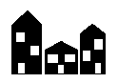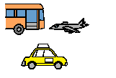

Community Access and

Inclusion Plan 2014-2018



3 Themes

3 Themes

No Steps

Make building easy to get into

Make transport easier to use

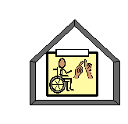

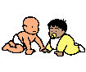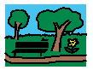

Services



Easier to find

Better to use

Library

Respite care

Children’s Services

Community Halls

Parks

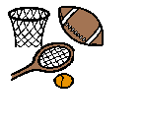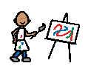

Activities

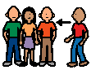

Be a part of

Sport

Festivals and Events

Art



Awareness

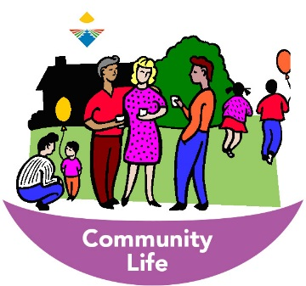

Make life better

To be included in community

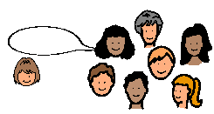

Join Us

The community will want you to join in

Tell the community about people with a disability