OPERATING ENVIRONMENT

OVERVIEW
We work in a complex social and political context with multiple factors that can affect how and how well we achieve our purpose. In deciding how to exercise our functions, we regularly assess the risks/challenges, opportunities, and capabilities in our environment that may affect our work, including over a multi-year horizon. The figure below is a summary of the key factors identified in the assessment for the 2021–22 (to 2025) environment. The table at the end of this section provides more information, including our management of the factors.

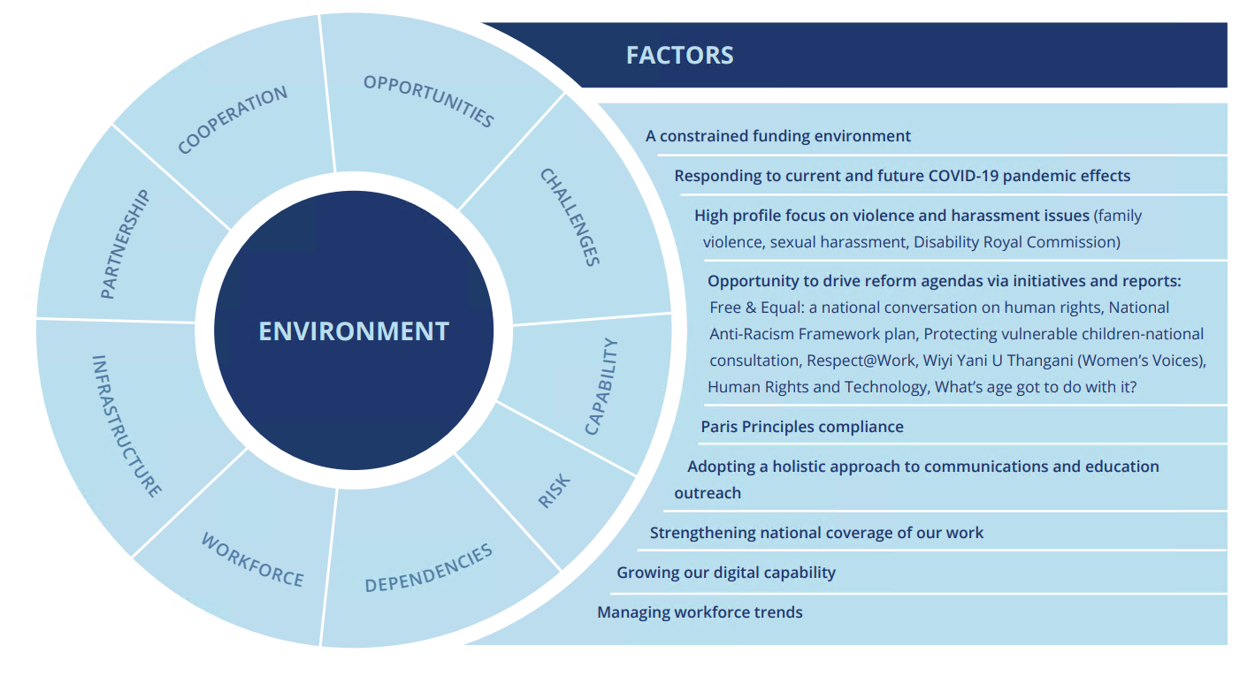

The Commission is currently investigating and seeking to address structural issues with its budget. The Commission’s budgetary position will be the most significant issue affecting its operations over the coming four-year period.
Our work involves a mixture of forward-looking, agenda-setting activities that seek to put important human rights front of mind, as well as reactive activities where we provide human rights expertise and input to government priorities, parliamentary processes, relevant court proceedings and through the operation of our national information service and complainthandling functions. We are most effective in our impact where our knowledge and expertise align with the external processes in which we engage.
Our work on cultural reform will expand with a focus on the Australian Parliament as a workplace, commencement of the National Sexual Harassment Council and implementation of recommendations from the Respect@Work report, commencement of a partnership with the Australian Federal Police, a continuation for the next four years of the cultural reform partnership with the Australian Defence Force, and partnerships with other industry and sector bodies.
We continue to operate in in the context of the global COVID-19 pandemic. Our Commissioners have a leadership role to provide robust, independent human rights expertise during the pandemic to ensure that no-one is left behind during and in the aftermath.
Our national information service and investigation and conciliation service will continue to provide information and assistance to people making and responding to complaints about discrimination and human rights breaches arising from responses to the pandemic. We have seen an extraordinary increase in complaint numbers in this period, which is anticipated to continue in the coming year and creates significant challenges for the Commission to maintain the timeliness in resolving disputes.
The Commission is finalising the Free and Equal project, which is aimed at identifying a national reform agenda for human rights for the next decade. This will involve setting out an agenda for national discrimination law reform as well as a framework for building a human rights culture through legislative and other measures.
The Commission will focus on the implementation of the findings of significant and novel research and consultation processes which provide guidance on key human rights challenges in our community. This includes the findings of the Human Rights and Technology Final Report; Wiyi Yanu U Thangani report on the voices of Aboriginal and Torres Strait Islander women and children; What’s age got to do with it? research report; Sharing the stories of Australian Muslims research report and our report on forced surgical procedures on people with intersex variations.
It also includes through the implementation of the report of the national inquiry into sexual harassment in Australian workplaces, Respect@Work.
We will also commence national engagement on the scoping of a new national anti-racism framework to better address racism and build social cohesion. Additionally, our IncludeAbility initiative will commence with the launch of an interactive portal with capacity building resources for both employers and employees, designed to promote the recruitment and retention of people with disability in the workplace. A key goal of removing barriers to employment for people with disability is critical to advancing economic security.
We anticipate that all our work will take place in a constrained resourcing environment, and with significant economic pressures facing the entire community.
We will look to embed further changes to working practices that have arisen during the COVID-19 pandemic, such as increased workplace flexibility and digital engagement tools.

CAPABILITY THROUGH DIGITAL INFRASTRUCTURE AND INVESTMENT
Information and communications technology (ICT) has a crucial role in supporting the organisation’s communication and sharing of information, both internally and externally. Investing in this aspect of our capability has been challenging, given our long-term fiscal environment and as a small Commonwealth agency.
Over recent years, our ICT team has led the Commission through a range of significant ICT infrastructure projects. Partnership arrangements have been entered into to deliver innovative, high value and low-cost ICT capabilities to service our organisational needs. This has led to the Commission being one of the first Commonwealth entities to deliver services through cloud-based infrastructure, as well as trialling industry leading options for an artificial intelligence centred document management system.
Last year our ICT team delivered significant capability in our initial technical and cultural response to the COVID–19 pandemic, where we were able to respond rapidly to the dramatic change in work practices, enabling the entire workforce to be transitioned to remote working arrangements within a week, supported by new digital tools for internal and external engagement, as well as full access to financial management and human resources functions remotely while maintaining appropriate security.
A year on from the pandemic we have continued to improve and embed a technical capability to support a remote workforce including an infrastructure project to standardised on Microsoft Teams as our telephony and video platform.

CAPABILTY AND OUR WORKFORCE
Our most important asset is our people. We understand the importance of a diverse and inclusive workplace culture and the need to foster excellence and expertise in our staff. With our internal and external stakeholders, we lead by example and operate in accordance with the human rights standards that we expect of others.
The main internal workforce capability gap that we face is matching the breadth of the work we want to do with the limited appropriated budget and other resources available to do so. Our challenge is to ensure that our workload remains achievable, and our staff are productive but not overwhelmed. This challenge particularly arises in supporting eight statutory officeholders and in managing our national complaint-handling function. In 2020, Commission staff responses to the State of the Service employee survey scored 82% on the wellbeing index relative to APS at 70% and 81% on employee engagement where the APS score was 73%. Whilst these results demonstrate that we are currently meeting the fine balance of employee loyalty and commitment, with the provision of a workplace culture and safe working environment, this needs to be monitored for future risk. High engagement scores without high wellbeing scores risk unsustainable performance outcomes.

KEY COMMISSON RESULTS IN THE 2020 AUSTRALIAN PUBLIC SERVICE (APS) EMPLOYEE CENSUS SURVEY:
93% of the respondent agreed: ‘I am proud to work in my agency’ (77% APS wide),
97% agreed they were happy to go the extra mile at work when required (93% APS wide), and
95% said ‘my workgroup successfully adapts to new ways of working when required e.g. during the pandemic (90% APS wide).

In managing our complaint-handling function, we ensure regular capacity building of our staff to handle complex interactions, build resilience and consistent skills upgrading in alternative dispute resolution to ensure swift resolution and satisfaction for all parties.
Our main externally facing challenge is attracting and retaining our staffing cohorts where small agency factors can limit the aspirations of staff to progress into senior roles. A new more flexible workforce is one strategy in maximising our efforts.
Building on our COVID-19 experience of remote working, where most staff considered they were as productive, or more productive, during this period, we have embedded hybrid working arrangements to leverage all the positive workforce benefits for our staff and for their work-life balance. This new operating environment creates opportunities for attracting a more national workforce despite a single Sydney-based office and will see some creative problem solving that may also increase efficiencies in service delivery.

COOPERATION AND CAPABILITY THROUGH OUR PARTNERSHIPS
The Commission regularly operates through partnerships and collaborations with government, business, the non-government sector and internationally.
We have built a reputation for expertise in human rights in research, consultation, and implementation design. Our operation as an independent agency is critical to our capability in this regard: it means we are a trusted neutral interlocutor that can bring diverse and often competing interests together to address difficult human rights challenges.
Partnerships increase our capability through shared skills and resources and create a collective ability to achieve outcomes greater than the individuals or organisations acting alone. It is a central feature of how we work.

OUR FOCUS ON SPORT
We recognise the important role that sport can play in furthering the promotion and protection of, and respect for, human rights. It is an accessible and relatable vehicle for cultural change. Sport contextualises rights and responsibilities for the broader public.
Over several years of engagement and partnership programs, the Commission has a deepened involvement in sport. The growing interest from sporting bodies to collaborate with the Commission is testament to our expertise, knowledge, and the value we bring to these relationships. For the period of this plan, the Commission will continue this role. For example, through our ongoing leadership and participation in the governance of Play by the Rules, in building on the independent reviews for Gymnastics Australia and Basketball Australia conducted in 2020-2021 and in working again with Golf Australia to develop golf and disability guidelines. With spectator racism continuing to be a significant challenge for the Australian sporting community, this will be particular a focus of the Commission’s work in 2021-2022.

Governments and entities from all sectors consistently invite us to work with them to share our human rights expertise and to enter collaborations on specific human rights projects and advocacy activities. In doing so, we have become accomplished in collaborating with professionalism and integrity.
With government partners, such arrangements include a partnership with the Australian Defence Force supporting and improving cultural reform across Defence; international technical cooperation that increases the human rights capabilities of neighbouring countries and contributes to regional cooperation and security; and collaborations with universities, sporting codes and business to provide guidance on responding to challenging human rights issues.
Our partnerships are diverse and take many forms, including agreements for in-kind support, pro bono and financial support. We also enter a range of ‘fee for service’ partnerships on a cost-recovery basis where we can provide our technical expertise to third parties. Our partnerships can be informal or formalised by a letter, MOU or legal contract and they may be short-to-long-term.
While the Commission’s partnership strategy is streamlined and centralised, it will be revised in 2021. This will ensure that we continue to approach our partnerships in a strategic, professional manner and through a risk lens.
Each year our planning process captures data on our partner organisations, the figure below is the range of partner categories in our forward workplan.
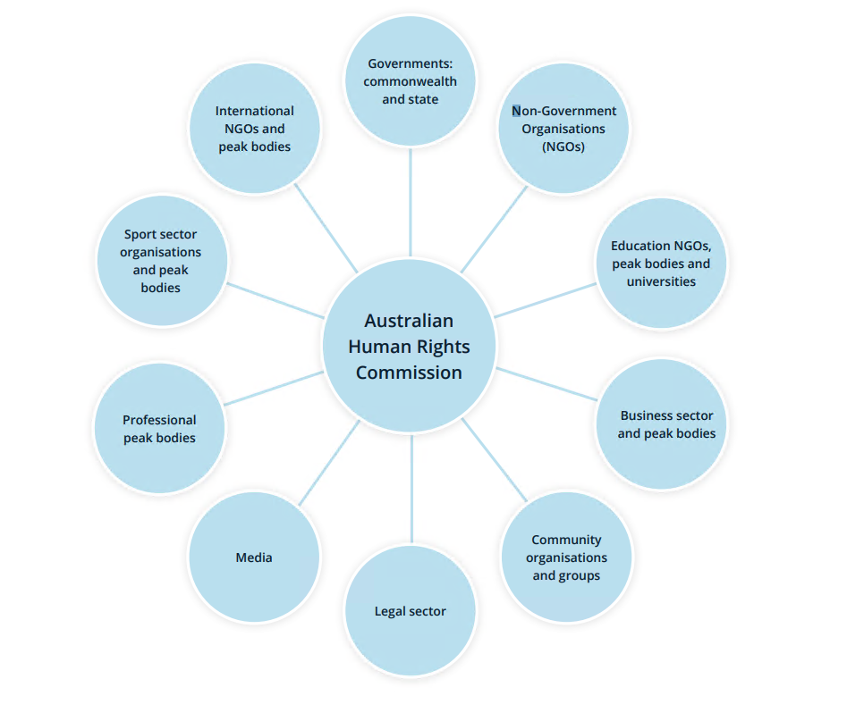

RISK OVERSIGHT AND MANAGEMENT
We adopt a positive risk management culture that promotes an open and proactive approach to managing risk.
Our existing risk management framework provides a mechanism for proactively identifying and mitigating risks across the organisation, and for monitoring the operating environment. The risk management framework is tailored to meet the needs of the Commission, and covers three main areas:
- Key strategic risks: including a constrained funding environment, damage to the Commission’s independence and reputation, not managing relationships with key government stakeholders and other external parties, and not responding quickly and effectively to a changing political landscape.
- Core business risks: including policy activities that are not aligned to the Commission’s strategic objectives, failing to provide an accessible and effective complaint handling service that complies with all relevant laws, and community engagement activities that fail to achieve the objective of increased public awareness of human rights.
- Corporate support risks: including failure to recruit and retain appropriately skilled and diverse staff, the misuse of assets or resources, business continuity processes not in place, IT interruption, outage or information compromise, and an unsafe work environment.
We have the following mitigation strategies and controls in place to manage these key risks: a risk owner has been allocated for each risk that has been identified; and the risk owner has responsibility for managing the particular risk.
We undertake regular reviews of the Commission’s risk management framework and the risks being managed, to ensure new risks are identified and existing risks remain appropriately managed. Our most recent review was undertaken by senior executive staff and the Accountable Authority in February 2020.
We have also embedded risk management into our decision-making and key business processes. For example, risk evaluations are conducted during procurement processes and in program planning processes. Simple templates have been developed to ensure these risk assessments are accessible to all staff.
We have also developed specialist policies and processes for particular risk categories, including: business continuity; pandemic planning; fraud control; work health and safety; privacy; child safety and wellbeing; and modern slavery in our supply chains. The Pandemic Planning Team (PPT) was established in response to the impact of COVID-19. The PPT meet regularly to reassess the Commission’s response to COVID-19 and to ensure business continuity.
We have commenced a major review of the Accountable Authority Authorisations and Accountable Authority Instructions, which includes ascertaining whether any further authorisations are required, particularly in the areas of risk management and performance accountability. In association with this, the Commission is reviewing and revising relevant policies and associated documentation.
In 2021, a Senior Compliance Officer commenced to review and improve the Commission’s compliance function to ensure relevant laws, government policies and internal guidelines are followed with a focus on governance and risk management.
We are supported by our internal auditors who conduct regular audit reviews and other assurance activities for our strategic planning and core business processes.
The Commission’s Audit and Risk Committee also has a role in overseeing risk management practices. The Audit and Risk Committee provides independent assurance to the Accountable Authority on the Commission’s financial and performance reporting responsibilities, risk oversight and management, and system of internal control and assurance. In 2021, the Commission appointed an independent Chair of the Audit and Risk Committee. All members of the Audit and Risk Committee are now external to the Commission.

Table 1. Key factors, challenges, opportunities, outlook, and management
This table summarises the key environmental, capability, cooperation and risk factors that may affect our operations in the four-year outlook of this year’s work plan.
It outlines the associated challenges, opportunities, our level of control over them and management strategies.
Factor | Assessment |  |  |  | Level of Control
 | Challenges, risks, opportunities and outlook |  | Management |  | A lot |  | Some |  | None
A constrained funding environment | Fiscal restraint across government appropriations is expected. The impact of this on small agencies will continue to drive tight internal budgeting.  The Commission is facing long term structural problems with its budget appropriation, which has not risen to account for the appointment of new commissioners or the rise in complaint numbers.  We have an increasing reliance upon external partnerships and fund-raising to support achievement of the Commission’s overall workplan.  While we have been successful in attracting funding for specific projects, in an unstable economic environment this support may be at risk over several of the reporting periods.  Building partnerships and work needs agility, guidance, coordination and recognition that not all Commission functions or priority work areas can attract such funding. |  | We need to:  - ensure our program of work is flexible to respond to changing government priorities that have key human rights impacts  - ensure our staffing levels are sustainable in light of long-term structural challenges with our budget position  - ensure support through core budget for such activities to ensure that the Commission maintains a balanced work program across all commissioners and areas of responsibility  - build the case for a more sustainable level of funding for the organisation, commensurate to the broad ranging functions of our Commissioners and the organisation  - continue to build our partnership and engagement capability using agreed principles and a strategic decision-making process to seek and implement partnership opportunities  - • ensure we can demonstrate our value prospect in achieving common goals and human rights benefits
Responding to the current and future COVID-19 pandemic effects | Our President and Commissioners have a key role in identifying the human rights impacts of the COVID-19 pandemic. This has included responding to:  - increased reports of racial discrimination, particularly faced by the Chinese community  - the gendered impact of the pandemic (due to the higher rates of women in casual and insecure work, greater demands on parents for caring responsibilities with school closures)  - impacts on older people, persons with disability and Aboriginal and Torres Strait Islander communities,  - mental health impacts on vulnerable groups, including children  - assessing the appropriateness of restrictions on human rights \ legal obligations under discrimination law relating to national vaccination roll outs, and the human rights impact of border closures and international travel caps. | To respond to the challenges presented by the pandemic, we will:  - reorientate our current project work to prioritise addressing COVID-19 related impacts  - proactively address emerging trends, including through our complaints and information services, to prevent human rights abuses and discrimination  - within remaining capacity, continue to progress other important work priorities while making necessary changes to external engagement  - support the leadership role of our Commissioners to provide robust, independent human rights expertise during the pandemic to ensure that no-one is left behind during and in the aftermath.
 | Before the pandemic, much of our work was anchored in face-to-face program components and advocacy. We swiftly ensured staff could work remotely (maintaining our business) and had the tools to conduct activities through digital engagement. This has minimised disruption to our work activities and ensured that we have greater digital engagement capabilities moving forward. | In this four-year period, we will continue to strategically build our technical and program digital capabilities, including through our learning management system, web-based submissions and engagement hub, and enhancing skills in web seminars and consultations.  We will continue to focus on partnerships as well as community engagement that ensures our activities and services are accessible to vulnerable and marginalised people and communities, to ensure that the increased reliance on digital technologies does not impact negatively.

Factor | Assessment |  |  |  | Level of Control
 | Challenges, risks, opportunities and outlook |  |  | Management | A lot | Some | None
Long term reform agendas to improve human rights outcomes | The Commission announced the ‘Free and Equal: An Australian conversation on human rights’ project in December 2018 as a flagship multi-year initiative to set out the main priorities for human rights reform over the next decade. The key challenge is to deliver a persuasive national reform agenda for human rights that can garner support from government and Parliament to drive the human rights priorities over the next decade at the federal level.  The realisation of the reform agenda will provide a long-term stage for this work, increasing the reach and relevance of our education and awareness programs to the broader community.  This work will be supplemented by a focus on implementation of the recommendations of key national reports: Human Rights and Technology Final Report, Wiyi Yani U Thangani (Women’s Voices): Securing our Rights, Securing our Future 2020 report, and the Respect@Work: Sexual Harassment National Inquiry Report. |  |  | - In the coming year, the Free and Equal project will conclude with the publication of a series of position papers setting out a long-term national reform agenda for human rights.  - Having conducted thorough and innovative research and consultation phases, the Commission will focus on building buy-in and consensus on achieving national reforms in relation to human rights and technology, Indigenous women, and addressing sexual harassment.  - New national consultations and research projects will commence to establish the required elements of a more comprehensive and effective approach to combatting racism and more effective protection of children in vulnerable situations.
Adopting a holistic approach to communications and education outreach | The Commission has restructured its communications and education functions in order to provide a more comprehensive, holistic approach to public engagement. This is to ensure dynamic engagement with the public in a variety of environments and contexts to improve engagement and outreach; be accessible to a broader group of people; and increase the understanding of human rights in the community. |  |  | To ensure the restructure meets its articulated objectives the Commission will:  - embed new approaches to our statutory education work to increase the reach of our existing outputs for broader public benefit  - increase our focus on knowledge translation and training activities  - expand and diversify of our digital platforms to enable people to access factual, authoritative, engaging and accessible resources on different human rights issues.
High profile focus on violence and harassment issues | A significant focus on violence, harassment and abuse against women, will likely ensure high public interest in the Commission’s research, consultation and reform proposals in these areas.  The cultural review of the Australian Parliament as a workplace will be a lead project on this work, while implementation of the recommendations of the Respect@ Work report will also likely receive greater focus.  The Royal Commission into institutional abuse of persons with disabilities and the now finalised Royal Commission into aged care provide a spotlight to advance human rights protections and a safeguarding focus for vulnerable groups and people. |  |  | The Commission will play a leading national role in identifying pathways to address sexual harassment, violence and abuse against women through a series of cultural reform projects (defence, Australian Federal Police, and sporting codes) as well as a national review of the Australian Parliament.  The Commission will also conduct and finalise activities targeted at addressing violence, harassment and abuse faced by others in the community, including by:  - research and public engagement on elder abuse  - publishing the outcomes of national consultations and surveys with Muslim communities  - leading national consultations with vulnerable children and families to inform the development of the 3rd national framework on protecting Australia’s children, and  - conducting Australia’s 5th national workplace sexual harassment prevalence survey in 2022.
Paris Principles compliance | The Paris Principles (Principles Relating to the Status of National Human Rights Institutions) provide an internationally agreed basis for assessing the independence and effectiveness of national human rights institutions. The Commission’s compliance will next be assessed in 2021/22, providing an opportunity to consider the effectiveness of the Commission’s operating arrangements and breadth of functions. |  |  | The Commission will work with the Government to  address compliance issues ahead of Australia’s next  accreditation review in 2021/22.
Factor |  | Assessment |  |  | Level of Control
 |  | Challenges, risks, opportunities and outlook | Management |  | A lot | Some | None
Ensuring national coverage of our work |  | The single base of our organisation in Sydney, with some Commissioners located inter-state, and our resourcing creates challenges for ensuring engagement with regional, rural and remote Australia.  The COVID-19 pandemic has significant implications for the foreseeable future for engagement strategies, with limits on the ability to conduct face to face consultations and travel nationally. | The COVID-19 pandemic has resulted in significant changes to external outreach strategies, due to the lack of ability to travel or conduct face to face consultation and meetings. Over the coming year, we shall look to embed these new practices and build our technical capability to conduct online and remote consultation.
Managing workforce trends |  | Underlying the staffing challenges of the future is an appreciation of a stronger mobility mindset among our newest cohorts and the need to harness this talent quickly and effectively rather than building for a longer term return on investment.  The breadth of work that the Commission engages in vs how much we can do within limited budget and resources continues to challenge our capacity.  There is a need to recognise the opportunities in effective home-based work (HBW) practices, virtual team environments and opening roles to geographically remote personnel as appropriate. | In managing a more mobile workforce our strategy includes investing in our more senior tiers to build the capacity of managers to work with this cohort and to develop internal systems to manage the retention of corporate knowledge.  Robust planning processes will be important in reality checking ambitious workplans with the aim to:  - ensure that our workload remains achievable against resourcing, and  - that staff and internal support systems are productive, but not overwhelmed.  We will build on our stronger digital capability to harness the productivity, attraction, retention and reputational benefits that could flow from greater HBW arrangements.
Strengthening our digital capacity |  | Last year’s investment in our digital technology infrastructure has delivered benefits including streamlined information management with 24/7/365 access to systems and data, increased security, more workforce flexibility and versatility and efficiencies in our program activities.  These benefits and our agility in this area were demonstrated in our swift response to remote working and our creation of a virtual ‘business as usual’ culture during the COVID-19 lockdown period. | Our focus is on:  - increased use of centralised web outreach through our new ‘Have your say’ portal  - increased use of digital engagement tools  - more strategic and coordinated communications  - outreach through digital channels.

