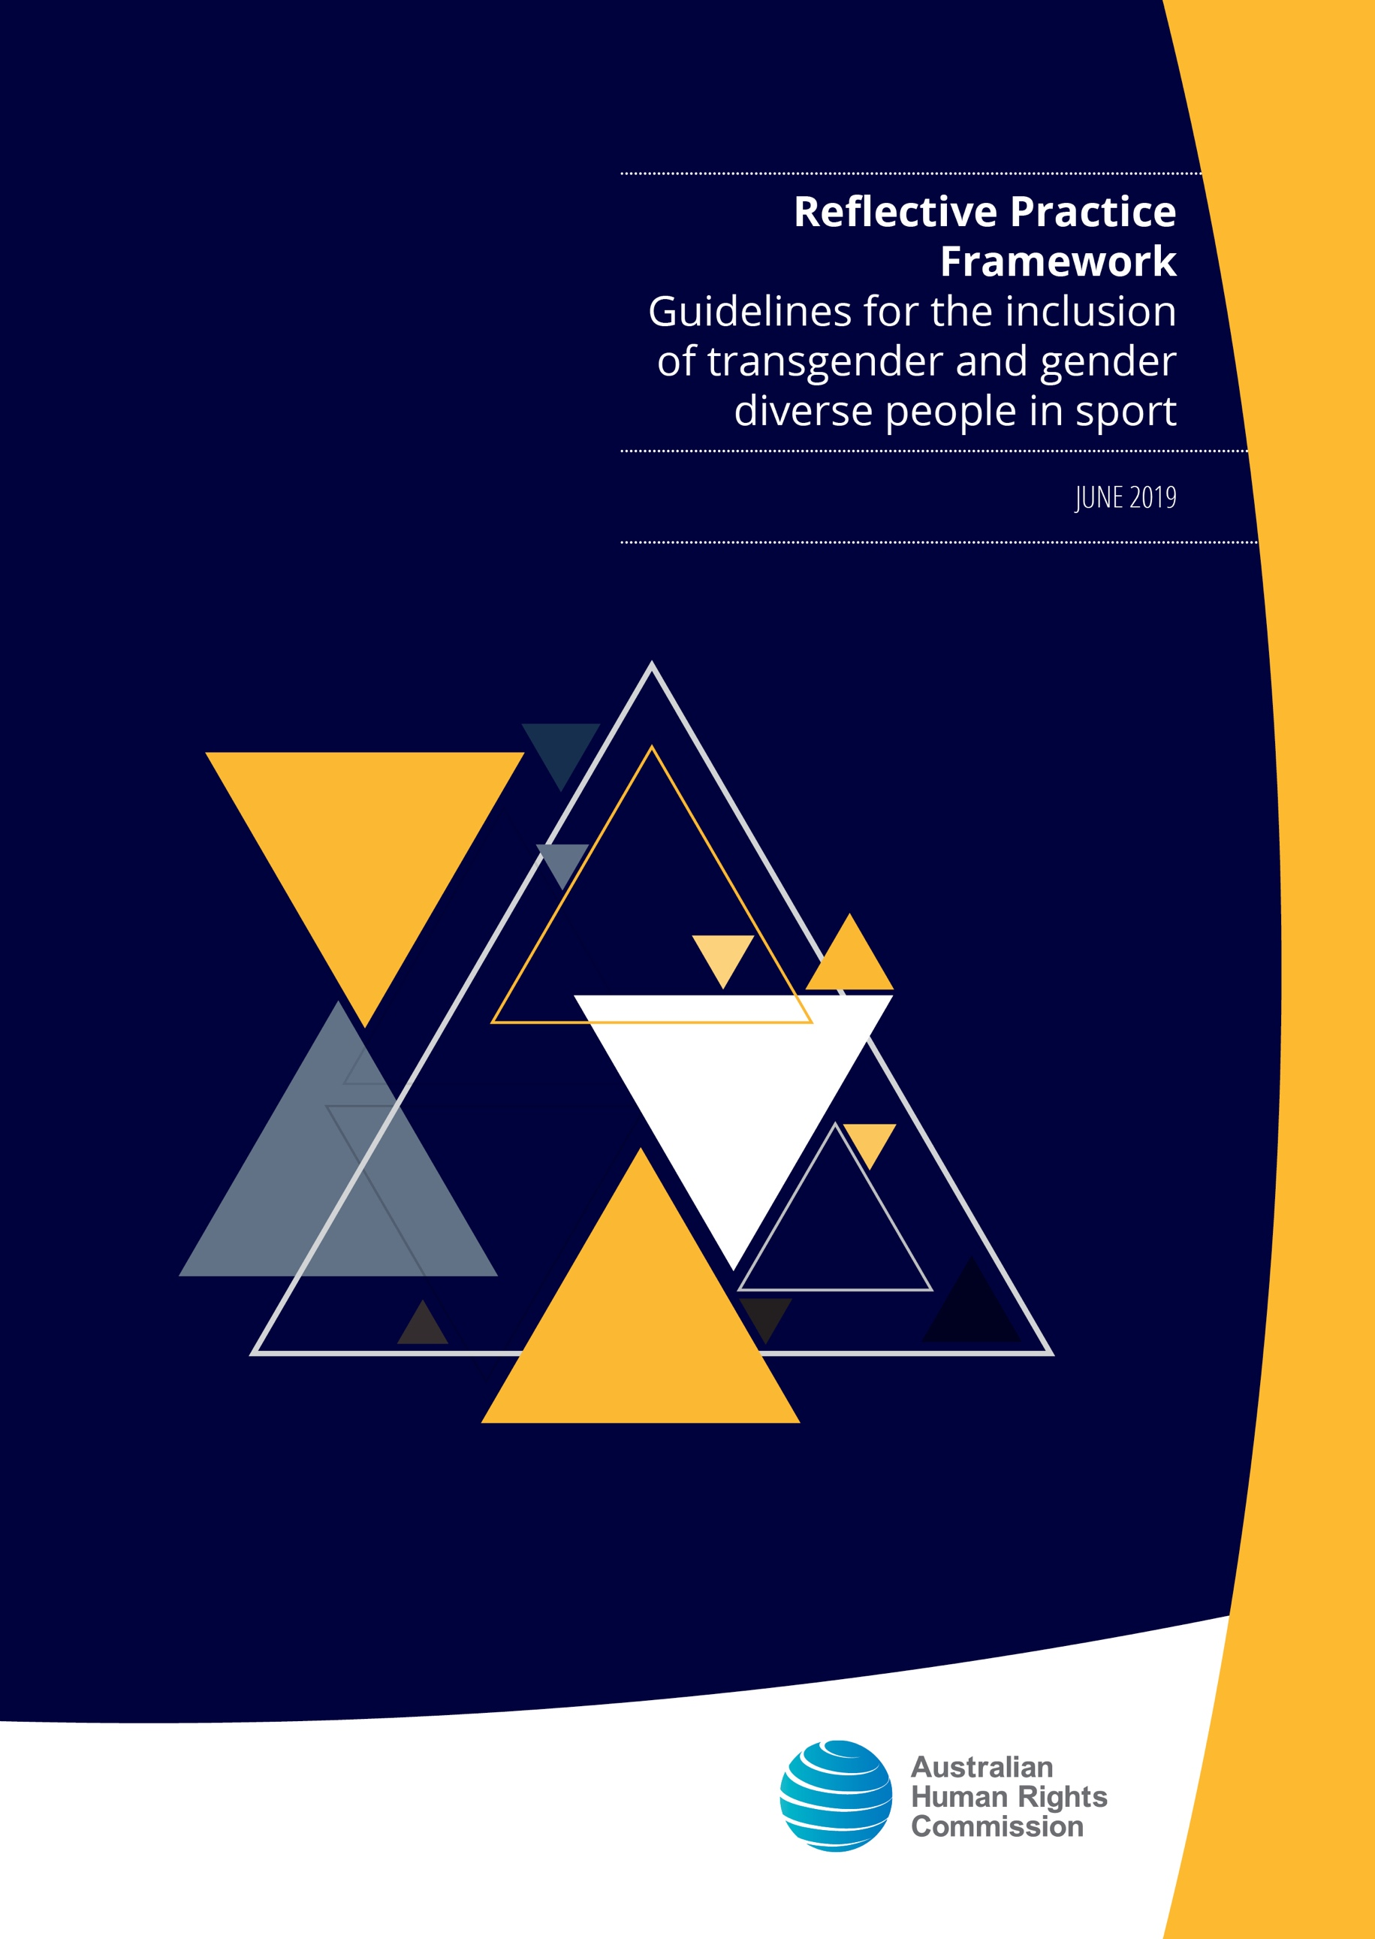

© Australian Human Rights Commission 2019.

The Australian Human Rights Commission encourages the dissemination and exchange of information presented in this publication.

Creative Commons logo


All material presented in this publication is licensed under the Creative Commons Attribution 4.0 International Licence, with the exception of:

• photographs and images;

• the Commission’s logo, any branding or trademarks;

• content or material provided by third parties; and

• where otherwise indicated.

To view a copy of this licence, visit <http://creativecommons.org/licenses/by/4.0/legalcode>.

In essence, you are free to copy, communicate and adapt the publication, as long as you attribute the Australian Human Rights Commission and abide by the other licence terms.

Please give attribution to: © Australian Human Rights Commission 2019.

Reflective Practice Framework • Guidelines for the inclusion of transgender and gender diverse people in sport • 2019

ISBN 978-1-925917-00-0

This publication can be found in electronic format on the Australian Human Rights Commission’s website at <https://www.humanrights.gov.au/our-work/publications>.

For further information about the Australian Human Rights Commission or copyright in this publication, please contact:

Australian Human Rights Commission

GPO Box 5218

SYDNEY NSW 2001

Telephone: (02) 9284 9600

Email: [communications@humanrights.gov.au](mailto:communications@humanrights.gov.au)

Reflective Practice Framework

Guidelines for the inclusion of transgender and gender diverse people in sport

June 2019

Australian Human Rights Commission 2019

Australian Human Rights Commission logo

**Contents**

1 Purpose 5

2 Structure 5

3 Short-term reflection point—initial response to the Guidelines 7

3.1 What should be assessed? 7

3.2 How is it assessed? 7

3.3 When should the assessment occur? 7

4 Medium-term reflection point—implementing the Guidelines 8

4.1 What should be assessed? 8

4.2 How is it assessed? 8

4.3 When should the assessment occur? 8

5 Longer-term reflection point—progress towards the objective 9

5.1 What should be assessed? 9

5.2 How is it assessed? 9

5.3 When should the assessment occur? 10

6 Identifying opportunities for improvement 11

Appendix A: Reflective Practice Framework Tool 12

# Purpose

The Reflective Practice Framework (the Framework) has been developed by the Australian Human Rights Commission (the Commission) to assist Sport Australia and the Coalition of Major Professional and Participation Sports (COMPPS) (together the Partners) to monitor the implementation and impact of the Guidelines for the inclusion of transgender and gender diverse people in sport (the Guidelines) in the period after their release.

The Framework will assist the Partners to monitor progress towards the long-term objective of the Guidelines—promotion of the inclusion of transgender and gender diverse people in sport.

# Structure

The Framework is designed to:

* assess the initial response to the Guidelines (short-term)
* assess the implementation of the Guidelines (medium-term)
* monitor progress of the Guidelines against the objective(s) of the Guidelines (longer-term).

The diagram on page 6 illustrates the operation of the Framework.

Suggestions for how each assessment may be conducted are included below. Other appropriate tools or methods may also be used, for example:

* interviews with sports administrators (for example, general managers of sporting organisations)
* reviews of formally reported membership demographics
* feedback forms completed by players.

At each assessment and reflection point, the Partners should identify any lessons and opportunities for improvement to be actioned before the longer-term reflection point. See Section 6 for further guidance.

It is also important to remember that the Guidelines are a living document. Opportunities for continuous improvement should be considered throughout the assessment period, and after the longer-term reflection point. Where opportunities for improvement are identified the Partners are encouraged to share these insights with the Commission.

A Framework implementation tool for Partners is included in Appendix A.

**REFLECTIVE PRACTICE FRAMEWORK DIAGRAM**

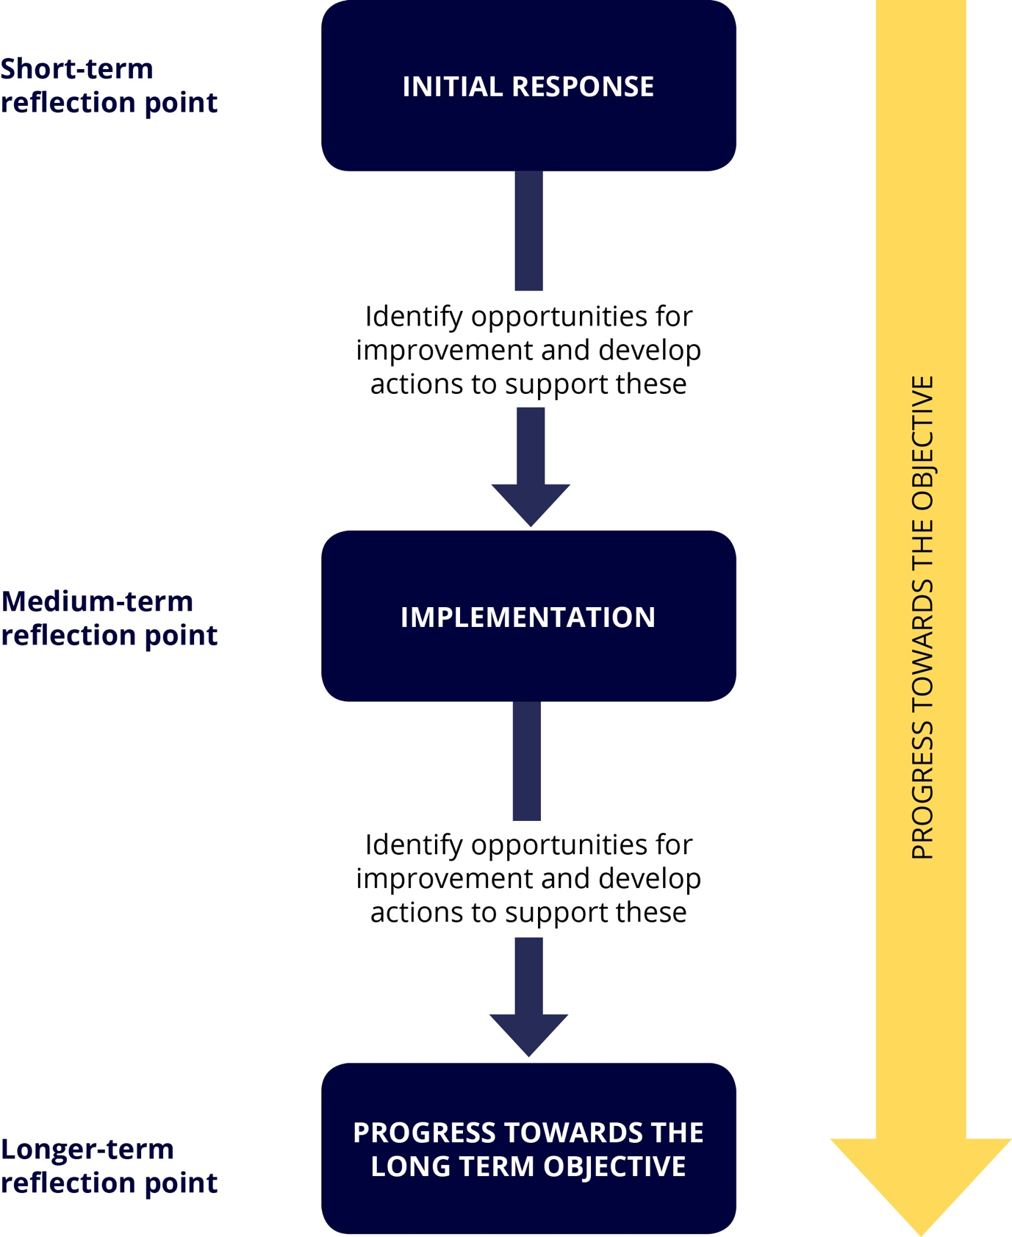

# Short-term reflection point—initial response to the Guidelines

## What should be assessed?

The short-term reflection point should be used to assess the initial response to the Guidelines.

This may involve determining whether the governing bodies of sporting organisations have formally received and adopted the Guidelines.

The Partners should assess if the Guidelines have:

* been well promoted to and by the leadership of sporting organisations
* been well received and accepted (in other words, welcomed as a positive addition to sport)
* prompted users to act (in other words, have the decision-makers discussed the Guidelines and how they might be implemented).

## How is it assessed?

The initial response could be assessed by conducting a short survey of those consulted during the development of the Guidelines, or another identifiable key stakeholder group (for example, members of a key peak body).

The survey questions should be designed to assess the points outlined in section 3.1 above, and identify areas for improvement.

## When should the assessment occur?

This assessment should occur shortly after the launch of the Guidelines. This will generally be three to six months after the Guidelines are launched.

# Medium-term reflection point—implementing the Guidelines

## What should be assessed?

The medium-term reflection point is used to assess the implementation of the Guidelines. Partners should assess:

* the steps taken to implement the Guidelines
* any barriers to implementing the Guidelines.

If any barriers are identified, the reasons for these barriers should be examined (in other words, resources, planning has commenced but no action yet taken etc).

## How is it assessed?

The implementation of the Guidelines may be assessed through a roundtable or forum (or a series of these) with the people responsible for implementing the practical steps outlined in the Guidelines. For example, Board and Management Committee members; general managers; and participation and diversity managers.

The discussion questions for the forum or roundtable should be designed to assess the points outlined in section 4.1 above, and identify areas for improvement.

To maximise engagement it may be appropriate to hold these discussions in tandem with other events (for example, a national conference).

## When should the assessment occur?

This assessment should occur at a point which aligns with the anticipated implementation of the Guidelines. This will generally be six to 12 months after the Guidelines are launched.

# Longer-term reflection point—progress towards the objective

## What should be assessed?

The Partners should assess progress towards the objective at the longer-term reflection point.

Assessing social impact of this nature is inherently difficult. There are many factors that may contribute to progress towards the objective in addition to the Guidelines (for example, national strategies which align with its aims). Despite these potential challenges it is valuable to undertake this assessment at this point.

Taking the time to reflect on the progress that has been made towards the objective will allow the Partner or sporting organisation to determine whether the underlying issues persist as a barrier to inclusion. For example, whether transgender and gender diverse people face structural barriers to participation in sport.

## How is it assessed?

Progress towards the objective could be assessed by conducting a detailed survey of a broad range of stakeholders. The stakeholders should include national sporting organisations, state sporting organisations, state and territory sport and recreation departments, player associations, clubs of all levels (local through to elite), and players of all levels.

A survey of this nature may ask questions similar to those outlined in the inclusion checklist in the Guidelines. For example:

* Have you made a commitment to the inclusion of transgender and gender diverse people in your sport?
* Have you implemented inclusive information collection processes?
* Has there been an increase in the reported number of transgender or gender diverse people participating in your sport?

The questions should be framed in a way that makes them applicable to all survey recipients. Alternatively you may wish to have different versions of the survey for individuals and organisations that are directly engaged in sport (for example, sporting organisations and players) and other stakeholders (for example, state and territory departments of recreation).

It may also be helpful to consider conducting a similar survey as part of the medium-term reflection point to allow for benchmarking.

## When should the assessment occur?

This assessment should occur approximately three to five years after the launch of the Guidelines, or at another time which aligns with another natural review point (for example, the review date for a strategy).

Section 6 – Identifying opportunities for improvement

This section outlines examples of possible outcomes at each reflection point (short-term, medium-term and longer-term) and the corresponding action that can be taken to address these. 
The examples and corresponding actions are listed below.
Example short-term reflection point:
•	The outcome of an assessment might be that the Guidelines have been well-received by metropolitan clubs but very few regional clubs are aware of them. The corresponding action might be to undertake further promotion in regional and rural areas.
•	The outcome of an assessment might be that while clubs support the Guidelines they need further support in translating the suggested steps into action. The corresponding action might be to develop or commission education and training to support the implementation of the Guidelines. 
Example medium-term reflection point:
•	The outcome of an assessment at the medium-term reflection point might be that sporting organisations have not progressed the development of an inclusion policy, as suggested by the Guidelines. The corresponding action might be to develop or commissioning of a model policy to assist clubs action this suggestion. 
Example longer-term reflection point:
•	The outcome of an assessment at the longer-term reflection point might be that while transgender and gender diverse individuals report feeling more welcome within a particular sport, younger members of this community (less than 18 years) still fell excluded and are hesitant to participate. The corresponding action might be to conduct further research regarding the different experiences of older and younger transgender and gender diverse people in the sport. 

# Identifying opportunities for improvement

After each reflection point the Partners should identify opportunities for improvement. This step allows the Partners to take action to maximise the role of the Guidelines in meeting the identified objective. Where opportunities for improvement are identified the Partners are encouraged to share these insights with the Commission.

Some examples of outcomes and actions are outlined below:

| **Reflection point** | **Outcome of assessment** | **Action to be taken** |
| --- | --- | --- |
| **Short-term** | The Guidelines have been well-received by metropolitan clubs but very few regional clubs were aware of them. | Undertake further promotion in regional and rural areas. |
| The Partner identified that clubs support the Guidelines but they need further support in translating the suggested steps into action. | Develop, or commission the development of, education and training to support the implementation of the Guidelines. |
| **Medium-term** | The Partner identified that most sporting organisations had not progressed the development of an inclusion policy, as suggested by the Guidelines. | Develop, or commission, the development of, a model policy to assist clubs action this suggestion. |
| **Longer-term** | The Partner identified that while transgender and gender diverse individuals report feeling more welcome within a particular sport, younger members of this community (less than 18 years) still feel excluded and are hesitant to participate. | Conduct further research regarding the different experiences of older and younger transgender and gender diverse people in the sport. |

Appendix A – Reflective Practice Framework Tool

The Reflective Practice Framework Tool is a table which allows the user to capture the following information for each reflection point (short-term, medium-term, and longer term):
•	What is being assessed?
•	How is it assessed?
•	When should the assessment occur?
•	Opportunities for improvement, including outcomes and action.
Each field in the table is cross-referenced to the relevant sub-headings of the document in sections 3 to 6.  

# Appendix A: Reflective Practice Framework Tool

This table can be used as a tool to implement the Framework. It is a visual representation of the Framework described above.

|  |  |  |  |  |  |
| --- | --- | --- | --- | --- | --- |
|  | **What is being assessed?** | **How is it assessed?** | **When should the assessment occur?** | **Opportunities for improvement** | |
| **Outcomes** | **Action** |
| **Short-term reflection point** | **Initial response to the Guidelines**  *See* ***Section 3.1*** *above.* | *See* ***section 3.2*** *above.* | *See* ***section 3.3*** *above.* | *See* ***section 6*** *above.* | *See* ***section 6*** *above.* |
| **Medium-term reflection point**  *Approach to be informed by opportunities for improvement identified at the short-term reflection point.* | **Implementation of the Guidelines**  *See* ***section 4.1*** *above.* | *See* ***section 4.2*** *above.* | *See* ***section 4.3*** *above.* | *See* ***section 6*** *above.* | *See* ***section 6*** *above.* |
| **Longer-term reflection point**  *Approach to be informed by opportunities for improvement identified at the medium-term reflection point.* | **Progress toward the objective**  *See* ***section 5.1*** *above.* | *See* ***section 5.2*** *above.* | *See* ***section 5.3*** *above.* | *See* ***section 6*** *above.* | *See* ***section 6*** *above.* |